Supplementary Table 1.

R. Time | Score | Compound Name | ION | Formula | Hit Score | 2D Structure
1.42 | 0.1976 | 7-Hydroxymitragynine | [M+H]+ | C23H30N2O5 | 4 | 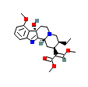
1.50 | 0.1503 | (S,S)-(+)-Tetrandrine | [M+H]+ | C38H42N2O6 | 4 | 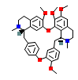
1.68 | 0.4044 | 5-Hydroxytryptophan | [M+H]+ | C11H12N2O3 | 3 | 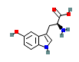
14.28 | 0.2709 | Gardneramine | [M+H]+ | C23H28N2O5 | 4 | 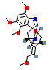
15.24 | 0.1489 | Aconitine | [M+H]+ | C34H47NO11 | 9 | 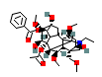
15.44 | 0.1525 | Chrysanthellin B | [M+H]+ | C58H94O26 | 8 | 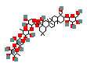
15.70 | 0.2243 | Vitexin | [M+H]+ | C21H20O10 | 4 | 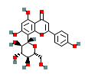
15.91 | 0.2003 | Isosilybin A | [M+H]+ | C25H22O10 | 6 | 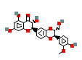
18.18 | 0.1340 | Oxyacanthine | [M+H]+ | C37H40N2O6 | 6 | 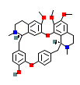
19.80 | 0.1327 | Thalsimidine | [M+H]+ | C37H38N2O7 | 10 | 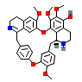
20.02 | 0.8144 | Lycorine-diacetate | [M+H]+ | C20H21NO6 | 4 | 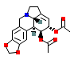
20.32 | 0.0638 | Luteolin 6-C-glucoside 8-C-arabinoside | [M+H]+ | C27H30O16 | 4 | 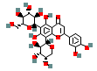
20.45 | 0.1031 | Aconitine | [M+H]+ | C34H47NO11 | 4 | 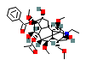
21.06 | 0.1055 | (+)-Tubocurarine chloride | [M+H]+ | C37H40N2O6 | 3 | 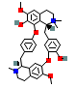
22.51 | 0.1342 | Apigenin-8-C-glucoside-2'-rhamnoside | [M+H]+ | C27H30O14 | 3 | 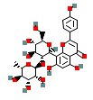
22.84 | 0.3697 | (-)-Podophyllotoxin | [M+H]+ | C22H22O8 | 2 | 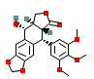
26.17 | 0.1741 | (+)-Tubocurarine chloride | [M+H]+ | C37H40N2O6 | 6 | 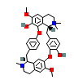
26.58 | 0.3589 | Ginsenoside compound K | [M+H]+ | C36H62O8 | 2 | 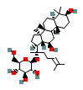
29.11 | 0.1729 | isosakuranetin-7-O-rutinoside | [M+H]+ | C28H34O14 | 6 | 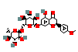
29.26 | 0.3588 | Orientin | [M+H]+ | C21H20O11 | 4 | 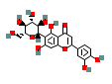
32.20 | 0.2065 | Furostane base -2H + O-Hex, O-Hex-Hex-dHex | [M+H]+ | C51H84O23 | 5 | 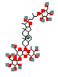
33.70 | 0.3868 | Brucine | [M+H]+ | C23H26N2O4 | 5 | 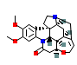

Table 1. LC–MS identified compounds from S. mukorossi extract with retention time, formula, ionization mode, and hit score.

