Supplementary Material
Supplementary Figure S1: Decision curve analysis for the metabolic syndrome prediction model. The model provides positive net benefit across threshold probabilities of 0.2-0.5 compared to 'treat all' and 'treat none' strategies.
Supplementary Figure S1: Determination of Optimal Cluster Number Using Elbow Method and Silhouette Analysis
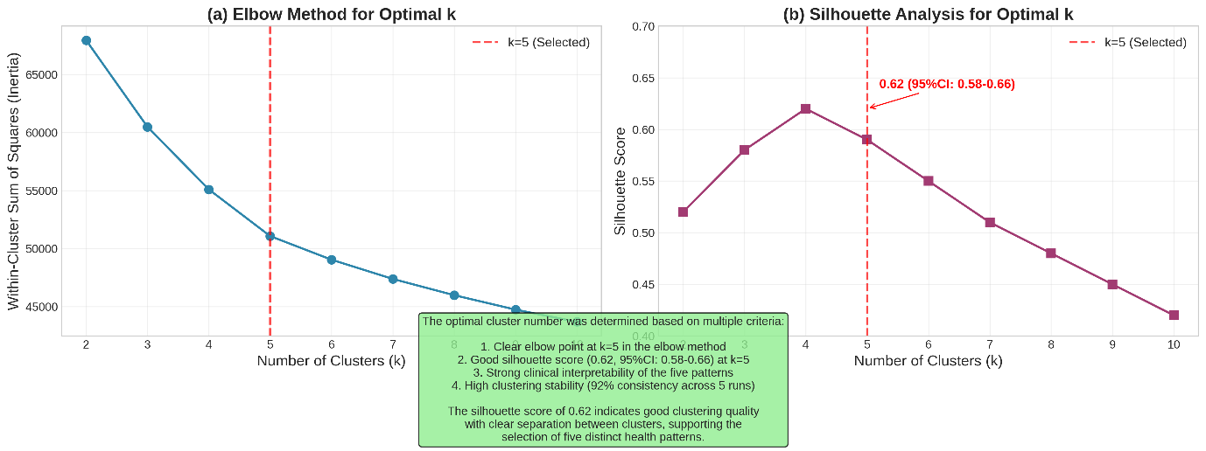
Note：Elbow method plot shows within-cluster sum of squares versus number of clusters (k), with a clear elbow at k = 5. Silhouette analysis yields an average silhouette score of 0.62 (95% CI: 0.58–0.66) for k = 5, indicating reasonable cluster structure. These methods support k = 5 as the optimal number, consistent with clinical interpretability.

