Supplementary Materials for
Epigenetic estimates reveal a species-specific extension of lifespan in modern humans

Xiangye Liu, Pingfen Zhu, Chunyan Hu, Qi Pan, Zhan Zhang, Weixiao Chen, Zixiang Xiong, Yang Yu, Xiaoxiao Zhang, Juan Du, Meng Li, Gaoming Liu, Xuming Zhou

Correspondence and requests for materials should be addressed to Xuming Zhou (E-mail: zhouxuming@ioz.ac.cn).

The file includes:
Table S1 to S3
Titles and legends for Table S4 to S6
Fig. S1 to S12
Reference

The following supplementary materials are provided by independent files:
Table S4 to S6

Table S1: A summary of well-established first-generation methylation clocks for age prediction

Clock Reference | CpGs | Sample | Tissue | MAE
Bocklandt, et al. 2011 | 2 | 62 | Saliva | 5.2
Koch & Wagner. 2011 | 5 | 130 | Multiple Tissues | 12.7
Hannum, et al. 2013 | 71 | 482 | Blood | 4.9
Horvath. 2013 | 353 | 8,000 | Multiple Tissues | 3.6
Weidner, et al. 2014 | 102 / 3 | 575 | Blood | 3.34 / 5.43
Lin, et al. 2016 | 99 / 3 | 1,659 | Blood | 3.45 / 10.9
Horvath, et al. 2018 | 391 | 896 | Multiple Tissues | Different
Zhang, et al. 2019 | 514 | 13,661 | Blood & Saliva | 2.04
McEwen, et al. 2019 | 94 | 1,032 | Buccal Cell | 0.35

MAE: Mean absolute error (years). The first author (or both authors connected by an ampersand if there were only two) and year of publication are used to represent the corresponding references. “Different” in “MAE” column represents that MAE is different among tissues. Certain references have described more than one methylation clocks, whose CpGs and MAE are distinguished using slashes.

Table S2: A summary of several novel epigenetic biomarkers combining second-generation methylation clocks and other measures

Biomarker | CpGs | Sample | Tissue | Combination
DNAm PhenoAge | 513 | 456 | Blood | 9 Clinical Measures & Chronological Age
DNAm GrimAge | 1,030 | 1,731 | Blood | 12 Plasma Protein Levels & Smoking Pack Year
DNAm TL | 140 | 2,256 | Blood | Leukocyte Telomere Length
DunedinPoAm | 46 | 810 | Blood | 18 Biomarkers Tracking Organ-System Integrity

Names designed for the novel epigenetic biomarkers in the corresponding references are kept. Different epigenetic biomarkers used distinct second-generation methylation clocks and other measures.

Table S3: A summary of original clocks and their corresponding PC-guided clocks utilized in this study

Original Clock | PC-guided Clock | PC Used | Source
Hannum-71 Clock | PCHannum | 390 | Study-obtained
Horvath-353 Clock | PCHorvath1 | 121 | Study-obtained
Horvath-391 Clock | PCHorvath2 | 140 | Study-obtained
Weidner-102 Clock | - | - | -
Weidner-3 Clock | - | - | -
Lin-99 Clock | PCLin | 208 | Self-trained
Lin-3 Clock | PCLin | 208 | Self-trained
Zhang-514 Clock | PCZhang | 406 | Self-trained
McEwen-94 Clock | - | - | -
DNAm PhenoAge | PCPhenoAge | 652 | Study-obtained

The first author of the corresponding references and CpG numbers connected by a hyphen are used as the name of original clocks. Further information on original clocks can be found in Table S1. All former available PC-guided clocks, along with instructions on training more of them were obtained from the same reference. PC-guided clocks either maintained their names (study-obtained ones) or were named according to the PC and first author pattern (self-trained ones, e.g., PCLin). Overall, four PC-guided clocks are obtained from the reference, while two are newly trained. Number of PCs with nonzero coefficients are distinct in “PC used” column based on the elastic net regression model. Dash means this corresponding PC-guided clock is not available.

Table S4: Source series information for the study samples

Table S4.xlsx

Series with heterogeneous sample origins are startified into smaller, labelled subseries. The sample size of each series indicates the number utilized in the study instead of the total. For analysis, histologically similar tissues/organs are pooled, and ethnic background are unified into categories. Consequently, information presented may not match the original series annotations.

Table S5: Methylation sites and respective coefficients/weights for methylation clocks

Table S5.xlsx

This table comprises 16 subtables, each listing the methylation sites with their corresponding coefficients (original clocks) or weights (PC-guided clocks) used in a methylation clock and labelled by its name. For PC-guided clocks, the weights are derived from PCs and their respective nonzero coefficients (Methods).

Table S6: Methylation values of target sites extracted from archaic hominin DNAm maps

Table S6.xlsx

This table comprises 4 subtables, each listing methylation values for target sites derived from either original clocks or PC-guided clocks, based on DNAm maps from Neandertals or Denisovans. Chromosomal location of each methylation site is presented. Note that the beta value of a site failed to match is set to zero, reflecting the perspective that the site could not be matched due to the absence of methylation in Neandertals or Denisovans.

- New PC-guided clocks trained
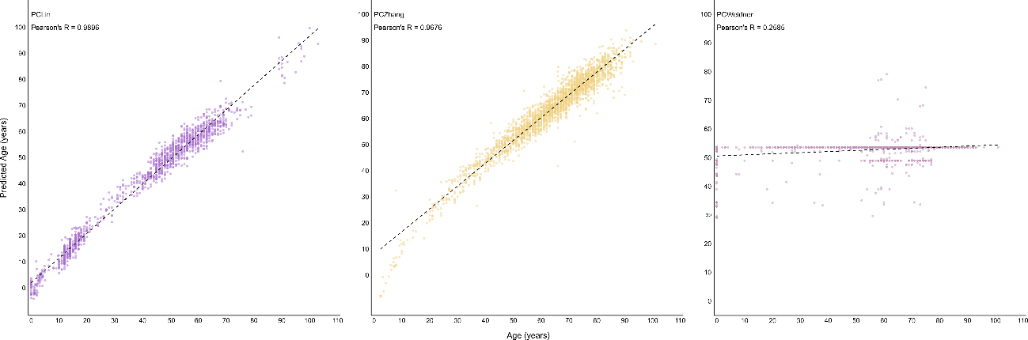
Fig. S1 | Age-correlation of estimation results using three newly trained PC-guided clocks within the training dataset. Individual points represent training samples, with the clock’s name and Pearson’s correlation coefficient between chronological age and predicted age displayed at the upper left corner. The dashed line shows the linear relationship between predicted age and chronological age. Note that PCWeidner substantially underperforms PCLin and PCZhang, rendering it unsuitable to be a PC-guided clock.

- Genomic analysis of methylation clocks
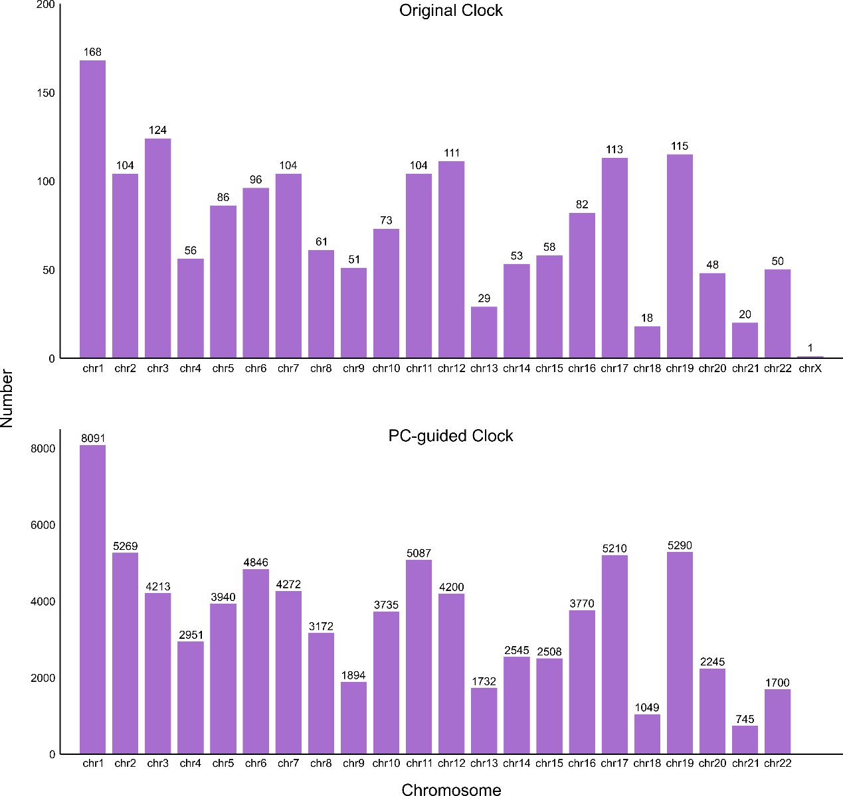
Fig. S2 | Chromosomal distributions of methylation sites in methylation clocks. The upper and lower panels show the distribution of methylation sites along the chromosomes in original clocks and PC-guided clocks, labelled at the top center. Each bar in a panel represents the number of target methylation sites derived from methylation clocks located on a specific chromosome. In the upper panel, values are shown for all 22 autosomes and the X chromosome (the Y chromosome excluded), confirming each contains at least one site from methylation clocks. In the lower panel, values are shown for only 22 autosomes, while sex chromosomes are excluded due to the absence of any target sites.

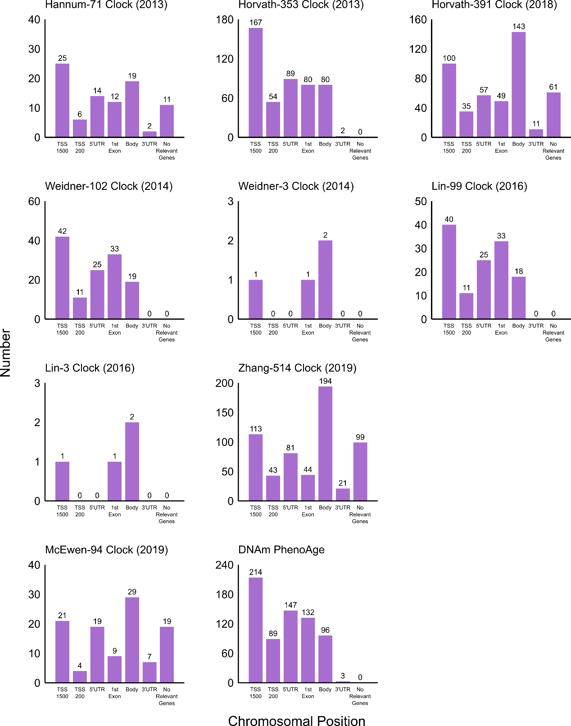
Fig. S3 | Chromosomal position distributions of methylation sites in each original clock. Each panel corresponds to a distinct original clock, labeled at the top. Within a panel, each bar represents the number of target methylation sites derived from an original clock, categorized by chromosomal positions according to 27K and 450K Beadchip annotations. This includes six genomic regions plus an additional category for sites not associated with any nearby genes. Values are shown for all seven groups. Note that some sites belong to different positions for more than one gene.

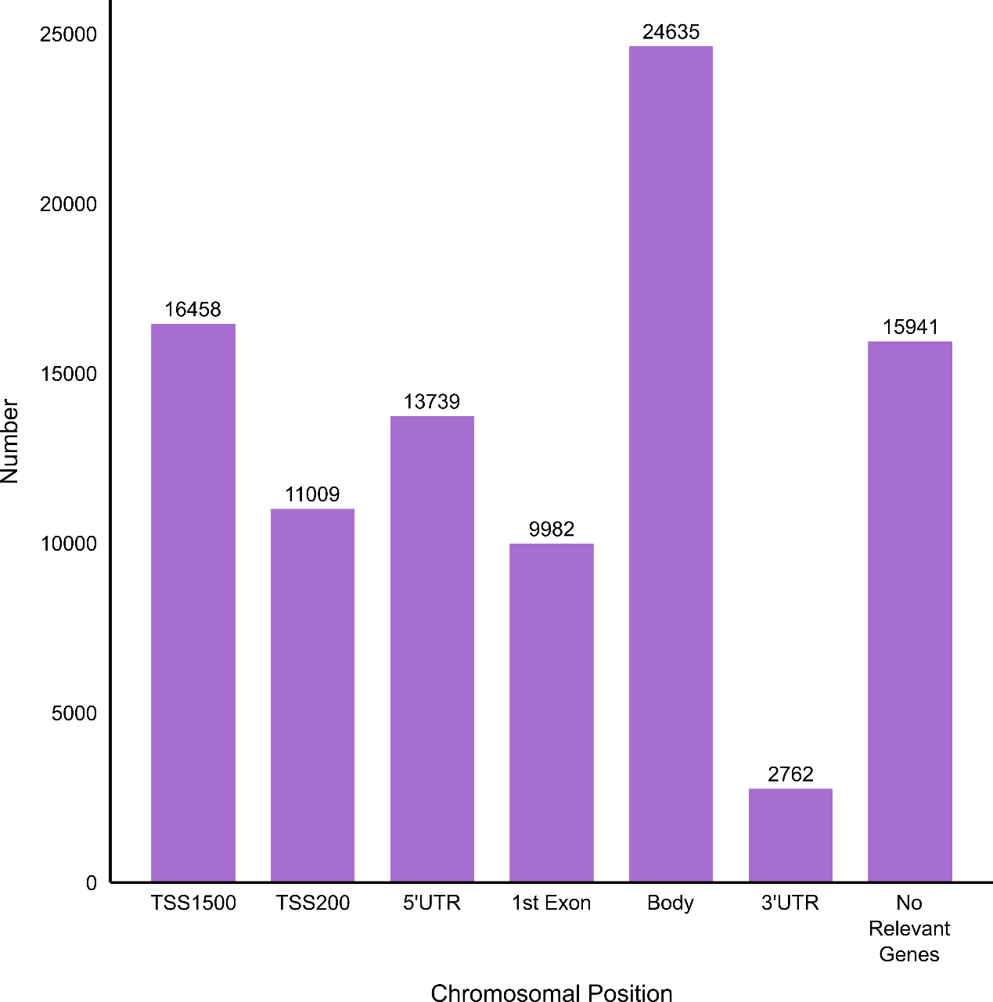
Fig. S4 | Chromosomal position distributions of methylation sites derived from PC-guided clocks. Each bar represents the number of target methylation sites derived from PC-guided clocks, categorized by chromosomal positions according to 27K and 450K Beadchip annotations. This includes six genomic regions plus an additional category for sites not associated with any nearby genes. Values are shown for all seven groups. Note that some sites belong to different positions for more than one gene. Since all PC-guided clocks used identical methylation sites, a single panel is sufficient.

- Outlier detection methods comparison for methylation sites
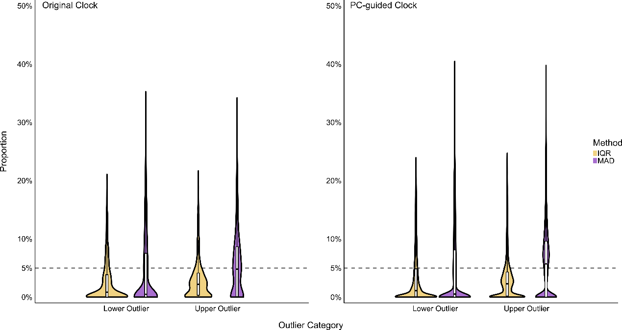
Fig. S5 | Outlier proportions of methylation sites in methylation clocks using different detection methods. The left and right panels show the proportions of methylation site value outliers in original clocks and PC-guided clocks, labelled at the upper left corner. Three outlier identification methods are used for methylation sites derived from methylation clocks: (i) the interquartile range (IQR) method, (ii) the median absolute deviation (MAD) method adjusted for non-normal distribution, and (iii) a threshold-based approach using the 5th and 95th percentiles. Each violin plot uses a unique color scheme to demonstrate the lower or upper outlier proportion distributions using either IQR or MAD method. The dashed horizontal line indicates the 5% outlier proportion level, corresponding to the fixed threshold method.

- Attempts of consistency analysis of CpG weights in PC-guided clocks
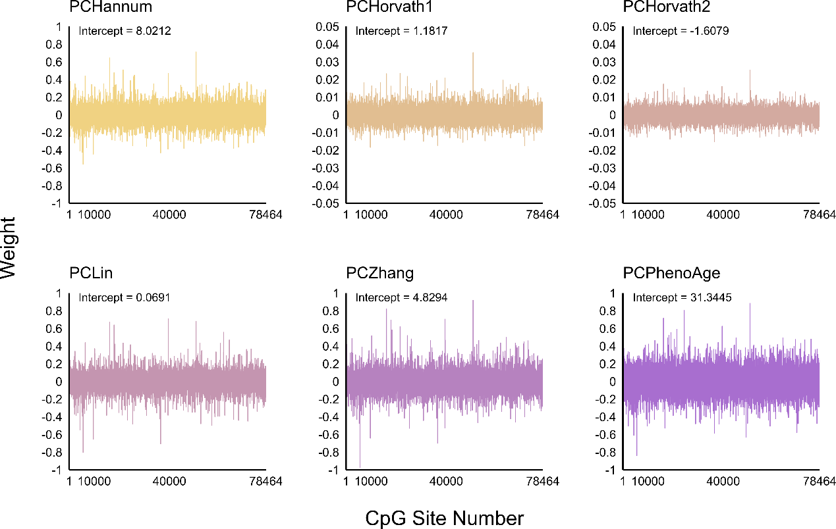
Fig. S6 | Distribution and fluctuation of methylation site weights in PD-guided clocks. Each panel with unique color scheme represents a PC-guided clock, labelled at the top. The line tracks the weight for each of the 78464 sites, and the intercept of the clock is shown. Note the distinct weight scale for PCHorvath1 and PCHorvath2, resulting from a specific mathematical transformation applied to their estimation results.

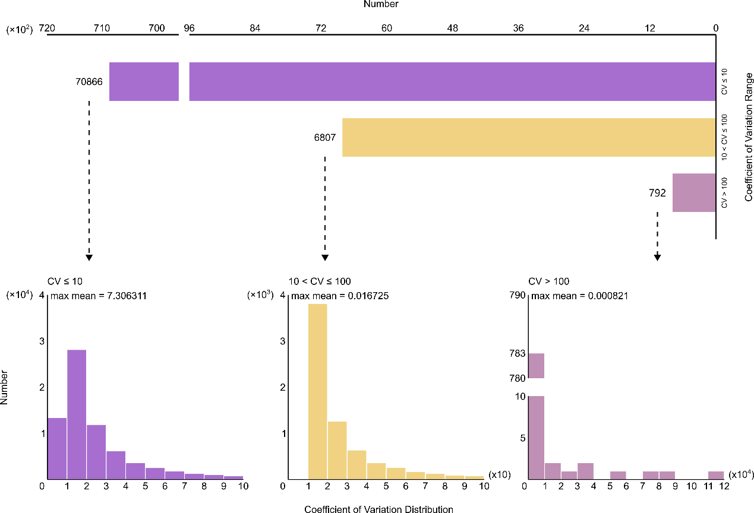
Fig. S7 | Distribution of the coefficient of variation (CV) for methylation site weights across PC-guided clocks. The upper panel categorized the number of methylation site weights (intercepts included) based on their CV into three ranges: CV ≤ 10, 10 < CV ≤ 100, and CV > 100. Three lower panels depict the distribution of CV within each of these groups, as labelled at the top. The maximum mean weight within each group is also provided at the upper left corner. Note that a CV exceeding 0.1 can be considered indicative of substantial divergence.

- Impact of random seed setting strategies in resampling
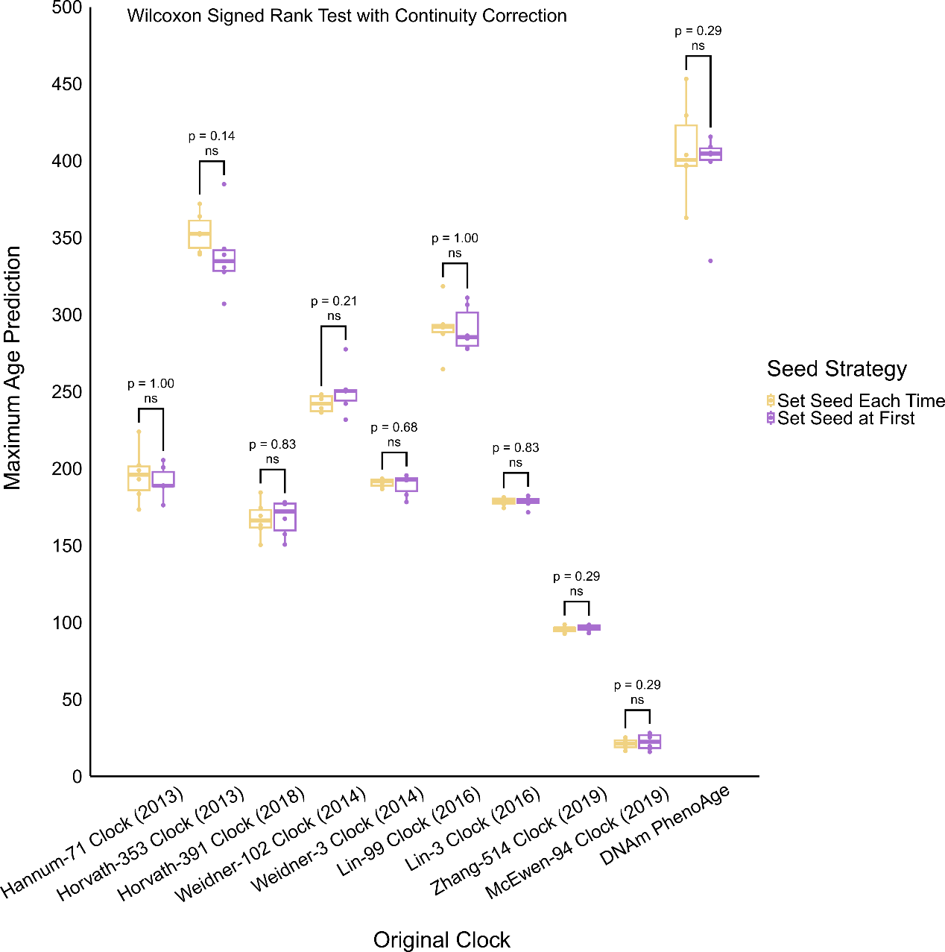
Fig. S8 | Comparison of maximum age prediction between two random seed setting strategies in resampling. Two seed strategies refer to (i) resetting the random seed before resampling each methylation site, and (ii) setting the random seed only once prior to resampling all methylation sites. Each boxplot summarizes the maximum age predictions obtained from each of six new sample groups (ranging from 10,000 to 200,000 in size) under a given seed strategy. Individual points represent the maximum age prediction within each group. Prediction differences between two seed strategies are assessed using Wilcoxon signed rank test with continuity correction, with p-values labelled.

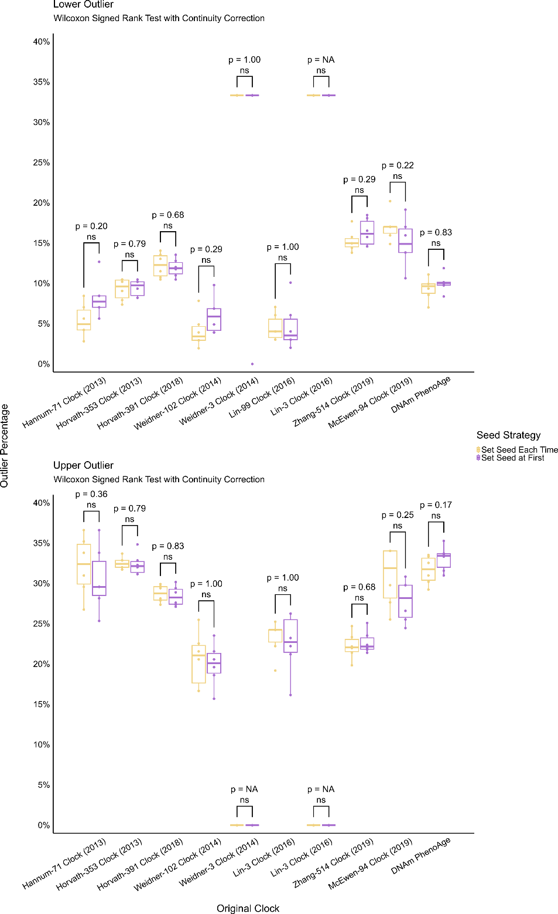
Fig. S9 | Comparison of outlier proportion between two random seed setting strategies in resampling. Two seed strategies refer to (i) resetting the random seed before resampling each methylation site, and (ii) setting the random seed only once prior to resampling all methylation sites. Two panel displays the distributions of lower and upper outlier proportions respectively, labelled at the upper left corner. Each boxplot summarizes the outlier proportions for samples with maximum age prediction obtained from each of six groups (ranging from 10,000 to 200,000 in size) under a given seed strategy. Individual points represent the outlier proportions for samples in each group. Prediction differences between two seed strategies are assessed using Wilcoxon signed rank test with continuity correction, with p-values labelled (NA p-value means that all values are identical).

- Impact of sample size on maximum age prediction in resampling
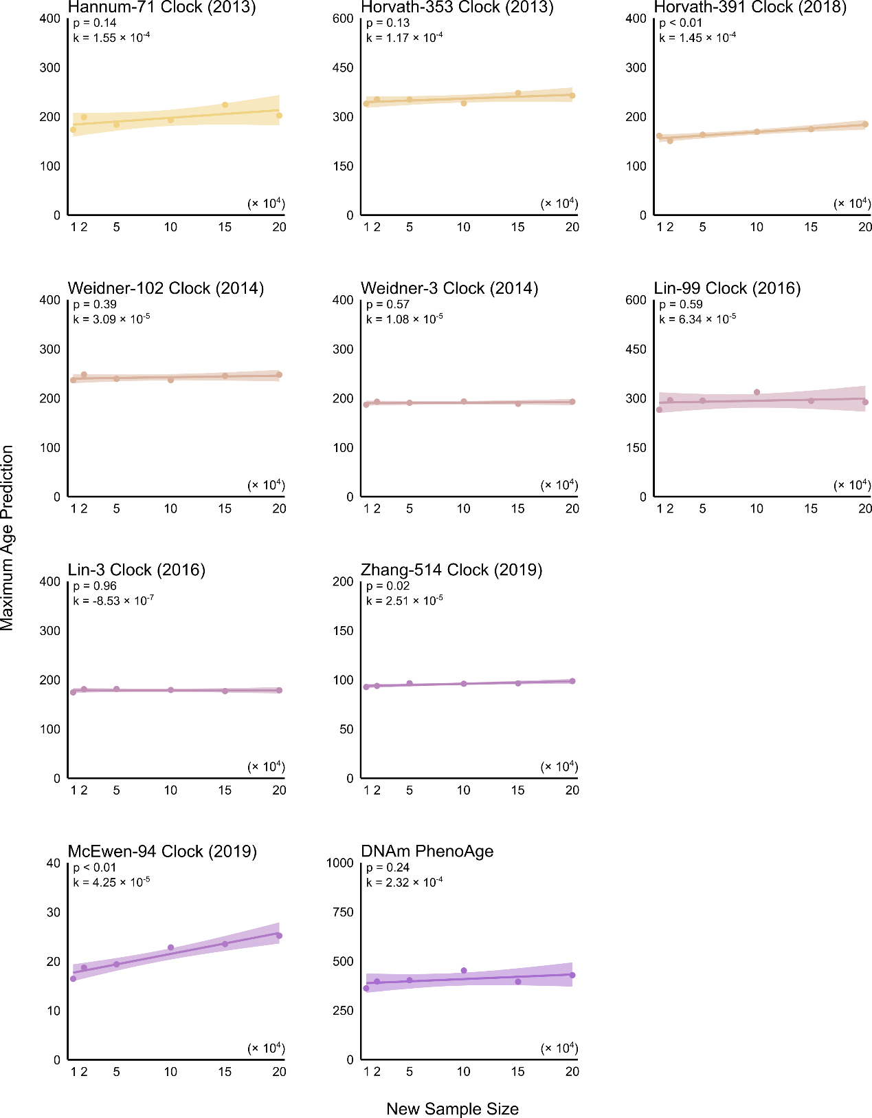
Fig. S10 | Relationship between sample size and maximum age prediction in original clocks. Each panel with unique color scheme and label to represent a distinct original clock depicts the maximum age predictions for six sample groups with varying sizes ranging from 10,000 to 200,000. The solid line shows the linear regression fit, with the shaded area displaying the confidence interval. The associated p-value and regression coefficient k for sample size are annotated in the upper left corner.

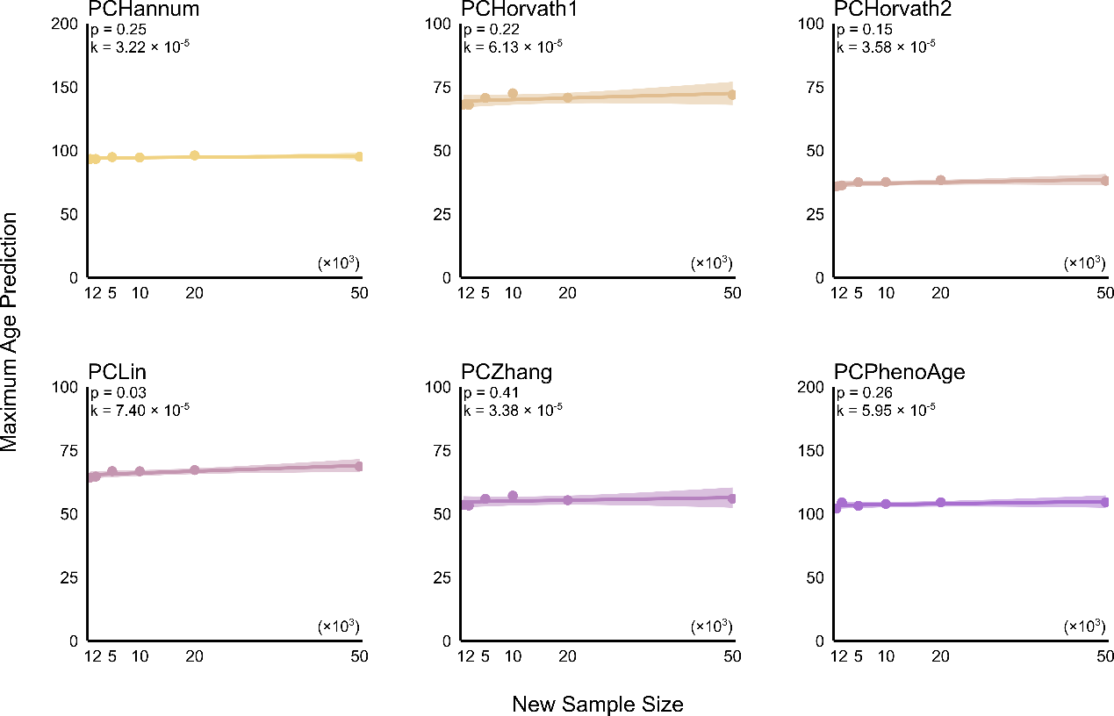
Fig. S11 | Relationship between sample size and maximum age prediction in PC-guided clocks. Each panel with unique color scheme and label to represent a distinct PC-guide clock depicts the maximum age predictions for six sample groups with varying sizes ranging from 1,000 to 50,000. The solid line shows the linear regression fit, with the shaded area displaying the confidence interval. The associated p-value and regression coefficient k for sample size are annotated in the upper left corner.

- Strengthening notions about age underestimation in PC-guided clocks
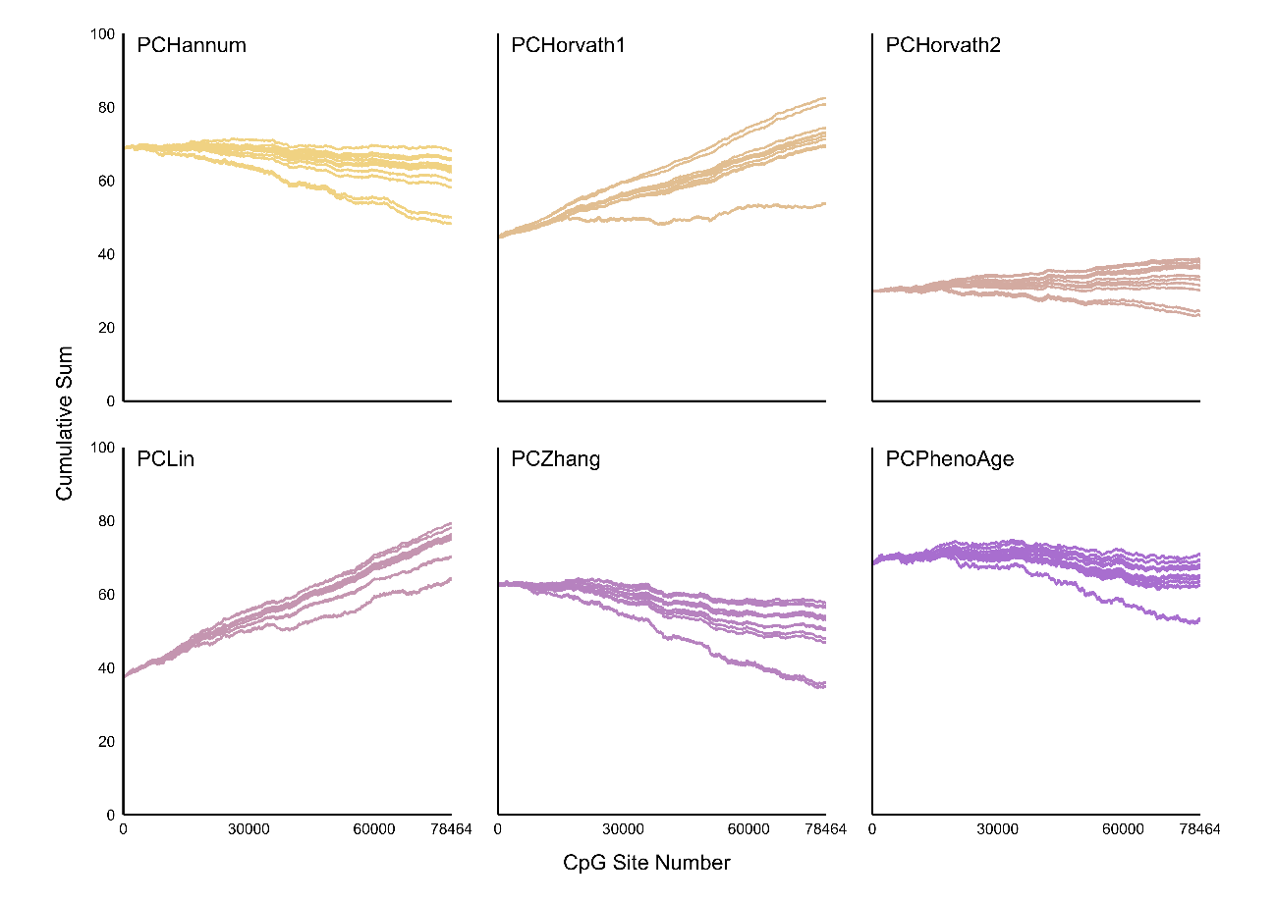
Fig. S12 | Cumulative estimation results for the 12 oldest samples from six PC-guided clocks. Each panel with unique color scheme shows the cumulative estimation results from one PC-guided clock as methylation value-weight products are sequentially added, starting from the fixed baseline until all 78,464 sites are incorporated. Individual trajectories represent distinct samples.

Reference
1. Bocklandt, S. et al. Epigenetic predictor of age. PLoS ONE 6, e14821 (2011).
2. Koch, C. M. & Wagner, W. Epigenetic-aging-signature to determine age in different tissues. Aging 3, 1018–1027 (2011).
3. Hannum, G. et al. Genome-wide methylation profiles reveal quantitative views of human aging rates. Mol. Cell 49, 359–367 (2013).
4. Horvath, S. DNA methylation age of human tissues and cell types. Genome Biol. 14, 3156 (2013).
5. Weidner, C. I. et al. Aging of blood can be tracked by DNA methylation changes at just three CpG sites. Genome Biol. 15, R24 (2014).
6. Lin, Q. et al. DNA methylation levels at individual age-associated CpG sites can be indicative for life expectancy. Aging 8, 394–401 (2016).
7. Horvath, S. et al. Epigenetic clock for skin and blood cells applied to Hutchinson Gilford Progeria Syndrome and ex vivo studies. Aging 10, 1758–1775 (2018).
8. Zhang, Q. et al. Improved precision of epigenetic clock estimates across tissues and its implication for biological ageing. Genome Med. 11, 54 (2019).
9. McEwen, L. M. et al. The PedBE clock accurately estimates DNA methylation age in pediatric buccal cells. Proc. Natl. Acad. Sci. U. S. A. 117, 23329–23335 (2020).
10. Levine, M. E. et al. An epigenetic biomarker of aging for lifespan and healthspan. Aging 10, 573–591 (2018).
11. Lu, A. T. et al. DNA methylation GrimAge strongly predicts lifespan and healthspan. Aging 11, 303–327 (2019).
12. Lu, A. T. et al. DNA methylation-based estimator of telomere length. Aging 11, 5895–5923 (2019).
13. Belsky, D. W. et al. Quantification of the pace of biological aging in humans through a blood test, the DunedinPoAm DNA methylation algorithm. eLife 9, e54870 (2020).
14. Higgins-Chen, A. T. et al. A computational solution for bolstering reliability of epigenetic clocks: implications for clinical trials and longitudinal tracking. Nat. Aging 2, 644–661 (2022).

