Supplementary Materials 1.
Survey Questions

This survey asks about the time lag between a research grant and its specific types of outputs, i.e., academic papers and patents. We empirically investigate KAKENHI in the past 20 years. We randomly select principal investigators of KAKENHI research projects and ask them whether selected publications (or patents) were the results of the specific project. We sincerely request you participate in our survey. The total response time is expected to be 10 minutes.

Our study, funded by MEXT and KAKENHI (see below), aims to clarify the average time lag between research funding and its outputs. Precise time lag data is essential to conduct input/output analysis, particularly in performance monitoring as well as ex-post policy assessment. However, such data is hardly available. Our research team develops a method to compute the time lag using funding and a bibliographic dataset. This survey, as a part of the above-mentioned study, is for validation of our method.

This study's potential contribution is to provide policy implications regarding both the research funding allocation system and the research evaluation system. Your participation is essential. Our survey does not intend to evaluate individual research projects. All of the answers are anonymized, and only the result of totaling or econometric analysis will be publicly disclosed. Other than gender and age (in the form of every ten years), we collect objective information on a KAKENHI project which you organized. Regarding your privacy (i.e., gender and age), you can skip answering them.

Koichi Sumikura,
Professor, National Graduate Institute for Policy Studies.

Tohru Yoshioka-Kobayashi,
Assistant Professor, Institute of Innovation Research, Hitotsubashi University.

[Disclosure of funding source of this study]
MEXT SciREX (Science for Science, Technology Innovation) Program:
https://scirex.grips.ac.jp/project/kyoshinkajitsugen21-2.html
JSPS KAKENHI 18H01029:
https://kaken.nii.ac.jp/grant/KAKENHI-PROJECT-18H01029/
JSPS KAKENHI
https://kaken.nii.ac.jp/ja/grant/KAKENHI-PROJECT-21H00748/

Backgrounds
Research outputs were not built in a day. We often take several months or even years to prepare research presentations, publish papers or file patents. As mentioned above, precise time lag data is essential to conduct input/output analysis. We may estimate the time lag observing reported outputs of research grants. But an inevitable bias exists in this estimation. Research projects sometimes (or even often) receive multiple funding. Thus, reported outputs do not always mean that they were created only with the focal funds. In other words, such estimation potentially overestimates or underestimates the time lag (see figure).
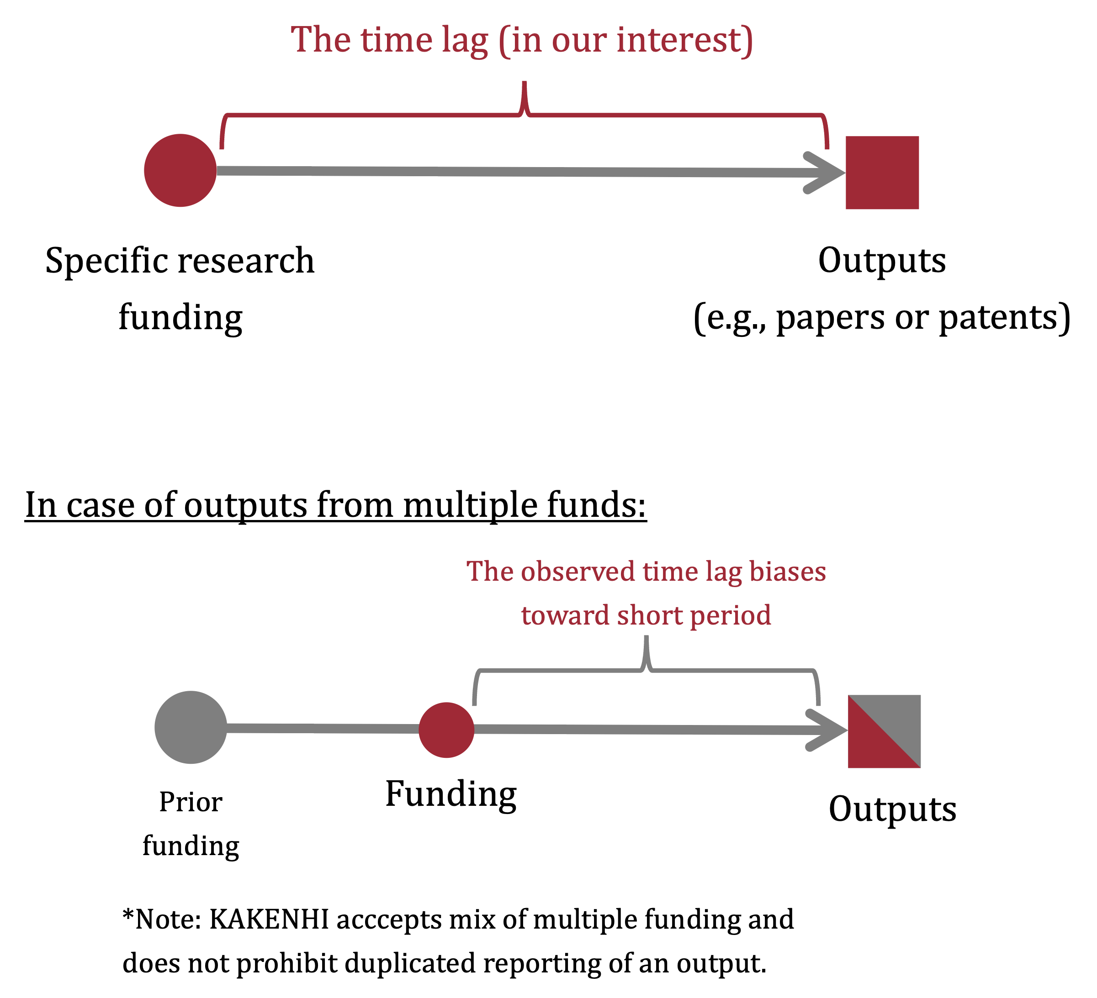
Concerning this bias, we developed a method to identify substantial outputs. Linking KAKENHI and Scopus datasets, we matched research funding and their outputs. In case of multiple linkages between output and funding, we proposed a logic to estimate the most relevant funding using funding disclosures in acknowledgment. Our survey asks respondents whether a selected publication or patent is substantially from a KAKENHI project in question and how long it takes to publish a paper on average. Answers are used to validate our method as well as identify some boundary conditions.

Thank you for your consideration of participation in our survey. Do you participate in our survey?
1) Yes, I will participate in this survey
2) No, I decline this survey

Main Questions

Q1. Are the following papers substantial outputs of the KAKENHI indicated below? If you are unable to determine it, please select "Difficult to determine."
Note:
The term "substantial" includes cases where the contribution of the focal KAKENHI is significant, even if it is the result of a prior or following research grant (see Figure).

[Inserted a title of KAKENHI Grant Project here]
[Inserted up to six titles of the papers reported as research outputs in the KAKENHI DB that mapped with WoS/SCOPUS]

1) "Yes, this is a substantial output of the said KAKENHI."
2) "No."
3) "Difficult to determine."

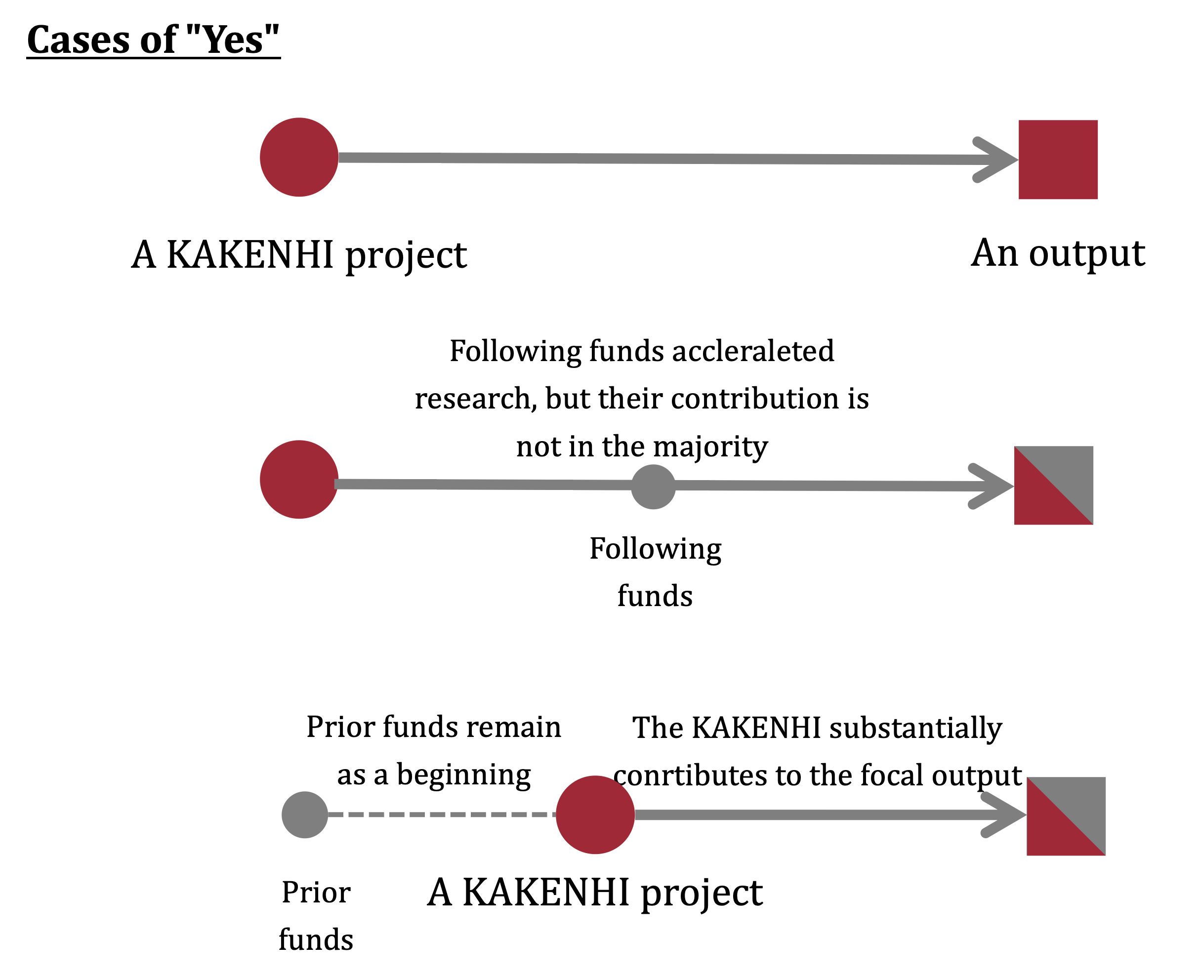
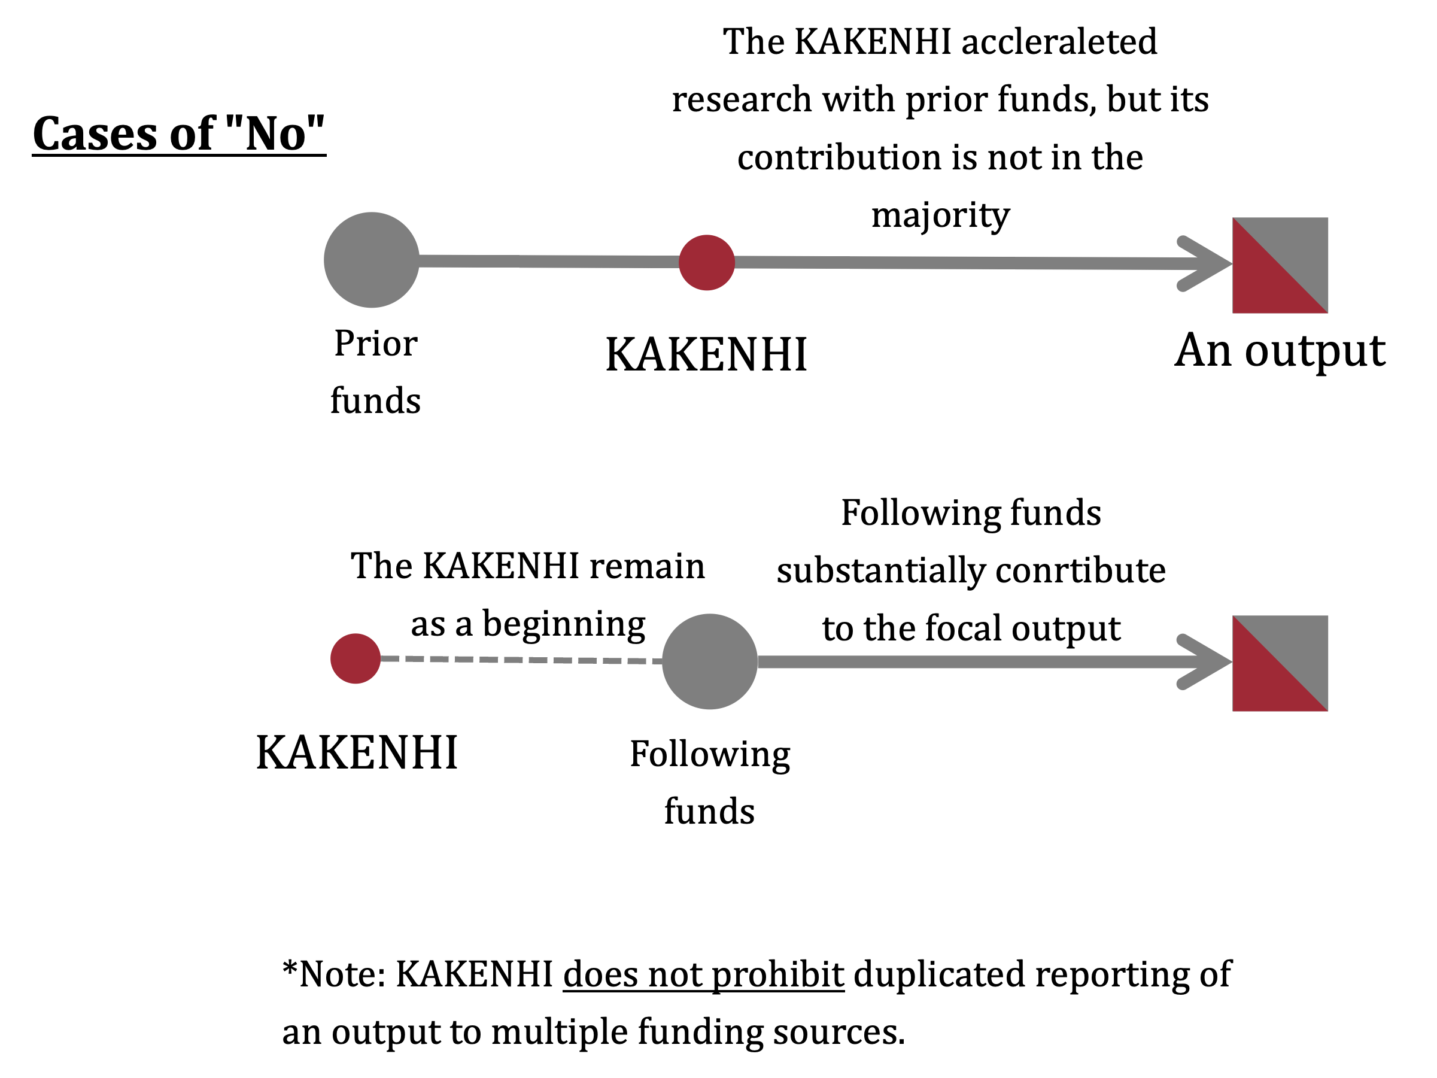

Q2. In publishing above mentioned papers, did any of the following circumstances contribute to a shorter (faster) time to publication? Please include circumstances that apply only to specific papers. If nothing is applicable, please select "13) Not applicable".

1) I/We could accelerate the research due to the availability of a large number of researchers (faculty, research associates, and/or doctoral students).
2) I/We could accelerate the research due to the participation of talented researchers.
3) I/We could accelerate the research due to the availability of a large number of technicians and/or research administrators.
4) I/We could accelerate the research due to multiple funds awarded.
5) I/We could accelerate the research due to the availability of (or shared use of) existing research facilities and equipment.
6) I/We could accelerate the research due to the reduced time to manage and/or administrate the research.
7) I/We could accelerate the research due to fewer research projects involved.
8) I/We could accelerate the research due to fewer educational activities and/or student research supervision.
9) I/We could accelerate the research due to fewer managerial and/or administrative tasks for the department and/or the university for which I/we worked.
10) I/We could accelerate the research due to personal circumstances.
11) I/We could publish a paper faster due to the early availability of research results.
12) I/We could publish a paper faster due to a rapid review and/or editing process.
13) Not applicable

Q3. In publishing above mentioned papers, did any of the following circumstances contribute to a longer time to publication? Please include circumstances that apply only to specific papers. If nothing is applicable, please select "13) Not applicable".

1) The research was delayed due to the availability and/or mobility (e.g., resignation) of researchers (faculty, research associates, and/or doctoral students).
2) The research was delayed due to the availability and/or mobility of technicians and/or research administrators.
3) The research was delayed due to a failure in additional fundraising.
4) The research was delayed due to a late allocation of the KAKENHI.
5) The research was delayed due to the trouble of a research facility and/or equipment.
6) The research was delayed due to the burden of administrative tasks for KAKENHI.
7) The research was delayed due to the large number of research projects involved.
8) The research was delayed due to a large number of educational activities and/or student research supervision.
9) The research was delayed due to a large number of managerial and/or administrative tasks for the department and/or the university for which I/we worked.
10) The research was delayed due to personal circumstances (e.g., child raising or nursing of the family).
11) The research was delayed because we failed to obtain the expected research results.
12) The publication was delayed due to a late review and/or editing process.
13) Not applicable

Q4. [This question is not limited to the above-mentioned KAKENHI project.] In your research, how long is the time lag between the receipt of research funds and the publication of the results? Please indicate your impression on how many years at the most.
Note:
We ask for your sense of the time lag. You do not need to calculate the average lag precisely.
The time lag means the duration between an allocation of funds and publication. This duration includes all intermediate activities, such as research, submissions, review, and revisions. If you have "ahead of print" or "in press" publications, please consider official publication dates.

Q4-1.An English peer-reviewed original/review article
Q4-2.A Japanese peer-reviewed original/review article
Q4-3.An English non-peer-reviewed original/review article
Q4-4.A Japanese non-peer-reviewed original/review article
Q4-5.Conference proceedings (in both English/Japanese)
Q4-6.Pre-prints and/or working papers (in both English/Japanese)

1)0 year (in the year of the first allocation of funds)
2)1 year
3)2 years
4)3 years
5)4 years
6)5 years
7)6 years
8)7 years
9) 8 years or more
10) Not applicable / Don't know

Q5. Please write down any comments you may have regarding the evaluation of research funding based on its outputs (e.g., papers). Although this study focuses on academic papers as research outputs, we will keep in mind that there is diversity in the outputs of research activities.

Q6. Are the following patents substantial outputs of the KAKENHI indicated below? If you are unable to determine it, please select "Difficult to determine."
Note:
The term "substantial" includes cases where the contribution of the focal KAKENHI is significant, even if it is the result of a prior or following research grant (see Figure).

[Inserted a title of KAKENHI Grant Project here]
[Inserted up to four titles and application numbers of patents reported as research outputs in the KAKENHI DB]

1) "Yes, this is a substantial output of the said KAKENHI."
2) "No."
3) "Difficult to determine."

Q7. [This question is not limited to the KAKENHI as mentioned above project.] In your research, how long is the time lag between receiving research funds and patent filings? Please indicate your impression on how many years at the most.
Note:
We ask for your sense of the time lag. You do not need to calculate the average lag precisely.
The time lag means the duration between an allocation of funds and a patent filing/submission to a Patent Office (not grant/registration of a patent).

We would like to ask you some basic questions about yourself.

Q8. Please select your age from the following categories. You can skip this question.

1) 10s
2) 20s
3) 30s
4) 40s
5) 50s
6) 60s
7) 70s
8) 80s or more
9)I do not want to answer it.

Q9. Please select your gender identity from the following categories. You can skip this question.

1)Female
2)Male
3)Others/I do not want to answer it

Thank you for your kind response.

