Supplementary Figures
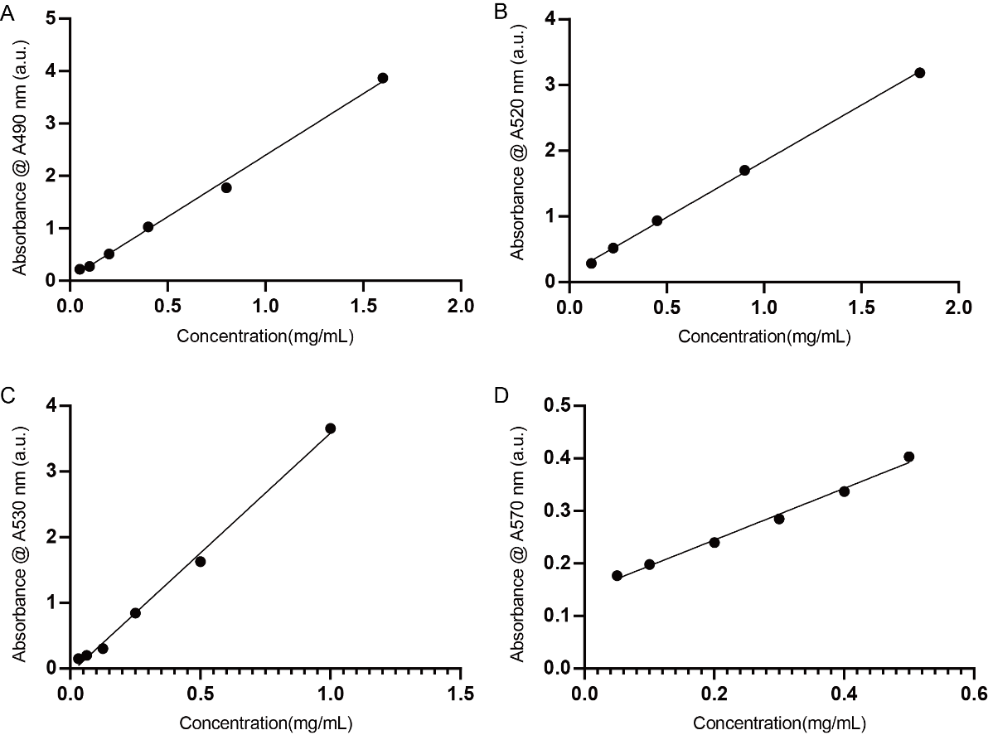
Fig. S1 The calibration curves for determining the content of polysaccharides. The standard curves for total sugar (A), reducing sugar (B), uronic acid (C) and protein content (D) are listed in sequence.
Fig. S2 The calibration curve of molecular weight.

