Supplementary Table S1. Gaps in coverage for the T2T assemblies of JCP043 (left) and AT141 (right) when mapping their respective Illumina reads.

JCP043 (race 1) |  |  |  | AT141 (race 4)
Chr #¹ | Length (bp) | Sequencing gaps² (bp) | Fraction  (%) | Chr #¹ | Length (bp) | Sequencing gaps² (bp) | Fraction  (%)
chr1 | 6,770,669 | 3,110 | 0.046 | Chr1 | 6,819,533 | 191,593 | 2.809
chr2 | 6,250,436 | 4,438 | 0.071 | Chr2 | 5,908,551 | 62,362 | 1.055
chr3 | 5,608,331 | 1,544 | 0.028 | Chr3 | 5,848,757 | 107,868 | 1.844
chr4 | 5,459,532 | 366 | 0.007 | Chr4 | 5,717,665 | 167,139 | 2.923
chr5-Core | 3,307,106 | 115 | 0.003 | Chr5 | 5,686,892 | 125,778 | 2.212
chr6 | 4,634,744 | 6,887 | 0.149 | Chr6 | 4,695,532 | 109,298 | 2.328
chr8 | 4,236,707 | 4,633 | 0.109 | Chr7 | 4,252,408 | 101,175 | 2.379
chr9 | 3,809,017 | 26 | 0.001 | Chr8-Core | 3,007,489 | 164,308 | 5.463
chr11 | 3,058,378 | 5,270 | 0.172 | Chr8-AC | 889,714 | 20,492 | 2.303
chr13 | 2,775,815 | 4,905 | 0.177 | Chr9 | 3,799,817 | 134,667 | 3.544
chr14-Core | 2,725,597 | 25 | 0.001 | Chr10 | 3,422,730 | 149,756 | 4.375
chr5-AC | 1,375,961 | 16,376 | 1.19 | Chr11 | 2,930,467 | 183,868 | 6.274
chr7 | 4,314,348 | 30,493 | 0.707 | Chr12 | 2,925,940 | 184,934 | 6.32
chr10 | 3,246,481 | 33,412 | 1.029 | Chr13 | 2,740,747 | 37,891 | 1.383
chr12 | 2,894,522 | 12,307 | 0.425 | Chr14 | 2,651,588 | 101,455 | 3.826
chr14-AC | 532,478 | 0 | 0 | Chr15 | 1,904,113 | 41,373 | 2.173
chr15 | 2,314,100 | 28,685 | 1.24 | Chr16 | 1,746,802 | 185,063 | 10.594
chr16 | 1,322,771 | 4,183 | 0.316 | Chr17 | 1,714,834 | 62,957 | 3.671
Total | 64,636,993 | 156,775 | 0.243 | Chr18 | 1,010,980 | 18,841 | 1.864
 |  |  |  | Chr19 | 827,607 | 22,511 | 2.72
 |  |  |  | Total | 68,502,166 | 2,173,329 | 3.219
¹Accessory (AC) chromosomes and genome regions are in bold.
²Illumina reads from JCP043 and AT141 were mapped to their corresponding T2T genome assembly with 99% sequence identity to ensure the mapping accuracy. Genomic regions where read depth is below 3× are considered sequencing gaps, and the sum of the gaps are shown per chromosome.

Supplementary Table S2. Categories and abundance of repetitive DNA in JCP043 and AT141.
Repeat class | JCP043 (race 1) |  |  |  | AT141 (race 4)
Repeat class | # of elements | Length (bp) | Percentage of sequence |  | # of elements | Length (bp) | Percentage of sequence
Total
DNA transposons
hobo-Activator (hAT) | 1,823 | 2,053,291 | 3.20% |  | 1,984 | 1,923,317 | 2.81%
Tc1-IS630-Pogo | 1,255 | 1,354,848 | 2.11% |  | 1,549 | 1,597,867 | 2.33%
MULE-MuDR | 532 | 599,642 | 0.94% |  | 789 | 804,886 | 1.17%
PiggyBac | 499 | 290,341 | 0.45% |  | 481 | 297,204 | 0.43%
Helitron | 107 | 241,750 | 0.38% |  | 125 | 214,530 | 0.31%
LTR retrotransposons
Gypsy/DIRS1 | 1,183 | 1,668,640 | 2.60% |  | 1,095 | 1,825,698 | 2.67%
Ty1/Copia | 521 | 621,320 | 0.97% |  | 672 | 622,497 | 0.91%
LINE retrotransposons | 797 | 908,800 | 1.42% |  | 939 | 1,147,814 | 1.68%
Unclassified | 7,831 | 2,612,862 | 4.08% |  | 9,908 | 4,339,046 | 6.33%
Satellites | 28 | 109,653 | 0.17% |  | 91 | 364,184 | 0.53%
Simple repeats | 6,839 | 284,043 | 0.44% |  | 7,007 | 292,105 | 0.43%
Low complexity | 774 | 36,439 | 0.06% |  | 777 | 36,996 | 0.05%
Abbreviations: LTR: Long Terminal Repeat; LINE: Long Interspearsed Nuclear Elements.

Supplementary Table S3. GO terms enriched in the accessory genome regions of JCP043 and AT141.
JCP043 |  |  | AT141
GO identifier¹ | GO category² | GO description | GO identifier¹ | GO category² | GO description
GO:0043171 | BP | peptide catabolic process | GO:0070212 | BP | protein poly-ADP-ribosylation
GO:0048878 | BP | chemical homeostasis | GO:0006302 | BP | double-strand break repair
GO:0033540 | BP | fatty acid beta-oxidation using acyl-CoA oxidase | GO:0030003 | BP | intracellular monoatomic cation homeostasis
GO:0042592 | BP | homeostatic process | GO:0006873 | BP | intracellular monoatomic ion homeostasis
GO:0006518 | BP | peptide metabolic process | GO:0050801 | BP | monoatomic ion homeostasis
GO:0006873 | BP | intracellular monoatomic ion homeostasis | GO:0055082 | BP | intracellular chemical homeostasis
GO:0030003 | BP | intracellular monoatomic cation homeostasis | GO:0055080 | BP | monoatomic cation homeostasis
GO:0055080 | BP | monoatomic cation homeostasis | GO:0048878 | BP | chemical homeostasis
GO:0055082 | BP | intracellular chemical homeostasis | GO:0019725 | BP | cellular homeostasis
GO:0050801 | BP | monoatomic ion homeostasis | GO:0042592 | BP | homeostatic process
GO:0051091 | BP | positive regulation of DNA-binding transcription factor activity | GO:0031930 | BP | mitochondria-nucleus signaling pathway
GO:0051090 | BP | regulation of DNA-binding transcription factor activity | GO:0051452 | BP | intracellular pH reduction
GO:0055088 | BP | lipid homeostasis | GO:0007035 | BP | vacuolar acidification
GO:0051452 | BP | intracellular pH reduction | GO:0035337 | BP | fatty-acyl-CoA metabolic process
GO:0007035 | BP | vacuolar acidification | GO:0051090 | BP | regulation of DNA-binding transcription factor activity
GO:0009062 | BP | fatty acid catabolic process | GO:0051091 | BP | positive regulation of DNA-binding transcription factor activity
GO:0070212 | BP | protein poly-ADP-ribosylation | GO:0000724 | BP | double-strand break repair via homologous recombination
GO:0034440 | BP | lipid oxidation | GO:0030641 | BP | regulation of cellular pH
GO:0019725 | BP | cellular homeostasis | GO:0006885 | BP | regulation of pH
GO:0072329 | BP | monocarboxylic acid catabolic process | GO:0051453 | BP | regulation of intracellular pH
GO:0051453 | BP | regulation of intracellular pH | GO:0035336 | BP | long-chain fatty-acyl-CoA metabolic process
GO:0006885 | BP | regulation of pH | GO:0000725 | BP | recombinational repair
GO:0030641 | BP | regulation of cellular pH | GO:0033559 | BP | unsaturated fatty acid metabolic process
GO:0009116 | BP | nucleoside metabolic process | GO:0098660 | BP | inorganic ion transmembrane transport
GO:0006635 | BP | fatty acid beta-oxidation | GO:0032107 | BP | regulation of response to nutrient levels
GO:0019395 | BP | fatty acid oxidation | GO:0006808 | BP | regulation of nitrogen utilization
GO:0030258 | BP | lipid modification | GO:0006812 | BP | monoatomic cation transport
GO:1901657 | BP | glycosyl compound metabolic process | GO:0001676 | BP | long-chain fatty acid metabolic process
GO:0031930 | BP | mitochondria-nucleus signaling pathway | GO:1990404 | MF | NAD+-protein mono-ADP-ribosyltransferase activity
GO:0015074 | BP | DNA integration | GO:0003950 | MF | NAD+ poly-ADP-ribosyltransferase activity
GO:0009450 | BP | gamma-aminobutyric acid catabolic process | GO:0009378 | MF | four-way junction helicase activity
GO:0009448 | BP | gamma-aminobutyric acid metabolic process | GO:0043138 | MF | 3'-5' DNA helicase activity
GO:0016042 | BP | lipid catabolic process | GO:0016705 | MF | oxidoreductase activity, acting on paired donors, with incorporation or reduction of molecular oxygen
GO:0003997 | MF | acyl-CoA oxidase activity | GO:0003678 | MF | DNA helicase activity
GO:0033293 | MF | monocarboxylic acid binding | GO:0046983 | MF | protein dimerization activity
GO:0005504 | MF | fatty acid binding | GO:0005506 | MF | iron ion binding
GO:0016634 | MF | oxidoreductase activity, acting on the CH-CH group of donors, oxygen as acceptor | GO:0016763 | MF | pentosyltransferase activity
GO:0043177 | MF | organic acid binding | GO:0004497 | MF | monooxygenase activity
GO:0031406 | MF | carboxylic acid binding | GO:0015318 | MF | inorganic molecular entity transmembrane transporter activity
GO:0004420 | MF | hydroxymethylglutaryl-CoA reductase (NADPH) activity | GO:0004420 | MF | hydroxymethylglutaryl-CoA reductase (NADPH) activity
GO:0004222 | MF | metalloendopeptidase activity | GO:0015075 | MF | monoatomic ion transmembrane transporter activity
GO:1990404 | MF | NAD+-protein mono-ADP-ribosyltransferase activity | GO:0008324 | MF | monoatomic cation transmembrane transporter activity
GO:0003950 | MF | NAD+ poly-ADP-ribosyltransferase activity | GO:0046906 | MF | tetrapyrrole binding
GO:0016491 | MF | oxidoreductase activity | GO:0020037 | MF | heme binding
GO:0004777 | MF | succinate-semialdehyde dehydrogenase (NAD+) activity | GO:0004198 | MF | calcium-dependent cysteine-type endopeptidase activity
GO:0009013 | MF | succinate-semialdehyde dehydrogenase [NAD(P)+] activity
GO:0005506 | MF | iron ion binding
GO:0016705 | MF | oxidoreductase activity, acting on paired donors, with incorporation or reduction of molecular oxygen
GO:0008061 | MF | chitin binding
GO:0051117 | MF | ATPase binding
GO:0004497 | MF | monooxygenase activity
GO:0046906 | MF | tetrapyrrole binding
GO:0020037 | MF | heme binding
GO:0043531 | MF | ADP binding
GO:0008395 | MF | steroid hydroxylase activity
GO:0140110 | MF | transcription regulator activity
¹GO terms in bold are enriched in both isolates.
²Abbreviations: BP: biological process, MF: molecular function.

Supplementary Table S4. Long-read and short-read assemblies used in the analysis of SIX genes and race-specific genes.
Lineage | Accession Number | forma specialis and race | SIX8 | SIX9.1 | SIX9.2 | SIX9.3 | SIX9.4 | SIX14 | Sequencing technology | Assembly accession
2B | 160527 | Fusarium oxysporum f. sp. cubense |  |  |  |  | X |  | PacBio Sequal | GCA_005930515.1
2E | Fo5176 | F. oxysporum f. sp. conglutinans |  |  | X |  | X |  | PacBio Sequal+Novaseq | GCA_014154955.1
2E | race1 | F. oxysporum f. sp. conglutinans | X |  | X |  | X |  | PacBio Sequal | GCA_014839635.1
2E | 39 | F. oxysporum f. sp. lini |  |  |  |  | X |  | PacBio RS+Illumina | GCA_013423245.1
2E | Fom005 | F. oxysporum f. sp. melonis |  |  |  |  |  |  | PacBio | GCA_001703205.2
2E | 110407-3-1-1 | F. oxysporum f. sp. niveum |  |  |  |  | X |  | Nanopore MinION | GCA_019593455.1
2E | Tf1262 | F. oxysporum f. sp. raphani |  |  | X | X | X |  | PacBio RSII | GCA_019157275.1
2E | LA3B | F. oxysporum f. sp. vasinfectum |  |  |  |  |  |  | PacBio RSII | GCA_009602545.1
2E | TF1 | F. oxysporum f. sp. vasinfectum race1 |  |  |  |  | X |  | PacBio RSII | GCA_009602505.1
2G | NRRL38295 | F. oxysporum f. sp. apii race 3 |  | X | X | X |  |  | PacBio RSII | GCA_014843565.1
2G | 274AC | F. oxysporum f. sp. apii race 4 |  | X | X | X |  |  | PacBio RSII | GCA_014843555.1
2G | Foci3-2 | F. oxysporum f. sp. coriandrii |  | X | X | X |  |  | PacBio RSII | GCA_014843415.1
2G | FociGL306 | F. oxysporum f. sp. coriandrii |  | X | X | X |  |  | PacBio RSII | GCA_014843445.1
2G | GL1381 | F. oxysporum f. sp. fragariae |  |  |  |  |  |  | PacBio RSII | GCA_016170095.2
2G | GL1315 | F. oxysporum f. sp. fragariae |  |  |  |  |  |  | PacBio RSII+Novaseq | GCA_016166095.1
2G | BRIP62122a | F. oxysporum f. sp. fragariae |  |  |  |  |  |  | PacBio Sequal | GCA_016166325.2
2G | MAFF7271510 | F. oxysporum f. sp. fragariae |  |  |  |  |  |  | PacBio Sequal | GCA_016164145.2
2G | GL1080 | F. oxysporum f. sp. fragariae |  |  |  |  |  |  | PacBio RSII | GCA_016170085.2
2G | 150523 | F. oxysporum f. sp. niveum | X | X | X | X | X | X | Nanopore +MinION | GCA_019593445.1
2G | 150524 | F. oxysporum f. sp. niveum | X | X | X | X | X | X | Nanopore MinION | GCA_019593505.1
2G | MR4003 | F. oxysporum f. sp. sesami | X |  | X | X | X |  | PacBio Sequal | GCA_017979615.1
2G | LA1E | F. oxysporum f. sp. vasinfectum |  |  |  |  |  |  | PacBio RSII | GCA_009602615.1
2G | 89-1A | F. oxysporum f. sp. vasinfectum race 4 |  | X |  | X | X |  | PacBio RSII | GCA_009602635.1
3B | 14-004 | F. oxysporum f. sp. vasinfectum |  |  |  |  |  |  | PacBio RSII | GCA_009602625.1
3D | Fol4287 | F. oxysporum f. sp. lycopersici race 2 | X | X |  |  |  | X | Pacbio Hifi+NovaSeq | GCA_000149955.2
3D | D11 | F. oxysporum f. sp. lycopersici race 3 | X | X |  |  |  | X | PacBio RSII | GCA_003977725.1
3D | 26406 | F. oxysporum f. sp. melonis |  |  |  |  |  |  | PacBio | GCA_002318975.1
3F | 207-A | F. oxysporum f. sp. apii race 2 |  | X |  |  |  |  | PacBio RSII | GCA_014843455.1
3F | 2a | F. oxysporum f. sp. lactucae race 1 |  |  |  |  | X | X | Hiseq | in-house
3F | 20a | F. oxysporum f. sp. lactucae race 1 |  |  |  |  | X | X | Hiseq | in-house
3F | 45a | F. oxysporum f. sp. lactucae race 1 |  |  |  |  | X | X | Hiseq | in-house
3F | 50a | F. oxysporum f. sp. lactucae race 1 |  |  |  |  | X | X | Hiseq | in-house
3F | 52a | F. oxysporum f. sp. lactucae race 1 |  |  |  |  | X | X | Hiseq | in-house
3F | 53a | F. oxysporum f. sp. lactucae race 1 |  |  |  |  | X | X | Hiseq | in-house
3F | 58a* | F. oxysporum f. sp. lactucae race 1 |  |  |  |  | X | X | Hiseq | in-house
3F | 74a | F. oxysporum f. sp. lactucae race 1 |  |  |  |  | X | X | Hiseq | in-house
3F | 6-14 | F. oxysporum f. sp. lactucae race 1 |  |  |  |  | X | X | Hiseq | in-house
3F | 7-14 | F. oxysporum f. sp. lactucae race 1 |  |  |  |  | X | X | Hiseq | in-house
3F | AC013 | F. oxysporum f. sp. lactucae race 1 |  |  |  |  | X | X | Hiseq | in-house
3F | AJ520* | F. oxysporum f. sp. lactucae race 1 |  |  |  |  | X | XX | Nanopore MinION+Miseq | GCA_045838095.1
3F | AJ718* | F. oxysporum f. sp. lactucae race 1 |  |  |  |  | X | XX | Nanopore MinION | GCA_045837815.1
3F | AJ865* | F. oxysporum f. sp. lactucae race 1 |  |  |  |  | X | XX | Nanopore MinION | GCA_045837925.1
3F | AL010 | F. oxysporum f. sp. lactucae race 1 |  |  |  |  | X | X | Hiseq | in-house
3F | AM163 | F. oxysporum f. sp. lactucae race 1 |  |  |  |  | X | X | Hiseq | in-house
3F | AP057 | F. oxysporum f. sp. lactucae race 1 |  |  |  |  | X | X | Hiseq | in-house
3F | AP068 | F. oxysporum f. sp. lactucae race 1 |  |  |  |  | X | X | Hiseq | in-house
3F | AS147 | F. oxysporum f. sp. lactucae race 1 |  |  |  |  | X | X | Hiseq | in-house
3F | AT142* | F. oxysporum f. sp. lactucae race 1 |  |  |  |  | X | X | Nanopore PromethION+Hiseq | in-house
3F | GL1546 | F. oxysporum f. sp. lactucae race 1 |  |  |  |  | X | X | Hiseq | in-house
3F | GL1692 | F. oxysporum f. sp. lactucae race 1 |  |  |  |  | X | X | Hiseq | in-house
3F | GL1693 | F. oxysporum f. sp. lactucae race 1 |  |  |  |  | X | X | Hiseq | in-house
3F | GL1815 | F. oxysporum f. sp. lactucae race 1 |  |  |  |  | X | X | Hiseq | in-house
3F | JCP024 | F. oxysporum f. sp. lactucae race 1 |  |  |  |  | X | X | Hiseq | in-house
3F | JCP043* | F. oxysporum f. sp. lactucae race 1 |  |  |  |  | X | X | Nanopore PromethION+PacBio HiFi+Hiseq | in-house
3F | JCP053 | F. oxysporum f. sp. lactucae race 1 |  |  |  |  | X | X | Hiseq | in-house
3F | JCP293 | F. oxysporum f. sp. lactucae race 1 |  |  |  |  | X | X | Hiseq | in-house
3F | JCP360 | F. oxysporum f. sp. lactucae race 1 |  |  |  |  | X | X | Hiseq | in-house
3F | JCP381 | F. oxysporum f. sp. lactucae race 1 |  |  |  |  | X | X | Hiseq | in-house
3F | Mya | F. oxysporum f. sp. lactucae race 1 |  |  |  |  | X | X | Hiseq | in-house
3F | SB1-1 | F. oxysporum f. sp. lactucae race 1 |  |  |  |  | X | X | Hiseq | in-house
3F | Fol321 | F. oxysporum f. sp. lactucae race 1 |  |  |  |  | X | X | Novaseq | GCA_045786965.1
3F | VSP-0794 | F. oxysporum f. sp. lactucae race 1 |  |  |  |  | X | X | Novaseq | GCA_045786735.1
3F | Fol621s | F. oxysporum f. sp. lactucae race 1 variant |  |  |  |  | X | X | Novaseq | GCA_045786925.1
3F | VSP-0916 | F. oxysporum f. sp. lactucae race 1 variant |  |  |  |  | X | X | Novaseq | GCA_045786885.1
1 | F9501* | F. oxysporum f. sp. lactucae race 2 | X | X | X | X | X | X | Hiseq | in-house
2G | FLK1001* | F. oxysporum f. sp. lactucae race 3 | X | X | X | X | X | X | Hiseq | in-house
3F | 888 | F. oxysporum f. sp. lactucae race 4 | X | X | X |  | X | X | Hiseq | in-house
3F | AJ516* | F. oxysporum f. sp. lactucae race 4 | X |  | X | X | XX | X | Nanopore MinION+Miseq | GCA_045838095.1
3F | AJ592* | F. oxysporum f. sp. lactucae race 4 | X | X | X | X | XX | X | Nanopore MinION | GCA_045838035.1
3F | AJ705* | F. oxysporum f. sp. lactucae race 4 | X | X | X | X | XX | X | Nanopore MinION | GCA_045837975.1
3F | AL088 | F. oxysporum f. sp. lactucae race 4 | X | X |  | X | X | X | Hiseq | in-house
3F | AL127 | F. oxysporum f. sp. lactucae race 4 | X |  | X |  | X | X | Hiseq | in-house
3F | AL185 | F. oxysporum f. sp. lactucae race 4 | X |  | X | X | X | X | Hiseq | in-house
3F | AM020 | F. oxysporum f. sp. lactucae race 4 | X |  | X | X | X | X | Hiseq | in-house
3F | AN072 | F. oxysporum f. sp. lactucae race 4 | X |  | X |  | X | X | Hiseq | in-house
3F | AP004 | F. oxysporum f. sp. lactucae race 4 | X |  | X | X | X | X | Hiseq | in-house
3F | AP114 | F. oxysporum f. sp. lactucae race 4 | X | X | X | X | X | X | Hiseq | in-house
3F | AT141* | F. oxysporum f. sp. lactucae race 4 | XX |  | X | X | XX | X | Nanopore PromethION+PacBio HiFi+Hiseq | in-house
3F | AU042 | F. oxysporum f. sp. lactucae race 4 | X |  | X | X | X | X | Novaseq | in-house
3F | AU069 | F. oxysporum f. sp. lactucae race 4 | X |  | X | X | X | X | Hiseq | in-house
3F | AU078 | F. oxysporum f. sp. lactucae race 4 | X |  | X | X | X | X | Hiseq | in-house
3F | AU122 | F. oxysporum f. sp. lactucae race 4 | X |  | X | X | X | X | Hiseq | in-house
3F | R4 | F. oxysporum f. sp. lactucae race 4 | X | X | X | X | X | X | Hiseq | in-house
3G | FoC_Fus2 | F. oxysporum f. sp. cepae |  |  |  |  | X |  | PacBio+Miseq | GCA_003615085.1
3G | Fol001 | F. oxysporum f. sp. lycopersici race 1 | X | X |  |  |  | X | PacBio RSII | GCA_015345885.1
3G | Fol010 | F. oxysporum f. sp. lycopersici race 1 | X | X |  |  |  | X | PacBio RSII | GCA_015345895.1
3G | Forc016 | F. oxysporum f. sp. radicis cucumerinum |  |  |  |  | X |  | PacBio | GCA_001702695.2
3G | Fo47 | tomato endophyte |  |  |  |  |  |  | PacBio RSII | GCA_013085055.1
Note: The T2T assemblies of JCP043 and AT141 are marked in bold. FOLac isolates used in the analysis of race-specific genes were indicated with asterisks. X and blank indicate the presence and absence of individual SIX genes in each isolate, respectively. XX indicate two copies.

Supplementary Table S5. Detailed information of several specific gene classes that are race 1 and race 4 specific based on the analysis of nine FOLac genomes.
Race 1 specific
Category | Gene ID | Chr | Start | End | Strand | Functional annotation
CAZYme | JCP043_012455 | chr7 | 1453573 | 1,456,232 | - | GH3
CAZYme and Effector | JCP043_017764 | chr12 | 626789 | 629,745 | + | CE5 and Apoplastic effector
CAZYme | JCP043_017955 | chr12 | 1451264 | 1,453,860 | - | AA3
CAZYme | JCP043_021024 | chr16 | 1219710 | 1221497 | - | CBM21
Effector | JCP043_010340 | chr5 | 4134367 | 4135346 | + | Apoplastic/cytoplasmic effector
Effector | JCP043_012389 | chr7 | 1144333 | 1144704 | - | Cytoplasmic effector
Effector | JCP043_012449 | chr7 | 1443332 | 1443700 | + | Apoplastic effector
Effector | JCP043_012626 | chr7 | 2246400 | 2246934 | - | Apoplastic effector
Effector | JCP043_012900 | chr7 | 3789501 | 3790539 | + | Cytoplasmic effector
Effector | JCP043_016282 | chr10 | 1812247 | 1813744 | + | Apoplastic effector
Effector | JCP043_016411 | chr10 | 2853039 | 2853428 | - | Apoplastic effector
Effector | JCP043_017967 | chr12 | 1510074 | 1512094 | + | Apoplastic effector
Effector | JCP043_018264 | chr12 | 2633223 | 2633608 | + | Apoplastic effector
Effector | JCP043_018319 | chr13 | 74964 | 75482 | - | Cytoplasmic effector
Effector | JCP043_018324 | chr13 | 85444 | 86717 | + | Apoplastic/cytoplasmic effector
Effector | JCP043_019457 | chr14 | 380320 | 381264 | + | Cytoplasmic effector
Effector | JCP043_020515 | chr15 | 913785 | 916174 | - | Apoplastic/cytoplasmic effector
Mimp effector | JCP043_010354 | chr5 | 4230880 | 4232159 | -
Mimp effector | chr5-rna:2834 | chr5 | 4231773 | 4232159 | -
Mimp effector | JCP043_012900 | chr7 | 3789501 | 3790539 | +
Mimp effector | chr15-rna:1564 | chr15 | 772953 | 773084 | -
Mimp effector | chr15-rna:1814 | chr15 | 1627088 | 1627255 | -
SM | JCP043_010116 | chr5 | 3068339 | 3069849 | - | Hypothetical protein, putatively involved in indole biosynthesis
SM | JCP043_017585 | chr11 | 2803794 | 2806167 | - | Hypothetical protein, putatively involved in terpene biosynthesis
SM | JCP043_020473 | chr15 | 455347 | 455798 | + | Hypothetical protein, putatively involved in cytokinin biosynthesis
Race 4 specific
Category | Gene ID | Chr | Start | End | Strand | Functional annotation
CAZYme | AT141_017965 | Chr13 | 342591 | 343655 | + | CE16
CAZYme and Effector | AT141_017966 | Chr13 | 344580 | 346134 | - | GH28 and Apoplastic effector
Effector | AT141_000011 | Chr1 | 72061 | 72558 | - | Apoplastic effector
Effector | AT141_006275 | Chr4 | 122737 | 123096 | + | Apoplastic effector
Effector | AT141_017919 | Chr13 | 113750 | 113992 | - | Apoplastic/cytoplasmic effector
Effector | AT141_018035 | Chr13 | 752272 | 752835 | + | Apoplastic/cytoplasmic effector
Effector | AT141_018150 | Chr13 | 1402276 | 1402842 | + | Apoplastic effector
Effector | AT141_020054 | Chr16 | 1650617 | 1650878 | + | Apoplastic effector
Effector | AT141_020387 | Chr18 | 202461 | 202752 | + | Apoplastic effector
Mimp effector | Chr5-rna:2843 | Chr5 | 4223968 | 4224519 | +
Mimp effector | Chr15-rna:980 | Chr15 | 1714414 | 1714719 | +
Mimp effector | Chr16-rna:1201 | Chr16 | 1253114 | 1253317 | +
SM | AT141_012629 | Chr8 | 390623 | 393087 | + | Hypothetical protein, putatively involved in terpene biosynthesis
SM | AT141_019910 | Chr16 | 900867 | 903575 | + | GH18
SM | AT141_019912 | Chr16 | 908238 | 908843 | + | Putative type-III polyketide synthase
SM | AT141_019913 | Chr16 | 913480 | 915093 | + | Phosphate transporter
SM | AT141_019917 | Chr16 | 933842 | 934143 | + | Hypothetical protein
SM | AT141_019918 | Chr16 | 934938 | 937413 | - | Hypothetical protein
Note: Nucleotide sequences of the race-specific genes are provided in Supplementary File S5.

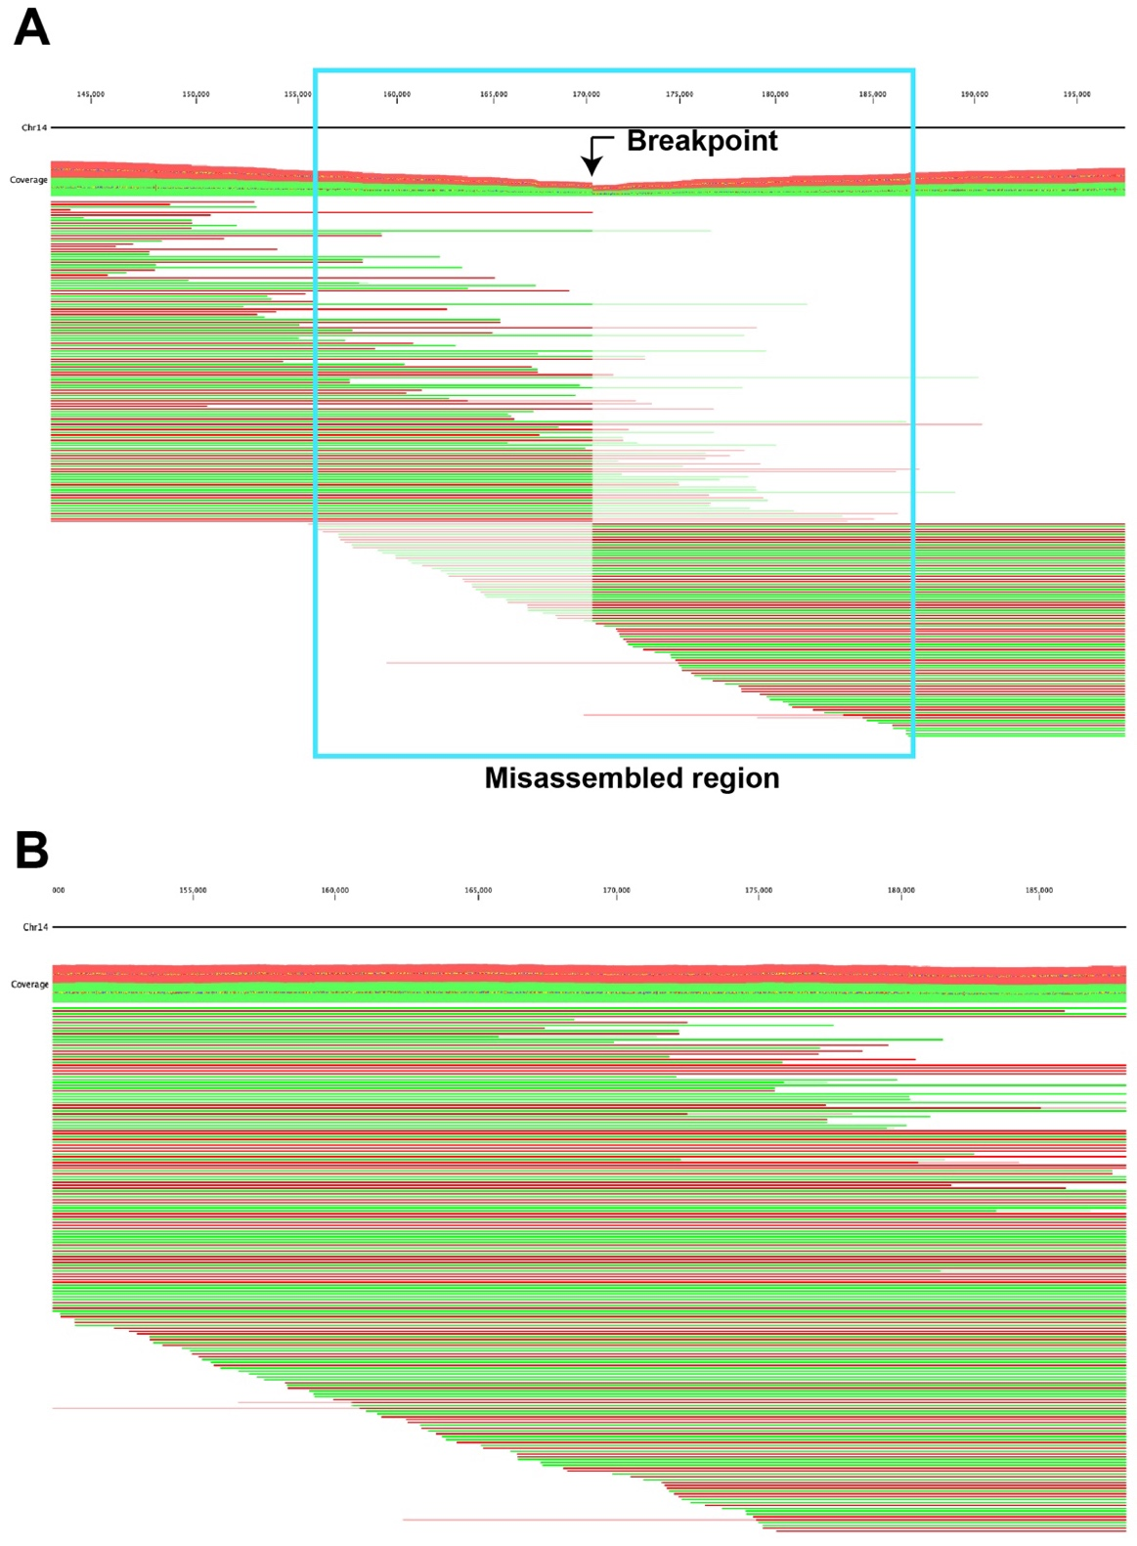
Supplementary Figure S1. ONT reads mapping to the NECAT assembly of AT141 before and after correction was made on the misassembled region. (A) Misassembled region marked in blue box was identified based on a sharp decrease in read depth with a breakpoint marked with an arrow. Mismatches in reads are indicated with light colors. Correction was made by splitting the contig into two pieces at the breakpoint, followed by end extension and rejoining. (B) The updated version of the contig was confirmed to be accurate based on uniform and continuous read coverage. Reads coded in red and green indicate forward and reverse directions, respectively.
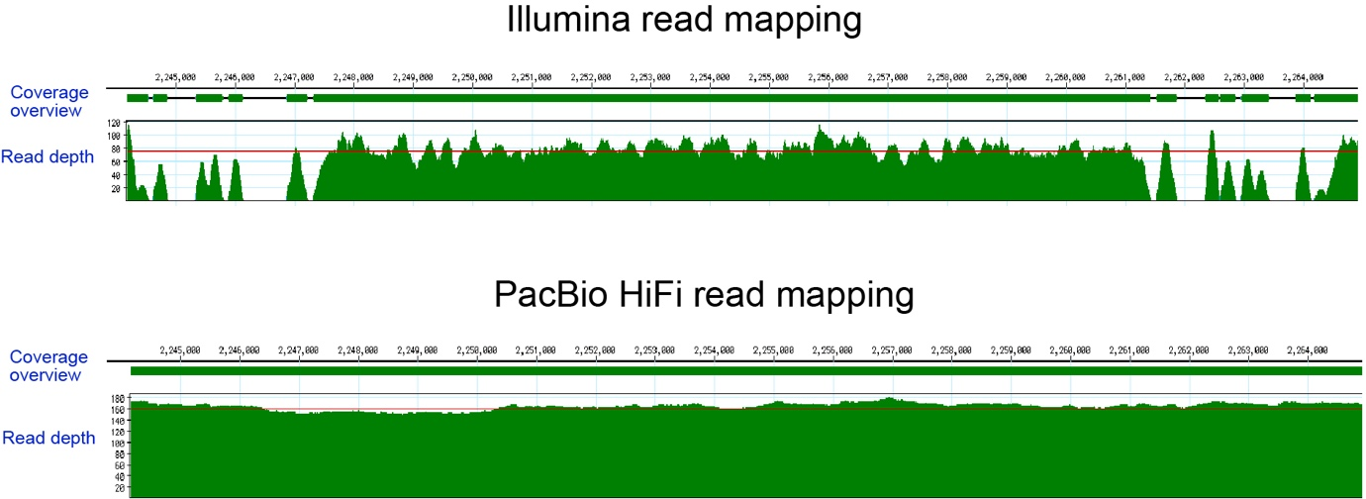
Supplementary Figure S2. Comparison of Illumina (top panel) vs. PacBio HiFi reads (bottom panel) mapping to the same accessory region of JCP043. Illumina reads displayed low and zero read coverage in multiple regions, whereas continuous and uniform read coverage was observed using PacBio HiFi reads.

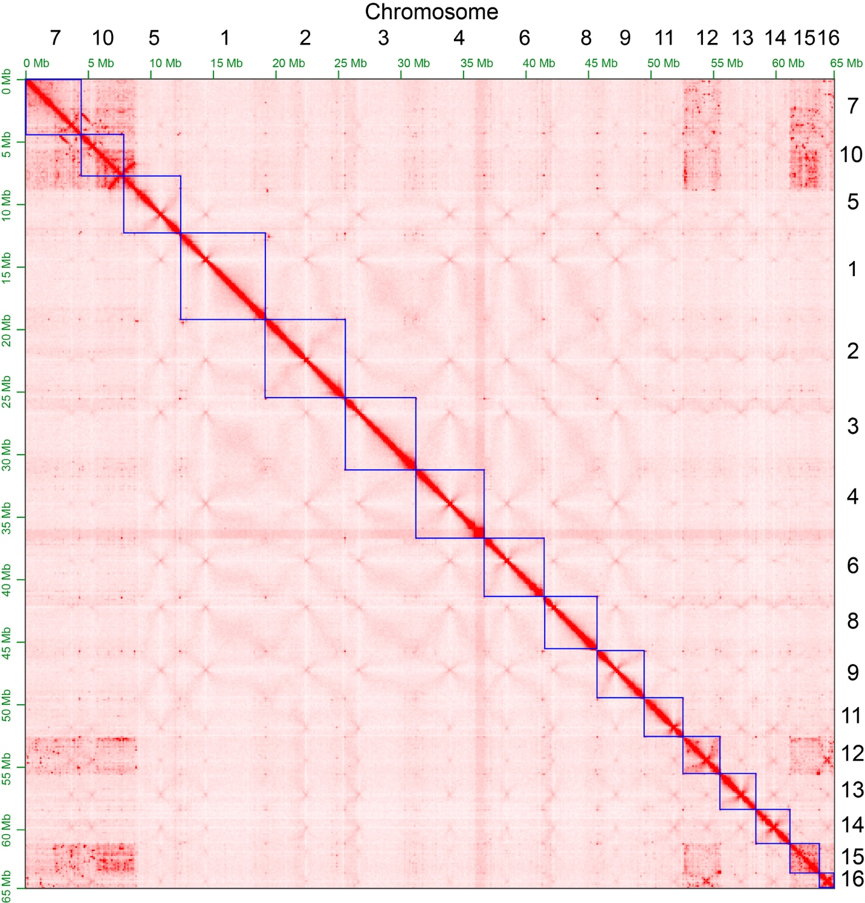
Supplementary Figure S3. Genome-wide Hi-C contact map showing the interaction matrices among 16 chromosomes. The red bright diagonal band within each square represents elevated contact frequency along the chromosome, indicating correct chromosome organization.
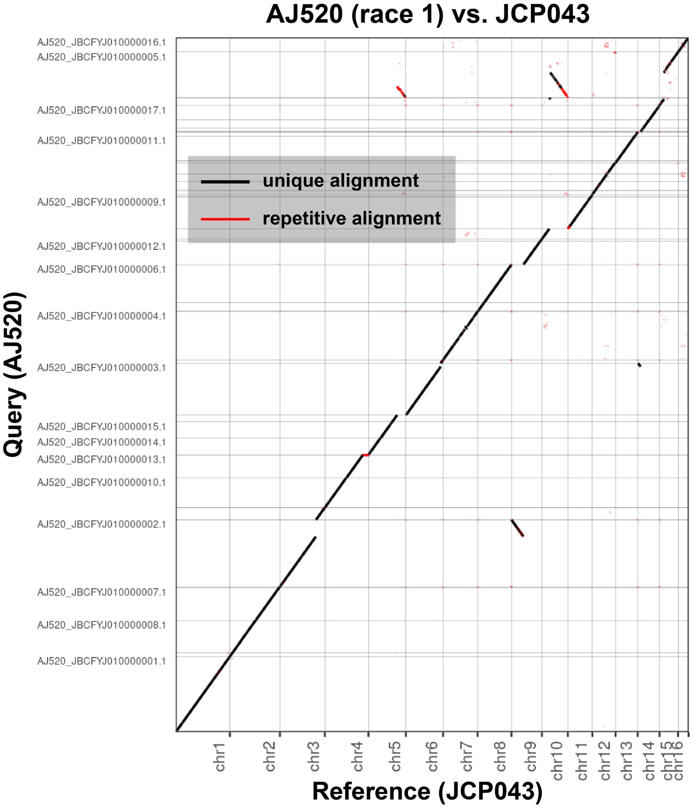

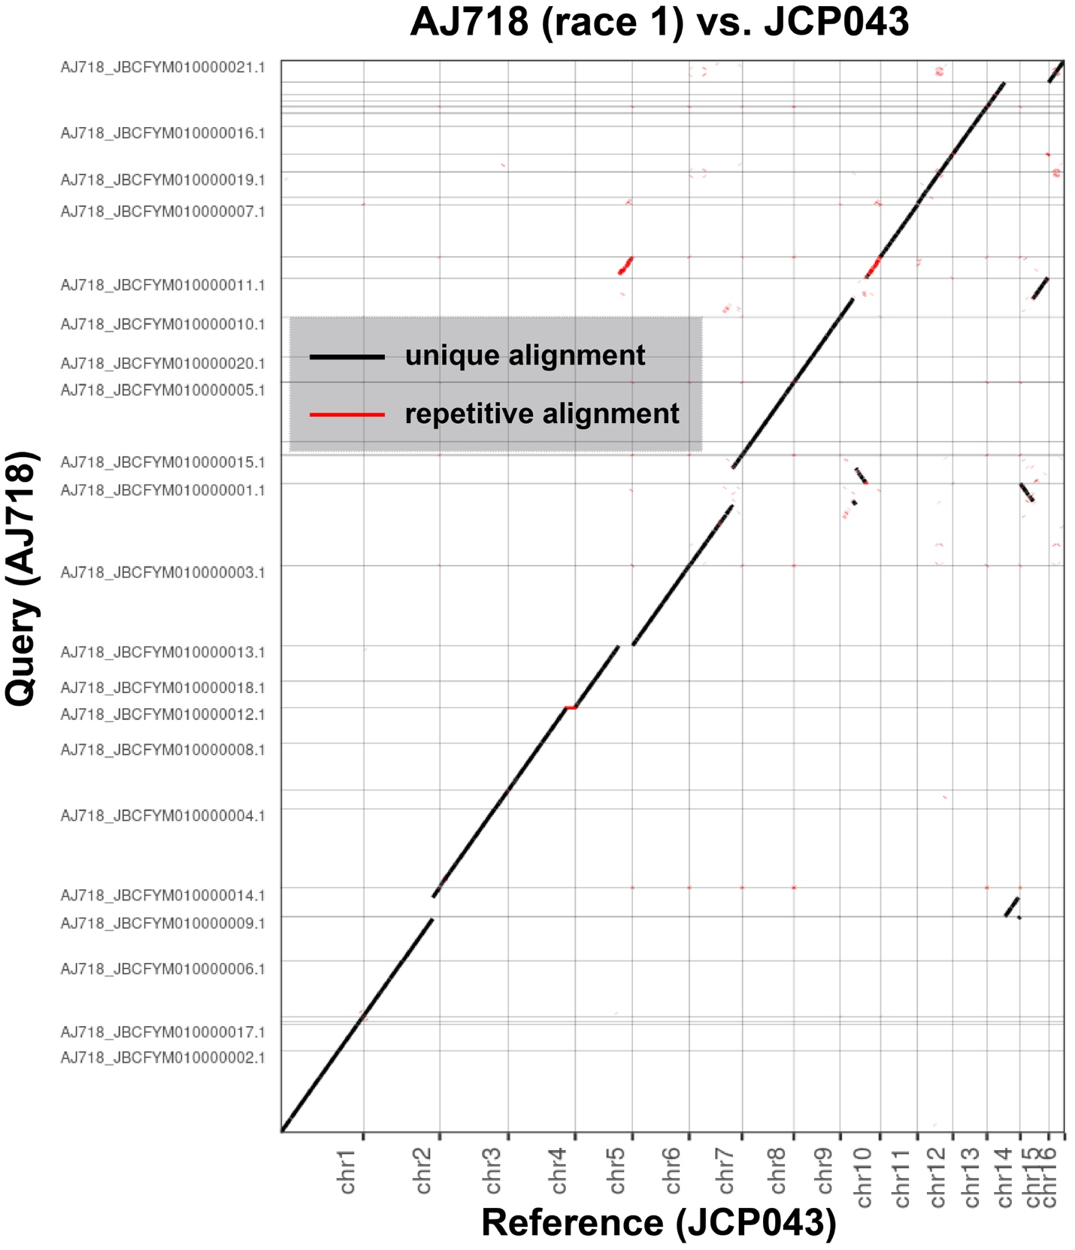

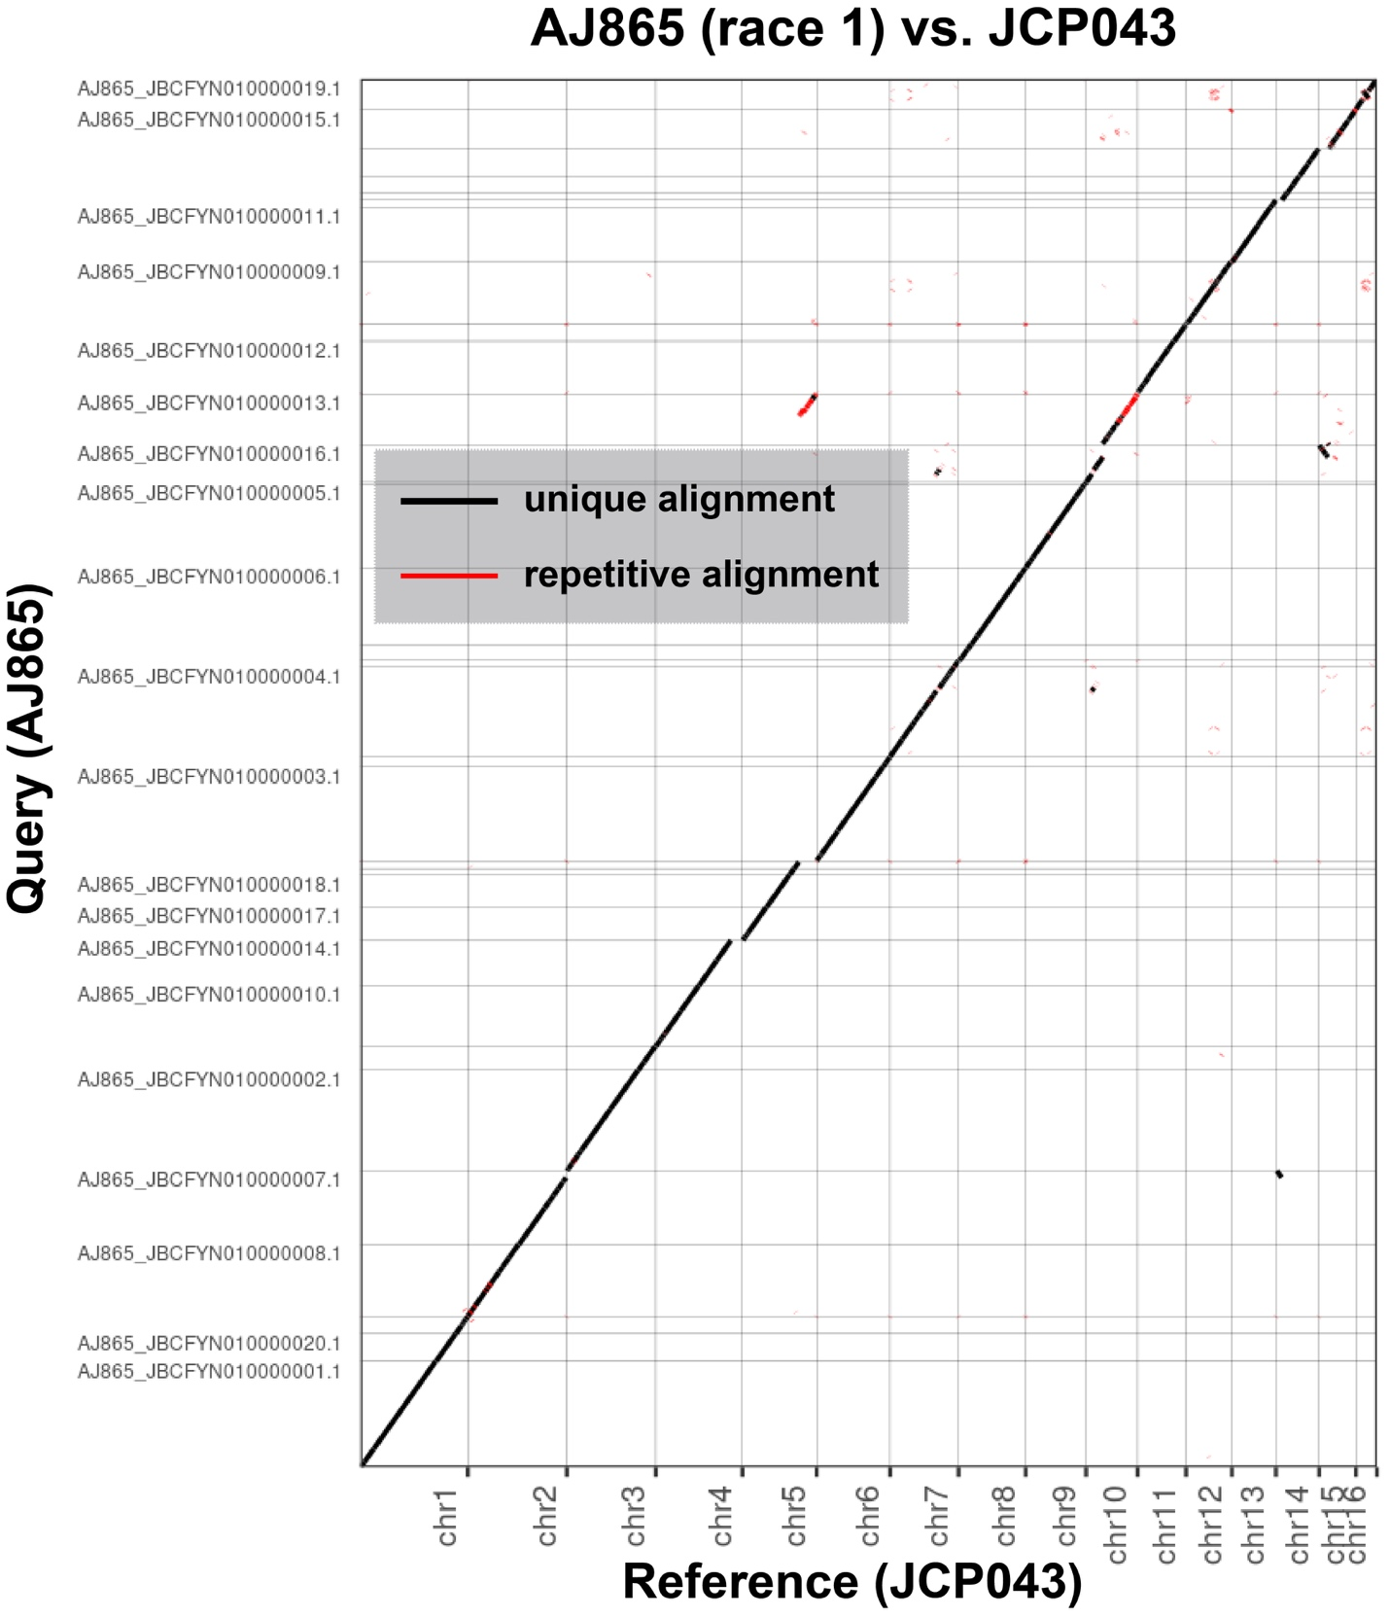
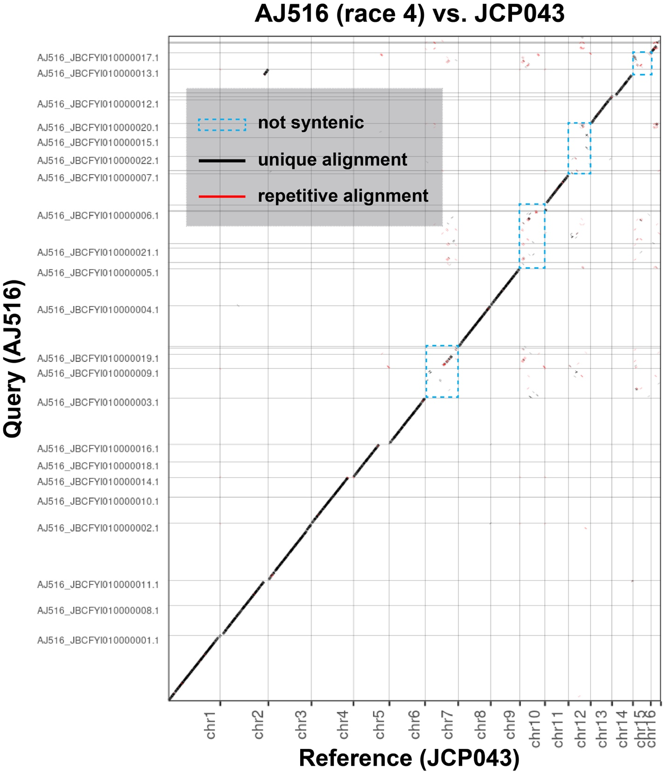

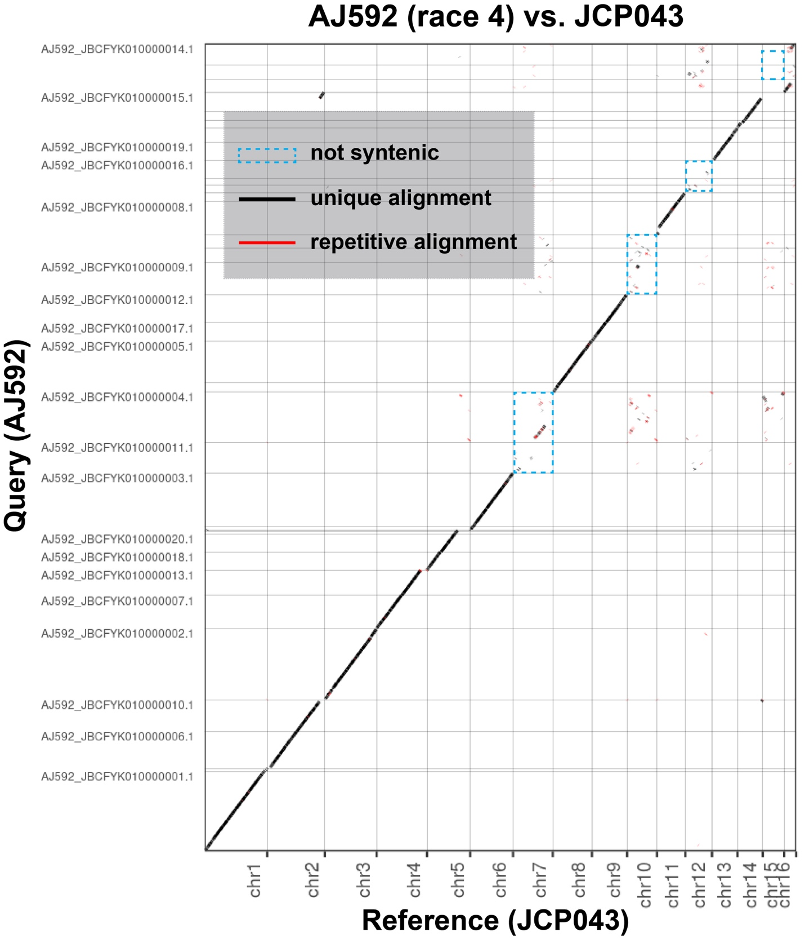
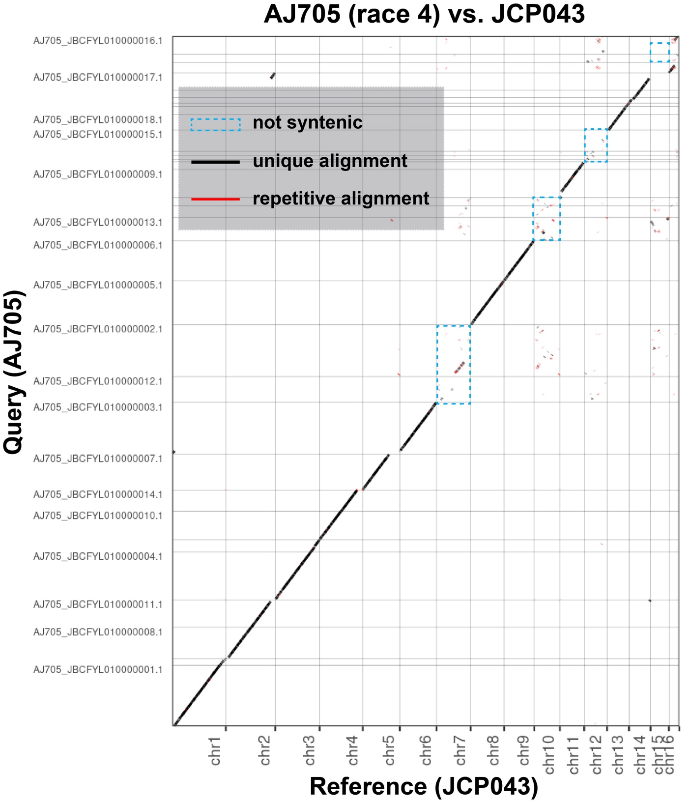
Supplementary Figure S4. Dot plots depicting the synteny between the T2T assembly of race 1 JCP043 (Reference) and each of the six published FOLac race 1 and 4 assemblies (Bates et al. 2024). The nucmer package (nucmer –maxmatch; -L 10000) was used to identify highly similar regions, followed by data visualization with Assemblytics (Nattestad and Schatz 2016). Accessory chromosomes 7, 10, 12 and 15 of JCP043 showed great synteny with the three FOLac race 1 isolates but not with the three FOLac race 4 isolates, which are highlighted in blue dotted rectangular boxes.
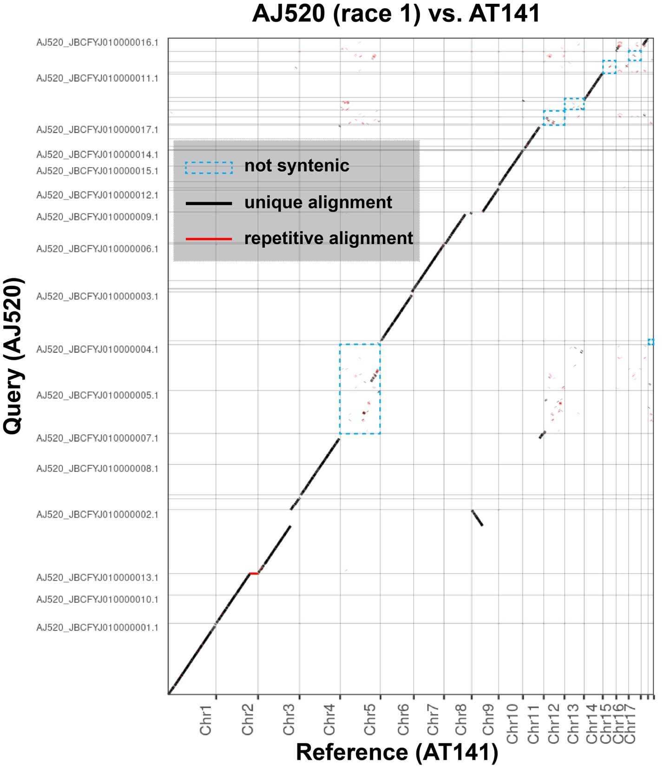

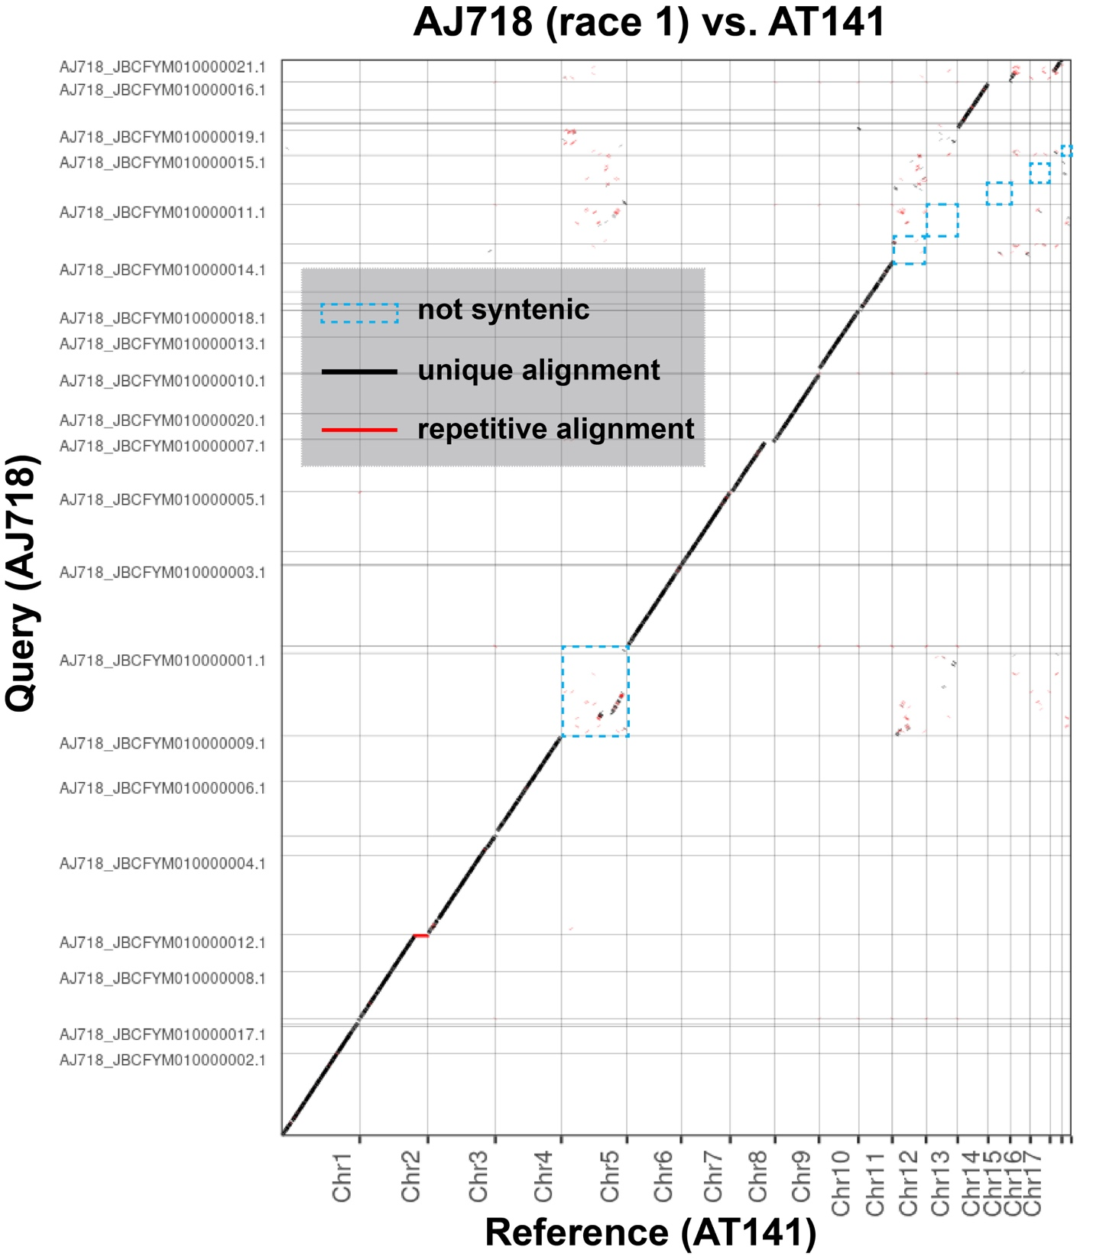

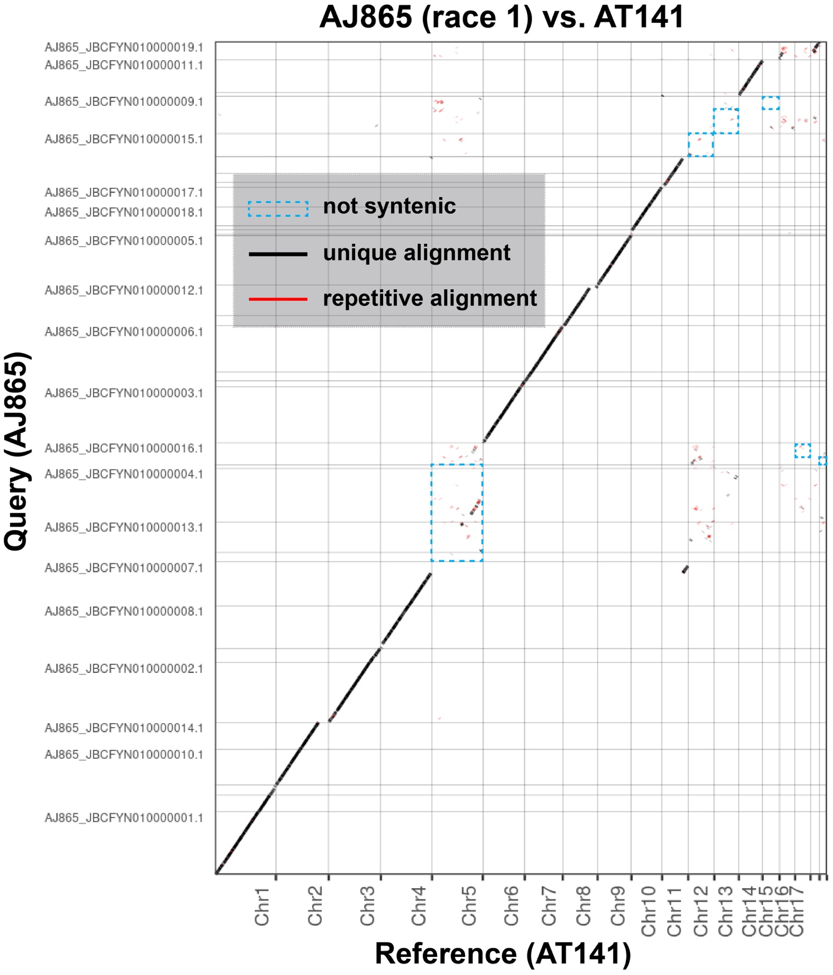

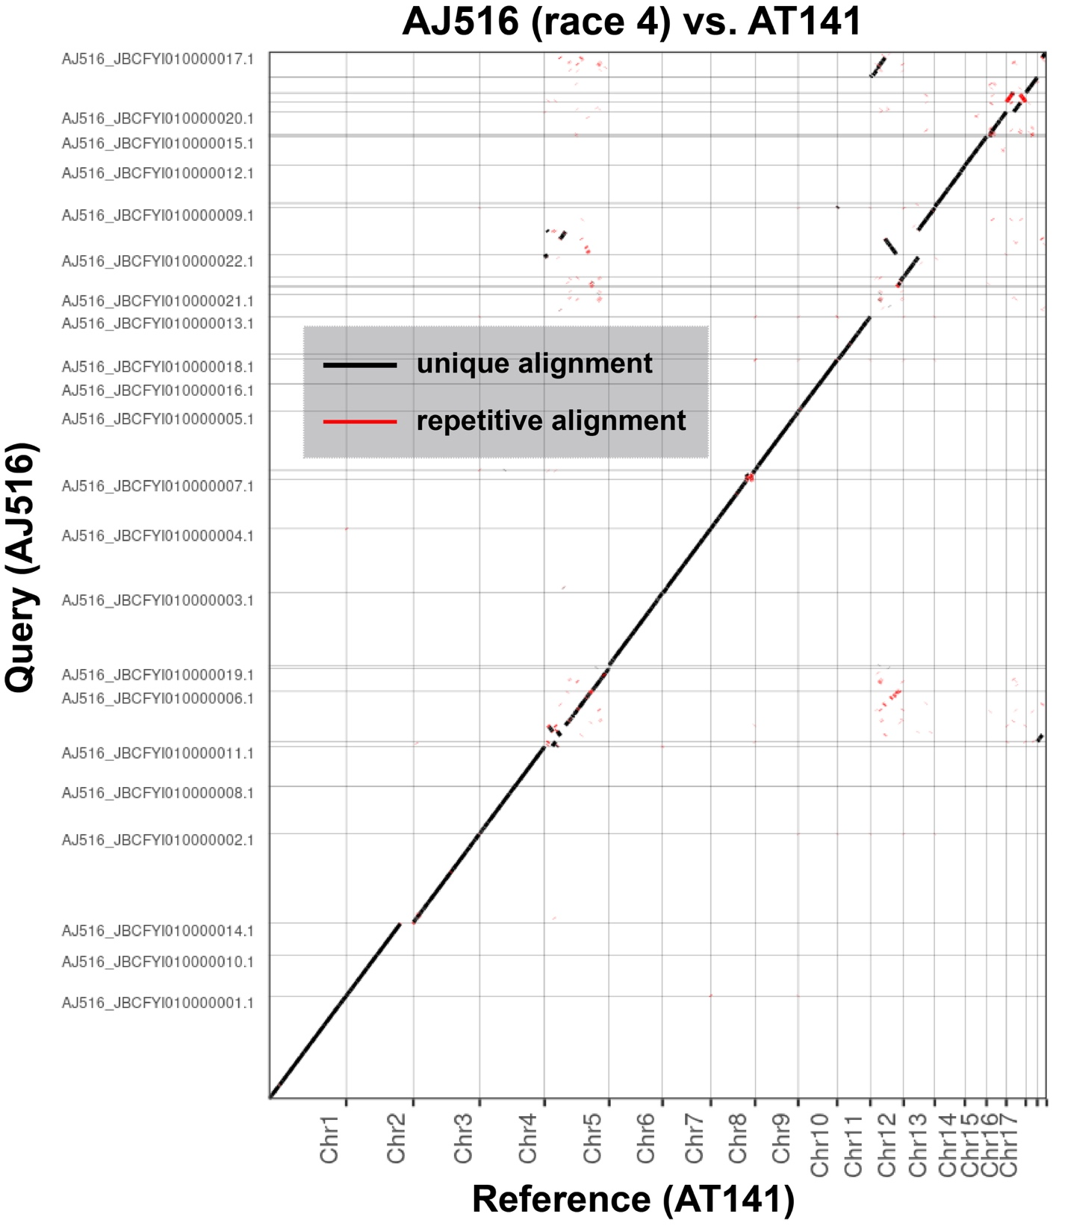

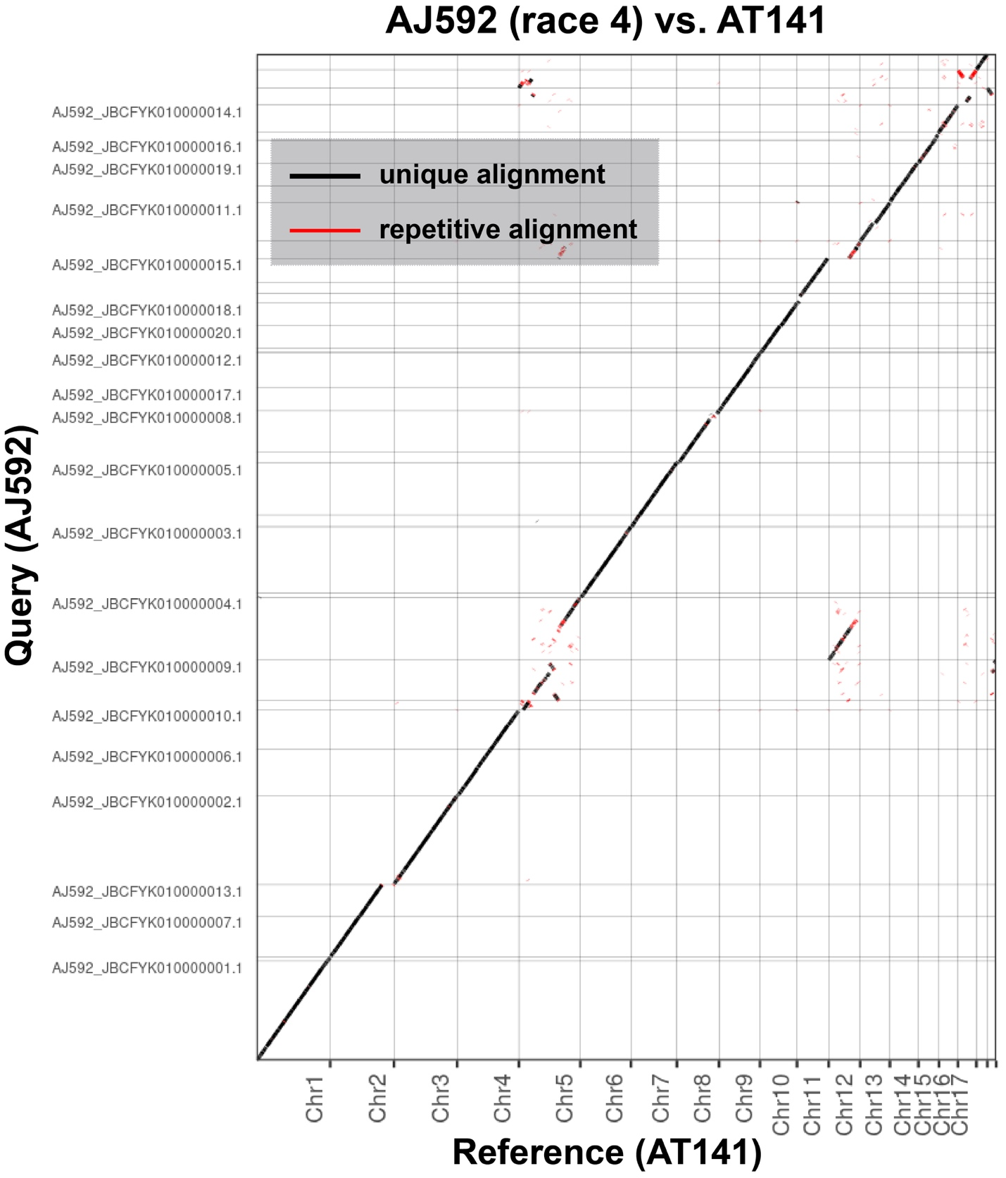

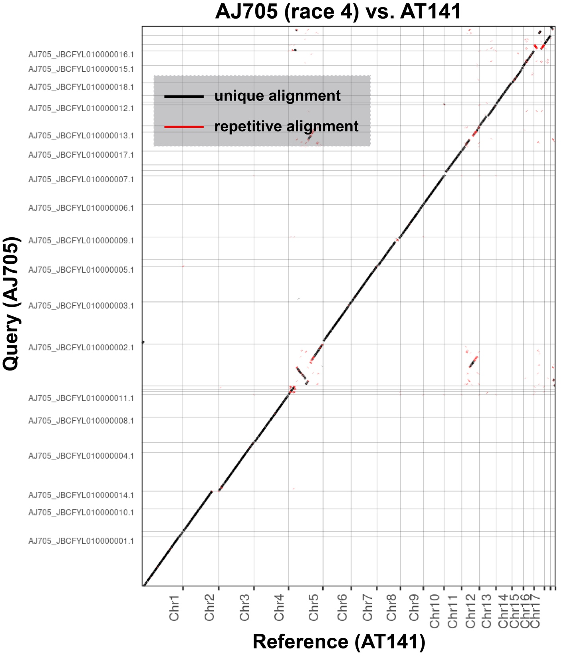
Supplementary Figure S5. Dot plots depicting the synteny between the T2T assembly of race 4 AT141 (Reference) and six published FOLac race 1 and 4 assemblies (Bates et al. 2024). The nucmer package (nucmer –maxmatch; -L 10000) was used to identify highly similar regions, followed by data visualization with Assemblytics. Accessory chromosomes 5, 12, 13, 15, 17, and 19 of AT141 showed great synteny with the three FOLac race 4 isolates but not with the three FOLac race 1 isolates, which are highlighted in blue dotted rectangular boxes.

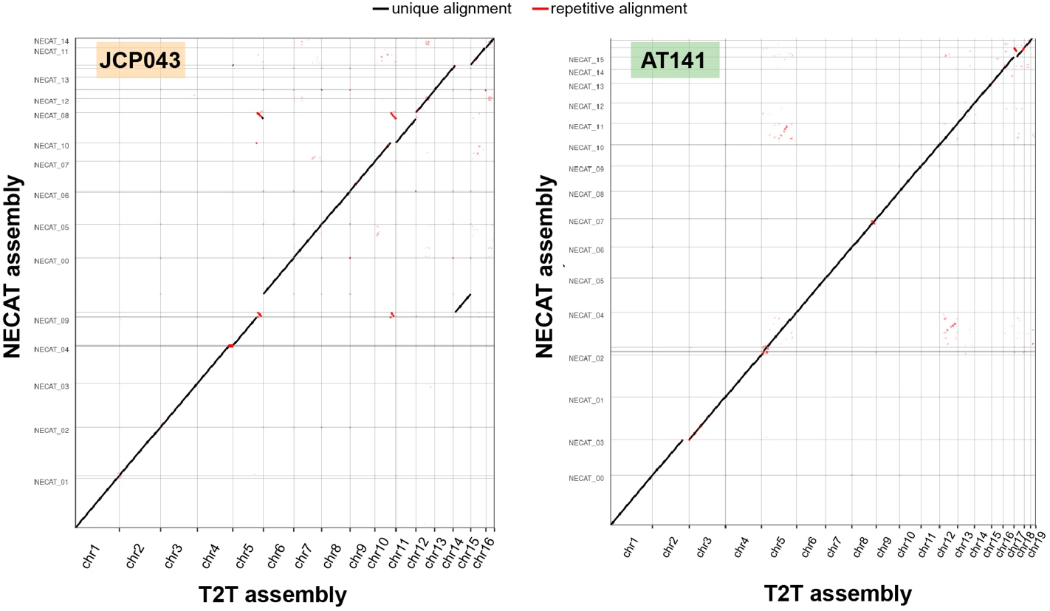

Supplementary Figure S6. Dot plots depicting the synteny between the T2T and NECAT assemblies of (A) JCP043 and (B) AT141. The nucmer package (nucmer –maxmatch; –L 10000) was used to identify highly similar regions, followed by data visualization with Assemblytics.

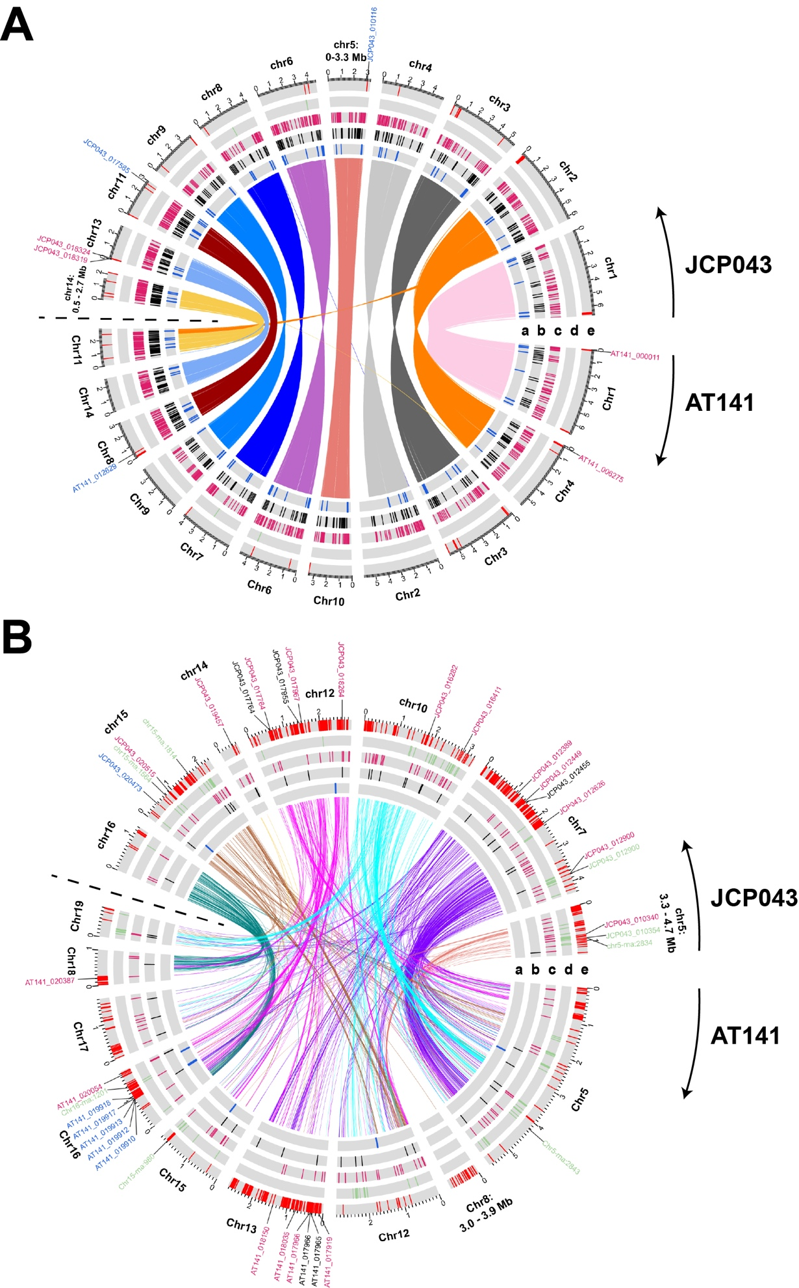
Supplementary Figure S7. Visualization of homologous gene pairs and the distribution of virulence and race-specific genes in the (A) core and (B) accessory genomes of JCP043 and AT141. Order of tracks from inward to outward (a-e) represent the location of: a: secondary metabolite (SM) gene clusters, b: secreted carbohydrate-activate enzymes (CAZYmes), c: effector genes, d: mimp-associated effector genes, and e: race-specific genes. Gene IDs of the race-specific virulence genes, including SM genes (blue), secreted CAZYmes (black), effectors (pink), and mimp-associated effectors (green), are shown outside of track e. See Supplementary Table S3 for detailed information of the race-specific virulence genes. Lines in the center represent pairs of homologous genes (15063 pairs in the core; 917 pairs in the accessory) identified with reciprocal best BLAST hit.
Variant calling criteria: Variant is present in >=70% of the mapped reads (with 99% sequence identity and read depth of >=3)

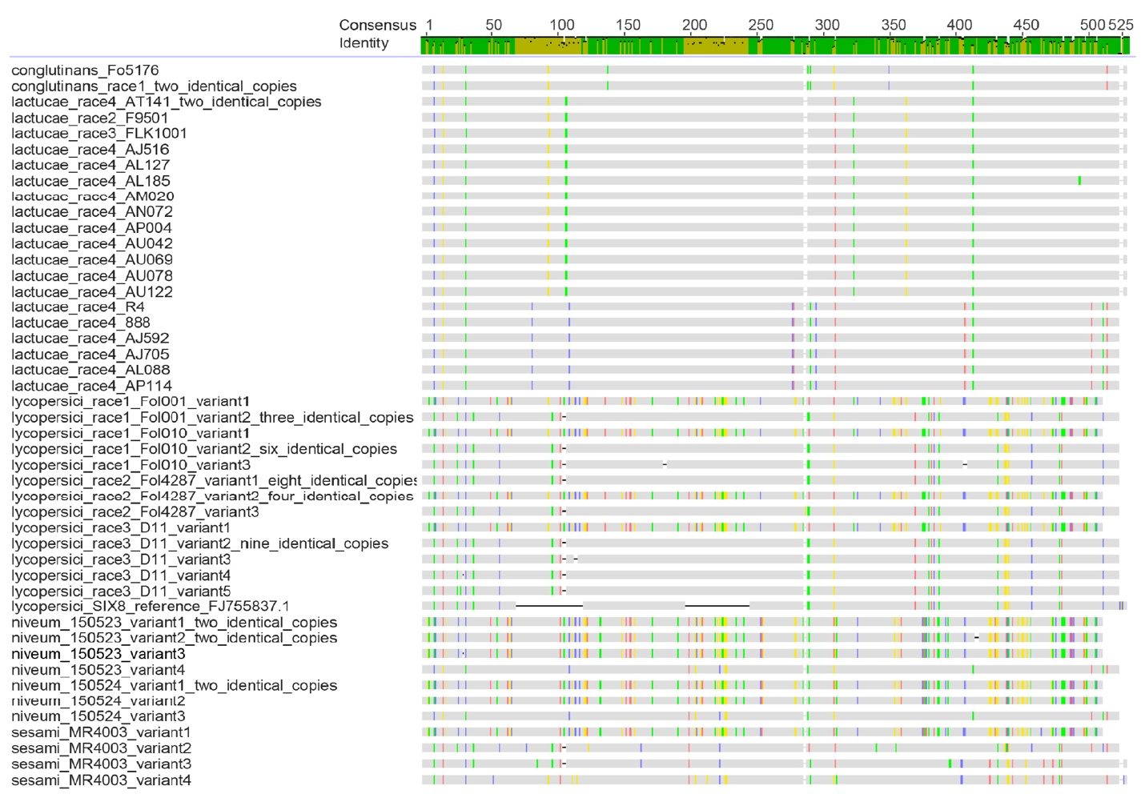
Supplementary Figure S8. MUSCLE alignment of SIX8 sequences from F. oxysporum ff. spp. conglutinans, lactucae, lycopersici, and niveum. Nucleotide with 100% identity among all the sequences are indicated with grey bars, whereas gaps and indels are indicated with horizontal lines. Single nucleotide polymorphisms are noted with colored lines. Identity scale for the consensus sequence shown on the top: green=100%, gold=30-99.9%.

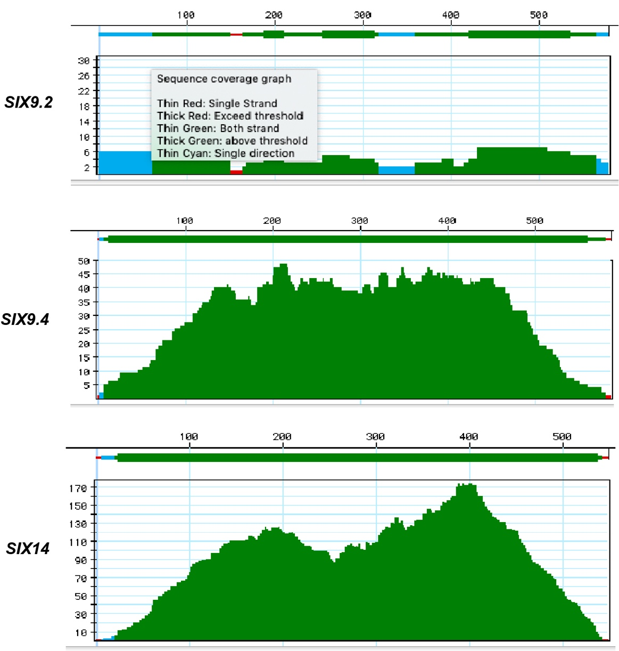

Supplementary Figure S9. Coverage of Illumina reads from AM163 (FOLac race 1) mapping to the reference sequences of SIX9.2, SIX9.4, and SIX14. Mapped reads that were one-directional and both-directional were indicated in blue and green lines, respectively. Red lines indicate regions where only one read was mapped. Detailed description of the coverage graph is shown in the box inserted in SIX9.2 read mapping graph. Coverage threshold is set to 2×.

