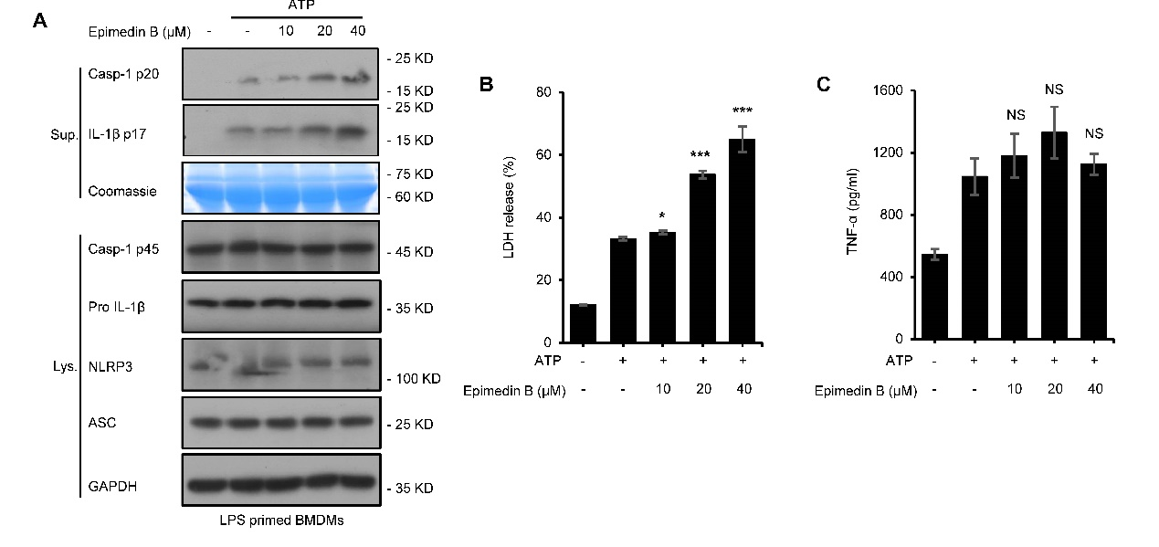
Supplementary Fig 1 Epimedin B promotes NLRP3 inflammasome activation in BMDMs stimulated by ATP (A) Western blot analysis of Sup. and Lys. derived from LPS-primed BMDMs subjected to treatment with various doses of epimedin B before ATP stimulation. (B-C) the release of LDH (B), ELISA of TNF-α (C) levels in supernatants (Sup) from samples described in A. Data are represented as mean ± SD from at least three biological samples. The significance of the differences was analyzed using unpaired Student’s t-test: *P <0.05, **P <0.01, ***P <0.001, NS; not significant, RLUs; the relative light units.
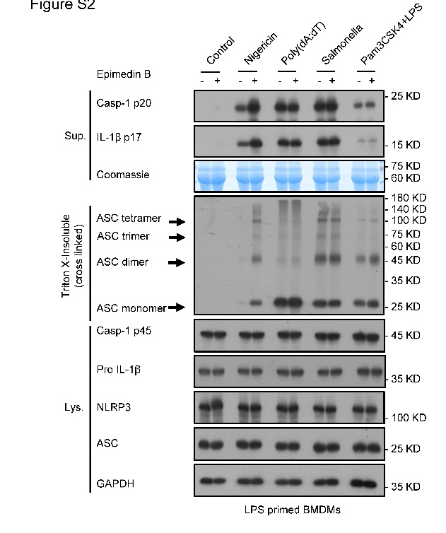
Supplementary Fig 2 Epimedin B specifically promotes nigericin-induced ASC oligomerization Western blot analysis of ASC oligomerization from LPS/Pam3CSK4-primed BMDMs subjected to treatment with epimedin B, following which they were stimulated with nigericin, poly (dA:dT), Salmonella, or intracellular LPS.
Supplementary Fig 3 Epimedin B specifically promotes nigericin or ATP-induced NLRP3 activation (A) Western blot analysis of Sup. and Lys. derived from LPS-primed BMDMs from WT or KO C57BL/6 treatment with epimedin B before nigericin stimulation. (B) Western blot analysis of Sup. and Lys. derived from LPS-primed BMDMs subjected to treatment with epimedin B after treated with MCC950 and then stimulated with nigericin.

