Supporting Figures and Supporting Tables
Table S1. Low-Cost Methane Abatement (<$100/tCO₂e)
Region | Waste |  | Energy |  | Agriculture |  | Total
Region | Landfill | Wastewater | Coal | Oil & gas | Livestock | Rice | Total
East Asia & Pacific | 140 | 27 | 377 | 89 | 60 | 168 | 860
Europe & Central Asia | 130 | 11 | 73 | 158 | 33 | 1 | 407
Latin America & Caribbean | 91 | 24 | 11 | 46 | 51 | 5 | 228
Middle East & North Africa | 127 | 10 | 0 | 173 | 4 | 4 | 317
North America | 25 | 1 | 16 | 83 | 66 | 2 | 193
South Asia | 78 | 19 | 28 | 28 | 33 | 48 | 234
Sub-Saharan Africa | 63 | 5 | 15 | 37 | 23 | 6 | 150
Total | 654 | 96 | 521 | 614 | 270 | 233 | 2389

Figure S1. Top mitigation technologies below 100$/tCO₂e by each macro-region across sectors
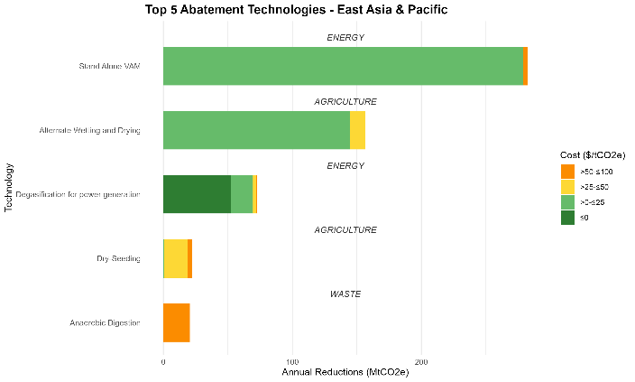
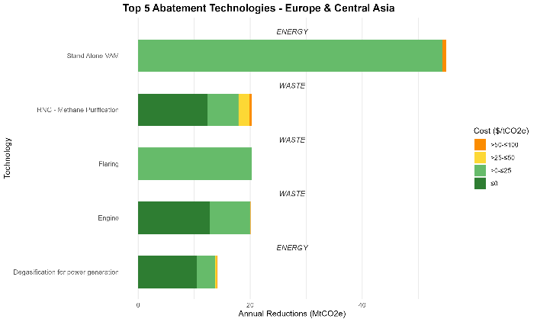
(supplementary file will contains data; under zero shows cost savings from energy recovery and cost savings)
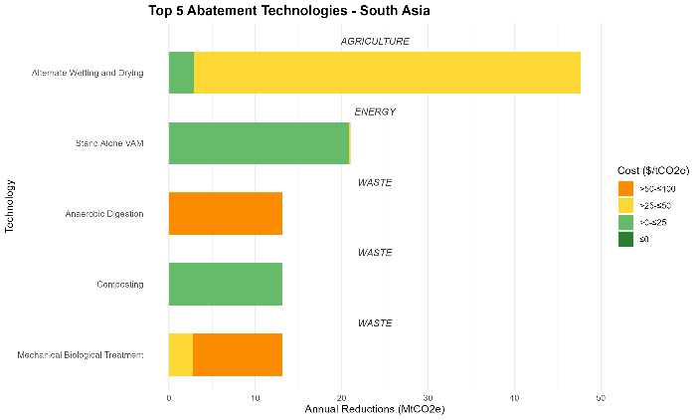
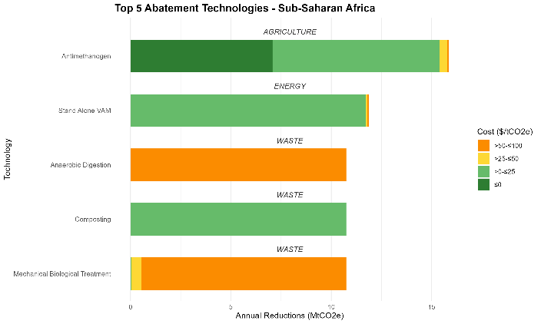
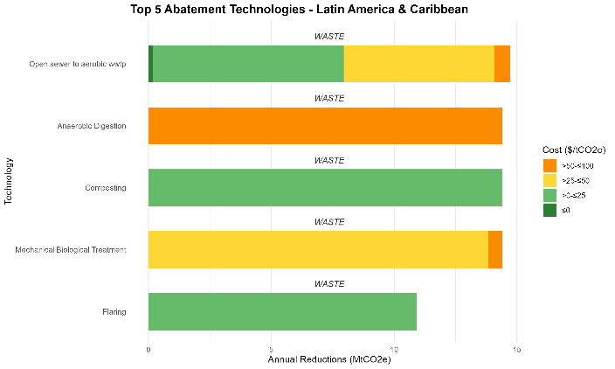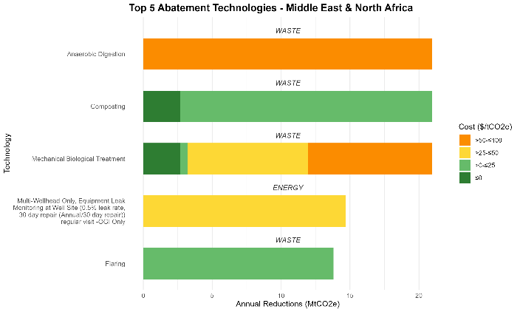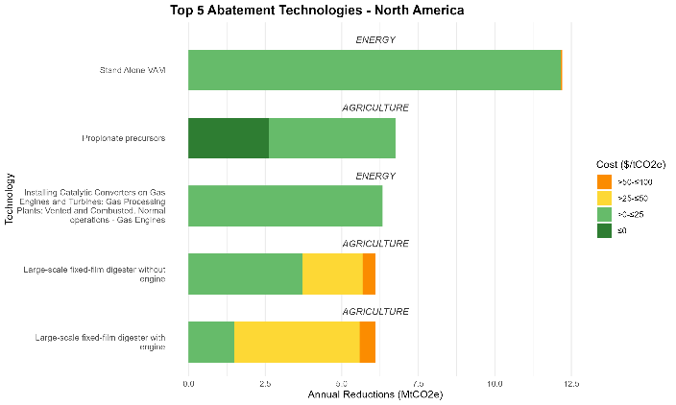
Table S2. Waste Mitigation Measures under $100/tCO₂e and countries with the most potential
Landfill Mitigation Measures under 100$/tCO2e | Global Mitigation Potential (MtCO2e) | Countries with most potential | Mitigation Possible at no Cost (MtCO2e)
Anaerobic Digestion | 93.1 | Pakistan, Russia, China | 0
Composting | 93.1 | Pakistan, Russia, China | 5.5
Mechanical Biological Treatment | 93.1 | Pakistan, Russia, China | 5.6
Flaring | 79.2 | Pakistan, Russia, China | 0
RNG - Methane Purification | 65.8 | Pakistan, Russia, China | 58.3
Direct Use | 65 | Pakistan, Russia, China | 63.7
Engine | 44.5 | Italy, USA, Canada | 29.2
Enhanced Oxidation | 43.1 | Pakistan, Russia, China | 0
Paper Recycling | 28.1 | Russia, China, Indonesia | 0.8
HP Engine | 16.9 | Pakistan, Russia, China | 15.8
Turbine | 16.2 | Pakistan, Russia, China | 15
Miroturbine | 15.2 | Pakistan, Russia, China | 14.8
Waste to Energy | 0.1 | Japan, Norway, Iceland | 0
Grand Total | 653.6 |  | 208.6
Wastewater Mitigation Measures under $100 M tCO2e | Mitigation Potential (MtCO2e) | Countries with most potential | Mitigation Possible at no Cost (MtCO2e)
Open sewer to aerobic wwtp | 55.9 | Indonesia, China, Brazil | 1.7
Latrine to aerobic wwtp | 25 | Bangladesh, Brazil, Mexico | 0
Wastewater treatment plant with anaerobic sludge digester with co-gen | 8 | Russia, Ukraine, Indonesia | 0
RNG - Methane Purification | 3.9 | Russia, USA, UK | 0
Septic tank to aerobic wwtp | 3.5 | Indonesia, China, India | 0
Grand Total | 96.3 |  | 1.8

Table S3: Low-cost mitigation potential by income status (MtCO₂e) in 2030
Row Labels | Coal | Oil & Gas | Landfill | Livestock | Rice | Wastewater | Total
Low income | 8 | 5 | 61 | 15 | 10 | 10 | 108
Lower middle income | 37 | 292 | 282 | 64 | 162 | 99 | 936
Upper middle income | 430 | 254 | 314 | 102 | 129 | 88 | 1318
High income | 46 | 179 | 160 | 172 | 16 | 31 | 605
Total | 522 | 730 | 817 | 352 | 317 | 228 | 2966

Table S4: Tech roadmap to Methane Abatement available below 100$/tCO₂e. Technologies with the most abatement potential shown with the three locations with the most abatement listed below each tech.
Technology | Global Abatement Potential (MtCO₂e) | As a share of GMP target | Sector | Source
Stand Alone VAM | 390.7 | 12% | Energy | Coal
China | 257.8 | 8% | Energy | Coal
Russia | 40.5 | 1% | Energy | Coal
India | 18.8 | 1% | Energy | Coal
Alternate Wetting and Drying | 214.3 | 7% | Agriculture | RICE
China | 118.1 | 4% | Agriculture | RICE
India | 38.8 | 1% | Agriculture | RICE
Viet Nam | 16.3 | 0% | Agriculture | RICE
Degasification for power generation | 96.9 | 3% | Energy | Coal
China | 66.5 | 2% | Energy | Coal
Russia | 10.4 | 0% | Energy | Coal
India | 4.9 | 0% | Energy | Coal
Anaerobic Digestion | 93.1 | 3% | Waste | Landfill
Pakistan | 9.7 | 0% | Waste | Landfill
Russian | 7.9 | 0% | Waste | Landfill
China | 7.3 | 0% | Waste | Landfill
Composting | 93.1 | 3% | Waste | Landfill
Pakistan | 9.7 | 0% | Waste | Landfill
Russian | 7.9 | 0% | Waste | Landfill
China | 7.3 | 0% | Waste | Landfill

