Supplementary Table captions
Supplementary Table S1. Atomic coordinate, isotropic thermal parameter, and occupancy of Ca_{2.82}(PO₄)₂:0.09Eu³⁺, 0.09Li⁺ phosphor.

Supplementary Table S2. Atomic coordinate, isotropic thermal parameter, and occupancy of Ca_{2.82}(PO₄)₂:0.09Eu³⁺, 0.09Na⁺ phosphor.

Supplementary Table S3. Atomic coordinate, isotropic thermal parameter, and occupancy of Ca_{2.82}(PO₄)₂:0.09Eu³⁺, 0.09K⁺ phosphor.

Supplementary Table S4. Ca−O and P−O lengths in Ca_{2.82}(PO₄)₂:0.09Eu³⁺, 0.09Li⁺ phosphor.

Supplementary Table S5. Ca−O and P−O lengths in Ca_{2.82}(PO₄)₂:0.09Eu³⁺, 0.09Na⁺ phosphor.

Supplementary Table S6. Ca−O and P−O lengths in Ca_{2.82}(PO₄)₂:0.09Eu³⁺, 0.09K⁺ phosphor.

Supplementary Table S1. Atomic coordinate, isotropic thermal parameter, and occupancy of Ca_{2.82}(PO₄)₂:0.09Eu³⁺, 0.09Li⁺ phosphor.
 | Atomic coordinates |  |  |  | Isotropic thermal parameter  B_{iso} (Å²) | Occupancy
Atom | Site | x | y | z | Isotropic thermal parameter  B_{iso} (Å²) | Occupancy
Ca(1) | 18b | 0.7260 | 0.8588 | 0.1671 | 0.4374 | 0.9776
Eu(1) | 18b | 0.7260 | 0.8588 | 0.1671 | 0.4374 | 0.0224
Ca(2) | 18b | 0.6215 | 0.8227 | −0.0337 | 0.3332 | 0.9632
Eu(2) | 18b | 0.6215 | 0.8227 | −0.0337 | 0.3332 | 0.0368
Ca(3) | 18b | 0.7259 | 0.8510 | 0.0613 | 0.5677 | 0.9758
Eu(3) | 18b | 0.7259 | 0.8510 | 0.0613 | 0.5677 | 0.0242
Ca(4) | 6a | 0.0000 | 0.0000 | −0.0870 | 1.7402 | 0.2905
Li | 6a | 0.0000 | 0.0000 | −0.0870 | 1.7402 | 0.2095
Ca(5) | 6a | 0.0000 | 0.0000 | 0.7364 | 0.9759 | 1.0000
P(1) | 6a | 0.0000 | 0.0000 | 0.0000 | 0.3814 | 1.0000
P(2) | 18b | 0.6904 | 0.8661 | 0.8682 | 2.1176 | 1.0000
P(3) | 18b | 0.6531 | 0.8470 | 0.7669 | 0.2029 | 1.0000
O(1) | 18b | 0.7316 | −0.0885 | −0.0909 | 2.1318 | 1.0000
O(2) | 18b | 0.7490 | 0.7655 | 0.8543 | 0.5653 | 1.0000
O(3) | 18b | 0.7336 | 0.0088 | 0.8479 | 0.2637 | 1.0000
O(4) | 18b | 0.5172 | 0.7657 | 0.8634 | 0.3174 | 1.0000
O(5) | 18b | 0.6023 | −0.0499 | 0.7785 | 0.4358 | 1.0000
O(6) | 18b | 0.5677 | 0.6916 | 0.7836 | 0.4572 | 1.0000
O(7) | 18b | 0.0939 | 0.9045 | 0.7801 | 0.0956 | 1.0000
O(8) | 18b | 0.6300 | 0.8271 | 0.7275 | 0.7406 | 1.0000
O(9) | 18b | 0.0134 | 0.8640 | −0.0087 | 0.7817 | 1.0000
O(10) | 6a | 0.0000 | 0.0000 | 0.0406 | 1.6234 | 1.0000

Supplementary Table S2. Atomic coordinate, isotropic thermal parameter, and occupancy of Ca_{2.82}(PO₄)₂:0.09Eu³⁺, 0.09Na⁺ phosphor.
 | Atomic coordinates |  |  |  | Isotropic thermal parameter  B_{iso} (Å²) | Occupancy
Atom | Site | x | y | z | Isotropic thermal parameter  B_{iso} (Å²) | Occupancy
Ca(1) | 18b | 0.7250 | 0.8576 | 0.1635 | 0.4722 | 0.9754
Eu(1) | 18b | 0.7250 | 0.8576 | 0.1635 | 0.4722 | 0.0246
Ca(2) | 18b | 0.6199 | 0.8212 | −0.0344 | 0.2661 | 0.9597
Eu(2) | 18b | 0.6199 | 0.8212 | −0.0344 | 0.2661 | 0.0403
Ca(3) | 18b | 0.7291 | 0.8516 | 0.0600 | 0.9577 | 0.9763
Eu(3) | 18b | 0.7291 | 0.8516 | 0.0600 | 0.9577 | 0.0237
Ca(4) | 6a | 0.0000 | 0.0000 | −0.0866 | 2.6293 | 0.3546
Na | 6a | 0.0000 | 0.0000 | −0.0866 | 2.6293 | 0.1454
Ca(5) | 6a | 0.0000 | 0.0000 | 0.7338 | 0.8030 | 1.0000
P(1) | 6a | 0.0000 | 0.0000 | 0.0000 | 1.2783 | 1.0000
P(2) | 18b | 0.6874 | 0.8608 | 0.8634 | 1.3596 | 1.0000
P(3) | 18b | 0.6522 | 0.8467 | 0.7658 | 0.2171 | 1.0000
O(1) | 18b | 0.7318 | −0.0890 | −0.0932 | 1.9463 | 1.0000
O(2) | 18b | 0.7659 | 0.7798 | 0.8543 | 0.8614 | 1.0000
O(3) | 18b | 0.7299 | 0.0058 | 0.8467 | 0.3395 | 1.0000
O(4) | 18b | 0.5167 | 0.7620 | 0.8606 | 0.7730 | 1.0000
O(5) | 18b | 0.5996 | −0.0490 | 0.7794 | 0.3900 | 1.0000
O(6) | 18b | 0.5735 | 0.6900 | 0.7841 | 0.1319 | 1.0000
O(7) | 18b | 0.0888 | 0.9064 | 0.7786 | 0.2456 | 1.0000
O(8) | 18b | 0.6301 | 0.8291 | 0.7264 | 0.7754 | 1.0000
O(9) | 18b | 0.0085 | 0.8639 | −0.0118 | 1.7284 | 1.0000
O(10) | 6a | 0.0000 | 0.0000 | 0.0405 | 0.8314 | 1.0000

Supplementary Table S3. Atomic coordinate, isotropic thermal parameter, and occupancy of Ca_{2.82}(PO₄)₂:0.09Eu³⁺, 0.09K⁺ phosphor.
 | Atomic coordinates |  |  |  | Isotropic thermal parameter  B_{iso} (Å²) | Occupancy
Atom | Site | x | y | z | Isotropic thermal parameter  B_{iso} (Å²) | Occupancy
Ca(1) | 18b | 0.7231 | 0.8572 | 0.1656 | 0.3000 | 0.9791
Eu(1) | 18b | 0.7231 | 0.8572 | 0.1656 | 0.3000 | 0.0209
Ca(2) | 18b | 0.6178 | 0.8229 | −0.0337 | 0.4193 | 0.9666
Eu(2) | 18b | 0.6178 | 0.8229 | −0.0337 | 0.4193 | 0.0334
Ca(3) | 18b | 0.7291 | 0.8516 | 0.0604 | 0.6996 | 0.9776
Eu(3) | 18b | 0.7291 | 0.8516 | 0.0604 | 0.6996 | 0.0224
Ca(4) | 6a | 0.0000 | 0.0000 | −0.0851 | 3.0462 | 0.3610
K | 6a | 0.0000 | 0.0000 | −0.0851 | 3.0462 | 0.1390
Ca(5) | 6a | 0.0000 | 0.0000 | 0.7332 | 0.8985 | 1.0000
P(1) | 6a | 0.0000 | 0.0000 | 0.0000 | 1.1528 | 1.0000
P(2) | 18b | 0.6855 | 0.8590 | 0.8697 | 1.3000 | 1.0000
P(3) | 18b | 0.6515 | 0.8465 | 0.7670 | 0.2061 | 1.0000
O(1) | 18b | 0.7287 | −0.0941 | −0.0927 | 1.6415 | 1.0000
O(2) | 18b | 0.7608 | 0.7721 | 0.8545 | 0.6230 | 1.0000
O(3) | 18b | 0.7335 | 0.0057 | 0.8470 | 0.1287 | 1.0000
O(4) | 18b | 0.5146 | 0.7647 | 0.8608 | 0.8914 | 1.0000
O(5) | 18b | 0.5993 | −0.0484 | 0.7795 | 0.3766 | 1.0000
O(6) | 18b | 0.5693 | 0.6801 | 0.7833 | 0.5314 | 1.0000
O(7) | 18b | 0.0842 | 0.9008 | 0.7781 | 0.2195 | 1.0000
O(8) | 18b | 0.6326 | 0.8261 | 0.7254 | 0.4003 | 1.0000
O(9) | 18b | 0.0085 | 0.8643 | −0.0121 | 1.4173 | 1.0000
O(10) | 6a | 0.0000 | 0.0000 | 0.0399 | 0.6735 | 1.0000

Supplementary Table S4. Ca−O and P−O lengths in Ca_{2.82}(PO₄)₂:0.09Eu³⁺, 0.09Li⁺ phosphor.
 | Ca−O and P−O bonds |  | Bond length (Å)
Ca−O† | Ca(1)−O | Ca(1)−O(3) | 2.5670
Ca−O† | Ca(1)−O | Ca(1)−O(4) | 2.4117
Ca−O† | Ca(1)−O | Ca(1)−O(4) | 2.4904
Ca−O† | Ca(1)−O | Ca(1)−O(5) | 2.4839
Ca−O† | Ca(1)−O | Ca(1)−O(6) | 2.3630
Ca−O† | Ca(1)−O | Ca(1)−O(8) | 2.4195
Ca−O† | Ca(1)−O | Ca(1)−O(9) | 2.4794
Ca−O† | Ca(2)−O | Ca(2)−O(1) | 2.3864
Ca−O† | Ca(2)−O | Ca(2)−O(2) | 2.4567
Ca−O† | Ca(2)−O | Ca(2)−O(3) | 2.3308
Ca−O† | Ca(2)−O | Ca(2)−O(5) | 2.6399
Ca−O† | Ca(2)−O | Ca(2)−O(6) | 2.8473
Ca−O† | Ca(2)−O | Ca(2)−O(7) | 2.4771
Ca−O† | Ca(2)−O | Ca(2)−O(7) | 2.3389
Ca−O† | Ca(2)−O | Ca(2)−O(9) | 2.3298
Ca−O† | Ca(3)−O | Ca(3)−O(1) | 2.6470
Ca−O† | Ca(3)−O | Ca(3)−O(2) | 2.5742
Ca−O† | Ca(3)−O | Ca(3)−O(3) | 2.3808
Ca−O† | Ca(3)−O | Ca(3)−O(5) | 2.3869
Ca−O† | Ca(3)−O | Ca(3)−O(6) | 2.4871
Ca−O† | Ca(3)−O | Ca(3)−O(8) | 2.5965
Ca−O† | Ca(3)−O | Ca(3)−O(8) | 2.5807
Ca−O† | Ca(3)−O | Ca(3)−O(10) | 2.5988
Ca−O† | Ca(4)−O | Ca(4)−O(1) | 2.4771
Ca−O† | Ca(5)−O | Ca(5)−O(4) | 2.2292
Ca−O† | Ca(5)−O | Ca(5)−O(7) | 2.3666
P−O | P(1)−O | P(1)−O(9) | 1.5297
P−O | P(1)−O | P(1)−O(10) | 1.5172
P−O | P(2)−O | P(2)−O(1) | 1.5953
P−O | P(2)−O | P(2)−O(2) | 1.5468
P−O | P(2)−O | P(2)−O(3) | 1.5254
P−O | P(2)−O | P(2)−O(4) | 1.5823
P−O | P(3)−O | P(3)−O(5) | 1.4832
P−O | P(3)−O | P(3)−O(6) | 1.5392
P−O | P(3)−O | P(3)−O(7) | 1.5207
P−O | P(3)−O | P(3)−O(8) | 1.4921

†The distances of Eu(1)−O, Eu(2)−O, Eu(3)−O, and Li−O equal to those of Ca(1)−O, Ca(2)−O, Ca(3)−O, and Ca(4)−O, respectively.

Supplementary Table S5. Ca−O and P−O lengths in Ca_{2.82}(PO₄)₂:0.09Eu³⁺, 0.09Na⁺ phosphor.
 | Ca−O and P−O bonds |  | Bond length (Å)
Ca−O† | Ca(1)−O | Ca(1)−O(3) | 2.5519
Ca−O† | Ca(1)−O | Ca(1)−O(4) | 2.4390
Ca−O† | Ca(1)−O | Ca(1)−O(4) | 2.4458
Ca−O† | Ca(1)−O | Ca(1)−O(5) | 2.3878
Ca−O† | Ca(1)−O | Ca(1)−O(6) | 2.2900
Ca−O† | Ca(1)−O | Ca(1)−O(8) | 2.4420
Ca−O† | Ca(1)−O | Ca(1)−O(9) | 2.4627
Ca−O† | Ca(2)−O | Ca(2)−O(1) | 2.4472
Ca−O† | Ca(2)−O | Ca(2)−O(2) | 2.4572
Ca−O† | Ca(2)−O | Ca(2)−O(3) | 2.3338
Ca−O† | Ca(2)−O | Ca(2)−O(5) | 2.6385
Ca−O† | Ca(2)−O | Ca(2)−O(6) | 2.7842
Ca−O† | Ca(2)−O | Ca(2)−O(7) | 2.4471
Ca−O† | Ca(2)−O | Ca(2)−O(7) | 2.3541
Ca−O† | Ca(2)−O | Ca(2)−O(9) | 2.3574
Ca−O† | Ca(3)−O | Ca(3)−O(1) | 2.6639
Ca−O† | Ca(3)−O | Ca(3)−O(2) | 2.5889
Ca−O† | Ca(3)−O | Ca(3)−O(3) | 2.4027
Ca−O† | Ca(3)−O | Ca(3)−O(5) | 2.4410
Ca−O† | Ca(3)−O | Ca(3)−O(6) | 2.5312
Ca−O† | Ca(3)−O | Ca(3)−O(8) | 2.5818
Ca−O† | Ca(3)−O | Ca(3)−O(8) | 2.5797
Ca−O† | Ca(3)−O | Ca(3)−O(10) | 2.5616
Ca−O† | Ca(4)−O | Ca(4)−O(1) | 2.4855
Ca−O† | Ca(5)−O | Ca(5)−O(4) | 2.2321
Ca−O† | Ca(5)−O | Ca(5)−O(7) | 2.3518
P−O | P(1)−O | P(1)−O(9) | 1.5342
P−O | P(1)−O | P(1)−O(10) | 1.5147
P−O | P(2)−O | P(2)−O(1) | 1.5223
P−O | P(2)−O | P(2)−O(2) | 1.5372
P−O | P(2)−O | P(2)−O(3) | 1.5737
P−O | P(2)−O | P(2)−O(4) | 1.5779
P−O | P(3)−O | P(3)−O(5) | 1.5320
P−O | P(3)−O | P(3)−O(6) | 1.5752
P−O | P(3)−O | P(3)−O(7) | 1.4719
P−O | P(3)−O | P(3)−O(8) | 1.4906

†The distances of Eu(1)−O, Eu(2)−O, Eu(3)−O, and Na−O equal to those of Ca(1)−O, Ca(2)−O, Ca(3)−O, and Ca(4)−O, respectively.

Supplementary Table S6. Ca−O and P−O lengths in Ca_{2.82}(PO₄)₂:0.09Eu³⁺, 0.09K⁺ phosphor.
 | Ca−O and P−O bonds |  | Bond length (Å)
Ca−O† | Ca(1)−O | Ca(1)−O(3) | 2.5810
Ca−O† | Ca(1)−O | Ca(1)−O(4) | 2.4088
Ca−O† | Ca(1)−O | Ca(1)−O(4) | 2.4943
Ca−O† | Ca(1)−O | Ca(1)−O(5) | 2.3831
Ca−O† | Ca(1)−O | Ca(1)−O(6) | 2.3025
Ca−O† | Ca(1)−O | Ca(1)−O(8) | 2.3846
Ca−O† | Ca(1)−O | Ca(1)−O(9) | 2.4555
Ca−O† | Ca(2)−O | Ca(2)−O(1) | 2.4411
Ca−O† | Ca(2)−O | Ca(2)−O(2) | 2.4121
Ca−O† | Ca(2)−O | Ca(2)−O(3) | 2.3295
Ca−O† | Ca(2)−O | Ca(2)−O(5) | 2.6767
Ca−O† | Ca(2)−O | Ca(2)−O(6) | 2.7964
Ca−O† | Ca(2)−O | Ca(2)−O(7) | 2.4194
Ca−O† | Ca(2)−O | Ca(2)−O(7) | 2.3896
Ca−O† | Ca(2)−O | Ca(2)−O(9) | 2.3590
Ca−O† | Ca(3)−O | Ca(3)−O(1) | 2.7063
Ca−O† | Ca(3)−O | Ca(3)−O(2) | 2.5613
Ca−O† | Ca(3)−O | Ca(3)−O(3) | 2.4131
Ca−O† | Ca(3)−O | Ca(3)−O(5) | 2.4272
Ca−O† | Ca(3)−O | Ca(3)−O(6) | 2.4697
Ca−O† | Ca(3)−O | Ca(3)−O(8) | 2.6336
Ca−O† | Ca(3)−O | Ca(3)−O(8) | 2.5557
Ca−O† | Ca(3)−O | Ca(3)−O(10) | 2.5741
Ca−O† | Ca(4)−O | Ca(4)−O(1) | 2.5107
Ca−O† | Ca(5)−O | Ca(5)−O(4) | 2.1978
Ca−O† | Ca(5)−O | Ca(5)−O(7) | 2.3629
P−O | P(1)−O | P(1)−O(9) | 1.5338
P−O | P(1)−O | P(1)−O(10) | 1.4920
P−O | P(2)−O | P(2)−O(1) | 1.4832
P−O | P(2)−O | P(2)−O(2) | 1.5770
P−O | P(2)−O | P(2)−O(3) | 1.5986
P−O | P(2)−O | P(2)−O(4) | 1.5858
P−O | P(3)−O | P(3)−O(5) | 1.5244
P−O | P(3)−O | P(3)−O(6) | 1.5774
P−O | P(3)−O | P(3)−O(7) | 1.5587
P−O | P(3)−O | P(3)−O(8) | 1.5665

†The distances of Eu(1)−O, Eu(2)−O, Eu(3)−O, and K−O equal to those of Ca(1)−O, Ca(2)−O, Ca(3)−O, and Ca(4)−O, respectively.

Supplementary Figure captions
Supplementary Fig. S1. XRD Rietveld refined profiles of Ca_{2.82}(PO₄)₂:0.09Eu³⁺, 0.09Li⁺ phosphor.

Supplementary Fig. S2. XRD Rietveld refined profiles of Ca_{2.82}(PO₄)₂:0.09Eu³⁺, 0.09Na⁺ phosphor.

Supplementary Fig. S3. XRD Rietveld refined profiles of Ca_{2.82}(PO₄)₂:0.09Eu³⁺, 0.09K⁺ phosphor.

Supplementary Fig. S4. Crystal structure of Ca_{2.93}(PO₄)₂:0.07Eu³⁺ phosphor drawn by the VESTA program and XRD Rietveld refinement data.

Supplementary Fig. S5. Crystal structure of Ca_{2.92}(PO₄)₂:0.08Eu³⁺ phosphor drawn by the VESTA program and XRD Rietveld refinement data.

Supplementary Fig. S6. Crystal structure of Ca_{2.91}(PO₄)₂:0.09Eu³⁺ phosphor drawn by the VESTA program and XRD Rietveld refinement data.

Supplementary Fig. S7. Crystal structure of Ca_{2.82}(PO₄)₂:0.09Eu³⁺, 0.09Li⁺ phosphor drawn by the VESTA program and XRD Rietveld refinement data.

Supplementary Fig. S8. Crystal structure of Ca_{2.82}(PO₄)₂:0.09Eu³⁺, 0.09Na⁺ phosphor drawn by the VESTA program and XRD Rietveld refinement data.

Supplementary Fig. S9. Crystal structure of Ca_{2.82}(PO₄)₂:0.09Eu³⁺, 0.09K⁺ phosphor drawn by the VESTA program and XRD Rietveld refinement data.

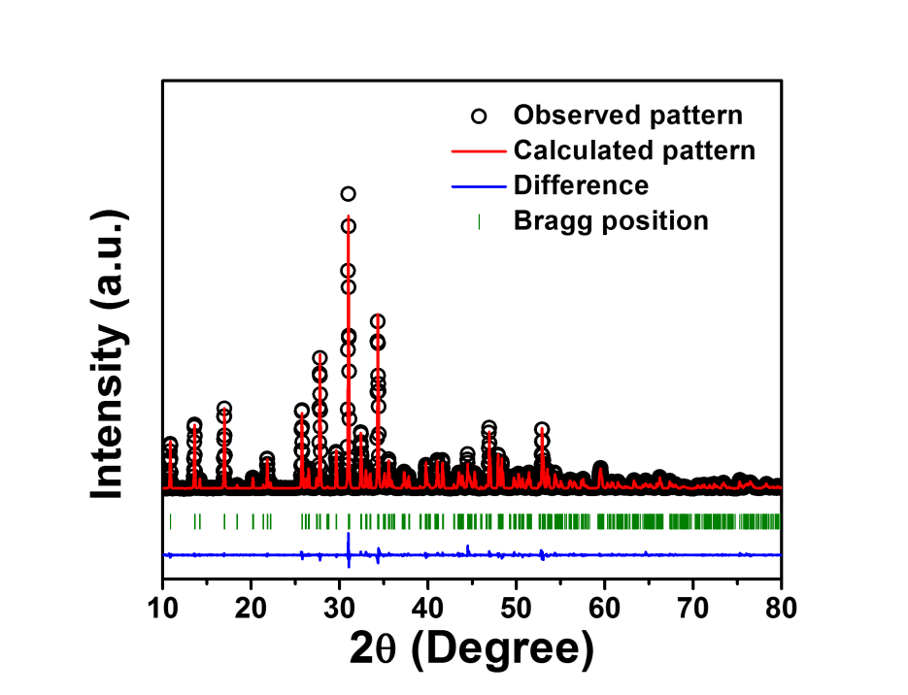
Supplementary Fig. S1. XRD Rietveld refined profiles of Ca_{2.82}(PO₄)₂:0.09Eu³⁺, 0.09Li⁺ phosphor.

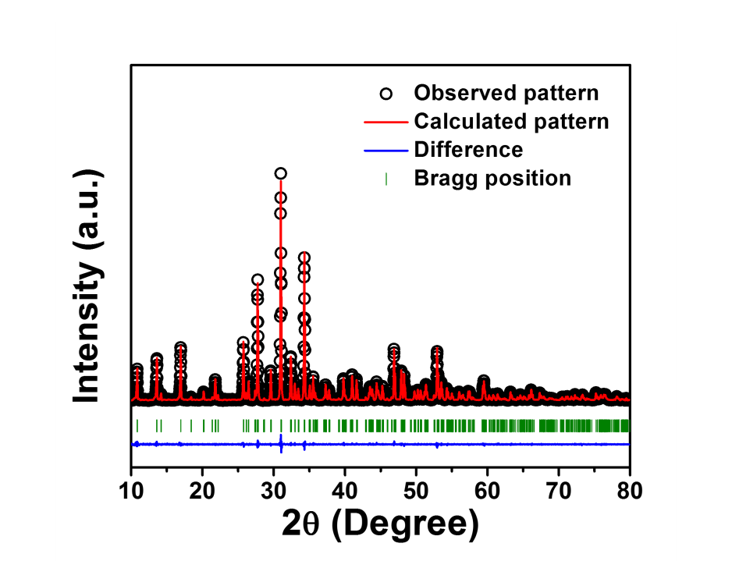
Supplementary Fig. S2. XRD Rietveld refined profiles of Ca_{2.82}(PO₄)₂:0.09Eu³⁺, 0.09Na⁺ phosphor.

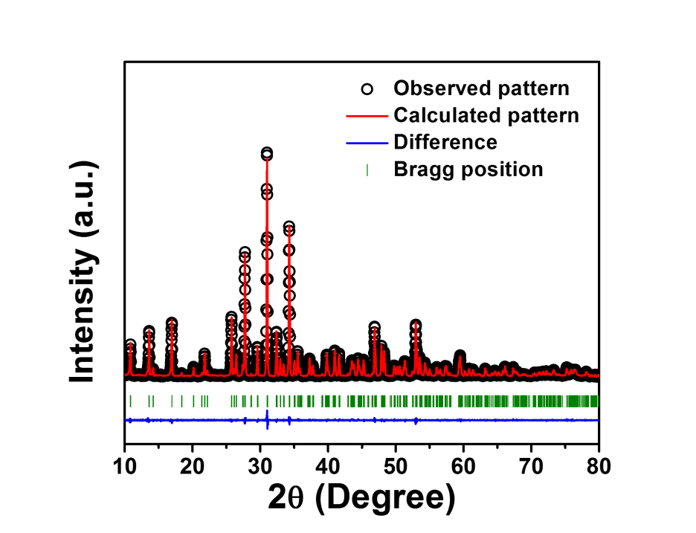
Supplementary Fig. S3. XRD Rietveld refined profiles of Ca_{2.82}(PO₄)₂:0.09Eu³⁺, 0.09K⁺ phosphor.

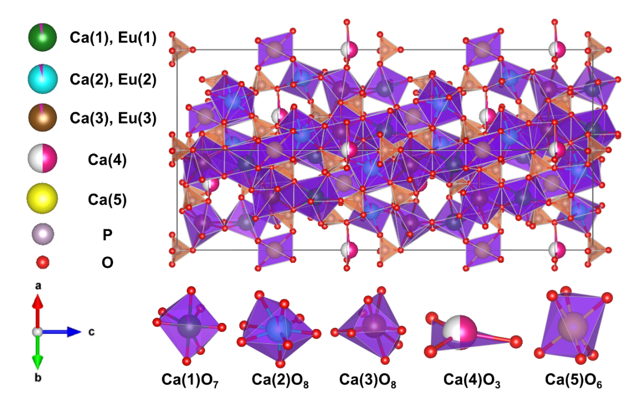
Supplementary Fig. S4. Crystal structure of Ca_{2.93}(PO₄)₂:0.07Eu³⁺ phosphor drawn by the VESTA program and XRD Rietveld refinement data.

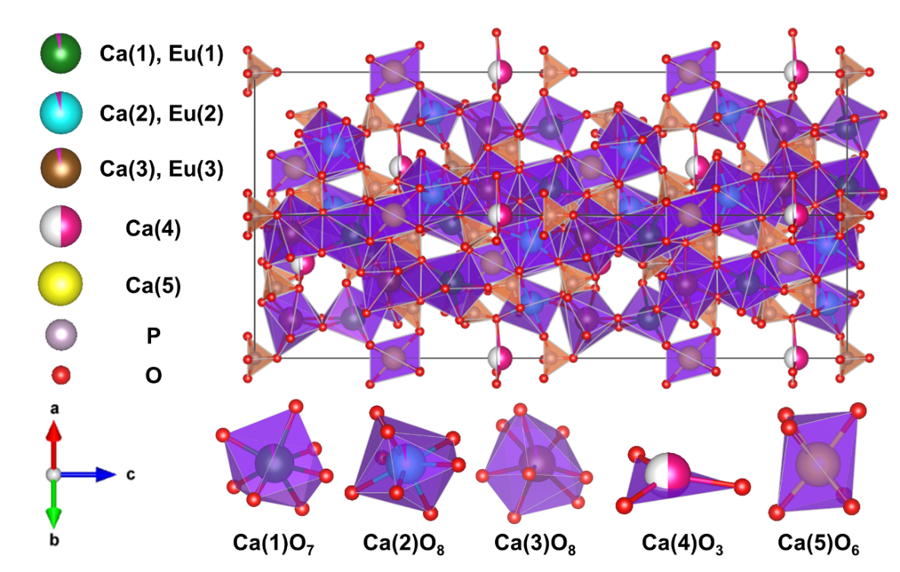
Supplementary Fig. S5. Crystal structure of Ca_{2.92}(PO₄)₂:0.08Eu³⁺ phosphor drawn by the VESTA program and XRD Rietveld refinement data.

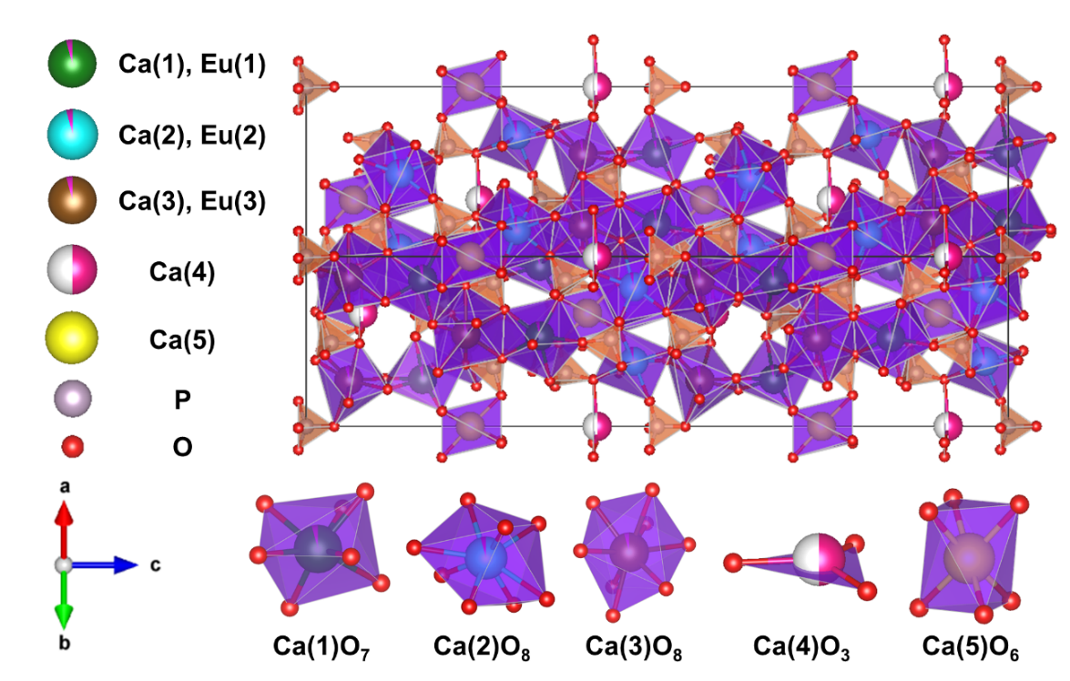
Supplementary Fig. S6. Crystal structure of Ca_{2.91}(PO₄)₂:0.09Eu³⁺ phosphor drawn by the VESTA program and XRD Rietveld refinement data.

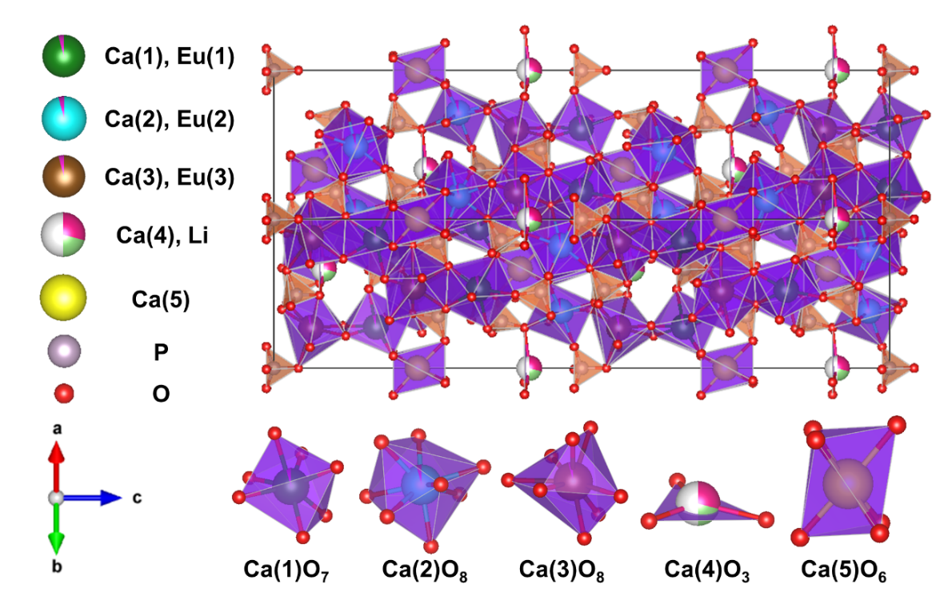
Supplementary Fig. S7. Crystal structure of Ca_{2.82}(PO₄)₂:0.09Eu³⁺, 0.09Li⁺ phosphor drawn by the VESTA program and XRD Rietveld refinement data.

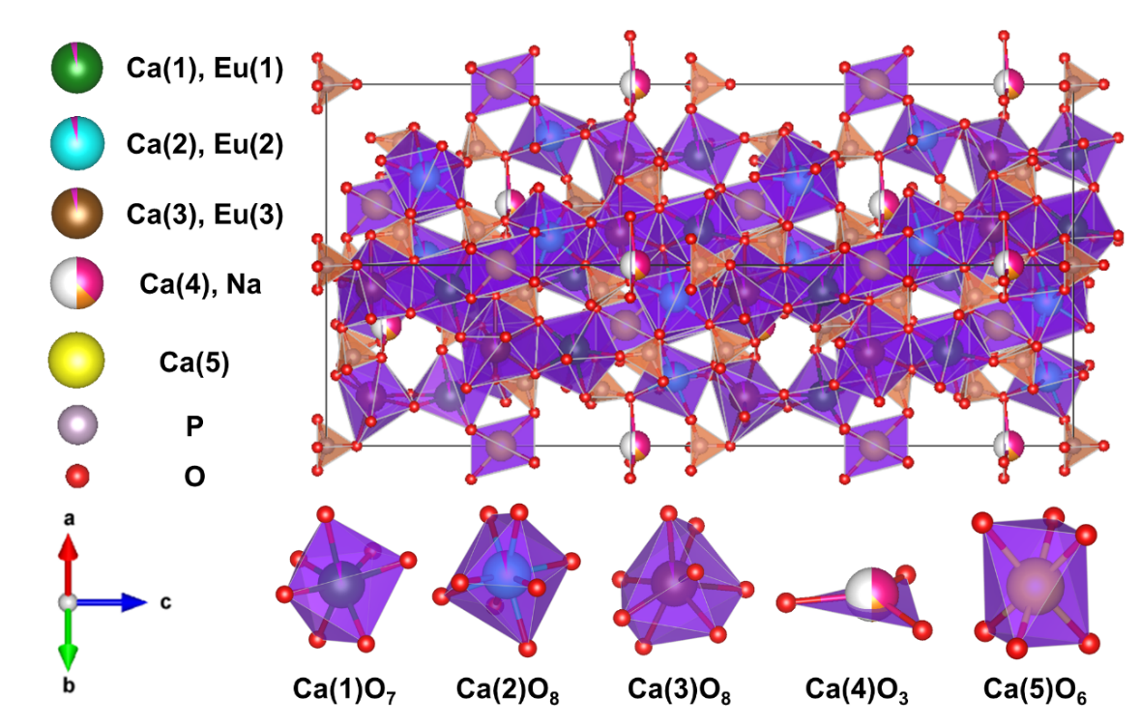
Supplementary Fig. S8. Crystal structure of Ca_{2.82}(PO₄)₂:0.09Eu³⁺, 0.09Na⁺ phosphor drawn by the VESTA program and XRD Rietveld refinement data.

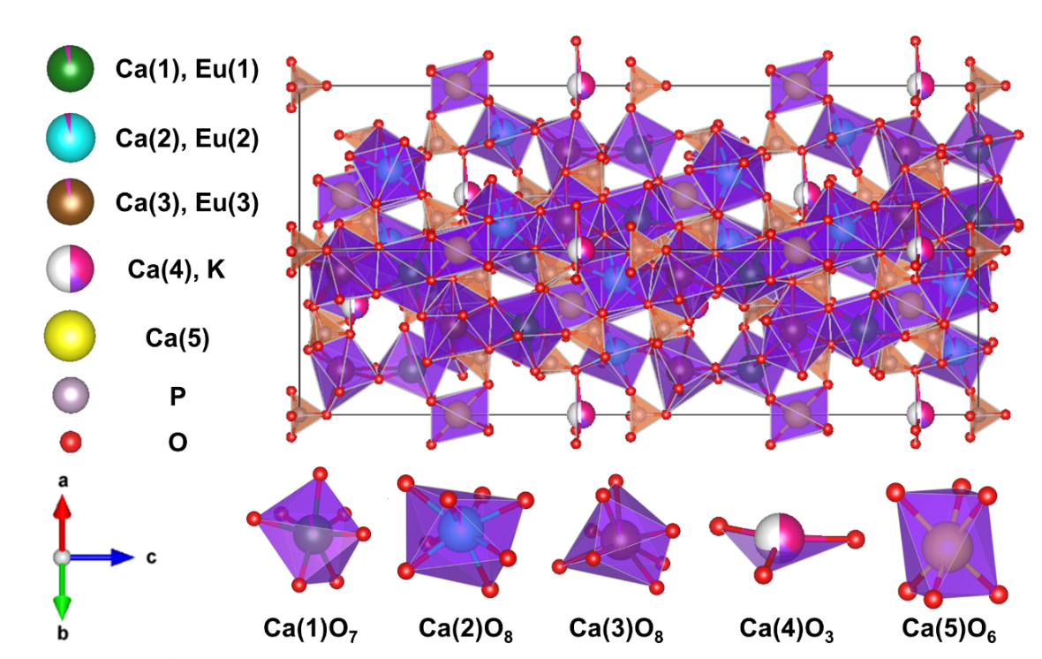
Supplementary Fig. S9. Crystal structure of Ca_{2.82}(PO₄)₂:0.09Eu³⁺, 0.09K⁺ phosphor drawn by the VESTA program and XRD Rietveld refinement data.

