SUPPLEMENTARY FILE

- Search Strategy:

CENTRAL search strategy
#1 MeSH descriptor: [Basal Ganglia Hemorrhage] explode all trees #2 MeSH descriptor: [Intracranial Hemorrhages] this term only
#3 MeSH descriptor: [Intracranial Hemorrhage, Hypertensive] this term only #4 MeSH descriptor: [Cerebral Hemorrhage] this term only
#5 MeSH descriptor: [Hemorrhagic Stroke] this term only
#6 (((brain* or cerebr* or cerebell* or intracerebral or intracran$ or parenchymal or intraparenchymal or intraventricular or infratentorial or supratentorial or basal gangli* or putaminal or putamen or posterior fossa or hemispher*) NEAR/5 (h?emorrhag* or h?ematoma* or bleed*))):ti,ab,kw #7 (ICH or ICHs):ti,ab,kw
#8 1-#7
#9 MeSH descriptor: [Anticoagulants] explode all trees
#10 MeSH descriptor: [Vitamin K] explode all trees and with qualifier(s): [antagonists & inhibitors ‐ AI] #11 MeSH descriptor: [Thrombin] explode all trees and with qualifier(s): [antagonists & inhibitors ‐ AI] #12 MeSH descriptor: [Factor Xa] this term only
#13 MeSH descriptor: [Blood Coagulation Factors] explode all trees and with qualifier(s): [antagonists & inhibitors ‐ AI]
#14 MeSH descriptor: [Antithrombins] explode all trees #15 MeSH descriptor: [Hirudin Therapy] this term only #16 (anticoagul* or antithromb*):ti,ab,kw
#17 (Vitamin K antagonist* or VKA or VKAs):ti,ab,kw #18 (direct* NEAR/3 thrombin NEAR/3 inhib*):ti,ab,kw #19 (DTI*):ti,ab,kw
#20 ((factor Xa or factor 10a or fXa or autoprothrombin c or thrombokinase) NEAR/3 inhib*):ti,ab,kw #21 (activated NEAR/3 (factor X or factor 10) NEAR/3 inhib*):ti,ab,kw
#22 (acenocoumarol* or dicoumarol* or ethyl biscoumacetate* or phenprocoumon* or warfarin* or ancrod* or citric acid* or coumarin* or chromonar* or coumestro* or esculi* or ochratoxin* or umbelliferone* or dermatan sulfate* or dextran* or edetic acid* or enoxaparin* or gabexate* or heparin* or lmwh* or nadroparin* or pentosan sulfuric polyester* or phenindione* or protein c or protein s or tedelparin*):ti,ab,kw
#23 (tinzaparin or parnaparin or dalteparin or reviparin or danaparoid or lomoparan or org 10172 or mesoglycan or polysaccharide sulphate* or sp54
or sp‐54 or md805 or md‐805 or cy222 or cy‐222 or cy216 or cy‐216):ti,ab,kw
#24 (Marevan or Fragmin* or Fraxiparin* or Klexane):ti,ab,kw
#25 (argatroban or MD805 or MD‐805 or dabigatran or ximelagatran or melagatran or efegatran or flovagatran or inogatran or napsagatran or bivalirudin or lepirudin or hirudin* or desirudin or desulfatohirudin or hirugen or hirulog or AZD0837 or bothrojaracin or odiparcil):ti,ab,kw #26 (xabans or antistasin or apixaban or betrixaban or du 176b or eribaxaban or fondaparinux or idraparinux or otamixaban or razaxaban or rivaroxaban or yagin or ym 150 or ym150 or LY517717):ti,ab,kw
#27 MeSH descriptor: [Platelet Aggregation Inhibitors] explode all trees
#28 MeSH descriptor: [Platelet Glycoprotein GPIIb‐IIIa Complex] explode all trees and with qualifier(s): [antagonists & inhibitors ‐ AI]
#29 (antiplatelet* or anti‐platelet* or antiaggreg* or anti‐aggreg* or (platelet* NEAR3 inhibit*) or (thrombocyt* NEAR3 inhibit*)):ti,ab,kw #30 (alprostadil* or aspirin* or acetylsalicylic acid or acetyl salicylic acid* or acetyl?salicylic acid or epoprostenol* or ketanserin* or ketorolac
tromethamine* or milrinone* or mopidamol* or procainamide* or thiophen* or trapidil* or picotamide* or ligustrazine* or levamisol* or suloctidil* or ozagrel* or oky046 or oky‐046 or defibrotide* or cilostazol or satigrel or sarpolgrelate or kbt3022 or kbt‐3022 or isbogrel or cv4151 or cv‐4151 or ((glycoprotein iib* or gp iib*) NEAR/5 (antagonist* or inhibitor*)) or GR144053 or GR‐144053 or triflusal):ti,ab,kw
#31 (Beraprost or Cicaprost or Cilostazol or Clopidogrel or Dipyridamole or Iloprost or Indobufen or Lepirudin or Pentosan Polysulfate or Pentoxifylline or Piracetam or Prostacyclin or Sulfinpyrazone or Sulphinpyrazone or Ticlopidine or Triflusal or Abciximab or Disintegrin or Echistatin or Eptifibatide or Lamifiban or Orbofiban or Roxifiban or Sibrafiban or Tirofiban or Xemilofiban or terutroban or picotamide or prasugrel):ti,ab,kw #32 (Dispril or Albyl* or Ticlid* or Persantin* or Plavix or ReoPro or Integrilin* or Aggrastat):ti,ab,kw
#33 #1-#32
#34 #8 AND #33

MEDLINE (Ovid) search strategy
1. exp basal ganglia hemorrhage/ or intracranial hemorrhages/ or cerebral hemorrhage/ or intracranial hemorrhage, hypertensive/ or hemorrhagic stroke/
2. ((brain$ or cerebr$ or cerebell$ or intracerebral or intracran$ or parenchymal or intraparenchymal or intraventricular or infratentorial or supratentorial or basal gangli$ or putaminal or putamen or posterior fossa or hemispher$) adj5 (h?emorrhag$ or h?ematoma$ or bleed$)).tw.
3. ((h?emorrhag$ or bleed$) adj5 (stroke or apoplex$)).tw.
4. (ICH or ICHs).tw.
5. or/1‐4
6. exp anticoagulants/
7. exp Vitamin K/ai or thrombin/ai or factor Xa/ai or exp Blood coagulation factors/ai
8. exp antithrombins/ or hirudin therapy/
9. (anticoagul$ or antithromb$).tw.
10. (Vitamin K antagonist$ or VKA or VKAs).tw.
11. (direct$ adj3 thrombin adj3 inhib$).tw.
12. DTI$1.tw.
13. ((factor Xa or factor 10a or fXa or autoprothrombin c or thrombokinase) adj3 inhib$).tw.
14. (activated adj3 (factor X or factor 10) adj3 inhib$).tw.
15. (acenocoumarol$ or dicoumarol$ or ethyl biscoumacetate$ or phenprocoumon$ or warfarin$ or ancrod$ or citric acid$ or coumarin$ or chromonar$ or coumestro$ or esculi$ or ochratoxin$ or umbelliferone$ or dermatan sulfate$ or dextran$ or edetic acid$ or enoxaparin$ or gabexate$ or heparin$ or lmwh$ or nadroparin$ or pentosan sulfuric polyester$ or phenindione$ or protein c or protein s or tedelparin$).tw,nm.
16. (tinzaparin or parnaparin or dalteparin or reviparin or danaparoid or lomoparan or org 10172 or mesoglycan or polysaccharide sulphate$ or sp54 or
sp‐54 or md805 or md‐805 or cy222 or cy‐222 or cy216 or cy‐216).tw,nm.
17. (Marevan or Fragmin$ or Fraxiparin$ or Klexane).tw,nm.
18. (argatroban or MD805 or MD‐805 or dabigatran or ximelagatran or melagatran or efegatran or flovagatran or inogatran or napsagatran or bivalirudin or lepirudin or hirudin$ or desirudin or desulfatohirudin or hirugen or hirulog or AZD0837 or bothrojaracin or odiparcil).tw,nm.

19. (xabans or antistasin or apixaban or betrixaban or du 176b or eribaxaban or fondaparinux or idraparinux or otamixaban or razaxaban or rivaroxaban or yagin or ym 150 or ym150 or LY517717).tw,nm.
20. exp platelet aggregation inhibitors/ or exp platelet glycoprotein gpiib‐iiia complex/ai
21. (antiplatelet$ or anti‐platelet$ or antiaggreg$ or anti‐aggreg$ or (platelet$ adj3 inhibit$) or (thrombocyt$ adj3 inhibit$)).tw.
22. (alprostadil$ or aspirin$ or acetylsalicylic acid or acetyl salicylic acid$ or acetyl?salicylic acid or epoprostenol$ or ketanserin$ or ketorolac tromethamine$ or milrinone$ or mopidamol$ or procainamide$ or thiophen$ or trapidil$ or picotamide$ or ligustrazine$ or levamisol$ or suloctidil$ or ozagrel$ or oky046 or oky‐046 or defibrotide$ or cilostazol or satigrel or sarpolgrelate or kbt3022 or kbt‐3022 or isbogrel or cv4151 or cv‐4151 or ((glycoprotein iib$ or gp iib$) adj5 (antagonist$ or inhibitor$)) or GR144053 or GR‐144053 or triflusal).tw,nm.
23. (Beraprost or Cicaprost or Cilostazol or Clopidogrel or Dipyridamole or Iloprost or Indobufen or Lepirudin or Pentosan Polysulfate or Pentoxifylline or Piracetam or Prostacyclin or Sulfinpyrazone or Sulphinpyrazone or Ticlopidine or Triflusal or Abciximab or Disintegrin or Echistatin or Eptifibatide or Lamifiban or Orbofiban or Roxifiban or Sibrafiban or Tirofiban or Xemilofiban or terutroban or picotamide or prasugrel).tw,nm.
24. (Dispril or Albyl$ or Ticlid$ or Persantin$ or Plavix or ReoPro or Integrilin$ or Aggrastat).tw,nm.
25. or/6‐24
26. randomized controlled trial.pt.
27. controlled clinical trial.pt.
28. randomized.ab.
29. placebo.ab.
30. drug therapy.fs.
31. randomly.ab.
32. trial.ti.
33. groups.ab.
34. or/26‐33
35. exp animals/ not humans.sh.
36. 34 not 35
37. 5 and 25 and 36

EMBASE (Ovid) search strategy
1. basal ganglion hemorrhage/ or brain hemorrhage/ or brain ventricle hemorrhage/ or cerebellum hemorrhage/
2. ((brain$ or cerebr$ or cerebell$ or intracerebral or intracran$ or parenchymal or intraparenchymal or intraventricular or infratentorial or supratentorial or basal gangli$ or putaminal or putamen or posterior fossa or hemispher$) adj5 (h?emorrhag$ or h?ematoma$ or bleed$)).tw.
3. ((h?emorrhag$ or bleed$) adj5 (stroke or apoplex$)).tw.
4. (ICH or ICHs).tw.
5. 1 or 2 or 3 or 4
6. anticoagulant agent/ or antivitamin k/ or exp blood clotting inhibitor/ or exp coumarin anticoagulant/ or defibrotide/ or dextran sulfate/ or fluindione/ or glycosaminoglycan polysulfate/ or exp heparin derivative/ or lupus anticoagulant/ or phenindione/
7. (anticoagul$ or antithromb$).tw.
8. (Vitamin K antagonist$ or VKA or VKAs).tw.
9. (direct$ adj3 thrombin adj3 inhib$).tw.
10. ((factor Xa or factor 10a or fXa or autoprothrombin c or thrombokinase) adj3 inhib$).tw.
11. (activated adj3 (factor X or factor 10) adj3 inhib$).tw.
12. (acenocoumarol$ or dicoumarol$ or ethyl biscoumacetate$ or phenprocoumon$ or warfarin$ or ancrod$ or citric acid$ or coumarin$ or chromonar$ or coumestro$ or esculi$ or ochratoxin$ or umbelliferone$ or dermatan sulfate$ or dextran$ or edetic acid$ or enoxaparin$ or gabexate$ or heparin$ or lmwh$ or nadroparin$ or pentosan sulfuric polyester$ or phenindione$ or protein c or protein s or tedelparin$).tw.
13. (tinzaparin or parnaparin or dalteparin or reviparin or danaparoid or lomoparan or org 10172 or mesoglycan or polysaccharide sulphate$ or sp54 or
sp‐54 or md805 or md‐805 or cy222 or cy‐222 or cy216 or cy‐216).tw.
14. (Marevan or Fragmin$ or Fraxiparin$ or Klexane).tw.
15. (argatroban or MD805 or MD‐805 or dabigatran or ximelagatran or melagatran or efegatran or flovagatran or inogatran or napsagatran or bivalirudin or lepirudin or hirudin$ or desirudin or desulfatohirudin or hirugen or hirulog or AZD0837 or bothrojaracin or odiparcil).tw.
16. (xabans or antistasin or apixaban or betrixaban or du 176b or eribaxaban or fondaparinux or idraparinux or otamixaban or razaxaban or rivaroxaban or yagin or ym 150 or ym150 or LY517717).tw.
17. or/6‐16
18. exp antithrombocytic agent/
19. fibrinogen receptor/dt [Drug Therapy]
20. (antiplatelet$ or anti‐platelet$ or antiaggreg$ or anti‐aggreg$ or (platelet$ adj5 inhibit$) or (thrombocyt$ adj5 inhibit$)).tw.
21. (alprostadil$ or aspirin$ or acetylsalicylic acid or acetyl salicylic acid$ or acetyl?salicylic acid or epoprostenol$ or ketanserin$ or ketorolac tromethamine$ or milrinone$ or mopidamol$ or procainamide$ or thiophen$ or trapidil$ or picotamide$ or ligustrazine$ or levamisol$ or suloctidil$ or ozagrel$ or oky046 or oky‐046 or defibrotide$ or cilostazol or satigrel or sarpolgrelate or kbt3022 or kbt‐3022 or isbogrel or cv4151 or cv‐4151 or ((glycoprotein iib$ or gp iib$) adj5 (antagonist$ or inhibitor$)) or GR144053 or GR‐144053 or triflusal).tw.
22. (Argatroban or Beraprost or Cicaprost or Cilostazol or Clopidogrel or Dipyridamole or Iloprost or Indobufen or Lepirudin or Pentosan Polysulfate or Pentoxifylline or Piracetam or Prostacyclin or Sulfinpyrazone or Sulphinpyrazone or Ticlopidine or Triflusal or Abciximab or Disintegrin or Echistatin or Eptifibatide or Lamifiban or Orbofiban or Roxifiban or Sibrafiban or Tirofiban or Xemilofiban or terutroban or picotamide or prasugrel).tw.
23. (Dispril or Albyl$ or Ticlid$ or Persantin$ or Plavix or ReoPro or Integrilin$ or Aggrastat).tw.
24. or/18‐23
25. 17 or 24
26. Randomized Controlled Trial/ or "randomized controlled trial (topic)"/ 27. Randomization/ 28. Controlled clinical trial/ or "controlled clinical trial (topic)"/ 29. control group/ or controlled study/ 30. clinical trial/ or "clinical trial (topic)"/ or phase 1 clinical trial/ or phase 2 clinical trial/ or phase 3 clinical trial/ or phase 4 clinical trial/
31. Crossover Procedure/
32. Double Blind Procedure/
33. Single Blind Procedure/ or triple blind procedure/
34. placebo/ or placebo effect/
35. (random$ or RCT or RCTs).tw.
36. (controlled adj5 (trial$ or stud$)).tw.
37. (clinical$ adj5 trial$).tw.
38. ((control or treatment or experiment$ or intervention) adj5 (group$ or subject$ or patient$)).tw.
39. (quasi‐random$ or quasi random$ or pseudo‐random$ or pseudo random$).tw.
40. ((control or experiment$ or conservative) adj5 (treatment or therapy or procedure or manage$)).tw.
41. ((singl$ or doubl$ or tripl$ or trebl$) adj5 (blind$ or mask$)).tw.
42. (cross‐over or cross over or crossover).tw.
43. (placebo$ or sham).tw.
44. trial.ti.
45. (assign$ or allocat$).tw.
46. controls.tw.
47. or/26‐46
48. (exp animals/ or exp invertebrate/ or animal experiment/ or animal model/ or animal tissue/ or animal cell/ or nonhuman/) not (human/ or normal human/ or human cell/)
49. 5 and 25 and 47
50. 49 not 48

- PRISMA Flow Diagram:

Identification
Included
Records identified from*:
Databases (n = 4762)
Registers (n = 43)
Records removed before screening:
Duplicate records removed (n = 2182)
Records screened
(n = 2623)
Records excluded
(n = 2610)
Reports sought for retrieval
(n = 13)
Reports not retrieved
(n = 0)
Reports assessed for eligibility
(n = 13)
Reports excluded:
Wrong population (n = 4)
Wrong study design (n = 5)
Records identified from:
Citation searching (n = 1)
Reports assessed for eligibility
(n = 1)
Reports excluded (n = 0):
Studies included in review
(n =5)
Reports of included studies
(n =5)
Reports sought for retrieval
(n = 1)
Reports not retrieved
(n = 0)
Screening

Figure S1: PRISMA Flow Diagram.

- Risk of Bias Assessment:

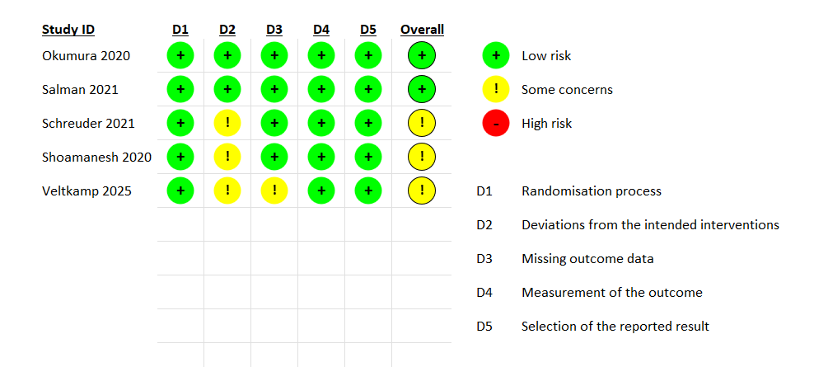

Figure S2: Figure table for Risk of Bias for Included RCTs.

- Forest Plots :

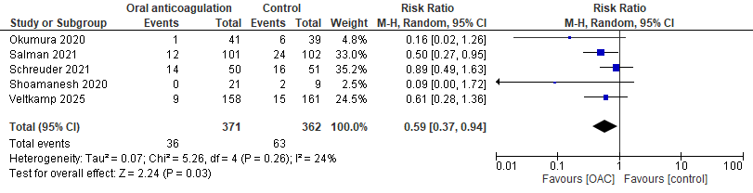
Fig. S3: Forrest Plot for MACE.

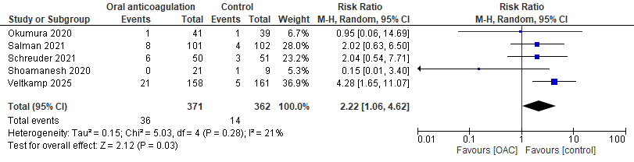
Fig. S4: Forrest Plot for Major Bleeding.

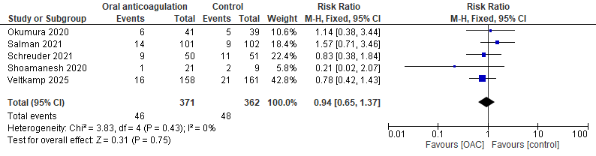
Fig. S5: Forrest Plot for All-cause Mortality.

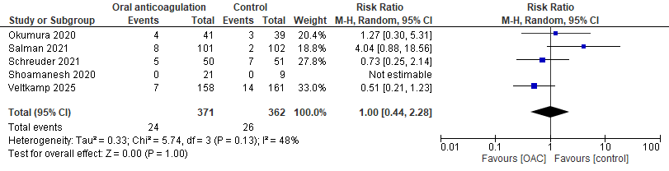
Fig. S6: Forrest Plot for Cardiovascular Mortality.

