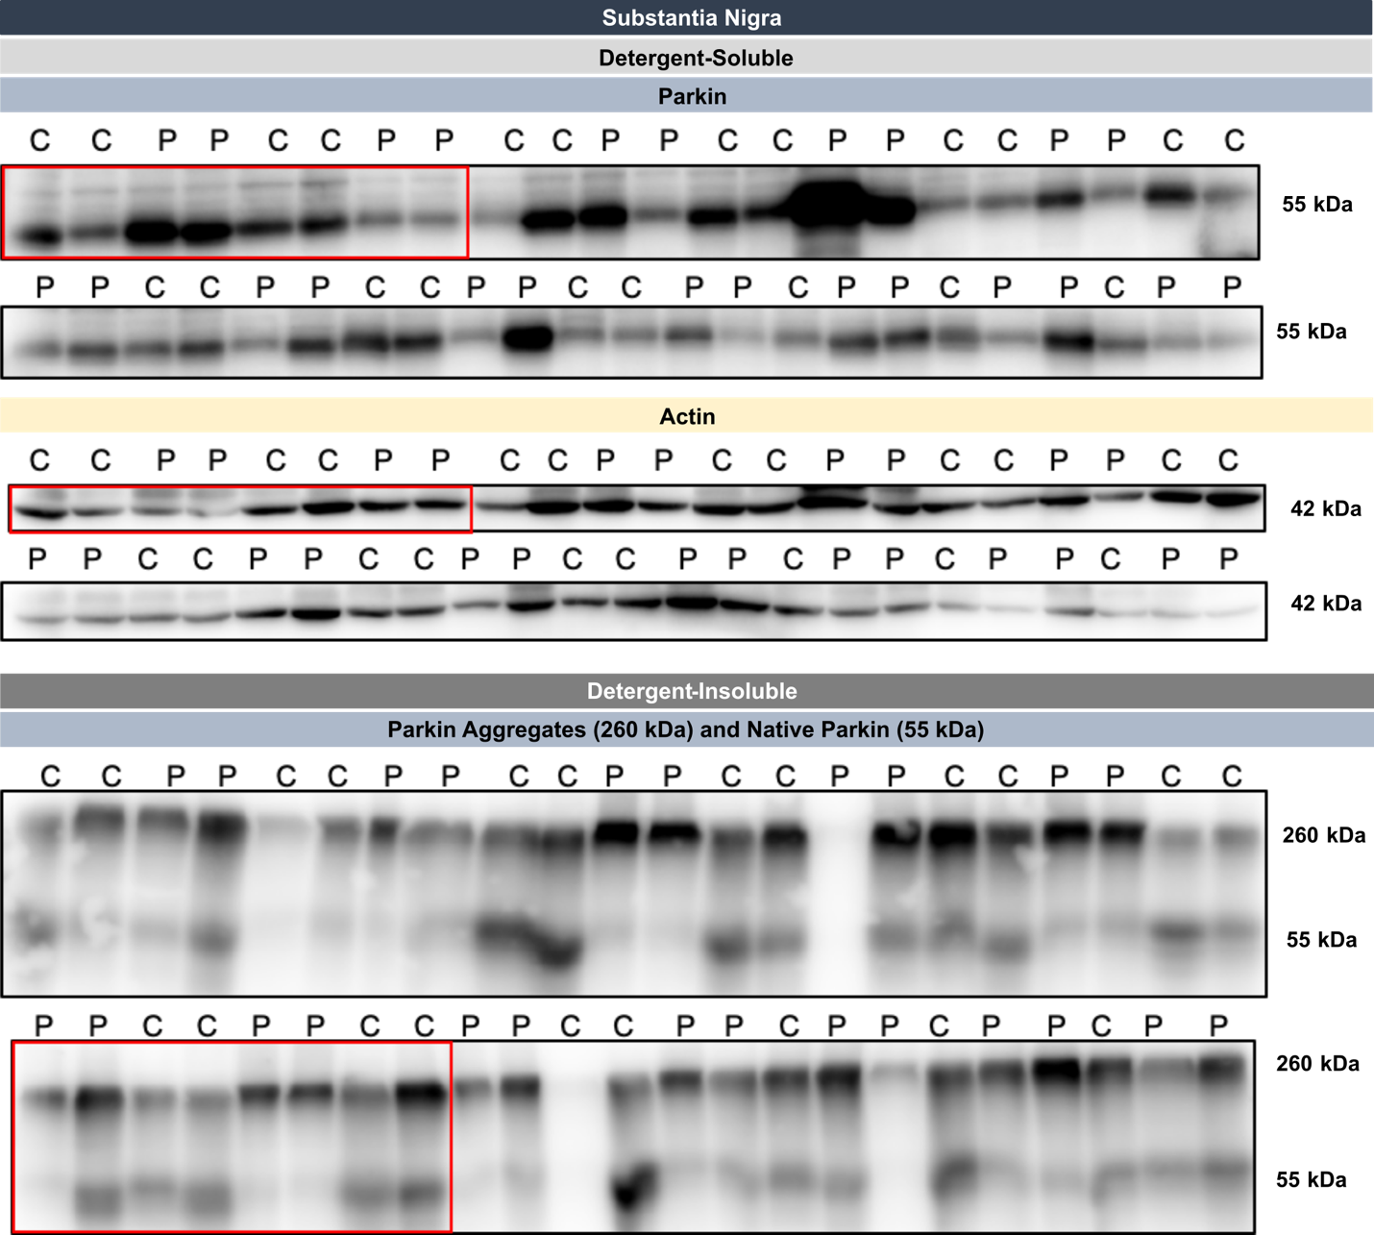

Supplementary Figure 1. Western Blot results for post-mortem parkin in the SN. Full WB image of parkin in the detergent-soluble and the detergent-insoluble fractions of the SN. The red rectangles correspond to the representative bands used in the main figures. Abbreviations: C, control individuals; P, Parkinson’s disease patients; WB, Western blot.

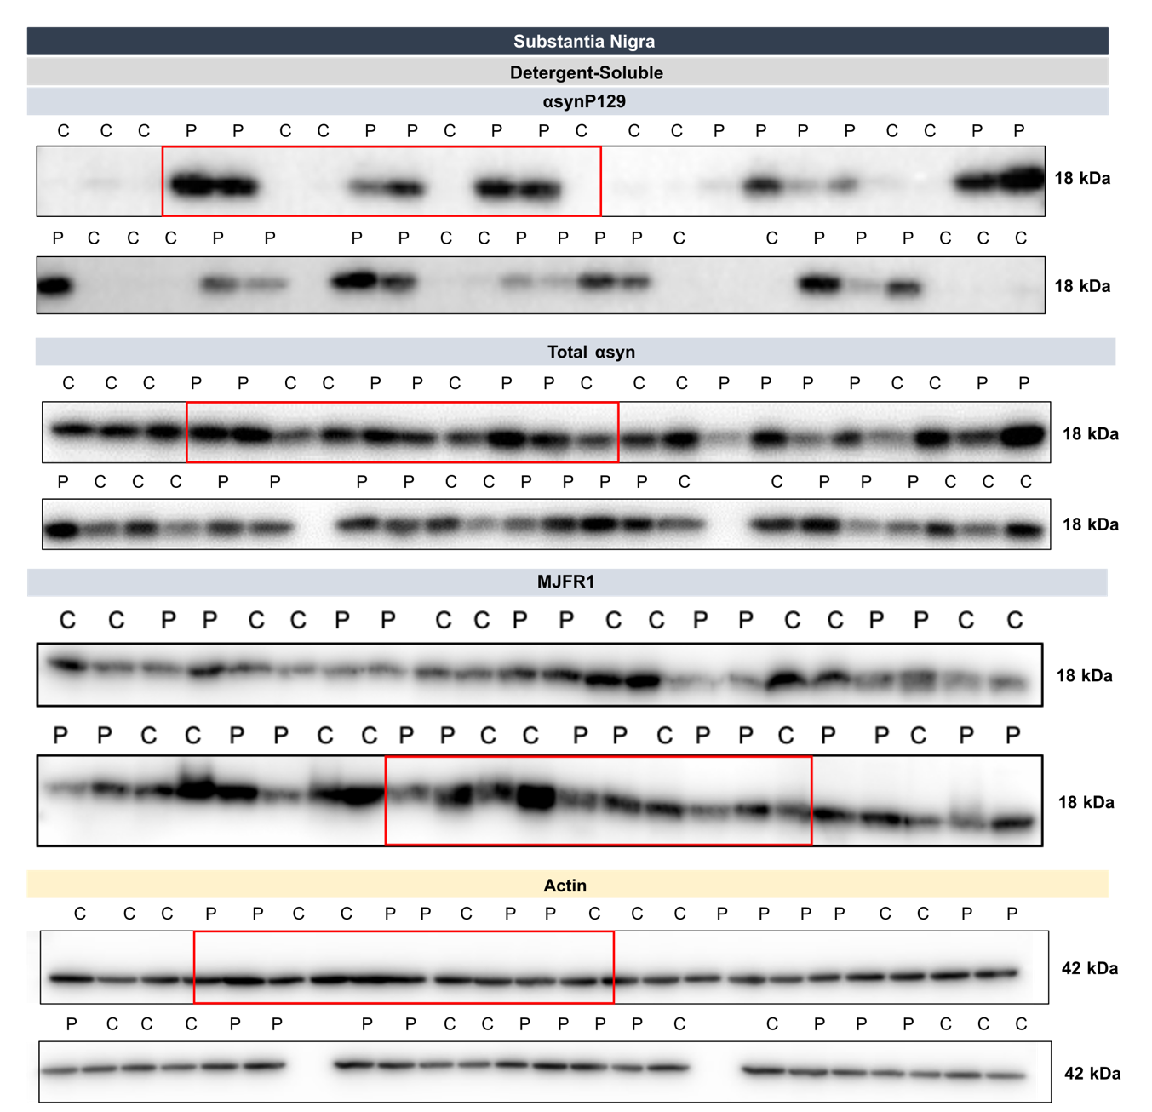
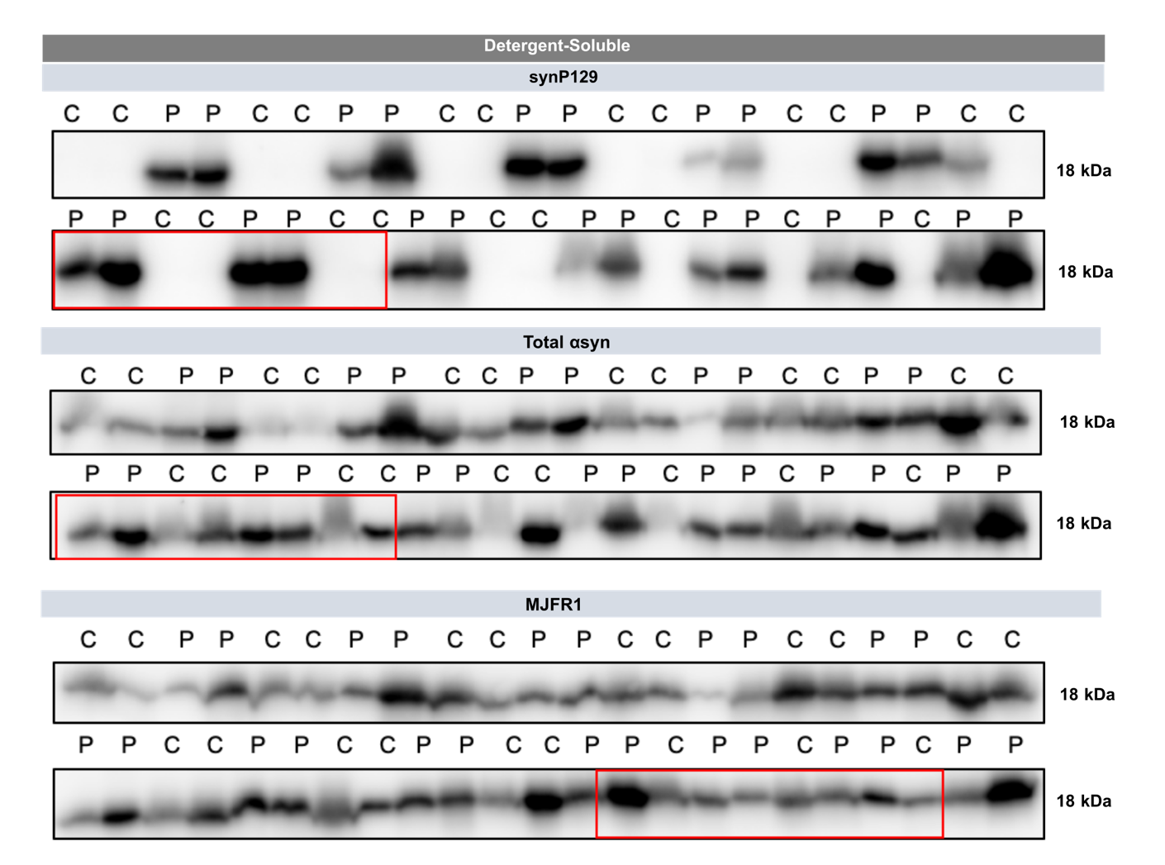
Supplementary Figure 2. Western Blot results for post-mortem αsyn in the SN. Full WB image of αsyn in the detergent-insoluble and the detergent-insoluble fractions of the SN. The red rectangles correspond to the representative bands used in the main figures. Abbreviations: C, control individuals; P, Parkinson’s disease patients; αsyn, α-synuclein; αsynP129, α-synuclein phosphorylated at serine 129; SN, substantia nigra; WB, Western blot.

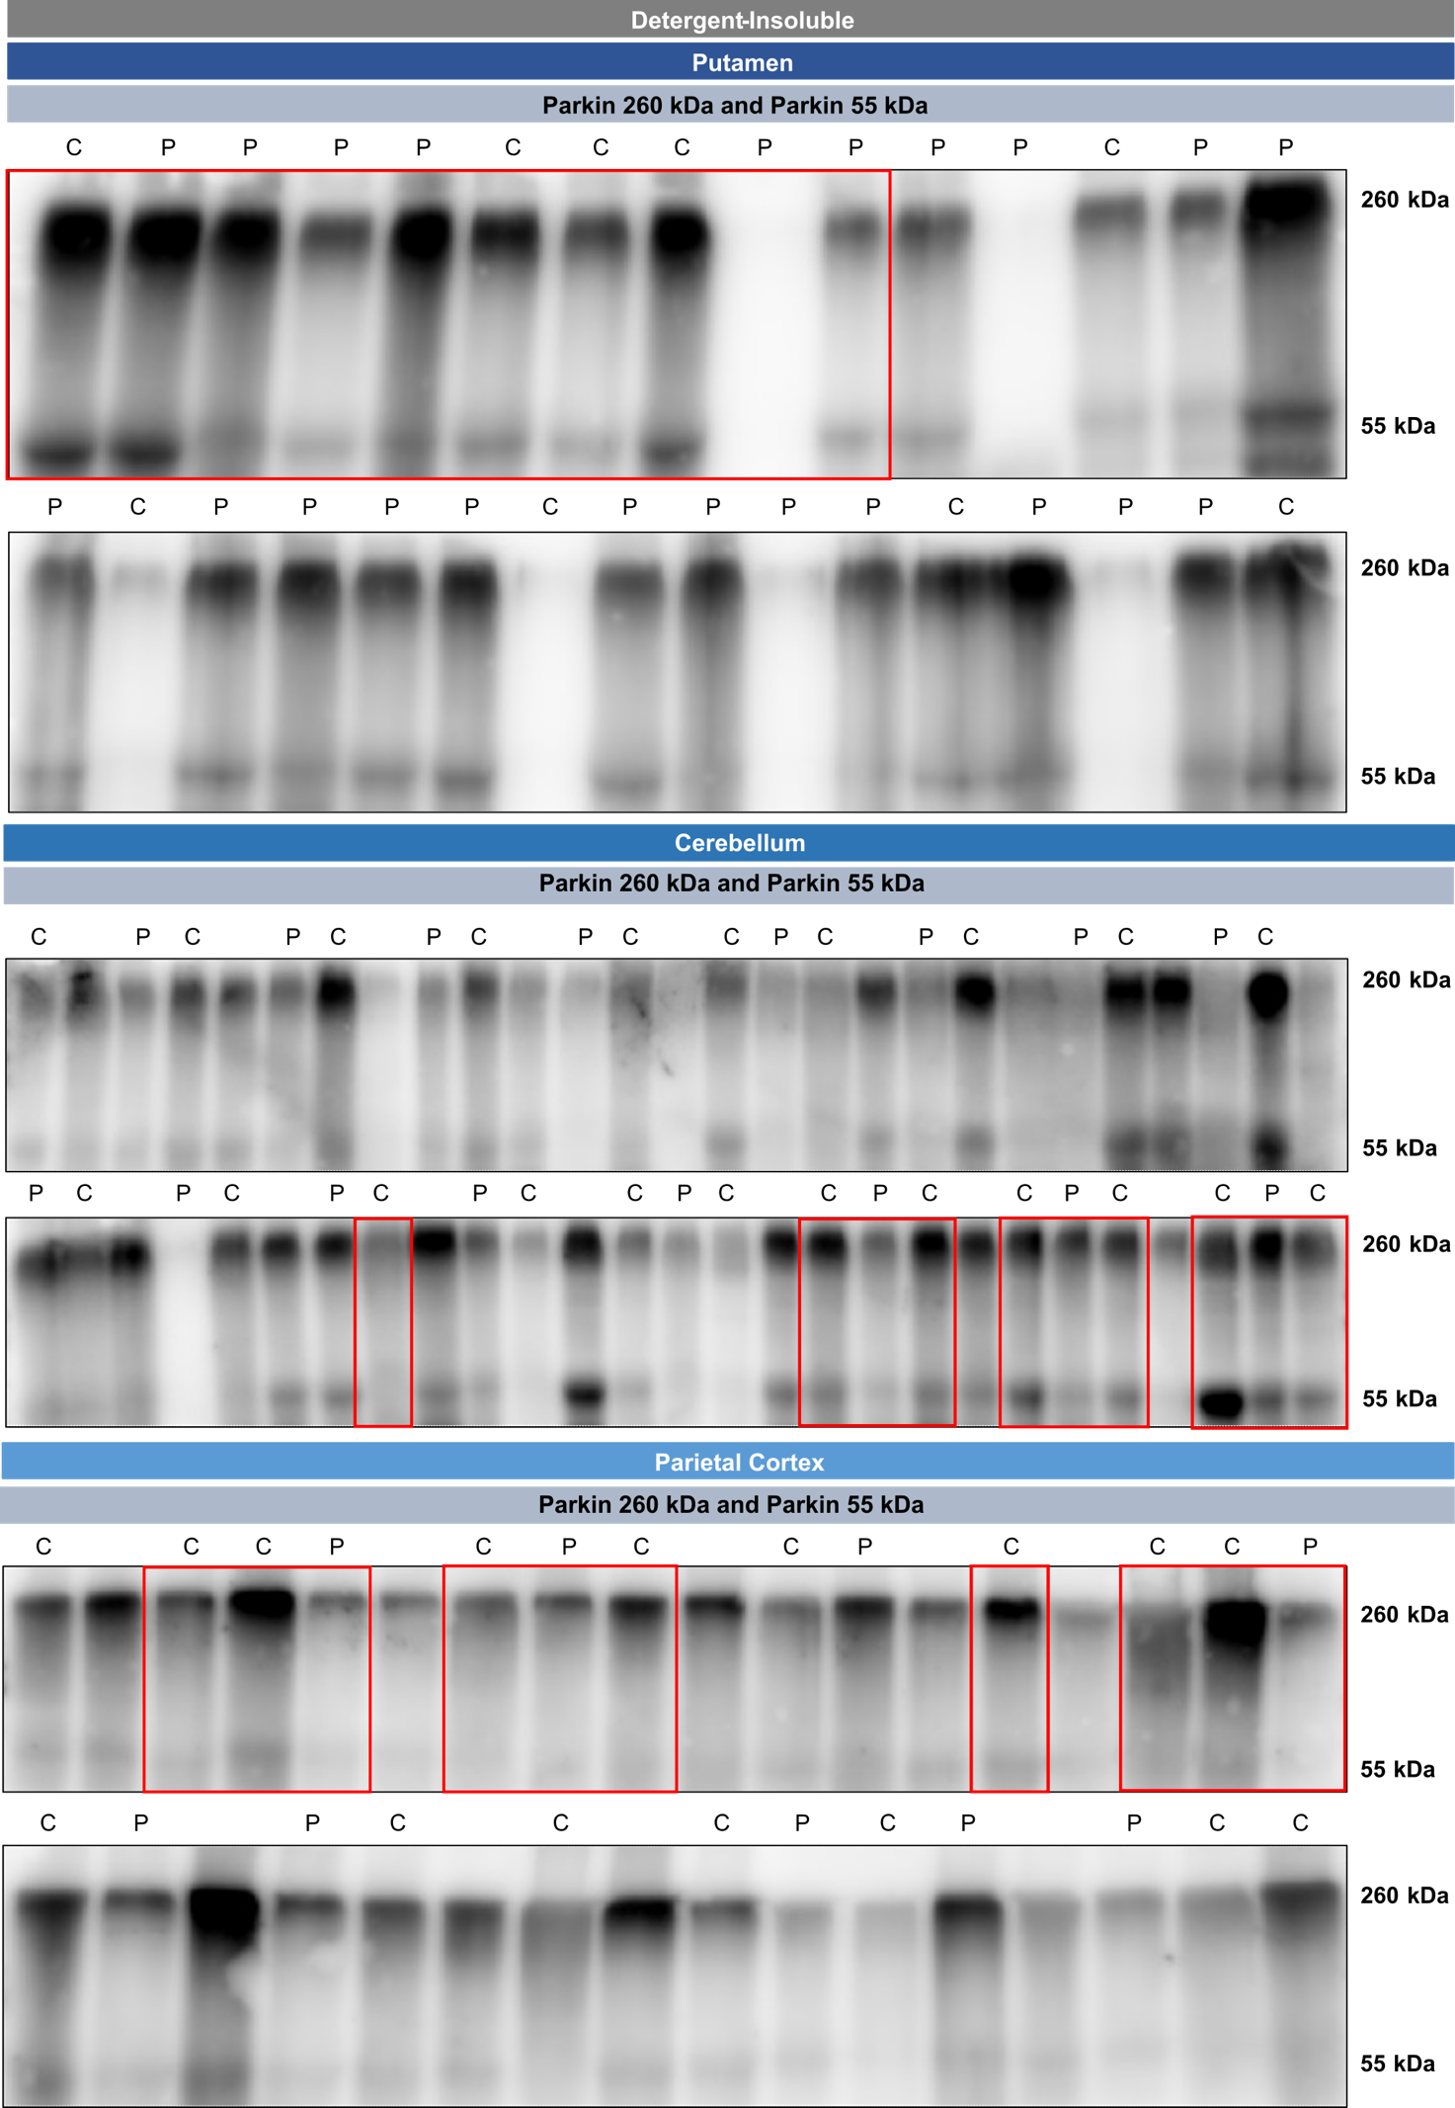
Supplementary Figure 3. Western Blot results for post-mortem parkin in the putamen, cerebellum and parietal cortex. Full WB image of parkin in the detergent-insoluble fractions of the putamen, cerebellum and parietal cortex. The red rectangles correspond to the representative bands used in the main figures. For WB in the cerebellum or in the parietal cortex, spaces between controls individuals and PD patients correspond to irrelevant individuals for this study. Abbreviations: C, control individuals; P, Parkinson’s disease patients; WB, Western blot.

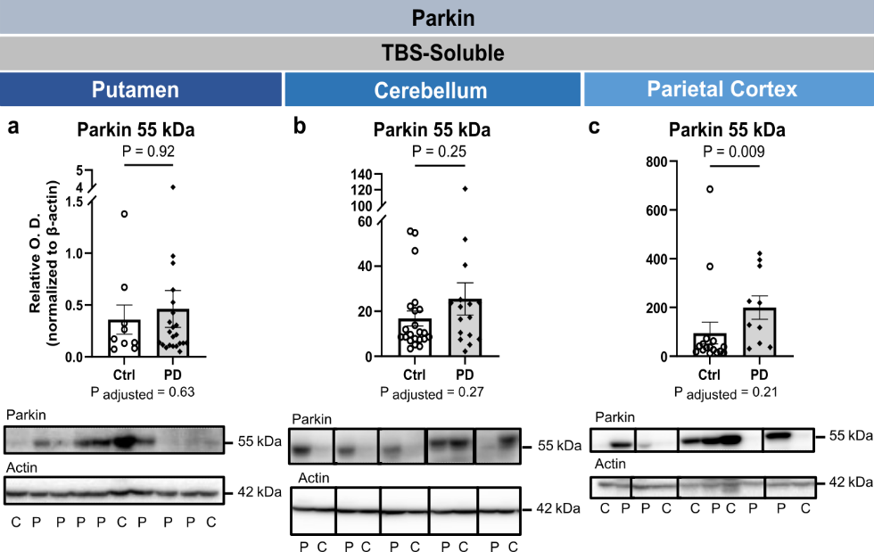
Supplementary Figure 4. Post-mortem levels of TBS-soluble parkin in the putamen, cerebellum and parietal cortex of PD patients. No differences were detected between controls and PD patients for native parkin (55 kDa) in the putamen (a) and the cerebellum (b) in the TBS-soluble fraction. In the parietal cortex, similar results were obtained after adjustments for age and sex were done (c). Statistical analysis: data are represented as mean ± SEM (Putamen, N= 9 ctrl and 22 PD; Cerebellum, N= 22 ctrl and 16 PD; Parietal Cortex, N= 16 ctrl and 10 PD); Mann-Whitney test (a-c); the P-value after adjustments for age and sex is provided. Abbreviations: Ctrl/C, control individuals; PD/P, Parkinson’s disease patients; SEM, standard error of the mean; O.D., Optical Density. Representative WB of bands are shown, where the inserted black vertical line indicates nonconsecutive bands. Full images are shown in Supplementary Figure 5.
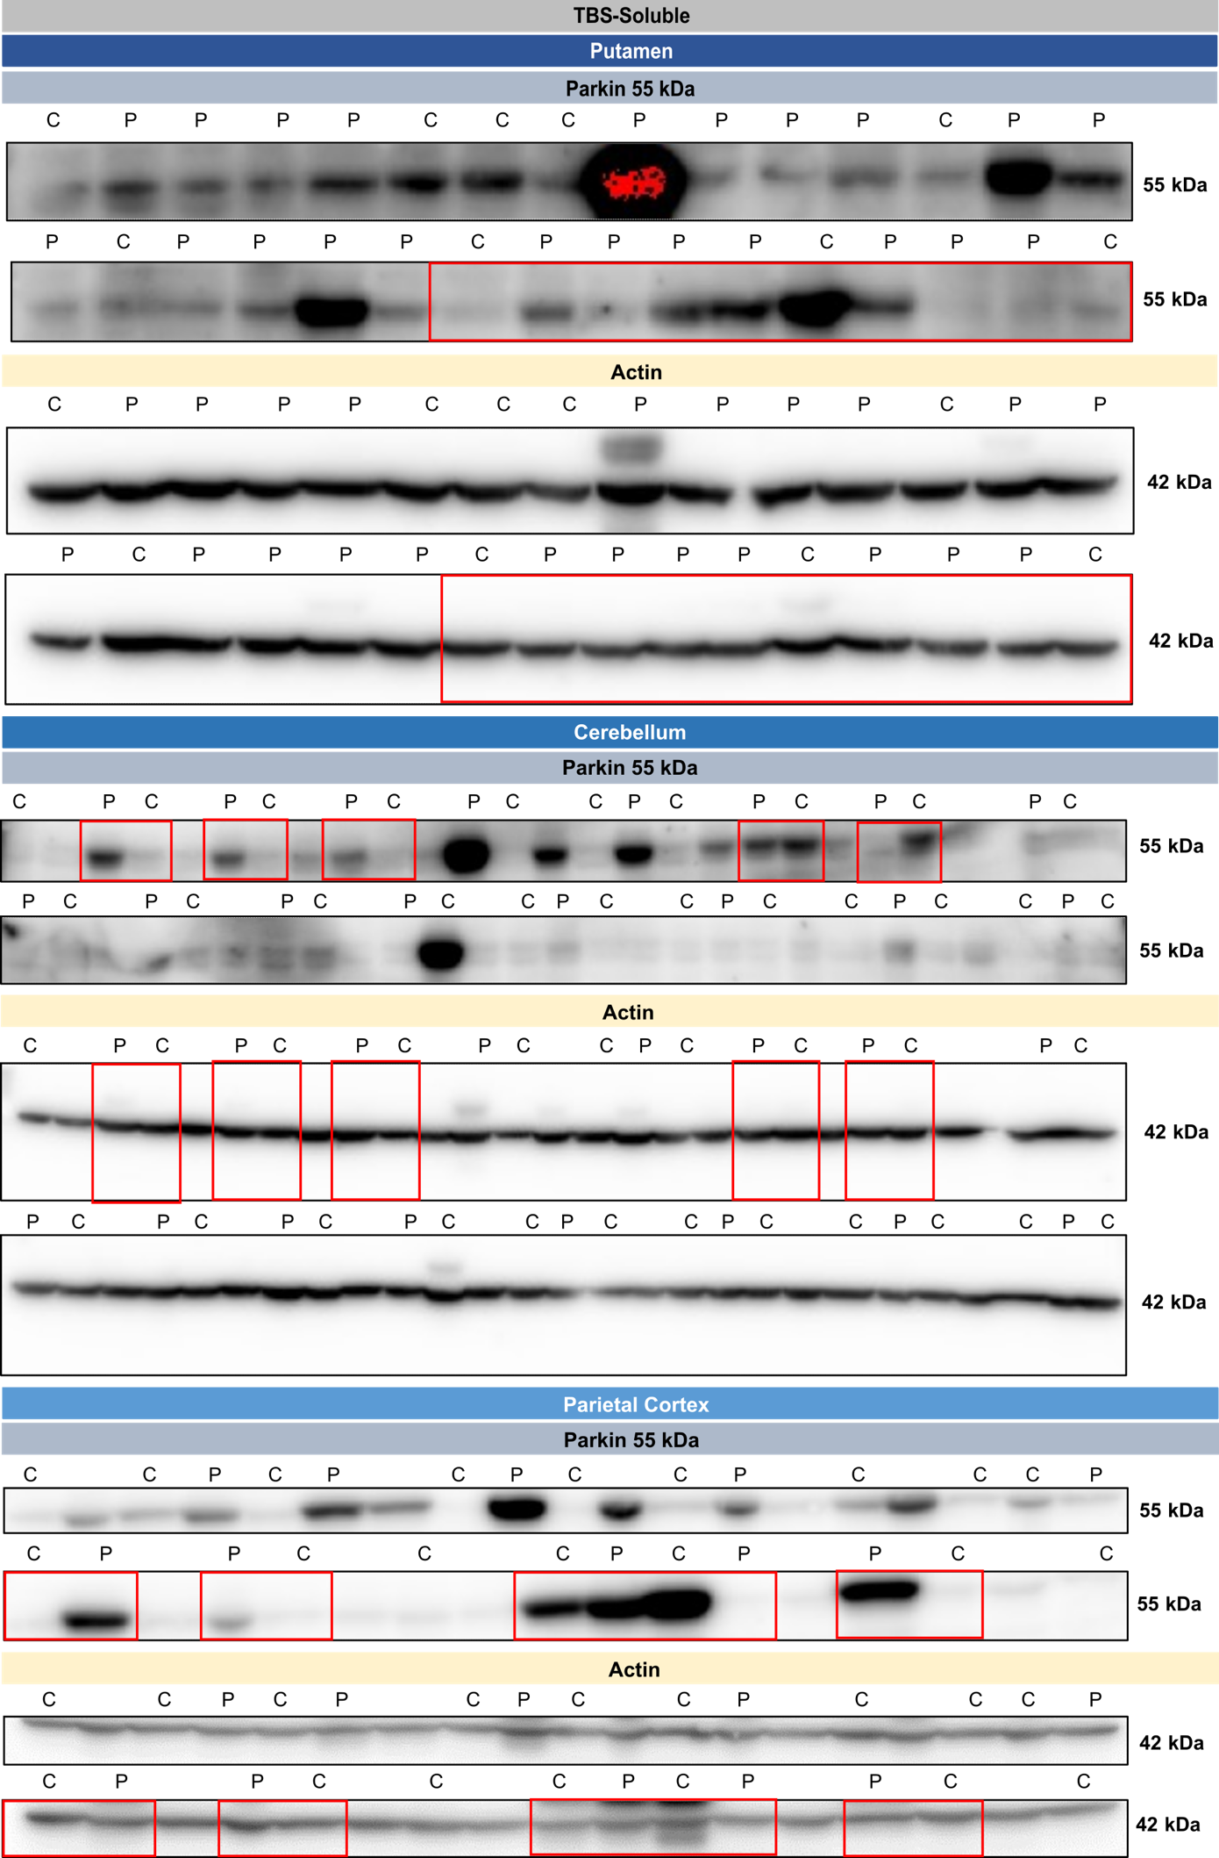
Supplementary Figure 5. Western Blot results for post-mortem parkin in the putamen, cerebellum and parietal cortex of the TBS-soluble fraction. Full WB image of parkin in the TBS-soluble fractions of the putamen, cerebellum and parietal cortex. The red rectangles correspond to the representative bands used in the main figures. For WB in the cerebellum or in the parietal cortex, spaces between control individuals and PD patients correspond to irrelevant individuals for this study. Abbreviations: C, control individuals; P, Parkinson’s disease patients; WB, Western blot.

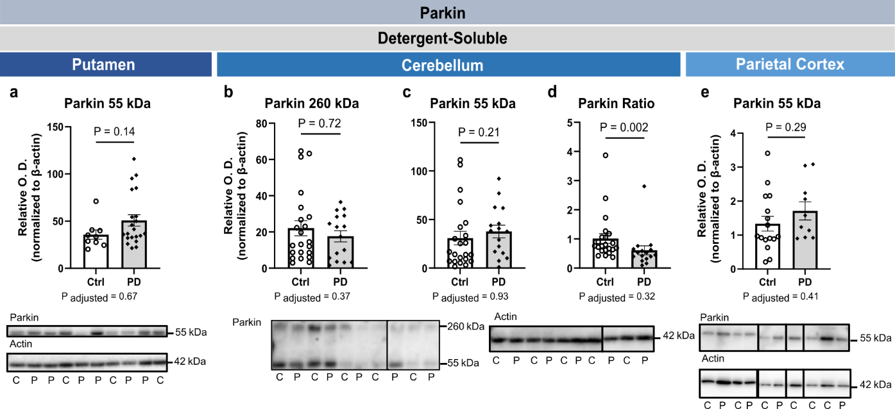
Supplementary Figure 6. Post-mortem levels of detergent-soluble parkin in the putamen, cerebellum and parietal cortex of PD patients. No differences were detected between controls and PD patients for native parkin (55 kDa) in detergent-soluble fractions of the putamen (a). In the cerebellum, differences in parkin aggregates (260 kDa) (b), native parkin (55 kDa) (c) and parkin ratio (260/55) levels (d) were nonsignificant between the two groups after adjustments for age and sex. In the parietal cortex, similar results for native parkin (55 kDa) were obtained after adjustments for age and sex were done (e). Statistical analysis: data are represented as mean ± SEM (Putamen, N= 9 ctrl and 21 PD; Cerebellum, N= 22 ctrl and 16 PD; Parietal Cortex, N= 16 ctrl and 9 PD); Mann-Whitney test (a-d); unpaired student T test (e); the P-value after adjustments for age and sex is provided. Abbreviations: Ctrl/C, control individuals; PD/P, Parkinson’s disease patients; SEM, standard error of the mean; O.D., Optical Density. Representative WB of bands are shown, where the inserted black vertical line indicates nonconsecutive bands. Full images are shown in Supplementary Figure 7.

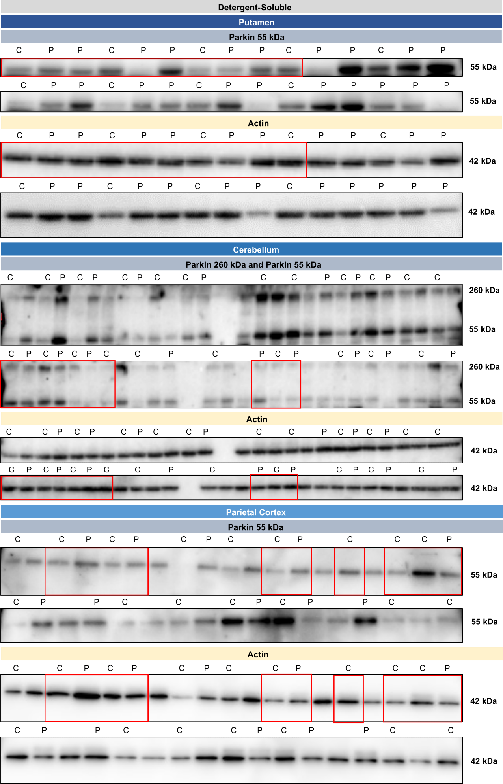
Supplementary Figure 7. Western Blot results for post-mortem parkin in the putamen, cerebellum and parietal cortex of the detergent-soluble fraction. Full WB image of parkin in the detergent-soluble fractions of the putamen, cerebellum and parietal cortex. The red rectangles correspond to the representative bands used in the main figures. For WB in the cerebellum or in the parietal cortex, spaces between control individuals and PD patients correspond to irrelevant individuals for this study. Abbreviations: C, control individuals; P, Parkinson’s disease patients; WB, Western blot.

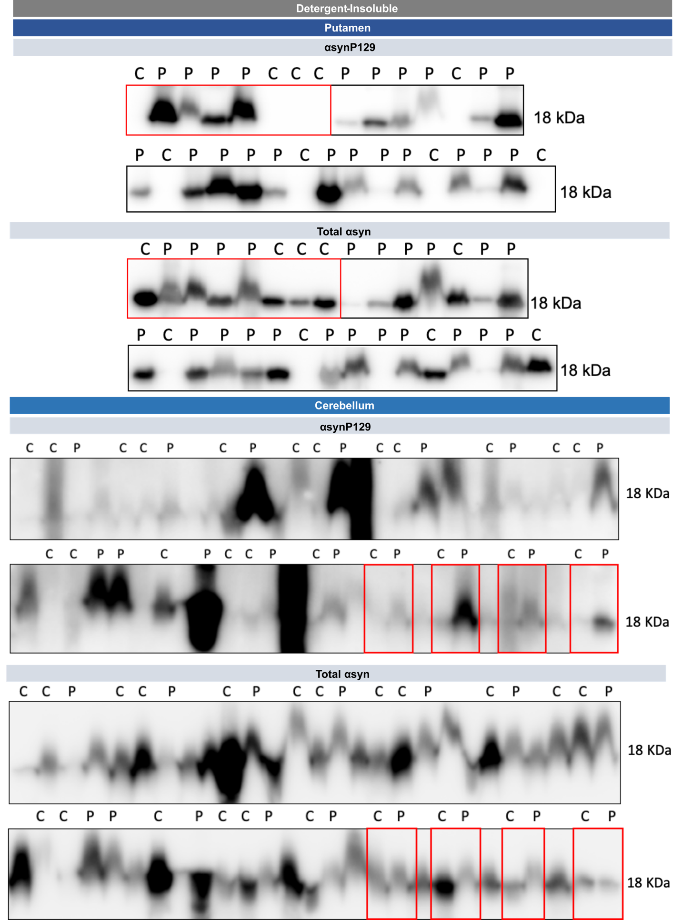
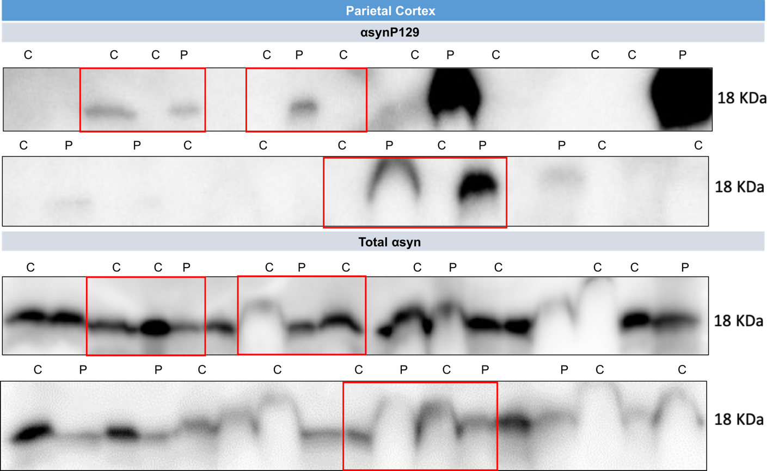
Supplementary Figure 8. Western Blot results for post-mortem αsyn in putamen, cerebellum and parietal cortex of the detergent-insoluble fraction. Full WB image of αsyn in the detergent-insoluble fractions of the putamen, cerebellum and parietal cortex. The red rectangles correspond to the representative bands used in the main figures. For WB in the cerebellum or in the parietal cortex, spaces between controls individuals and PD patients correspond to irrelevant individuals for this study. Abbreviations: C, control individuals; P, Parkinson’s disease patients; αsyn, α-synuclein; αsynP129, α-synuclein phosphorylated at serine 129; WB, Western blot.

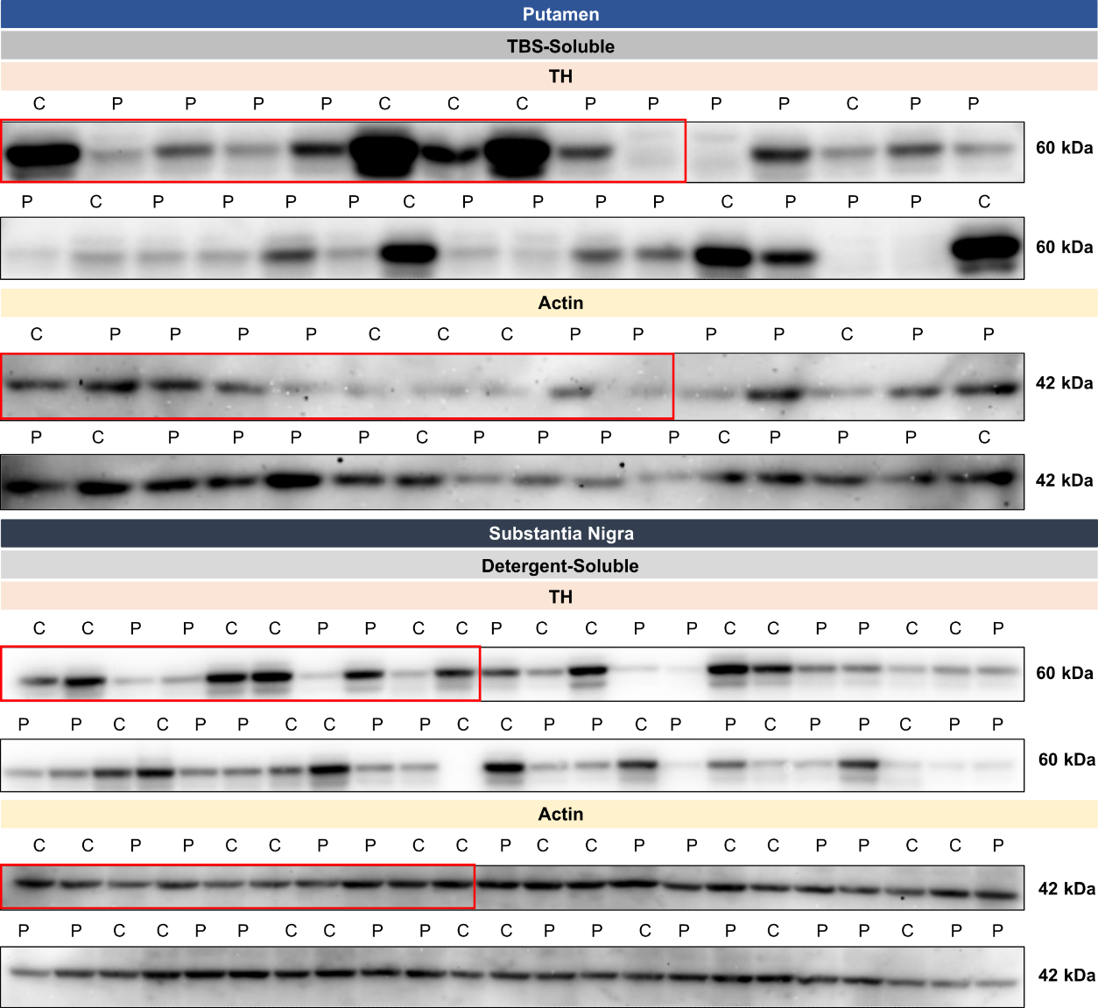
Supplementary Figure 9. Western Blot results for post-mortem TH in putamen and substantia nigra. Full WB image of TH in the TBS-soluble fraction of the putamen and in the total fraction of the SN. The red rectangles correspond to the representative bands used in the main figures. Abbreviations: C, control individuals; P, Parkinson’s disease patients; TH, tyrosine hydroxylase; SN, substantia nigra; TBS, tris-buffered saline; WB, Western blot.
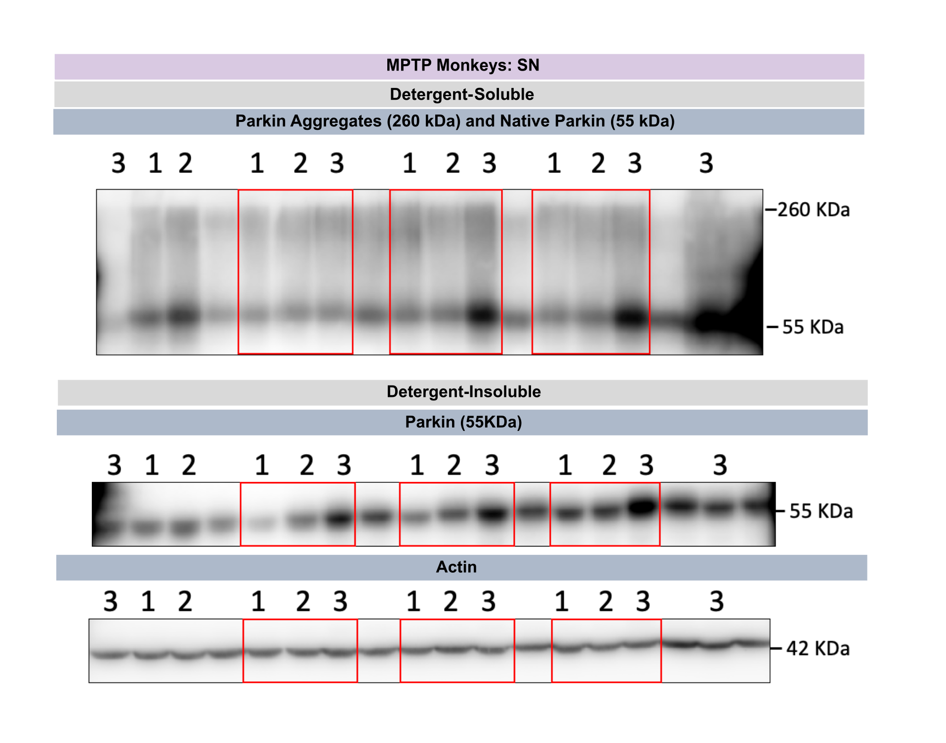
Supplementary Figure 10. Western Blot results for post-mortem parkin in the SN of MPTP non-human primates. Full WB image of parkin in the detergent-soluble and the detergent-insoluble fraction of the SN of MPTP non-human primates. The red rectangles correspond to the representative bands used in the main figures. Spaces between groups of monkeys correspond to irrelevant monkeys for this study. Legend for MPTP monkeys WB: 1, intact; 2, MPTP; 3, MPTP+DOPA. Abbreviations: MPTP, 1-methyl-4-phenyl-1,2,3,6-tetrahydropyridine; DOPA, levodopa; SN, substantia nigra; WB, Western blot.

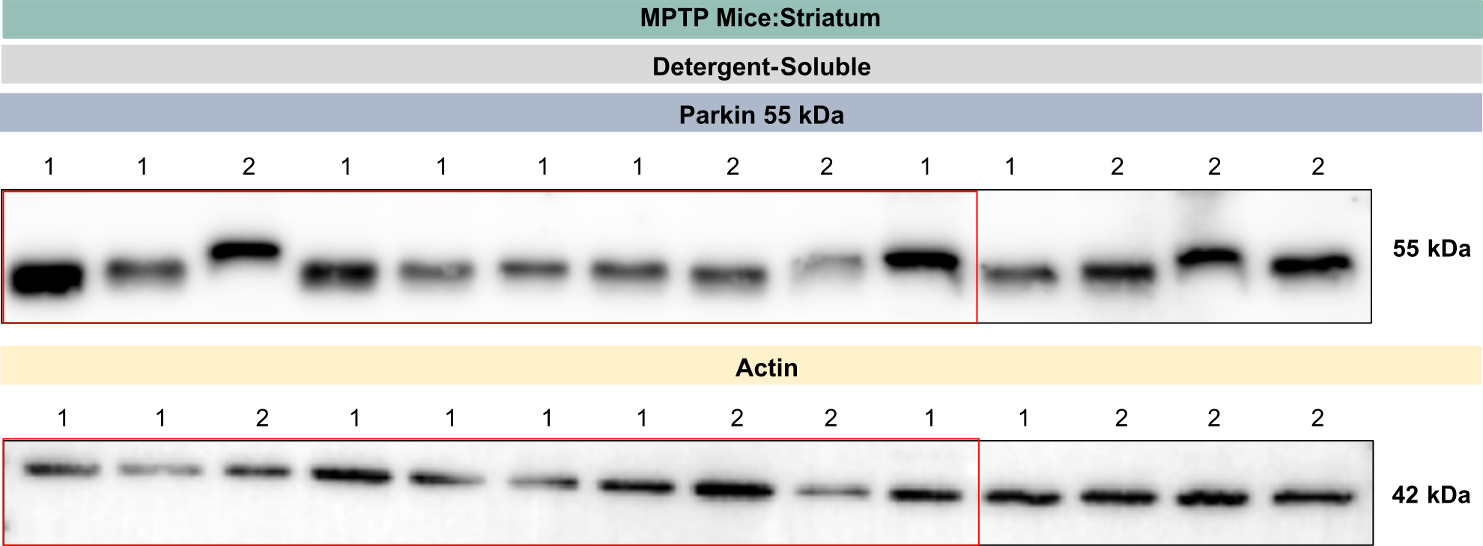
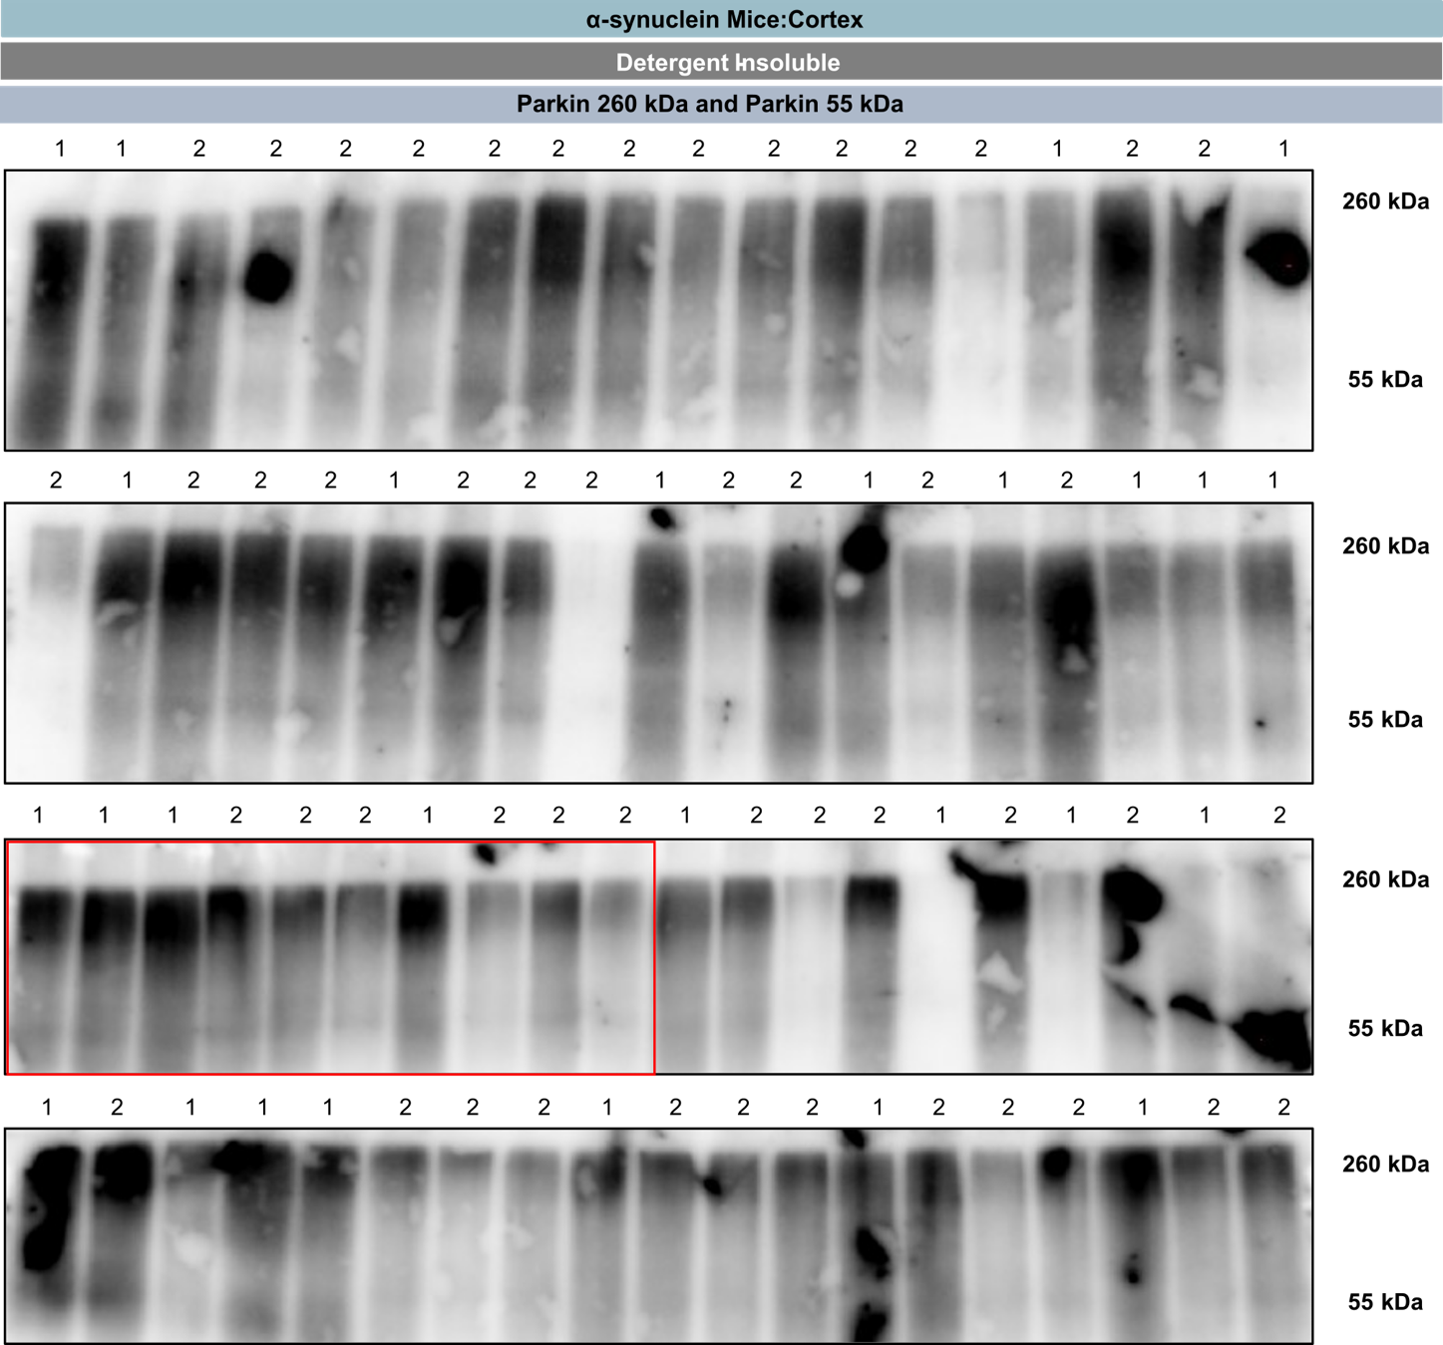

Supplementary Figure 11. Western Blot results for parkin in striatum of MPTP mice and in cortex of α-synuclein mice. Full WB image of α-syn in the detergent-soluble fraction of the striatum of MPTP mice and in the detergent-insoluble fraction of the cortex of mice. The red rectangles correspond to the representative bands used in the main figures. Legend for MPTP mice WB: 1, saline; 2, MPTP. Legend for αsyn mice WB: 1, NonTg; 2, Tg (αsyn). Abbreviations: αsyn, α-synuclein; MPTP, 1-methyl-4-phenyl-1,2,3,6-tetrahydropyridine; NonTg, nontransgenic; Tg, transgenic; WB, Western blot.

 | Characteristics |  | Controls | PD | Statistical Analysis
 | N |  | 21 | 24 | ----
 | Men/Women |  | 11/10 | 15/9 | C; χ2 = 0.47; p=0.49
 | Mean Age at Death (years) |  | 75.3 (1.6) | 80.5 (1.6) | STT, p=0.011  MW, p=0.021
 | Age of Onset (years) |  | ---- | 67.7 (2.0) | ----
 | Disease Duration (years) |  | ---- | 12.6 (1.2) | ----
 | Freezing of Gait (FOG) (n) |  | ---- | 16/24 | ----
 | Age at levodopa Initiation (years) |  | ---- | 70.5 (2.2) | ----
 | First levodopa Dose (mg) |  | ---- | 360.4 (43.2) | ----
 | Last levodopa Dose (mg) |  | ---- | 681.3 (80.6) | ----
 | Levodopa Induced Motor Complications (LIC) No/Yes (n) |  | ---- | 7/17 | ----
 | Dyskinesia Duration (months) |  | ---- | 52.8 (9.4) | ----
 | Postmortem Interval (hours) |  | 17.8 (1.6) | 17.6 (2.3) | STT, p=0.92
 | Full Brain Weight (g) |  | 1276.25 (63.3) | 1300.5 (43.8) | STT, p=0.71
 | Braak Score 0/1-2/2/3-4/5/5-6 (n) |  | 12/0/0/0/0/1 | 16/1/3/2/0/0 | ----
 | H&Y Stage 0/2/2.5/3/3.5/4/4.5/5 (n) |  | 12/0/1/0/0/0/0/0 | 0/2/3/3/2/2/4/8 | ----
 | SN Lewy Bodies (No/Yes, n) |  | 21/0 | 0/24 | ----

Supplementary Table 1. Clinical and demographic for the control and PD groups. The postmortem diagnosis was performed by a neuropathologist for each patient and the clinical assessments were accomplished by AHR and AR^{2,3}. The values are presented as means (SD). Statistical analyses were performed using Contingency (C), Student unpaired t-test (STT) or Mann-Whitney tests (MW). Abbreviations: PD, Parkinson’s disease patients; C, contingency; H&Y, Hoehn and Yahr scale; MW, Mann-Whitney; ROD, relative optical density; SD, standard deviations; SN, substantia nigra; STT, Student unpaired t-test.

1 Morissette, M., Bourque, M., Tremblay, M. & Di Paolo, T. Prevention of L-Dopa-Induced Dyskinesias by MPEP Blockade of Metabotropic Glutamate Receptor 5 Is Associated with Reduced Inflammation in the Brain of Parkinsonian Monkeys. Cells 11 (2022). https://doi.org:10.3390/cells11040691
2 Rajput, A. H. Contributions of human brain biochemical studies to movement disorders. Parkinsonism Relat Disord 8, 425-431 (2002). https://doi.org:10.1016/s1353-8020(02)00026-3
3 Rajput, A. H. & Rajput, A. Saskatchewan movement disorders program. Can J Neurol Sci 42, 74-87 (2015). https://doi.org:10.1017/cjn.2015.13

