Supplementary data

Treatment / tumor elimination rate (%) | CT26 MSH2KO (%) | CT26 WT (%) | 4T1 MSH2KO (%) | B16F10 MSH2KO (%)
no antibody | 0 | 0 | 0 | 0
isotypes | 0 | 0 | 0 | 0
anti PD1 | 14 | 0 | 0 | 0
anti TIM3 | 0 | 0 | 0 | 0
anti TIGIT | 0 | 0 | 0 | 0
anti LAG3 | 0 | 0 | 0 | 0
anti CTLA4 | 0 | 0 | 0 | 0
anti TREM2 | 0 | 0 | 0 | 0
anti IFITM | 10 | 0 | 0 | 0
anti PD1 TIM3 | 25 | 0 | 0 | 0
anti PD1 TIGIT | 12 | 10 | 0 | 0
anti PD1 LAG3 | 59 | 20 | 0 | 0
anti PD1 CTLA4 | 10 | 0 | 0 | 0
anti PD1 CTLA4 LAG3 | 71 | 50 | 17 | 17
anti PD1 CTLA4 LAG3 TREM2 | 100 | 73 | 33.33 | 15
Table 1) Percentage of complete tumor elimination in mice according to treatment

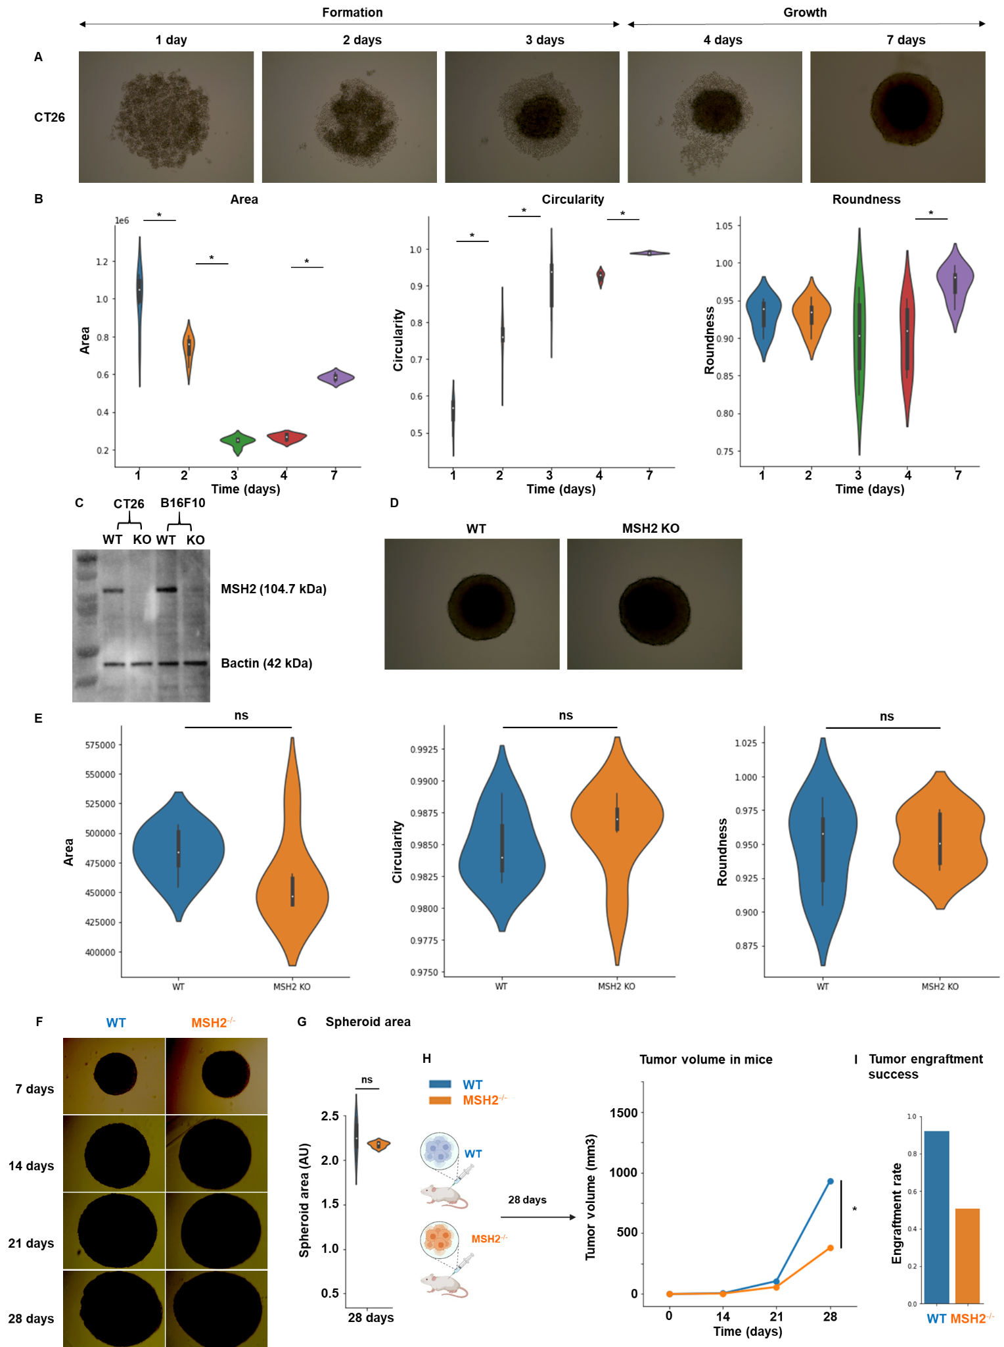
Extended Figure 1) Effect of the TME on MSH2 KO tumor development.
A 10,000 WT CT26 thawed cells were used per spheroid in a 96 well plate. B After 1,2,3,4 and 7 days, roundness, circularity and area of CT26 spheroids were measured using ImageJ software. N=6 replicates. C MSH2 was deleted in CT26 and B16F10 cells using Crispr and cell lines were subcloned. Western Blot to assess MSH2 deletion was performed using anti-Bactin antibody (Abcam, clone 8226), anti MSH2 antibody (Thermo Scientific, clone FE11) and anti-mouse secondary antibody (Thermo Scientific, clone A28177). N=3 D 10,000 WT or MSH2 KO CT26 cells were used per spheroid in a 96 well plate. E After 3 days, roundness, circularity and area were measured using ImageJ software. N=6 replicates. F 10,000 CT26 cells were used per spheroid in a 96 well plate. G After 28 days, the area was measured using ImageJ software. N=6 replicates. H 200,000 CT26 tumors, either deleted or not for MSH2, were allowed to grow for 28 days in BALB/C mice. Tumor volume during growth (in mm3). N= 7 to 27. I Tumor engraftment rate (in %). N= 26 to 48. Mann-Whitney U Test was used for all comparisons, and the difference was deemed significant if p value<0.05.
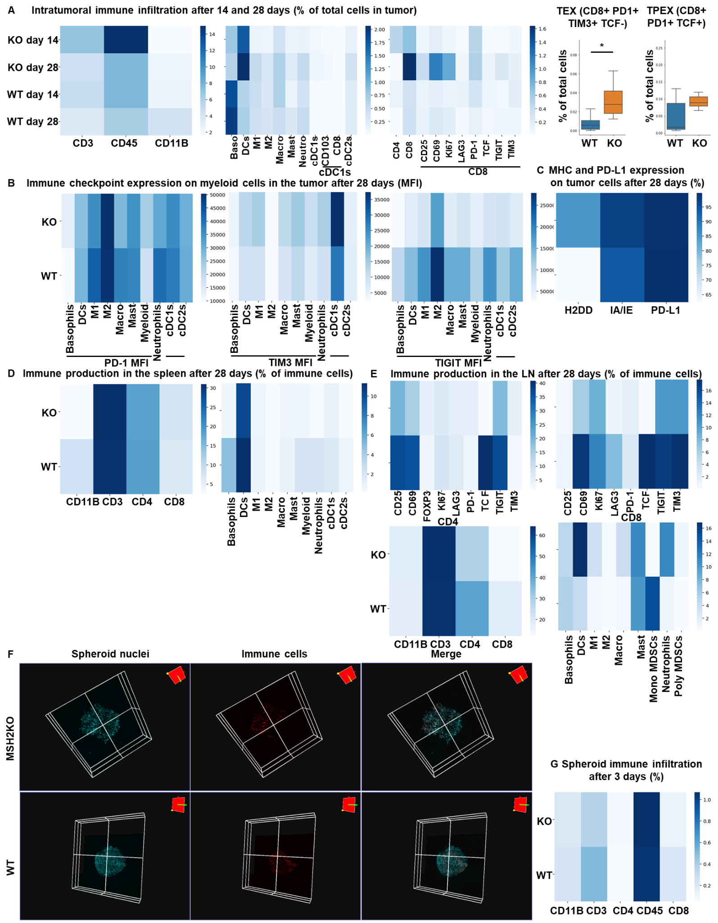
Extended Figure 2) Immune landscape of MSH2 KO and WT tumors and spheroids, spleen and lymph nodes.
CT26 tumors deleted or not for MSH2 are growing for 28 days in BALB/C mice. A Quantification of differential immune checkpoint expression and immune infiltration according to the MSI status after 14 days and 28 days. N=6 replicates, Mann-Whitney U Test, p value<0.05. B Immune checkpoint expression on tumor infiltrating myeloid cells after 28 days. N=6 replicates, Mann-Whitney U Test, p value<0.05. C MHC and PD-L1 expression by tumor cells after 28 days. N=6 replicates, Mann-Whitney U Test, p value<0.05. D/E Immune production in the spleen/lymph nodes of mice injected by WT and MSH2 KO tumors after 28 days. F CT26 spheroid deleted for MSH2 are growing for 28 co-cultured with immune cells for 3 days. Splenocytes immune cells are previously labeled by cell tracker (red). Spheroid cell nuclei are labeled with Nunc blue (blue). 3D Bi-photon imaging. G 10,000 CT26 cells deleted or not for MSH2 are growing for 3 days as spheroids and 100,000 PBMC from 3 spleens are activated with IL-15. Then, spheroids and PBMC are incubated for 3 days. Flow cytometry staining of spheroids after dissociation. Quantification of differential immune checkpoint expression and lymphocyte infiltration according to the MSH2 status. N=6. Mann-Whitney U Test, p value<0.05

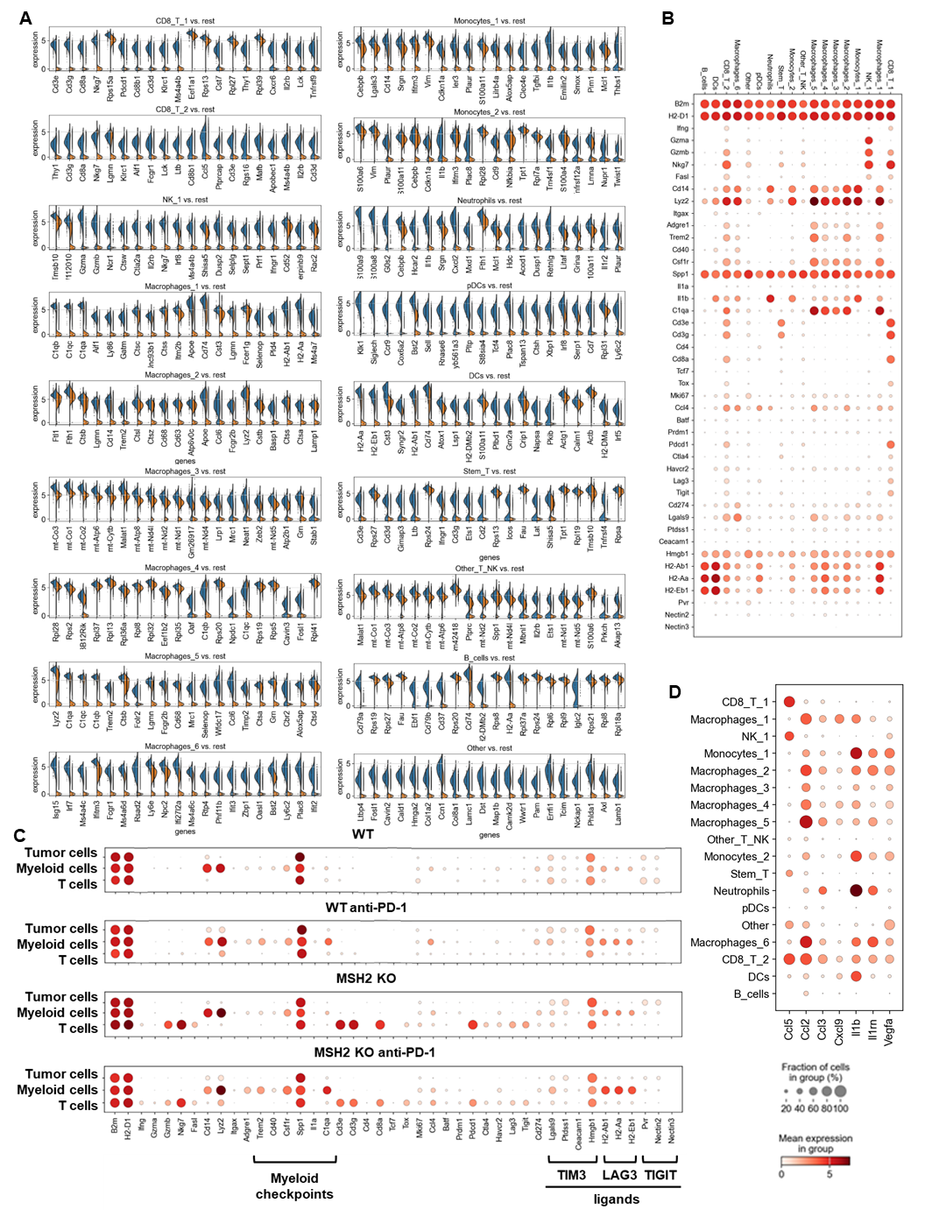
Extended Figure 3) Single cell analysis of immune cells in CT26 WT and MSH2 KO tumor with or without anti-PD-1 therapy.
ScRNASeq of immune cells in CT26 WT and MSH2 KO tumor with or without anti-PD-1 therapy. A More significantly upregulated genes in each immune cluster (Wilcoxon test). B Immune checkpoint and myeloid immunosuppressive molecule expression in each immune cluster. C Single cell analysis of WT and MSH2 KO tumor and immune cells after 28 days, with or without anti-PD-1 therapy. D cytokine production by immune cells. N=3 tumors per condition.
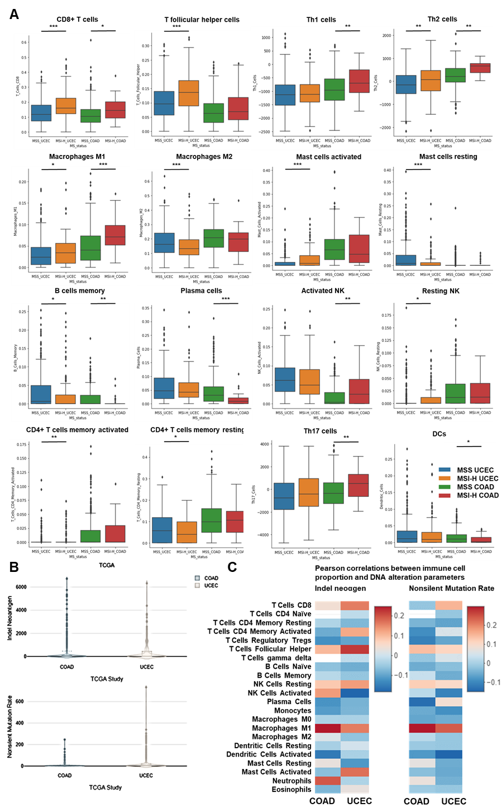
Extended Figure 4) Immune infiltration in MMRd UCEC and COAD human tumors.
A CIBERSORT TCGA analysis of UCEC (N = 528 patients) and COAD (N = 442 patients) tumor infiltration by immune cells. Mann-Whitney U Test, p value<0.05 B Indel neoantigen load and Non-silent mutation rate in COAD and UCEC TCGA cohorts on CRI iAtlas. C Pearson correlations between immune cell proportion and DNA alteration parameters in CRI iAtlas TCGA UCEC (N = 543 patients) and COAD (N = 445 patients) cohort.

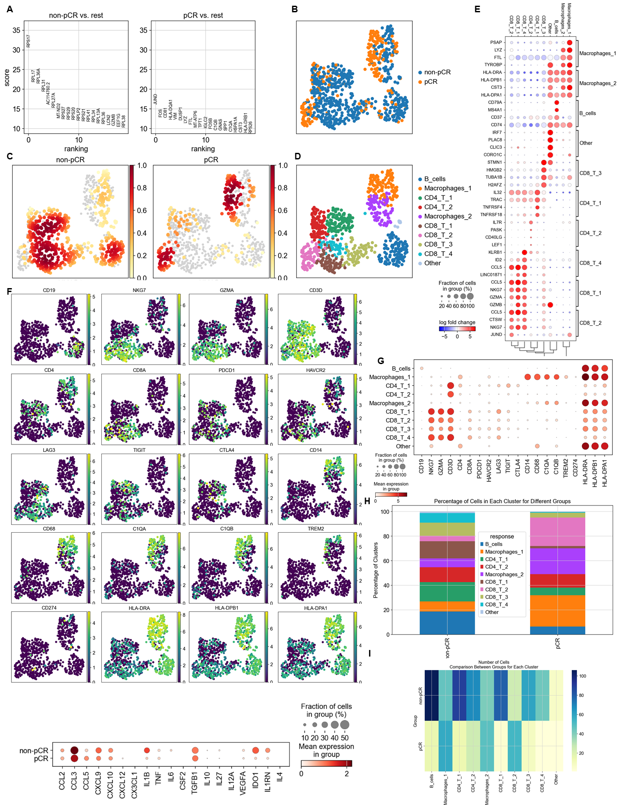
Extended Figure 5) Single cell RNAseq analysis of immune cells in MMRd CRC patients that responded or not to anti-PD-1 therapy.
We reanalyzed human MMRd CRC patient data previously published [Jianxia Li et al, Cancer cell 2023] with a focus on patients that completely responded or not to anti-PD-1 therapy and the underlying T cell and macrophage profiles. A More significantly upregulated genes in immune cells in patients that responded or not to anti-PD-1 therapy (Wilcoxon test). B ScRNAseq UMAP of immune cells in patients that responded or not to anti-PD-1 therapy. C Density UMAP of immune cells in patients that responded or not to anti-PD-1 therapy. D UMAP of immune clusters following leiden clustering by scanpy. E More significantly upregulated genes in each immune cluster. F/G Immune checkpoint and myeloid immunosuppressive molecule expression in each immune cluster. H/I Percentage/number of cells in each immune cluster.

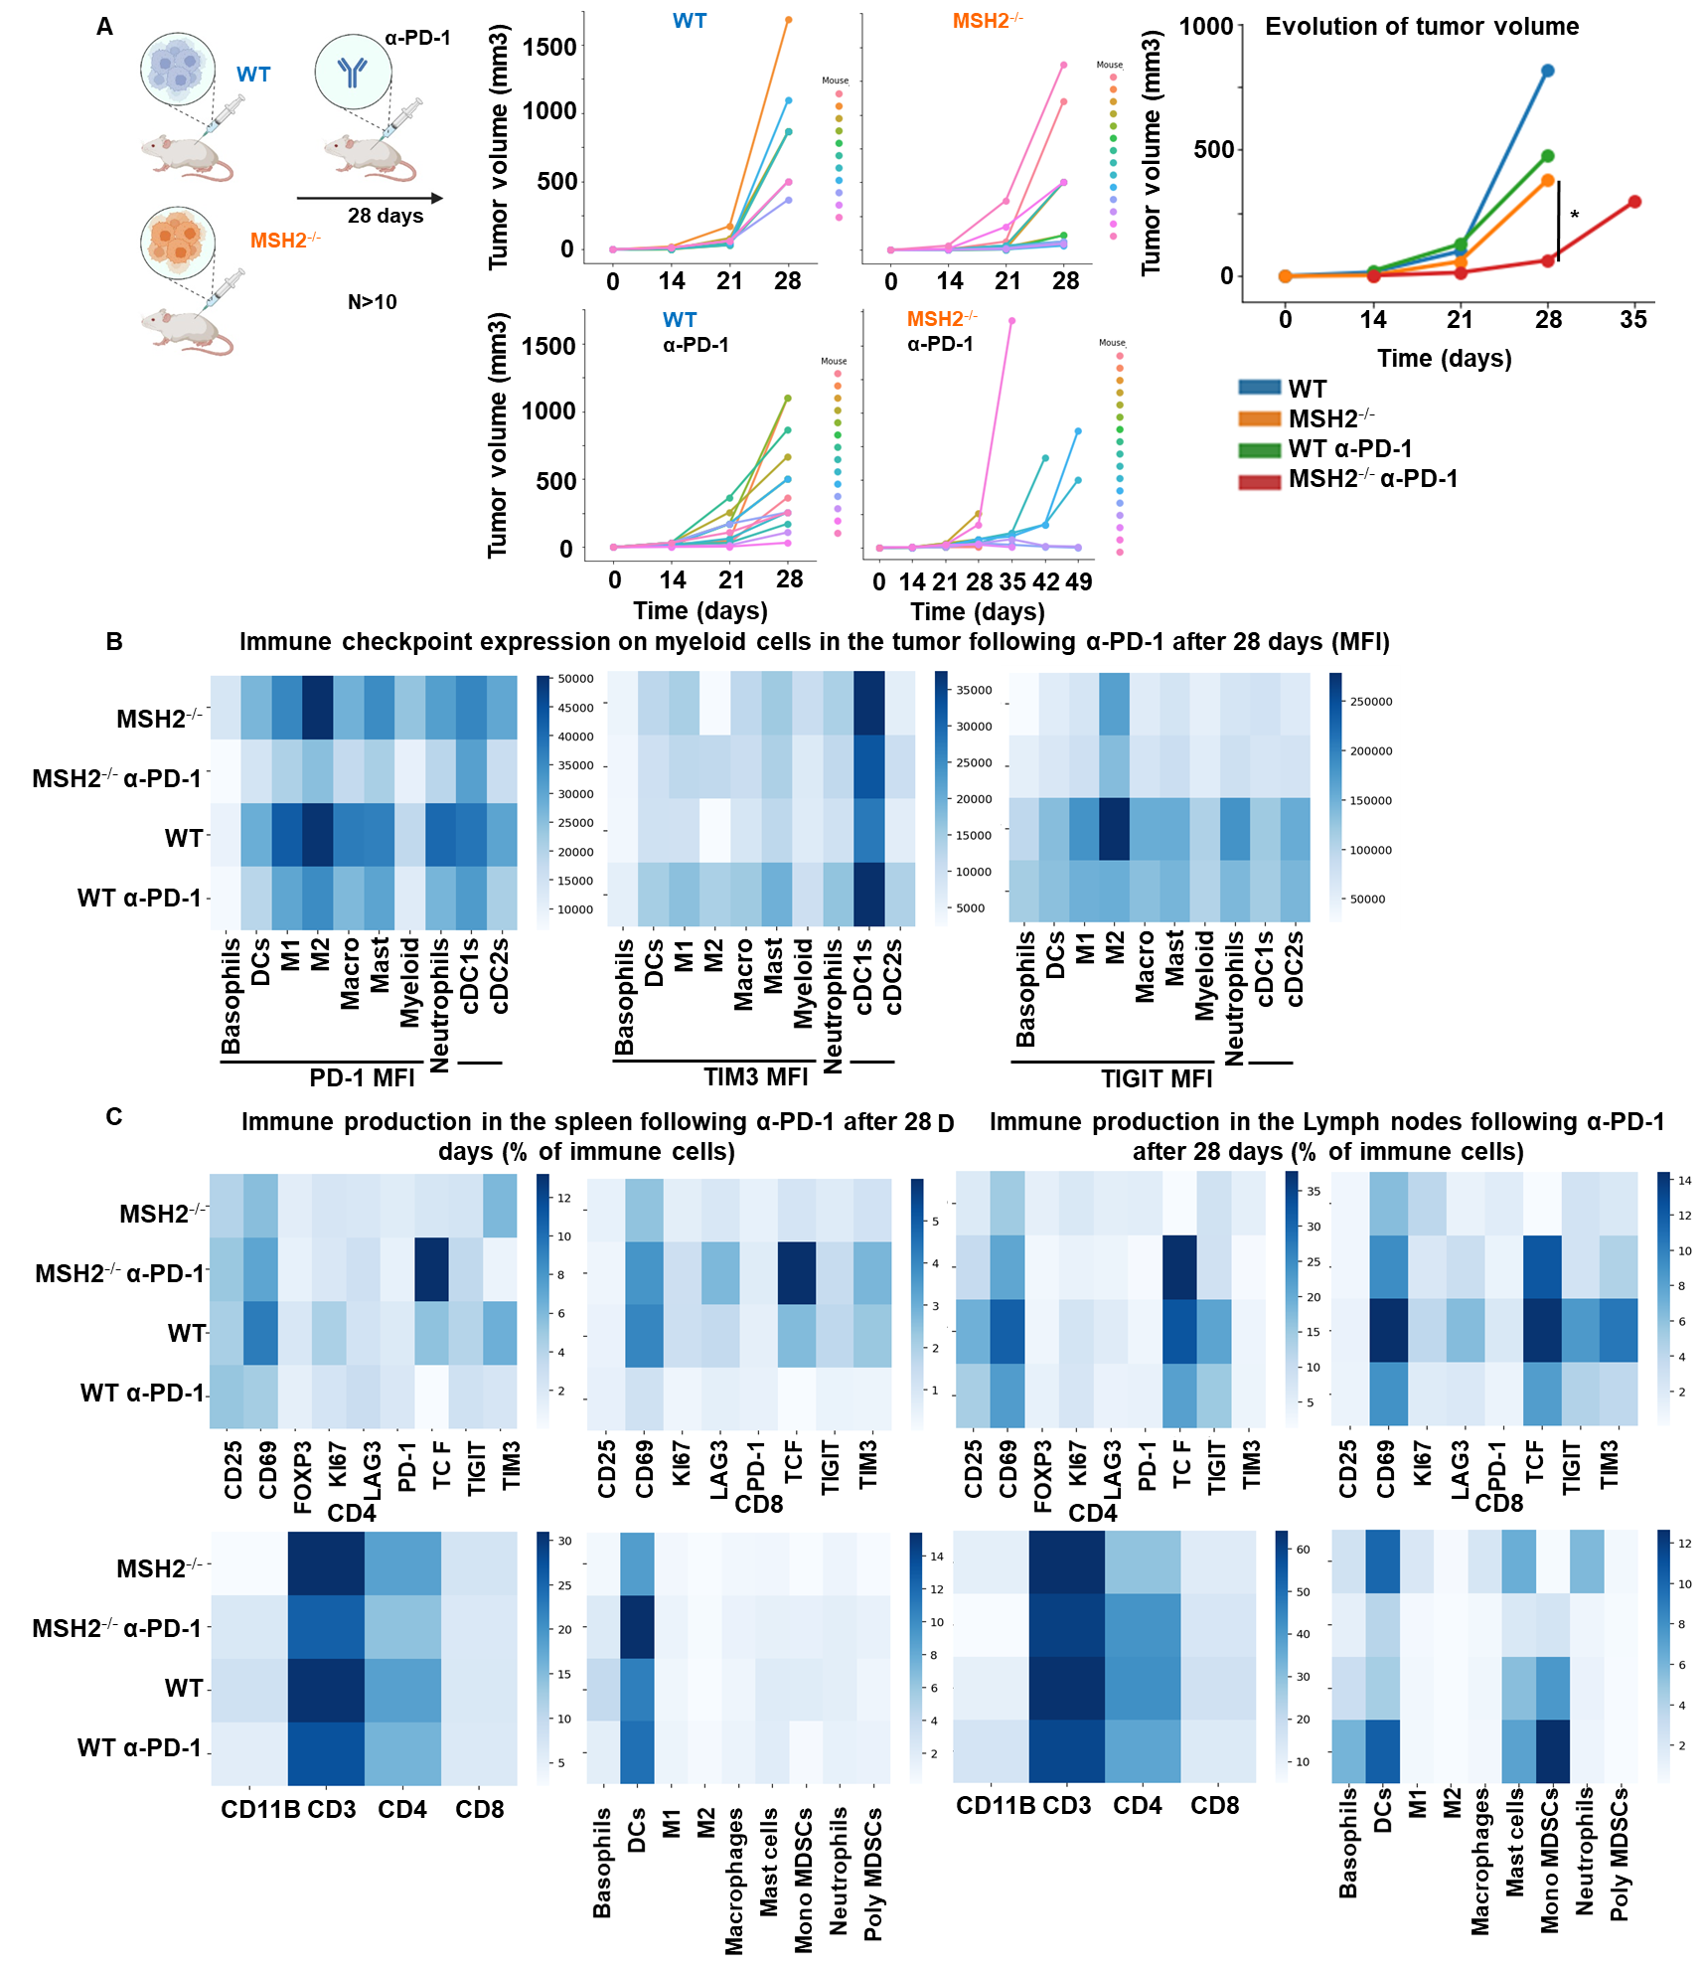
Extended Figure 6) Immune landscape of MSH2 KO and WT tumors, spleen and lymph nodes after anti-PD-1 therapy.
A CT26 tumors deleted or not for MSH2 are growing for 28 days in BALB/C mice, with or without anti PD-1 twice a week after 14 days. B Immune checkpoint expression on tumor infiltrating myeloid cells after 28 days following anti-PD-1. C/D Immune production in the spleen/lymph nodes of mice injected by WT and MSH2 KO tumors after 28 days following anti-PD-1. N=6 replicates, Mann-Whitney U Test, p value<0.05

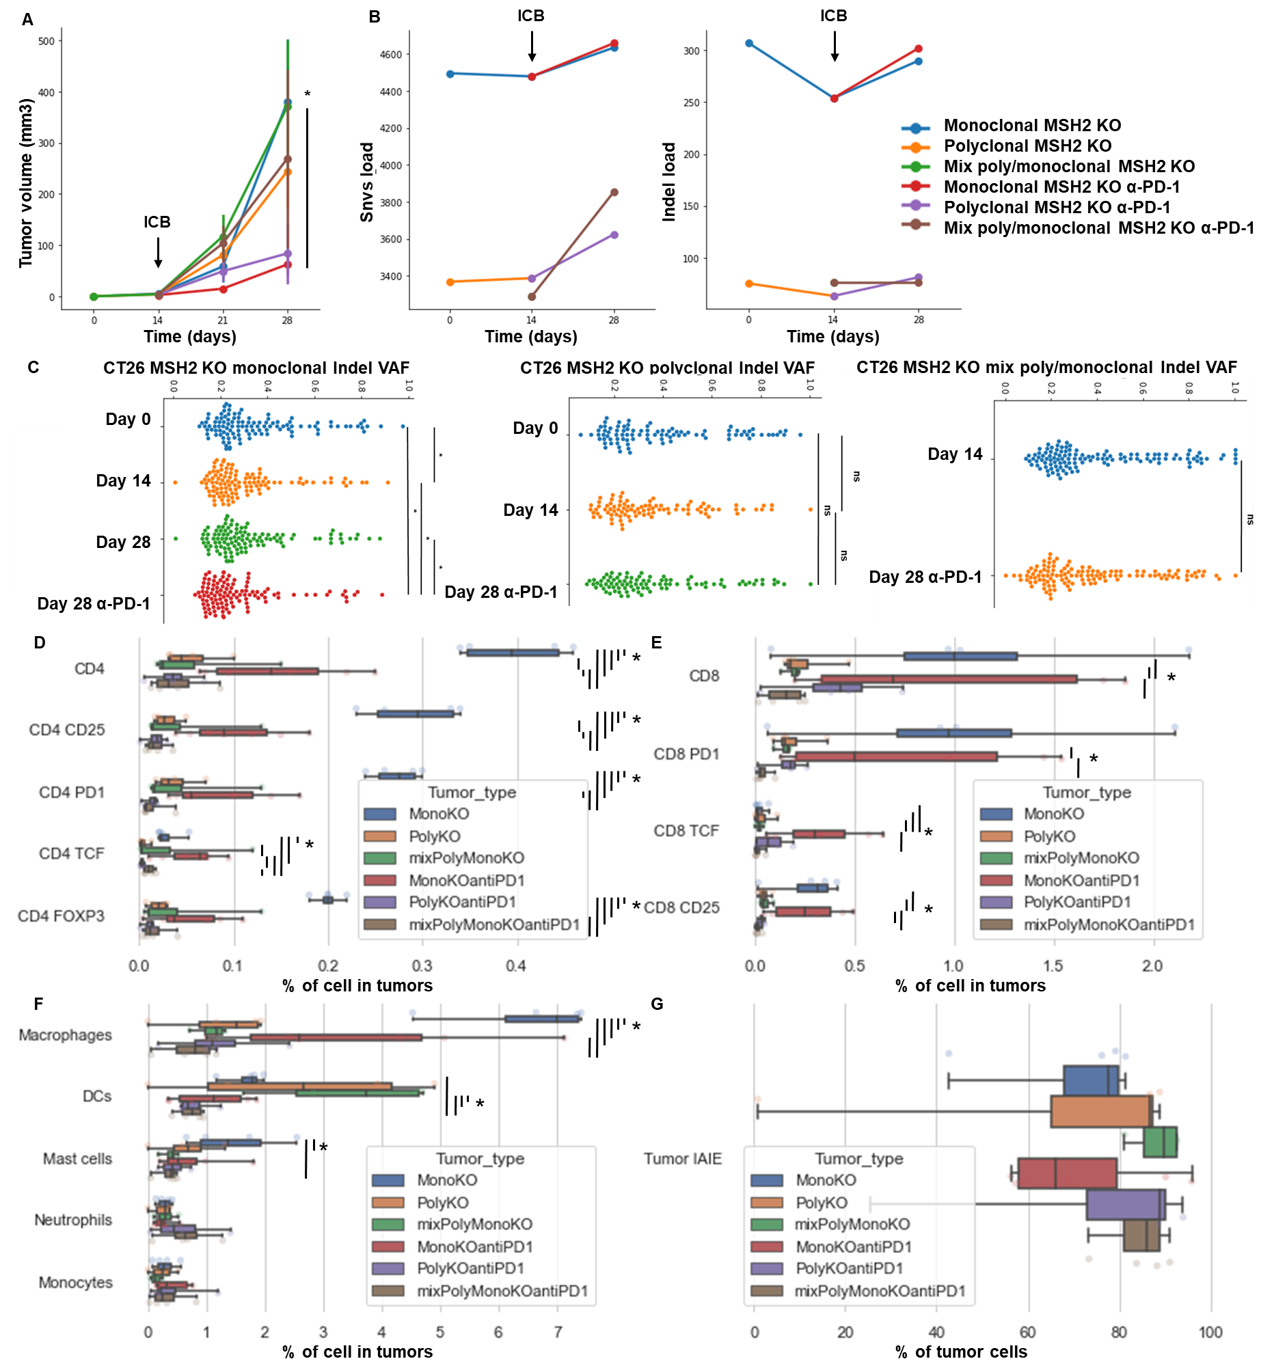
Extended Figure 7) High indel and snv loads and infiltration by TCF+ CD4+ and CD8+ T cells correlate with longitudinal response to ICB and immunoediting.
Monoclonal or polyclonal CT26 tumors deleted for MSH2 are growing for 28 days in BALB/C mice, with or without anti PD-1 twice a week after 14 days. A Tumor volume in vivo over 28 days in the absence or presence of anti-PD-1 (100 µg twice a week after 14 days ) therapy (in mm3). N= 6 to 27, Mann-Whitney U Test, pvalue<0.05. B Indel and snv count with effect on the coding sequence following whole exome sequencing (strelka, varcode). C Quantification of tumor mutational allele frequency changes following ICB. Mann-Whitney U Test, pvalue<0.05. Quantification of D CD4 + T cell, E CD8+ T cell and F myeloid infiltration according to the MSI status and ICB. G Quantification of MHCII expression on tumors. N=4 replicates, Mann-Whitney U Test, pvalue<0.05

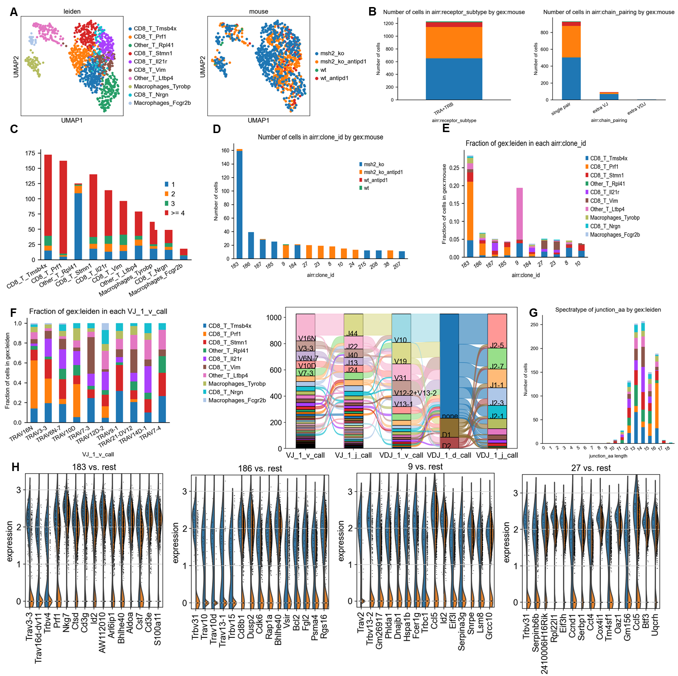
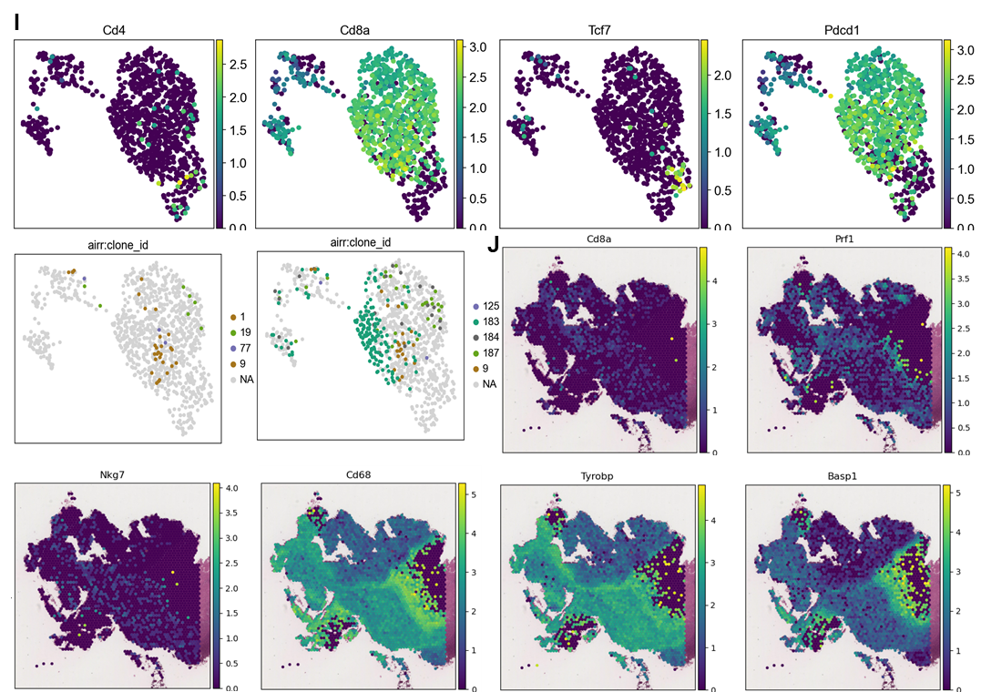
Extended Figure 8) TCRseq analysis paired with scRNAseq analysis on MMRd tumor according to anti-PD-1 therapy.
A scRNAseq clustering on immune cells infiltrating tumors expressing TCRs. B The dataset contains only α/β T-cell receptors. Filtering to exclude all cells that don’t have at least one full pair of receptor sequences and multichain cells. C Clonal expansion, number of cells in each clonotype. D/E Clonotype abundance in each cluster and in each condition. F 10 most abundant V-genes and exact combinations of VDJ genes. G Length distribution of CDR3 regions. H Overexpressed genes in the more abundant clonotypes. I Gene expression in clones shared between different tumor types. J Spatial localization of main CD8 and macrophage clones in MSH2 KO tumors after ICB.
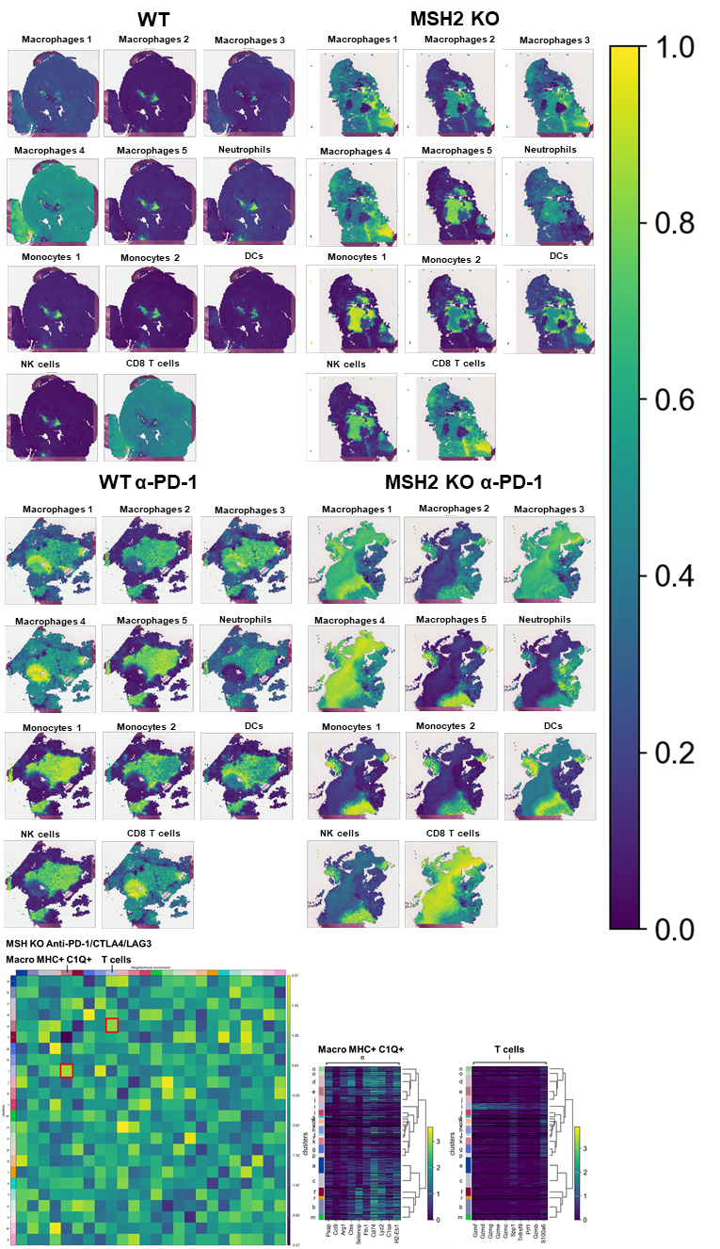
Extended Figure 9) Spatial RNAseq analysis of immune cells in CT26 WT and MSH2 KO tumor with or without ICB therapy.
Spatial localization of each scRNAseq immune cluster in CT26 WT and MSH2 KO tumor with or without ICB therapy. Neighborhood enrichment was performed using scanpy and squidpy.

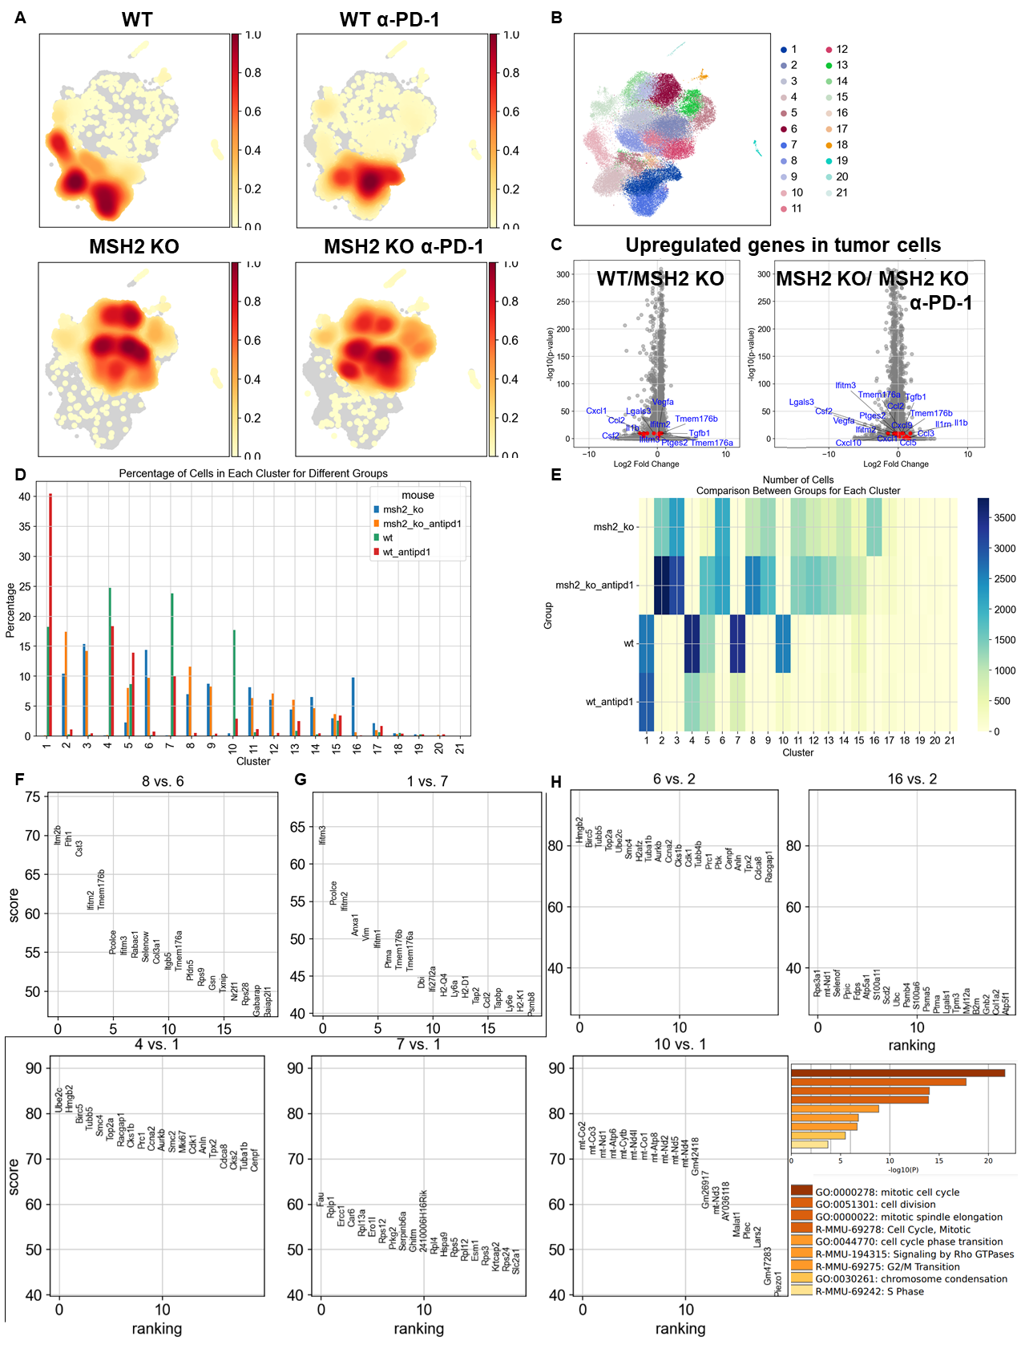
Extended Figure 10) Single cell RNAseq analysis of tumor cells in CT26 WT and MSH2 KO tumor with or without anti-PD-1 therapy.
A Density UMAP of tumor cells, after performing exclusion of immune cells, in CT26 WT and MSH2 KO tumor with or without anti-PD-1 therapy. B ScRNAseq UMAP of tumor cells in CT26 WT and MSH2 KO tumor with or without anti-PD-1 therapy, following leiden clustering by scanpy. C More significantly upregulated genes in tumor cells in CT26 WT and MSH2 KO tumor with or without anti-PD-1 therapy (Wilcoxon test). D/E Percentage/number of cells in each tumor cluster. F More significantly upregulated genes in MSH2 KO tumor cluster resisting anti-PD-1 therapy compared to cluster responding to anti-PD-1 (Wilcoxon test). G More significantly upregulated genes in WT tumor cluster resisting anti-PD-1 therapy compared to cluster responding to anti-PD-1 (Wilcoxon test). H More significantly upregulated genes in WT and MSH2 KO tumor clusters targeted by anti-PD-1 therapy compared to cluster resisting anti-PD-1 (Wilcoxon test) and corresponding gene enrichment analysis with metascape.

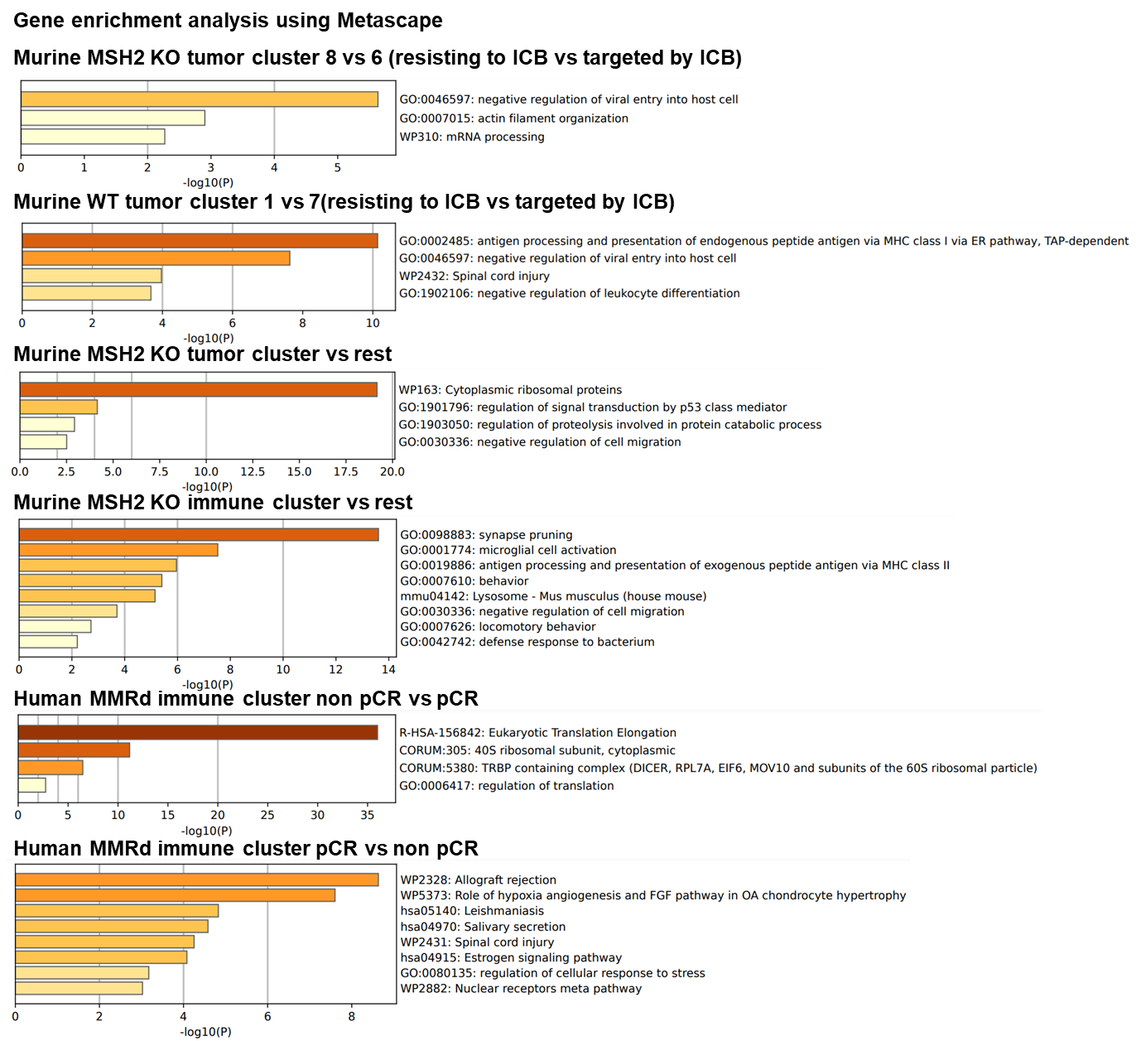
Extended Figure 11) Gene enrichment analysis in immune and tumor scRNAseq clusters.
Gene enrichment analysis was performed using Metascape (66) in immune and tumor scRNAseq clusters.

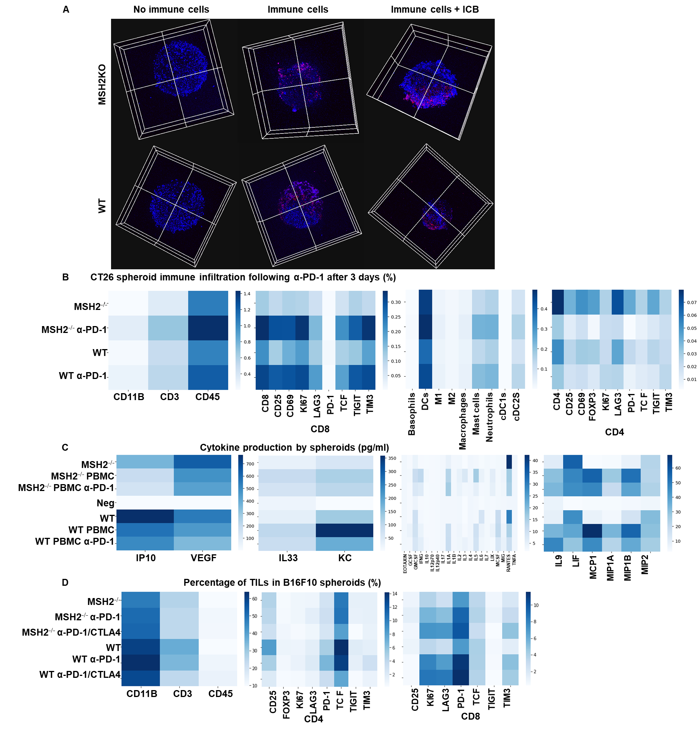
Extended Figure 12) Immune landscape of MSH2 KO and WT spheroids after anti-PD-1/CTLA4 therapy.
A CT26 spheroids deleted for MSH2 are growing for 3 days and then co-cultured with or without immune cells for 3 more days and ICB. Splenocytes immune cells are previously labeled by cell tracker (red). Spheroid cell nuclei are labeled with Nunc blue (blue). 3D bi-photon imaging of spheroid infiltration by immune cells. B 10,000 CT26 cells deleted or not for MSH2 are growing for 3 days as spheroids and 100,000 PBMC from 3 spleens are activated with IL-15. Then, spheroids and PBMC are incubated for 3 days. PBMC were incubated before with anti-PD-1 (10 µg/mL). Flow cytometry staining of spheroids after dissociation. Quantification of differential immune checkpoint expression and lymphocyte infiltration according to the MSH2 status and ICB. N=6. Mann-Whitney U Test, p value<0.05 C Cytokine production in spheroids measured by Luminex (pg/mL). N=4. Mann-Whitney U Test, p value<0.05. D 10,000 B16F10 cells deleted or not for MSH2 are growing for 3 days as spheroids and 100,000 PBMC from 3 spleens are activated with IL-15. Then, spheroids and PBMC are incubated for 3 days. PBMC were incubated before with anti-PD-1 or anti-CTLA4 (10 µg/mL). Flow cytometry staining of spheroids after dissociation. Quantification of differential immune checkpoint expression and lymphocyte infiltration according to the MSH2 status and ICB. N=6. Mann-Whitney U Test, p value<0.05

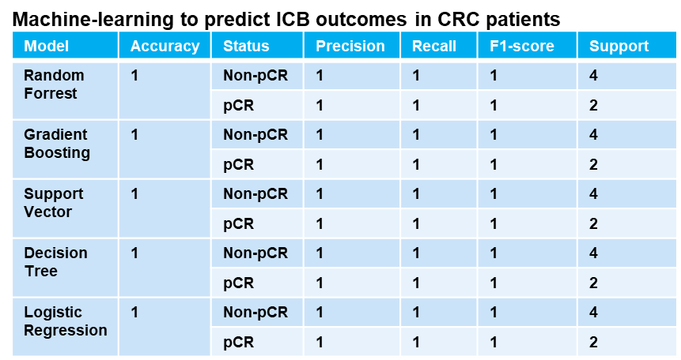
Extended Figure 13) Machine-learning to predict ICB outcomes in CRC patients.
Cell paper and KEYNOTE 177 Gastroenterology paper data : n = 29 patients (13, 33). Responders n = 12. Non-responders n = 17. More A*03:01 in responders vs non-responders (Chi2 = 5.117844498910676, p-value = 0.023681014076523402). No statistical difference for other HLA. More MSIH Status in responders (Chi2 = 6.674496076839828, p-value = 0.00978021596680159). Based on MSI status and A*03:01 data, 5 machine-learning models managed to predict CRC patient response to ICB with an accuracy of 100%.
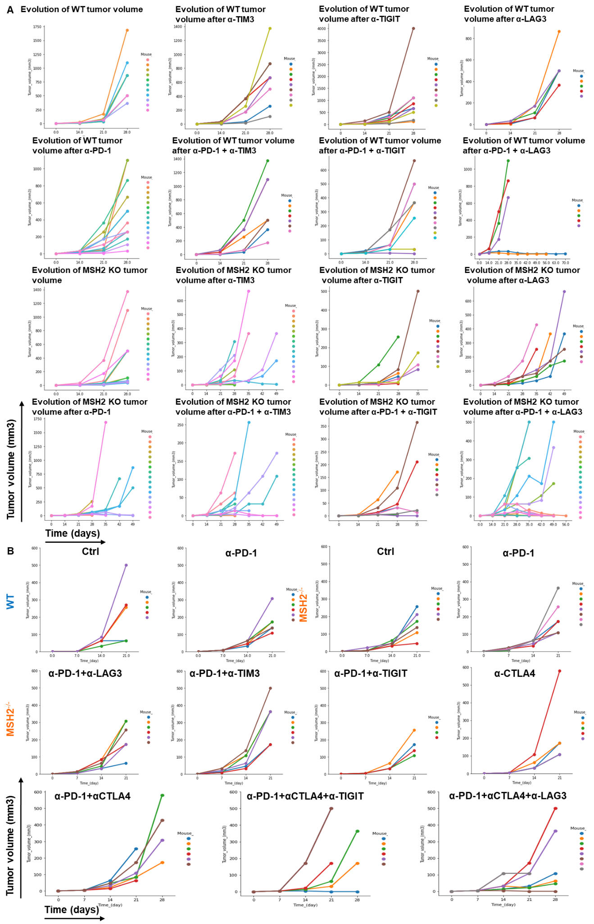
Extended Figure 14) Impact of targeted multiple checkpoint combinations on MMRd tumor growth.
Tumor volume in vivo over time of CT26 (A) and 4T1 (B) WT and MSH2 KO cells (200,000 cells/tumor) in the absence or presence of anti-PD-1, anti-TIM3, anti-LAG3, anti-TIGIT or anti CTLA4 (100 µg twice a week after 14 days ) therapy (in mm3). N= 5 to 20 per arm. Mann-Whitney U Test, p value<0.05.

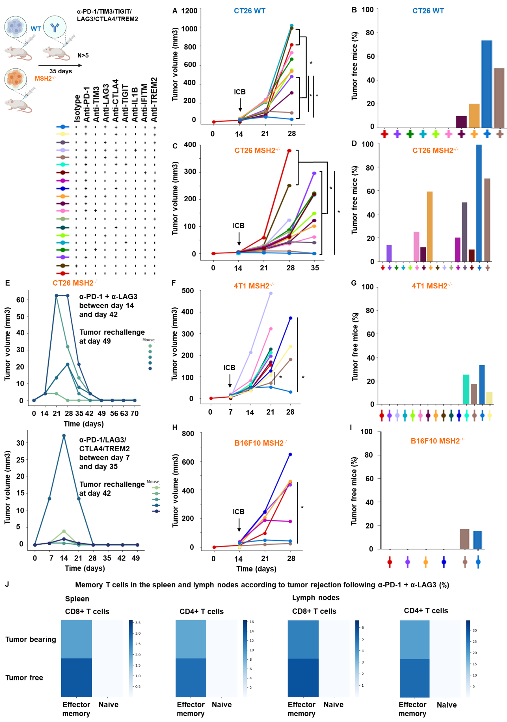
Extended Figure 15) Myeloid and T cell targeting therapeutic combinations overcome resistance in both MMRd and MMRp tumors and elicit robust immune memory.
A/C/F/H Tumor volume (mean) in vivo over time of CT26, B16F10 and 4T1 WT and MSH2 KO cells (200,000 cells/tumor) in the absence or presence of anti-PD-1, anti-TIM3, anti-LAG3, anti-TIGIT, anti-IL1B, anti-TREM2, anti-IFITM or anti CTLA4 (100 µg twice a week after 14 days ) therapy (in mm3). N= 5 to 20 per arm. Mann-Whitney U Test, p value<0.05. B/D/G/I Complete response of CT26, B16F10 and 4T1 WT and MSH2 KO tumors after ICB combinations (%). E After CT26 MSH2 KO tumor elimination following anti-PD-1 + anti-LAG3 therapy, treatment was stopped and a second tumor was inoculated on the opposite flank and its growth was measured for 3 weeks. N= 5. J Percentage of memory T cells in spleens and lymph nodes of mice that rejected or not a CT26 MSH2 KO tumor following anti-PD-1 + anti-LAG3 after 49 days (flow cytometry).

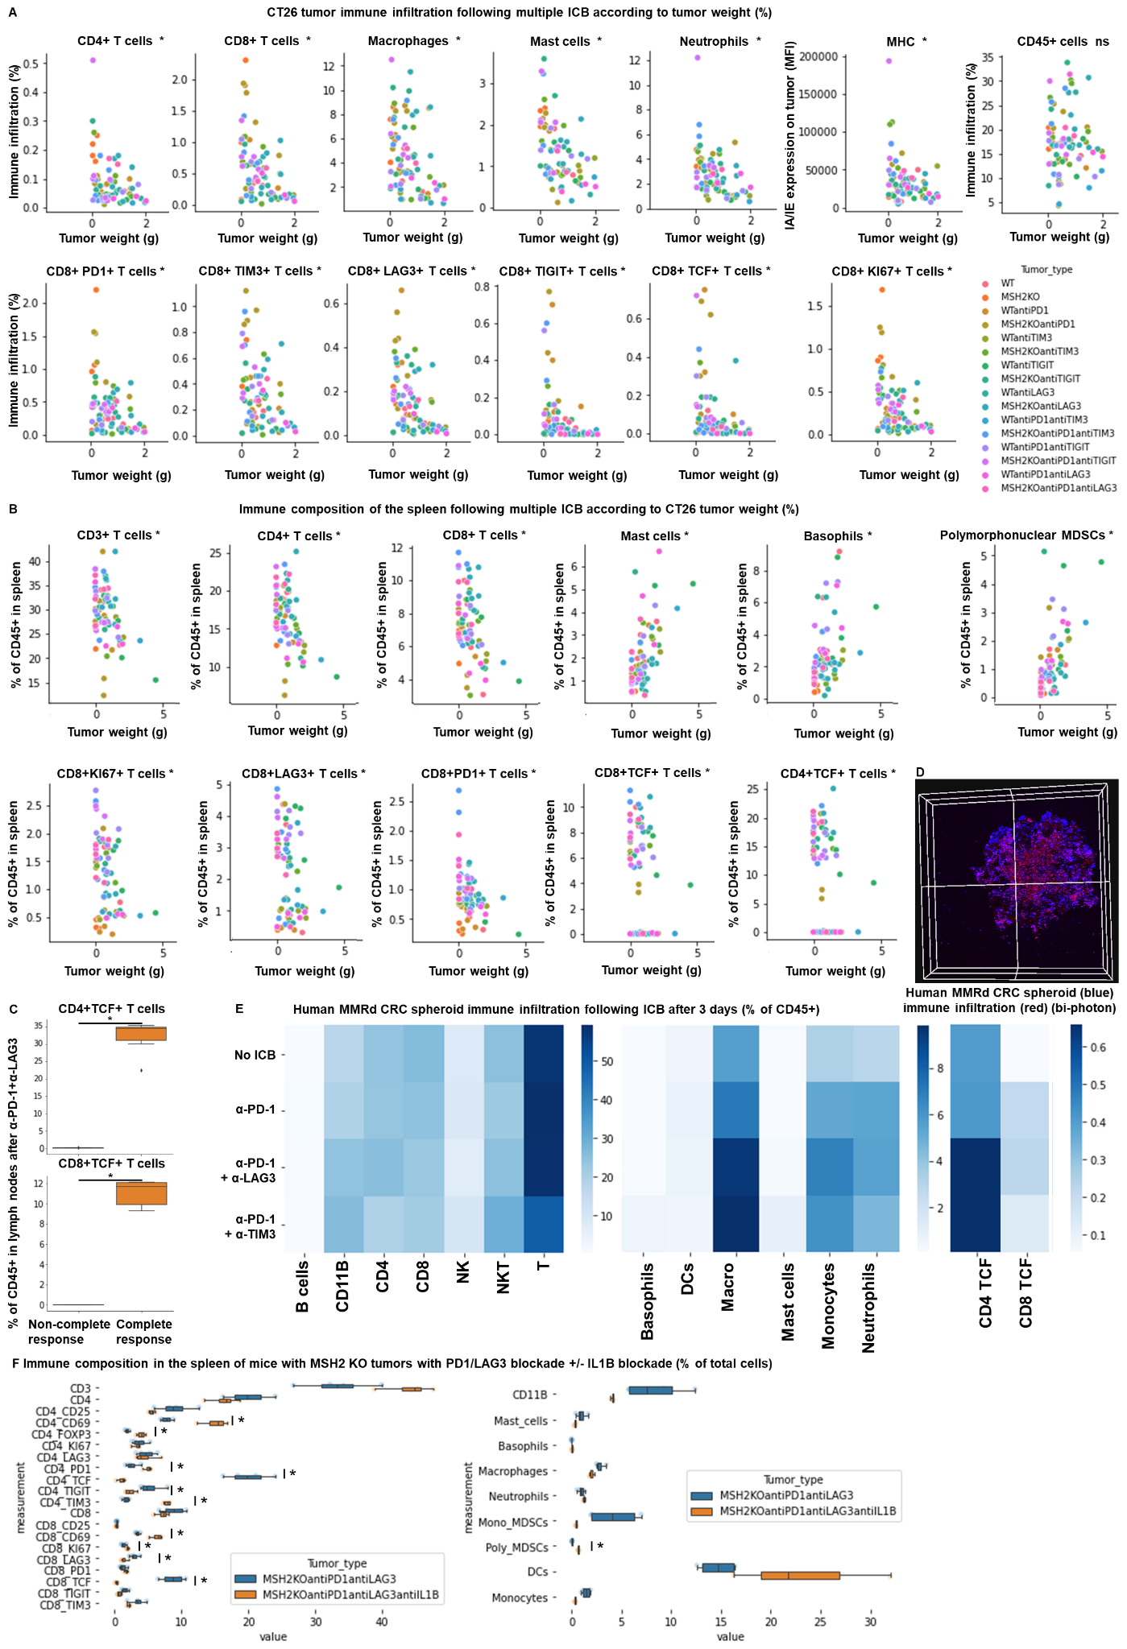
Extended Figure 16) TCF+ T cells, neutrophils and macrophages orchestrate the response to targeted checkpoint/myeloid combinations.
WT and MSH2 KO CT26 tumors are growing 28 days in absence or presence of anti-PD-1, anti-TIM3, anti-LAG3 or anti-TIGIT (100 µg twice a week after 14 days ) therapy. A Linear regression, intratumoral immune infiltration and according to tumor weight, ICB and MSI status (flow cytometry). B/C Linear regression, immune composition in spleens and lymph nodes according to tumor weight, ICB and MSI status (flow cytometry). N= 79. Mann-Whitney U Test, p value<0.05. D/E 10,000 MMRd CRC patient-derived cells are growing for 3 days as spheroids and 100,000 PBMC from 3 donors are activated with IL-15. Then, spheroids and PBMC are incubated for 3 days. PBMC were incubated before with anti-PD-1, anti-TIM3 and anti-LAG3 (10 µg/mL). D Immune cells are previously labeled by cell tracker (red). Spheroid cell nuclei are labeled with Nunc blue (blue). 3D Bi-photon imaging. E Flow cytometry staining of spheroids after dissociation. Quantification of differential immune checkpoint expression and lymphocyte infiltration according to ICB. N=4. Mann-Whitney U Test, p value<0.05 F Immune composition in spleens of mice with MSH2 KO CT26 tumors according to the addition of PD1/LAG3 blockade +/- IL1B blockade (flow cytometry).
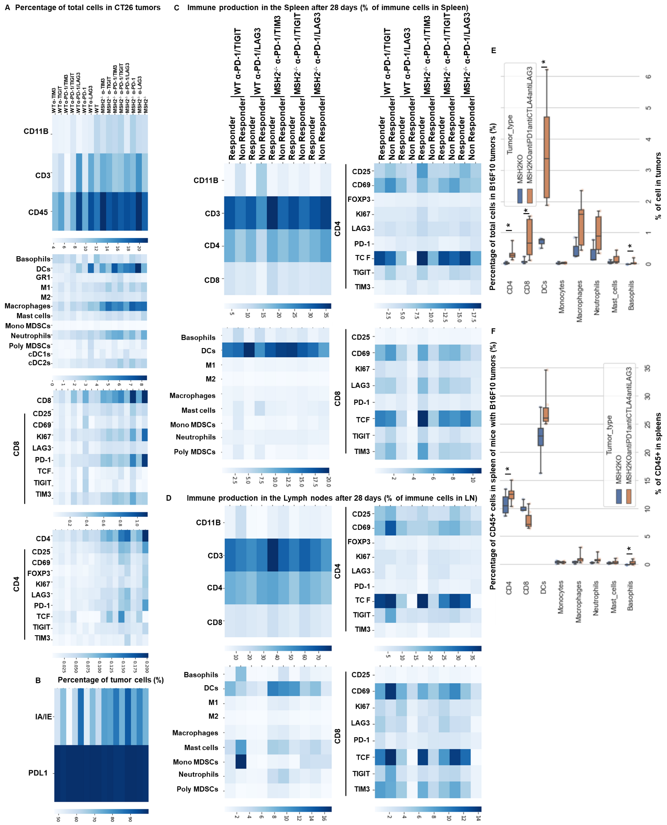
Extended Figure 17) Impact of targeted multiple checkpoint combinations on MMRd tumor infiltration and immune composition in spleens and lymph nodes.
CT26 and B16F10 WT and MSH2 KO tumors are growing 28 days in absence or presence of anti-PD-1, anti-TIM3, anti-LAG3 or anti-TIGIT (100 µg twice a week after 14 days ) therapy. A/B/E Quantification by flow cytometry of differential immune checkpoint and lymphocyte infiltration expression according to the MSI status and ICB. C/D/F Immune composition in spleens and lymph nodes according to complete response following multiple ICB therapy. Responders are defined as free-tumor mice. N= 4. Mann-Whitney U Test, p value<0.05.

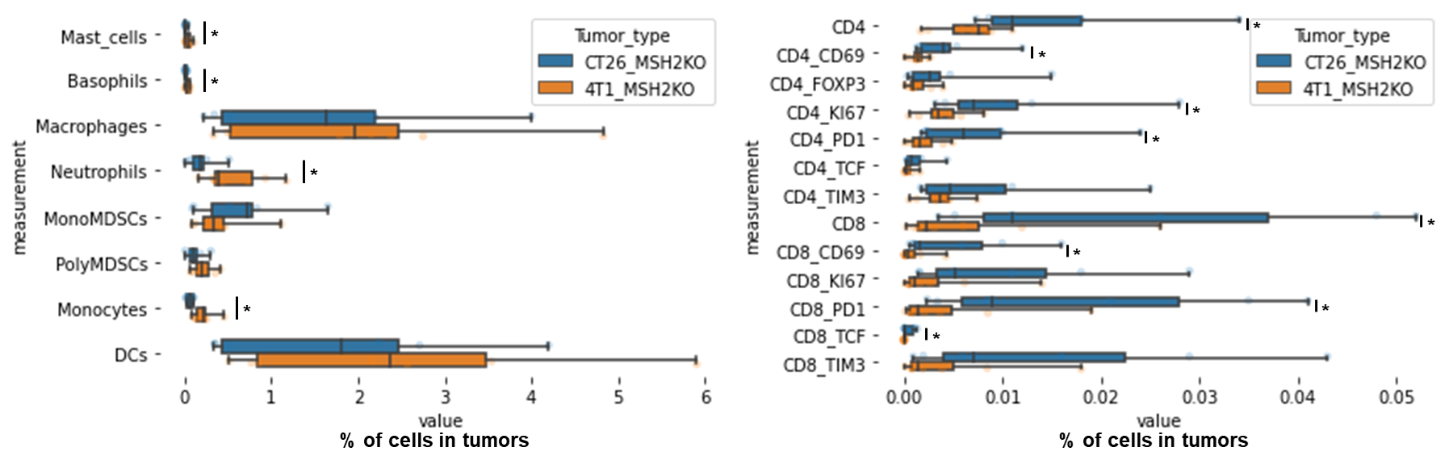
Extended Figure 18) Immune infiltration of MSH2 KO CT26 and 4T1 tumors.
CT26 and 4T1 tumors deleted or not for MSH2 are growing for 21 days in BALB/C mice. Quantification of differential immune checkpoint and lymphocyte infiltration expression according to the MSI status and ICB. N=8 replicates, Mann-Whitney U Test, p value<0.05

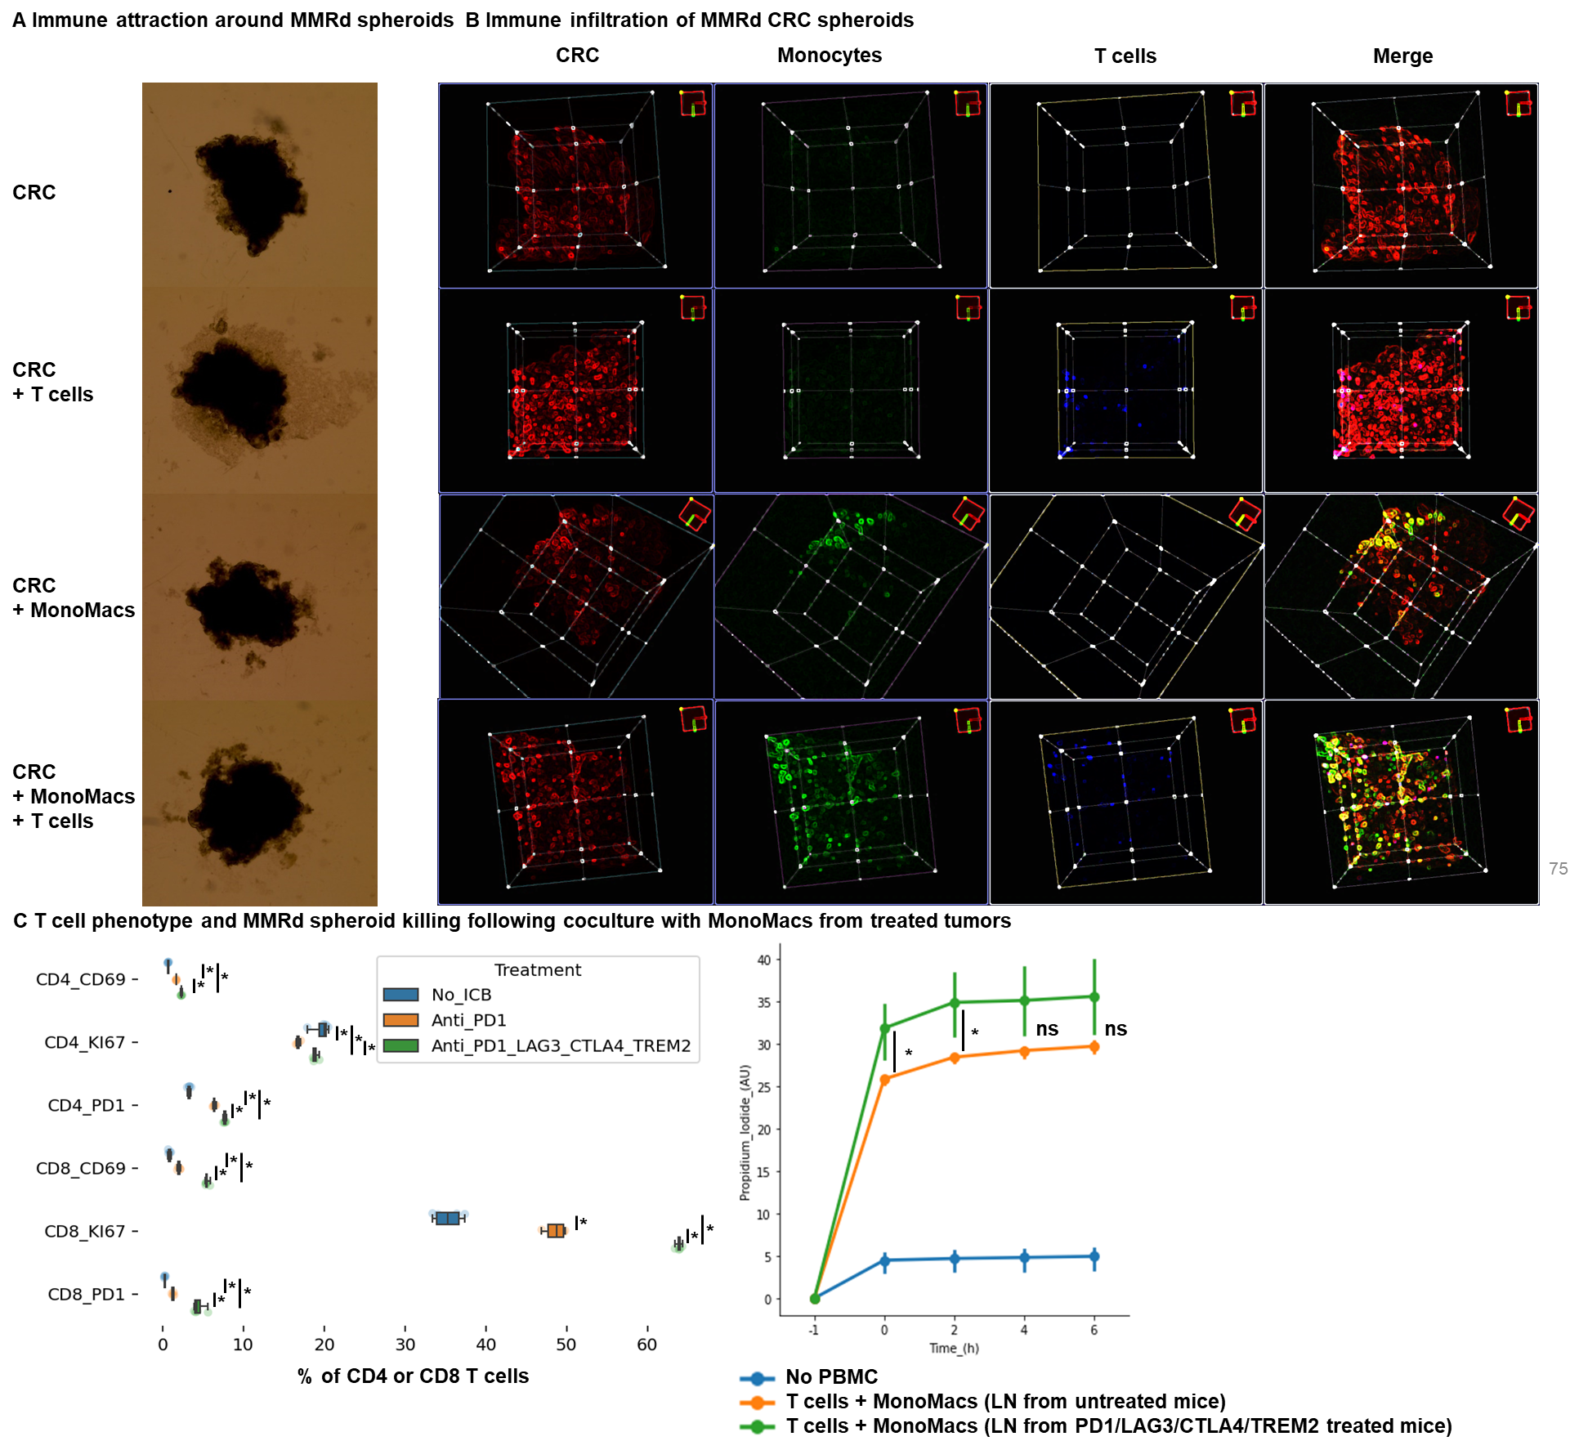
Extended Figure 19) T cell and monocyte infiltration in human MMRd CRC spheroids
MMRd CRC human spheroids were amplified for 7 days, with n=10,000 CRC cells per spheroid and the Spherotribe kit (Idylle). In parallel, T cells and monocytes from blood were labeled with DeepRed/DeepGreen cell trackers for 30min respectively. Monocytes and T cells were added to spheroids (10,000 monocytes and 100,000 T cells per spheroid). Spheroids were washed to remove non-infiltrating immune cells before analysis. A After 5 days, spheroid size and subsequent immune attraction was evaluated by microscopy and ImageJ. B Spheroid infiltration by monocytes and T cells and 3D aggregate formation were shown with BiPhoton. C Murine T cell phenotype and MMRd spheroid killing following coculture with Macrophages from tumor or LN of mice bearing CT26 MSH2 KO tumors treated with anti-PD-1 or anti-PD-1/LAG3/CTLA4/TREM2. N= 4 replicates, Mann-Whitney U Test, p value<0.05

