Supplementary material
Phage–antibiotic synergy restores β-lactam efficacy in MDR Klebsiella quasipneumoniae biofilms and suppresses resistance
Tinatini Tchatchiashvili^{1,2*}, Mike Marquet¹, Ekaterine Gabashvili³, Kamran A. Mirza^{1,2}, Mara Lohde¹, Christian Brandt^{1,6}, Ralf Ehricht^{4,5,6}, Mathias W. Pletz^{1,2,}†, Oliwia Makarewicz ^{1,2,}†
¹Institute of Infectious Disease and Infection Control, Jena University Hospital, Friedrich-Schiller-University Jena, 07747 Jena, Germany
²Leipniz Center for Photonics in Infectious Research, 07745 Jena, Germany
³Cluster of Excellence Balance of the Microverse, Friedrich Schiller University Jena, 07745 Jena, Germany
⁴Leibniz Institute of Photonic Technology, Member of the Research Alliance “Leibniz Health Technologies” and the Leibniz Centre for Photonics in Infection Research (LPI), 07745 Jena, Germany
⁵Institute of Physical Chemistry, Friedrich Schiller University Jena, 07743 Jena, Germany
⁶InfectoGnostics Research Campus Jena, Center for Applied Research, 07743 Jena, Germany

* Correspondence:
Tinatini Tchatchiashvili
Tinatini.tchatchiashvili@med.uni-jena.de
†These authors contributed equally to this work as senior authors.
Supplementary Fig. S1. Representative light sheet fluorescence microscopy (LSFM) images of mature K. quasipneumoniae ATCC 700603 biofilms over a 24-hour period. (A – D) Untreated control; (E – H) biofilms treated with ceftazidime at 0.25× MIC; (I – L) biofilms treated with phage vB_KpUKJ_2 at 10⁸ PFU/mL; (M – P) biofilms treated with a combination of ceftazidime (0.25× MIC) and phage vB_KpUKJ_2 (10⁸ PFU/mL). Treatment durations, 0 h, 4 h, 8 h and 24 h are indicated. Images show X–Y plane sections of biofilms stained with calcein acetoxymethyl (CAM). Cellular esterases in viable cells convert CAM into fluorescent calcein, causing the entire cell to fluoresce. Images were acquired from three randomly selected fields per sample, with consistent observations across all replicates. Imaging was performed at 62.5× magnification. Scale bars: 5 μm.

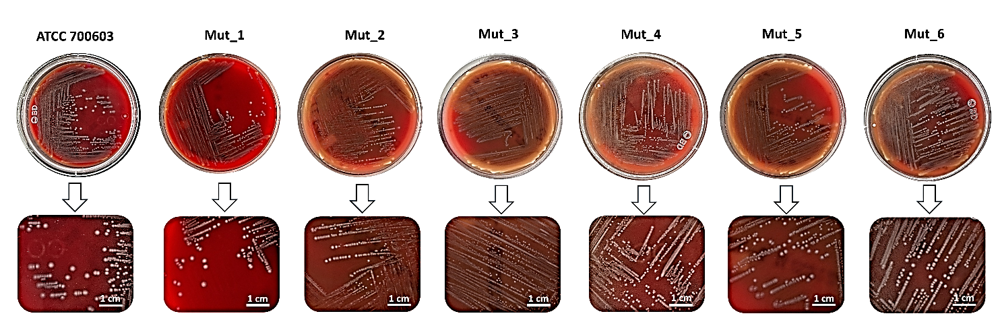
Supplementary Fig. S2 Colony morphology of K. quasipneumoniae ATCC 700603 and its phage-resistant mutants grown on blood agar plates. The squared boxes denote regions shown at higher magnification. A 1 cm scale bar is provided for reference.

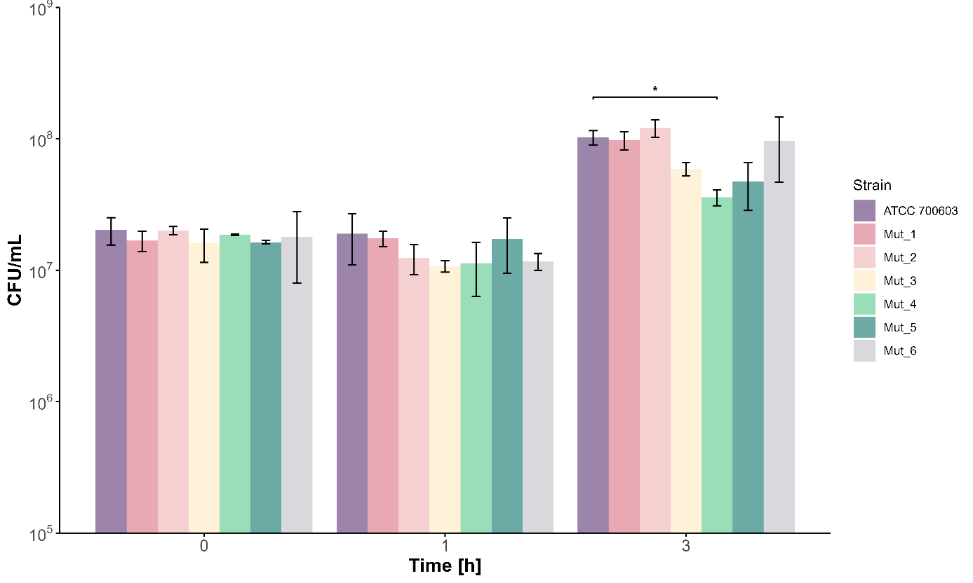
Supplementary Fig. S3 Characteristics of six phage-resistant mutants in comparison with parental K. quasipneumoniae ATCC 700603 strain. Bactericidal effect of human serum at 0, 1 and 3 hours determined as CFU/mL. The data are presented as mean ± SD (n = 3). Statistical analyses were performed using one-way ANOVA followed by Tukey’s multiple comparisons test. Significance was assumed at p-values <0.05 and is indicated as asterisks: *p <0.05.

Supplementary Table S1 Synergy quantification for planktonic bacteria using the AUC-based Highest Single Agent (HSA) synergy model, calculating the S_{HSA} synergy scores (S_{HSA})
 | Phage 10⁴ PFU/mL | Phage 10⁶ PFU/mL | Phage 10⁸ PFU/mL
CAZ 2.0x MIC | -0.04 | -0.03 | -0.03
CAZ 1.0x MIC | -0.05 | -0.02 | -0.01
CAZ 0.50x MIC | -0.07 | -0.04 | 0.05
CAZ 0.25x MIC | -0.16 | -0.22 | 0.29

Supplementary Table S2 CAZ MICs of phage-resistant mutants
Mutant ID | MIC (mg/L) | EUCAST interpretation
Mutant 1 | 64 | R
Mutant 2 | 32 | R
Mutant 3 | 64 | R
Mutant 4 | 32 | R
Mutant 5 | 64 | R
Mutant 6 | 64 | R
EUCAST: European Committee on Antimicrobial Susceptibility Testing

