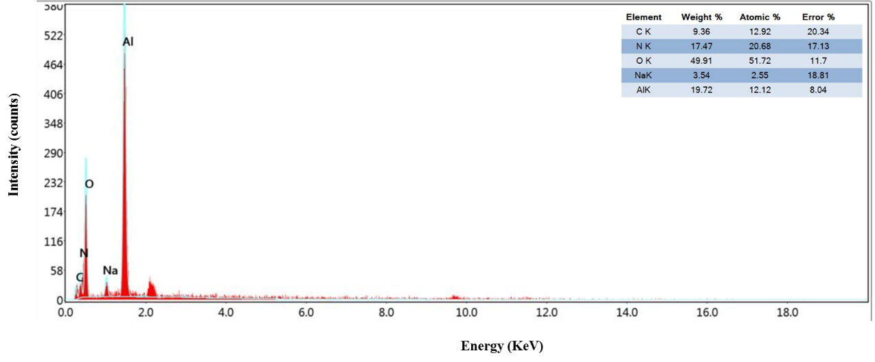

Fig. S1. Energy-dispersive X-ray (EDX) spectrum of AO@Cs, confirming the elemental composition of the synthesized material.
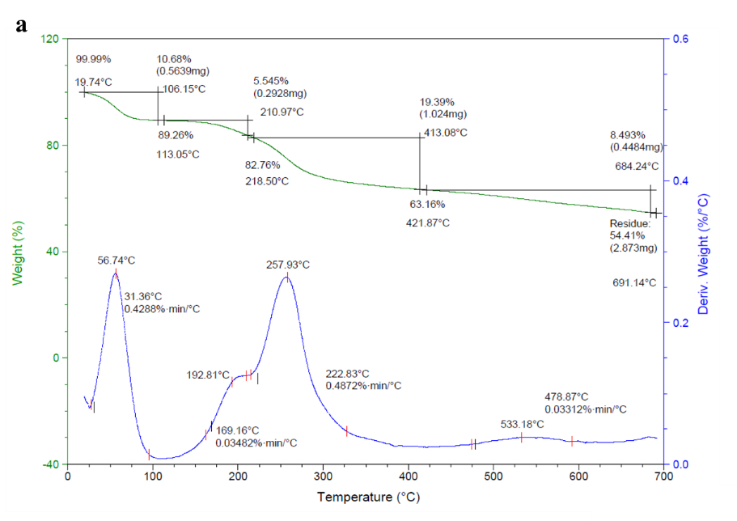

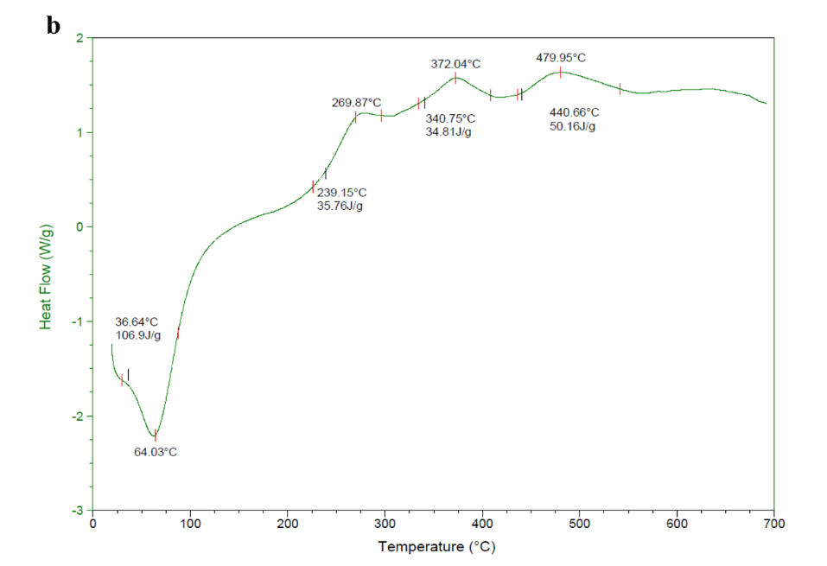

Fig. S2. (a) TGA and (b) DSC curves of α-AO@CS, showing the thermal stability, weight loss behavior, and characteristic transitions of the composite.

Fig.S3. Pseudo-first order (PFO) kinetic model for humic acid adsorption onto Al₂O₃, chitosan, and α-AO@CS composite. The PFO model shows poor correlation with experimental data, with calculated qe​ values deviating significantly from experimental ones. This indicates that the PFO model is not suitable to describe the adsorption kinetics of humic acid.
Table: S1. Effect of key operational parameters pH, adsorbent dosage, contact time, initial humic acid concentration (C₀), and temperature on the removal efficiency (%R) of humic acid using Al₂O₃, chitosan, and the α-AO@CS composite.

Parameters |  | Al₂O₃ | Chitosan | α-AO@CS
pH | 3 | 89.68 | 22.26 | 42.10
pH | 5 | 80.97 | 16.59 | 47.16
pH | 7 | 49.19 | 74.90 | 91.70
pH | 9 | 23.47 | 46.55 | 89.47
pH | 11 | 19.22 | 42.50 | 58.30
Dosage (g) | 0.05 | 67.81 | 41.69 | 67.00
Dosage (g) | 0.1 | 79.76 | 82.83 | 77.12
Dosage (g) | 0.2 | 88.66 | 80.65 | 96.36
Dosage (g) | 0.4 | 89.68 | 69.23 | 90.08
Dosage (g) | 0.6 | 90.89 | 49.79 | 96.15
Dosage (g) | 0.8 | 88.26 | 32.79 | 95.34
Dosage (g) | 1 | 89.68 | 50.60 | 95.95
Dosage (g) | Avg. | 84.96 | 58.23 | 88.29
Dosage (g) | Min. | 67.81 | 32.79 | 67.00
Dosage (g) | Max. | 90.89 | 82.83 | 96.36
Time | 10 | 81.78 | 65.99 | 90.28
Time | 30 | 86.84 | 72.47 | 89.47
Time | 60 | 85.83 | 78.14 | 91.09
Time | 90 | 86.33 | 78.14 | 88.66
Time | 120 | 88.36 | 78.95 | 87.85
Time | 160 | 87.85 | 75.71 | 86.23
Time | 180 | 89.88 | 66.80 | 82.18
Time | Avg. | 86.70 | 73.74 | 87.97
Time | Min. | 81.78 | 65.99 | 82.18
Time | Max. | 89.88 | 78.95 | 91.09
Conc (C₀) | 5 | 90.04 | 85.42 | 96.98
Conc (C₀) | 10 | 89.61 | 80.04 | 96.44
Conc (C₀) | 20 | 88.56 | 73.46 | 94.52
Conc (C₀) | 40 | 91.19 | 73.32 | 82.98
Conc (C₀) | 60 | 91.56 | 66.53 | 73.76
Conc (C₀) | 80 | 93.94 | 37.41 | 68.38
Conc (C₀) | 100 | 92.49 | 39.75 | 64.49
Conc (C₀) | Avg. | 91.06 | 65.13 | 82.51
Conc (C₀) | Min. | 88.56 | 37.41 | 64.49
Conc (C₀) | Max. | 93.94 | 85.42 | 96.98
Temperature (ºc) | 25 | 71.66 | 90.28 | 95.95
Temperature (ºc) | 35 | 73.68 | 91.90 | 96.76
Temperature (ºc) | 45 | 75.71 | 92.71 | 97.57
Temperature (ºc) | 55 | 77.73 | 94.33 | 97.57
Temperature (ºc) | 65 | 79.76 | 95.14 | 98.38
Temperature (ºc) | Avg. | 75.71 | 92.87 | 97.25
Temperature (ºc) | Min. | 71.66 | 90.28 | 95.95
Temperature (ºc) | Max. | 79.76 | 95.14 | 98.38

