Table S1. Predicted genes associated with biocontrol activity in Ba.YN.J3 genome
Ba.YN.J3-antifungal activities description | Gene name | Gene annotation | Chromosome location
Siderophore | fhuA | Ferrichrome transport ATP-binding protein | 422,724-423,482
 | fhuC | Iron(3+)-hydroxamate import ATP-binding protein | 3,315,269-3,316,075
 | fhuG | Iron(3+)-hydroxamate import system permease protein | 3,316,094-3,317,104
 | fhuB | Iron(3+)-hydroxamate import system permease protein | 3,317,104-3,318,159
 | fhuD | Iron(3+)-hydroxamate-binding protein | 3,318,389-3,319,327
Hydrolase | amyA | Alpha-amylase | 327,965-329,944
 | aprE | Subtilisin E | 1,066,766-1,067,914
 | gmuD | 6-phospho-beta-glucosidase | 3,837,921-3,839,321
 | pel | Pectate lyase | 781,646-782,911
 | eglS | Endoglucanase | 1,917,337-1,918,782
 | sleL | Cortical fragment-lytic enzyme | 24,672-25,952
 | ydhD | Putative sporulation-specific glycosylase | 1,337,618-1,338,880
Bioflim | tasA | Major biofilm matrix component | 2,613,490-2,614,275
 | bslA | Biofilm-surface layer protein A | 3,098,790-3,099,329
 | bslB | Probable biofilm-surface layer protein B | 3,761,586-3,762,050
Chemotaxis | cheB | CheB-2 chemotaxis-specific methylesterase | 1,685,054-1,686,121
 | cheA | Chemotaxis protein histidine kinase | 1,686,097-1,688,145
 | cheC | Chemotaxis protein | 1,688,657-1,689,286
 | cheD | Chemotaxis protein | 1,689,283-1,689,783
 | cheY | Chemotaxis protein | 1,889,530-1,889,856
 | cheR | Chemotaxis protein methyltransferase | 2,373,962-2,374,894
 | cheW | Chemotaxis signal transduction protein | 1,404,884-1,405,768
 | cheZ | Chemotaxis phosphatase | 1,122,677-1,123,552
 | cheV | Chemotaxis protein | 1,404,884-1,405,768
 | motA | Chemotaxis protein | 2,989,516-2,990,331
 | motB | Chemotaxis protein | 2,988,837-2,989,526
 | mcpA | Methyl-accepting chemotaxis protein | 3,109,897-3,111,882
 | mcpB | Methyl-accepting chemotaxis protein | 3,114,183-3,116,168
 | fligG | Flagellar motor switch protein | 1,667,572-1,668,588
 | fliM | Flagellar motor switch protein | 1,675,021-1,676,019
 | fliN/Y | Flagellar motor switch protein | 1,676,009-1,677,145
 | tlpB | Methyl-accepting chemotaxis protein | 3,107,775-3,109,781
Stress tolerance | clpB | ATP-dependent Clp protease | 1,371,924-1,373,972
 | clpE | ATP-dependent protease ATP-binding subunit ClpE | 1,371,924-1,373,972
 | dnaJ | molecular chaperone DnaJ | 2,680,075-2,681,202
 | dnaE | DNA polymerase III subunit alpha | 2,939,024-2,942,371
 | proA | glutamate-5-semialdehyde dehydrogenase | 1,321,034-1,322,281
 | proB | glutamate 5-kinase | 1,319,925-1,321,037
 | betB | betaine-aldehyde dehydrogenase | 3,096,403-3,097,875
 | cspA | cold shock protein | 531,604-531,807
 | atpA | F-type H+-transporting ATPase subunit alpha | 3,668,216-3,669,724
 | nhaC | Na+:H+ antiporter | 2,443,291-2,444,697
 | opuA | osmoprotectant transport system ATP-binding protein | 3,375,708-3,376,853
 | proP | proline/betaine transporter | 523,476-524,879
 | treB | PTS system, trehalose-specific IIB component | 821,770-823,221
 | sigB | RNA polymerase sigma-B factor | 514,796-515,584
 | comA | two-component system, NarL family, sensor histidine kinase ComA | 1,248,665-1,249,330
 | comP | wo-component system, NarL family, sensor histidine kinase ComP | 3,158,153-3,159,337
 | degS | two-component system, NarL family, sensor histidine kinase DegS | 3,537,179-3,538,297
 | degU | two-component system, NarL family, sensor histidine kinase DegU | 3,536,413-3,537,036
Secondary metabolites | srfAA | surfactin non-ribosomal peptide synthetase SrfAA | 362,784-373,538
 | srfAB | surfactin non-ribosomal peptide synthetase SrfAB | 373,560-384,320
 | srfAC | surfactin non-ribosomal peptide synthetase SrfAC | 384,355-388,191
 | srfAD | surfactin non-ribosomal peptide synthetase SrfAC | 388,211-388,942
 | pksF | Polyketide biosynthesis malonyl-ACP decarboxylase PksF | 997,079-998,323
 | pksE | trans-AT polyketide synthase, acyltransferase and oxidoreductase domains | 1,452,539-1,454,938
 | pks | Acyl transferase domain in polyketide synthase (PKS) enzymes | 1,467,210-1,471,982
 | pksC | polyketide biosynthesis malonyl-CoA-[acyl-carrier-protein] transacylase | 1,759,531-1,760,412
 | pksD | bacillaene synthase trans-acting acyltransferase | 1,760,603-1,761,523
 | pksG | Polyketide biosynthesis 3-hydroxy-3-methylglutaryl-ACP synthase | 1,764,131-1,765,393
 | pksJ | Polyketide synthase | 1,766,962-1,781,916
 | pksL | Polyketide synthase | 1,781,900-1,795,336
 | PksM | Polyketide synthase | 1,795,354-1,805,895
 | pksN | Polyketide synthase | 1,805,885-1,822,183

Table S2. Predicted genes associated with PGP activity in Ba.YN.J3 genome
Ba.YN.J3-PGP activities description | Gene name | Gene annotation | Chromosome location
Nitrogen fixation | yutI | Putative nitrogen fixation protein | 3,218,141-3,218,401
 | nifU | Nitrogen fixation protein | 3,257,360-3,257,803
 | nifU | nitrogen fixation protein | 3,257,360-3,257,803
 | nifS | Putative cysteine desulfurase | 2,797,824-2,798,975
 | nifF | Nitrogen fixation protein | 1,415,465-1,415,980
 | nifH | iron sulfur cluster binding proteins | 4,054,051-4,054,830
 | gltB | glutamate synthase (NADPH) large chain | 2,037,361-2,041,905
 | NarK | Nitrate/nitrite transporter | 3,452,526-3,453,758
Nitrogen metabolism | nasE | Assimilatory nitrite reductase [NAD(P)H] small subunit | 352,319-352,639
 | nasD | Nitrite reductase [NAD(P)H] | 352,660-355,077
 | gudB | Cryptic catabolic NAD-specific glutamate dehydrogenase | 2,394,478:2,395,752
 | rocG | Catabolic NAD-specific glutamate dehydrogenase | 3,760,114-3,761,400
Phosphate metabolism | pstB1 | Phosphate import ATP-binding protein | 2,633,686-2,634,459
 | pstB2 | Phosphate import ATP-binding protein | 2,634480-2,635,286
 | pstA | Phosphate transport system permease protein | 2,635,305-2,636,189
 | pstC | Phosphate transport system permease protein | 2,636,189-2,637,118
 | pstS | Phosphate transport system permease protein | 2,637,167-2,638,204
 | ugpC | Sn-glycerol-3-phosphate ABC transporter ATP-binding protein | 3,244,152-3,245,258
 | glpQ | glycerophosphoryl diester phosphodiesterase | 1,000,708-1,001,424
 | rsbU | Phosphoserine phosphatase | 512,951-513,958
 | pgpH | Cyclic-di-AMP phosphodiesterase | 2,667,564-2,669,696
Potassium-solubation | kimA | Potassium transporter | 471,864-473,708
 | ktrA | Ktr system potassium uptake protein A | 3,099,493-3,100,161
 | ktrC | K+ transport system regulatory component | 1,176,700-1,178,544
 | trkA | Trk system potassium uptake protein | 1,444,805-1,445,470
 | kdpD | K+-sensing histidine kinase | 1,919,668-1,921,041
IAA production | trpA | Tryptophan synthase alpha chain | 711,962-712,669
 | trpB | Tryptophan synthase beta chain | 2,365,905-2,367,107
 | trpC | Indole-3-glycerol phosphate synthase | 2,367,746-2,368,498
 | trpD | Anthranilate phosphoribosyltransferase | 2,368,491-2,369,507
 | trpE | Anthranilate synthase component 1 | 2,369,479-2,371,026
 | trpP | Probable tryptophan transport protein | 1,038,504-1,039,055

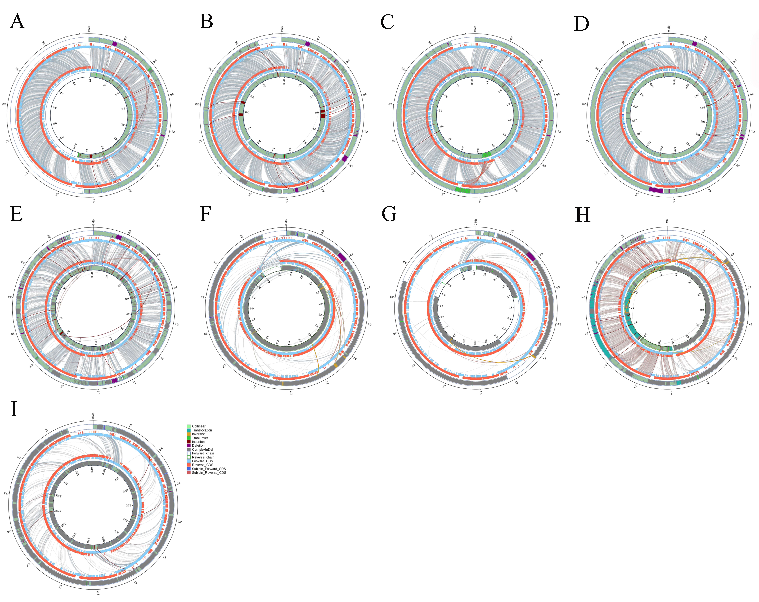
Note: A-I represents Structural variations between Ba.YN.J3 and Ba.GKT04, Ba.DSM7, Ba.ZKY01, Bv.FZB42, Bs.168, Pm.14581, Bc.FORC.047, Bh.ZB201702 and Bp.SAFR.032, respectively.
The inner circle represents the query genome, while the outer circle represents the reference genome. Different colored bands connecting the two circles indicate various genomic rearrangements: Collinear (syntenic regions), Translocation (translocated regions), Inversion (inverted regions), and Tran+Inver (translocated and inverted regions). Insertion and Deletion refer to insertions and deletions of at least 50 bp, respectively. ComplexInDel indicates unaligned but spatially corresponding regions. The directional chains are defined as follows: Forward_chain for sequences on the forward strand with coordinates increasing clockwise, and Reverse_chain for sequences on the reverse strand with coordinates increasing counter-clockwise. Coding sequences (CDS) are further annotated: Forward_CDS and Reverse_CDS represent CDS on the forward and reverse strands, respectively. Subjoin_Forward_CDS and Subjoin_Forward_CDS denote additional CDS from the forward and reverse strands. In cases where the paired sequences of DeleteGene or InsertGene have 100% identity, they are annotated as supplementary CDS.

Figure S1. Structural variations between Ba. YN.J3 and nine conparative Bacillus strains

