Supporting materials
article title: Steroid metabolism in thermophilic actinobacteria Saccharopolyspora hirsuta subsp. hirsuta VKM Ac-666^{T}
journal name: Current Genetics
author names: Tatyana G. Lobastova, Victoria V. Fokina, Sergey V. Tarlachkov, Andrey A. Shutov, Eugeny Yu. Bragin, Alexey V. Kazantsev, Marina V. Donova
affiliation and e-mail address of the corresponding author:
Federal Research Center “Pushchino Center for Biological Research of the Russian Academy of Sciences”, G.K. Skryabin Institute of Biochemistry and Physiology of Microorganisms RAS, Pushchino, Moscow Region, 142290, Russian Federation;
Corresponding author: Victoria V. Fokina, e-mail: 2vvfokina@gmail.com

Table of contents
No | Figure Capture | Page
S1 | HPLC-profile (mobile phase acetonitrile:2-propanol:water (50:45:5 v/v/v/)) of cholesterol (standard), λ(200 nm) | 3
S2 | HPLC-profile (mobile phase acetonitrile:2-propanol:water (50:45:5 v/v/v/)) of cholest-4-en-3-one (cholestenone) (standard), λ (240 nm) | 4
S3 | Figure S4 HPLC-profile (mobile phase acetonitrile:2-propanol:water (50:45:5 v/v/v/))  of the individual compound isolated from the transformation media at the cholesterol conversion by S.hirsuta: cholest-4-en-3-one (II), λ (240 nm) | 5
S4 | Figure S5 HPLC-profile (mobile phase acetonitrile:2-propanol:water (50:45:5 v/v/v/))  of the individual compound isolated from the transformation media at the cholesterol conversion by S.hirsuta: cholesta-1,4-dien-3-one (III), λ (240 nm) | 6
S5 | Figure S6 HPLC-profile (mobile phase acetonitrile:2-propanol:water (50:45:5 v/v/v/))  of the individual compound isolated from the transformation media at the cholesterol conversion by S.hirsuta: 26-hydroxycholest-4-en-3-one (IV), λ (240 nm) | 7
S6 | Figure S7 HPLC-profile (mobile phase acetonitrile:2-propanol:water (50:45:5 v/v/v/))  of the individual compound isolated from the transformation media at the cholesterol conversion by S.hirsuta: 3-oxo-cholest-4-en-26-oic acid (V), λ (240 nm) | 8
S7 | Figure S8 HPLC-profile (mobile phase acetonitrile:2-propanol:water (50:45:5 v/v/v/))  of the individual compound isolated from the transformation media at the cholesterol conversion by S.hirsuta: 3-oxo-cholesta-1,4-dien-26-oic acid (VI), λ (240 nm) | 9
S8 | Figure S9 HPLC-profile (mobile phase acetonitrile:2-propanol:water (50:45:5 v/v/v/))  of the individual compound isolated from the transformation media at the cholesterol conversion by S.hirsuta: 26-hydroxycholesterol (VII), λ (200 nm) | 10
S9 | Figure S10 HPLC-profile (mobile phase acetonitrile:2-propanol:water (50:45:5 v/v/v/))  of the individual compound isolated from the transformation media at the cholesterol conversion by S.hirsuta: 3β-hydroxycholest-5-en-26-oic acid (VIII), λ (200 nm) | 11
S10 | Figure S11 HPLC-profile (mobile phase acetonitrile:water:acetic acid (60:40:0.01 v/v/v/))  of the individual compound isolated from the transformation media at the cholesterol conversion by S.hirsuta: 26-hydroxycholest-4-en-3-one (IV), λ (240 nm) | 12
S11 | Figure S12 HPLC-profile (mobile phase acetonitrile:water:acetic acid (60:40:0.01 v/v/v/))  of the individual compound isolated from the transformation media at the cholesterol conversion by S.hirsuta: 3-oxo-cholest-4-en-26-oic acid (V), λ (240 nm) | 13
S12 | Figure S13 HPLC-profile (mobile phase acetonitrile:water:acetic acid (60:40:0.01 v/v/v/))  of the individual compound isolated from the transformation media at the cholesterol conversion by S.hirsuta: 3-oxo-cholesta-1,4-dien-26-oic acid (VI), λ (240 nm) | 14
S13 | Figure S14 HPLC-profile (mobile phase acetonitrile:water:acetic acid (60:40:0.01 v/v/v/))  of the individual compound isolated from the transformation media at the cholesterol conversion by S.hirsuta: 26-hydroxycholesterol (VII), λ (200 nm) | 15
S14 | Figure S15 HPLC-profile (mobile phase acetonitrile:water:acetic acid (60:40:0.01 v/v/v/))  of the individual compound isolated from the transformation media at the cholesterol conversion by S.hirsuta: 3β-hydroxycholest-5-en-26-oic acid (VIII), λ (200 nm) | 16
S15 | S16 Mass spectrum [M+H]⁺ of cholest-4-en-3-one (384) (II) | 17
S16 | Figure S17 Mass spectrum [M+H]⁺ of cholesta-1,4-dien-3-one (382) (III), (collision energy 33 eV) | 18
S17 | Figure S18 Mass spectrum [M+H]⁺ of 26-hydroxy-cholest-4-en-3-one (400) (IV) | 18
S18 | Figure S19 Mass spectrum [M-H]⁺ of 3-oxo-cholest-4-en-26-oic acid (414) (V) | 19
S19 | Figure S20 Mass spectrum [M-H]⁺ of 3-oxo-cholesta-1,4-dien-26-oic acid (412) (VI) | 20
S20 | Figure S21 Mass spectrum [M-H]⁺ of 26-hydroxycholesterol (402) (VII) | 21
S21 | Figure S22 Mass spectrum [M-H]⁺ of 3β-hydroxycholest-5-en-26-oic acid (416) (VIII) | 22
S22 | Figure S23 ¹H-NMR spectrum of cholest-4-en-3-one (II) | 23
S23 | Figure S24 ¹H-NMR spectrum of 3-oxo-cholest-4-en-26-oic acid (V) | 24
S24 | Figure S25 ¹³C-NMR spectrum of 3-oxo-cholest-4-en-26-oic acid (V) | 25
S25 | Figure S26 ¹H-NMR spectrum of 3-oxo-cholesta-1,4-dien-26-oic acid (VI) | 26
S26 | Figure S27 ¹³C-NMR spectrum of 3-oxo-cholesta-1,4-dien-26-oic acid (VI) | 27
S27 | Figure S28 ¹H-NMR spectrum of 26-hydroxycholesterol (VII) | 28
S28 | Figure S29 ¹³C-NMR spectrum of 26-hydroxycholesterol (VII) | 29
S29 | Figure S30 ¹H-NMR spectrum of 3β-hydroxycholest-5-en-26-oic acid (VIII) | 30
S30 | Figure S31 ¹³C-NMR spectrum of 3β-hydroxycholest-5-en-26-oic acid (VIII) | 31
S31 |  | 32

Figure S1 HPLC-profile (mobile phase acetonitrile:2-propanol:water (50:45:5 v/v/v/))

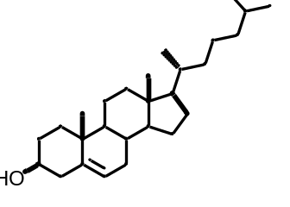
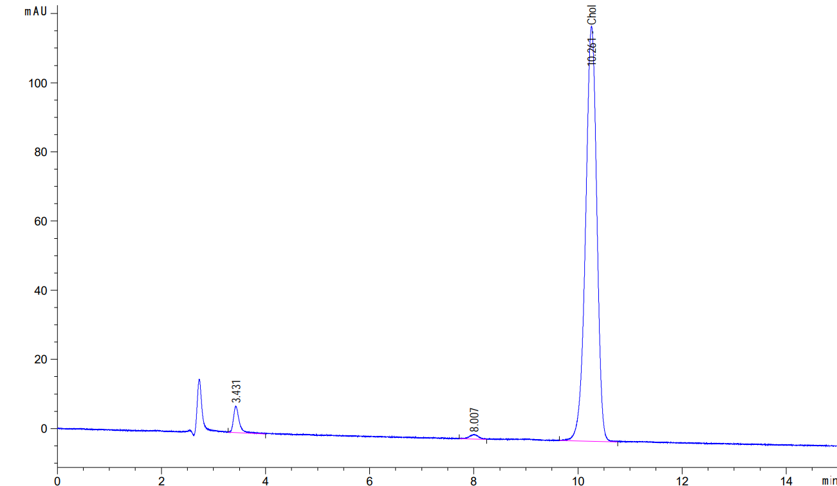
Cholesterol (standard), λ(200 nm)
Figure S2 HPLC-profile (mobile phase acetonitrile:2-propanol:water (50:45:5 v/v/v/))

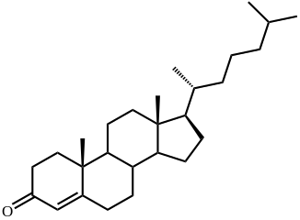
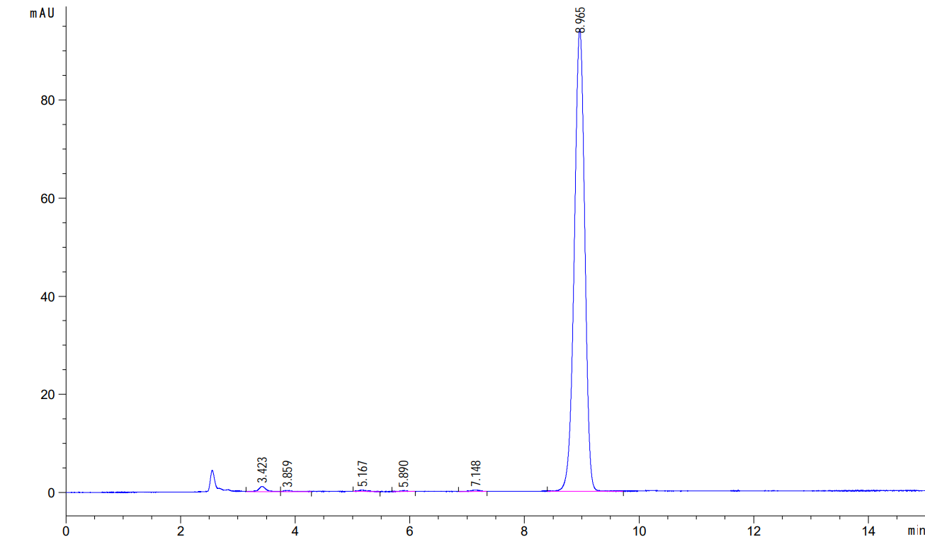
Cholest-4-en-3-one (cholestenone) (standard), λ (240 nm)
Figure S3 HPLC-profile (mobile phase acetonitrile:2-propanol:water (50:45:5 v/v/v/))
of the individual compound isolated from the transformation media at the cholesterol conversion by S.hirsuta

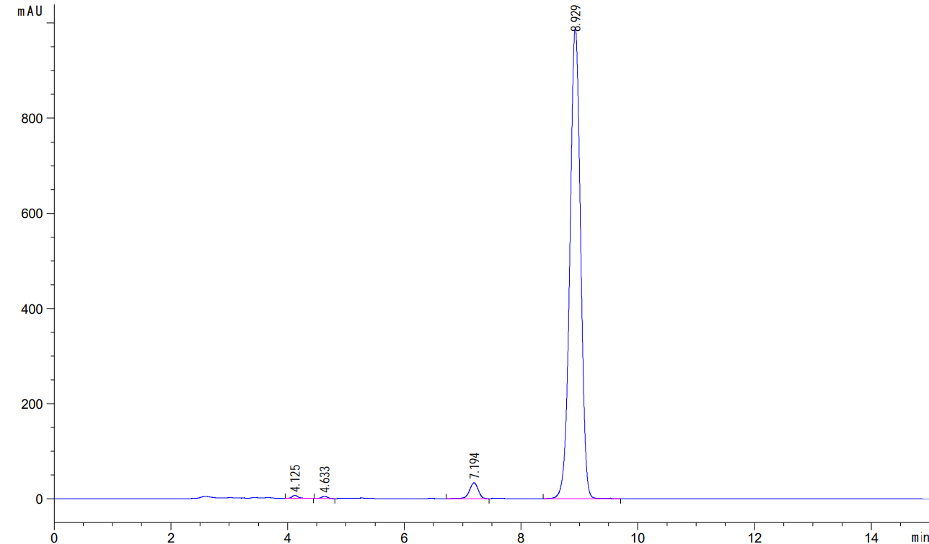
Cholest-4-en-3-one (II), λ (240 nm)

Figure S4 HPLC-profile (mobile phase acetonitrile:2-propanol:water (50:45:5 v/v/v/))
of the individual compound isolated from the transformation media at the cholesterol conversion by S.hirsuta

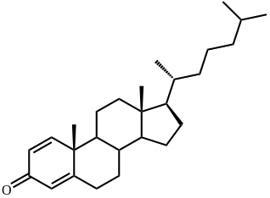
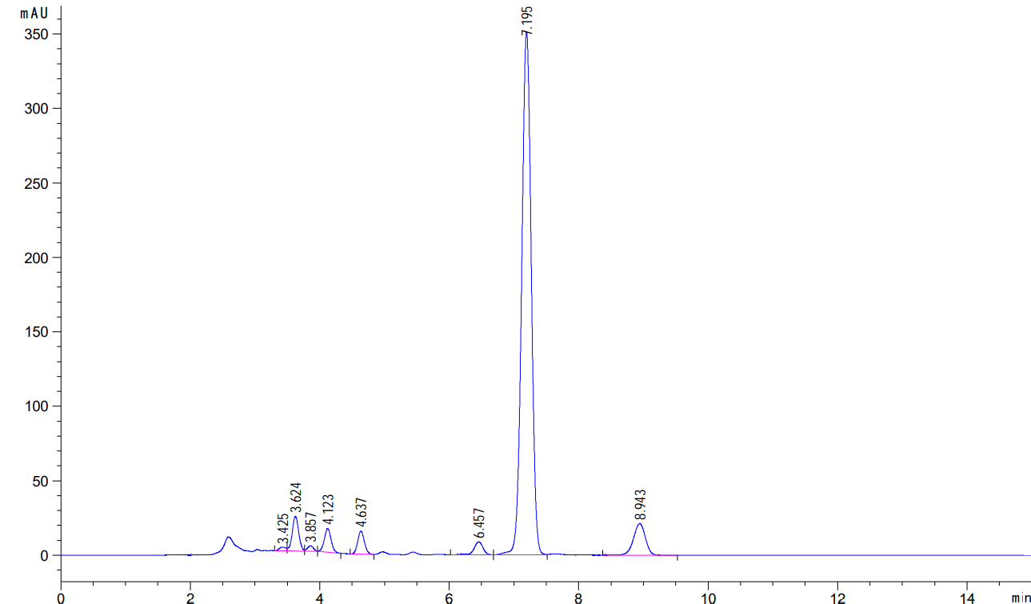
Cholesta-1,4-dien-3-one (III), λ (240 nm)
Figure 5 HPLC-profile (mobile phase acetonitrile:2-propanol:water (50:45:5 v/v/v/))
of the individual compound isolated from the transformation media at the cholesterol conversion by S.hirsuta

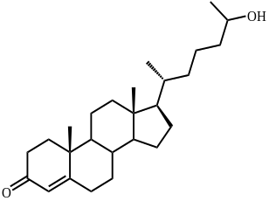
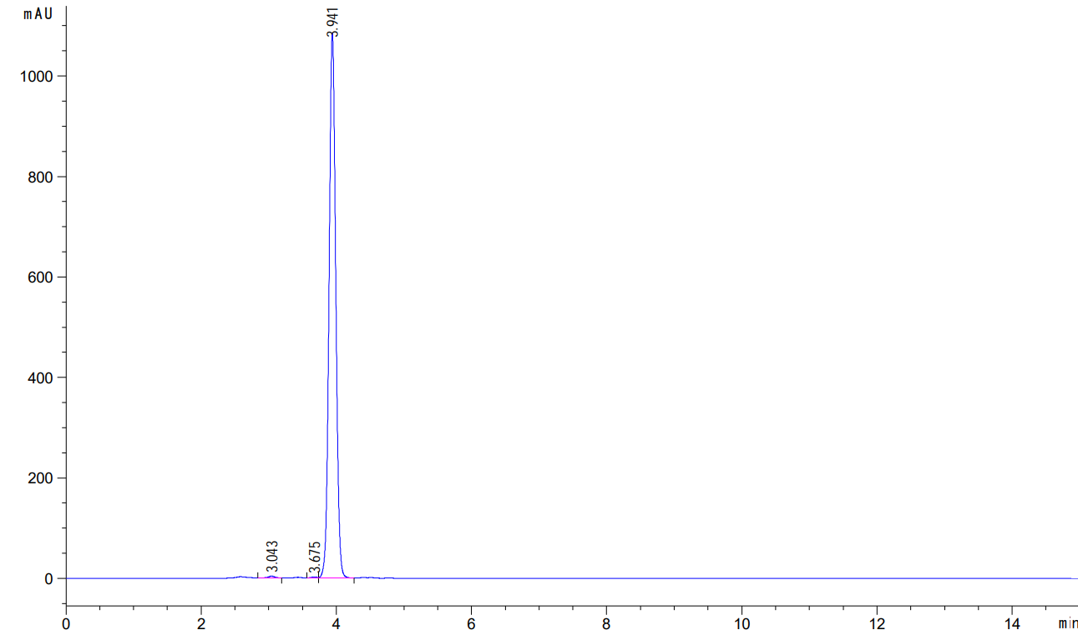
26-Hydroxycholest-4-en-3-one (IV), λ (240 nm)
Figure S6 HPLC-profile (mobile phase acetonitrile:2-propanol:water (50:45:5 v/v/v/))
of the individual compound isolated from the transformation media at the cholesterol conversion by S.hirsuta

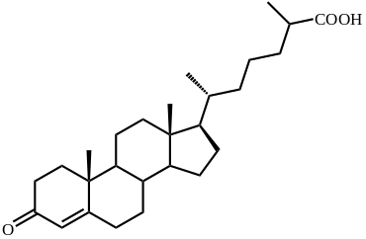
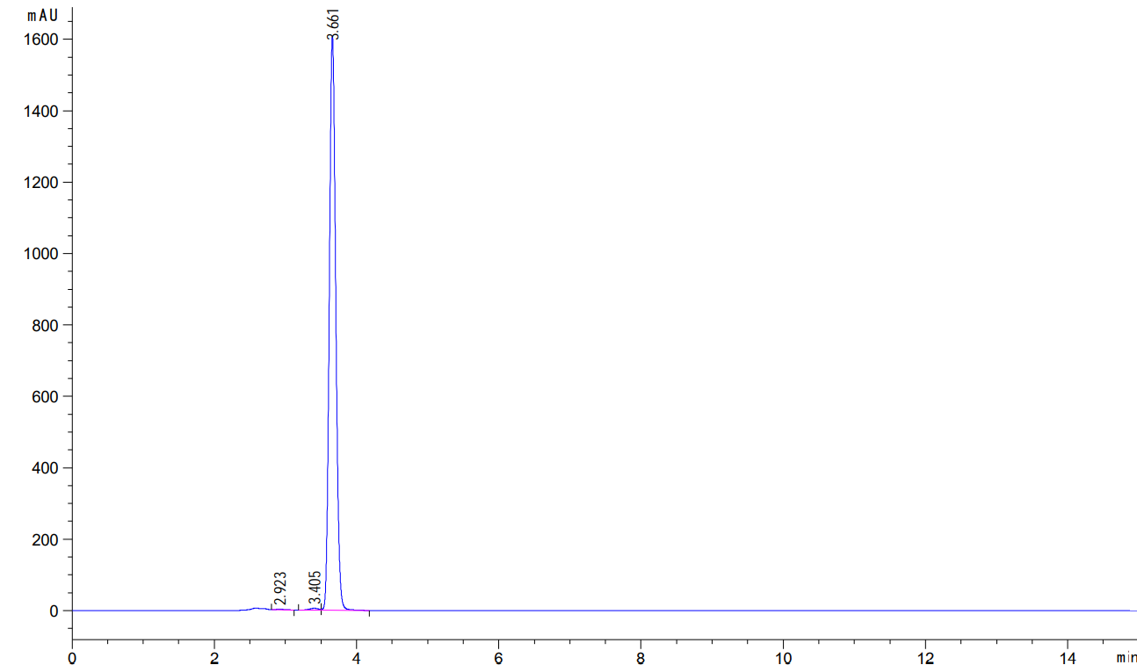
3-Oxo-cholest-4-en-26-oic acid (V), λ (240 nm)
Figure S7 HPLC-profile (mobile phase acetonitrile:2-propanol:water (50:45:5 v/v/v/))
of the individual compound isolated from the transformation media at the cholesterol conversion by S.hirsuta

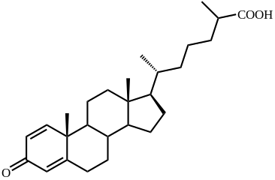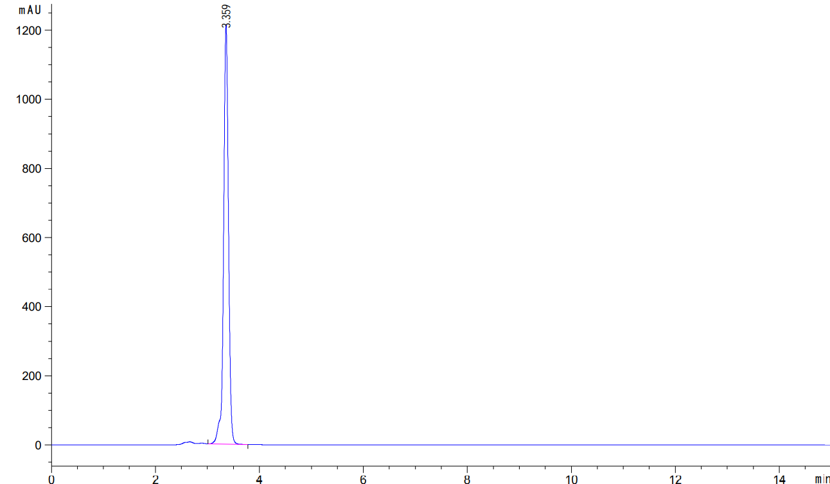
3-Oxo-cholesta-1,4-dien-26-oic acid (VI), λ (240 nm)
Figure S8 HPLC-profile (mobile phase acetonitrile:2-propanol:water (50:45:5 v/v/v/))
of the individual compound isolated from the transformation media at the cholesterol conversion by S.hirsuta

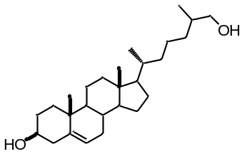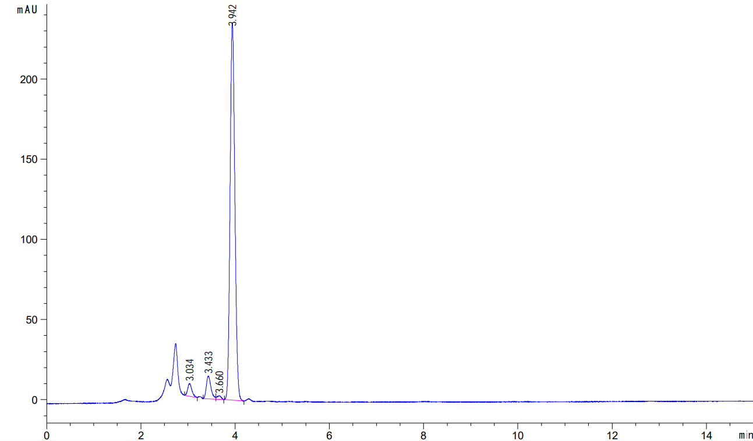
26-Hydroxycholesterol (VII), λ (200 nm)
Figure S9 HPLC-profile (mobile phase acetonitrile:2-propanol:water (50:45:5 v/v/v/))
of the individual compound isolated from the transformation media at the cholesterol conversion by S.hirsuta

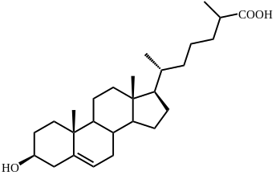
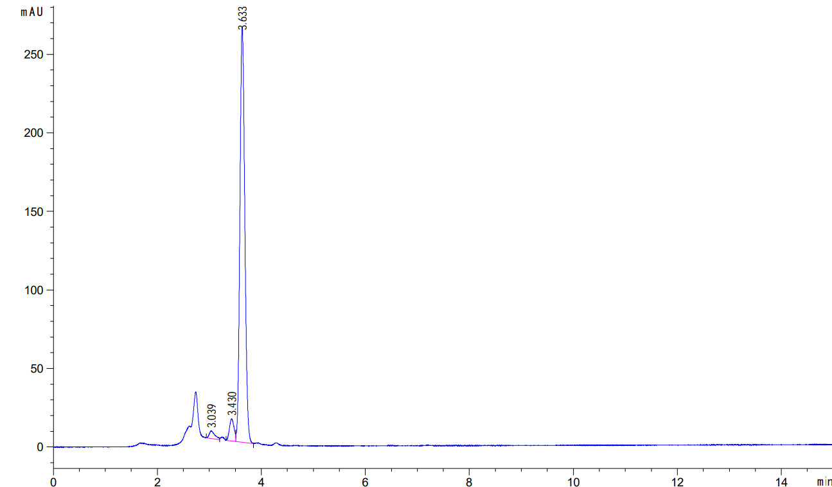
3β-Hydroxycholest-5-en-26-oic acid (VIII), λ (200 nm)
Figure S10 HPLC-profile (mobile phase acetonitrile:water:acetic acid (60:40:0.01 v/v/v/))
of the individual compound isolated from the transformation media at the cholesterol conversion by S.hirsuta

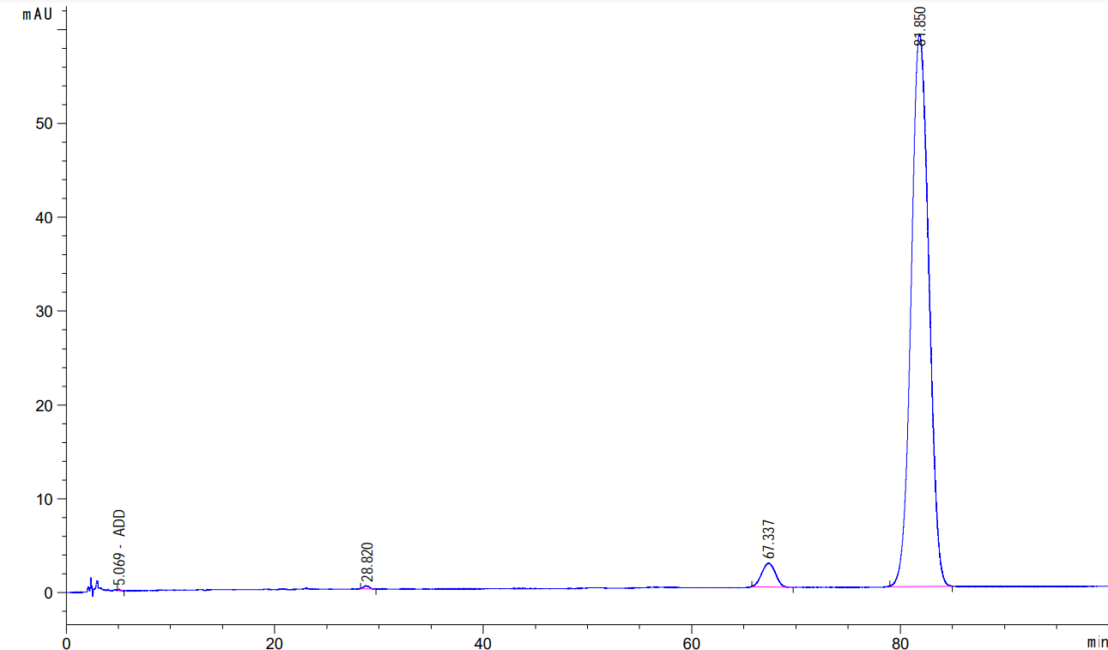
26-Hydroxycholest-4-en-3-one (IV), λ (240 nm)

Figure S11 HPLC-profile (mobile phase acetonitrile:water:acetic acid (60:40:0.01 v/v/v/))
of the individual compound isolated from the transformation media at the cholesterol conversion by S.hirsuta

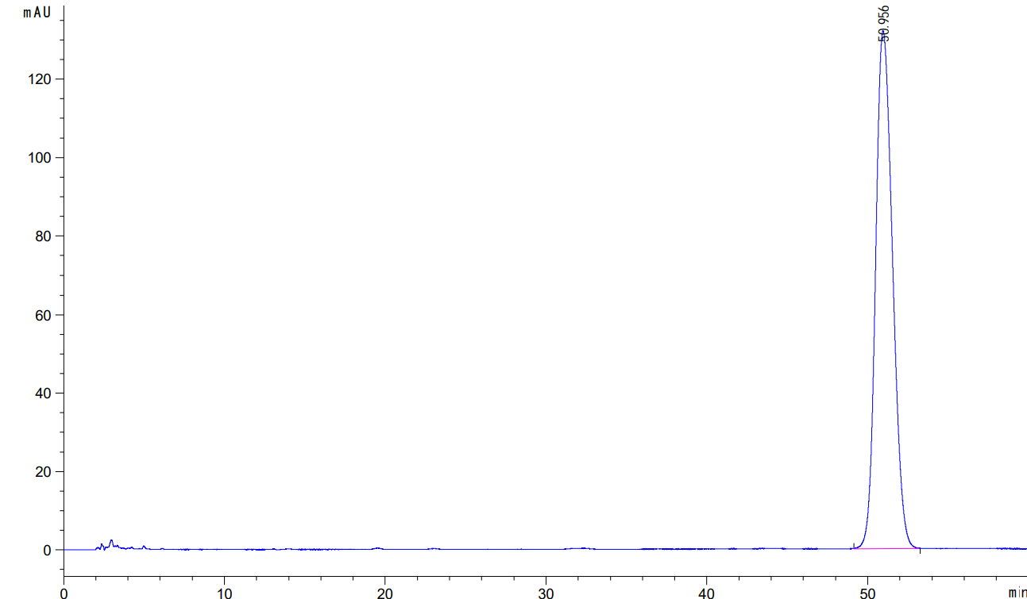
3-Oxo-cholest-4-en-26-oic acid (V), λ (240 nm)
Figure S12 HPLC-profile (mobile phase acetonitrile:water:acetic acid (60:40:0.01 v/v/v/))
of the individual compound isolated from the transformation media at the cholesterol conversion by S.hirsuta

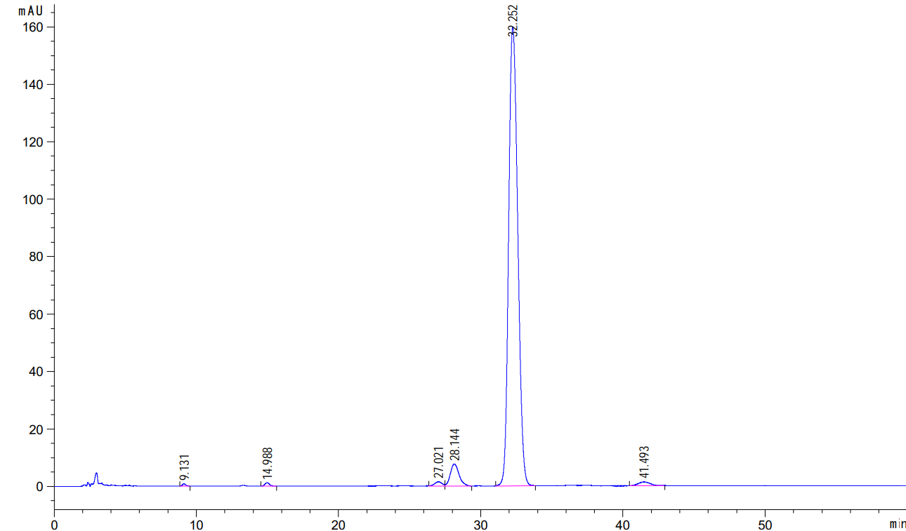
3-Oxo-cholesta-1,4-dien-26-oic acid (VI), λ (240 nm)
Figure S13 HPLC-profile (mobile phase acetonitrile:water:acetic acid (60:40:0.01 v/v/v/))
of the individual compound isolated from the transformation media at the cholesterol conversion by S.hirsuta

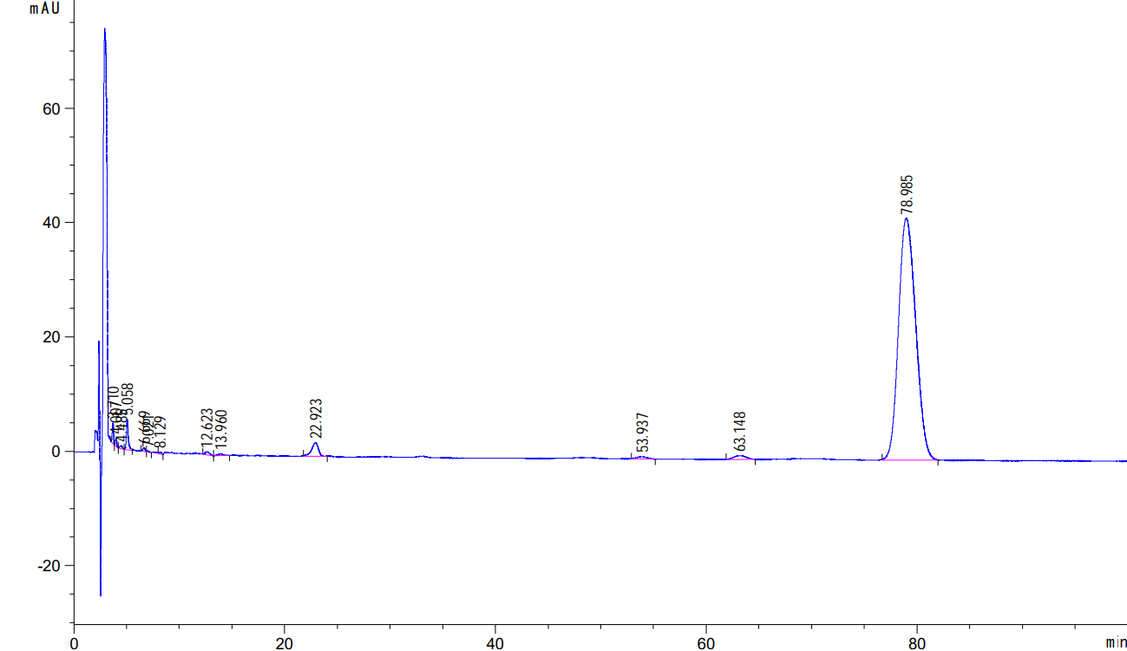
26-Hydroxycholesterol (VII), λ (200 nm)
Figure S14 HPLC-profile (mobile phase acetonitrile:water:acetic acid (60:40:0.01 v/v/v/))
of the individual compound isolated from the transformation media at the cholesterol conversion by S.hirsuta

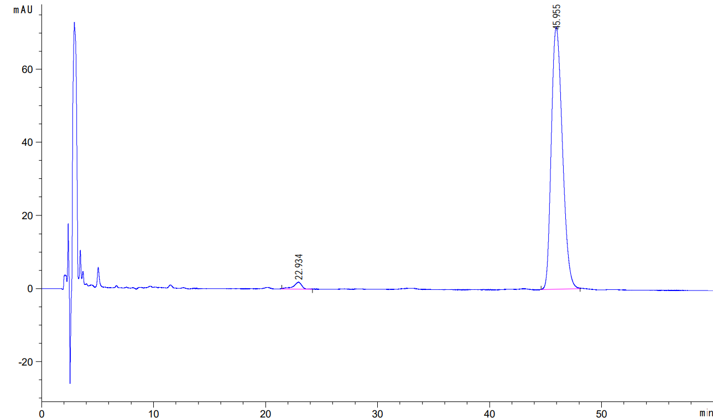
3β-Hydroxycholest-5-en-26-oic acid (VIII), λ (200 nm)
Figure S15 Mass spectrum [M+H]⁺
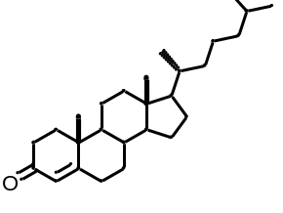
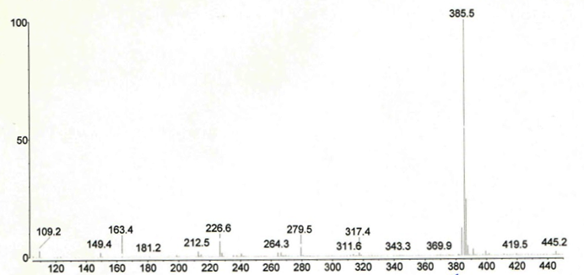
Cholest-4-en-3-one (384) (II)
Figure S16 Mass spectrum [M+H]⁺
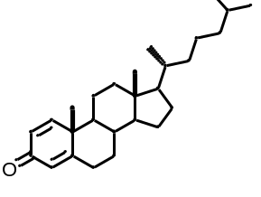
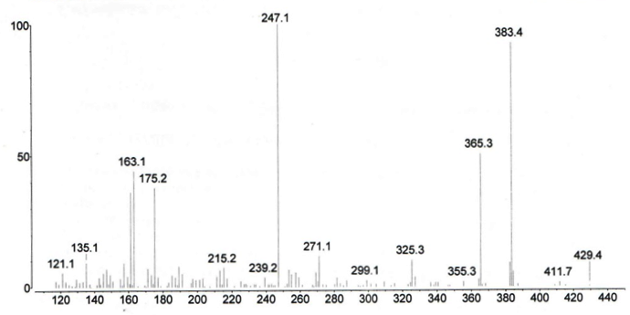
Cholesta-1,4-dien-3-one (382) (III), (collision energy 33 eV)
Figure S17 Mass spectrum [M+H]⁺
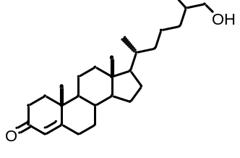
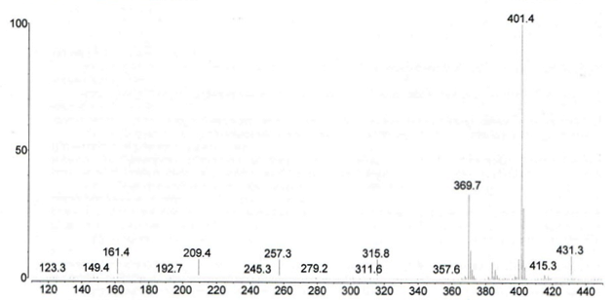
26-Hydroxy-cholest-4-en-3-one (400) (IV)

Figure S18 Mass spectrum [M-H]⁺

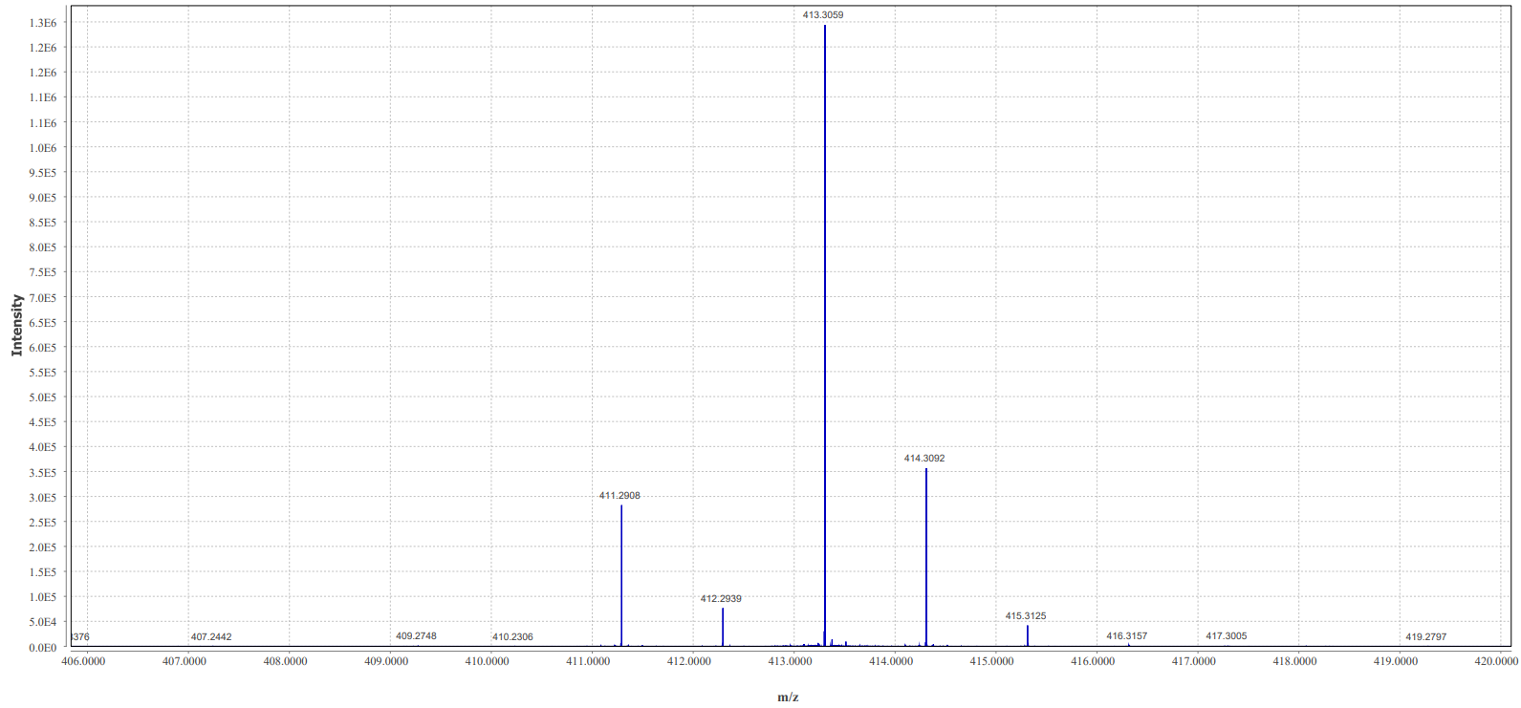
HRMS-ESI (m/z): [M-H]⁺ calcd for C₂₇H₄₁O₃ 413,3056; found 413,3059
3-Oxo-cholest-4-en-26-oic acid (414) (V)

Figure S19 Mass spectrum [M-H]⁺

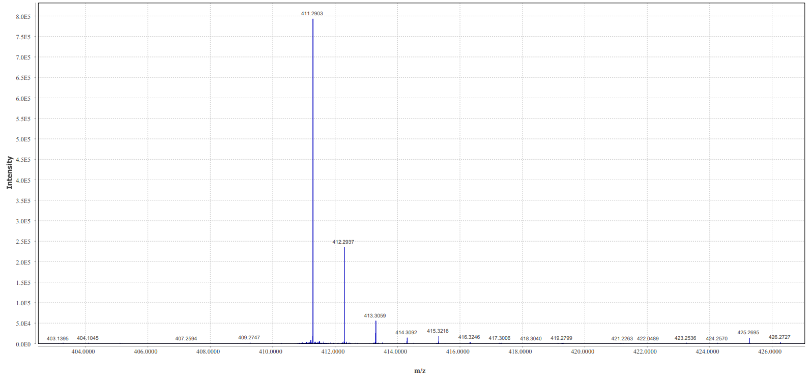
HRMS-ESI (m/z): [M-H]⁺ calcd for C₂₇H₃₉O₃ 411,2899; found 411, 2903
3-Oxo-cholesta-1,4-dien-26-oic acid (412) (VI)

Figure S20 Mass spectrum [M-H]⁺

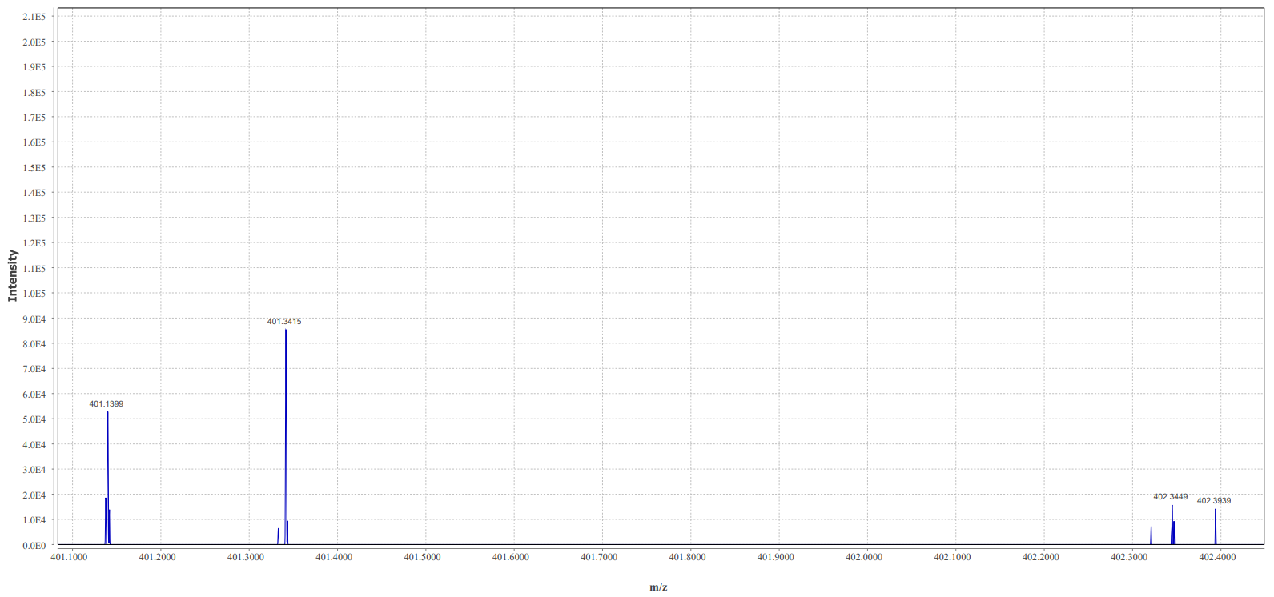
HRMS-ESI (m/z): [M-H]⁺ calcd for C₂₇H₄₅O₂ 401,3420; found 401,3415
26-Hydroxycholesterol (402) (VII)

Figure S21 Mass spectrum [M-H]⁺

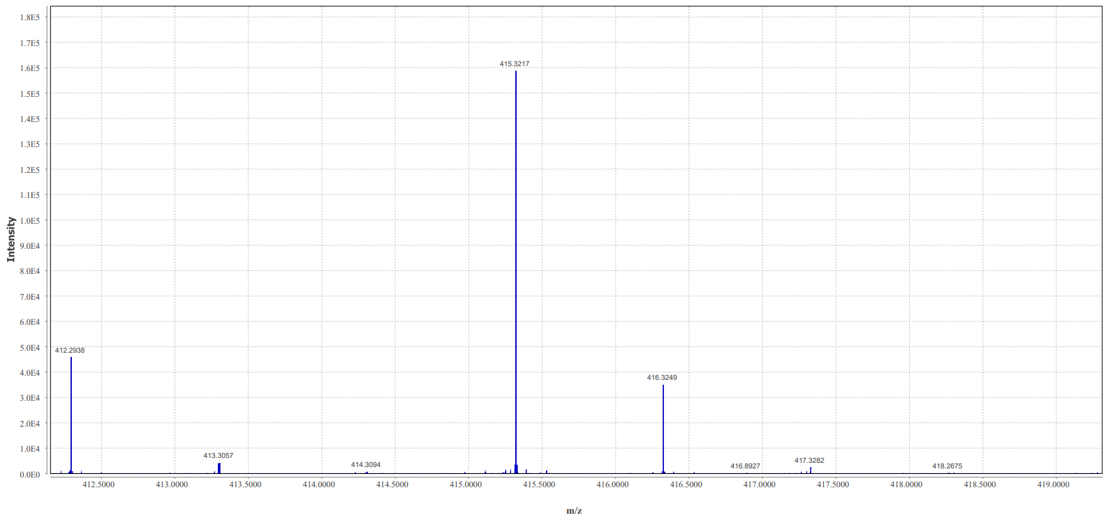
HRMS-ESI (m/z): [M-H]⁺ calcd for C₂₇H₄₃O₃ 415,3212; found 415,3217
3β-Hydroxycholest-5-en-26-oic acid (416) (VIII)
Figure S22 ¹H-NMR spectrum
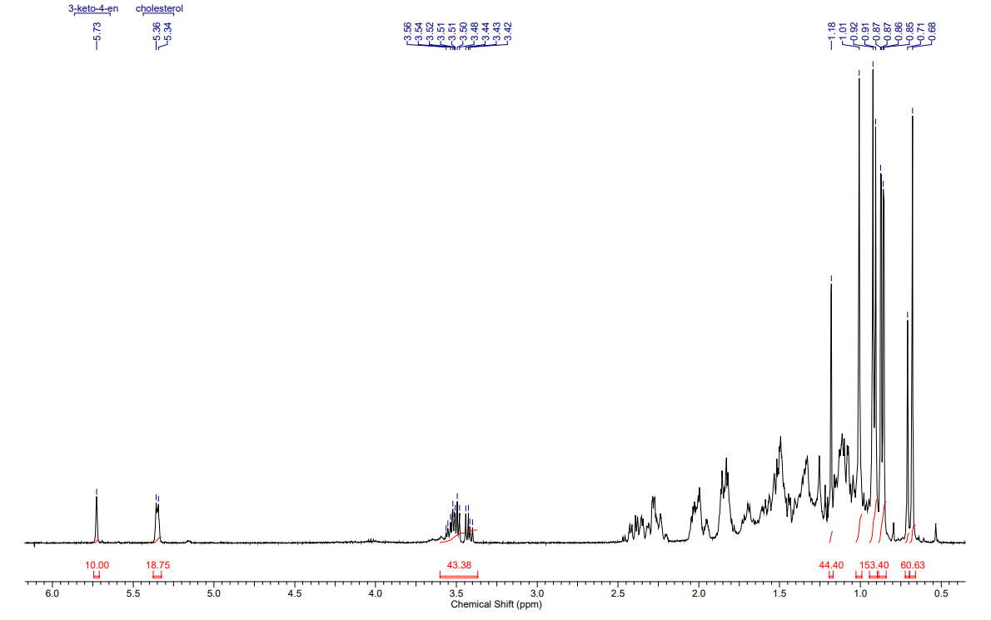
Cholest-4-en-3-one (II)
Figure S23 ¹H-NMR spectrum
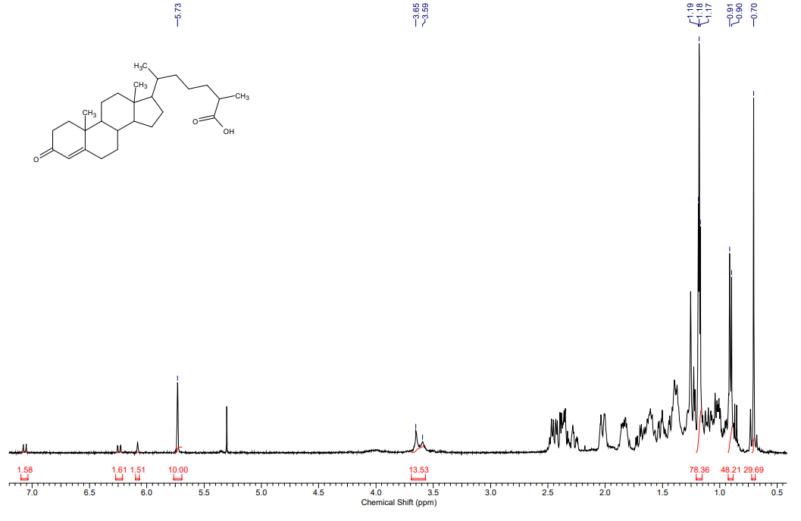3-Oxo-cholest-4-en-26-oic acid (V)
Figure S24 ¹³C-NMR spectrum

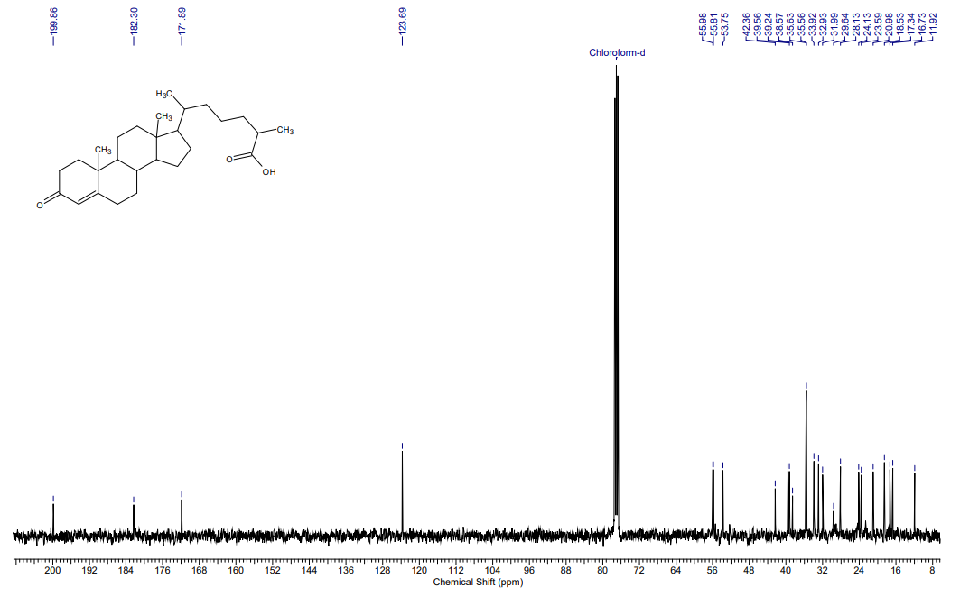
3-Oxo-cholest-4-en-26-oic acid (V)
Figure S25 ¹H-NMR spectrum
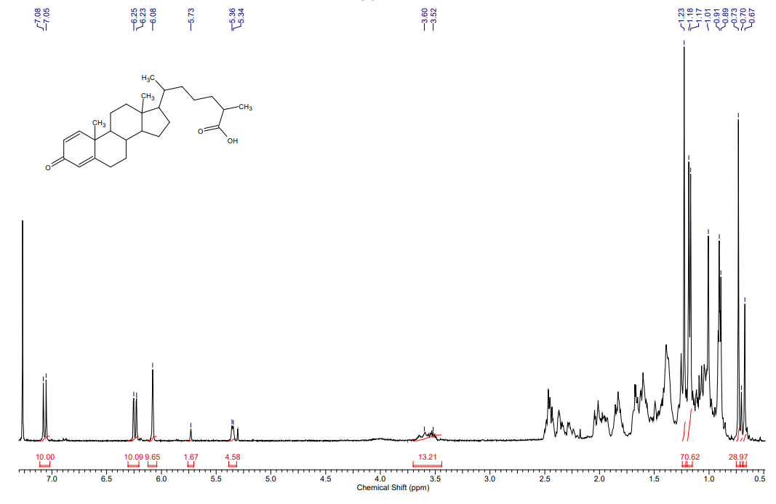3-Oxo-cholesta-1,4-dien-26-oic acid (VI)
Figure S26 ¹³C-NMR spectrum
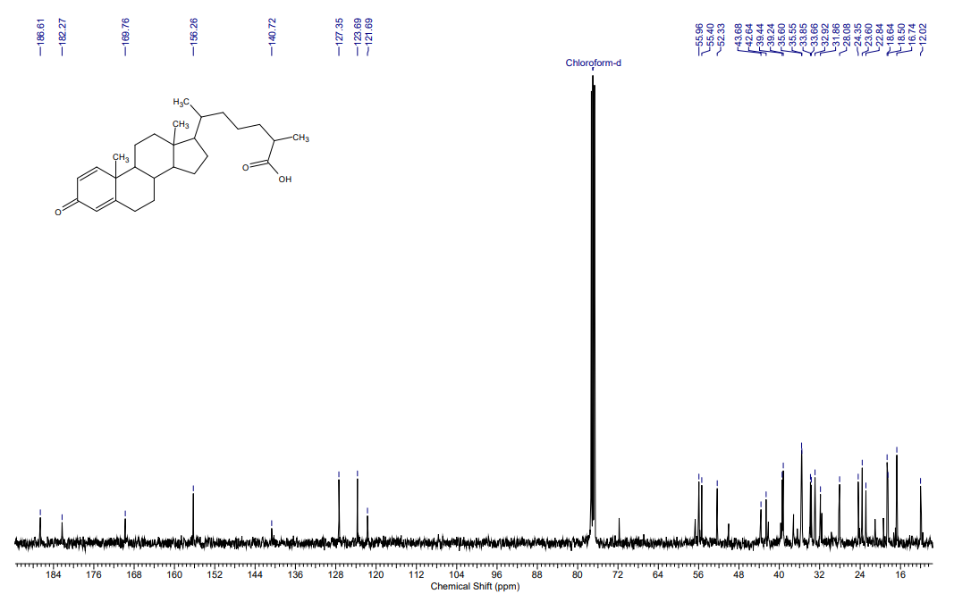
3-Oxo-cholesta-1,4-dien-26-oic acid (VI)
Figure S27 ¹H-NMR spectrum
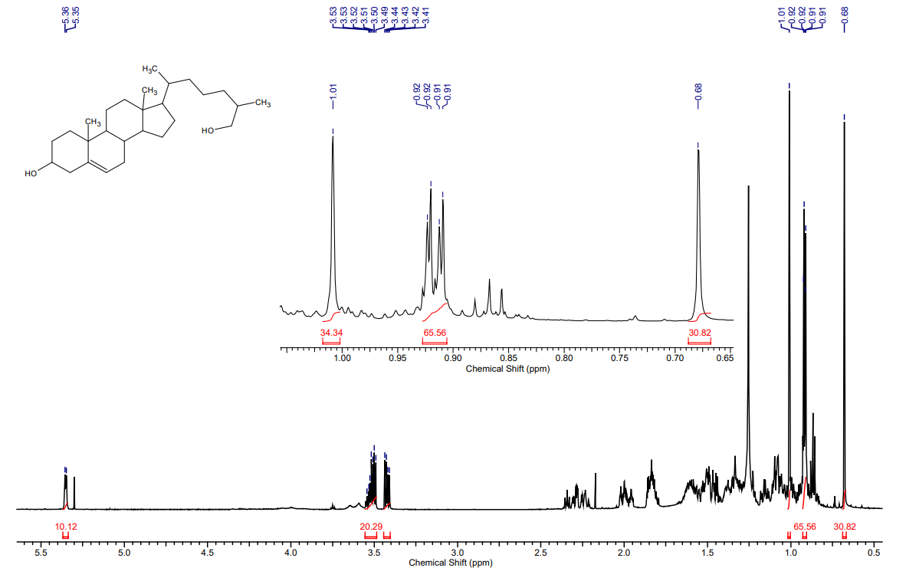26-Hydroxycholesterol (VII)
Figure S28 ¹³C-NMR spectrum
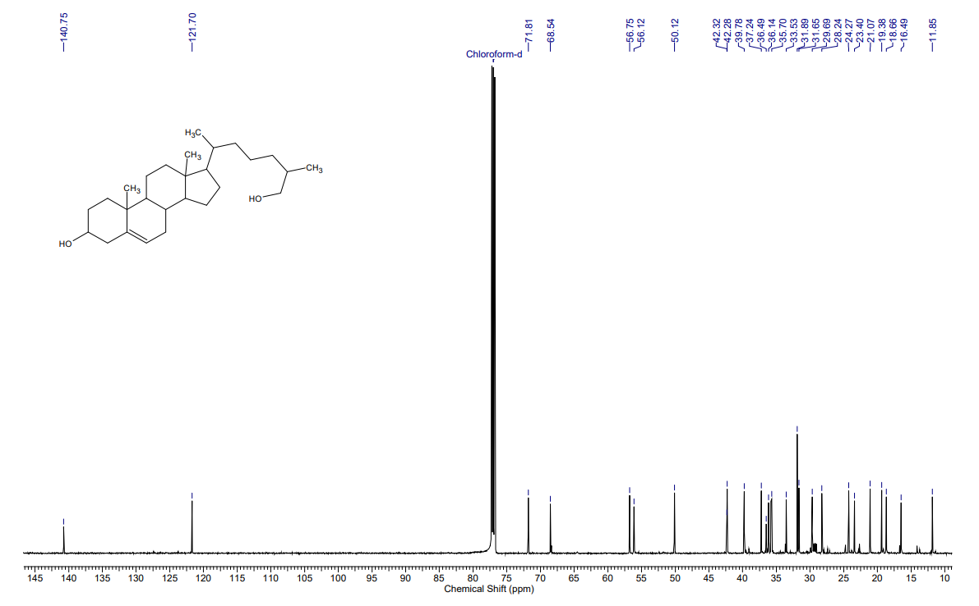
26-Hydroxycholesterol (VII)
Figure S29 ¹H-NMR spectrum
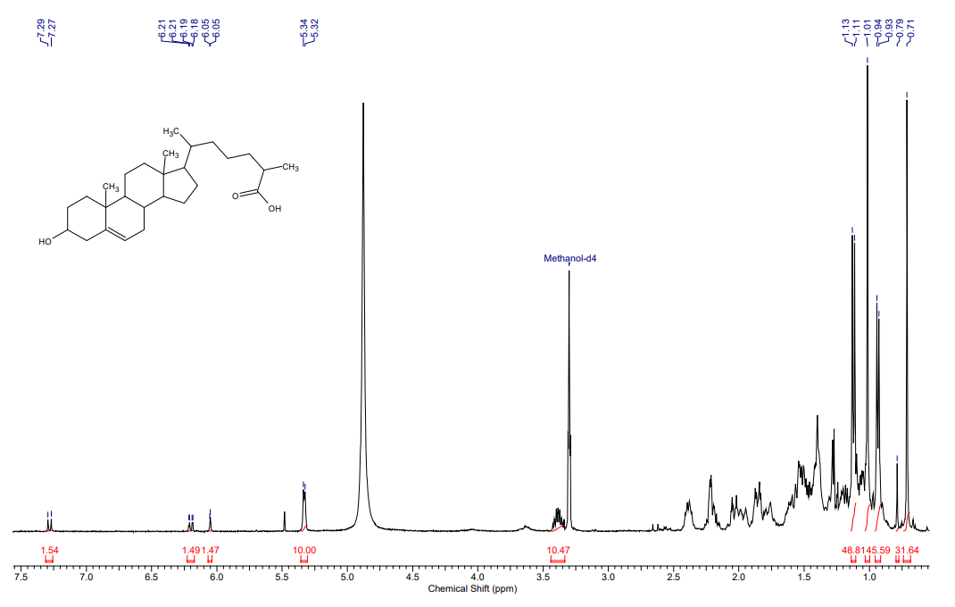3β-Hydroxycholest-5-en-26-oic acid (VIII)
Figure S30 ¹³C-NMR spectrum
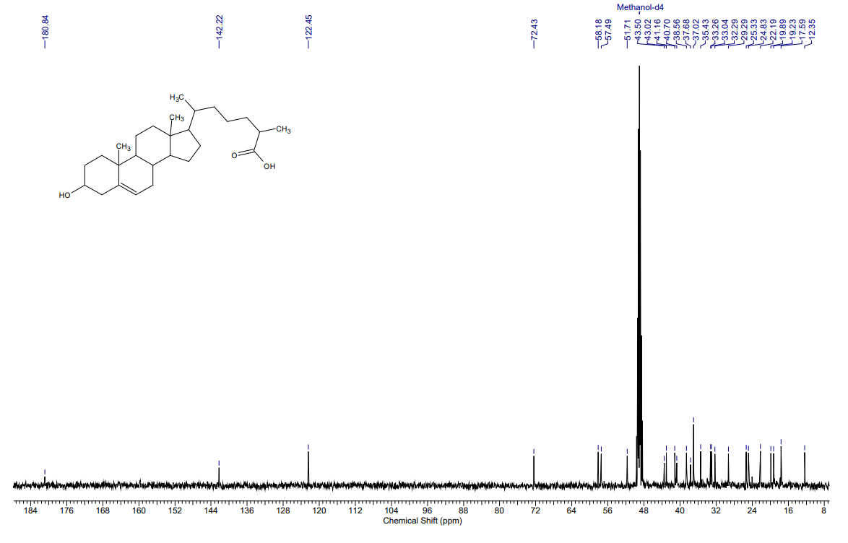
3β-Hydroxycholest-5-en-26-oic acid (VIII)

