Supplementary Material for
Predicting summer droughts in Central Europe from winter NAO
Cong Jiang ¹, Chris Soulsby ^{2,3,1}, Hjalmar Laudon ³, Songjun Wu ¹, Doerthe Tetzlaff ^{1, 4, 2}
¹ Leibniz-Institute of Freshwater Ecology and Inland Fisheries (IGB), Department of Ecohydrology and Biogeochemistry, Berlin, Germany
² Northern Rivers Institute, University of Aberdeen, Aberdeen, UK
³ Department of Forest Ecology and Management, Swedish University of Agricultural Science (SLU), Sweden
⁴ Department of Geography, Humboldt University Berlin, Berlin, Germany
Correspondence to: Cong Jiang (cong.jiang@igb-berlin.de)

Contents of this file
Figure S1 to Figure S8
Table S1
Text S1 to Text S4

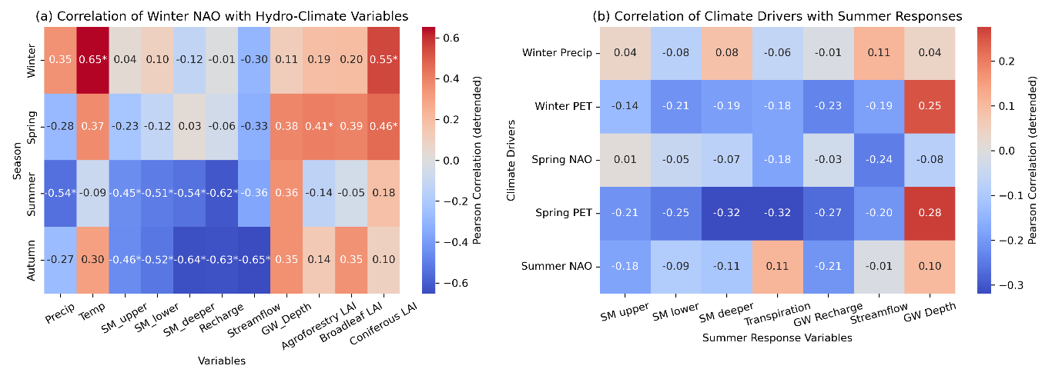
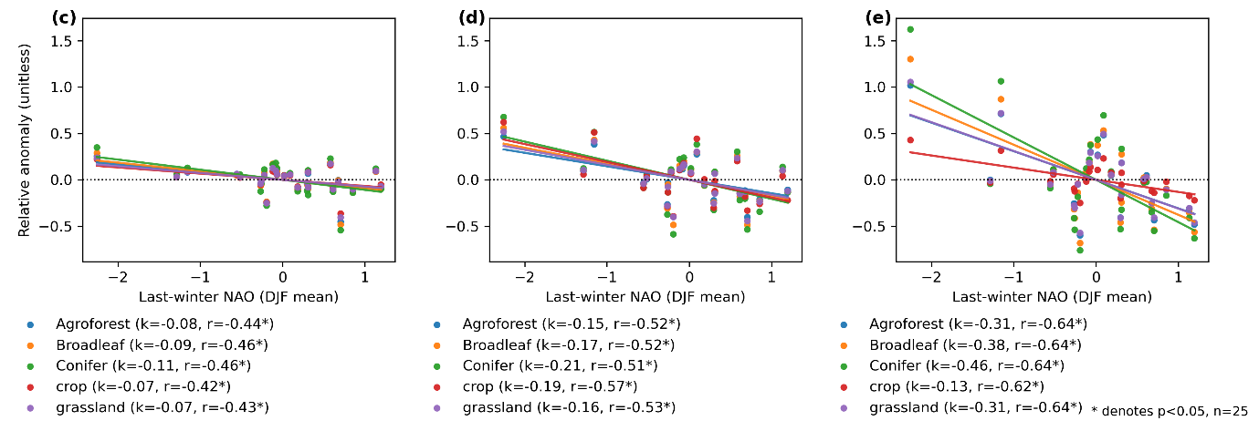

Figure S1. Correlation heatmaps showing the influence of the North Atlantic Oscillation (NAO) and climate drivers on hydro-ecohydrological variables in the Demnitzer Mill Creek catchment (DMC) (a) Detrended correlations between the winter NAO index and subsequent seasonal (winter, spring, summer, autumn) climate and hydrological variables. (b) Correlations between seasonal climate drivers (NAO, precipitation, PET) and summer ecohydrological responses, including soil moisture, groundwater recharge, transpiration, groundwater depth, and streamflow. Modeled soil moisture, transpiration, and groundwater recharge at the broadleaf forest site, along with observed groundwater depth and streamflow from gauge stations (Figure 4), are presented. (c–e) Relationships between detrended previous winter NAO, expressed as the December–February (DJF) mean index, and detrended autumn soil moisture anomalies for surface (0–10 cm), lower (10–30 cm), and deep (30–100 cm) layers. Anomalies are relative to the 2000–2024 summer mean for land-use types: broadleaf forest, conifer forest, agroforest, crop, and grassland. Values represent Pearson correlation coefficients after detrending; asterisks (*) denote statistical significance at p < 0.05.
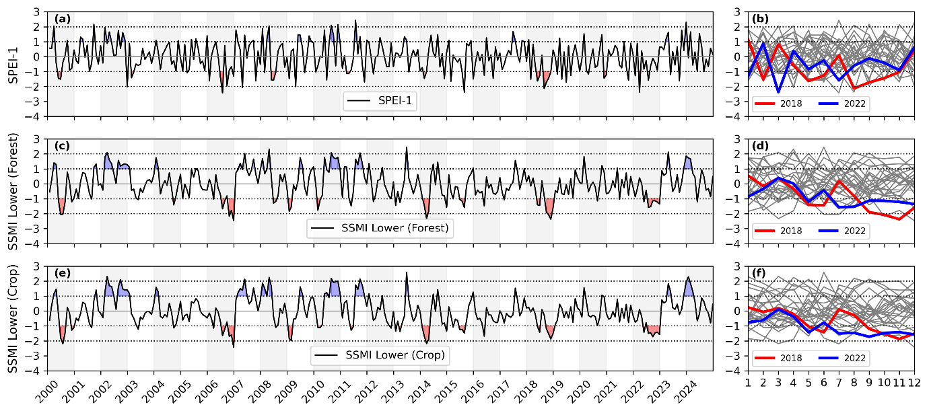

Figure S2. Monthly time series (left) and intra-annual cycles (right) of different standardized 1-month drought indices for the Demnitzer Mill Creek (DMC) catchment, Germany (2000–2024). Panels show (a, b) SPEI-1, (c, d) SSMI (lower 10–30 cm) for broadleaf forest, and (e, f) SSMI (lower 10–30 cm) for crop. Red shading denotes drought (index < –1) and blue denotes wet anomalies (index > 1). Gray lines indicate all years; colored lines highlight drought years 2018 and 2022.

Text S1. Synoptic-Scale Atmospheric Anomalies Associated with the 2018 and 2022 Droughts in Central Europe
The droughts of 2018 and 2022 (Figure S3) illustrate how synoptic-scale atmospheric anomalies compound ecohydrological drought risk in Central Europe’s lowlands. Both events were characterized by persistent positive anomalies in 500 hPa geopotential height (Z500), reflecting quasi-stationary blocking highs that suppressed moisture advection into the region (Figures S3a, S3b). At 850 hPa, easterly wind anomalies reduced onshore Atlantic moisture transport, exacerbating precipitation deficits (Figures S3c, S3d, S3g and S3h). These circulation anomalies coincided with widespread positive surface temperature anomalies, which elevated evaporative demand and accelerated soil moisture depletion (Figures S3e and S3f). Together, the persistence of blocking and altered westerly flow patterns sustained drought conditions across Central Europe during these events, consistent with earlier studies linking atmospheric circulation anomalies to European droughts (Bakke et al., 2023; Benedict et al., 2021; Buras et al., 2020).

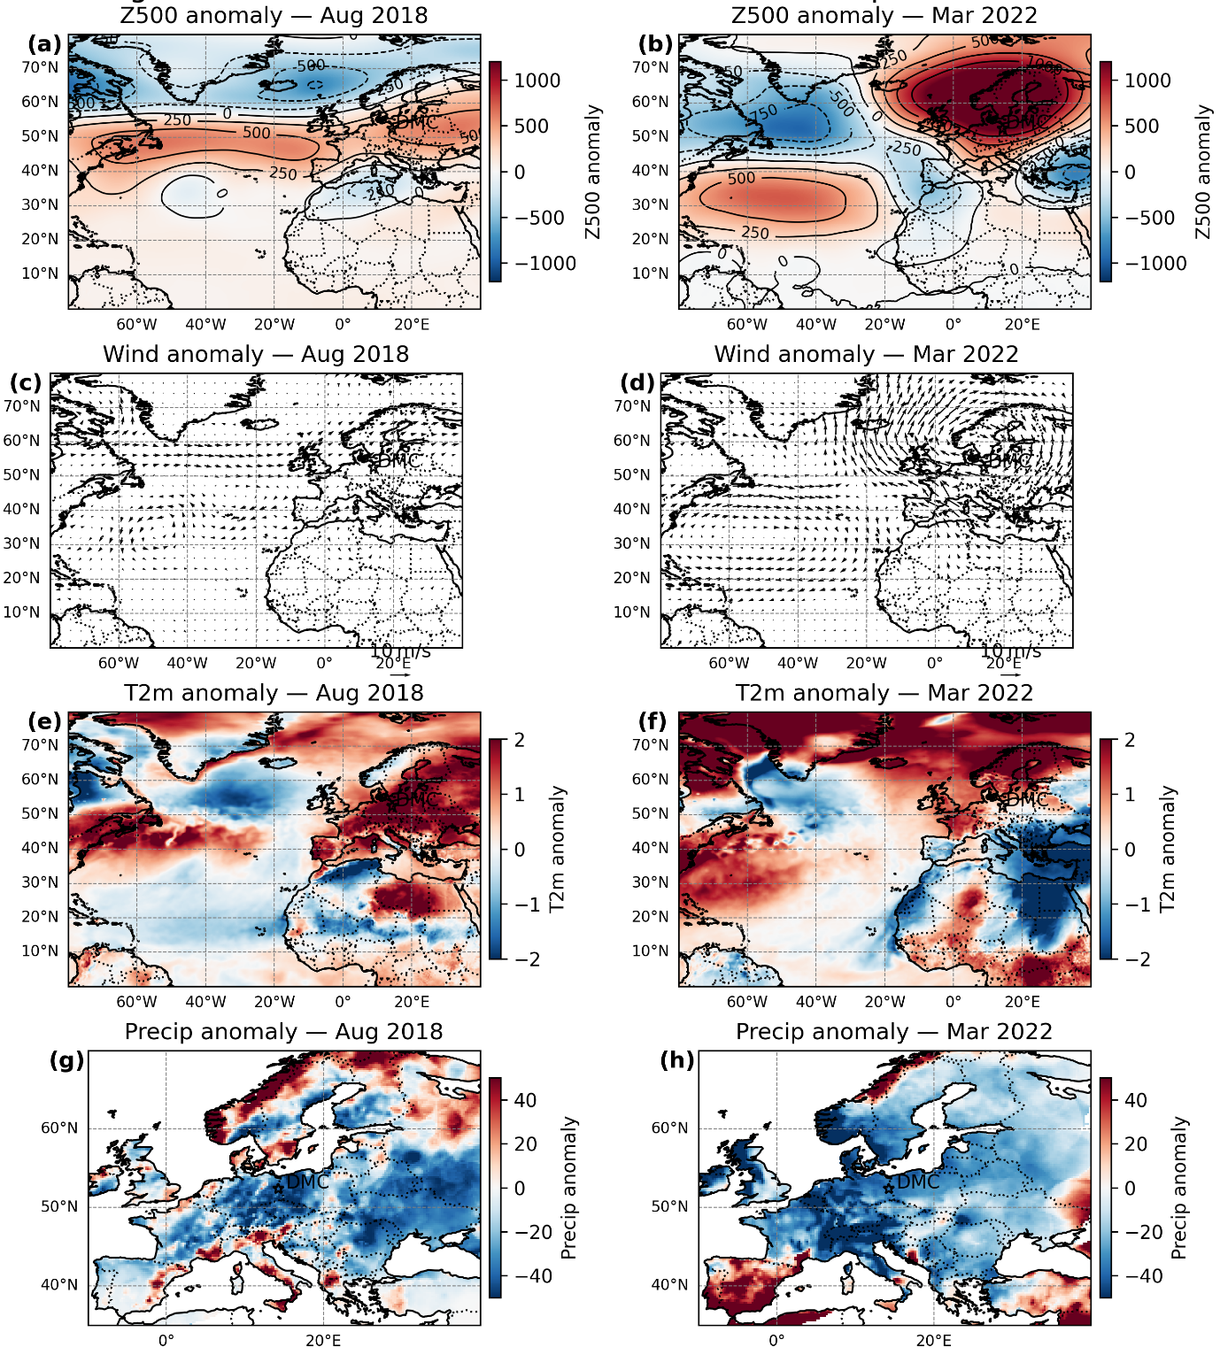

Figure S3. Monthly anomalies for August 2018 (left) and March 2022 (right): (a–b) 500 hPa geopotential height anomalies (Z500; shading, with 250 m contours), (c–d) 850 hPa wind anomalies (vectors; reference = 10 m s⁻¹), (e–f) 2 m air temperature anomalies (T2m), and (g–h) precipitation anomalies. Z500, wind, and T2m are shown over the North Atlantic–Europe sector; precipitation over Europe. The DMC site (14.25°E, 52.38°N) is marked by a star. Anomalies are relative to the study climatology.

Text S2. Winter NAO and Hydroclimatic Variability at the DMC Catchment
Comparison of winter NAO indices with hydroclimatic variability at DMC revealed a strong correlation: positive NAO winters frequently align with dry summers and droughts (Figure S3), while negative NAO winters often precede wetter conditions and even exceptional streamflow peaks, as observed in 2010 (Figure 2g and Figure S4e). A pronounced NAO phase shift during 2010–2012 (Santos et al., 2013) coincided with marked declines in summer streamflow and groundwater levels at the DMC site (Wu et al., 2021), underscoring the importance of winter teleconnections for subsequent ecohydrological responses.

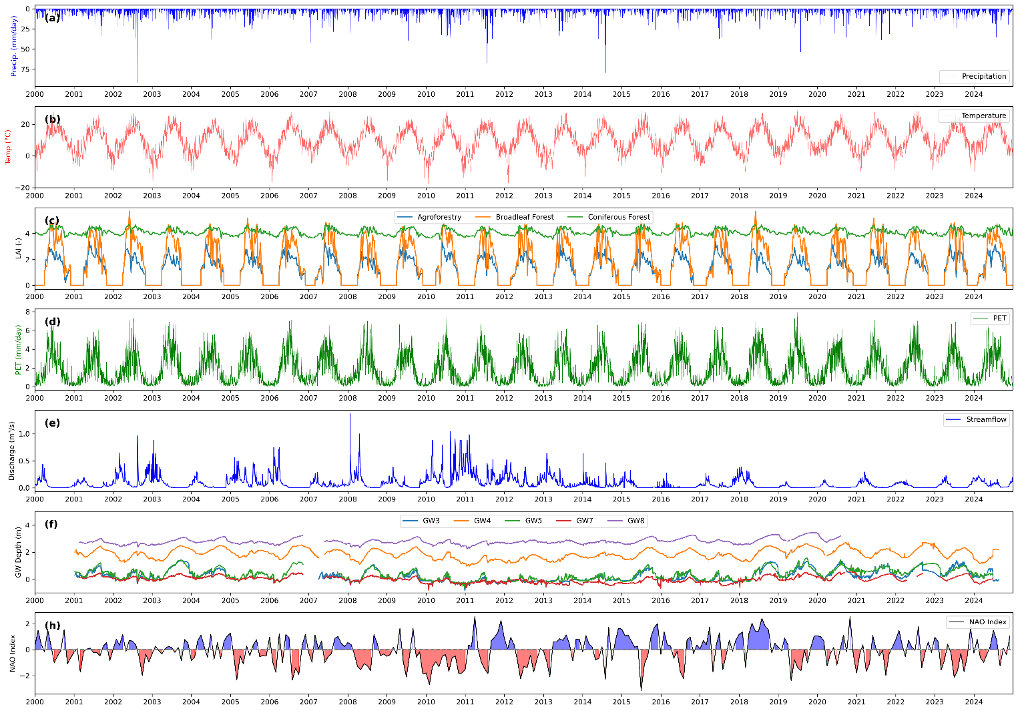

Figure S4. Time series of observed and derived ecohydrological and climatic variables in the DMC catchment: (a) Precipitation, (b) Air temperature, (c) Leaf area index (LAI) for agroforest, conifer, and broadleaf forests, (d) Potential evapotranspiration (PET), (e) Streamflow, (f) Groundwater level, (g) North Atlantic Oscillation (NAO) index. Shaded areas in the time series indicate negative NAO (red, index < –1) and positive NAO (blue, index > +1). All variables are at daily resolution, except for the NAO index, which is at monthly resolution.

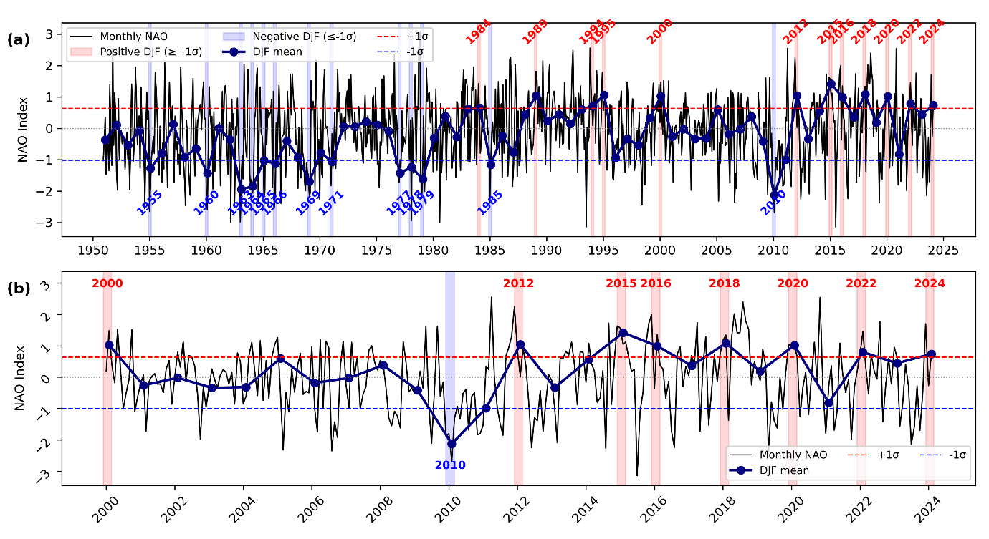

Figure S5. Monthly North Atlantic Oscillation (NAO) index values (black line) and winter (DJF) mean NAO (navy blue circles and line) for (a) 1950–2024, classified using the 1950–2024 baseline mean (μ) and standard deviation (σ), and (b) 2000–2024, classified using the 2000–2024 baseline. Shaded vertical red and blue bands indicate positive (NAO⁺; DJF ≥ μ + σ) and negative (NAO⁻; DJF ≤ μ – σ) winters, respectively. Horizontal red and blue dashed lines represent the thresholds of μ + σ and μ – σ, respectively.

Table S1. Kling-Gupta Efficiency (KGE) values for soil moisture and δ²H in soil water, based on observed values compared to the mean simulated values.
Forest sites | Soil moisture [-] |  |  | Soil water isotope [-]  δ²H
Forest sites | Upper soil compartment | Lower soil compartment | Deep soil compartment | Upper soil compartment | Lower soil compartment | Deep soil compartment
Broadleaf Forest | 0.60 | 0.72 | 0.84 | 0.58 | 0.74 | 0.64
Agroforestry | 0.72 | 0.76 | 0.78 | 0.81 | 0.84 | 0.78
Grassland | 0.87 | 0.67 | 0.71 | 0.72 | 0.76 | 0.60
Cropland | 0.53 | 0.54 | 0.71 | 0.82 | 0.84 | 0.28

Text S3. Evolution of Drought Indices and Ecohydrological Variables Under Positive and Negative Winter NAO Phases
Figure S6 indicates that short-term anomalies (SPI-1, SPEI-1) show drier conditions during positive NAO winters from late winter and early spring, with deficits extending into summer. Seasonal-scale anomalies (SPI-3, SPEI-3) begin to diverge between phases from April onward, with positive NAO years remaining drier through summer. Annual-scale anomalies (SPI-12, SPEI-12) display persistent deficits in both precipitation and precipitation–PET balance by the end of positive NAO years. Overall, these patterns demonstrate that winter NAO exerts a cumulative influence on hydroclimatic conditions across multiple timescales, with positive phases progressively preconditioning the basin for drier growing seasons.
Across all depths, positive NAO winters are associated with negative soil moisture anomalies compared to negative NAO winters, with the strongest deficits occurring in summer (Fig. S7a–f). Negative anomalies first appear in the upper soil layer (starting in April, Figs. S7a, S7b), then in the lower (starting in May, Figs. S7c, S7d) and deep layers (starting in June, Figs. S7e, S7f), indicating an approximate one-month lag in drought propagation through the soil profile. This pattern is similar for standardized index under both cropland and forest cover.
Recharge negative anomalies closely align with soil moisture deficits (starting in April, Figs. S7g, S7h) and persist throughout the year in positive NAO years. For transpiration, cropland shows positive anomalies during winter, and both broadleaf forest and cropland exhibit positive anomalies in spring, likely due to warmer winter and spring conditions during positive NAO phases, followed by negative anomalies in summer (starting in June, Figs. 7i, 7j), consistent with the soil moisture anomalies observed in that season.
Standardized streamflow indices are generally much lower in positive NAO years, with deficits beginning in May and reaching their largest values in summer and autumn (Fig. S7k). Positive NAO years also show reduced groundwater levels from May through the following autumn, with deficits continuing over this period (Fig. S7l).
Overall, positive winter NAO phases precondition the catchment for ecohydrological drought, with deficits propagating from soil moisture to vegetation water use, streamflow and groundwater storage, and with stronger impacts in cropland areas.

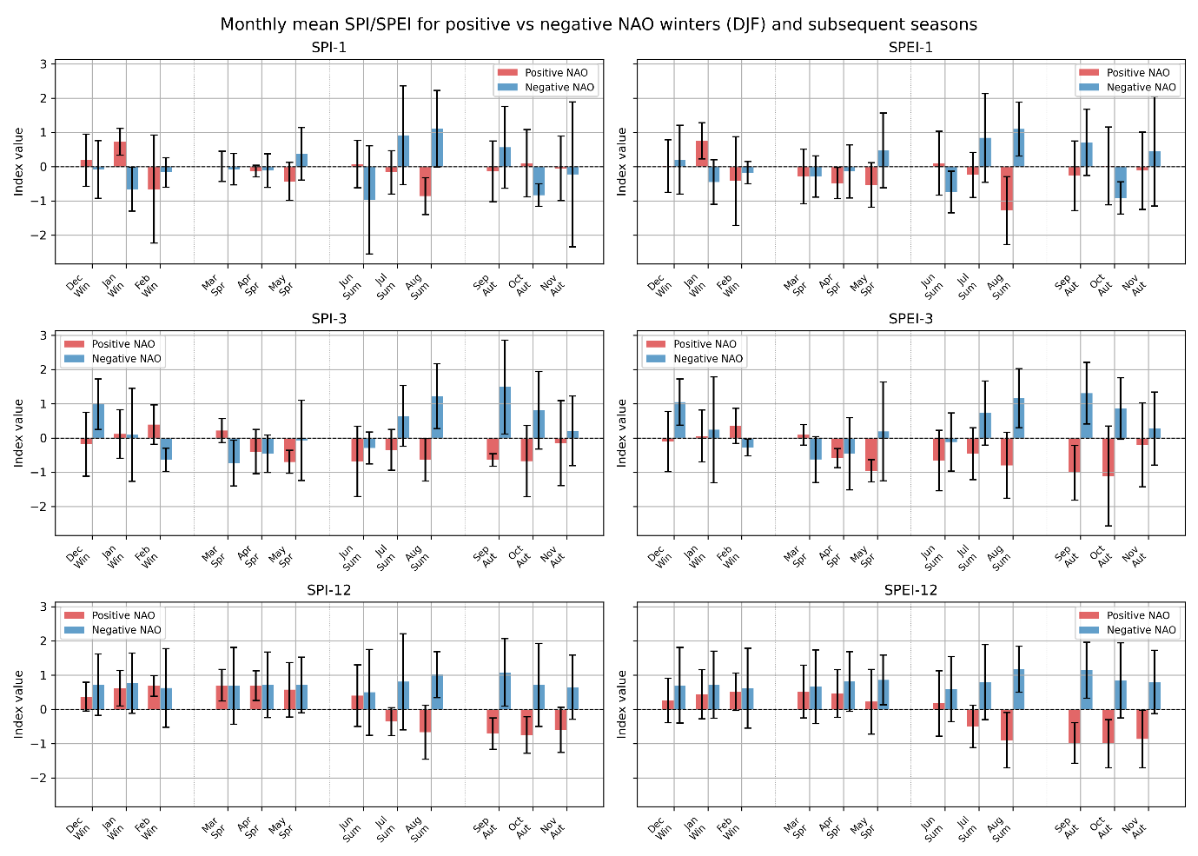

Figure S6. Monthly means of standardized precipitation indices (left: SPI-1, SPI-3, SPI-12) and standardized precipitation–evapotranspiration indices (right: SPEI-1, SPEI-3, SPEI-12) in the Demnitz Millcreek Basin for positive and negative North Atlantic Oscillation (NAO) winters, averaged over 2000–2024. For each index (separate panels), bars show the mean and standard deviation for each month within winter (DJF), spring (MAM), summer (JJA), and autumn (SON), composited separately for winters with strongly positive (red) and negative (blue) NAO phases. Positive NAO years include 2000, 2012, 2015, 2018, and 2020; negative NAO years include 2010, 2011, and 2021. Error bars represent interannual standard deviation. The x-axis indicates months grouped by season.

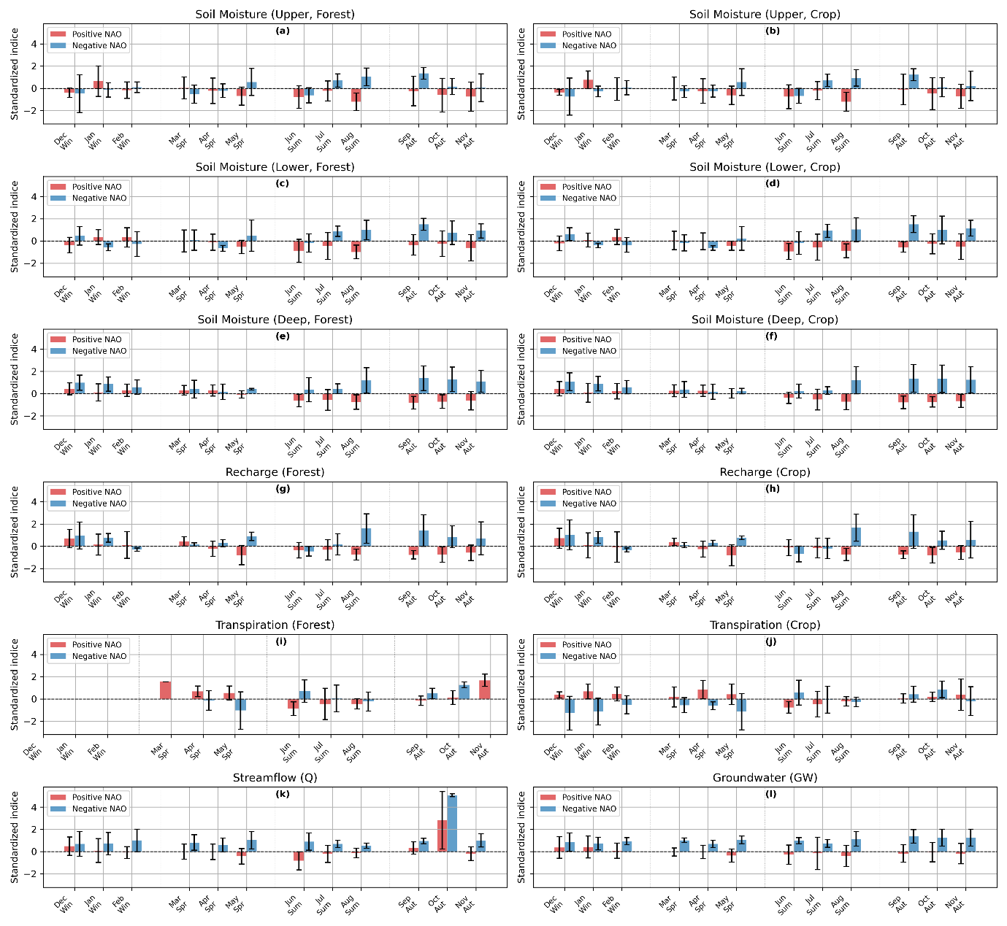

Figure S7. Monthly standardized ecohydrological indices (soil moisture at different depths, groundwater, recharge, transpiration, and streamflow) in the Demnitz Millcreek Basin (2000–2024) under positive and negative winter NAO years. Each panel shows the mean (± standard deviation) monthly standardized indices, with red bars for positive NAO winters and blue bars for negative NAO winters. Indices are computed for both forest and crop land cover types. See Methods for the standardization procedures.

Text S4. Relationship between Winter NAO and Vegetation Dynamics in Europe
To explore this further, we also examine how the influence of the winter NAO on hydroclimatic and vegetation conditions across Europe has evolved over the past four decades (Figure S8). Figures 8a and 8b extend this analysis to vegetation dynamics, showing that positive winter NAO phases are associated with higher winter and spring NDVI, particularly in conifer-dominated regions (consistent with Figure S1a). Although the correlations are not always statistically significant in spring, the pattern suggests that warmer positive NAO winters stimulate early leaf development and higher transpiration rates (see Figures S7i–j), leading to elevated pre-summer LAI. However, this early greening and higher leaf area, combined with reduced summer precipitation (Figures 1b, 3a–b), likely intensifies subsequent summer soil moisture depletion and drought severity.
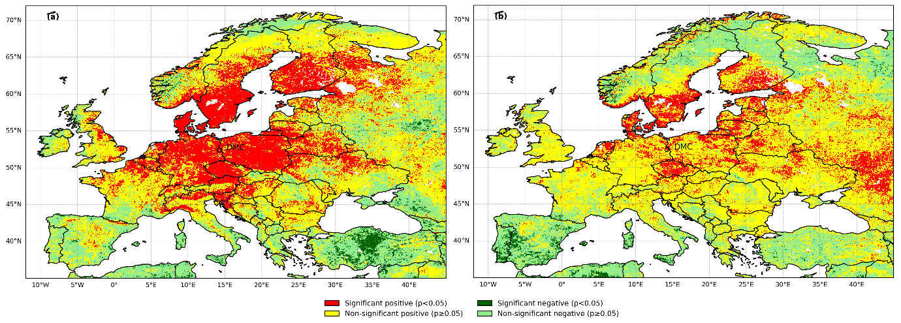

Figure S8. (a) Correlation between winter NAO (DJF) and winter NDVI (JJA) from 1982 to 2022, indicating vegetation response to NAO-induced hydroclimatic anomalies. (b) Correlation between winter NAO (DJF) and spring NDVI (March–May, MAM) from 1982 to 2022, showing the early-season vegetation sensitivity to winter atmospheric circulation anomalies. Warm colors indicate positive correlations, and green colors indicate negative correlations. Dark shades denote statistically significant correlations (p < 0.05), while light shades represent non-significant correlations.

