Supplementary Material for “Global wind stilling and the role of sub-monthly variability in explaining deficiencies in atmospheric reanalyses”

Paul-Arthur Monerie¹, Reinhard Schiemann¹, David J Brayshaw², Jon I Robson¹
¹National Centre for Atmospheric Science
²University of Reading

The supplementary material contains 11 figures.

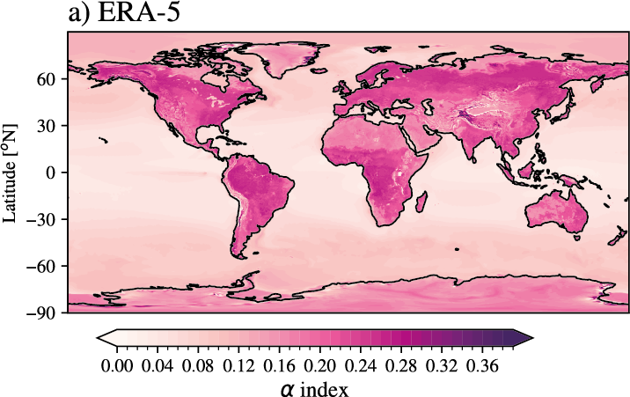
Figure S1: Values of the $a$index, computed using ERA5 and following Equation 7 (See the main text).

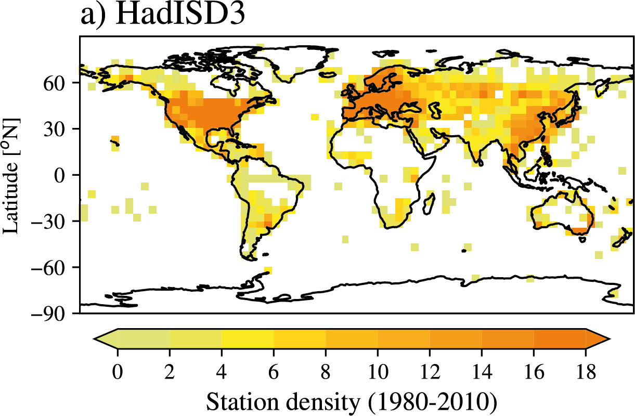
Figure S2: Number of stations used from HadiSD3 and for each 5° x 5° grid point, averaged over the 1980-2010 period.

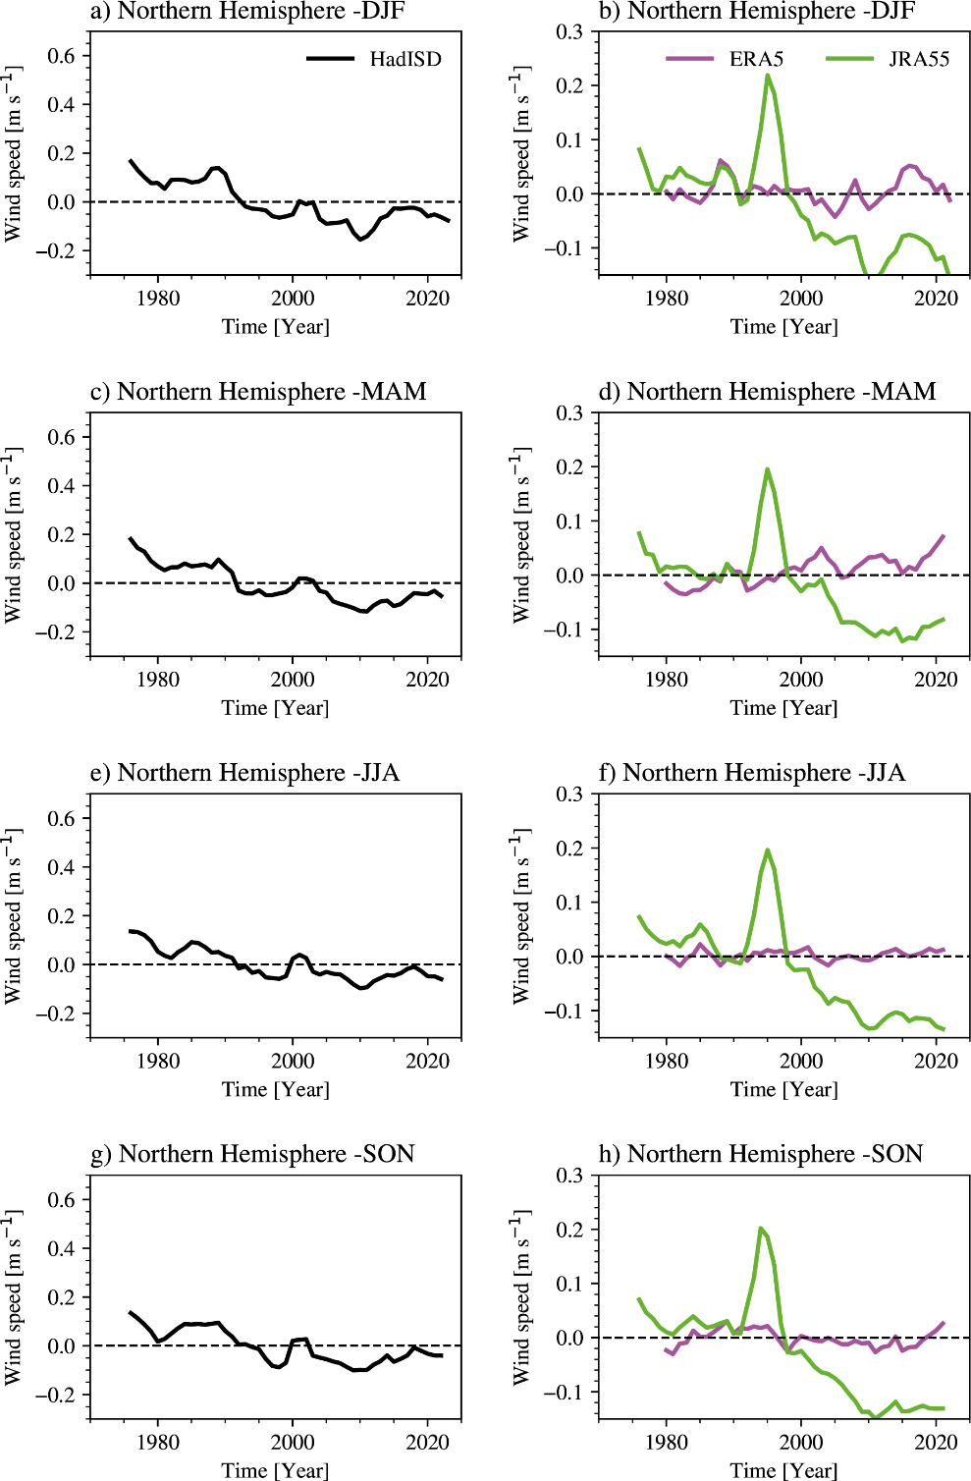
Figure S3: Annual mean wind speed anomaly [m s⁻¹] over land and the northern hemisphere [0-70°N] in (left) observation (HadISD3) and (right) ERA5 and JRA55, for (a-b) DJF, (c-d) MAM, (e-f) JJA, and (g-h) SON. Anomalies are computed relative to the period 1980-2010. A 3-year running mean was applied to reduce high-frequency variability.

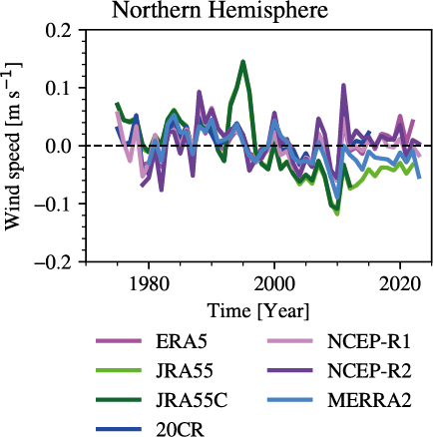
Figure S4: Annual mean wind speed anomaly [m s⁻¹] over land and the northern hemisphere [0-70°N] in (a) observation (HadISD3) and (b) a set of reanalyses. The wind speed is computed using the monthly means of the meridional and zonal components of the wind speed. Anomalies are computed relative to the period 1980-2010.

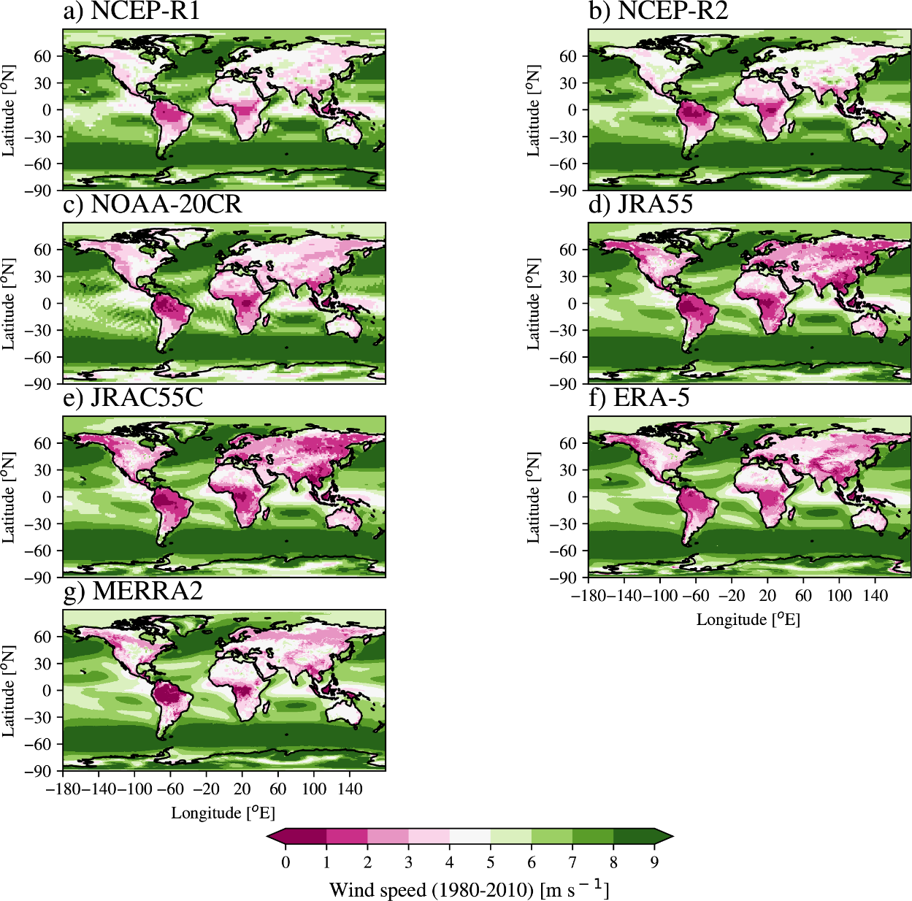
Figure S5: Annual mean near-surface wind speed [m s⁻¹] averaged over the period 1980-2010. The wind speed is computed using the highest available frequency variability of the zonal and meridional components of the wind. The results are given for (a) NCEP-R1, (b) NCEP-R2, (c) 20CR, (d) JRA55, (e) JRA55C, (f) ERA5, and (g) MERRA2.

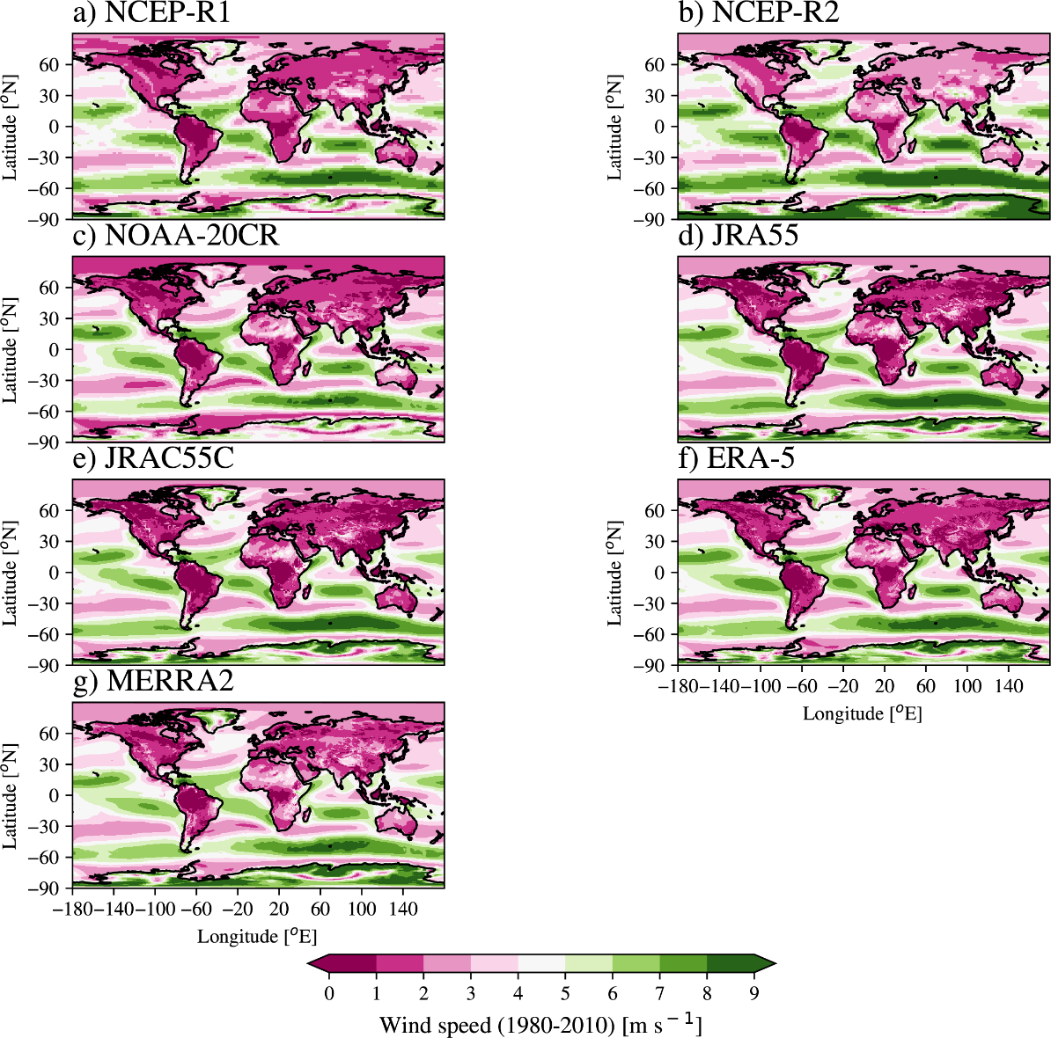
Figure S6: Annual mean near-surface wind speed [m s⁻¹] averaged over the period 1980-2010. The wind speed is computed using the monthly means of the zonal and meridional components of the wind. The results are given for (a) NCEP-R1, (b) NCEP-R2, (c) 20CR, (d) JRA55, (e) JRA55C, (f) ERA5, and (g) MERRA2.

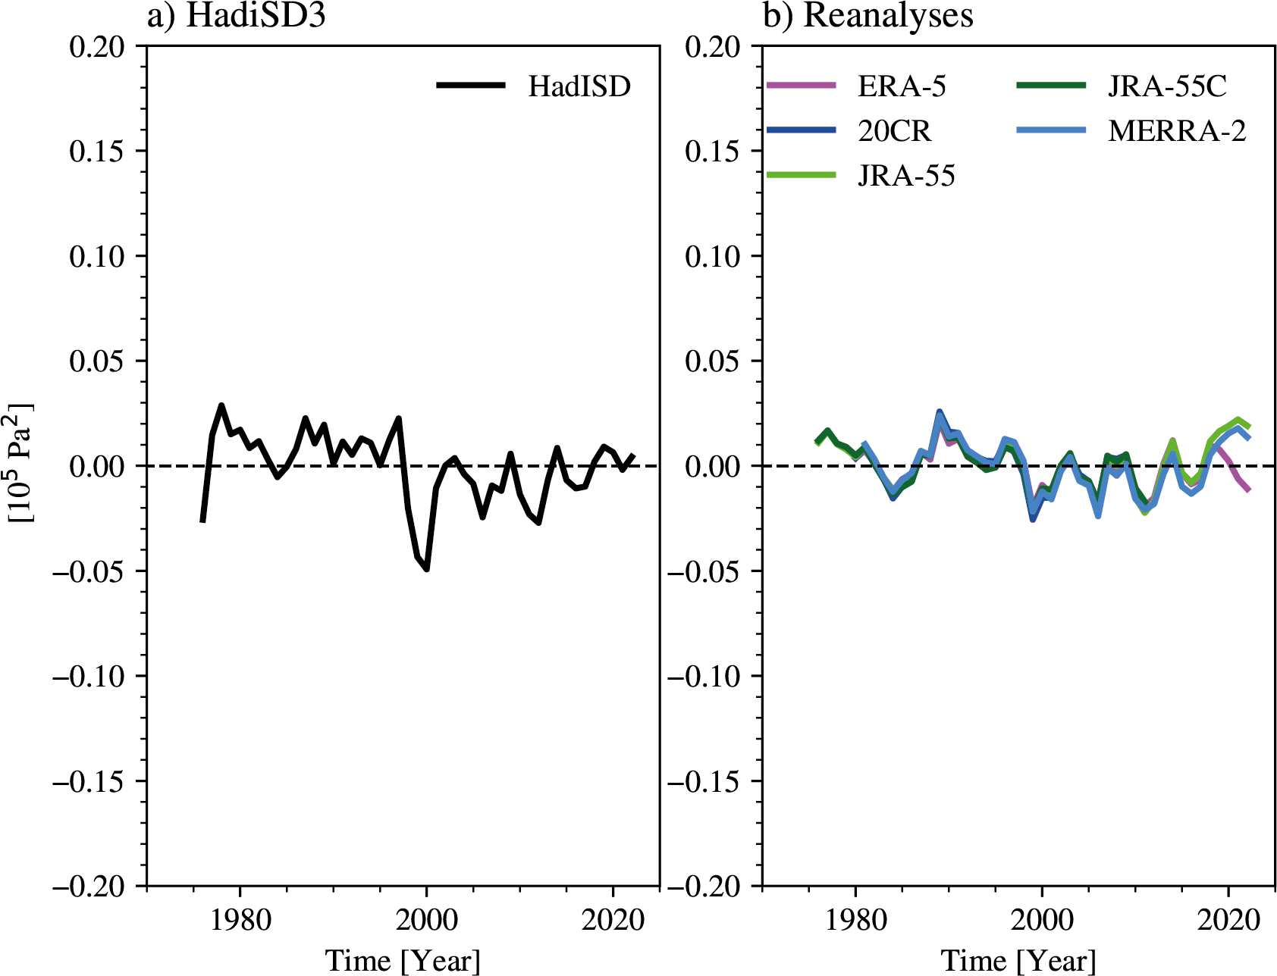
Figure S7: Annual mean storm track activity over the Northern Hemisphere [0°-70°N] over land, for (a) HadISD3, and (b) a set of reanalyses. The storm track activity is defined as the annual mean variance computed from the daily values of the sea level pressure after applying a 2-6 bandpass Butterworth filter and removing the seasonal cycle.

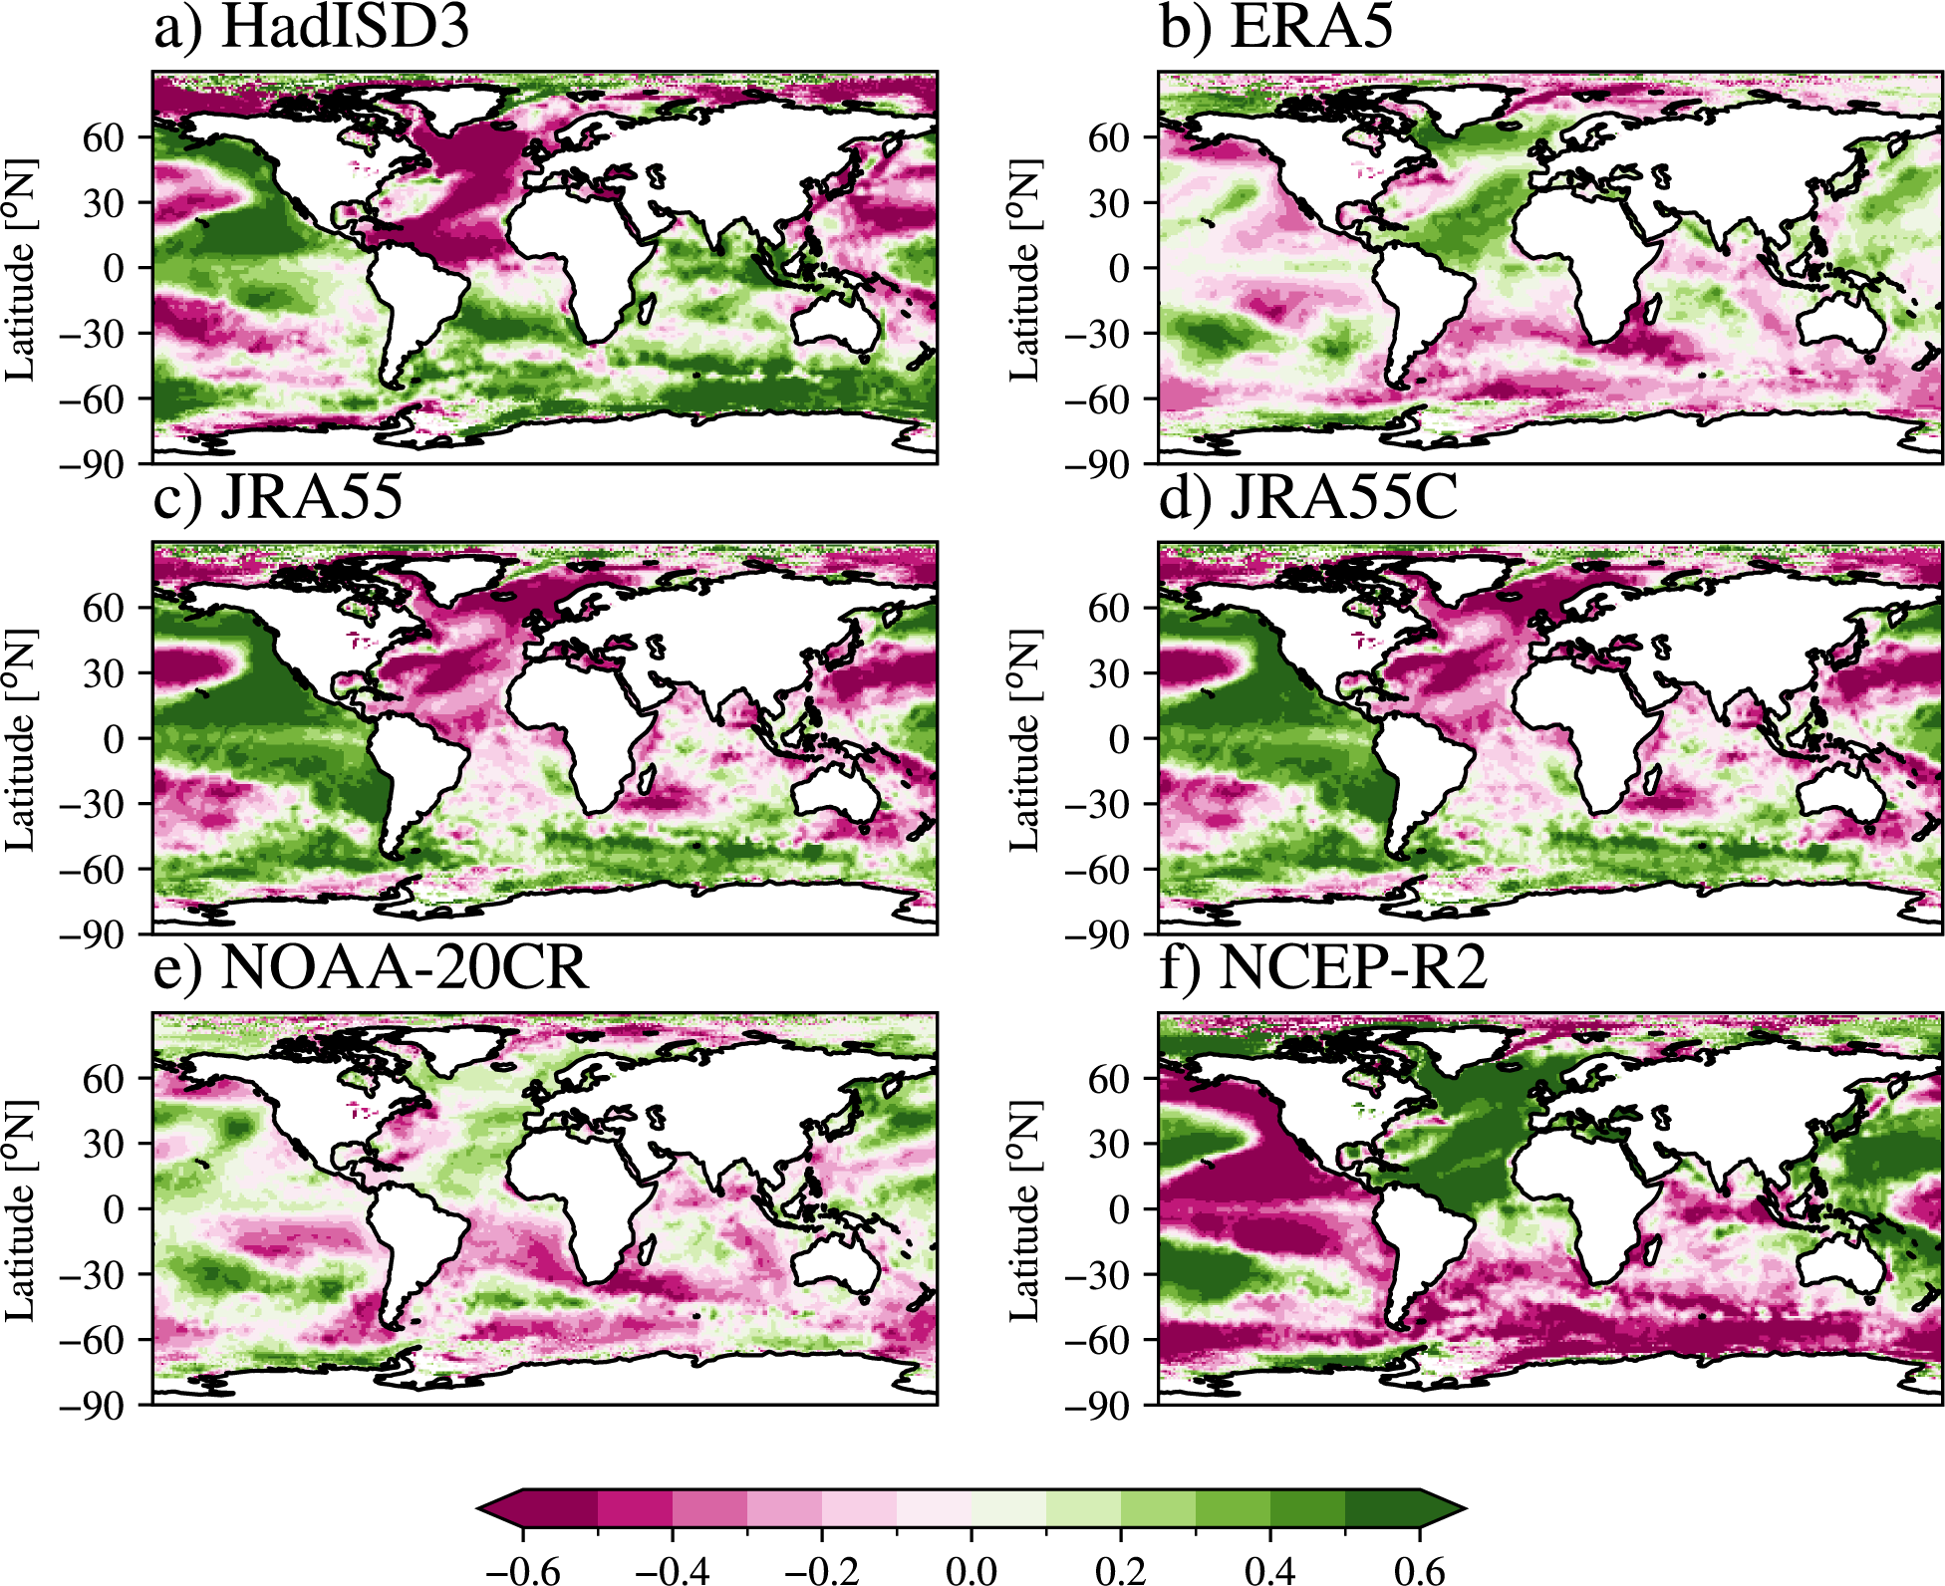
Figure S8: Correlation coefficient between annual mean sea surface temperature (HadISST) and annual mean near-surface wind speed over the period 1980-2010 for (a) HadISD3, (b) ERA5, (c) JRA55, (d) JRA55C, (e) 20CR, and (f) NCEP-R2. The externally forced responses in sea surface temperature and wind speed are removed by regressing out (using a linear regression) the effects of the changes in annual mean global mean sea surface temperature on sea surface temperature for each grid point and Northern Hemisphere mean near-surface wind speed.

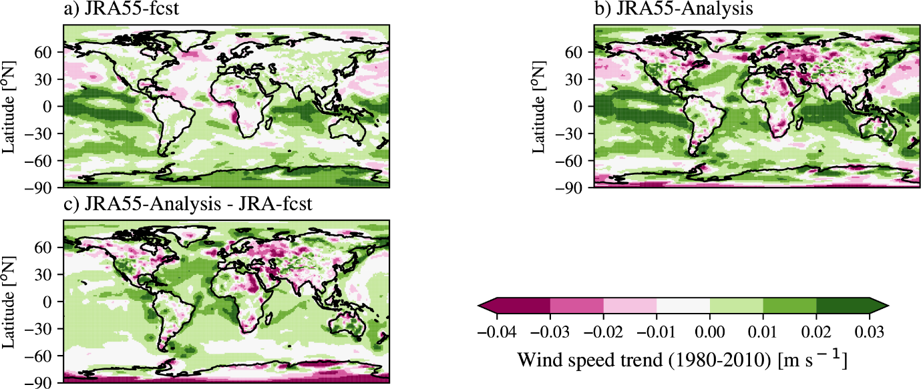
Figure S9: 1980-2010 trend in annual mean near-surface wind speed [m s⁻¹] for (a) the JRA55 forecasts, the (b) JRA55 reanalysis, and (c) the difference between the forecast and the reanalysis.

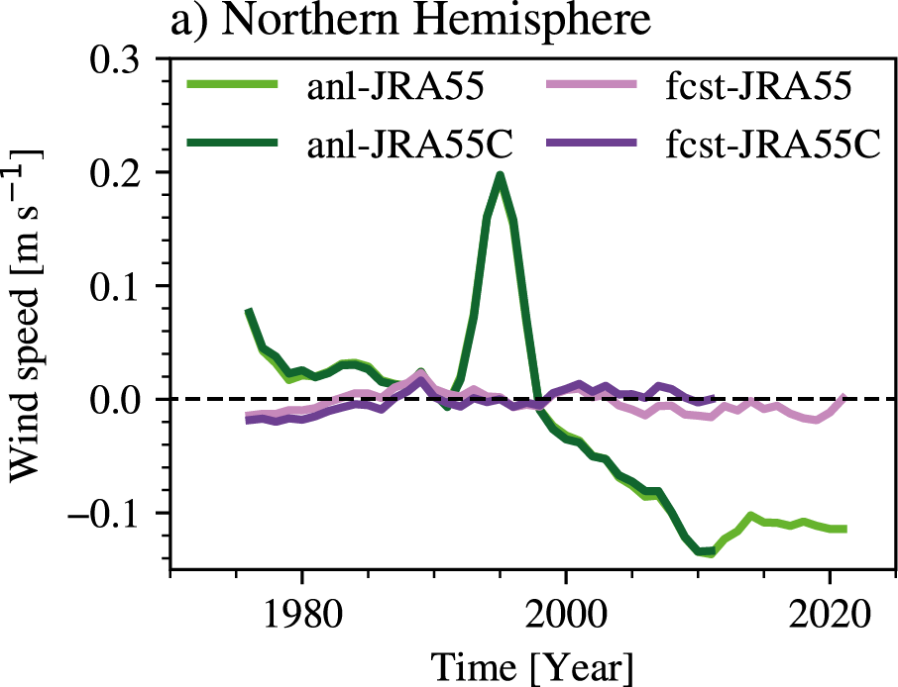
Figure S10: Annual mean wind speed anomaly [m s⁻¹] over land and the northern hemisphere [0-70°N] for the reanalyses of JRA55 (light green) and JRA55C (dark green), and the forecasts of JRA55 (light purple) and JRA55C (dark purple). Anomalies are computed relative to the period 1980-2010. A 3-year running mean was applied to reduce high-frequency variability.

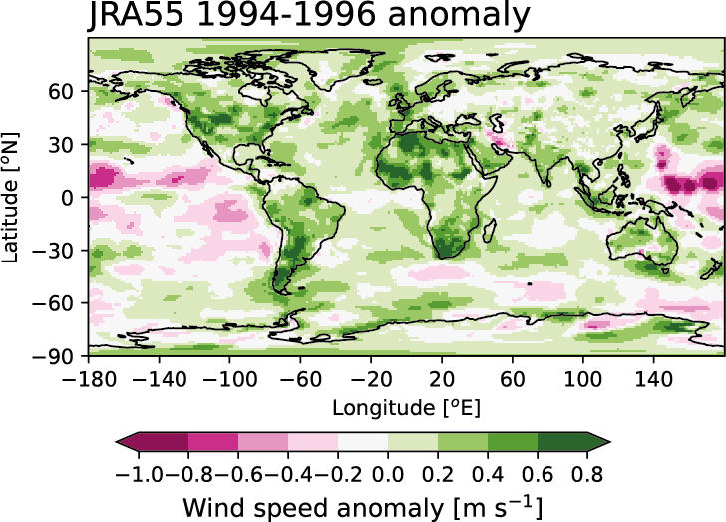
Figure S11: Anomaly in annual mean wind speed [m s⁻¹] in JRA55 for the period 1994-1996 and relative to 1980-2010.

