Supplementary data
Figure S1: Kaplan-Meier estimate of overall survival (OS) for the acquisition of protocol donor group (n = 49) vs no acquisition of protocol donor group (n = 61)

Figure S2: Kaplan-Meier estimate of overall survival (OS) for related (n = 23) vs. unrelated (n = 44) vs. cord blood (n = 25) transplantation.

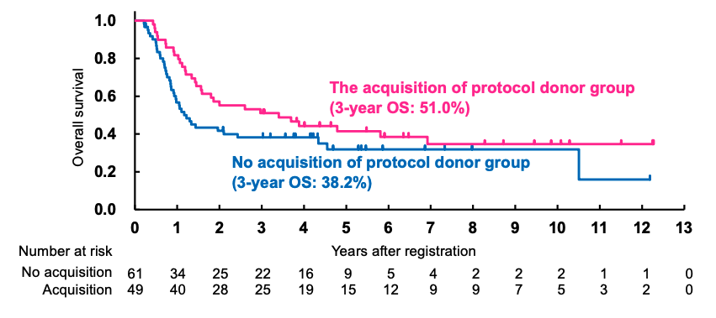
Figure S1

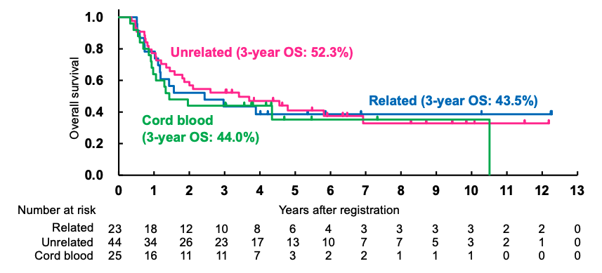
Figure S2

