APPENDIX
SUPPLEMENTARY FIGURE
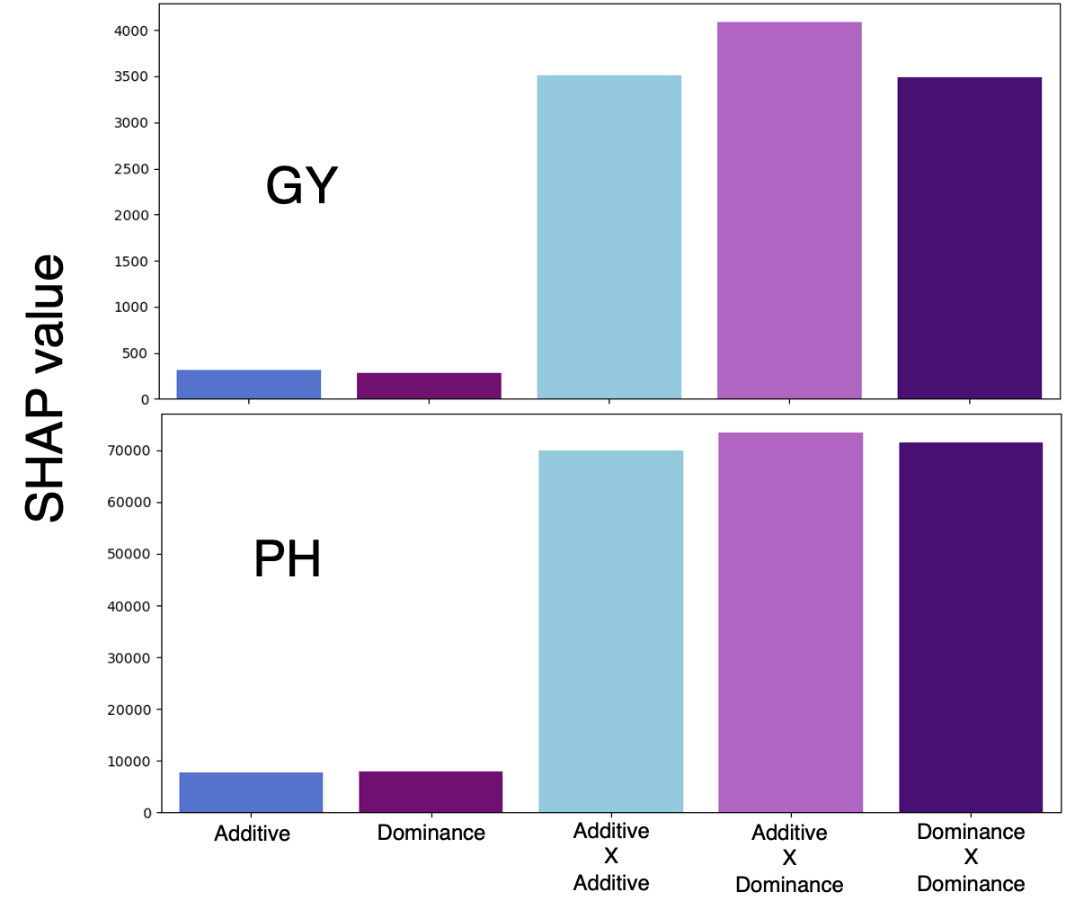
SFig1. Relative contribution of additive and dominance SNP markers to model predictions for Grain Yield and Plant Height. The bar plot displays the proportion of the total absolute Shapley Additive Explanation (SHAP) values attributed to each effect type (additive in blue, dominance in purple, Additive X Additive in light Blue, Additive X Dominance in light shade of purple and Dominance X Dominance in darker shade of purple), reflecting the relative influence of additive main, dominance main and interactive effects on 2NPLGBM model output.
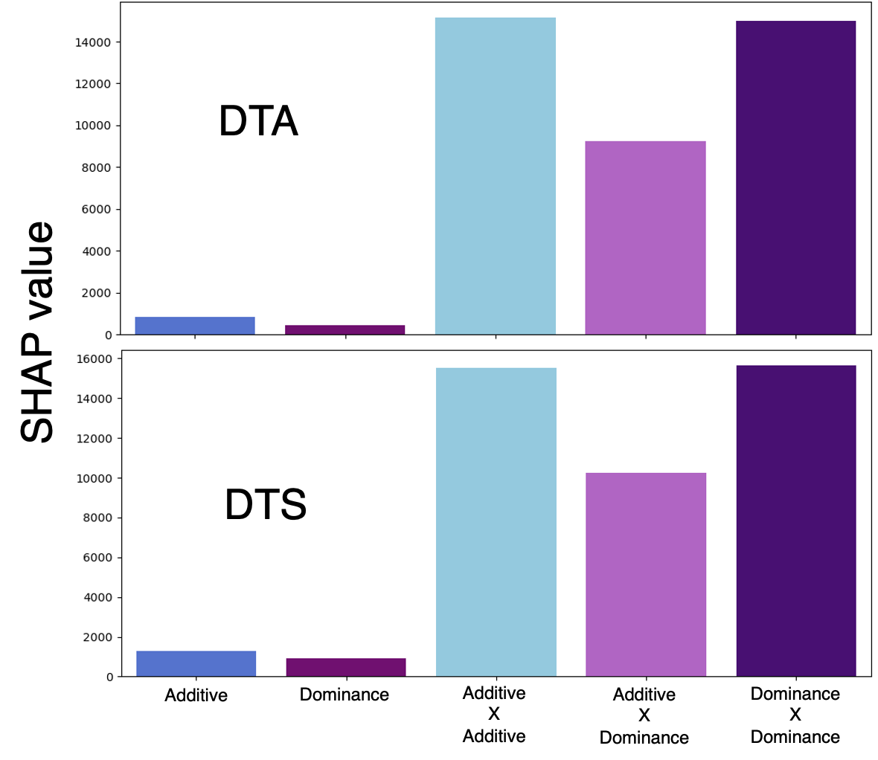
SFig2. SFig1. Relative contribution of additive and dominance SNP markers to model predictions for Days to Anthesis and Days to Silking. The bar plot displays the proportion of the total absolute Shapley Additive Explanation (SHAP) values attributed to each effect type (additive in blue, dominance in purple, Additive X Additive in light Blue, Additive X Dominance in light shade of purple and Dominance X Dominance in darker shade of purple), reflecting the relative influence of additive main, dominance main and interactive effects on 2NPLGBM model output.

