Supplementary Information
Towards a Comprehensive Wastewater Virome Atlas for Pathogen Monitoring
Nitin Shukla^{1,2}, Jinal Thakor¹, Priyank Chavda¹, Harshal Purohit¹, Harshil Patel¹, Saurabh Thakar³, Aesha Raval³, Jinal Prajapati³, Jay Solanki³, Deeparati Datta³, Harshita karri³, Abhijeet Mondal³, Niraj Singh¹, Snehal Bagatharia¹, Chaitanya Joshi¹, Madhvi Joshi^{1*}, Chandrashekar Mootapally^{2*}, Varun Shah^{3*}, Ramesh Pandit^{1*}
¹Gujarat Biotechnology Research Centre (GBRC), Department of Science and Technology, Government of Gujarat, Gandhinagar-382010 India.
²GTU-School of Applied Sciences and Technology (GTU-SAST), Gujarat Technological University, Ahmedabad, Gujarat, India.
³Gujarat Biotechnology University, Nr. Gujarat International Finance Tec-City, Gandhinagar-382355, Gujarat, India.
*Corresponding authors
Dr. Ramesh Pandit
Scientist-B,
Gujarat Biotechnology Research Centre
Department of Science and Technology
Govt. of Gujarat, Gandhinagar, Gujarat-382011, India
Email: ramesh.scib@gbrc.res.in
Dr. Varun Shah
Assistant Professor,
Gujarat Biotechnology University,
Gandhinagar, Gujarat, India
Email: varun.shah@gbu.edu.in
Dr. Chandrashekar Mootapally
Assistant Professor,
School of Applied Sciences and Technology (SAST-GTU),
Gujarat Technological University
Ahmedabad-382424, Gujarat, India
Email: chandu.avi@gmail.com
Dr. Madhvi Joshi
Scientist-D,
Gujarat Biotechnology Research Centre
Department of Science and Technology
Govt. of Gujarat, Gandhinagar, Gujarat-382011, India
Email: madhvimicrobio@gmail.com

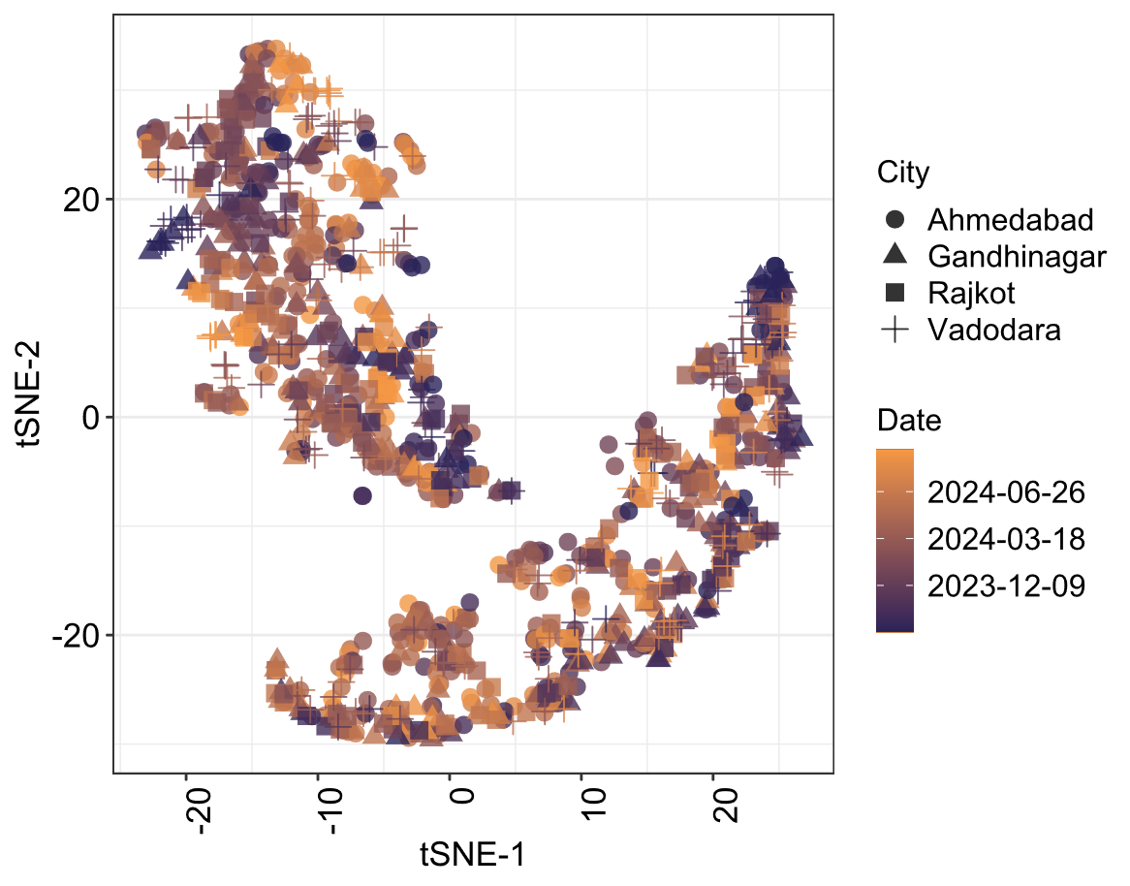
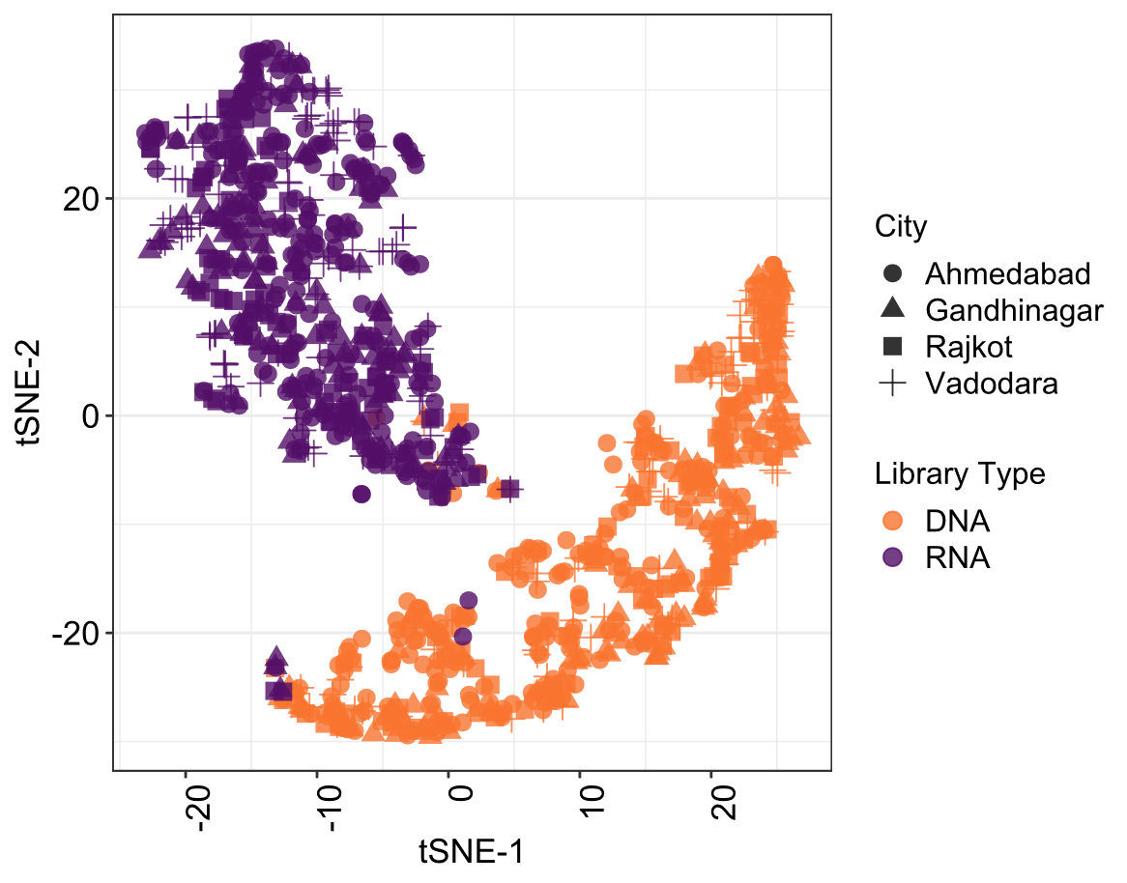

Figure S1. t-distributed Stochastic Neighbor Embedding (t-SNE) plots for (A) DNA libraries and (B) RNA libraries, visualized at the city level, and across different time points.

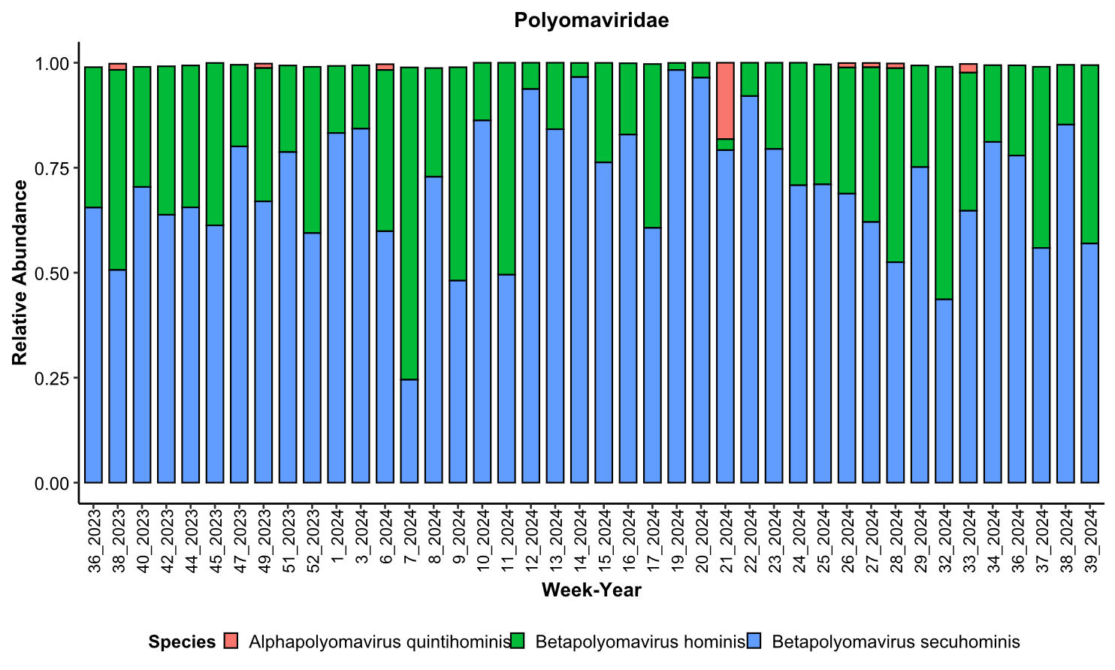
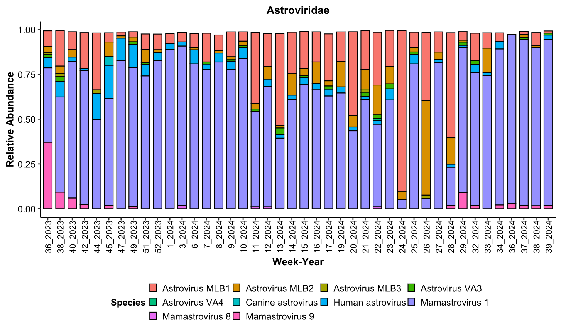
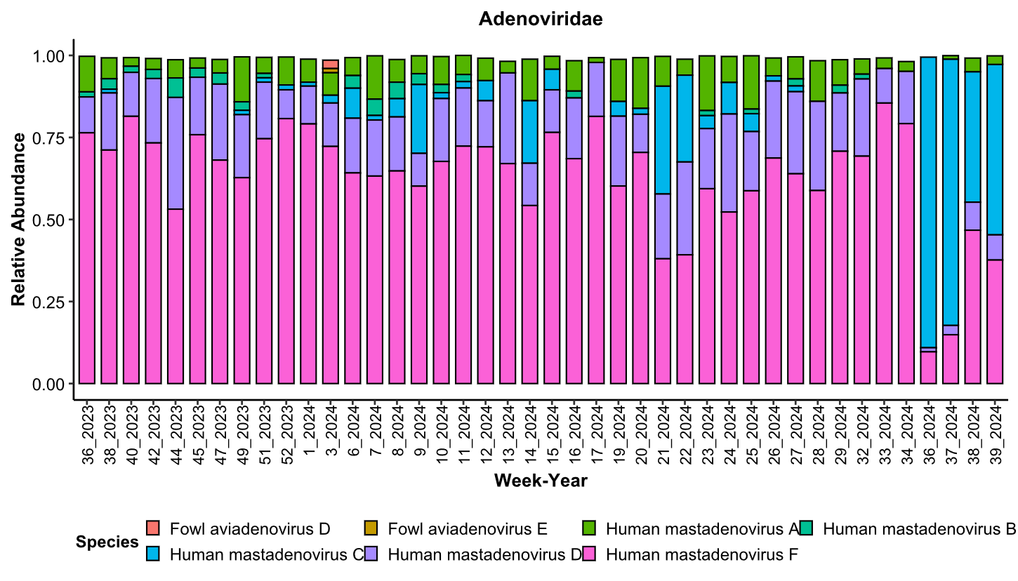
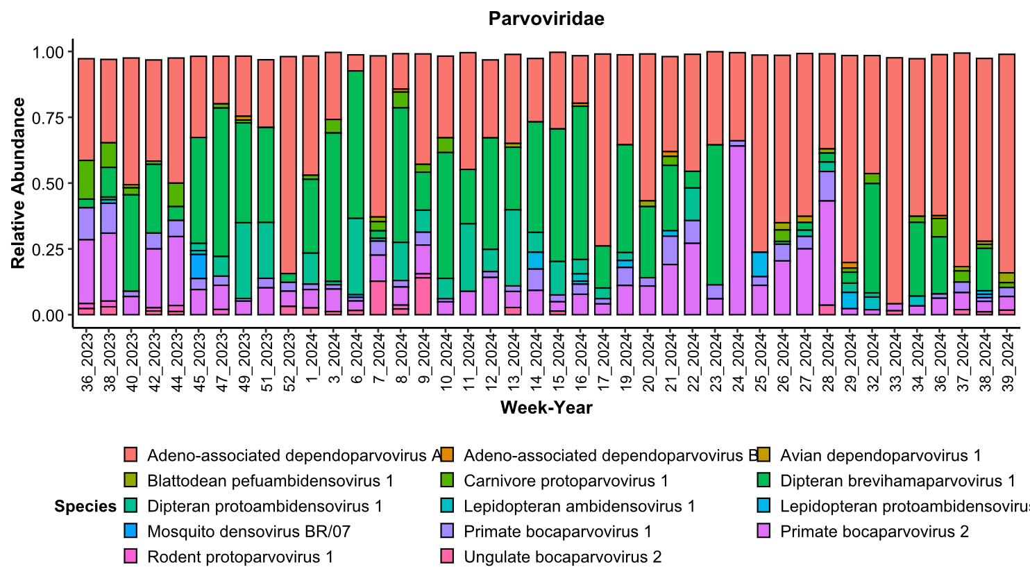

Figure S2. Relative abundance of top species of virus with abundance cutoff >1 percent, for different families of viruses over different weeks of the year.

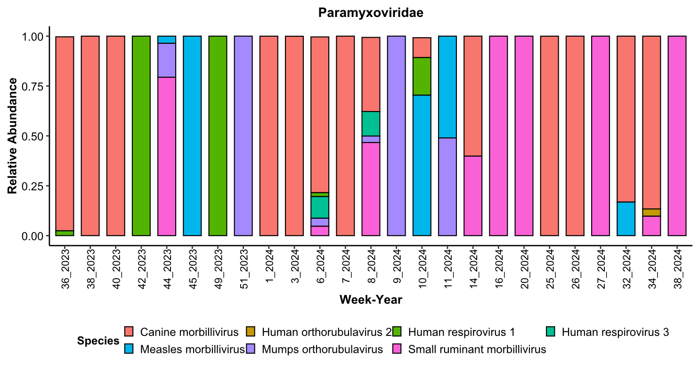
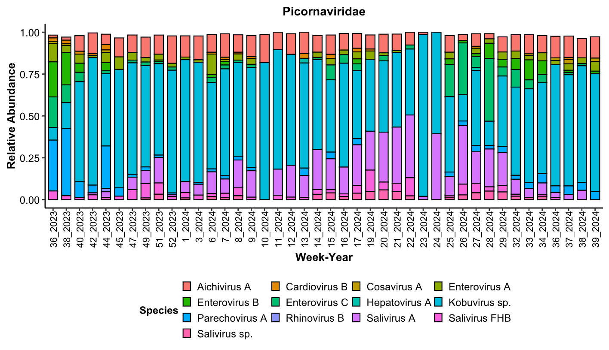
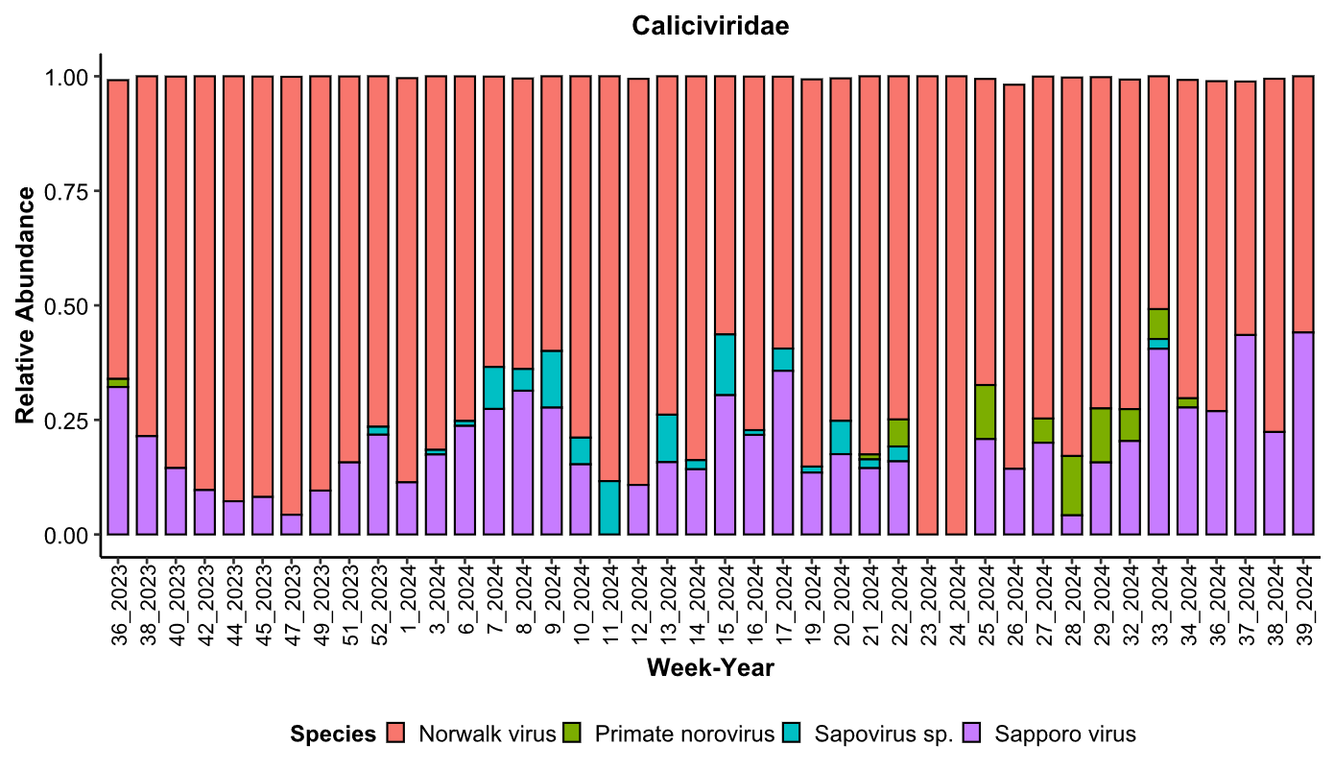
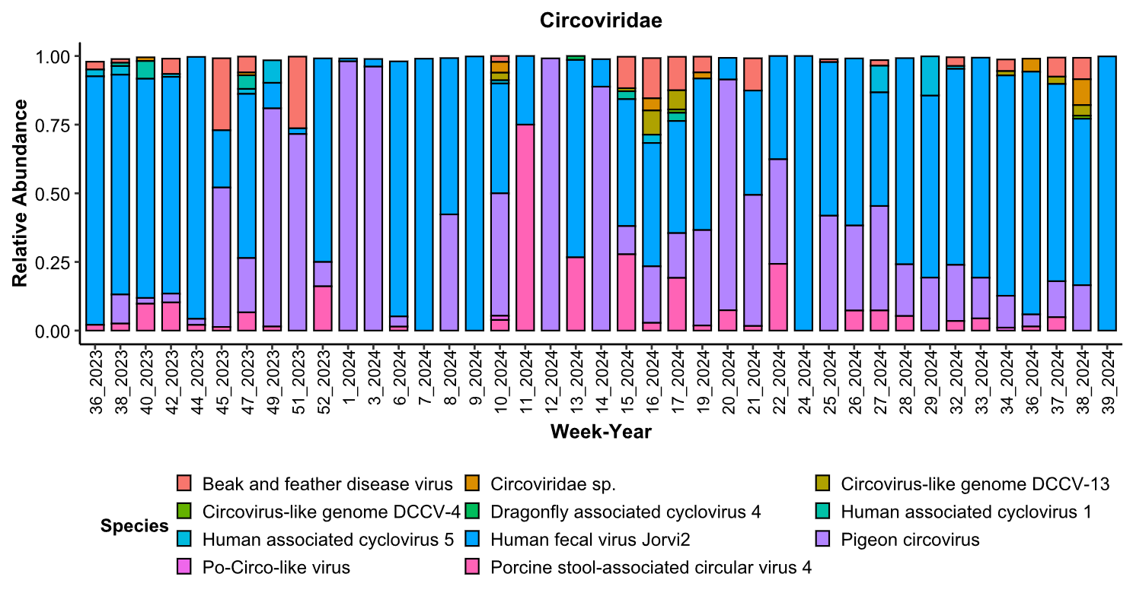

Figure S3. Relative abundance of top species of virus with abundance cutoff >1 percent, for different families of viruses over different weeks of the year.

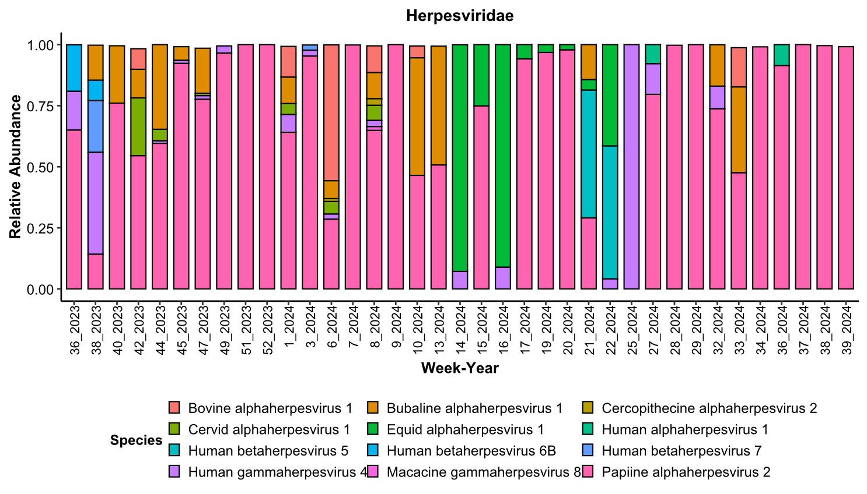
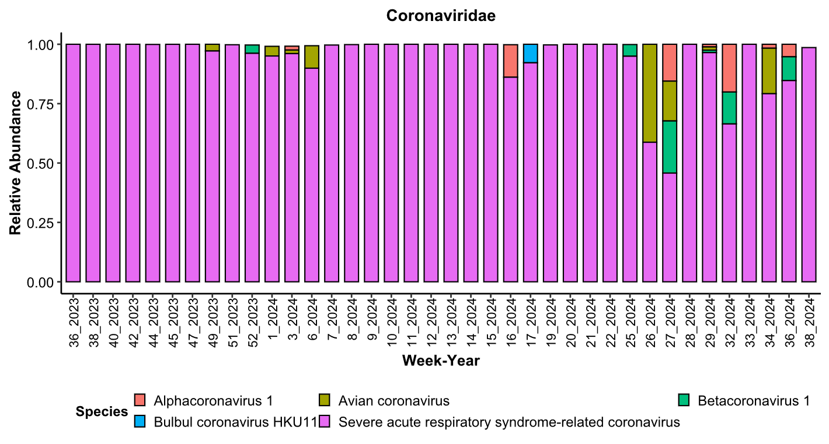
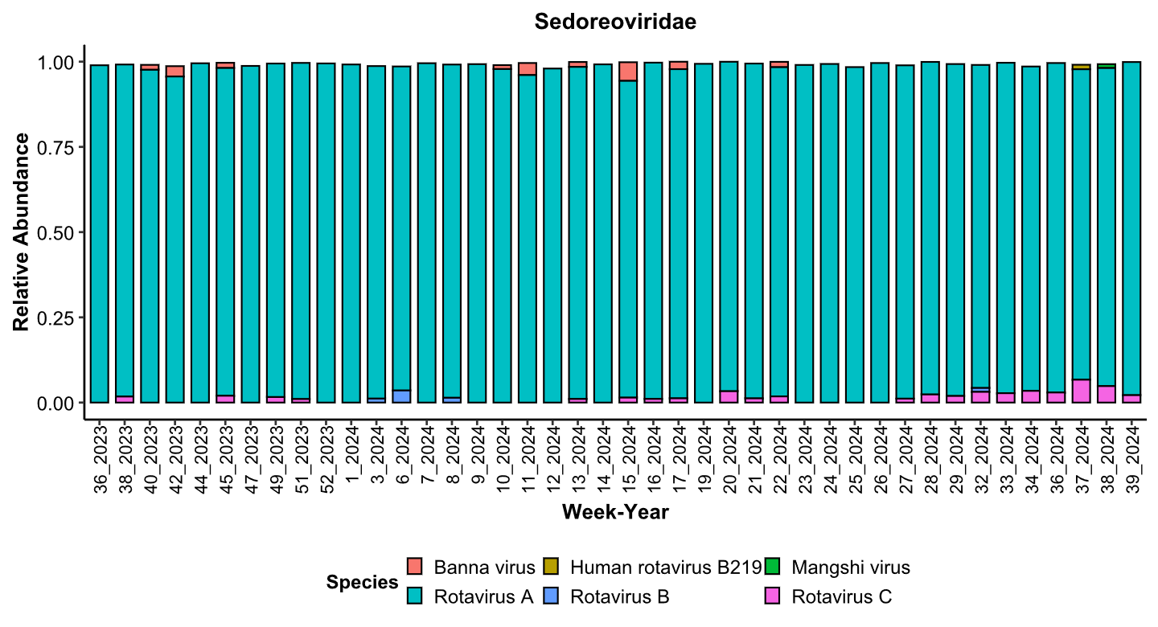
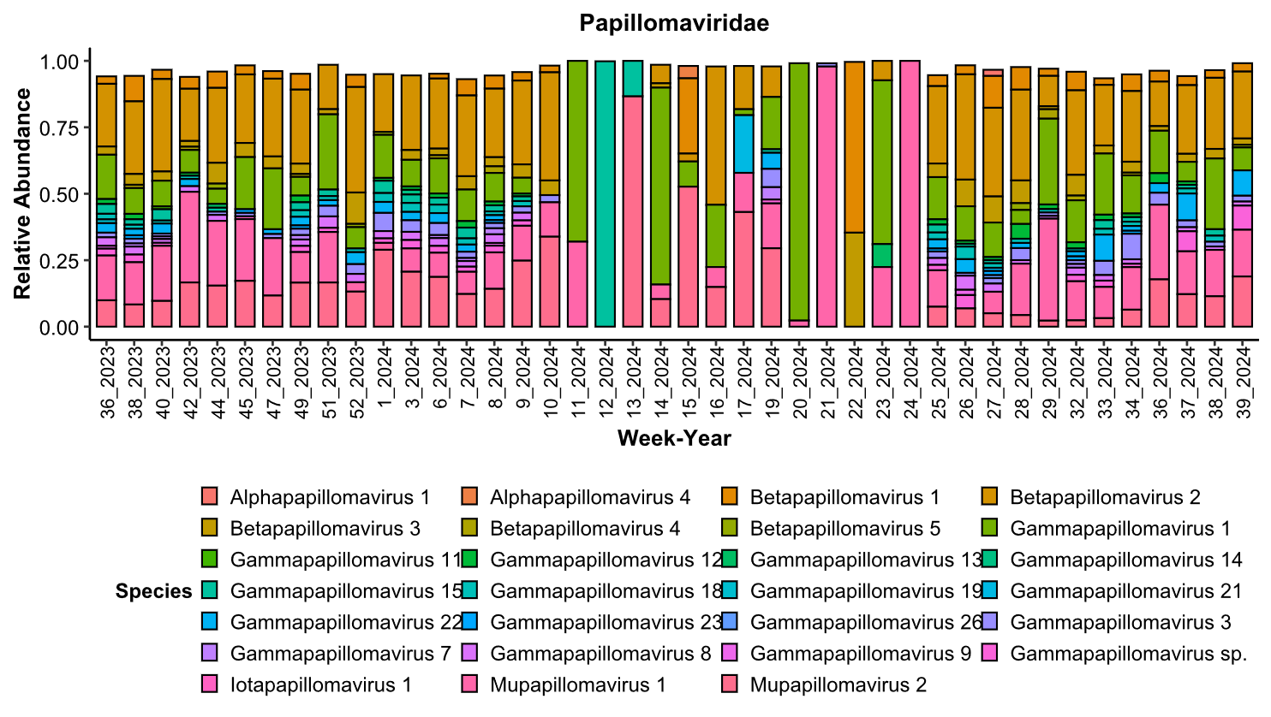

Figure S4. Relative abundance of top species of virus with abundance cutoff >1 percent, for different families of viruses over different weeks of the year.

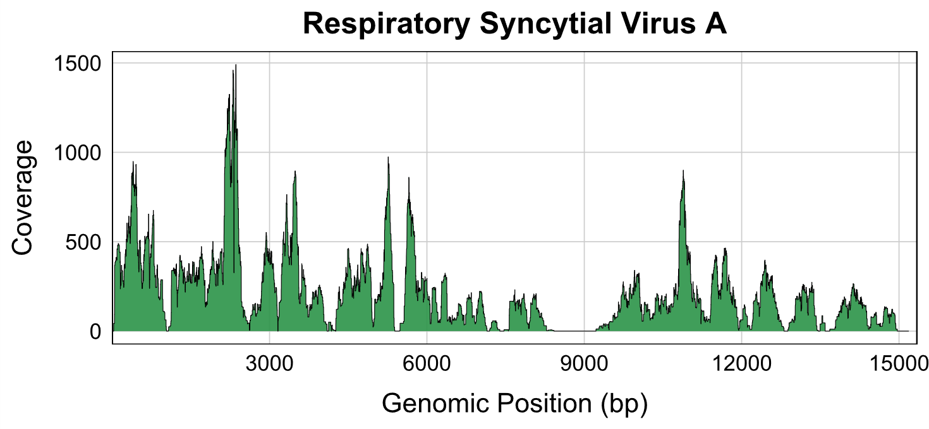
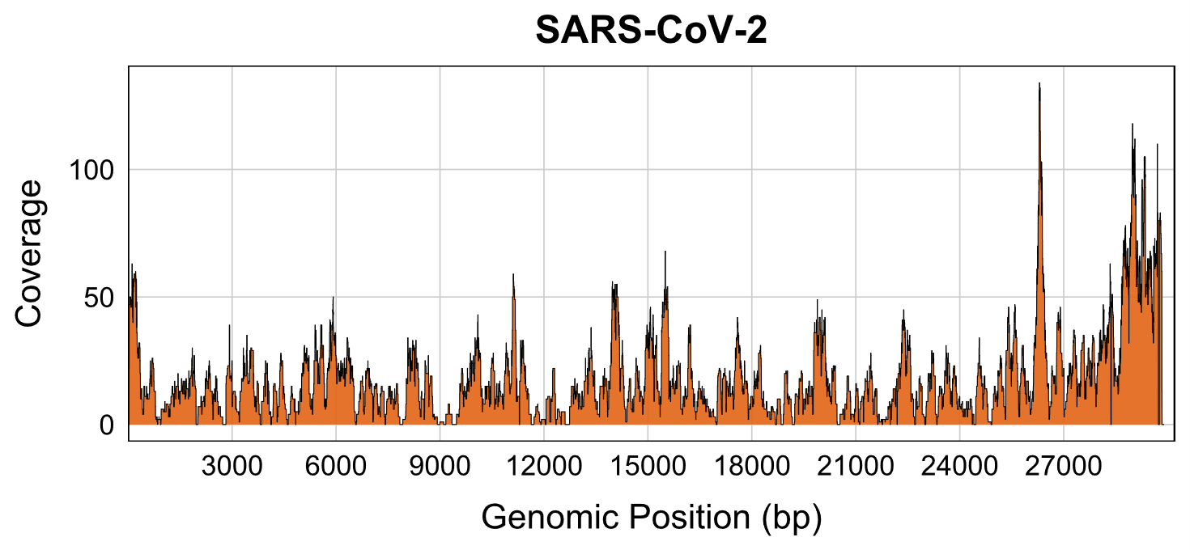
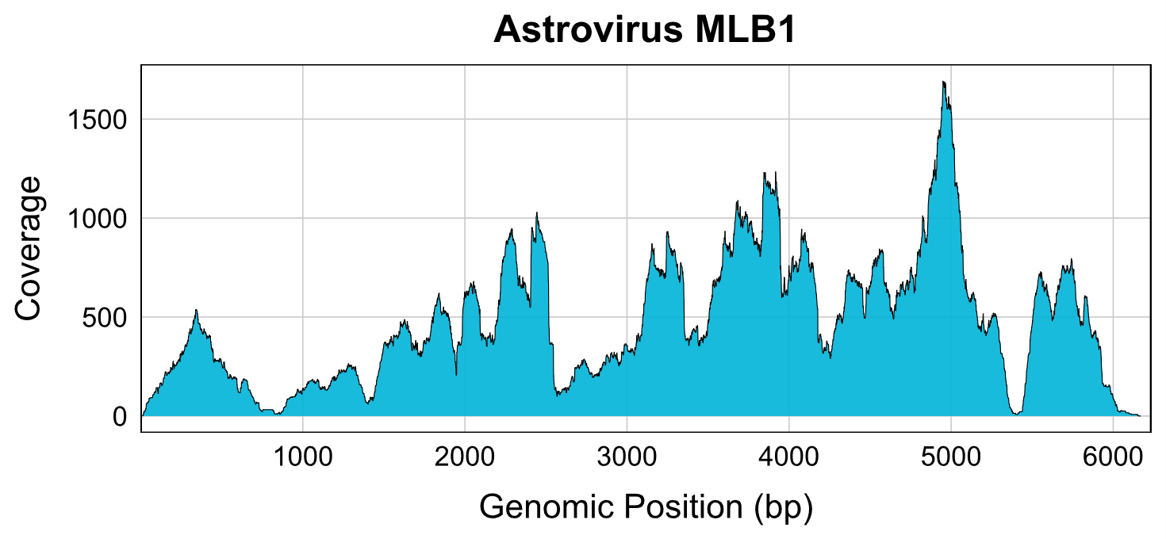
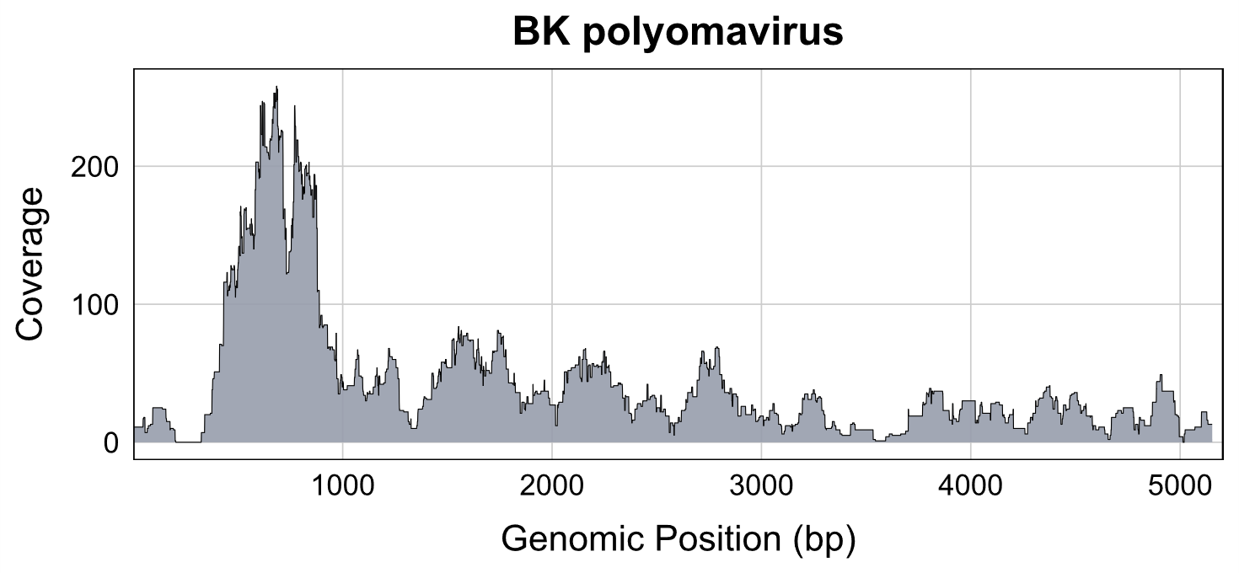
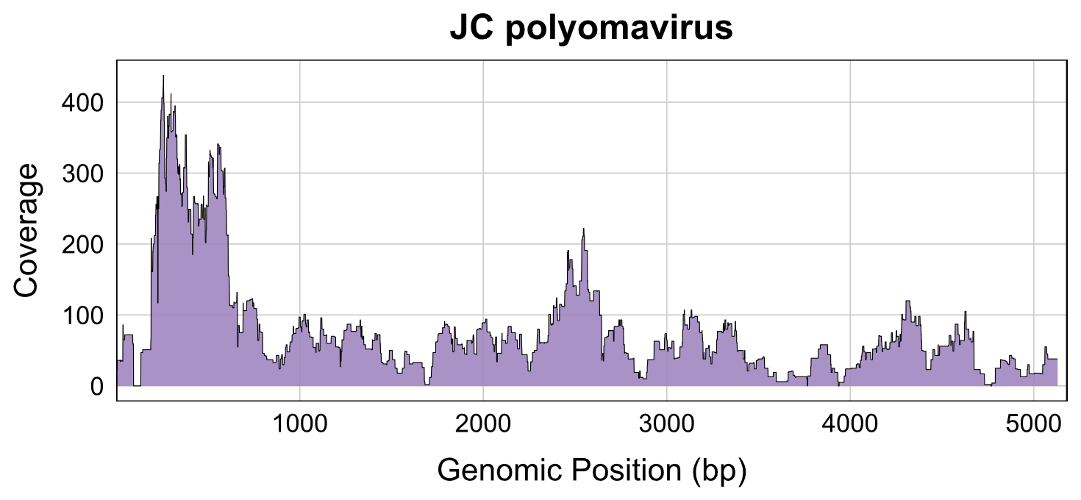
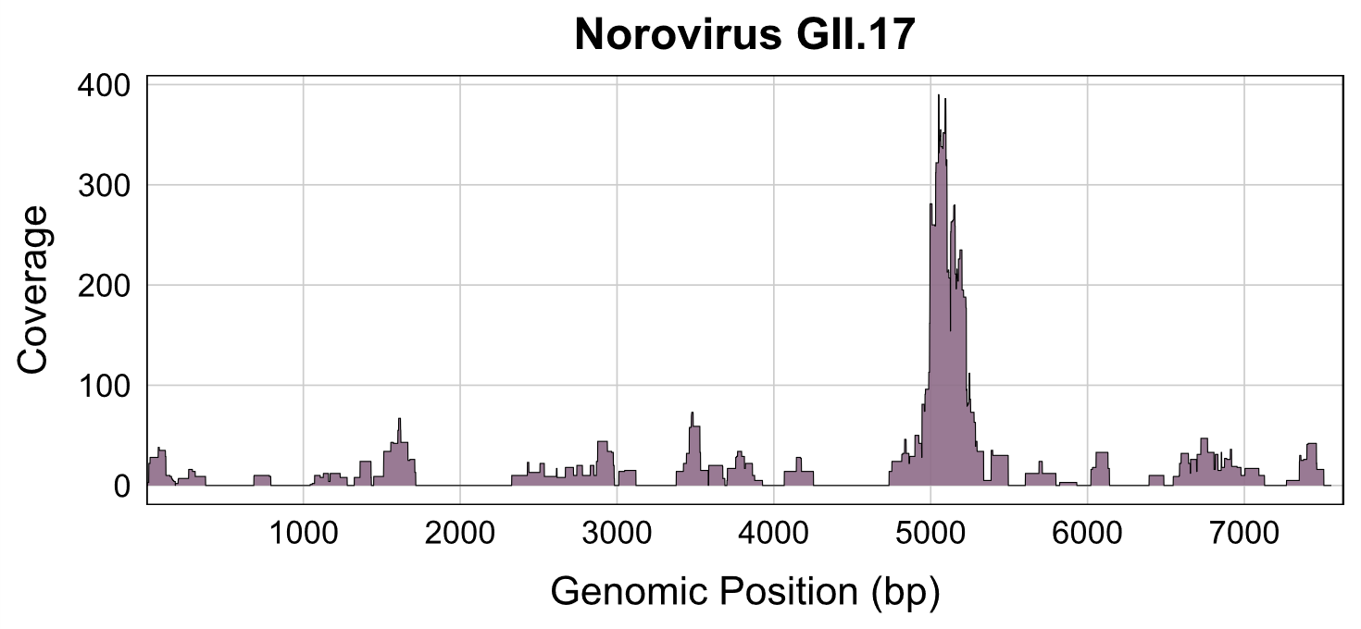
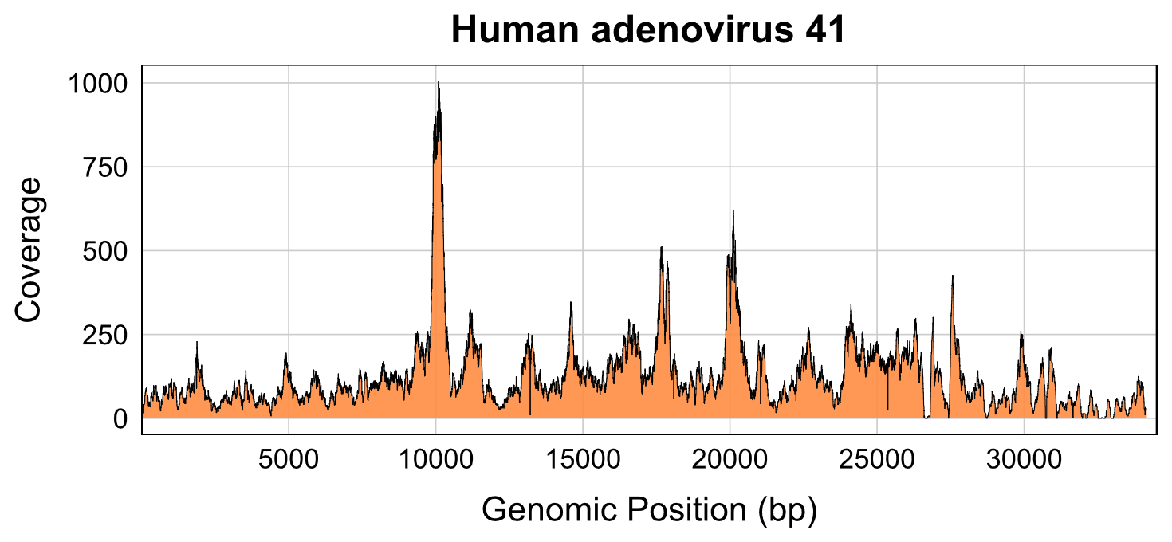
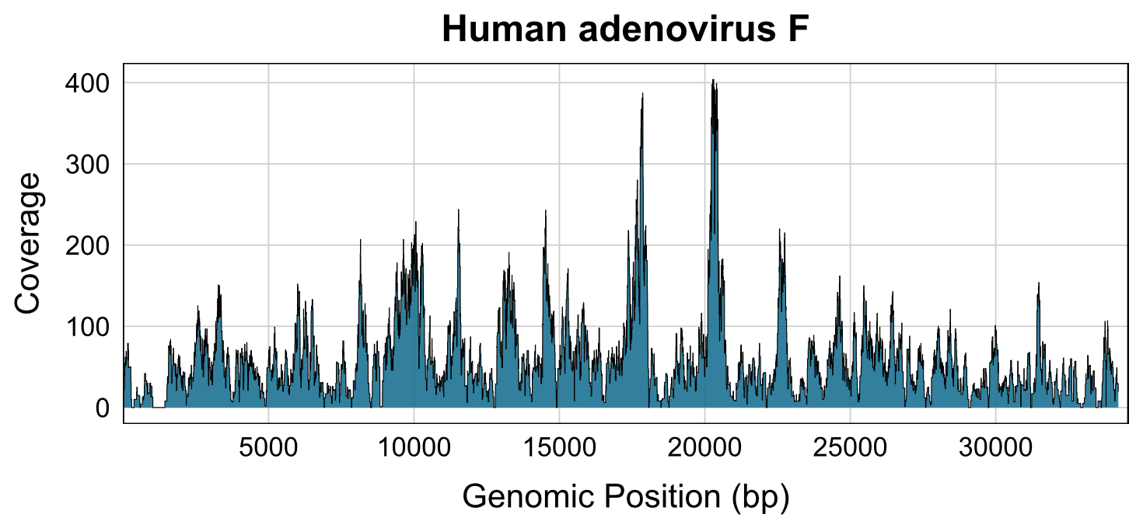

Figure S5. Genome coverage plots for selected clinically relevant viruses detected in
wastewater. The x-axis denotes genomic position (bp), and the y-axis shows sequencing coverage depth, demonstrating the extent of genome recovery.

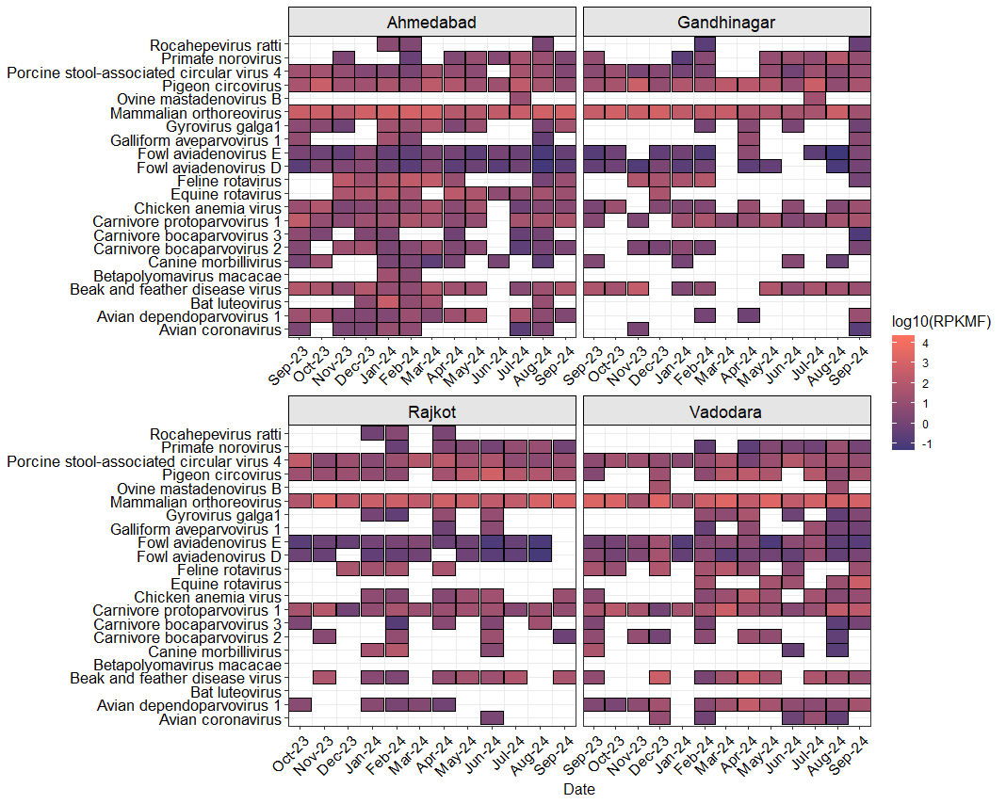
Figure S6. Temporal distribution and abundance of animal-associated viruses in wastewater across four cities. Heatmap showing the detection and relative abundance of animal-associated viruses in wastewater samples collected from Ahmedabad, Gandhinagar, Rajkot, and Vadodara between September 2023 and September 2024. Each tile represents a unique virus detected in a given month, with color intensity corresponding to the log-transformed RPKMF values (log₁₀ RPKMF), a proxy for sequencing-based viral abundance. The panel illustrates dynamic temporal variation in the presence of viruses linked to animal hosts, including avian, mammalian, and zoonotic viruses, highlighting city-specific patterns in their prevalence.

