Comparison of HPLC and NMR for quantification of the main volatile fatty acids in rumen digesta

Supplementary
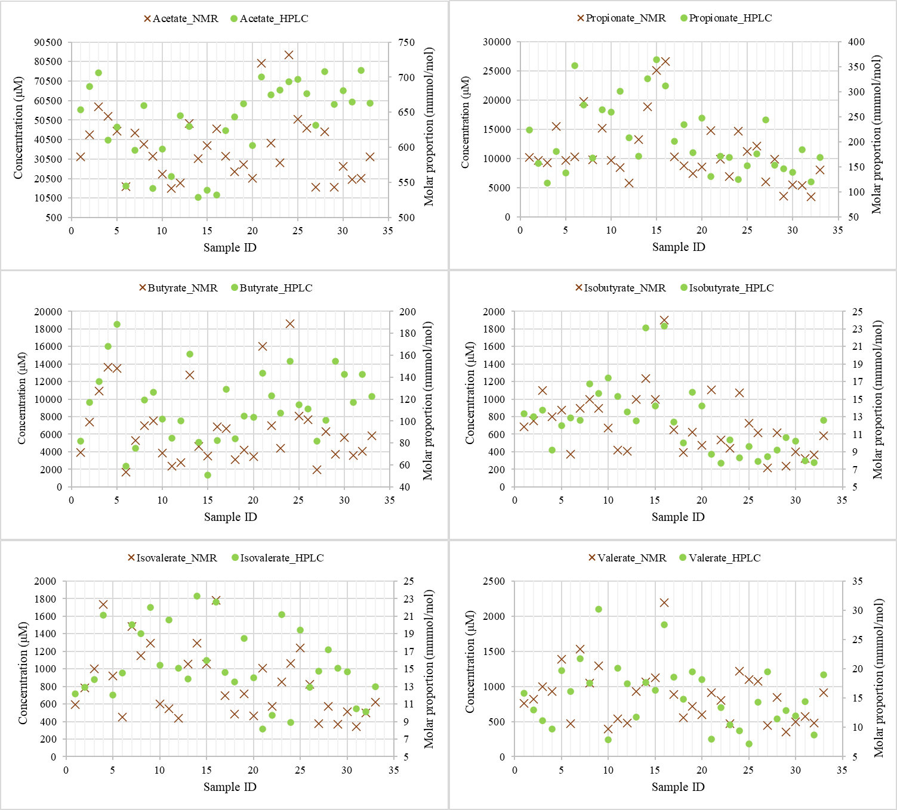
Fig. S1 Comparison of HPLC (mmol/mol) and NMR (Mm) of VFAs in the same rumen samples
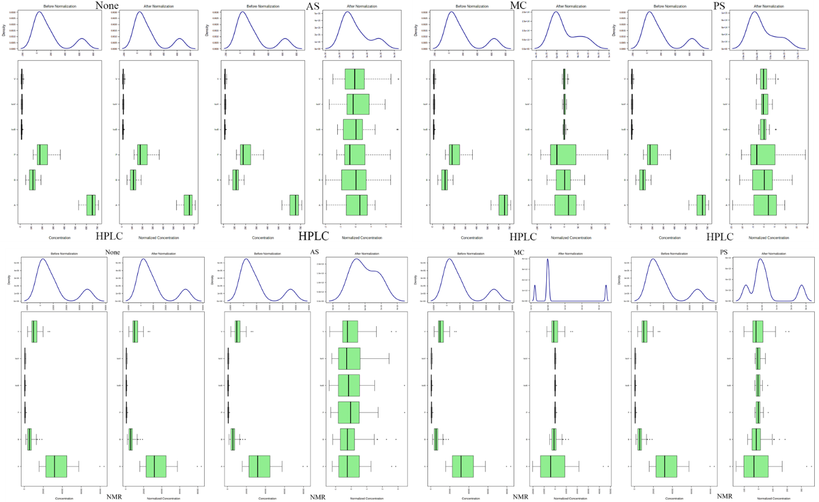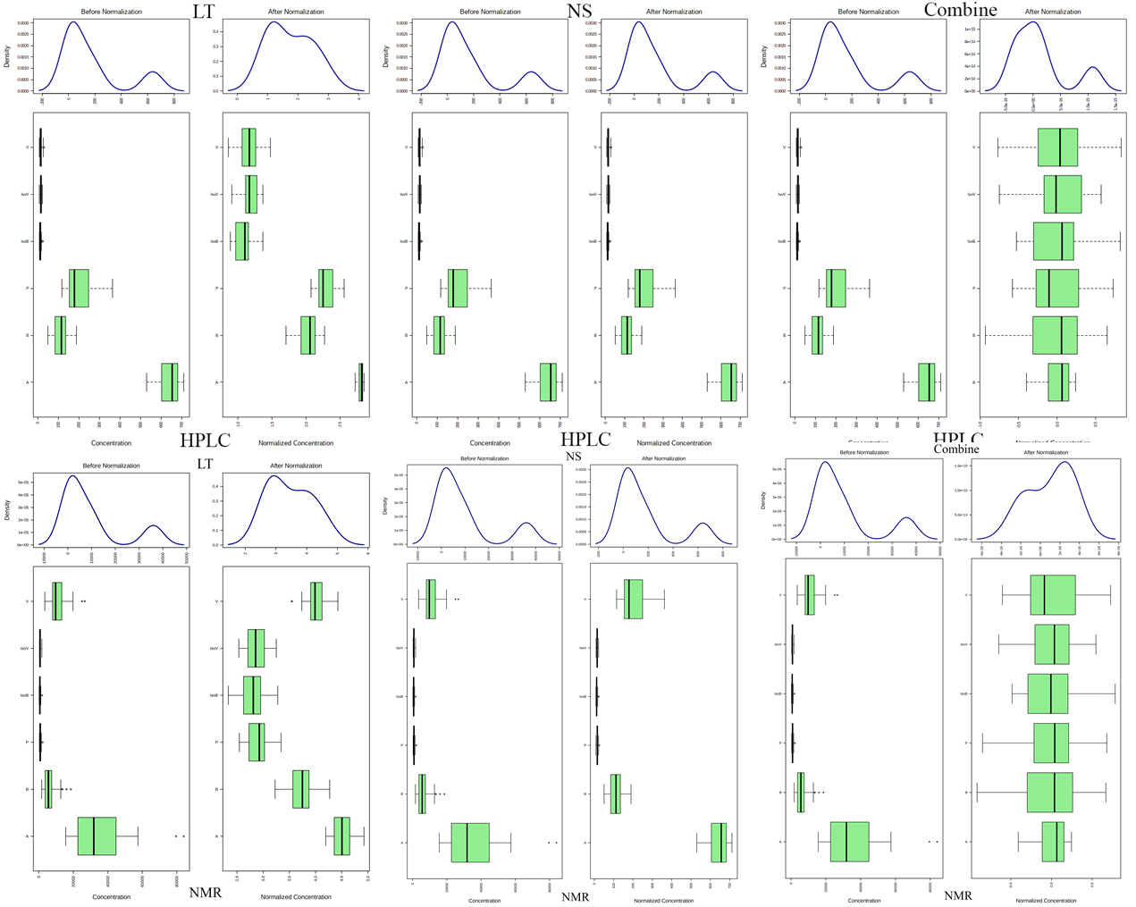
Fig. S2 Data pre-treatment comparison of variable distribution Data pre-treatment results of the NMR and HPLC data of VFAs under six different pre-treatments, including MC, AS, PS, LT, NS and Combine. None represents data without pre-treatment. Line plots show the overall data distribution based on kernel density estimation, before normalization—on the left, and after normalization—on right, while the two horizontal box plots on the bottom show the distributions of individual variables or metabolite concentrations, before and after normalization

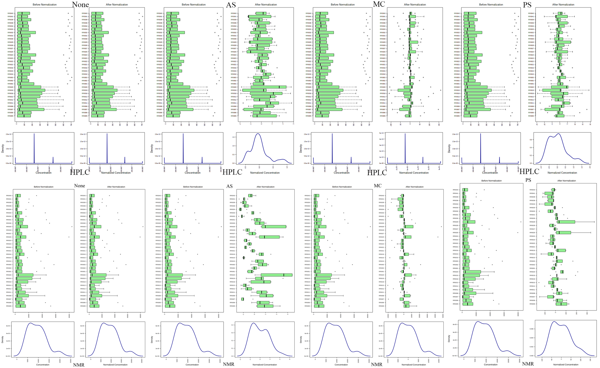
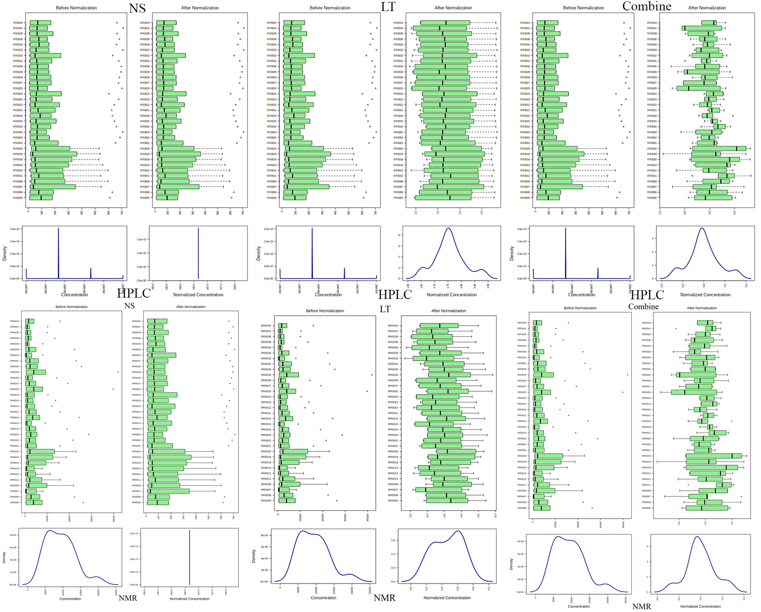
Fig. S3 Data pre-treatment comparison of sample distribution Data pre-treatment results of the NMR and HPLC data of VFAs under six different pre-treatments, including MC, AS, PS, LT, NS and Combine. None represents data without pre-treatment. Line plots show the overall data distribution based on kernel density estimation, before normalization—on the left, and after normalization—on right, while the two horizontal box plots on the bottom show the distributions of individual variables or metabolite concentrations, before and after normalization

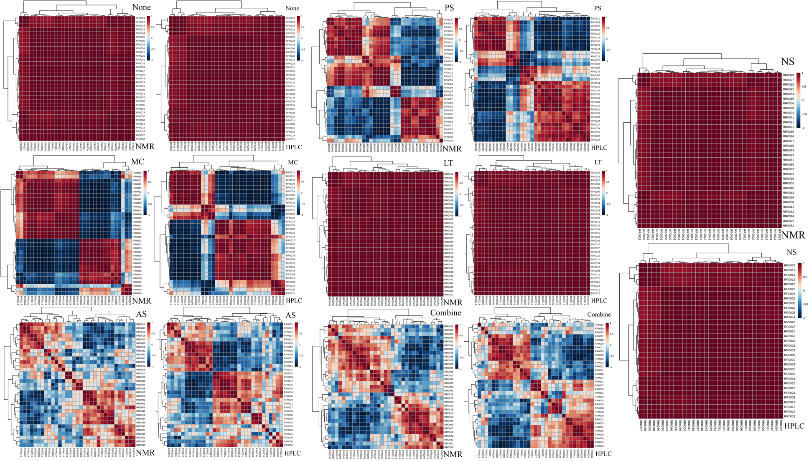
Fig. S4 Correlation heatmaps comparison of HPLC and NMR sample data Pearson correlation heatmaps of the NMR and HPLC data of VFAs under six different pre-treatments, including MC, AS, PS, LT, NS and Combine. None represents data without pre-treatment. The blue colour indicates that the correlation coefficient is close to 1, and the red colour indicates that the correlation coefficient is close to -1. The lines on the heat map indicate hierarchical clustering results. * Indicates a significant correlation, p<0.05

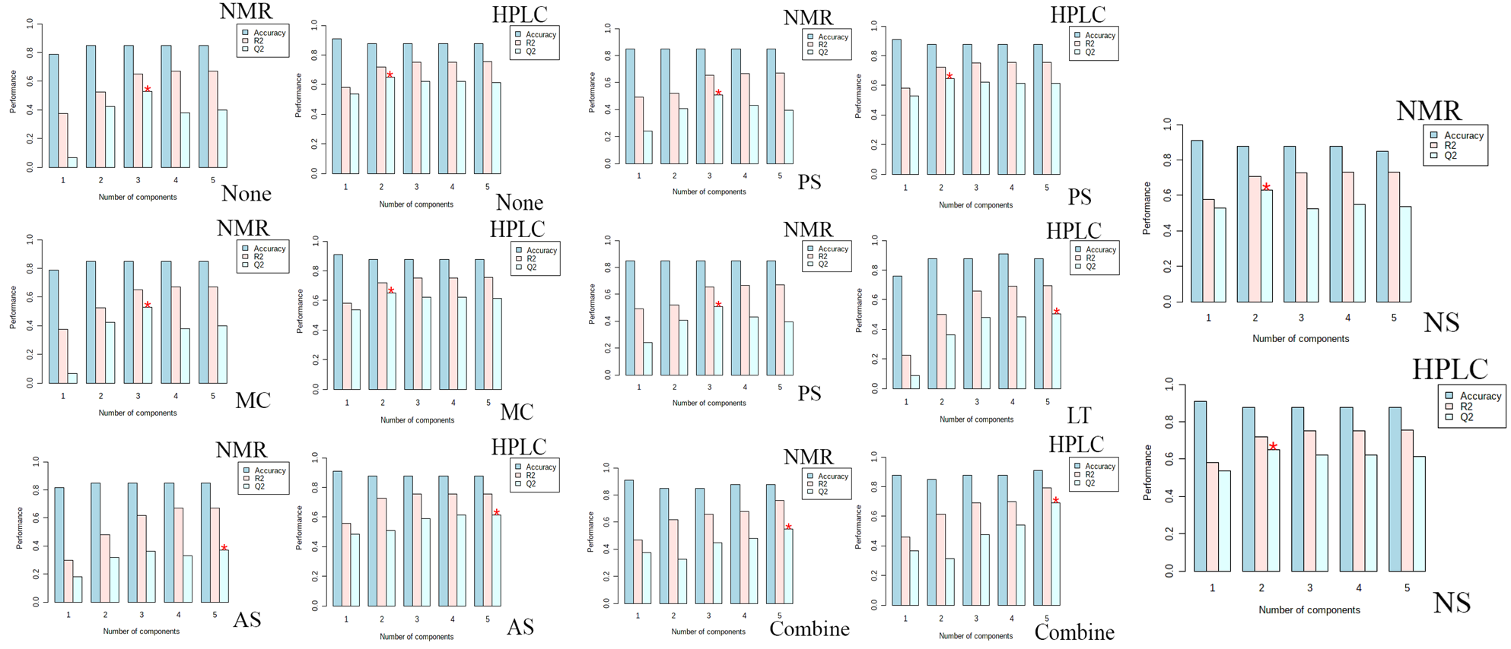
Fig. S5 PLS-DA analysis Cross-validation results PLS-DA analysis Cross-validation results of the NMR and HPLC data of VFAs under six different pre-treatments, including MC, AS, PS, LT, NS and Combine. None represents data without pre-treatment. The sum of squares captured by the model-R², the cross-validated Q², and the prediction accuracy-Accuracy. The default criterion is Q², red star indicates that a three-component model is the best. PLS-DA performs 10-fold cross-validation on the top five principal components.

