Supplementary Information
Urban morphology, not scale, dominates building-operational carbon emissions across 520 million buildings in China
Yuxin Chen¹, Kaipeng Ren², Yida Sun¹, Diling Liang³, Quan Wen¹, Yuli Shan⁴, Dabo Guan^{1,3 *}

Affiliations:
- Department of Earth System Science, Tsinghua University, Beijing 100084, China.
- College of Science, China University of Petroleum (Beijing), Beijing 102249, China.
- The Bartlett School of Sustainable Construction, University College London, London WC1E 7HB, UK.
- School of Geography, Earth and Environmental Sciences, University of Birmingham, Birmingham B15 2TT, UK

Supplementary Figure
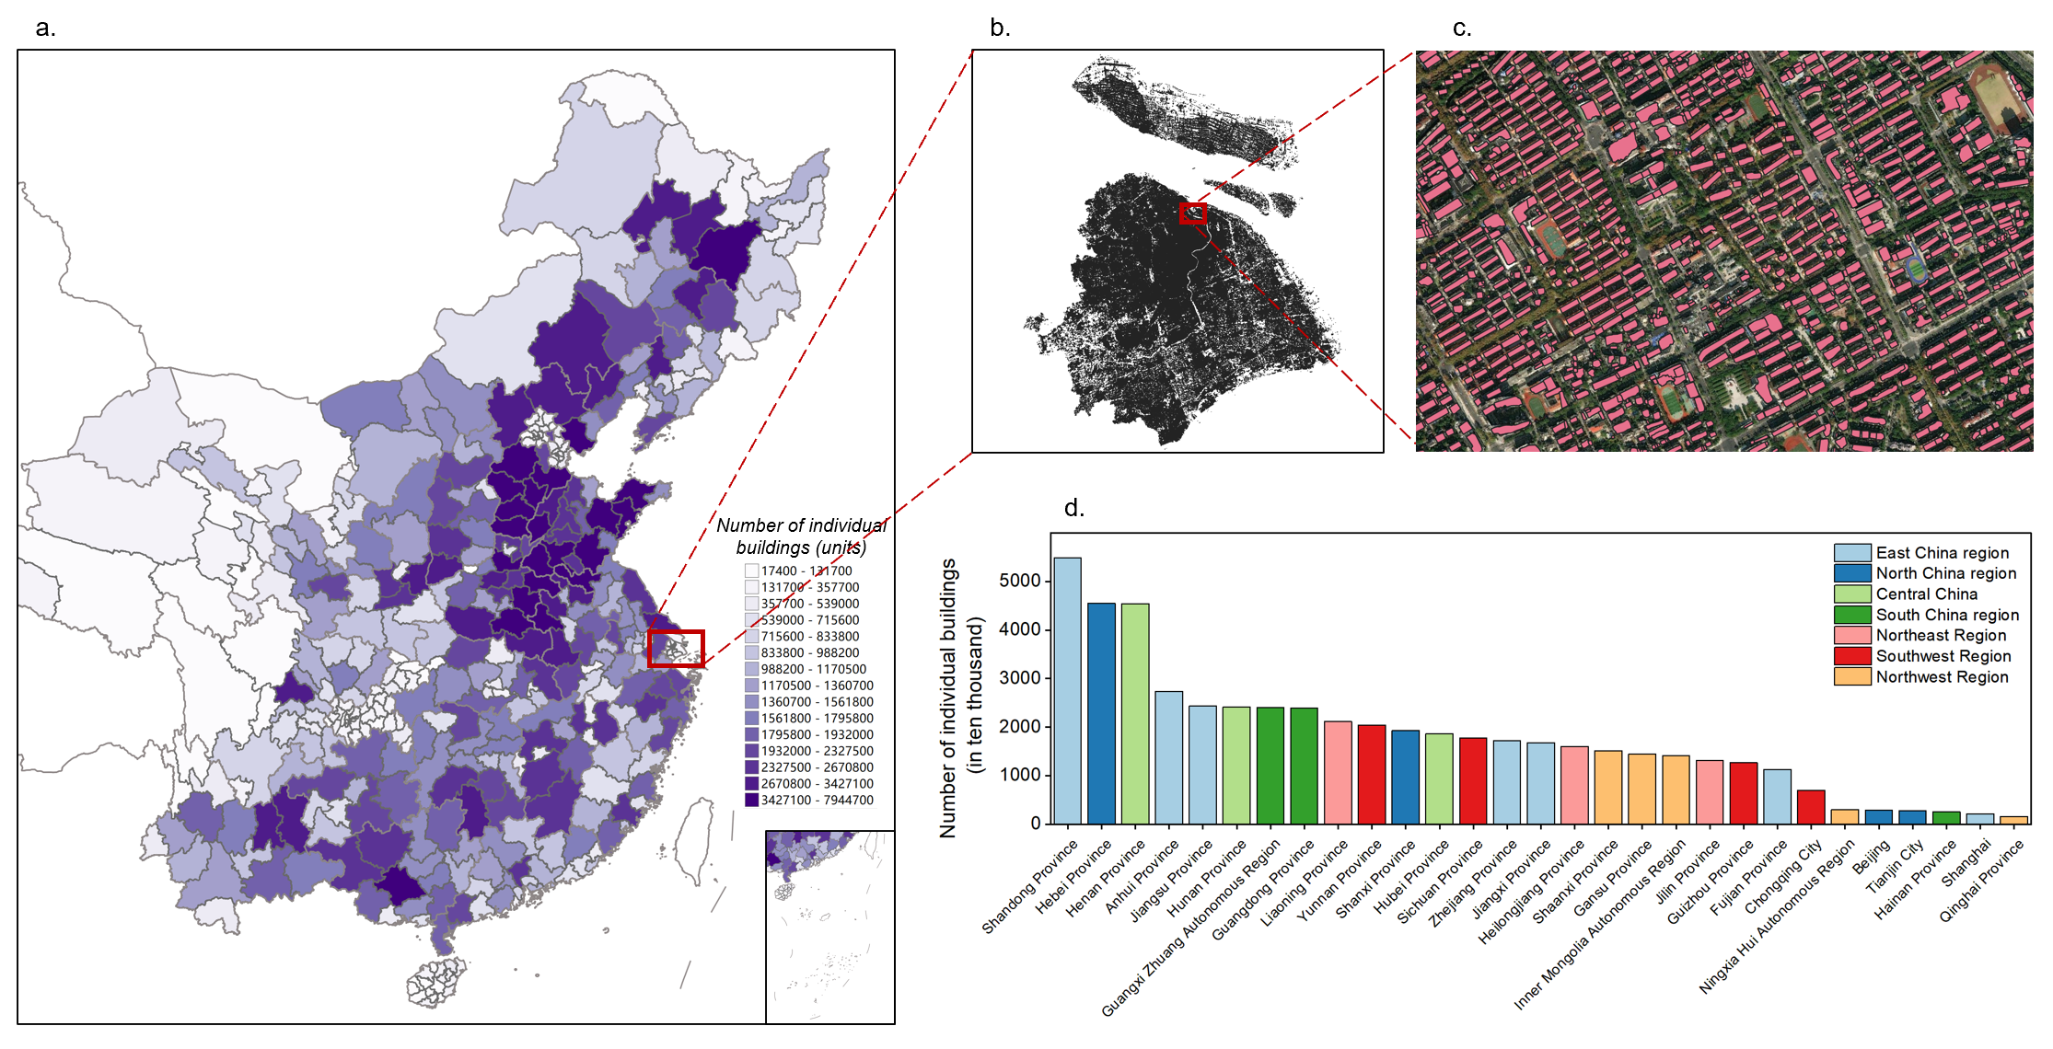
Supplementary Fig. 1 | Details of the Chinese individual building database. a shows the number of individual buildings within the study coverage of this paper, measured in number of structures. b presents a magnified view of Shanghai from panel a, while c provides a further zoomed-in illustration of a selected area in Shanghai, where pink polygons represent footprints of individual buildings. d displays the number of individual buildings by province (unit: 10,000 buildings), with bar colors indicating the geographical region of each province.

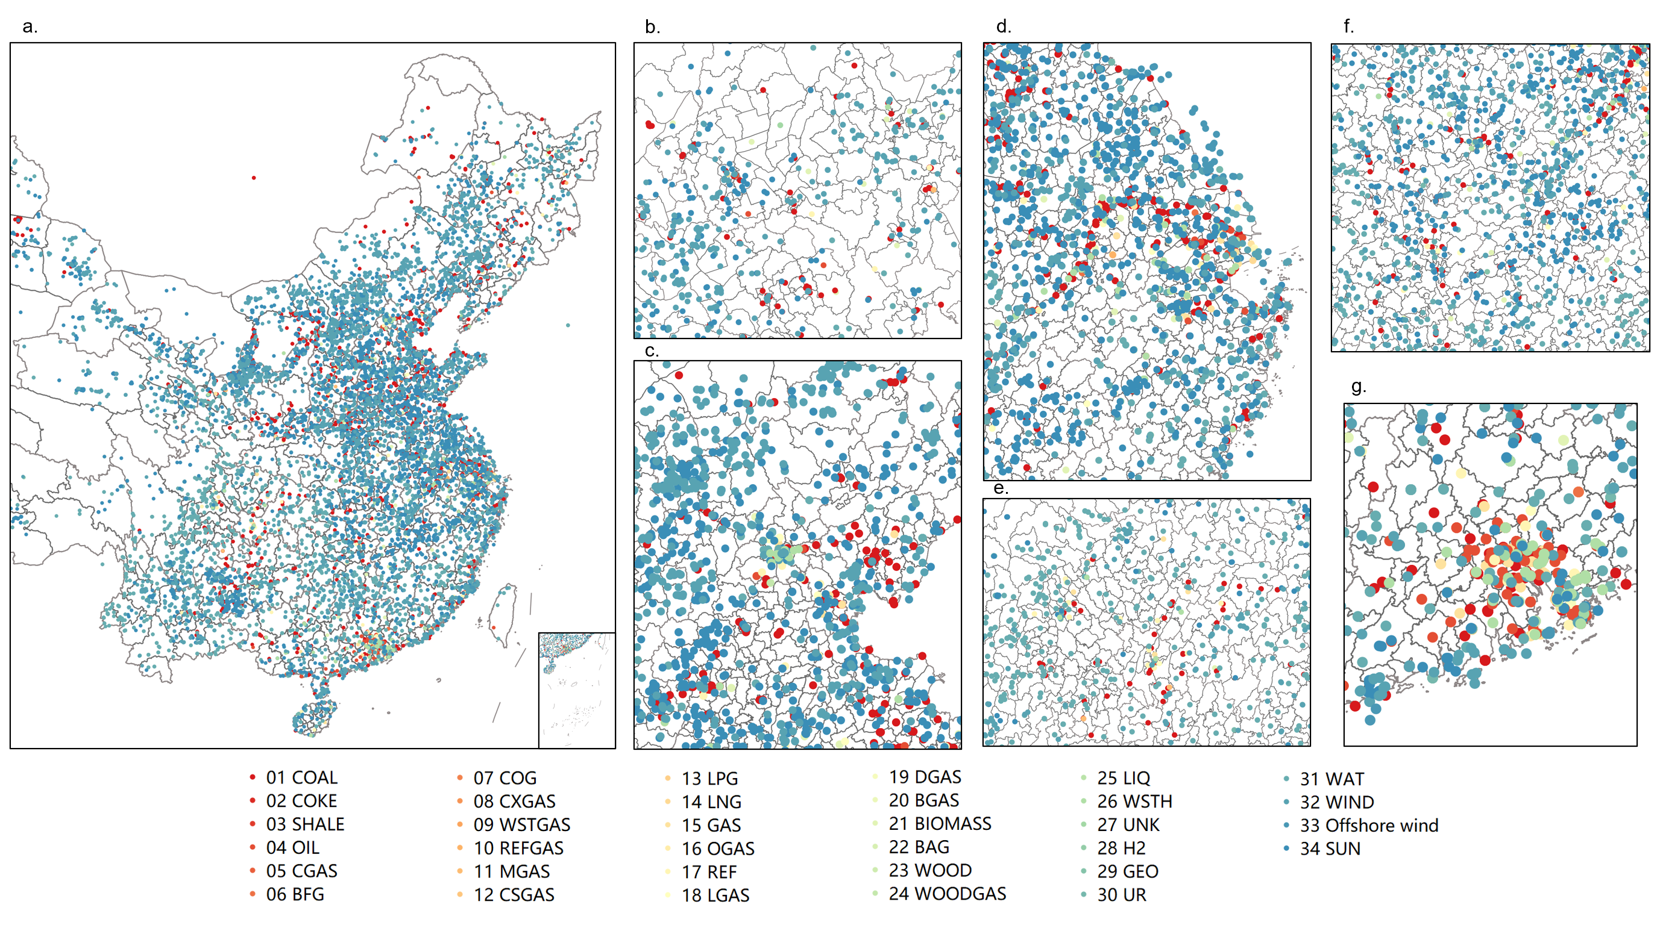
Supplementary Fig.2 | Information map of point-source power plants in China by energy type. This figure depicts the spatial distribution and energy composition of point-source power plants across China. a, National overview showing all identified power generation units. b–g, Enlarged views of six major urban agglomerations: Harbin–Changchun (b), Beijing–Tianjin–Hebei (c), Yangtze River Delta (d), Chengdu–Chongqing (e), Middle Yangtze River (f), and Pearl River Delta (g). Each power plant is classified by energy type, corresponding to codes 01–34 in the legend: (01) coal-fired, (02) petroleum coke, (03) oil shale, (04) oil-fired, (05) syngas from coal gasification, (06) blast furnace gas, (07) coke oven gas, (08) Corex gas, (09) refinery off-gas or industrial process gas, (10) waste gas, (11) coal mine gas, (12) coalbed methane, (13) liquefied petroleum gas (LPG), (14) liquefied natural gas (LNG), (15) gas-fired, (16) oil-gasified crude or refined residue, (17) refuse incineration, (18) landfill gas, (19) sewage digestion gas, (20) biogas, (21) agricultural waste and energy crop, (22) bagasse, (23) wood or wood waste, (24) syngas from wood or biomass gasification, (25) black liquor, (26) waste heat, (27) unknown, (28) hydrogen, (29) geothermal, (30) uranium, (31) hydropower, (32) onshore wind, (33) offshore wind, and (34) solar.

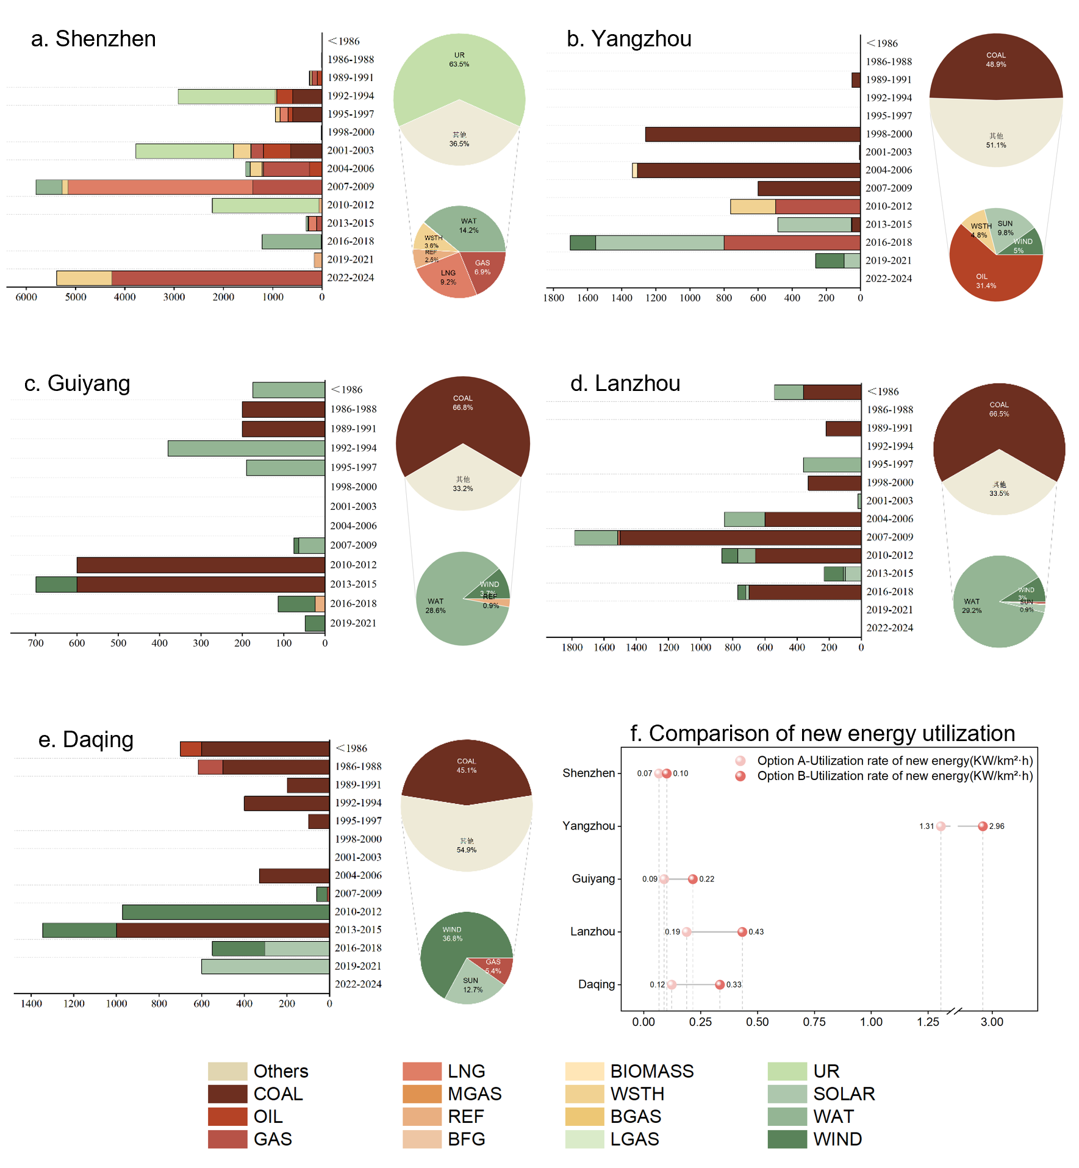

Supplementary Fig.3 | Comparison of power generation structure and renewable energy utilization rates in representative cities. a–e, Power generation composition of five representative cities—Shenzhen, Yangzhou, Guiyang, Lanzhou, and Daqing. Each panel combines a bar chart and a composite pie chart. The bar charts illustrate point-source power generation units within city boundaries, where the x-axis denotes installed capacity (MW) for each unit and the y-axis represents the commissioning year. The accompanying pie charts show the proportional contributions of local point-source units by energy type and imported electricity to total power generation. f, Comparison of renewable energy utilization rates among the five cities. Light red dots represent Scheme 1, in which the urban building footprint includes all building types (residential, commercial, and public), whereas dark red dots represent Scheme 2, which considers only commercial and public building footprints in the calculation.
Carbon emissions during the operational phase of buildings are strongly correlated with the emission intensity of the electricity sector, as indirect electricity use constitutes a substantially larger share of total energy consumption than direct fuel use. This critical linkage necessitates a detailed disaggregation of urban power generation structures to accurately evaluate how regional electricity mixes influence building-related emissions. Our analysis integrates operational parameters from 30,745 point-source power generation units across China, encompassing installed capacity, 35 distinct fuel types, and operational status. By coupling city-specific, fuel-diverse supply-side facilities into the model, we capture the environmental implications of their evolving configurations over time. Model-based calculations reveal a clear gradient in the carbon intensity of electricity across the five representative cities: Shenzhen (0.159 kg CO₂ kWh⁻¹), Guiyang (0.542), Yangzhou (0.546), Lanzhou (0.659), and Daqing (0.974). This gradient not only reflects the varying degrees of power-sector decarbonization among cities but also underscores the decisive influence of regional energy supply structures and resource endowments on urban emission profiles.

Shenzhen records the lowest carbon intensity among the five cities (0.159 kg CO₂ kWh⁻¹), reflecting its highly diversified and clean-energy-oriented electricity mix. Nuclear power (UR) dominates generation at 63.5%, providing a stable baseload supply with near-zero operational emissions. This is complemented by renewable sources—hydropower (WAT, 14.2%) and natural gas–based generation from liquefied natural gas (LNG, 9.2%) and pipeline gas (GAS, 6.9%)—which together produce substantially lower emissions than coal. Moreover, Shenzhen has advanced waste-to-energy integration, with waste heat recovery (WSTH, 3.6%) and refuse incineration (REF, 2.5%) contributing to a circular and resource-efficient energy system. Collectively, these features underscore how sustained investment in a non–fossil-fuel-dominated power infrastructure underpins Shenzhen’s superior carbon performance.

Guiyang and Yangzhou exhibit remarkably similar electricity carbon intensities, yet the energy pathways leading to these outcomes differ sharply—highlighting how regional resource endowments shape urban energy structures. In hydropower-rich Guiyang, coal-based generation (COAL, 66.8%) remains dominant; however, a substantial share of hydropower (WAT, 28.6%), supplemented by wind (WIND, 3.7%) and waste-to-energy (REF, 0.9%), offsets the carbon intensity of coal, maintaining an overall moderate level of 0.542 kg CO₂ kWh⁻¹. In contrast, Yangzhou’s electricity mix reflects both its transitional stage and historical legacy as an eastern coastal city. While coal contributes a smaller share (COAL, 48.9%) than in Guiyang, oil-fired generation (31.4%)—a typically more carbon-intensive source—elevates its emissions baseline. Nonetheless, Yangzhou’s rapid expansion of renewables, with solar (SUN, 9.8%), wind (WIND, 5.0%), and waste-to-energy (REF, 4.8%) collectively accounting for nearly 20% of generation, has reduced its overall carbon intensity to 0.546 kg CO₂ kWh⁻¹, signaling tangible progress in its energy transition.

Lanzhou and Daqing display notably high electricity carbon intensities, underscoring the structural constraints faced by traditional industrial cities in decarbonizing their power systems. Lanzhou’s electricity supply remains dominated by local coal-fired generation (COAL, 66.5%), the principal contributor to its carbon intensity of 0.659 kg CO₂ kWh⁻¹. However, the city benefits from hydropower supplied by the Yellow River, with hydroelectricity (WAT) comprising 29.2% of its mix—partially mitigating the emissions impact of its fossil dependence. Daqing exemplifies the inertia characteristic of legacy energy systems. Despite impressive progress in renewable deployment—wind (WIND, 36.8%) and solar (SUN, 12.7%) together approaching 50% of total generation—the entrenched dominance of coal (COAL, 45.1%) continues to anchor the city’s carbon intensity at 0.974 kg CO₂ kWh⁻¹, the highest among all cities studied. This outcome illustrates that in long-industrialized regions, scaling up clean energy must be accompanied by the accelerated phase-out of high-carbon assets to achieve substantive reductions in electricity-related emissions.

A horizontal comparison reveals substantial disparities in renewable energy utilization among the five cities, reflecting the combined influence of regional resource endowments, building structural characteristics, and policy orientation. Yangzhou (Scheme 2: 2.959 kW km⁻²·h) exhibits the most outstanding performance, driven by large-scale photovoltaic (PV) deployment on commercial and industrial buildings—where industrial structures account for over 40% of installations—supported by proactive local policy incentives. Its utilization far exceeds that of other cities, such as Shenzhen (0.101 kW km⁻²·h), underscoring the structural advantage of industrial-oriented cities in distributed solar development. Both Daqing (Scheme 2: 0.335 kW km⁻²·h) and Lanzhou (0.433 kW km⁻²·h) show significant increases in utilization rates after excluding residential buildings, with rises of 175% and 130%, respectively. This concentration reflects the clustering of PV installations in low-density industrial zones—Daqing’s industrial buildings average 5–10 km² in footprint—and in public institutions, where over 60% of school and hospital rooftops are utilized in Lanzhou. In contrast, Shenzhen’s low utilization rate is constrained by its ultra-high building density and predominantly residential urban structure, with residential land use exceeding 60%. The dominance of high-rise buildings severely limits rooftop availability, highlighting the developmental bottlenecks faced by high-density cities under conventional rooftop PV models.

Longitudinally, building type exerts a pronounced influence on renewable energy utilization. Across all cases, the results under Scheme 2 (considering only commercial and public buildings) are consistently higher than those under Scheme 1 (all building types), with Daqing and Yangzhou exhibiting the greatest increases. This finding underscores the pivotal role of commercial and industrial cities—typically characterized by medium-to-low floor area ratios—in enhancing PV hosting capacity. In contrast, although Guiyang (0.215 kW km⁻²·h) demonstrates improvement under Scheme 2, its potential remains limited by frequent cloud cover and mountainous topography, revealing the dual constraints of natural environment and urban morphology on PV efficiency. Quantitative analysis further indicates that even after excluding residential buildings, residential-dominated cities such as Shenzhen experience only modest gains (a 53% increase), underscoring the need to transition from conventional rooftop systems toward integrated solutions such as building-integrated photovoltaics (BIPV) and three-dimensional PV applications (e.g., elevated highways or curtain walls) to overcome spatial limitations associated with extreme volumetric density. In summary, disparities in urban renewable energy utilization are shaped not only by installed capacity but also by the spatial configuration of buildings, the availability of solar resources, and the adaptability of local policies. Future urban PV planning should integrate considerations of building density, typology, and policy frameworks to design differentiated development pathways, thereby enhancing the precision and effectiveness of urban energy transition strategies.

Supplementary Table
Supplementary Table 1 | Mapping of point of interest (POI) types to building categories
Primary Category | Secondary Category | Specific Classification / Notes
Residential Buildings - Urban | Place Names and Address Information | House number information
Residential Buildings - Urban | Place Names and Address Information | Generic place names
Residential Buildings - Urban | Place Names and Address Information | Address data
Residential Buildings - Urban | Commercial and Residential | Residential areas / estates
Residential Buildings - Urban | Commercial and Residential | Commercial-residential complexes
Residential Buildings - Rural | Place Names and Address Information | House number information
Residential Buildings - Rural | Place Names and Address Information | Generic place names
Residential Buildings - Rural | Place Names and Address Information | Address data
Residential Buildings - Rural | Commercial and Residential | Residential areas / villages
Residential Buildings - Rural | Commercial and Residential | Commercial-residential complexes
Industrial Buildings | Commercial and Residential | Industrial parks
Industrial Buildings | Commercial and Residential | Industrial buildings
Industrial Buildings | Companies and Enterprises | Factories
Industrial Buildings | Companies and Enterprises | Corporate offices
Industrial Buildings | Companies and Enterprises | Well-known enterprises
Industrial Buildings | Companies and Enterprises | Business registries
Retail & Hospitality Buildings | Food and Beverage Services
Retail & Hospitality Buildings | Shopping Services
Retail & Hospitality Buildings | Accommodation Services
Transportation, Storage & Postal Buildings | Life Services | Logistics and express delivery
Transportation, Storage & Postal Buildings | Life Services | Post offices
Transportation, Storage & Postal Buildings | Road Affiliated Facilities
Transportation, Storage & Postal Buildings | Transportation Facility Services | (Excluding 'Pick-up/Drop-off Zones', 'Parking Lots')
Institutional & Public Service Buildings | Government and Social Organizations
Institutional & Public Service Buildings | Science, Education & Culture
Institutional & Public Service Buildings | Healthcare Services
Institutional & Public Service Buildings | Sports and Recreation Services | (Excluding 'Leisure Venues')
Institutional & Public Service Buildings | Financial and Insurance Services
Institutional & Public Service Buildings | Life Services
Institutional & Public Service Buildings | Motorcycle Services | (Excluding 'Funeral Services', 'Logistics/Express', 'Post Offices')
Institutional & Public Service Buildings | Automotive Services
Institutional & Public Service Buildings | Automotive Repair
Institutional & Public Service Buildings | Automotive Sales
Other Land Use  (Excluding) | Companies and Enterprises | Agricultural, Forestry, Livestock & Fishery Bases
Other Land Use  (Excluding) | Place Names and Address Information | Transportation-related toponyms
Other Land Use  (Excluding) | Place Names and Address Information | Landmark / hotspot toponyms
Other Land Use  (Excluding) | Place Names and Address Information | Natural feature toponyms
Other Land Use  (Excluding) | Life Services | Funeral and interment facilities
Other Land Use  (Excluding) | Sports and Recreation Services | Leisure venues
Other Land Use  (Excluding) | Passage Facilities
Other Land Use  (Excluding) | Scenic Spots and Historic Sites

Supplementary Table 2 | Selection criteria and key characteristics of representative cities
No. | Climate zone | City | Urban type | Key characteristics
1 | Hot summer warm winter | Shenzhen | Compact City | High floor area ratio, three-dimensional development
2 | Hot summer cold winter | Yangzhou | Traditional Dense City | Medium floor area ratio, low-density traditional layout
3 | Temperate | Guiyang | Mountainous Cluster City | Topographically constrained, clustered development
4 | Cold | Lanzhou | Linear Valley City | Low-density linear expansion along river valley, high floor area ratio
5 | Severe cold | Daqing | Resource-based Dispersed City | Ultra-low density, resource-driven dispersed distribution

Supplementary Table 3 | Sectoral Disaggregation and Matching Methodology Based on Energy Balance Table
NO. | Energy Balance Table Sector | Statistical Coverage | Building Energy Consumption | Included in This Study? | Building Type | Excluded Energy Types
① | Agriculture, Forestry, Animal Husbandry, and Fishery | Primary industry energy use | Does not include building energy use | No | — | —
② | Industry | Secondary industry energy use, including mining, manufacturing, and public utility production and supply | Includes building energy use (e.g., office buildings, staff dormitories) | Yes (excluding mining-related sectors) | Industrial buildings | Exclude kerosene, gasoline, diesel, and fuel oil
③ | Construction | Secondary industry energy use related to construction activities | Similar to sector ② | No | — | —
④ | Transportation, Warehousing, and Postal Services | Rail, road, waterway, air, pipeline, urban public transport, and related handling, storage, and postal services | Includes functional building energy use (e.g., stations, airports, post offices) | Yes (100% of coal consumption + 40% of electricity consumption) | Transportation/warehouse/postal buildings | Kerosene, gasoline, diesel, and fuel oil attributed to mobile emission sources
⑤ | Wholesale, Retail, Hotel, and Catering Services | Tertiary industry dominated by service sectors | Primarily building energy use, but includes transportation energy within the sector | Yes | Wholesale/retail/hotel/catering buildings
⑥ | Others | Mainly covers other tertiary sectors beyond ④ and ⑤, including science/education/culture/health/sports and public administration | Similar to sector⑤ | Yes | Science/education/culture/health/sports buildings
⑦ | Urban Residential Consumption | Urban household energy use | Primarily building energy use | Yes | Urban residential buildings
⑧ | Rural Residential Consumption | Rural household energy use | Primarily building energy use | Yes | Rural residential buildings

Supplementary Table 4 Summary of typology analysis of building energy consumption and CO₂ emissions (representative literatures)|
No. | Typical research | Method/Model | Research object | Research scale | Time period | Assessing index | Typology of cities/building
1 | Berril et al., 2021¹ | Linear regression model of energy end-use | Residential energy demand | U.S. | 2015 | Energy end-use in urban home | Housing type (Single/multifamily)
2 | Yap et al., 2025² | A graph deep learning model that integrates open data on building energy usage and crowdsourced geospatial information | Building operating carbon emissions | 5 global cities (Melbourne, NYC, Seattle, Singapore, Washingtion DC), 595173 buildings | Single year | Total annual energy consumption by each building | Population density, Local climate zone, urban heat island intensity, GDP per capita
3 | Yu et al., 2024³ | A combination of “top-down” and “bottom-up” methods through an extensive collection of statistical data | Energy consumption and carbon emissions of building operations | 321 cities in China | 2015-2020 | Carbon emissions from building operations, City-level building end-use carbon emissions | 321 cities are classified by heating behavior and temperature into 3 regions.
4 | You et al., 2025⁴ | LCA Avoid-Shift-Improve (ASI) framework to explore the impact of building demand-side solutions (DSS) | Residential building carbon emissions and NPV | Urban and rural residential buildings in China | 2020-2060 | 11 single-DSS-measure scenarios and 9 typical combinations, including: Low (Base), medium (ASI1), and high levels (ASI2) of all measures; high level of only avoid (A2), shift (S2) or improve (I2) measures; scenario with most optimistic decarbonization (PD), NPV-saving (PNS), and cost effectiveness (PCE) | 3 climate zones including northern area, transition area and southern area
5 | Zhang et al., 2025⁵ | Dynamic material flow analysis with a lifecycle footprint analysis | The interplay between carbon, material, and economic footprint in Dutch residential sector | Dutch residential sector | 2015-2050 | Carbon, material, and economic footprint | Houses are divided into 5 types (detached, semi-detached, terraced, apartment and maisonette) under 5 vintage types (Newly built home 2015-2050, Existing home 2001-2014, 1981-2000, 1961-1980, up to 1960).
6 | Wang et al., 2022⁶ | Combining POI data processing and emission factor approach to conduct spatial temporal analysis of carbon emissions from building operation | Carbon emissions from building operation | Beijing | 2005-2020 | Temporal and spatial distribution of carbon emissions in different sectors | Public buildings, residential buildings, industrial buildings and transportation hubs
7 | Xia et al., 2025⁷ | A dynamic housing stock model that incorporates housing vacancy | Residential building | China | 2023-2060 | Housing vacancy rate | All completed residential buildings is classify into demolished, vacant and in-service. Vacant residential buildings are divided into underused, new vacant, and reusable residential building
8 | Güneralp et al., 2017⁸ | GCAM is used to quantify the influence of urban density on energy use of heating and cooling from top-down perspectives. Bottom-up 3CSEP HEB model is used to quantify the energy savings from retrofitting options. | Urban population densities, Energy use for heating and cooling | Global and 11 regions | 2020-2050 | Building energy use | Urban population density
9 | Tang et al., 2025⁹ | BOCE downscaling method.  Multi-scale Geographically Weighted Regression (MGWR) | Building operating carbon emissions | Guangdong-Hong Kong-Macao Greater Bay Area | 2015, 2020 | 1 km-resolution BOCE map | Public and residential, socio-economic factors, natural and climate factors.
10 | Boccalatte et al., 2020¹⁰ | Urban Weather Generator, EnergyPlus | Urban climate, Heating and cooling energy demand of residential building | Rome, Paris and Helsinki | Daily/ Weekly/ Whole year | UHI intensity, Building energy consumption | building height, building surface density, average canyon width

Supplementary Table 5 Summary of modeling tools of building energy consumption and CO₂ emissions (representative literatures)|
No. | Typical research | Method/Model | Research object | Research scale | Time period | Assessing index | Typology of cities/building
1 | Naeem et al., 2025¹¹ | EnergyPlus | Commercial building energy demand | Multi-zone office building in U.S. | 2022-07.05-09.11 | Operational digital twin technology | Thermal zone inside a building
2 | Yan et al., 2022¹² | DeST | Whole lifecycle of building | Building energy modelling program | - | High-performance simulation based on parallel computation | Building thermal envelope and fabric load, Space-cooling equipment performance, Space-Heating equipment performance
3 | Quan et al., 2016¹³ | UMI (Urban Modeling Interface) and UWG (Urban Weather Generator) | Building energy use | Nine Shanghai neighborhoods | - | Floor area ratio | Building density
4 | Song et al., 2024¹⁴ | AutoBPS and EnergyPlus | Urban Building Energy Modeling | Shanghai City, China | - | Footprints, AOIs, POIs, Land cover | Building footprints, building heights, Point of Interest (POIs), areas of interest (AOIs)
5 | Deng et al., 2025¹⁵ | Top-down emission model | Commercial building operational carbon emissions | 30 provinces excluded Tibet, Hong Kong, Macau, and Taiwan | 2020-2060 | Energy peak level and time | Building floor area, per capita areas of commercial building
6 | Dawodu et al., 2016¹⁶ | Autodesk EcoTect 2011 (A simulation-driven building environmental analysis software that can conduct geometry analysis) | Residential building heating and cooling energy demand | Neighbourhood (Meso) level in Ningbo city, China | 1st January-31st December | Floor Area Ratio (FAR) | Building density
7 | Tümtürk, 2025¹⁷ | Longitudinal morphological dataset | Building type transition | New York, Midtown Manhattan, Central Melbourne, Eixample, Barcelona | 1890-2021; 1888-2020; 1890-2017 | Accessible Ground Space Index (AGSI) and Accessible Floor Space Index (AFSI) | Urban density
8 | Haddad et al., 2024¹⁸ | CityBES | Cooling load and energy conservation potential | 3323 buildings in Riyadh, Saudi Arabia. | - | - | -
9 | Chen et al., 2017¹⁹ | CityBES and Energyplus | Automatic generation and simulation of urban building energy models | 940 office and retail buildings in six city districts in northeast San Francisco, United States | - | Energy conservation measure | Building types
10 | Weiler et al., 2022²⁰ | SimStadt and INSEL | Automatic energy system modeling and simulation (Rule based and optimization based) | 11 buildings in a German suburban town (Wüstenro) | 2020/2050 | Total annual cost | -

Supplementary Method
Assessment of Urban Renewable Energy Utilization Rate
The renewable energy utilization rate is a critical metric for assessing the efficiency and sustainability of urban energy systems. It reflects the capacity of a city to harness renewable energy sources relative to its available spatial and temporal resources. In this study, we employ the distributed photovoltaic (PV) utilization rate at the city level to characterize this indicator. This metric quantifies the density of PV deployment per unit building area and per unit effective generation time, serving as a proxy for the efficiency of solar energy integration within urban built environments.
The city-level renewable energy utilization rate ($U$) is defined as the ratio of the total installed capacity of distributed PV systems within the city to the product of the total building footprint area and the annual effective utilization hours of PV generation. Mathematically, it is expressed as:
$$\begin{aligned}U=\frac{C_{city}}{A×H}\#\text{(1)}\end{aligned}$$
Where, $U$ is the city-level renewable energy utilization rate (in kW/km²·h), $C_{city}$ is the total installed distributed PV capacity at the city level (in kW), and $A$ is the total building footprint area of the city (in km²). $H$ is the annual effective utilization hours of PV generation, which are sourced from the PV Resource Development Planning Table, with units in hours. The unit of $U$ is kW/km²·h, which represents the installed PV capacity (in kW) per square kilometer of building footprint area and per hour of effective annual generation time. This metric can be interpreted as the PV power carrying capacity density per unit land area and per unit time, reflecting the efficiency of PV deployment over urban building spaces.

The city-level distributed PV capacity ($C_{city}$) is derived from the provincial distributed PV capacity, scaled by the ratio of the city’s rooftop PV deployment potential to that of the province:
$$\begin{aligned}C_{city}=C_{prov}×\frac{P_{city}}{P_{prov}}\#\text{(2)}\end{aligned}$$
Where, $C_{prov}$ is the distributed PV capacity of the province where the city is located, obtained from the National Energy Administration (https://www.nea.gov.cn/2022-03/09/c_1310508114.htm), with units in kW. $P_{city}$ and $P_{prov}$ represent the rooftop PV deployment potential of the city and province, which are referenced from the study by Shi et al.(2025).

The building footprint area $A$ is defined differently in each scheme:
- Scheme 1:
The building footprint area encompasses all building types, including residential, commercial, and public buildings.
$$\begin{aligned}A_{1}=A_{residential}+A_{commercial}+A_{public}\#\text{(3)}\end{aligned}$$
The utilization rate is therefore:
$$\begin{aligned}U=\frac{C_{city}}{A_{1}×H}\#\text{(4)}\end{aligned}$$
- Scheme 2:
The building footprint area includes only commercial and public buildings, excluding residential structures.
$$\begin{aligned}A_{2}=A_{commercial}+A_{public}\#\text{(5)}\end{aligned}$$
The utilization rate is therefore:
$$\begin{aligned}U=\frac{C_{city}}{A_{2}×H}\#\text{(6)}\end{aligned}$$
Both schemes share the same numerator $C_{city}$ and the same denominator factor $H$. The sole difference lies in the definition of the building footprint area $A$. This approach allows for a direct comparison of how the inclusion or exclusion of residential building areas influences the perceived efficiency of distributed PV deployment at the city level.

Supplementary References
1. Berrill, P., Gillingham, K. T. & Hertwich, E. G. Linking Housing Policy, Housing Typology, and Residential Energy Demand in the United States. Environ. Sci. Technol. 55, 2224–2233 (2021).
2. Yap, W., Wu, A. N., Miller, C. & Biljecki, F. Revealing building operating carbon dynamics for multiple cities. Nat Sustain https://doi.org/10.1038/s41893-025-01615-8 (2025) doi:10.1038/s41893-025-01615-8.
3. Yu, Y. et al. City-level building operation and end-use carbon emissions dataset from China for 2015–2020. Sci Data 11, 138 (2024).
4. You, K. et al. Mitigating emissions and costs through demand-side solutions in Chinese residential buildings. Nat Commun 16, 7358 (2025).
5. Zhang, C. et al. Revealing the interplay between decarbonisation, circularity, and cost-effectiveness in building energy renovation. Nat Commun 16, 7153 (2025).
6. Wang, J. et al. High-resolution temporal and spatial evolution of carbon emissions from building operations in Beijing. Journal of Cleaner Production 376, 134272 (2022).
7. Xia, B. et al. Exploiting vacant urban residential buildings to promote carbon neutrality in China. Nat Commun 16, 7661 (2025).
8. Güneralp, B. et al. Global scenarios of urban density and its impacts on building energy use through 2050. Proc. Natl. Acad. Sci. U.S.A. 114, 8945–8950 (2017).
9. Tang, Y. et al. High resolution spatial distribution of CO₂ emissions from building operations and driving factors in the Guangdong-Hong Kong-Macao Greater Bay Area. Sustainable Cities and Society 131, 106708 (2025).
10. Boccalatte, A., Fossa, M., Gaillard, L. & Menezo, C. Microclimate and urban morphology effects on building energy demand in different European cities. Energy and Buildings 224, 110129 (2020).
11. Naeem, A. et al. EnergyPlus as a computational engine for commercial building operational digital twins. Energy and Buildings 329, 115257 (2025).
12. Yan, D. et al. DeST 3.0: A new-generation building performance simulation platform. Build. Simul. 15, 1849–1868 (2022).
13. Quan, S. J. et al. Urban Form and Building Energy Performance in Shanghai Neighborhoods. Energy Procedia 88, 126–132 (2016).
14. Song, C. et al. Developing urban building energy models for shanghai city with multi-source open data. Sustainable Cities and Society 106, 105425 (2024).
15. Deng, Y. et al. Provincial allocation of China’s commercial building operational carbon toward carbon neutrality. Applied Energy 384, 125450 (2025).
16. Dawodu, A. & Cheshmehzangi, A. Impact of Floor Area Ratio (FAR) on Energy Consumption at Meso Scale in China: Case Study of Ningbo. Energy Procedia 105, 3449–3455 (2017).
17. Tümtürk, O. Multiple pathways to urban density: A comparative diachronic analysis of building type transitions across three city centers. Cities 167, 106308 (2025).
18. Haddad, S. et al. Quantifying the energy impact of heat mitigation technologies at the urban scale. Nat Cities 1, 62–72 (2024).
19. Chen, Y., Hong, T. & Piette, M. A. Automatic generation and simulation of urban building energy models based on city datasets for city-scale building retrofit analysis. Applied Energy 205, 323–335 (2017).
20. Weiler, V. et al. Automatic dimensioning of energy system components for building cluster simulation. Applied Energy 313, 118651 (2022).

