Supplementary Table 1. List of Covariates Related to Severity at Long-Term Care Hospitals
Category | Covariate
Details of benefit claims | Sex, age, ECI (Elixhauser comorbidity index) score (group), and the number of patients diagnosed with cancer
Patient evaluation tables | Fixed rate status, coma status, long-term admission status, the level of cognitive ability, presence of delirium, level of understanding, insertion of an indwelling catheter, presence of a urinary tract infection, presence of lower limb paralysis, presence of fever, fever temperature score, presence of a terminal illness, presence of bedsore, past history of bedsores, management of urinary catheters***, implementation of oxygen therapy, use of a ventilator, number of stage 3 bedsores, number of stage 4 bedsores, and long-term care grade code
Long-term care institution resource report status | The number of doctors, number of nurses, number of pharmacists, doctor levels, nurse levels, number of beds, doctors’ specialties (internal medicine, urinary system, etc.)
Long-term care benefit appropriateness evaluation | The number of patients per doctor, number of patients per nurse, number of patients per nursing personnel, psychotropic substance prescription rate levels, levels of ratios of patients with improved activities of daily living, hemoglobin A1c test results among patients with diabetes, long-term stay (181 days or more) patient proportion, and levels of local community return rates

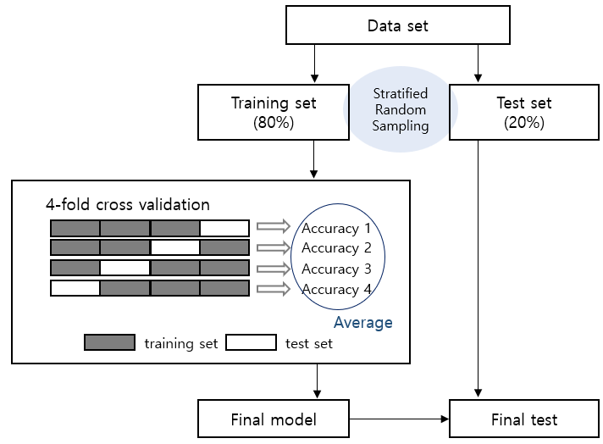
Supplementary Figure 1. Schematic diagram of the model development process

Supplementary Table 2. SAAR Model Validity for the Amount of Antimicrobials Administered Among Inpatients under Fee-for-Service
Category | Antimicrobial class | Model | Dataset (observed value)  (number of long-term care hospitals, number of patients) |  | Model validity |  | Appropriateness  (AIC*)
 |  |  |  |  | MAPE* | R2 | Appropriateness  (AIC*)
Pneumonia | Total | - Sex + number of nurses + number of pharmacists + past history of severe medical conditions + insertion of an indwelling catheter | Training | 986 institutions, 35,510 patients | 2.43 | 0.90 | 280,888
Pneumonia | Total |  | Test | 986 institutions, 9,451 patients | 1.49 | 0.90 | 280,888
Pneumonia | Broad-spectrum antibiotics primarily used for hospital-acquired infections | - Number of specialists + number of nurses + past history of severe medical conditions + insertion of an indwelling catheter + administration of oxygen therapy | Training | 904 institutions, 29,415 patients | 1.35 | 0.87 | 231,893
Pneumonia |  |  | Test | 904 institutions, 7,858 patients | 1.53 | 0.85 | 231,893
Pneumonia | Carbapenem antimicrobials | - Sex + number of nurses + number of pharmacists + number of beds + local community return rate + administration of oxygen therapy | Training | 683 institutions, 14,333 patients | 1.95 | 0.77 | 89,276
Pneumonia | Carbapenem antimicrobials |  | Test | 683 institutions, 3,918 patients | 1.59 | 0.74 | 89,276
Septicemia | All antibiotics | - Sex + ECI score + local community return rate + insertion of an indwelling catheter | Training | 861 institutions, 37,630 patients | 2.64 | 0.92 | 293,467
Septicemia | All antibiotics |  | Test | 861 institutions, 9,936 patients | 2.49 | 0.93 | 293,467
Septicemia | Broad-spectrum antibiotics primarily used for hospital-acquired infections | - Sex + ECI score + number of specialists + number of nurses | Training | 796 institutions, 28,882 patients | 1.49 | 0.90 | 228,809
Septicemia |  | - Sex + ECI score + number of specialists + number of nurses | Test | 796 institutions, 7,665 patients | 1.17 | 0.90 | 228,809
Septicemia | Carbapenem antimicrobials | - ECI score + number of specialists + number of nurses + total number of beds + local community return rate + psychotropic substance prescription rate + insertion of an indwelling catheter | Training | 594 institutions, 14,057 patients | 3.53 | 0.80 | 98,204
Septicemia | Carbapenem antimicrobials |  | Test | 594 institutions, 3,847 patients | 6.48 | 0.75 | 98,204
* MAPE: Mean Absolute Percentage Error
* AIC: Akaike Information Criterion

A. Total
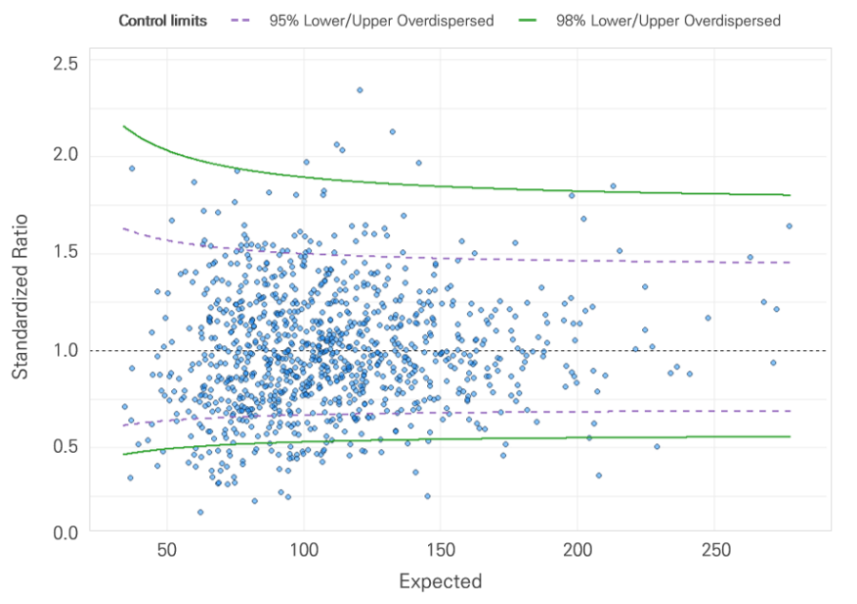
B. Broad-spectrum antibiotics primarily used for hospital-acquired infections
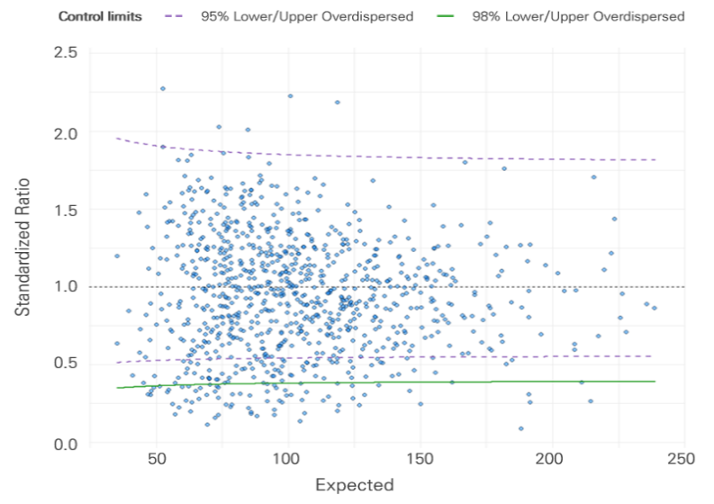
C. Carbapenem antimicrobials
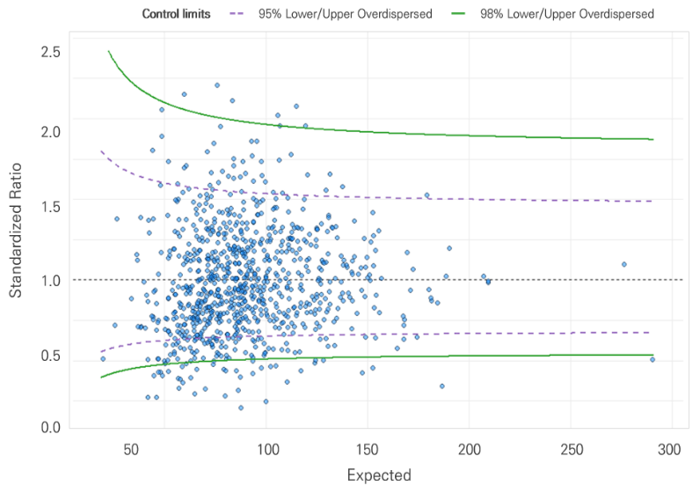
Supplementary Figure 2. Comparison of SAAR in pneumonia
A. Total
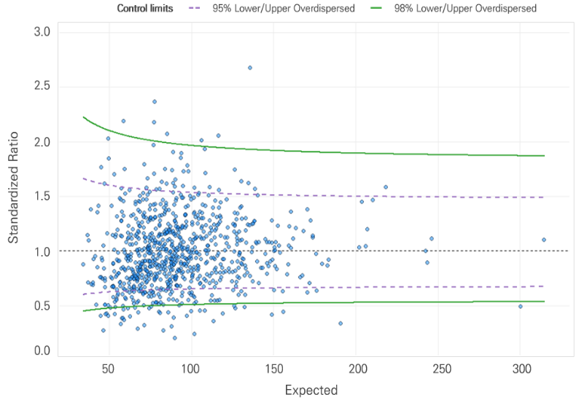
B. Broad-spectrum antibiotics primarily used for hospital-acquired infections
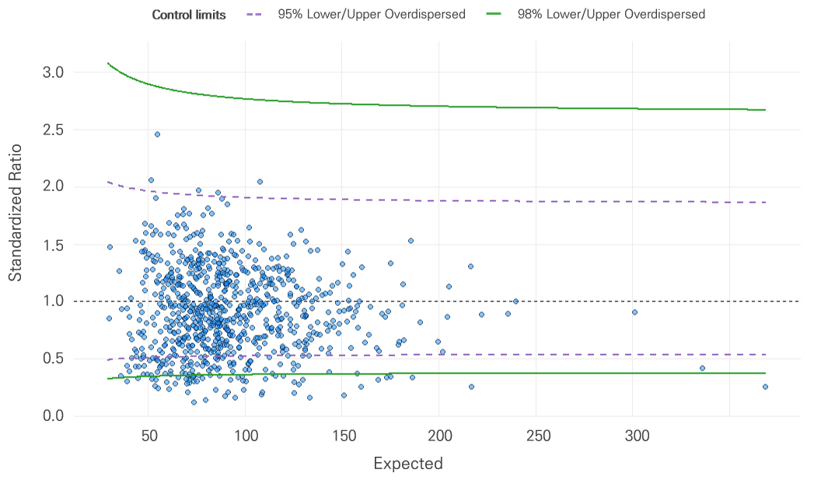
C. Carbapenem antimicrobials
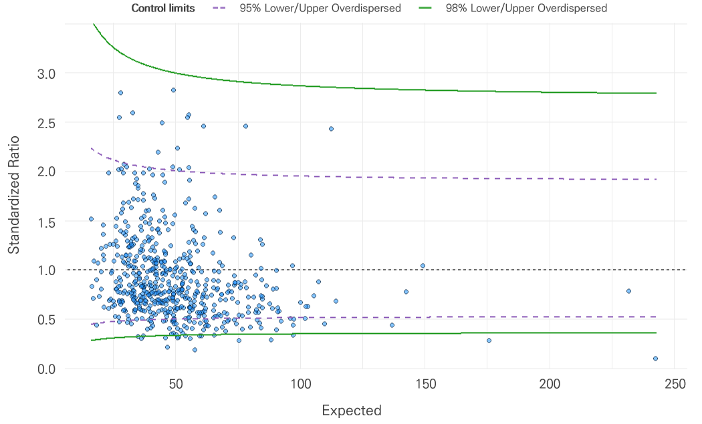
Supplementary Figure 3. Comparison of SAAR in septicemia

