Supporting Information

Electron-beam sintering achieves dual-phase transparent solid-state electrolytes for batteries

Zhanhui Jia^{1,#}, Weijiang Xue^{1,#}, Hao Shen^{1,*}, Ruohong Ke², Sujia Yan¹, Feier Shangguan¹, Zhen Wang¹, Jiawu Cui¹, Zhaowei Wang¹, Yuhao Tian¹, Wang Hay Kan^{3,4}, Ching-Yu Chiang⁵, Evan Ma¹, Bing Han^{2,*}, Jennifer L. M. Rupp^{6,*}, Marca M. Doeff⁷, Wei Tang^{1,*}, Kai Chen^{1,*}

1. State Key Laboratory for Mechanical Behavior of Materials & National Innovation Platform (Center) for Industry-Education Integration of Energy Storage Technology & School of Chemical Engineering and Technology, Xi’an Jiaotong University, Xi’an 710049, P. R. China.
2. Ningbo Institute of Digital Twin, Eastern Institute of Technology, Ningbo, Zhejiang 315200, P.R. China.
3. Spallation Neutron Source Science Center, Dongguan 523803, China
4. China Institute of High Energy Physics, Chinese Academy of Sciences, Beijing 100049, China
5. National Synchrotron Radiation Research Center, Hsinchu 30076, Taiwan, ROC
6. Department of Chemistry, School of Natural Sciences, Technical University of Munich, Garching, Germany.
7. Energy Storage and Distributed Resources Division, Lawrence Berkeley National Laboratory, Berkeley, CA 94720, USA

Figure S1. XRD patterns of LLZTO-1 (a), LLZTO-3 (b), LLZTO-5 (c), LLZTO-10 (d), LLZTO-TF (e) and LLZTO powder purchased from MTI (f).

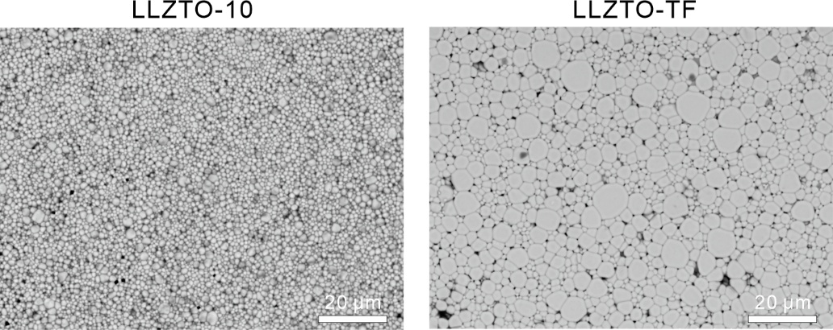

Figure S2. SEM images of thermal etched surface of LLZTO pellet.

Figure S3. (a) Optical photos of samples with microcracks and SEM photos of the cracks in the corresponding samples. (b) Statistic study of the crack width and area in different samples.

Figure S4. Finite element analysis (FEA) study of the thermal gradient.

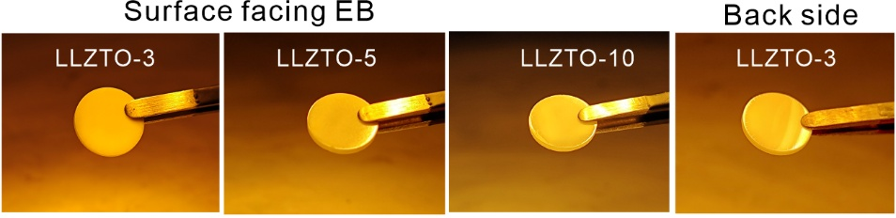

Figure S5. Optical photos of samples without microcrack

Figure S6. Optical photos of LLZTO pellets with different thickness

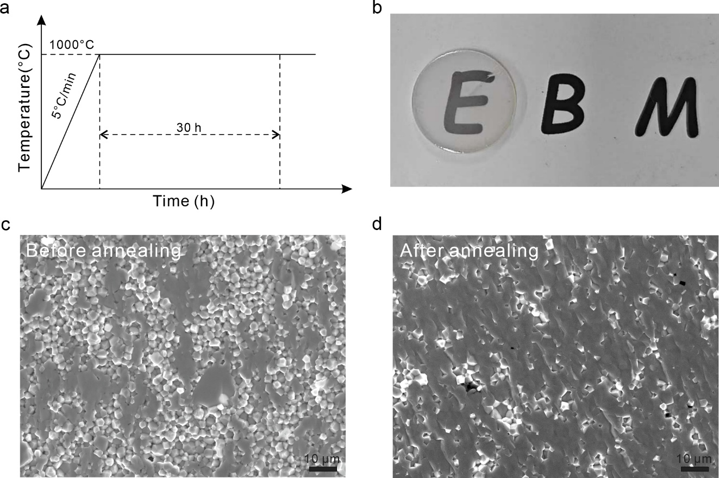

Figure S7. Annealing treatment profile of LLZTO-10 (a). Optical photos of LLZTO-10 pellets after annealing, with a thickness is about 1 mm. The cross-sectional SEM images of LLZTO-10 pellets before (c) and after (d) annealing.

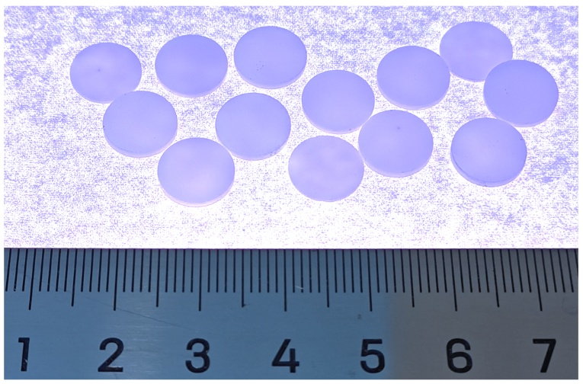

Figure S8. Pellets sintered in a single e-beam-sintering experiment, demonstrating excellent scalability.

Figure S9. EIS spectrum of Li/LLZTO/Li cells.

Figure S10. CCD measurement of the Li | LLZTO-5 | Li (a) and Li | LLZTO-TF | Li (b) symmetric cells with a fixed capacity of 0.1 mAh cm⁻² for each plating/stripping process at 60 °C.

Figure S11. (a) CCD measurement of the Li | LLZTO-5 | Li symmetric cells with a fixed capacity of 0.1 mAh cm⁻² for each plating/stripping process at 60 °C and (b) in-situ EIS measurement. (c) CCD measurement of the Li | LLZTO-TF | Li symmetric cells with a fixed capacity of 0.1 mAh cm⁻² for each plating/stripping process at 60 °C and (d) in-situ EIS measurement.

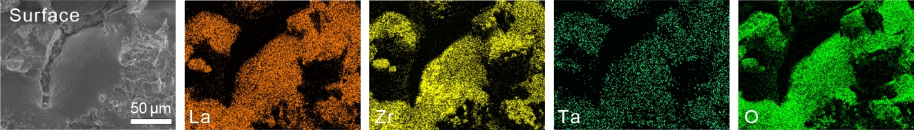

Figure S12. EDS mapping of LLZTO surface exposed to the electron beam without graphite buffer layer

Figure S13. XRD patterns of LLZTO surface exposed to the electron beam without graphite buffer layer

Figure S14. EDS elemental mapping collected from the surface of e-beam-sintered LLZTO samples

Figure S15. Monte Carlo simulation result showing the e-beam interaction volume in LLZTO at the accelerating voltage of 60 kV

Figure S16. Monte Carlo simulation result of the e-beam interaction volume in a 0.1 mm-graphite paper buffer layer at the accelerating voltage of 60 kV

Figure S17. Normalized X-ray absorption spectroscopy (XAS) data at the Zr K-edge for LLZTO samples at 295 K and reference compounds.

Figure S18. UV–Vis absorption spectra of LLZTO samples.

Figure S19. Particle size distribution and morphology of LLZTO powder purchased from MTI Corporation.

Figure S20. Schematic of electron beam sintering
Based on the above processing parameters, the following quantities can be calculated for a single-pass scan over a single green compact:
(1) Number of scan lines
Given that the green compact has a diameter of 13 mm and the hatch spacing between adjacent scan lines is 1.2 mm, the total number of scan lines N required to fully cover the single compact: $$N=\left[\frac{2r}{∆y}\right]+1=\left[\frac{13}{1.2}\right]+1=10+1=11$$
(2) Effective length of each scan line
Assuming linear scanning across the diameter of the circular compact, the effective length:
$$L_{i}=2\sqrt{{r^{2}-y}_{i}^{2}}$$
(3) Total scan length
The total scanning distance (L) is equal to the sum of the number of scanned lines multiplied by the length of each line:
$$L=13\left(L_{mid}\right)+2×\left(12.78+12.08+10.82+8.76+5.0\right)=13+2×49.44=111.88 mm$$
(4) Total scan time
Assuming a constant scan speed, the total scanning time t can be estimated as:
$$t_{total}=\frac{L}{v}=\frac{111.88 mm}{17600 mm/s}≈0.00636 s=6.36 ms$$

Figure S21. Temperature contours during the cooling stage of the LLZTO pellet. Different cooling rate in zero-dimensional heating (a) and two-dimensional heating (b) modes.

