Supplementary Information for

Confined water-selective highways in a densified photothermal membrane enable ultrafast purification of complex wastewater

Jie Li¹, Qiang Jia², Shijie Xing¹, Jingtao Bi¹, Lei Wang¹, Zhiyuan Guo¹, Jing Wang¹, Panpan Zhang^{1,*}, Zhi-Yong Ji^{1,*} & Liangti Qu^{3,*}

¹Engineering Research Center of Seawater Utilization Technology of Ministry of Education, Hebei Collaborative Innovation Center of Modern Marine Chemical Technology, Tianjin Key Laboratory of Chemical Process Safety, School of Chemical Engineering and Technology, Hebei University of Technology, Tianjin 300401, China
²College of Materials Science and Engineering, Beijing University of Technology, Beijing, 100124, China
³Key Laboratory of Organic Optoelectronics & Molecular Engineering, Ministry of Education, Department of Chemistry, Tsinghua University, Beijing 100084, P. R. China
E-mail: zhangpanpan@hebut.edu.cn; jizhiyong@hebut.edu.cn; lqu@mail.tsinghua.edu.cn
Table of contents
Experimental procedures
Figure S1. Fabrication process of DPM_{n}-X
Figure S2. SEM characterization of DPM_{n}-PAMPS
Figure S3. Water evaporation performance of DPM_{n}-PAMPS
Figure S4. Photographs of DPM₁₀-PAMPS
Figure S5. SEM characterization of DPM₁₀-X
Figure S6. XPS characterization of DPM₁₀-PAAm
Figure S7. XPS characterization of DPM₁₀-Tre
Figure S8. XPS characterization of DPM₁₀-SA
Figure S9. XPS characterization of DPM₁₀-PAMPS
Figure S10. Interaction energies between hydrophilic polymers and water
Figure S11. Water states investigation of DPM₁₀-X
Figure S12. Custom-designed sealed device to purify water/VOCs solutions
Figure S13. Interaction energies between PAMPS and VOCs
Figure S14. MD simulation models of DPM₁₀-PAMPS
Figure S15. Snapshot using DPM₁₀-PAMPS for water/ethanol separation
Figure S16. MSD of water and ethanol in molecular dynamics simulations
Figure S17. Density analysis of water and ethanol in molecular dynamics simulations
Figure S18. Standard curves of three aromatic VOCs, respectively
Figure S19. Performance of DPM₁₀-PAMPS on complex aromatic VOCs removal
Figure S20. Standard curves of three alcoholic VOCs, respectively
Figure S21. Effect of mass fraction of alcoholic VOCs on the separation performance
Figure S22. Performance of DPM₁₀-PAMPS on complex alcoholic VOCs removal
Figure S23. Comparison of ethanol removal from water with previous work
Figure S24. Comparison of isopropanol removal from water with previous work
Figure S25. Comparison of n-butanol removal from water with previous work
References

S1 Supplementary methods
S1.1 Chemicals and materials
Acrylamide (AAm, 99% electrophoretic grade), trehalose (Tre, 99%), sodium alginate (SA, 99.5%), 2-acrylamido-2-methyl-1-propanesulfonic acid sodium salt (AMPS, 50 wt% in H₂O), ammonium persulfate ((NH₄)₂S₂O₈, 99.99%), N,N’-methylenebisacrylamide (MBAA, 99.7%), calcium chloride dihydrate (CaCl₂, 99.5%), benzene (C₆H₆, 99.5%), toluene (C₇H₈, 99.5%), phenol (C₆H₅OH, 99.5%), ethanol (C₂H₅OH, 99.7%), isopropanol (C₃H₇OH, 99.5%), n-butanol (C₄H₉OH, ≥99.5%), sodium chloride (NaCl, 99.5%), sulfuric acid (H₂SO₄, 98 wt%), potassium permanganate (KMnO₄, 99.7%), sodium nitrate (NaNO₃, 99.7%) hydrogen peroxide (H₂O₂, 30 wt%) hydrochloric acid (HCl, 37 wt%) were purchased from Shanghai Macklin Biochemical Technology Co., Ltd. Graphite powder (325 mesh) was purchased from Qingdao Huatai Lubrication and Sealing Technology Co. The water used in the experiments was ultra-pure deionized water.
S1.2 Preparation of DPM_{n}-X
Graphene oxide (GO) was synthesized via a modified Hummers method. To prepare the mixed dispersion, a hydrophilic polymer solution (5 wt%) was introduced into the GO suspension (7.0 mg mL⁻¹) at a volume ratio of 1:9, followed by thorough homogenization under ultrasonication. A certain amount of ethanol was added to the mixed solution to reduce the surface tension and regulate the oriented ice crystal growth rate. The resulting dispersion was rapidly pre-frozen horizontally in liquid nitrogen and subsequently freeze-dried (BIOCOOL, FD-1A-50+) to sublimate the ice under low temperature and pressure, yielding three-dimensional (3D) GO/hydrophilic polymer aerogels with interconnected porous architectures. The as-prepared aerogels were compressed under uniaxial pressure (5–15 MPa) to form freestanding two-dimensional (2D) membranes. Subsequently, thermal annealing (200 °C, 2 h) was employed to reduce GO, enhancing the structural stability of the densified photothermal membrane (DPM).
Different crosslinking strategies were employed for various DPMs. Specifically, for samples containing acrylamide (AAm) and 2-acrylamido-2-methyl-1-propanesulfonic acid sodium salt (AMPS), photo-crosslinking was performed by immersing the membranes in an aqueous solution of ammonium persulfate ((NH₄)₂S₂O₈, 0.1 mol L⁻¹, 200 µL) as the initiator and N,N’-methylenebisacrylamide (MBAA, 0.1 mol L⁻¹, 30 µL) as the crosslinker, followed by UV irradiation for 2 h. Sodium alginate (SA)-added DPMs were ionically crosslinked in CaCl₂ solution (0.5 mol L⁻¹) for 30 min. Trehalose (Tre)-loaded DPMs required no further treatment, as Tre was uniformly distributed within graphene sheets via strong hydrogen bonding. The resulting samples are denoted as DPM_{n}-X, where n denotes the applied mechanical compression strength (5–15 MPa), and X refers to the incorporated hydrophilic polymer (PAAm, Tre, SA, and PAMPS), respectively. This precise control over n and X enables the fine-tuning of interlayer nanostructures and chemical microenvironments in DPM_{n}-X.
S1.3 Melting behavior of DPM_{n}-X by DSC assessment
The ice melting characteristics of fully hydrated samples were investigated by differential scanning calorimetry (DSC). After removing surface water, samples were completely sealed in aluminum crucibles, cooled to −80 °C at −5 °C min⁻¹, held for 30 min, and subsequently heated to 40 °C at 5 °C min⁻¹. All measurements were conducted under a constant nitrogen flow (50 mL min⁻¹).
S1.4 Solar-driven interfacial evaporation (SDIE) experiments
The SDIE performance of DPM_{n}-X was characterized using a custom-designed testing system illuminated by a xenon lamp light source (CEL-PE300L-3A) equipped with an AM 1.5 G optical filter to simulate standard solar irradiation (1 kW m⁻²). Samples (20 mm × 20 mm) were subjected to continuous illumination until surface temperature stabilization. After the sample surface temperature reached a steady state, an electronic balance with a resolution of 0.1 µg was used to measure the difference in system mass loss before and after exposure to continuous sunlight for 1 h, thereby calculating the water evaporation rate.
S1.5 Water purification of complex wastewater
The water purification performance of wastewater containing highly concentrated ions and strongly polar VOCs based on the optimized DPM₁₀-PAMPS was evaluated using a custom-designed sealed device (effective area: 20 mm × 20 mm) under simulated solar illumination (CEL-PF300L-3A xenon lamp, AM 1.5G spectrum). Under solar irradiation, the increased interfacial temperature provides a strong driving force for the selective evaporation of water molecules. The water purification process employed a precisely controlled feed system. To evaluate performance across diverse hypersaline conditions, feed solutions included NaCl brines with salinities of 3.5 wt%, 10 wt%, and 20 wt%, as well as mixed heavy-metal brines (Cr³⁺, Pb²⁺, Zn²⁺, Ni²⁺, and Cu²⁺ in an equal mass ratio of 1:1:1:1:1) with salinities of 5 wt%, 10 wt%, 15 wt%, and 20 wt%. For the treatment of water/VOCs solutions, the VOCs, including benzene, toluene, phenol, ethanol, isopropanol, or n-butanol, with different concentrations, were selected.
The original solutions were continuously delivered to the device at a constant flow rate using a precision peristaltic pump. This configuration maintained a steady-state VOCs concentration throughout the experiments. The system incorporated an air circulation with generated water vapor being condensed in a −20 °C cold trap for subsequent analysis. The quantitative analysis of VOCs was performed using high-performance liquid chromatography (HPLC, Agilent G1322A) and gas chromatography (GC, Agilent 7890B), respectively. Standard curves were established for each VOC by correlating HPLC/GC peak areas with known concentrations, ensuring accurate quantification (R²>0.990 for all analytes). The separation performance of DPM₁₀-PAMPS was evaluated using the separation factor (α), as defined by the following equations¹:
$$\begin{aligned}\text{α}\text{=}\frac{{{\text{P}}_{\text{W}}}/{{\text{P}}_{\text{E}}}}{{{\text{F}}_{\text{W}}}/{{\text{F}}_{\text{E}}}}\#\text{(}\text{1}\text{)}\end{aligned}$$
where P_{W} and P_{E} denoted the mass fractions of water and alcoholic VOCs in the collected water, F_{W} and F_{E} represented the corresponding mass fractions in the feed solution.
S1.6 Characterization
The cross-sectional microstructures of the samples were revealed by scanning electron microscopy (SEM, QUANTA250-FEI, America), while energy dispersive spectroscopy (EDS) was used to estimate the elemental composition of the samples. The functional groups on samples were characterized by Fourier transform infrared (FTIR, V80, Germany) spectra in the range of 600–3600 cm⁻¹. X-ray photoelectron spectroscopy (XPS, ESCALAB 250XI, America) was recorded to analyze the element composition and surface chemical environment of samples. Surface temperature of the samples was monitored using the IR camera (Fluke TiX1000). The water contact angle was observed using a water contact angle analyzer (DSA100, KRÜSS, Germany). A differential scanning calorimeter (DSC, Hengjiu, HSC-4, China) was used to determine the melting and evaporation behavior of the samples to analyze the water states in the samples. Raman spectroscopy (inVia, Renishaw, England) was used to analyze the water states within the samples. The xenon lamp light source (CEL-PE300L-3A) was equipped with an AM 1.5 G optical filter to simulate standard solar irradiation (1 kW m⁻²). The standard profiles of benzene, toluene, and phenol were characterized by high-performance liquid chromatography (HPLC, Agilent G1322A), while alcoholic VOCs (ethanol, isopropanol, and n-butanol) were quantified using gas chromatography (GC, Agilent 7890B) with flame ionization detection.
S2 Fabrication process of DPM_{n}-X
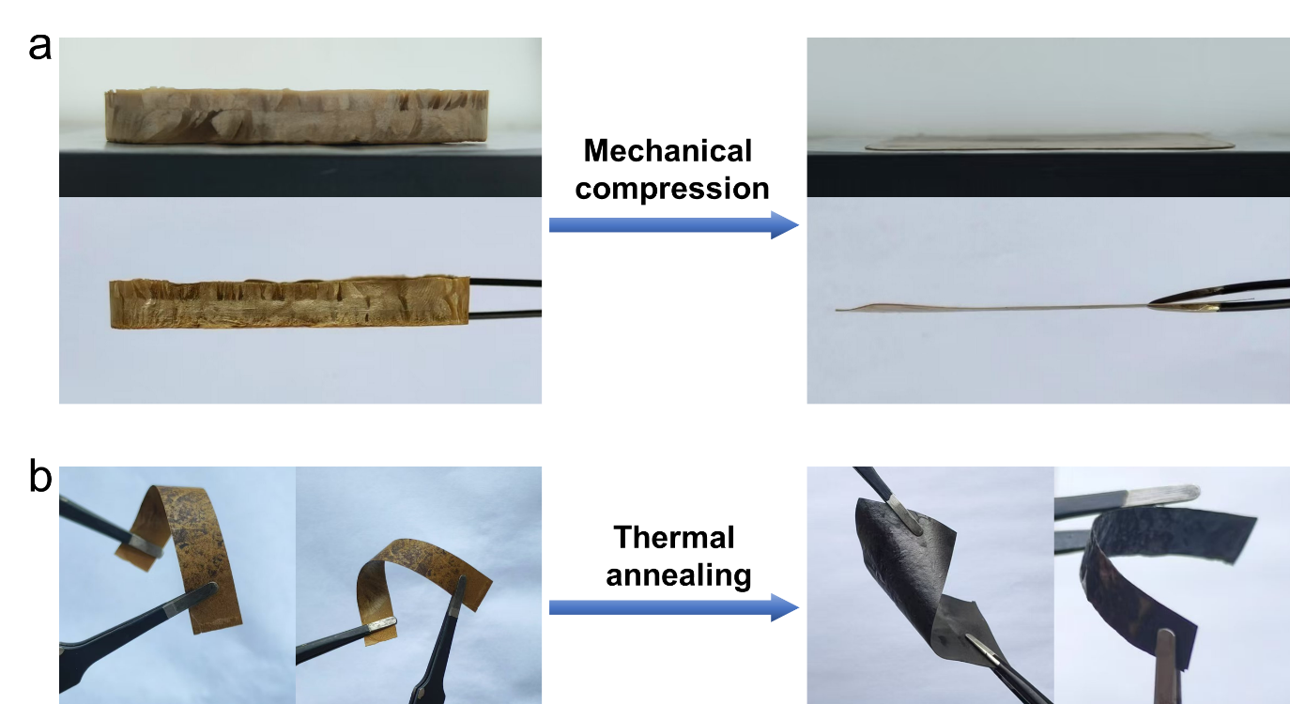
Supplementary Fig. S1 a Photographs of the GO/hydrophilic polymer aerogel before and after mechanical compression. The 3D aerogel was transformed into a 2D dense membrane. b The obtained DPM_{n}-X has good mechanical properties after thermal annealing.
A mixture of graphene oxide (GO) and hydrophilic polymers was freeze-dried via horizontal directional freezing to construct a 3D framework, followed by mechanical compression, thermal annealing, and chemical crosslinking to yield DPM_{n}-X. After mechanical compression, the thickness of the 3D aerogel is markedly reduced, yielding a 2D dense membrane. Subsequent thermal annealing turned the densified 2D membrane black and endowed it with excellent mechanical robustness, as evidenced by the absence of visible damage after bending.

S3 Mechanical compression strength regulation for densification
S3.1 SEM characterization of DPM_{n}-PAMPS
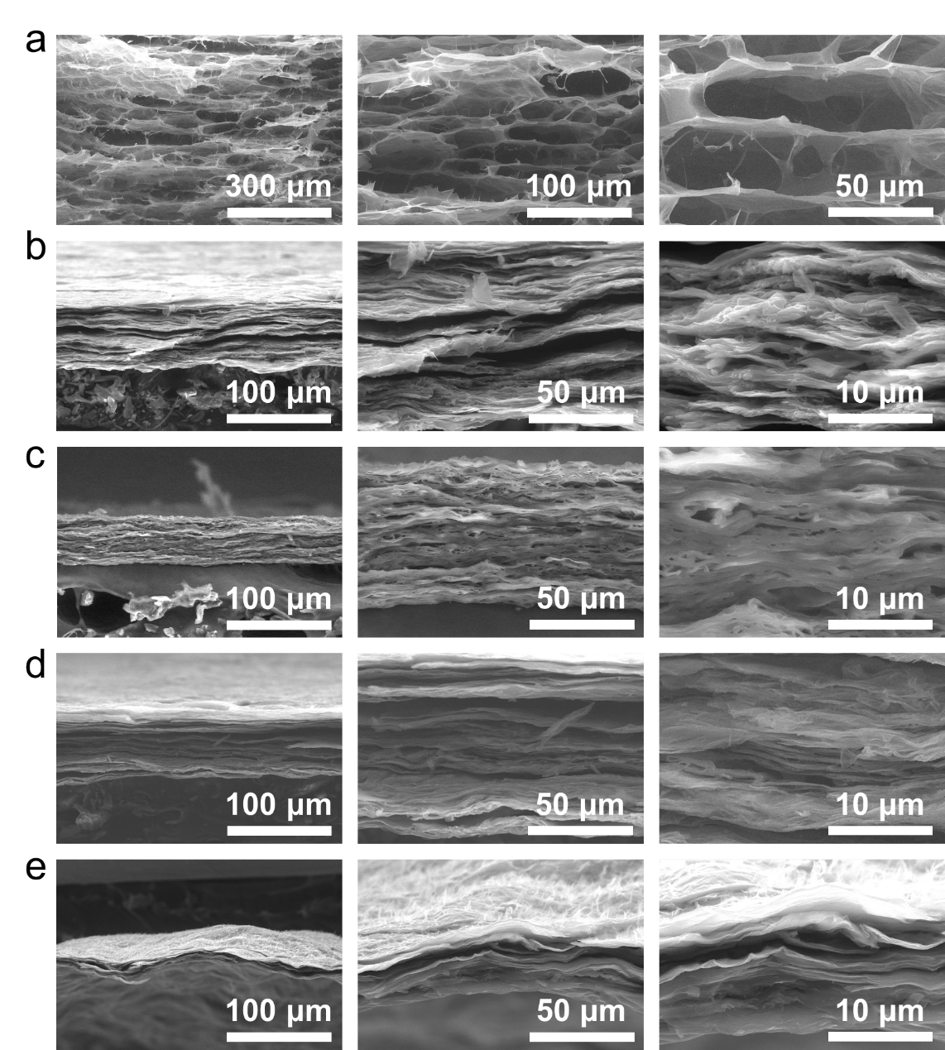
Supplementary Fig. S2 a−e SEM images of DPM_{n}-PAMPS with the applied mechanical compression strength n=0, 5, 10, and 15 MPa or vacuum filtration, respectively.
Mechanical compression is employed to densify the DPM. Here, DPM_{n}-PAMPS are selected to investigate the effect of varying mechanical compression strength (n=0, 5, 10, and 15 MPa) on the degree of interlayer nanostructural densification. Increasing the mechanical compression strength progressively compacts the interlayer nanostructures of DPM_{n}-PAMPS. However, all DPM_{n}-PAMPS remain less compact than the vacuum-filtrated counterpart (DPM_{F}-PAMPS).

S3.2 Water evaporation performance of DPM_{n}-PAMPS
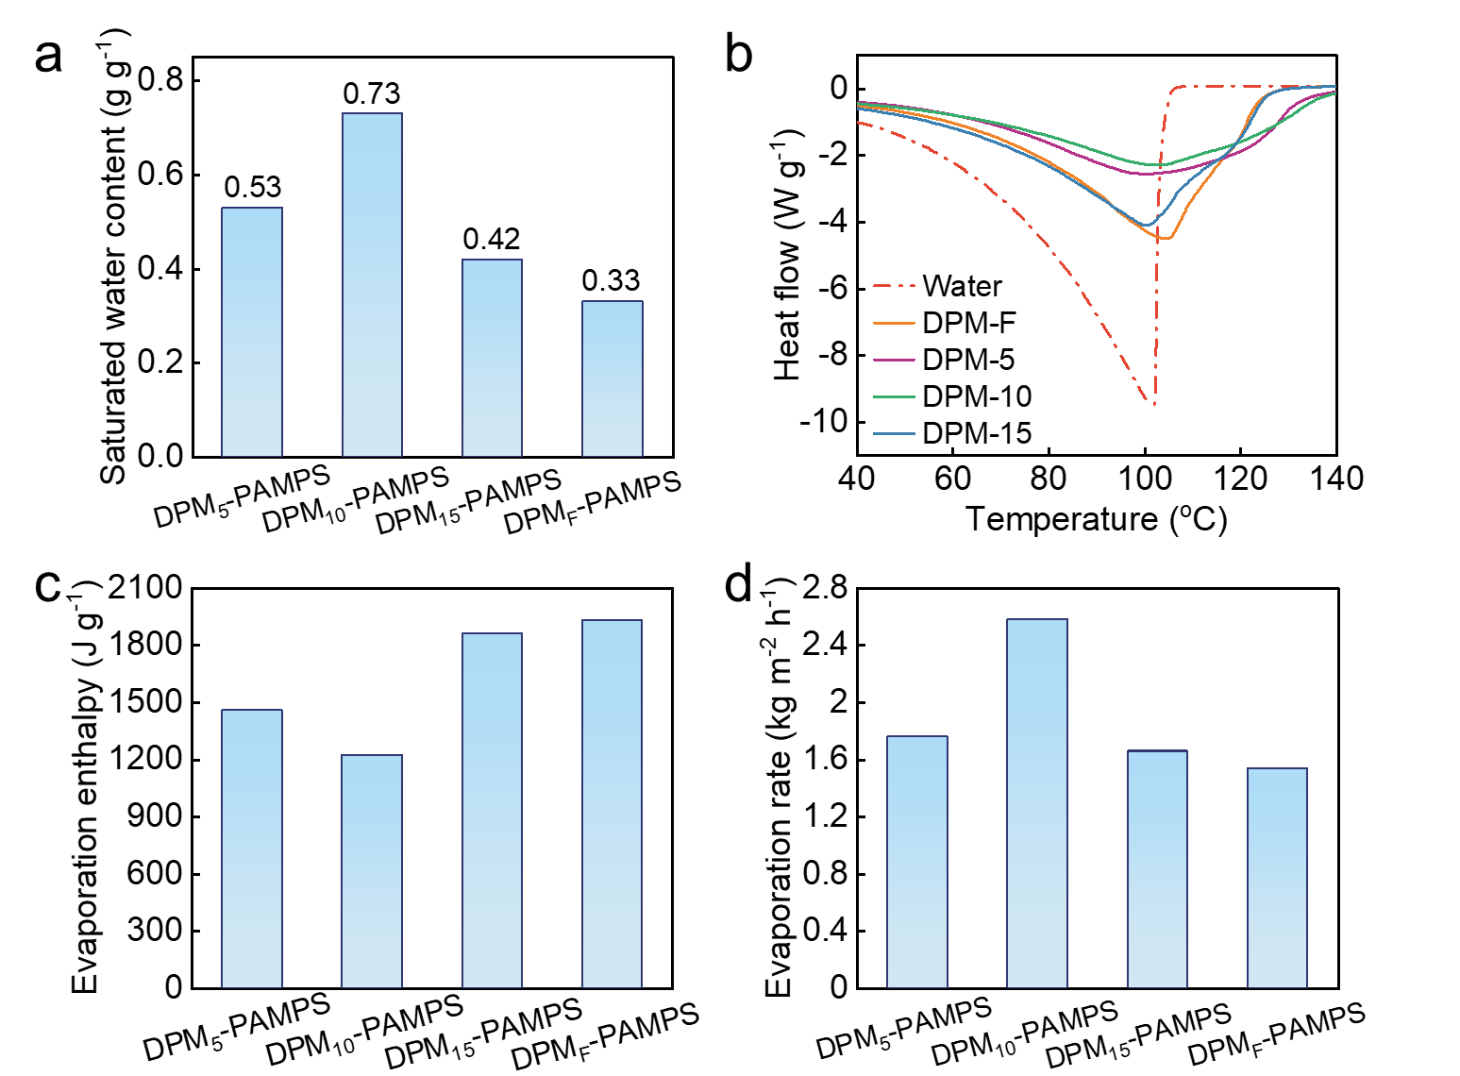
Supplementary Fig. S3 a Saturated water content of DPM_{n}-PAMPS and DPM_{F}-PAMPS. b DSC thermograms and (c) calculated evaporation enthalpy of water and water in DPM_{n}-PAMPS and DPM_{F}-PAMPS. d Water evaporation rate of DPM_{n}-PAMPS and DPM_{F}-PAMPS under 1 kW m⁻².
The degree of interlayer nanostructures densification critically governs water transport, thermal losses, and overall water evaporation performance. DPM₁₀-PAMPS exhibits the highest saturated water content of 0.73 g g⁻¹ and the lowest melting enthalpy of 1224.30 J g⁻¹, which is likely its balance of water transport and thermal losses, thereby achieving the highest water evaporation rate of 2.58 kg m⁻² h⁻¹. For DPM₅-PAMPS, the loosely packed structure permits excessive water flow and heat dissipation, thus lowering the evaporation rate. In contrast, DPM₁₅-PAMPS and DPM_{F}-PAMPS possess overly compact architectures that restrict water transport, also resulting in reduced water evaporation rate. These findings indicate that a mechanical compressive strength of 10 MPa is optimal.

S3.3 Photographs of DPM₁₀-PAMPS
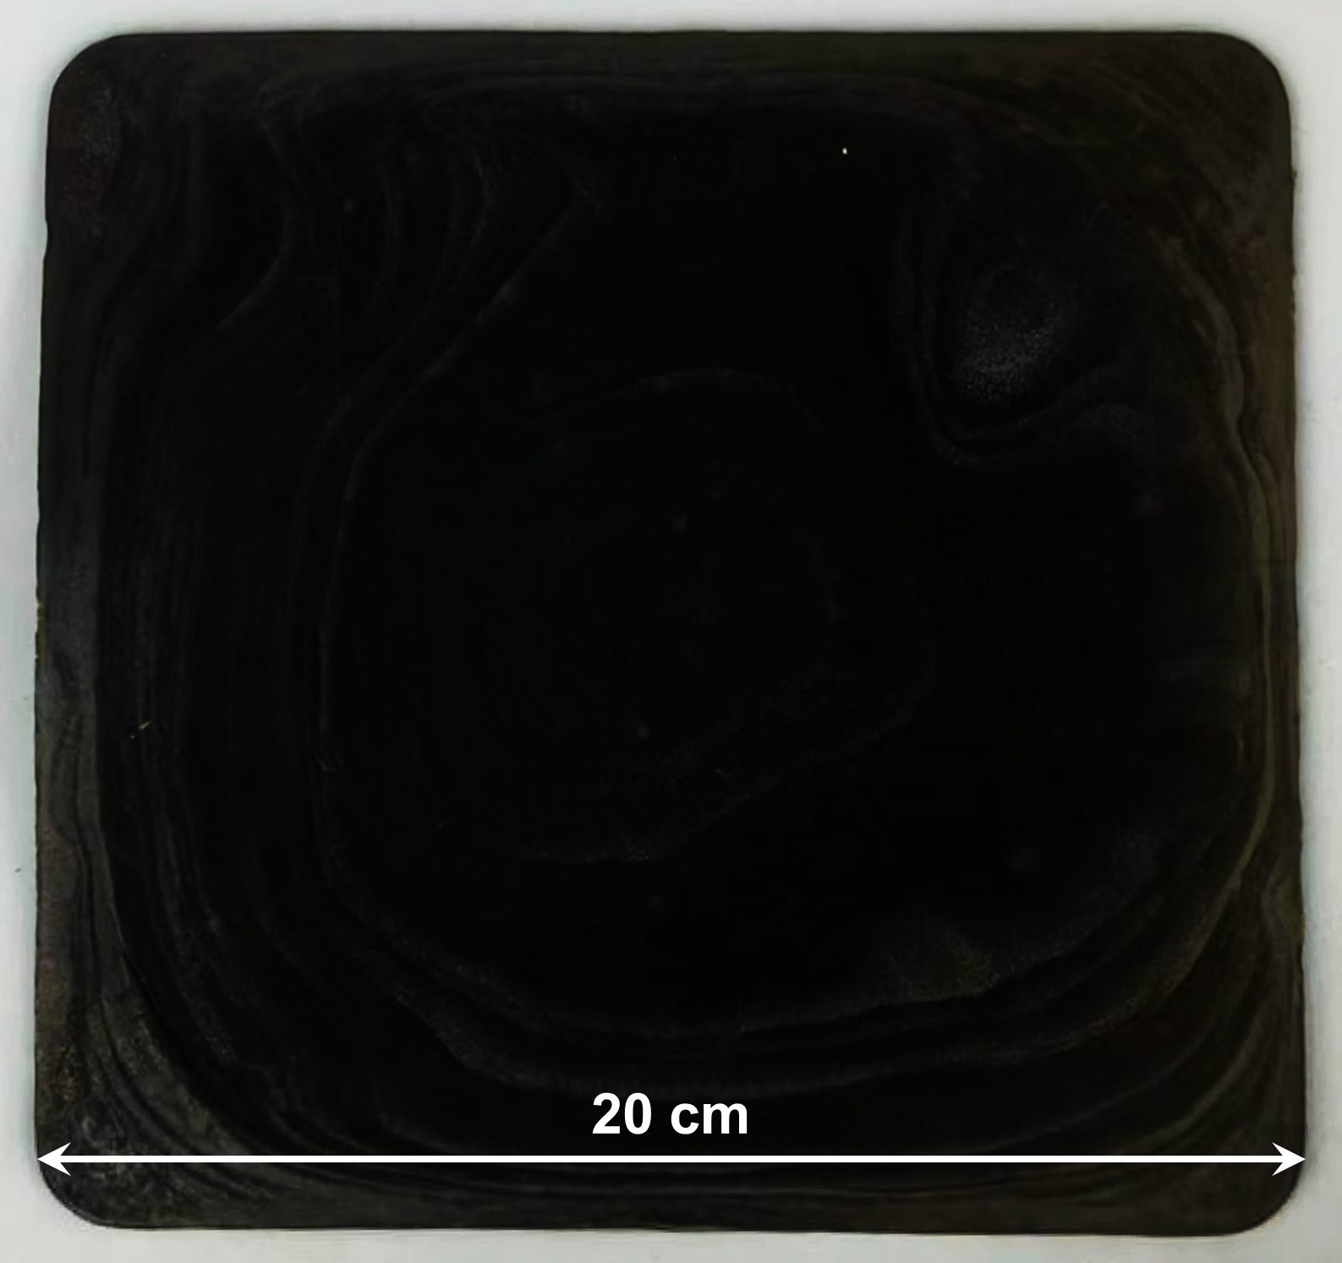
Supplementary Fig. S4 Photographs of DPM₁₀-PAMPS with a diameter of about 20 cm.

S4 Selection of hydrophilic polymers for DPM₁₀-X
S4.1 SEM characterization of DPM₁₀-X
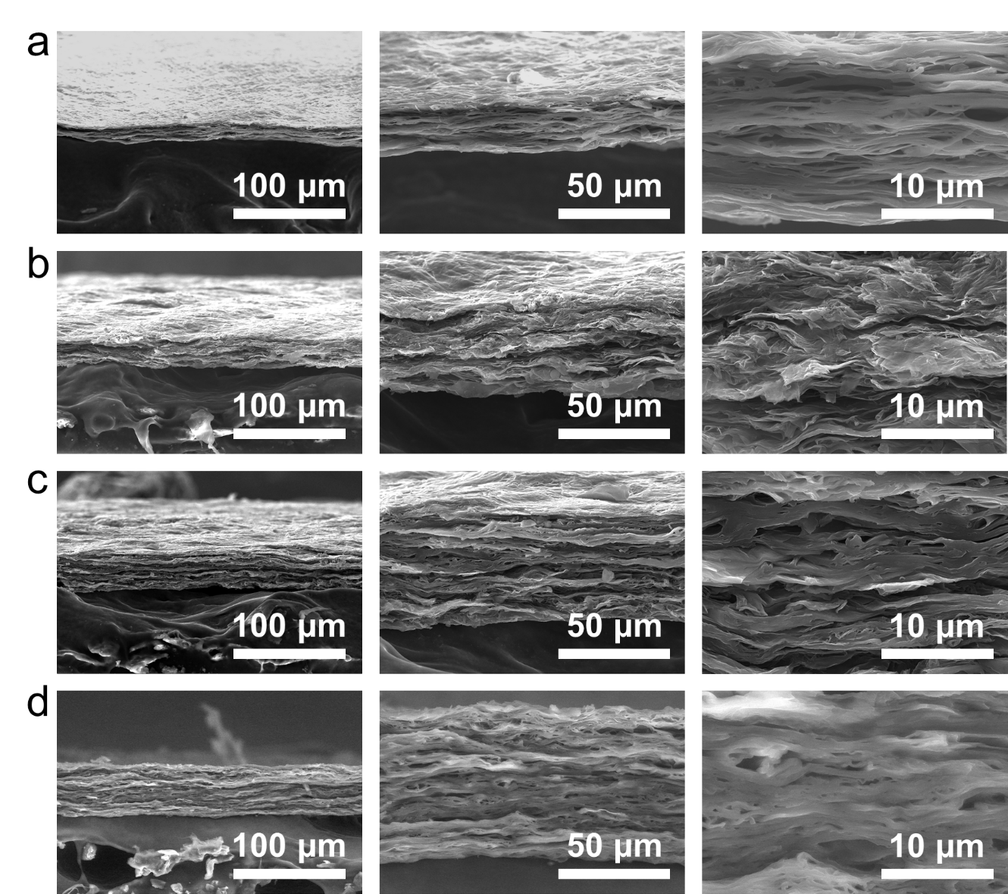
Supplementary Fig. S5 Cross-section SEM images of (a) DPM₁₀-PAAm, (b) DPM₁₀-Tre, (c) DPM₁₀-SA, and (d) DPM₁₀-PAMPS, respectively. All the DPM₁₀-X samples exhibit significantly densified interlayer nanostructures.

S4.2 XPS characterization of DPM₁₀-X
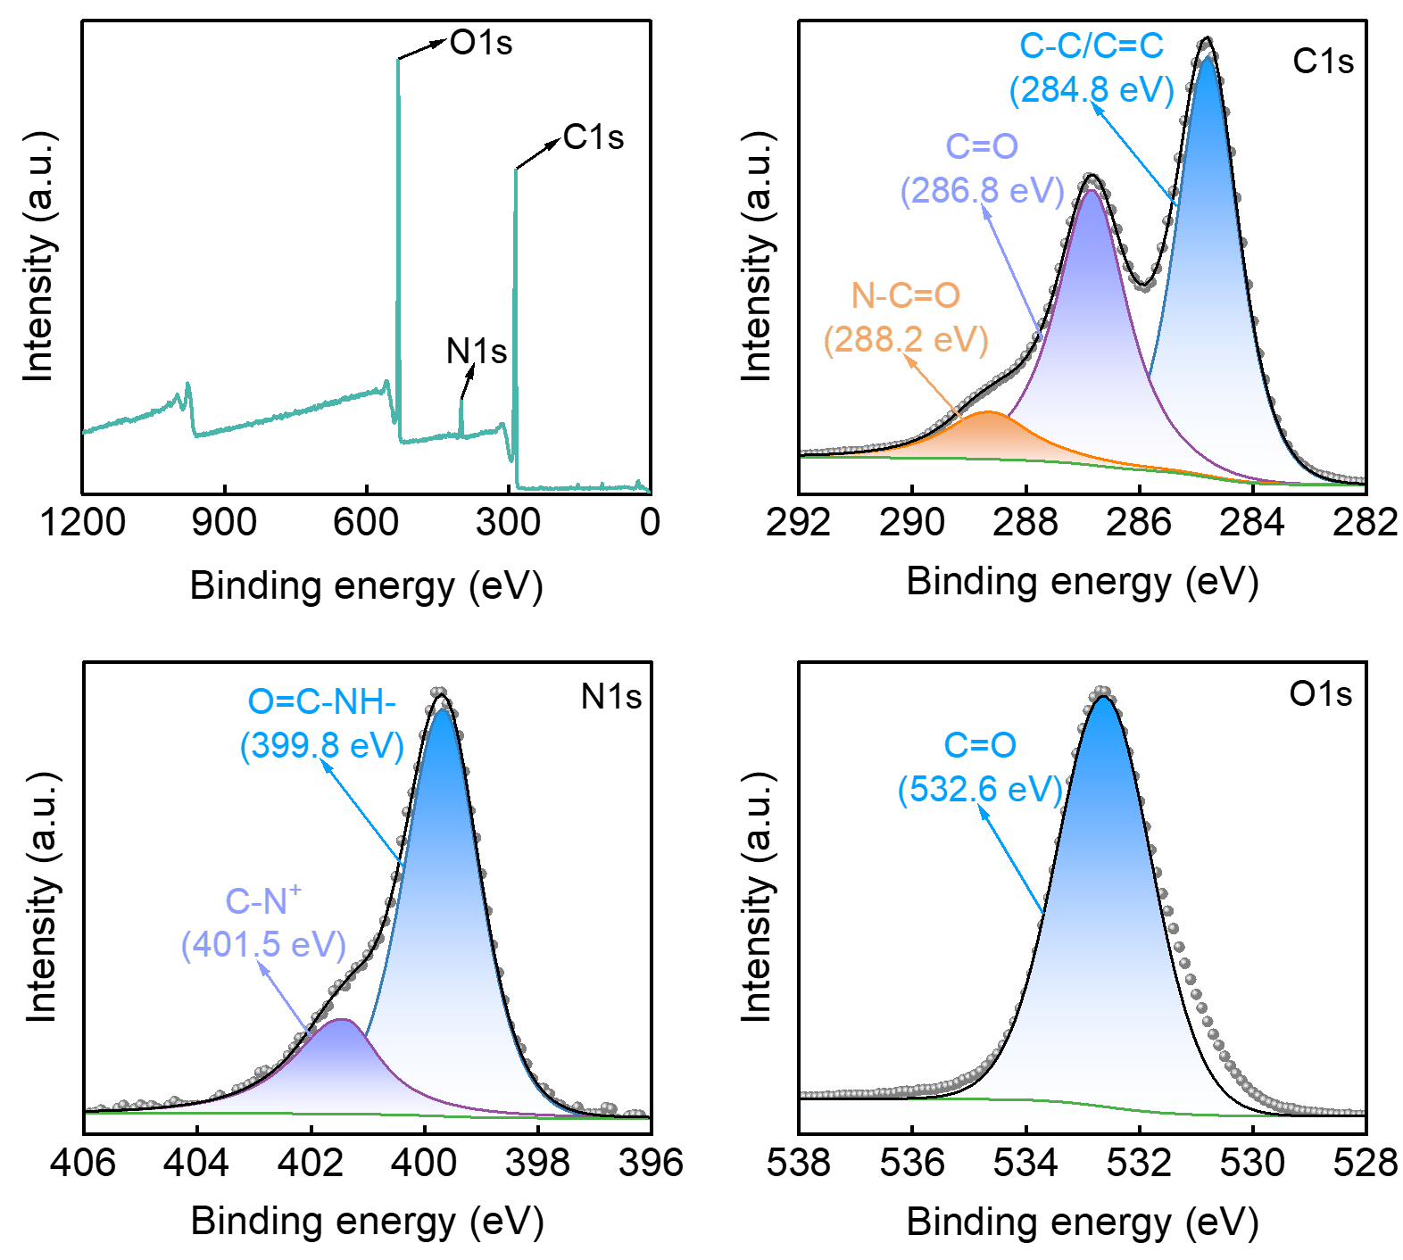
Supplementary Fig. S6 Full spectrum, and corresponding C1s, N1s, O1s high resolution XPS spectra of DPM₁₀-PAAm, respectively.

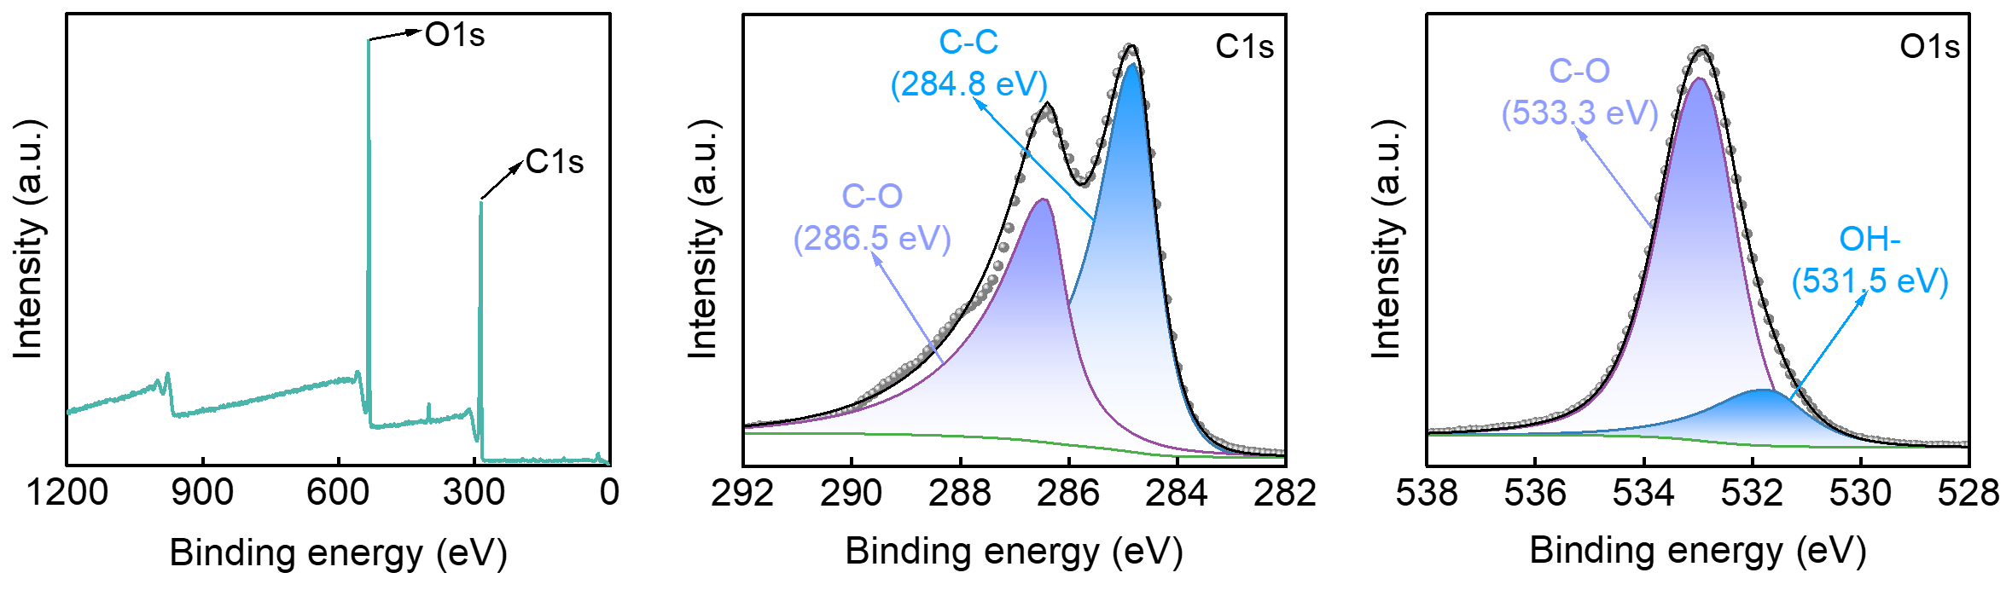
Supplementary Fig. S7 Full spectrum, and corresponding C1s, O1s high resolution XPS spectra of DPM₁₀-Tre, respectively.
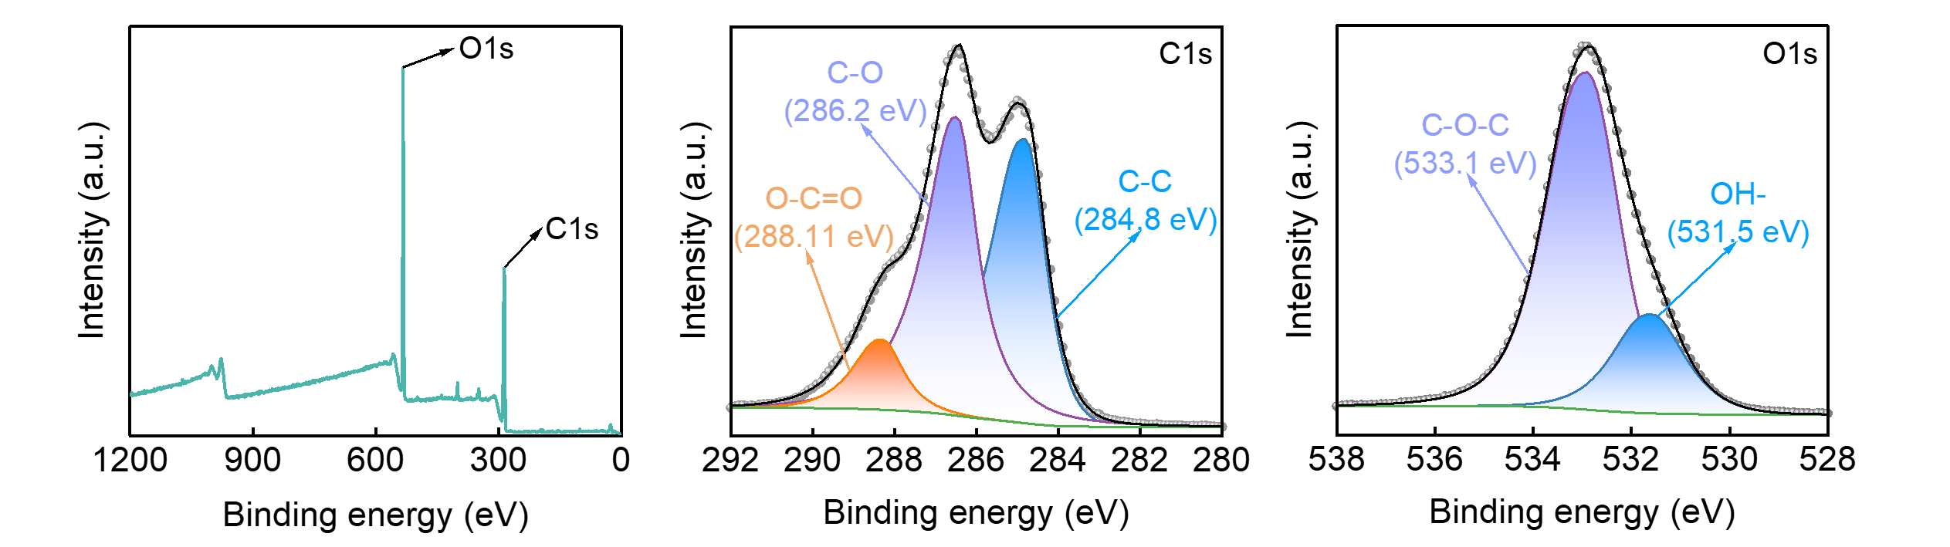
Supplementary Fig. S8 Full spectrum, and corresponding C1s, O1s high resolution XPS spectra of DPM₁₀-SA, respectively.

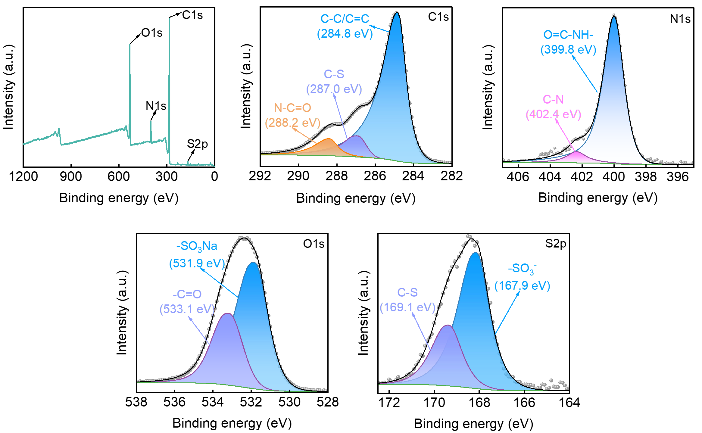
Supplementary Fig. S9 Full spectrum, and corresponding C1s, N1s, O1s, S2p high resolution XPS spectra of DPM₁₀-PAMPS, respectively.

S5 Interaction energies between hydrophilic polymers and water
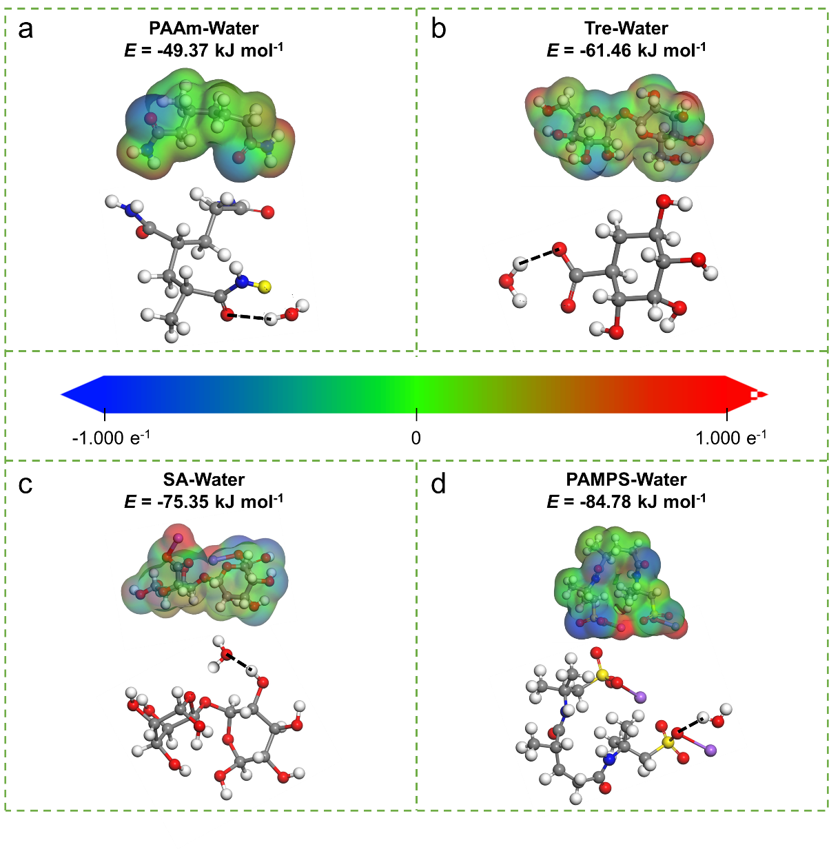
Supplementary Fig. S10 Molecular models and the corresponding binding energy of (a) PAAm-water, (b) Tre-water, (c) SA-water, and (d) PAMPS-water, respectively.
We employ a series of hydrophilic polymers bearing distinct functional groups, including amide (acrylamide, AAm), hydroxyl (trehalose, Tre), carboxyl (sodium alginate, SA), and sulfonate (2-acrylamido-2-methylpropane sulfonic acid sodium salt, AMPS) to precisely regulate the interlayer nanostructures and chemical environments of DPM. Among them, the interlayer hydrophilic functional groups of the DPM₁₀-X play a pivotal role in mediating interactions with water molecules. The interactions between water molecules and DPM₁₀-PAAm or DPM₁₀-Tre are primarily governed by hydrogen bonding, with the abundant –OH groups in DPM₁₀-Tre exhibiting stronger binding affinity toward water. In contrast, DPM₁₀-SA and DPM₁₀-PAMPS engage in both hydrogen bonding and ion-dipole interactions with water molecules, leading to further enhanced water affinity. To demonstrate this, density-functional theory (DFT) was used to calculate the binding energies among PAAm-water, Tre-water, SA-water, and PAMPS-water molecules. DFT calculations were performed using the DMol3 module within Material Studio, and the exchange-correlation energies of the electrons were described by the generalized gradient approximation (GGA) using the Becke-Lee-Yang-Parr (BLYP) correction. The Fermi drag tail was 0.005 Ha (1 Ha=27.211 eV) and the atomic orbital truncation energy was 5.2 Å. The convergence criteria for the calculation of the geometry optimization meter and the energies are set with the following parameters: the energy tolerance was 1.0 × 10⁻⁵ Ha/atom, the self-consistent field tolerance was 1.0 × 10⁻⁵ Ha/atom, the maximal force tolerance was 0.004 Ha/Å, and the maximal displacement difference was 0.005 Å.
The binding energy indicates the interaction strength among the components within the system. Given that the binding energy is negative, a lower value suggests a stronger interaction existing in the system. For the calculation of binding energies between hydrophilic polymers and water, we built a model of the interaction of PAAm (two repeated structural units), Tre, SA, and PAMPS (two repeated structural units) with water molecules. The binding energy (E_{AB}) between A and B can be defined by the following equation²:
$$\begin{aligned}{\text{E}}_{\text{AB}}\text{=}{\text{E}}_{\text{Total}}\text{-}{\text{E}}_{\text{A}}\text{-}{\text{E}}_{\text{B}}\#\text{(2)}\end{aligned}$$
where E_{Total}, E_{A} and E_{B} are the total energy of the system and the energy of each component in the model, respectively.
S6 Water states investigation of DPM₁₀-X
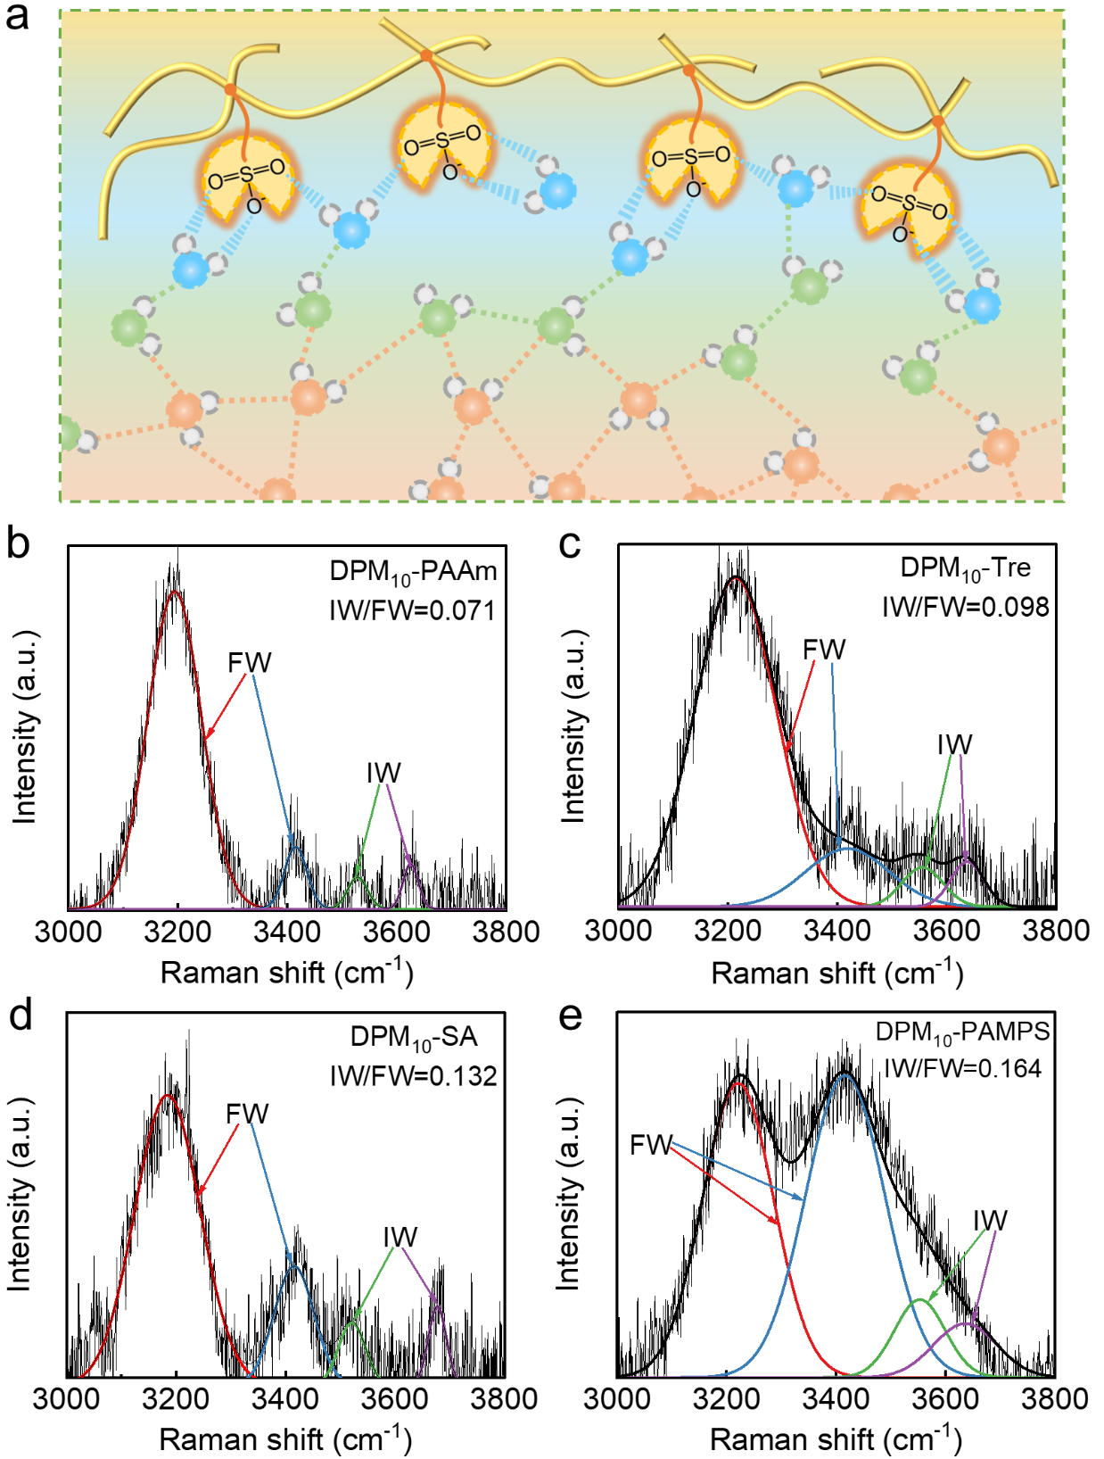
Supplementary Fig. S11 a Schematic illustration of three types of water states in the DPM₁₀-X. Raman spectra with fitting curves of (b) DPM₁₀-PAAm, (c) DPM₁₀-Tre, (d) DPM₁₀-SA, and (e) DPM₁₀-PAMPS, respectively.

Owing to the dynamic interactions between DPM₁₀-X and water molecules, there are three types of water states, comprising free water (FW), intermediate water (IW), and bound water (BW). BW and IW are preferentially localized near the polymer chains, while FW dominates the bulk phase, reflecting the hierarchical hydration dynamics. The FW (light red) exhibits thermodynamic stabilization via four hydrogen bonds with adjacent water molecules, while BW (light blue) is immobilized by polymer chains, forming more than two hydrogen bonds with the polymer matrix. Consequently, IW (light green) in the interfacial region lacks direct polymer stabilization and instead relies on hydrogen bonding with adjacent FW molecules, resulting in an activated IW state³.
Raman spectroscopy further confirms this distinct hydration hierarchy within DPM₁₀-X, revealing the molecular signatures of each water state. Raman spectra of the DPM₁₀-X are fitted by four peaks through the Gaussian function, which are located at 3233, 3401, 3514, and 3630 cm⁻¹. The Raman peaks at 3233 and 3401 cm⁻¹ are assigned to the in-phase and out-of-phase O−H stretching modes, respectively, indicating that FW is stabilized by a tetrahedral hydrogen-bonding network. In contrast, the peaks at 3514 and 3630 cm⁻¹ correspond to the symmetric and asymmetric O−H stretches under weakened hydrogen-bonding environments, characteristic of IW in the interfacial region. Notably, BW exhibits strongly restricted O−H vibrations due to confinement by hydrophilic polymer chains, resulting in Raman signals overlapping with polymer-associated O−H groups. Deconvolution analysis reveals that DPM₁₀-PAMPS possesses a significantly higher IW/FW ratio (0.164) compared to other samples, demonstrating that enhanced polymer-water interactions promote IW formation. This interfacial hydration layer facilitates water activation, critical for accelerating water evaporation.

S7 Custom-designed sealed device to purify water/VOCs solutions
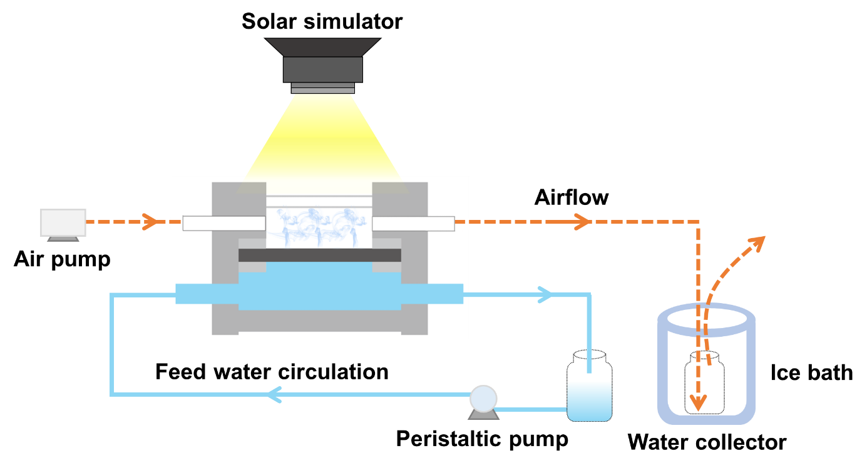
Supplementary Fig. S12 Schematic illustration of the custom-designed sealed device to purify water/VOCs solutions.
To explore the water-selective permeation performance of the prepared DPM₁₀-PAMPS, water/VOCs separation experiments were performed in a homemade membrane module with an effective evaporation area of 20 mm×20 mm. A uniform xenon lamp light source system (CEL-PF300L-3A) was used to simulate light illumination and provide the driving force for the selective evaporation of water molecules. To maintain a constant concentration of VOCs in the device, a mixture of water and benzene (or toluene, phenol, ethanol, isopropanol, n-butanol) at different concentrations was continuously injected into the membrane module at the same flow rate via a peristaltic pump (circulating VOCs solutions are indicated by blue solid arrows). Furthermore, an air circulation system was attached to simulate the design of a large solar water purification system, and the obtained water vapor was transported to a cold trap (−20 °C) to condense and obtain the permeate (the obtained vapor is indicated by the red dotted arrow).
S8 Interaction energies between PAMPS and VOCs
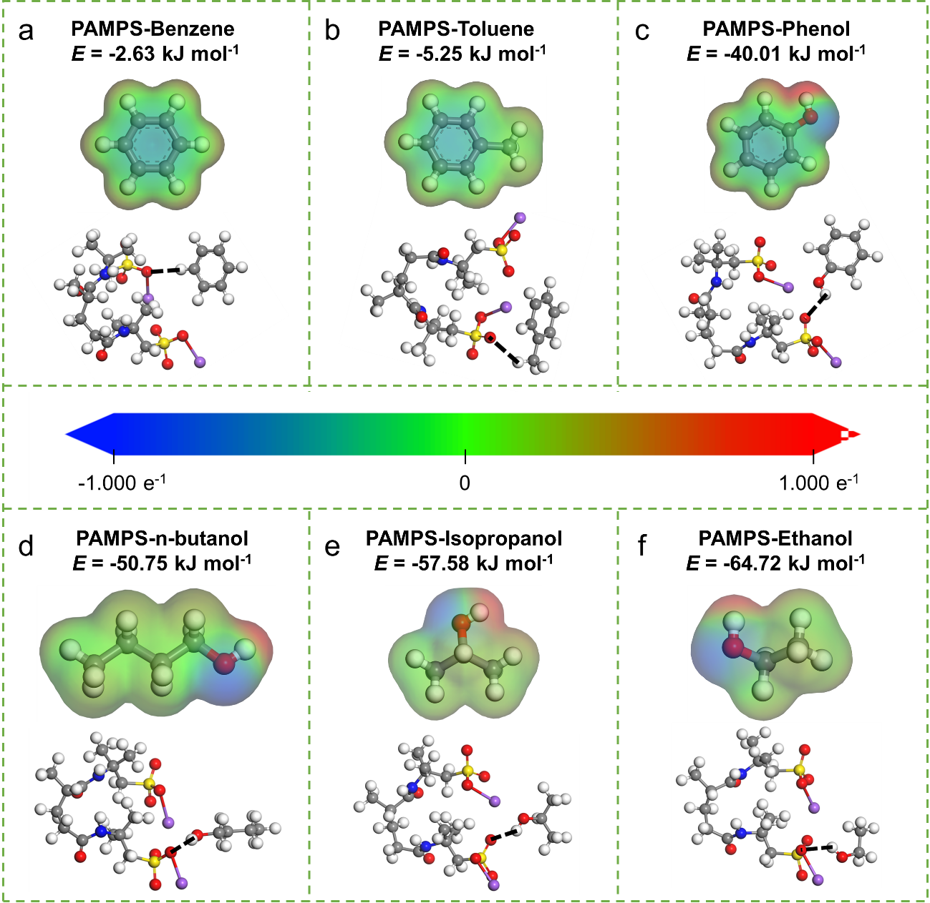
Supplementary Fig. S13 Molecular models and the corresponding binding energy of (a) PAMPS-benzene, (b) PAMPS-toluene, (c) PAMPS-phenol, (d) PAMPS-n-butanol, (e) PAMPS-isopropanol, and (f) PAMPS-ethanol, respectively.
Numerous highly toxic volatile organic compounds (VOCs) are ubiquitously present in the water cycle. However, their complex physicochemical properties render the separation of VOCs from water extremely challenging. While nonpolar or weakly polar aromatic VOCs exhibit low solubility in water, their inherent volatility and tendency to form azeotropes with water lead to persistent trace-level contamination, posing significant risks to both human health and the environment. On the other hand, strongly polar VOCs such as alcohol, bearing hydrophilic −OH groups, possess polarity and boiling points comparable to those of water molecules, making their removal via conventional separation methods virtually impossible. Furthermore, we selected two representative classes of VOCs for evaluation, including common aromatic VOCs (benzene, toluene, phenol) and strongly polar alcoholic VOCs (ethanol, isopropanol, and n-butanol). Comparative analysis of interaction energies between PAMPS (previously identified as exhibiting the strongest water affinity) and selected VOCs reveals a distinct trend in intermolecular binding strength: benzene < toluene < phenol < n-butanol < isopropanol < ethanol < water.

S9 MD simulations using DPM₁₀-PAMPS for water/ethanol separation
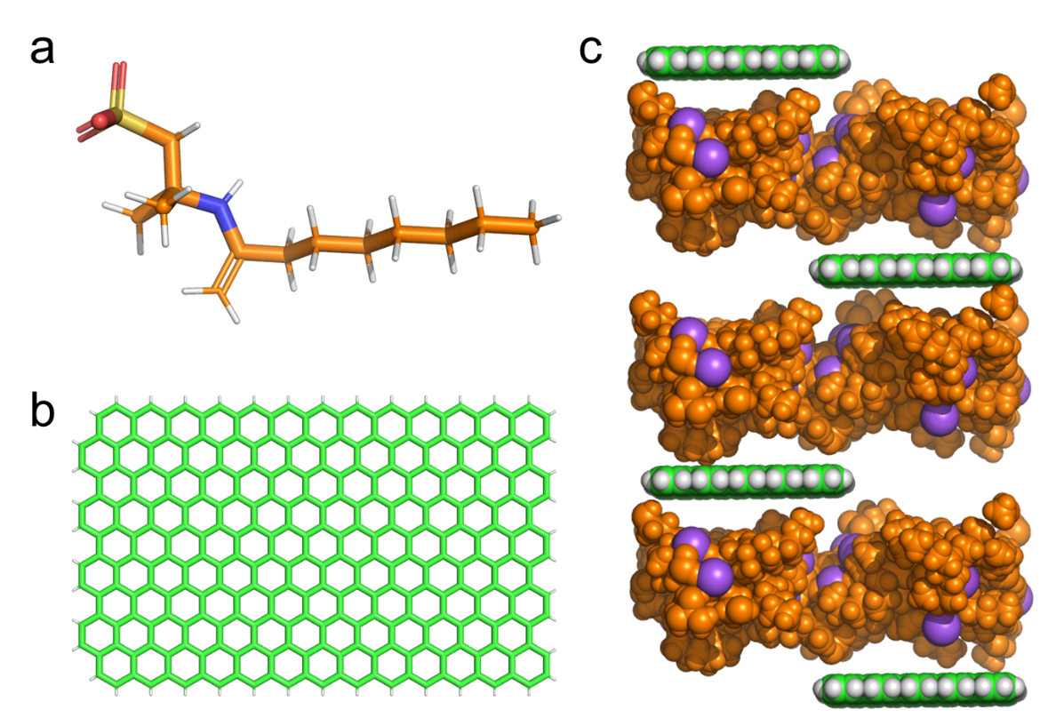
Supplementary Fig. S14 MD simulation models of (a) 2-acrylamido-2-methyl-1-propanesulfonic acid sodium salt monomer, (b) pristine graphene, and (c) DPM₁₀-PAMPS, respectively.
Based on the 2D structure of the hydrophilic polymer 2-acrylamido-2-methyl-1-propanesulfonic acid sodium salt, the molecular structure of PAMPS is constructed and optimized using Discovery Studio 2024. Subsequently, CHARMM-GUI is used to model graphene barriers and graphene intermediate layers. Considering the actual structure of DPM₁₀-PAMPS, graphene is arranged in a half-layer structure with alternating upper and lower layers, and PAMPS is filled between the graphene layers, where PAMPS, graphene, and Na⁺ are in orange, green, and purple, respectively.
The molecular dynamics simulations are performed using Gromacs 2021, an open-source MD simulation software primarily employed for biomolecular systems (e.g., proteins, lipids, nucleic acids) and various materials science applications. The Amber force field is adopted for this simulation. The simulation system is constructed in Gromacs with a simulation box containing: a bottom layer of 1000 water molecules and 1000 ethanol molecules mixture, followed by the pre-constructed DPM₁₀-PAMPS hybrid membrane, and finally a vacuum layer on the top side where a graphene barrier is placed to prevent liquid penetration across periodic boundaries. Prior to production runs, energy minimization is conducted to eliminate unreasonable atomic contacts in initial configurations, followed by 100 ps NVT equilibration (canonical ensemble maintaining constant Number of particles, Volume, and Temperature) to reach the target temperature. The production simulation employs a leap-frog algorithm for Newton’s equations integration with a 2 fs timestep over 25,000,000 steps (total 50 ns), during which pulling forces are applied to the graphene barrier to drive water/ethanol permeation through the hybrid membrane. Furthermore, the simulation employs the V-rescale thermostat to maintain the system temperature at 298.15 K. Long-range electrostatic interactions are treated using the Particle Mesh Ewald (PME) method with a cutoff scheme, while dispersion corrections are applied to account for long-range van der Waals interactions under the same cutoff framework.

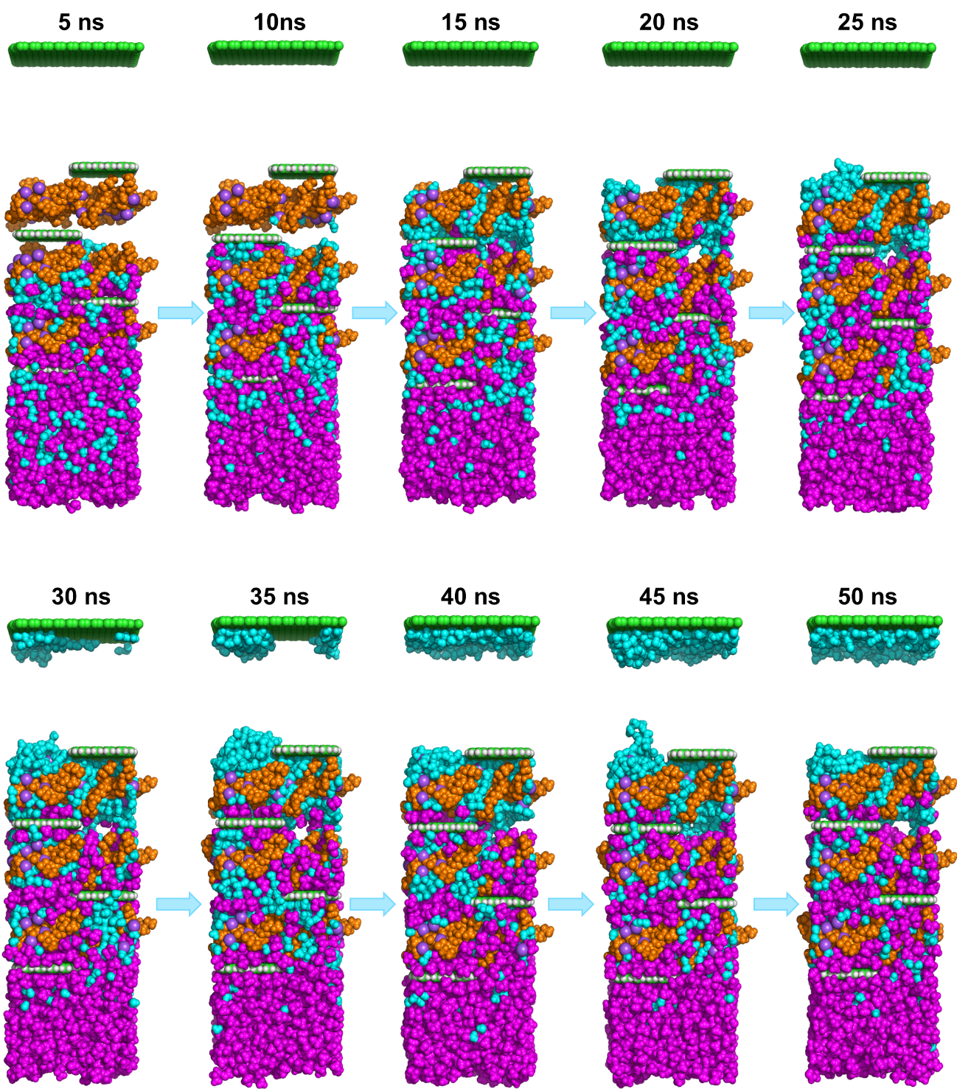
Supplementary Fig. S15 MD simulation snapshots of DPM₁₀-PAMPS models at different time from 0 to 50 ns. Graphene, PAMPS, water, ethanol, and Na⁺ are in green, orange, cyan, magenta, and purple, respectively.
A snapshot is an analysis tool used in MD simulations. It represents the exact state of the simulated system at a specific point in time, which is a benefit to examine and analyze the dynamic behavior of the system in detail, including but not limited to the interactions between atoms, the trajectories of molecules, and the evolution of the overall structure. By standardizing the details of the MD simulation, we can obtain the conformations of the system at different time points (0−50 ns). Within a total simulation time of 50 ns, DPM₁₀-PAMPS shows a preferential transport capacity for water compared to ethanol. Notably, no ethanol molecules were observed in the snapshot at the 50 ns time point, demonstrating the excellent performance of DPM₁₀-PAMPS in separating water and ethanol. The results show that DPM₁₀-PAMPS displays preferential water transport while effectively excluding ethanol. No ethanol molecules are observed in the snapshot, demonstrating the excellent elimination performance of ethanol from water using DPM₁₀-PAMPS. Our previous DFT calculations indicate that the intermolecular interactions between water and VOCs generally follow the order of benzene < toluene < phenol < n-butanol < isopropanol < ethanol < water. Therefore, other VOCs with weaker interactions with water than ethanol can also be separated from water using DPM₁₀-PAMPS.

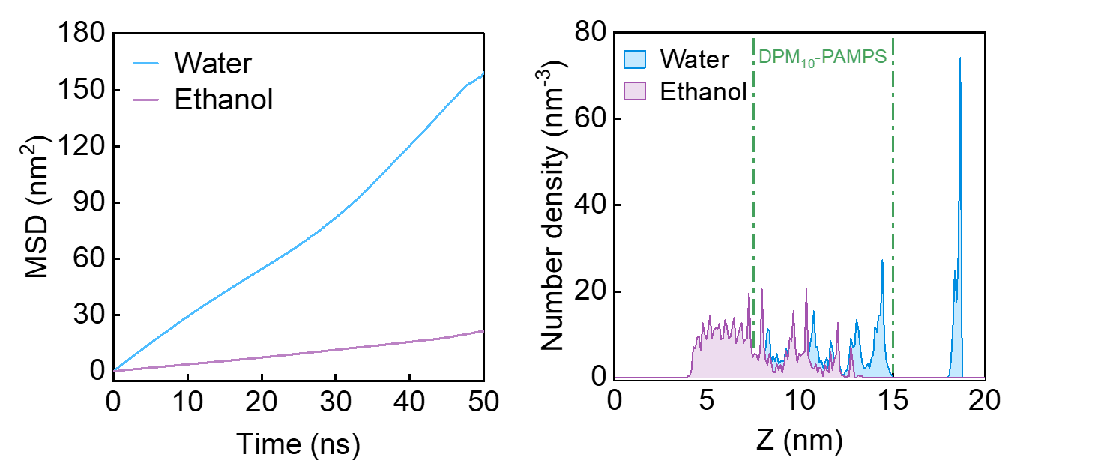
Supplementary Fig. S16 MSD curves of water and ethanol molecules over time in the MD simulations for water/ethanol treatment based on DPM₁₀-PAMPS.
Mean Square Displacement (MSD) analysis is an important tool used to study the diffusion behavior of molecules or atoms. MSD analysis evaluates the diffusion of particles over time during a simulation by calculating the average square displacement of the particles. The MSD curve over time (usually linear) reflects the change in the average position of the selected molecules or atom groups during the simulation. Supplementary Fig. S16 simulates the MSD curve of water and ethanol over time in DPM₁₀-PAMPS to investigate the influence on selective diffusion behavior. The horizontal axis represents time, and the vertical axis represents the MSD value. The diffusion coefficients of water and ethanol are (5.057±2.005)×10⁻⁶ cm² s⁻¹ and (6.670±0.900)×10⁻⁷ cm² s⁻¹, which sufficiently proves that DPM₁₀-PAMPS has a preferential water transport while effectively excluding ethanol.

Supplementary Fig. S17 Density profiles of water and ethanol at different positions in the MD simulations for water/ethanol separation using DPM₁₀-PAMPS.
Density is primarily used to analyze the density distribution of different components in a molecular system. A density plot shows how the density of water and ethanol changes at different positions. The horizontal axis represents position, and the vertical axis represents the density at the corresponding position. Comparison of the density changes of water and ethanol at different positions at the final moment. The density profiles of water and ethanol at different positions demonstrate that only water molecules selectively transport across the DPM₁₀-PAMPS, whereas ethanol molecules are effectively retained, demonstrating the excellent performance of DPM₁₀-PAMPS in purifying water/ethanol mixtures.
S10 Performance of DPM₁₀-PAMPS in removing aromatic compounds from water
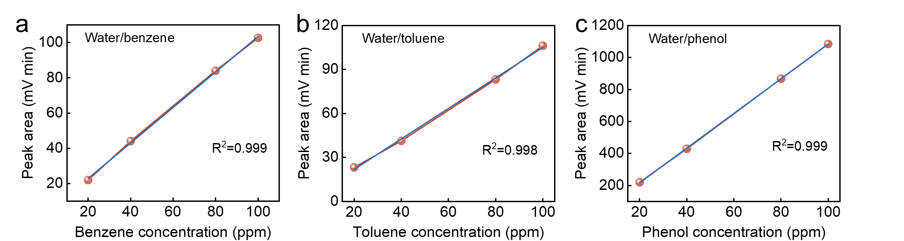
Supplementary Fig. S18 Standard curves of (a) benzene, (b) toluene, and (c) phenol, respectively.

Table S1. Summary of concentrations before and after treatment of water/aromatic VOCs using DPM₁₀-PAMPS
VOCs | Initial concentration (ppm) |  |  |  | WHO  (ppm) | US-EPA  (ppm)
VOCs | 100 | 300 | 500 | 1000 | WHO  (ppm) | DWEL¹ | MCL²
Benzene | 0.004 | - | 0.001 | 0.003 | 0.01 | 0.1 | 0.005
Toluene | 0.001 | 0.029 | 0.058 | - | 0.7 | 3 | 1
Phenol | 0.01 | - | 0.05 | 0.04 | - | 11 | -
¹DWEL, Drinking Water Equivalent Level
²MCL, Maximum Contaminant Level

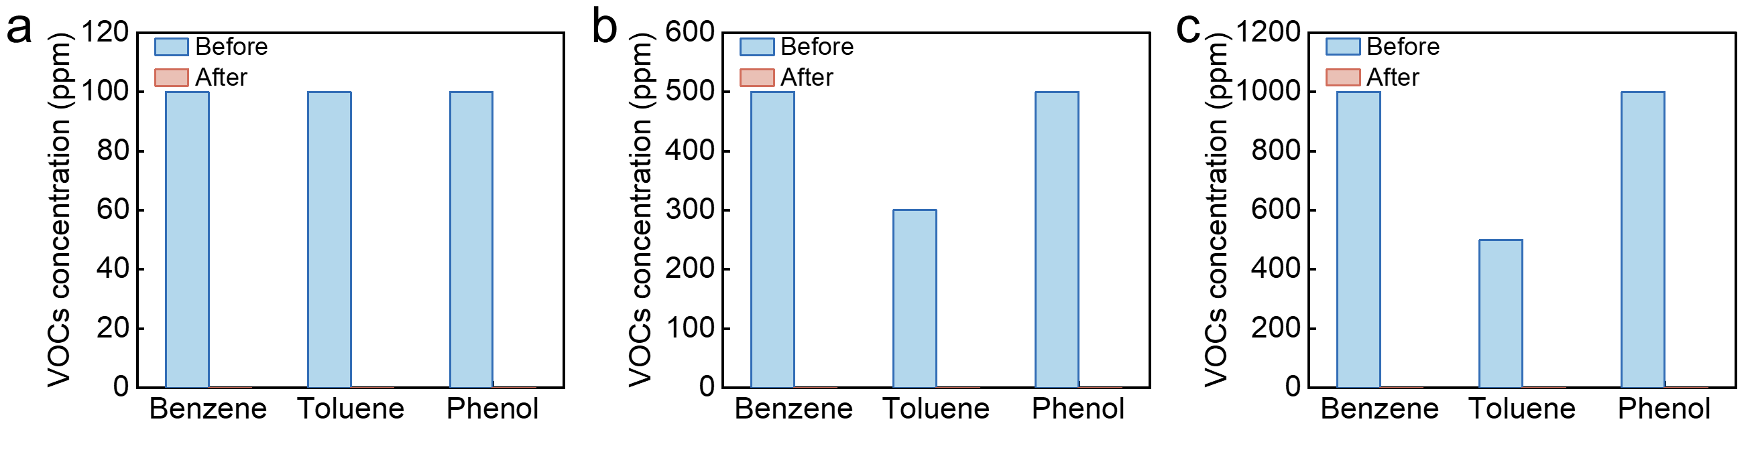
Supplementary Fig. S19 The performance of DPM₁₀-PAMPS on complex aromatic VOCs removal.
The challenges in separating benzene, toluene, phenol, and water arise from their distinct physicochemical properties. Benzene readily forms an azeotrope with water and is highly toxic, requiring azeotropic distillation or liquid-liquid extraction. Toluene has a close boiling point to benzene and tends to form emulsions, necessitating high-efficiency fractional distillation or transport. Phenol exhibits high water solubility due to its strong polarity and hydrogen bonding, making pH-adjusted extraction or steam distillation essential. Meanwhile, water can form azeotropes or hydrogen bonds with all three components, requiring dehydration via molecular sieves or salting-out. In summary, benzene and toluene separation relies on volatility differences, phenol demands overcoming polar interactions, and water removal involves disrupting azeotropes or hydrogen-bonding networks. Furthermore, we systematically evaluated the removal performance of DPM₁₀-PAMPS for complex aromatic VOCs by establishing concentration gradients of benzene, toluene, and phenol (in which the benzene/toluene/phenol mixture solution concentration is 100/100/100 ppm, 500/300/500 ppm, and 1000/500/1000 ppm, respectively). Remarkably, DPM₁₀-PAMPS demonstrated excellent elimination efficiency across all tested concentrations, achieving consistent removal of residual benzene (0.001–0.004 ppm), toluene (0.017–0.027 ppm), and phenol (0.01–0.05 ppm) in these multicomponent solutions.

S11 Exploring of DPM₁₀-PAMPS in removing strongly polar VOCs from water
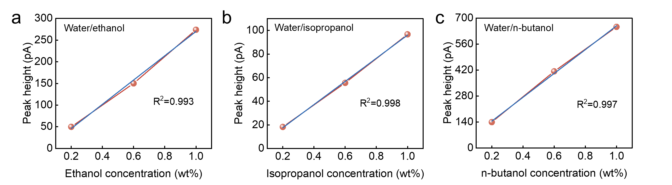
Supplementary Fig. S20 Standard curves of (a) ethanol, (b) isopropanol, and (c) n-butanol, respectively.

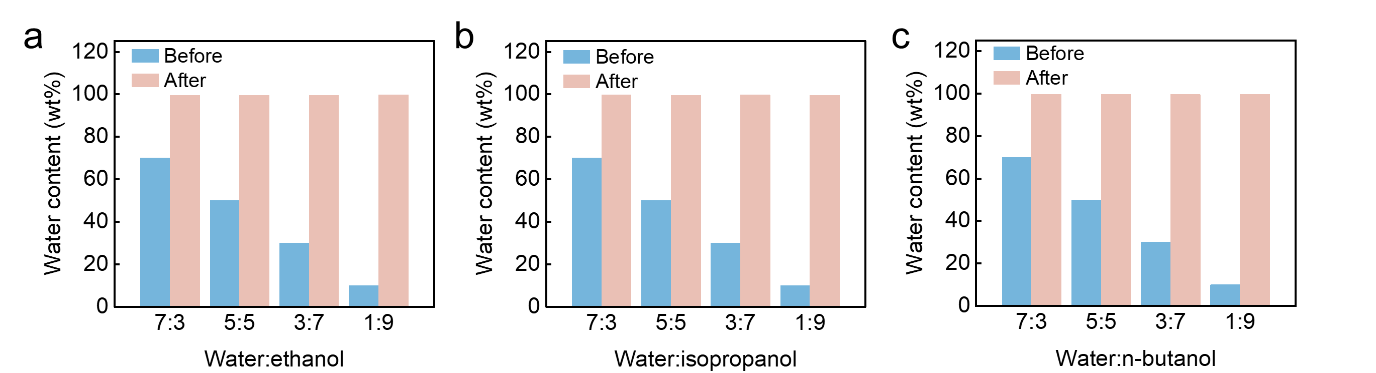
Supplementary Fig. S21 a−c Effect of mass fraction of strongly polar alcoholic VOCs on the separation performance using DPM₁₀-PAMPS.
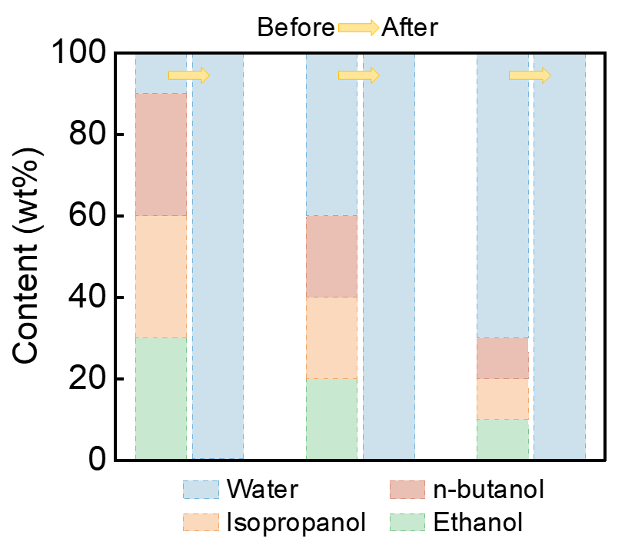
Supplementary Fig. S22 Performance of DPM₁₀-PAMPS in removing complex, strongly polar alcoholic VOCs from water.
The separation challenges for ethanol, isopropanol, n-butanol, and water stem from their distinct physicochemical properties. Ethanol forms a minimum-boiling azeotrope with water, requiring advanced distillation or molecular sieves. Isopropanol similarly creates an azeotrope while exhibiting greater hydrophobicity than ethanol. n-butanol shows limited water solubility but forms heterogeneous azeotropes, enabling phase separation. However, in complex wastewater systems containing ethanol, isopropanol, and n-butanol, the competitive intermolecular interactions and multi-component azeotropic behavior pose a significant challenge for the selective separation of water. Furthermore, in the complex solutions with 30 wt%, 60 wt%, and 90 wt%, where ethanol, isopropanol, and n-butanol are present in an equal mass ratio of 1:1:1. Notably, the resultant water contents reached exceptional purity levels of 99.75%, 99.66%, and 99.52%, respectively, demonstrating the outstanding separation performance of DPM₁₀-PAMPS membranes.

S12 Performance of DPM₁₀-PAMPS in removing aromatic VOCs from water compared with previous reports
Table S2 Performance comparison of phenol removal from water with previously reported work.
Samples | Light  density | Water  evaporation rate  (kg m^{–2} h^{–1}) | VOCs  type | Initial  concentration  (ppm) | Removal  rate | Ref
Activated carbon | - | - | Phenol | 10–100 | ~95% | ⁴
Immobilized enzymes | - | - | Phenol | 20–100 | ~92% | ⁵
Polytetrafluoroethylene membrane | - | - | Phenol | 45 | 88.89% | ⁶
Polydimethylsiloxane/polyether block amide | - | 0.1 | Phenol | 112 | 86.6% | ⁷
CuFeMnO₄ on ceramic substrate | 1 sun | 1.45 | Phenol | 20 | ~98.2% | ⁸
Nano-TiO₂/zeolite/silica gel | - | - | Phenol | 50 | 90% | ⁹
P25 TiO₂ | - | - | Phenol | 30 | 95% | ¹⁰
Pr-doped TiO₂ nanoparticles | - | - | Phenol | 12.5 | 99% | ¹¹
Carbon membranes | - | - | Phenol | 50 | 98.51% | ¹²
Iron oxide-coated ceramic membranes | - | - | Phenol | 50 | 77% | ¹³
p-type NiO semiconductor | - | - | Phenol | 100 | 90% | ¹⁴
TiO₂/activated carbon | - | - | Phenol | 100 | 68.03% | ¹⁵
Polymer inclusion membrane | - | - | Phenol | 25 | 85.56% | ¹⁶
N-isopropylacrylamide/tributyl phosphate/ poly (vinyl alcohol) | - | - | Phenol | 90 | 85% | ¹⁷
Macroporous polystyrene crosslinked with divinylbenzene | - | - | Phenol | 50 | 90% | ¹⁸
SWEG | 1 sun | 1.4 | Phenol | 100 | 99.2% | ¹⁹
g-C₃N₄@PANI/PS | 1 sun | 1.3 | Phenol | 20 | 95% | ²⁰
covalent triazine framework (CTF-OX) | 1 sun | 1.19 | Phenol | 50 | 98% | ²¹
PANI-PA photothermal membrane | 1 sun | 1.0 | Phenol | 200 | 97% | ²²
MPS-PPy membrane | 1 sun | 1.12 | Phenol | 5 | 90% | ²³
P25-coated Flammulina | 1 sun | ~1 | Phenol | 5 | 78% | ²⁴
Zr-Fc MOF/SWCNT/gelatin, ZSG | 1 sun | 1.53 | Phenol | 10 | 95% | ²⁵
m-TiO_{2–x} NFM | 1 sun | 1.05 | Phenol | 10 | 95% | ²⁶
Cu/W₁₈O₄₉@Graphene/PDMS | 1 sun | 1.41 | Phenol | 10 | 99% | ²⁷
DPM₁₀-PAMPS | 1 sun | 2.58 | Phenol | 1000 | 99.99% | This work

S13 Performance of DPM₁₀-PAMPS in eliminating strongly polar alcoholic VOCs from water compared with previous work
Table S3 Performance comparison of ethanol removal from water with previously reported work.
Sample type | Temperature  (°C) | Ethanol content  in feed water (wt%) | Permeation flux  (kg m^{–2} h^{–1}) | Separation factor | Ref
DPM₁₀-PAMPS | 25 | 90 | 2.58 | 2638 | This work
SA-PSBMA@GO/PAN | 77 | 90 | 2.14 | 1370 | ¹
GO-TFNC | 70 | 80 | 2.2 | 308 | ²⁸
SA-PTA | 30 | 90 | 1.11 | 1866 | ²⁹
SA-PVP-PWA | 70 | 96 | 1.5 | 1000 | ³⁰
SA-rGO/PAN | 77 | 90 | 1.70 | 1566 | ³¹
SA-PAA@Fe₃O₄/PAN | 77 | 90 | 1.63 | 1044 | ³²
SA/PEI-PDA/PAN | 77 | 90 | 1.20 | 1807 | ³³
GO/mPAN | 70 | 90 | 1.80 | 1791 | ³⁴
SA-ZIF-L | 76 | 90 | 1.21 | 1840 | ³⁵
PEI/TA/HPAN | 76 | 90 | 1.34 | 1012 | ³⁶
CS/MOF-801 | 50 | 90 | 1.93 | 2156 | ³⁷
TMC/AETH | 25 | 90 | 1.59 | 1116 | ³⁸
TMC/TAEA | 25 | 90 | 1.15 | 1491 | ³⁹
TMC/DETA | 25 | 90 | 0.86 | 1116 | ⁴⁰
GO | 24 | 85 | 0.25 | 227 | ⁴¹
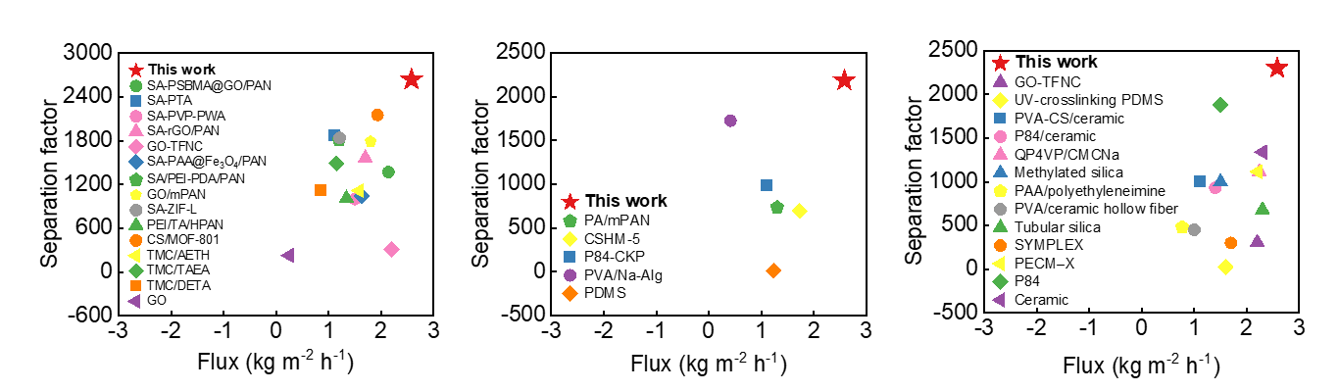
Supplementary Fig. S23 Separation factor comparison of DPM₁₀-PAMPS with previously reported work for ethanol removal from water.
Table S4 Performance comparison of isopropanol removal from water with previously reported work.
Samples | Temperature  (°C) | Isopropanol content  in feed water (wt%) | Permeation flux  (kg m^{–2} h^{–1}) | Separation factor | Ref
DPM₁₀-PAMPS | 25 | 90 | 2.58 | 2186 | This work
PA/mPAN | 30 | 70 | 1.30 | 736 | ⁴²
CSHM-5 | 70 | 70 | 1.73 | 694 | ⁴³
P84-CKP | 60 | 85 | 1.11 | 988 | ⁴⁴
PVA/Na-Alg | 45 | 90 | 0.41 | 1727 | ⁴⁵
PDMS | 50 | 5 | 1.23 | 12.2 | ⁴⁶
Supplementary Fig. S24 Separation factor comparison of DPM₁₀-PAMPS with previously reported work for isopropanol removal from water.

Table S5 Performance comparison of n-butanol removal from water with previously reported work.
Samples | Temperature  (°C) | n-butanol content  in feed water (wt%) | Permeation flux  (kg m^{–2} h^{–1}) | Separation factor | Ref
DPM₁₀-PAMPS | 50 | 90 | 2.58 | 2299 | This work
GO-TFNC | 70 | 80 | 2.20 | 308 | ²⁸
UV-crosslinking PDMS | 50 | 5 | 1.60 | 22.7 | ⁴⁶
PVA-CS/ceramic | 70 | 90 | 1.12 | 1000 | ⁴⁷
P84/ceramic | 95 | 95 | 1.40 | 931 | ⁴⁸
QP4VP/CMCNa | 60 | 90 | 2.24 | 1116 | ⁴⁹
Methylated silica | 60 | 94 | 1.50 | 1000 | ⁵⁰
PAA/polyethyleneimine | 50 | 95 | 0.77 | 481 | ⁵¹
PVA/ceramic hollow fiber | 80 | 95 | 1.00 | 450 | ⁵²
Tubular silica | 70 | 95 | 2.30 | 680 | ⁵³
SYMPLEX | 25 | 90 | 1.70 | 300 | ⁴⁹
PECM-X | 60 | 90 | 2.21 | 1116 | ⁵⁴
P84 | 95 | 95 | 1.50 | 1880 | ⁵⁵
Ceramic | 70 | 95 | 2.3 | 1340 | ⁵⁶
Supplementary Fig. S25 Separation factor comparison of DPM₁₀-PAMPS with previously reported work for n-butanol removal from water.

Supplementary reference
1. Zhao, J. et al. Incorporating zwitterionic graphene oxides into sodium alginate membrane for efficient water/alcohol separation. ACS Appl. Mater. Interfaces 8, 2097–2103 (2016).
2. Zhang, P. et al. Hydrogen-bond-repairing solar evaporator with reconstructed large-width channels for durable solarizing seawater. Nano Lett. 24, 11615–11623 (2024).
3. Zhou, X., Guo, Y., Zhao, F., Shi, W. & Yu, G. Topology-controlled hydration of polymer network in hydrogels for solar-driven wastewater treatment. Adv. Mater. 32, e2007012 (2020).
4. Mohanty, K., Das, D. & Biswas, M. N. Treatment of phenolic wastewater in a novel multi-stage external loop airlift reactor using activated carbon. Sep. Purif. Technol. 58, 311–319 (2008).
5. Ensuncho, L., Alvarez-Cuenca, M. & Legge R. L. Removal of aqueous phenol using immobilized enzymes in a bench scale and pilot scale three-phase fluidized bed reactor. Bioprocess Biosyst. Eng. 27, 185–191 (2005).
6. Singh, D. & Sirkar, K. K. Desalination of brine and produced water by direct contact membrane distillation at high temperatures and pressures. J. Membr. Sci. 389, 380–388 (2012).
7. Yahaya, G. O. Separation of phenol from aqueous streams by a composite hollow fiber based pervaporation process using polydimethyl siloxane (PDMS)/polyether-block-amide (PEBA) as two-layer membranes. Sep. Purif. Technol. 44, 2894–2914 (2009).
8. Shi, L. et al. Multi-functional 3D honeycomb ceramic plate for clean water production by heterogeneous photo-Fenton reaction and solar-driven water evaporation. Nano Energy 60, 222–230 (2019).
9. Zainudin, N. F., Abdullah, A. Z. & Mohamed, A. R. Characteristics of supported nano-TiO₂/ZSM-5/silica gel (SNTZS): Photocatalytic degradation of phenol. J. Hazard. Mater. 174, 299–306 (2010).
10. Grzechulska, J. & Morawski, A. W. Photocatalytic labyrinth flow reactor with immobilized P25 TiO₂ bed for removal of phenol from water. Appl. Catal. B: Environ. 46, 415–419 (2003).
11. Chiou, C. & Juang, R. Photocatalytic degradation of phenol in aqueous solutions by Pr-doped TiO₂ nanoparticles. J. Hazard. Mater. 149, 1–7 (2007).
12. Sun, M. et al. Enhanced removal ability of phenol from aqueous solution using coal-based carbon membrane coupled with electrochemical oxidation process. Colloid. Surface. A 540, 186–193 (2018).
13. Harman, B. I., Koseoglu, H., Yigit, N. O., Beyhan, M. & Kitis, M. The use of iron oxide-coated ceramic membranes in removing natural organic matter and phenol from waters. Desalination 261, 27–33 (2010).
14. Gondal, M. A., Seddigi, Z. S., Nasr, M. M. & Gondal, B. Spectroscopic detection of health hazardous contaminants in lipstick using Laser Induced Breakdown Spectroscopy. J. Hazard. Mater. 175, 726–732 (2010).
15. Ngamsopasiriskun, C., Charnsethikul, S., Thachepan, S. & Songsasen, A. Removal of phenol in aqueous solution by nanocrystalline TiO₂/activated carbon composite catalyst. Kasetsart J. Nat. Sci. 44, 1176–1182 (2010).
16. Pérez-Silva, I. et al. Phenol removal process development from synthetic wastewater solutions using a polymer inclusion membrane. Ind. Eng. Chem. Res. 52, 4919–4923 (2013).
17. Pan, G. & Kurumada, K. I. Hybrid gel reinforced with coating layer for removal of phenol from aqueous solution. Chem. Eng. J. 138, 194–199 (2008).
18. İpek, İ., Kabay, N., Yüksel, M., Yapıcı, D. & Yüksel, Ü. Application of adsorption-ultrafiltration hybrid method for removal of phenol from water by hypercrosslinked polymer adsorbents. Desalination 306, 24–28 (2012).
19. Zhang, P. et al. Super water-extracting gels for solar-powered volatile organic compounds management in the hydrological cycle. Adv. Mater. 34, 2110548 (2022).
20. Xia, Q. et al. A floating integrated solar micro-evaporator for self-cleaning desalination and organic degradation. Adv. Funct. Mater. 33, 2214769 (2023).
21. Cho, W. et al. Supramolecular engineering of amorphous porous polymers for rapid adsorption of micropollutants and solar-powered volatile organic compounds management. Adv. Mater. 34, 2206982 (2022).
22. Wei, X. et al. A polyaniline nanofiber array supported ultrathin polyamide membrane for solar-driven volatile organic compound removal. J. Mater. Chem. A 10, 20424–20430 (2022).
23. Qi, D. et al. Polymeric membranes with selective solution-diffusion for intercepting volatile organic compounds during solar-driven water remediation. Adv. Mater. 32, 2004401 (2020).
24. Deng, J. et al. Self-suspended photothermal microreactor for water desalination and integrated volatile organic compound removal. ACS Appl. Mater. Interfaces 12, 51537–51545 (2020).
25. Ma, X. et al. A photothermal and Fenton active MOF-based membrane for high-efficiency solar water evaporation and clean water production. J. Mater. Chem. A 8, 22728–22735 (2020).
26. Song, C. et al. Volatile-organic-compound-intercepting solar distillation enabled by a photothermal/photocatalytic nanofibrous membrane with dual-scale pores. Environ. Sci. Technol. 54, 9025–9033 (2020).
27. Ren, L., Yang, X., Sun, X. & Yuan, Y. Synchronizing efficient purification of VOCs in durable solar water evaporation over a highly stable Cu/W₁₈O₄₉@graphene material. Nano Lett. 24, 715–723 (2024).
28. Yeh, T., Wang, Z., Mahajan, D., Hsiao, B. S. & Chu, B. High flux ethanol dehydration using nanofibrous membranes containing graphene oxide barrier layers. J. Mater. Chem. A 1, 12998–13003 (2013).
29. Adoor, S. G. et al. Exploration of nanocomposite membranes composed of phosphotungstic acid in sodium alginate for separation of aqueous–organic mixtures by pervaporation. Sep. Purif. Technol. 113, 64–74 (2013).
30. Magalad, V. T. et al. Polymeric blend nanocomposite membranes for ethanol dehydration-effect of morphology and membrane-solvent interactions. J. Membr. Sci. 430, 321–329 (2013).
31. Cao, K. et al. Enhanced water permeation through sodium alginate membranes by incorporating graphene oxides. J. Membr. Sci. 469, 272–283 (2014).
32. Zhao, C. et al. High pervaporation dehydration performance of the composite membrane with an ultrathin alginate/poly(acrylic acid)-Fe₃O₄ active layer. Ind. Eng. Chem. Res. 53, 1606–1616 (2014).
33. Zhao, J. et al. Manipulating the interfacial interactions of composite membranes via a mussel-inspired approach for enhanced separation selectivity. J. Mater. Chem. A 3, 19980–19988 (2015).
34. Hung, W. et al. Pressure-assisted self-assembly technique for fabricating composite membranes consisting of highly ordered selective laminate layers of amphiphilic graphene oxide. Carbon 68, 670–677 (2014).
35. Liu, G. et al. Pervaporation performance comparison of hybrid membranes filled with two-dimensional ZIF-L nanosheets and zero-dimensional ZIF-8 nanoparticles. J. Membr. Sci. 523, 185–196 (2017).
36. Liu, G. et al. Preparation of ultrathin, robust membranes through reactive layer-by-layer (LbL) assembly for pervaporation dehydration. J. Membr. Sci. 537, 229–238 (2017).
37. Li, Q. et al. High efficient water/ethanol separation by a mixed matrix membrane incorporating MOF filler with high water adsorption capacity. J. Membr. Sci. 544, 68–78 (2017).
38. Huang, S. et al. Characterization, transport and sorption properties of poly(thiol ester amide) thin-film composite pervaporation membranes. J. Membr. Sci. 322, 139–145 (2008).
39. Huang, S. et al. Interfacially polymerized thin-film composite polyamide membranes: Effects of annealing processes on pervaporative dehydration of aqueous alcohol solutions. Sep. Purif. Technol. 72, 40–47 (2010).
40. Ang, M. B. M. Y. et al. Surface properties, free volume, and performance for thin-film composite pervaporation membranes fabricated through interfacial polymerization involving different organic solvents. Polymers 12, 2326 (2020).
41. Tang, Y. P., Paul, D. R. & Chung, T. S. Free-standing graphene oxide thin films assembled by a pressurized ultrafiltration method for dehydration of ethanol. J. Membr. Sci. 458, 199–208 (2014).
42. Huang, S. et al. Positron annihilation study on thin-film composite pervaporation membranes: Correlation between polyamide fine structure and different interfacial polymerization conditions. Polymers 51, 1370–1376 (2010).
43. Liu, Y., Su, Y., Lee, K. & Lai, J. Crosslinked organic-inorganic hybrid chitosan membranes for pervaporation dehydration of isopropanol-water mixtures with a long-term stability. J. Membr. Sci. 251, 233–238 (2005).
44. Qiao, X., Chung, T. Diamine modification of P84 polyimide membranes for pervaporation dehydration of isopropanol. AIChE J. 52, 3462–3472 (2006).
45. Dong, Y., Zhang, L., Shen, J., Song, M. & Chen, H. Preparation of poly(vinyl alcohol)-sodium alginate hollow-fiber composite membranes and pervaporation dehydration characterization of aqueous alcohol mixtures. Desalination 193, 202–210 (2006).
46. Zhuang, Y. et al. Polydimethylsiloxane membrane formed by thiol-ene photopolymerization for bio-alcohols pervaporation. Sep. Purif. Technol. 329, 125138 (2024).
47. Zhu, Y., Xia, S., Liu, G. & Jin, W. Preparation of ceramic-supported poly(vinyl alcohol)–chitosan composite membranes and their applications in pervaporation dehydration of organic/water mixtures. J. Membr. Sci. 349, 341–348 (2010).
48. Kreiter, R., Wolfs, D. P., Engelen, C. W. R., van Veen, H. M. & Vente, J. F. High-temperature pervaporation performance of ceramic-supported polyimide membranes in the dehydration of alcohols. J. Membr. Sci. 319, 126–132 (2008).
49. Liu, T. et al. Preparation and characterization of polyelectrolyte complex membranes bearing alkyl side chains for the pervaporation dehydration of alcohols. J. Membr. Sci. 429, 181–189 (2013).
50. Bettens, B. et al. Pervaporation of binary water-alcohol and methanol-alcohol mixtures through microporous methylated silica membranes: Maxwell-Stefan modeling. Comput. Chem. Eng. 34, 1775–1788 (2010).
51. Zhang, G., Song, X., Ji, S., Wang, N. & Liu, Z. Self-assembly of inner skin hollow fiber polyelectrolyte multilayer membranes by a dynamic negative pressure layer-by-layer technique. J. Membr. Sci. 325, 109–116 (2008).
52. Peters, T. A. et al. Ceramic-supported thin PVA pervaporation membranes combining high flux and high selectivity; contradicting the flux-selectivity paradigm. J. Membr. Sci. 276, 42–50 (2006).
53. Verkerk, A. W., van Male, P., Vorstman, M. A. G. & Keurentjes, J. T. F. Properties of high flux ceramic pervaporation membranes for dehydration of alcohol/water mixtures. Sep. Purif. Technol. 22, 689–695 (2001).
54. van Veen, H. M., van Delft, Y. C., Engelen, C. W. R. & Pex, P. P. A. C. Dewatering of organics by pervaporation with silica membranes. Sep. Purif. Technol. 22, 361–366 (2001).
55. Huang, J. & Meagher, M. M. Pervaporative recovery of n-butanol from aqueous solutions and ABE fermentation broth using thin-film silicalite-filled silicone composite membranes. J. Membr. Sci. 192, 231–242 (2001).
56. Eda, G., Fanchini, G. & Chhowalla, M. Large-area ultrathin films of reduced graphene oxide as a transparent and flexible electronic material. Nat. Nanotechnol. 3, 270–274 (2008).

