Supplementary Information for:

Programming Local Confinements in Crystalline Frameworks through Reticular Chemistry
Xianhui Tang,^{1,2} Xiaoliang Wang,^{1,2} Zi-Ming Ye,^{1,2} Shengyi Su,^{1,2} Julian S. Magdalenski,^{1,2} Bang Hou,^{1,2} Timothy Y.-Z. Li,¹ Kent O. Kirlikovali,^{1,2} Nathan C. Gianneschi,^{1,5} Haomiao Xie,^{1,2}* and Omar K. Farha^{1,2,3,4}*
1. Department of Chemistry, Northwestern University, Evanston, Illinois 60208, United States
2. International Institute for Nanotechnology, Northwestern University, Evanston, Illinois 60208, United States
3. Department of Chemical & Biological Engineering, Northwestern University, Evanston, Illinois 60208, United States
4. Paula M. Trienens Institute for Sustainability and Energy, Northwestern University, Evanston, IL, USA
5. Department of Biomedical Engineering, Materials Science & Engineering, and Pharmacology, Simpson-Querrey Institute, Chemistry of Life Processes Institute, and Lurie Cancer Center.Northwestern University, 2145 Sheridan Road, Evanston, Illinois 60208. United States

Table of Contents
- Materials and general procedures S2
- Synthesis S3
- Supplementary Tab. 1 Crystal data and structure refinement S12
- Supplementary Fig. 14-29 Additional X-ray crystallographic structures S13
- Supplementary Fig. 30-31 SEM images S21
- Supplementary Fig. 32-33 TGA curves. S22
- Supplementary Fig. 34-35 VT-PXRD patterns. S23
- Supplementary Fig. 36-37 Gas adsorption-desorption isotherms S24
- Supplementary Fig. 38-39 XPS spectra. S25
- Supplementary Fig. 40-41 Isosteric heat of adsorption S26
- Supplementary Fig. 42-43 Diffuse-reflectance IR spectroscopy (DRIFTS) S27
- Supplementary Fig. 44-45 Thermal swing adsorption S28
- Supplementary Fig. 46-51 DFT simulation S29
- References S33
1. Materials and General Procedures
All the chemicals are commercially available and have been used without further purification. Thermogravimetric analyses (TGA) were performed on a TGA/DCS system (Mettler-Toledo, Columbus, OH) with STARe software. Samples were heated from 25 to 600 °C at a rate of 5 °C/min under N₂ with a flow rate of 20 mL/min. MS spectrum was collected on Agilent 6230 LC-TOF Mass Spectrometer with ESI ionization Source, connected to Agilent 1290 Infinity LC stack. Powder X-ray diffraction (PXRD) data were collected on a STOE-STADI P powder diffractometer operating at 40 kV voltage and 40 mA current with Cu-Kα1 X-ray radiation (λ = 0.154056 nm) in transmission geometry. The calculated PXRD patterns were produced using the Mercury software and single-crystal reflection data. N₂ sorption isotherms were measured using a Micromeritics ASAP 2420 surface area analyzer at 77 K. Before the isotherm measurement, samples were thermally activated at 160 °C for 12 h under dynamic vacuum on a Micromeritics Smart Vac Prep. SEM images were acquired using a Hitachi SU8030 scanning electron microscope. EDS line scans were collected concurrently with SEM images. Prior to imaging, the sample was coated with OsO₄ (~9 nm) in a Denton Desk III TSC Sputter Coater. NMR spectra were collected on a Bruker S4 Avance III 500 MHz system equipped with DCH CryoProbe and automated with a BACS-60 autosampler.
X-ray Photoelectron Spectroscopy (XPS). Thermo Scientific ESCALAB 250 Xi (Al Kα radiation, hν = 1486.6 eV) equipped with an electron flood gun at the KECKII/NUANCE facility at Northwestern University was used to probe the surface of the sample. An air-free cell was used to ensure a measurement without air exposure, where samples were transferred to the air-free cell in an Ar-filled MBraun Glovebox. XPS data were analyzed using Thermo Scientific Advantage Data System software, and all spectra were referenced to the C 1s peak (284.8 eV).
Variable Temperature X-ray Diffraction Analyses. Activated samples were loaded into 0.5 mm i.d. glass capillaries to a ~1.0 cm packed length and secured with a ~5 mm glass-fiber plug. The capillaries were spun during heating from 298 to 873 K in ambient air at 5 °C/min with 5 min isothermal holds at each set temperature.
Gas Adsorption Measurements. Single-component adsorption isotherms were collected on a Micromeritics 3Flex surface characterization analyzer. Ultra-high-purity gases (99.999%, Praxair; N₂, CO₂, O₂, He) were used for all measurements. Before analysis, samples (30-50 mg) were loaded into oven-dried, tared TranSealTM-equipped tubes (Micromeritics) and outgassed under vacuum by heating to 200 °C at 1 °C/min until the desorption rate was < 3 mbar/min. For isotherms collected between 298 and 318 K, a Micromeritics thermocouple-controlled heating mantle was used to regulate sample temperature.
Thermal Swing Cycling Measurements. Thermal-swing cycling was performed on a TA Instruments thermogravimetric analyzer. Samples of NU-6000-OH-CO₂ and NU-6001-OH-CO₂ were placed in 100 µL aluminum pans, introduced into the balance/furnace under dry N₂ (50 mL min⁻¹), and regenerated at 200 °C for 30 min. Each cycle comprised an adsorption step followed by desorption. For adsorption, the furnace was cooled to 25-27 °C, the gas was switched to 15% CO₂/85% N₂ at 50 mL min⁻¹, and the temperature was held for 20-200 min. For desorption, the gas was returned to dry N₂, the temperature was ramped to 200 °C at 5 °C/min, and then held at 200 °C for 20-25 min.
DRIFTS Measurements. DRIFTS measurements were performed on a Nicolet iS50 spectrometer equipped with a liquid-N₂-cooled MCT detector and a Praying Mantis diffuse-reflectance accessory (Harrick Scientific). Anhydrous KBr was used to collect background spectra. Samples of NU-6000-OH-CO₂ and NU-6001-OH-CO₂ were homogenized with anhydrous KBr and placed in the sample cup of a high-temperature reaction chamber fitted with ZnSe windows. The chamber was sealed and purged with dry N₂, and spectra were recorded at intervals while heating from 25 °C to 200 °C.
Heats of adsorption. The isosteric heat of adsorption (Qst) of CO₂ was estimated from the single-component adsorption isotherms measured at 298, 308, and 318K using the MicroActive software (version 3.01, Micromeritics Instrument Corporation) accompanying the Micromeritics 3Flex gas sorption analyzer. An interpolated curve is generated by spline fitting of data points to determine the pressures at equivalent loadings for each temperature. The Qst is calculated at fixed loadings from the slope of the isosteres according to the Clausius−Clapeyron equation (1).
$${(ln p)}_{n}=\left(\frac{Q_{st}}{R}\right)\left(\frac{1}{T}\right)+C (1)$$
Electrical Diffraction (ED) Crystallography. The single-crystal ED data were collected at room temperature under a nitrogen cryostream using a Rigaku equipped with an electronic-noise free Hybrid Photon Counting Detector and Cryostream 105-300 K (Gatan Elsa 698). Data reduction and analysis were performed with ‘CrysAlisPro’. The structures were determined by intrinsic phasing (SHELXT 2018/2)¹ and refined by full-matrix least squares refinement on F² (SHELXL-2018/3)² using the Olex2³ software package. All hydrogen atom positions were added to their mother carbon atoms by geometry and refined by a riding model. SADI, ISOR, and RIGU restraints were used to obtain reasonable parameters. The disordered non-coordinated solvent molecules and counterions were removed using the solvent mask option in Olex2. The contents of the solvent and counterions are not represented in the unit cell contents in the final crystal data. Crystal data and details of the data collection are given in Table S1. CCDC 2490282-2490284 and 2498086 contain the supplementary crystallographic data for this paper. The data can be obtained free of charge from the Cambridge Crystallographic Data Centre via www.ccdc.cam.ac.uk/data_request/cif.
Humid CO₂ capture measurements. Dynamic breakthrough experiments were conducted using a Micromeritics Breakthrough Analyzer (BTA) equipped with a Pfeiffer mass spectrometer (GSD 350 02 Omnistar) at the outlet to continuously monitor and quantify the effluent gas composition. A stainless-steel column (length = 305 mm, inner diameter = 4.93 mm) was packed with 193 mg of NU-6000-OH to form a fixed-bed sorbent layer. Three mass-flow controllers precisely regulated the flow rates of He, N₂, and CO₂ during operation. Prior to testing, the packed column was activated in situ at 200 °C for 2 h under He flow and subsequently cooled to room temperature. For humid-gas experiments, the N₂ stream was passed through a temperature-controlled saturator to achieve target relative humidity levels of 50 % and 90 %.

2. Synthesis
2.1 Synthesis of ligand
BBTA were synthesized according to the published procedure⁴.
BBTA: ¹H NMR (500 MHz, DMSO-d₆) δ: 8.38 (s, 2H).
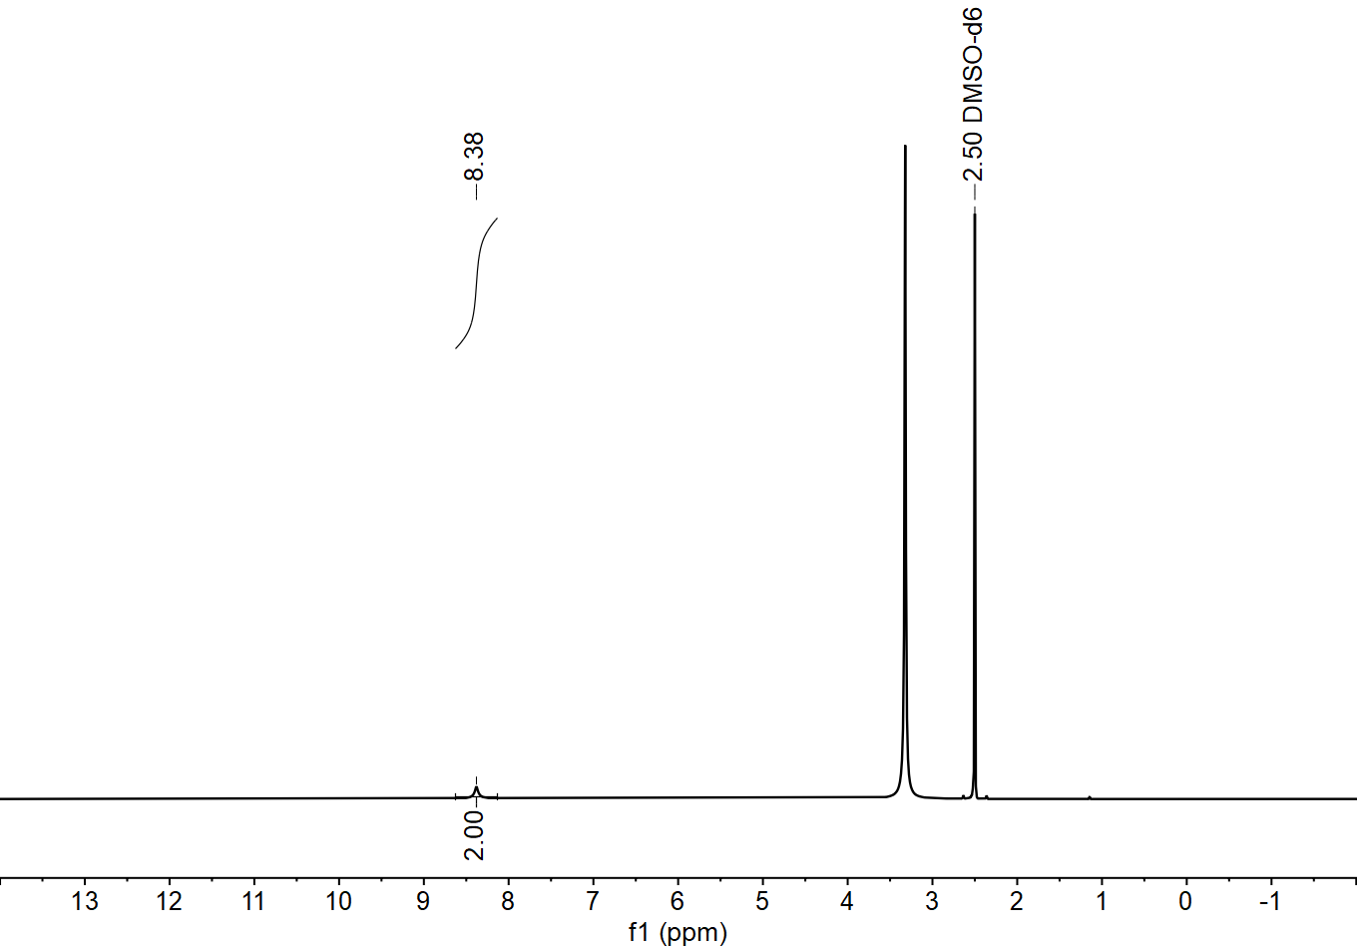
Supplementary Fig. 1. ¹H NMR Spectrum (500 MHz, DMSO-d₆, 298 K) of BBTA.

Intermediate 1 was synthesized according to the published procedure⁵.
Supplementary Fig. 2. Synthesis of TPHTA.
TPHTA: Add triphenylene-2,3,6,7,10,11-hexaammonium chloride (1) (3.97 g, ~7.40 mmol, 1.0 equiv.), acetic acid (27 mL), and DI water (9 mL) to a 100 mL round-bottom flask equipped with a stir bar. Cool the flask to below 0 °C using an ice-water bath. Add a solution of NaNO₂ (1.84 g, 26.64 mmol, ~3.6 equiv.) in DI water (9 mL) slowly to the reaction mixture. Stir the reaction at below 0°C in the ice-water bath for 30 min. Remove the bath, allowing the reaction mixture to warm slowly to room temperature. Allow the reaction mixture to stir at room temperature for 14 h. Dilute the mixture with DI water (23 mL) and filter. Wash the resulting solid thoroughly with DI water, ethanol, and diethyl ether in turn and air-dry. ¹H NMR (500 MHz, DMSO-d₆) δ: 9.26 (s, 6H). ¹H NMR (500 MHz, TFA-d) δ 9.51 (s, 6H). ¹³C NMR (126 MHz, DMSO-d₆) δ: 137.5, 133.2, 130.1, 129.0, 128.9, 124.8. ¹³C NMR (126 MHz, TFA-d) δ: 134.2, 132.6, 110.4.
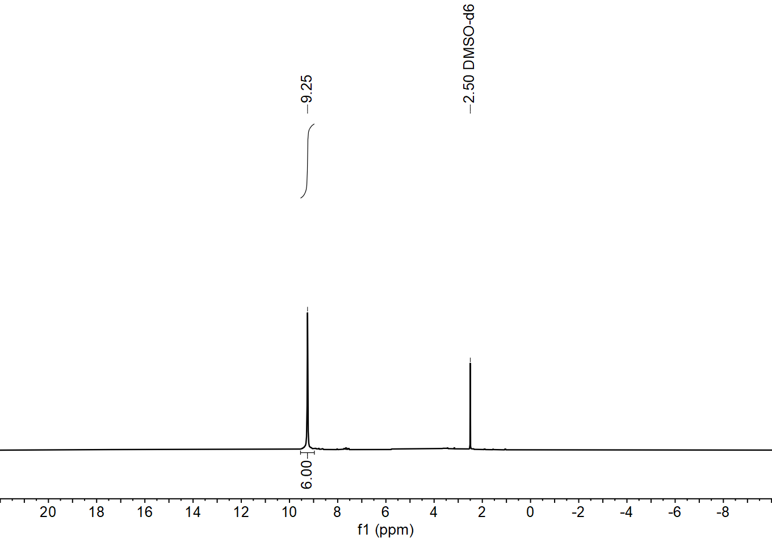
Supplementary Fig. 3. ¹H NMR Spectrum (500 MHz, DMSO-d₆, 298 K) of TPHTA.
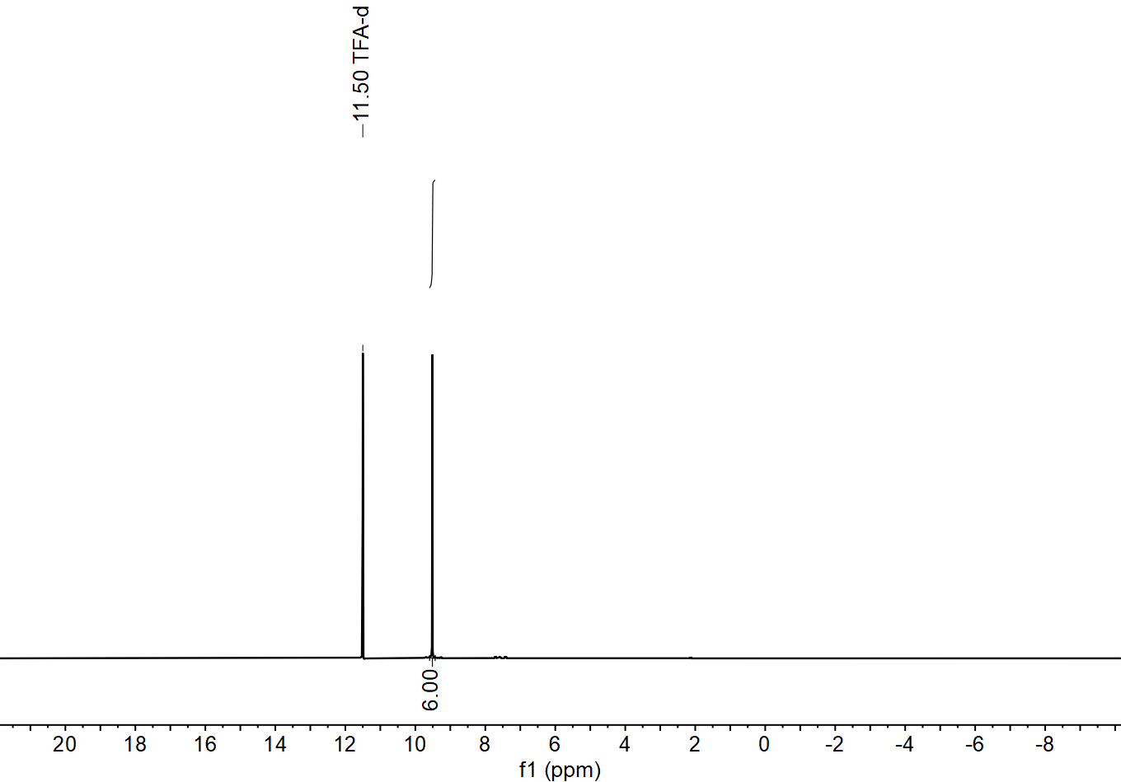
Supplementary Fig. 4. ¹H NMR Spectrum (500 MHz, TFA-d, 298 K) of TPHTA.
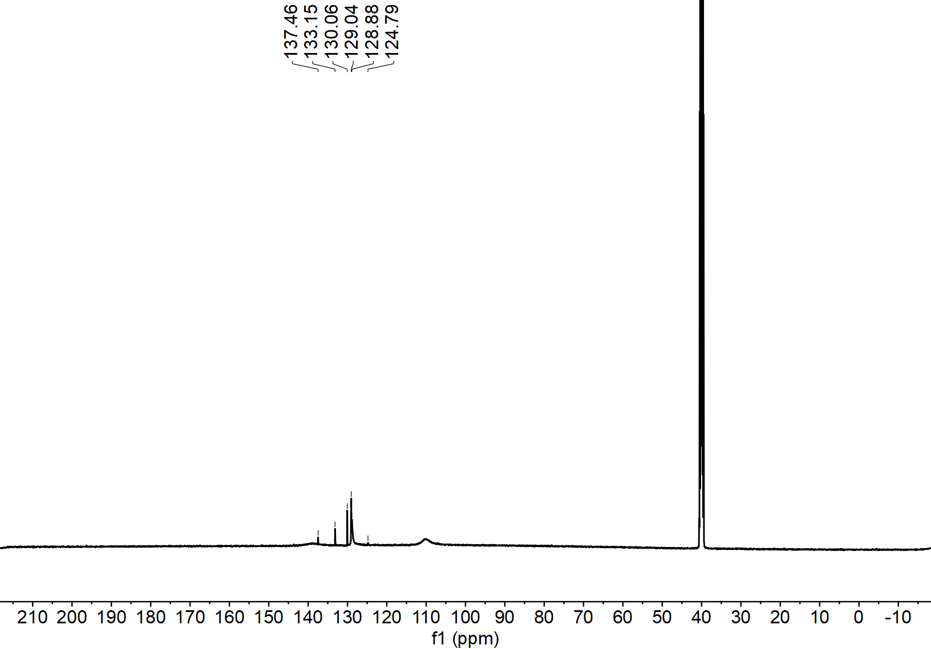
Supplementary Fig. 5. ¹³C NMR Spectrum (500 MHz, DMSO-d₆, 298 K) of TPHTA.
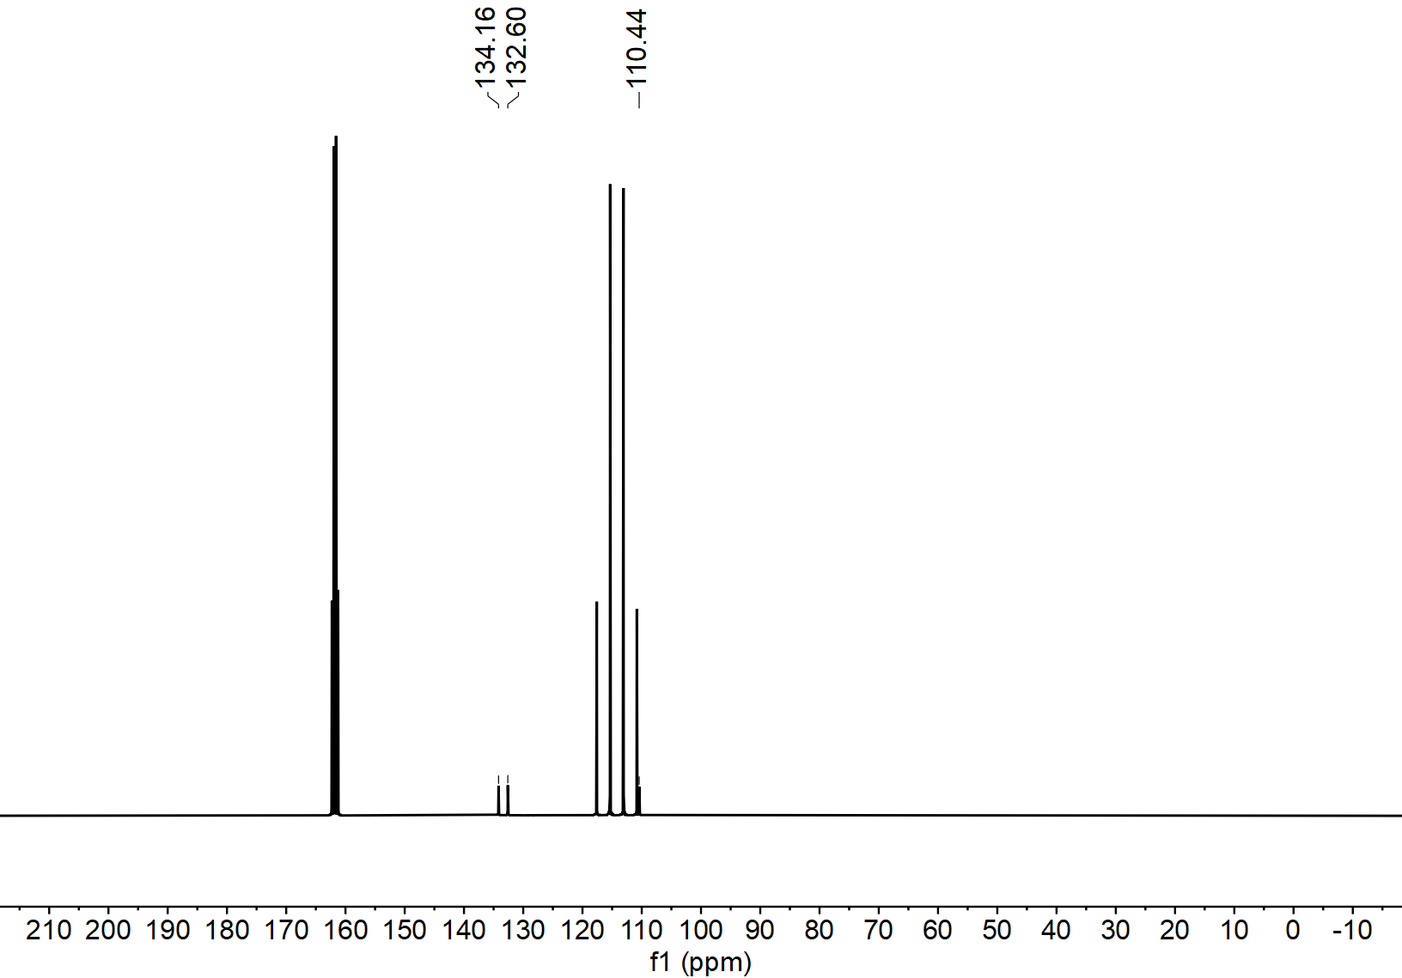
Supplementary Fig. 6. ¹³C NMR Spectrum (500 MHz, TFA-d, 298 K) of TPHTA.

The intermediate 2 was synthesized according to the published procedure⁶.
Supplementary Fig. 7. Synthesis of TPTTA.
TPTTA: Add 2,3,6,7,14,15-Hexaaminotriptycene hexahydrochloride (2) (4.17 g, ~7.40 mmol, 1.0 equiv.), acetic acid (27 mL), and DI water (9 mL) to a 100 mL round-bottom flask equipped with a stir bar. Cool the flask to below 0 °C using an ice-water bath. Add a solution of NaNO₂ (1.84 g, 26.64 mmol, ~3.6 equiv.) in DI water (9 mL) slowly to the reaction mixture. Stir the reaction at below 0°C in the ice-water bath for 30 min. Remove the bath, allowing the reaction mixture to warm slowly to room temperature. Allow the reaction mixture to stir at room temperature for 14 h. Dilute the mixture with DI water (23 mL) and filter. Wash the resulting solid thoroughly with DI water, ethanol, and diethyl ether in turn and air-dry. ¹H NMR (500 MHz, DMSO-d₆) δ: 15.57 (s, 3H), 7.98 (d, J = 91.6 Hz, 6H), 6.09 (s, 2H).¹H NMR (500 MHz, TFA-d) δ 8.25 (s, 6H), 6.33 (s, 2H). ¹³C NMR (126 MHz, DMSO-d₆) δ: 143.8, 143.0, 140.3, 132.0, 113.8, 106.7, 52.7.
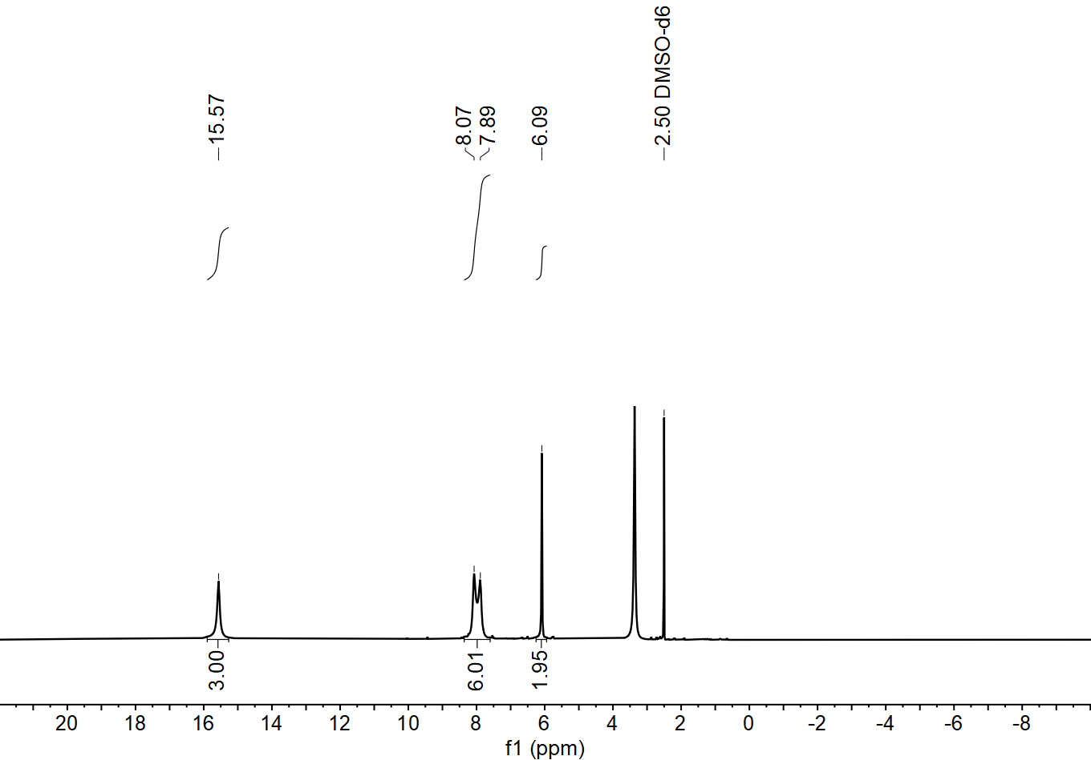
Supplementary Fig. 8. ¹H NMR Spectrum (500 MHz, DMSO-d₆, 298 K) of TPTTA.
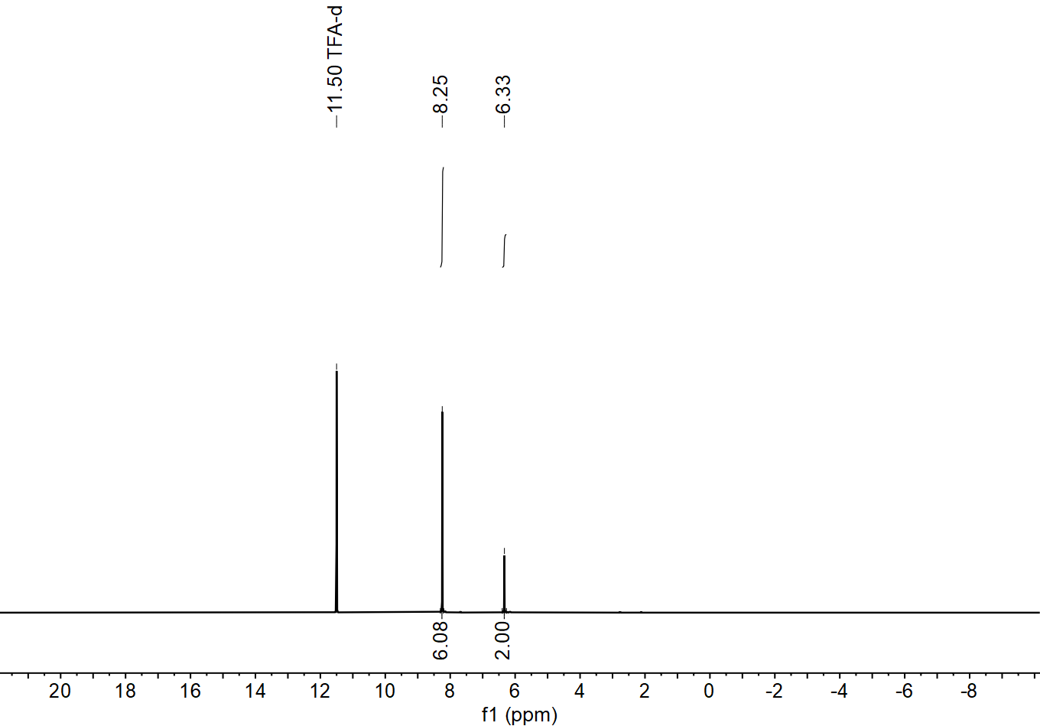
Supplementary Fig. 9. ¹H NMR Spectrum (500 MHz, TFA-d, 298 K) of TPTTA.
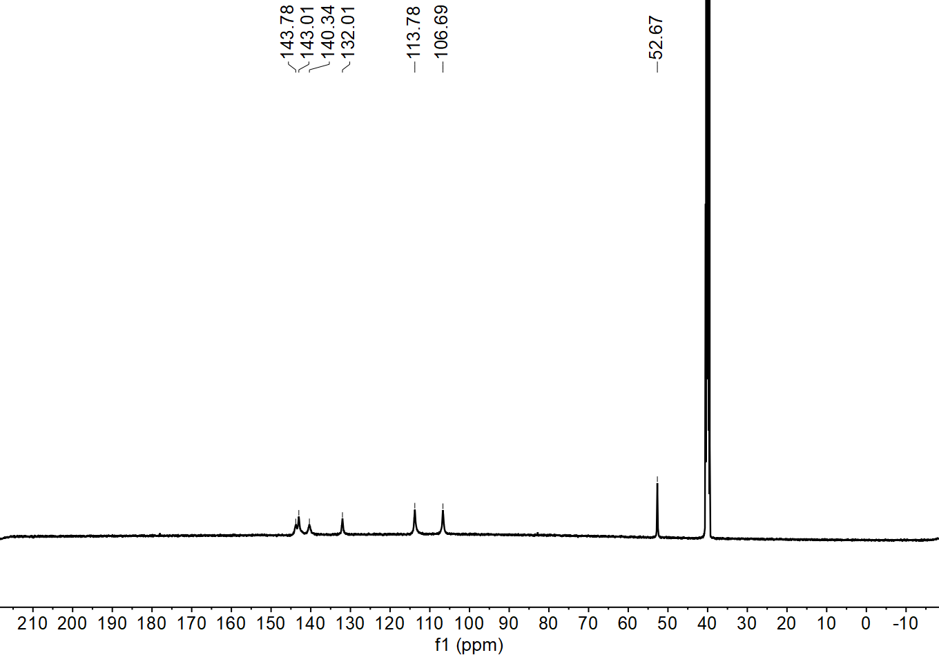
Supplementary Fig. 10. ¹³C NMR Spectrum (500 MHz, DMSO-d₆, 298 K) of TPTTA.
2.2 Synthesis of NU-6000 and NU-6001
Synthesis of NU-6000: A mixture of TPHTA (20.00 mg, 56.93 × 10⁻³ mmol), BBTA (6.08 mg, 37.95 × 10⁻³ mmol), ZnCl₂ (100.00 mg, 0.73 mmol), and DMF (4 mL) was heated in an oven at 140 °C for 3 days. Brown powder of NU-6000 was obtained as a cube with a size of 1 μm, which was not suitable for X-ray diffraction but for Micro-ED. The brown powder was collected by centrifuging, washed with DMF (3 × 40 mL) and methanol (3 × 40 mL), then dried in air.
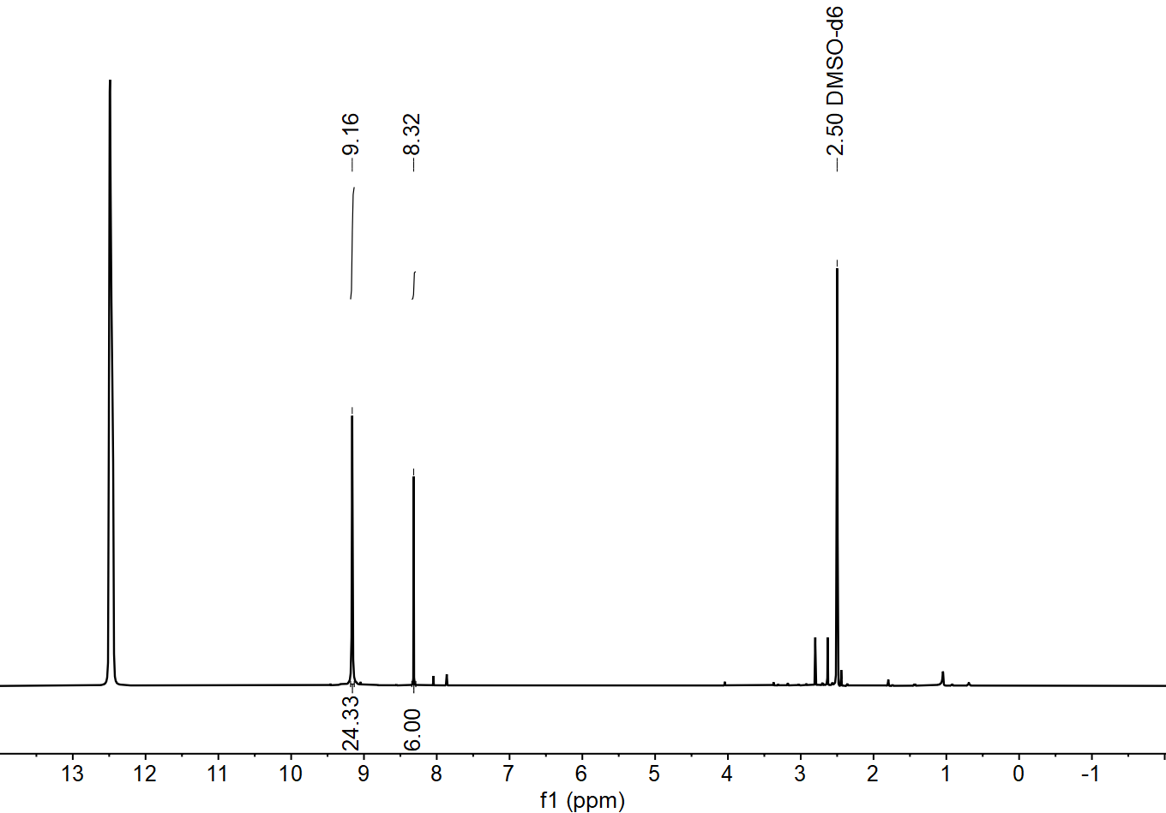
Supplementary Fig. 11. ¹H NMR spectrum of acid digested NU-6000, giving rise to 4:3 ratio of TPHTA:BBTA.
Synthesis of NU-6001: A mixture of TPTTA (20.00 mg, 53.00 × 10⁻³ mmol), BBTA (5.66 mg, 35.33 × 10⁻³ mmol), ZnCl₂ (100.00 mg, 0.73 mmol), and DMF (4 mL) was heated in an oven at 140 °C for 3 days. Off-white powder of NU-6000 was obtained as a cube with a size of 1 μm, which was not suitable for X-ray diffraction but for Micro-ED. The off-white powder was collected by centrifuging, washed with DMF (3 × 40 mL) and methanol (3 × 40 mL), then dried in air.
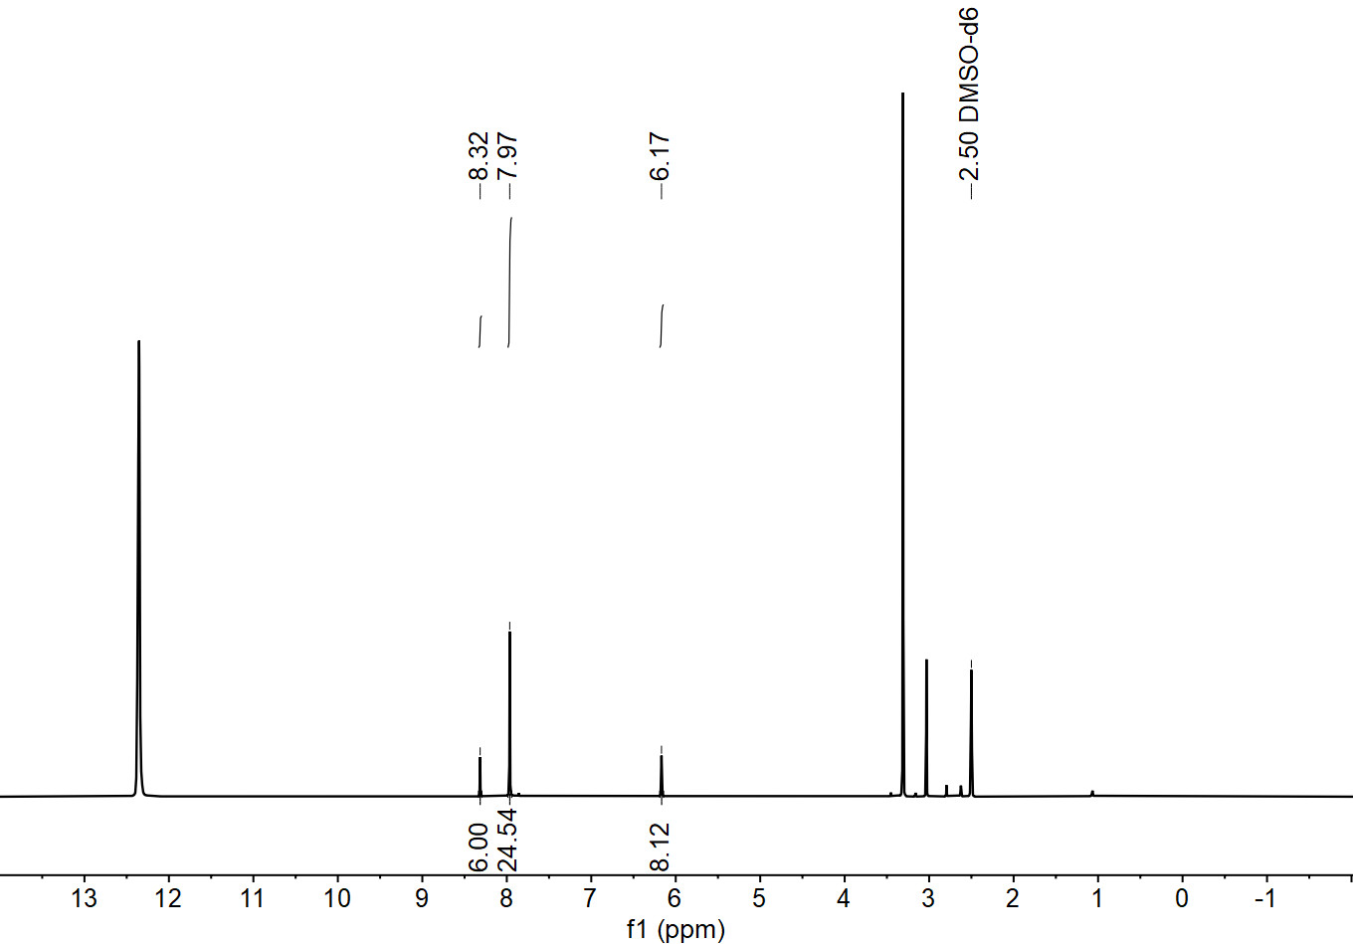
Supplementary Fig. 12. ¹H NMR spectrum of acid digested NU-6001, giving rise to 4:3 ratio of TPTTA:BBTA.
Synthesis of NU-6000-OH: A sample of 1 (40 mg) was soaked in a 0.1 M aqueous solution of NaHCO₃ (3 × 40 mL, 10 min. per soak). The brown solid was then collected by filtration and washed with water (3 × 20 mL) and anhydrous MeOH (3 × 20 mL). The sample used for further analysis was dried under vacuum at 200 °C for 1 h to generate NU-6000-OH.
Synthesis of NU-6001-OH: A sample of NU-6001 (40 mg) was soaked in a 0.001 M aqueous solution of NaHCO₃ (3 × 40 mL, 5 min. per soak). The off-white solid was then collected by filtration and washed with water (3 × 20 mL) and anhydrous Acetone (3 × 20 mL). The sample used for further analysis was dried under vacuum at 200 °C for 1 h to generate NU-6001-OH.

3. Supplementary Tab. 1. Crystal data and structure refinement for NU-6000, NU-6001, NU-6000-OH, and NU-6000-HOCO₂.
Identification code | NU-6000 | NU-6001 | NU-6000-OH | NU-6001-HOCO₂
Empirical formula | C₉₀H₃₀Cl₁₂N₅₄Zn₁₅ | C₉₈H₃₈Cl₁₂N₅₄Zn₁₅ | C₉₀H₃₀N₅₄O₁₂Zn₁₅ | C_{93.36}H₃₀N₅₄O_{18.71}Zn₁₅
Formula weight | 3273.89 | 3378.046 | 3040.45 | 3188.18
Temperature (K) | 293 K  100.0 K  100.0 K  100.0 K
Crystal system | Cubic | Cubic | Cubic | Cubic
space group | Pm-3n | Pm-3n | Pm-3n | Pm-3n
Unit cell dimensions | a = 22.494(2) Å,  b = 22.494(2) Å  c = 22.494(2) Å | a = 22.461(5) Å,  b = 22.461(5) Å  c = 22.461(5) Å | a = 22.6230(16) Å  b = 22.6230(16) Å  c = 22.6230(16) Å | a = 22.134(3) Å  b = 22.134(3) Å  c = 22.134(3) Å
Volume (Å³), Z | 11382(2), 2 | 11331(8), 2 | 11578(2), 2 | 10843(4), 2
Density (calculated) (mg/m³) | 0.955 | 1.103 | 0.872 | 0.976
Absorption coefficient (mm⁻¹) | 0.000 | 0.000 | 0.000 | 0.000
F(000) | 1020.0 | 1228.0 | 951.0 | 995.0
θ range for data collection (º) | 0.09 to 1.798 | 0.09 to 1.198 | 0.09 to 1.796 | 0.092 to 1.498
Limiting indices | -27 ≤ h ≤ 27  -28 ≤ k ≤ 28  -24 ≤ l ≤ 25 | -18 ≤ h ≤ 18  -18 ≤ k ≤ 18  -18 ≤ l ≤ 18 | -28 ≤ h ≤ 28  -25 ≤ k ≤ 26  -26 ≤ l ≤ 25 | -23 ≤ h ≤ 23  -22 ≤ k ≤ 22  -23 ≤ l ≤ 23
Reflections collected | 34679 | 15621 | 47666 | 31787
Independent reflections | 2106 [R(int) = 0.4506] | 652 [R(int) = 0.8802] | 2138 [R(int) = 0.3891] | 1187[R(int) = 0.5191]
Completeness | 100% | 99.8% | 100% | 100%
Refinement method | Full-matrix least-squares on F²  Full-matrix least-squares on F²  Full-matrix least-squares on F²  Full-matrix least-squares on F²  Full-matrix least-squares on F2
Data / restraints / parameters | 2106/93/76 | 652/87/79 | 2138/0/77 | 1187/121/98
Goodness-of-fit on F² | 1.580 | 1.049 | 1.686 | 1.610
Final R indices [I>2sigma(I)] | R₁=0.2371, wR₂=0.5039 | R₁=0.1230, wR₂=0.3283 | R₁=0.2522, wR₂=0.4793 | R₁=0.1757, wR₂=0.4290
R indices (all data) | R₁=0.2791, wR₂=0.5283 | R₁=0.2019, wR₂=4373 | R₁=0.2717, wR₂=0.4939 | R₁=0.2298, wR₂=0.4659
Largest diff. peak and hole | 0.20 and -0.39 e.A⁻³ | 0.14 and -0.13 e.A⁻³ | 0.45 and -0.18 e.A⁻³ | 0.20 and -0.33 e.A⁻³

4. Additional X-ray crystallographic structures
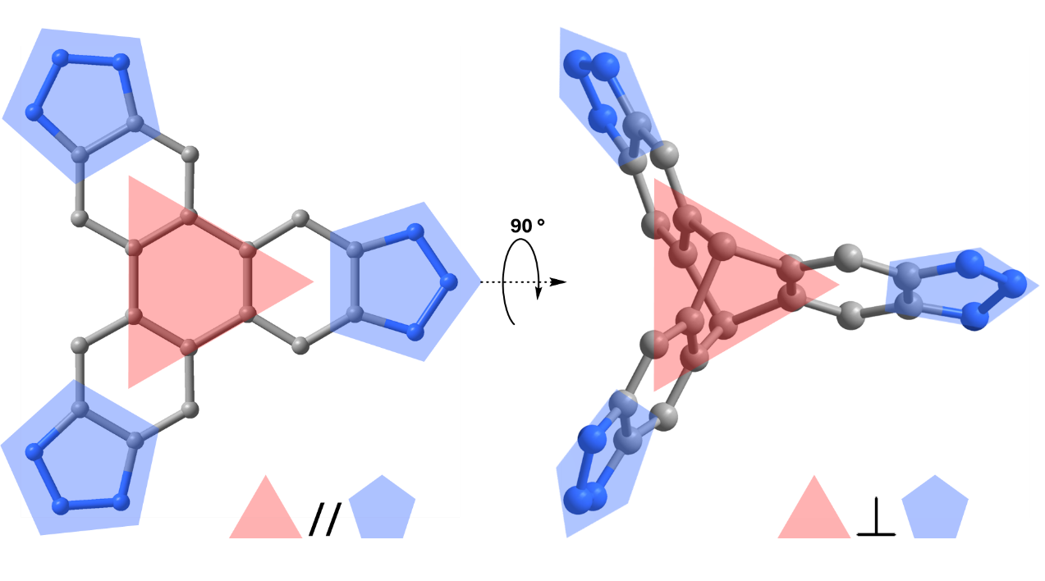
Supplementary Fig. 13. The coordinated triazole arms are parallel to the C₃ symmetric core on the ligand TPHTA in NU-6000 (left), and the coordinated triazole arms are vertical to the C₃ symmetric core on the ligand TPTTA in NU-6001 (right).
(a) (b)
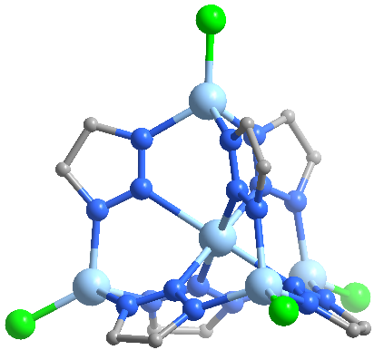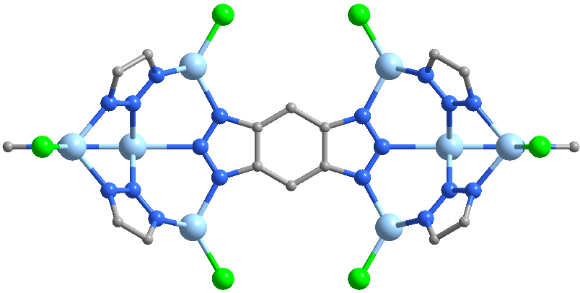
(c)
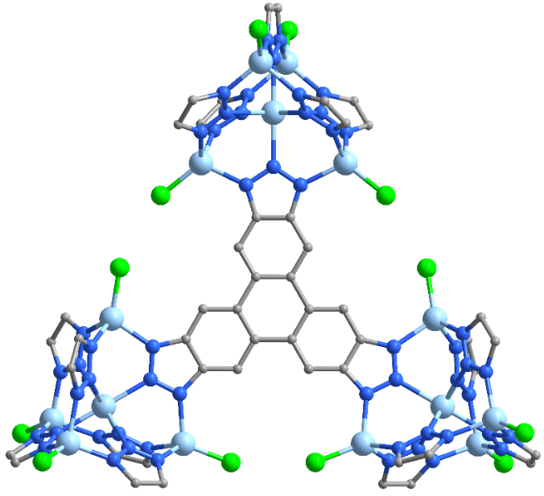
Supplementary Fig. 14. The coordination environments of (a) the node [Zn₅Cl₄]⁶⁺, (b) the ligand BBTA, and (c) ligand TPHTA in NU-6000.
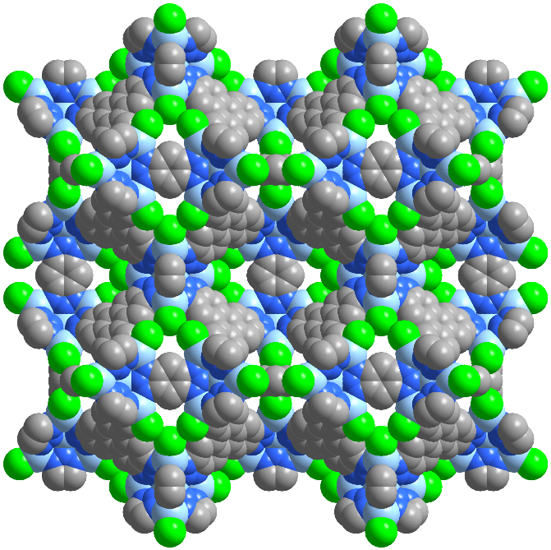
Supplementary Fig. 15. Space-filling model of NU-6000 viewed along the c-axis.
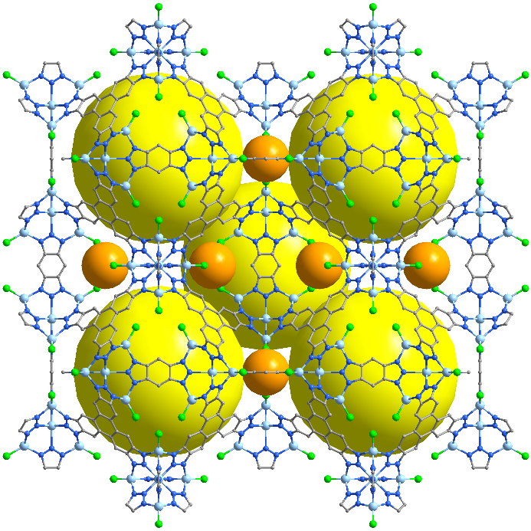
Supplementary Fig. 16. 3D structure formed by the adjacent octahedral cages in NU-6000 viewed along the c-axis.
(a) (b)
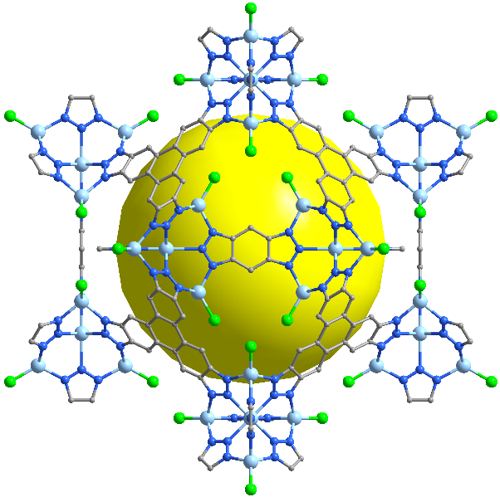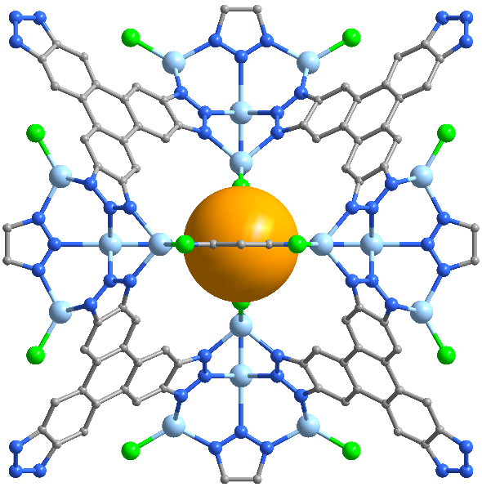
Supplementary Fig. 17. (a) Octahedral internal cavity and (b) Tetrahydral internal cavity in NU-6000.

(a) (b)
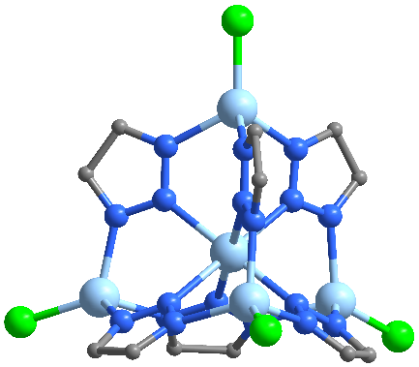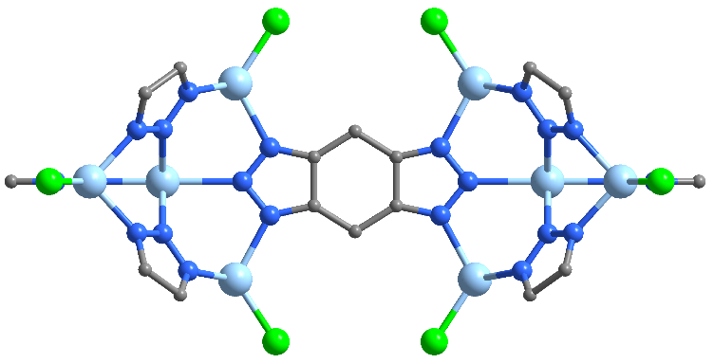
(c)
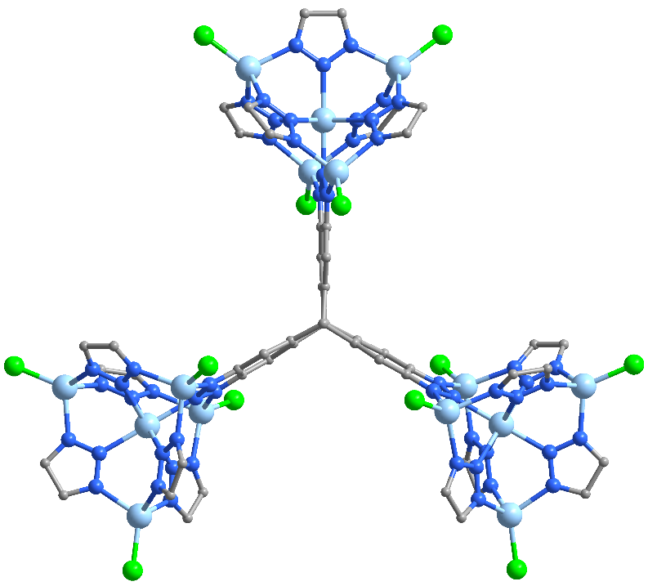
Supplementary Fig.18. The coordination environments of (a) the node [Zn₅Cl₄]⁶⁺, (b) the ligand BBTA, and (c) ligand TPTTA in NU-6001.
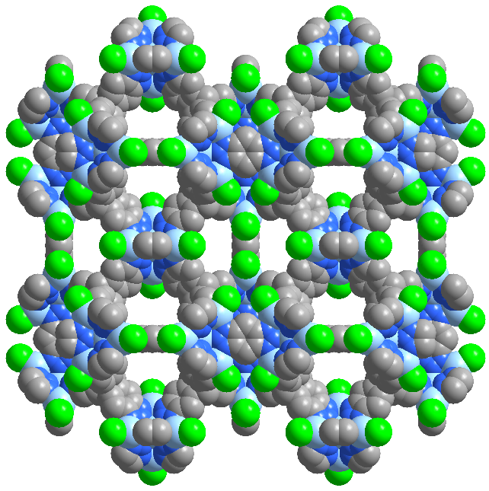
Supplementary Fig. 19. Space-filling model of NU-6001viewed along the c-axis.
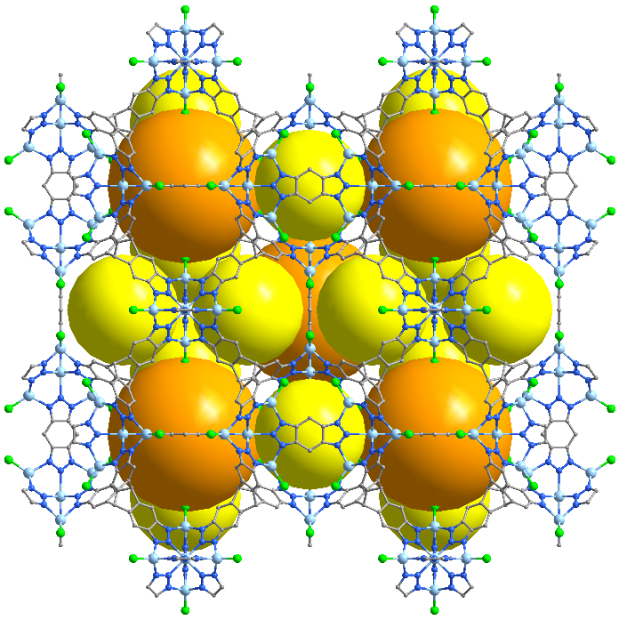
Supplementary Fig. 20. 3D structure formed by the adjacent octahedral cages in NU-6001 viewed along the c-axis.
(a) (b)
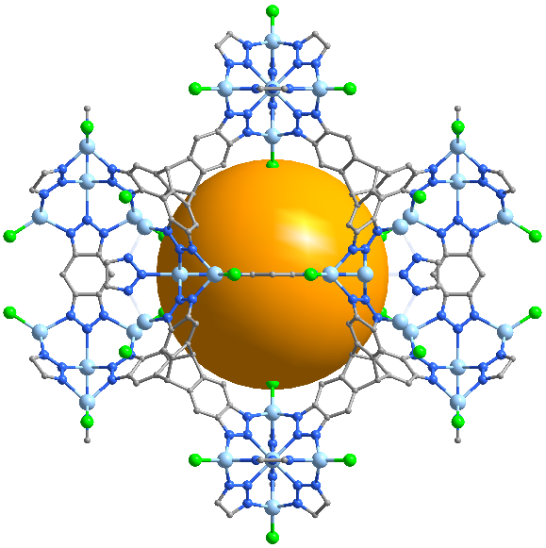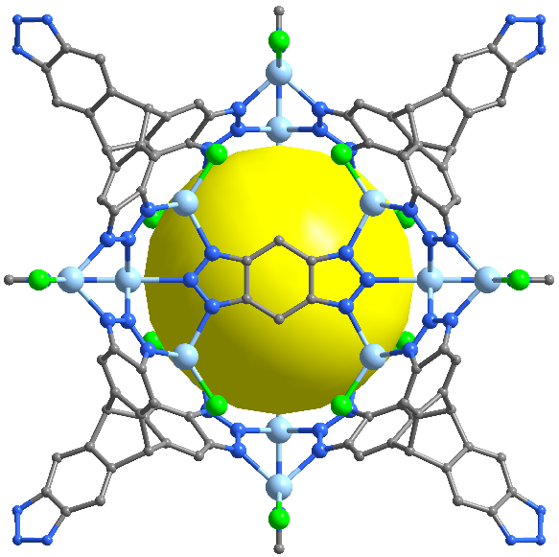
Supplementary Fig.21. (a) Octahedral internal cavity and (b) Tetrahydral internal cavity in NU-6001.

(a) (b)
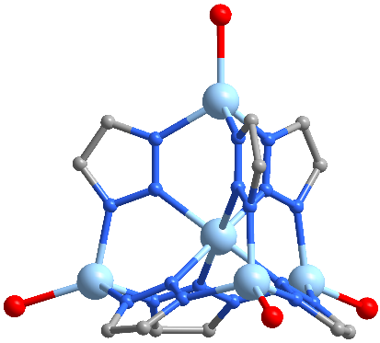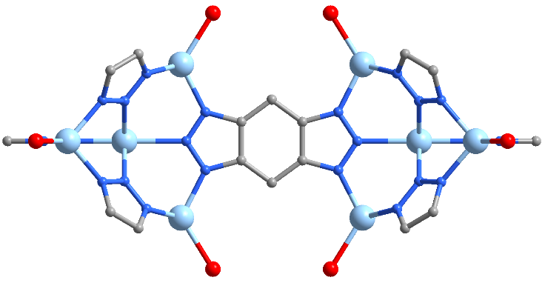
(c)
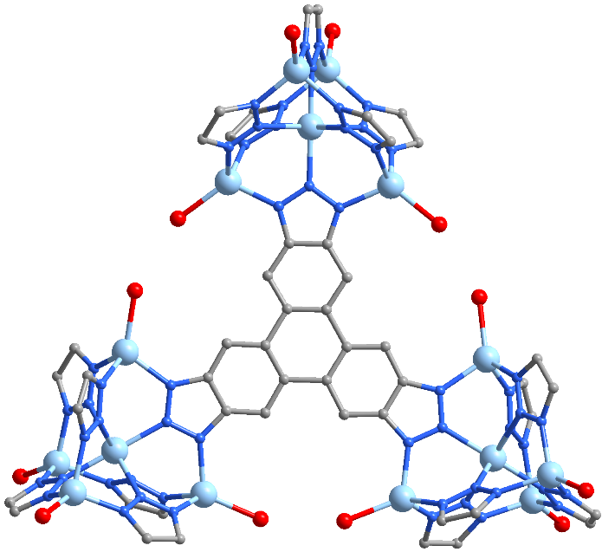
Supplementary Fig. 22. The coordination environments of (a) the node [Zn₅Cl₄]⁶⁺, (b) the ligand BBTA, and (c) ligand TPHTA in NU-6000-OH.
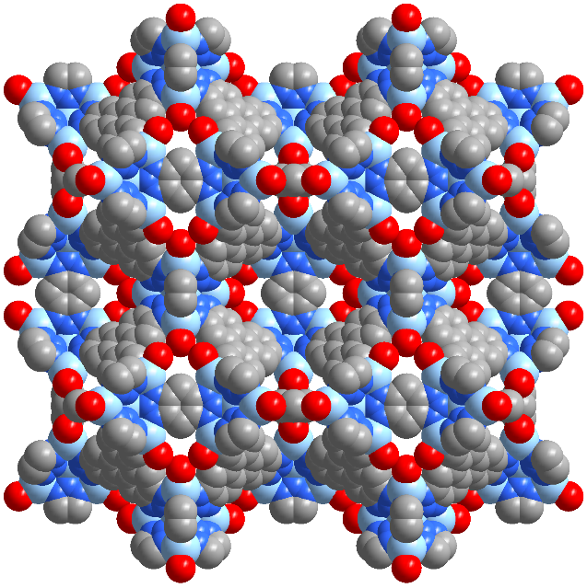
Supplementary Fig. 23. Space-filling model of NU-6000-OH viewed along the c-axis.
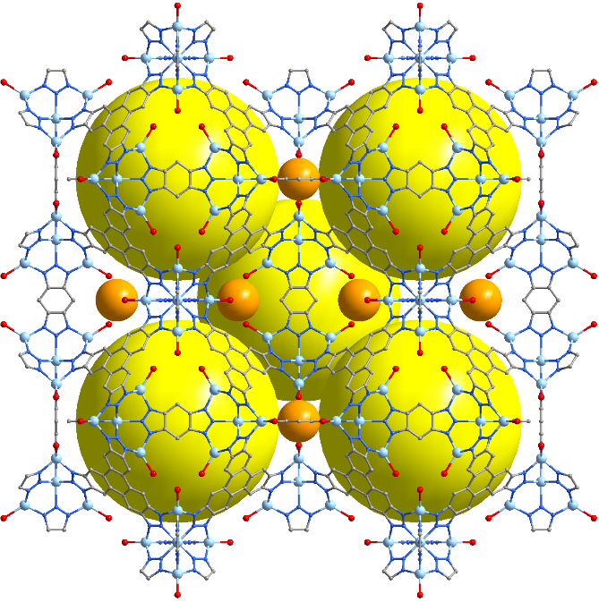
Supplementary Fig. 24. 3D structure formed by the adjacent octahedral cages in NU-6000-OH viewed along the c-axis.
(a) (b)
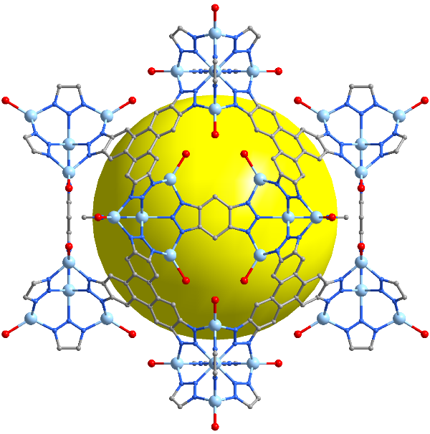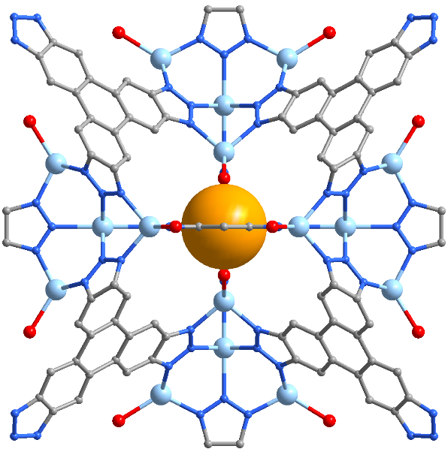
Supplementary Fig. 25. (a) Octahedral internal cavity and (b) Tetrahydral internal cavity in NU-6000-OH.

(a) (b)
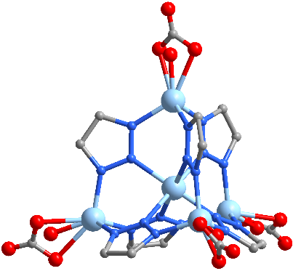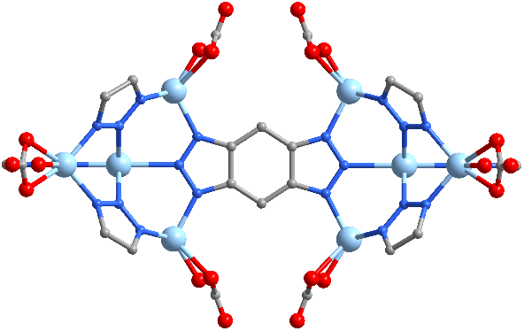
(c)
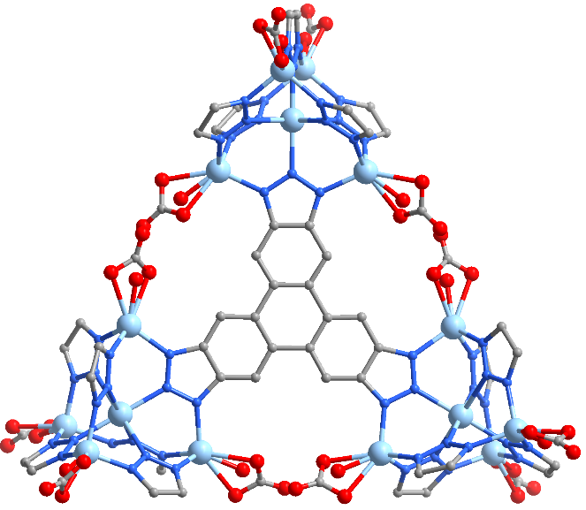
Supplementary Fig. 26. The coordination environments of (a) the node [Zn₅Cl₄]⁶⁺, (b) the ligand BBTA, and (c) ligand TPHTA in NU-6000-HCO₃.
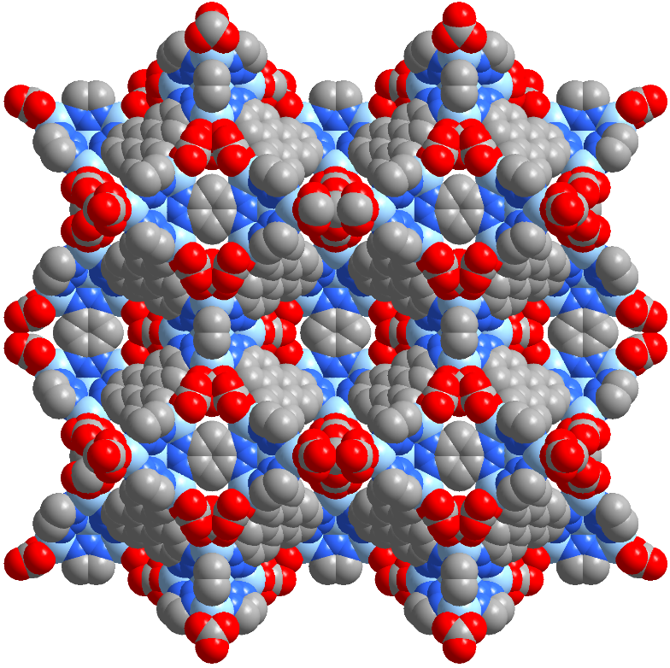
Supplementary Fig. 27. Space-filling model of NU-6000-HCO₃ viewed along the c-axis.
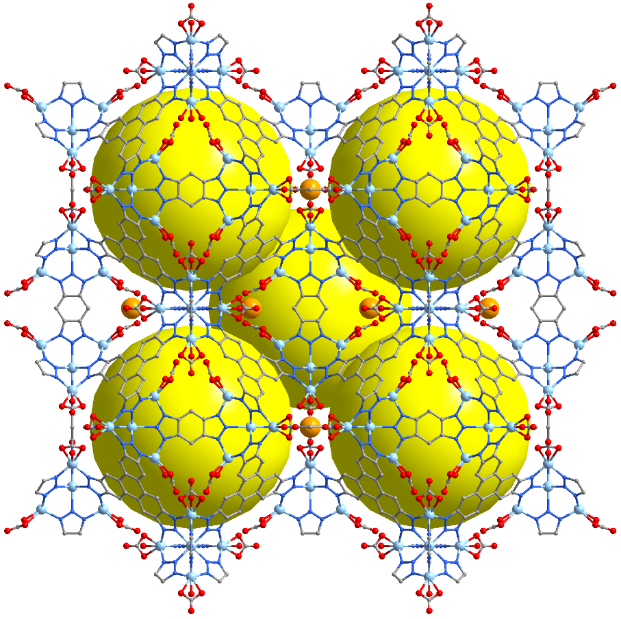
Supplementary Fig. 28. 3D structure formed by the adjacent octahedral cages in NU-6000-HCO₃ viewed along the c-axis.
(a) (b)
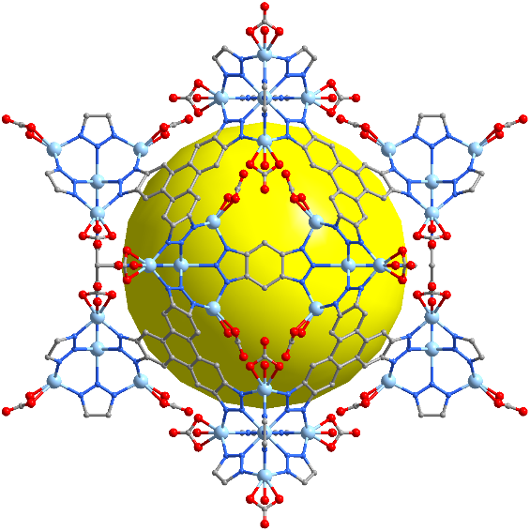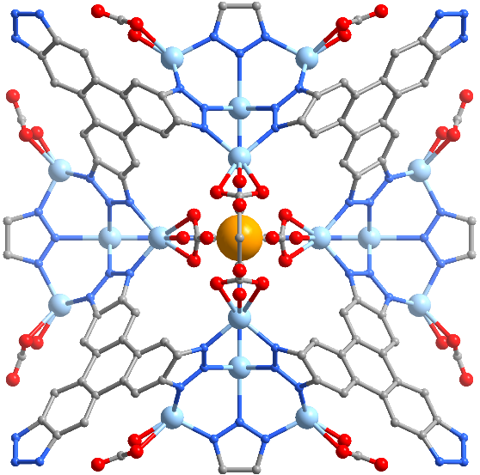
Supplementary Fig. 29. (a) Octahedral internal cavity and (b) Tetrahydral internal cavity in NU-6000-HCO₃.

5. SEM images
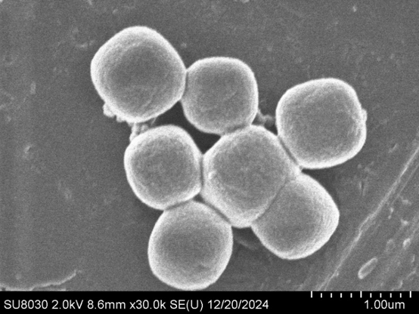
Supplementary Fig. 30. SEM image of NU-6000.
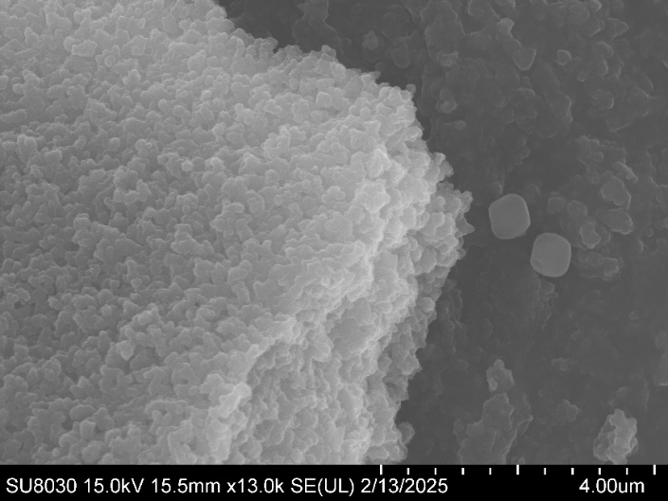
Supplementary Fig. 31. SEM image of NU-6001.
6. TGA curves
Supplementary Fig. 32. TGA curves of NU-6000 and NU-6000-OH.
Supplementary Fig. 33. TGA curves NU-6001 and NU-6001-OH.

7. VT-PXRD patterns.
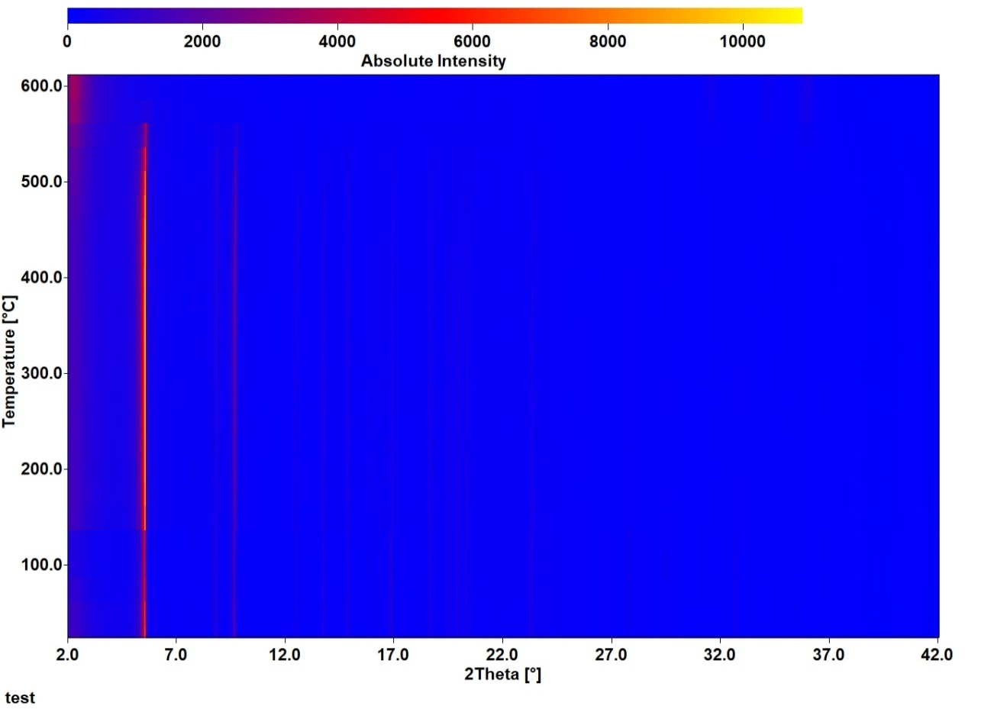
Supplementary Fig. 34. VT-PXRD patterns of NU-6000-OH.
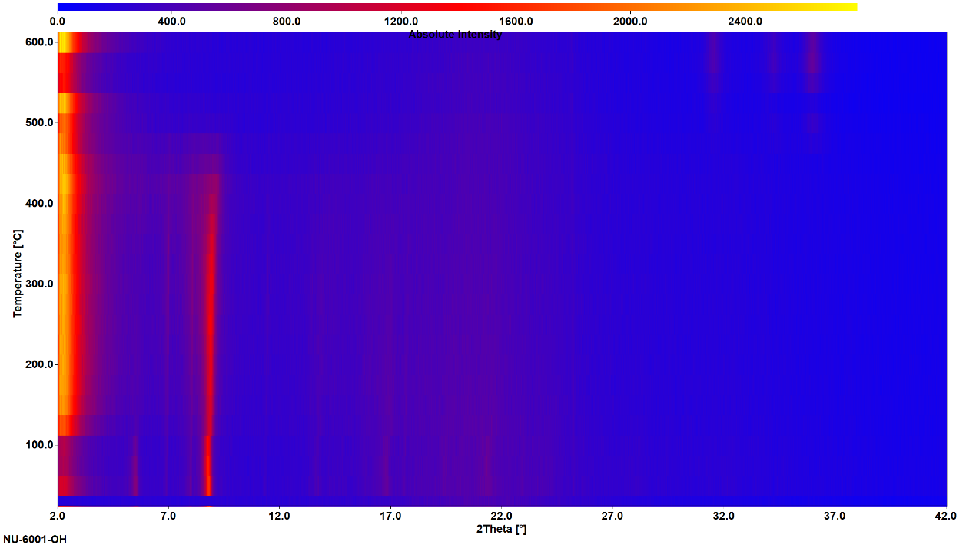
Supplementary Fig. 35. VT-PXRD patterns of NU-6001-OH.

8. Gas adsorption-desorption isotherms
Supplementary Fig.36. CO₂ adsorption-desorption isotherms of NU-6000 at 195 K.
Supplementary Fig. 37. H₂O adsorption-desorption isotherms of NU-6000 at 298 K.
Supplementary Fig. 38. N₂ adsorption-desorption isotherms of NU-6001 at 77 K.

9. XPS spectra.
Supplementary Fig. 39. The Cl 2p region of the XPS spectrum of NU-6000-OH
Supplementary Fig. 40. The Cl 2p region of the XPS spectrum of NU-6001-OH

10. Isosteric heat of adsorption
Supplementary Fig. 41. Isosteric heat of adsorption (Qst) for NU-6000 as a function of the amount of CO₂ adsorbed (n).
Supplementary Fig. 42. Isosteric heat of adsorption (Qst) for NU-6001 as a function of the amount of CO₂ adsorbed (n).

11. Diffuse-reflectance IR spectroscopy (DRIFTS)
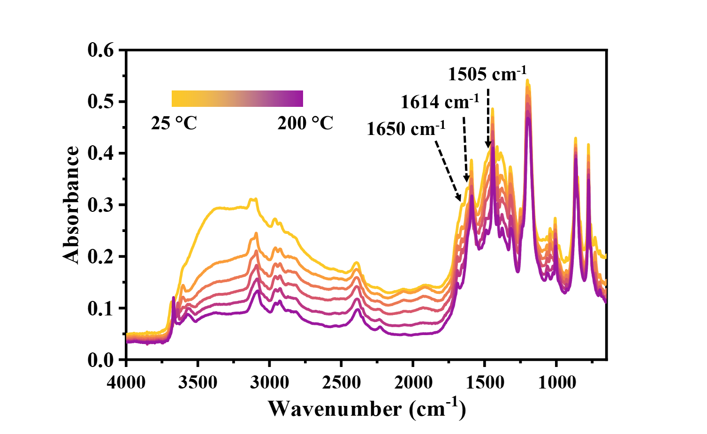
Supplementary Fig. 43. Evolution of the IR spectrum of NU-6000-OH-CO₂ upon heating under a N₂ atmosphere.
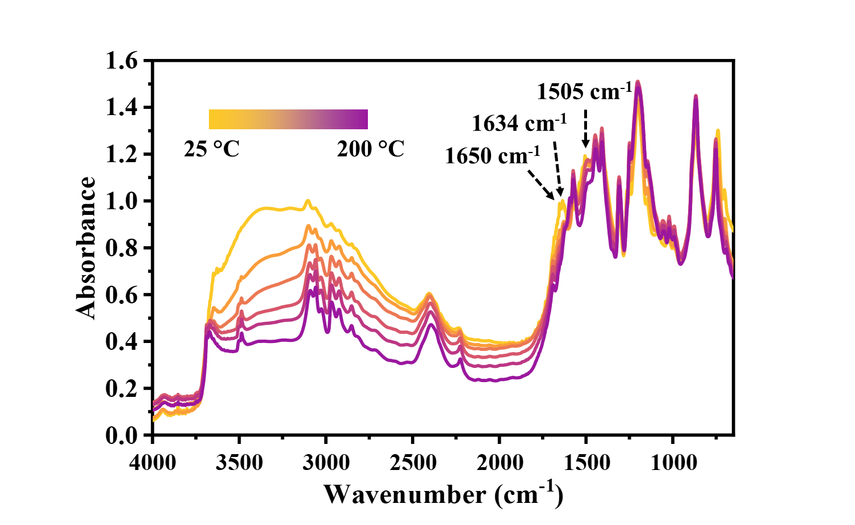
Supplementary Fig. 44. Evolution of the IR spectrum of NU-6001-OH-CO₂ upon heating under a N₂ atmosphere.

12. Thermal swing adsorption
Supplementary Fig. 45. Adsorption-desorption cycling of NU-6000-OH under simulated flue gas conditions (15% CO₂ in N₂), showing changes in CO₂ uptake (cyan) and temperature swing (orange).
Supplementary Fig. 46. Adsorption-desorption cycling of NU-6001-OH under simulated flue gas conditions (15% CO₂ in N₂), showing changes in CO₂ uptake (cyan) and temperature swing (orange).

13. DFT simulation
All density functional theory (DFT) calculations were performed using the ORCA 6.1.0 package⁷. Cluster models of the tetrahedral pores in NU-6000 were derived from the CO₂-adsorbed SCXRD structure, centered on the metal–hydroxide nodes relevant to CO₂ binding. Geometry optimizations and vibrational frequency calculations were carried out at the PBE-D3(BJ)/def2-SVP level. The Perdew–Burke–Ernzerhof (PBE) generalized-gradient-approximation functional was used in conjunction with Grimme’s D3(BJ) empirical dispersion correction to accurately describe long-range dispersion interactions. The def2-SVP basis set was employed for all atoms, combined with the def2-ECP effective core potential for metal centers when appropriate. The Resolution of Identity (RI) approximation was applied along with the def2/J auxiliary basis set to accelerate Coulomb and exchange integral evaluations. All self-consistent field (SCF) iterations were converged under TightSCF criteria (10⁻⁸ Eh in energy, 10⁻⁵ Eh/Bohr in gradients). Vibrational frequencies were evaluated numerically (NumFreq) within a partial-Hessian scheme including only atoms directly participating in CO₂ binding and proton transfer: Zn centers, their coordinated N atoms, bridging –OH groups, –HCO³⁻ moieties, and hydrogen atoms involved in hydrogen-bonding within the pore. All remaining framework atoms were kept frozen during the frequency calculation. Thermochemical corrections were obtained at 298.15 K and 1 atm, employing the standard rigid-rotor and harmonic-oscillator approximations implemented in ORCA. All computed vibrational frequencies were real, confirming that the optimized structures correspond to true minima on the potential-energy surface. Single-point energy refinements were subsequently performed at the PBE-D3(BJ)/def2-TZVP level of theory on the optimized geometries, using the same dispersion and RI settings.
The final Gibbs free energy for each species was calculated as:
G = E_{TZVP} – [E_{ZPE} + ∆H(T) - TS(T)]_{SVP}, _{numFreq}
Where E_{TZVP} is the total electronic energy from the single-point calculation at PBE-D3(BJ)/def2-TZVP level. E_{ZPE} is the zero-point vibrational energy, ∆H(T) and TS(T) are the thermal enthalpy and entropy contributions at temperature T obtained from the partial-frequency calculation at the PBE-D3(BJ)/def2-SVP level.
The Gibbs free-energy change for the adsorption of nCO₂ molecules was determined as:
∆G = G_{MOF} + nG_{CO2} - G_{MOF+CO2}
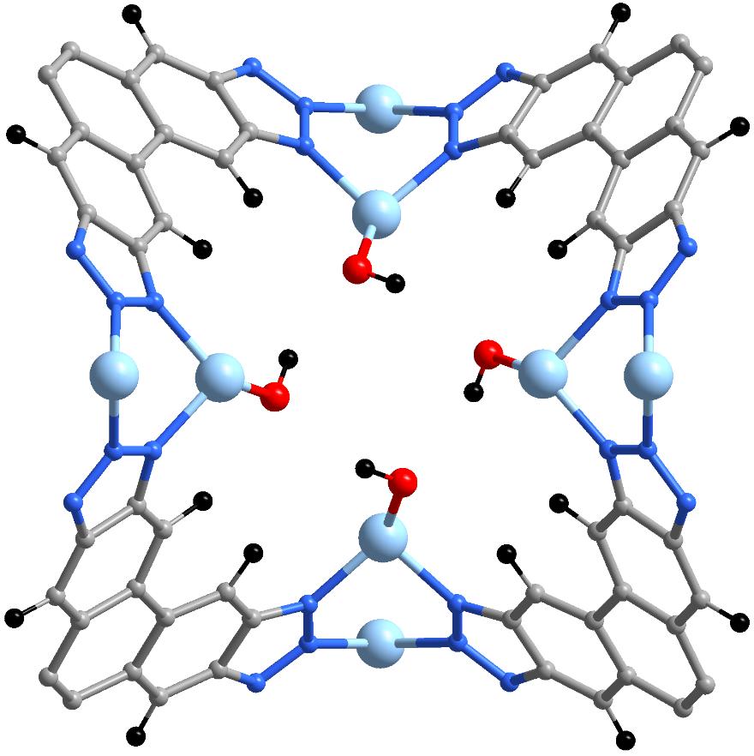
2.95 Å
2.93 Å
2.92 Å
2.89 Å
Supplementary Fig. 47. DFT optimized structures of NU-6001-OH; Blue: N; Red: O; Gray: C; Black: H; Pale blue: Zn.
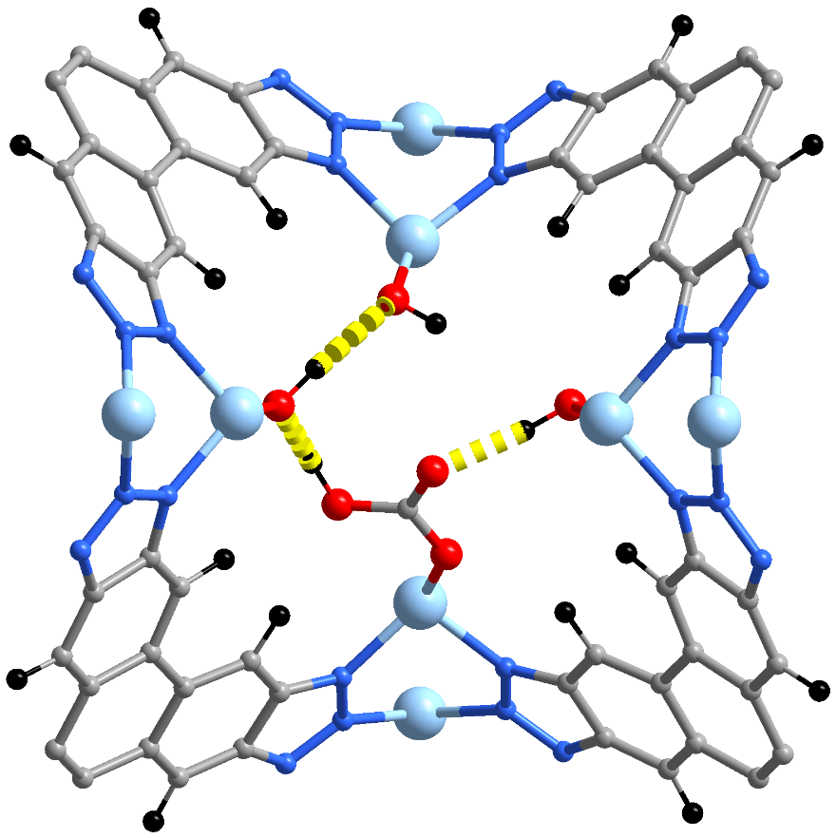
2.52 Å
1.86 Å
3.24 Å
1.45 Å
Supplementary Fig. 48. DFT optimized structures of NU-6001-OH with one CO₂ molecule; Blue: N; Red: O; Gray: C; Black: H; Pale blue: Zn; Yellow dashed line: hydrogen bond.
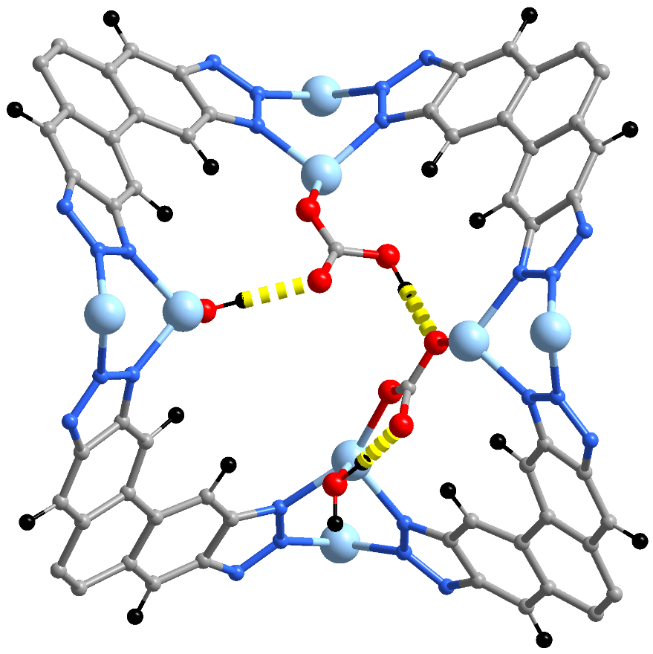
1.67 Å
1.41 Å
1.91 Å
Supplementary Fig. 49. DFT optimized structures of NU-6001-OH with two adjacent CO₂ molecules; Blue: N; Red: O; Gray: C; Black: H; Pale blue: Zn; Yellow dashed line: hydrogen bond.
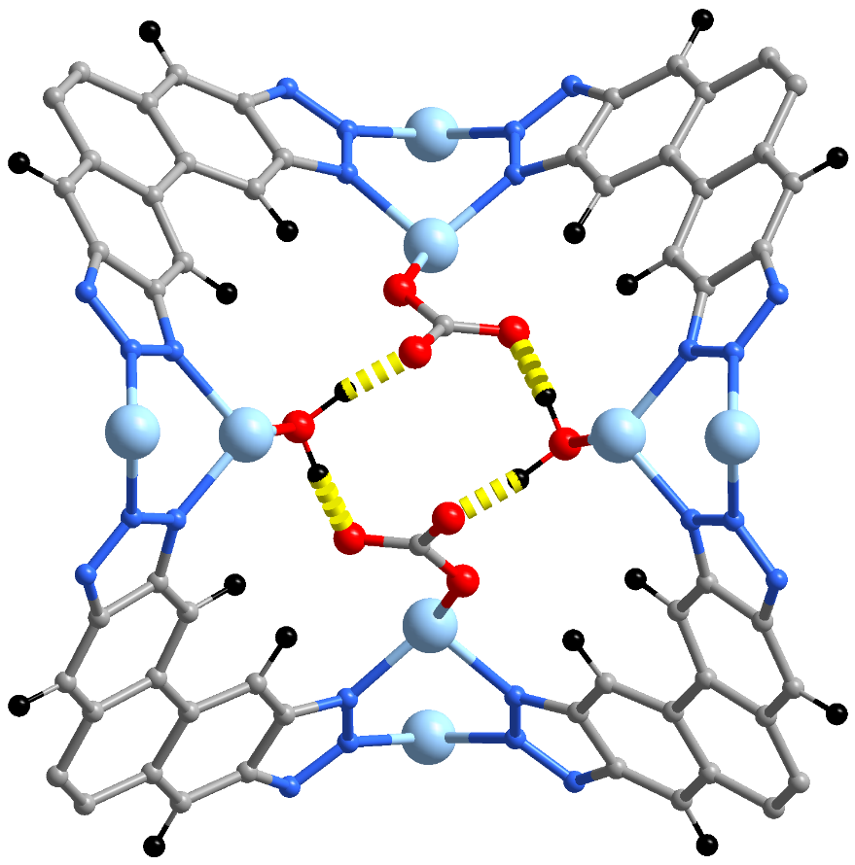
1.45 Å
1.47 Å
1.45 Å
1.48 Å
Supplementary Fig. 50. DFT optimized structures of NU-6001-OH with two opposite CO₂ molecules; Blue: N; Red: O; Gray: C; Black: H; Pale blue: Zn; Yellow dashed line: hydrogen bond.
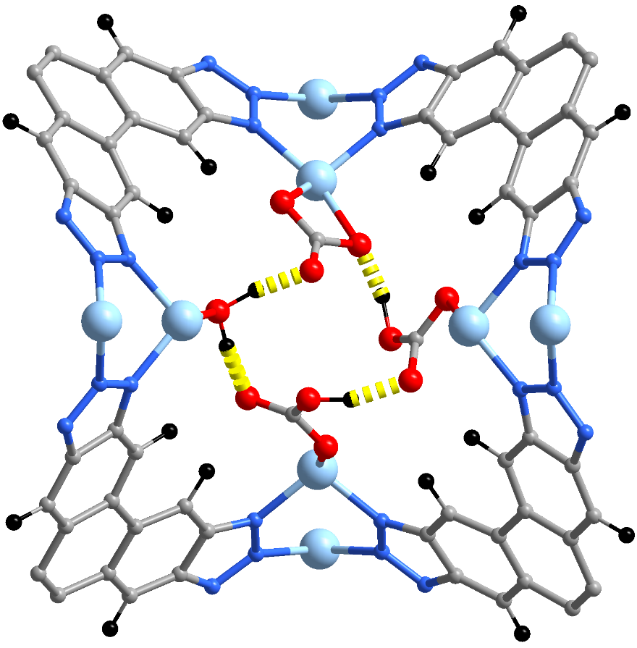
1.36 Å
1.53 Å
1.45 Å
1.56 Å
Supplementary Fig. 51. DFT optimized structures of NU-6001-OH with three CO₂ molecules; Blue: N; Red: O; Gray: C; Black: H; Pale blue: Zn; Yellow dashed line: hydrogen bond.
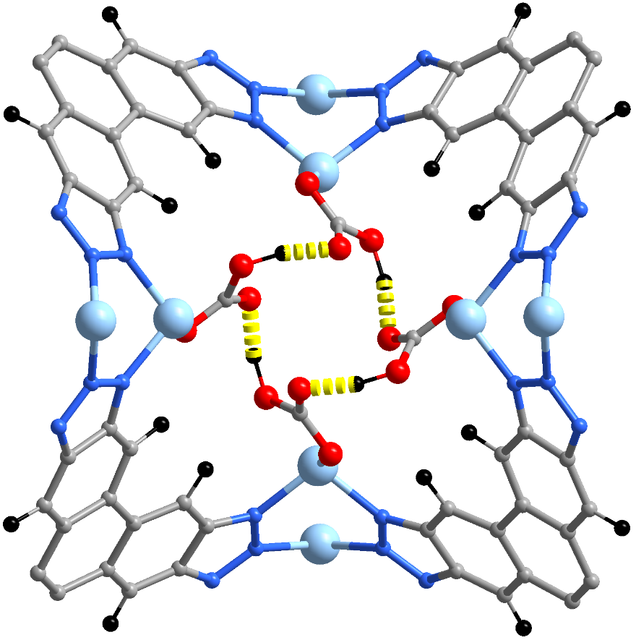
1.43 Å
1.43 Å
1.43 Å
1.43 Å
Supplementary Fig. 52. DFT optimized structures of NU-6001-OH with four CO₂ molecules; Blue: N; Red: O; Gray: C; Black: H; Pale blue: Zn; Yellow dashed line: hydrogen bond.

14. References
[1] (a) Sheldrick, G. M. A short history of SHELX. Acta Cryst. A. 2008, 64, 112-122; (b) Sheldrick, G. M. Crystal Structure Refinement with SHELXL. Acta Cryst. C. 2015, 71, 3-8.
[2] Dolomanov, O. V.; Bourhis, L. J.; Gildea, R. J.; Howard, J. A. K.; Puschmann, H. OLEX2: A Complete Structure Solution, Refinement and Analysis Program. J. Appl. Crystallogr. 2009, 42, 339-341.
[3] Spek, A. L. Single-Crystal Structure Validation with the Program PLATON. J. Appl. Crystallogr. 2003, 36, 7-13.
[4] (a) Hart, H.; Ok, D. J. Org. Chem. 1986, 51, 979; (b)Coburn M.D.; Berlin, J.K. Synthesis 1974, 869; (c)Boyer J.H.; Buriks, R.S. Organic Syntheses Wiley, New York, 1973, Collect. Vol. V, p 1067.
[5] Chen, L.; Kim, J.; Ishizuka, T.; Honsho, Y.; Saeki, A.; Seki, S.; Ihee, H.; Jiang, D. J. Am. Chem. Soc. 2009, 131, 7287-7292.
[6] White, N. G.; MacLachlan, M. J. Soluble tetraaminotriptycene precursors. J. Org. Chem. 2015, 80, 8390-8397.
[7] Neese, F. Software update: the ORCA program system, version 6.0 WIRES Comput. Molec. Sci. 2025 15, e70019.

