Supplementary Information
All at once: a sstR2-targeted radiohybrid theranostic agent for PET imaging and β⁻ therapy with excellent preclinical performance
Sandra Deiser^{1,2,§}, Sebastian Fenzl^{1,3,§}, Victor König¹, Shigeyoshi Inoue^{3,*} and Angela Casini^{1,2,*}
¹ Chair of Pharmaceutical Radiochemistry, Department of Chemistry, School of Natural Sciences, Technical University of Munich, Walther-Meißner-Str. 3, 85748 Garching b. München, Germany
² Chair of Medicinal and Bioinorganic Chemistry, Department of Chemistry, TUM School of Natural Sciences, Technical University of Munich, Lichtenbergstr. 4, 85748 Garching b. München, Germany
³ Chair of Silicon Chemistry, School of Natural Sciences, Technical University of Munich, Lichtenbergstr. 4, 85748 Garching b. München, Germany

§ Equal contribution
*Corresponding authors: angela.casini@tum.de; s.inoue@tum.de

List of Abbreviations
To simplify the nomenclature of the SST-ligands, the three-letter code was used to describe the amino acids.
2-CTC | 2-Chlorotrityl chloride
DCM | Dichloromethane
DIPEA | N,N-diisopropylethylamine
DMEM | Dulbecco’s modified Eagle’s medium
DMF | Dimethylformamide
DMSO | Dimethyl sulfoxide
DOTA(^{t}Bu)₃ | 1,4,7,10-Tetraazacyclododecane-1,4,7,10-tetraacetic acid 1,4,7-tri-tert-butyl
DOTA(^{t}Bu)₂ | trans-(di-tert-butyl)-1,4,7,10-tetraazacyclododecane-1,4,7,10-tetraacetic acid
DOTA-GA | 2-[1,4,7,10-Tetraazacyclododecane]-pentanedioic acid
ESI-MS | Electrospray ionization mass spectrometry
FBS | Fetal bovine serum
Fmoc | Fluorenylmethoxycarbonyl
HATU | Hexafluorophosphate azabenzotriazole tetramethyl uronium
HBSA | Hank’s balanced salt solution + 1% bovine serum albumine
HBSS | Hank’s balanced salt solution
HOAt | 1-Hydroxy-7-azabenzotriazole
HSA | Human serum albumin
IC₅₀ | Half maximal inhibitory concentration
logD_{7.4} | Octanol-PBS_{7.4} partition coefficient
MeCN | Acetonitrile
MeOH | MeOH
NMP | 1-Methylpyrrolidin-2-one
O₂Oc | 8-Amino-3,6-dioxaoctanoic acid
PBS | Phosphate-buffered saline
RCC | Radiochemical conversion
RCP | Radiochemical purity
RCY | Radiochemical yield
RP-HPLC | Reverse phase high performance liquid chromatography
SPPS | Solid-phase peptide synthesis
sst | Somatostatin
t_{R} | Retention time
TBTU | 2-(1-H-Benzotriazole-1-yl)-1,1,3,3-tetramethylaminium tetrafluoroborate
TFA | Trifluoroacetic acid
TIPS | Triisopropylsilane

Experimental Section
General
The solvents were obtained technical or in HPLC-grade from Sigma-Aldrich (Munich, Germany), Alfa Aesar (Karlsruhe, Germany), Carl Roth GmbH & Co. KG (Karlsruhe, Germany) or VWR International GmbH (Darmstadt, Germany). The water for the HPLC solvents was supplied by the in-house Millipore Barnsted MicroPure-System from Thermo Fischer Scientific Inc. (Morrisville PA, USA). The Ultrapur® water and DMSO (anhydrous) were purchased from Sigma Aldrich (Munich, Germany). Synthesis of (SiFA)SeFe was performed according to established procedures.^{[1]} Chemicals for liquid phase synthesis and deuterated solvents were obtained from VWR International GmbH (Darmstadt, Germany), Carl Roth GmbH & Co. KG (Karlsruhe, Germany, Tokyo Chemical Industry (Tokio, Japan), Gelest Inc. (Morrisville PA, USA), and Sigma-Aldrich (Munich, Germany) and used without further purification. Amino acids were sourced from Carbolution Chemicals GmbH (St. Ingbert, Germany), IRIS Biotech GmbH (Marktredewitz, Germany), Millipore-Sigma HGaA (Darmstadt, Germany) or Sigma Aldrich (Munich, Germany). The Chelator DOTA(tBu)₃ was obtained from CheMatech (Dijon, France). Coupling reagents as well as other chemicals required for peptide synthesis were acquired from Macrocyclics Inc. (Dallas, USA), Molekula GmbH (Garching, Germany) or Sigma Aldrich (Munich, Germany). The 2-CTC-resin was purchased from IRIS Biotech GmbH (Marktredewitz, Germany). Thallium(III) trifluoroacetate, glycerol, imidazole, and hydroxylammonium chloride were purchased from Sigma Aldrich (Munich, Germany). All reagents were used without further purification. Cell culture media DMEM/F-12 (1:1) + GlutaMAX™-I and RPMI medium 1640 were purchased from Thermo Fisher Scientific (Waltham, Massachusetts, USA). Media additives such as fetal bovine serum (FBS), l-Gln solution (200 mm), and MEM non-essential amino acid solution were acquired from Bio&SELL (Nürnberg, Germany) and Sigma Aldrich (Munich, Germany), respectively. Hanks’ balanced salt solution (HBSS), Phosphate-Buffered Saline pH = 7.4 (PBS) and Trypsin/EDTA (0.05%/0.02% in PBS without Ca²⁺/Mg²⁺) were purchased from Sigma Aldrich (Munich, Germany). Bovine serum albumin (BSA) and Trypan Blue (0.4%) were purchased from Biowest (Nuaillé, France).
Radionuclides and Materials for radioactive labelling and evaluation
Radioactive labelling with Iodine-125 for affinity studies was performed with a [¹²⁵I]NaI-solution in 40 mm NaOH (74 TBq/mM) from HARTMANN ANALYTIC GmbH (Braunschweig, Germany). Iodogen for the synthesis was purchased from Pierce™ Biotechnology (Rockford Il, United States). Radioactive labelling solution with fluorine-18 in target water ([¹⁸O]H₂O) was supplied by Klinikum rechts der Isar (Munich,Germany). For ¹⁷⁷Lu-labelling, a solution of [¹⁷⁷Lu]LuCl₃ (1 GBq) Radiochemical Grade EndolucinBeta® n.c.a. (40 GBq/mL) in 0.04 m HCl was acquired from ITM Isotope Technologies Munich SE (Munich, Germany). The Cartridges for ¹⁸F-labelling were supplied by Waters GmbH (Eschborn, Germany). Protein LoBind® tubes were purchased from Eppendorf SE (Hamburg, Germany). Silica gel 60 coated aluminum stripes and iTLC-SG stripes and for reaction controls were obtained from Agilent (Santa Clara, California, USA) and Merck KGaA (Darmstadt, Germany), respectively. The 24-well plates for IC₅₀ studies were supplied from Thermo Scientific Inc. (Waltham, Massachusetts, USA) and sterile cell culture flasks were acquired from Greiner Bio-One GmbH (Frickenhausen, Germany). Centrifugal filters for stability studies in human serum were purchased from VWR International GmbH (Darmstadt, Germany).
Instruments
Analytical and preparative RP-HPLC was carried out on Shimadzu Corp. Instruments (Kyoto, Japan) equipped with two LC-20AD gradient pumps, a CBM-20A communications module and a Smartline UV detector 2500 (λ = 220 nm, λ = 254 nm) from Dr. Ing. Herbert Knauer GmbH (Berlin, Germany). For analytical RP-HPLC a flow rate of 1.0 mL/min was used. Quality controls of peptic ligands were performed on a MultoKrom® 100-5 C18-column (125 × 4.6 mm, 5 μm particle size, CS Chromatographie GmbH). Different gradients of MeCN (J. T. Baker® ultra-gradient HPLC rate, mixed with 5% H₂O and 0.1% TFA) in H₂O (0.1% TFA) were used as eluents for all RP-HPLC operations. Preparative HPLC was performed with a Multospher® 100 C18-column (150 × 10 mm, 5 μm particle size, CS Chromatographie GmbH) at a flow rate of 5.0 mL/min. Different gradients of MeCN (J. T. Baker® ultra-gradient HPLC rate, mixed with 5% H₂O and 0.1% TFA) in H₂O (0.1% TFA) were used as eluents for all RP-HPLC operations. All RP-HPLC chromatograms were analyzed via the LabSolutions software.
Radiolabelled compounds were investigated by analytical Radio-RP-HPLC from Shimadzu Corp. (Kyoto, Japan), comprising of two LC-20AD gradient pumps, a DGU-20A degassing unit, a SIL-20A autosampler, a CTO-10AS column oven, a FRC-10A fraction collector, a SPD-20A UV/Vis detector (λ = 220 nm), a HERM LB500 (NaI-scintillation crystal) radio-detector (from the company Berthold Technologies GmbH, Bad Wilbad, Germany) and a CBM-20A communications module. For the characterization of radioactively labelled peptidic compounds, a Multospher® 100 C18-column (125 × 4.6 mm, 5 μm particle size, CS Chromatographie GmbH) was used.
Radioactive TLCs were analyzed using a Scan-RAM™ from LabLogic (Koblenz, Germany). The acquired data were processed using the Laura Software (Koblenz, Germany). For the quantification of the activities of radio-labelled compounds an automatic 2480 WIZARD2 γ counter from PerkinElmer Inc. (Waltham, USA) was used. For the quantification of some activities within ex vivo biodistribution studies with [¹⁷⁷Lu]Lu-rhTATE4 an APEX y-counter with an GX4018 detector from MIRION Technologies (Atlanta, Georgia, USA) and a CP-5SL Cryo-Pulse® 5 Cryostat from CANBERRA (Toledo, Spain) was used. All activities were analyzed via the Apex-Gamma software. The calibration curve was determined using Excel software (Microsoft Corporation, Redmond, WA, USA). ESI-MS spectra are recorded on an expression CMS mass spectrometer with a quadrupole analyzer and an electron spray ionizer (positive mode) (Advion Inc., Ithaca, New York, USA). All ESI-MS spectra were analyzed via the Advion Mass Express software. Freeze-drying was carried out on an Alpha 1.2 Lyophiliser from Martin Christ Gefriertrocknungsanlagen GmbH (Osterode im Harz, Germany) with a RZ-2 rotary vane pump from Vacuubrand GmbH & Co. KG (Wertheim, Germany). µSPECT/CT scans of mice were recorded on a VECTor4 small-animal SPECT/PET/OI/CT from MILabs (Utrecht, Netherlands). All Scans were analyzed via the PMOD software from PMOD Technologies LCC (Fällanden, Switzerland).
General synthesis methods (GS)
Solid-phase peptide synthesis using Fmoc strategy (Fmoc-SPPS)
The resin is loaded with a Fmoc-protected amino acid at the C-terminus. The Fmoc protecting group is then removed and coupled to the next amino acid using coupling reagents. After completion, the peptide is cleaved from the resin.
GS1: Loading of the 2-CTC resin
The 2-chloro-tritylchlorid (2-CTC) resin (loading capacity: 1.6 mmol/g) was swollen for 30 min in 5 mL NMP and then washed with DMF (6 × 5 mL). The resin was loaded with an Fmoc protected amino acid (AA) using Fmoc-AA-OH (1.5 eq.) and DIPEA (N,N-Diisopropylethylamine) (1.5 eq.) in DMF (N,N-Dimethylformamide) in a 20 mL peptide syringe. After 15 min of pre-activation at room temperature (RT), another 3.0 eq. of DIPEA was added and the mixture was shaken at RT for 2 h. MeOH (1 mL/g resin) was added to the resin and shaken for 15 minutes. Afterwards, the resin was washed five times each with DMF (5 mL), MeOH (5 mL) and DCM (5 mL) and dried in a desiccator.

GS2: Standard peptide coupling to the resin
The loaded resin is swollen in NMP for 30 min, washed six times with DMF (5 mL), and N-terminally Fmoc deprotected. Prior to coupling at the C-terminus of side-chain-protected Fmoc-AA-OH (1.5 eq.), preactivation is performed with TBTU (1.5 eq.), HOAt (1.5 eq.), and DIPEA (4.0 eq.) in 5 mL DMF. After 10 min, the activated solution is added to the resin-bound peptide containing the free amine (2-CTC-AA-NH2) and shaken for 1.5 h at RT. The resin is then washed six times with DMF (5 mL) and, after Fmoc deprotection, washed another six times with DMF (5 mL). Now the next amino acid can be reacted, or washed six times with DCM and dried in a desiccator.

GS3: Deviating peptide coupling to the resin
After swelling the resin in NMP for 30 min and washing with DMF (6 × 5 mL), the respective substrate is coupled to the resin-bound peptide (Table S1). The resin is then washed six times with DMF (5 mL).
GS4: Fmoc deprotection
N-terminal Fmoc-protected amino acids or peptides bound to the resin are deprotected by adding 20% piperidine in DMF (5 mL). The deprotection reagent is added twice (1×5 min, 1×15 min). The resin is then washed with DMF (6 × 5 mL each).

GS5: Acetyl deprotection
Acetyl deprotection is performed by dissolving 50 µmol of the peptide in MeOH and adding NaOMe until the pH is 11-12. After 15 min, the reaction is stopped by adding TFA (pH = 2).

GS6: Cleavage from the resin with retention of acid labile protective groups
The peptide bound to the resin is mixed with 5 mL of 2,2,2-Trifluorethanol (TFE)/DCM/AcOH (3/6/1) and agitated for 20 min at RT. The solution with the protected peptide is collected and then evaporated under a nitrogen stream.

GS7: Cleavage from the resin with removal of acid-labile protection groups
The peptide bound to the resin is mixed with 5 mL of TFA/TIPS/H₂O (95/2.5/2.5) and agitated two times for 45 min at RT. The solution with the deprotected peptide is collected in a 50 mL round-bottom flask and the remaining resin is washed once with 5 mL TFA and stirred overnight. The following day, the TFA is evaporated under nitrogen stream.

Synthesis of cold metal complexes
GS8: Complexation with lutetium
For the incorporation of lutetium, LuCl₃ (20 mM in H₂O, 3.0 eq.) is added to a 2 mm solution of the compound in DMSO and diluted to 1 mm by addition of DMSO. The obtained solution is incubated at 80 ⁰C for 15 min.

GS9: Synthesis of the binding motif TATE on resin with protecting groups (PG) (H-TATE(PG)-2-CT)
The synthesis of H-TATE(PG)-2-CT is carried out on the resin using the general working procedures (GS). 2-CTC resin is loaded with Fmoc-l-Thr(^{t}Bu)-OH (GS1). This is followed by the coupling of Fmoc-l-Cys(Acm)-OH, Fmoc-l-Thr(^{t}Bu)-OH, Fmoc-l-Lys(Boc)-OH, Fmoc-d-Trp(Boc)-OH, Fmoc-l-Tyr(^{t}Bu)-OH, Fmoc-l-Cys(Acm)-OH and Fmoc-d-Phe-OH (GS2). Before the coupling of the next amino acid in each case, the N-terminus is Fmoc-deprotected (GS4). The final amino acid is only deprotected after the formation of the disulfide bridge.

Formation of the disulfide bridge
Fmoc-d-Phe-l-Cys(Acm)-l-Tyr(tBu)-d-Trp(Boc)-l-Lys(Boc)-l-Thr(^{t}Bu)-l-Cys(Acm)-l-Thr(^{t}Bu)-2-CT (1.0 eq.) is mixed with Tl(TFA)₃ (4.0 eq.) and glycerol (4.0 eq.) in DMF (8 mL/g resin). After 1 h at RT, the solution is discarded and a fresh solution of the reaction solution is added to the resin for another 1 h at RT. The resin is then washed with DMF (6 × 5 mL/g resin). Test cleavage from the resin with retention of acid labile protective groups is used to verify the completeness of the cyclization (GS6). Characterization is investigated by analytical RP-HPLC and ESI-MS. After final Fmoc deprotection, the product, H-d-Phe-cyclo[l-Cys-l-Tyr(^{t}Bu)-d-Trp(Boc)-l-Lys(Boc)-l-Thr(^{t}Bu)-l-Cys]-l-Thr(^{t}Bu)-2-CT is present bound to the resin.
RP-HPLC (10-90% MeCN/H₂O with 0.1% TFA, v/v, 15 min, λ = 220 nm) for H-TATE(PG)-OH: t_{R} = 13.4 min.
MS (ESI positive): m/z calculated for H-TATE(PG)-OH: 1416.7; found: 1418.3 [M + H⁺]⁺.

Synthesis of SiFAlin-TATE
The synthesis of SiFAlin-TATE is carried out on resin using the general working procedures (GS). The resin-bound synthesis of H-TATE(PG)-2-CT (GS9) is followed by the coupling of Fmoc-O₂Oc-OH (GS3), Fmoc-l-Asp(O^{t}Bu)-OH (GS3), Fmoc-l-Asp(O^{t}Bu)-OH (GS2), Fmoc-Asn(Ac₃AcNH-β-Glc)-OH (GS3) and bis-Boc-amino-oxyacetic acid (GS3). Before the coupling of the next amino acid in each case, the N-terminus is Fmoc-deprotected (GS4). After resin cleavage, removal of all protecting groups (GS7) and acetyl deprotection (GS5), purification is carried out by RP-HPLC (30-35% MeCN/H₂O with 0.1% TFA, v/v, 20 min, λ = 220 nm).

Oximligation
1.0 eq. TATE-O₂OC-l-Asp-l-Asp-Asn-amino-oxy-acid and 4.0 eq. SiFAlin aldehyde in 400 µL phosphate buffer/MeCN (1/1, v/v) are vesified with 4 N NaOH solution until a pH of pH = 4 is established. After 20 min the solution is diluted 1/1 with H₂O (+0.1% TFA) and purified by RP-HPLC (20-45-60% MeCN/H₂O with 0.1% TFA, v/v, 10-30 min, λ = 220 nm), 3.41 mg (1.52 μmol, 5%) is obtained in the form of a white solid.

RP-HPLC (10-60% MeCN/H₂O with 0.1% TFA, v/v, 15 min, λ = 220 nm) for SiFAlin-TATE: t_{R} = 13.5 min.
MS (ESI positive): m/z calculated for SiFAlin-TATE: 2241.9, found: 1082.5 [M + H⁺]⁺.

Synthesis of Lu-DOTA-TATE
The synthesis of Lu-DOTA-TATE is carried out on resin using the general working procedures (GS). The resin-bound synthesis of H-TATE(PG)-2-CT (GS9) is followed by the coupling of DOTA(tBu)₃ (GS3). After resin cleavage, removal of all protecting groups (GS7) and purification by RP-HPLC (15-40% MeCN/H₂O with 0.1% TFA, v/v, 30 min, λ = 220 nm), 1.11 mg (7.73 μmol, 19%) DOTA-TATE is obtained in the form of a white solid. Afterwards, the incorporation of lutetium (GS8) was performed.
RP-HPLC (10-60% MeCN/H₂O with 0.1% TFA, v/v, 15 min, λ = 220 nm) for Lu-DOTA-TATE: t_{R} = 8.5 min.
MS (ESI positive): m/z calculated for Lu-DOTA-TATE: 1606.5, found: 804.6 [M + 2H⁺]²⁺.

Synthesis of Lu-rhTATE4
The synthesis of rhTATE4 is carried out on resin using the general working procedures (GS). The resin-bound synthesis of H-TATE(PG)-2-CT (GS9) is followed by the coupling of Fmoc-O₂Oc-OH (GS3), Fmoc-(SiFA)SeFe-OH (GS3), Fmoc-d-Asp-O^{t}Bu (GS3) and DOTA(^{t}Bu)₃ (GS3). Before the coupling of the next amino acid in each case, the N-terminus is Fmoc-deprotected (GS4). After resin cleavage, removal of all protecting groups (GS7) and purification by RP-HPLC (30-50% MeCN/H₂O with 0.1% TFA, v/v, 30 min, λ = 220 nm), 4.08 mg (2.05 μmol, 3%) is obtained in the form of a white solid. Afterwards the incorporation of lutetium (GS8) takes place.
RP-HPLC (10-60% MeCN/H₂O with 0.1% TFA, v/v, 15 min, λ = 220 nm) for Lu-rhTATE4: t_{R} = 13.0 min.
MS (ESI positive): m/z calculated for Lu-rhTATE4: 2159.8, found: 1081.0 [M + 2H⁺]²⁺.

Radiolabelling
GS10: ¹⁸F-labelling
For ¹⁸F-labelling, the aq. fluorine-18 (120 MBq) is retained on a SAX cartridge (Sep-Pak Accel Plus QMA Carbonate Plus Light, 46 mg, Waters) preconditioned with 10 mL H₂O. The cartridge is dried with air (10 mL), then washed slowly with dry DMSO (8 mL) and dried again with air (10 mL). The dried fluorine-18 is eluted with 500 µL ammonium formate (40.0 mg in 500 µL dry DMSO) into a 1.5 mL reaction tube (Protein LowBind, Eppendorf®). The reaction takes places by adding 30 µL (30 nmol) of the ligand (1 mm in DMSO) at 40 °C for 5 min. The reaction is stopped by adding 10 mL of PBS pH = 3 (pH = 3 adjusted with 1 m aq. HCl). The solution is then slowly loaded onto an Oasis HLB Plus Light cartridge (30 mg sorbent, 30 µm particle size) preconditioned with absolute EtOH (10 mL) and H₂O (10 mL). The cartridge is washed with PBS pH = 7.4 (10 mL) and then dried with air (10 mL). The ¹⁸F-labelled ligand is eluted using an elution cocktail of abs. EtOH and PBS pH = 7.4 (7/3 v/v; 300 µL). Quality controls are performed by analytical radio-RP-HPLC (MeCN/H₂O: 10-60% with 0.1% TFA in 15 min) and radio-thin layer chromatography (flow agent: 60% MeCN/ 40% PBS (6/4 v/v) with 10% NaOAc in H₂O (2 M) and 1% TFA, stationary phase: TLC silica gel 60 F₂₅₄ from Merck Millipore).

[¹⁸F]SiFAlin-TATE
¹⁸F-labelling is carried out according to GS10. The formation of the desired product is confirmed by Radio-RP-HPLC and Radio-TLC.
Radio-RP-HPLC (MeCN/H₂O: 10-60% with 0.1% TFA in 15 min): t_{R} = 15.5 min, RCY [d.c.] = 59%, RCP = 98%.
Radio-TLC (flow agent: 60% MeCN/ 40% PBS (6/4 v/v) with 10% NaOAc in H₂O (2 m) and 1% TFA, stationary phase: TLC silica gel 60 F₂₅₄ from Merck Millipore): RCP = 98%.

[¹⁸F]Lu-rhTATE4
¹⁸F-labelling is carried out according to GS10. The formation of the desired product is confirmed by Radio-RP-HPLC and Radio-TLC.
Radio-RP-HPLC (MeCN/H₂O: 10-60% with 0.1% TFA in 15 min): t_{R} = 14.6 min, RCY [d.c.] = 38%, RCP = 99%.
Radio-TLC (flow agent: 60% MeCN/ 40% PBS (6/4 v/v) with 10% NaOAc in H₂O (2 m) and 1% TFA, stationary phase: TLC silica gel 60 F₂₅₄ from Merck Millipore): RCP = 99%.

GS11: ¹⁷⁷Lu- labelling
For ¹⁷⁷Lu-labelling, the aq. [¹⁷⁷Lu]LuCl₃ (30 MBq) is added to 1 µL (1 nmol) of the ligand (1 mm stock in DMSO), 10 µL of a NaOAc buffer (pH = 5.5), 22 µL 0.04 M HCl and reacted at 70 °C for 5 min.

[¹⁷⁷Lu]Lu-DOTA-TATE
¹⁷⁷Lu-labelling is carried out according to GS11. The formation of the desired product is confirmed by Radio-RP-HPLC and Radio-TLC.
Radio-RP-HPLC (MeCN/H2O: 10-60% with 0.1% TFA in 15 min): t_{R} = 8.5 min, RCY [d.c.] > 99%, RCP > 99%.
Radio-TLC (flow agent: 1 M NH₄OAc/DMF (1/1, v/v), stationary phase: TLC silica gel 60 F₂₅₄ from Merck Millipore): RCP > 99%.
Radio-TLC (flow agent: 0.1 M sodium citrate × 1.5 H₂O, stationary phase: iTLC-SC from Merck Millipore): RCP > 99%.

[¹⁷⁷Lu]Lu-rhTATE4
¹⁷⁷Lu-labelling is carried out according to GS11. The formation of the desired product is confirmed by Radio-RP-HPLC and Radio-TLC.
Radio-RP-HPLC (MeCN/H2O: 10-60% with 0.1% TFA in 15 min): t_{R} = 11.9 min, RCY [d.c.] = 99%, RCP = 99%.
Radio-TLC (flow agent: 1 M NH₄OAc/DMF (1/1, v/v), stationary phase: TLC silica gel 60 F₂₅₄ from Merck Millipore): RCP > 99%.
Radio-TLC (flow agent: 0.1 M sodium citrate × 1.5 H₂O, stationary phase: iTLC-SC from Merck Millipore): RCP = 99%.

GS12: ¹²⁵I-labelling
[¹²⁵I]I-TOC
For in vitro studies (IC₅₀, n = 3), 50-150 µg of TOC are dissolved in 20 µL of DMSO and 280 µL of TRIS buffer (25 mM TRIS-HCl, 0.4 mM NaCl, pH = 7.5) in a 1.5 mL Eppendorf reaction tube (Protein LowBind). The solution is transferred to another reaction tube (1.5 mL, Protein LowBind) coated with Iodogen® (150 µg) and 5.00 µL of (10 - 20 MBq) [¹²⁵I]NaI (74 TBq, 40 mM NaOH, HARTMANN ANALYTIC GmbH (Braunschweig, Germany)) is added. After 15 min at RT, the reaction is stopped by separation from the oxidant (Iodogen®) and the crude product is purified by analytical RP-HPLC [(20-40% in 15 min): t_{R} = 5.1 min]. 10 vol% Na-ascorbate solution (100 mM in H₂O, radiolysis quencher) is added to the resulting product solution. The concentration of [¹²⁵I]I-TOC is determined volumetrically by transferring the solution to a new vessel (20 mL reaction vessel) and the amount of [¹²⁵I]I-TOC contained is measured using an activimeter. The product obtained has a radiochemical yield of RCY (radio-RP-HPLC) = 42.9% and a radiochemical purity of RCP (radio-RP-HPLC) > 99%. Analysis of [¹²⁵I]I-TOC was performed by co-injection of [^{nat}I]I-TOC using a radio-RP-HPLC. [¹²⁵I]I-TOC is stored at −4 °C and can be used for up to three weeks.
Radio-RP-HPLC (20-50% MeCN/H₂O with 0.1% TFA, v/v, 20 min): t_{R} = 5.1 min.

Figures

HPLC chromatograms
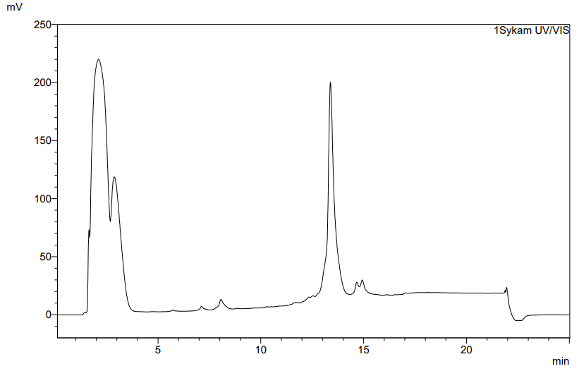
Figure S1: RP-HPLC chromatogram of the reaction control of H-TATE(PG)-OH using the analytical control method 10-90% B (15 min, λ = 220 nm, MultoKrom® 100-5 C18-column (125 × 4.6 mm, 5 μm particle size, CS Chromatographie GmbH, t_{R} = 13.4 min).
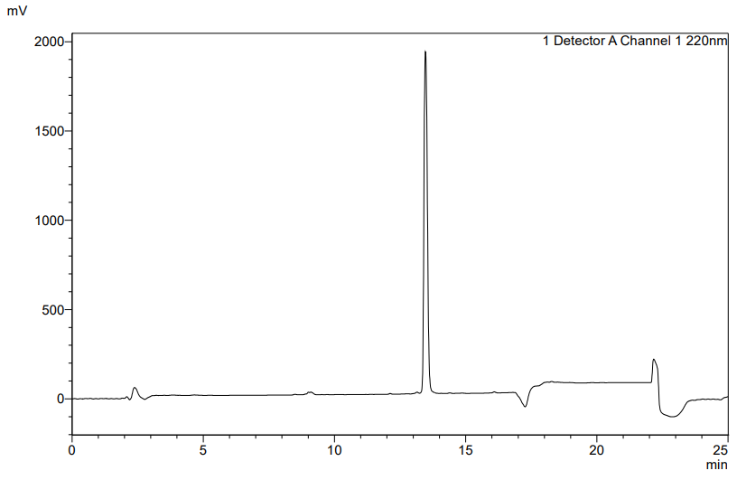
Figure S2: RP-HPLC chromatogram of SiFAlin-TATE using the analytical control method 10-60% B (15 min, λ = 220 nm, MultoKrom® 100-5 C18-column (125 × 4.6 mm, 5 μm particle size, CS Chromatographie GmbH), t_{R} = 13.5 min).

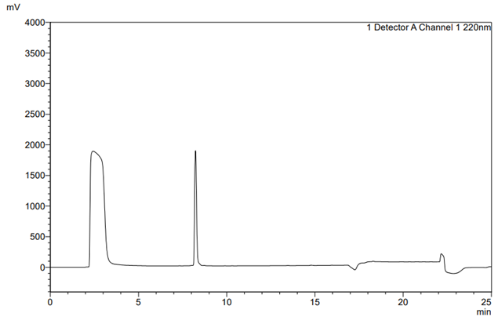
Figure S3: RP-HPLC chromatogram of Lu-DOTA-TATE using the analytical control method 10-60% B (15 min, λ = 220 nm, MultoKrom® 100-5 C18-column (125 × 4.6 mm, 5 μm particle size, CS Chromatographie GmbH), t_{R} = 8.5 min).

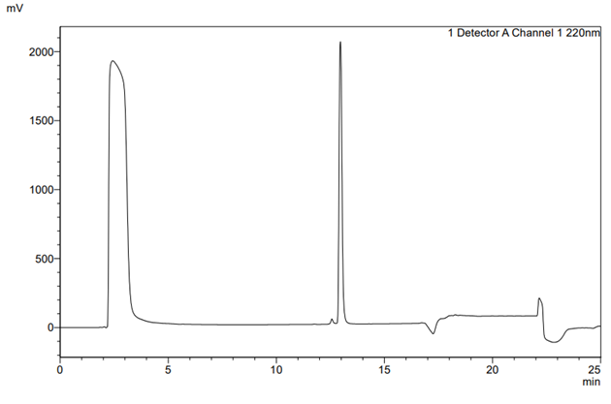
Figure S4: RP-HPLC chromatogram of Lu-rhTATE4 using the analytical control method 10-60% B (15 min, λ = 220 nm, MultoKrom® 100-5 C18-column (125 × 4.6 mm, 5 μm particle size, CS Chromatographie GmbH), t_{R} = 13.0 min).
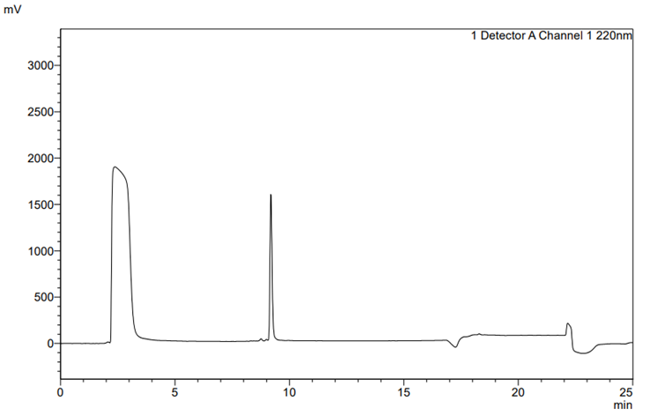
Figure S5: RP-HPLC chromatogram of [^{nat}I]TOC using the analytical control method 10-60% B (15 min, λ = 220 nm, MultoKrom® 100-5 C18-column (125 × 4.6 mm, 5 μm particle size, CS Chromatographie GmbH), t_{R} = 9.2 min).

Mass spectra
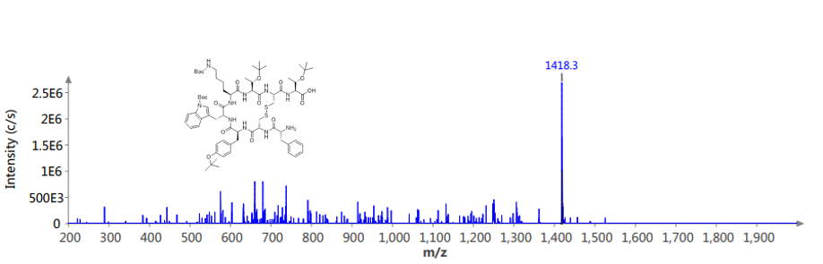
Figure S6: ESI⁺-mass spectrum of H-TATE(PG)-OH.

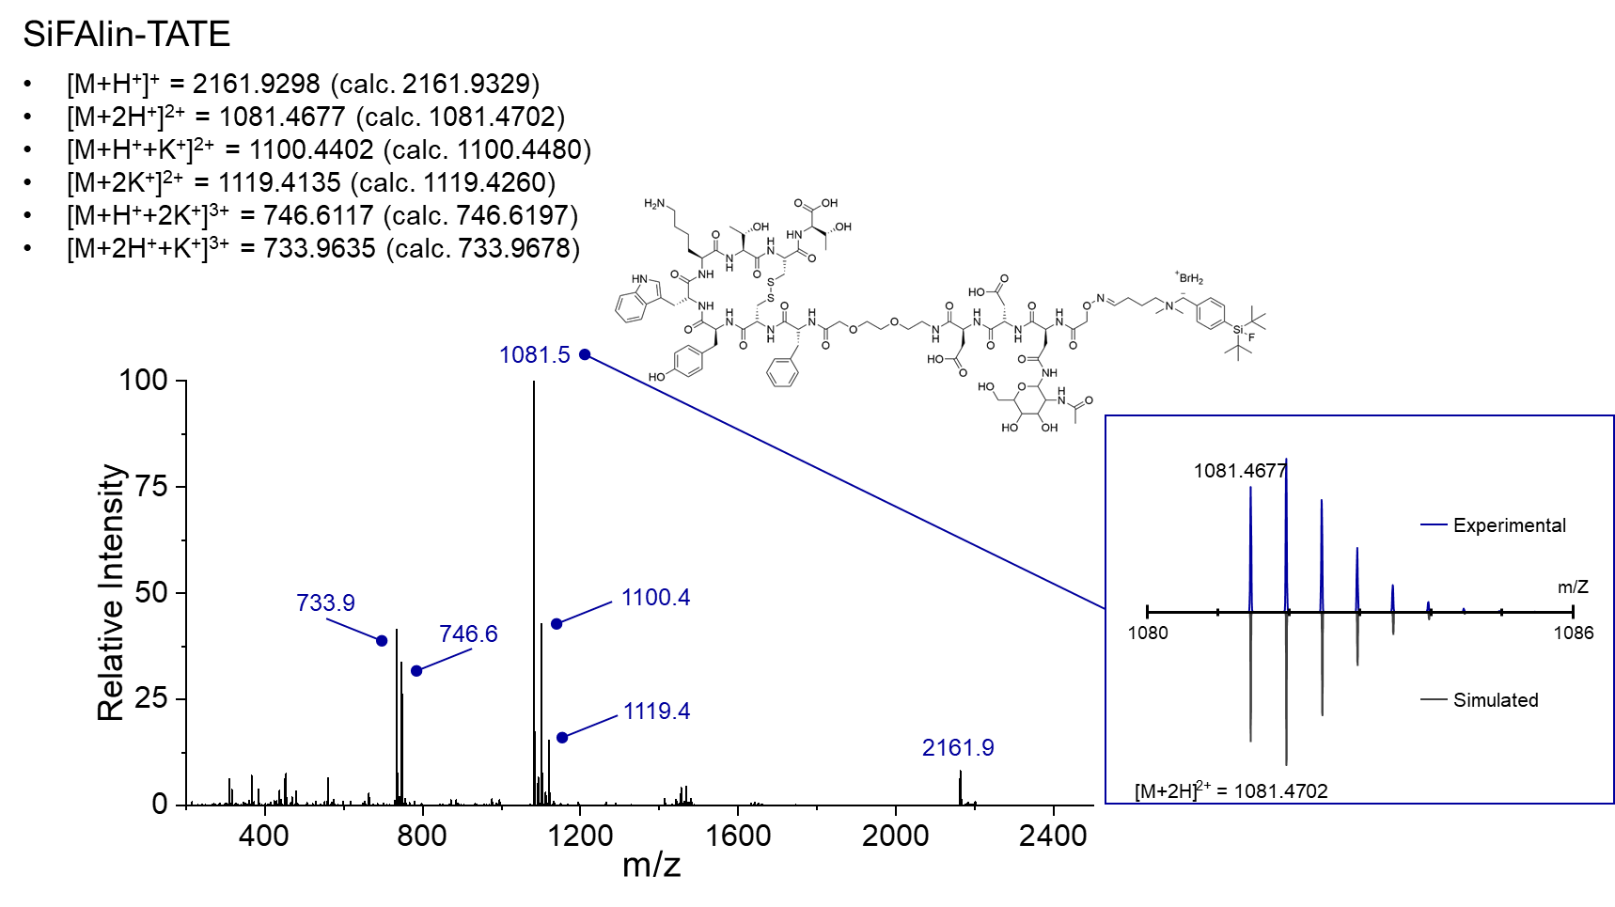
Figure S7: HR-ESI⁺ mass spectrum of SiFAlin-TATE.

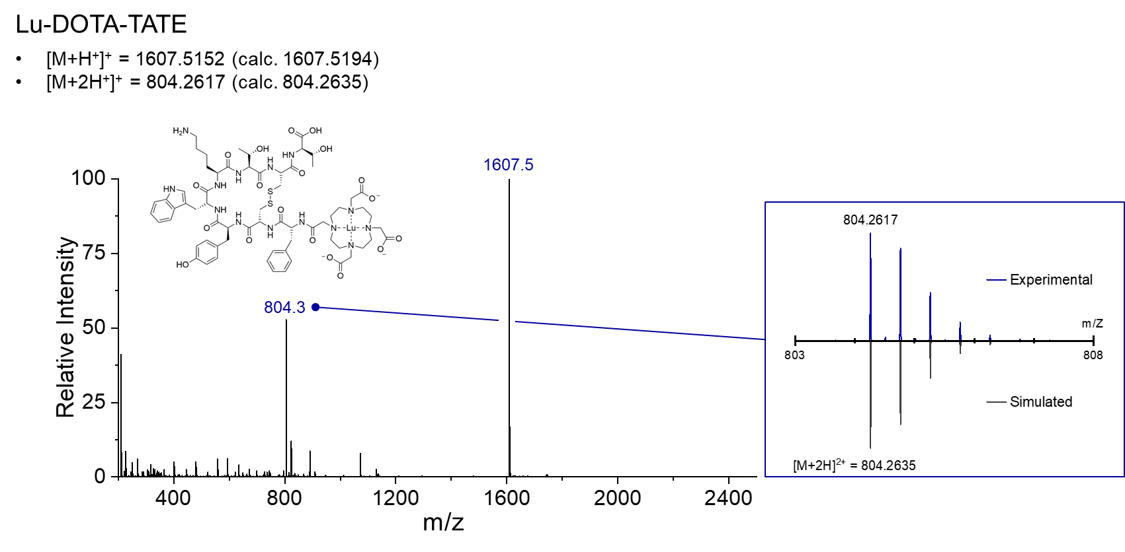
Figure S8: HR-ESI⁺ mass spectrum of Lu-DOTA-TATE.

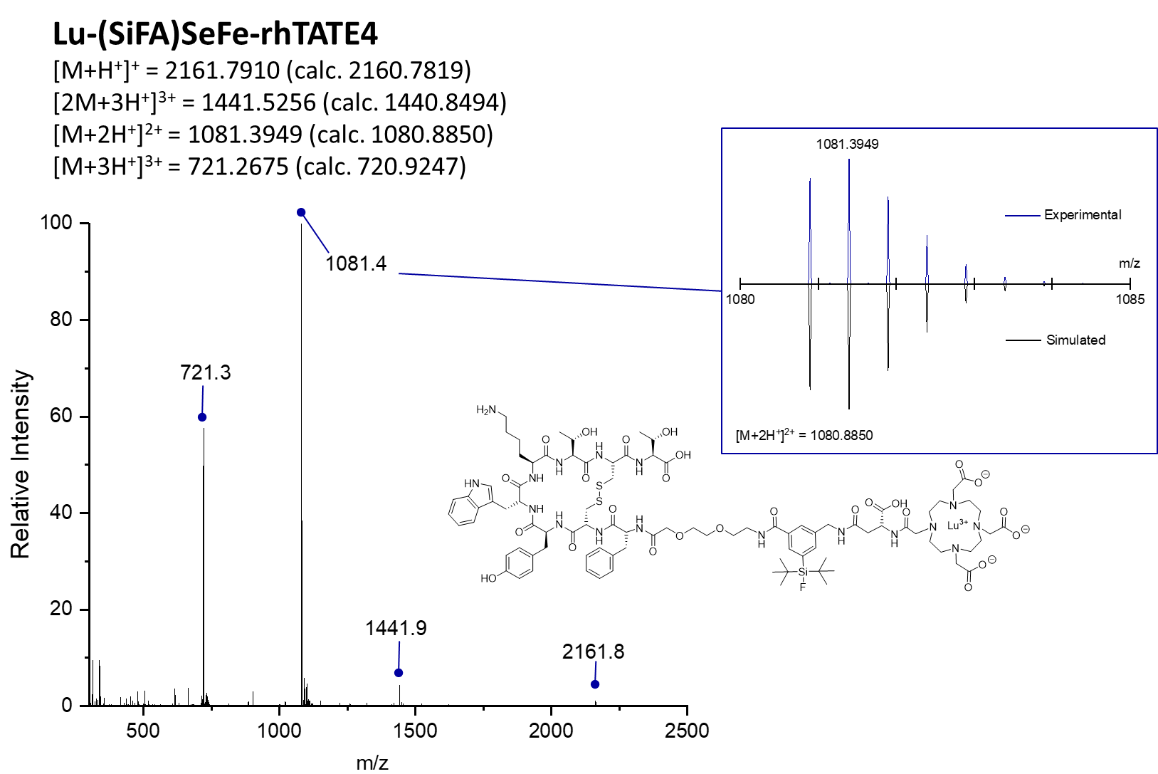
Figure S9: HR-ESI⁺ mass spectrum of Lu-rhTATE4.

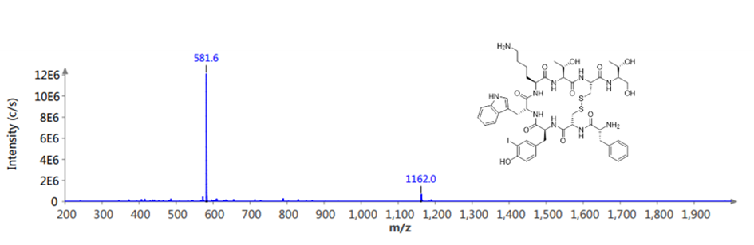
Figure S10: ESI mass spectrum of I-TOC.

Radiochemical characterization

Radio-RP-HPLC
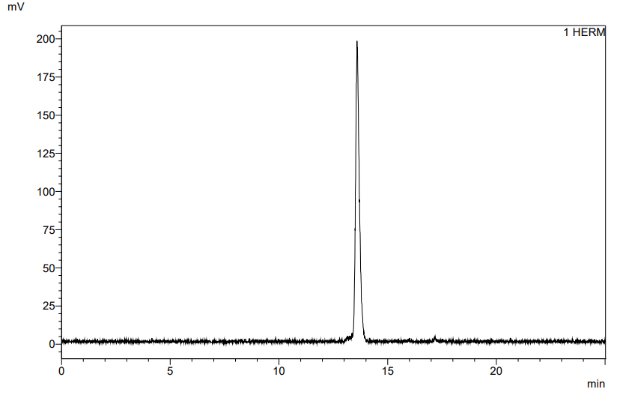
Figure S11: Radio-RP-HPLC chromatogram of [¹⁸F]SiFAlin-TATE using the analytical control method 10-60% B (15 min, MultoKrom® 100-5 C18-column (125 × 4.6 mm, 5 μm particle size, CS Chromatographie GmbH), t_{R} = 13.6 min).

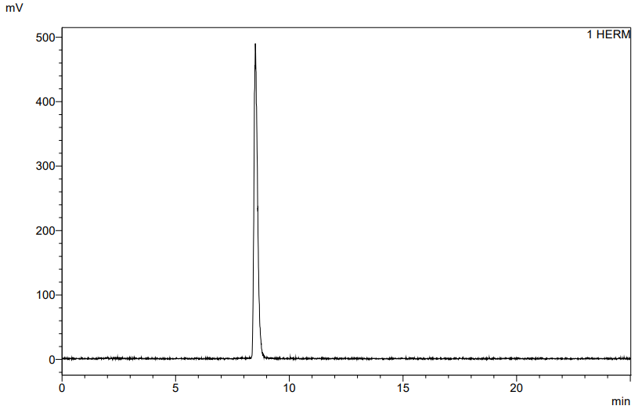
Figure S12: Radio-RP-HPLC chromatogram of [¹⁷⁷Lu]Lu-DOTA-TATE using the analytical control method 10-60% B (15 min, MultoKrom® 100-5 C18-column (125 × 4.6 mm, 5 μm particle size, CS Chromatographie GmbH), t_{R} = 8.5 min).

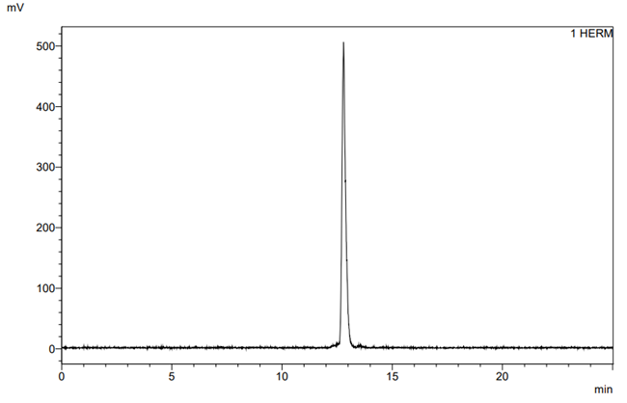
Figure S13: Radio-RP-HPLC chromatogram of [¹⁸F]Lu-rhTATE4 using 10-60% B (125 × 4.6 mm, 5 μm particle size, CS Chromatographie GmbH), t_{R} = 14.6 min).

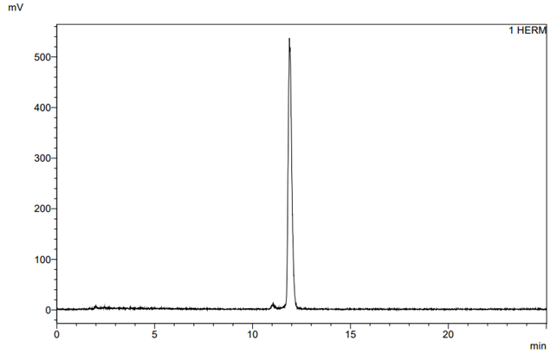
Figure S14: Radio-RP-HPLC chromatogram of [¹⁷⁷Lu]Lu-rhTATE4 using 10-60% B (125 × 4.6 mm, 5 μm particle size, CS Chromatographie GmbH), t_{R} = 11.9 min).

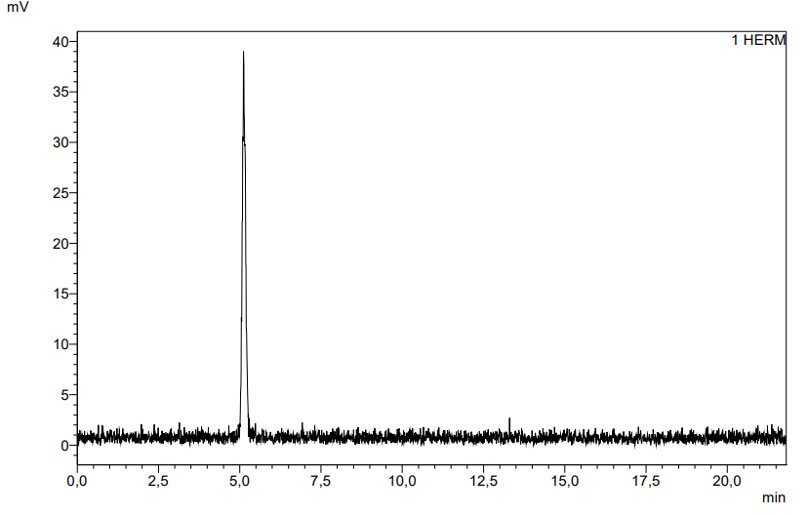
Figure S15: Radio-RP-HPLC chromatogram of [¹²⁵I]TOC using the analytical control method 20-50% B (15 min, MultoKrom® 100-5 C18-column (125 × 4.6 mm, 5 μm particle size, CS Chromatographie GmbH), t_{R} = 5.1 min).

Radio-TLC
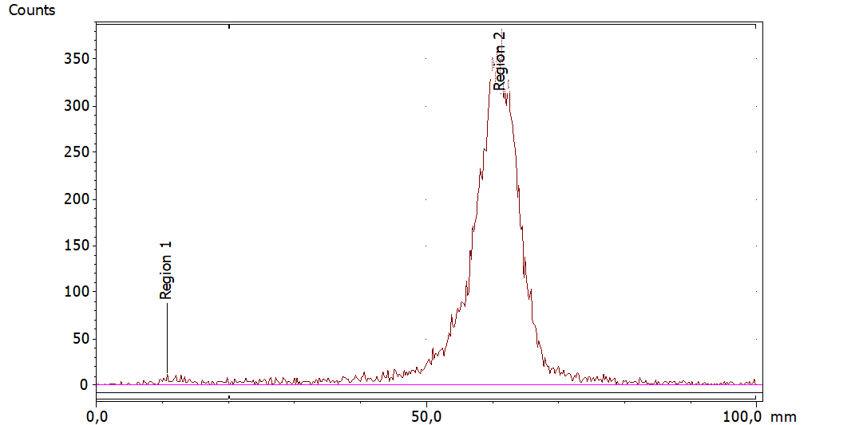
Figure S16: Radio-TLC chromatogram of [¹⁸F]SiFAlin-TATE (flow agent: 60% MeCN/ 40% PBS (6/4 v/v) with 10% NaOAc in H₂O (2 M) and 1% TFA, stationary phase: TLC silica gel 60 F₂₅₄ from Merck Millipore).

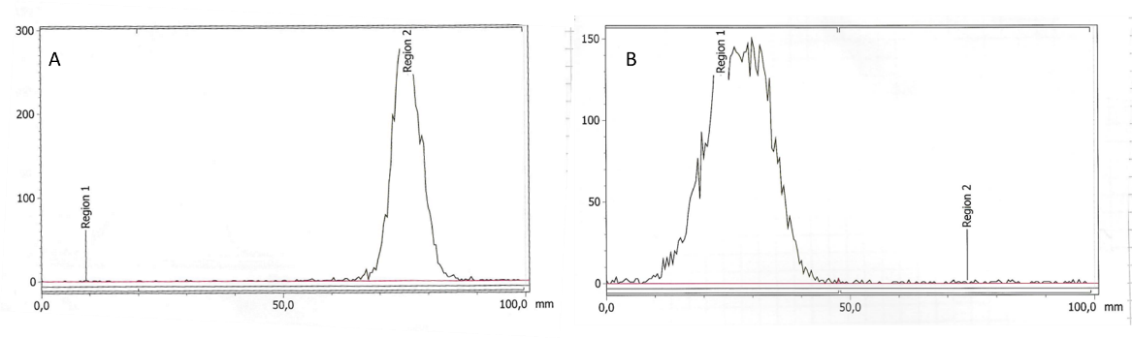
Figure S17: Radio-TLC chromatogram of [¹⁷⁷Lu]Lu-DOTA-TATE using A: 1 M NH₄OAc/DMF (1/1, v/v), stationary phase: TLC silica gel 60 F₂₅₄ and B: 0.1 M sodium citrate × 1.5 H₂O, stationary phase: iTLC-SC.

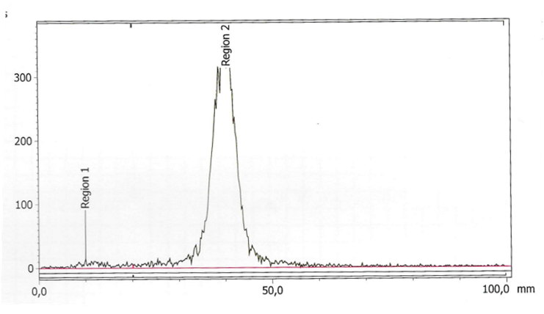
Figure S18: Radio-TLC chromatogram of [¹⁸F]Lu-rhTATE4 using 60% MeCN/ 40% PBS (6/4 v/v) with 10% NaOAc in H₂O (2 M) and 1% TFA, stationary phase: TLC silica gel 60 F₂₅₄ from Merck Millipore.

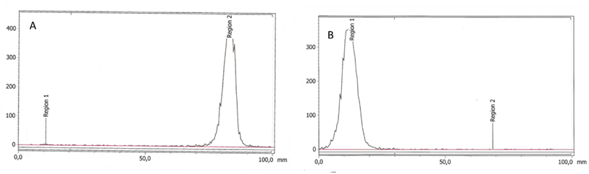
Figure S19: Radio-TLC chromatogram of [¹⁷⁷Lu]Lu-rhTATE4 using A: 1 M NH₄OAc/DMF (1/1, v/v), stationary phase: TLC Silica gel 60 F₂₅₄ and B: 0.1 M sodium citrate × 1.5 H₂O, stationary phase: iTLC-SC.

In vitro and in vivo data

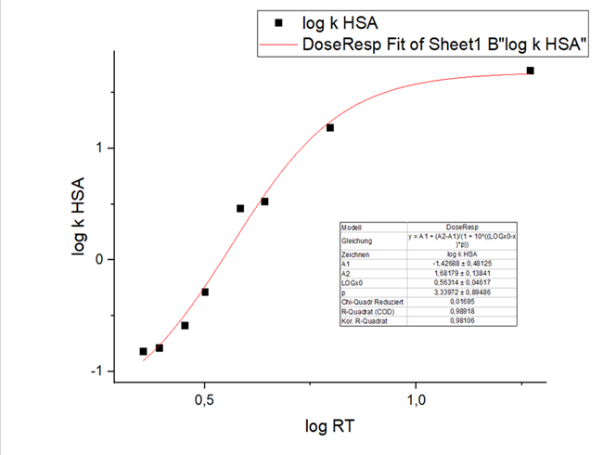
Figure S20: Fit function calculated by non-linear regression to determine the HSA binding.

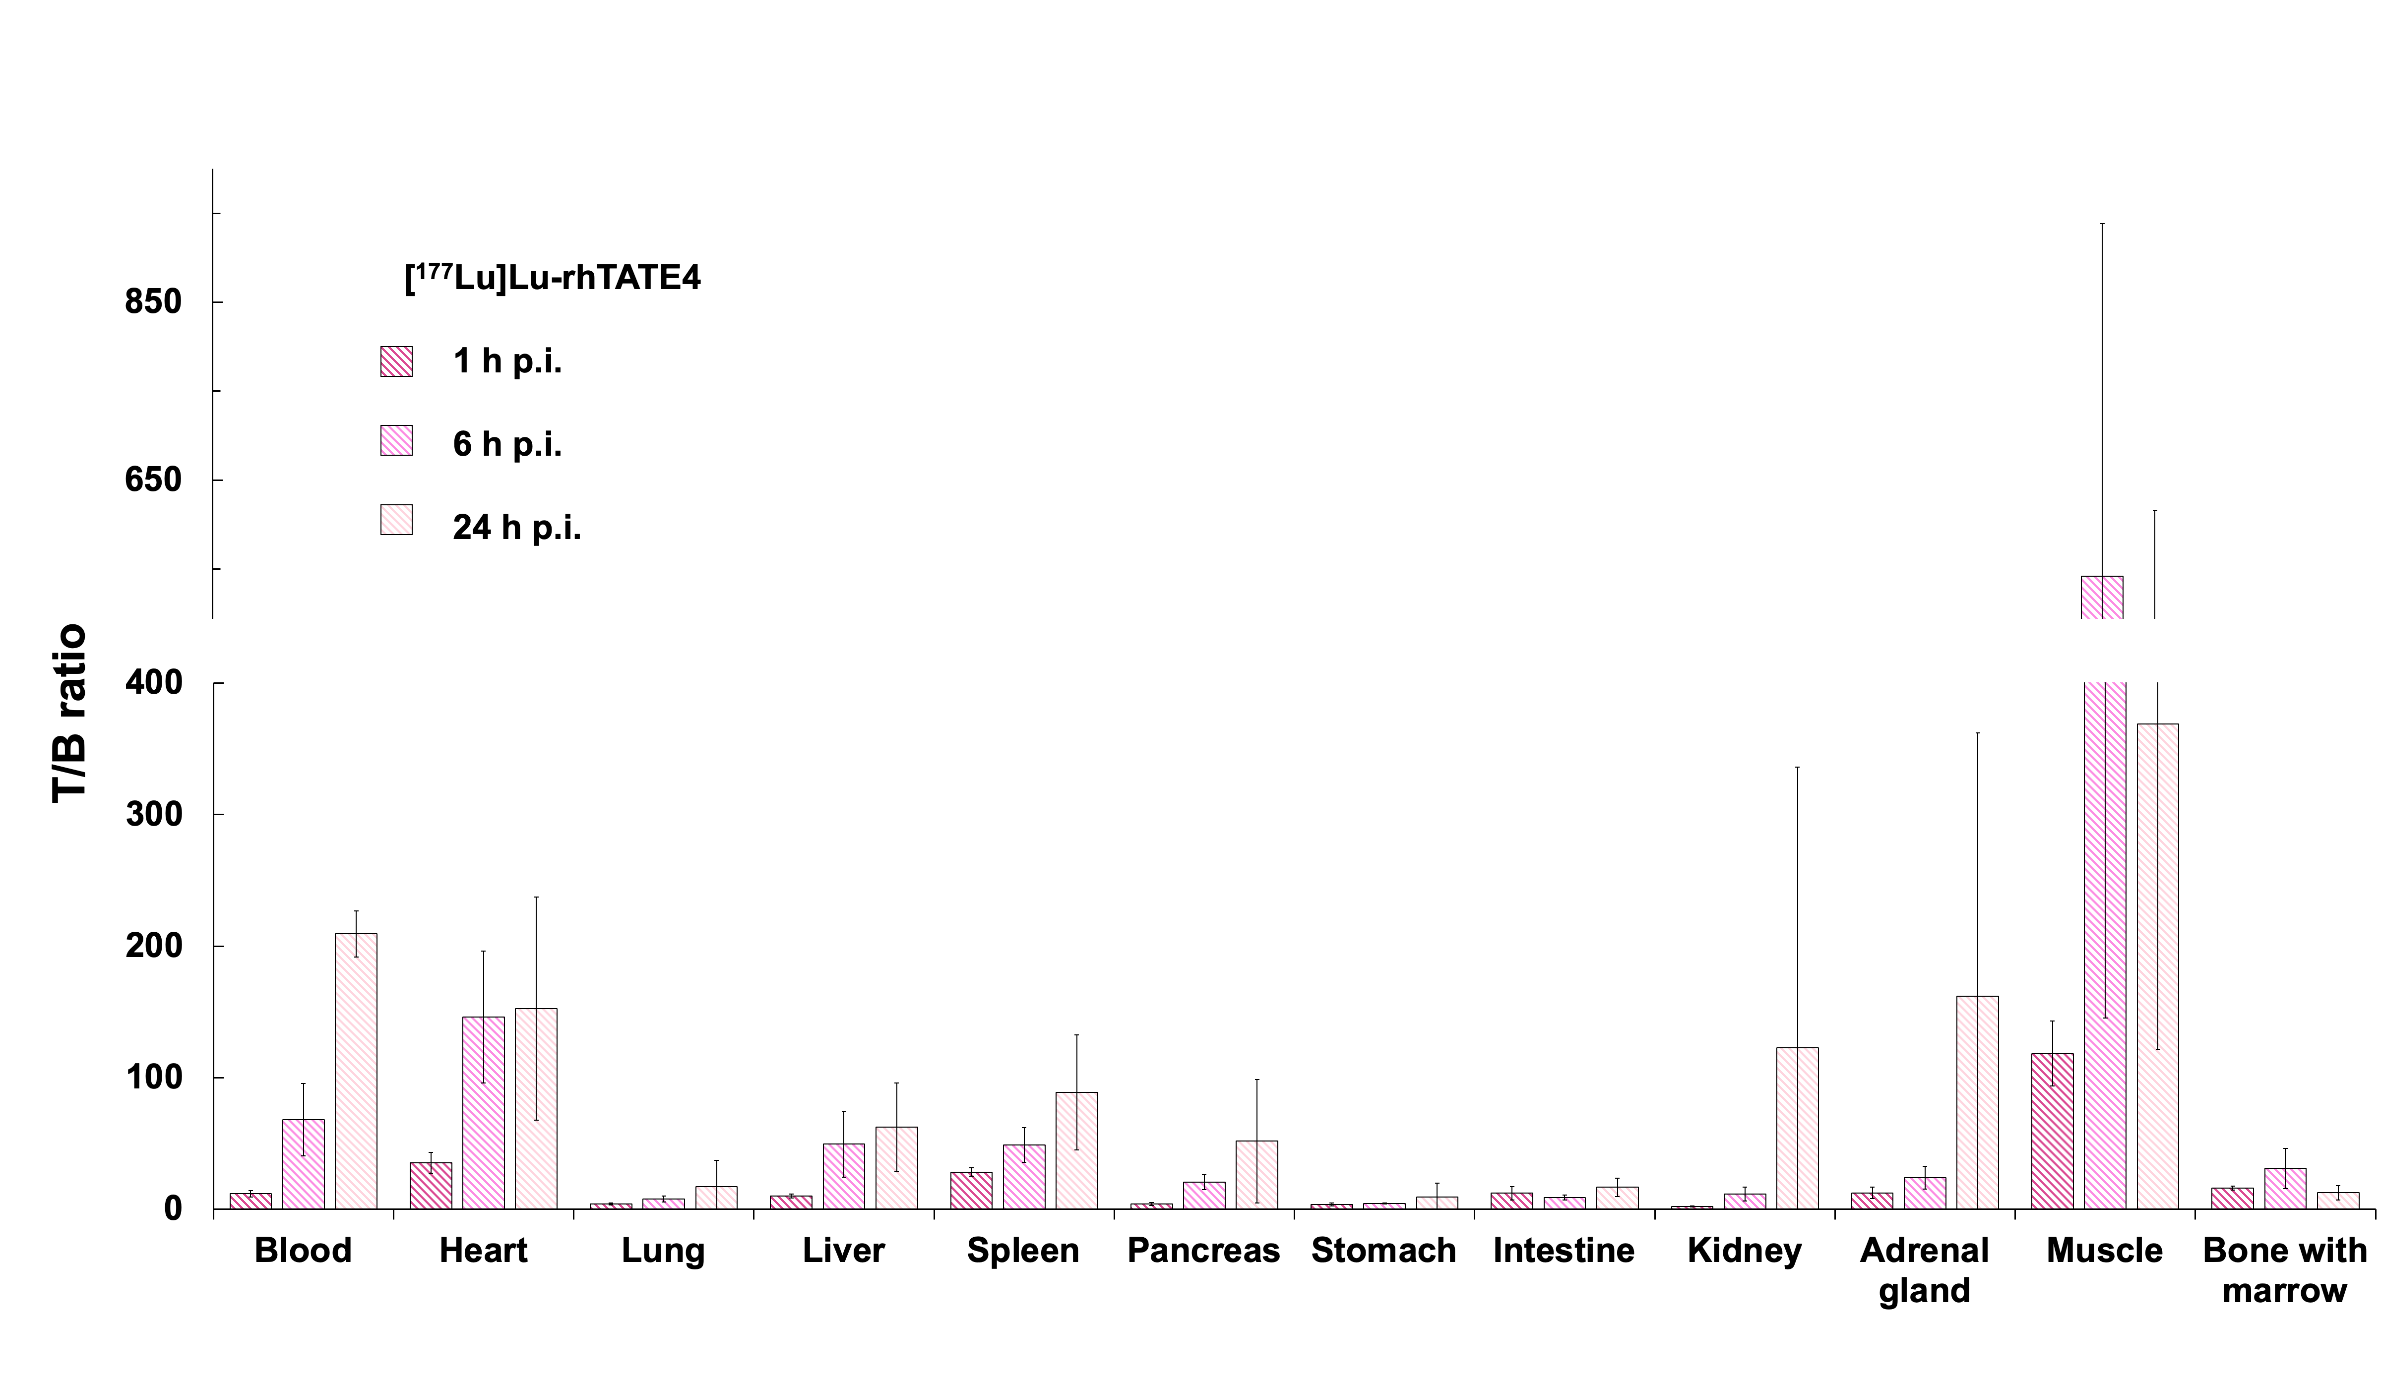
Figure S21: T/B-ratios of [¹⁷⁷Lu]Lu-rhTATE4 at 1 h, 6 h and 24 h p.i. (300 pmol each).

Tables
Table S1: Deviating equivalents, coupling reagents, base (DIPEA), pre-activation times, and reaction times for coupling the respective substrates to the resin-bound peptide (1.0 eq.).
Substrate | eq. | TBTU [eq.] | HATU  [eq.] | HOAt [eq.] | Base [eq.] | Preactivation [min] | Time [h]
Fmoc-O₂Oc-OH | 2.0 | - | 1.9 | 1.9 | 2.0 | 15 | 1.5
DOTA(tBu)₃ | 1.5 | - | 1.5 | 1.5 | 4.5 | 15 | 3.0
Fmoc-l-Asp(^{t}Bu)-OH | 3.0 | 3.0 | - | 3.0 | 9.0 | 2 | 2.0
Fmoc-Asn(Ac₃AcNH-β-Glc)-OH | 2.0 | 1.9 | 1.9 | - | 2.0 | 2 | 2.0
bis-Boc-amino-oxyacetic acid | 2.0 | 1.9 | - | 1.9 | 2.0 | 2 | 2.0
Fmoc-(SiFA)SeFe-OH | 1.5 | 1.5 | - | 1.5 | 3.5 | 15 | 2.0

Table S2: Compounds for the calibration curve and their respective literature-known HSA-binding percentages.^{[2-3]}
Compound | HSA-binding [%]
Benzyl alcohol | 13.15
Aniline | 14.06
Phenol | 20.69
Benzoic acid | 34.27
Carbamazepine | 75.00
4-Nitrophenol | 77.65
Estradiol | 94.81
Probenecid | 95.00
Glibenclamide | 99.00

Nonlinear regression was performed using OriginPro 2016G software. (Northampton, United States) using a fit function to calculate the HSA bindings of the examined compounds based on their retention time.

Table S3: Results of ¹⁸F-/¹⁷⁷Lu-labelling reporting radiochemical conversion (RCC), radiochemical yield decay corrected (RCY_{d.c.}), radiochemical purity via radio-RP-HPLC (RCP_{HPLC}), and radiochemical purity via radio-TLC (RCP_{TLC}).
Compound | RCC [%] | RCY_{d.c.} [%] | RCP_{HPLC} [%] | RCP_{TLC} [%]
[¹⁸F]SiFAlin-TATE | 59 | 59 | 98 | 98
[¹⁷⁷Lu]Lu-DOTA-TATE | - | ≥99 | ≥99 | ≥99
[¹⁸F]Lu-rhTATE4 | 55 | 38 | 98 | 99
[¹⁷⁷Lu]Lu-rhTATE4 | - | 99 | 99 | 99

Table S4: Summary of in vitro data, including lipophilicity (logD_{ph7.4}, n=6), human serum albumin binding (HSA, n=1), binding affinity (IC₅₀, n=3), and stability studies in human serum (% intact tracer, n=3) after 1 h (¹⁸F-labelled, except for [¹⁷⁷Lu]Lu-DOTA-TATE) and 24 h (¹⁷⁷Lu-labelled) incubation at 37 °C.

Compound | logD_{ph=7.4} |  | HSA [%] | IC₅₀  [nM] | Intact tracer  [%]
Compound | ¹⁸F | ¹⁷⁷Lu | HSA [%] | IC₅₀  [nM] | 1 h | 24 h
[^{nat/177}Lu]Lu-DOTA-TATE | - | $-$3.70 ± 0.05 | 51 | 7.24 ± 0.91 | ≥99 ± 0.0 | 98 ± 3.0
[^{nat/18}F]SiFAlin-TATE | $-$1.41 ± 0.07 | - | 92 | 7.46 ± 1.40 | 98 ± 0.0 | -
[^{nat/18}F][^{nat/177}Lu]-rhTATE4 | $-$1.42 ± 0.05 | $-$1.70 ± 0.06 | 95 | 9.32 ± 0.49 | ≥99 ± 0.0 | 91 ± 2.0

Table S5: Biodistribution of [^{nat/18}F]Lu-rhTATE4 in selected organs [%ID/g] at 1 h, 6 h and 24 h p.i. in AR42J tumor-bearing female CD1-nu/nu mice. * Out of linear regression of the device.
Organ | ¹⁸F-labelled |  | ¹⁷⁷Lu-labelled
Organ | 1 h (n=3) | 1 h block (n=1) | 1 h (n=5) | 6 h (n=6) | 24 h (n=5)
Blood | 4.88 ± 0.23 | 6.13 | 2.70 ± 0.38 | 0.32 ± 0.13 | 0.04 ± 0.02
Heart | 1.38 ± 0.08 | 1.57 | 0.91 ± 0.13 | 0.15 ± 0.05* | 0.05 ± 0.02
Lung | 6.87 ± 0.21 | 6.34 | 7.57 ± 0.93 | 3.37 ± 1.68 | 1.30 ± 0.68
Liver | 5.47 ± 0.47 | 6.26 | 3.11 ± 0.41 | 0.53 ± 0.28 | 0.19 ± 0.09
Spleen | 1.34 ± 0.08 | 1.27 | 1.17 ± 0.39 | 0.49 ± 0.29 | 0.16 ± 0.10
Pancreas | 11.65 ± 0.51 | 0.75 | 8.66 ± 3.93 | 1.05 ± 0.37 | 0.26 ± 0.18
Stomach | 10.63 ± 0.99 | 2.50 | 9.30 ± 2.43 | 5.08 ± 2.43 | 2.14 ± 0.98
Intestine | 2.50 ± 0.20 | 1.83 | 3.14 ± 1.50 | 2.83 ± 1.52 | 0.63 ± 0.43
Kidney | 26.88 ± 1.49 | 40.30 | 14.80 ± 1.95 | 1.93 ± 0.70 | 0.55 ± 0.26
Adrenal gland | 3.27 ± 0.39 | 1.98 | 2.67 ± 0.52* | 0.93 ± 0.38* | 0.22 ± 0.14
Muscle | 0.34 ± 0.03 | 0.50 | 0.27 ± 0.06* | 0.07 ± 0.06* | 0.01 ± 0.01
Bone + marrow | 1.74 ± 0.45 | 1.56 | 1.97 ± 0.43* | 0.77 ± 0.45* | 1.31 ± 0.68
Bone | 0.56 ± 0.29 | 0.89 | - | - | -
Tumor | 53.58 ± 5.51 | 1.96 | 32.15 ± 8.55 | 22.97 ± 12.04 | 10.32 ± 7.04

Table S6: T/B ratio of [¹⁸F]Lu-rhTATE4 and [¹⁷⁷Lu]Lu-rhTATE4 in selected organs [%ID/g] at 1 h, 6 h and 24 h p.i. in AR42J tumor-bearing female CD1-nu/nu mice. * Out of linear regression of the device.
Organ | ¹⁸F-labelled | ¹⁷⁷Lu-labelled
Organ | 1 h (n=3) | 1 h (n=5) | 6 h (n=6) | 24 h (n=5)
Blood | 10.87 ± 0.78 | 11.82 ± 2.52 | 68.35 ± 27.52 | 209.44 ± 17.56
Heart | 38.49 ± 5.26 | 35.26 ± 7.94 | 146.24 ± 50.23* | 152.49 ± 84.74
Lung | 7.37 ± 0.97 | 4.20 ± 0.83 | 7.80 ± 2.28 | 17.24 ± 20.16
Liver | 9.09 ± 1.73 | 10.15 ± 1.61 | 49.52 ± 24.92 | 62.47 ± 33.76
Spleen | 40.13 ± 4.45 | 28.36 ± 3.14 | 48.85 ± 13.13 | 89.06 ± 43.70
Pancreas | 4.54 ± 0.54 | 4.17 ± 1.24 | 20.17 ± 5.60 | 51.80 ± 46.97
Stomach | 4.86 ± 0.26 | 3.67 ± 1.23 | 4.48 ± 0.55 | 9.38 ± 10.45
Intestine | 21.31 ± 3.54 | 12.34 ± 5.11 | 8.96 ± 2.00 | 16.79 ± 6.98
Kidney | 1.85 ± 0.26 | 2.14 ± 0.38 | 11.58 ± 5.41 | 122.78 ± 213.46
Adrenal gland | 17.33 ± 1.73 | 12.44 ± 4.32* | 24.09± 8.58* | 162.17 ± 200.05
Muscle | 143.62 ± 24.52 | 118.32 ± 24.68* | 542.02 ± 396.48* | 368.79 ± 247.24
Bone + marrow | 31.61 ± 6.12 | 16.24 ± 1.60* | 31.16 ± 15.29* | 12.66 ± 5.43
Bone | 77.52 ± 27.54 | - | - | -

REFERENCES
[1] S. Deiser, S. Fenzl, V. König, M. Drexler, L. M. Smith, M. E. George, R. Beck, T. H. Witney, S. Inoue, A. Casini, (SiFA) SeFe: A Hydrophilic Silicon-Based Fluoride Acceptor Enabling Versatile Peptidic Radiohybrid Tracers, Journal of Medicinal Chemistry, 2024, 67, 14077-14094.
[2] K. Valko, S. Nunhuck, C. Bevan, M. H. Abraham, D. P. Reynolds, Fast Gradient HPLC Method to Determine Compounds Binding to Human Serum Albumin. Relationships with Octanol/Water and Immobilized Artificial Membrane Lipophilicity, Journal of Pharmaceutical Sciences, 2003, 92, 2236-2248.
[3] K. Yamazaki, M. Kanaoka, Computational prediction of the plasma protein‐binding percent of diverse pharmaceutical compounds, Journal of Pharmaceutical Sciences, 2004, 93, 1480-1494.
[4] T. Günther, N. Holzleitner, D. Di Carlo, N. Urtz-Urban, C. Lapa, H.-J. Wester, in Pharmaceutics, Vol. 15, 2023.

