SUPPLEMENTAL FILES

Protocol Optima GE 1.5 T
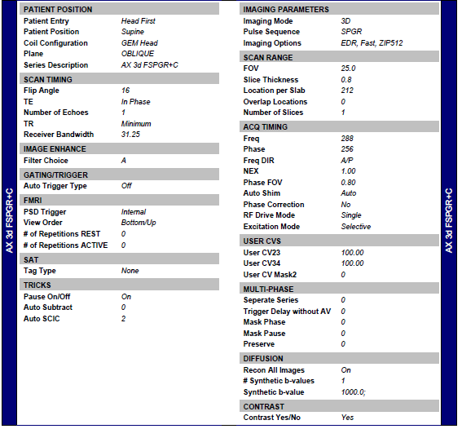

Protocol Artist GE 1.5 T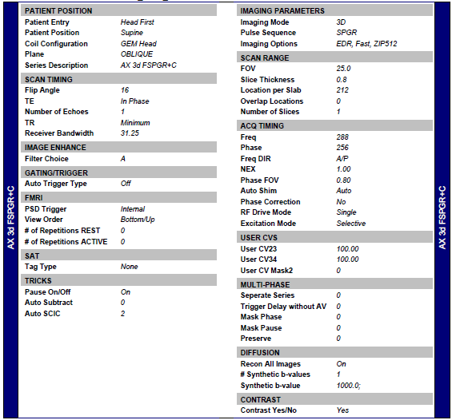

Philips Achieva 3T
Parameter | Value
Scanner Field Strength | 3T
Nucleus | ¹H (Proton)
Sequence Type | 3D FFE (Fast Field Echo)
Imaging Mode | TFE (Turbo Field Echo), multishot
Weighting | T1
Orientation | Transverse
Flip Angle (°) | 8
TR / TE (ms) | 6.0 / 2.7
TFE Factor | 218
FOV (AP × RL × FH, mm) | 230 × 183.1 × 170
Acquisition Voxel Size (mm³) | 1 × 1 × 1
Reconstruction Voxel Size (mm³) | 0.53 × 0.53 × 1
Matrix Size (ACQ / Recon) | 232 × 183 / 432
Slices / Slice Gap (mm) | 170 / 0
Parallel Imaging (SENSE) | Yes; RL: 1.4, FH: 1
Bandwidth (Hz) | 299.3
Water-Fat Shift (pixels) | 1.45
Fat / Water Suppression | None
Inversion Prepulse | Yes; delay: 1000 ms
Partial Echo / Halfscan | No / No
Acquisition Time (min:s) | 6:37
NSA (Number of Averages) | 1
SAR (Whole Body / Local) | < 0.2 W/kg / < 7%
PNS Level | 72% (Normal)
Max B1+rms | 0.60 µT
Sound Pressure Level | 22.9 dB

