Supplementary Materials
S1 Ablation Study
To rigorously evaluate the contributions of different components in our framework, we conducted a comprehensive ablation study across various configurations: 1D Projection (baseline), 2D Projection, 3D Projection, 1D without patch embeddings, and 2D without patch embeddings. These configurations test different aspects of our architecture: 1D, 2D, and 3D Projection variants modify the dimensionality of the attention mechanism (projecting instance features onto 1-dimensional, 2-dimensional, or 3-dimensional spaces for attention weight calculation), while the "without patch embeddings" variants remove tissue-level context by using only cell-level information without the corresponding patch-level features from the same spatial regions. Performance was assessed using accuracy, sensitivity, specificity, and AUC on both validation and test sets.
S1.1 Validation Performance Comparison
The 1D Projection (baseline) achieved a mean validation AUC of 67.63 ± 3.34, with sensitivity and specificity at 59.92 ± 2.91 and 63.92 ± 4.74, respectively. The 2D Projection demonstrated significant improvements, achieving a 3.6% higher mean validation AUC (70.06 ± 1.95) than the baseline. Notably, the 2D variant improved sensitivity by 12.7% (67.55 ± 7.37 vs. 59.92 ± 2.91), confirming its ability to better model feature interactions through orthogonal attention mechanisms. Expanding to 3D Projection did not yield further gains; instead, validation AUC dropped by 3.3% (67.61 ± 6.93) compared to 2D, with sensitivity and specificity variance spiking (> ±10.01 std), indicating overparameterization and training instability.
The most severe degradation occurred when patch embeddings were removed. The 1D variant without patches collapsed to a 15.3% lower validation AUC (57.31 ± 3.83) than the baseline, while the 2D variant preserved marginally better performance (62.08 ± 4.83 AUC), still 8.4% worse than standard 2D. This underscores that patch embeddings contribute critically to model performance, meaning that they capture some complementary information to the cell-level representations.
S1.2 Test Set Confirmation
Test results mirrored validation trends: 2D Projection achieved the highest mean AUC (74.28 ± 3.07), outperforming 1D by 4.9% (70.84 ± 2.48) and 3D by 3.9% (71.50 ± 2.00). Specificity stability also improved (2D std: ±5.78 vs. 1D: ±6.38), reinforcing its robustness. Removing patch embeddings consistently degraded test metrics, validating our design choice to retain them.
The final model (2D attention with patch embeddings) was selected based on validation metrics, with test results and cell-specific analyses further corroborating its advantage, see Table S1 for detailed results. This systematic evaluation ensures that our design decisions are empirically grounded, maximizing both discriminative power and robustness.
Table S1: Performance comparison across ablation settings, showing validation and test results (mean ± std) for models with different projection dimensions (1D, 2D, 3D) and patch embedding configurations. Bold values highlight top-performing configurations per metric, while the underlined show the second best. P.E. denotes patch embeddings, A.P. denotes attention projection, Acc stands for accuracy, Sen for sensitivity, and Spe for specificity.
Ablation Settings |  | Validation Results |  |  |  | Test Results
P.E. | A.P. | Accuracy | Sensitivity | Specificity | AUC | Accuracy | Sensitivity | Specificity | AUC
ü | 1D | 62.38±4.03 | 59.91±2.91 | 63.90±4.74 | 67.63±3.34 | 65.46±3.21 | 67.30±5.51 | 63.90±6.38 | 70.83±2.48
ü | 2D | 65.74±3.22 | 67.55±7.37 | 64.34±6.94 | 70.06±1.95 | 68.60±1.62 | 61.89±6.17 | 73.32±5.78 | 74.28±3.07
ü | 3D | 62.08±8.04 | 67.68±10.01 | 58.52±10.25 | 67.61±6.93 | 64.16±2.30 | 66.94±8.37 | 62.25±9.16 | 71.50±2.00
û | 1D | 57.60±5.54 | 54.60±7.64 | 59.37±5.25 | 57.30±3.83 | 61.18±0.85 | 55.75±3.56 | 64.89±3.67 | 63.52±2.26
û | 2D | 58.53±5.38 | 65.15±12.7 | 54.07±7.29 | 62.07±4.83 | 61.58±3.61 | 64.34±5.59 | 59.90±3.93 | 64.28±5.27
Table S2: Performance comparison of state-of-the-art MIL methods with our best performing model. Metrics show mean ± standard deviation across test folds. *DAMIL uses a different encoder (CTransPath), and data folds compared to other methods. Best performance in each metric is bolded, while second-best is underlined.
Model | Accuracy (%) | Sensitivity (%) | Specificity (%) | AUC (%)
AttMIL | 61.55 ± 8.23 | 55.77 ± 12.04 | 65.39 ± 7.79 | 66.57 ± 5.55
TransMIL | 58.85 ± 5.14 | 54.75 ± 5.29 | 61.26 ± 9.2 | 62.29 ± 3.85
CLAM | 61.13 ± 7.52 | 56.52 ± 12.89 | 64.56 ± 12.18 | 66.13 ± 5.90
CAMIL | 66.77 ± 3.75 | 57.50 ± 7.17 | 72.60 ± 3.63 | 67.47 ± 5.70
Kim et al. | 61.84 ± 7.18 | 68.00 ± 11.6 | 58.16 ± 17.93 | 66.81 ± 5.54
DAMIL* | 63.50 ± 3.10 | 53.00 ± 7.90 | 69.30 ± 6.60 | 64.90 ± 1.20
PathRosetta (ours) | 71.72 ± 4.82 | 65.81 ± 7.39 | 75.47 ± 5.38 | 77.84 ± 3.99
Table S3: Performance comparison of cell-type-specific models, the All-Cells model, and the Combined Model for ILA recurrence prediction. Metrics include accuracy, sensitivity, specificity, and AUC (mean ± standard deviation across test folds). The Combined Model (ensemble) achieves the highest performance across all metrics (bold). The second-best results are underlined.
Model | Accuracy (%) | Sensitivity (%) | Specificity (%) | AUC (%)
Stromal Cells | 63.81 ± 4.40 | 62.89 ± 7.27 | 64.26 ± 7.63 | 71.69 ± 6.31
Inflammatory Cells | 64.12 ± 3.50 | 62.09 ± 5.50 | 65.27 ± 3.84 | 70.27 ± 6.49
Neoplastic Cells | 65.64 ± 4.78 | 63.36 ± 4.69 | 67.13 ± 5.52 | 71.92 ± 3.26
Dead Cells | 67.30 ± 1.73 | 64.38 ± 10.63 | 69.14 ± 7.80 | 72.99 ± 3.89
Benign Epithelial Cells | 69.14 ± 2.84 | 64.94 ± 4.39 | 71.24 ± 4.99 | 74.98 ± 3.36
All-Cells | 68.60 ± 1.62 | 61.89 ± 6.17 | 73.32 ± 5.78 | 74.28 ± 3.07
Combined Model | 71.72 ± 4.82 | 65.81 ± 7.39 | 75.47 ± 5.38 | 77.84 ± 3.99
Table S4: HR and C-Index of all models including cell-type specific, all-cell and combined models. The table also shows the 95% confidence interval of the HRs with a p-value < 0.005, as well as the standard deviation of C-Index across folds.
Model | HR | C-Index
Stromal Cell | 5.44 [2.69–11.02] | 0.671 ± 0.05
Inflammatory Cell | 5.06 [2.41–10.62] | 0.666 ± 0.02
Neoplastic Cell | 4.98 [2.46–10.06] | 0.663 ± 0.04
Dead Cell | 5.69 [2.96–10.96] | 0.688 ± 0.02
Benign Epithelial Cell | 6.04 [3.15–11.56] | 0.708 ± 0.02
All-Cells | 7.70 [3.80–15.60] | 0.698 ± 0.03
Combined Model | 9.54 [4.34–20.98] | 0.704 ± 0.02
Table S5: Subgroup-wise performance metrics of the model across demographic and clinical variables. N denotes the number of patients in each subgroup. The results are reported by combining the test splits from all cross-validation folds, ensuring complete coverage of the dataset. "Old Grade" refers to the traditional predominant pattern–based grading system in WHO 4th Ed. (2015), whereas "New Grade" corresponds to the IASLC grading system in WHO 5th Ed. (2021). Metrics reported include AUC, accuracy, sensitivity, and specificity, computed separately for each subgroup to evaluate model fairness and robustness.
Subgroup | N | Accuracy | Sensitivity | Specificity | AUC
White | 149 | 71.14 | 66.67 | 73.91 | 75.93
African American | 20 | 65.00 | 75.00 | 58.33 | 77.08
Age < 65 | 100 | 66.00 | 64.71 | 66.67 | 69.56
Age >= 65 | 89 | 74.16 | 65.79 | 80.39 | 80.70
Female | 107 | 69.16 | 61.29 | 72.37 | 71.43
Male | 77 | 70.13 | 69.23 | 71.05 | 75.44
New Grade G1 | 24 | 87.50 | 100.00 | 86.96 | 86.96
New Grade G2 | 53 | 73.58 | 70.00 | 74.42 | 73.26
New Grade G3 | 112 | 64.29 | 63.93 | 64.71 | 69.98
Old Grade G1 | 57 | 75.44 | 60.00 | 78.72 | 69.36
Old Grade G2 | 102 | 70.59 | 70.83 | 70.37 | 77.78
Old Grade G3 | 28 | 60.71 | 53.85 | 66.67 | 62.05
Stage I | 130 | 73.85 | 64.86 | 77.42 | 75.12
Stage II | 41 | 65.85 | 69.57 | 61.11 | 69.57
Stage III | 15 | 53.33 | 58.33 | 33.33 | 52.78
Table S6: Performance comparison of the best-performing models, selected based on validation results from five-fold cross-validation on the WFBCCC cohort, on the TCGA-LUAD and CPTAC-LUAD external test sets. The table reports key performance metrics, including AUC, accuracy, sensitivity and specificity, comparing state-of-the-art MIL methods and the proposed PathRosetta framework.
 | TCGA-LUAD |  |  |  | TCGA-CPTAC
Model | Accuracy (%) | Sensitivity (%) | Specificity (%) | AUC (%) |  | Accuracy (%) | Sensitivity (%) | Specificity (%) | AUC (%)
AttMIL | 69.51 | 90.38 | 33.33 | 65.90 |  | 50.00 | 44.44 | 55.56 | 45.68
TransMIL | 59.76 | 61.54 | 56.67 | 63.59 |  | 55.56 | 11.11 | 100.0 | 62.96
CLAM | 68.29 | 86.54 | 36.67 | 65.64 |  | 55.56 | 66.67 | 44.44 | 62.96
CAMIL | 50.00 | 26.92 | 90.00 | 63.46 |  | 33.33 | 00.00 | 66.67 | 38.27
Kim et al. | 68.29 | 82.69 | 43.33 | 69.68 |  | 55.56 | 22.22 | 88.89 | 60.49
PathRosetta (ours) | 74.39 | 75.00 | 73.33 | 75.96 |  | 72.22 | 66.67 | 77.78 | 76.54

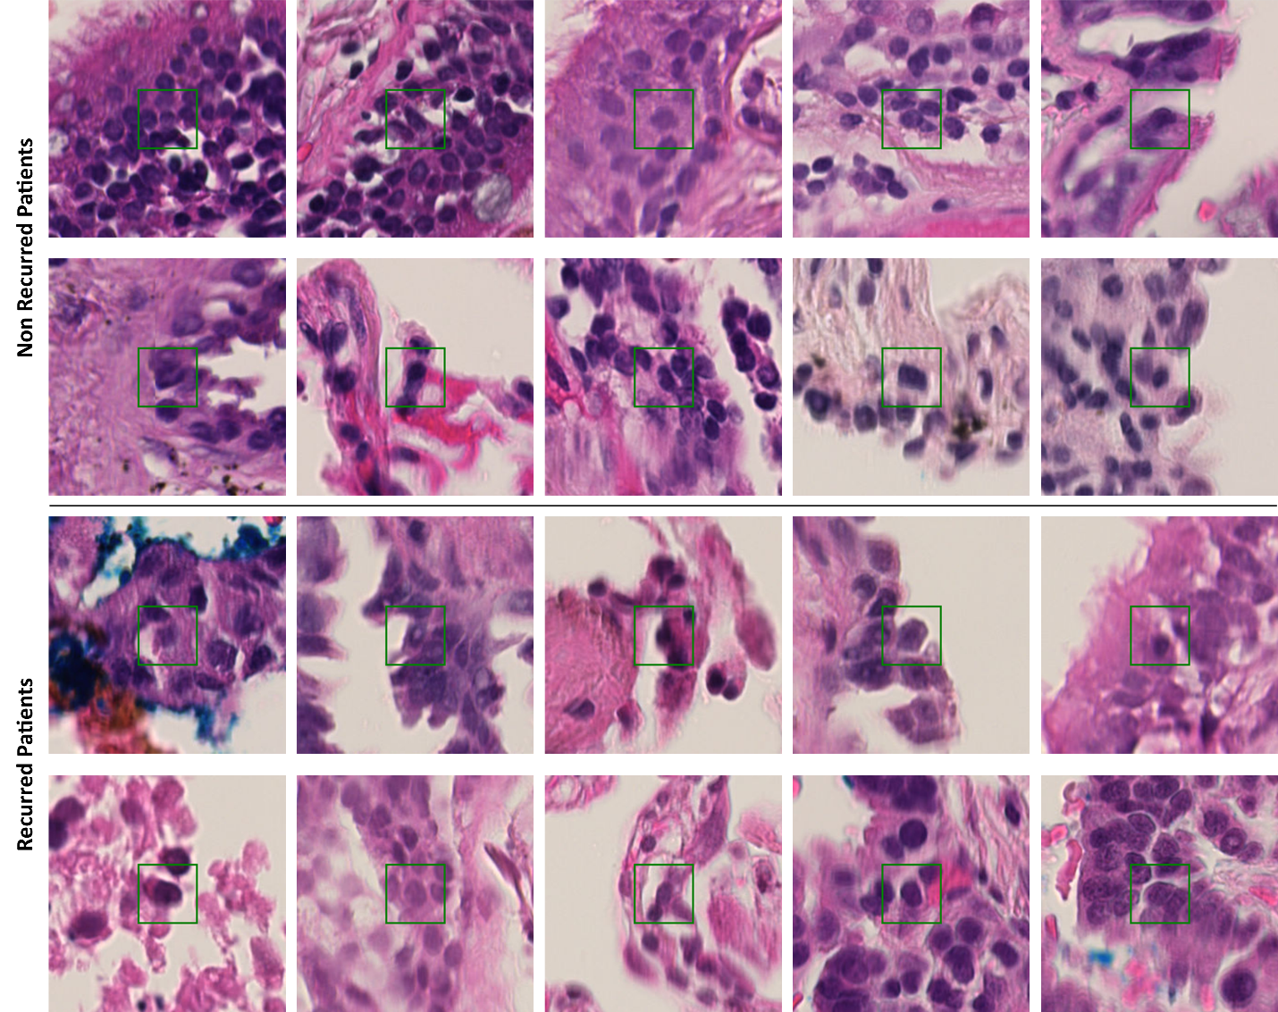
Figure S1: This figure displays sample cells from recurrent and non-recurrent patients, encoded differently by CellViT++, leading to their distinct spatial separation in the 3D t-SNE embedding space (Fig. 7).
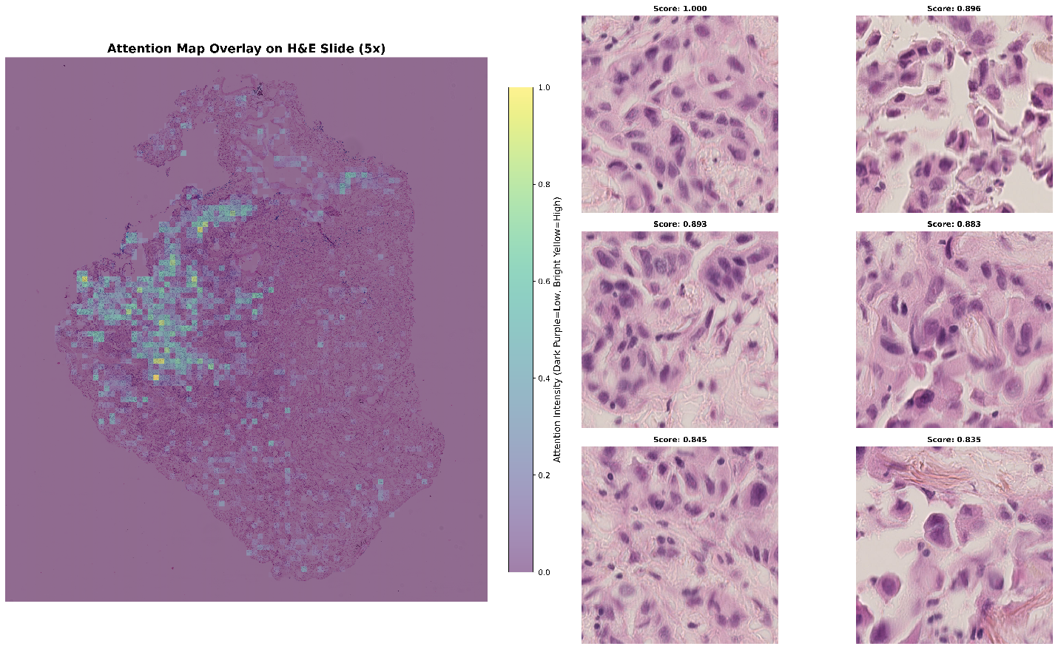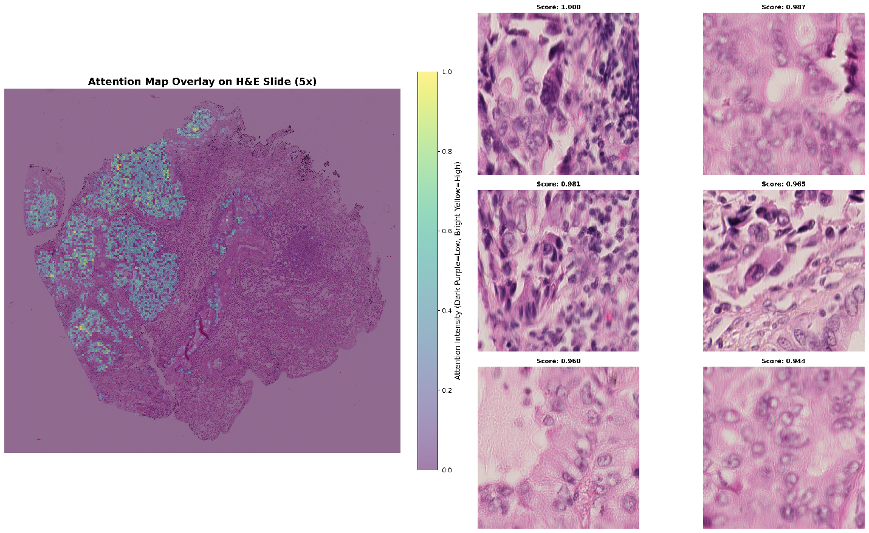
Figure S2: Attention maps for correctly predicted recurred patients. In each row, a representative WSI’s attention map is shown alongside its topmost highly attended patches. These patterns are all consistent with known poor prognostic indicators.
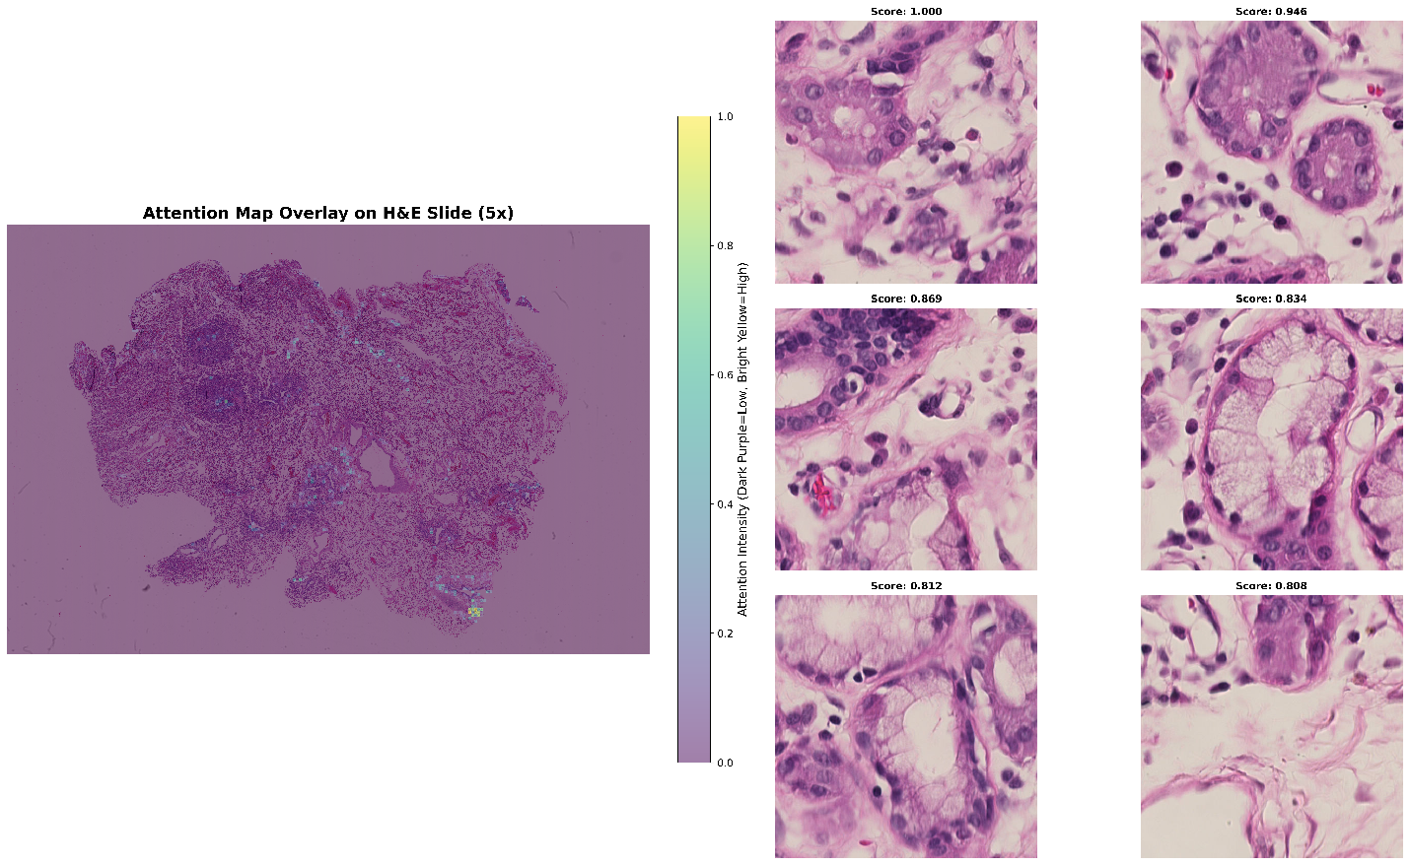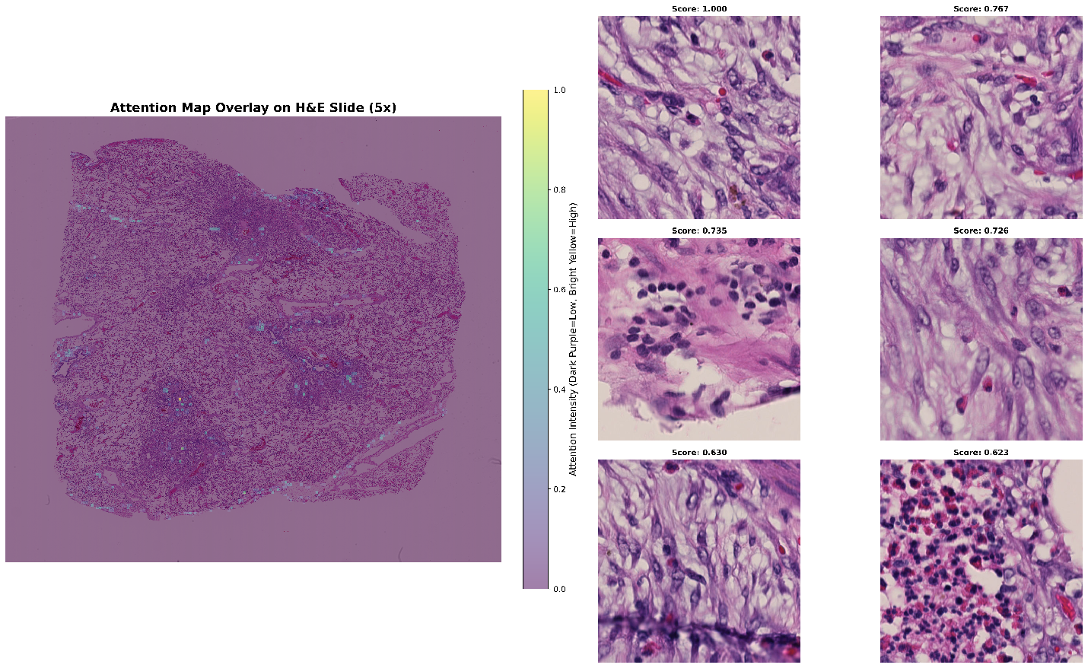
Figure S3: Attention maps for correctly predicted non-recurred patients. These patterns suggest the model integrates microenvironmental cues in its risk assessment.
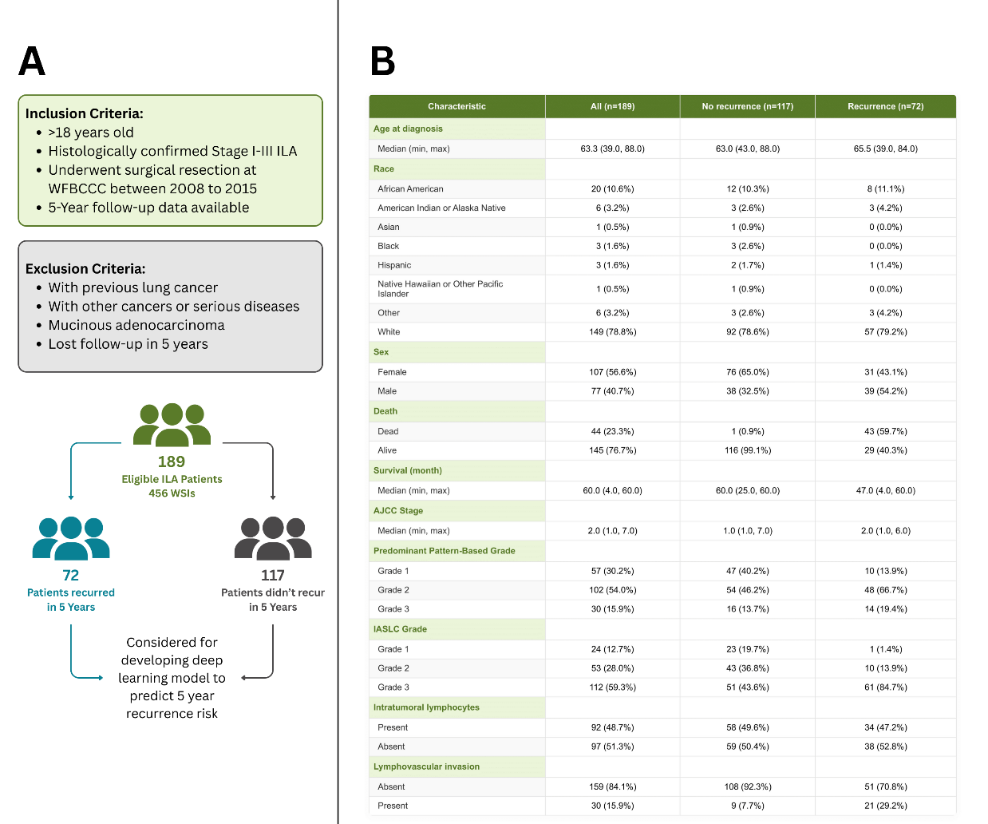
Figure S4: (A) Study population characteristics and cohort design. This shows patient selection criteria for invasive lung adenocarcinoma cases from 2008-2015, including exclusion criteria (previous lung cancer, other cancers or serious diseases (life-threatening conditions), mucinous adenocarcinoma, and lost follow-up within 5 years). The final study population comprised 189 patients with 456 whole slide images, stratified into recurrence (patients = 72, WSIs = 170) and non-recurrence (patients = 117, WSIs = 286) groups based on 5-year follow-up data. (B) Demographic and clinical characteristics of patients with invasive lung adenocarcinoma examined in this study. Data are presented for the entire cohort (n=189) and stratified by recurrence status (no recurrence, n=117; recurrence, n=72). Variables include age at diagnosis, race, sex, survival outcomes, AJCC stage, histological grade (old and new classification systems), intratumoral lymphocytes, and lymphovascular invasion status.

