Supplementary materials
Genome mining discovery of hydrogen production pathway of Klebsiella sp. WL1316 fermenting cotton stalk hydrolysate
Yanbin Li¹, Qin Zhang^{1,† *}, Zhanwen Liu², Hui Jiang², Qinghua Jia²
¹College of Biological and Food engineering, Anhui Polytechnic University, Wuhu, Anhui, 241000, China, ²College of Life Science, Tarim University, Alaer, Xinjiang, 843300, China

Correspondence
Qin Zhang, College of Biological and Food Engineering, Anhui Polytechnic University, Wuhu, Anhui, 241000, China
Email: jhtabszq@163.com; zhangqin@ahpu.edu.cn
ORCID: http://orcid.org/0000-0001-5718-526X

Supplementary Table 1 Genome information of the reference strains for comparative genomics analysis.
General features |  | Klebsiella pneumoniae subsp. HS11286 | Klebsiella pneumoniae subsp. NTUH-K2044 | Klebsiella oxytoca KONIH1 | Enterobacter ludwigii  EcWSU1 | Enterobacter sp. R4-368
 | Accession number of BioProject | PRJNA  78789 | PRJDA  21069 | PRJNA  202895 | PRJNA  67983 | PRJNA  18917
 | Genome size (Mb) | 5.33 | 5.25 | 6.15 | 4.73 | 5.04
 | Gene number (#) | 5,404 | 5,044 | 5,856 | 4,597 | 4,852
 | GC content (%) | 57.5 | 57.7 | 55.9 | 54.6 | 54.0
 | rRNA number | 25 | 25 | 25 | 25 | 29
 | tRNA number | 62 | 87 | 85 | 84 | 87
 | Other RNA number | 1 | 11 | 9 | 9 | 8

Supplementary Table 2 The annotated functional protein of and their Gene_ids
Gene_id | Name of functional protein
Hydrogenase cluster gene encoding proteins
ZhydN | Fe-S-cluster-containing hydrogenase components 2
hycB | Fe-S-cluster-containing hydrogenase components 2
STM2843 | Fe-S-cluster-containing hydrogenase components 2
hycG | Ni,Fe-hydrogenase III small subunit
ECs3577_2 | Ni,Fe-hydrogenase III large subunit
STM2842 | Hydrogenase maturation factor
STM2856 | Hydrogenase maturation factor/ [NiFe] hydrogenase metallocenter assembly protein
hypD | Hydrogenase maturation factor/ hydrogenase expression/formation protein
hypE | Hydrogenase maturation factor/ hydrogenase metallocenter assembly protein
STM2845 | Ni,Fe-hydrogenase maturation factor
hypB | Ni²⁺-binding GTPase involved in regulation of expression and maturation of urease and hydrogenase/ hydrogenase nickel incorporation protein HypB
ZureG.2 | Ni²⁺-binding GTPase involved in regulation of expression and maturation of urease and hydrogenase
hypA | Zn finger protein HypA/HybF (possibly regulating hydrogenase expression)/ Putative hydrogenase nickel incorporation protein hypA 1
fdnH | Fe-S-cluster-containing hydrogenase components 1
fdoH | Fe-S-cluster-containing hydrogenase components 1
STM0965 | Fe-S-cluster-containing hydrogenase components 1
Formate hydrogenlyase gene encoding proteins
STM2848 | Formate hydrogenlyase subunit 6/ Formate hydrogenlyase complex 3 iron-sulfur protein
STM2321 | Formate hydrogenlyase subunit 6
STM2850 | Formate hydrogenlyase subunit 4
ZhycC | Formate hydrogenlyase subunit 3
HycH | Formate hydrogenlyase maturation HycH family protein
HycA | Formate hydrogenlyase regulatory protein HycA
STM2859 | Formate hydrogen-lyase transcriptional activator

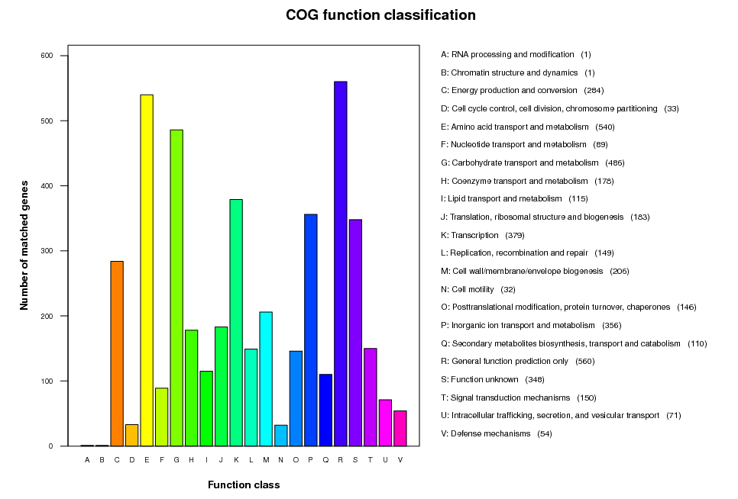
Supplementary Fig. 1 COG function classification of the Klebsiella sp. WL1316 genome. X-axis represents the function classification, Y-axis represents the annotated gene numbers.

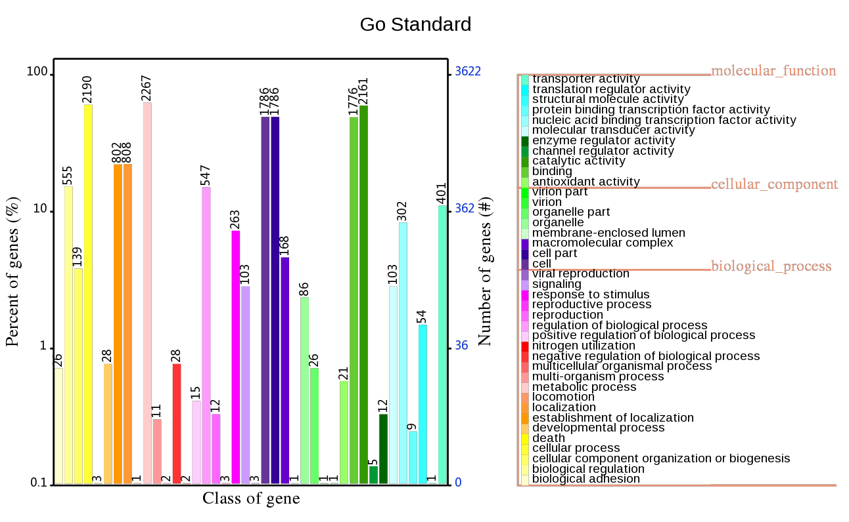
Supplementary Fig. 2 GO function classification of the Klebsiella sp. WL1316 genome. X-axis represents the function classification, Y-axis represents the annotated gene numbers.

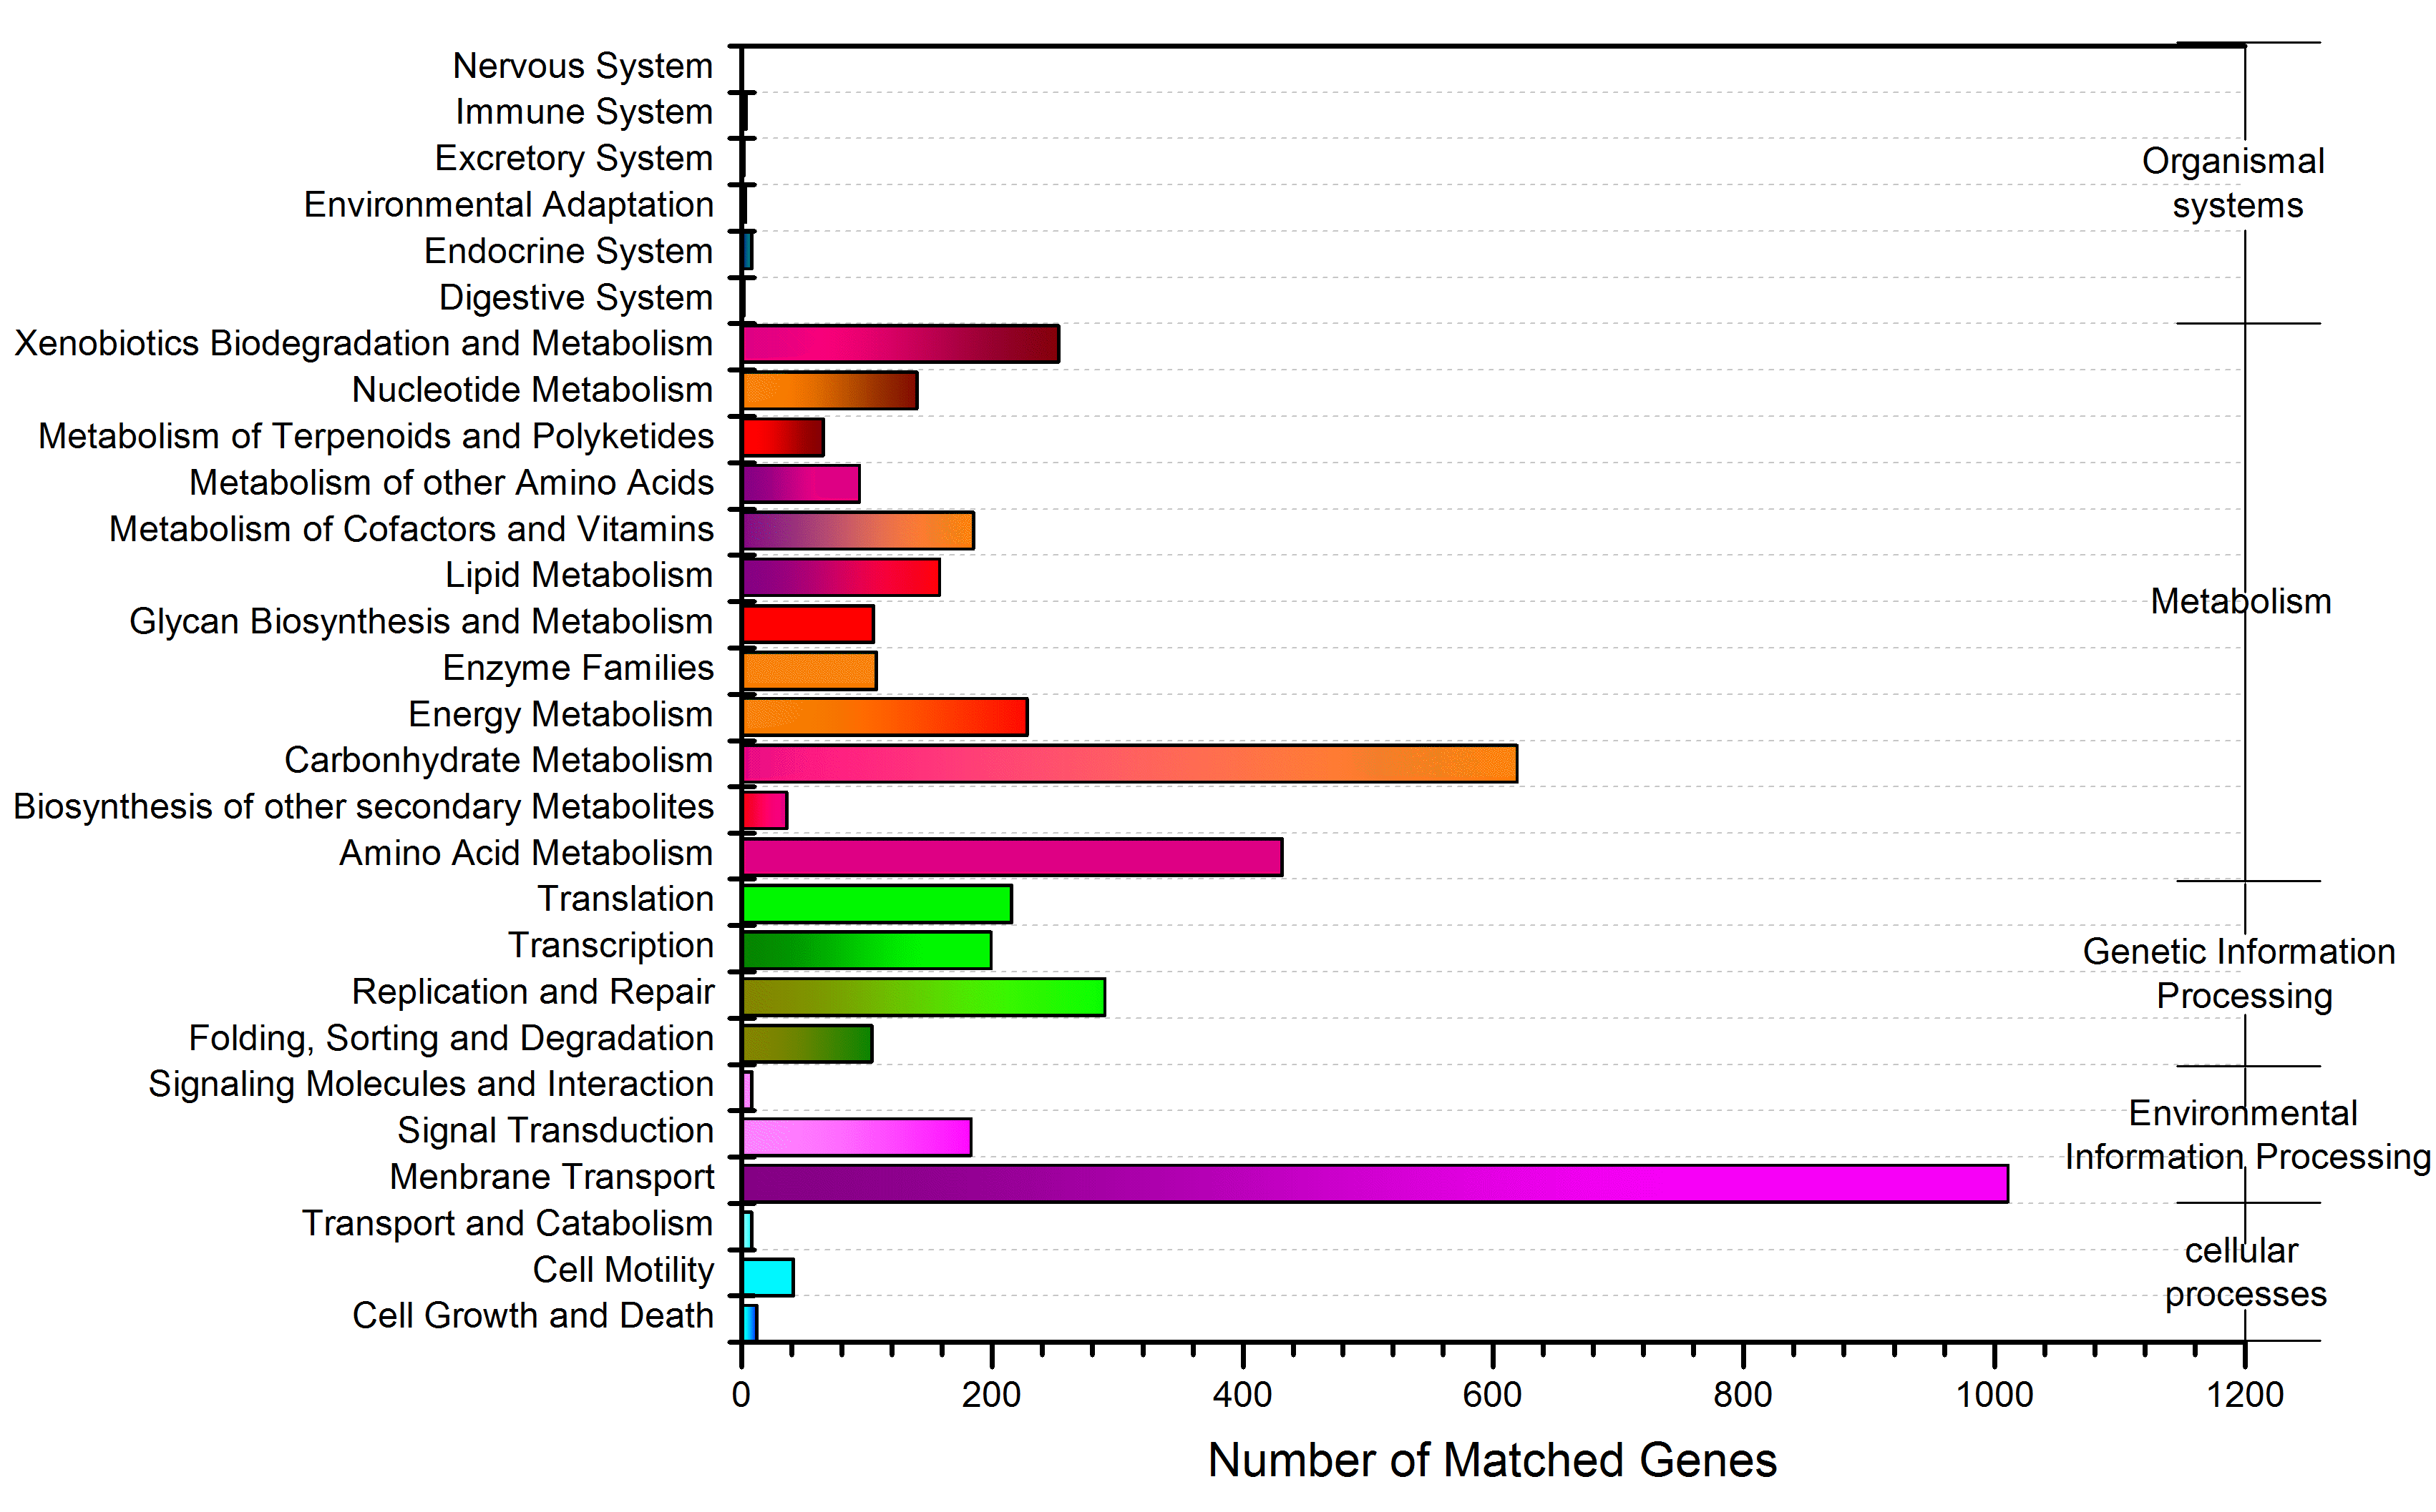
Supplementary Fig. 3 KEGG function classification of the Klebsiella sp. WL1316 genome. X-axis represents the function classification, Y-axis represents the annotated gene numbers.

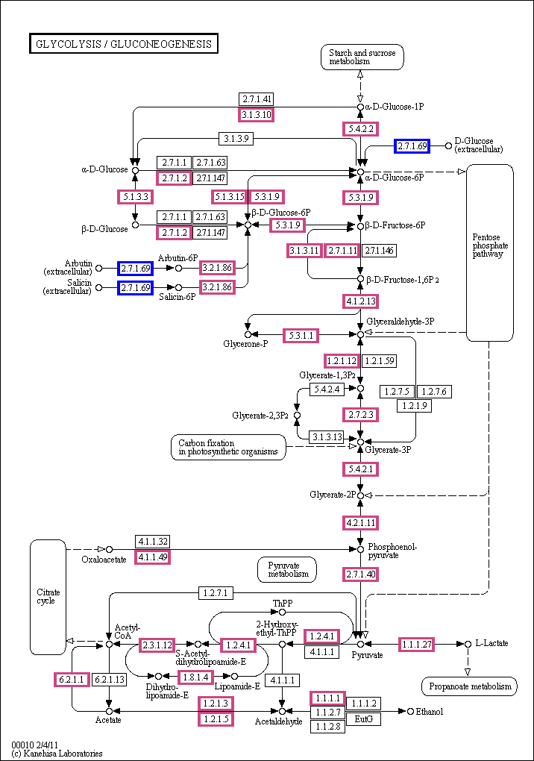
Supplementary Fig. 4 Glucose metabolism- and fermentation-related metabolic pathways of Klebsiella sp. WL1316 BLAST based on KEGG database.

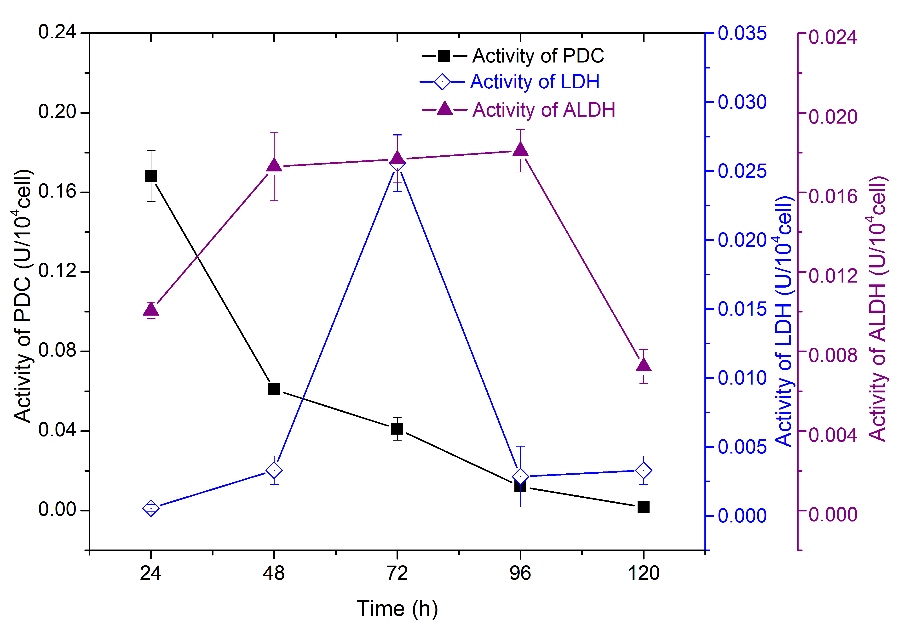
Supplementary Fig. 5 Analysis of the activity of key enzymes for biohydrogen production.

