Supplementary Information File
for
Physiologically Adaptive Soft Millirobot for Atraumatic, Image-Guided Endovascular Therapy
Tuan-Anh Le, Husnu H. Alabay, Prabh G. Singh, Melissa G. Austin, Pamela Manco Urbina, Sanjay Misra, Hakan Ceylan

The PDF file includes:

Tables S1 to S8
Supplementary text 1 to 13
Figures S1 to S56
References (1-44)

Other Supplementary Material for this manuscript includes the following:

Movies S1 to S10

Table S1. Blood vessels suitable for safe deployment of EndoBot in endoluminal delivery applications
 | Vessel type | Description | Diameter (mm) | Blood flow rate  (mL/min) | Blood flow velocity  (cm/s)
Human | Middle cerebral artery | Lateral part of the brain | 2 – 5 (1) | 93–149 (2) | 27–39 (2)
Human | Brachial artery | Major artery of the upper arm | 3 – 4 (3, 4) | 5–90 (5) | 4.2–11.13 (6)
Human | Coronary arteries | Main arteries that supply blood to the heart muscle | 1.3 – 4.5 (7, 8) | ~70–80 (9) | 13–41 (10)
Human | Cephalic Vein | Vein that drains blood from the lateral arm and empties into the axillary vein | 2.5 – 4.5 (11, 12) | 14–42 (13) | 5.7–12.1 (13)
Human | Umbilical Vein | Vein that connects the placenta to the fetus | 1.9 – 2.4 (14) | 63–373 (15) | 8–10 (15)
Rat | Inferior vena cava | Large vein from the lower body to the heart | 2 – 3.3 (16, 17) | 10 (18) | 7.6–10 (18)
(1) Measured postmortem after fixation with formalin.
(2) (3) (4) (5) Measured under resting conditions.
(6) Average of right and left radial arteries.
(7, 8) Mean values of right and left coronary arteries.
(9) for 100 g myocardial tissue at rest.
(10) During angiography, velocities in systole and diastole.
(13) Blood flow in healthy individuals – blood flow velocity: end-diastolic maximum velocity
(14) Measured under ex-vivo condition.
(15) 63 mL/min and 8 cm/s at 20 weeks to 373 mL/min and 10 cm/s at 38 weeks of pregnancy.
(16, 17) Measured under anesthesia.
(18) Peak velocity.

Supplementary Text 1: EndoBot fabrication and magnetization methods
Fig. S1 navigates the stepwise process of EndoBot fabrication using a customized soft lithography method. Fabrication starts with the design of a master positive mold and a pin with precise dimensions using SolidWorks (Dassault Systèmes, France). The pin diameter matches to the positive mold inner core cylinder size. They were 3D printed with FormLabs 3B+ 3D printer (FormLabs, Somerville, MA). Subsequently, the master positive mold was used to create a silicone negative mold. A 10:1 weight ratio of SYLGARD 184 silicone elastomer base (also referred to as polydimethylsiloxane, or PDMS across the text) and curing agent (base to crosslinker mass ratio) were prepared and cured in a heater at 80°C for 2 hours. Following the removal of the positive mold, the surface of the negative mold cavity was passivated using air plasma (2-5 min) and isopropyl alcohol treatment, as described in reference (19).
Base-to-crosslinker mass ratios and NdFeB-to-PDMS powder mass ratios were varied in the refinement process of EndoBot (Supplementary text 2). The composition of each precursor was mixed thoroughly (~10 min) followed by degassing under vacuum. Subsequently, the composite was cast into the passivated negative PDMS mold and cured inside the heater at 80°C for 2 hours. Following the curing, the EndoBot was gently recovered from the negative PDMS mold.
Fig. S2 outlines the EndoBot magnetization process. EndoBots were subjected to a high uniform magnetic field (~1.1 T) using a custom built magnetic yoke in the direction perpendicular to its major helical axis. To build the yoke, a pair of cylindrical N52 NdFeB magnets were positioned with their opposite poles facing each other, separated by a small gap of 9 mm. The EndoBot was secured to a rod (holder 1) using a water-soluble adhesive. This rod was then placed inside a closed container (holder 2) and exposed to the magnetic field, ensuring that M_{r} is created perpendicular to the main helical axis of EndoBot.
Fig. S3 shows the repeatability of the EndoBot fabrication and scalability across a diameter range of 1.0-4.0 mm. Fig. S4 reveals the surface of an EndoBot with 2.1 mm diameter (EB2.1) using scanning electron microscopy (SEM) equipped with a secondary electron detector (SED) (Phenom G6 ProX SEM with EDS). Uniformly distributed NdFeB magnetic particles appear as bright features due to their higher atomic number contrasted within the darker PDMS matrix. Energy dispersive X-ray spectroscopy (EDS) mapping of the surface distinguishes the magnetic particles from the polymer matrix. Fig. S5 shows the 3D surface topography of EB2.1, reconstructed from SEM with SED images acquired at four rotational angles (90°, 180°, 270°, and 360°) using ProSuite image analysis software (Nanoscience Instruments). A maximum peak-to-valley height difference of 3.4 µm and an average roughness of 1.67 ± 0.06 µm were measured across three randomly selected profiles.
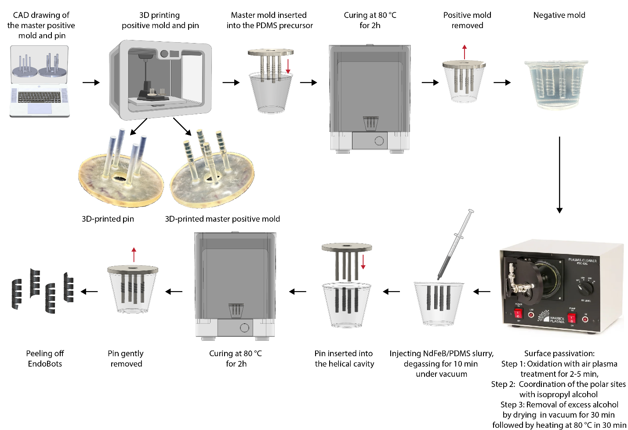
Figure S1. EndoBot fabrication process.

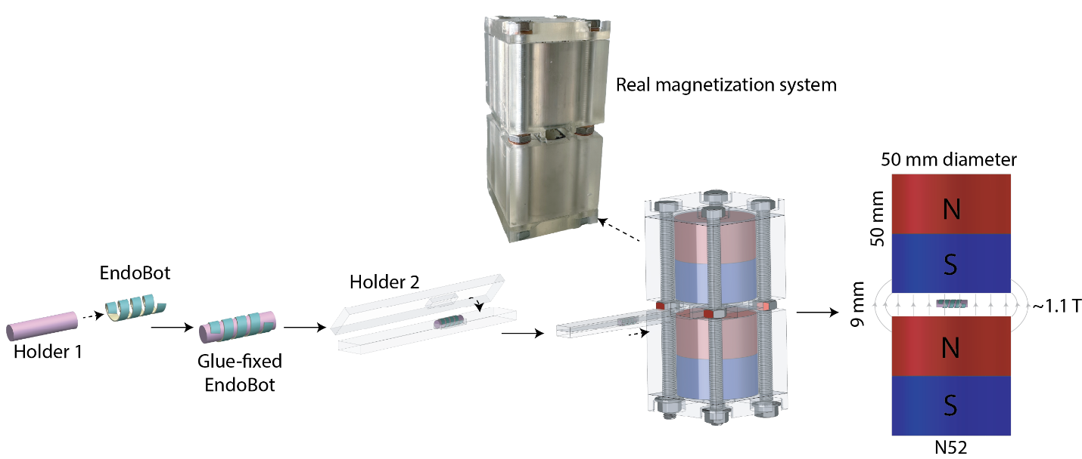
Figure S2. EndoBot magnetization process. To generate a strong and directionally well-controlled M_{r}, EndoBots were subjected to high uniform magnetic field (~1.1 T) using a custom build magnetic yoke.

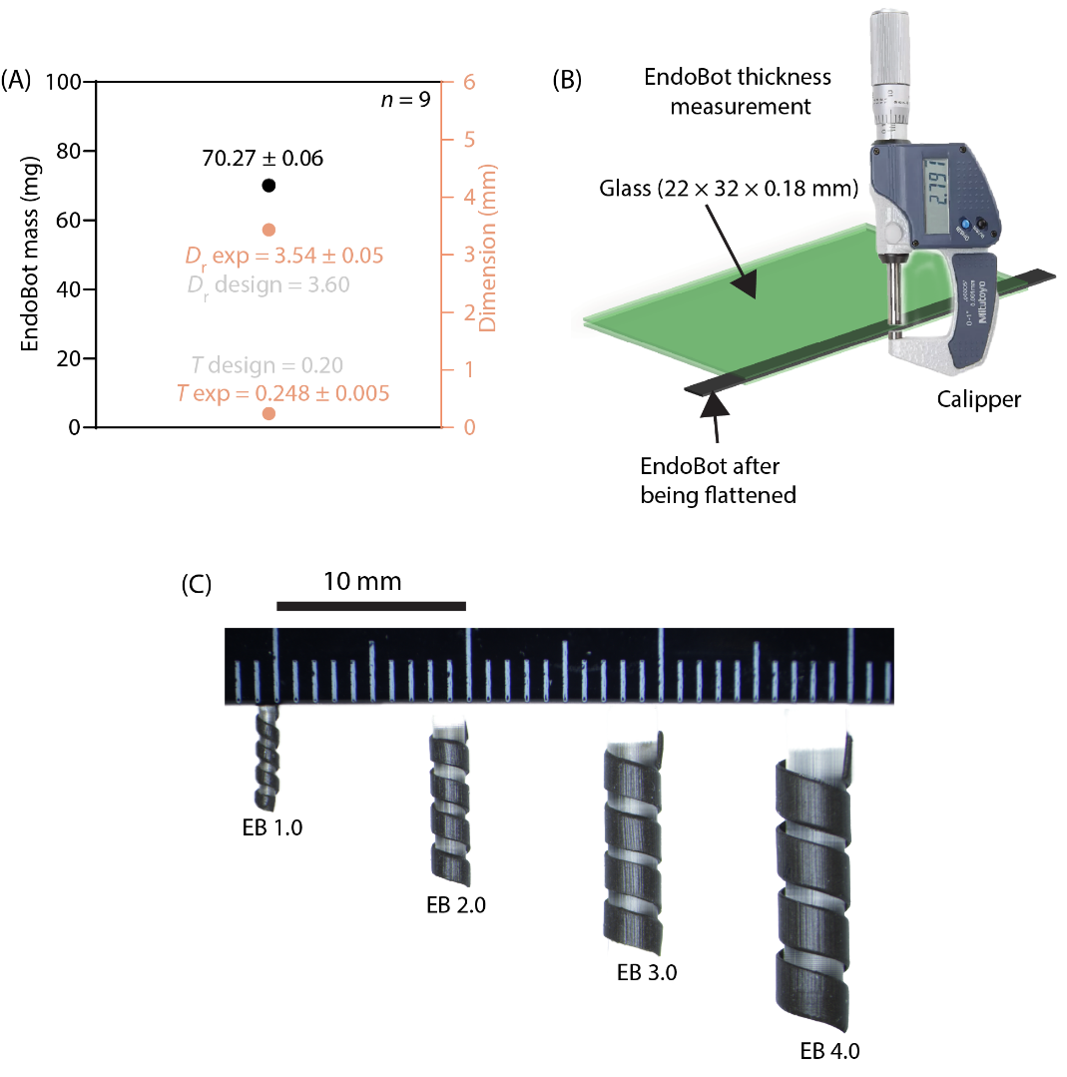
Figure S3. Consistency and scalability of the EndoBot fabrication method. (A) Precision and accuracy of the fabrication process. (B) EndoBot thickness was measured using a high precision digital micrometer (Mitutoyo Corporation, Kawasaki, Japan; accuracy: 0.001 mm). To ensure accurate measurement, the helical structure was first uncoiled and placed between two thin glass coverslips. The total thickness of the assembly (coverslips + EndoBot) was recorded. The EndoBot was then removed, and the combined thickness of the two coverslips was measured separately. The thickness of the EndoBot was calculated by subtracting the coverslip-only measurement from the total. (C) Scalable fabrication of EndoBots with diameters ranging from 1.0 to 4.0 mm.

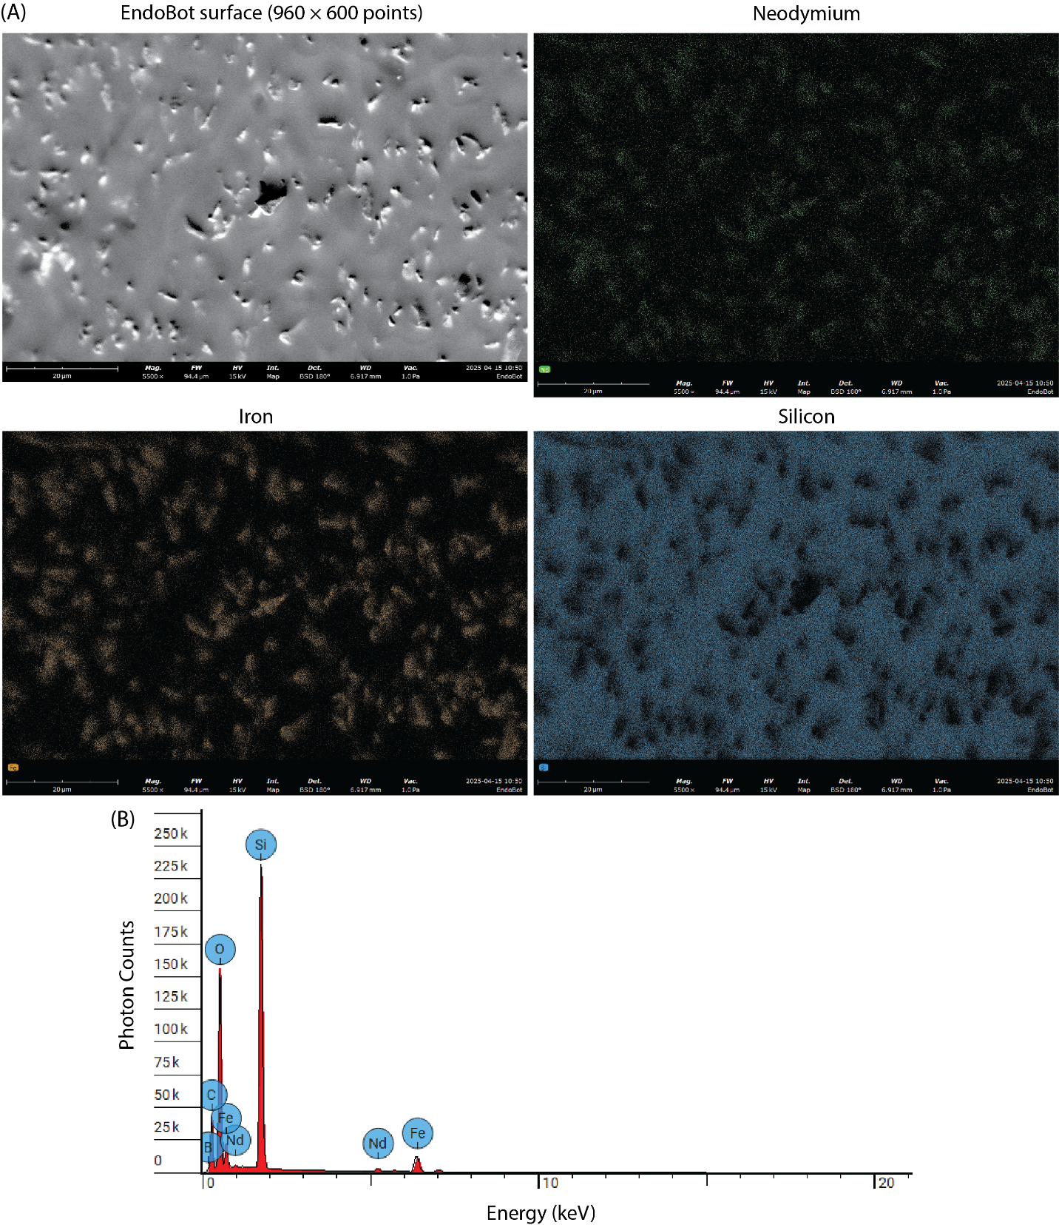
Figure S4. EDS characterization of an EB2.1 surface. (A) Scanning electron microscopy image using a back-scattered electron detector (180º). EDS mapping of Nd, Fe, and Si showing the distribution of the NdFeB particles within the PDMS matrix. (B) EDS spectrum.

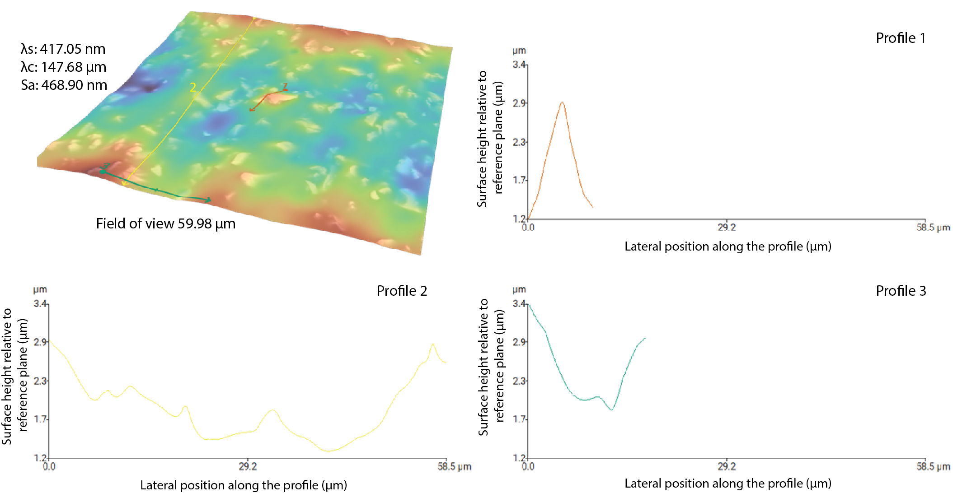
Figure S5. Topographical analysis of an uncoated EB2.1 surface.

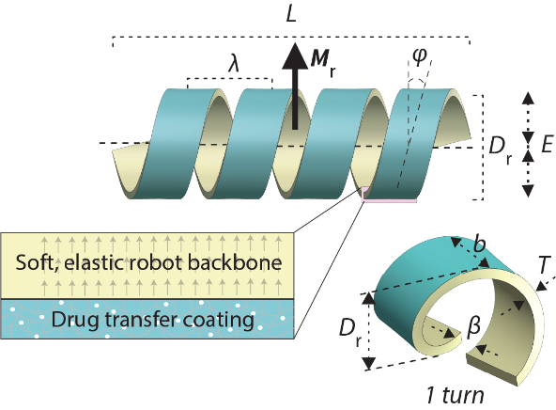
Table S2. Key structural parameters of the mechanically adaptive surface-crawling EndoBot.
Parameters | Nominal value  (as fabricated) | Range of change during successful motion | Function | Justification base
⁽¹⁾ ${D_{r}}/{D_{c}}$ | N/A | 1.1 - 1.5 | Mechanical adaptation | Figs. 2, 7,  S48-51
⁽²⁾ $L$/$D_{r}$ | 3.3 | 3.3 - 7.0 | Magnetic torque distribution | Adopted from (20-22)
$$\frac{L}{}$$ | 4.8 | 4.8 - 6.7 | Adaptive distribution of the cross-sectional stress across the robot body | Figs. 2, 4, 7, 9, S47-S51
⁽³⁾ $T∝D_{r}^{0.49}$ | N/A | N/A | Impose mechanical cost to unintended deformation, high blood-flow stability | Supplementary text 3
$$\frac{b}{β}$$ | 2.6 | 2.6 – 3.0 | Maximizing contact interaction surface of the robot | Fig. S12
 | 14° | 14° | High blood-flow patency  High lumen contact | Fig. S12
⁽¹⁾ D_{c} is the actual EndoBot diameter under compressive deformation.
⁽²⁾ Calculation of EndoBot length:
L = number of turns × helical pitch length + 2 × half of helical blade thickness
= number of turns × λ + 2 × b/2
⁽³⁾ T = 0.2 mm was optimized for EB3.6 (Supplementary text 2). We then scaled the robot thickness with the nominal robot diameter based on the scaling analysis and experimental validation in Supplementary text 3.

Supplementary Text 2: Design and refinement of EndoBot

Radial Force Evaluation: Parallel Plate Compression vs. Circumferential Compression
Although radial pressure from the vascular environment is distributed circumferentially, flat-plate compression is a widely accepted experimental proxy to evaluate radial stiffness for soft and symmetric structures. Similar to prior studies on compliant stents (23), the symmetry and material compliance allow deformation to distribute radially under uniaxial compression, providing a representative measure of radial resistance.
To evaluate the radial force of the EndoBot under mechanical compression, two distinct methods were employed: (1) parallel plate compression, mimicking a typical mechanical test using a load cell; and (2) circumferential compression, simulating uniform radial loading analogous to in vivo vascular constraints.

Parallel Plate Compression
In the first method, the EndoBot was compressed between two rigid flat plates along a Cartesian axis (e.g., x-axis) as shown in Fig. S6a. The reaction force measured at one of the plates (either by simulation or load cell in experiment), reliably represents the axial mechanical resistance of the EndoBot under symmetric deformation.:
$F_{radial}= \int_{S}{T_{s}·n dS}$ (1)
where: ​T_{s} is stress tensor; ​n is the unit normal vector of the contact surface (in this case, aligned with the compression direction); S is the surface area of contact between the EndoBot and the plate.
This reaction force is identical to what a load cell would measure in physical testing, as load cells operate by measuring the net force transmitted through a mechanical interface. For symmetric structures like the EndoBot, and in the absence of significant friction or lateral constraints, this axial reaction force indirectly reflects the internal radial resistance due to lateral bulging of the soft material.

Circumferential Compression
The second method applies uniform radial compression on the EndoBot's entire outer surface (Fig. S6b), resembling in vivo vascular loading. In this case, no direct plate reaction force exists. Instead, the radial force is computed by integrating the radial component of the stress tensor across the entire outer surface of the EndoBot:
$F_{radial}= \int_{S}{p_{r} dS}$ (2)
where $p_{r}$ is radial pressure defined as the component of the internal stress tensor projected onto the radial direction in the xz-plane (assume that EndoBot alongs the y-axis). It quantifies the distributed normal stress acting perpendicularly from the center of the object outward along the radial vector. Mathematically, it is expressed as:
​
$$p_{r}= \frac{x}{r}·{}_{xx}+\frac{z}{r}·{}_{xz}$$
Where ${}_{xx}$ and ${}_{xz}$are components of the Cauchy stress tensor in Cartesian coordinates, and $r=\sqrt{x^{2}+z^{2}}$ is the distance from the radial axis to the evaluation point.
This expression captures the true radial component of internal stresses under symmetric confinement.
Fig. S6c compares the radial forces obtained from both methods. Although the two approaches involve different loading and measurement mechanisms, under the assumptions of material symmetry, uniform deformation, and small strain, the total force measured from the plate in parallel compression can approximate the total radial resistance derived from circumferential compression. (The radial force in circumferential compression is approximately 1.1 times greater than that in flat-plate compression). Therefore, flat-plate compression was employed in this study as a practical method for measuring radial force, primarily due to the unavailability of a setup capable of performing circumferential compression.

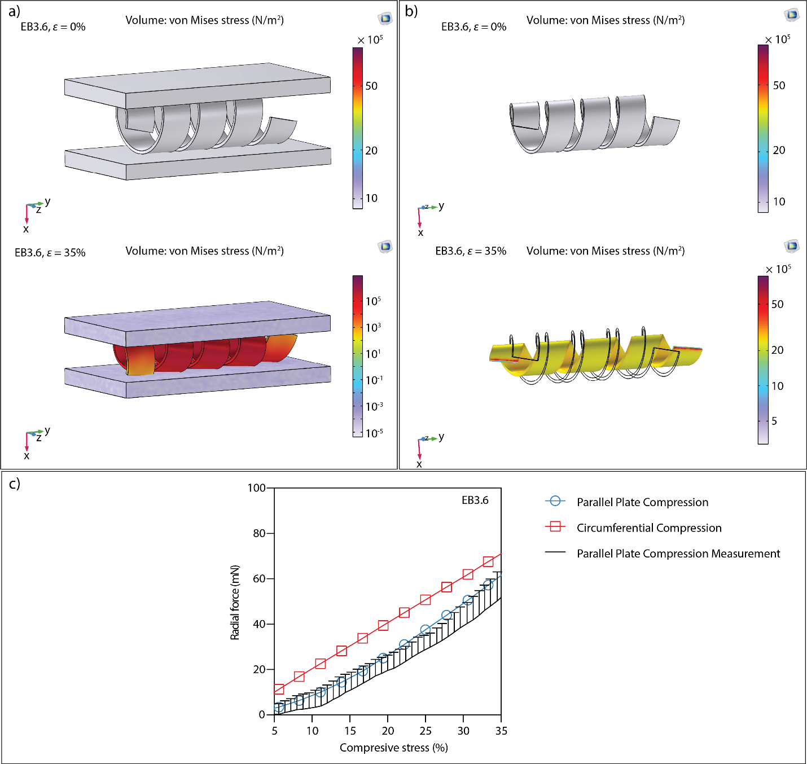
Figure S6. Radial Force Evaluation: Flat-Plate Compression vs. Circumferential Compression. (a) Flat-plate compression simulation for EB3.6 at ε = 0% and ε = 35%. (b) Circumferential compression for EB3.6 at ε = 0% and ε = 35%. (c) Comparison of radial forces measured by both methods.

Refinement Approach
The mechanical behavior of EndoBot is primarily governed by its effective elastic modulus (E) along the cross-section of its helical axis. It critically influences key performance characteristics:
(1) The radial force exerted by EndoBot on the vessel lumen
(2) Its ability to dynamically conform to vascular irregularities and navigate anatomical variations, (3) Its robustness during corkscrew locomotion under magnetic actuation; and
(4) Its stability under physiological blood flow,

To tailor E effectively, and maximize these functional outcomes, we systematically refined three core structural and compositional parameters below:

Refinement 1: EndoBot Thickness (T)
T was systematically varied at 0.1, 0.2, and 0.4 mm, while maintaining a fixed NdFeB:PDMS mass ratio of 4:1 and a base:crosslinker mass ratio of 10:1.

Refinement 2: Magnetic Powder-to-Elastomer Ratio
The NdFeB:PDMS mass ratio was varied at 1:1, 2:1, and 4:1 while maintaining a fixed base:crosslinker mass ratio of 10:1 and a fixed T of 0.2 mm.

Refinement 3: PDMS Crosslinker Ratio
The base:crosslinker mass ratio was varied at 2:1, 5:1, and 10:1 while maintaining a constant NdFeB:PDMS mass ratio of 4:1 and a fixed T of 0.2 mm.

Through these systematic variations, we evaluated the resulting performance using five key outcome measures below:

Outcome Measure 1: Radial Force (F_{radial}) (Fig. S7):
The total radial force generated by EndoBot is the sum of intrinsic elastic and extrinsic magnetic forces:
F_{radial} = F_{intrinsic} + F_{extrinsic} (3)

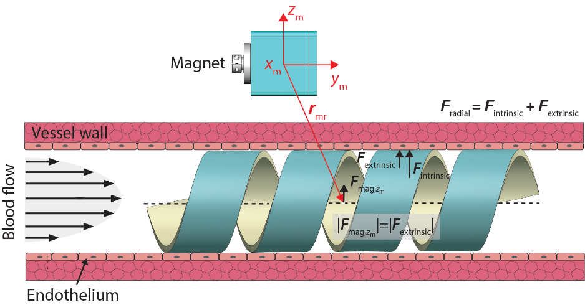
Intrinsic force (F_{intrinsic}) originates from stored elastic energy resulting from compressive strain ε, and scales proportionally with EndoBot thickness and NdFeB:PDMS mass ratio:

Fig. S7A, D reveals that
|F_{intrinsic}| ∝ E ∝ T^{3.05}, ∝ (NdFeB:PDMS mass ratio)^{1.05}, ∝ ε

Extrinsic force (F_{extrinsic}) is generated by the radial magnetic pulling force applied in the z_{m}-direction. This force is calculated using the magnetic force density relation:
$F_{mag}\left(r_{mr}\right)=\left(M_{r}∙∇\right)B\left(r_{mr}\right)$ (4)

where, $F_{mag}$ is the magnetic pulling force, $r_{mr}$ is the position vector of the EndoBot in the magnet-centric local coordinate system (x_{m}-y_{m}-z_{m}), $M_{r}$is the magnetization of EndoBot, and $∇B$ is the spatial gradient of the magnetic flux density B.

Fig. S7B, C reveals that
|F_{extrinsic}| ∝ ${|F}_{mag}|$ ∝ |$M_{r}|$ ∝ T, ∝ (NdFeB:PDMS)^{0.78}

At maximum compression (ε = 35%) and field strength (|B| ~145 mT), an EB3.6 configuration with T = 0.4 mm and NdFeB:PDMS = 4:1 resulted in |F_{radial}| ≈ 421 mN, corresponding to a radial pressure of ~5.4 kPa, which corresponds to around half of the pressure threshold required for endothelial rupture:
$Radial pressure=\frac{\left|F_{radial}\right|}{Outer surface area of EndoBot}$ (5)

Outcome Measure 2. Recovery Rate After Compressive Strain (Fig. S8):
As shown in Fig. 2C, each EndoBot was subjected to compressive load with ε linearly increasing from 0%−40% in 10 s using UniVert S2 mechanical tester (CellScale, Canada). Following the unloading, recovery of the EndoBot diameter was quantified as follows:

$Recovery Rate \left(\%\right)=100 × (1-\frac{D_{r}- D_{rec}}{D_{r}}$) (6)

where D_{rec} is the measured robot diameter following the unloading.

Outcome Measure 3: Conformal Deformation Capacity Under Magnetic Propulsion (Fig. S9):
Using a blood-filled conical vessel model (A-labelled, Table S6), the conformal deformation capacity (C) of EB3.6 was assessed under constant magnetic actuation parameters (~145 mT, ~30 Hz).
C ∝ T, ∝ log(NdFeB:PDMS)

Outcome Measure 4: Vascular Patency (Fig. S10):
The impact of T on vascular patency (S) was defined as the percentage of the lumen cross-sectional area not occupied by EndoBot, thereby allowing uninterrupted blood flow:

$S \left(\%\right)=100 × (\frac{S_{lumen}-S_{project}}{S_{lumen}}$) (7)

where S_{project} is cross-sectional area occupied by EndoBot and S_{lumen} is the total cross-sectional area of the vessel lumen.
S ∝ T^{x}, with x being -0.28, -0.32 and -0.49 for ε = 0%, ε = 10%, ε = 35% respectively. This shows that vascular patency has a higher sensitivity to compression with increased Endobot thickness.

Outcome Measure 5: Hydrodynamic Stability Under Blood Flow (Fig. S11):
The static stability of EB3.6 variants was evaluated by gradually increasing luminal flow rates in the absence of external magnetic fields, until the device starts dislocating due to elevated fluid drag. We observed that the stability improves with increasing T, primarily due to a corresponding increase in the F_{intrinsic} generated by elastic deformation. The resulting higher normal contact force at the device-lumen interface enhances friction, delaying the onset of the passive device migration. Please see Supplementary texts 5 and 6 for friction and drag force modeling.

Comparative Evaluation of Outcome Measures Across Design Parameters (Table 3): The three structural and compositional refinement parameters, T, NdFeB:PDMS mass ratio, and base:crosslinker mass ratio jointly influence the mechanical performance of EndoBot, shaping its elasticity, stability, conformability and vascular patency. Table S3 summarizes the performance outcomes from the refinement process. Optimizing these parameters involves balancing functional and performance trade-offs to ensure safest and most effective navigation and drug delivery within the established limits.
EndoBot thickness was found to be the most influential parameters governing mechanical deformation. Since the effective elastic modulus scales nearly cubically with the robot thickness (E ∝ T^{3.05}), even modest increases in thickness substantially increases intrinsic radial force (|F_{intrinsic}| ∝ T^{3.05}), enhancing structural rigidity and recovery after deformation.
Performance at T= 0.1 mm: While EB3.6 exhibited high conformal deformation capacity up to 47% and highest vascular patency (~83-88%, ε=10-35%), low radial force compromised hydrodynamic stability with flow-induced device migration occurred at 90 mL/min (ε=10%), and recovery after compression was severely limited (~87.2%). Uncontrolled internal deformations within the vessel during magnetic actuation were also frequently observed (Fig. S9), indicating insufficient structural integrity and unpredictable operational safety challenges.
Performance at T= 0.4 mm: It substantially enhanced mechanical properties with recovery rate reaching ~98%, and flow stability improved significantly (>150 mL/min- beyond our pump capacity). However, the conformal deformation capacity dropped sharply to ~28%, limiting adaptive crawling capacity. Moreover, vascular patency declined down to ~42% (ε=35%), increasing the risk of device-induced embolization. Although the total achievable radial pressure (~5.6 kPa, ε=35%) remained below the endothelial damage threshold (~12 kPa), it was relatively high and may raise safety concerns under unanticipated and dynamic vascular scenarios, such as vasoconstriction.
Optimal Design at T= 0.2 mm: It offered high structural fidelity under magnetic actuation throughout the study, exhibited low radial pressure (≤ 1 kPa, ε=35%), high flow resistance (≥ 120 mL/min, ε=10%) and recovery after compressive strain (~94%) while maintaining high deformation capacity (~42%) and vascular patency (~68-76%, ε=10-35%). This configuration minimized excessive vessel contact pressures while preserving magnetic actuation efficiency and adaptive geometry.
NdFeB:PDMS mass ratio was another, yet less impactful, mechanical tuning parameter to improve the effective elastic modulus of EndoBot (|F_{intrinsic}| ∝ (NdFeB:PDMS mass ratio)^{1.05} ), and its stability against blood flow. A key advantage of this approach was, however, is to improve the device performance without detrimenting vascular patency as opposed to thickness tuning. Within the soft elastomeric body, NdFeB powder functioned as mechanical reinforcement, increasing structural stiffness as its relative concentration rose. This led to a corresponding increase in intrinsic radial force and pressure (from 0.1 kPa to 1.0 kPa), which in turn enhanced resistance to luminal flow. A caveat is that this reinforcement also slightly reduced the ability to deform effectively with magnetic actuation, from 50% down to 42%.
An additional and substantial benefit of increased NdFeB content was enhanced radio-opacity (Fig. 7B). EndoBot constructed with a 4:1 NdFeB:PDMS ratio exhibited superior X-ray visibility, exceeding the clinical imaging standard provided by Omnipaque™. This feature is critical for real-time fluoroscopic tracking and clinical translation.
Therefore, by balancing improved flow stability, acceptable structural stiffness, and exceptional fluoroscopic visibility, we selected 4:1 NdFeB:PDMS ratio as the optimal formulation for the yield design.
PDMS base-to-crosslinker ratio was useful to fine tune the elasticity of EndoBot, allowing for reductions in radial pressure and improvements in conformal deformation capacity without compromising X-ray visibility (as opposed to NdFeB:PDMS ratio) and vascular patency (as opposed to tuning T). Notably, variations in the base-to-crosslinker ratio had minimal impact on recovery rate after compressive strain and stability under blood flow.
As a result, we selected 10:1 base-to-crosslinker ratio as the optimal formulation, which consistently yielded the lowest radial pressure and highest conformal deformation, and hence was selected as the optimal formulation for elastic fine-tuning in the final device design.

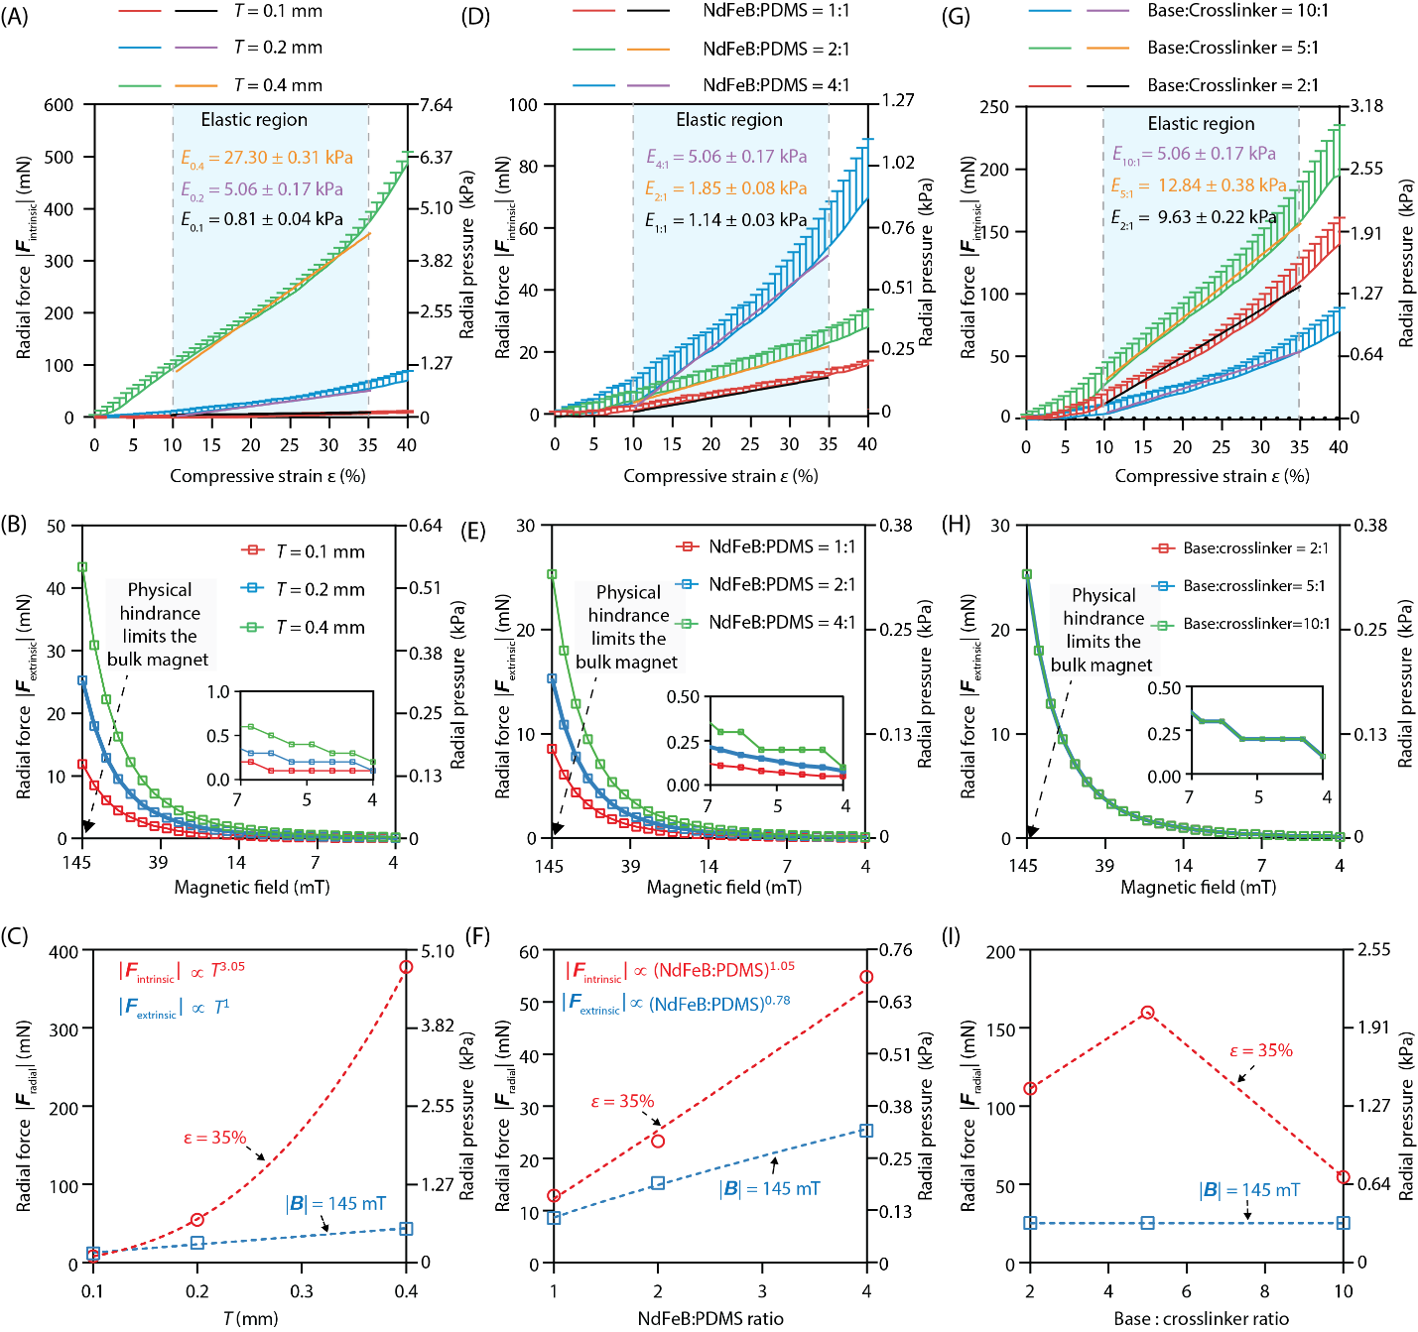
Figure S7. Intrinsic |F_{intrinsic}| and extrinsic |F_{extrinsic}| radial force dynamics of EB3.6. (A) (B) and (C) Radial forces with respect to the EndoBot thickness. E_{0.1}, E_{0.2} and E_{0.4} denote the effective elastic modulus with 0.1-, 0.2- and 0.4-mm Endobot thickness. (D), (E) and (F) Radial forces with respect to the NdFeB:PDMS mass ratio. E_{1:1}, E_{1:2} and E_{4:1} denote the effective elastic modulus with 1:1 2:1 and 4:1 NdFeB:PDMS mass ratio. (G), (H) and (I) Radial forces with respect to base:crosslinker mass ratio. E_{2:1}, E_{5:1} and E_{10:1} denote the effective elastic modulus with 2:1 5:1 and 10:1 base:crosslinker mass ratio. All linear fitting lines have R² > 0.98.

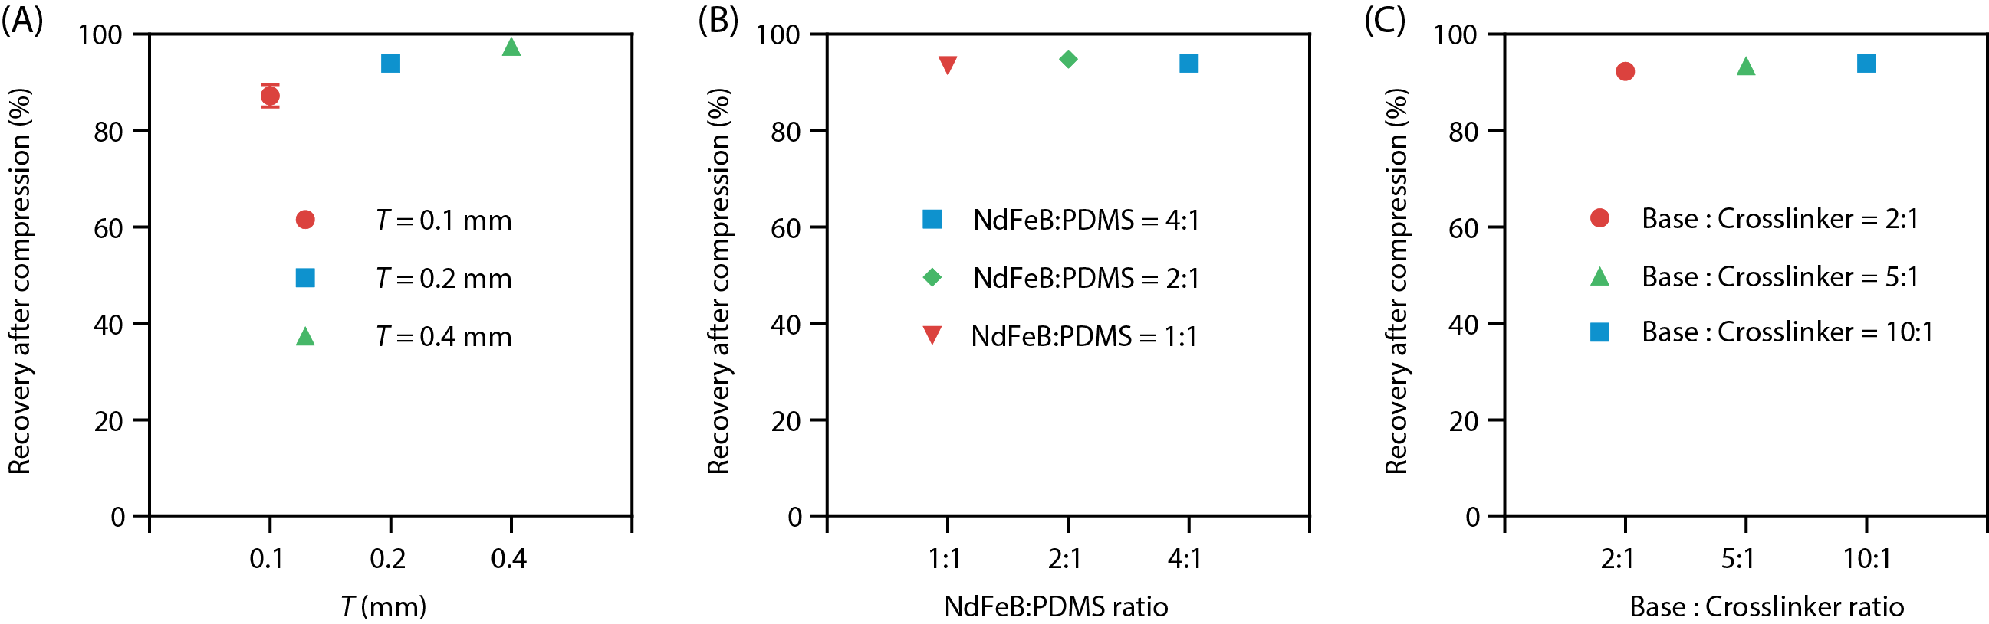
Figure S8. Recovery rate after compressive load. (A) Refinement 1, (B) Refinement 2, (C) Refinement 3 using EB3.6 as the model design.

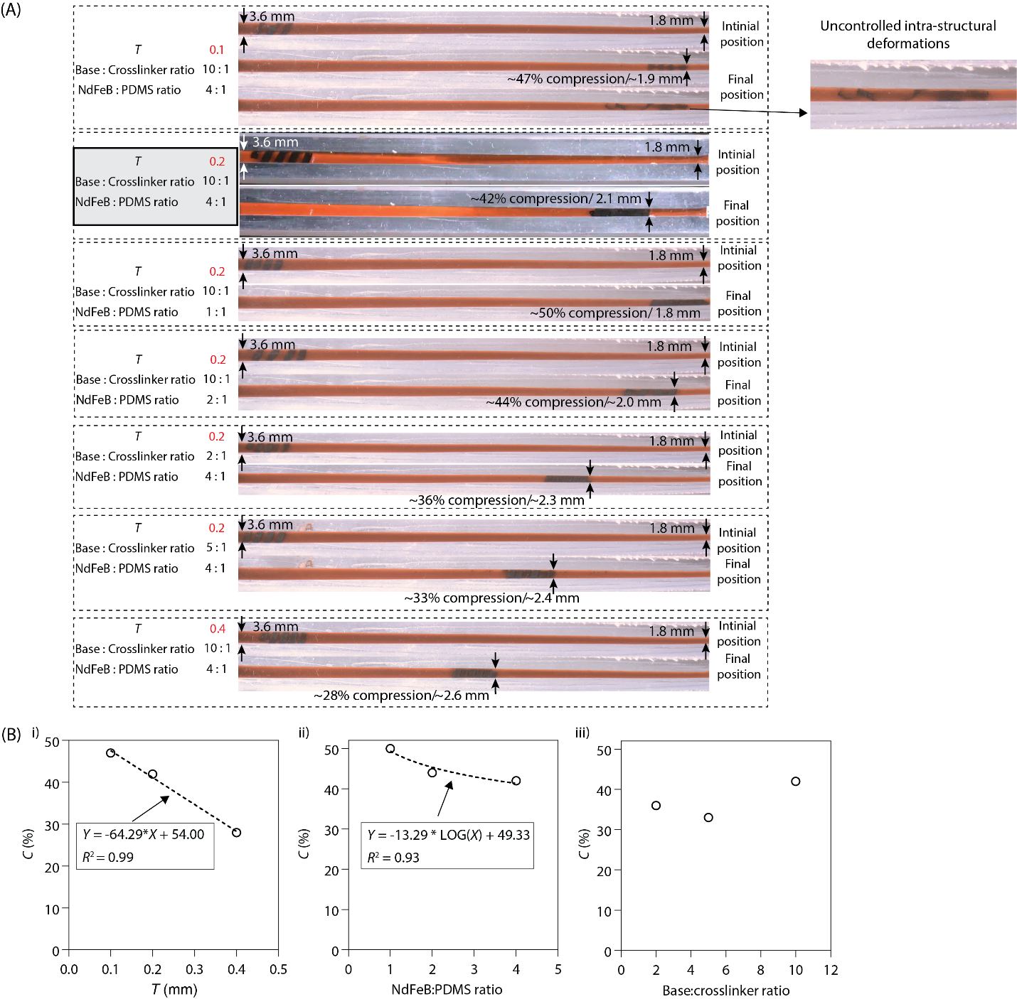
Figure S9. Measuring conformal deformation capacity (C) under magnetic propulsion using a conical phantom vessel. (A) EB3.6 with varying T, NdFeB:PDMS and base-to-crosslinker mass ratios were systematically assessed under comparable magnetic actuation conditions. The initial magnetic field was set at 4 mT and gradually increased as the vessel diameter decreased up to ~145 mT while the actuation frequency was kept constant (30 Hz). (B) Plots of deformation capacity as a function of (i) T, (ii) NdFeB:PDMS mass ratios, and (iii) base-to-crosslinker mass ratios.

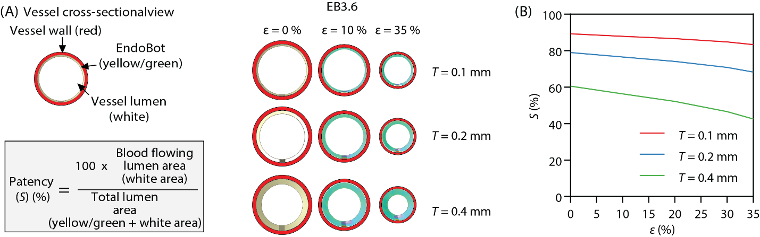
Figure S10. The impact of EndoBot thickness on the vascular patency. (A) Illustration of the patency for EB3.6 designs with varying T under compressive strain. (B) Patency of EB3.6 as a function of its thickness and compressive strain.

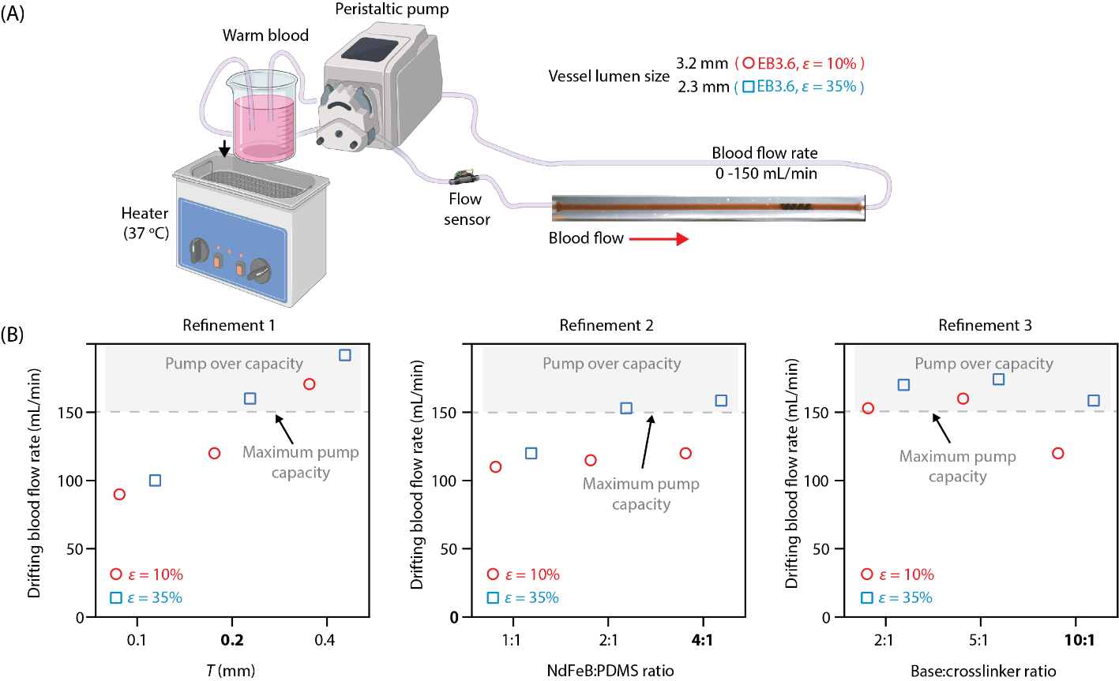

Figure S11. Static stability of EndoBot under blood flow with intrinsic friction forces without the assistance of external magnetic fields.

Table S3. Summary of performance outcomes from EndoBot structural and compositional refinements
T | 0.1 mm |  |  | 0.2 mm |  |  | 0.4 mm
ε | 10% | 35% |  | 10% | 35% |  | 10% | 35%
Radial pressure | 0.2 kPa | 0.3 kPa |  | 0.4 kPa | 1.0 kPa |  | 1.8 kPa | 5.4 kPa
Stability under blood flow rate without the assistance of external magnetic fields | 90 mL/min | 100 mL/min |  | 120 mL/min | >150 mL/min |  | >150 mL/min | >150  mL/min
Conformal deformation capacity | 47% |  |  | 42% |  |  | 28%
Recovery rate after compression | 87.2% |  |  | 94.0% |  |  | 97.5%
Vascular patency | 87.9% |  | 83.4% | 76.6% |  | 68.2% | 56.2% |  | 42.5%

NdFeB:PDMS ratio: | 1:1 |  |  | 2:1 |  |  | 4:1
ε | 10% | 35% |  | 10% | 35% |  | 10% | 35%
Radial pressure | 0.1 kPa | 0.3 kPa |  | 0.2 kPa | 0.5 kPa |  | 0.4 kPa | 1.0 kPa
Stability under blood flow rate without the assistance of external magnetic fields | 110 mL/min | 120 mL/min |  | 115 mL/min | >150 mL/min |  | 120 mL/min | >150  mL/min
Conformal deformation capacity | 50% |  |  | 44% |  |  | 42%
Recovery rate after compression | 93.5% |  |  | 94.9% |  |  | 94.0%
Vascular patency | 76.6% |  | 68.2% | 76.6% |  | 68.2% | 76.6% |  | 68.2%

Base:crosslinker | 2:1 |  |  | 5:1 |  |  |  | 10:1
ε | 10% | 35% |  |  | 10% | 35% |  |  | 10% | 35%
Radial pressure | 0.5 kPa | 1.7 kPa |  |  | 0.7 kPa | 2.4 kPa |  |  | 0.4 kPa | 1.0 kPa
Stability under blood flow rate without the assistance of external magnetic fields | >150 mL/min | >150 mL/min |  |  | >150 mL/min | >150 mL/min |  |  | 120 mL/min | >150  mL/min
Conformal deformation capacity | 36% |  |  |  | 33% |  |  |  | 42%
Recovery rate after compression | 92.3% |  |  |  | 93.4% |  |  |  | 94.0%
Vascular patency | 76.6 |  | 68.2 |  | 76.6 |  | 68.2 |  | 76.6 |  | 68.2

Supplementary Text 3: On the Scalability of EndoBot
We assessed the scalability of the EndoBot design using two primary outcome measures:
- Conformal Deformation Capacity: the capability of EndoBot to adapt conformally to vessel narrowing through deformation.
- Elastic Recovery Rate: the extent and reliability of EndoBot for elastic recovery following compressive strain.

1. Conformal Deformation Capacity: We hypothesized that the maximum deformation capacity of EndoBot ($ℇ_{max}$), under magnetic actuation, is independent of the EndoBot size. This scale independence is also integral to validate our Operational Limit Rule 2, ensuring adaptive passage where EndoBot is operated under a maximum of 35% compression.
To test this hypothesis and identify the relevant design parameters, we used a conical-shaped phantom vessel similar to Fig. 9 (A-typed vessel in Table S6) as a model platform. As EndoBot moves in this vessel, it conformally adapts to vessel narrowing by elastic deformation. This deformation stores elastic energy ($U_{elastic}$), which is driven by the magnetic actuation.
As described in Supplementary Text 2, the mechanical properties of EndoBot can be modulated through three key parameters: (1) EndoBot thickness $T$ (2) the ratio of NdFeB to PDMS, and (3) the base-to-crosslinker ratio in the elastomer matrix. Among these parameters, thickness was identified as the most influential, with the intrinsic force scaling:
$${|F}_{intrinsic}|∝ T^{3.05}$$
Therefore, uniform geometric scaling is not appropriate for EndoBot. Instead, the thickness should be selectively adjusted according to:
T $∝D_{r}^{a}$ where $0<a <1$

Magnetic Actuation Energy: Magnetic actuation of EndoBot relies on torque generated by the interaction between its internal magnetization and an externally applied rotating magnetic field. Consequently, the magnetic energy required per actuation cycle ($U_{cycle}$) can be expressed as:
$U_{cycle}=2π{|M}_{r}||B|\sin\left(δ\right)$ (6)
where $M_{r}$ is the magnetization of the EndoBot; $B$ represents the magnitude of the externally applied magnetic field flux; and $\sin\left(δ\right)$ is the sine of the constant angular lag angle $δ$ between the robot’s internal magnetization direction and the direction of the external magnetic field during steady-state synchronous rotation.

Given that $M_{r}$ scales proportionally with the EndoBot volume, $M_{r}∝D_{r}^{a+2}$. Therefore, the magnetic energy required per actuation cycle also inherently exhibits cubic scaling:
$$U_{cycle}∝D_{r}^{a+2}$$

Elastic Energy Storage and Equilibrium: Maximum sustainable deformation occurs when magnetic energy input per rotation cycle equals the elastic energy stored in EndoBot:
$U_{cycle}=$ $U_{elastic}$ (7)

In a linear elastic regime, as experimentally confirmed in Figs. S7A and S13B, the elastic energy can be approximated by:
$U_{elastic}= \frac{1}{2}K∆x^{2}$ (8)

where $K$is the effective stiffness of EndoBot and $∆x$ is the absolute compressive displacement.

At maximum deformation, $ε_{max}$, the equilibrium condition is:
$2πM_{r}B\sin\left(δ\right)=\frac{1}{2}K∆x^{2}$ (9)

To assess deformation independently of size, we define dimensionless deformation as:
$ε_{max}=\frac{∆x}{D_{r}}$ (10)
Thus, equilibrium scales as:

$D_{r}^{a+2}∝K\left(ε_{max}^{2}D_{r}^{2}\right)⇒ \sqrt{\frac{D_{r}^{a}}{K}}∝$ $ε_{max}$

For $ε_{max}$ to be scale-independent, stiffness $K$ must scale as:
$$K∝D_{r}^{a}$$

Relating Stiffness and Thickness: Experimentally determined stiffness, $K$, relates to intrinsic force by:
$K=\frac{{|F}_{intrinsic}|}{∆x}$ (11)

Given that |F_{intrinsic}| ∝ T^{3.05} (Fig. S7C), then the equation scales as:
$$K∝ \frac{T^{3.05}}{D_{r}} ⇒ T∝{\left(KD_{r}\right)}^{1/{3.05}}$$

Since ${K∝D}_{r}^{a}$, it follows that:
$$T∝{\left(D_{r}^{a}D_{r}\right)}^{1/{3.05}} ⇒{T∝D}_{r}^{{\left(a+1\right)}/{3.05}}$$

Comparing the two-scaling relations T ∝ $D_{r}^{a}$ and T ∝ $D_{r}^{{\left(a+1\right)}/{3.05}}$:
$a=\frac{a+1}{3.05}⇒ a≈0.49$
Consequently, to maintain scale-independent maximum compression capacity under magnetic actuation, the EndoBot thickness should scale with nominal diameter as:
$$T∝D_{r}^{0.49}$$

To validate this scaling, we first fabricated EB1.5, EB2.1, EB2.8 and EB3.6 (Fig S1A, Table S4) with NdFeB:PDMS ratio of 4:1 and base:crosslinker ratio of 10:1, using scaling relations in Table S2. Fig. S13B shows the compressive strain-intrinsic force response of these EndoBots under dynamic compressive load. Analysis of these experimental results indicated a scaling relationship for effective stiffness given by $K∝D_{r}^{0.52}$ (Fig. S13C), closely aligning with our theoretical prediction and thereby confirming the validity of the proposed scaling approach.

2. Recovery After Compressive Strain:
Fig. S13D shows that EB1.5, EB2.1, EB2.8 and EB3.6 demonstrate comparable recovery of ~94% after compressive strain. This behavior supports scale-independent Operational Limit Rule 1: EndoBot must maintain at least 10% bias compressive strain (ε_{bias} ≥ 10%) along the target vessel.

We further validated the scale-independent conformal deformation capability of EB2.1 and EB3.6 (~42%). under comparable magnetic actuation conditions, with |B| is up to 145 mT and constant 30 Hz magnetic field rotation frequency (Fig. S14, Supplementary movie 1)

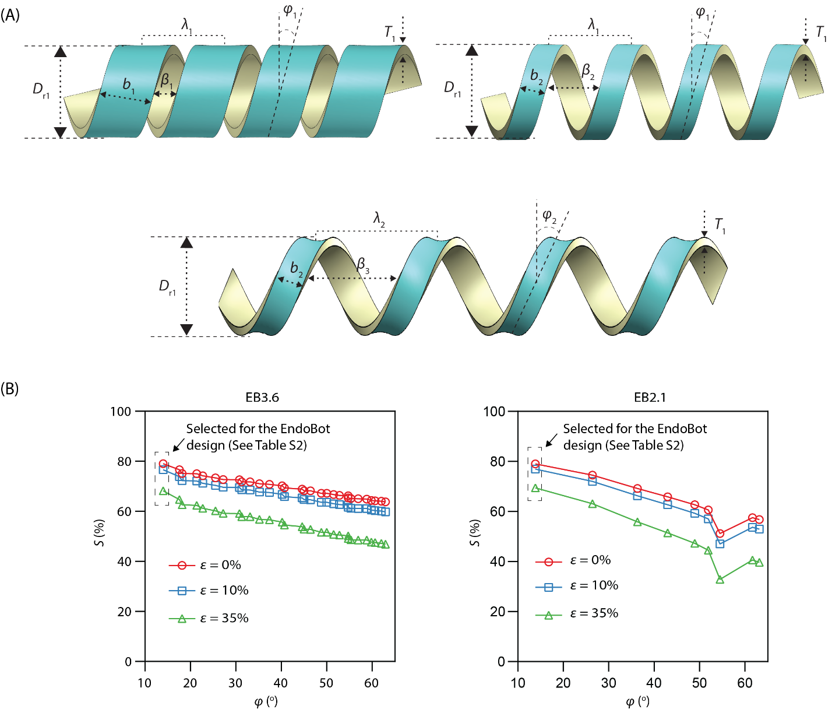
Figure S12. Refinement of the EndoBot design to enhance the interactive robot surface area for vessel lumen surface while maintaining maximal vascular patency. (A) Comparison of different EndoBot configurations with constant nominal robot diameter (D_{r}) and thickness (T), helical blade thickness (b), helical pitch length (λ), groove size (β), and helical angle (φ). To maximize the vessel contact, which is critical for robust crawling locomotion and effective drug transfer, b should be maximized, while β and φ minimized. With constant λ, decreasing b and increasing β reduce the total robot surface area. For constant b, increasing λ maintains overall robot surface area but increasing φ reduces effective interaction surface due to increased curvature of the robot. In the presented EndoBot configurations, the relative scalar sizes are as follows: λ₁ < λ₂, b₁ > b₂, β₁ < β₂ < β₃, and ϕ₁ < ϕ₂. (B) Vascular patency (S) dramatically decreases with increasing φ.

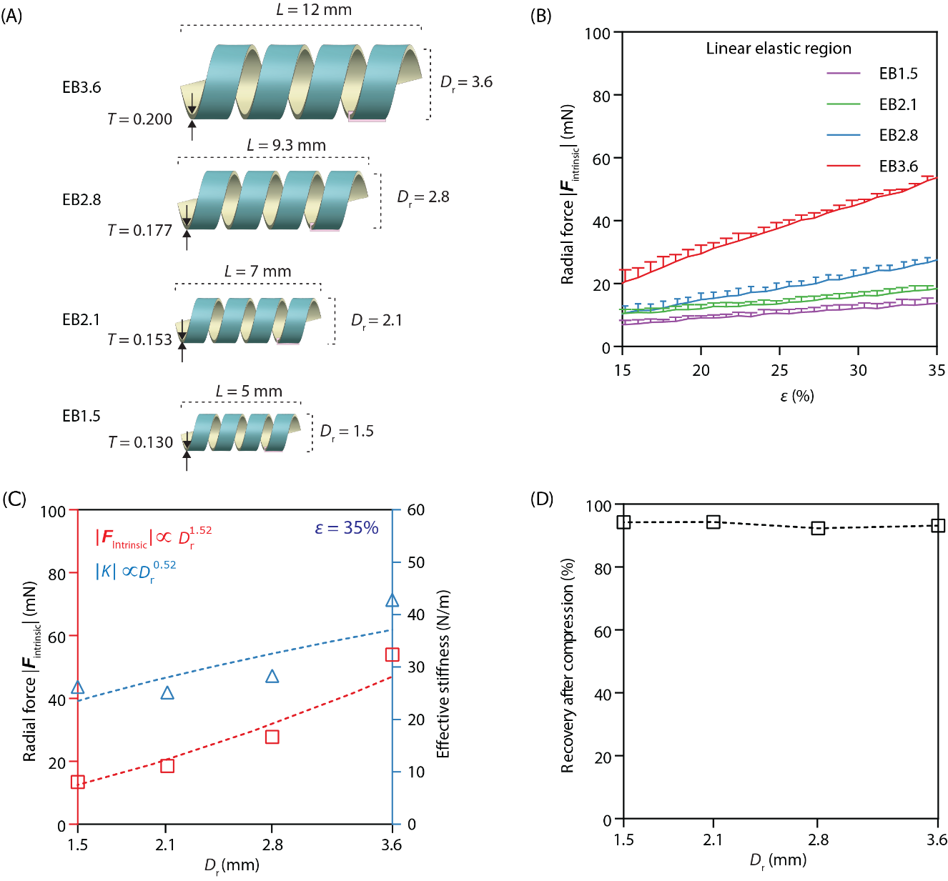
Figure S13. Radial force, and recovery after compression measurement when scaling EndoBot. (A) Changes in design parameters when EndoBot was scaled while keeping the NdFeB:PDMS ratio at 4:1 and the base:crosslinker at 10:1. (B) Intrinsic radial force |F_{intrinsic}| dynamics of EB3.6, EB 2.8, EB2.1 and EB1.5 with different ε from 0% to 40%. (C) Relationship between radial force (|F_{intrinsic}|) or effective stiffness K and different D_{r} at maximum ε of elastic region (ε = 35 %). (D) Recovery after compression 0-40%.

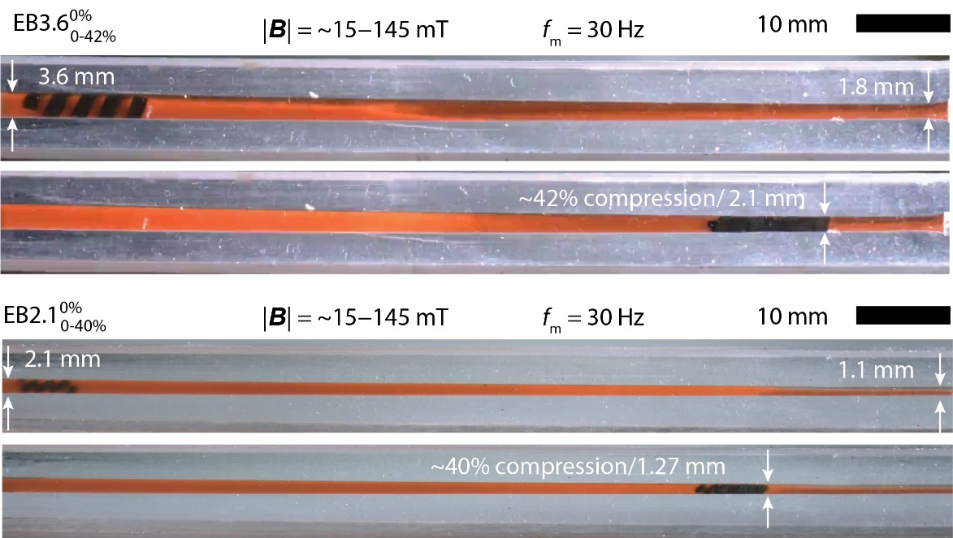

Figure S14. Scale-independent conformal deformation capacity of EndoBot for two robot sizes (EB2.1 and EB3.6).
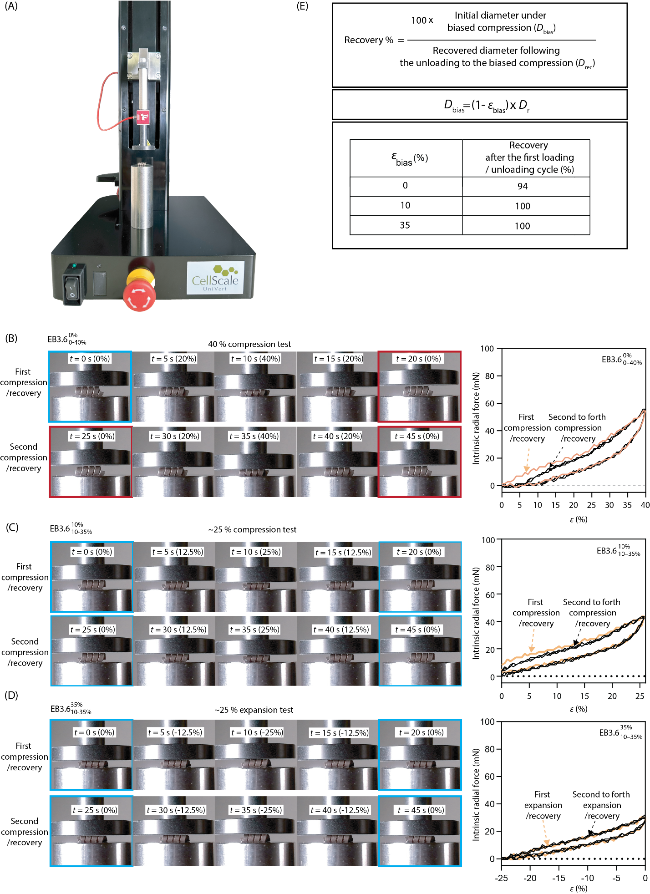
Figure S15. Recovery of EndoBot diameter following repetitive compressive strain. (A) Mechanical test instrument (Cellscale Univert with load cell 2.5 N) used for measuring the intrinsic radial force (equivalent to the stress resulting from the strain) exerted by EndoBot under compression. (B) Intrinsic radial force dynamics of ${EB}_{0-40\%}^{0\%}$ undergoing compression starting from 0% (ε_{bias} =0%), followed by a symmetric unloading back to 0% initial compression. (C) Intrinsic radial force dynamics of ${EB}_{10-35\%}^{10\%}$ undergoing further compression from 10% bias strain (ε_{bias} =10%) to 35% compressive strain, followed by a symmetric unloading back to 10% bias compression. The compressive strain value, ε, is re-set to 0 at ε_{bias} =10%. (D) Intrinsic radial force dynamics of ${EB}_{10-35\%}^{35\%}$ undergoing unloading from 35% to 10% (ε_{bias} =35%), followed by loading back to 35% bias compression. The compressive strain value, ε, is re-set to 0 at ε_{bias} =35%. Four cycles of testing were conducted for each sample (Fig 2Cii). Within each cycle, there was a preload phase of 0 s, a linear loading phase of 10 s, a hold phase of 0 s, an unloading phase of 10 s, and a rest phase of 5s. (E) Recovered robot diameter after the first loading and unloading cycle in the compression test under 0%, 10%, and 35% bias strain. 100% recovery to the biased diameter is critical to ensure the crawling locomotion along non-uniform vessel.

Table S4. Blueprints of EB1.5, EB2.1, EB2.8 and EB3.6 used in this study
Physical parameters | EB1.5 | EB2.1 | EB2.8 | EB3.6
Overall length, L (mm) | 5.0 | 7.0 | 9.3 | 12.0
Fabricated diameter, D_{r} (mm) | 1.5 | 2.1 | 2.8 | 3.6
Thickness, T (mm) | 0.130 | 0.153 | 0.177 | 0.200
Pitch length, λ (mm) | 1.04 | 1.46 | 1.94 | 2.5
Groove, β (mm) | 0.29 | 0.41 | 0.54 | 0.7
Helical blade thickness b (mm) | 0.75 | 1.05 | 1.4 | 1.8
Helical angle, ϕ (°) | 14 | 14 | 14 | 14
Surface area (mm²) | 13.6 | 26.7 | 47.5 | 78.5
PDMS base to crosslinker ratio | 10:1 | 10:1 | 10:1 | 10:1
NdFeB : PDMS ratio | 4:1 | 4:1 | 4:1 | 4:1
Magnetic moment × 10⁻³, |M_{r}| (A.m²) | 0.20 | 0.46 | 0.97 | 1.80

Table S5. Tabulated version of results summarized in Figure 2E and 2F
ε_{bias (%)} | Additional room for compression* (%) | Additional room for expansion** | Recovery after unloading***
0 | 35 | 0 ± 0.0 | 94 ± 0.6
10 | 25 | 5.5 ± 1.0 | 100 ± 0.0
15 | 20 | 8.5 ± 0.2 | 100 ± 0.0
20 | 15 | 13.0 ± 1.0 | 100 ± 0.0
25 | 10 | 18.0 ± 3.0 | 100 ± 0.0
30 | 5 | 22.0 ± 2.5 | 100 ± 0.0
35 | 0 | 24.0 ± 1.3 | 100 ± 0.0
* Additional room is the percentage calculated based on the nominal diameter of EndoBot. The total of additional room for compression and expansion is always lower than 35%. The difference indicates dissipated energy and, hence, a mild material hysteresis. This led us to conceptualize bias straining and Rule 1, so that we can ensure surface crawling.
** Additional room for expansion is the recovered diameter (D_{rec}) when the unloading cell reads 0 mN stress.
*** Recovery after unloading is the percentage recovery of the robot diameter (D_{rec}) compared to the initial diameter under biased compression ($D_{bias})$

Supplementary Text 4: Phantom vessel designs and fabrication

Table S6. Phantom vessels used in this study
Figure | Label | Design | Material
2F, S8, S13 | A | 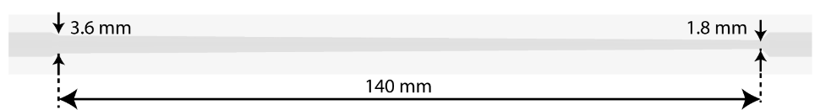 | PDMS
2G, 4C | B | 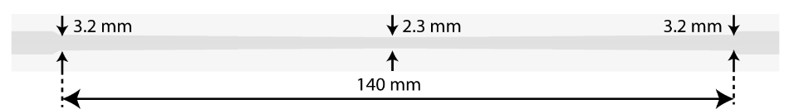 | PDMS
4A, 3B-C, 6C, S10, S25 | C | 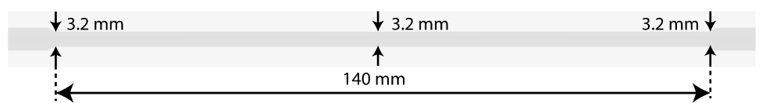 | PDMS
3B | D | 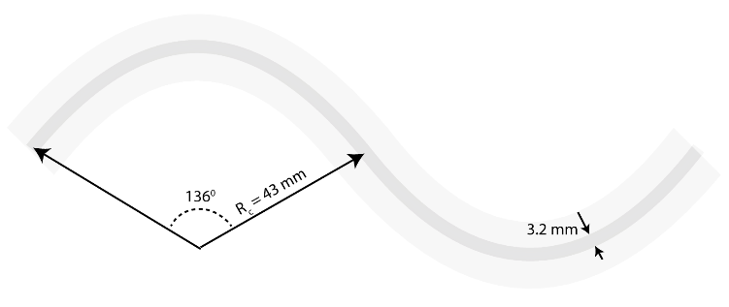 | PDMS
3B-C, S10 | E | 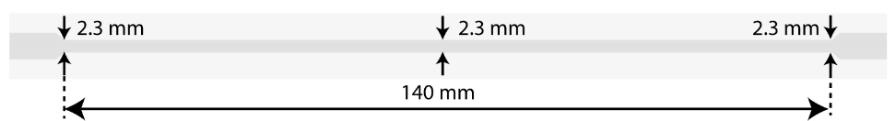 | PDMS
4D | F | Human arm size, cephalic vein-mimetic structure  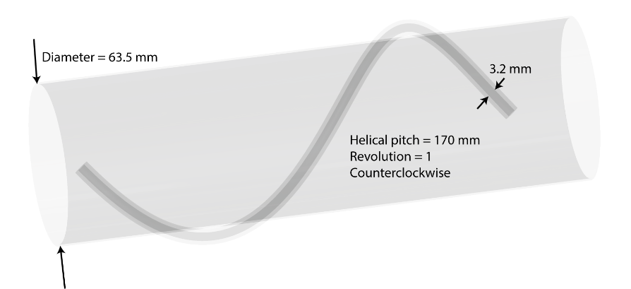 | commercial silicone tubing
S26 | G | 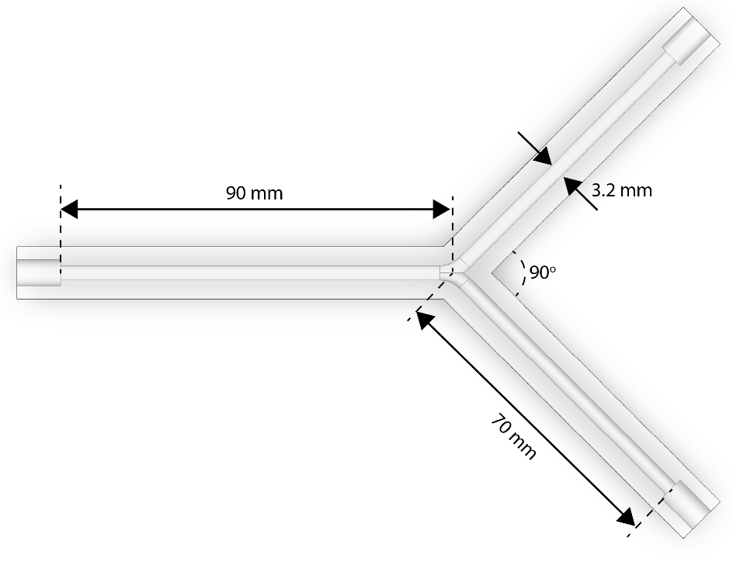 | PDMS

PDMS-Based Phantom Vessels: PDMS was used for constructing most of our phantom vessels due to following reasons:
- Mechanical stability and ease of molding/fabrication of the material with desired shapes and sizes,
- Comparable mechanical properties with human vessels (a Young’s modulus of 2.6 MPa for PDMS (24) compared to 1-3 MPa for human arteries(25, 26)),
- Widespread acceptance of biocompatibility and hemocompatibility in biomedical applications(27),
The fabrication process for PDMS-based vessels is illustrated in Fig. S16. Initially, a CAD mold was designed using SolidWorks. The mold, consisting of an internal and external part, was then 3D printed using the FormLabs 3B+ 3D printer. Subsequently, the mold was coated with non-adhesive Ease Release 200 spray (Mann Release Technologies, Macungie, PA, USA). The mold was then filled with a mixture of SYLGARD™ 184 Silicone Elastomer Base and Curing Agent, combined at a 10:1 mass ratio. After curing at 80°C for 2 hours, the internal mold was removed, and the cured PDMS was demolded from the external mold, resulting in the vessel phantom in its final form. Before experiment, the PDMS-based phantoms were placed in the plasma cleaner for 5 minutes, cleaned with ethanol for 30 minutes and then dried at 80°C for 30 minutes, which removed the wax residuals.

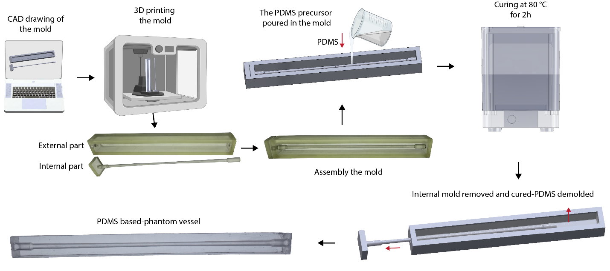
Figure S16. Fabrication of PDMS-based phantom vessels.

Silicone Tubing-Based Phantom Vessels: We constructed a 3D helical vessel labeled as F-labeled vessel phantom in Table S6. Given the challenges associated with using PDMS material for creating the 3D vessel phantom in this context, we opted for platinum-cured silicone tubing (16# LG-SIL-16#, Longer Pump, USA) with a diameter of 3.2 mm which also exhibits similar mechanical properties to those of vessels (with a Young’s modulus of around 0.2-1.2 MPa (28)). This silicone tube was wrapped around a plastic, arm-size tube (McMaster-Carr, USA) with a diameter of 63.5 mm. The tubing mimics a random anatomy of cephalic vein where EndoBot could be remotely moved inside using our current human-scale fluoroscopic-guided magnetic navigation platform.

Supplementary Text 5: Friction force modeling
The friction force applied on EndoBot is given by:
$F_{friction}{=F}_{friction,||}+F_{friction,}= {{}_{||}{|F}_{radial}|e}_{||}+{{}_{}{|F}_{radial}|e}_{}$ (12)

where F_{friction,||} and F_{friction,⊥} are the frictional forces parallel and perpendicular to the helix, respectively; e|| and e⊥ are the unit vectors in the parallel and perpendicular directions of the helix, respectively; μ|| and μ⊥ are coefﬁcient of friction (CoF) in the parallel and perpendicular directions, respectively. F_{radial}, F_{intrinsic}, F_{extrinsic} are described in Supplementary text 2. The CoFs were used from the reference (29). Depending on the mobility status of EndoBot, either static or kinetic CoF was used.
Fig. S17 shows friction forces applied on an EB3.6 undergoing up to 40% compressive strain. We estimate that the intrinsic friction force between the EndoBot and the PDMS-based vessel is approximately twice as high as that between the EndoBot and a human vein vessel.
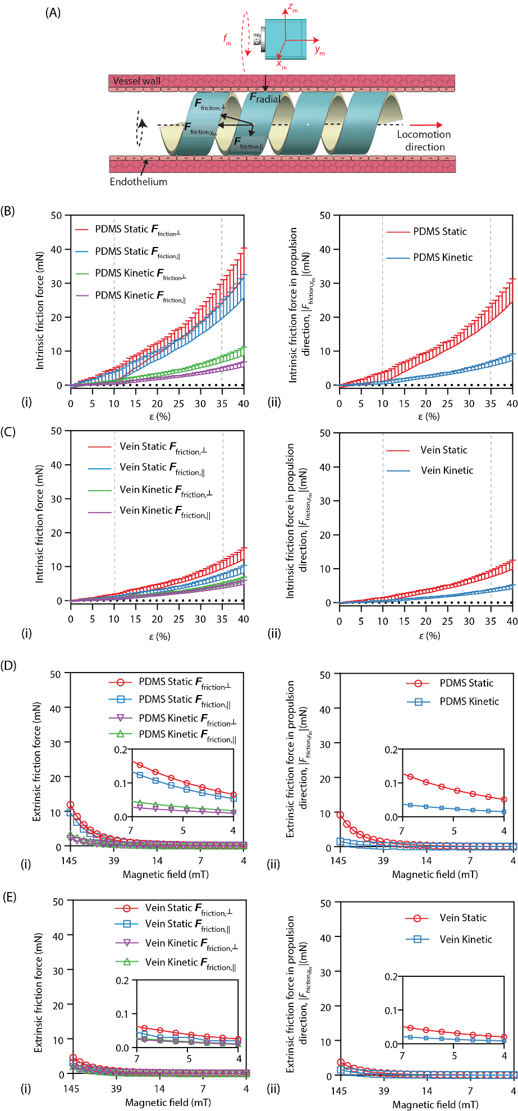
Figure S17. Friction force estimations for EB3.6 under compressive strain. (A) Description of the friction forces applied on EndoBot during cork-screw locomotion within a vessel. (B) Intrinsic components of the friction forces in a PDMS-based phantom vessel. (C) Intrinsic components of the friction forces in a human vein vessel. (D) Extrinsic components of the friction forces in a PDMS-based phantom vessel. (E) Extrinsic components of the friction forces in a human vein vessel.

Supplementary Text 6: Drag force modeling
We used two models to predict the drag force F_{drag} applied to EndoBot within blood vessel. As it moves by surface crawling, the drag force is exerted on the inner surface of the robot.
Pressure drop model (Hagen-Poiseuille Equation) (30): Considering blood as an incompressible Newtonian fluid undergoing laminar flow through a vessel with a uniform circular cross-section, the drag force due to pressure drop (F_{drag}) can be described as:

$F_{drag}=∆P × \left(S_{lumen}-S_{project}\right)$ (13)

where $∆P$ is the pressure drop across the vessel segment, $S_{lumen}$ is the total cross-sectional area of the vessel lumen, and $S_{project}$ is the cross-sectional area projected by EndoBot. The pressure drop is expressed by the Hagen Poiseulle equation as:

$∇P=\frac{8 μ_{blood}L Q}{π{\left(\frac{D_{ε}-T}{2}\right)}^{4}}$ (14)

where $μ_{blood}$is dynamic viscosity of blood, $Q$ is blood flow rate, $D_{ε}$ is the diameter of EndoBot under compressive strain, $ε$, within the vessel segment, $T$ and L are the thickness and length of the robot, respectively.

COMSOL Multiphysics Drag Force Model
The drag force (F_{drag}) was numerically modeled using the Fluid Flow module (Laminar Flow Analysis) in COMSOL Multiphysics 6.1 (31). The force was calculated by integrating the stress distribution over the EndoBot surface:

$F_{drag}= \int_{S}{σ_{y_{m}}}dS$ (15)

where $σ_{y_{m}}$is the fluid stress acting in the direction of flow (y_{m}) direction, and dS represents an infinitesimal surface area element on EndoBot.
Fig. S18 compares the computed drag forces from both the analytical (Hagen–Poiseuille-based) model and the numerical COMSOL simulation under varying blood flow rates and compressive strain ($ε$).

While both approaches yield similar trends, a slight deviation of the COMSOL model from the pressure drop model is likely due to its ability of the COMSOL model to account for the precise robot geometry. Specifically, the relationship between drag force and compressive strain is as follows:

Analytical model: |F_{drag}| ∝ 1/$D_{ε}$^{3.0}
COMSOL model: |F_{drag}| ∝ 1/$D_{ε}$^{3.2}

Static stability analysis: Static stability is defined as the condition in which EndoBot maintains zero velocity (|v_{r}$|=0$ mm/s). This condition is maintained when the sum of the propulsive ($F_{propulsion}$) and frictional forces (${ F}_{friction}$) is greater than or equal to the opposing drag force ($F_{drag}$):
$$F_{propulsion}+{ F}_{friction}≥F_{drag}$$
$F_{propulsion}$ remains essentially constant throughout experiments, independent of vessel compressive state (ε = 10% or ε = 35%) and flow rates.
At |B| = 0 mT:
$F_{propulsion}$ is 0 mN.
$F_{friction}$ remains nearly constant across tested flow rates for each compressive state.
At |B| = 0 mT:
$ε$ = 10%, $|F_{friction}|$= 1.2 mN ± 2.5 mN
$ε$ = 35%, $|F_{friction}|$= 19.2 mN ± 4.9 mN

$F_{drag}$ increases linearly with flow rate (${|F}_{drag}|∝{Flow rate}^{1}$) (Fig. S18)
At 120 mL/min flow rate where EB3.6 started drifting:
$ε$ = 10%, $|F_{drag}|$= 0.55 mN
$ε$ = 35%, $|F_{drag}|$= 1.81 mN

Given these relationships, static stability strongly depends on the frictional force magnitude relative to drag: At ε = 10%, the frictional force (1.2 ± 2.5 mN) is relatively low and can be overcome by the drag force (0.55 mN at 120 mL/min), making the EB3.6 susceptible to losing static stability with increasing flow rates (Fig. S19). At ε = 35%, the significantly larger frictional force (19.2 ± 4.9 mN) far exceeds the drag force (1.25 mN at 120 mL/min), ensuring robust static stability even at higher flow rates. Thus, the EB3.6 configuration demonstrates substantially enhanced static stability under higher compression (ε = 35%), effectively resisting displacement under challenging hemodynamic conditions.

Kinetic stability analysis: Kinetic stability is defined as the condition in which EndoBot maintains controlled motion (|v_{r}$|>0$ mm/s), successfully overcoming static friction and actively resisting passive downstream drift due to flow. To achieve kinetic stability, the propulsive force ($F_{propulsion}$) must be equal to or greater than the sum of the resistive frictional force (${ F}_{friction}$) the opposing drag force ($F_{drag}$):
$$F_{propulsion} ≥F_{friction}+F_{drag}$$
$F_{propulsion}$ is defined as the total magnetic force combining torque and pulling forces (Supplementary text 8). In this experiment, its magnitude was comparable under both compressive strains of ε = 10% and ε =35%.
$F_{friction}$ remains nearly constant across tested flow rates for each compressive state.
At |B| = 6 mT and $f_{m}$ = 30 Hz where:
$ε$ = 10%, $|F_{friction}|$= 0.42 ± 0.8 mN
$ε$ = 35%, $|F_{friction}|$= 5.68 ± 1.4 mN
At |B| = 145 mT and $f_{m}$ = 30 Hz where:
$ε$ = 10%, $|F_{friction}|$= 3.06 ± 0.8 mN
$ε$ = 35%, $|F_{friction}|$= 8.32 ± 1.4 mN

$F_{drag}$ is independent of the external magnetic field and increases linearly with flow rate (${|F}_{drag}|∝{Flow rate}^{1}$):
At 120 mL/min flow rate where EB3.6 started drifting:
$ε$ = 10%, $|F_{drag}|$= 0.55 mN
$ε$ = 35%, $|F_{drag}|$= 1.81 mN
At a flow rate of approximately 35 mL/min, where EB3.6 (ε = 35%) achieves peak stability under magnetic conditions (|B| = 145 mT, $f_{m}$ = 30 Hz), the total resistive force ($F_{friction}+ F_{drag}$) reaches approximately 8.7 ± 1.4 mN. In contrast, under identical conditions, EB3.6 (ε = 10%) experiences a substantially lower combined resistive force of about 3.2 ± 0.8 mN. Consequently, the significantly lower resistance at ε = 10% preserves a larger fraction of the available propulsive force, enabling EB3.6 (ε = 10%) to sustain controlled locomotion against substantially higher flow rates (up to approximately 130 mL/min).
Even a minimal magnetic actuation (|B| = 6 mT, $f_{m}$ = 30 Hz) is sufficient to propel EB3.6 (ε = 10%) forward up to 15 mL/min, corresponding to a combined resistive force of less than 0.50 mN. Conversely, under the same low-field condition (6 mT, 30 Hz), the higher resistive forces at ε = 35% (~6 mN) completely exceed the available propulsion, preventing motion. This indicates that excessively high frictional forces at higher compression levels limit the capacity for magnetic actuation to overcome flow-induced resistive forces, thus reducing kinetic stability and locomotion performance at elevated flow rates.

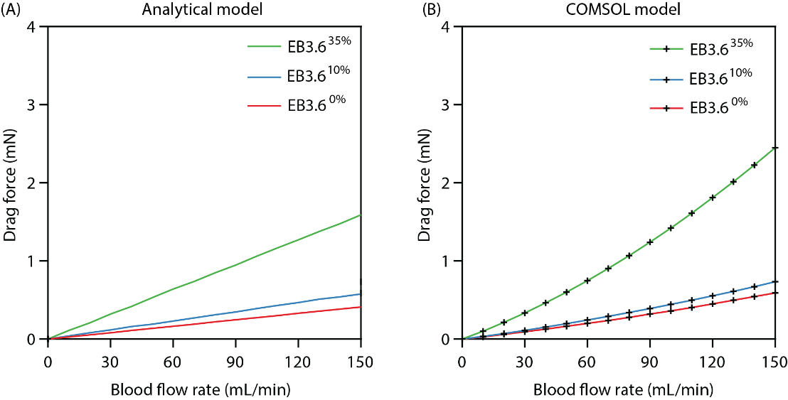
Figure S18. Drag force applied on EB3.6 under constant 10% and 35% compressive strains as a function of blood flow rate. (A) Analytical model. (B) COMSOL model.

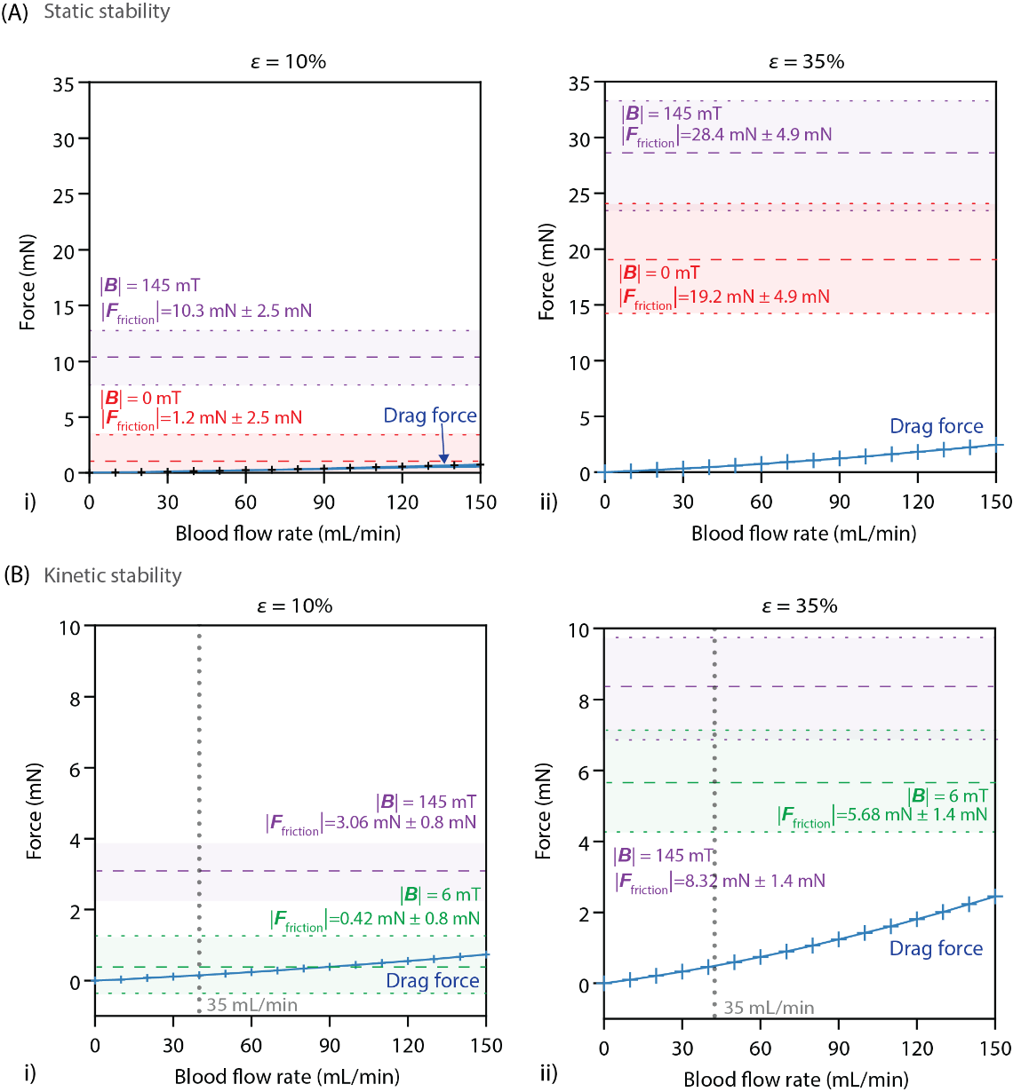
Figure S19. Resistive forces acting on EB3.6 and their scaling (A) Static condition (EndoBot is immobile) with robot experiencing (i) 10% (ii) 35% compressive strains. (B) Kinetic condition (EndoBot is performing corkscrew locomotion with surface crawling) with robot experiencing (i) 10% (ii) 35% compressive strains.

Supplementary Text 7: Blood flow setup
Blood flow setup with peristaltic pump
To replicate diverse anatomical and physiological conditions and variations in veins, we created modular flow setups as shown in Fig. 3A. This setup comprises a peristaltic pump (G100-2J, Longer Pump, USA), platinsm-cured soft silicone tubing (3.2 mm diameter), a liquid flow sensor (SLF3S-4000B, Sensirion AG, Stäf, Switzerland), and various phantoms vessel shown in Table S6. Fresh cow or human blood (Innovative Research, Inc., USA) was utilized in all experiments conducted within this flow system.
Its continuous flow capability and low pressure variation better mimics the hemodynamics in venous flow.

Blood flow setup with pulsatile pump
To mimic arterial pulsatility and better reproduce physiological hemodynamic conditions, especially in large vessels, we utilized a pulsatile flow setup as shown in Fig. 3D. This system includes a pulsatile pump (Pulsatile Blood Pump, Model 1421, Harvard Apparatus, Holliston, MA, USA), a liquid flow sensor, and straight phantom vessels (Phantoms C and E, Table S6). Fresh cow blood (Innovative Research, Inc., USA) was used for all experiments in this setup.
Due to the large blood volume required to prime and operate the pulsatile system, it was only used in experiments evaluating the stability of EndoBot, where pulsatile motion plays a critical role in simulating arterial flow dynamics.

Fig. S20A shows the blood flow profile using peristaltic pump while Fig. S20B shows the blood flow profile using the pulsatile pump. Due to inherent variability in blood flow rates, peak flow rate measurements were employed to evaluate the performance of the EndoBot under dynamic fluid flow conditions. Additionally, the relationship between blood flow rate and blood flow velocity for EB3.6 at compressive strains of 10% and 35% is presented in Fig. S20B. The observed shear stress on the inner EndoBot wall exceeded typical physiological shear stresses (0.1-0.6 Pa for healthy human veins and 1-7 Pa for healthy human arteries) encountered in arteries and veins of similar diameters (2.4–3.3 mm). Therefore, successful navigation and stability of EndoBot even under these supraphysiological conditions can show its promising capability for real-world vascular environments (32).

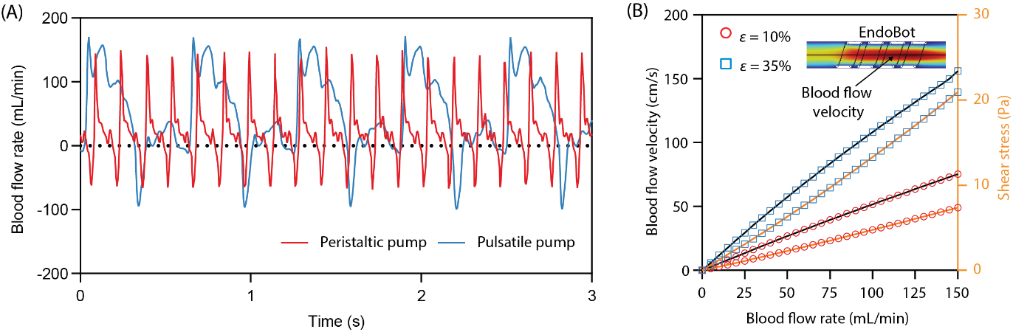
Figure S20. Characterization of blood flow driven by pumps. (A) Representative flow profile generated by the peristaltic pump and pulsatile pump, demonstrating periodic variations in flow rate (pulsatile pump setup information: stroke volume 20 mL, %Systole/Diastole: 40/60 and pump rate: 100 bpm). (B) Relationship between blood flow rate and corresponding blood flow velocity and shear stress for EB3.6 at compressive strains of 10% and 35%. Measurements of blood flow velocity were taken at the centerline of the vessel. Both blood flow velocity and shear stress were obtained from COMSOL simulations using the Fluid Flow module (Laminar Flow Analysis) in COMSOL Multiphysics 6.1.

Supplementary Text 8: Magnetic robot control, torque and force modeling
Human-scale, open space, three-dimensional magnetic actuation platform: An LBR Med 7 R800 robot arm (KUKA AG, Augsburg, Germany) with seven degrees of freedom was employed to precisely control the position and orientation of the magnetic field within the three-dimensional workspace of EndoBot. This setup provided accurate manipulation of magnetic field direction and magnitude from a mechanically safe distance (r_{mr}).
The KUKA robot arm setup consists of three interconnected systems: the Sunrise Workbench application, the controller unit, and the robot arm itself. The KUKA Sunrise Workbench 2.6.5 RapiMed V-24 is used for programming, configuring, and managing all robot applications. The Cabinet Interface Board for Small Robots (CIB-SR, 00-188-812), housed within the controller unit, manages high-level robot operations and runs on KUKA Sunrise. OS Med 2.6.5-6. The LBR Med 7 R800 robot arm supports a 7 kg payload, has an 800 mm reach, and is configured for floor mounting with specific safety settings. It operates with Firmware version V 1.5.4, which handles low-level control and hardware communication. Mounted on the end effector of the robot arm was a custom-designed DC motor (EC-I30, Maxon Precision Motors, Taunton, MA, USA), enabling high-performance rotation of an external permanent magnet (N52 cylindrical magnet, dimensions: 50 mm × 50 mm, K&J Magnetics, Inc., USA). Although it is capable of rotation speeds up to ~100 Hz, operational speeds were intentionally limited to 30 Hz to ensure user safety. The rotation speed of the DC motor was regulated through an ESCON 70/10 servo controller coupled with a variable resistor of 10 kΩ, powered by a DC power supply (Tek Power TP610E, 60 V, 10 A). The setup of the robot arm with the attached magnet is shown in Figs. 1A and 6A.
For effective tracking and clarity of explanation within this manuscript, a global coordinate system (x-y-z), anchored at the base of the robotic arm (Fig. 1A), and a local coordinate system for magnet (x_{m}-y_{m}-z_{m}), aligned with the center of the magnet (Fig. 1D), were defined to describe positions, velocities, and orientations consistently. The rotating magnet, characterized by its magnetic dipole moment (M_{m}), actuates EndoBot, located at position r_{mr} and with magnetic dipole moment (M_{r}), to rotate around EndoBot-axis (Fig. S21A) in the opposite direction when it rotates around the y_{m}-axis. As the magnet translates along a three-dimensional trajectory at velocity v_{m}, EndoBot follows a predefined path by adjusting its relative positions r_{mr}(x_{mr}, y_{mr}, z_{mr}) along the x_{m}, y_{m}, and z_{m} axes (Fig. 1D). The y_{m}-axis of the magnet’s local coordinate system consistently aligns tangentially to the vessel’s centerline, maximizing torque transmission from a short distance.
Magnetic torques: The magnetic torque applied on EndoBot is defined by:

$τ_{mag}\left(r_{mr}\right)=M_{r}×$ $B\left(r_{mr}\right)$ (16)

Expanding this vector cross product into its components, we have:
$τ_{mag} \left(r_{mr}\right)=\left[\begin{aligned}T_{mag,x_{m}} \\ T_{mag,y_{m}} \\ T_{mag,z_{m}}\end{aligned}\right]= \left[\begin{matrix}M_{r,y_{m}}B_{z_{m}}\left(r_{mr}\right) - & M_{r,z_{m}}B_{y_{m}}\left(r_{mr}\right) \\ M_{r,z_{m}}B_{x_{m}}\left(r_{mr}\right) - & M_{r,x_{m}}B_{z_{m}}\left(r_{mr}\right) \\ M_{r,x_{m}}B_{y_{m}}\left(r_{mr}\right) - & M_{r,y_{m}}B_{x_{m}}\left(r_{mr}\right)\end{matrix}\right]$ (17)

where $τ_{mag}=[T_{mag,x_{m}}, T_{mag,y_{m}}, T_{mag,z_{m}}]$ is magnetic the torque ($N∙m$), $M_{r}=[M_{r,x_{m}}, M_{r,y_{m}}, M_{r,z_{m}}]$ is the magnetic moment vector of EndoBot in the magnet-centric local coordinate system, and $B\left(r_{mr}\right)=[B_{x_{m}}\left(r_{mr}\right), B_{y_{m}}\left(r_{mr}\right), B_{z_{m}}\left(r_{mr}\right)]$ is the magnetic field vector at the EndoBot position $r_{mR}$.
Magnetic forces: The magnetic pulling forces applied on EndoBot are defined by:
$F_{mag} \left(r_{mr}\right)=\left[\begin{aligned}F_{mag,x_{m}} \\ F_{mag,y_{m}} \\ F_{mag,z_{m}}\end{aligned}\right]= \left[\begin{aligned}M_{r,x_{m}}\frac{∂B_{x_{m}}\left(r_{mr}\right)}{∂x_{m}}+M_{r,y_{m}}\frac{∂B_{y_{m}}\left(r_{mr}\right)}{∂x_{m}}+M_{r,z_{m}}\frac{∂B_{z_{m}}\left(r_{mr}\right)}{∂x_{m}} \\ M_{r,x_{m}}\frac{∂B_{x_{m}}\left(r_{mr}\right)}{∂y_{m}}+M_{r,y_{m}}\frac{∂B_{y_{m}}\left(r_{mr}\right)}{∂y_{m}}+M_{r,z_{m}}\frac{∂B_{z_{m}}\left(r_{mr}\right)}{∂y_{m}} \\ M_{r,x_{m}}\frac{∂B_{xm}\left(r_{mr}\right)}{∂z_{m}}+M_{r,y_{m}}\frac{∂B_{y_{m}}\left(r_{mr}\right)}{∂z_{m}}+M_{r,z_{m}}\frac{∂B_{z_{m}}\left(r_{mr}\right)}{∂z_{m}}\end{aligned}\right]$ (18)
The pulling force ($F_{mag,z_{m}}$) in the direction of z_{m} is equivalent of the extrinsic component of the radial force, F_{extrinsic} (Fig. S7).
The magnetic field was modeled using the AC/DC magnetic field module in COMSOL Multiphysics 6.1 and validated experimentally using a GM1-ST DC Gauss-meter (AlphaLab, Inc., Salt Lake City, UT, USA). Measurements correlated closely with simulation predictions (Fig. S21A). Due to the rotation of the magnet during experimentation, the magnetic field at the EndoBot position exhibited temporal variation. When the centers of the external magnet and the EndoBot are aligned along the z_{m} axis (i.e., y_{mr}=x_{mr}=0), the magnetic torque $T_{mag,y_{m}}$ is maximized, resulting in the most efficient propulsion of the robot in the direction of the y_{m}-axis. The maximum torque $T_{mag,y_{m}}$ occurs when the distance between the magnet and EndoBot is minimized, due to the significant increase in the magnetic field component $B_{z_{m}}\left(r_{mr}\right)$ along the z_{m} direction (Fig.S21Bi). However, a physical hindrance limits the vertical placement of the magnet to approximately z_{mr}=−52 mm, a constraint imposed for safety reasons. This still allowed generation of effective magnetic fields ranging between 145 mT at |z_{mr}| = 52 mm and 4 mT (|z_{mr}| = 182 mm). To maintain this optimal alignment, the robotic arm must be continuously repositioned and reoriented as EndoBot moves. If EndoBot accelerates along the y_{m}- axis, for example, due to external flow or suboptimal response from the robot arm carrying the magnet, torque${ T}_{mag,y_{m}}$ decreases as $B_{z_{m}}\left(r_{mr}\right)$ is reduced (Fig.S21Biii). At the same time, $B_{y_{m}}\left(r_{mr}\right)$ increases when the EndoBot is misaligned (Fig.S21Biiv) generating a corrective magnetic pulling force along the y_{m}-direction. This force helps realign the EndoBot with the magnet to keep the optimization condition.
Representative examples of magnetic field changes, corresponding to magnet rotations around the -axis from 0° to 360°, are provided in Fig. S22.
The magnitude of the magnetic moment of EndoBot, |M_{r}|, was derived from the magnetization curve in the datasheet of NdFeB D50 (MQP-15-7-20065, Magnequench, Germany). Specific magnetic moment values for each EndoBot configuration used in the demonstrations herein are summarized in Table S4.
To validate the force values, we measured and confirmed the pulling force $F_{mag,z_{m}}$applied on EB3.6 in the z_{m} direction using a balance (BCE822-1S, Sartorius Lab Instruments GmbH & Co. KG, 37070 Goettingen, Germany) as shown in Fig. S23.
The variations in the maximum absolute magnetic torque and force with respect to different values of |y_{mr}| and |z_{mr}| as shown in Fig. S24 (x_{mr} kept at 0), which are consistent with the trends discussed above based on the results in Fig. S20, specifically, maximum force |$F_{mag,y_{m}}$| occurs at |y_{mr}| = 25 mm, while maximum torque |$T_{mag,y_{m}}$| is achieved at |y_{mr}| = 0 mm and |z_{mr}| = 52mm.
These findings help explain the actuation behavior shown in Fig. S25, where the highest EndoBot velocity is observed during forward movement from y_{mr} = 25 mm to y_{mr} = 0 mm (Fig. S24C), a range that leverages both high magnetic force |$F_{mag,y_{m}}$| and high magnetic torque |$T_{mag,y_{m}}$| regions for effective propulsion.
Specifically, the maximum speed of the EndoBot ${EB3.6}_{10\%}^{10\%}$ within a 3.2 mm diameter vessel is 14.3 ± 2.9 mm/s, achieved at 30 Hz, y_{mr} = ~ 25 mm and z_{mr} = -52 mm (magnetic field ~145 mT), while the maximum speed of ${EB3.6}_{35\%}^{35\%}$within a 2.3 mm diameter vessel is 14.5 ± 7.9 mm/s, also achieved at 30 Hz, y_{mr} = ~ 25 mm and z_{mr} = -52 mm. No step-out frequency was observed under the magnetic actuation conditions prescribed in this study.
EndoBot Control: A fuzzy logic control approach was applied in the magnetic actuation and navigation of EndoBot. This algorithm relied on the relative positioning and orientation of the external magnet with respect to EndoBot under different environmental conditions. In this scheme, the human operator adjusts the external magnet’s position and rotation direction in real time based on the relative position between the magnet and EndoBot, as well as the local blood flow conditions. The control decisions are guided by fuzzy rules rather than fixed thresholds, enabling flexible responses to uncertain and dynamic environments.
The maximum possible magnetic torque is used to rotate EndoBot and initiate forward movement (in certain conditions, such as in vivo scenarios where the target vessel is located deep within tissue, the minimum vertical distance (|z_{mr}|=52 mm) required to achieve maximum torque may not be attainable due to anatomical constraints). As EndoBot moves, the external magnet must be repositioned to maintain central alignment along the z_{m}-axis, ensuring sustained magnetic torque. If misalignment occurs (i.e., y_{mr} >0), the pulling magnetic force is generated as discussed above, which not only helps realign EndoBot but also contributes to its movement.
In situations where the magnetic torque cannot generate movements such as when EndoBot moves against high blood flow rate or encounters high friction between the robot and vessel, fuzzy logic recommends supplementing torque with additional pulling force $F_{mag,y_{m}}$ by translating the external magnet in the direction of the y_{m} axis (y_{mr}≠0). This added force helps overcome resistance and maintain motion. To maintain high torque while generating a high pulling force, y_{mr} should be kept within the range of 0 to ±25 mm. Beyond this range, the torque significantly diminishes, leading to reduced control and less efficient actuation. This adaptation demonstrates how fuzzy logic enables smooth transitions between magnetic torque-dominant and magnetic pulling force-assisted actuation modes in response to varying levels of flow and friction.
In addition, the external magnet’s rotation direction is incorporated as fuzzy control input, particularly critical under low or no blood flow conditions. In such scenarios, EndoBot’s movement is governed by its rotation: counterclockwise rotation propels it forward (e.g., left to right in Fig. S25), while clockwise rotation moves it backward (right to left), as defined by the coordinate system in Fig. 1D. Conversely, in high-blood-flow environments where drag force dominates and forward propulsion along the flow can destabilize the robot, the rotation direction is fixed based on the flow direction to ensure movement against the flow and maintain stability. In these cases, directional control is achieved solely by adjusting y_{mr} and translating the external magnet, as described earlier.
Notably, maintaining maximum torque by minimizing z_{mr} or maximizing frequency f_{m} is most beneficial in dynamic environments, such as in vivo conditions with pulsatile flow and rapid directional changes. In non-dynamic environments, however, like in low-flow regions, excessive torque may cause EndoBot to move too quickly for the robot arm to follow. In such cases, fuzzy control logic relaxes the torque-maximization priority, instead optimizing for smoother, synchronized movement that aligns with the mechanical capabilities of the system.
This flexible, adaptive control framework allows EndoBot to achieve robust navigation performance across a wide range of physiological and experimental conditions. By adjusting control objectives in real time based on input variables, the fuzzy system balances torque, translational force, and rotation direction to optimize safety, responsiveness, and effectiveness.

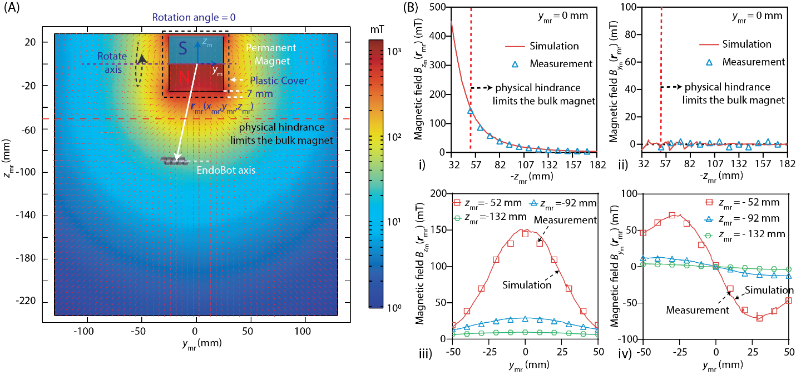
Figure S21. Magnetic field lines around EndoBot when the permanent magnet is on standby. (A) Snapshot of the magnetic field lines on the y_{m}z_{m}-plane with the magnet fixed at a rotation angle of 0°. (B) Comparison of the magnetic field components $B_{y_{m}}\left(r_{mr}\right)$and $B_{z_{m}}\left(r_{mr}\right)$under different conditions. (i)-(ii) When the centers of the external magnet and the EndoBot are aligned along the z_{m} axis (i.e., y_{mr}=x_{mr}=0). (iii)-(iv) When EndoBot is positioned at various y_{mr} while z_{mr} is fixed at -52, -92, and -132 mm. When the centers of the external magnet and the EndoBot are aligned along the z_{m} axis, the magnetic torque $T_{mag,y_{m}}$ is maximized, resulting in the most efficient propulsion of the robot in the direction of the y_{m}-axis. To maintain these optimal conditions, the robot arm must be continuously repositioned and reoriented as EndoBot moves, guided by continuous visual feedback. If EndoBot accelerates along the y_{m}- axis, for example, due to external flow or suboptimal response from the robot arm carrying the magnet, a corrective pulling corrective magnetic pulling force $F_{mag,y_{m}}$is applied along the y_{m}-direction. This force, resulting from an increase in the magnetic field component $B_{y_{m}}\left(r_{mr}\right)$, helps realign EndoBot.

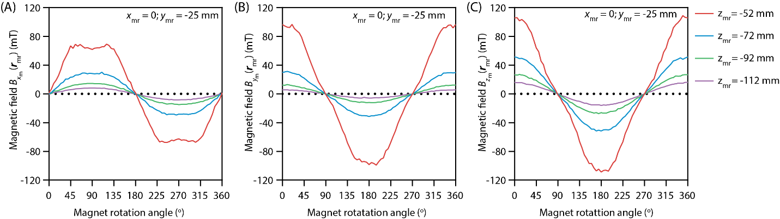
Figure S22. Magnetic field distribution of $B_{x_{m}}\left(r_{mr}\right)$, $B_{y_{m}}\left(r_{mr}\right)$ and $B_{z_{m}}\left(r_{mr}\right)$, at various positions when the external magnet is rotated around y_{m}-axis from 0° to 360⁰. (A) Magnetic field x_{m}-component $B_{x_{m}}\left(r_{mr}\right)$. (B) Magnetic field y_{m}-component $B_{y_{m}}\left(r_{mr}\right)$, and (C) Magnetic field z_{m}-component $B_{z_{m}}\left(r_{mr}\right)$.

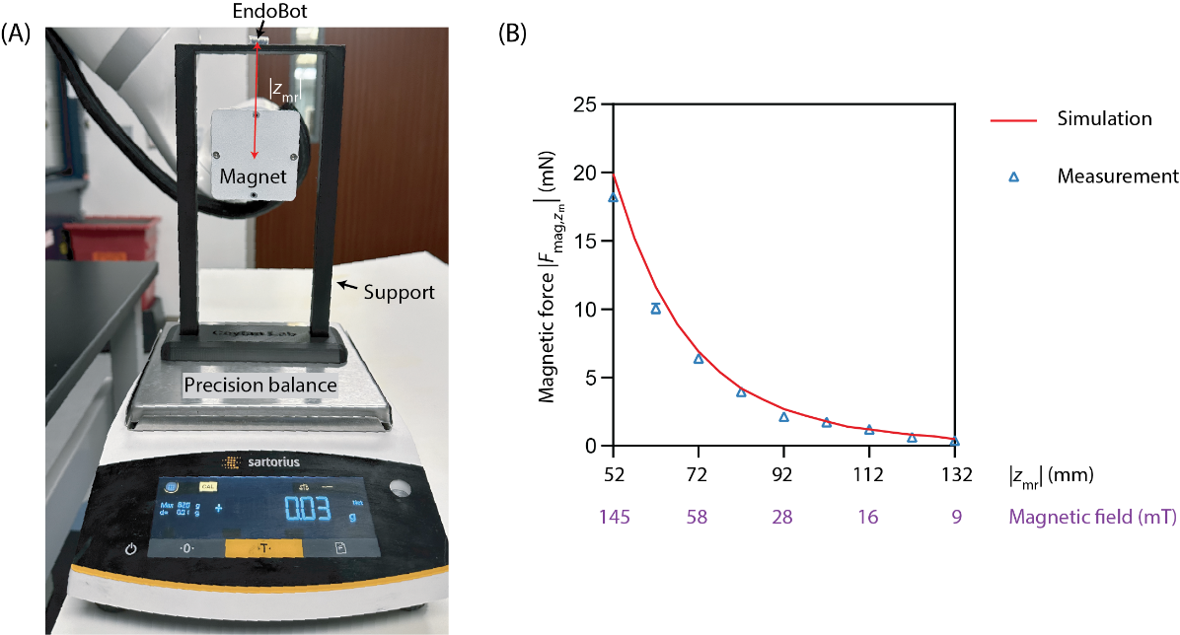

Figure S23. Magnetic force evaluation. (A) Customer-designed setup for measuring magnetic force on EndoBot EB3.6 with different magnetic field or |z_{mr}|, using a precision balance. (B) Absolute magnetic force |$F_{mag,z_{m}}$| along z_{m} axis, demonstrating a close match between measured values and simulation results.

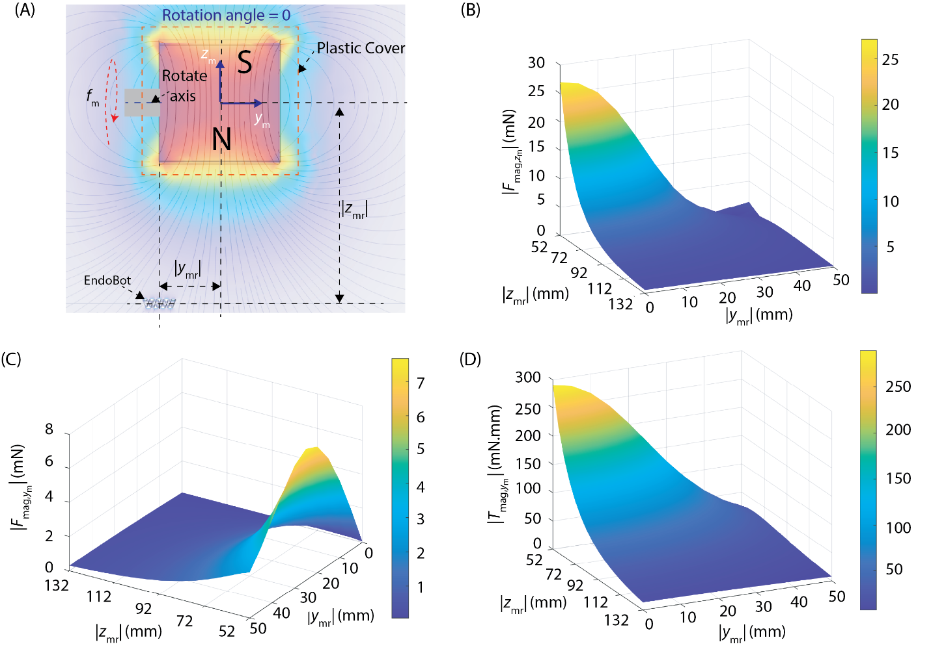
Figure S24. Maximization of stabilizer force under flow and magnetic torque for EndoBot propulsion. Maximum achieved absolute magnetic forces and torques with different |y_{mr}| and |z_{mr}|. (A) Definition of |y_{mr}| and |z_{mr}|. (B) Maximum absolute magnetic retraction force |$F_{mag,z_{m}}$| in z_{m} direction. (C) Maximum absolute magnetic retraction force |$F_{mag,y_{m}}$| in y_{m} direction. (D) Maximum absolute magnetic torque |$T_{mag,y_{m}}$| in y_{m} direction.

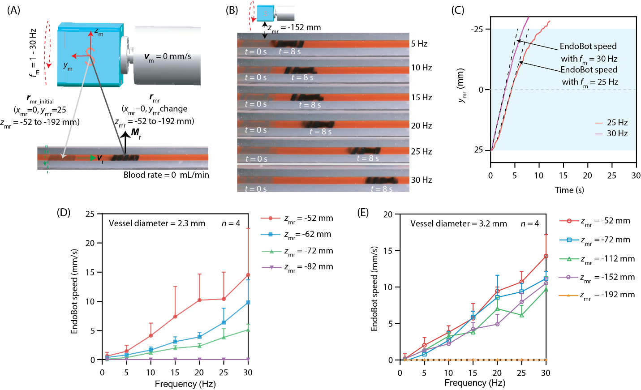
Figure S25. EndoBot magnetic propulsion mechanism. The external magnet is kept at a certain vertical distance, |z_{mr}| and an initial horizontal distance, |y_{mr}|. Since EndoBot is confined in a straight-line vessel, x_{mr} remained constant during the experiment. (A) Description of experimental conditions. (B) An example of an EndoBot ${EB3.6}_{10\%}^{10\%}$moving within a 3.2 mm diameter vessel channel under different frequencies ranging from 5 to 30 Hz. (C) Definition of EndoBot speed, calculated as the maximum slope of displacement over time. The EndoBot speed results of (D) the EndoBot ${EB3.6}_{35\%}^{35\%}$ moving within vessel diameters of 2.3 mm and (E) the EndoBot ${EB3.6}_{10\%}^{10\%}$moving within vessel diameters of 3.2 mm.

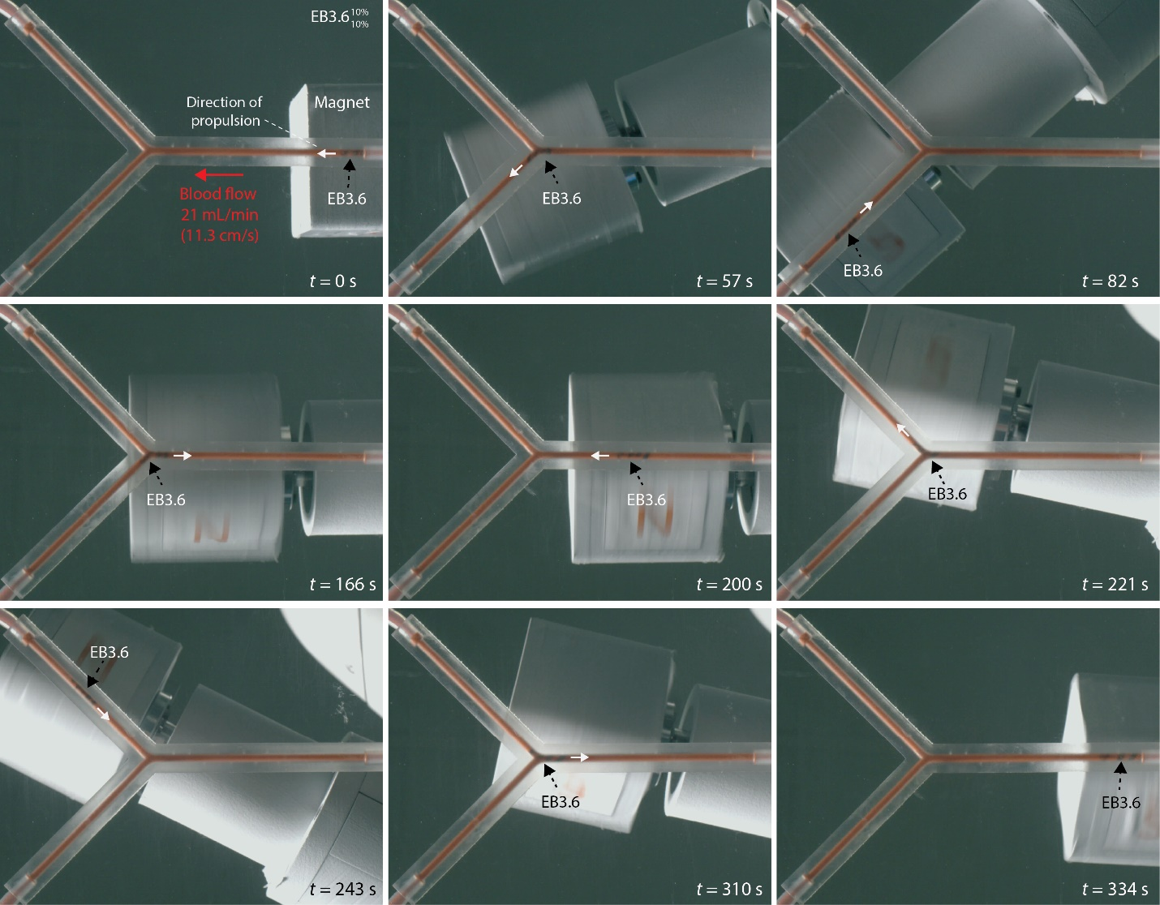
Figure S26. Magnetic propulsion performance of EB3.6 in a bifurcated Y-shaped vessel. |B| = 145 mT, f_{m} = 30 Hz, |v_{m}| = 1-5 mm/s.

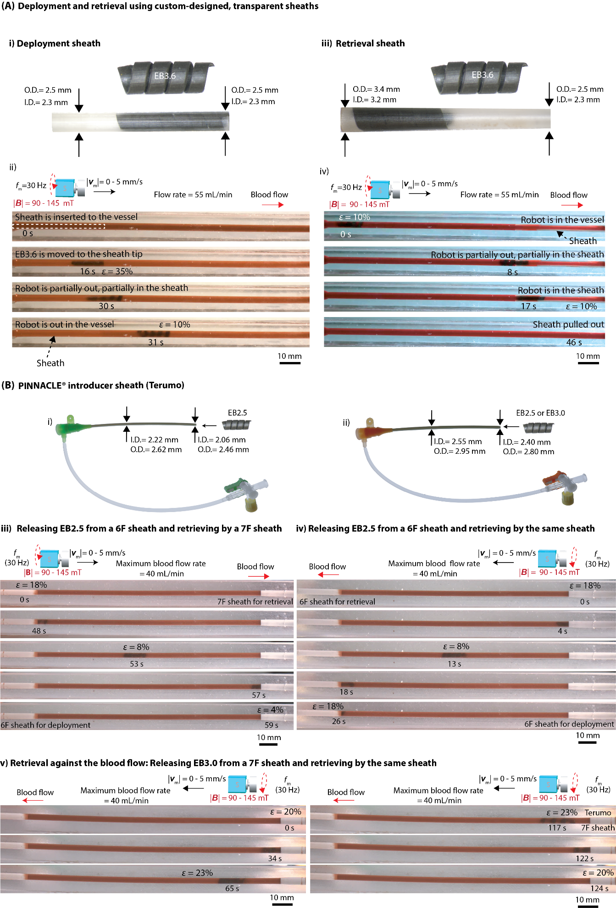
Figure S27. Demonstration of wireless EndoBot deployment and retrieval methods. (A) Custom-fabricated transparent sheaths: (i) Deployment concept illustrating an EB3.6 EndoBot emerging from a sheath under 35% compressive strain into a phantom vessel experiencing 10% strain, deployed in the direction of blood flow. (ii) Retrieval concept showing a sheath with a conical entry, applying 10% compressive strain to the robot to facilitate smooth entry and minimize the likelihood of the robot mistakenly entering gaps between the sheath and vessel wall. (B) Deployment and retrieval using commercial 6F and 7F PINNACLE® introducer sheaths (Terumo): (i) EB2.5 deployment from a 6F sheath downstream, followed by retrieval into a 7F sheath positioned downstream. (ii) EB2.5 deployment and retrieval using two separate 6F sheaths downstream. (iii) EB3.0 deployment from and retrieval back into the same 7F sheath positioned upstream, demonstrating successful retrieval against blood flow direction. All tests conducted using straight-line phantom vessels (A-type, Table S6) with an inner diameter of 2.3 mm.

Supplementary Text 9: Biocompatibility assessment of EndoBot
As a blood-contacting device, EndoBot and its corkscrew locomotion must result in minimal adverse interactions with blood and endothelial cells (ECs) lining the vessel intima. Although the thrombogenicity of such devices is difficult to predict, we conducted a comprehensive series of tests to evaluate coagulative properties of EndoBots, hemolytic potential, platelet activation, and cytotoxicity. These tests followed commonly accepted in vitro protocols aligned with ISO-10993-Part 4 (Biological evaluation of medical devices: Selection of tests for interactions with blood) guidelines and customized procedures tailored to our application context(33, 34).
The impact of EndoBot locomotion on the coagulation tendency of blood: The envisioned operational timescale of EndoBot within a blood vessel is short-term (< 15 min). During this period, its surface material composition and locomotion could potentially trigger blood coagulation. To assess this risk, we continuously monitored the real-time translational velocity of ${EB3.6}_{10\%}^{10\%}$ moving in a phantom vessel (A-type, straight line, Table S6) filled with whole bovine blood under constant magnetic actuation (~12-15 mT, 10 Hz) for 30 min. The experimental setup is illustrated in Fig. S28 where phantom vessel used in this experiment was a 20 cm long platinum-cured silicone tubing, containing 1.6 mL of blood. To drive the locomotion of ${EB3.6}_{10\%}^{10\%}$ from the left to the right, the actuator magnet and the ${EB3.6}_{10\% }^{10\%}$was initially positioned at r_{mr} of x_{mr} = 0 mm, y_{mr} = -80 mm, and z_{mr} = -112 mm followed by a clockwise rotation frequency of f_{m} =10 Hz, without translating the magnet (referred to as a forward lap). To move the ${EB3.6}_{10\%}^{10\%}$from the right to the left, the magnet and ${EB3.6}_{10\%}^{10\%}$ were positioned at r_{mr} coordinates of x_{mr} = 0 mm, y_{mr} = 80 mm, and z_{mr} = -112 mm with a counterclockwise rotation frequency of f_{m} =10 Hz, also without translating the magnet (referred to as a backward lap). The blood was pre-heparinized at 0.5 U/mL, approximately matching the prophylactic dose recommended for adults undergoing endovascular procedures for deep vein thrombosis(35). A gradual or sudden decrease in the robot velocity over ~40 forward-backward traversals (~560 cm total distance) under constant magnetic actuation would suggest coagulation-induced drag. However, mean velocities remained stable (5.9 ± 0.9 mm/s forward and 5.9 ± 0.8 mm/s backward), demonstrating no signs of coagulation-induced drag. This key observation provides translatable evidence for future animal and human procedures under comparable endovascular interventions, such as stenting.
Activated Clotting Time (ACT) Assessment: To evaluate the potential coagulation effects of EndoBot surfaces, samples were first cleaned using alcohol and phosphate-buffered saline (PBS), followed by 30 minutes of plasma cleaning. After surface preparation, the samples were coated with the drug transfer layer.
Three different 24-hour further surface treatments were then applied to elucidate clotting time activation dynamics:

- Positive Treatment (Collagen-treated EndoBot): Coated EB3.6 samples (n=3) were incubated in 1 mg/mL gelatin (collagen surrogate) in PBS.
- Negative Treatment (Heparin-treated EndoBot): Coated EB3.6 samples (n=3) were incubated in 1 mL of heparin solution (1,000 units/mL).
- No Treatment (Untreated EndoBot): Coated EB3.6 samples (n=3) were incubated in 1 mL of ultrapure water (ddH₂O).

Following these treatments, the surface-modified EndoBots were first thoroughly washed with PBS and carefully transferred into low protein-binding microcentrifuge tubes, each containing 900 µL of fresh, heparinized human whole blood (Innovative Research, Inc., USA). To initiate coagulation, CaCl₂ solutions were added in low volume ratios to reverse the anticoagulant effect of heparin. Two concentrations of CaCl₂ were tested, corresponding to final blood volume ratios of:

- 1:50 (v/v), resulting in a final CaCl₂ concentration of 3.6 mM in blood
- 1:65 (v/v), resulting in a final concentration of 2.8 mM in blood

Upon CaCl₂ addition, blood was immediately tested for clotting activity using an i-STAT point-of-care blood analyzer and Celite ACT cartridges (Abbott Laboratories, Chicago, IL).
Under these test conditions, ACT values for the “Untreated EndoBot” group were comparable to both control samples, indicating no enhanced or reduced procoagulant activity due to surface exposure.
Complete Blood Count: To assess the hematological impact of EndoBot surface treatments, a complete blood count (CBC) test was performed using a HESKA HT5 hematology analyzer. Parameters measured included hemoglobin, red blood cell (RBC) count, hematocrit, platelet count, white blood cell (WBC) count, and differential leukocyte profiles. For each test condition (positive, negative and untreated groups described in the previous section), a surface-treated EndoBot was incubated in 1 mL of EDTA-treated human whole blood (Innovative Research, Inc., USA) for 60 minutes. A control sample, 1 mL of the same blood without an EndoBot, was also included.
Following incubation, samples were analyzed for hematological integrity. As shown in Fig. S29, all measured parameters remained within established normal ranges, with no signs of abnormal cell morphology or significant deviations in blood counts. These results further support the hemocompatibility of the surface-treated EndoBots. Additionally, the absence of detectable procoagulant activity aligns with prior designations of silica filler-free PDMS (used in EndoBot) as a reference material for blood compatibility by the U.S. National Heart, Lung, and Blood Institute(36).
Hemolysis studies: Hemolysis measures the rupture of red blood cells (RBCs) and subsequent release of their intracellular components. It can be induced by mechanical stress during EndoBot locomotion, or RBC-robot surface interactions. Such released molecules may, in turn, trigger thrombogenesis by activating platelets(37).
To evaluate potential hemolytic effects, we first evaluated the mechanical effects. We evaluated the impact of locomotion frequency on hemolysis, we measured free hemoglobin released from RBCs after exposing fresh, sodium citrate treated-bovine blood (Innovative Research, Inc., USA). We moved ${EB3.6}_{10\%}^{10\%}$ in a straight vessel phantom at varying locomotion frequencies, i.e., 1, 10, and 30 Hz, for 15 min using the same setup described in Fig. S28. A negative control was prepared by filling a phantom vessel with blood, without EndoBot deployment in it, to dissect blood-vessel surface interactions. After the experiment, 1 mL blood samples were gently transferred into low protein binding microcentrifuge tubes (Thermo Scientific, USA). These tubes were agitated for 20 minutes at 1500 rpm at 4ºC to separate RBCs. 20 μL from the supernatant of each sample group was sampled to measure dissolved hemoglobin within the plasma using a ready-to-use kit from Abcam (Cat. #ab234046).
Following the protocol within the supplier’s kit, samples from all five groups were mixed with the hemoglobin detector, and the hemoglobin signal at 575 nm was recorded. The hemoglobin concentration was calculated based on the standard curve provided with the kit. The hemolysis rate was then calculated using the following equation:

$Hemolysis rate \left(\%\right)=\frac{H_{sample,1.6 mL}-H_{neg,1.6 mL}}{H_{pos, 1L}}×100\%$ (19)

where H_{sample, 1.6 mL} is the amount of released hemoglobin in the 1.6 mL blood sample after treatment with EndoBot, H_{neg, 1.6 mL} is the amount of released hemoglobin in the 1.6 mL untreated blood sample due to blood aging, and H_{pos, 1L} is the amount of released hemoglobin in 1 L of blood after fully rupturing all RBCs. To calculate the total hemoglobin within untreated blood per unit of volume, 1 mL of fresh cow blood was mixed with 9 mL of distilled water (dH2O) in a 1:10 volume ratio to fully rupture the hemoglobin in the blood with osmotic pressure. The resulting amount was extrapolated to 1L of blood.
Next, we evaluated the impact of surface treatment on hemolysis. The EndoBot samples underwent the same treatment protocol described in the ACT Assessment above. The treated ${EB3.6}_{10\%}^{10\%}$ samples were then moved inside EDTA-treated human blood (Innovative Research, Inc., USA) for 15 minutes at a locomotion frequency of 30 Hz using the same setup described in Fig S28. Three EndoBot samples were prepared for each treatment group (n=3).
All EndoBot samples from this study were subsequently collected for platelet activation studies.
Platelet activation assessment: EndoBots following the hemolysis experiment were gently and briefly cleaned in PBS and then immediately fixed in 4% formaldehyde/PBS solution for 48 hours within refrigerator (~4 C°) to preserve their structural integrity. Following fixation, the samples were stained with PE Mouse Anti-Human CD62P antibody (conjugate antibody) (BD Pharmingen, USA) to detect platelet activation marker of P-selectin protein as a reliable marker to characterize platelet activation and aggregation(38). The blood-contacting inner surfaces of the EndoBots were meticulously analyzed for platelet activation, adhesion, and aggregation(34). High-resolution fluorescence imaging of P-selectin proteins was conducted using an Olympus IX73 fluorescence microscope, providing detailed visualization of platelet activation and aggregation.
Cytotoxicity: To assess the potential cytotoxicity of leachable substances from EndoBot, we evaluated their impact on human umbilical vein endothelial cells (HUVECs). HUVECs were obtained from the American Type Culture Collection (ATCC) and cultured in Endothelial Cell Basal Medium-2 (EBM-2; Lonza, Cat. #CC-3156) supplemented with the EGM-2 BulletKit (Lonza, Cat. #CC-4176). Cells were expanded in T-225 flasks and passaged using standard trypsinization protocols. For the cytotoxicity assay, HUVECs were seeded in 96-well plates at a density of 2 × 10³ cells per well in triplicate (n= 3). After allowing 24 hours for cell attachment, the culture medium was replaced with EBM-2 media previously exposed to EndoBot samples (EB3.6 variants). The cells were then incubated with this conditioned media for an additional 24 hours at 37 °C in a humidified incubator with 5% CO₂.
Conditioned media were prepared by incubating different EB3.6 samples in 1 mL of EGM-2 media for 7 days under standard cell culture conditions. These EB3.6 samples varied in composition, including:

- NdFeB:PDMS mass ratios: 0.5:1, 1:1, 2:1, and 4:1

- PDMS base-to-crosslinker mass ratios: 10:1 and 5:1

Each formulation was placed in separate, closed 1.5 mL tubes during the incubation period. To assess cell viability, Calcein AM staining was performed using the Live/Dead Cell Imaging Kit (Invitrogen, Thermo Fisher Scientific). Fluorescence microscopy images were acquired with an Olympus IX73 microscope using 5x objective, and live/dead cell counts were performed using an integrated hybrid cell count analysis module. For each condition, at least four images (n = 4) were analyzed to ensure statistical robustness. Cell viability was quantified as the percentage of live cells relative to the untreated control group using the following equation:

$Cell viablitiy \left(\%\right)=\frac{N_{sample}}{N_{control}}×100\%$ (20)

Where N_{sample} is the number of live cells in the experimental group, N_{control} is the number of live cells counted in the control group (cells grown in the medium without EndoBot exposure, while their media were changed to fresh EGM-2 media together with the EndoBot-exposed media replacement). Table S7 shows that there is no significant reduction in cell viability across all tested EndoBot formulations, indicating a lack of cytotoxic effects from leachable components.

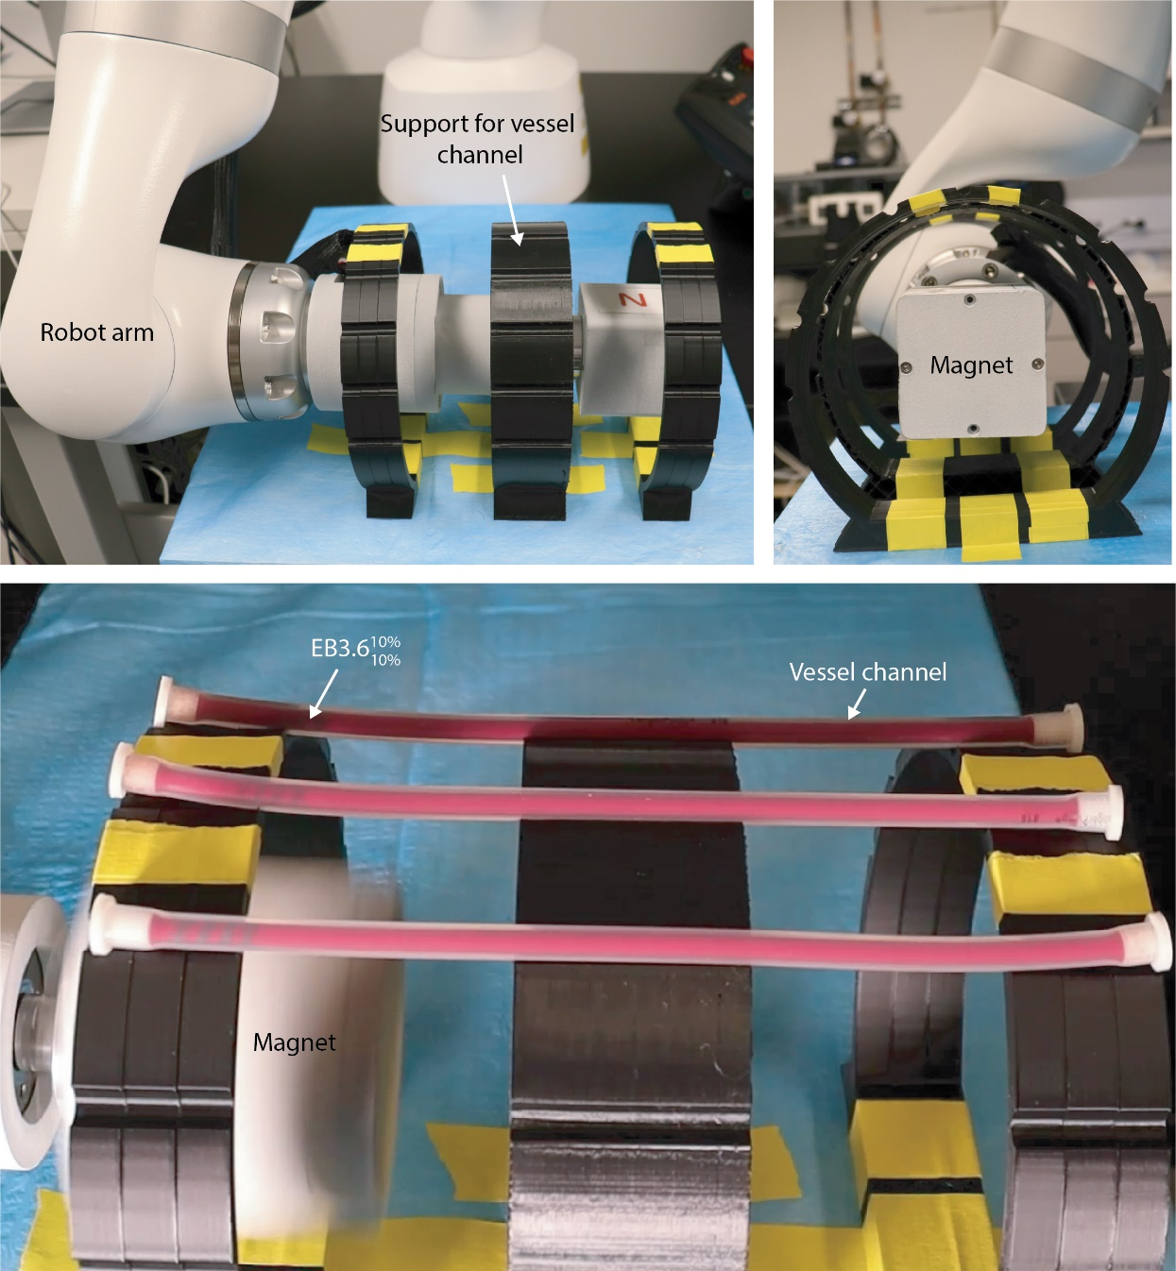
Figure S28. Experimental setup for the blood compatibility experiments described in Figs. 5A, C−E. A custom-designed support was used to position three straight-lined tube phantom vessels, enabling the simultaneous movement of three ${EB3.6}_{10\%}^{10\%}$ samples under similar magnetic field conditions, achieving n = 3 to ensure the repeatability replication of the observations.

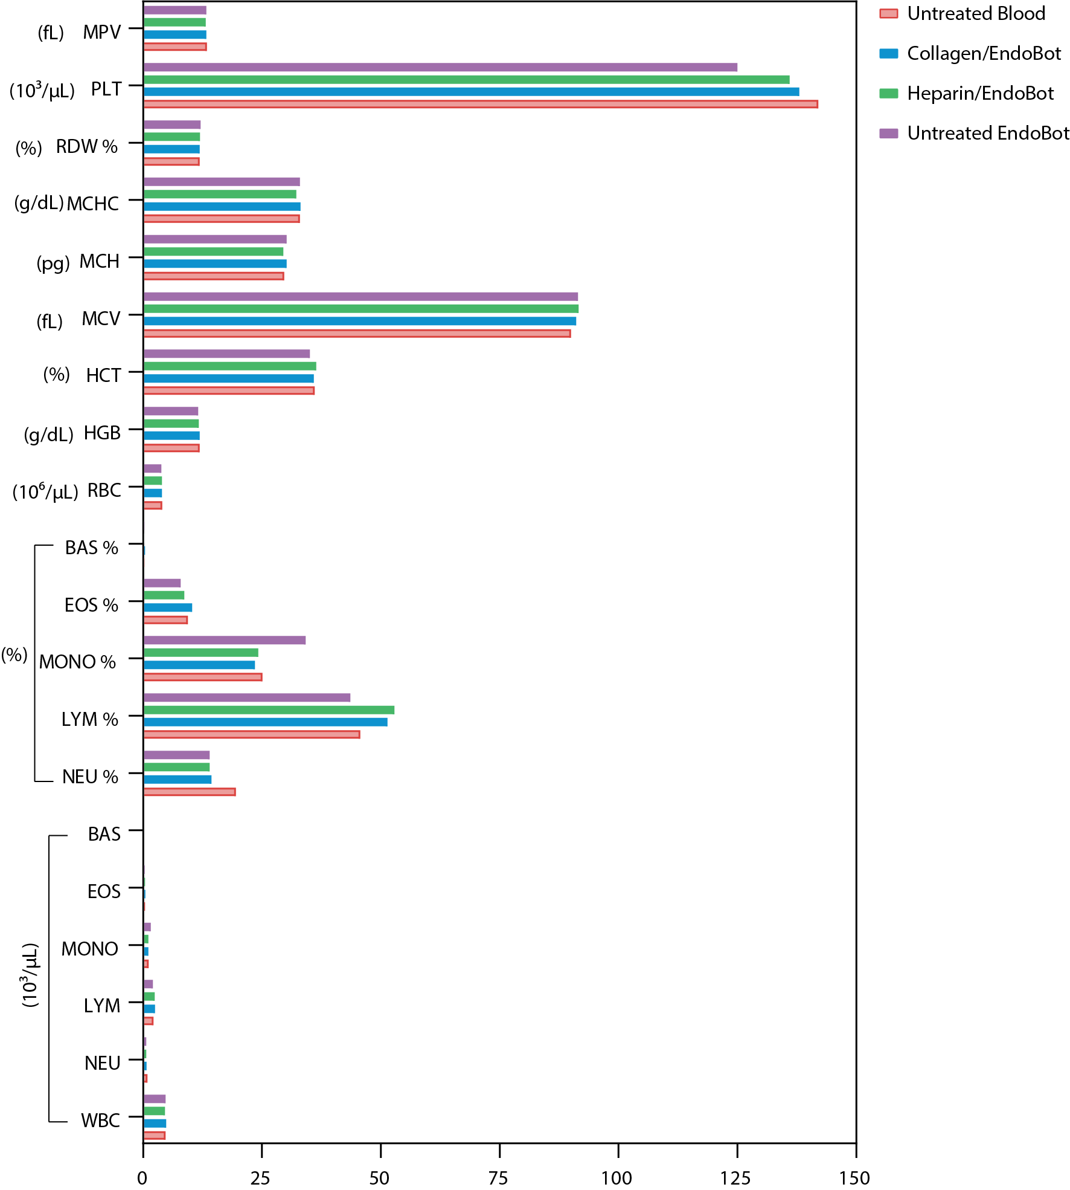
Figure S29. Complete blood count of human blood after 1 hour exposure to surface-treated EndoBots.

Table S7. HUVEC viability assessment.
Base to crosslinker ratio | PDMS:NedFeB ratio | Live cell count  (per field of 5×) | Percentage (%)
10:1 | 1:0.5 | 2648 ±134 | 105.3% ±5.3%
10:1 | 1:1 | 2535 ±220 | 100.8% ±8.8%
10:1 | 1:2 | 2598 ±243 | 103.3% ±9.7%
10:1 | 1:4 | 2633 ±151 | 104.7% ±6.0%
5:1 | 1:0.5 | 2552 ±99 | 101.5% ±3.9%
5:1 | 1:1 | 2602 ±199 | 103.5% ±7.9%
5:1 | 1:2 | 2569 ±167 | 102.2% ±6.6%
5:1 | 1:4 | 2567 ±176 | 102.1% ± 7.0%
No treatment | No treatment | 2515 ±256 | 100.0% ±10.9%

Supplementary Text 10: Fluoroscopic-guided steering, localization and tracking of EndoBot in vitro
To enable clinically compatible real-time imaging and control of EndoBot, we integrated a clinical C-arm X-ray fluoroscopy system with our custom-built robot arm–controlled magnetic manipulation platform (eX-MMPt). This platform facilitates 3D magnetic actuation and fluoroscopic visualization tailored for endovascular imaging, localization, and tracking. Fluoroscopic videos were acquired using an OEC 3D C-arm system (General Electric, Boston, MA) in both cinefluoroscopic (cine) and digital subtraction (DS) modes (Figs. 6C-D, and S35). The open geometry of the C-arm accommodates the robot arm with high kinematic flexibility, allowing precise modulation of magnetic field direction and strength for EndoBot actuation. DICOM image files were exported as .JPEG and .MP4 formats using RadiAnt DICOM Viewer (version 2023.1, 64-bit) for reporting and analysis. This eX-MMPt platform was employed in both ex vivo and in vivo studies described herein.
Virtual reality (VR) assisted navigation: To address limitations associated with contrast-based visualization for untethered robotic navigation, we developed a virtual reality (VR)–based framework that integrates a digital twin of the environment, a real-time robot avatar, and positional tracking data (Fig. S36) (39). Communication between the physical and virtual environments is established using a custom interface through the Robot Operating System (ROS2), enabling bidirectional data exchange via publish/subscribe mechanisms. This modular system allows for future expansion to wireless and cross-continental connectivity. Virtual twins of the phantom channels were created by importing CAD models (.OBJ files, designed in Fusion 360) into the Unity 2022.3.0f1 environment (Unity Technologies). Spatial alignment between real and virtual spaces was achieved via a calibration protocol involving:

- Frame size normalization of input videos,
- Positional and rotational correction based on visual markers (X-ray–opaque fiducials),
- Pixel-to-millimeter scaling for accurate dimensional mapping.

A custom Python script (Python3) initialized the ROS2-based communication network and passed calibration parameters to Unity, allowing precise positioning and orientation of the virtual phantom twin. ROS-TCP-Endpoint libraries were used to bridge Unity® with the ROS2 network.

EndoBot detection and localization: For automated EndoBot detection, we used a YOLOv8 (You Only Look Once) model (Ultralytics, MD, USA) trained on 1,210 annotated images, including a dedicated subset of 368 EndoBot-specific examples. The average image resolution was 1.64 megapixels (ranging from 0.41 to 5.75 MP), and the median image dimensions were 2552 × 1208 pixels. The training dataset was prepared and labeled using the Roboflow platform (Roboflow Inc., Des Moines, Iowa, USA) (40). The model was trained over 280 epochs using the YOLOv8n architecture with a batch size of 16 and an input size of 640 × 640 pixels. The OneCycleLR scheduler was used with an initial learning rate of 0.01. Optimization was performed using SGD with momentum 0.937 and weight decay 0.0005. The training utilized extensive data augmentation strategies, including Mosaic (always enabled), AutoAugment (RandAugment), horizontal flip (50%), HSV hue/saturation/brightness shifts (h=0.015, s=0.7, v=0.4), translation (±10%), scale jittering (50%), and random erasing (40%). Rotation, vertical flip, shear, perspective distortion, and cropping were disabled to preserve anatomical fidelity. All training and inference were conducted on an HP ZBook Studio G10 Mobile Workstation (Model: 9LB69US#ABA) equipped with an Intel Core i7-13800H processor, 32 GB DDR5 RAM (2 × 16 GB, 5600 MHz), and a 1 TB NVMe PCIe Gen4x4 SSD. The system featured an NVIDIA RTX 4070 Laptop GPU (8 GB GDDR6. The YOLOv8 model was deployed via a Python-based script to perform inference on both pre-recorded and live-streamed fluoroscopic videos(41). Detected robot positions were extracted in real time, and the bounding box and center point were mapped onto the Unity® environment (Fig. S37). The robot avatar in the virtual twin was dynamically updated to reflect the detected position and trajectory of EndoBot during fluoroscopic navigation. As demonstrated with an EB3.6 model navigating a PDMS-based phantom vessel (Supplementary movie 4), the system achieved stable real-time tracking in both DS and cine modes. The bounding box was overlaid in post-processed videos to visually confirm detection fidelity (Fig. S37). Performance evaluation showed strong generalization, with smoothly decreasing loss curves (box_loss, cls_loss, dfl_loss) for both training and validation sets (Fig. S38a). The model achieved a mean average precision (mAP@0.5) of 0.996 and mAP@0.5:0.95 of ~0.80. The optimal F1-score occurred at a confidence threshold of 0.443, and precision–recall curves demonstrated stable behavior. The normalized and raw confusion matrices (Fig. S38b) confirmed robust performance: of 137 EndoBot instances, 136 were correctly identified, with only one false positive and no background misclassification. One example of qualitative results, including representative images with overlaid bounding boxes and confidence scores, is shown in Fig. S37.

In our study, having an object detection modality that ensures high accuracy, real-time performance, and robust reliability is critical for safely and effectively detecting the untethered EndoBot within tissues. Losing track of the EndoBot, even briefly, could result in catastrophic failure and pose significant risk to the patient. We selected YOLOv8 because it performs independent object detection in every frame, making it inherently more robust to occlusion, motion blur, and sudden appearance changes, conditions that are common in internal medical environments. Unlike basic tracking scripts, which rely on continuous visibility and pre-initialized bounding boxes, YOLOv8 can re-detect objects after temporary loss, does not drift over time, and includes built-in classification capabilities, which are essential as we expand to detect additional elements like fiducial markers or vein movements. Moreover, YOLOv8 integrates seamlessly with Python-based workflows, making it easily modifiable and scriptable, which is essential for our system’s extensibility and rapid iteration across future applications.
Real-time processing of visual data further allowed us to precisely determine and display average robot velocity. Even when the visibility of structural details diminished due to the passage of the robot arm or magnet through the imaging field, the EndoBot detection algorithm maintained reliable performance without interruptions or loss of localization precision. Similarly, our previous results demonstrated reliable tracking even when the visual signal is nearly indistinguishable from background noise. This highlights the significance of robot detection algorithms for ensuring the safe and effective navigation of untethered endovascular robots.
3D localization via milestone-based inference: Given the inherent 2D limitations of fluoroscopic imaging, we implemented a 3D localization algorithm that infers z-axis position by correlating 2D projection data with a pre-defined 3D digital twin geometry (Figs. S39, S40). Virtual milestones are spherical markers (1/4th of EndoBot length) manually placed along the vessel centerline, defining spatial segments for robot localization. The detected 2D center point of the robot was mapped to the nearest milestone, enabling reconstruction of full 3D trajectories (Fig. 6D, Fig. S41). To generate realistic vessel models, we scanned a human umbilical vein filled with injectable radiopaque Vascupaint Silicone Rubber (MediLumine, Montral, Quebec, Canada) material using the OEC 3D C-arm. The image data were segmented using 3D Slicer software (42), and 3D-printed molds were fabricated from ABS using a K1 Mx AI fast printer (Creality, Shenzhen, China). These molds were coated with Ease Release 200 spray and cast in PDMS (SYLGARD™ 184, 10:1 base-to-curing-agent ratio). After curing, the ABS sacrificial mold was dissolved in acetone, yielding a compliant PDMS-based phantom. Prior to experiments, the phantom was plasma-cleaned (5 min), ethanol-washed (30 min), and dried (80 °C, 30 min). Fluoroscopic images showed limited lumen detail during the passage of EB2.1 along the phantom vessel (Fig. 6D), but spatial alignment between the physical and virtual environments enabled accurate localization and tracking. Subsequently, a Python script was developed to utilize the trained dataset for EndoBot detection on pre-recorded videos or real-time stream. With this EndoBot detection model, the center position of the EndoBot during movement was recorded.
Although biplane fluoroscopy, which employs two X-ray sources could address the challenge of 3D localization limitation, it also significantly increases overall X-ray radiation exposure(43). Therefore, this VR-enhanced method significantly reduces reliance on contrast agents for localizing and tracking EndoBot, future efforts will focus on extending the capability to 3D navigation in animal models. Additionally, for magnetic robot control, biplane fluoroscopy imposes operational constraints on the external magnet and robotic arm, as X-ray beams are obstructed in at least one plane at any given time. Expanding the virtual twin concept offers a promising alternative, enabling precise 3D localization with a single X-ray source while minimizing radiation exposure and preserving the flexibility of robotic actuation.
Real-time synchronization and system delay compensation: To quantify system delay and optimize synchronization, we characterized the lag introduced by image acquisition and processing (Fig. S42). Upon receiving a new frame (F) from the stream input, the detection process is initiated immediately. Under our computational conditions, EndoBot detection process (t_{d}) takes ~25 ms per frame while the frame rate is set at 15 fps, corresponding to an interval of 66 ms between frames. This process allows the system to redundantly process the same frame up to 2.5 times within each interval. Processing the same frame multiple times unnecessarily increases computational workload without offering any additional benefit, and it may also result in erroneous or inconsistent data generation.
To address these issues, we implemented a flexible waiting mechanism within the detection loop. Once the detection for the current frame (𝐷) is completed, the system pauses for a defined waiting period (𝑡_{w}) until the next frame is captured. This ensures each frame is processed exactly once, minimizes computational load, and prevents the transmission of duplicate or misaligned data within the ROS2 network. The system consistently delivered accurate real-time robot velocity data and maintained detection fidelity even during transient occlusion by the robot arm or magnet. This robustness was previously confirmed in low-fluoroscopic contrast and high background image noise conditions, validating the reliability of our detection algorithm (39).

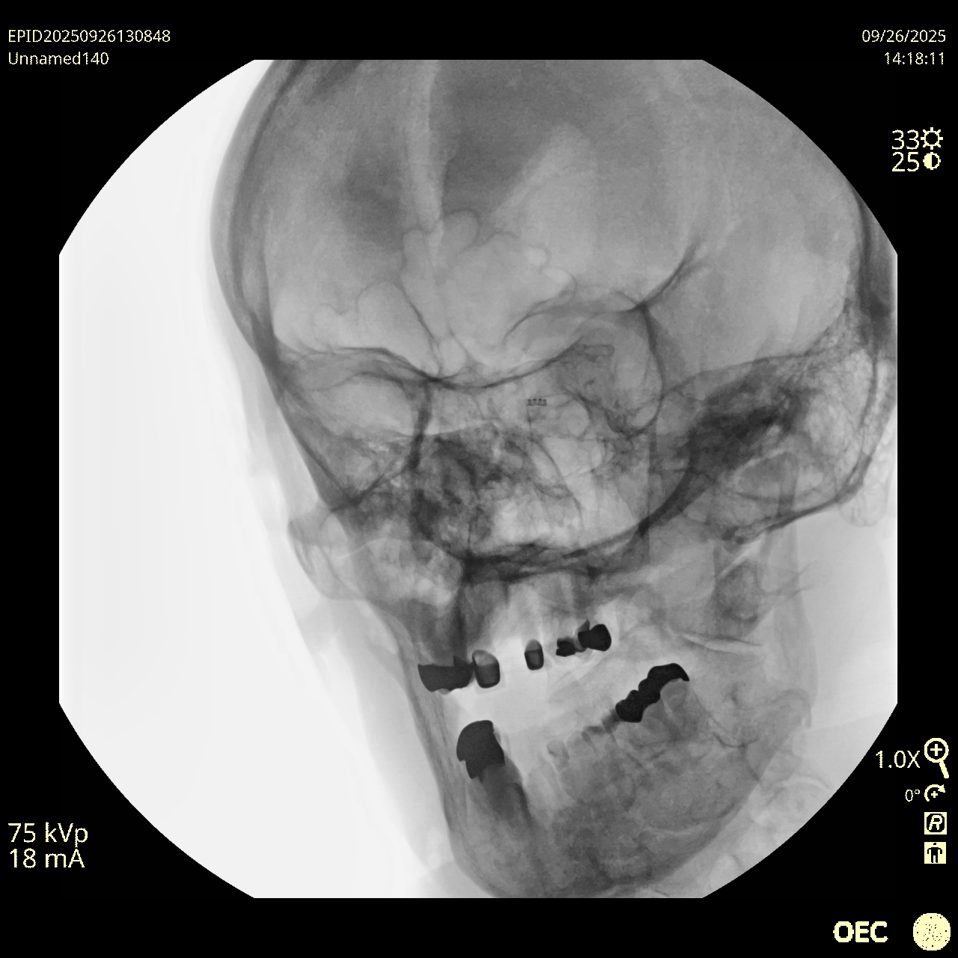
Figure S30. Complete X-ray view corresponding to Fig. 6Bi, with EB1.7 remaining clearly visible in human intracranial anatomical region.
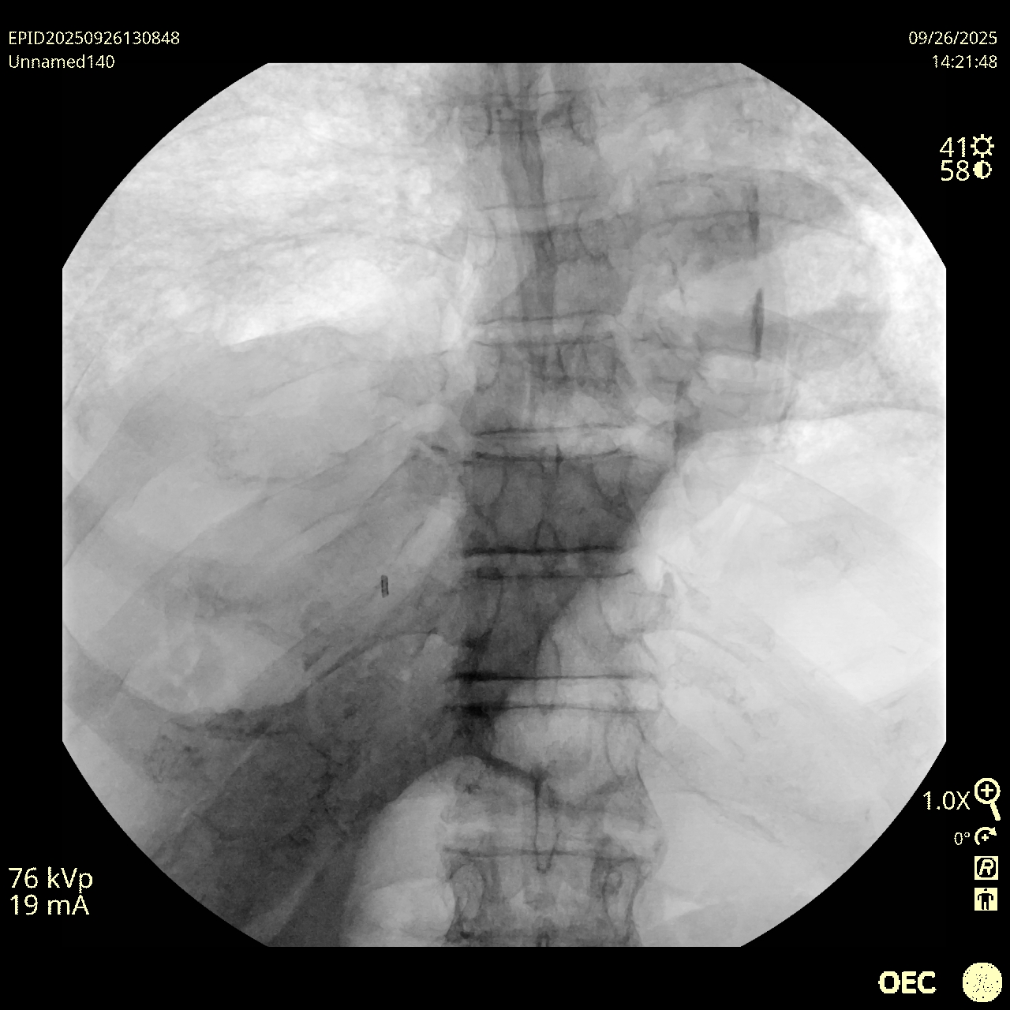
Figure S31. Complete X-ray view corresponding to Fig. 6Bii, with EB1.7 remaining clearly visible in human intrathoracic anatomical region.

Figure S32. Complete X-ray view corresponding to Fig. 6Biii, with EB1.7 remaining clearly visible in human in-leg anatomical region.
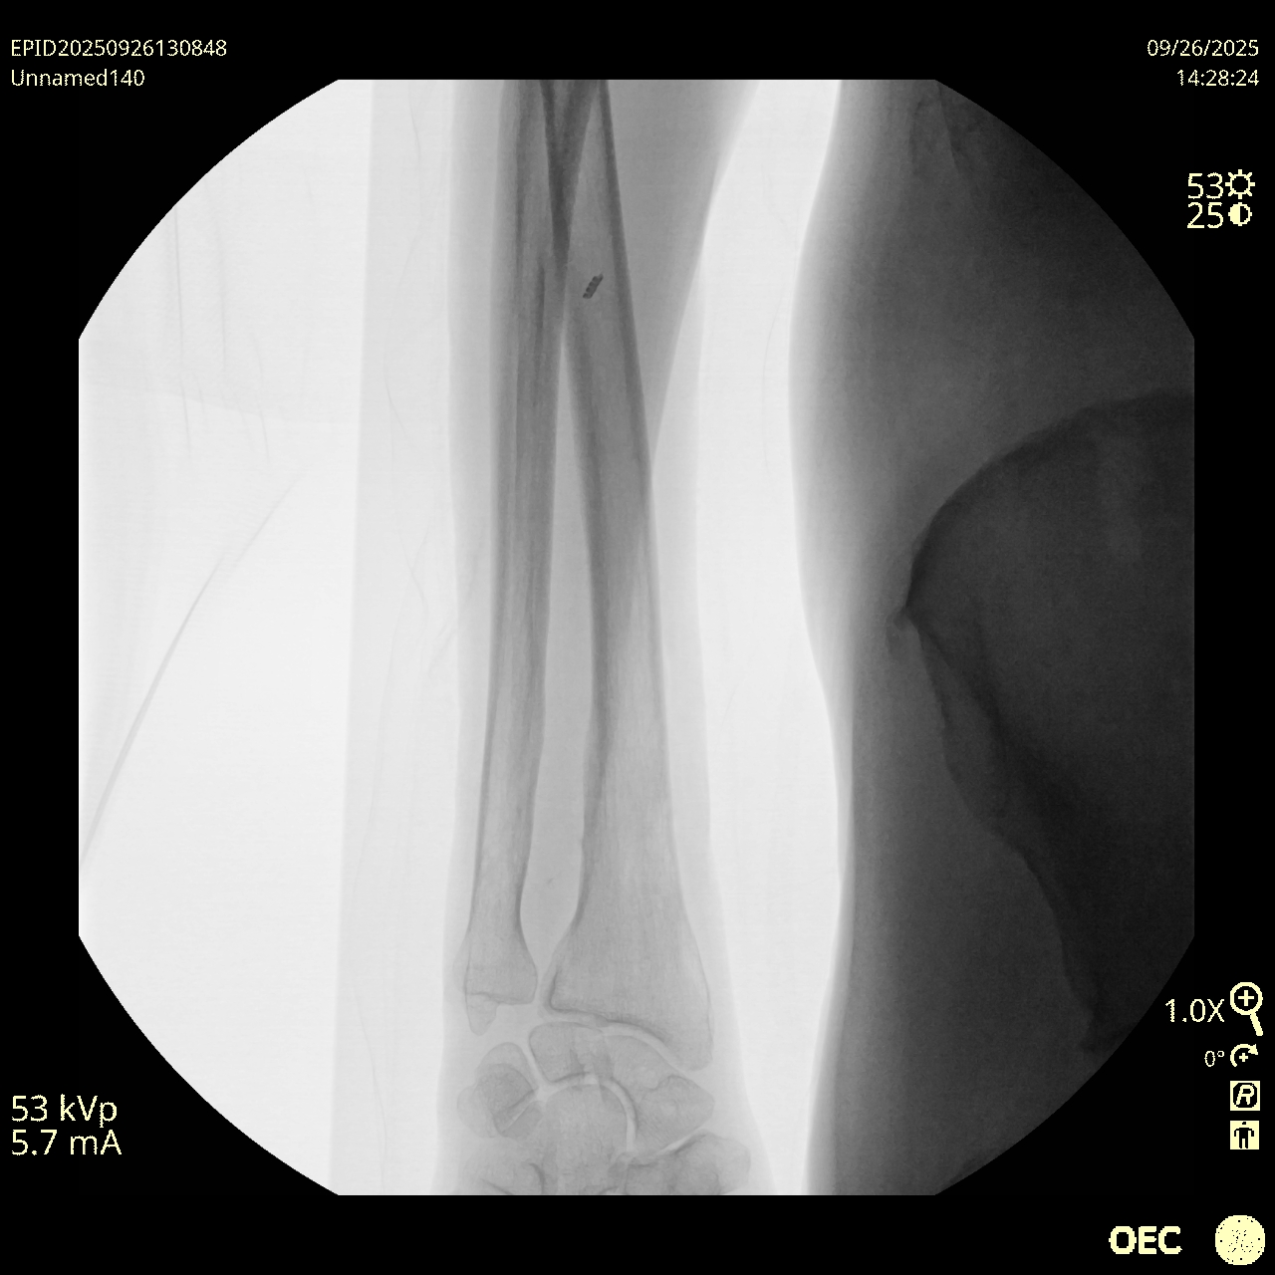
Figure S33. A EB1.7 remains clearly visible in human in-arm anatomical region.
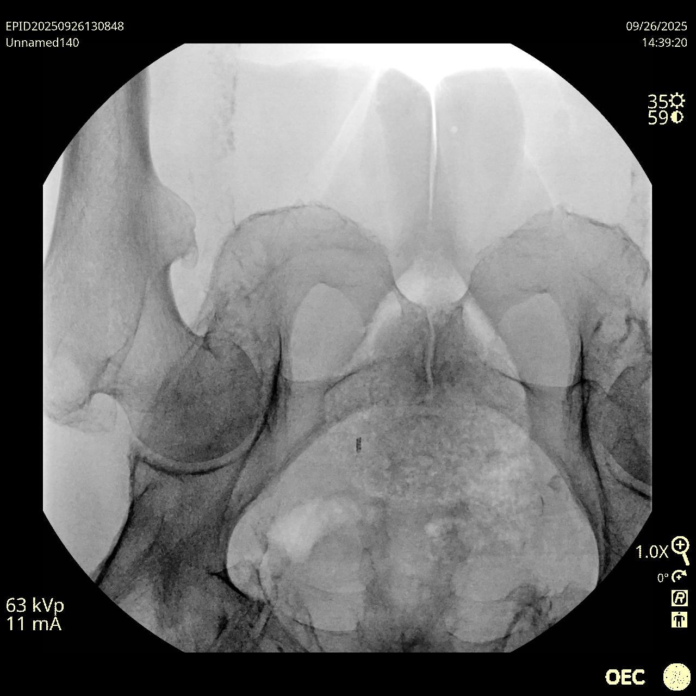
Figure S34. A EB1.7 remains clearly visible in human pelvic anatomical region.

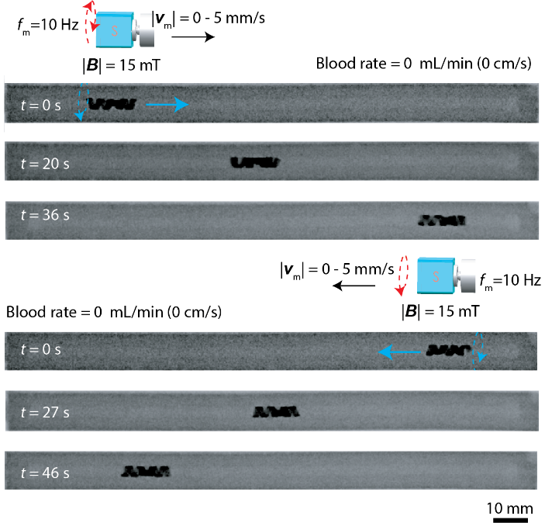
Figure S35. Fluoroscopic-guided locomotion of ${EB3.6}_{10\%}^{10\%}$ within blood-filled straight-line (A-type, Table 6) phantom vessel (no flow). To move ${EB3.6}_{10\%}^{10\%}$from left to right (0s-36s), the magnet is rotated counterclockwise and moved from left to right (x_{mr} = 0, 25 ≥ y_{mr} ≥0 mm, z_{mr} = -112 mm, f_{m} = 10 Hz, |v_{m}| = 0-5 mm/s) and while to move ${EB3.6}_{10\%}^{10\%}$ from right to left (0s-46s), the magnet is rotated clockwise and moved from right to left (operational conditions: x_{mr} = 0, 0 ≥ y_{mr} ≥ -25 mm, z_{mr} = -112 mm, f_{m} = 10 Hz, |v_{m}| = 0-5 mm/s).

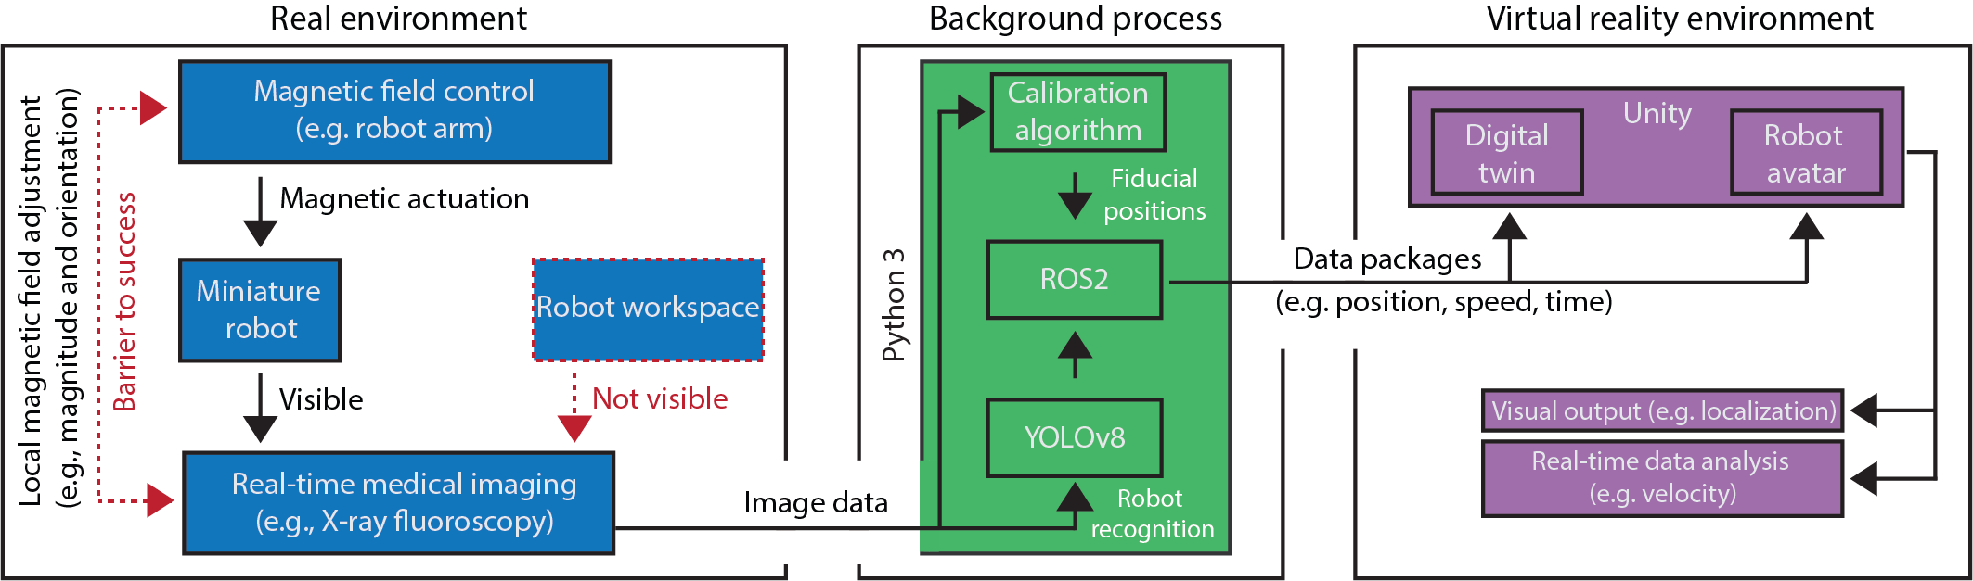
Figure S36. The schematic diagram illustrating the data processing and interface connections in the virtual enhancement strategy.

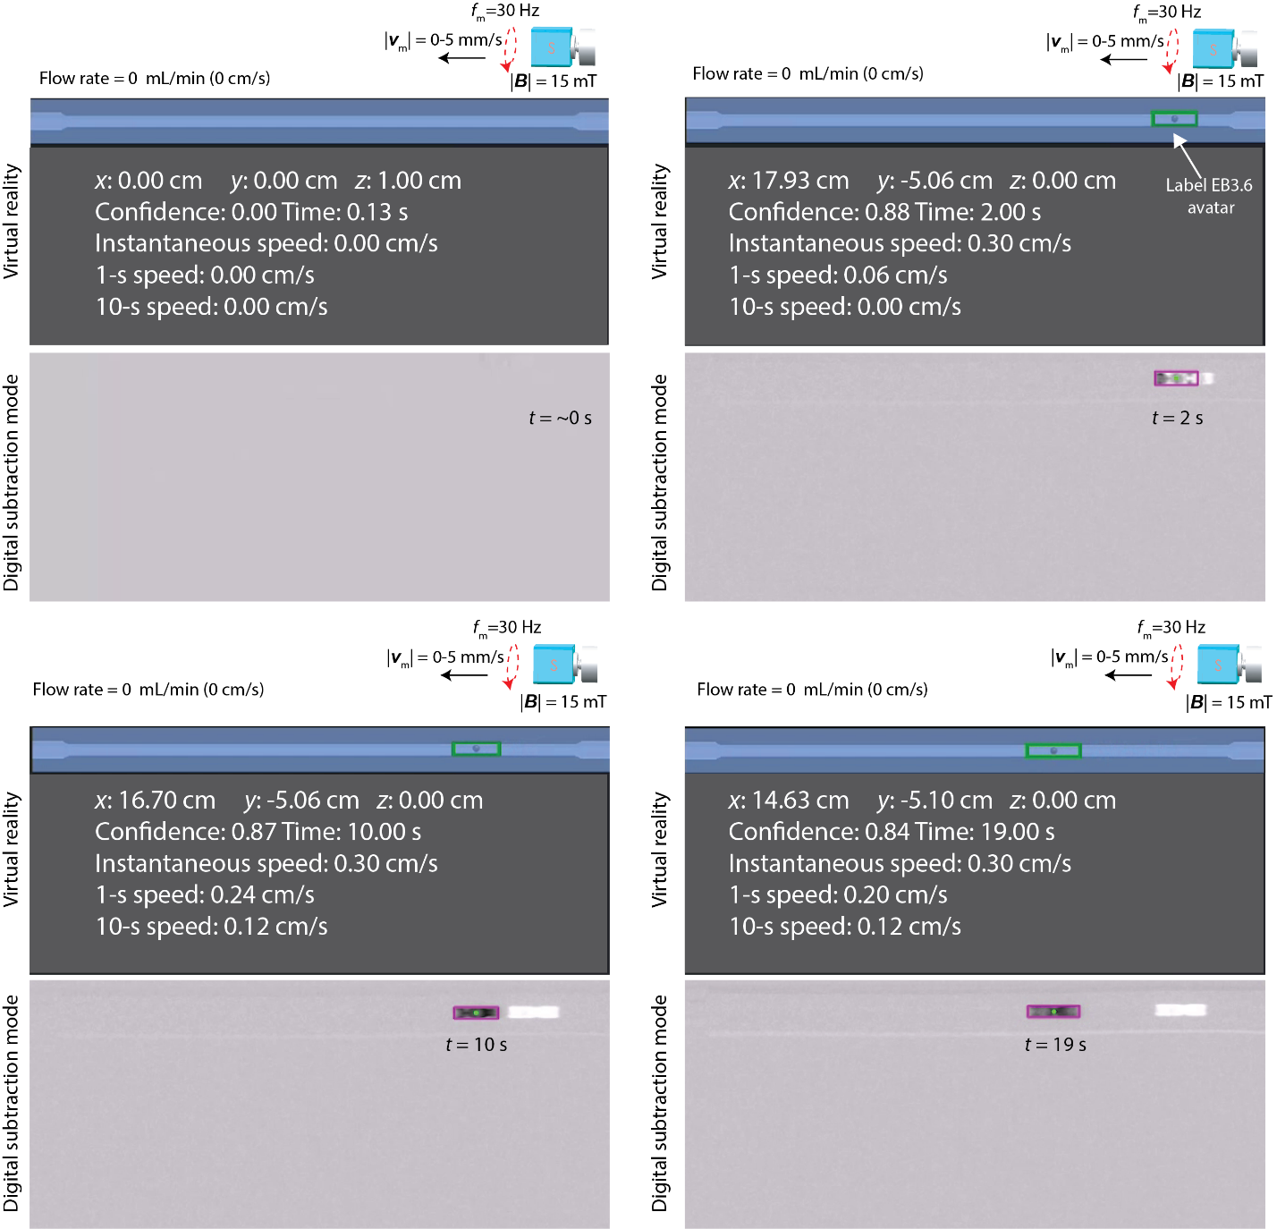
Figure S37. Virtual reality enhanced two-dimensional real-time localization and tracking under fluoroscopic guidance. In the digital subtraction mode, a series of X-ray images are continuously captured of the same area. The output image is produced by subtracting the previous image from the current one, which enhances robot detection while minimizing background noise. For an untethered device like EndoBot, this results in near-zero environmental information in which it is operated. The digital twin interface ensures safe and efficient navigation of EndoBot (operation condition: the magnet is rotated clockwise and moved from right to left, x_{mr} = 0, 0 ≥ y_{mr} ≥ -25 mm, z_{mr} = -112 mm, f_{m} = 30 Hz, |v_{m}| = 0-5 mm/s).

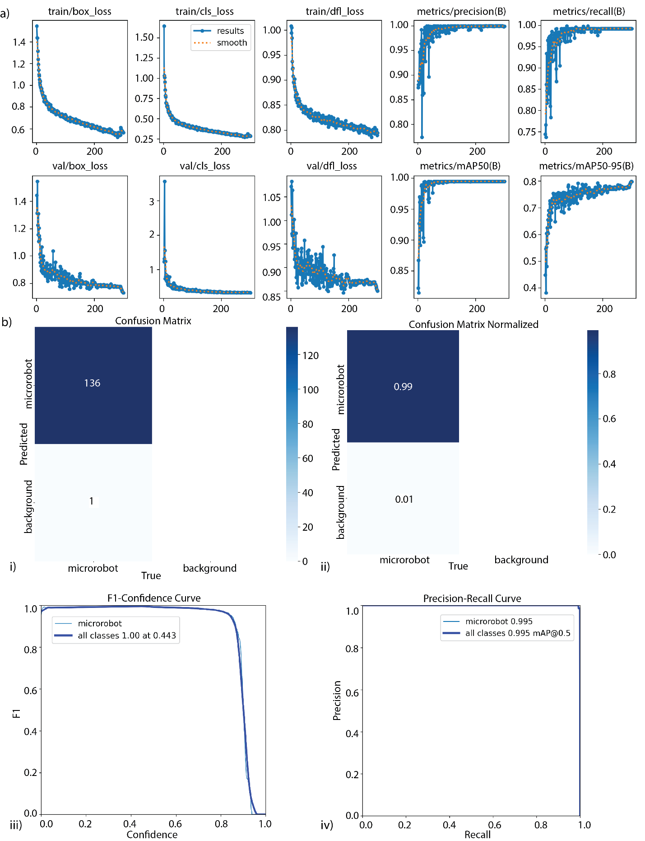

Figure S38. YOLOv8 training performance, evaluation metrics, and detection accuracy for EndoBot localization. (a) Training and validation performance curves of the YOLOv8n model over 280 epochs. The first row shows training losses: box regression (box_loss), classification (cls_loss), and distribution focal loss (dfl_loss). The second row shows corresponding validation losses. The rightmost columns show precision, recall, mAP@0.5, and mAP@0.5:0.95, all demonstrating stable convergence and strong model generalization. (b) Evaluation metrics at the final epoch. i) confusion matrix with raw counts showing 136 correct EndoBot predictions and 1 false positive. Ii) normalized confusion matrix. Iii): F1 score vs. confidence curve indicating an optimal confidence threshold of 0.443. iv) precision–recall (PR) curve showing near-perfect separation with mAP@0.5 of 0.995 for the microrobot class.

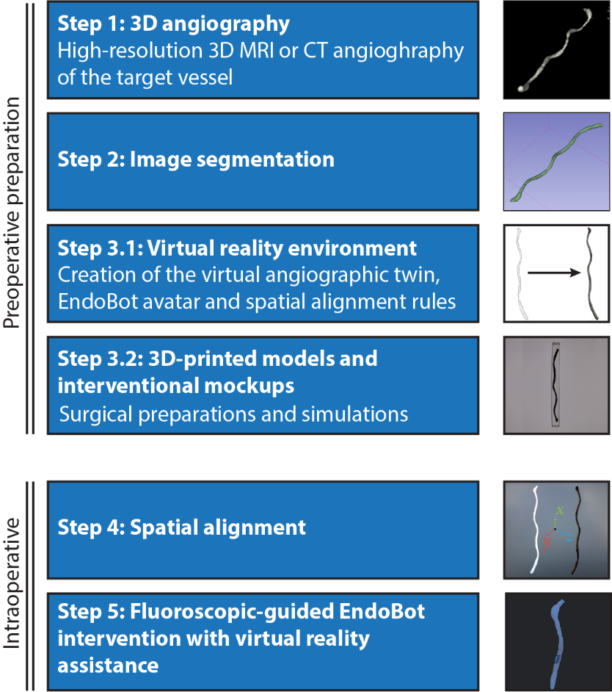
Figure S39. Workflow for clinical integration of EndoBot control using virtual reality assistance. Virtual anatomical modeling is critical for the real-time localization, tracking and precise remote navigation of untethered miniature robots like EndoBot within the human body. This strategy begins with preoperative planning, which includes high-resolution imaging (e.g., MRI or X-ray) of the target tissue or organ. The acquired data are segmented to generate a digital twin of the anatomy in the virtual environment. These segmentation datasets can also be used to fabricate 3D-printed anatomical models for preprocedural planning and surgical rehearsal (Fig. S40). After synchronizing the coordinate systems of the virtual and physical spaces, EndoBot interventions can be performed safely, guided by integrated visual tracking and real-time feedback through the VR interface (Fig. 6D, Fig. S41).

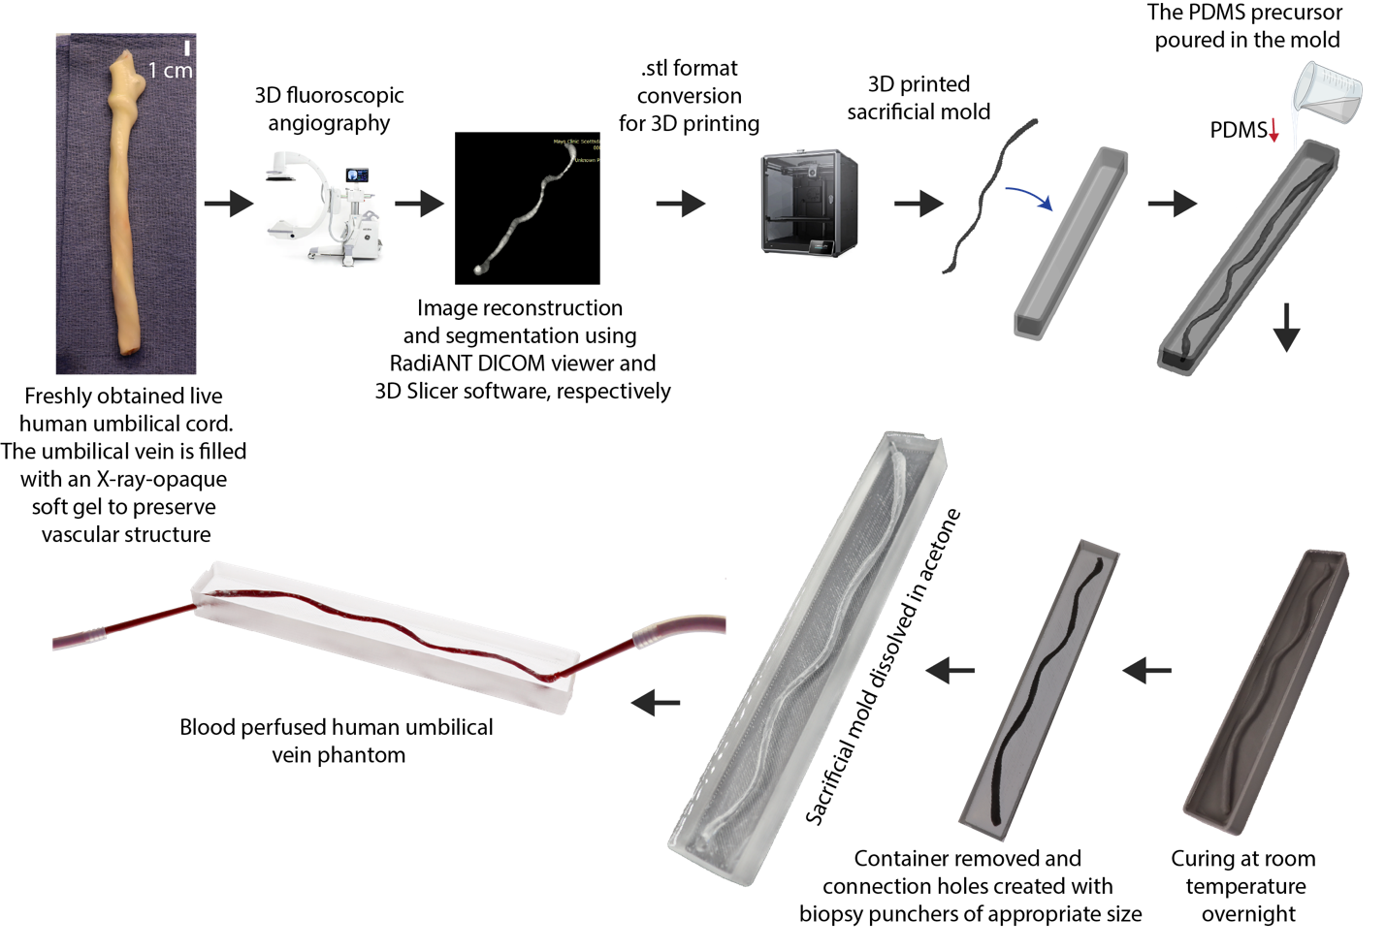
Figure S40. A feasibility demonstration: 3D fluoroscopic angiography, segmentation, and fabrication of a mock-up phantom umbilical vein for pre-interventional robot assessment demonstration.

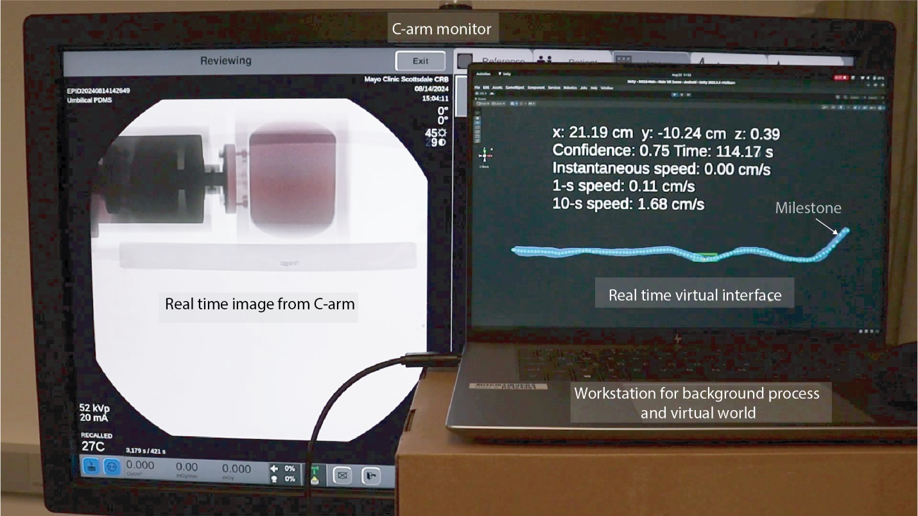
Figure S41. Close-up view of the real-time captured fluoroscopic stream from the C-arm monitor for robot detection, localization, and tracking within the digital twin of a 3D umbilical vein segment.

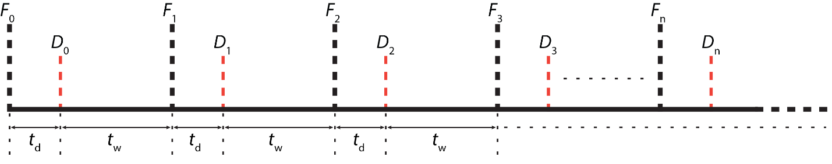

Figure S42. Real-time synchronization and system delay compensation approach.

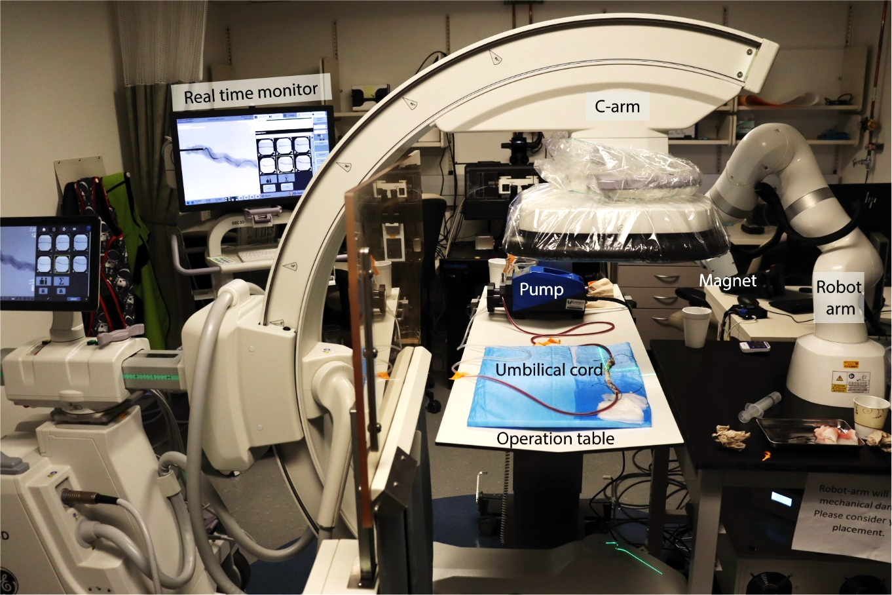
Figure S43. X-ray fluoroscopy-guided magnetic EndoBot manipulation setup during an angiography demonstration in a normothermic, blood-perfused, human live umbilical vein.

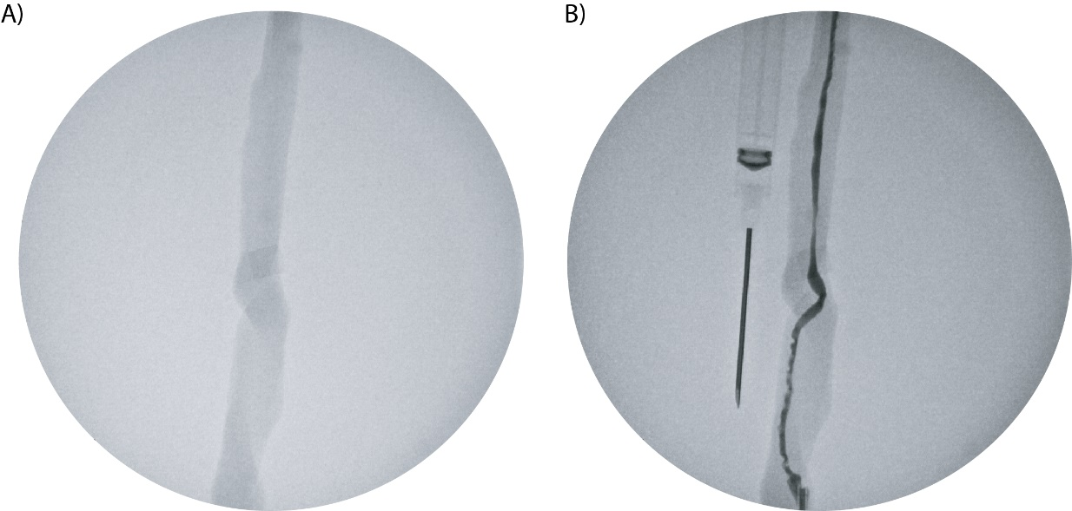
Figure S44. Perfused umbilical veins under the C-arm without and with contrast agent. (A) Without contrast agent. (B) With contrast agent.

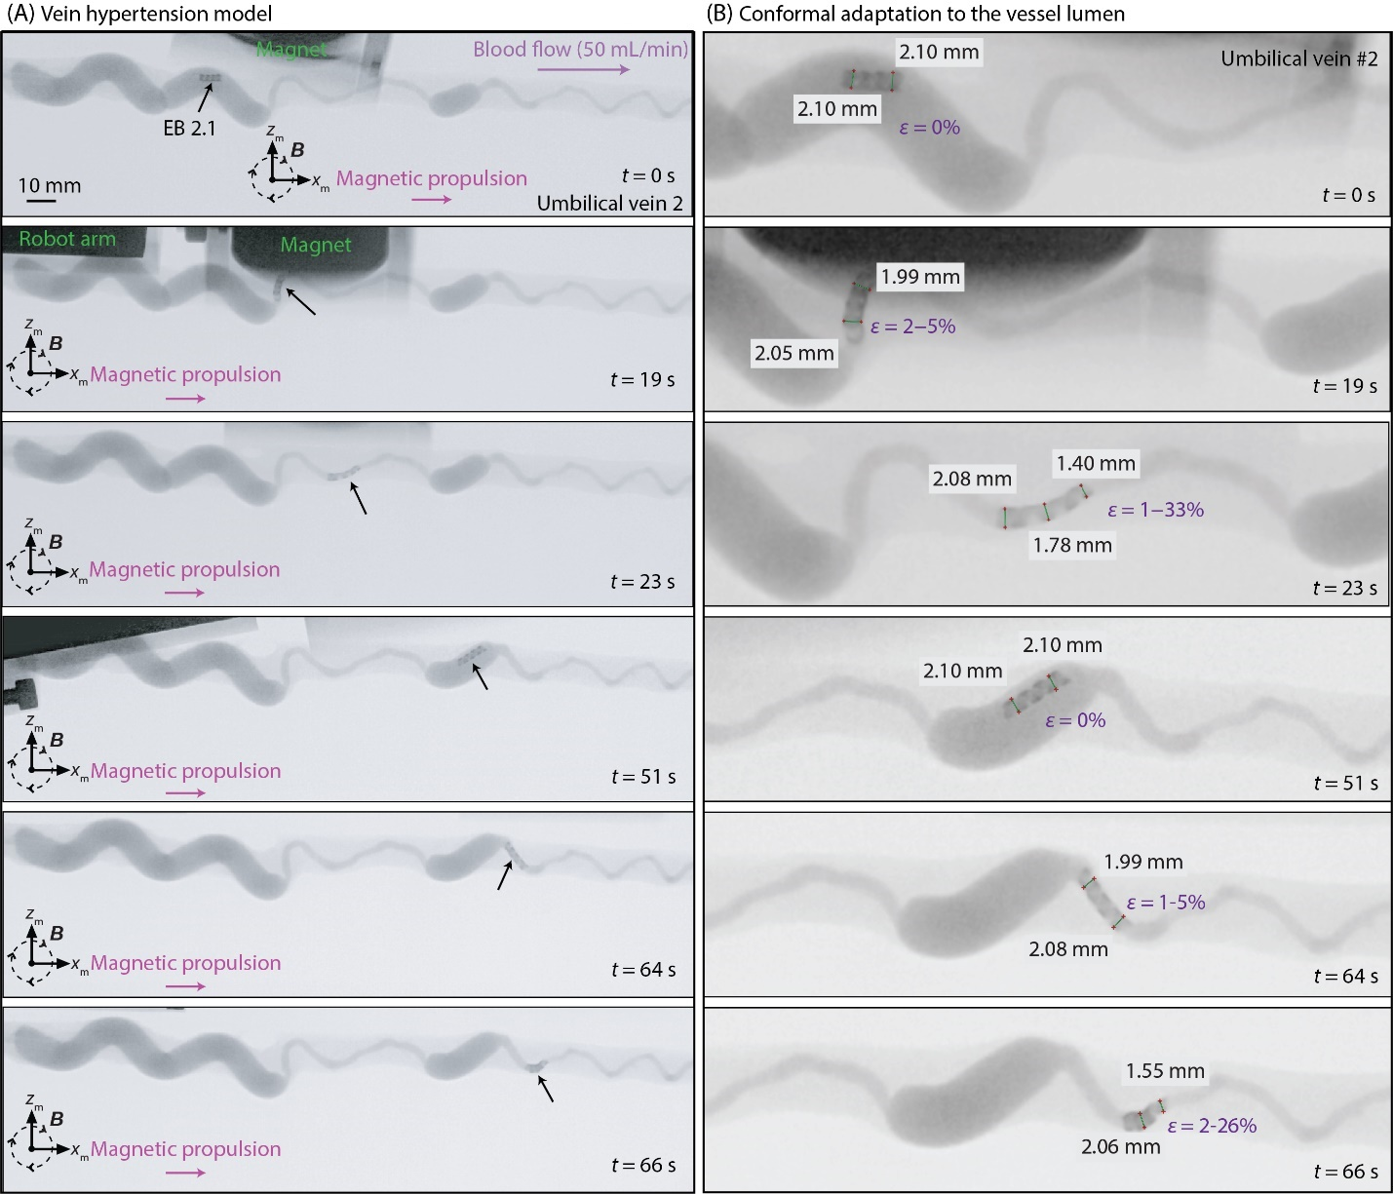
Figure S45. EB2.1 navigating normothermically perfused human umbilical vein #2 under real-time fluoroscopic guidance, serving as a venous hypertension model. (A) Sequential snapshots depict the navigation of EndoBot. (B) Zoomed-in view of EndoBot’s positions with its diameter measured, showing conformal adaptation of EndoBot to the vessel lumen within umbilical vein #2 at the corresponding time points in (A).

Supplementary Text 11: Histological analysis of ex vivo-perfused umbilical veins
Fixed tissue samples were paraffin-embedded, sectioned at 4 μm thickness, and mounted onto glass microscope slides. To assess vessel wall morphology and endothelial integrity, the first set of slides was stained with Hematoxylin and Eosin (H&E) and Masson trichrome. A second set underwent immunohistochemical staining for CD31/PECAM-1 (Abcam, cat. #ab182981), a widely used marker for endothelial cells with confirmed cross-reactivity in human, mouse, and rat tissues. Detection of the CD31/PECAM-1 primary antibody was carried out using a goat anti-rabbit IgG H&L secondary antibody conjugated to Alexa Fluor 488 (Abcam, cat. #150077). All stained sections were imaged using an Olympus EP50 upright microscope and an Olympus IX73 inverted fluorescence microscope (Olympus, Tokyo, Japan).

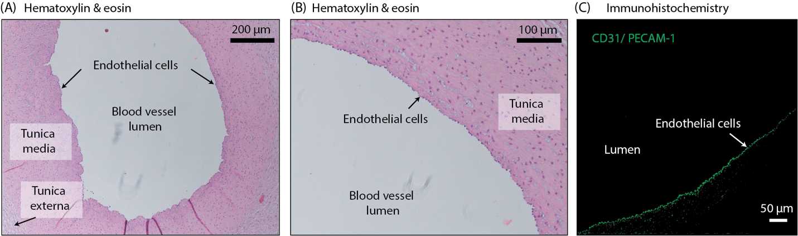
Figure S46. Histologic analysis of umbilical vein #3 demonstrating preserved endothelial integrity and vessel wall structure after repeated EndoBot navigation. (A) Masson trichrome staining highlights collagen-rich structures and confirms intact vessel architecture. (B) Hematoxylin and eosin (H&E) staining reveals normal cellular morphology within the vessel wall layers. (C) CD31/PECAM-1 immunohistochemical staining confirms the presence of an intact endothelial cell lining. As no well-defined or continuous internal elastic lamina is present in the human umbilical vein, we were not able to observe it herein (44).

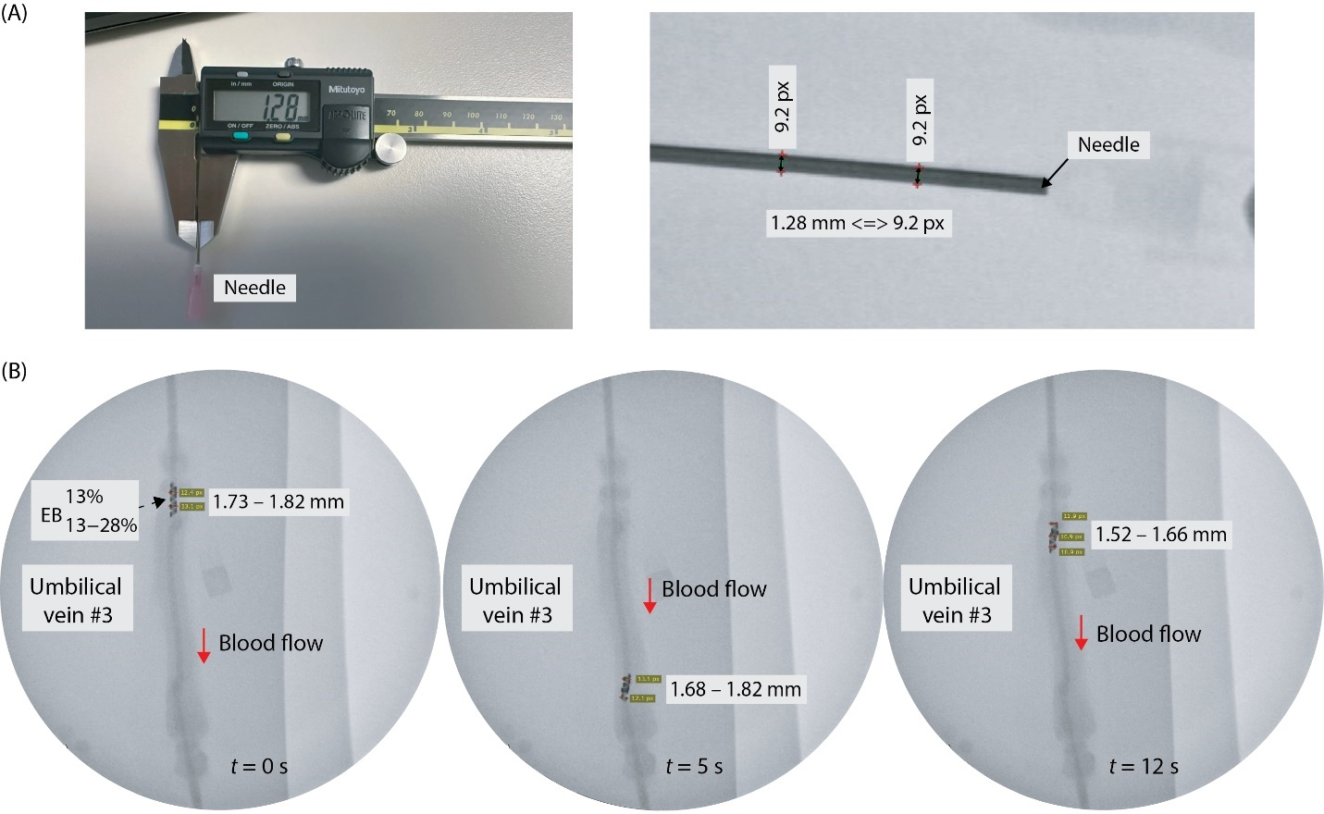
Figure S47. Fluoroscopic-guided navigation of ${EB2.1}_{13-28\%}^{13\%}$ in the umbilical vein #3 under fluoroscopic guidance using iohexol (Omnipaque) contrast enhancer injected into the bloodstream. (A) Needle size used as a reference for measuring EndoBot diameter. (B) Sequential snapshots depicting the navigation of EndoBot within umbilical vein #3, with its diameter measured at each time point, showing conformal adaptation to the vessel lumen along the robot’s length.

Supplementary Text 12: Drug transfer coating formulation, refinement and performance evaluation
Formation and refinement of coating material: Five coating formulations were prepared by using polymethyl methacrylate (PMMA) and acetyl tributyl citrate (ATBC) for mechanical refinement and assessment as a transient endoluminal drug depot and excipient:

Formulation 1: 1.9 wt.% PMMA in ATBC
Formulation 2: 3.7 wt.% PMMA in ATBC
Formulation 3: 7.1 wt.% PMMA in ATBC
Formulation 4: 13.2 wt.% PMMA in ATBC
Formulation 5: 100% PMMA (no ATBC)

4 mL of each formulation was dissolved in 6 mL of acetone using a Hei-PLATE magnetic stirrer (Heidolph Instruments, Germany) to ensure complete solubilization. Following dissolution, 200 µL of Rhodamine B (2 mg/mL in acetone) was added to each solution as a fluorescent dye for IVIS imaging and to enhance visual tracking. The mixtures were transferred to 25-mm–radius plastic containers and left to dry slowly under ambient conditions until complete evaporation of acetone.
Viscosity and coating behavior assessment: To evaluate coating viscosity and brushability of the remaining coating after the removal of acetone, a pointing brush was dipped 1 mm into each acetone-dried formulation and withdrawn at a constant rate of 0.1 mm/s using our CellScale Univert mechanical testing system. The final withdrawal distance was 4 mm, at which point an image was captured to document material behavior (Fig. S45A). A supplementary video shows this process for the optimal formulation (Formulation 2: 3.7 wt.% PMMA/ATBC) (Supplementary movie 6).
Images revealed that increasing PMMA content yielded more viscous materials. Higher PMMA ratios produced cohesive and uniform filaments with improved adherence and mechanical integrity. To demonstrate manual applicability, a Rod of Asclepius symbol was drawn with Formulation 2 (3.7 wt.% PMMA/ATBC) on a plastic surface using a pointing brush and imaged via IVIS (Fig. S45B).
Serum dissolution resistance testing (Fig. 45C): To evaluate the resistance of the coating to serum-mediated erosion, we prepared five additional samples incorporating fluorescein isothiocyanate (FITC), chosen for its low reactivity with ATBC. This decision followed preliminary experiments using Rhodamine B, during which we observed that prolonged incubation led to a loss of fluorescence, likely due to chemical interaction with the formulation, resulting in inaccurate longitudinal measurements. In contrast, FITC maintained stable fluorescence over time and was therefore used for subsequent analysis.
A 1 mg/mL FITC solution in acetone was prepared, and 1 mL was added to each formulation. After complete evaporation of acetone, a uniform coating layer formed at the bottom of each glass vial. Subsequently, 10 mL of bovine serum (Innovative Research, Inc., USA) was added to each vial, and FITC release was monitored over time. At predefined intervals (0, 15, 30, and 45 minutes, then hourly up to 12 hours), 200 µL aliquots were withdrawn in triplicate (n = 3) and transferred to a 96-well plate for fluorescence analysis. After each sampling, an equivalent volume (200 µL) of fresh bovine serum was carefully added back to maintain constant sample volume.
FITC concentrations were quantified using an IVIS imaging system and referenced against a linear calibration curve prepared from known concentrations (from 20 µg/mL down to 0.097 µg/mL). The amount of retained FITC within the coating at the bottom of the glass vial was interpreted as an indicator of resistance to serum dissolution.
Flow-induced erosion stability (Fig S45D): To evaluate the stability of the coating under shear conditions, a 3.7 wt.% PMMA/ATBC solution was prepared by dissolving 160 mg PMMA in 4 mL ATBC and 6 mL acetone. From this, 500 µL was combined with 500 µL Rhodamine B (2 mg/mL in acetone). Acetone was allowed to evaporate in the glass container and film was formed on the glass surface. As a control, a separate film containing only Rhodamine B (1 mg/mL in acetone) was prepared under identical conditions without the transfer coat. In both glass containers, 18 mL of bovine serum and the container was subjected to high-speed vortex mixing for 5 minutes using the Vortex Genie 2 Mixer (Scientific Industries SI-0236, USA). Following this, serum was removed, and the coated surfaces were qualitatively inspected. The transfer coating remained visibly intact on the glass surface, indicating robust resistance to flow-induced erosion.
Incorporating the transfer coating onto EndoBot: To apply the coating to the EndoBot's outer surface, 3.7 wt.% PMMA/ATBC was prepared as described. A total of 120 µL of this solution was mixed with 120 µL Rhodamine B (2 mg/mL in acetone), yielding a final 240 µL coating solution. The EndoBot was flattened and fixed in place inside a container using a water-soluble glue. Then, the coating solution was applied to the container by using a micropipette controller. After complete acetone evaporation, a lubricant transfer coating uniformly formed on the EndoBot surface.
Fragmentation of the coating during and after delivery: Fragmentation of the coating during endovascular delivery poses a potential risk of downstream occlusion and tissue ischemia. To assess fragmentation, we integrated a 10 µm pore-sized polytetrafluoroethylene syringe filter (Merck Millipore, NY1002500, Ireland) into a closed-loop circulation system.
Inner lumen surface of a 6-cm segment of platinum-cured silicone tubing (inner diameter: 3.2 mm) was uniformly coated with 480 µL of 3.7 wt.% PMMA/ATBC containing Rhodamine B dissolved within acetone. After the complete dissolution of acetone, the coated segment was connected to a closed-loop circuit containing 15 mL bovine serum. The circulation was operated at a flow rate of 6-10 cm/s for 30 minutes.
After circulation, the coated segment underwent an additional open loop washing continuously with 150 mL fresh serum over 15 minutes to remove all potential residual fragments. All serum containing Rhodamine B, both freely released and as part of detached coating, was collected. Rhodamine B content in the circulation was quantified via IVIS imaging using a pre-established standard curve. The 10 µm filter was also imaged via IVIS to quantify retained coating fragments (designated as “Coating +” condition, Fig. 8E).
To establish a baseline to dissect non-specific Rhodamine B adsorption, a control experiment was conducted by coating the inner tube lumen surface with an amount of Rhodamine B equivalent to that released during the Coating + test into 15 mL of fresh bovine serum. This solution was circulated in an identical system with a new 10 µm filter for 30 minutes, followed by open-loop washing with 150 mL of clean serum. The filter was then analyzed by IVIS to assess non-specific Rhodamine adsorption and distinguish it from coating debris (designated as “Coating -” condition, Fig. 8E).

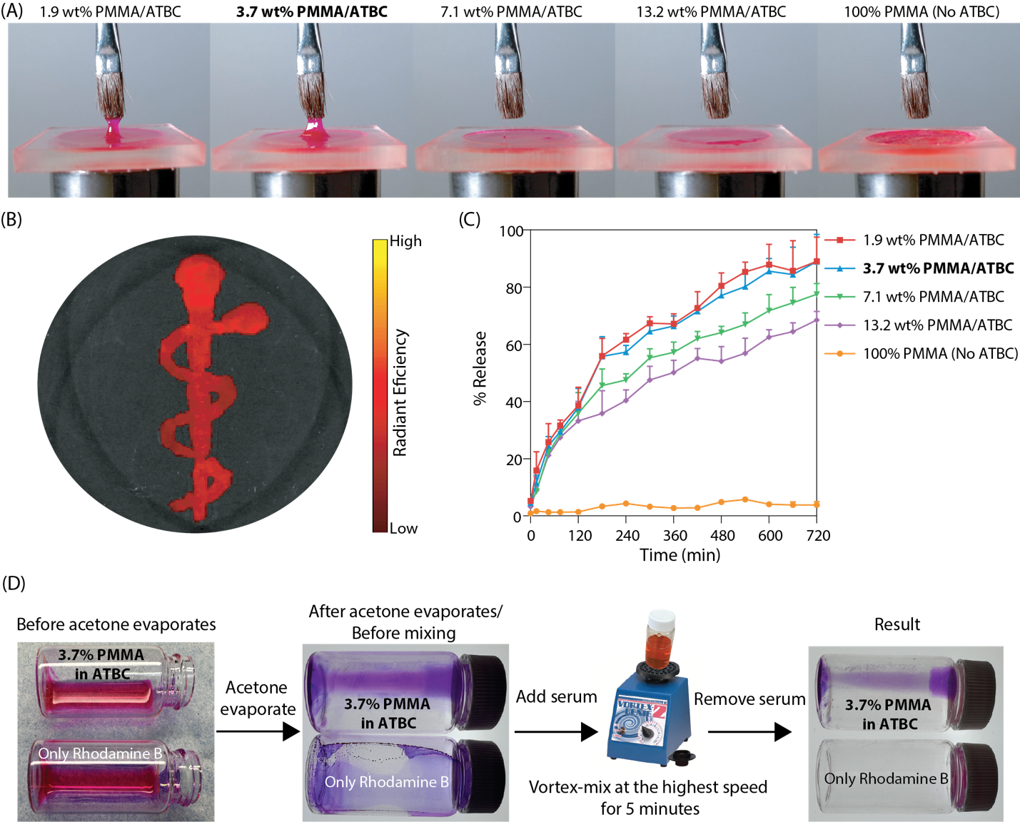
Figure S48. Refinement and evaluation of coating material for EndoBot-mediated drug transfer layer. (A) Mechanical refinement of coating material. (B) Practical demonstration: the Rod of Asclepius symbol created using the optimized coating material, showcasing its precision and stability in forming drug coatings. (C) Resistance of the coating material to serum dissolution. (D) Flow-induced erosion stability under harsh vertexing conditions in serum for 5 minutes.

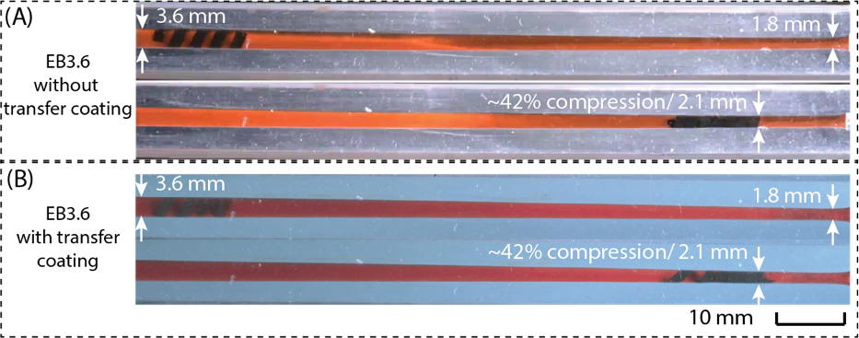
Figure S49. Assessing the potential impact of the transfer coating on the mechanical properties of the entire construct by comparing the conformal deformation capacity under magnetic propulsion using a conical phantom vessel. (A) EB3.6 without coating. (B) EB3.6 with transfer coating.

Supplementary Text 13: Rat experiments
In Fig. S27, we demonstrate the deployment and retrieval of EndoBots under physiological flow conditions using camera-guided imaging. Here, we extend this demonstration to evaluate the compatibility of standard clinical vascular sheaths (sizes ranging from 4F to 7F) with EndoBots of diameters between 1.4 mm and 3.8 mm. Visual confirmation of compatibility and fluoroscopic visibility is provided in Fig. S50.
All animal experiments followed guidelines set forth by the Application Format for Ethical Approval for Research Involving Animals and were approved by the Institutional Animal Care and Use Committee (IACUC-A00007480-24) at Mayo Clinic Scottsdale, Arizona, USA. Procedures were conducted to minimize animal discomfort, employing appropriate anesthetic and analgesic agents.
A total of 5 rats were used. EndoBots without drug-transfer coating were tested in rats #1, #2, and #3 to evaluate mechanical vascular tissue damage. Rats #4 and #5 received EndoBots coated with encapsulated Rhodamine B to demonstrate drug delivery capabilities.
Initially, rats were anesthetized with 3% isoflurane (0.75 L/min oxygen) for intraperitoneal (IP) injection of pentobarbital sodium (Leucadia, 50 mg/mL stock solution, for 50 mg/kg IP dose). Anesthesia was maintained with additional doses (20 mg/kg) every 50-60 minutes. Preoperative analgesia was achieved with buprenorphine hydrochloride injection (0.3 mg/mL stock solution, for 0.1 mg/kg subcutaneous dose). Following anesthesia, the abdomen was opened, and the inferior vena cava (IVC) was exposed and measured precisely using calipers. A 6F PINNACLE® vascular sheath (Terumo) was inserted via a slightly modified Seldinger technique (Fig. S51). Briefly, a guidewire was introduced smoothly into the IVC, followed by careful sheath insertion and guidewire removal. The sheath was prefilled with heparin (1000 IU/mL) to minimize thrombosis risk, and additional heparin was applied topically to the abdomen to counteract thrombosis from blood leakage.
Upon successful sheath placement, rats were transferred beneath a C-arm fluoroscopic imaging system for EndoBot deployment (Fig. 9A). After experimental procedures, euthanasia was performed using Euthasol (390 mg/mL; dose: 450–550 mg/kg).
EB2.1 was propelled magnetically (|B| = ~20-60 mT and f_{m} = ~ 10−30 Hz) in the caudal direction. When reaching the catheter/sheath tip at the IVC interface, the deployment into the vessel lumen was assisted by venography with contrast agent injection. Contrast flushing enabled brief vessel visualization and facilitated EndoBot entry into the vessel lumen (Fig. 9B and Supplementary movies 8 and 9). To maintain stable magnetic control under high physiological blood flow and flushing-induced turbulence, the magnetic propulsion direction was temporarily reversed, and magnets were positioned closely to apply magnetic pulling force in the opposite direction of flow. We developed this deployment method after accidentally losing an EB2.1 to hear in Rat #1 as shown in Supplementary movie 10.
After each procedure, selected IVC segments subjected to EndoBot passage were excised and fixed in 10% formalin (24 hours, 4–5°C), embedded in paraffin, sectioned (2–3 µm thickness), and stained with Hematoxylin & Eosin (H&E), Masson trichrome and CD31 staining using the same approach and materials as in the ex vivo umbilical vein characterization described in Supplementary text 11. Microscopic evaluation of vessel wall integrity and endothelial integrity was performed using Olympus EP50 and IX73 inverted fluorescence microscopes.
Feasibility of flow resistant endoluminal drug delivery was assessed in rats #4 and #5, each undergoing four forward-and-backward EndoBot passes within the IVC (compression levels: 9–19% in rat #4; 7–46% in rat #5). Post-navigation, normal blood flow was maintained for an additional 15 minutes before euthanasia, enabling assessment of drug-transfer coating stability. Subsequent IVIS imaging of harvested treated and untreated IVC segments confirmed successful and stable deposition of Rhodamine B onto the vessel luminal surface (Fig. 9D).

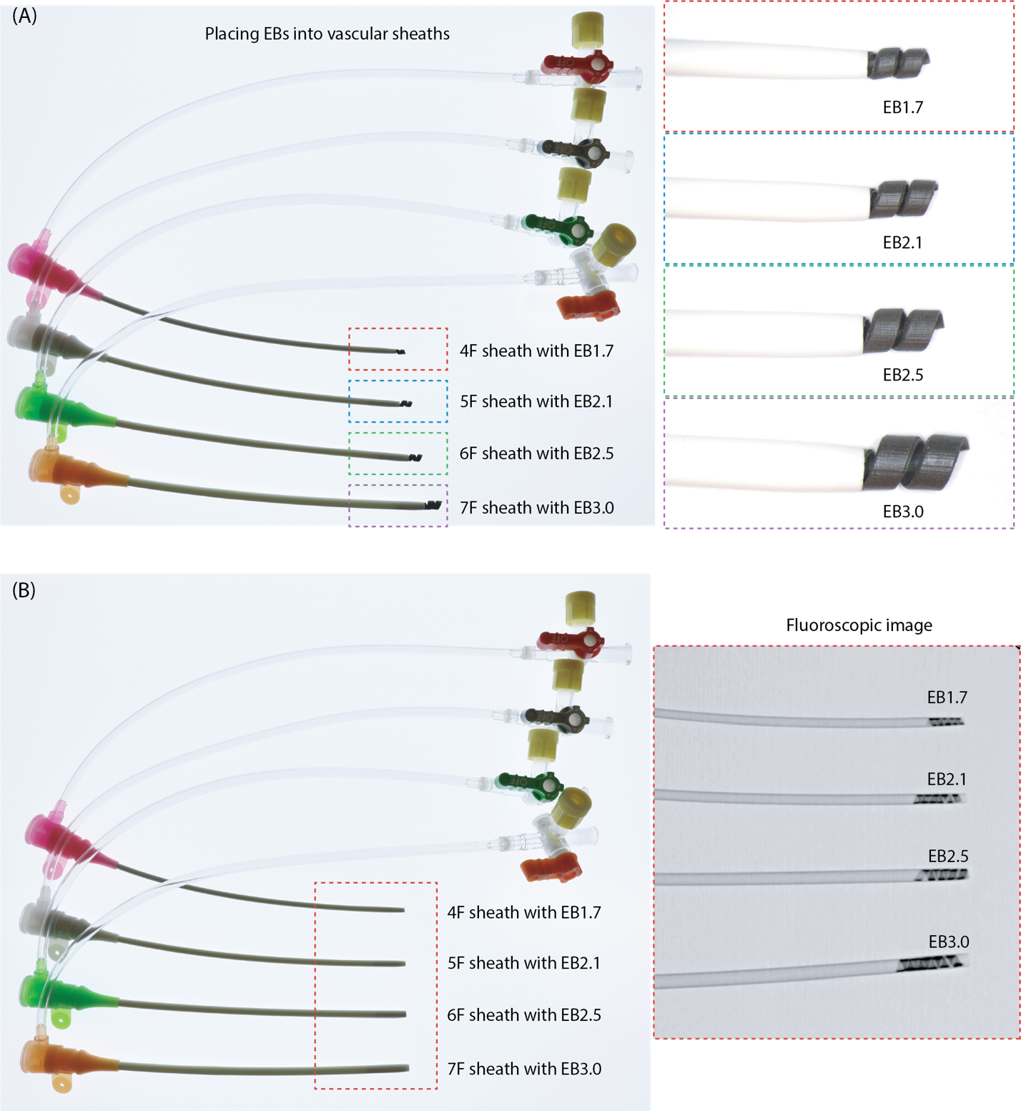
Figure S50. Compatibility of clinical vascular sheaths with EndoBot variants and pre-deployment imaging. (A) Assembly of standard vascular sheaths (4F-7F) preloaded with EndoBots of corresponding sizes (EB1.7 to EB3.0), demonstrating sheath-device compatibility for in vivo experiments. (B) Fluoroscopic images used to verify EndoBot helicity and positioning within each sheath prior to intravascular deployment.

Table S8. Compressive strain ranges experienced by EB2.1 in each rat IVC during navigation
Rat number | Initial strain in 6F sheath  (%) | Anticipated bias strain based on angiography* $(_{bias}$) | Minimum experienced strain** $(_{min}$) (%) | Maximum experienced strain*** $(_{max}$) (%)
1 | 2 | 10 | 0 | 7
2 | 2 | 10 | 5 | 27
3 | 2 | 10 | 5 | 28
4 | 2 | 10 | 9 | 19
5 | 2 | 10 | 7 | 46
* Based on intraoperative fluoroscopic angiography, EB2.1 was selected to achieve approximately 10% bias strain within the inferior vena cava (IVC), in accordance with Rule 1.
** Due to dynamic contraction of the vein and its noncylindrical geometry, the actual strain experienced within the vessel was lower than the intended minimum (bias) strain.
*** Dynamic venous contraction and geometric irregularities resulted in higher strains within the vessel than the anticipated maximum strain.

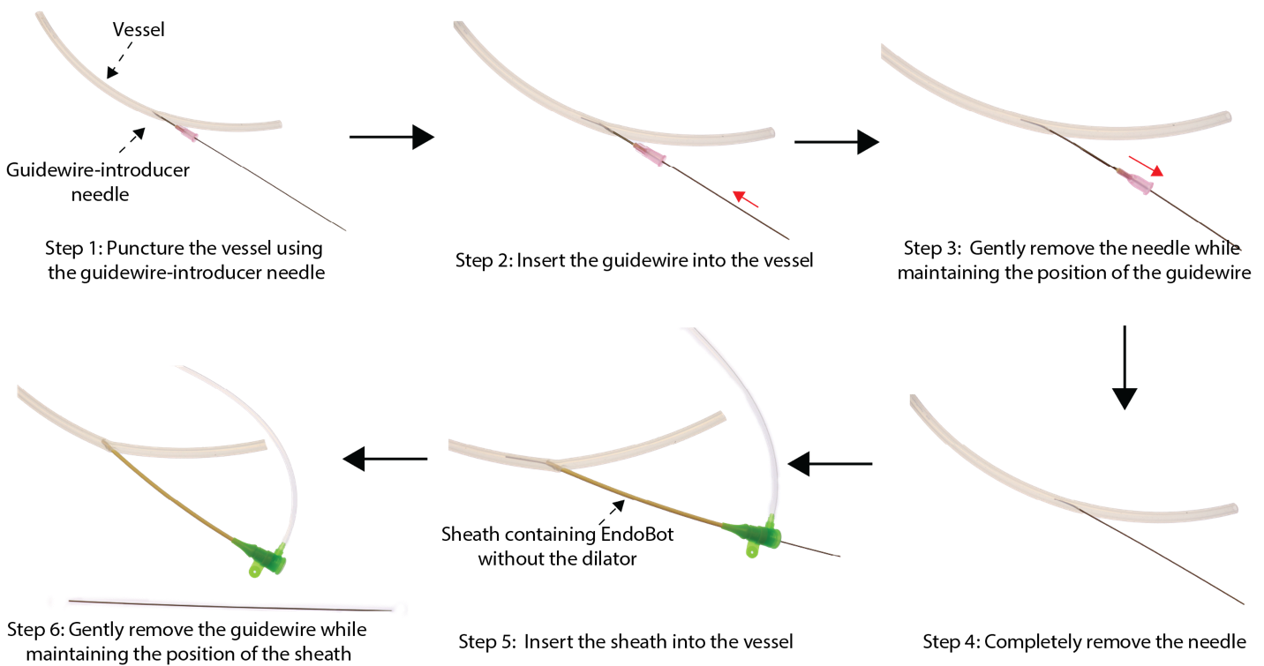

Figure S51. Stepwise illustration of modified Seldinger technique for 6F Pinnacle vascular sheath insertion. Diagram outlining the sequential steps used to access the target vessel segment: (1) puncture with a guidewire-introducer needle, (2) insertion of the guidewire, (3) withdrawal of the needle while maintaining guidewire position, (4) advancement of the sheath (preloaded with EndoBot and without a dilator) over the guidewire, and (5) final withdrawal of the guidewire, completing the sheath placement for intravascular navigation.

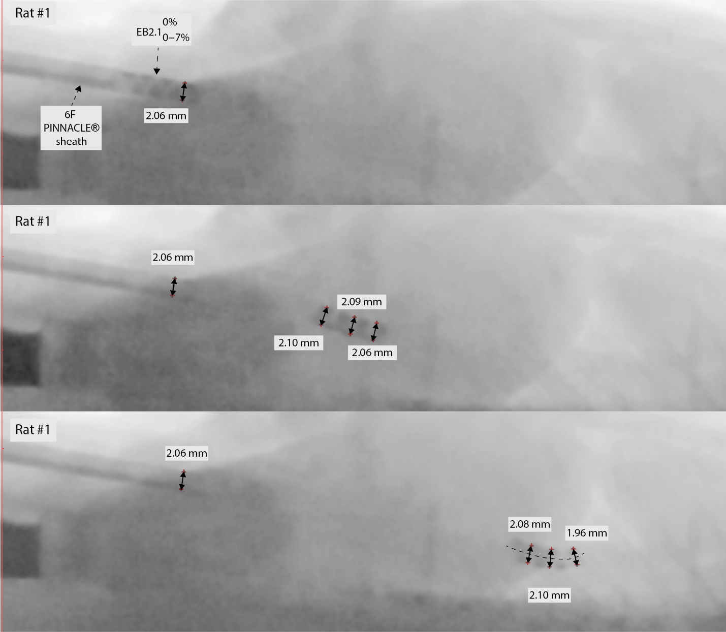
Figure S52. Fluoroscopic snapshots of ${EB2.1}_{0-7\%}^{0\%}$ in the IVC of rat #1. Diameter measurements at various positions along the vessel confirm the device's conformal adaptation to dynamic luminal geometries during navigation.

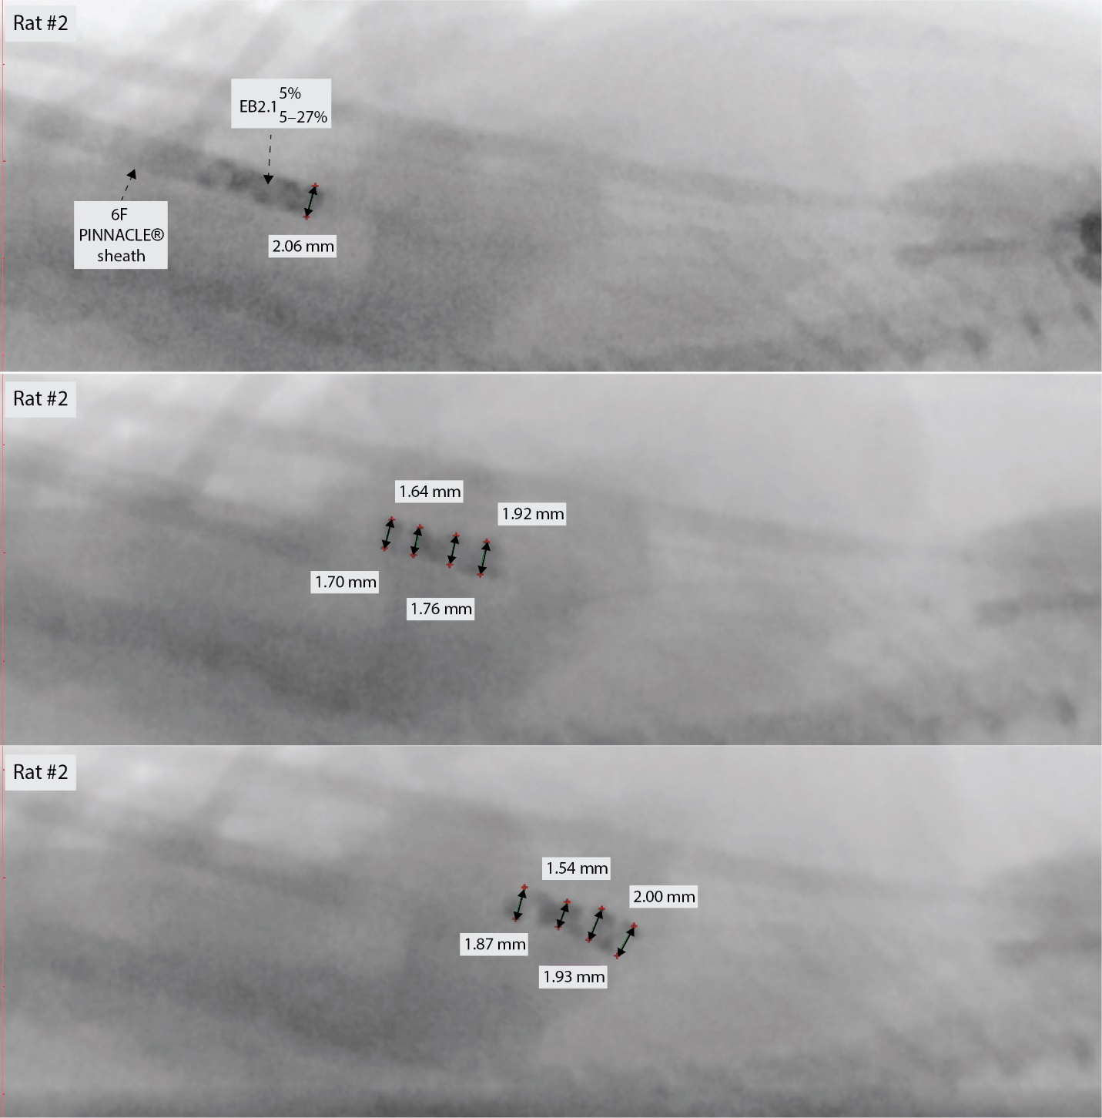
Figure S53. Fluoroscopic snapshots of ${EB2.1}_{5-27\%}^{5\%}$in the IVC of rat #2. Diameter measurements at various positions along the vessel confirm the device's conformal adaptation to dynamic luminal geometries during navigation.

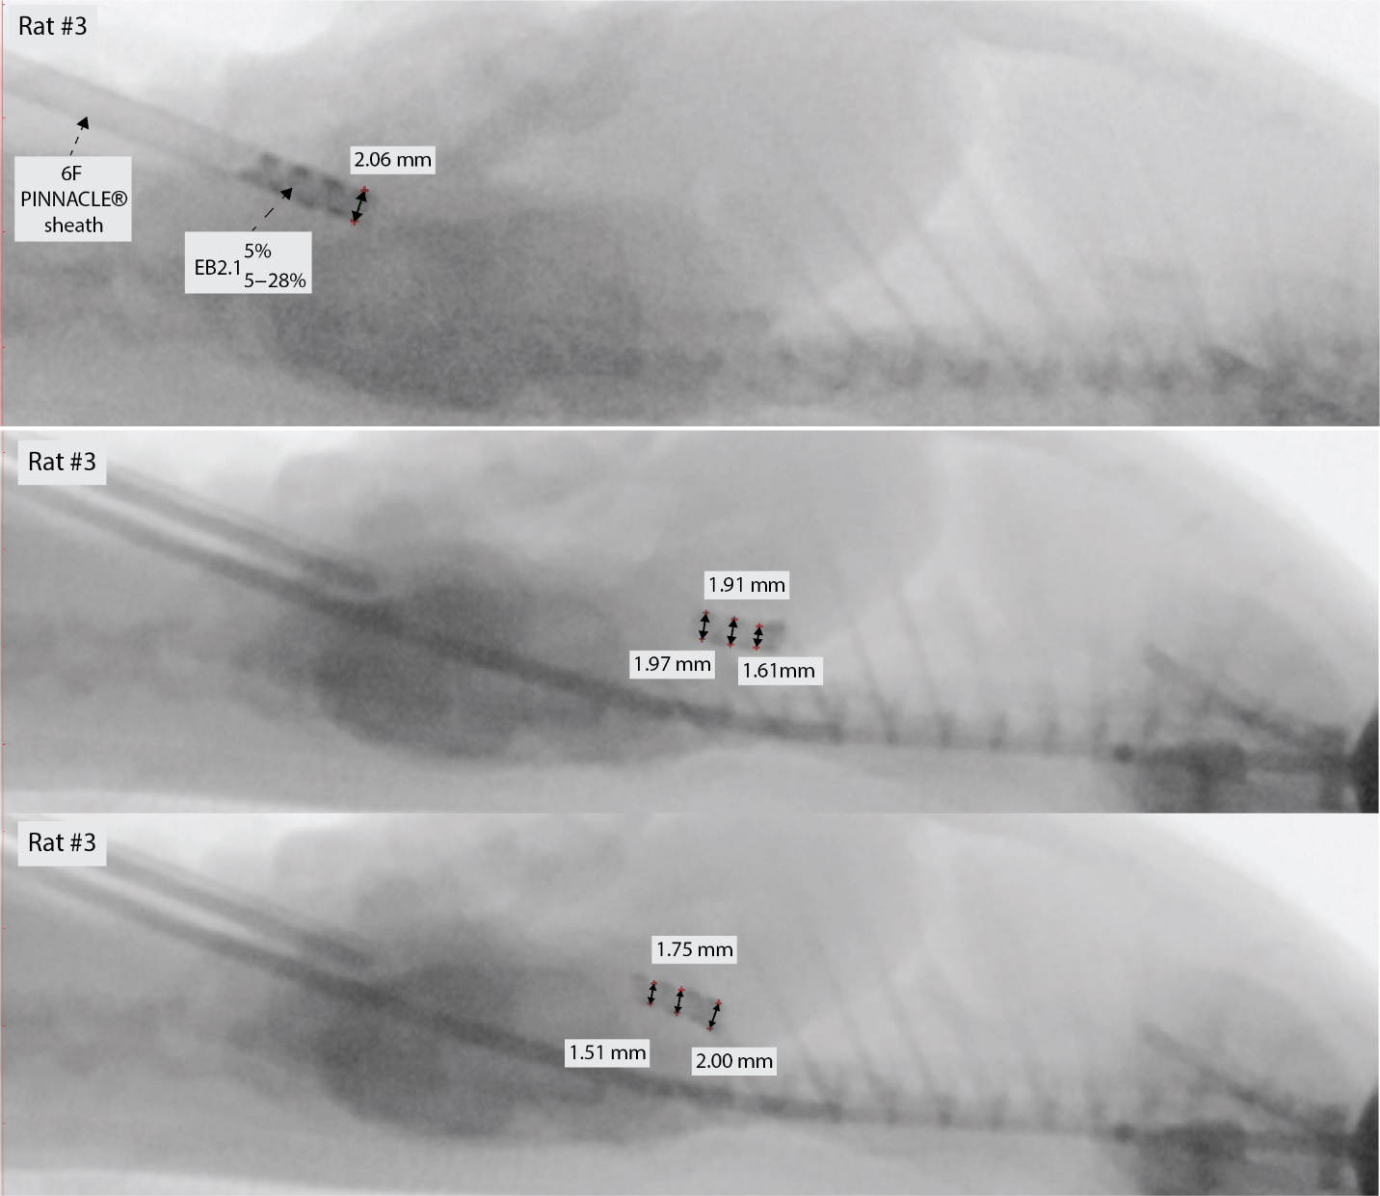
Figure S54. Fluoroscopic snapshots of ${EB2.1}_{5-28\%}^{5\%}$in the IVC of rat #3. Diameter measurements at various positions along the vessel confirm the device's conformal adaptation to dynamic luminal geometries during navigation.

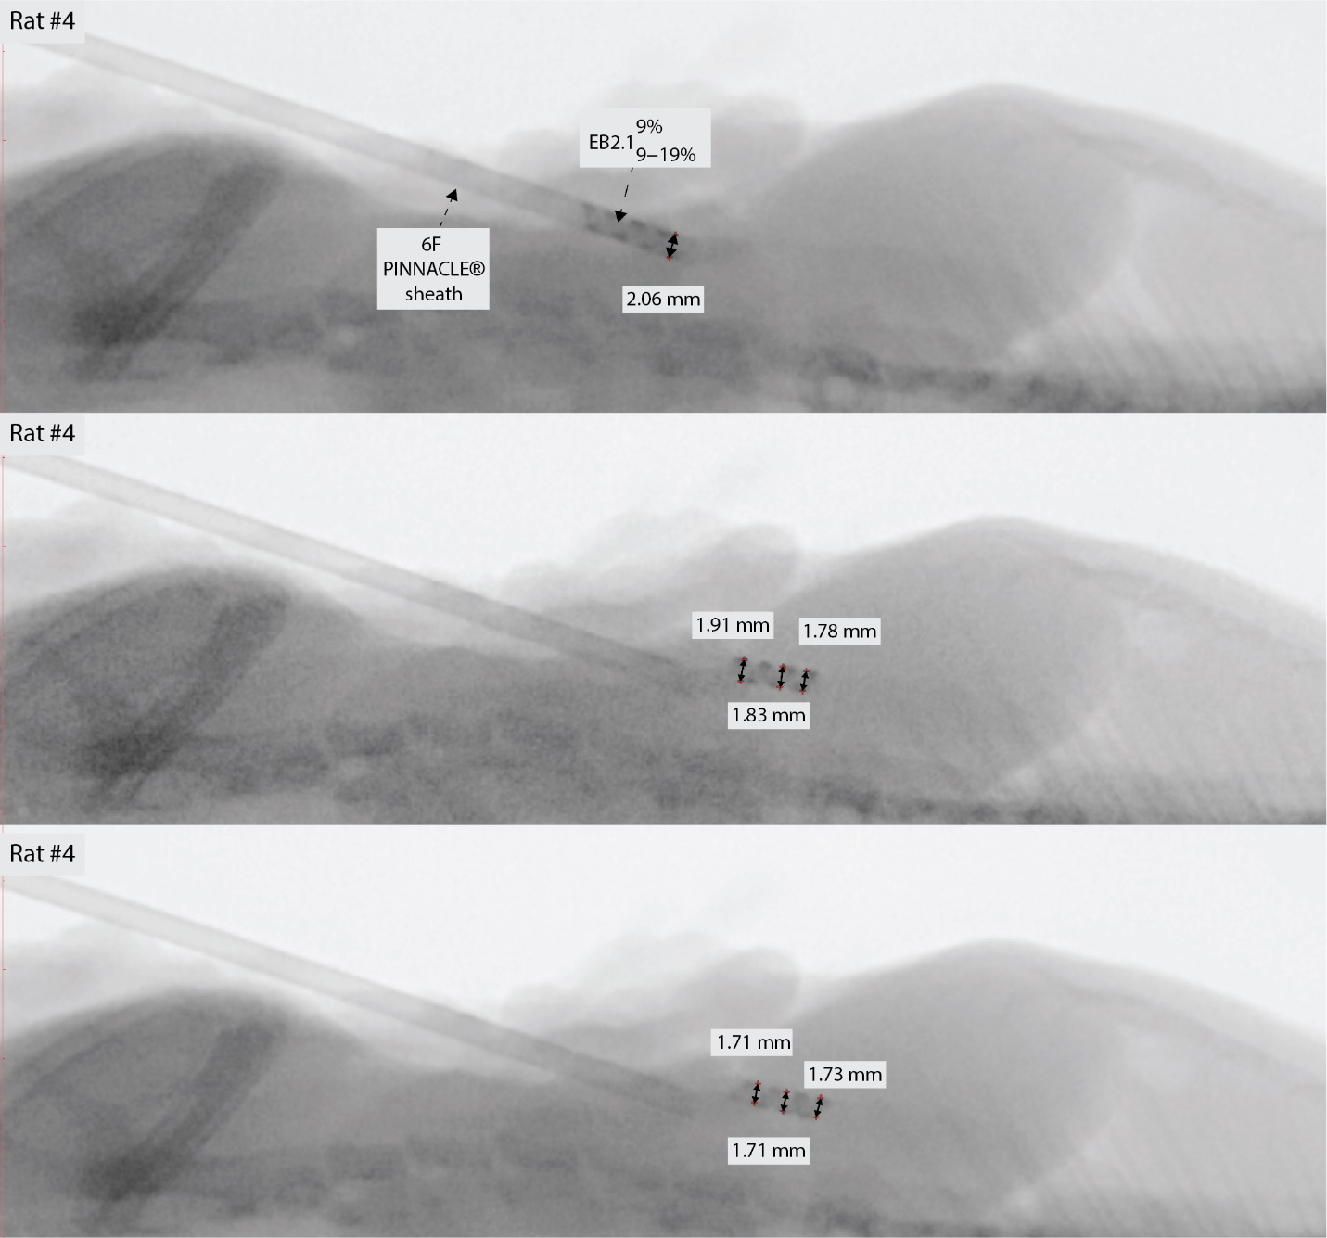
Figure S55. Fluoroscopic snapshots of ${EB2.1}_{9-19\%}^{9\%}$in the IVC of rat #4. Diameter measurements at various positions along the vessel confirm the device's conformal adaptation to dynamic luminal geometries during navigation.

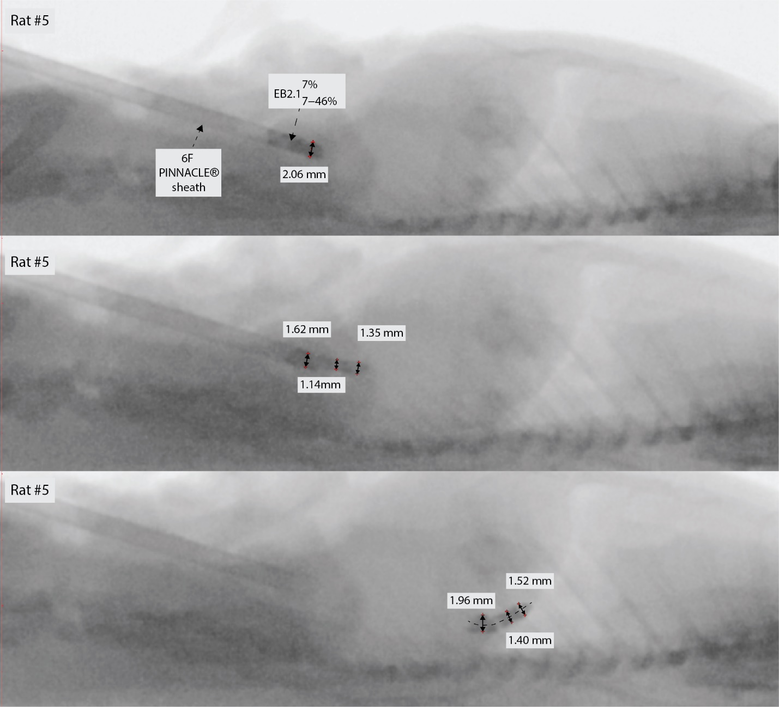
Figure S56. Fluoroscopic snapshots of ${EB2.1}_{7-46\%}^{7\%}$in the IVC of rat #3. Diameter measurements at various positions along the vessel confirm the device's conformal adaptation to dynamic luminal geometries during navigation.

References:
1. S. A. Gunnal, M. S. Farooqui, R. N. Wabale, Study of Middle Cerebral Artery in Human Cadaveric Brain. Ann Indian Acad Neurol 22, 187-194 (2019).
2. K. W. Stock, S. G. Wetzel, P. A. Lyrer, E. W. Radü, Quantification of blood flow in the middle cerebral artery with phase-contrast MR imaging. European Radiology 10, 1795-1800 (2000).
3. H. A. Chami et al., Brachial artery diameter, blood flow and flow-mediated dilation in sleep-disordered breathing. Vasc Med 14, 351-360 (2009).
4. Y. Tomiyama et al., Accurate quantitative measurements of brachial artery cross-sectional vascular area and vascular volume elastic modulus using automated oscillometric measurements: comparison with brachial artery ultrasound. Hypertens Res 38, 478-484 (2015).
5. S. Trager, M. Pignataro, J. Anderson, J. M. Kleinert, Color flow Doppler: Imaging the upper extremity. The Journal of Hand Surgery 18, 621-625 (1993).
6. X. Zhou et al., Investigation of Ultrasound-Measured Flow Velocity, Flow Rate and Wall Shear Rate in Radial and Ulnar Arteries Using Simulation. Ultrasound Med Biol 43, 981-992 (2017).
7. J. T. Dodge Jr, B. G. Brown, E. L. Bolson, H. T. Dodge, Lumen diameter of normal human coronary arteries. Influence of age, sex, anatomic variation, and left ventricular hypertrophy or dilation. Circulation 86, 232-246 (1992).
8. M. Muneeb et al., Assessment of the Dimensions of Coronary Arteries for the Manifestation of Coronary Artery Disease. Cureus 15, e46606 (2023).
9. R. J. Barry, in Supplements to Clinical Neurophysiology, E. Başar, C. Başar-Eroĝlu, A. Özerdem, P. M. Rossini, G. G. Yener, Eds. (Elsevier, 2013), vol. 62, pp. 55-65.
10. D. Sharif, A. Sharif-Rasslan, C. Shahla, A. Khalil, U. Rosenschein, Differences in Coronary Artery Blood Velocities in the Setting of Normal Coronary Angiography and Normal Stress Echocardiography. Heart International 10, heartint.5000221 (2015).
11. H. Irfan, G. S. Ooi, M. M. Kyin, P. Ho, Revealing Maximal Diameter of Upper Limb Superficial Vein with an Elevated Environmental Temperature. Int J Chronic Dis 2016, 8096473 (2016).
12. M. B. Silva, Jr. et al., A strategy for increasing use of autogenous hemodialysis access procedures: impact of preoperative noninvasive evaluation. J Vasc Surg 27, 302-307; discussion 307-308 (1998).
13. R. Albayrak et al., Hemodynamic changes in the cephalic vein of patients with hemodialysis arteriovenous fistula. Journal of Clinical Ultrasound 35, 133-137 (2007).
14. T. Lysyy et al., Ex vivo isolated human vessel perfusion system for the design and assessment of nanomedicines targeted to the endothelium. Bioengineering & translational medicine 5, e10154 (2020).
15. M. Barbieri, D. D. Di Martino, E. M. Ferrazzi, T. Stampalija, Umbilical vein blood flow: State-of-the-art. Journal of Clinical Ultrasound 51, 318-325 (2023).
16. B. M. Seitz, T. Krieger-Burke, G. D. Fink, S. W. Watts, Serial Measurements of Splanchnic Vein Diameters in Rats Using High-Frequency Ultrasound. Front Pharmacol 7, 116 (2016).
17. B. Lanz, C. Poitry-Yamate, R. Gruetter, Image-Derived Input Function from the Vena Cava for 18F-FDG PET Studies in Rats and Mice. Journal of Nuclear Medicine 55, 1380-1388 (2014).
18. H. Park, E. Yeom, S. J. Lee, X-ray PIV measurement of blood flow in deep vessels of a rat: An in vivo feasibility study. Scientific Reports 6, 19194 (2016).
19. S.-H. Kim, S. Lee, D. Ahn, J. Y. Park, PDMS double casting method enabled by plasma treatment and alcohol passivation. Sensors and Actuators B: Chemical 293, 115-121 (2019).
20. H. Ceylan et al., 3D-Printed Biodegradable Microswimmer for Theranostic Cargo Delivery and Release. ACS Nano 13, 3353-3362 (2019).
21. Y. Deng, A. Paskert, Z. Zhang, R. Wittkowski, D. Ahmed, An acoustically controlled helical microrobot. Sci Adv 9, eadh5260 (2023).
22. F. Qiu, B. J. Nelson, Magnetic Helical Micro-and Nanorobots: Toward Their Biomedical Applications. Engineering 1, 21-26 (2015).
23. O. Krischek, E. Miloslavski, S. Fischer, S. Shrivastava, H. Henkes, A comparison of functional and physical properties of self-expanding intracranial stents [Neuroform3, Wingspan, Solitaire, Leo+, Enterprise]. Minim Invasive Neurosurg 54, 21-28 (2011).
24. Z. Wang, A. A. Volinsky, N. D. Gallant, Crosslinking effect on polydimethylsiloxane elastic modulus measured by custom‐built compression instrument. Journal of Applied Polymer Science 131, (2014).
25. J. C. Kohn, M. C. Lampi, C. A. Reinhart-King, Age-related vascular stiffening: causes and consequences. Frontiers in genetics 6, 132758 (2015).
26. Y. Long et al., A geometric scaling model for assessing the impact of aneurysm size ratio on hemodynamic characteristics. BioMedical Engineering OnLine 13, 1-14 (2014).
27. A. Gökaltun, Y. B. Kang, M. L. Yarmush, O. B. Usta, A. Asatekin, Simple surface modification of poly (dimethylsiloxane) via surface segregating smart polymers for biomicrofluidics. Scientific reports 9, 7377 (2019).
28. E. Cho et al., Characterization of mechanical and dielectric properties of silicone rubber. Polymers 13, 1831 (2021).
29. T. Wang et al., Adaptive wireless millirobotic locomotion into distal vasculature. Nature Communications 13, 4465 (2022).
30. F. M. White. (McGraw-Hill, 2016).
31. M. A. López et al., Finite Element Model Of A Helical Swimming Robot In COMSOL Multiphysics®.
32. A. M. Malek, S. L. Alper, S. Izumo, Hemodynamic shear stress and its role in atherosclerosis. Jama 282, 2035-2042 (1999).
33. K. Stang et al., Hemocompatibility testing according to ISO 10993-4: Discrimination between pyrogen- and device-induced hemostatic activation. Mat Sci Eng C-Mater 42, 422-428 (2014).
34. S. Braune et al., In Vitro Thrombogenicity Testing of Biomaterials. Adv Healthc Mater 8, e1900527 (2019).
35. M. A. Smythe et al., Guidance for the practical management of the heparin anticoagulants in the treatment of venous thromboembolism. J Thromb Thrombolysis 41, 165-186 (2016).
36. L. National Heart, B. Institute, Guidelines for Blood-Material Interactions: Report of the National Heart, Lung, and Blood Insitute Working Group, US Dept. Of Health And Human Services. Public Health Service, National Institutes Of Health, Bethesda, Md, (1985).
37. C. C. Helms et al., Mechanisms of hemolysis-associated platelet activation. J Thromb Haemost 11, 2148-2154 (2013).
38. J. F. Theoret, D. Yacoub, A. Hachem, M. A. Gillis, Y. Merhi, P-selectin ligation induces platelet activation and enhances microaggregate and thrombus formation. Thromb Res 128, 243-250 (2011).
39. H. Ceylan, T. A. Le, H. H. Alabay, X-ray fluoroscopy guided localization and steering of miniature robots using virtual reality enhancement. Frontiers in Robotics and AI 11, (2024).
40. B. Dwyer, Nelson, J., Hansen, T., et. al. , Roboflow (Version 1.0) [Software]. Available from https://roboflow.com. computer vision., (2024).
41. G. Jocher, Chaurasia, A., & Qiu, J. (2023). Ultralytics YOLO (Version 8.0.0).[Software]. Available from https://github.com/ultralytics/ultralytics. (2023).
42. D. S. h. p. http://www.slicer.org, 3D Slicer.
43. C. S. Hong, Z. C. Chen, K. T. Tang, W. T. Chang, The Effectiveness and Safety between Monoplane and Biplane Imaging During Coronary Angiographies. Acta Cardiol Sin 36, 105-110 (2020).
44. L. Manuel Barrios Arpi, in Histology, T. Heinbockel, V. D. C. Shields, Eds. (IntechOpen, Rijeka, 2019), chap. Chapter 3.

