Morphological and simple sequence repeat (SSR)-based diversity of Capsicum germplasm characterizes population structure and enables marker-assisted selection for Phytophthora capsici resistance
Deepa Jaganathan^{1,2}, Jessica Michelle Gibbs¹, Noel Thomas¹, Theodore McAvoy¹, Mahnaz Azad³, Miaoying Tian³, Dennis N. Lozada⁴, William Hendricks Railey⁵, Amol N. Nankar^{1,2}*
¹ Department of Horticulture, University of Georgia, Tifton, GA 37193, United States
² Institute of Plant Breeding, Genetics and Genomics (IPBGG), University of Georgia, Tifton, GA 37193, United States
³ Department of Plant Pathology, University of Georgia, Tifton, GA 37193, United States
⁴Department of Plant and Environmental Sciences and Chile Pepper Institute, New Mexico State University, Las Cruces, NM 88003, United States
⁵Abraham Balwin Agricultural College, Tifton, GA 31793, United States
*Corresponding author: amolnankar@uga.edu

Supplementary Tables

Supplementary Table 1 Results of principal component analysis of UGA-Capsi-Core pepper accessions
 | PC1 | PC2 | PC3 | PC4 | PC5 | PC6 | PC7 | PC8
Importance of components
Standard deviation | 1.46 | 1.129 | 1.105 | 0.996 | 0.923 | 0.885 | 0.704 | 0.503
Eigen value | 2.132 | 1.274 | 1.221 | 0.991 | 0.853 | 0.782 | 0.495 | 0.253
Proportion of Variance | 0.2665 | 0.1593 | 0.1526 | 0.1239 | 0.1066 | 0.0977 | 0.0619 | 0.0316
Cumulative Proportion | 0.2665 | 0.4257 | 0.5783 | 0.7022 | 0.8088 | 0.9064 | 0.9684 | 1
Trait contribution
Germination | 8.52 | 0.61 | 8.52 | 48.74 | 2.04 | 17.41 | 14.16 | 0.00
Plant Vigor | 12.91 | 8.9 | 20.19 | 0.73 | 20.67 | 0.49 | 35.62 | 0.49
Days to Flowering | 0.93 | 24.77 | 27.98 | 0.16 | 13.85 | 15.17 | 17.14 | 0.01
NuMini Beller of Lobes | 12.35 | 6.31 | 0.1 | 32.84 | 11.98 | 16.69 | 19.47 | 0.27
Plant Height | 29.35 | 13.74 | 1.42 | 1.16 | 4.84 | 0.64 | 0.17 | 48.67
Main Stem Height | 27.85 | 16.98 | 4.18 | 0.05 | 0.23 | 0.53 | 2.21 | 47.97
Lodging | 1.52 | 6.01 | 28.38 | 12.06 | 45.73 | 3.58 | 0.13 | 2.59
Days to Maturity | 6.56 | 22.68 | 9.23 | 4.27 | 0.64 | 45.5 | 11.11 | 0.00
Note: Values <0.01 are reported as 0.00 due to rounding.

Supplementary Table 2. Correlation coefficient among quantitative traits of UGA-Capsi-Core pepper accessions
 | Germination | Plant Vigor | Days to Flowering | NuMini Beller of Lobes | Plant Height | Main Stem Height | Lodging | Days to Maturity
Germination | 1*** | 0.286*** | 0.058^{ns} | -0.016^{ns} | 0.175*** | 0.183*** | 0.078^{ns} | -0.058^{ns}
Plant Vigor | 0.286*** | 1*** | -0.034^{ns} | -0.274*** | 0.15*** | 0.169*** | 0.197*** | -0.172***
Days to Flowering | 0.058^{ns} | -0.034^{ns} | 1*** | -0.058*** | 0.126^{ns} | 0.088^{ns} | -0.011^{ns} | -0.175***
Number of Lobes | -0.016^{ns} | -0.274*** | -0.058*** | 1*** | -0.24*** | -0.192*** | -0.092* | 0.144**
Plant Height | 0.175*** | 0.15*** | 0.126^{ns} | -0.24*** | 1*** | 0.727*** | 0.102* | -0.123**
Main Stem Height | 0.183*** | 0.169*** | 0.088^{ns} | -0.192*** | 0.727*** | 1*** | -0.055^{ns} | -0.138***
Lodging | 0.078^{ns} | 0.197*** | -0.011^{ns} | -0.092* | 0.102* | -0.055^{ns} | 1*** | -0.025^{ns}
Days to Maturity | -0.058^{ns} | -0.172*** | -0.175*** | 0.144** | -0.123** | -0.138*** | -0.025^{ns} | 1***
Note: ***p < 0.001; **p < 0.01; *p < 0.05; ns = non-significant.

Supplementary Table 3: Number of alleles observed before and after binning using TANDEM
Marker | No of Allele | No of allele after binning
SSR9 | 8 | 7
SSR3 | 9 | 9
HpmsE034 | 13 | 12
HpmsE062 | 15 | 15
ZL6726 | 13 | 13
HpmshsMADS | 14 | 14
CAMS089 | 16 | 16
U196349 | 16 | 16
CONTIG1896 | 7 | 7
CaNB-5170 | 14 | 14
EPMS 331 | 11 | 11
EPMS 342 | 24 | 24
EPMS 376 | 17 | 17
EPMS 418 | 18 | 18
EPMS 480 | 16 | 16
EPMS 501 | 13 | 13
GPMS 117 | 22 | 21
Hpms1-1 | 14 | 14
EPMS 399 | 9 | 9
EPMS 404 | 8 | 8
EPMS 542 | 6 | 6
GPMS 112 | 9 | 9
HPMS1-117 | 10 | 10
HPMS 2-2 | 9 | 9

Supplementary Table 4: Clustering of UGA-Capsi-Core accessions based on Phytophthora linked SSR marker screening
Accessions | Cluster | Species | Varietal group
UGA-CAPS-032 | 1 | C. annuum | Banana
UGA-CAPS-050 | 1 | C. annuum | Banana
UGA-CAPS-051 | 1 | C. annuum | Banana
UGA-CAPS-172 | 1 | C. annuum | Banana
UGA-CAPS-173 | 1 | C. annuum | Banana
UGA-CAPS-206 | 1 | C. annuum | Banana
UGA-CAPS-218 | 1 | C. annuum | Banana
UGA-CAPS-044 | 1 | C. annuum | Bell
UGA-CAPS-178 | 1 | C. annuum | Bell
UGA-CAPS-253 | 1 | C. annuum | Bell
UGA-CAPS-254 | 1 | C. annuum | Bell
UGA-CAPS-260 | 1 | C. annuum | Bell
UGA-CAPS-353 | 1 | C. annuum | Bell
UGA-CAPS-354 | 1 | C. annuum | Bell
UGA-CAPS-356 | 1 | C. annuum | Bell
UGA-CAPS-357 | 1 | C. annuum | Bell
UGA-CAPS-368 | 1 | C. annuum | Bell
UGA-CAPS-369 | 1 | C. annuum | Bell
UGA-CAPS-370 | 1 | C. annuum | Bell
UGA-CAPS-371 | 1 | C. annuum | Bell
UGA-CAPS-372 | 1 | C. annuum | Bell
UGA-CAPS-373 | 1 | C. annuum | Bell
UGA-CAPS-375 | 1 | C. annuum | Bell
UGA-CAPS-376 | 1 | C. annuum | Bell
UGA-CAPS-381 | 1 | C. annuum | Bell
UGA-CAPS-222 | 1 | C. annuum | Cherry
UGA-CAPS-374 | 1 | C. annuum | Conical (Bell)
UGA-CAPS-068 | 1 | C. annuum | Habanero
UGA-CAPS-041 | 1 | C. annuum | Italian Frier
UGA-CAPS-043 | 1 | C. annuum | Italian Frier
UGA-CAPS-046 | 1 | C. annuum | Italian Frier
UGA-CAPS-047 | 1 | C. annuum | Italian Frier
UGA-CAPS-055 | 1 | C. annuum | Italian Frier
UGA-CAPS-066 | 1 | C. annuum | Italian Frier
UGA-CAPS-076 | 1 | C. annuum | Italian Frier
UGA-CAPS-079 | 1 | C. annuum | Italian Frier
UGA-CAPS-174 | 1 | C. annuum | Italian Frier
UGA-CAPS-177 | 1 | C. annuum | Italian Frier
UGA-CAPS-179 | 1 | C. annuum | Italian Frier
UGA-CAPS-182 | 1 | C. annuum | Italian Frier
UGA-CAPS-204 | 1 | C. annuum | Italian Frier
UGA-CAPS-214 | 1 | C. annuum | Italian Frier
UGA-CAPS-216 | 1 | C. annuum | Italian Frier
UGA-CAPS-217 | 1 | C. annuum | Italian Frier
UGA-CAPS-219 | 1 | C. annuum | Italian Frier
UGA-CAPS-220 | 1 | C. annuum | Italian Frier
UGA-CAPS-221 | 1 | C. annuum | Italian Frier
UGA-CAPS-327 | 1 | C. annuum | Italian Frier
UGA-CAPS-033 | 1 | C. annuum | Finger Hot
UGA-CAPS-053 | 1 | C. annuum | Finger Hot
UGA-CAPS-049 | 1 | C. annuum | Jalapeno
UGA-CAPS-175 | 1 | C. annuum | Jalapeno
UGA-CAPS-215 | 1 | C. annuum | Jalapeno
UGA-CAPS-264 | 1 | C. annuum | Jalapeno
UGA-CAPS-265 | 1 | C. annuum | Jalapeno
UGA-CAPS-319 | 1 | C. annuum | Jalapeno
UGA-CAPS-323 | 1 | C. annuum | Jalapeno
UGA-CAPS-074 | 1 | C. annuum | Lamayo
UGA-CAPS-113 | 1 | C. annuum | Lamayo
UGA-CAPS-268 | 1 | C. annuum | Lamayo
UGA-CAPS-048 | 1 | C. annuum | Mini Bell
UGA-CAPS-069 | 1 | C. annuum | Mini Bell
UGA-CAPS-106 | 1 | C. annuum | Mini Bell
UGA-CAPS-109 | 1 | C. annuum | Mini Bell
UGA-CAPS-110 | 1 | C. annuum | Mini Bell
UGA-CAPS-112 | 1 | C. annuum | Mini Bell
UGA-CAPS-118 | 1 | C. annuum | Mini Bell
UGA-CAPS-119 | 1 | C. annuum | Mini Bell
UGA-CAPS-181 | 1 | C. annuum | Mini Bell
UGA-CAPS-262 | 1 | C. annuum | Mini Bell
UGA-CAPS-263 | 1 | C. annuum | Mini Bell
UGA-CAPS-031 | 1 | C. annuum | Mini Sweet
UGA-CAPS-036 | 1 | C. annuum | Mini Sweet
UGA-CAPS-040 | 1 | C. annuum | Mini Sweet
UGA-CAPS-045 | 1 | C. annuum | Mini Sweet
UGA-CAPS-067 | 1 | C. annuum | Mini Sweet
UGA-CAPS-104 | 1 | C. annuum | Mini Sweet
UGA-CAPS-105 | 1 | C. annuum | Mini Sweet
UGA-CAPS-107 | 1 | C. annuum | Mini Sweet
UGA-CAPS-108 | 1 | C. annuum | Mini Sweet
UGA-CAPS-111 | 1 | C. annuum | Mini Sweet
UGA-CAPS-114 | 1 | C. annuum | Mini Sweet
UGA-CAPS-115 | 1 | C. annuum | Mini Sweet
UGA-CAPS-116 | 1 | C. annuum | Mini Sweet
UGA-CAPS-117 | 1 | C. annuum | Mini Sweet
UGA-CAPS-120 | 1 | C. annuum | Mini Sweet
UGA-CAPS-121 | 1 | C. annuum | Mini Sweet
UGA-CAPS-146 | 1 | C. annuum | Mini Sweet
UGA-CAPS-171 | 1 | C. annuum | Mini Sweet
UGA-CAPS-205 | 1 | C. annuum | Mini Sweet
UGA-CAPS-212 | 1 | C. annuum | Mini Sweet
UGA-CAPS-252 | 1 | C. annuum | Mini Sweet
UGA-CAPS-261 | 1 | C. annuum | Mini Sweet
UGA-CAPS-266 | 1 | C. annuum | Mini Sweet
UGA-CAPS-267 | 1 | C. annuum | Mini Sweet
UGA-CAPS-269 | 1 | C. annuum | Mini Sweet
UGA-CAPS-324 | 1 | C. annuum | Mini Sweet
UGA-CAPS-325 | 1 | C. annuum | Mini Sweet
UGA-CAPS-326 | 1 | C. annuum | Mini Sweet
UGA-CAPS-328 | 1 | C. annuum | Mini Sweet
UGA-CAPS-213 | 1 | C. annuum | Mini Sweet
UGA-CAPS-029 | 1 | C. annuum | Pod type
UGA-CAPS-038 | 1 | C. annuum | Pumpkin Shape
UGA-CAPS-052 | 1 | C. annuum | Pumpkin Shape
UGA-CAPS-078 | 1 | C. annuum | Pumpkin Shape
UGA-CAPS-321 | 1 | C. annuum | Pumpkin Shape
UGA-CAPS-322 | 1 | C. annuum | Pumpkin Shape
UGA-CAPS-034 | 1 | C. annuum | Pumpkin Shape
UGA-CAPS-035 | 1 | C. annuum | Pumpkin Shape
UGA-CAPS-039 | 1 | C. annuum | Pumpkin Shape
UGA-CAPS-042 | 1 | C. annuum | Pumpkin Shape
UGA-CAPS-054 | 1 | C. annuum | Pumpkin Shape
UGA-CAPS-075 | 1 | C. annuum | Serrano
UGA-CAPS-320 | 1 | C. annuum | Snack Type
UGA-CAPS-073 | 1 | C. annuum | Tomato
UGA-CAPS-037 | 1 | C. annuum | Italian Frier
UGA-CAPS-102 | 1 | C. annuum | Mini Bell
UGA-CAPS-400 | 1 | C. annuum | Cayenne
UGA-CAPS-401 | 1 | C. annuum | Banana
UGA-CAPS-402 | 1 | C. annuum | Bell
UGA-CAPS-404 | 1 | C. annuum | Finger Hot
UGA-CAPS-406 | 1 | C. annuum | Finger Hot
UGA-CAPS-409 | 1 | C. annuum | Habanero
UGA-CAPS-419 | 1 | C. annuum | Finger Hot
UGA-CAPS-425 | 1 | C. annuum | Finger Hot
UGA-CAPS-426 | 1 | C. annuum | Jalapeno
UGA-CAPS-427 | 1 | C. annuum | Pimiento
UGA-CAPS-428 | 1 | C. annuum | Bell
UGA-CAPS-429 | 1 | C. annuum | Finger Hot
UGA-CAPS-430 | 1 | C. annuum | Mini Sweet
UGA-CAPS-431 | 1 | C. annuum | Mini Sweet
UGA-CAPS-432 | 1 | C. baccatum | Finger Hot
UGA-CAPS-433 | 1 | C. baccatum | Aleppo
UGA-CAPS-437 | 1 | C. chinense | Aleppo
UGA-CAPS-447 | 1 | C. annuum | Jalapeno
UGA-CAPS-448 | 1 | C. annuum | Anaheim
UGA-CAPS-449 | 1 | C. annuum | Anaheim
UGA-CAPS-450 | 1 | C. annuum | Anaheim
UGA-CAPS-451 | 1 | C. annuum | Anaheim
UGA-CAPS-452 | 1 | C. annuum | Anaheim
UGA-CAPS-453 | 1 | C. annuum | Bell
UGA-CAPS-454 | 1 | C. annuum | Banana
UGA-CAPS-455 | 1 | C. annuum | Bell
UGA-CAPS-456 | 1 | C. annuum | Cayenne
UGA-CAPS-457 | 1 | C. annuum | Bell
UGA-CAPS-458 | 1 | C. annuum | Jalapeno
UGA-CAPS-459 | 1 | C. annuum | Jalapeno
UGA-CAPS-460 | 1 | C. annuum | Jalapeno
UGA-CAPS-461 | 1 | C. annuum | Jalapeno
UGA-CAPS-462 | 1 | C. annuum | Jalapeno
UGA-CAPS-463 | 1 | C. annuum | Jalapeno
UGA-CAPS-464 | 1 | C. annuum | Bird’s Eye
UGA-CAPS-465 | 1 | C. annuum | Cayenne
UGA-CAPS-007 | 2 | C. annuum | Banana
UGA-CAPS-008 | 2 | C. annuum | Banana
UGA-CAPS-020 | 2 | C. annuum | Banana
UGA-CAPS-024 | 2 | C. annuum | Banana
UGA-CAPS-025 | 2 | C. annuum | Banana
UGA-CAPS-026 | 2 | C. annuum | Banana
UGA-CAPS-027 | 2 | C. annuum | Banana
UGA-CAPS-082 | 2 | C. annuum | Banana
UGA-CAPS-089 | 2 | C. annuum | Banana
UGA-CAPS-132 | 2 | C. annuum | Banana
UGA-CAPS-136 | 2 | C. annuum | Banana
UGA-CAPS-138 | 2 | C. annuum | Banana
UGA-CAPS-141 | 2 | C. annuum | Banana
UGA-CAPS-144 | 2 | C. annuum | Banana
UGA-CAPS-153 | 2 | C. annuum | Banana
UGA-CAPS-154 | 2 | C. annuum | Banana
UGA-CAPS-155 | 2 | C. annuum | Banana
UGA-CAPS-161 | 2 | C. annuum | Banana
UGA-CAPS-163 | 2 | C. annuum | Banana
UGA-CAPS-164 | 2 | C. annuum | Banana
UGA-CAPS-165 | 2 | C. annuum | Banana
UGA-CAPS-166 | 2 | C. annuum | Banana
UGA-CAPS-167 | 2 | C. annuum | Banana
UGA-CAPS-223 | 2 | C. annuum | Banana
UGA-CAPS-230 | 2 | C. annuum | Banana
UGA-CAPS-303 | 2 | C. annuum | Banana
UGA-CAPS-304 | 2 | C. annuum | Banana
UGA-CAPS-305 | 2 | C. annuum | Banana
UGA-CAPS-306 | 2 | C. annuum | Banana
UGA-CAPS-307 | 2 | C. annuum | Banana
UGA-CAPS-070 | 2 | C. annuum | Banana
UGA-CAPS-168 | 2 | C. annuum | Bell
UGA-CAPS-255 | 2 | C. annuum | Bell
UGA-CAPS-257 | 2 | C. annuum | Bell
UGA-CAPS-259 | 2 | C. annuum | Bell
UGA-CAPS-277 | 2 | C. annuum | Bell
UGA-CAPS-311 | 2 | C. annuum | Bell
UGA-CAPS-315 | 2 | C. annuum | Bell
UGA-CAPS-355 | 2 | C. annuum | Bell
UGA-CAPS-358 | 2 | C. annuum | Bell
UGA-CAPS-359 | 2 | C. annuum | Bell
UGA-CAPS-360 | 2 | C. annuum | Bell
UGA-CAPS-361 | 2 | C. annuum | Bell
UGA-CAPS-362 | 2 | C. annuum | Bell
UGA-CAPS-364 | 2 | C. annuum | Bell
UGA-CAPS-365 | 2 | C. annuum | Bell
UGA-CAPS-366 | 2 | C. annuum | Bell
UGA-CAPS-367 | 2 | C. annuum | Bell
UGA-CAPS-391 | 2 | C. annuum | Bell
UGA-CAPS-318 | 2 | C. annuum | Bell
UGA-CAPS-091 | 2 | C. annuum | Cayenne
UGA-CAPS-131 | 2 | C. annuum | Cayenne
UGA-CAPS-133 | 2 | C. annuum | Cayenne
UGA-CAPS-137 | 2 | C. annuum | Cayenne
UGA-CAPS-156 | 2 | C. annuum | Cayenne
UGA-CAPS-157 | 2 | C. annuum | Cayenne
UGA-CAPS-158 | 2 | C. annuum | Cayenne
UGA-CAPS-159 | 2 | C. annuum | Cayenne
UGA-CAPS-169 | 2 | C. annuum | Cayenne
UGA-CAPS-363 | 2 | C. annuum | Conical (Bell)
UGA-CAPS-068 | 2 | C. annuum | Habanero
UGA-CAPS-004 | 2 | C. annuum | Italian Frier
UGA-CAPS-006 | 2 | C. annuum | Italian Frier
UGA-CAPS-023 | 2 | C. annuum | Italian Frier
UGA-CAPS-087 | 2 | C. annuum | Italian Frier
UGA-CAPS-098 | 2 | C. annuum | Italian Frier
UGA-CAPS-170 | 2 | C. annuum | Italian Frier
UGA-CAPS-207 | 2 | C. annuum | Italian Frier
UGA-CAPS-226 | 2 | C. annuum | Italian Frier
UGA-CAPS-231 | 2 | C. annuum | Italian Frier
UGA-CAPS-275 | 2 | C. annuum | Italian Frier
UGA-CAPS-281 | 2 | C. annuum | Italian Frier
UGA-CAPS-301 | 2 | C. annuum | Italian Frier
UGA-CAPS-072 | 2 | C. annuum | Italian Frier
UGA-CAPS-022 | 2 | C. annuum | Finger Hot
UGA-CAPS-028 | 2 | C. annuum | Finger Hot
UGA-CAPS-030 | 2 | C. annuum | Finger Hot
UGA-CAPS-176 | 2 | C. annuum | Finger Hot
UGA-CAPS-208 | 2 | C. annuum | Finger Hot
UGA-CAPS-209 | 2 | C. annuum | Finger Hot
UGA-CAPS-225 | 2 | C. annuum | Finger Hot
UGA-CAPS-227 | 2 | C. annuum | Finger Hot
UGA-CAPS-229 | 2 | C. annuum | Finger Hot
UGA-CAPS-270 | 2 | C. annuum | Jalapeno
UGA-CAPS-093 | 2 | C. annuum | Mini Bell
UGA-CAPS-134 | 2 | C. annuum | Mini Bell
UGA-CAPS-139 | 2 | C. annuum | Mini Bell
UGA-CAPS-142 | 2 | C. annuum | Mini Bell
UGA-CAPS-150 | 2 | C. annuum | Mini Bell
UGA-CAPS-160 | 2 | C. annuum | Mini Bell
UGA-CAPS-274 | 2 | C. annuum | Mini Bell
UGA-CAPS-005 | 2 | C. annuum | Mini Sweet
UGA-CAPS-019 | 2 | C. annuum | Mini Sweet
UGA-CAPS-021 | 2 | C. annuum | Mini Sweet
UGA-CAPS-083 | 2 | C. annuum | Mini Sweet
UGA-CAPS-084 | 2 | C. annuum | Mini Sweet
UGA-CAPS-086 | 2 | C. annuum | Mini Sweet
UGA-CAPS-088 | 2 | C. annuum | Mini Sweet
UGA-CAPS-094 | 2 | C. annuum | Mini Sweet
UGA-CAPS-099 | 2 | C. annuum | Mini Sweet
UGA-CAPS-101 | 2 | C. annuum | Mini Sweet
UGA-CAPS-140 | 2 | C. annuum | Mini Sweet
UGA-CAPS-145 | 2 | C. annuum | Mini Sweet
UGA-CAPS-149 | 2 | C. annuum | Mini Sweet
UGA-CAPS-151 | 2 | C. annuum | Mini Sweet
UGA-CAPS-162 | 2 | C. annuum | Mini Sweet
UGA-CAPS-210 | 2 | C. annuum | Mini Sweet
UGA-CAPS-211 | 2 | C. annuum | Mini Sweet
UGA-CAPS-224 | 2 | C. annuum | Mini Sweet
UGA-CAPS-228 | 2 | C. annuum | Mini Sweet
UGA-CAPS-256 | 2 | C. annuum | Mini Sweet
UGA-CAPS-258 | 2 | C. annuum | Mini Sweet
UGA-CAPS-271 | 2 | C. annuum | Mini Sweet
UGA-CAPS-273 | 2 | C. annuum | Mini Sweet
UGA-CAPS-278 | 2 | C. annuum | Mini Sweet
UGA-CAPS-279 | 2 | C. annuum | Mini Sweet
UGA-CAPS-300 | 2 | C. annuum | Mini Sweet
UGA-CAPS-313 | 2 | C. annuum | Mini Sweet
UGA-CAPS-316 | 2 | C. annuum | Mini Sweet
UGA-CAPS-317 | 2 | C. annuum | Mini Sweet
UGA-CAPS-351 | 2 | C. annuum | Mini Sweet
UGA-CAPS-352 | 2 | C. annuum | Mini Sweet
UGA-CAPS-077 | 2 | C. annuum | Mini Sweet
UGA-CAPS-096 | 2 | C. annuum | Mini Sweet
UGA-CAPS-099 | 2 | C. annuum | Mini Sweet
UGA-CAPS-097 | 2 | C. annuum | Pepperoncini
UGA-CAPS-081 | 2 | C. annuum | Pimento
UGA-CAPS-080 | 2 | C. annuum | Pumpkin Shape
UGA-CAPS-085 | 2 | C. annuum | Pumpkin Shape
UGA-CAPS-095 | 2 | C. annuum | Pumpkin Shape
UGA-CAPS-276 | 2 | C. annuum | Pumpkin Shape
UGA-CAPS-312 | 2 | C. annuum | Pumpkin Shape
UGA-CAPS-302 | 2 | C. annuum | Pumpkin Shape
UGA-CAPS-349 | 2 | C. annuum | Habanero
UGA-CAPS-350 | 2 | C. annuum | Habanero
UGA-CAPS-272 | 2 | C. annuum | Serrano
UGA-CAPS-100 | 2 | C. annuum | Mini Bell
UGA-CAPS-148 | 2 | C. annuum | Mini Sweet
UGA-CAPS-308 | 2 | C. annuum | Pimiento
UGA-CAPS-309 | 2 | C. annuum | Pimiento
UGA-CAPS-310 | 2 | C. annuum | Mini Sweet
UGA-CAPS-434 | 2 | C. baccatum | Habanero
UGA-CAPS-435 | 2 | C. chacoense | Bird’s Eye
UGA-CAPS-436 | 2 | C. chinense | Cubanelle
UGA-CAPS-439 | 2 | C. chinense | Pimiento
UGA-CAPS-441 | 2 | C. frutescens | Bird’s Eye
UGA-CAPS-442 | 2 | C. galapagoense | Bird’s Eye
UGA-CAPS-444 | 2 | C. annuum | Bell
UGA-CAPS-445 | 2 | C. annuum | Bell
UGA-CAPS-446 | 2 | C. annuum | Jalapeno
UGA-CAPS-475 | 2 | C. annuum | Jalapeno
UGA-CAPS-476 | 2 | C. annuum | Bird’s Eye
UGA-CAPS-477 | 2 | C. annuum | Snack Type
UGA-CAPS-478 | 2 | C. annuum | Cayenne
UGA-CAPS-479 | 2 | C. annuum | Habanero
UGA-CAPS-480 | 2 | C. annuum | Habanero
UGA-CAPS-482 | 2 | C. annuum | Habanero
UGA-CAPS-483 | 2 | C. annuum | Mini Sweet
UGA-CAPS-484 | 2 | C. annuum | Mini Sweet
UGA-CAPS-485 | 2 | C. annuum | Finger Hot
PS 1498 | 2 | C. annuum | N/A
PS 1536 | 2 | C. annuum | N/A
PS 1634 | 2 | C. annuum | N/A
UGA-CAPS-010 | 3 | C. annuum | Banana
UGA-CAPS-011 | 3 | C. annuum | Banana
UGA-CAPS-065 | 3 | C. annuum | Banana
UGA-CAPS-183 | 3 | C. annuum | Banana
UGA-CAPS-185 | 3 | C. annuum | Banana
UGA-CAPS-189 | 3 | C. annuum | Banana
UGA-CAPS-193 | 3 | C. annuum | Banana
UGA-CAPS-194 | 3 | C. annuum | Banana
UGA-CAPS-197 | 3 | C. annuum | Banana
UGA-CAPS-198 | 3 | C. annuum | Banana
UGA-CAPS-201 | 3 | C. annuum | Banana
UGA-CAPS-202 | 3 | C. annuum | Banana
UGA-CAPS-203 | 3 | C. annuum | Banana
UGA-CAPS-232 | 3 | C. annuum | Banana
UGA-CAPS-283 | 3 | C. annuum | Banana
UGA-CAPS-288 | 3 | C. annuum | Banana
UGA-CAPS-245 | 3 | C. annuum | Banana
UGA-CAPS-001 | 3 | C. annuum | Bell
UGA-CAPS-009 | 3 | C. annuum | Bell
UGA-CAPS-057 | 3 | C. annuum | Bell
UGA-CAPS-064 | 3 | C. annuum | Bell
UGA-CAPS-125 | 3 | C. annuum | Bell
UGA-CAPS-195 | 3 | C. annuum | Bell
UGA-CAPS-240 | 3 | C. annuum | Bell
UGA-CAPS-249 | 3 | C. annuum | Bell
UGA-CAPS-250 | 3 | C. annuum | Bell
UGA-CAPS-285 | 3 | C. annuum | Bell
UGA-CAPS-337 | 3 | C. annuum | Bell
UGA-CAPS-338 | 3 | C. annuum | Bell
UGA-CAPS-344 | 3 | C. annuum | Bell
UGA-CAPS-377 | 3 | C. annuum | Bell
UGA-CAPS-378 | 3 | C. annuum | Bell
UGA-CAPS-379 | 3 | C. annuum | Bell
UGA-CAPS-380 | 3 | C. annuum | Bell
UGA-CAPS-382 | 3 | C. annuum | Bell
UGA-CAPS-383 | 3 | C. annuum | Bell
UGA-CAPS-384 | 3 | C. annuum | Bell
UGA-CAPS-385 | 3 | C. annuum | Bell
UGA-CAPS-386 | 3 | C. annuum | Bell
UGA-CAPS-387 | 3 | C. annuum | Bell
UGA-CAPS-388 | 3 | C. annuum | Bell
UGA-CAPS-389 | 3 | C. annuum | Bell
UGA-CAPS-390 | 3 | C. annuum | Bell
UGA-CAPS-392 | 3 | C. annuum | Bell
UGA-CAPS-237 | 3 | C. annuum | Bell
UGA-CAPS-127 | 3 | C. annuum | Cayenne
UGA-CAPS-129 | 3 | C. annuum | Cayenne
UGA-CAPS-192 | 3 | C. annuum | Cayenne
UGA-CAPS-200 | 3 | C. annuum | Cayenne
UGA-CAPS-340 | 3 | C. annuum | Bird’s Eye
UGA-CAPS-002 | 3 | C. annuum | Italian Frier
UGA-CAPS-003 | 3 | C. annuum | Italian Frier
UGA-CAPS-012 | 3 | C. annuum | Italian Frier
UGA-CAPS-016 | 3 | C. annuum | Italian Frier
UGA-CAPS-058 | 3 | C. annuum | Italian Frier
UGA-CAPS-060 | 3 | C. annuum | Italian Frier
UGA-CAPS-061 | 3 | C. annuum | Italian Frier
UGA-CAPS-062 | 3 | C. annuum | Italian Frier
UGA-CAPS-063 | 3 | C. annuum | Italian Frier
UGA-CAPS-135 | 3 | C. annuum | Italian Frier
UGA-CAPS-184 | 3 | C. annuum | Italian Frier
UGA-CAPS-187 | 3 | C. annuum | Italian Frier
UGA-CAPS-188 | 3 | C. annuum | Italian Frier
UGA-CAPS-196 | 3 | C. annuum | Italian Frier
UGA-CAPS-233 | 3 | C. annuum | Italian Frier
UGA-CAPS-234 | 3 | C. annuum | Italian Frier
UGA-CAPS-235 | 3 | C. annuum | Italian Frier
UGA-CAPS-241 | 3 | C. annuum | Italian Frier
UGA-CAPS-243 | 3 | C. annuum | Italian Frier
UGA-CAPS-292 | 3 | C. annuum | Italian Frier
UGA-CAPS-298 | 3 | C. annuum | Italian Frier
UGA-CAPS-056 | 3 | C. annuum | Finger Hot
UGA-CAPS-242 | 3 | C. annuum | Finger Hot
UGA-CAPS-013 | 3 | C. annuum | Lamayo
UGA-CAPS-014 | 3 | C. annuum | Lamayo
UGA-CAPS-122 | 3 | C. annuum | Mini Bell
UGA-CAPS-128 | 3 | C. annuum | Mini Bell
UGA-CAPS-130 | 3 | C. annuum | Mini Bell
UGA-CAPS-238 | 3 | C. annuum | Mini Bell
UGA-CAPS-239 | 3 | C. annuum | Mini Bell
UGA-CAPS-251 | 3 | C. annuum | Mini Bell
UGA-CAPS-286 | 3 | C. annuum | Mini Bell
UGA-CAPS-291 | 3 | C. annuum | Mini Bell
UGA-CAPS-339 | 3 | C. annuum | Mini Bell
UGA-CAPS-015 | 3 | C. annuum | Mini Sweet
UGA-CAPS-018 | 3 | C. annuum | Mini Sweet
UGA-CAPS-124 | 3 | C. annuum | Mini Sweet
UGA-CAPS-126 | 3 | C. annuum | Mini Sweet
UGA-CAPS-190 | 3 | C. annuum | Mini Sweet
UGA-CAPS-247 | 3 | C. annuum | Mini Sweet
UGA-CAPS-248 | 3 | C. annuum | Mini Sweet
UGA-CAPS-287 | 3 | C. annuum | Mini Sweet
UGA-CAPS-289 | 3 | C. annuum | Mini Sweet
UGA-CAPS-294 | 3 | C. annuum | Mini Sweet
UGA-CAPS-295 | 3 | C. annuum | Mini Sweet
UGA-CAPS-296 | 3 | C. annuum | Mini Sweet
UGA-CAPS-299 | 3 | C. annuum | Mini Sweet
UGA-CAPS-330 | 3 | C. annuum | Mini Sweet
UGA-CAPS-331 | 3 | C. annuum | Mini Sweet
UGA-CAPS-332 | 3 | C. annuum | Mini Sweet
UGA-CAPS-333 | 3 | C. annuum | Mini Sweet
UGA-CAPS-336 | 3 | C. annuum | Mini Sweet
UGA-CAPS-343 | 3 | C. annuum | Mini Sweet
UGA-CAPS-123 | 3 | C. annuum | Mini Sweet
UGA-CAPS-017 | 3 | C. annuum | Pepperoncini
UGA-CAPS-347 | 3 | C. annuum | Pimiento
UGA-CAPS-284 | 3 | C. annuum | Pumpkin Shape
UGA-CAPS-280 | 3 | C. annuum | Pumpkin Shape
UGA-CAPS-059 | 3 | C. annuum | Pumpkin Shape
UGA-CAPS-236 | 3 | C. annuum | Pumpkin Shape
UGA-CAPS-282 | 3 | C. annuum | Pumpkin Shape
UGA-CAPS-297 | 3 | C. annuum | Pumpkin Shape
UGA-CAPS-329 | 3 | C. annuum | Pumpkin Shape
UGA-CAPS-335 | 3 | C. annuum | Pumpkin Shape
UGA-CAPS-345 | 3 | C. annuum | Pumpkin Shape
UGA-CAPS-346 | 3 | C. annuum | Pumpkin Shape
UGA-CAPS-191 | 3 | C. annuum | Serrano
UGA-CAPS-244 | 3 | C. annuum | Mini Bell
UGA-CAPS-246 | 3 | C. annuum | Mini Sweet
UGA-CAPS-290 | 3 | C. annuum | Banana
UGA-CAPS-341 | 3 | C. annuum | Mini Bell
UGA-CAPS-342 | 3 | C. annuum | Bell
UGA-CAPS-348 | 3 | C. annuum | Mini Sweet
UGA-CAPS-393 | 3 | C. annuum | Bell
UGA-CAPS-394 | 3 | C. annuum | Cayenne
UGA-CAPS-395 | 3 | C. annuum | Bell
UGA-CAPS-396 | 3 | C. annuum | Jalapeno
UGA-CAPS-397 | 3 | C. annuum | Bell
UGA-CAPS-398 | 3 | C. annuum | Cayenne
UGA-CAPS-399 | 3 | C. annuum | Finger Hot
UGA-CAPS-403 | 3 | C. annuum | Pimiento
UGA-CAPS-405 | 3 | C. annuum | Finger Hot
UGA-CAPS-407 | 3 | C. annuum | Finger Hot
UGA-CAPS-408 | 3 | C. annuum | Finger Hot
UGA-CAPS-410 | 3 | C. annuum | Finger Hot
UGA-CAPS-411 | 3 | C. annuum | Finger Hot
UGA-CAPS-412 | 3 | C. annuum | Cayenne
UGA-CAPS-413 | 3 | C. annuum | Tapered Cone
UGA-CAPS-414 | 3 | C. annuum | Finger Hot
UGA-CAPS-415 | 3 | C. annuum | Finger Hot
UGA-CAPS-416 | 3 | C. annuum | Finger Hot
UGA-CAPS-417 | 3 | C. annuum | Finger Hot
UGA-CAPS-418 | 3 | C. annuum | Finger Hot
UGA-CAPS-420 | 3 | C. annuum | Finger Hot
UGA-CAPS-421 | 3 | C. annuum | Finger Hot
UGA-CAPS-422 | 3 | C. annuum | Cubanelle
UGA-CAPS-423 | 3 | C. annuum | Cayenne
UGA-CAPS-424 | 3 | C. annuum | Finger Hot
UGA-CAPS-466 | 3 | C. annuum | Bell
UGA-CAPS-467 | 3 | C. annuum | Anaheim
UGA-CAPS-468 | 3 | C. annuum | Jalapeno
UGA-CAPS-469 | 3 | C. annuum | Bell
UGA-CAPS-470 | 3 | C. annuum | Cubanelle
UGA-CAPS-471 | 3 | C. annuum | Bell
UGA-CAPS-472 | 3 | C. annuum | Bell
UGA-CAPS-473 | 3 | C. annuum | Snack Type
UGA-CAPS-474 | 3 | C. annuum | Bird’s Eye

Supplementary Figures
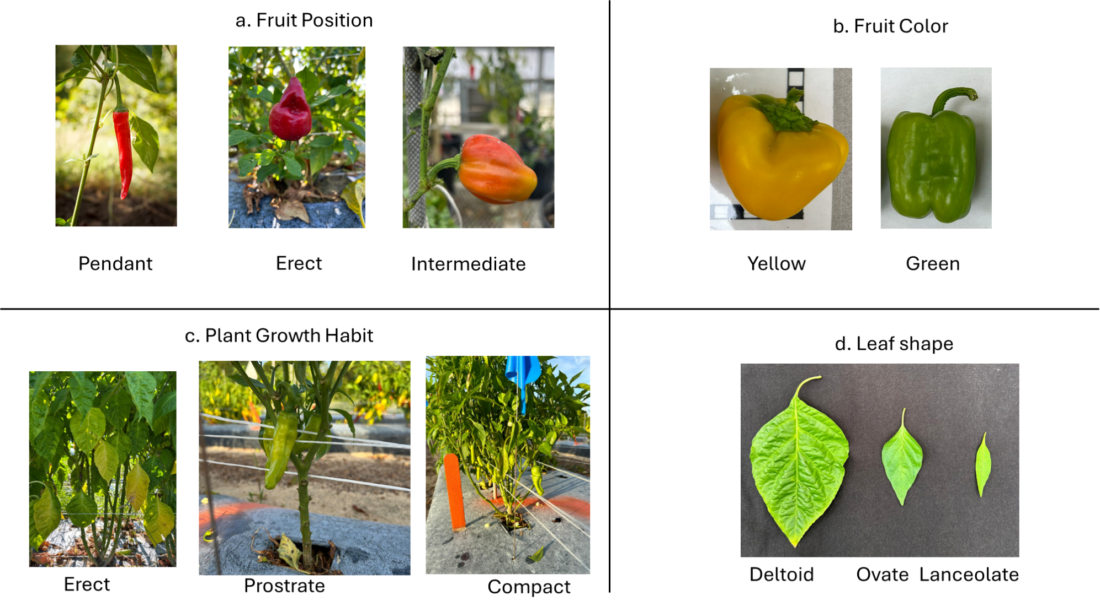
Supplementary Figure 1 Qualitative characteristics measured across the six varietal groups in the current study. a Fruit position is categorized as pendant, erect and intermediate b Fruit color is measured as yellow, green and red c Plant growth habit is measured as erect, prostrate and compact d Leaf shape is categorized as deltoid, ovate and lanceolate.

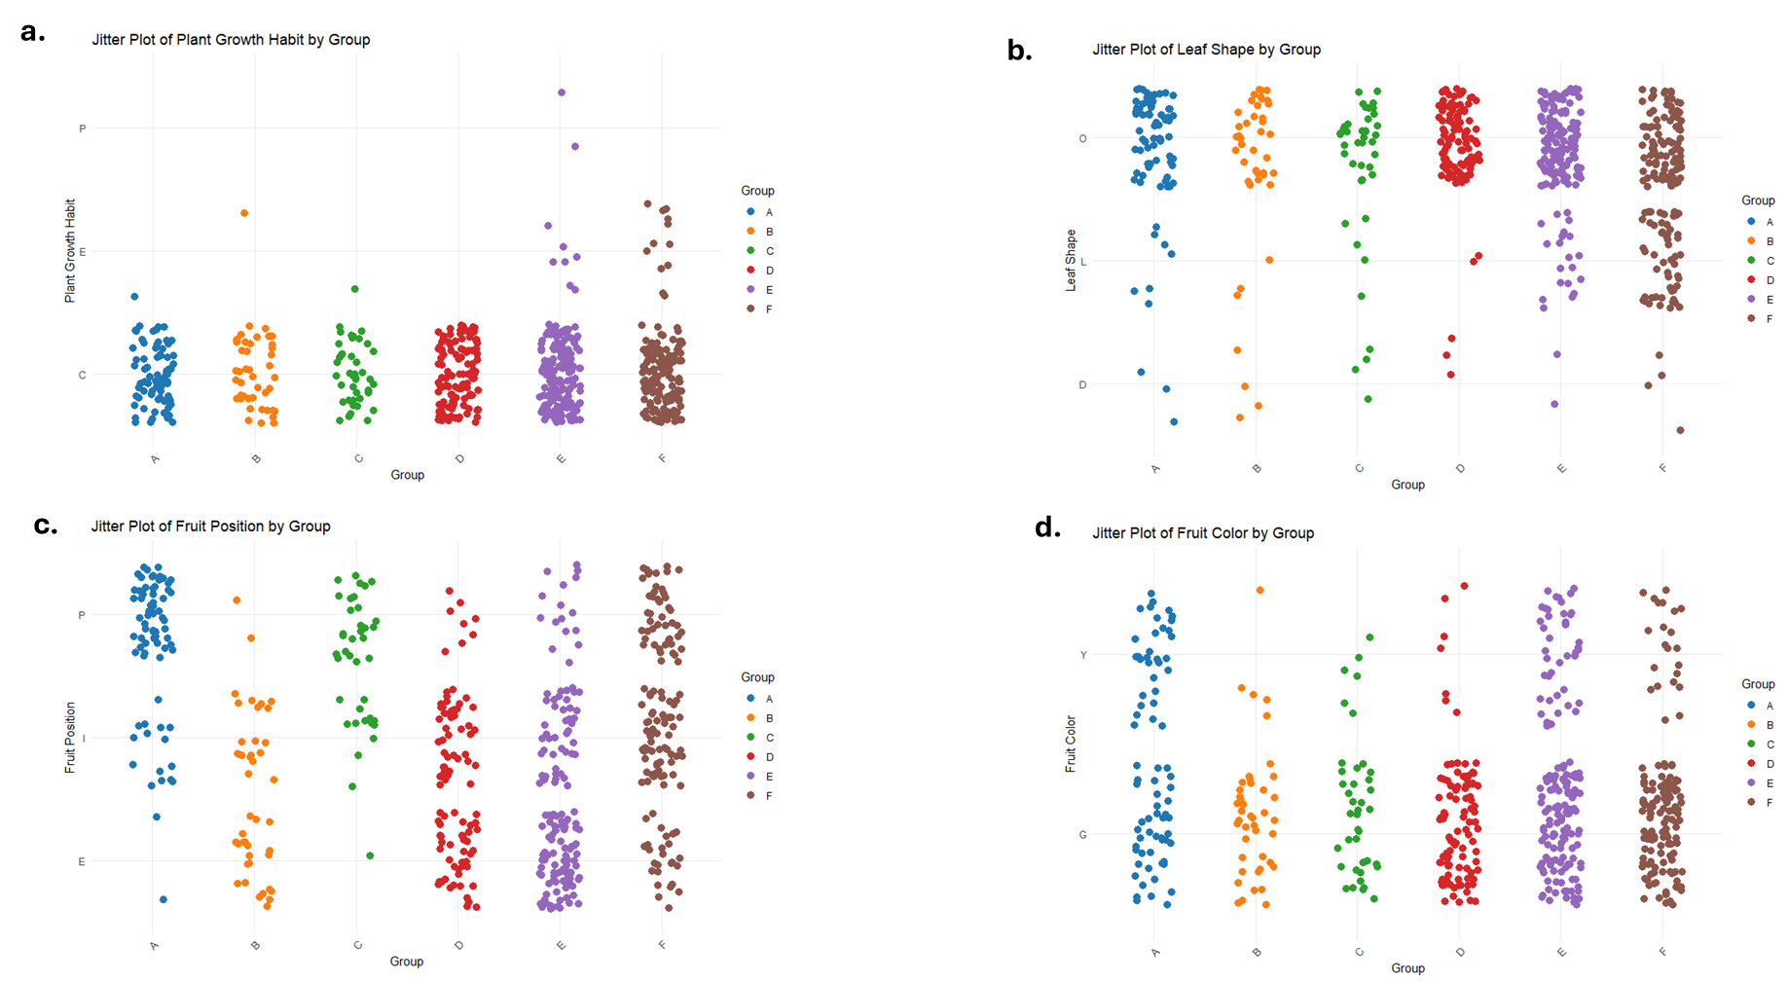
Supplementary Figure 2 Categorical distribution of 4 qualitative traits across varietal groups of UGA-CAPS pepper accessions a P- Prostrate; E- Erect, C- Composite. b O- Ovate, L- Lanceolate, D – Deltoid c P- Pendant, I – Intermediate, E- Erect, d Y- Yellow, G- Green

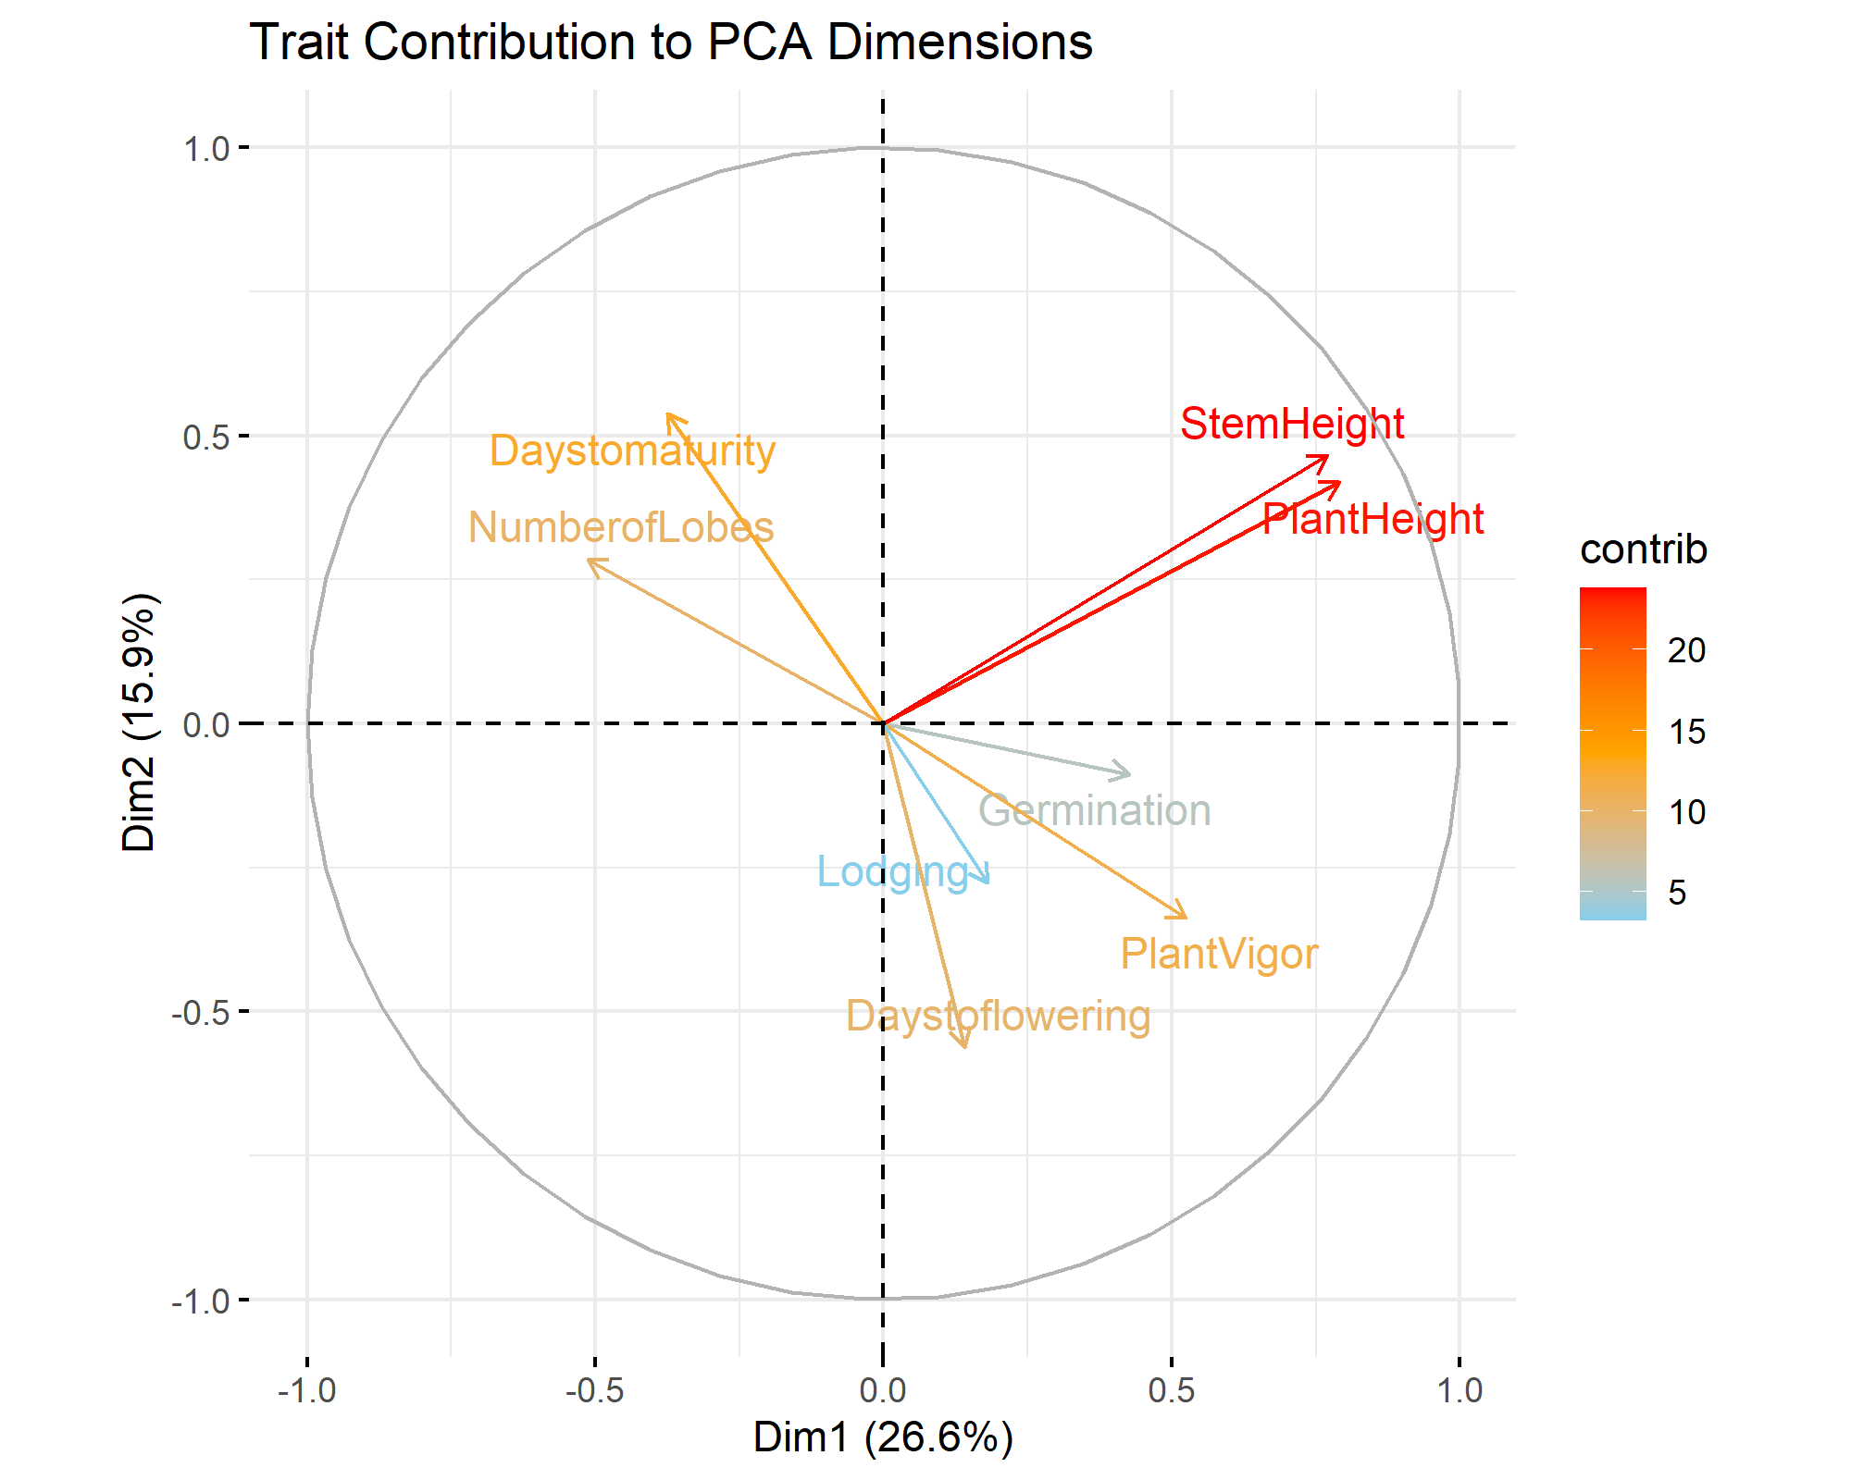
Supplementary Figure 3 Trait contributions to PCA (PC1–PC2). A variable factor map showing the contributions of eight quantitative traits to the first two principal components (Dim1 and Dim2), which explained 26.6% and 15.9% of the variance, respectively. Arrow length and direction indicate the strength and correlation of each trait with the axes, while color intensity reflects the percentage contribution. Traits such as Plant Height and Main stem Height loaded strongly on PC1, while Days to Flowering and Days to Maturity were mostly associated with PC2.
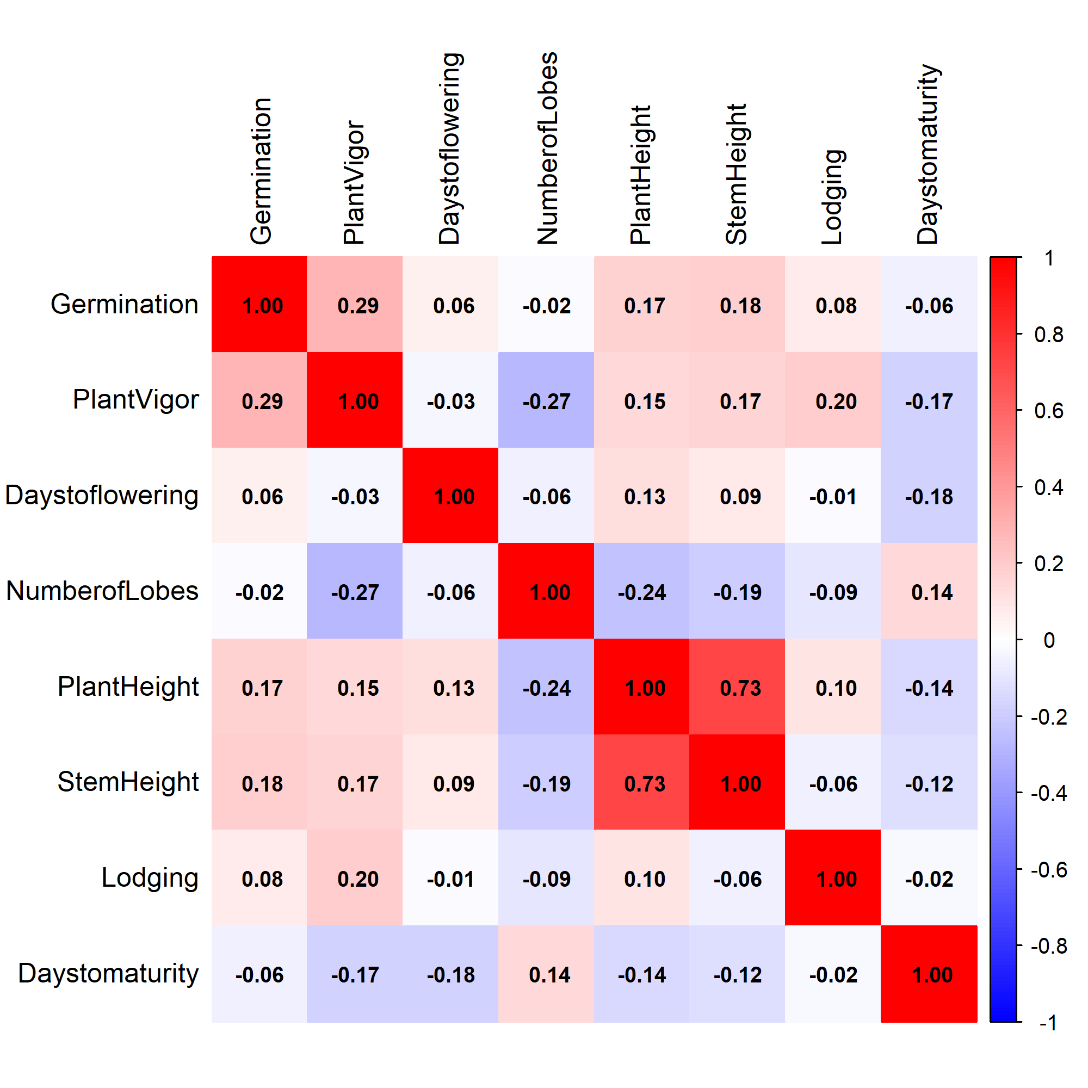
Supplementary Figure 4 Pearson correlation matrix of quantitative traits for the UGA-Capsi-Core pepper accessions

