Morphological and simple sequence repeat (SSR)-based diversity of Capsicum germplasm characterizes population structure and enables marker-assisted selection for Phytophthora capsici resistance
Deepa Jaganathan^{1,2}, Jessica Michelle Gibbs¹, Noel Thomas¹, Theodore McAvoy¹, Mahnaz Azad³, Miaoying Tian³, Dennis N. Lozada⁴, William Hendricks Railey⁵, Amol N. Nankar^{1,2}*
¹ Department of Horticulture, University of Georgia, Tifton, GA 37193, United States
² Institute of Plant Breeding, Genetics and Genomics (IPBGG), University of Georgia, Tifton, GA 37193, United States
³ Department of Plant Pathology, University of Georgia, Tifton, GA 37193, United States
⁴Department of Plant and Environmental Sciences and Chile Pepper Institute, New Mexico State University, Las Cruces, NM 88003, United States
⁵Abraham Balwin Agricultural College, Tifton, GA 31793, United States
*Corresponding author: amolnankar@uga.edu
Supplementary Figure 5
Note: The images presented here are raw, uncropped files. The gel image consists of three rows. Part 1 shows a zoomed view of the first two rows, and Part 2 shows a zoomed view of the last two rows. The complete gel image covering all three rows is presented as a single image. Minor adjustments were applied to enhance brightness and clarity. Missing accessions were rescored by repeating the analysis under identical conditions. The respective gel images of repetition PCR were given next to the original gel images.

SSR9 Plate 1
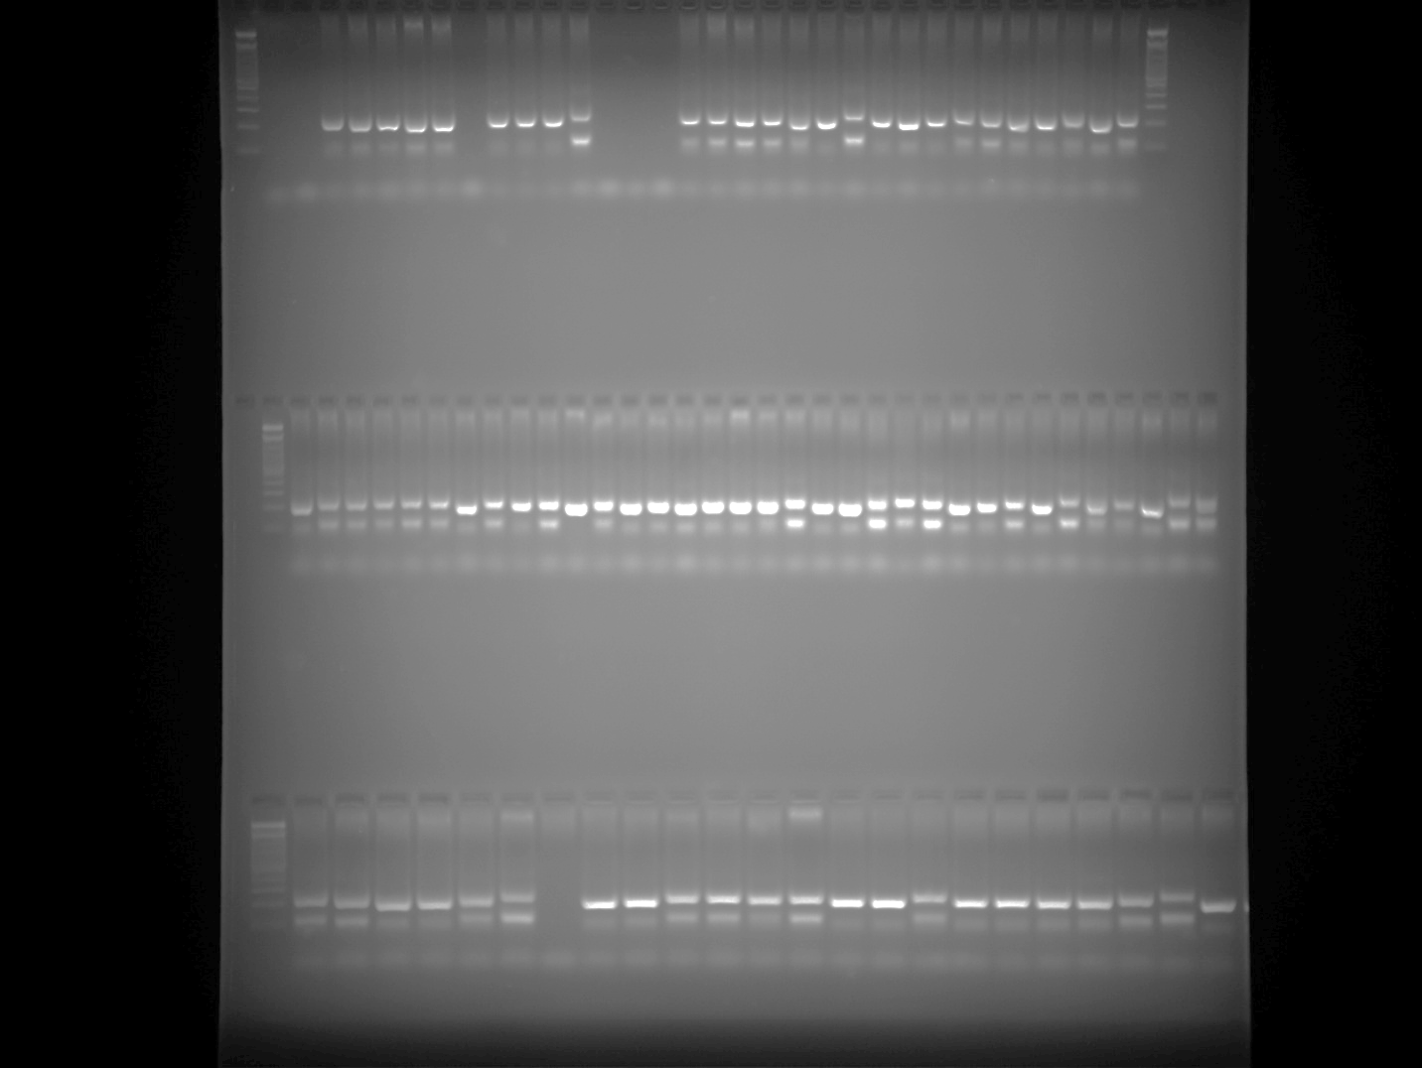

SSR9 Plate 2 Part 1
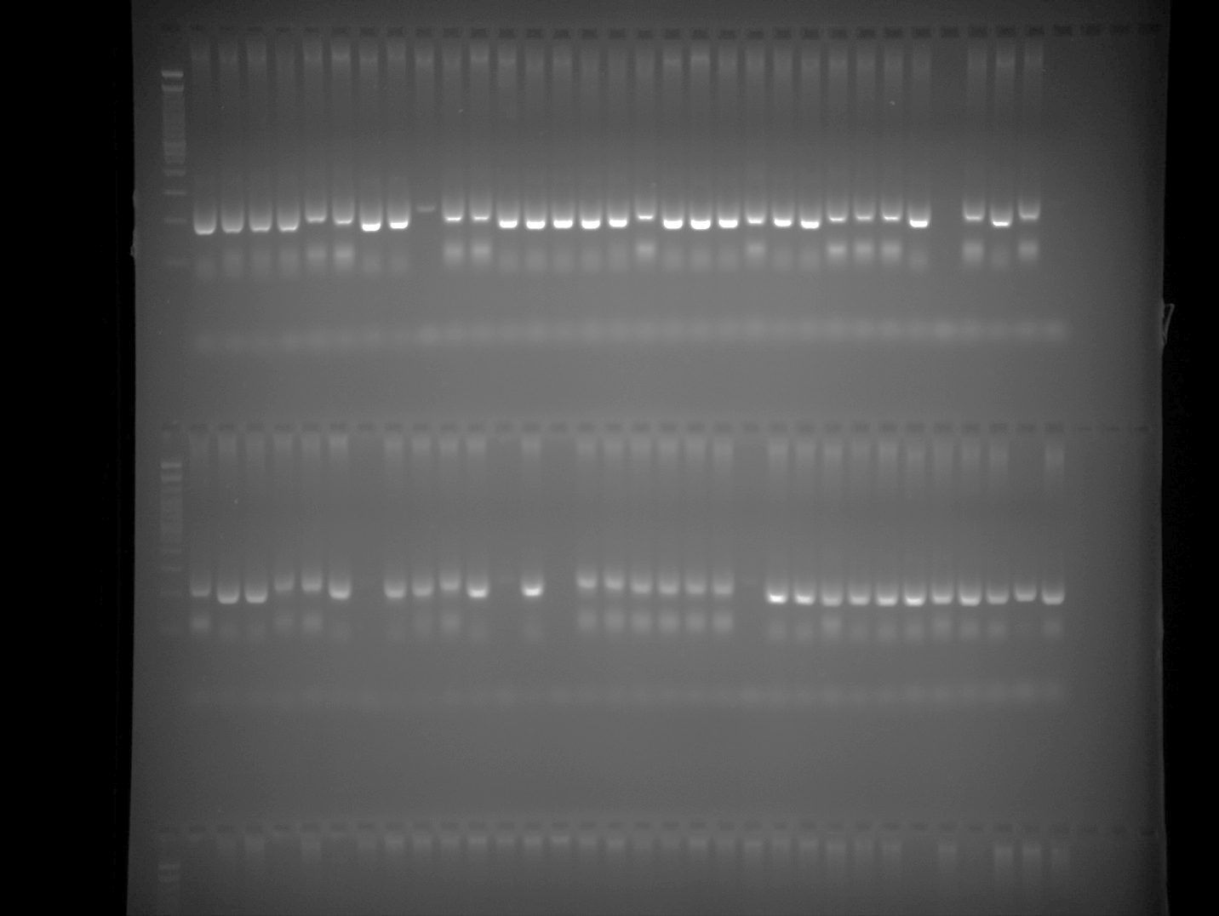

SSR9 Plate 2 Part 2
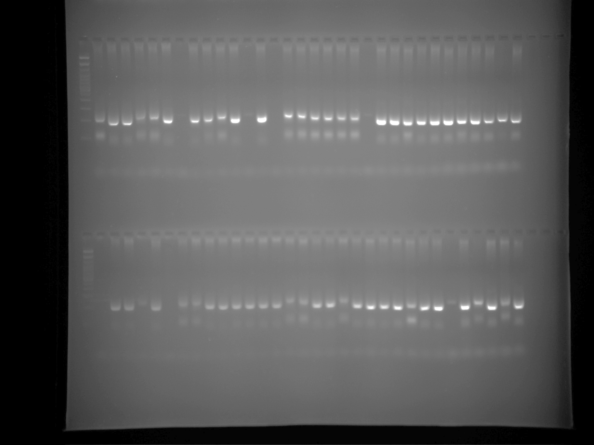

SSR9 Plate 3 Part 1
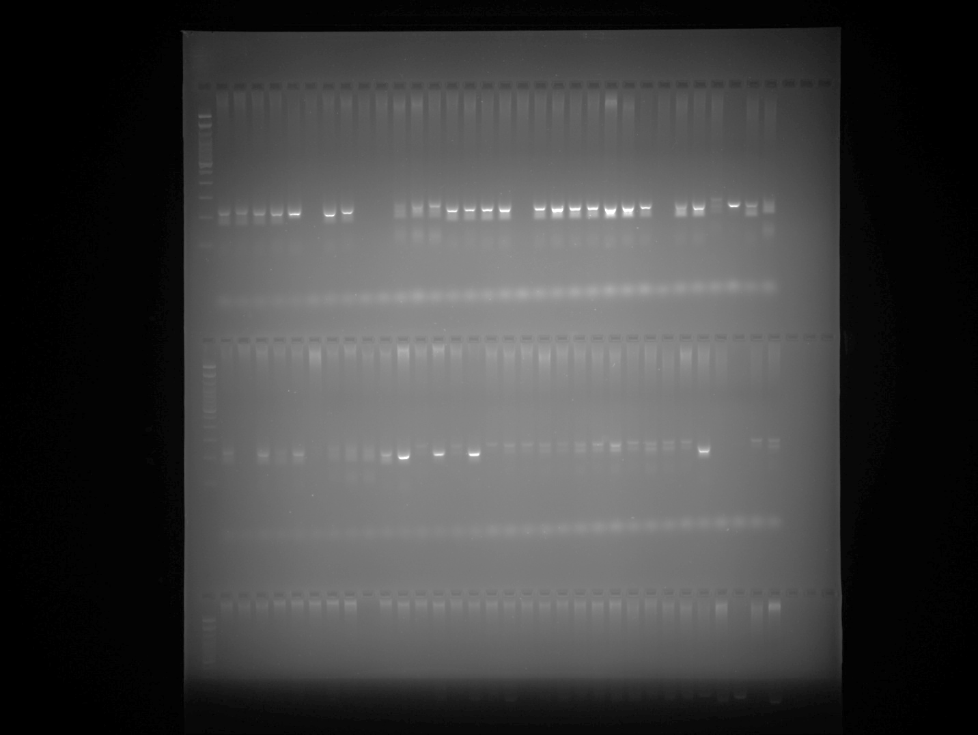

SSR9 Plate 3 Part 2
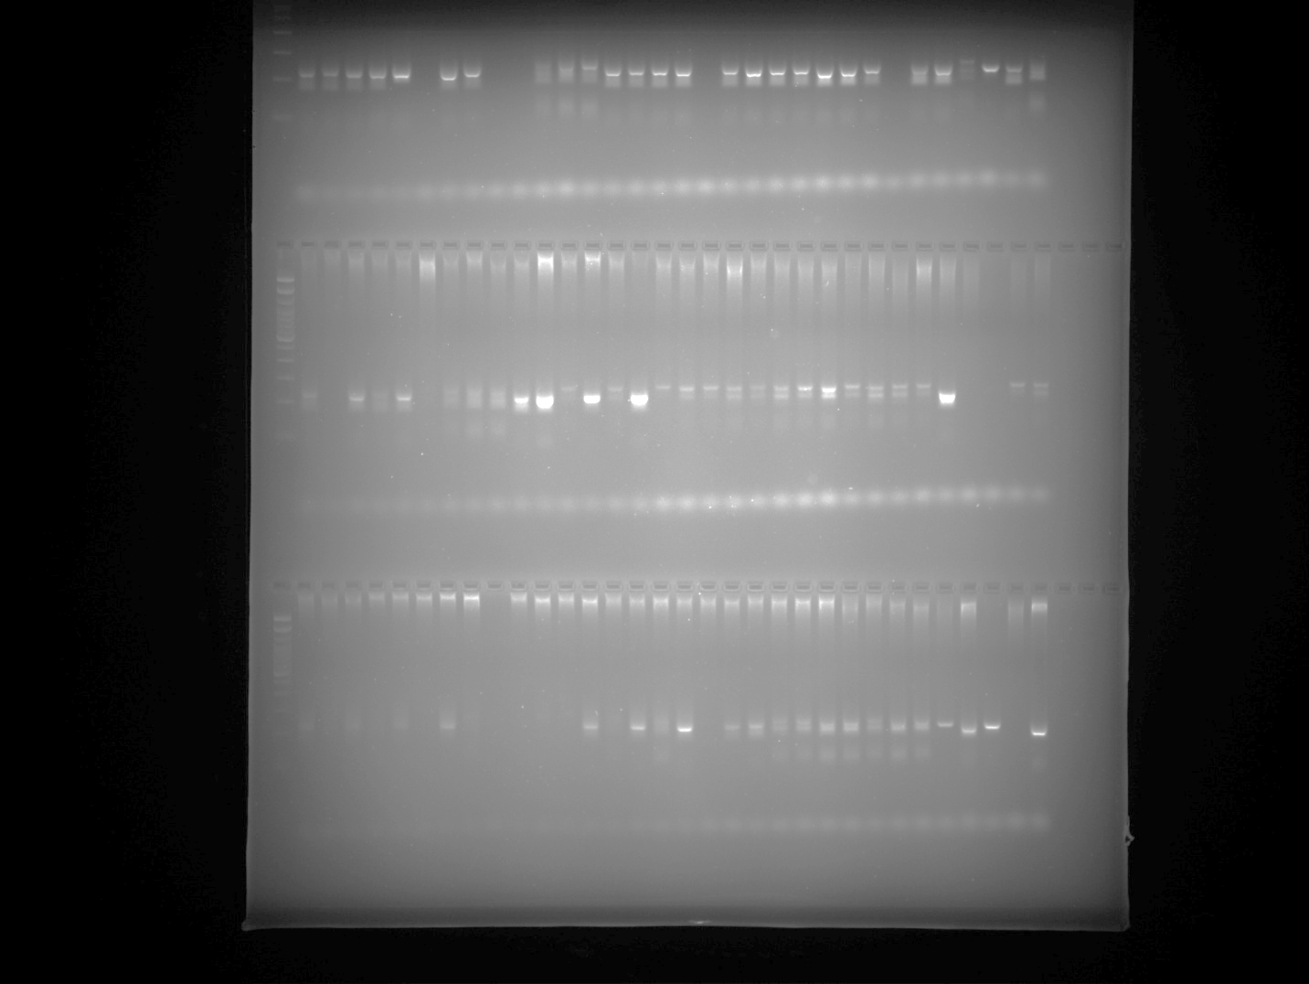

SSR9 Plate 4 Part 1
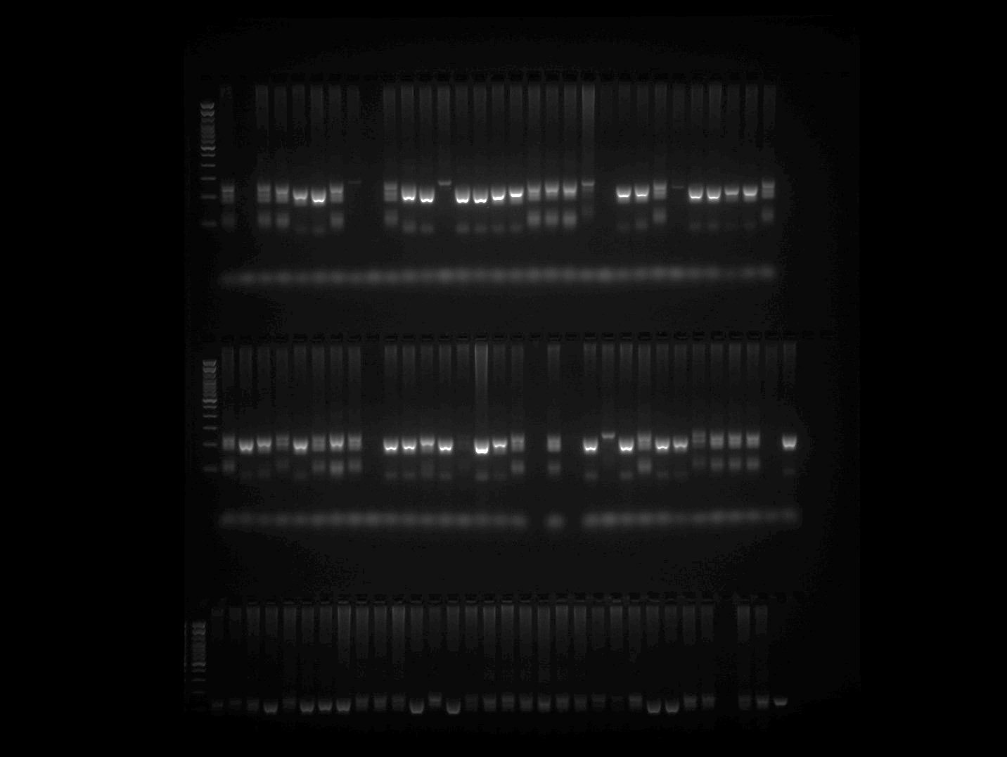

SSR9 Plate 4 Part 2
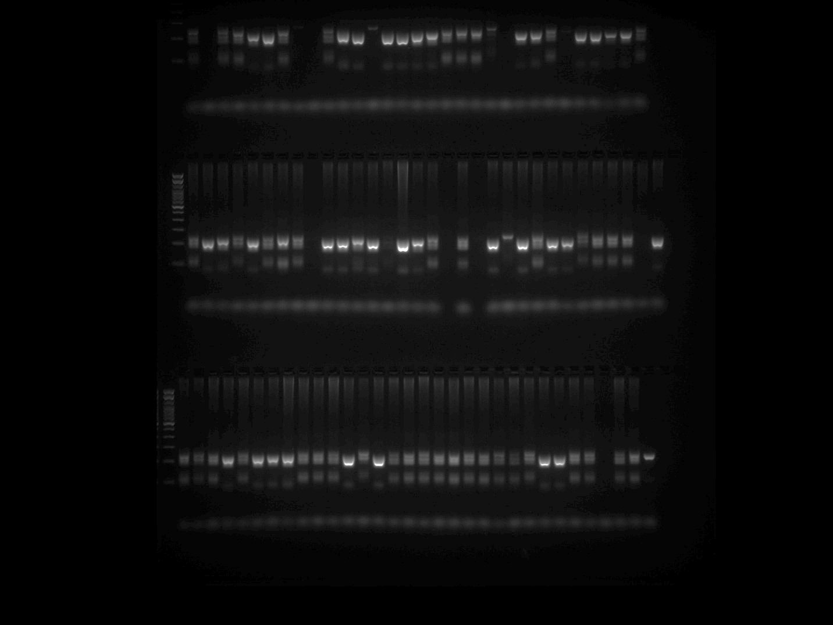

SSR9 Plate 5
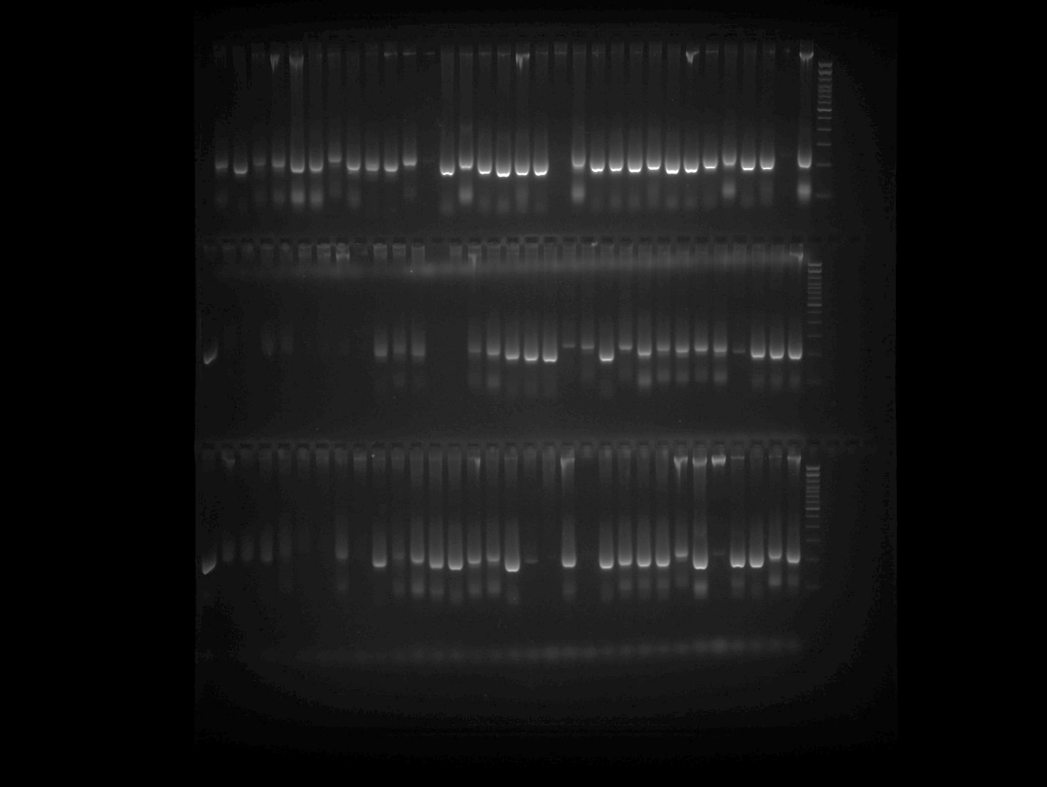

SSR3 Plate 1
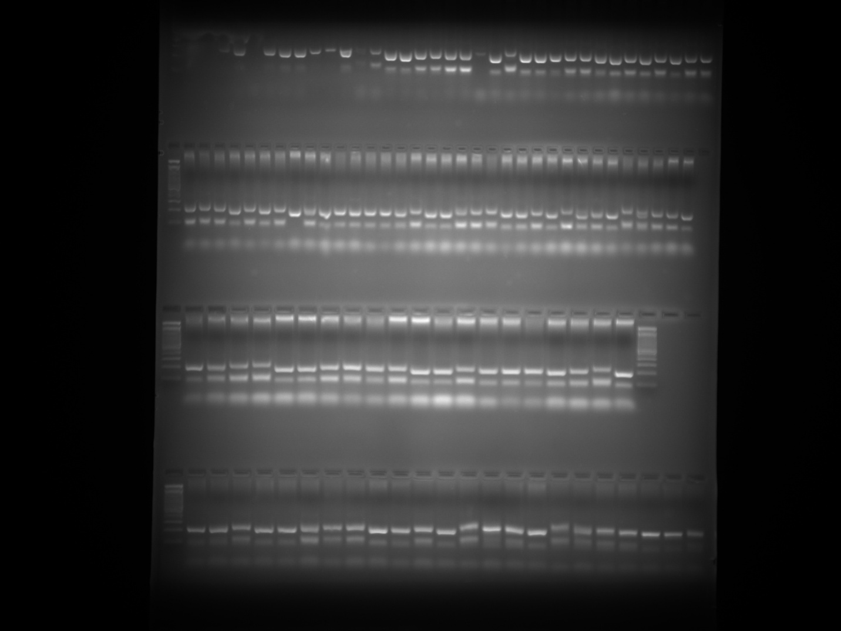

SSR3 Plate 2 Part 1
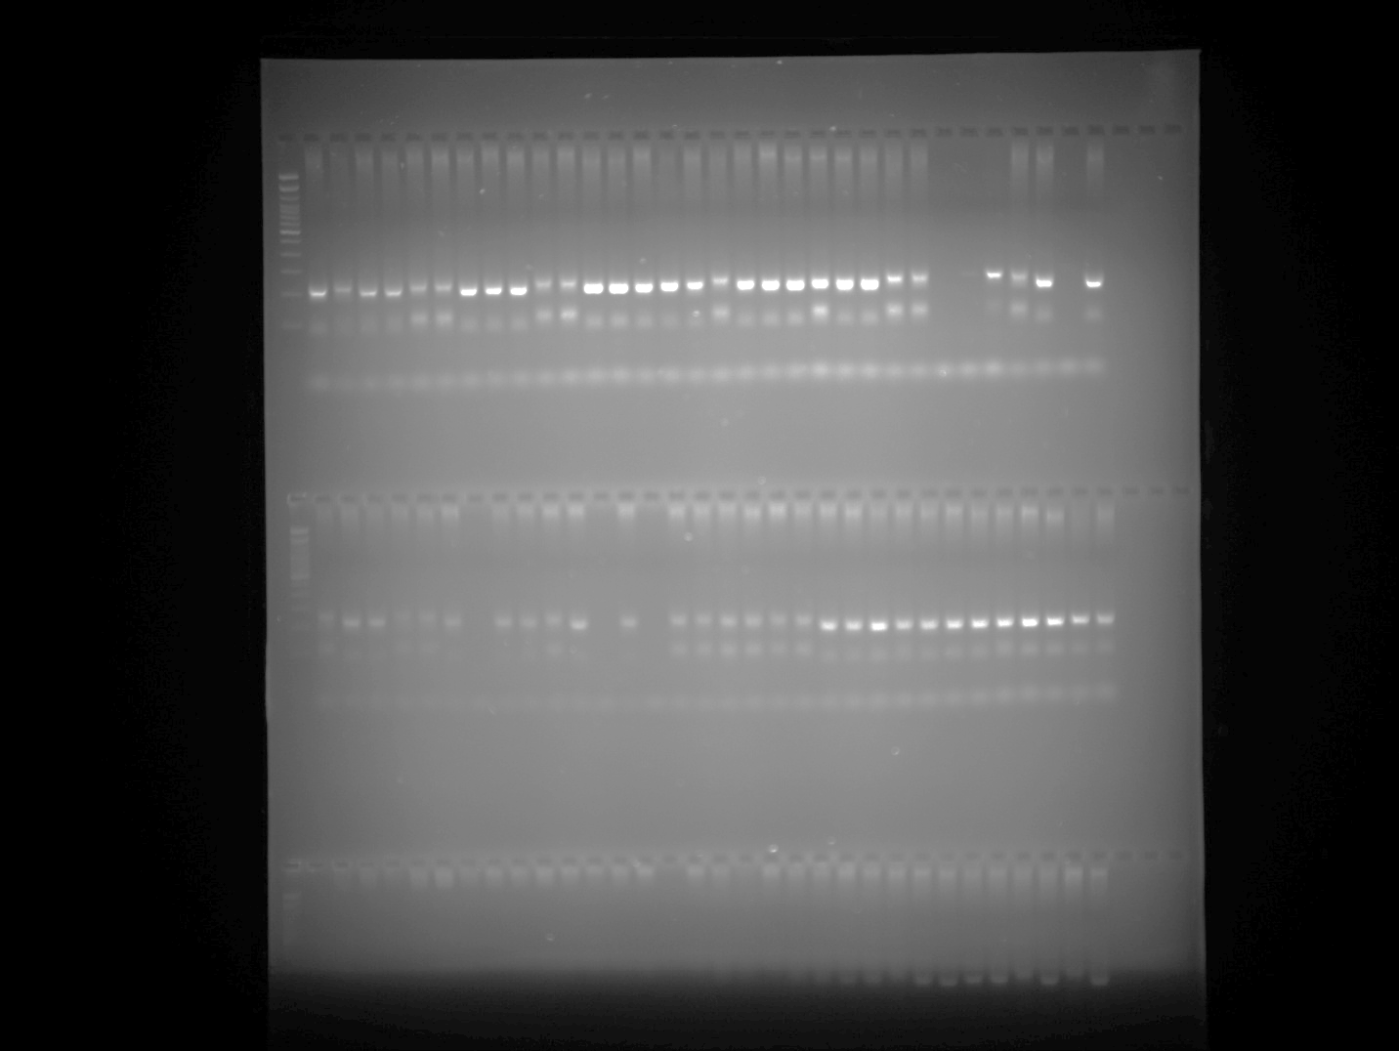

SSR3 Plate 2 repetition (row2)
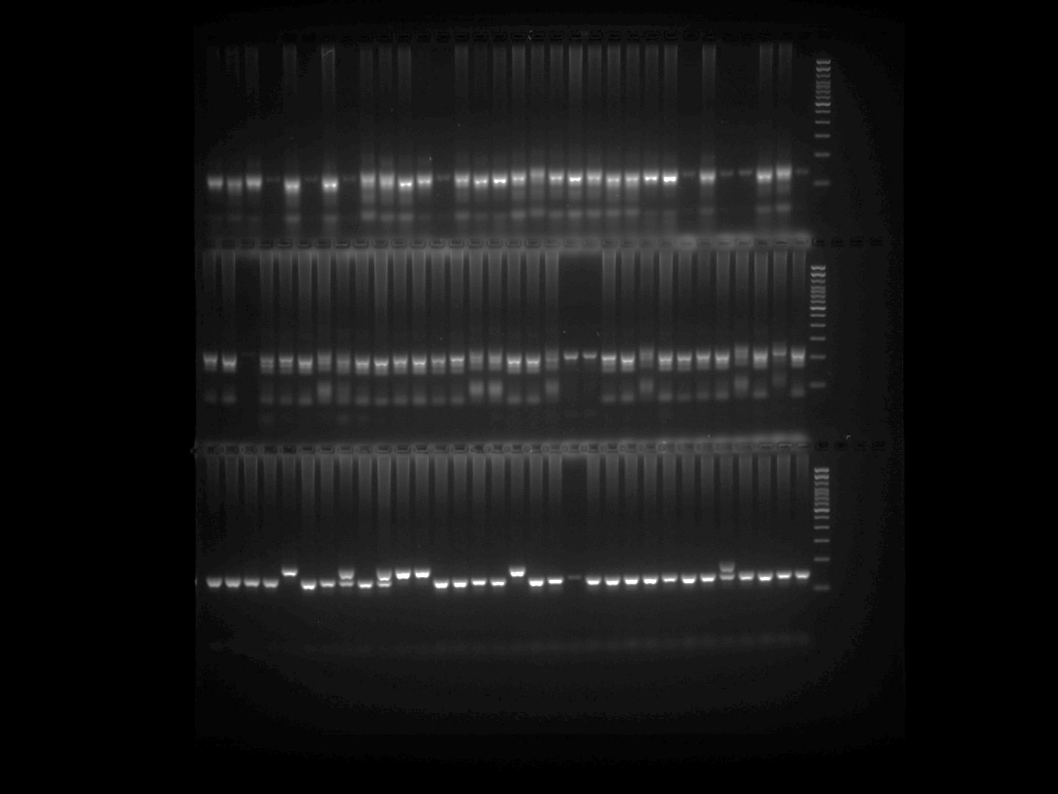

Note: PCR was repeated for the samples belonging to Row 3 of the SSR3 Plate 2 gel image and presented in the above gel image at row 2.

SSR3 Plate 3
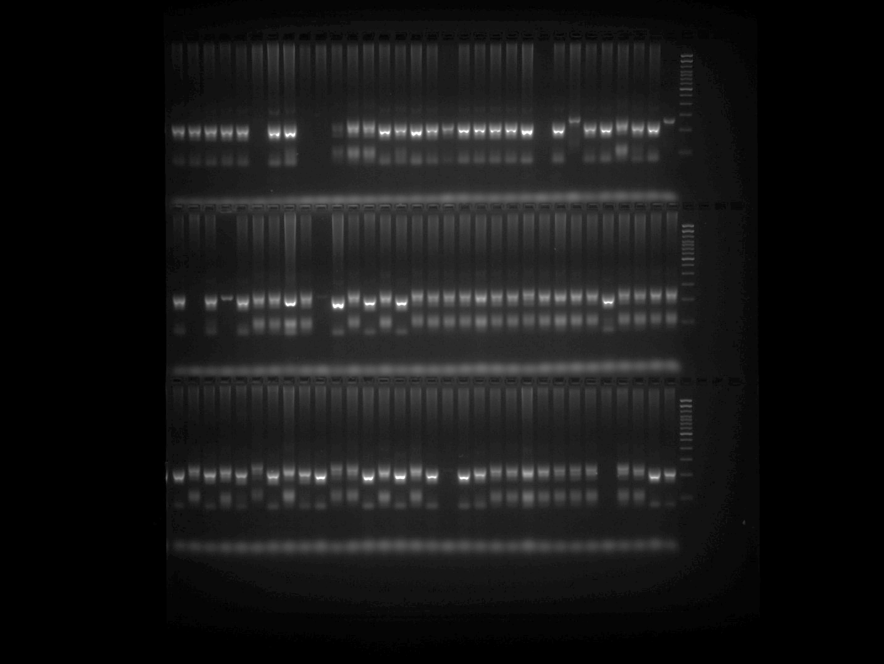

SSR3 Plate 4
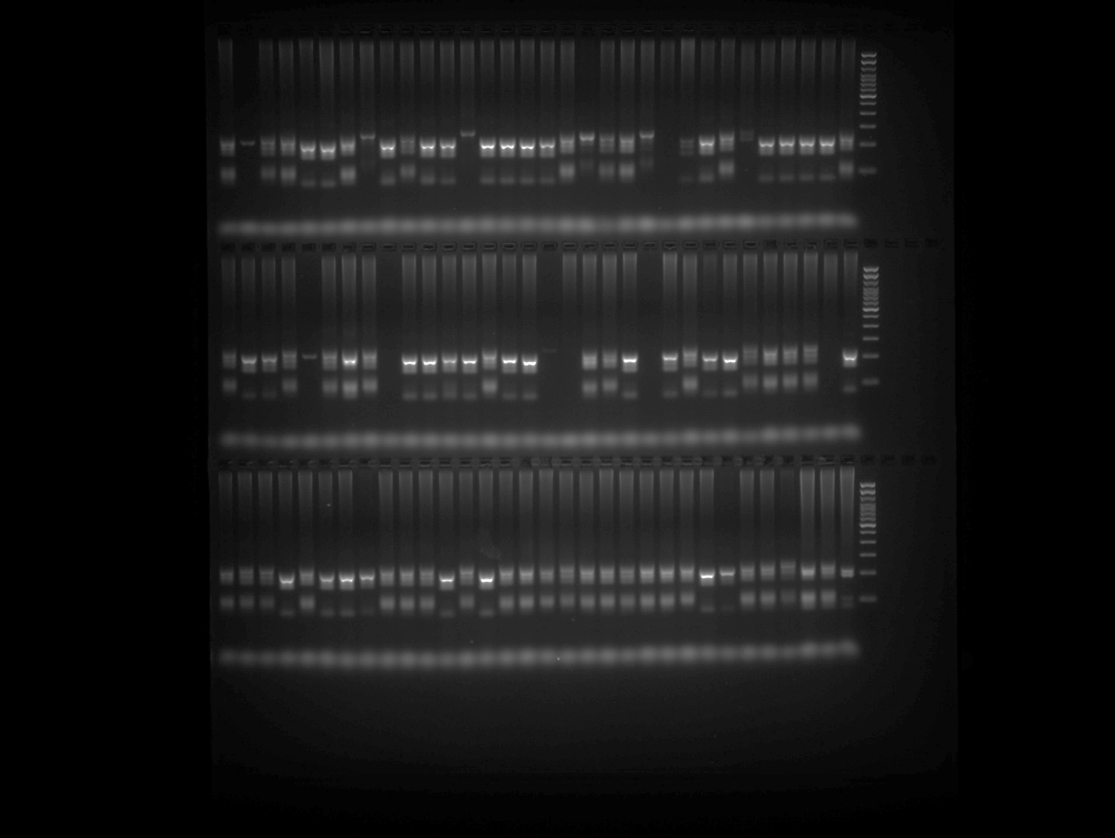

SSR3 Plate 5
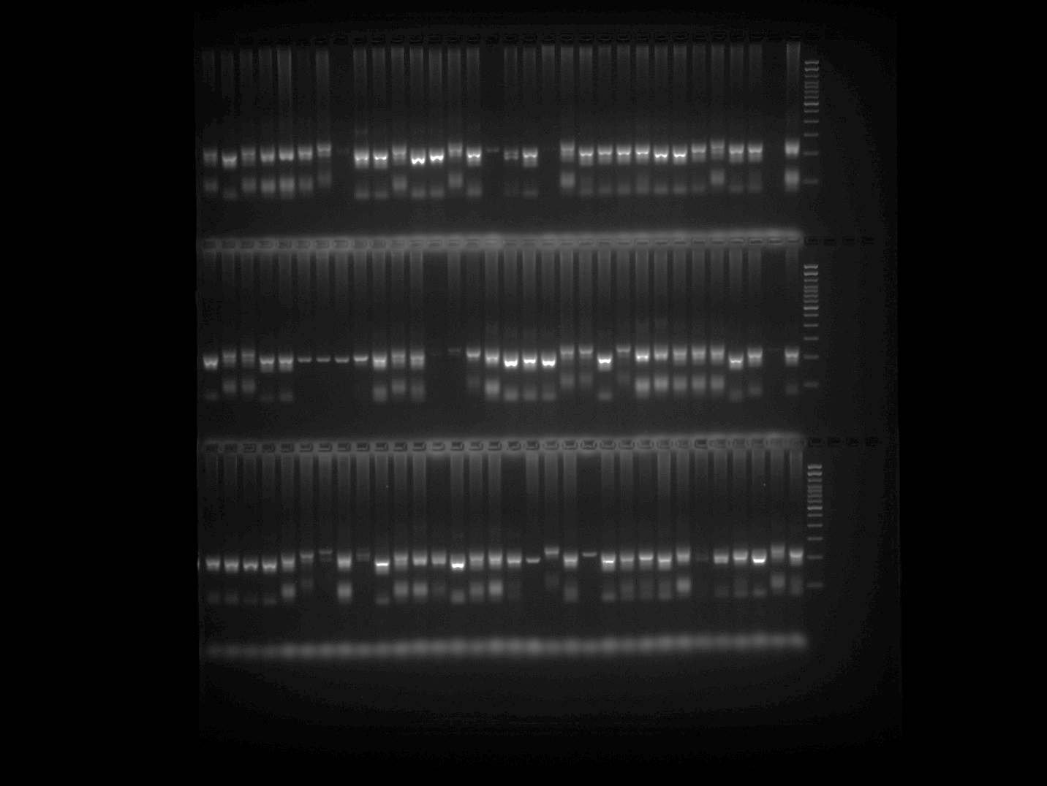

HpmsE034 Plate 1
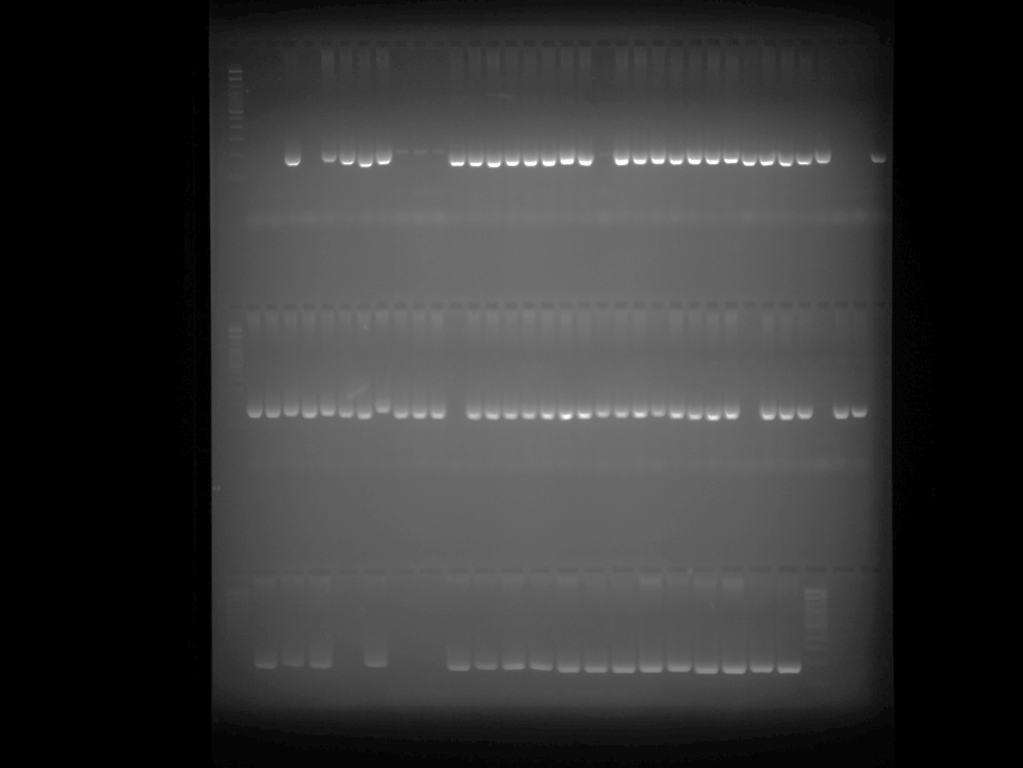

HpmsE034 Plate 2 Part 1
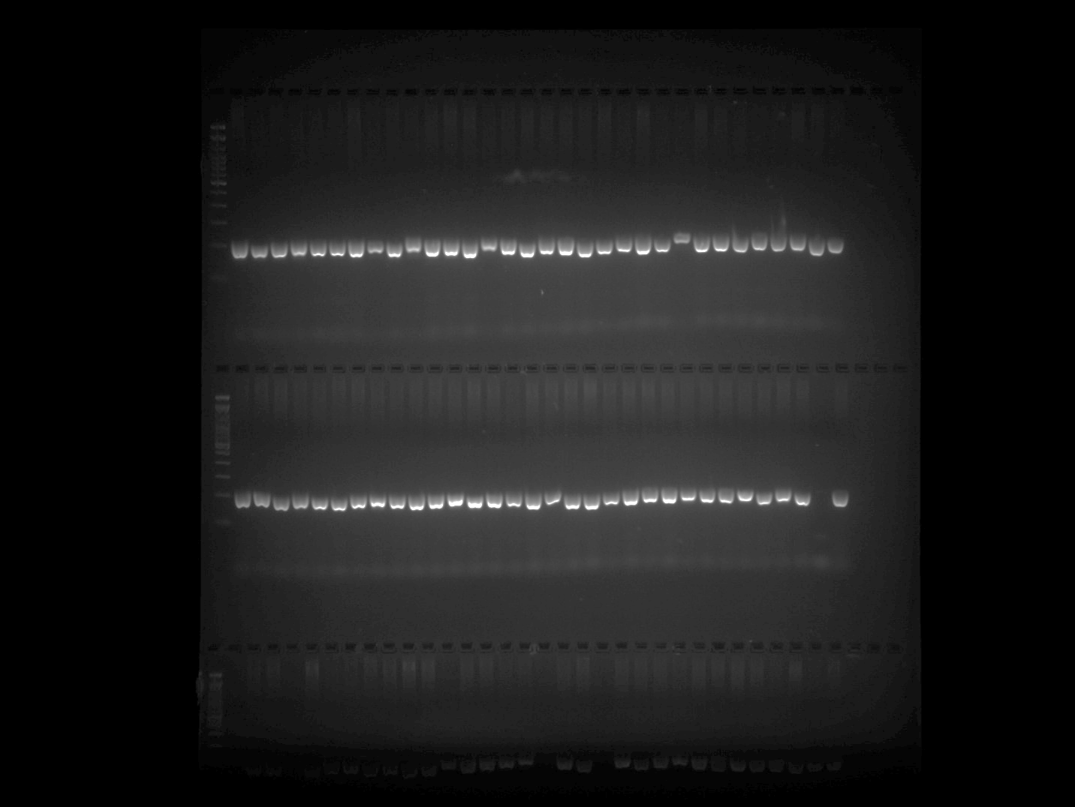

HpmsE034 Plate 2 Part 2
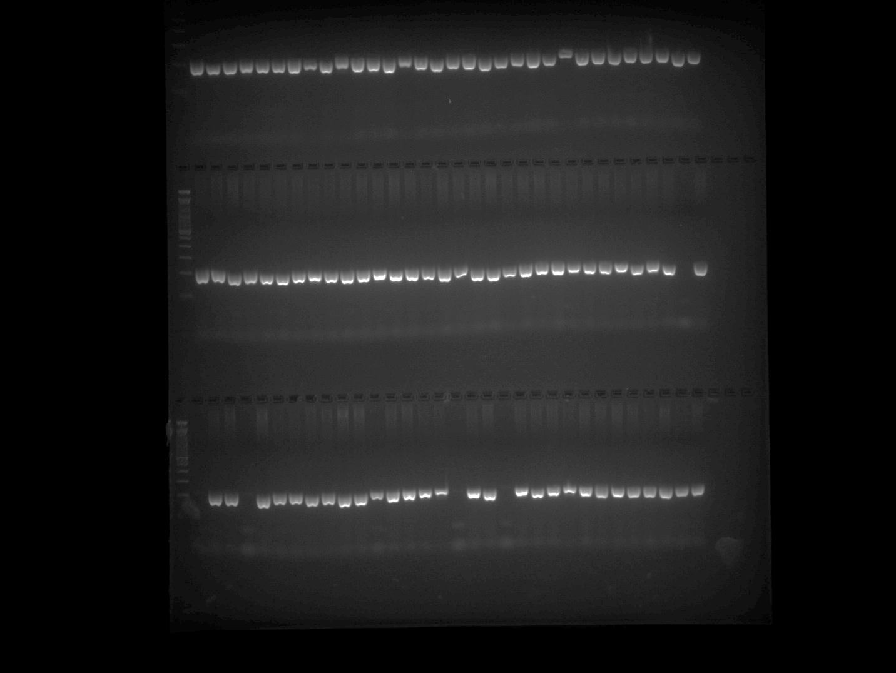

HpmsE034 Plate 3 Part 1
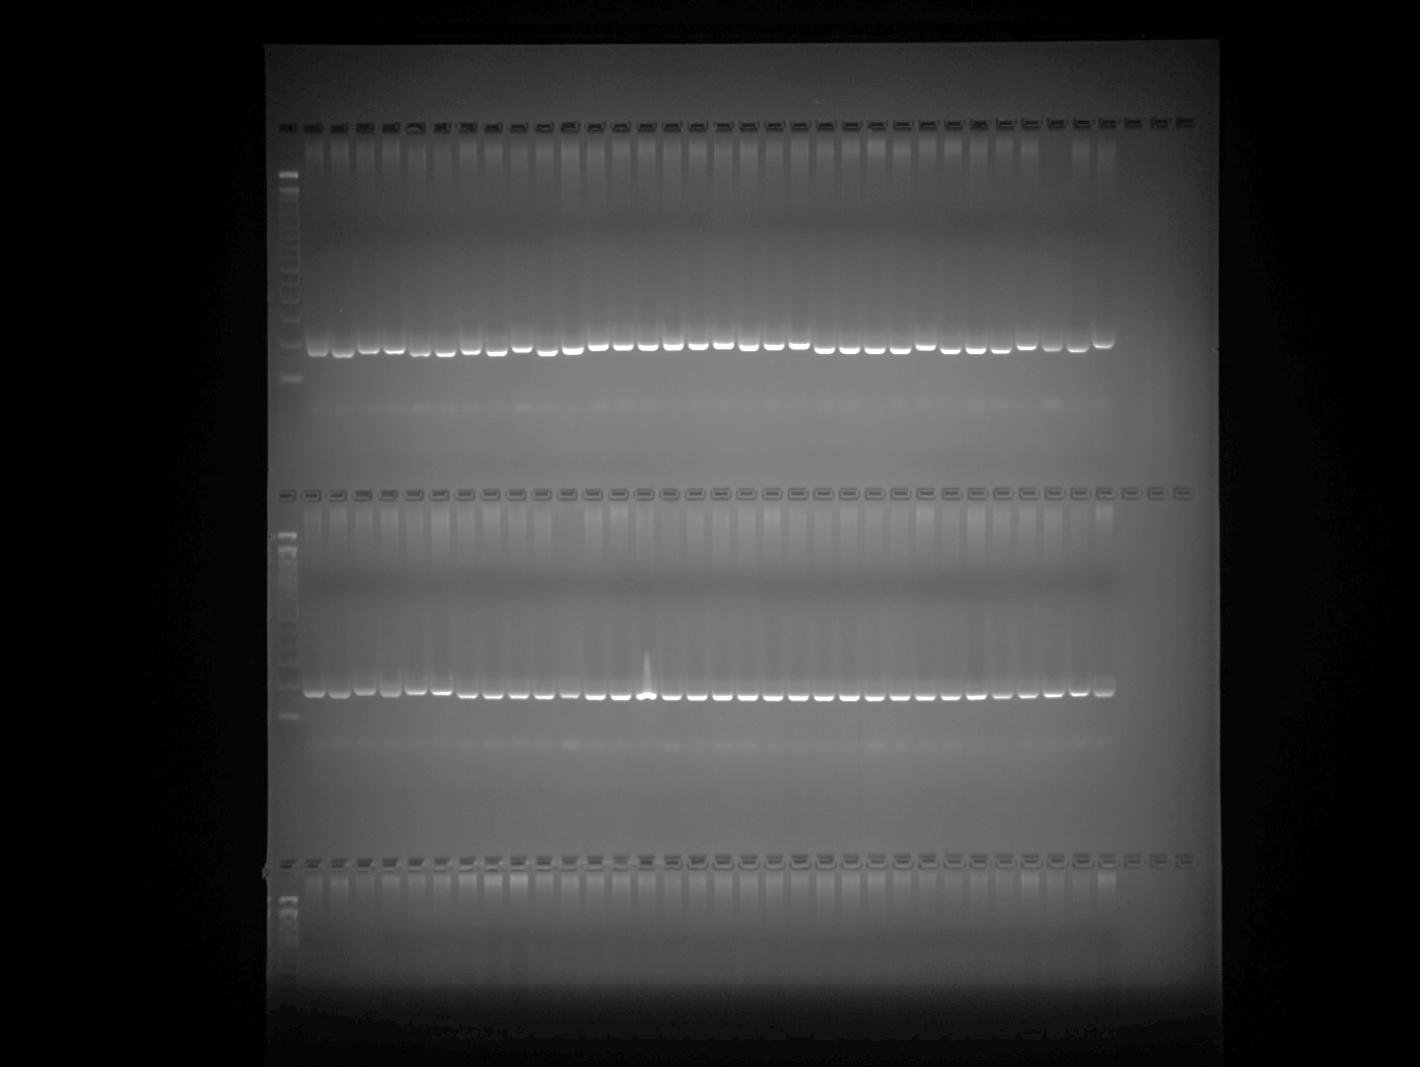

HpmsE034 Plate 3 Part 2
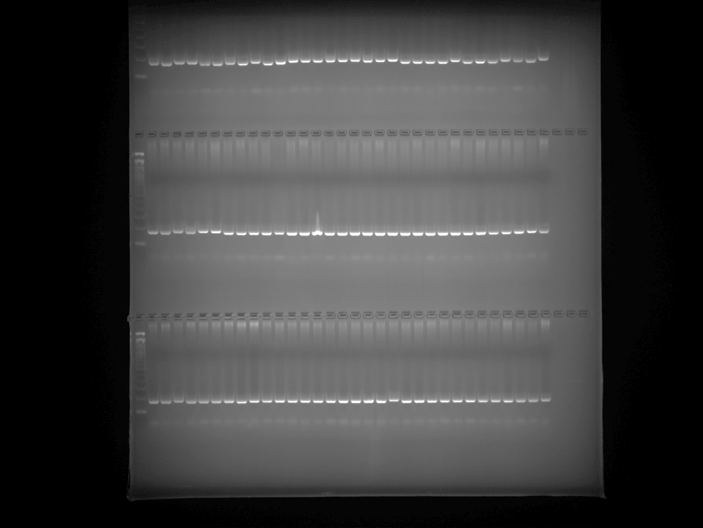

HpmsE034 Plate 4 Part 1
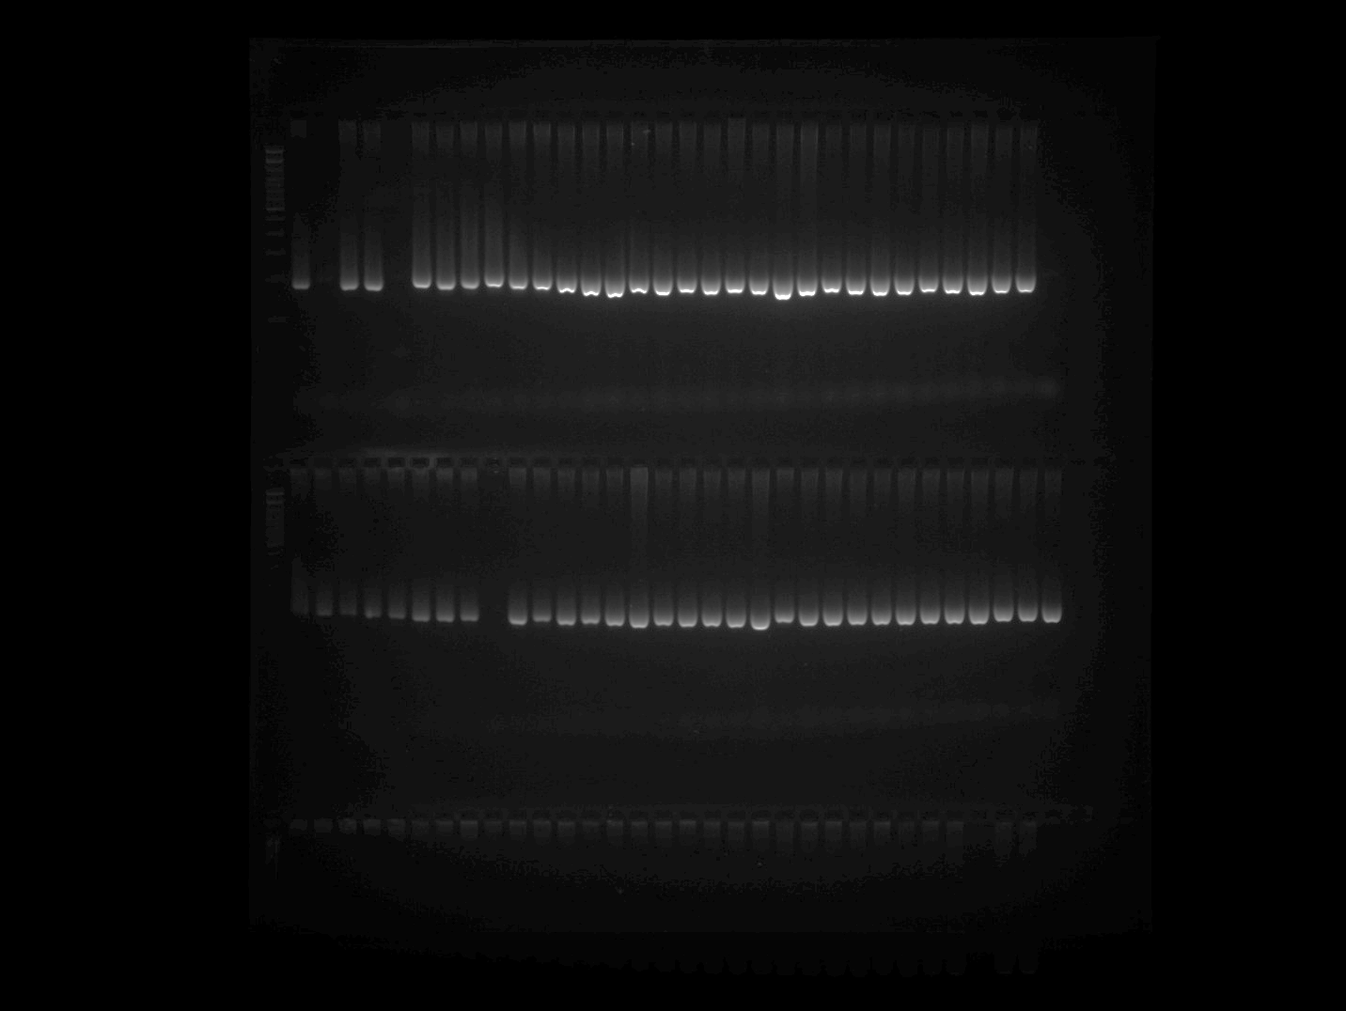

HpmsE034 Plate 4 Part 2
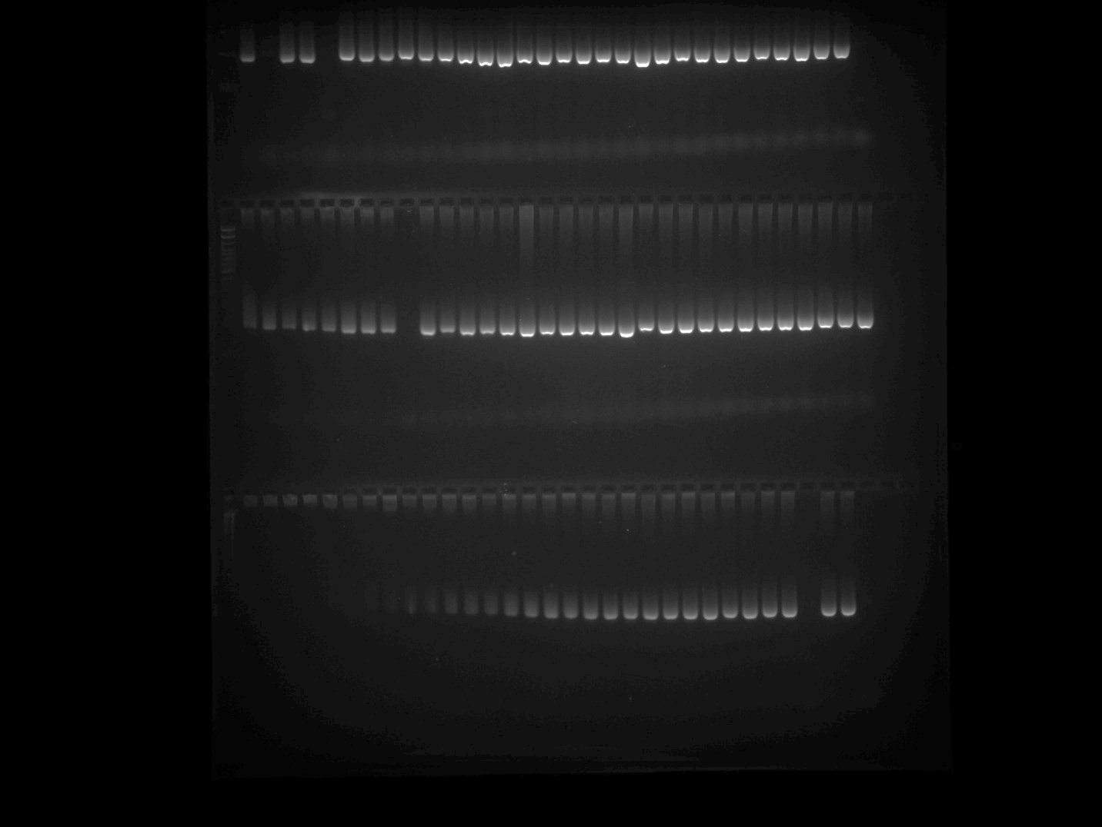

HpmsE034 Plate 4 Repeated (row 1)
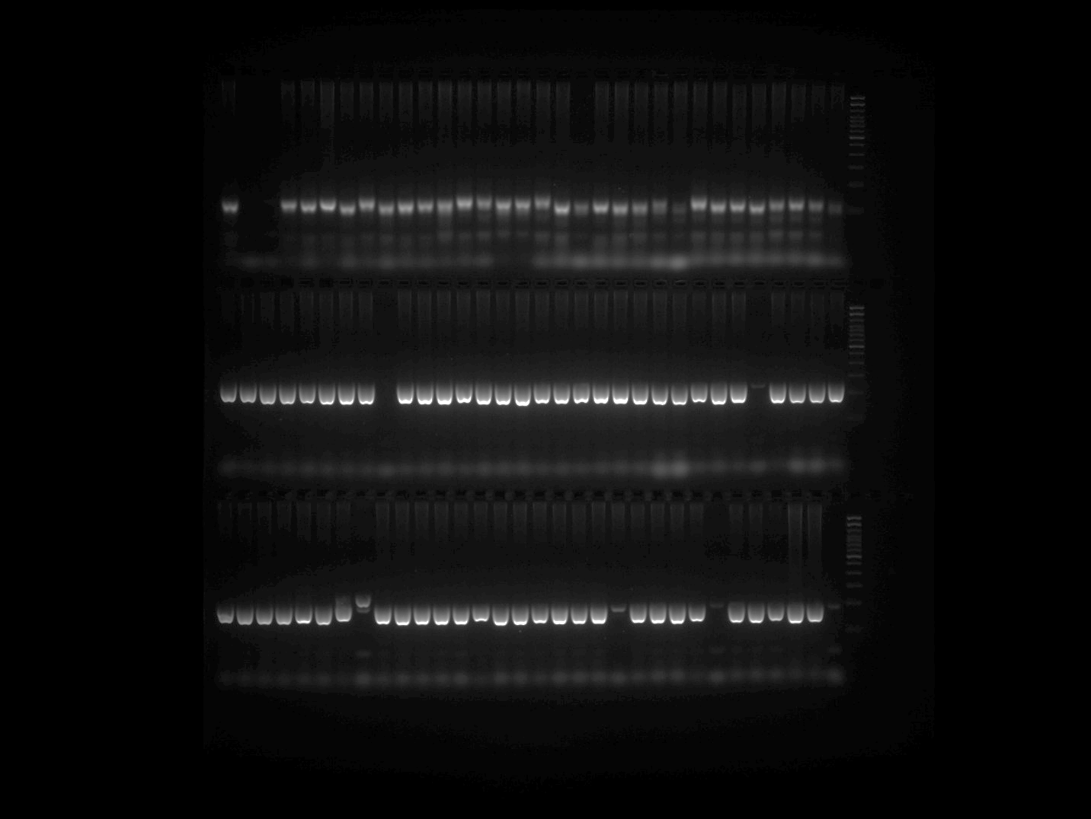
Note: PCR was repeated for the samples belonging to Row 3 of HpmsE034 Plate 4 gel image and presented in the above gel image at row 1.

HpmsE034 Plate 5
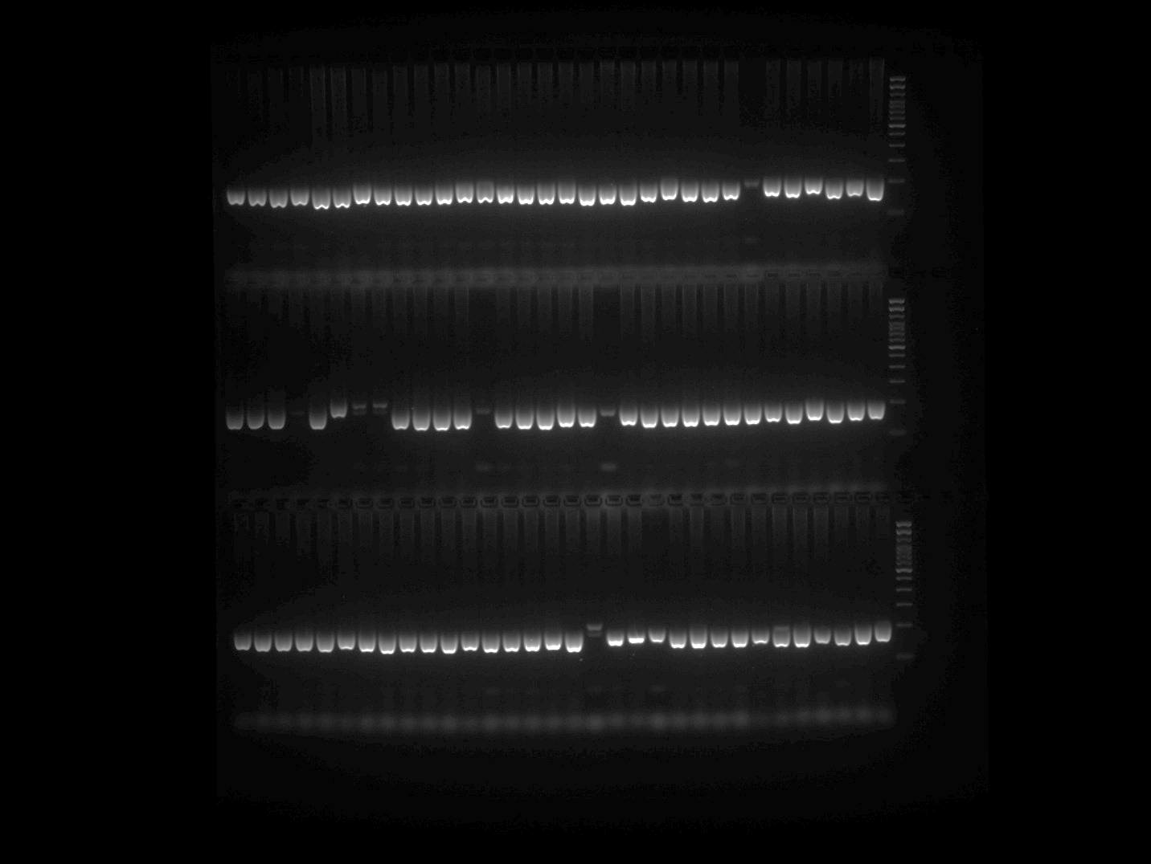

HpmsE062 Plate 1
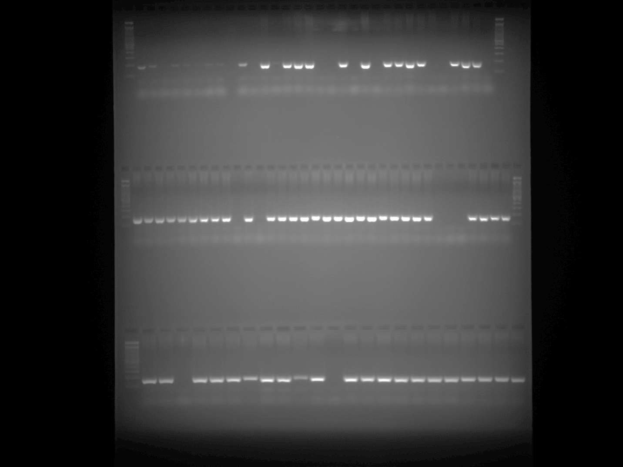

HpmsE062 Plate 2 Part 1
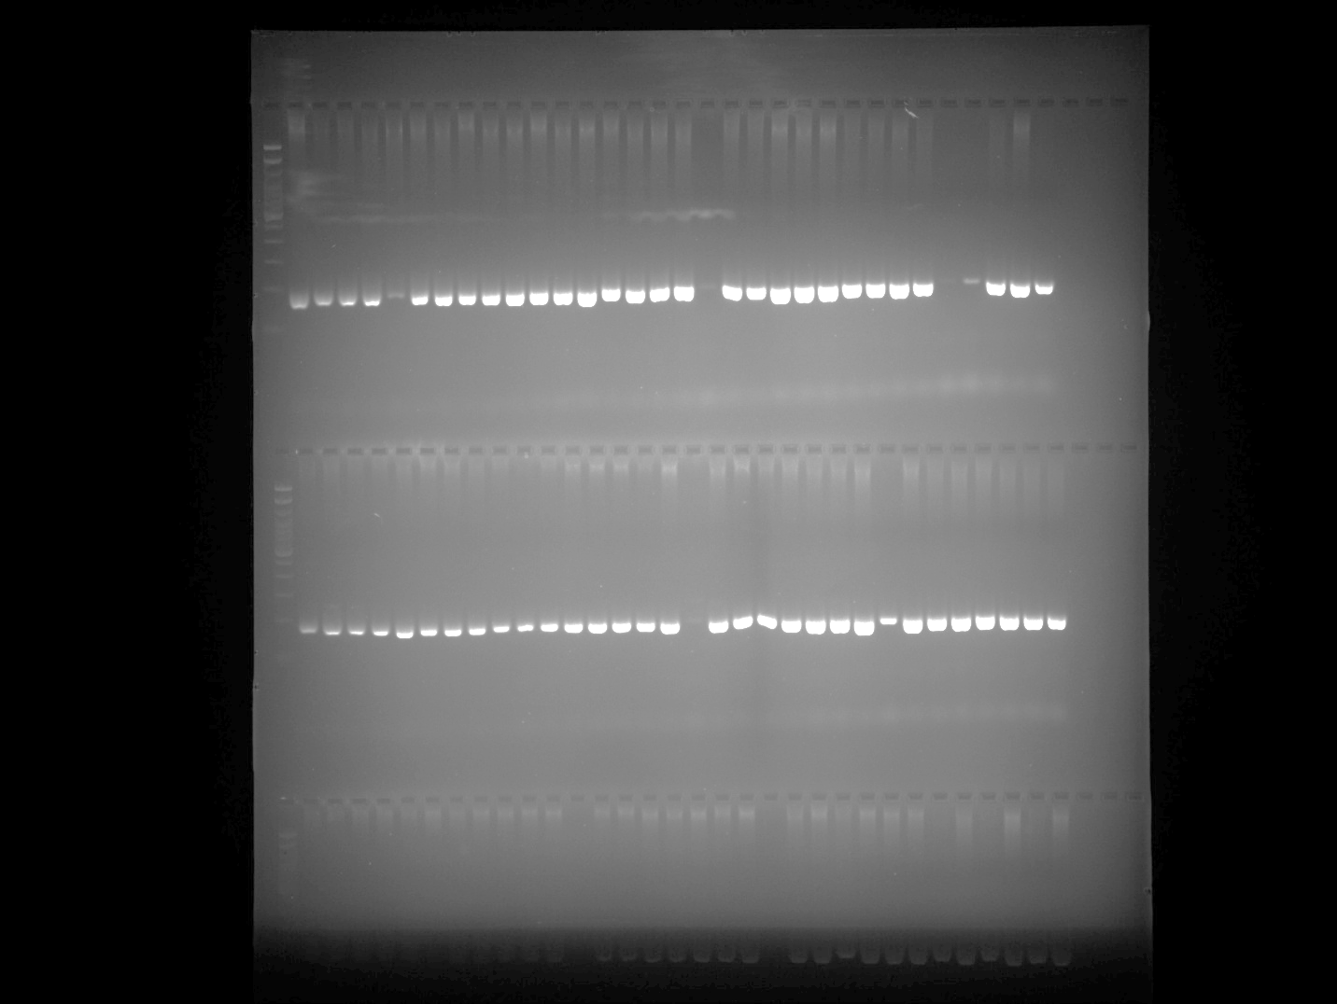

HpmsE062 Plate 2 Part 2
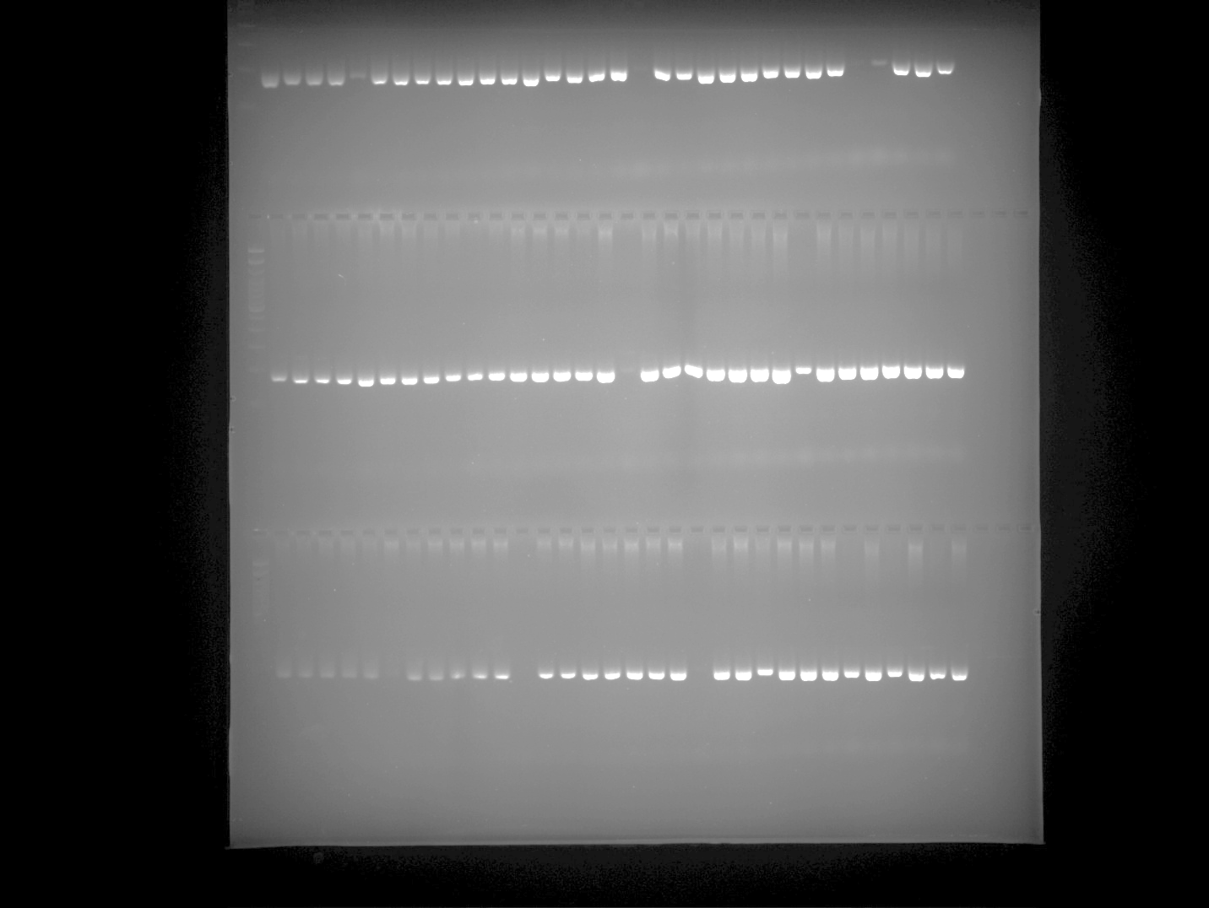

HpmsE062 Plate 3 Part 1
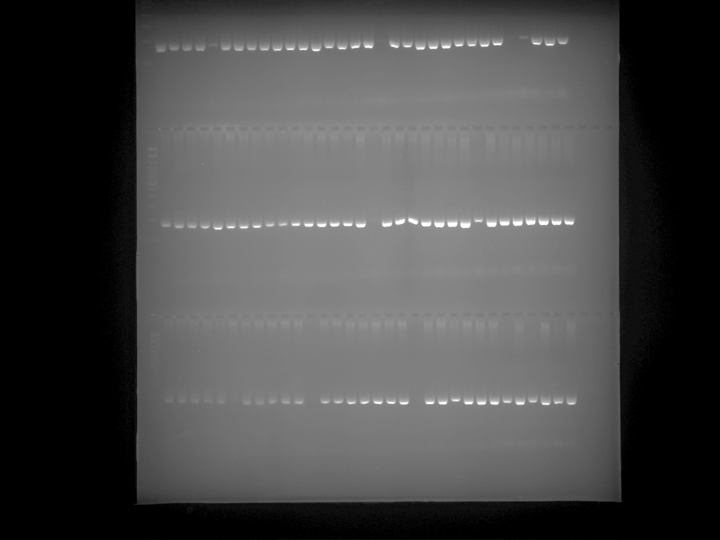

HpmsE062 Plate 3 Part 2
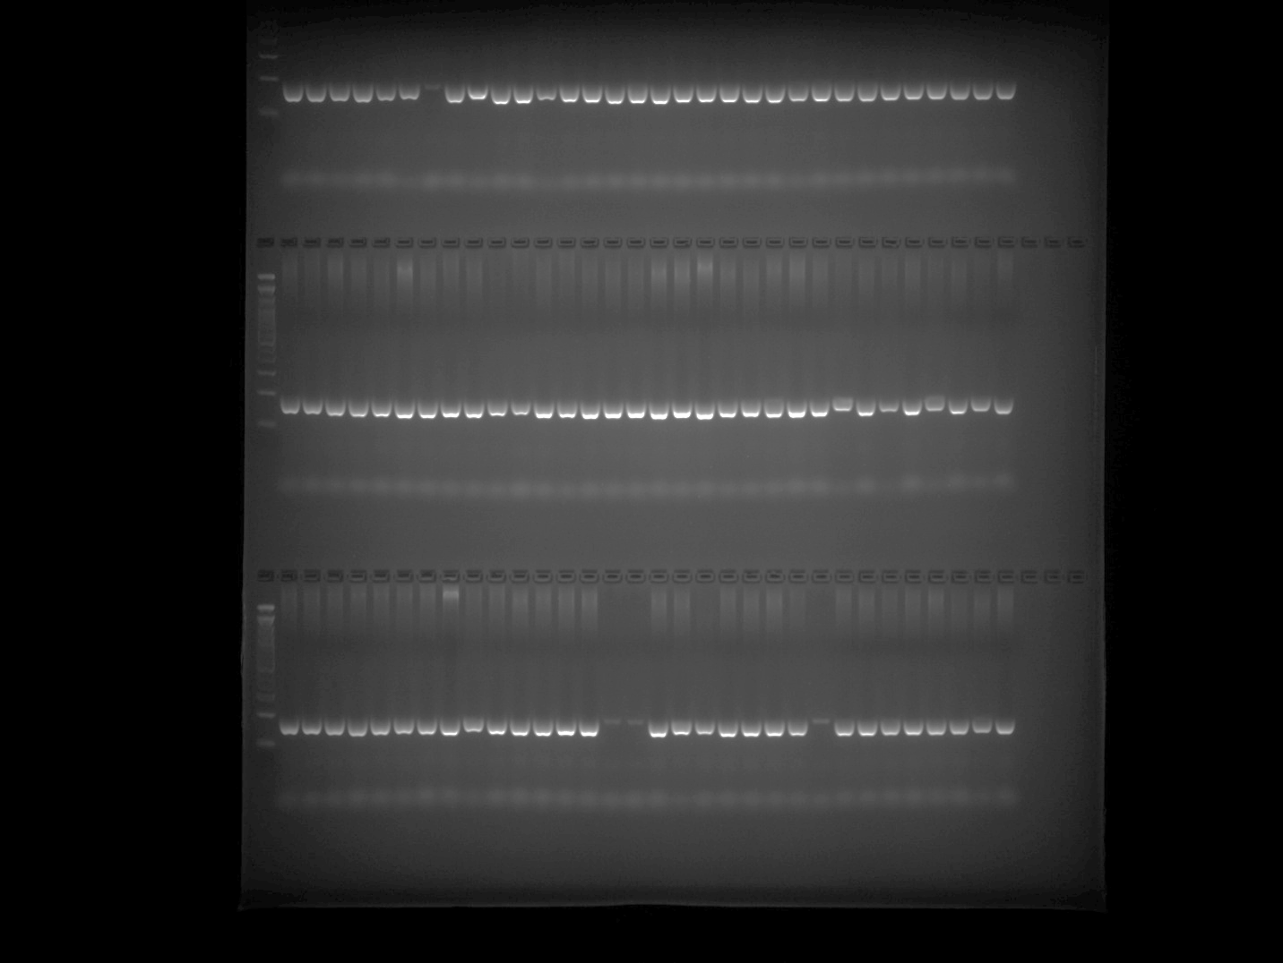

HpmsE062 Plate 4
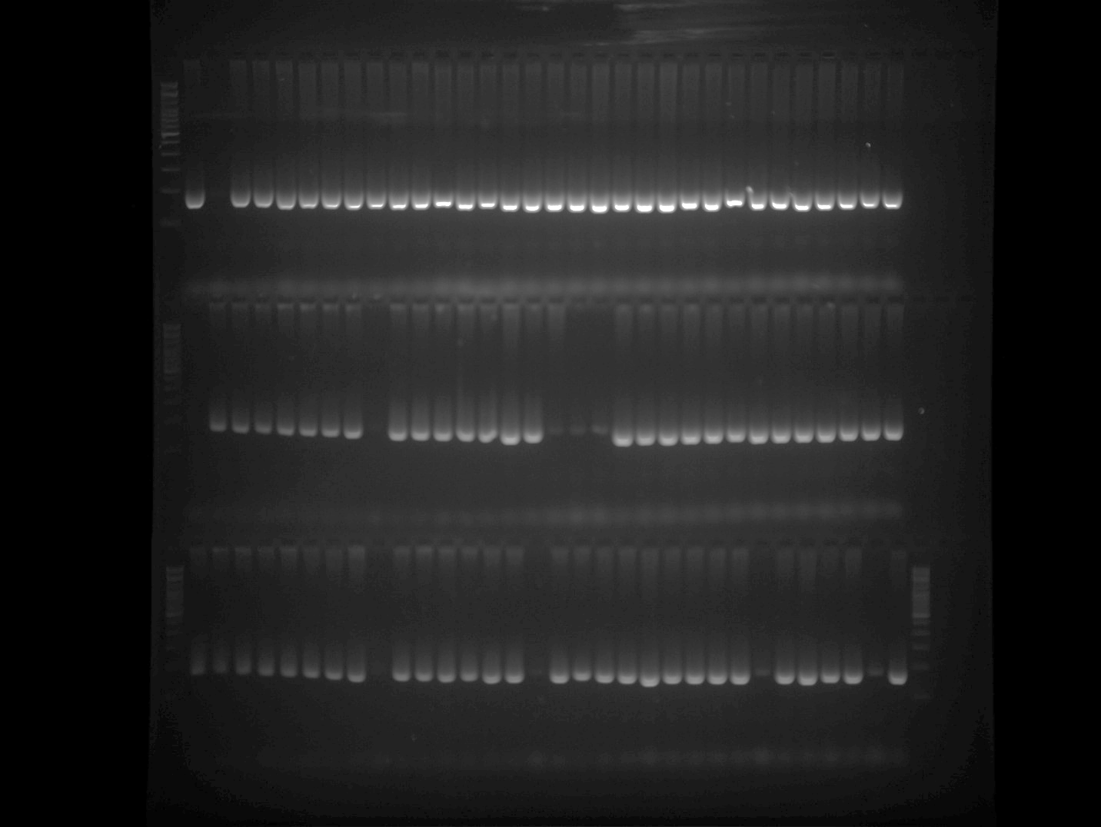

HpmsE062 Plate 5
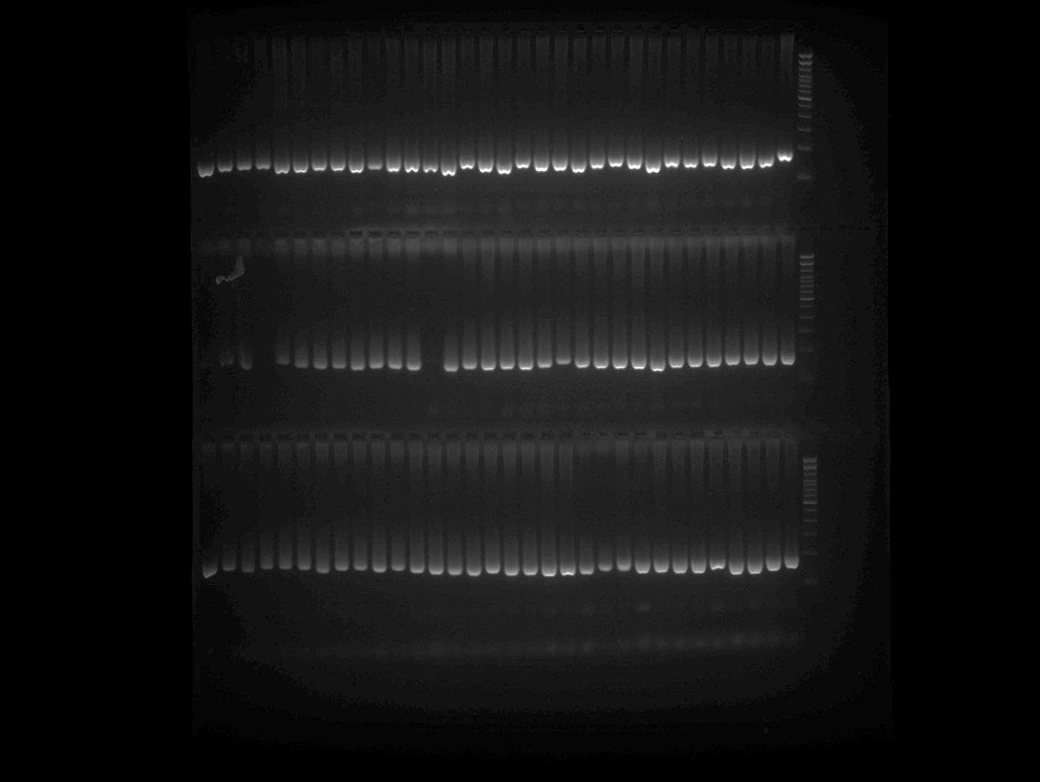

ZL6726 Plate 1
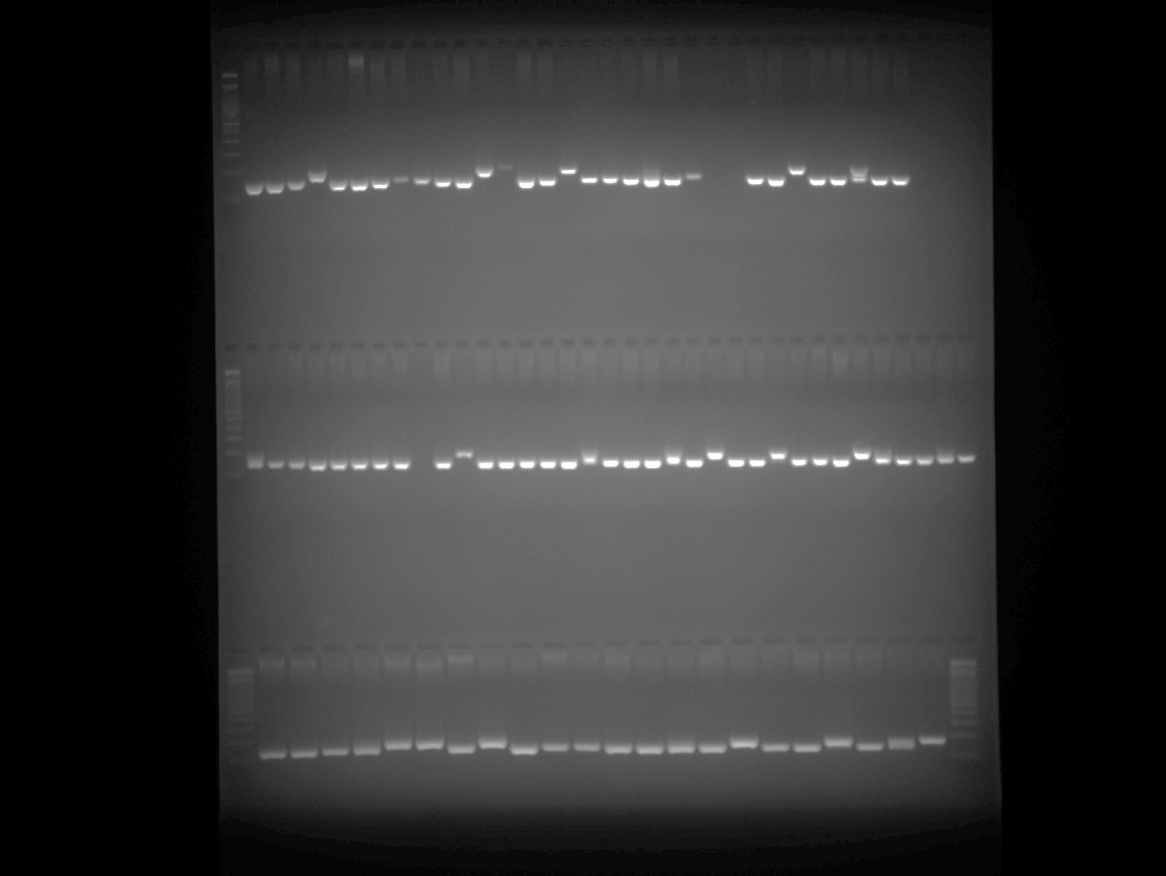

ZL6726 Plate 2 Part 1
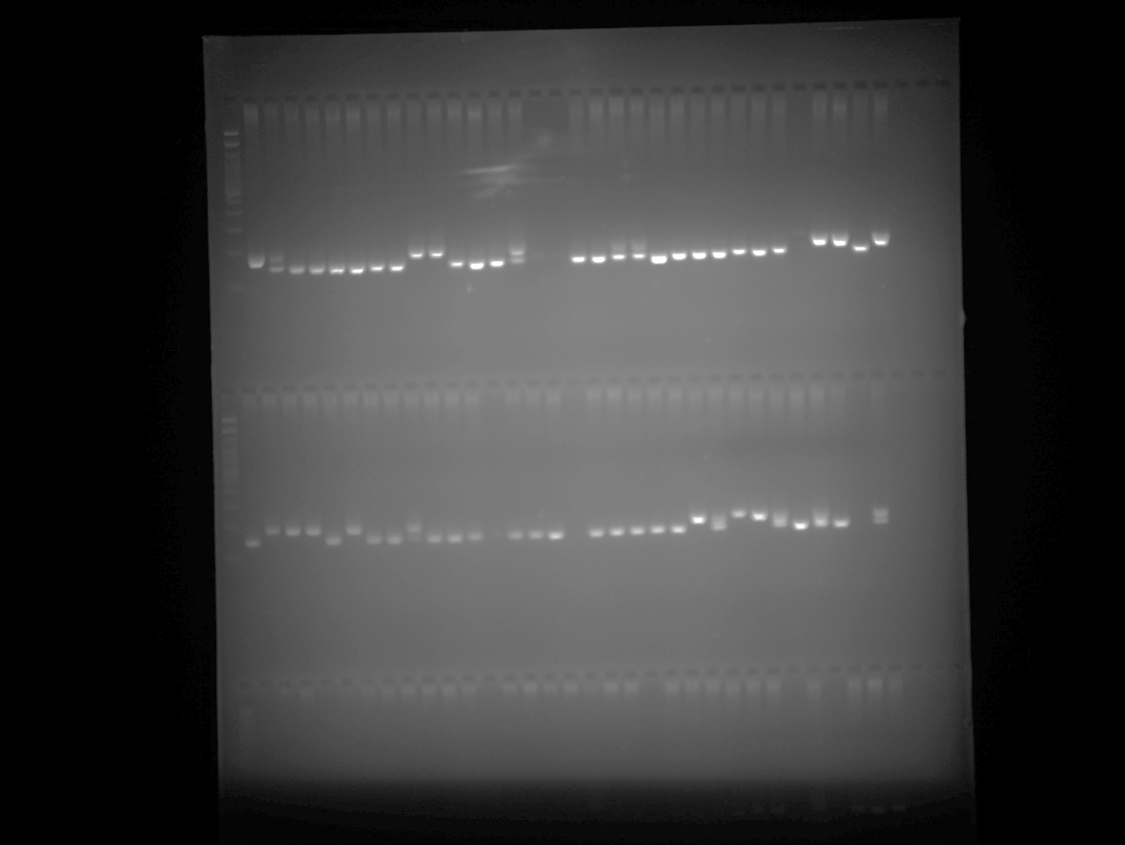

ZL6726 Plate 2 Part 2
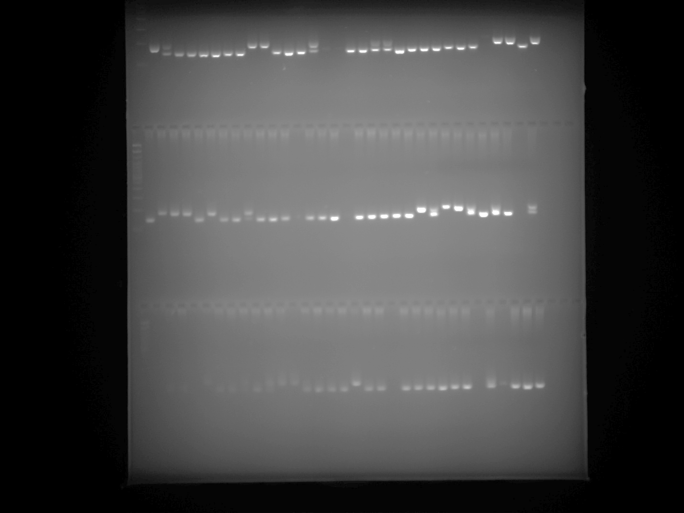

ZL6726 Plate 2 Part 2 repeated (row3)

Note: PCR was repeated for the samples belonging to Row 3 of ZL6726 Plate 2 gel image and presented in the above gel image at row 3.

ZL6726 Plate 3 Part 1
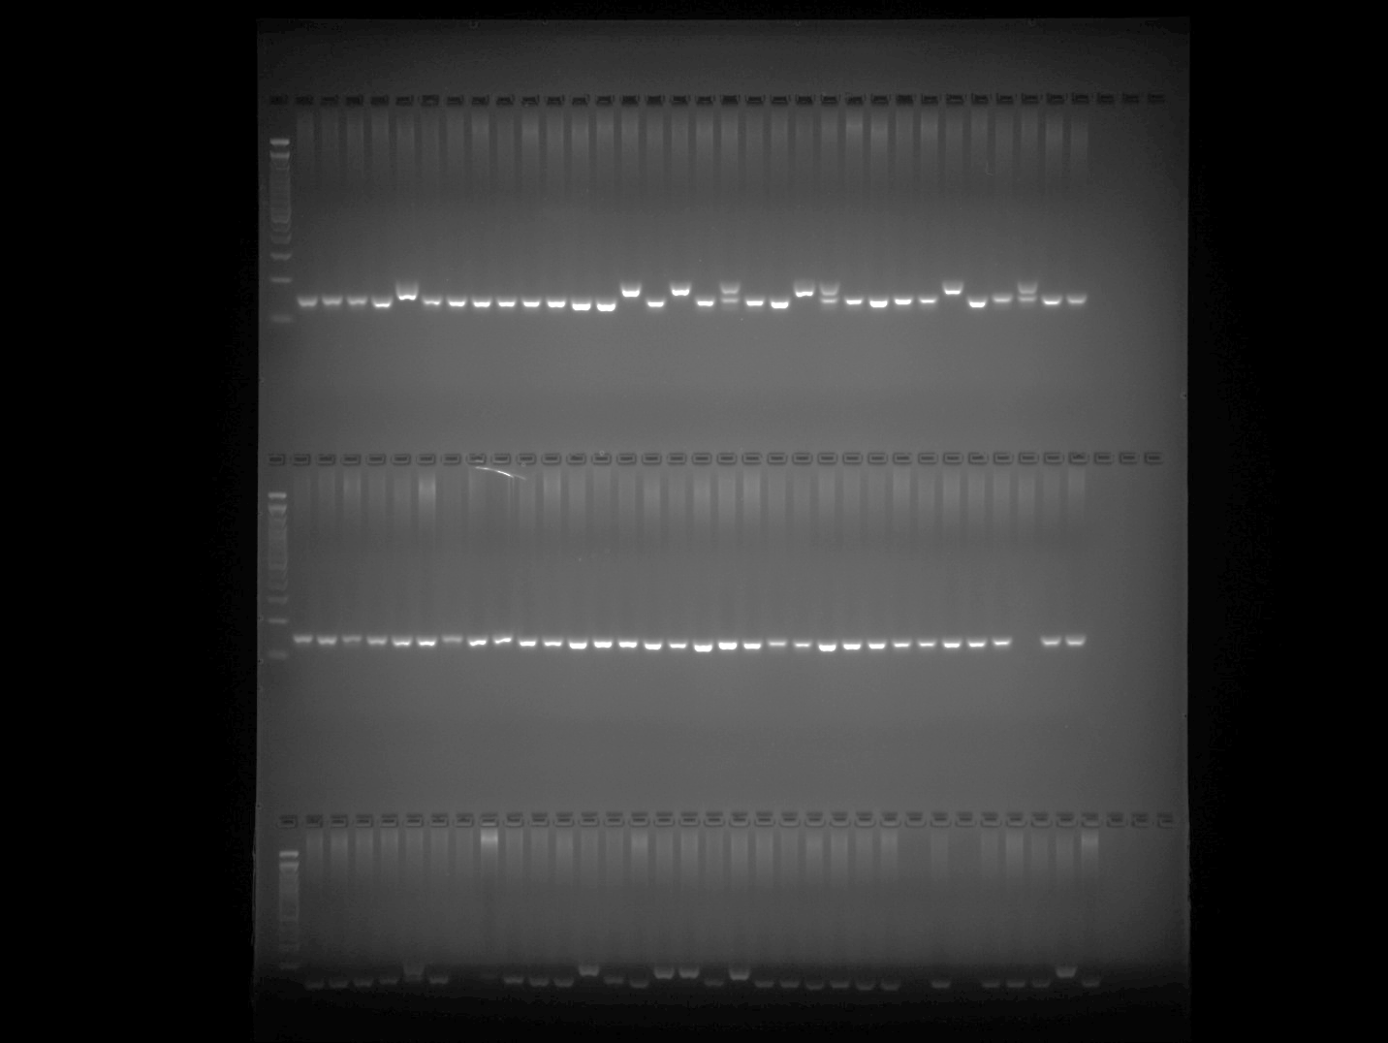

ZL6726 Plate 3 Part 2
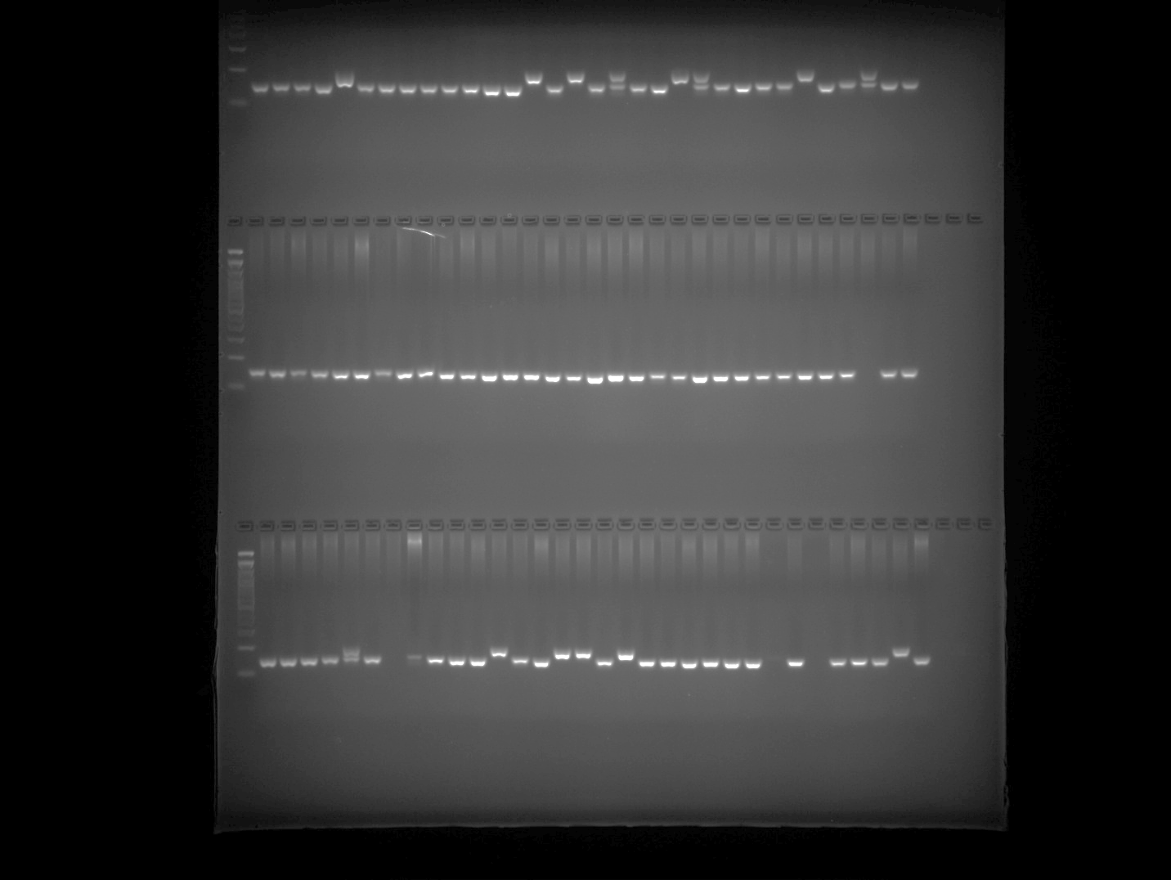

ZL6726 Plate 4
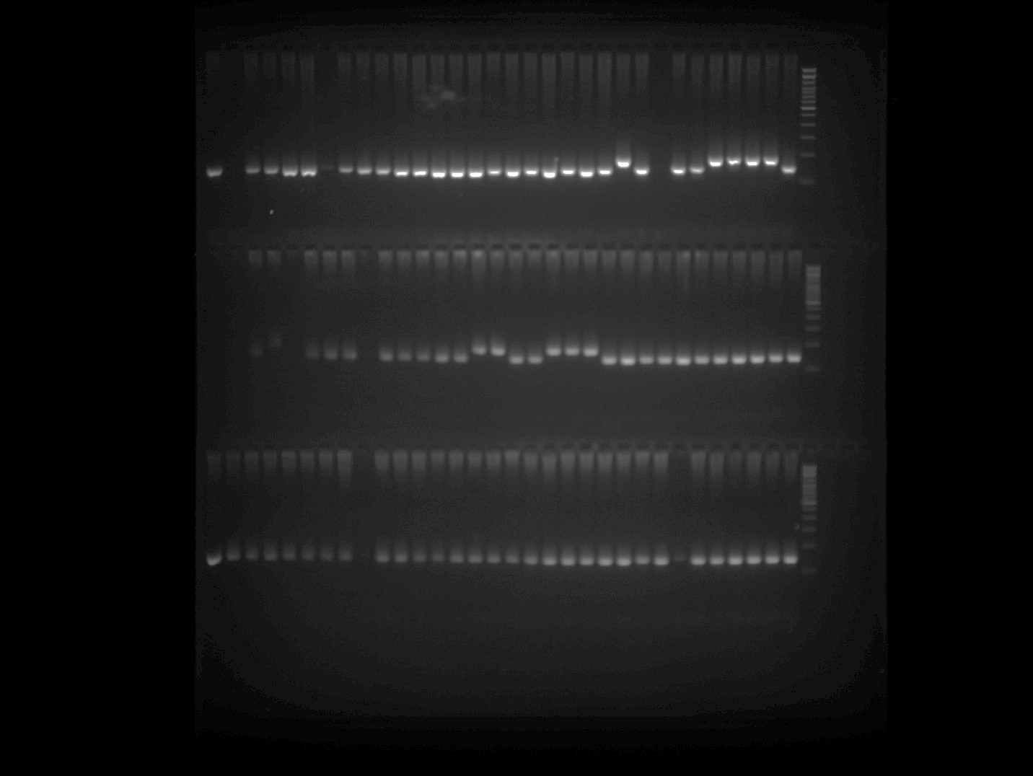

ZL6726 Plate 5
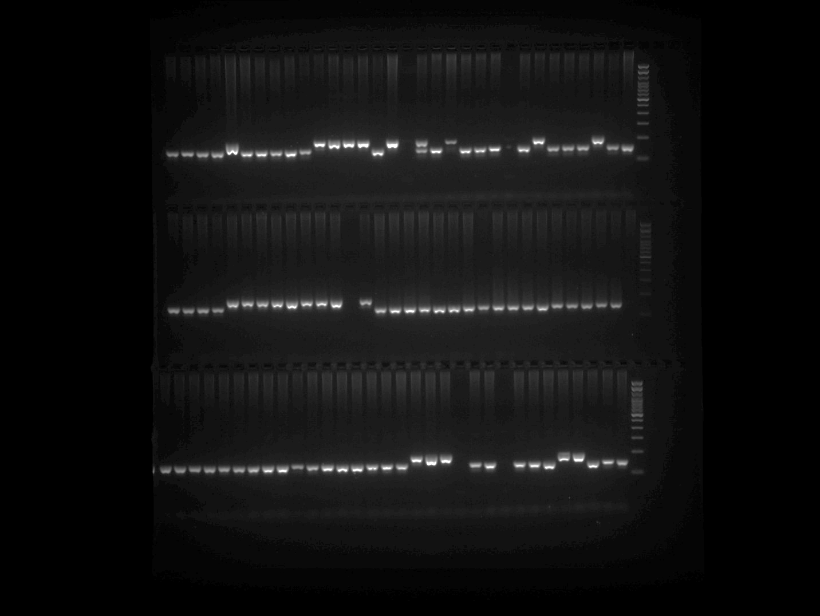

HpmshsMADS Plate 1
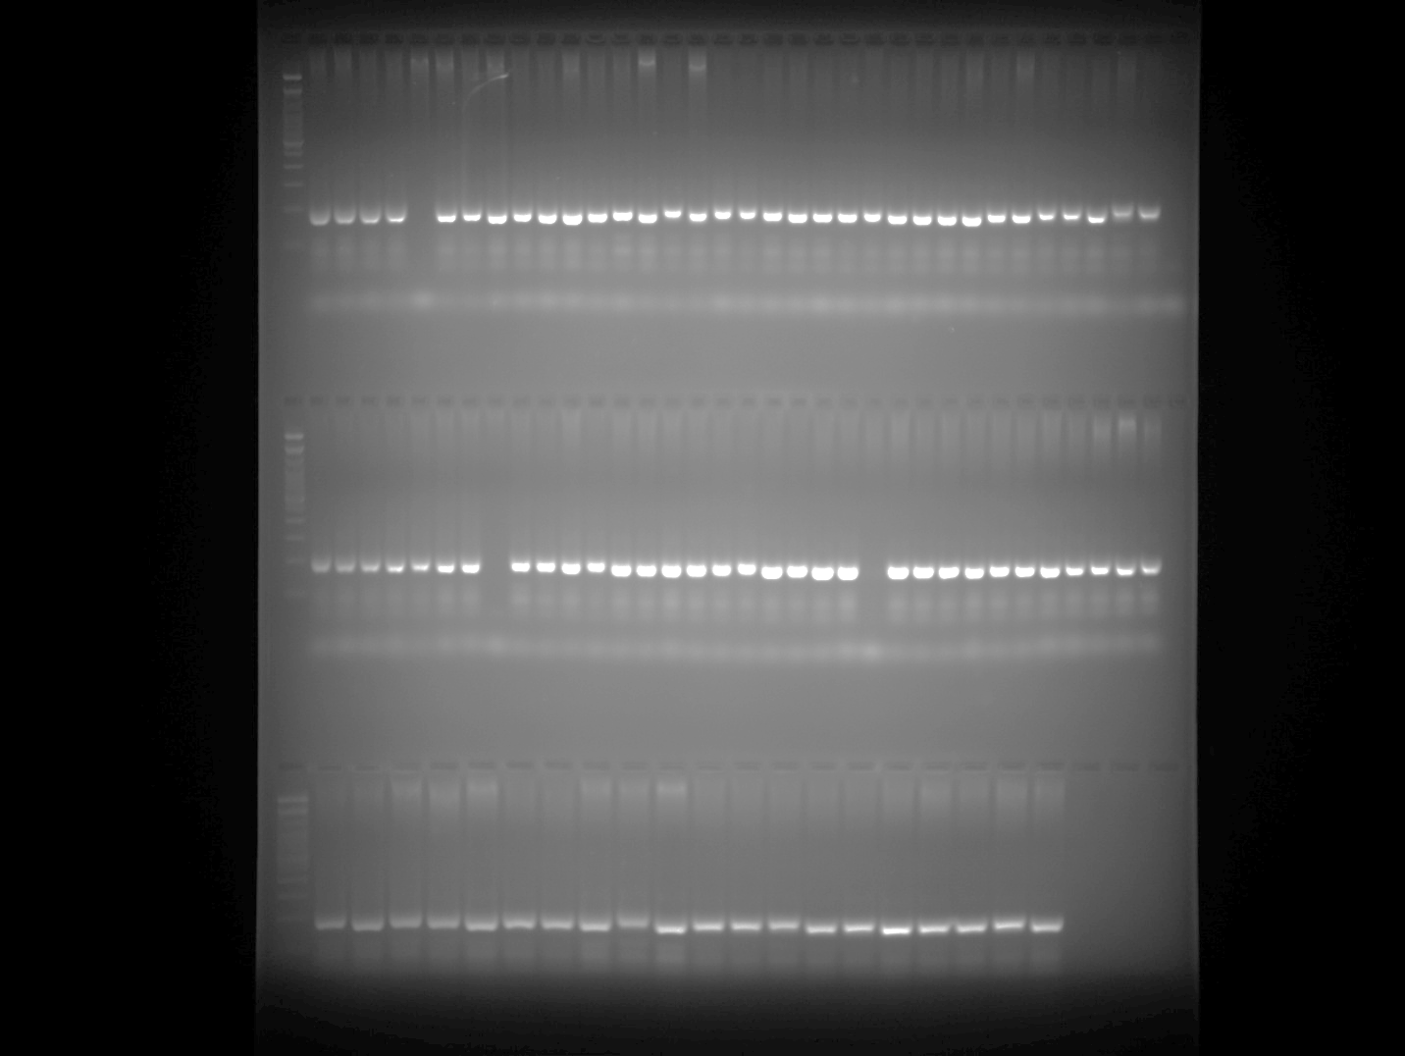

HpmshsMADS Plate 2 Part 1
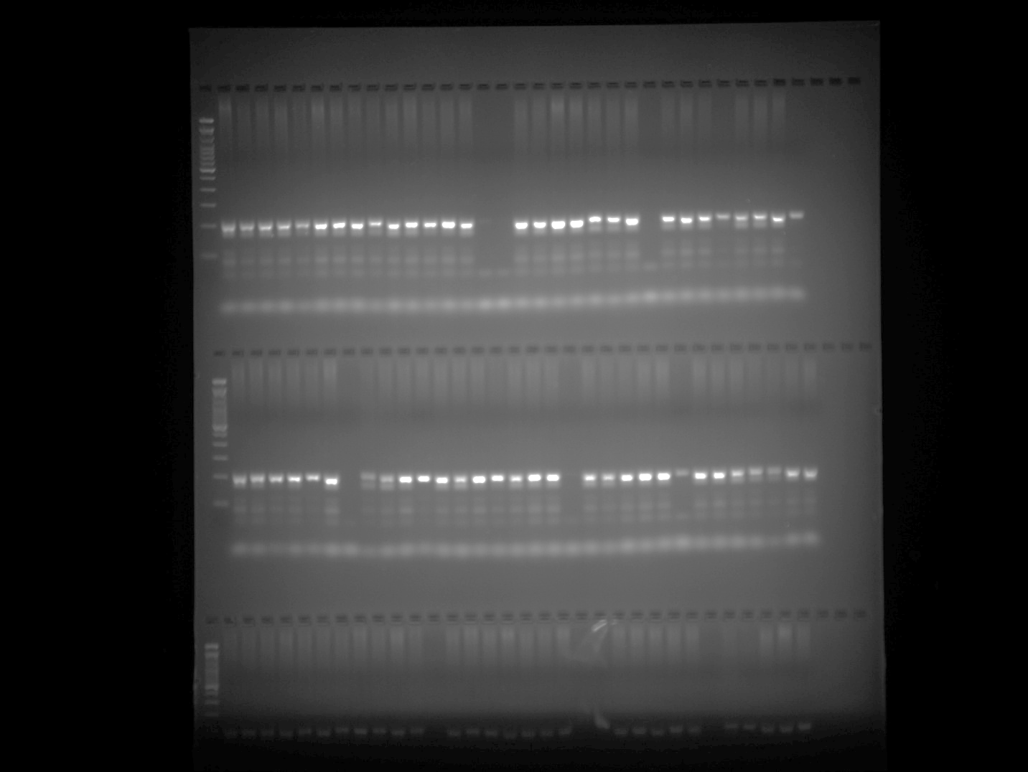

HpmshsMADS Plate 2 Part 2
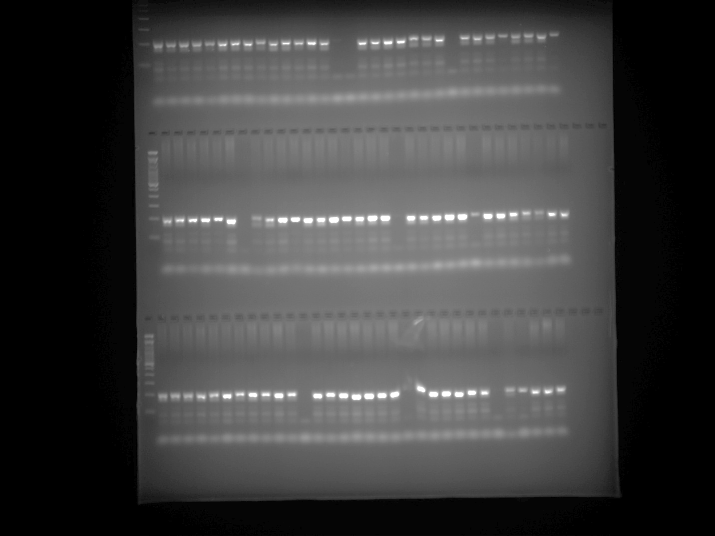

HpmshsMADS Plate 3 Part 1
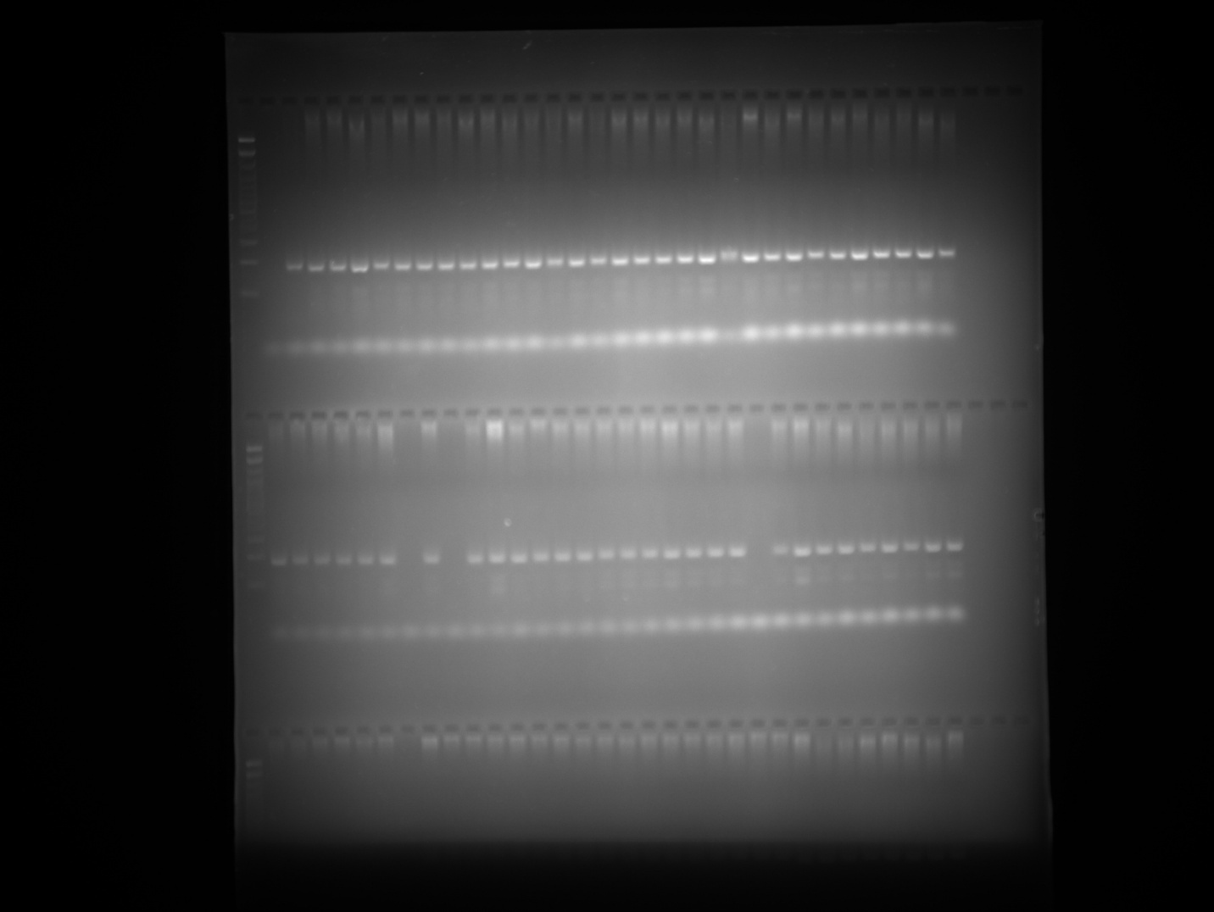

HpmshsMADS Plate 3 Part 2
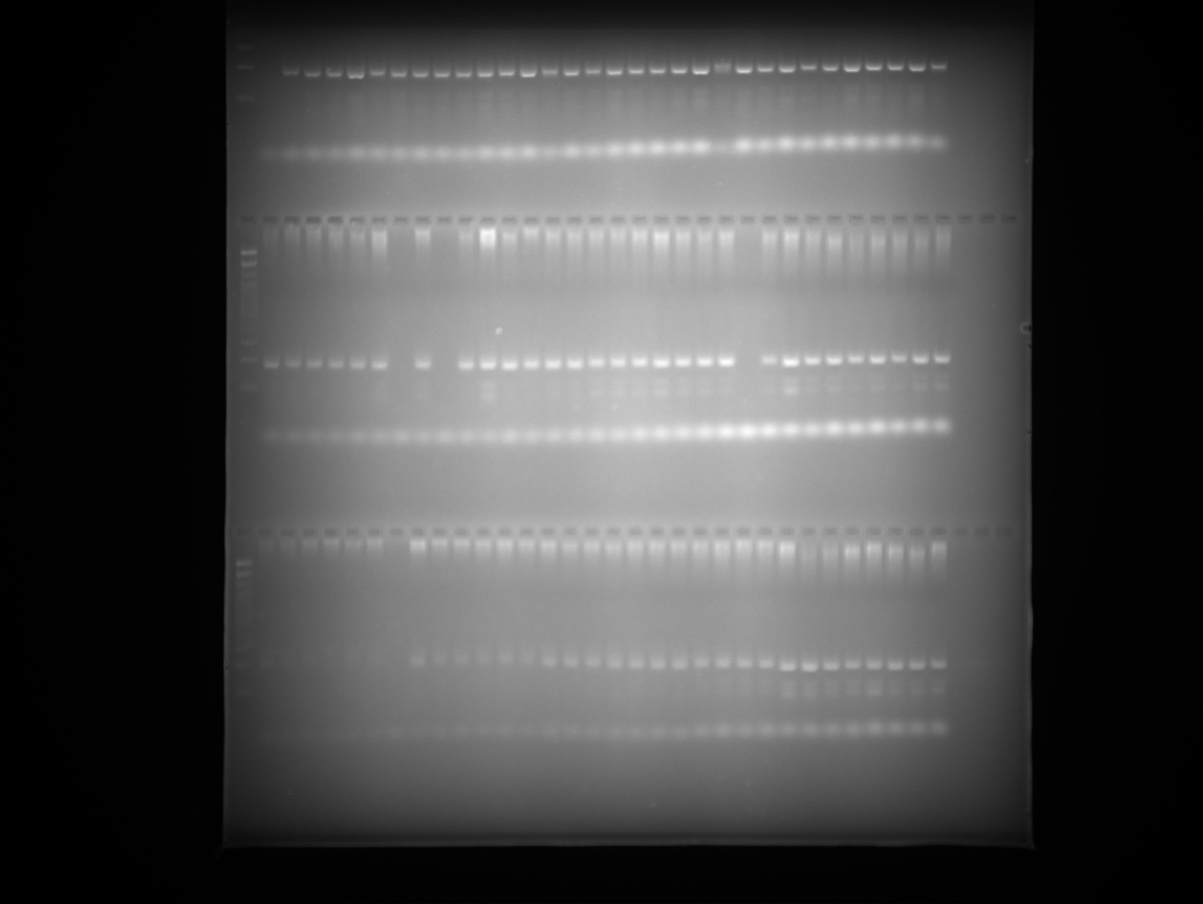

HpmshsMADS Plate 4

HpmshsMADS Plate 5
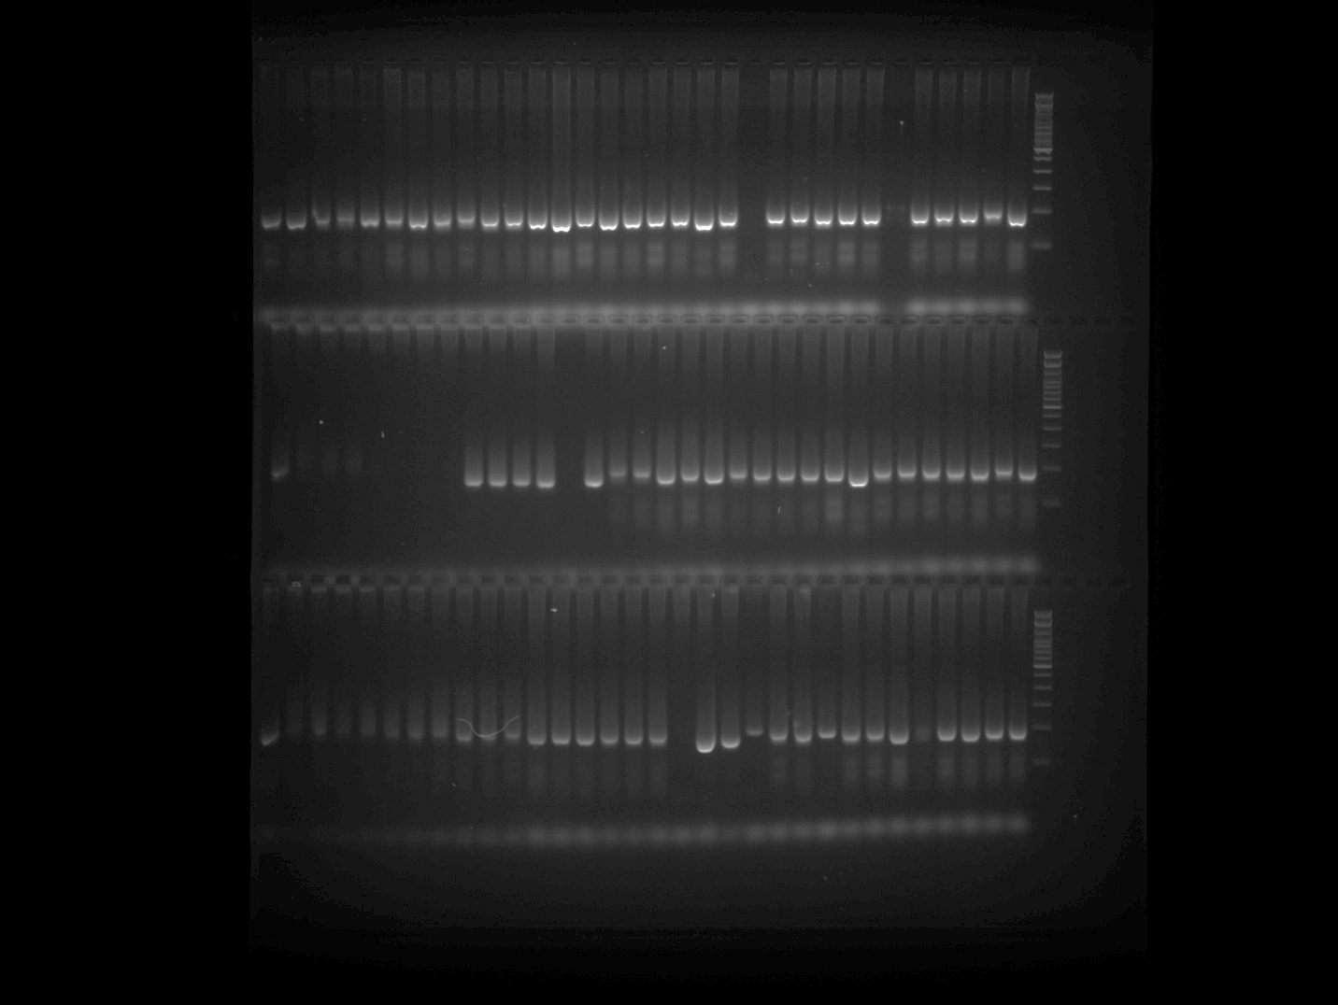

HpmshsMADS Plate 5 repeated (row3 last 8 wells)

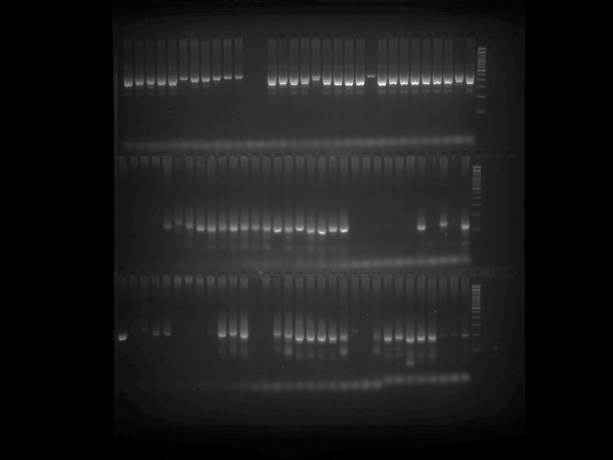

Note: PCR was repeated for the samples belonging to first 8 well in the Row 2 of the HpmshsMADS Plate 5 gel image and presented in the above gel image at row 3, last 8 well.

CAMS089 Plate 1
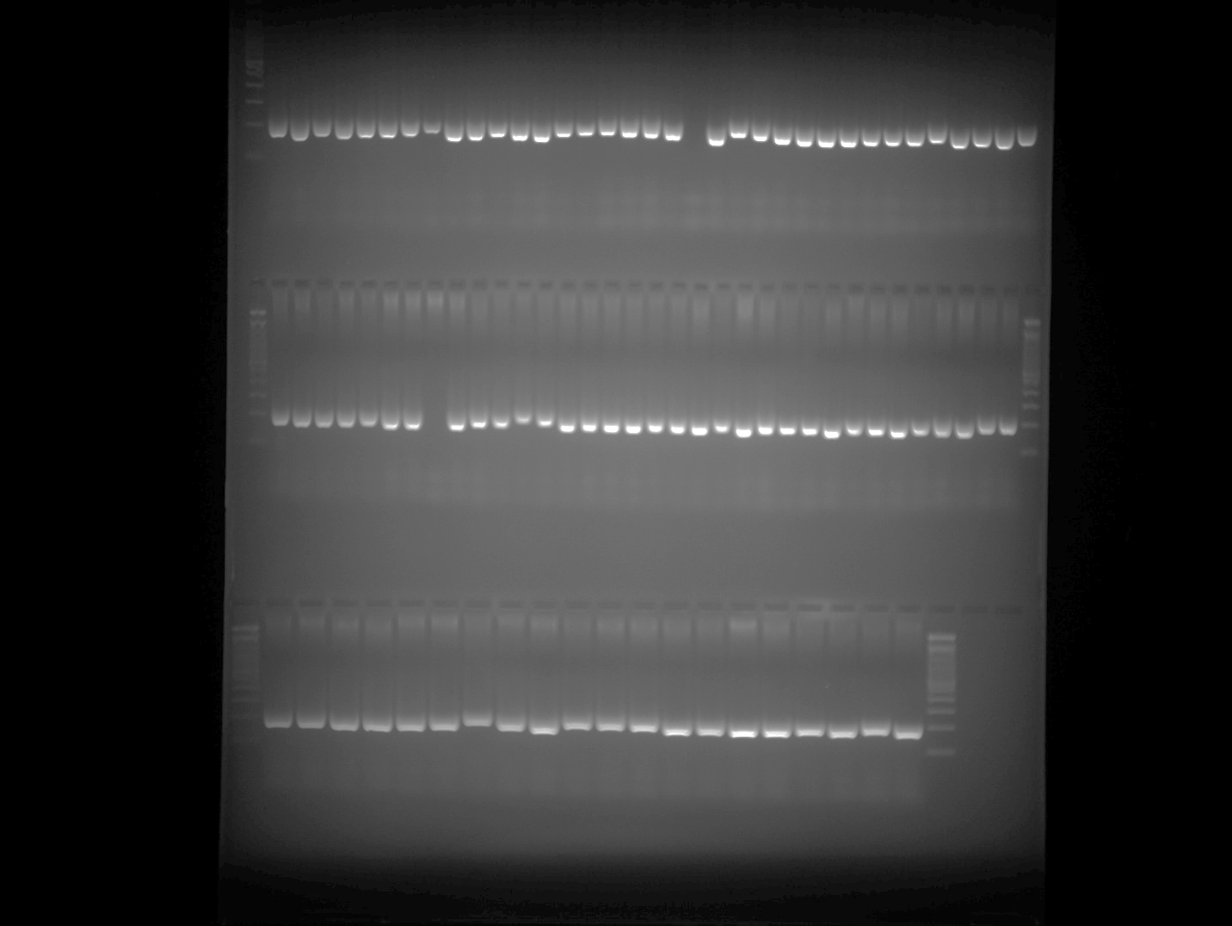

CAMS089 Plate 2 Part 1
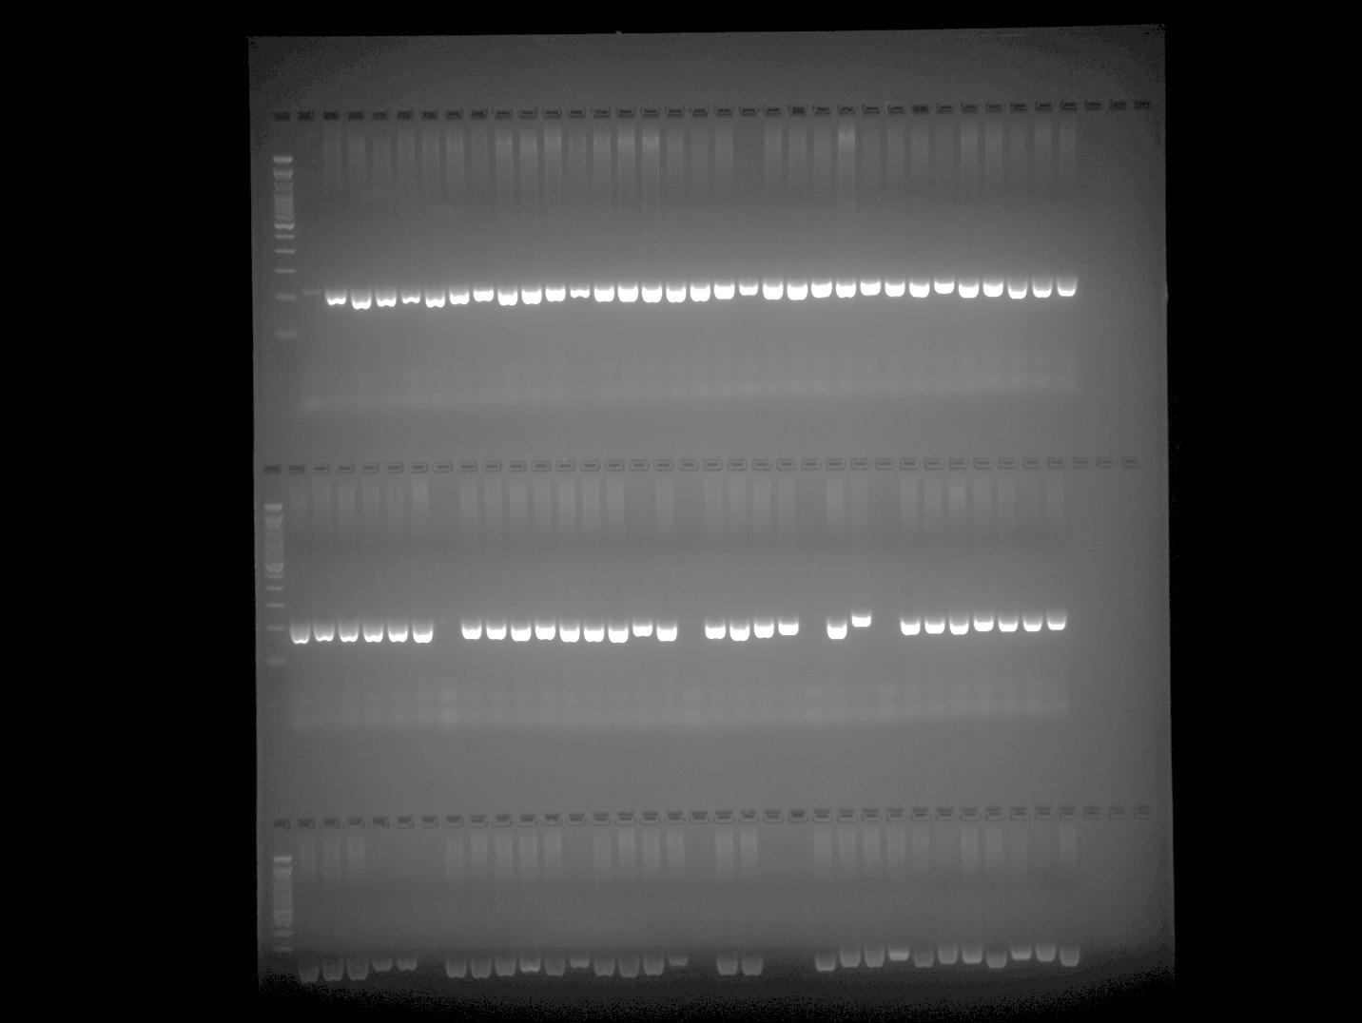

CAMS089 Plate 2 Part 2
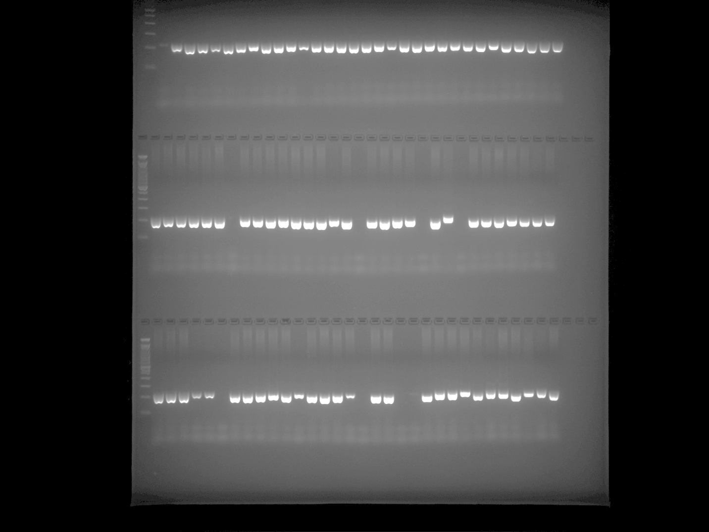

CAMS089 Plate 3 Part 1
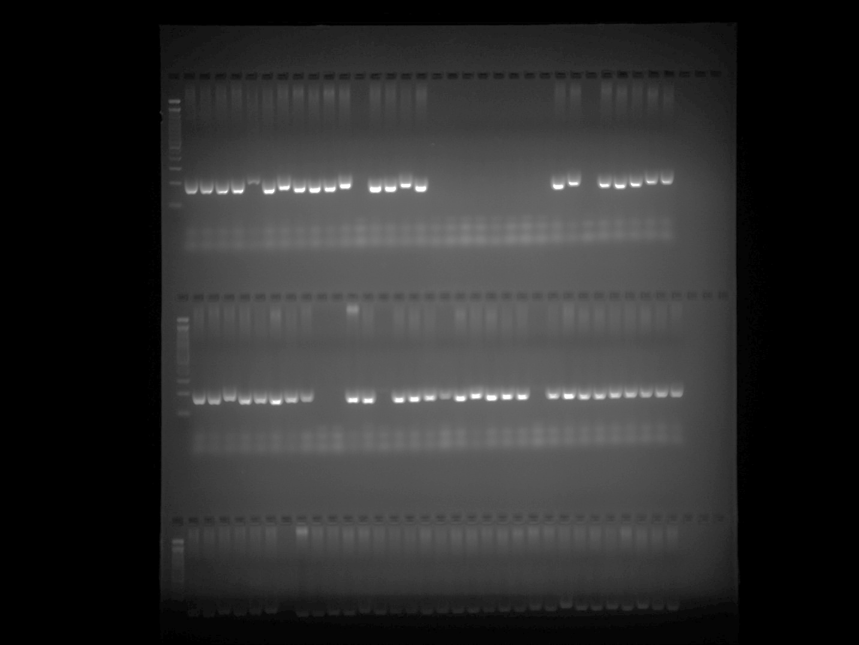

CAMS089 Plate 3 Part 2
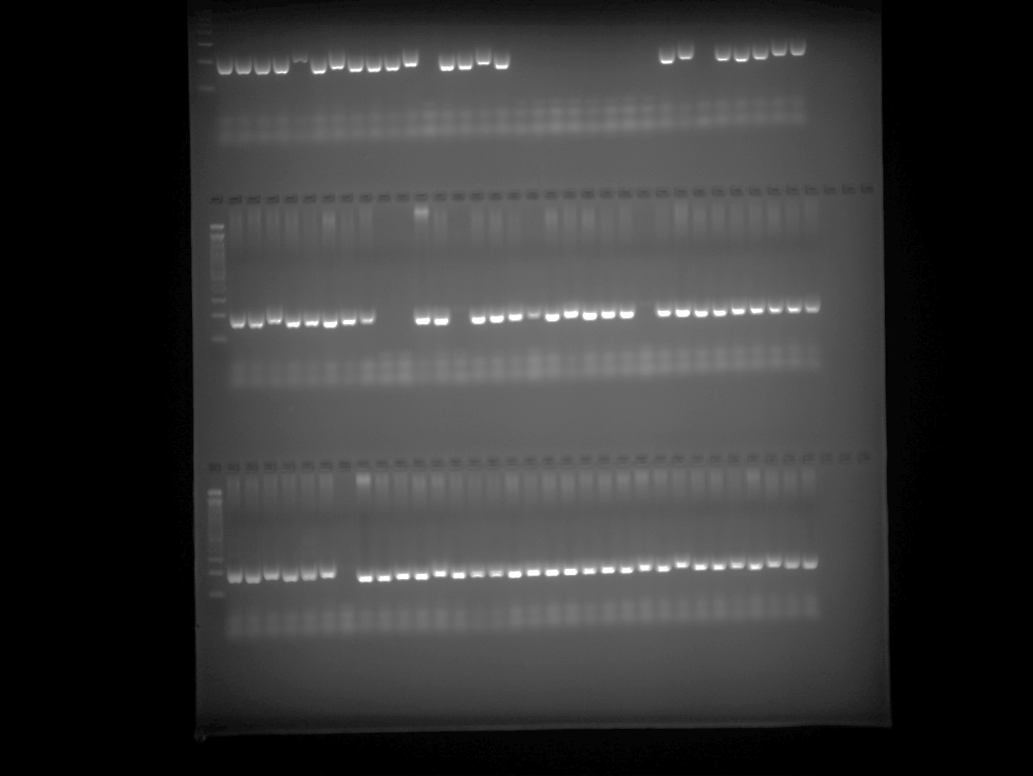

CAMS089 Plate 4
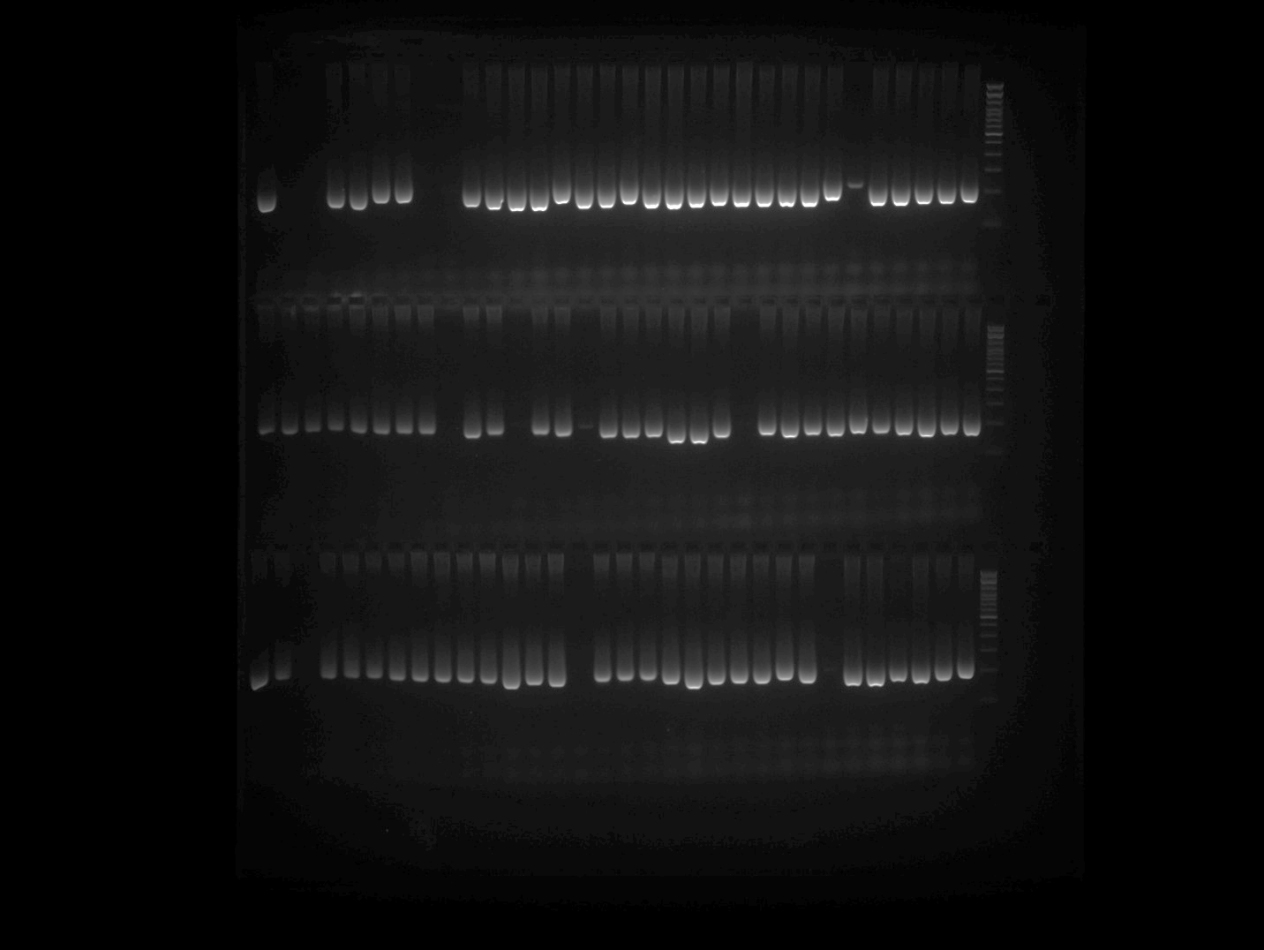

CAMS089 Plate 5
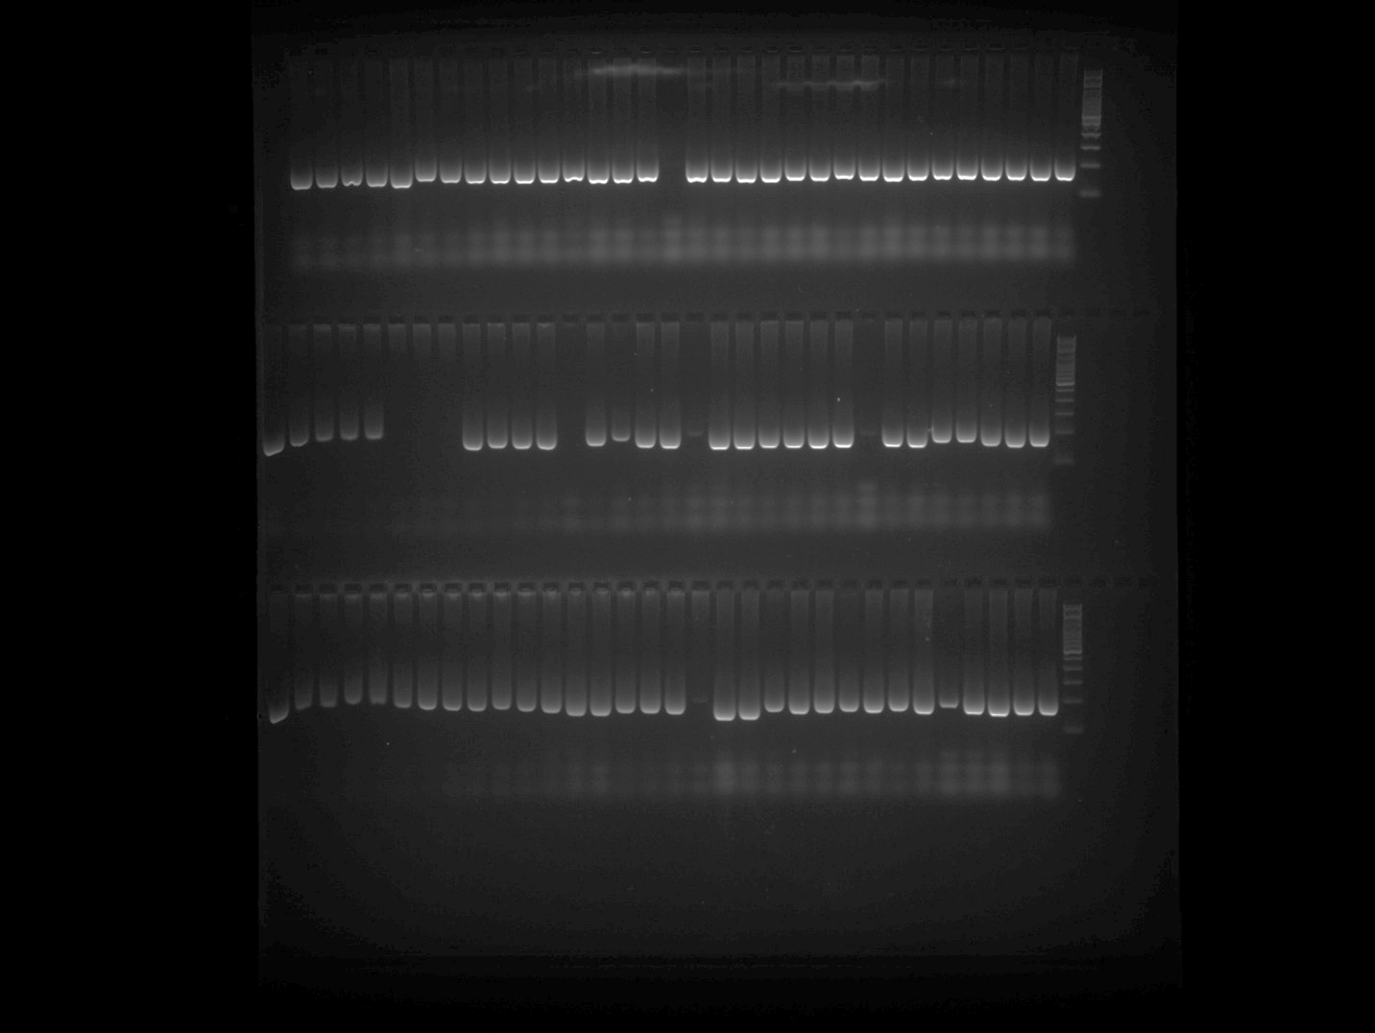

U196349 Plate 1
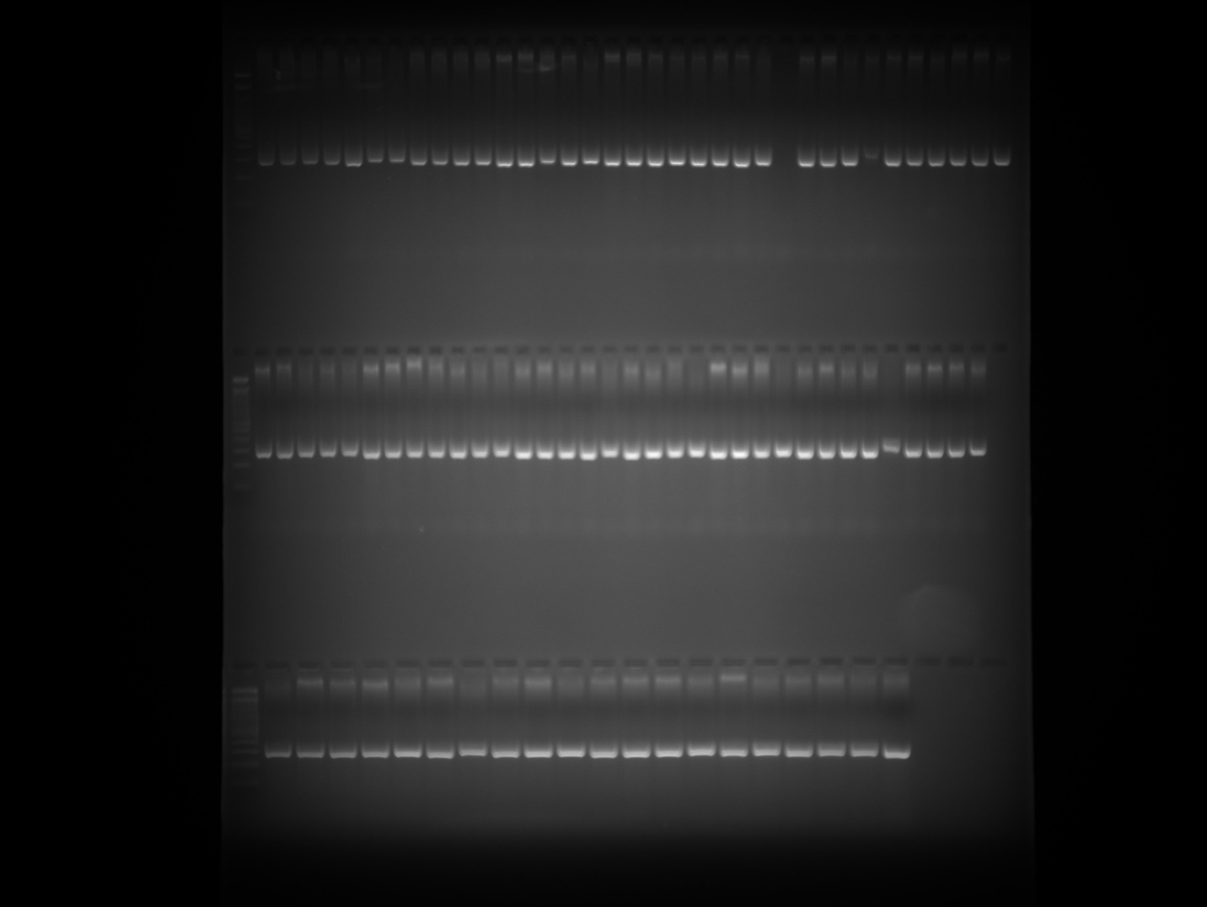

U196349 Plate 2 Part 1
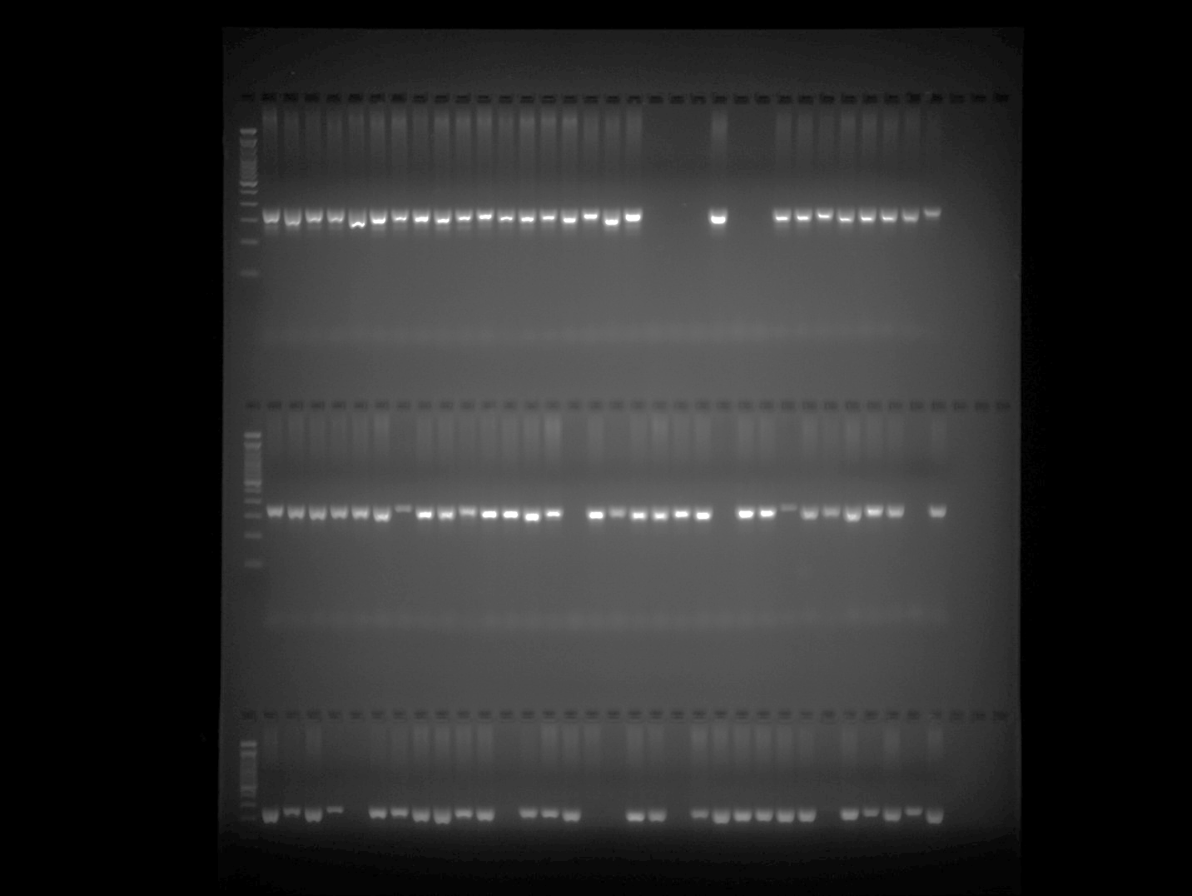

U196349 Plate 2 Part 2
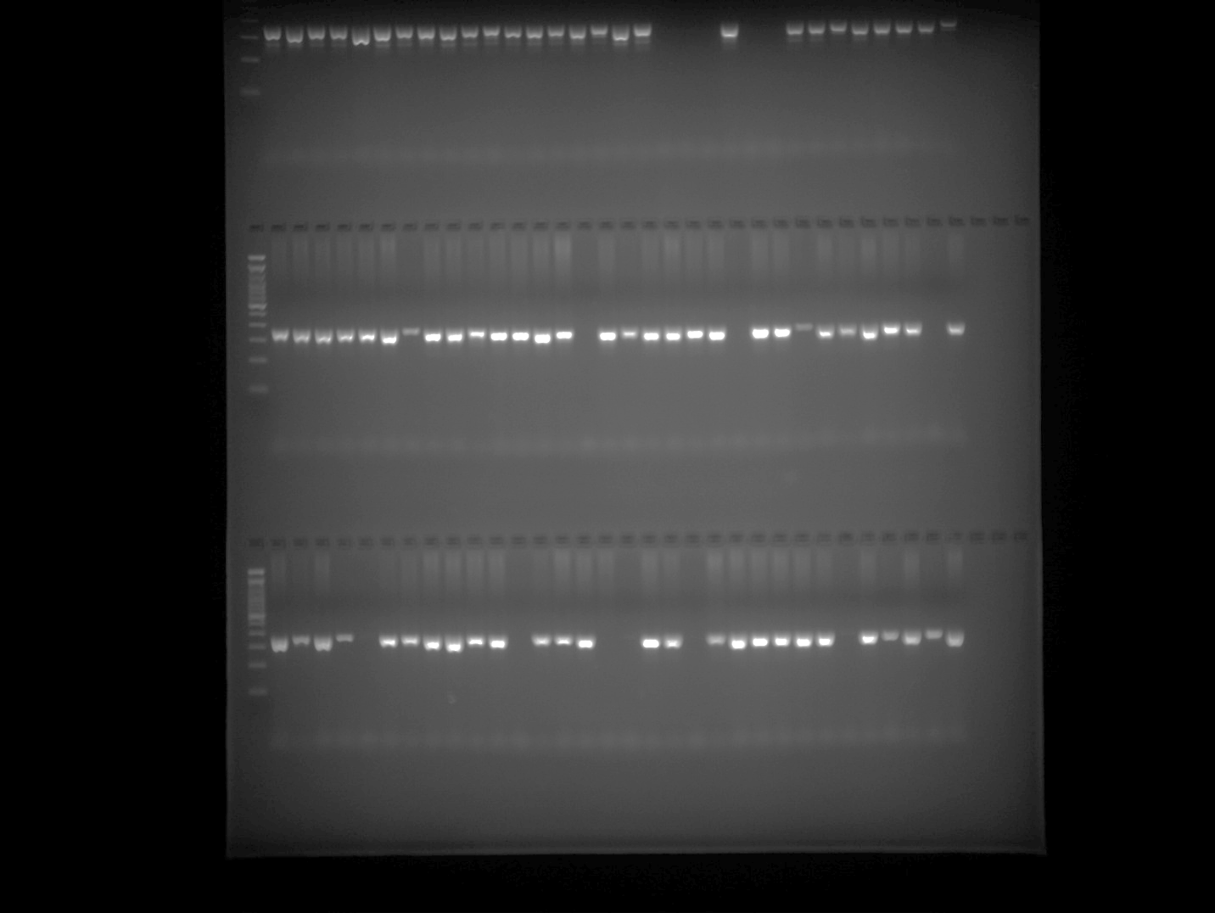

U196349 Plate 3 Part 1
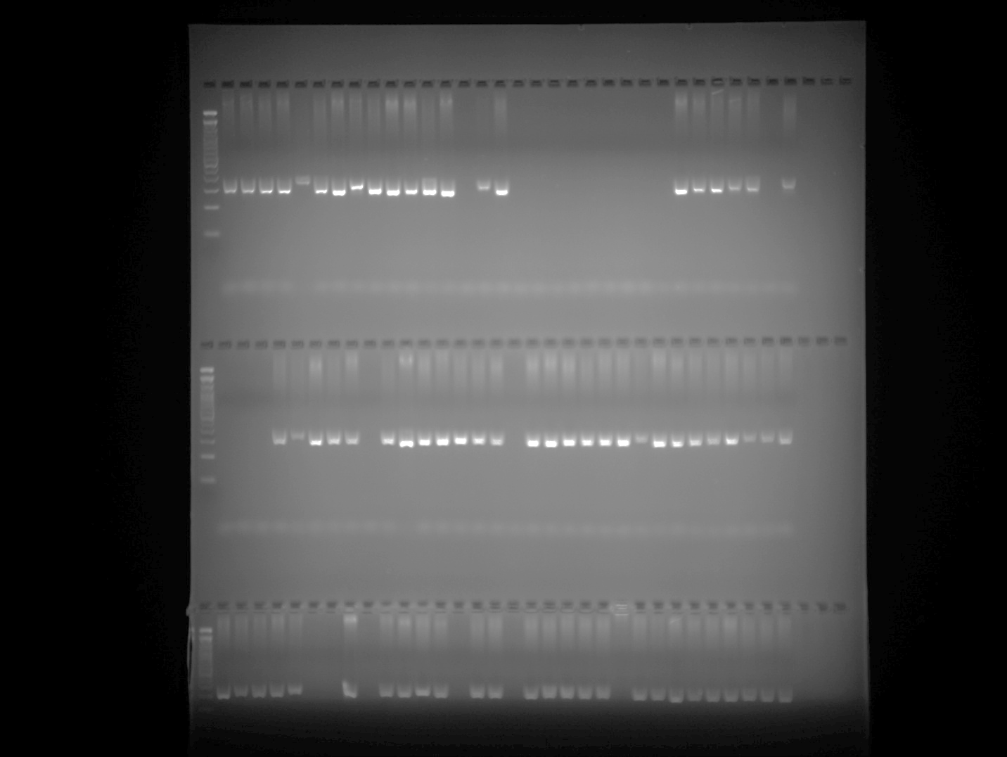

U196349 Plate 3 repetition (row1)
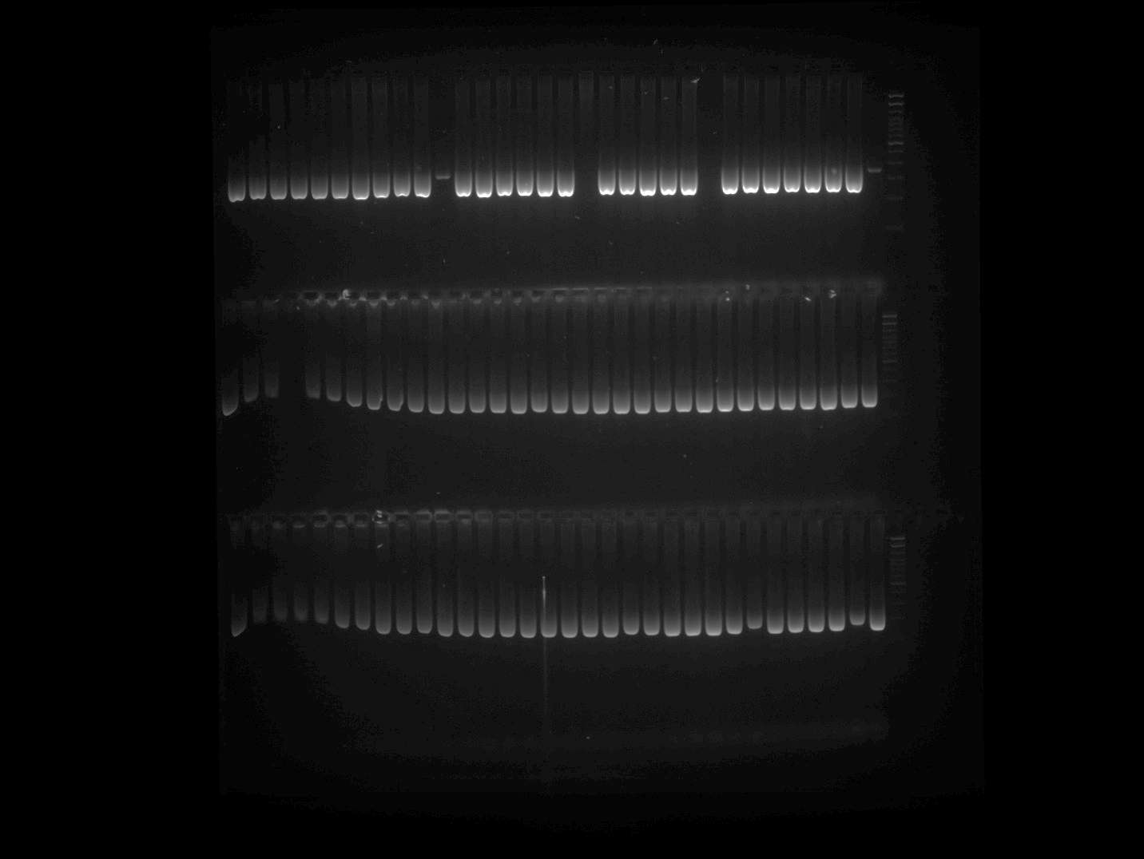
Note: PCR was repeated for the samples belonging to Row 1 of U196349 Plate 3 gel image and presented in the above gel image at row 1.

U196349 Plate 3 Part 2
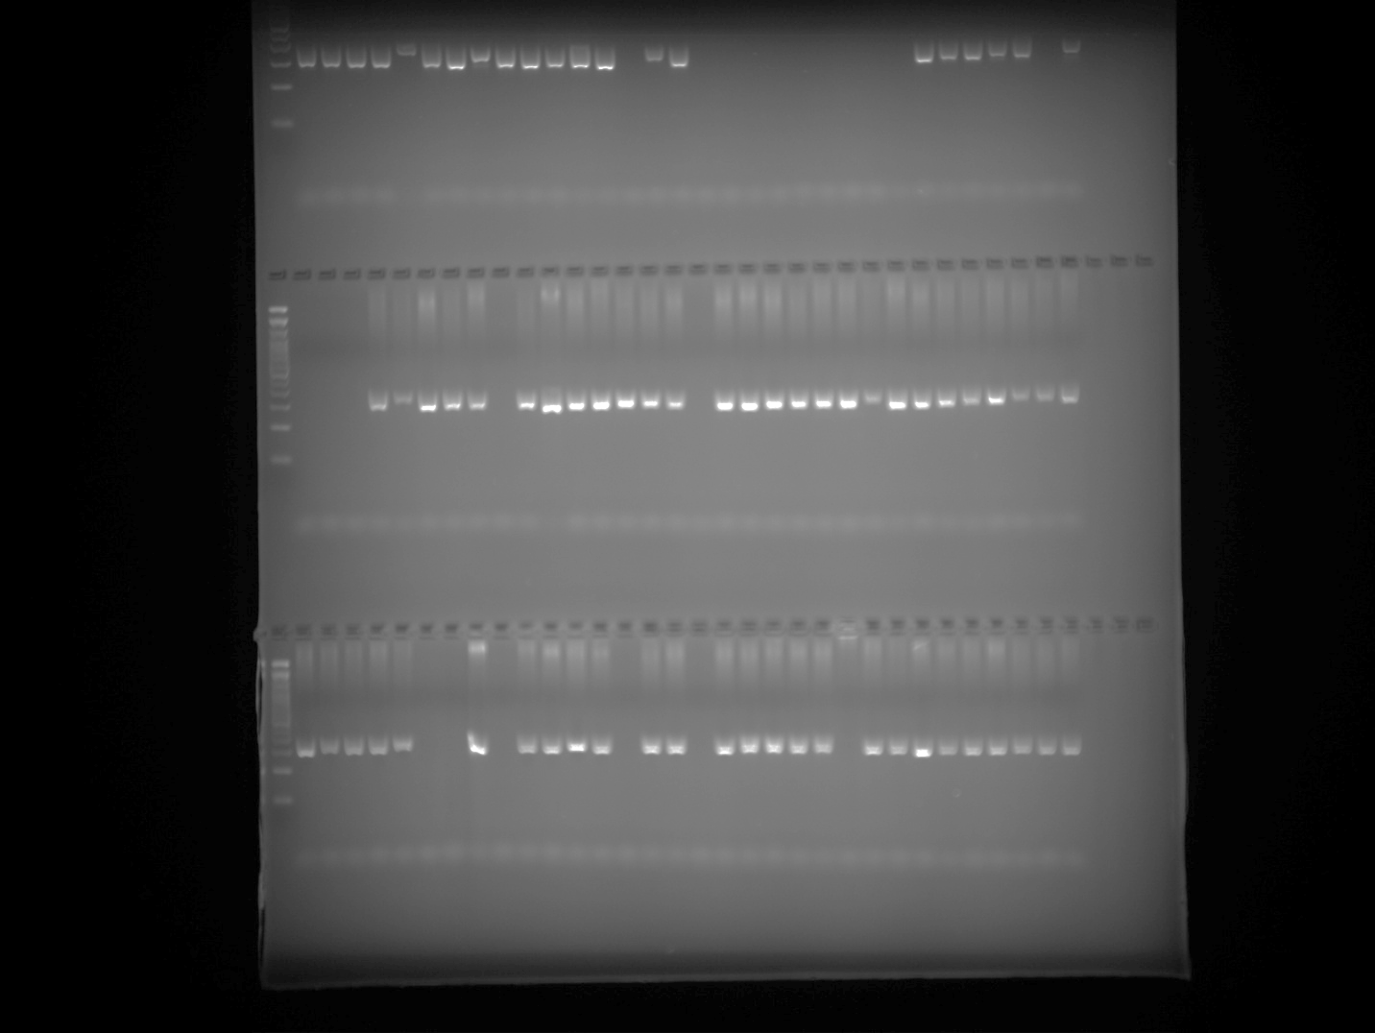

U196349 Plate 4
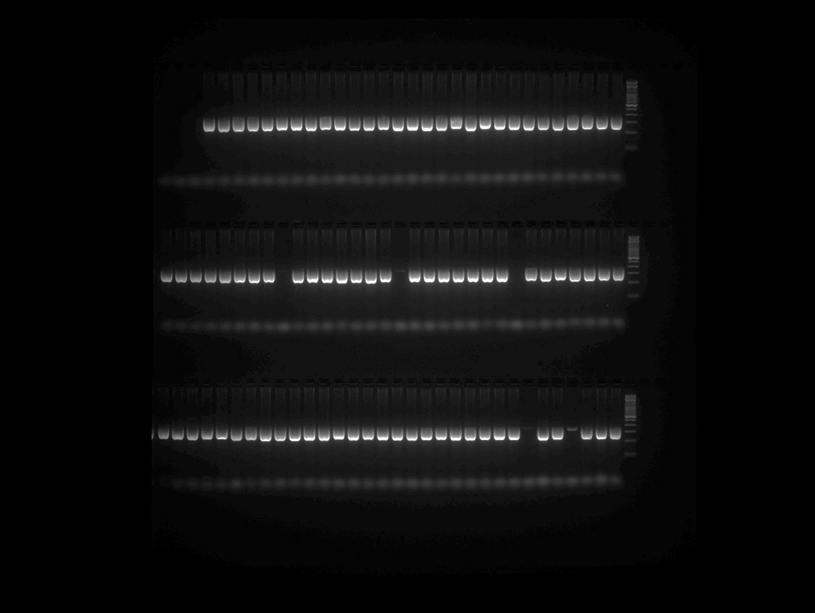

U196349 Plate 5
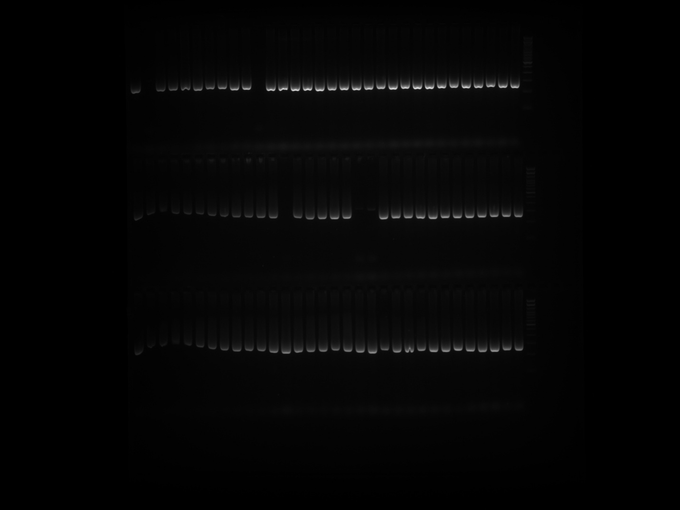

CaNB-5170 Plate 1 Part 1
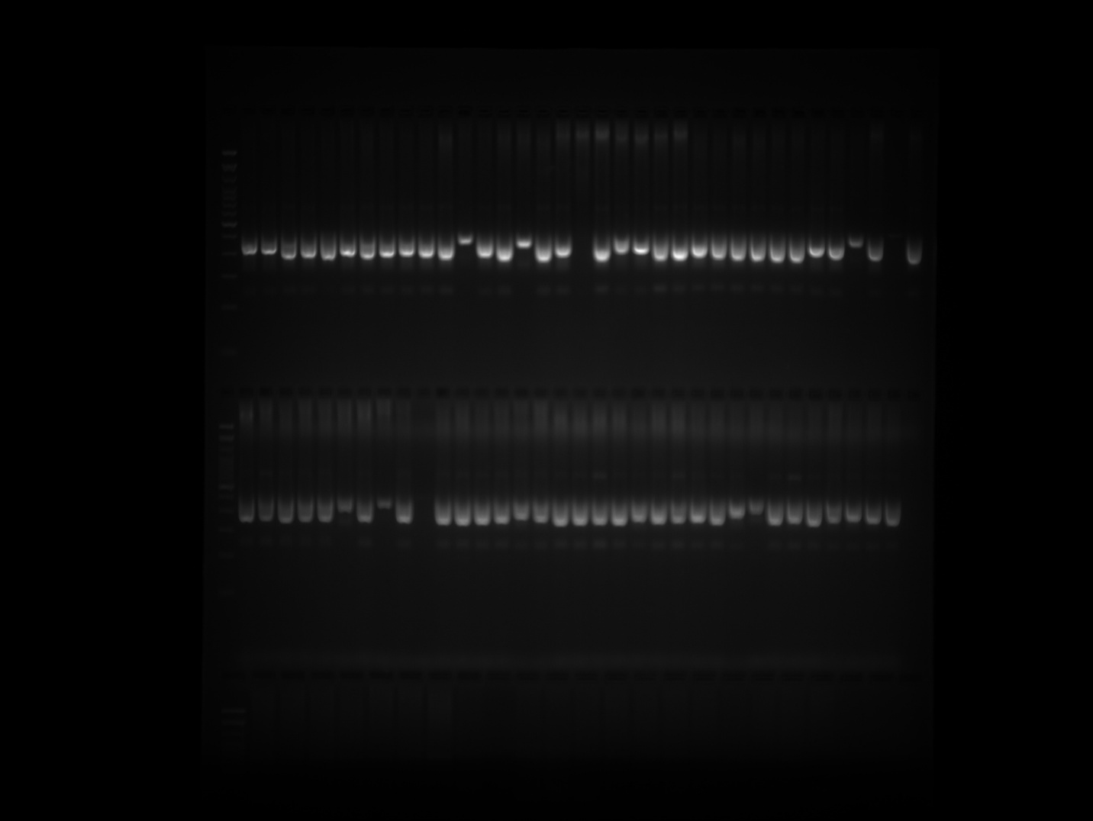

CaNB-5170 Plate 1 Part 2
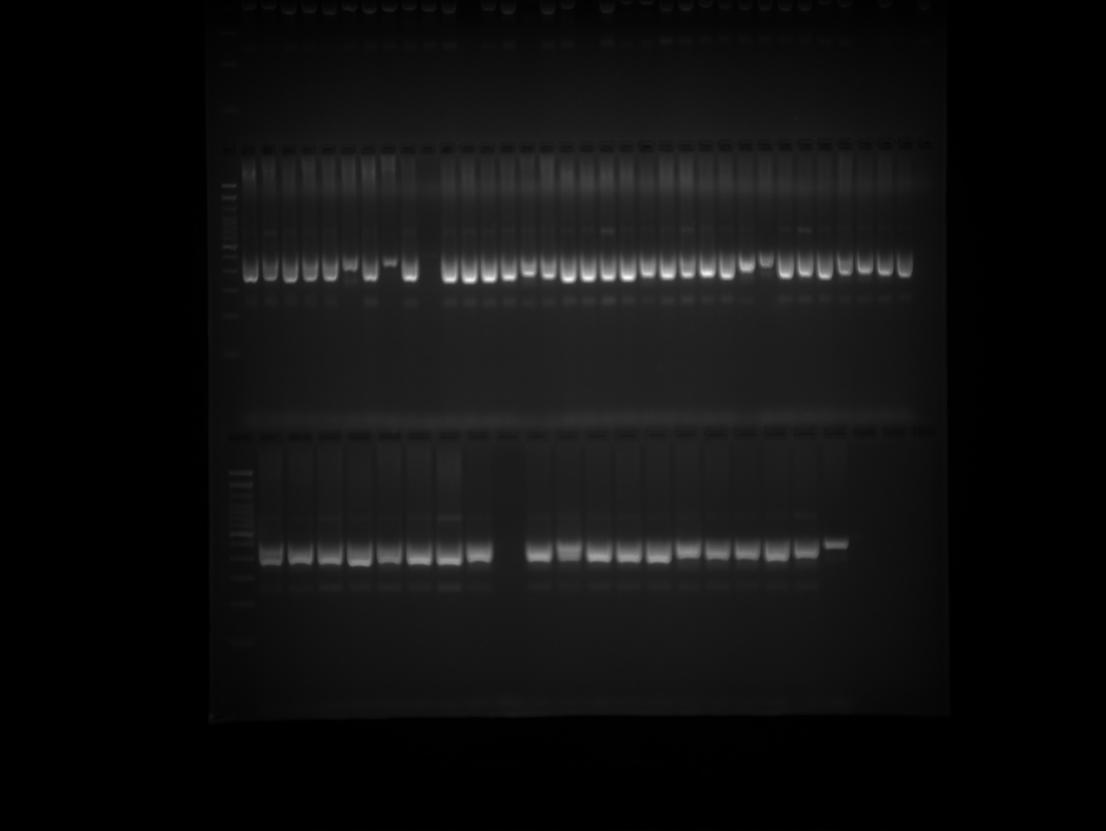

CaNB-5170 Plate 2 Part 1
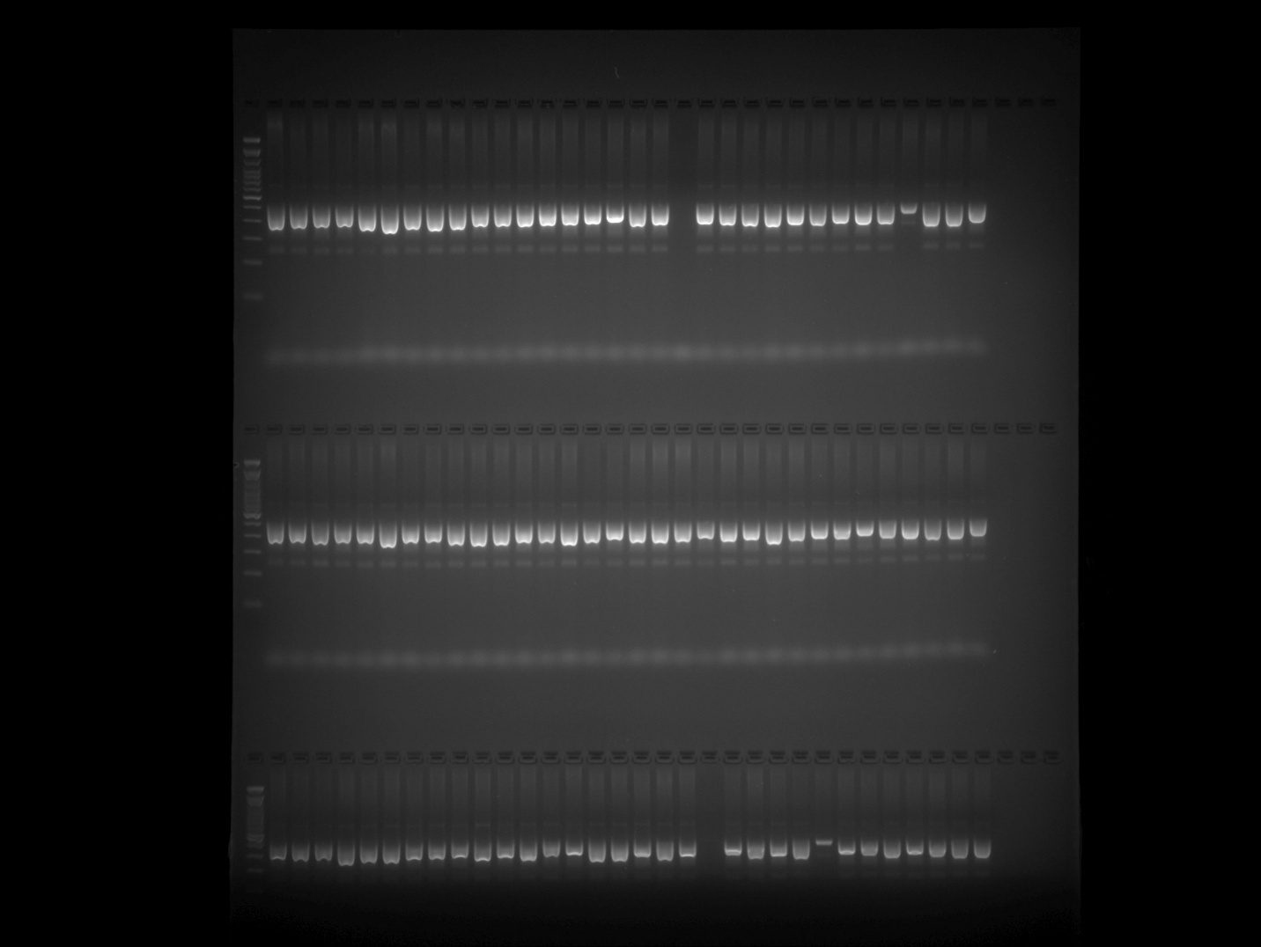

CaNB-5170 Plate 2 Part 2
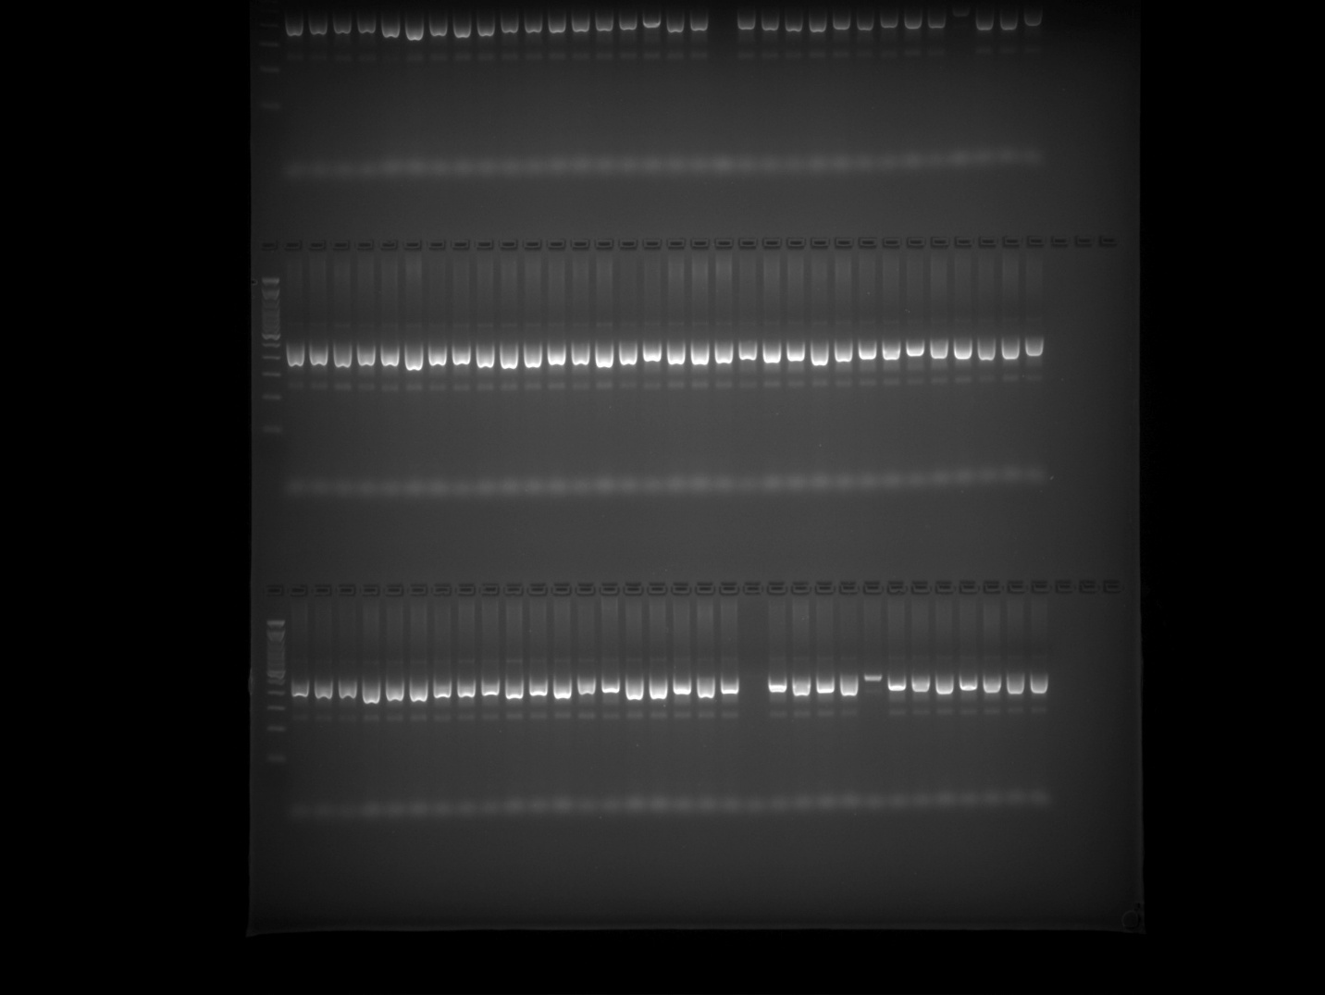

CaNB-5170 Plate 3 Part 1
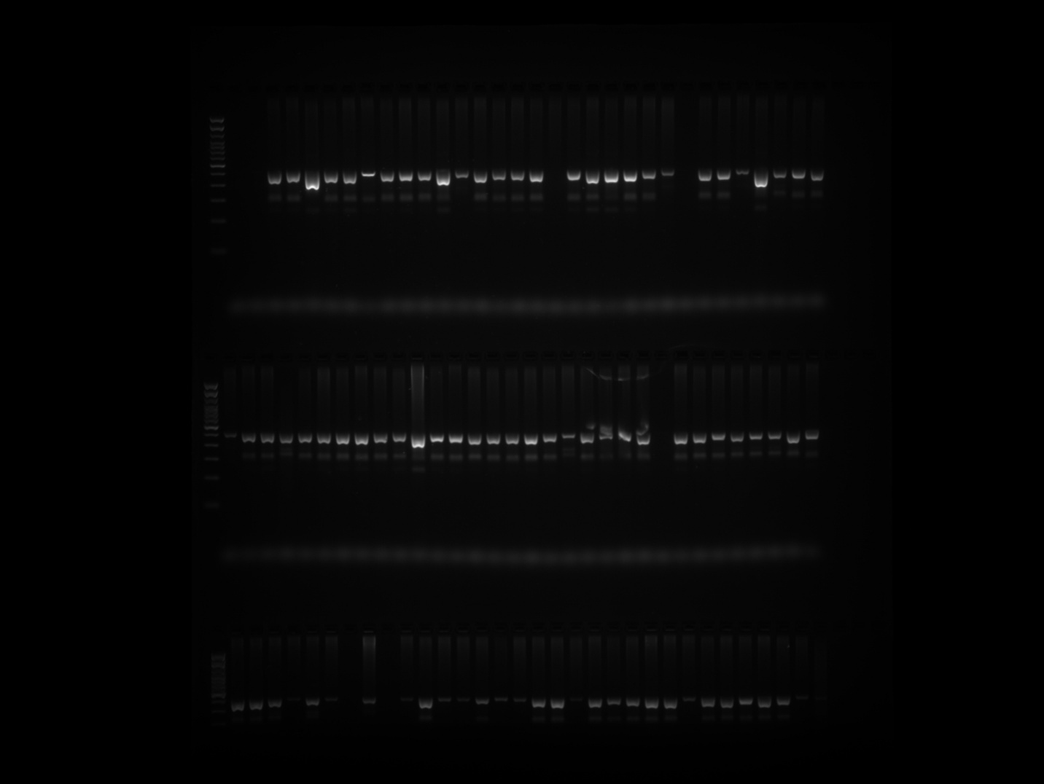

CaNB-5170 Plate 3 Part 2
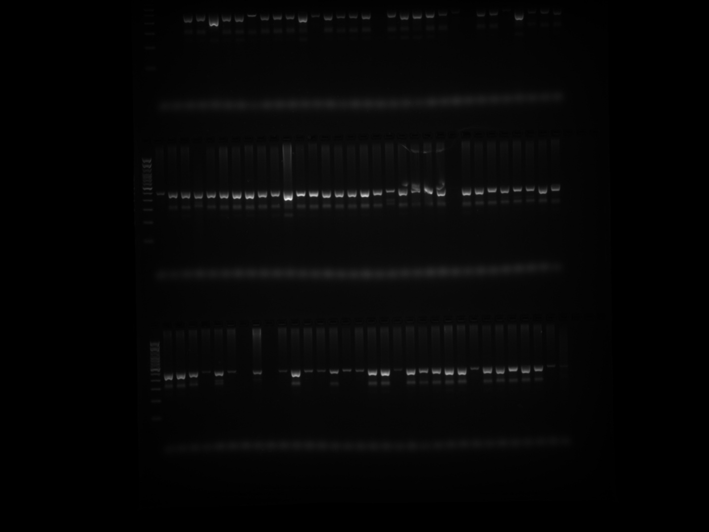

CaNB-5170 Plate 4
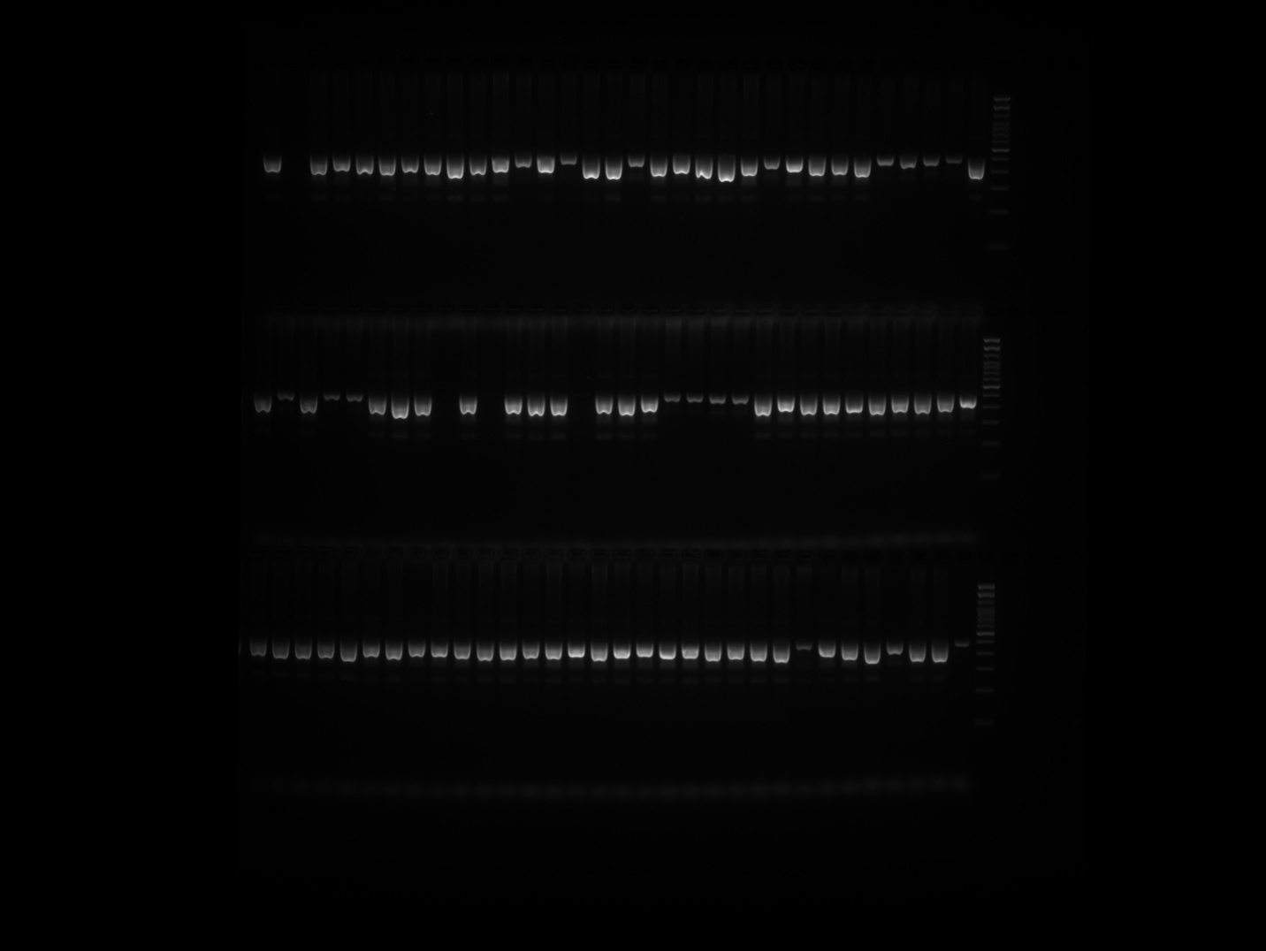

CaNB-5170 Plate 5
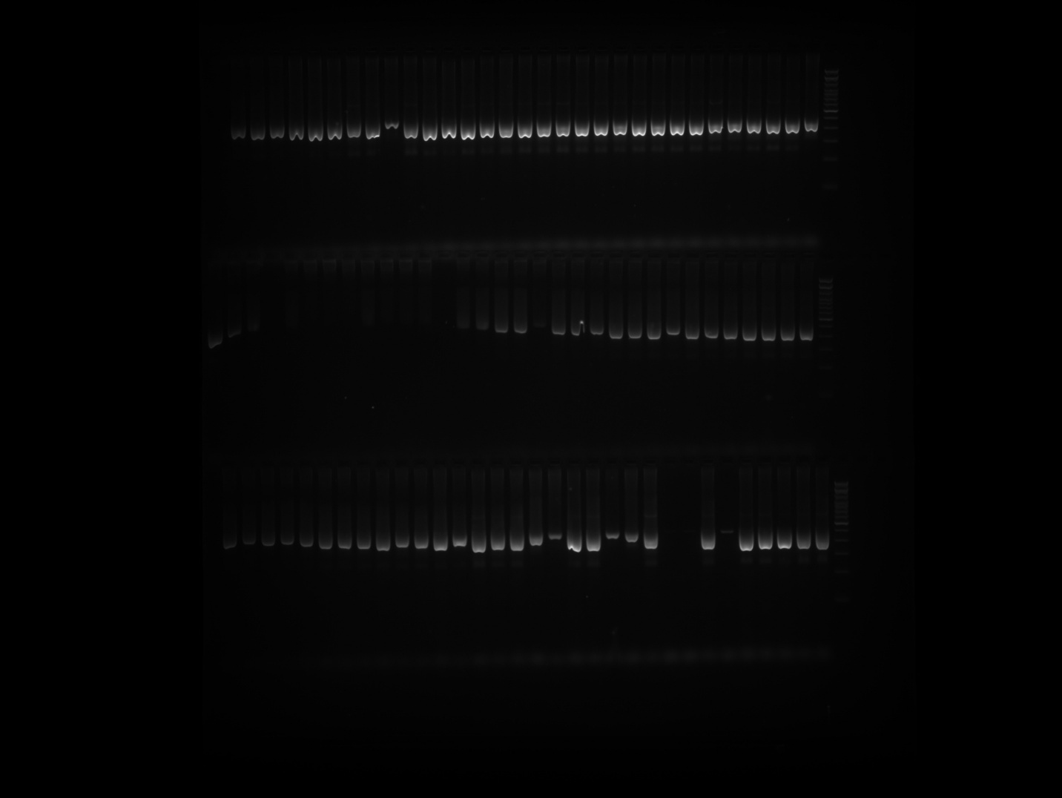

EPMS 331 Plate 1 Part 1
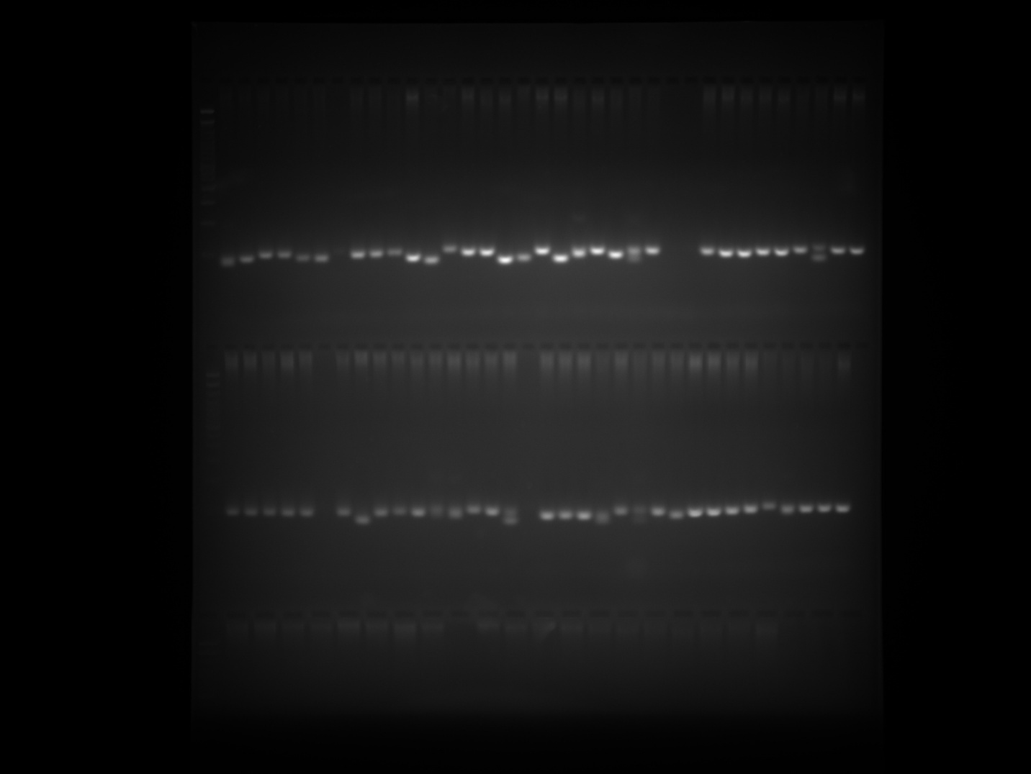

EPMS 331 Plate 1 Part 2
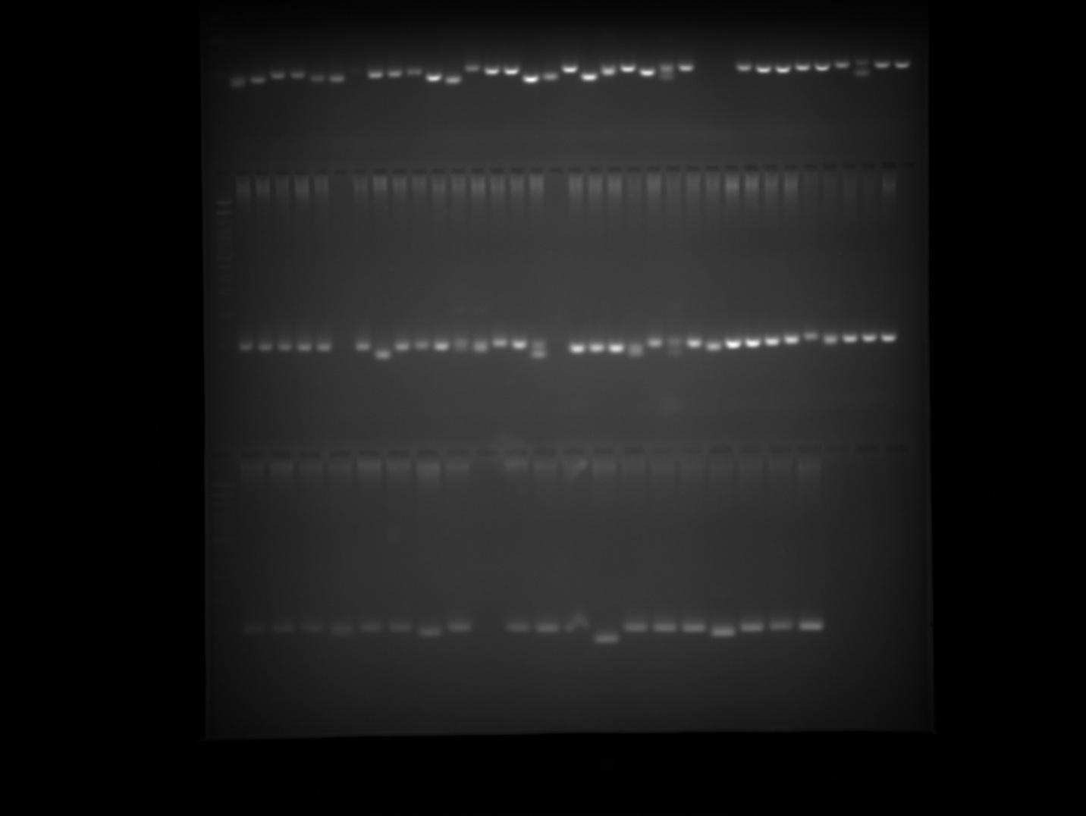

EPMS 331 Plate 2 Part 1
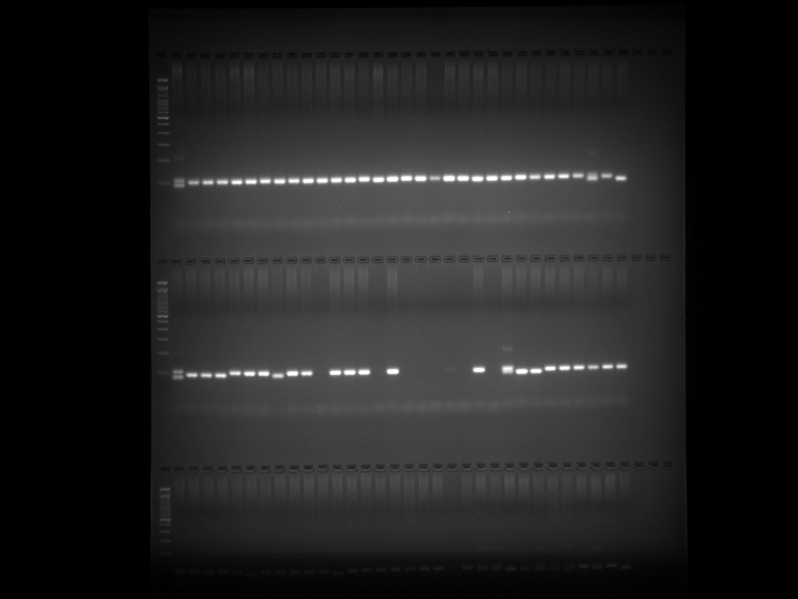

EPMS 331 Plate 2 Part 2
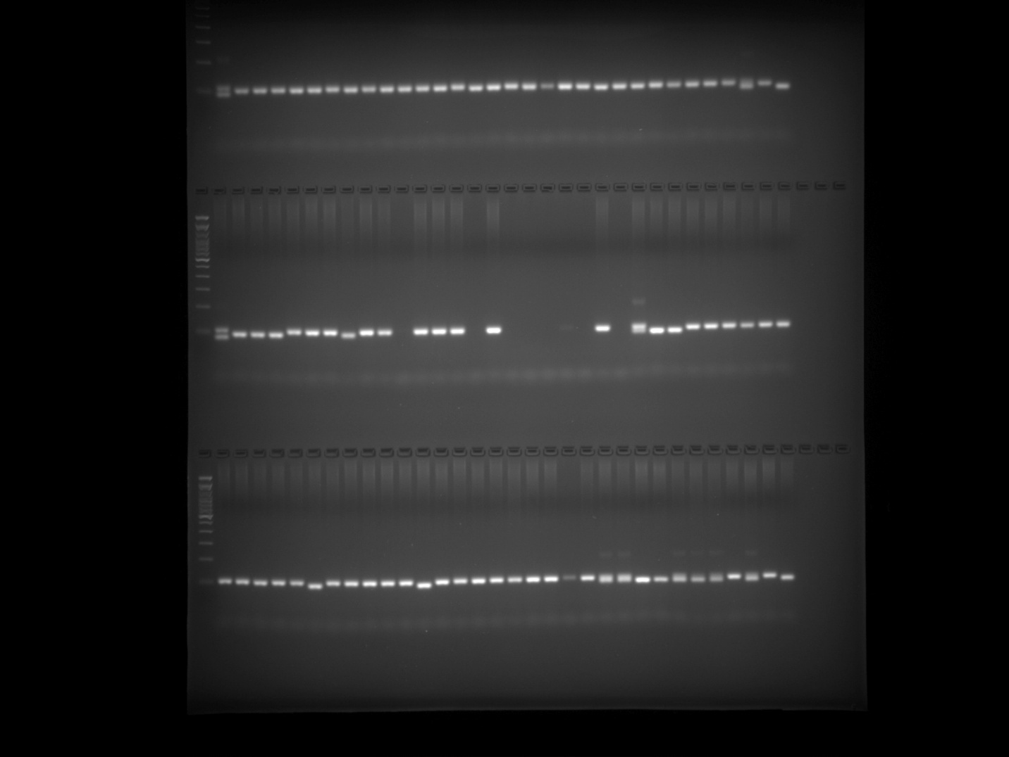

EPMS 331 Plate 3 Part 1
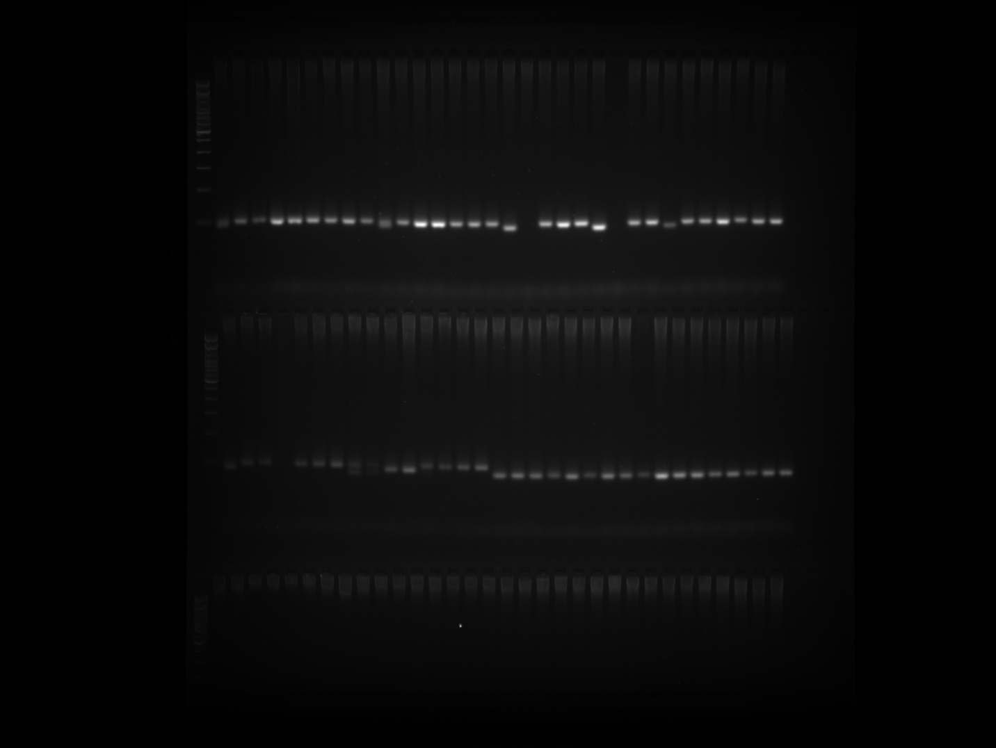

EPMS 331 Plate 3 Part 2
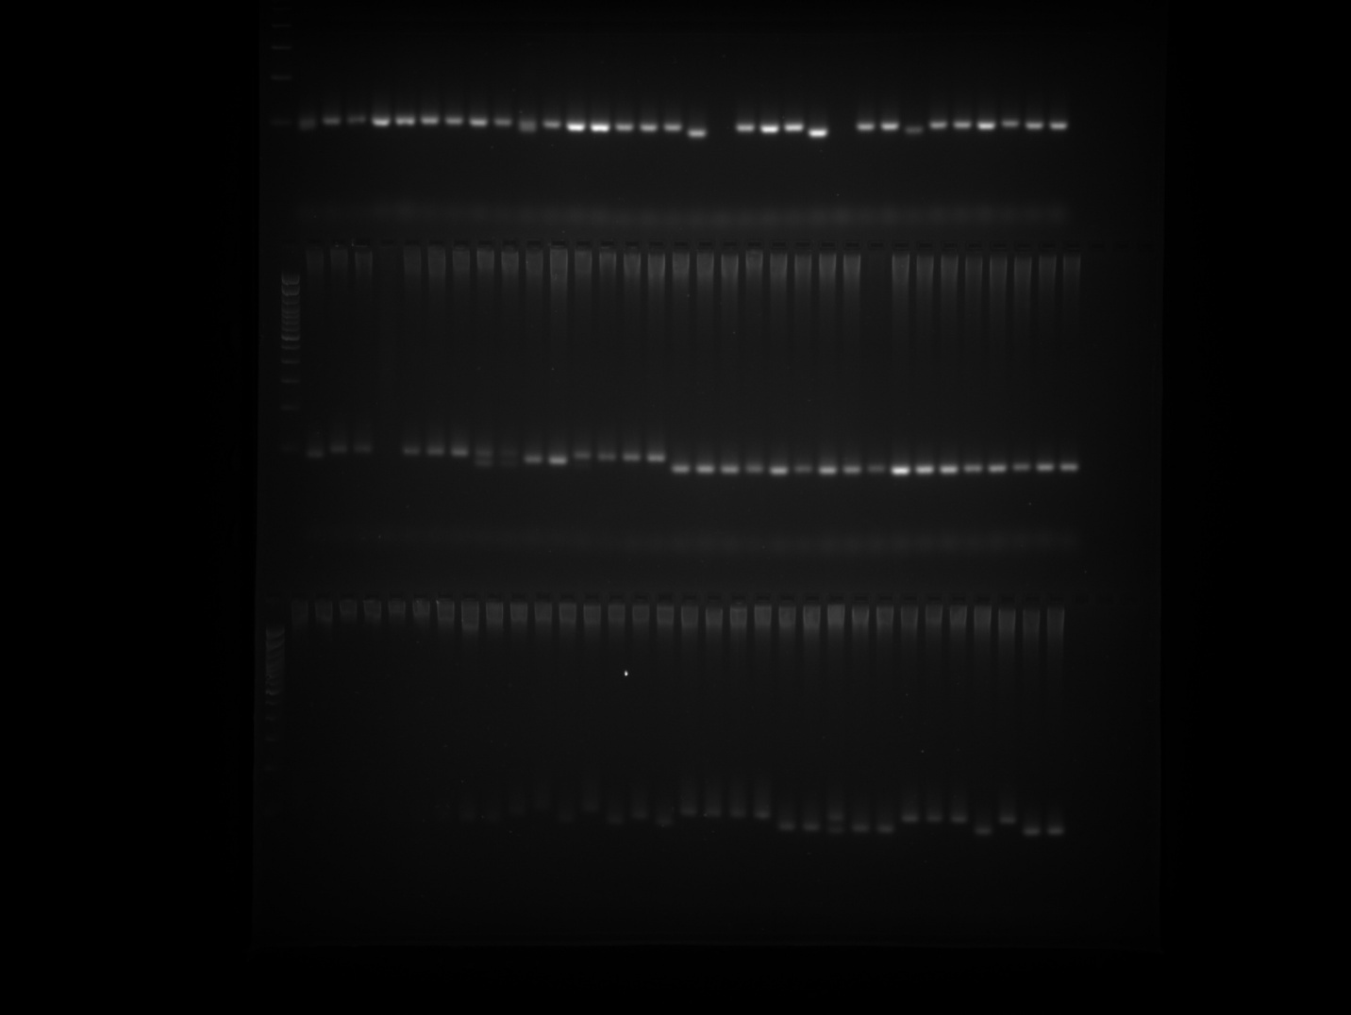

EPMS 331 Plate 4
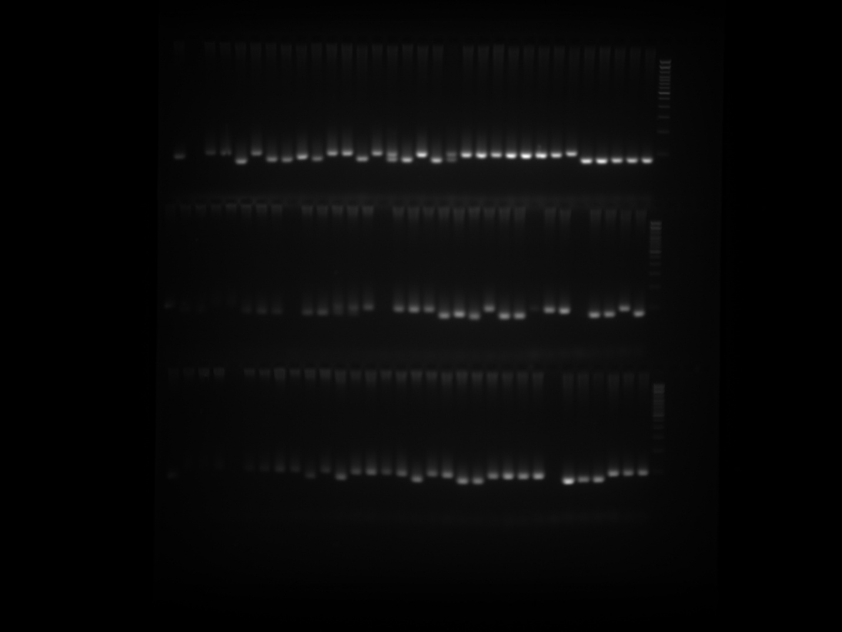

EPMS 331 Plate 5
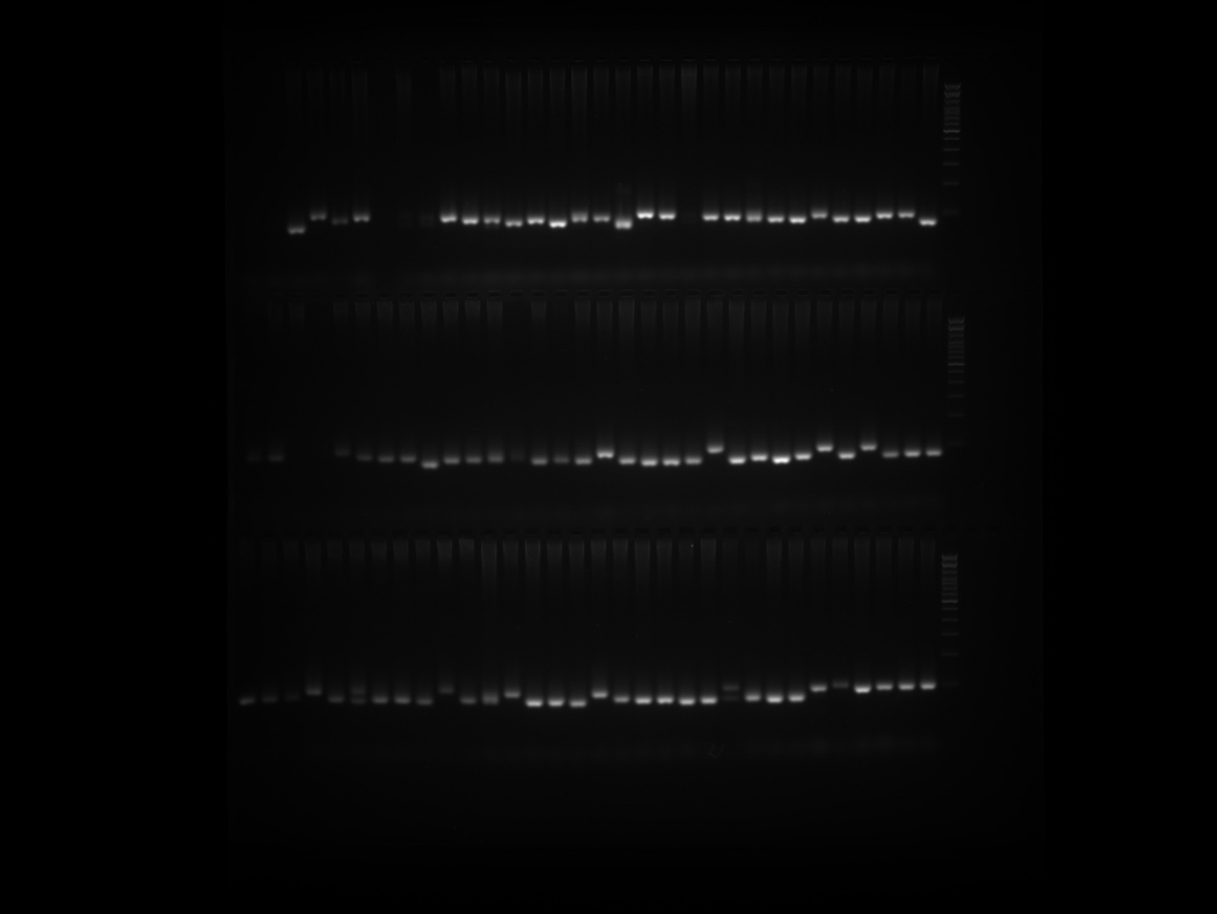

EPMS 342 Plate 1 Part 1
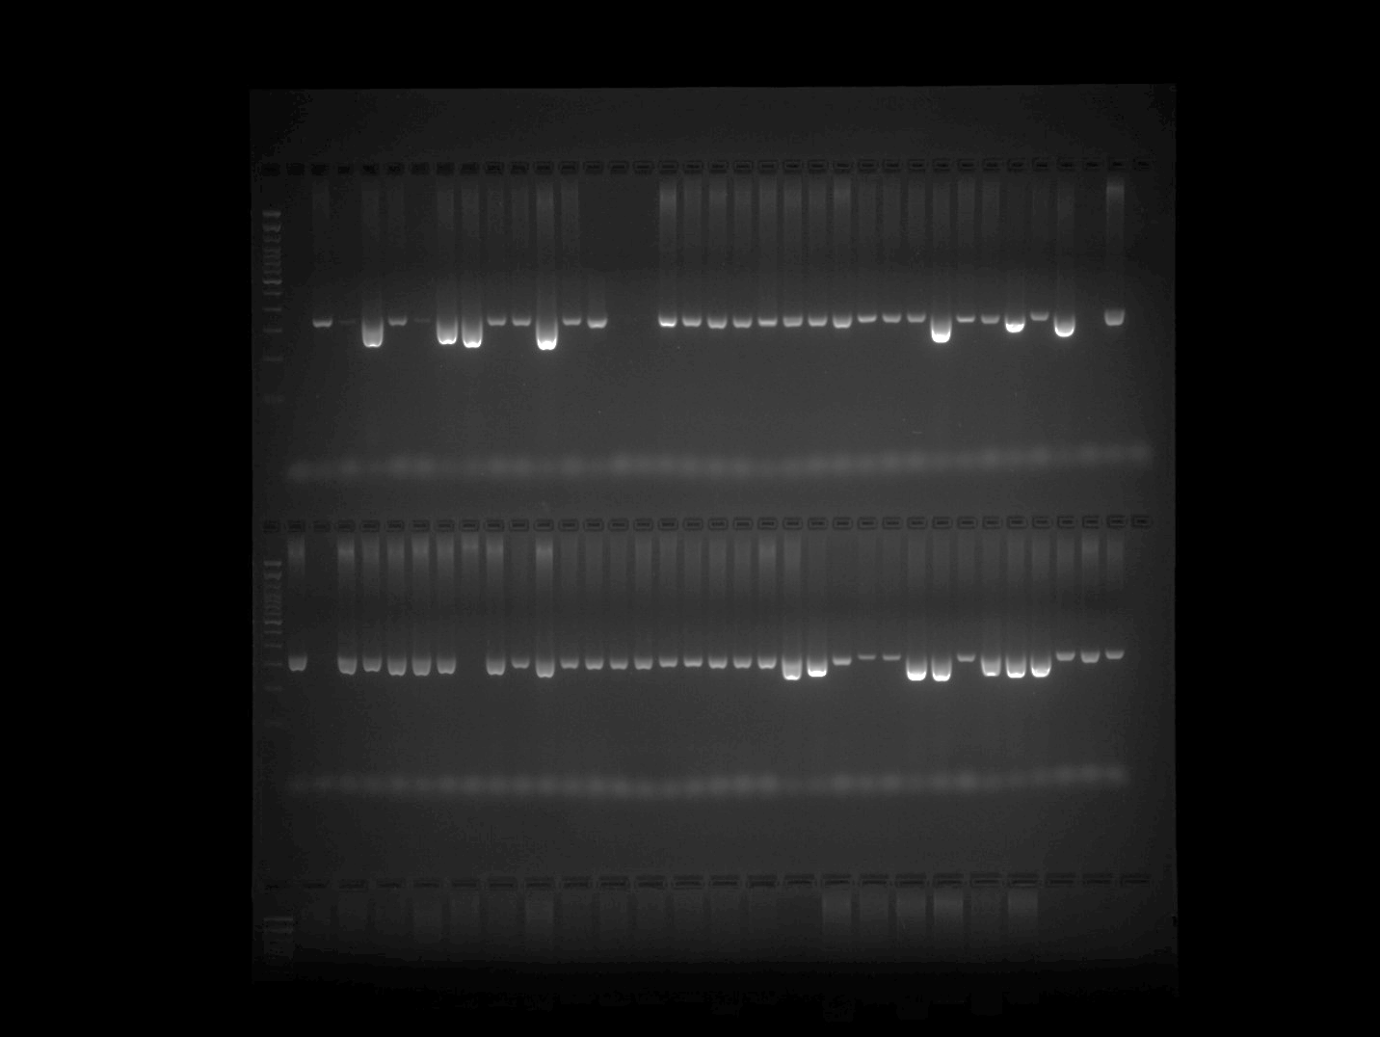

EPMS 342 Plate 1 Part 2
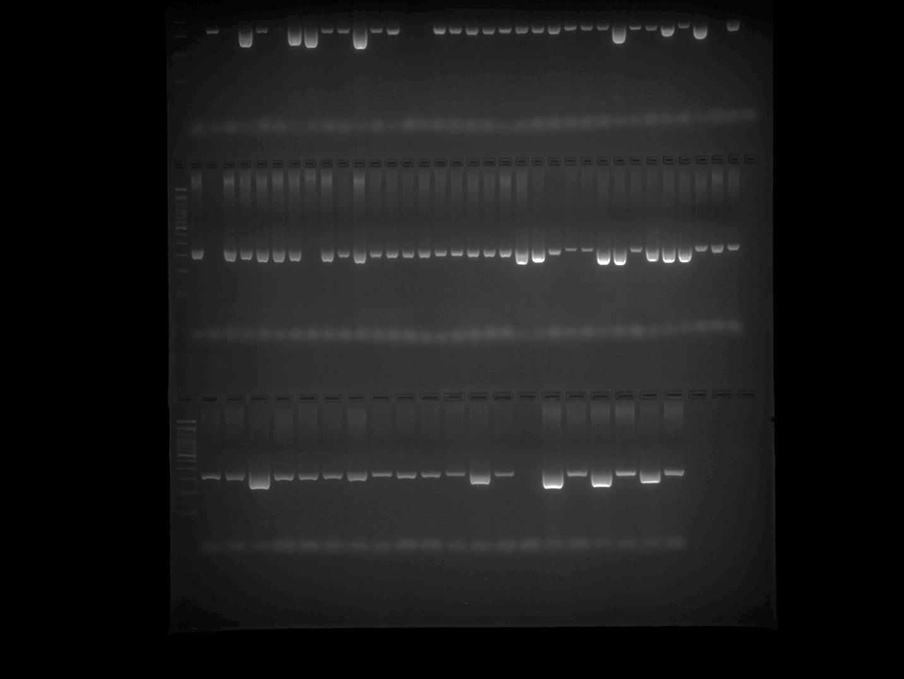

EPMS 342 Plate 2
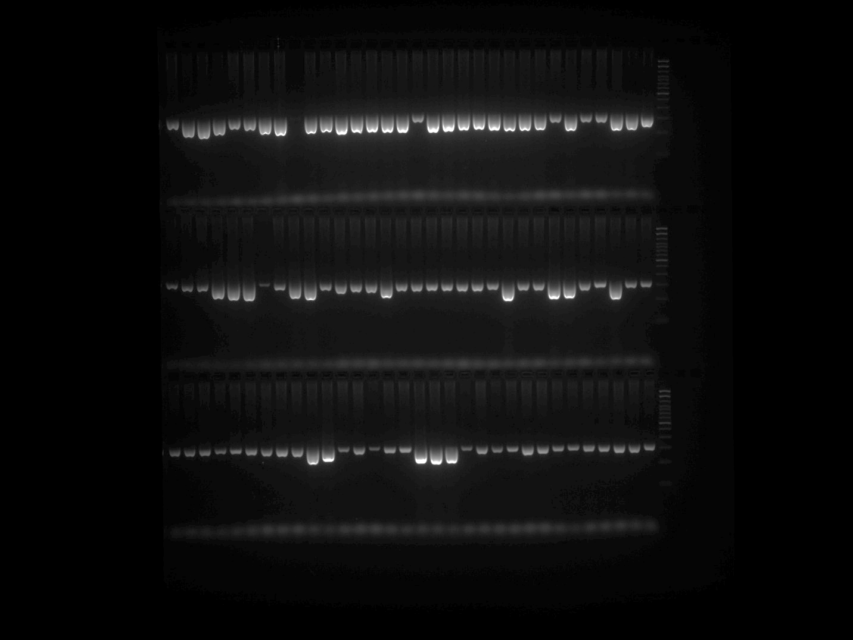

EPMS 342 Plate 3 Part 1
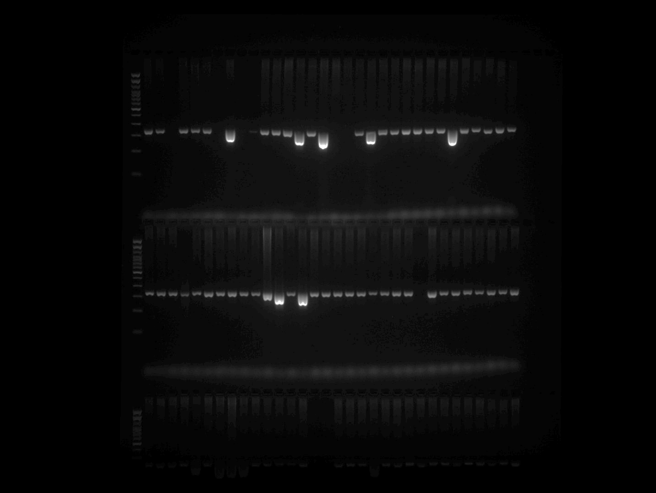

EPMS 342 Plate 3 Part 2
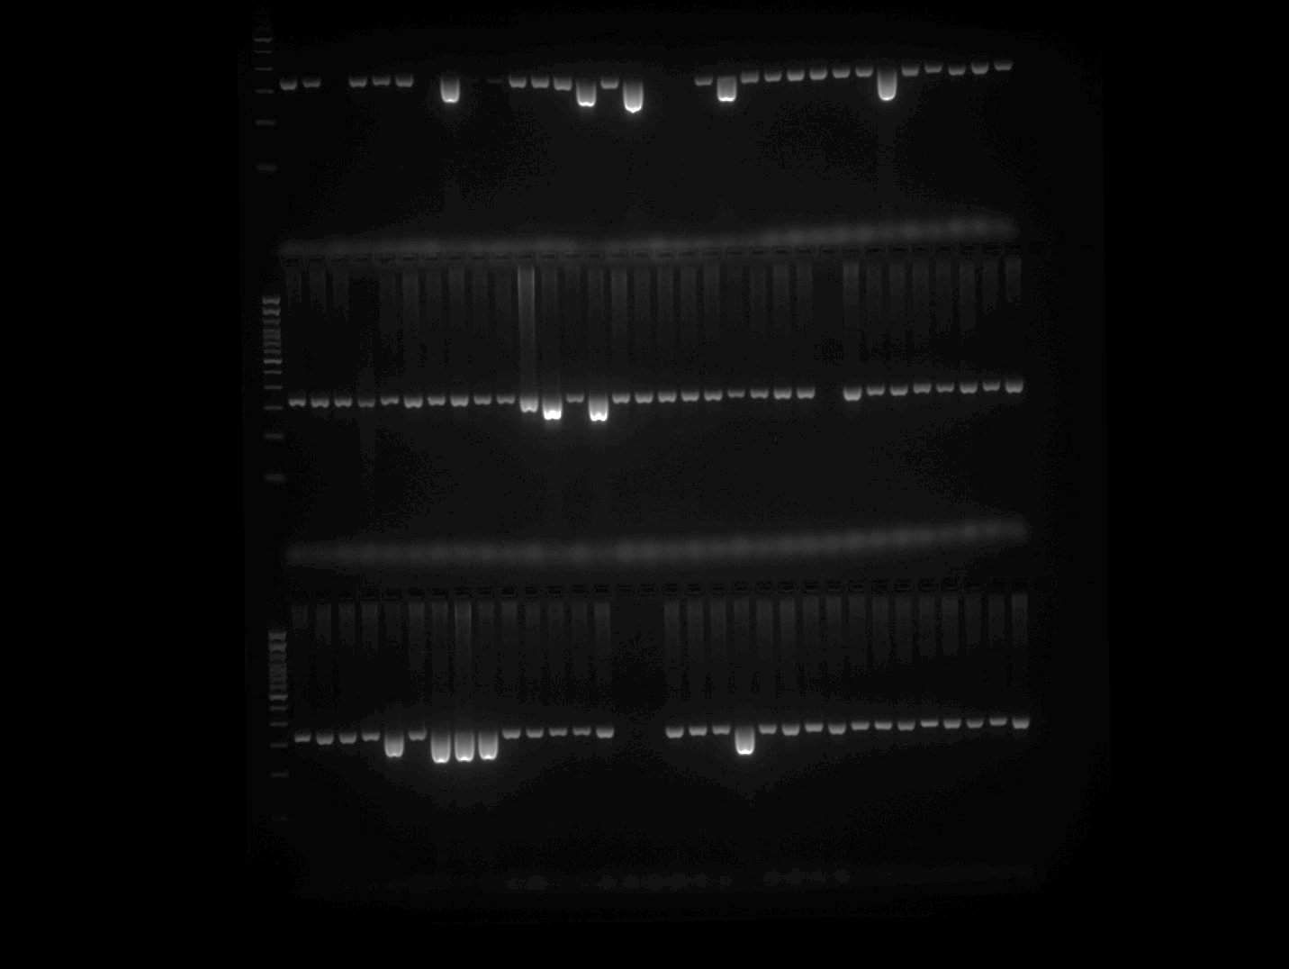

EPMS 342 Plate 4
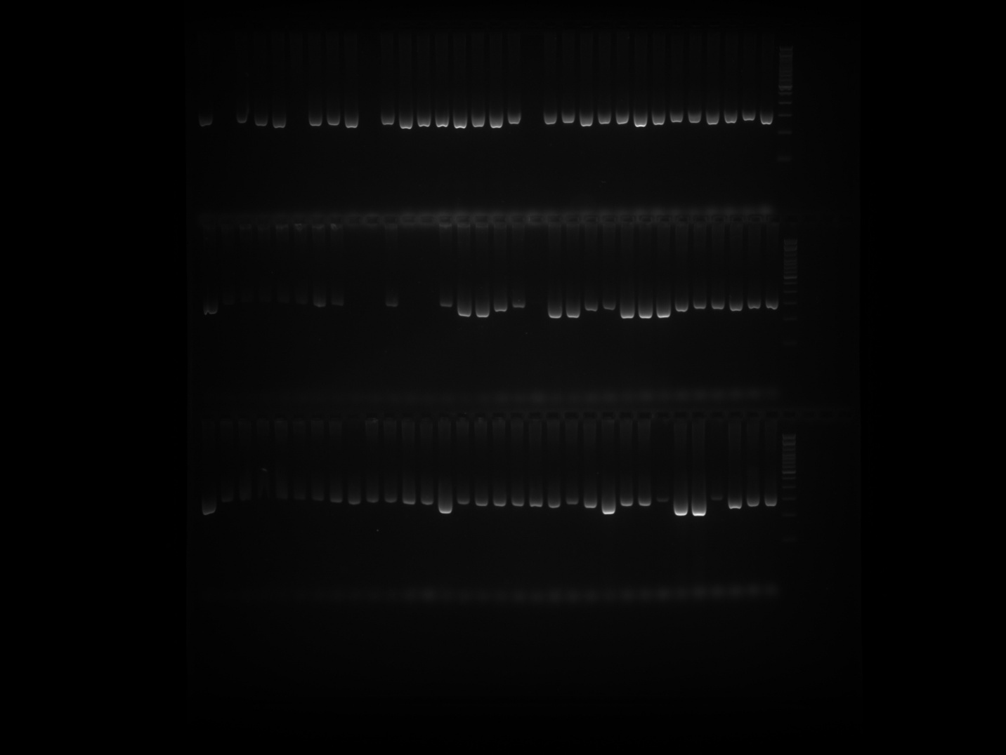

EPMS 342 Plate 5
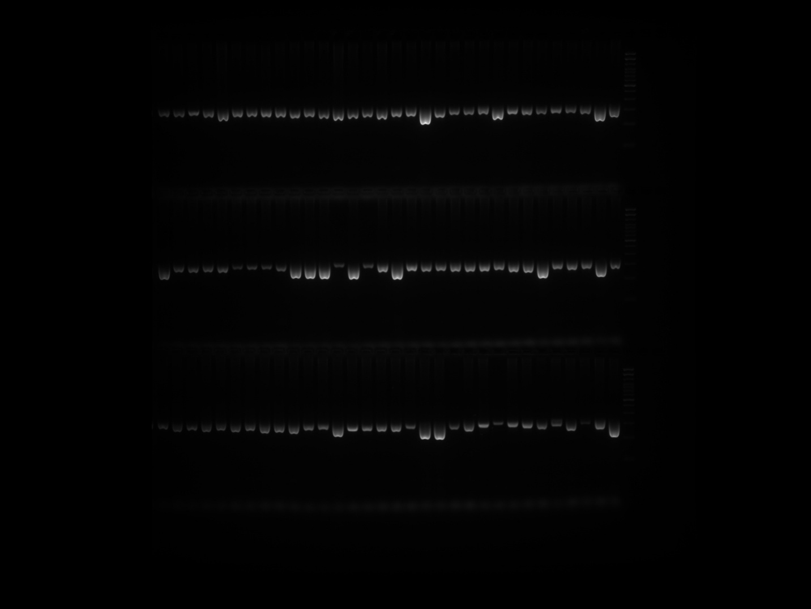

EPMS 376 Plate 1 Part 1
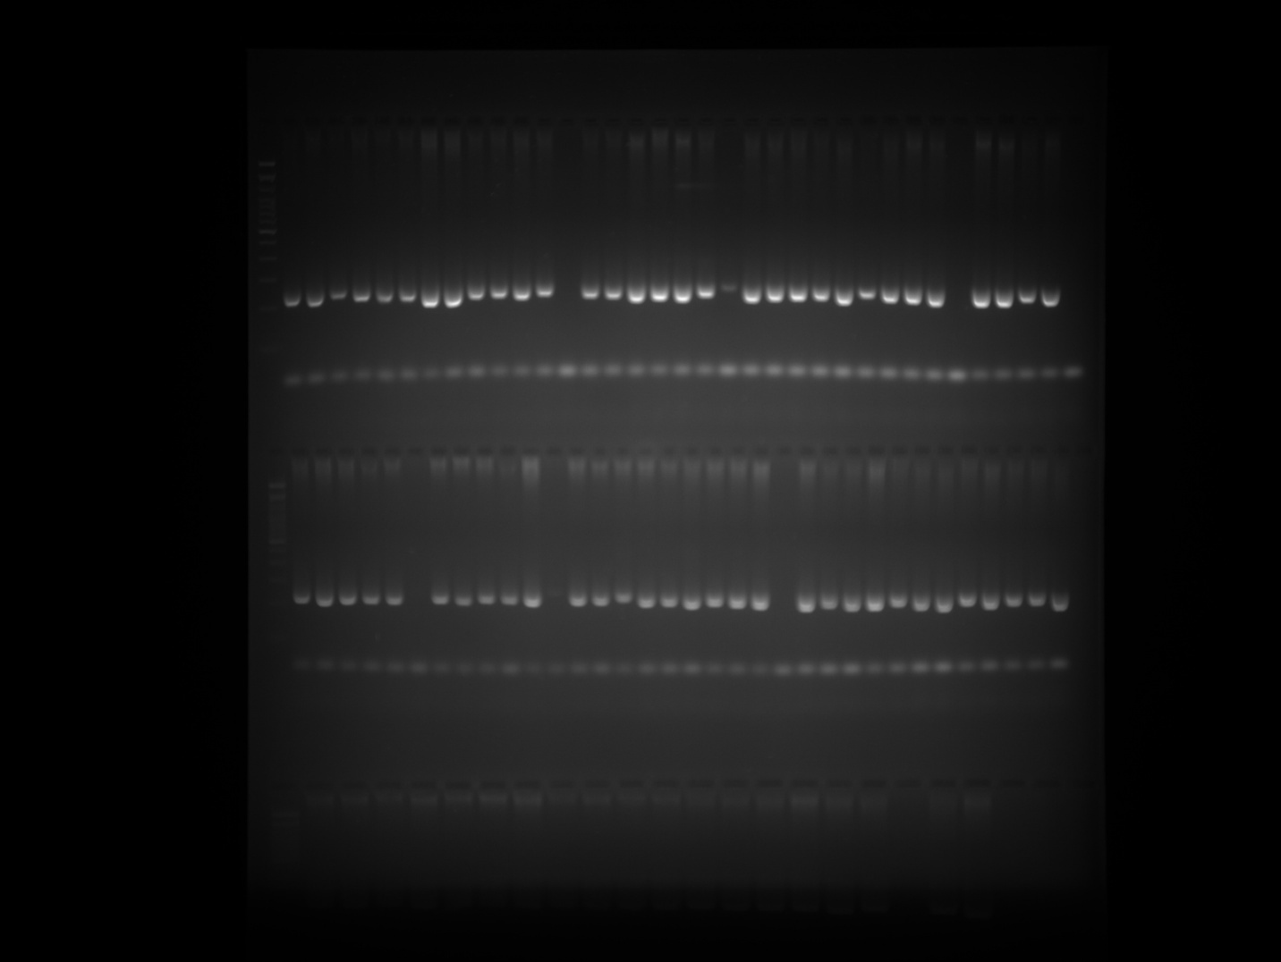

EPMS 376 Plate 1 Part 2
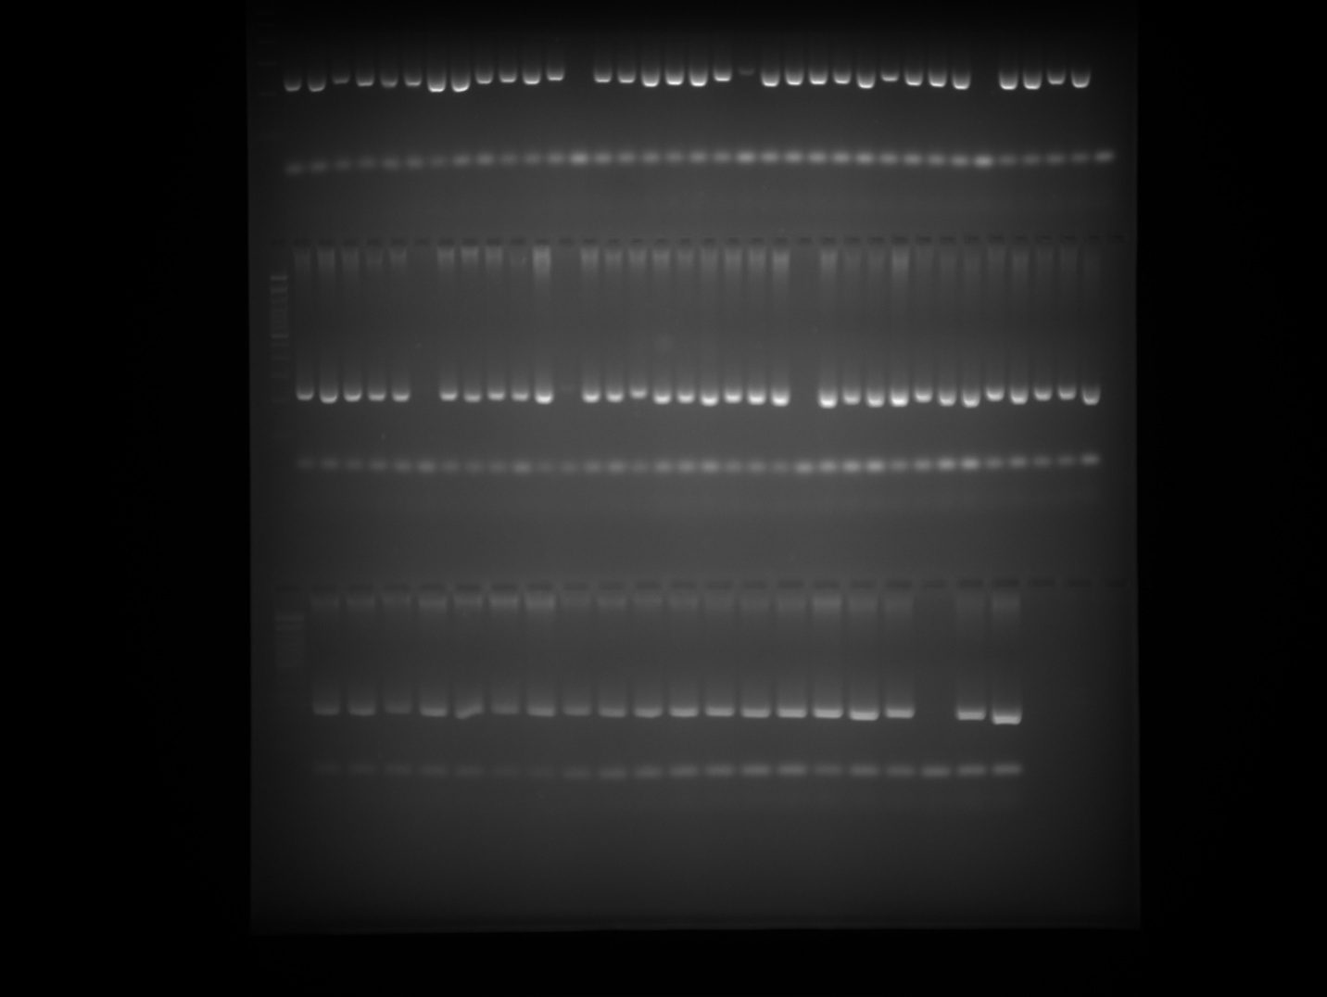

EPMS 376 Plate 2 Part 1
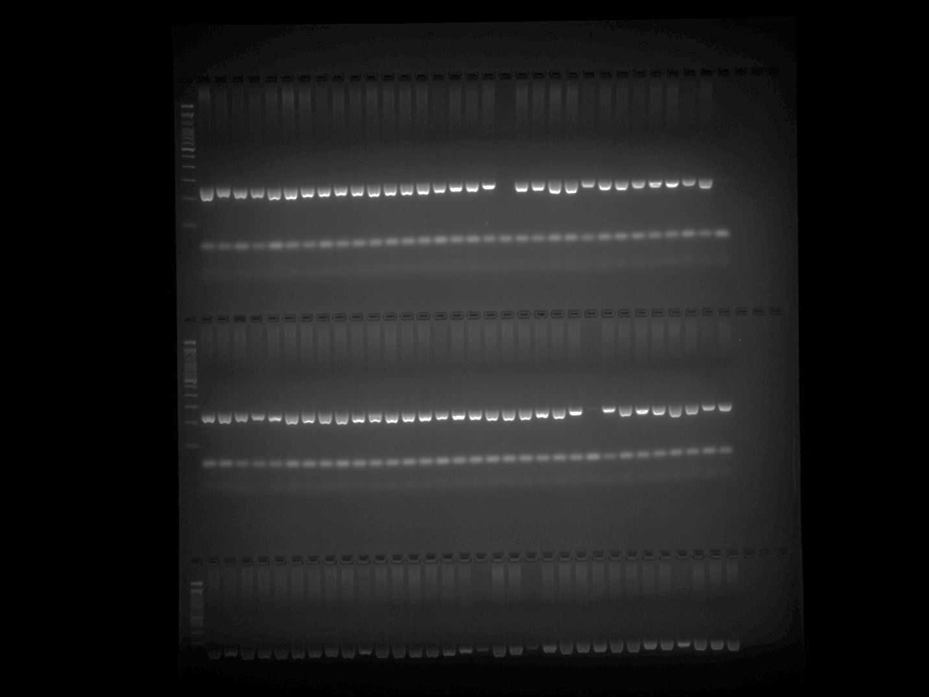

EPMS 376 Plate 2 Part 2
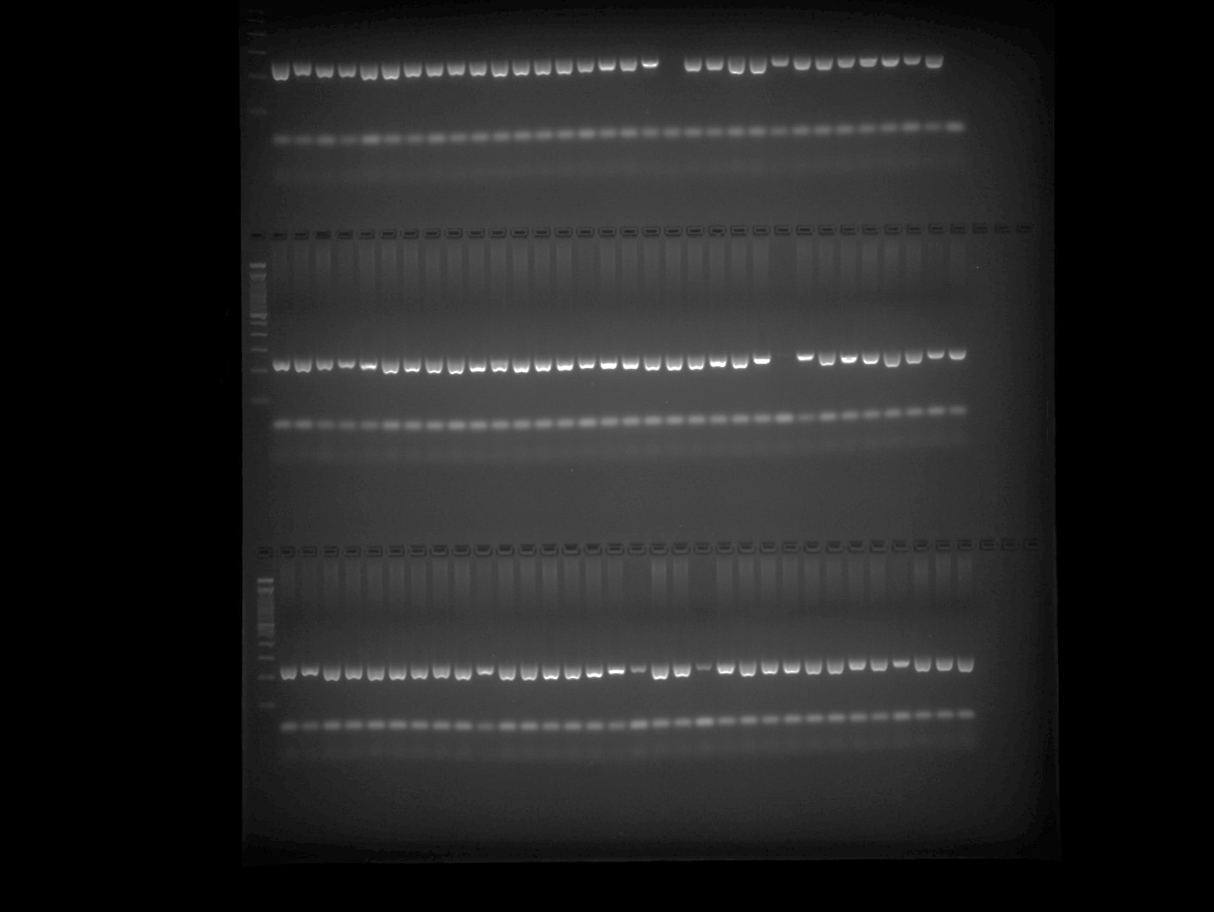

EPMS 376 Plate 3 Part 1
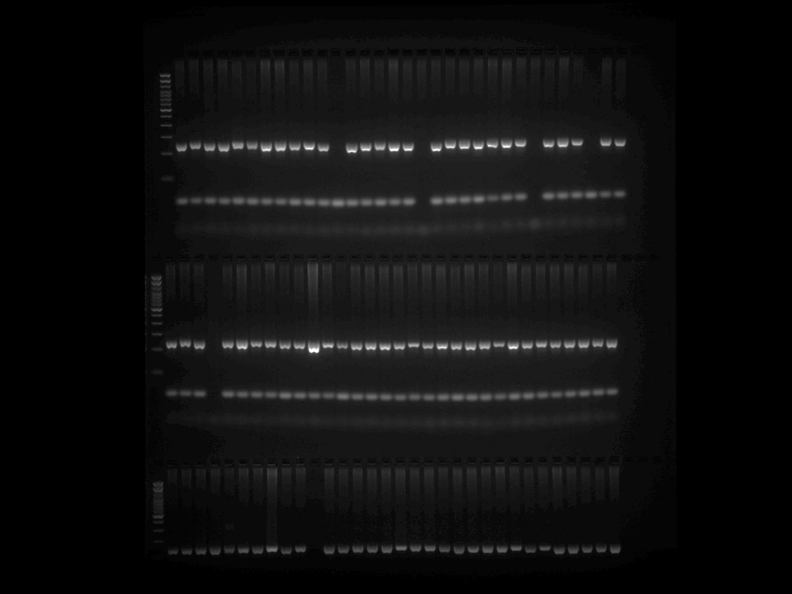

EPMS 376 Plate 3 Part 2
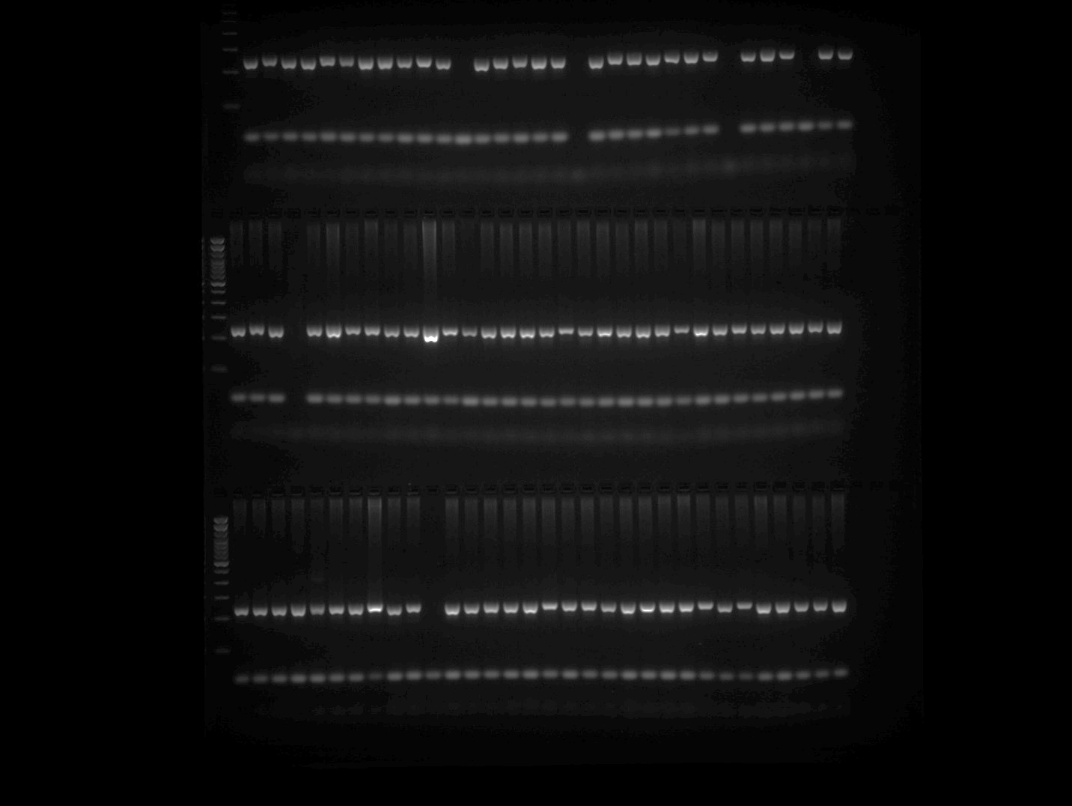

EPMS 376 Plate 4
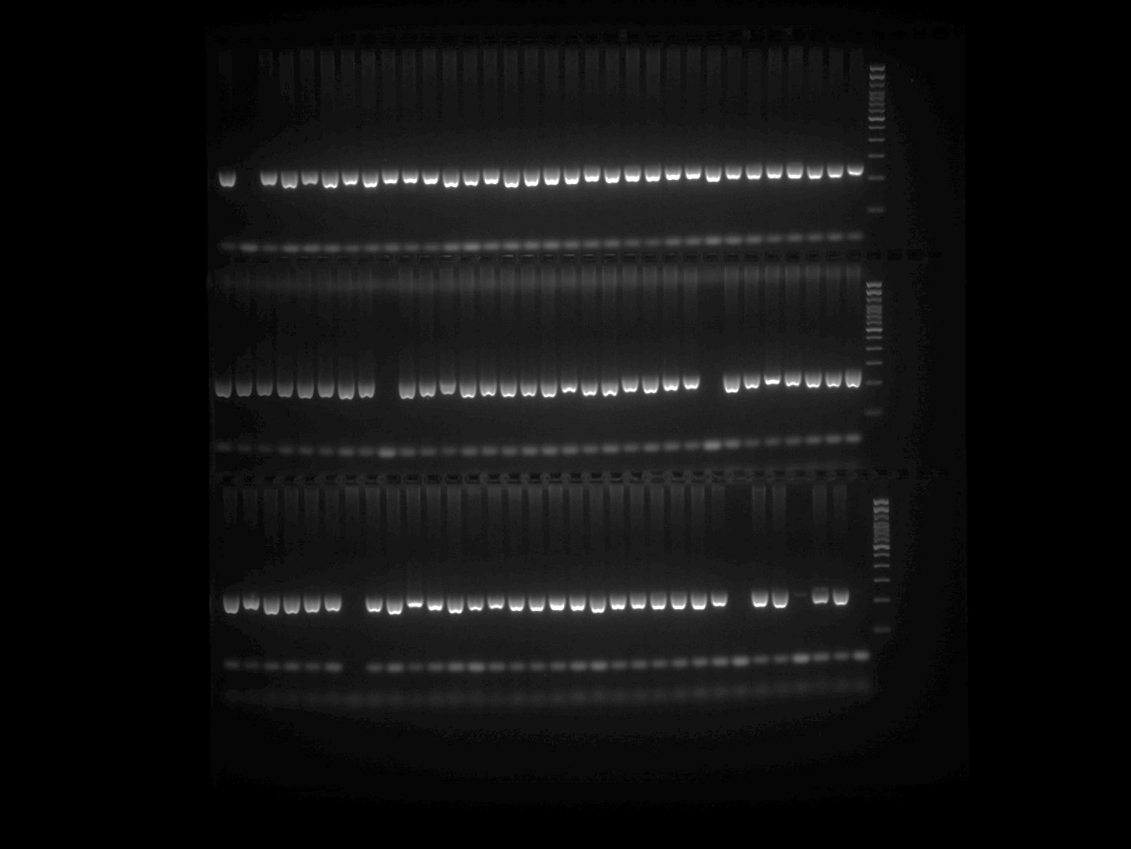

EPMS 376 Plate 5
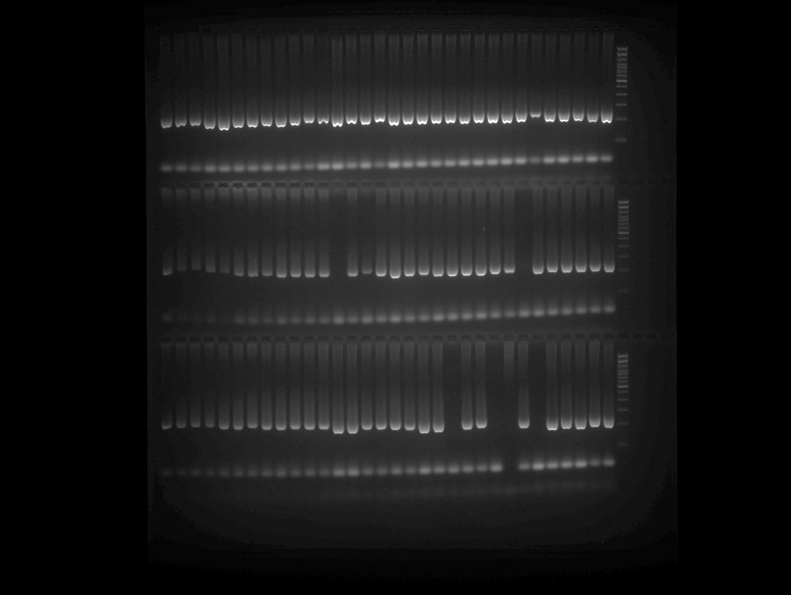

EPMS 418 Plate 1 Part 1
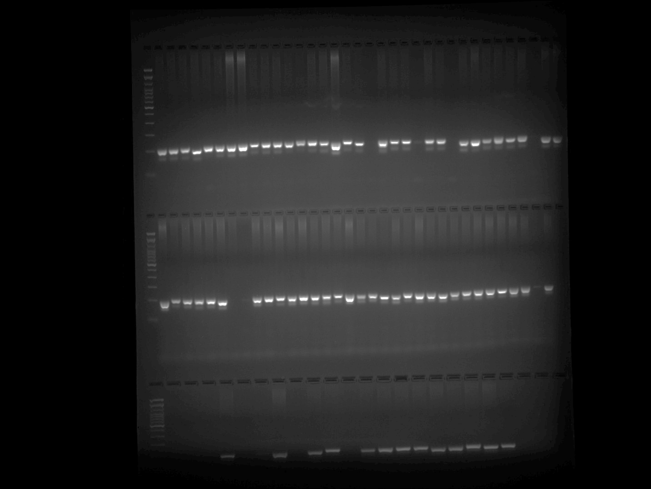

EPMS 418 Plate 1 Part 2
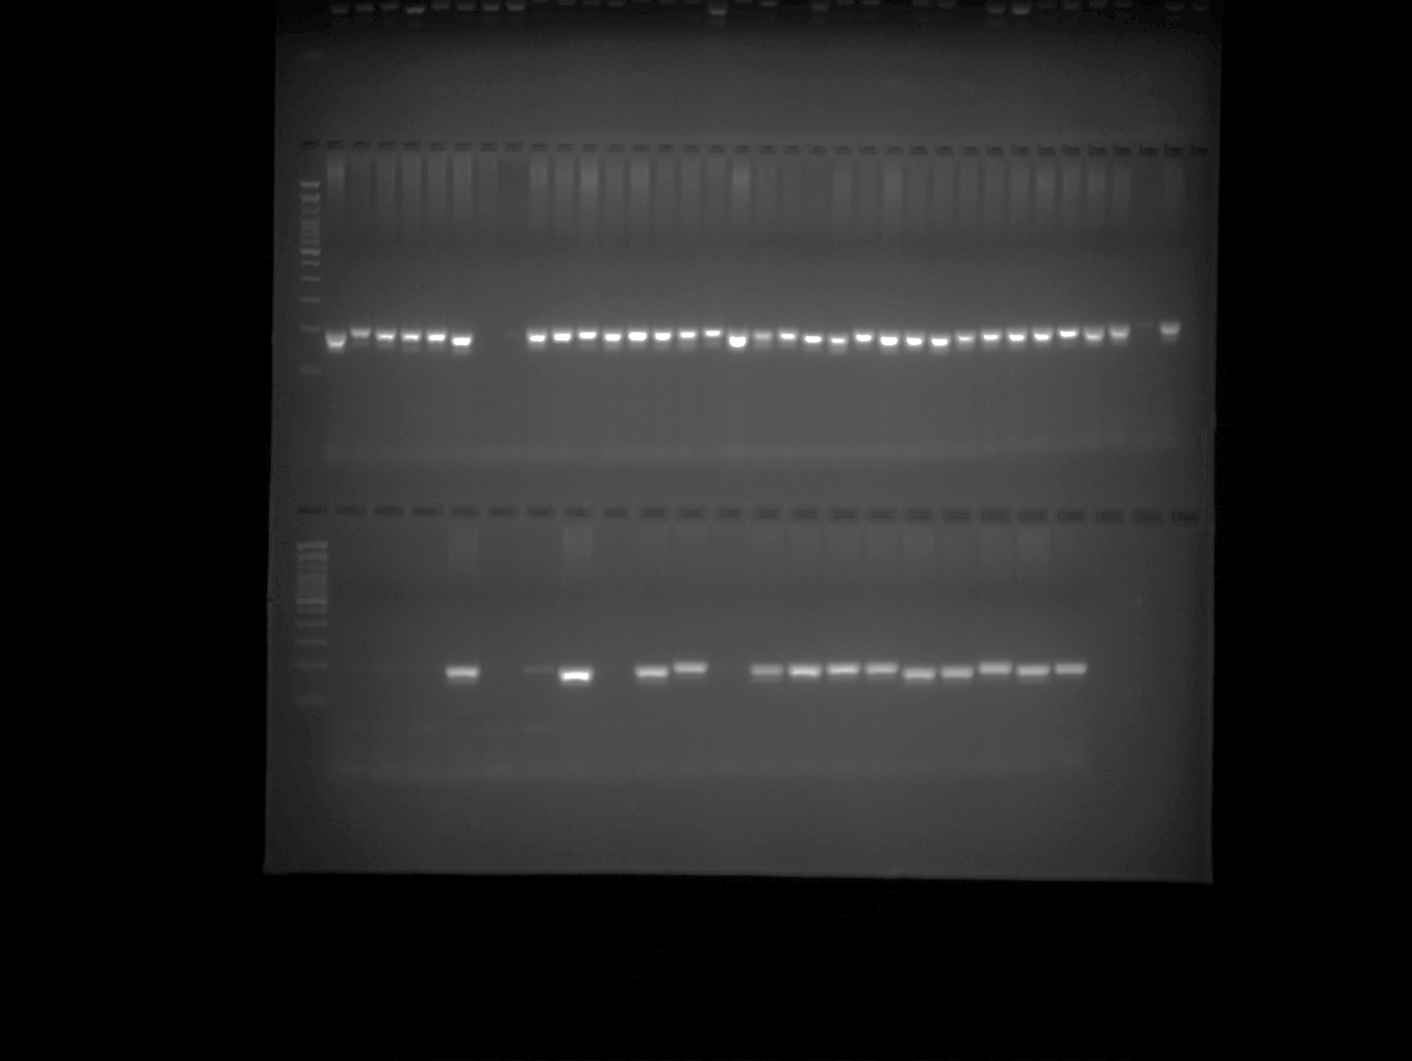

EPMS 418 Plate 2 Part 1
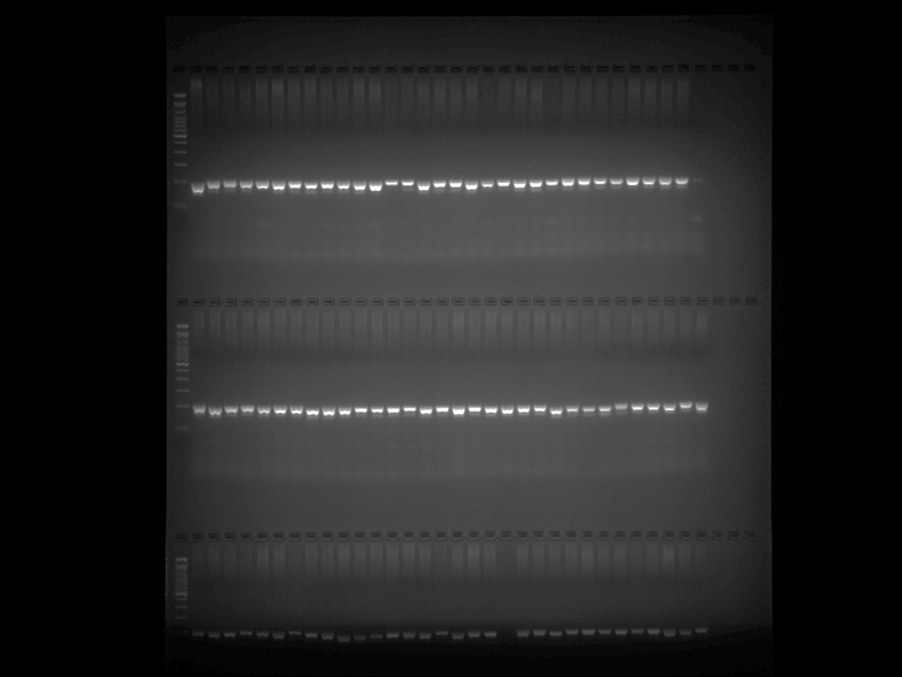

EPMS 418 Plate 2 Part 2
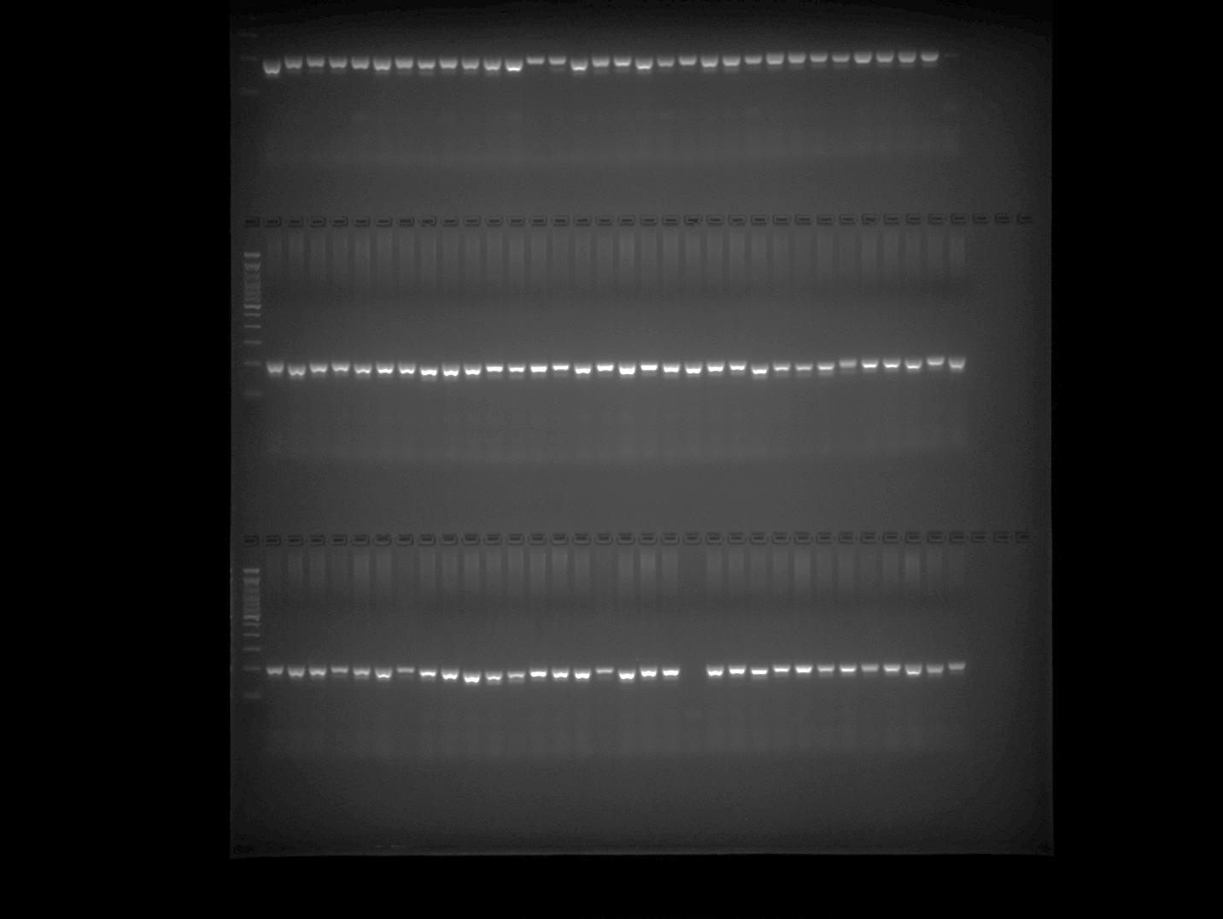

EPMS 418 Plate 3 Part 1
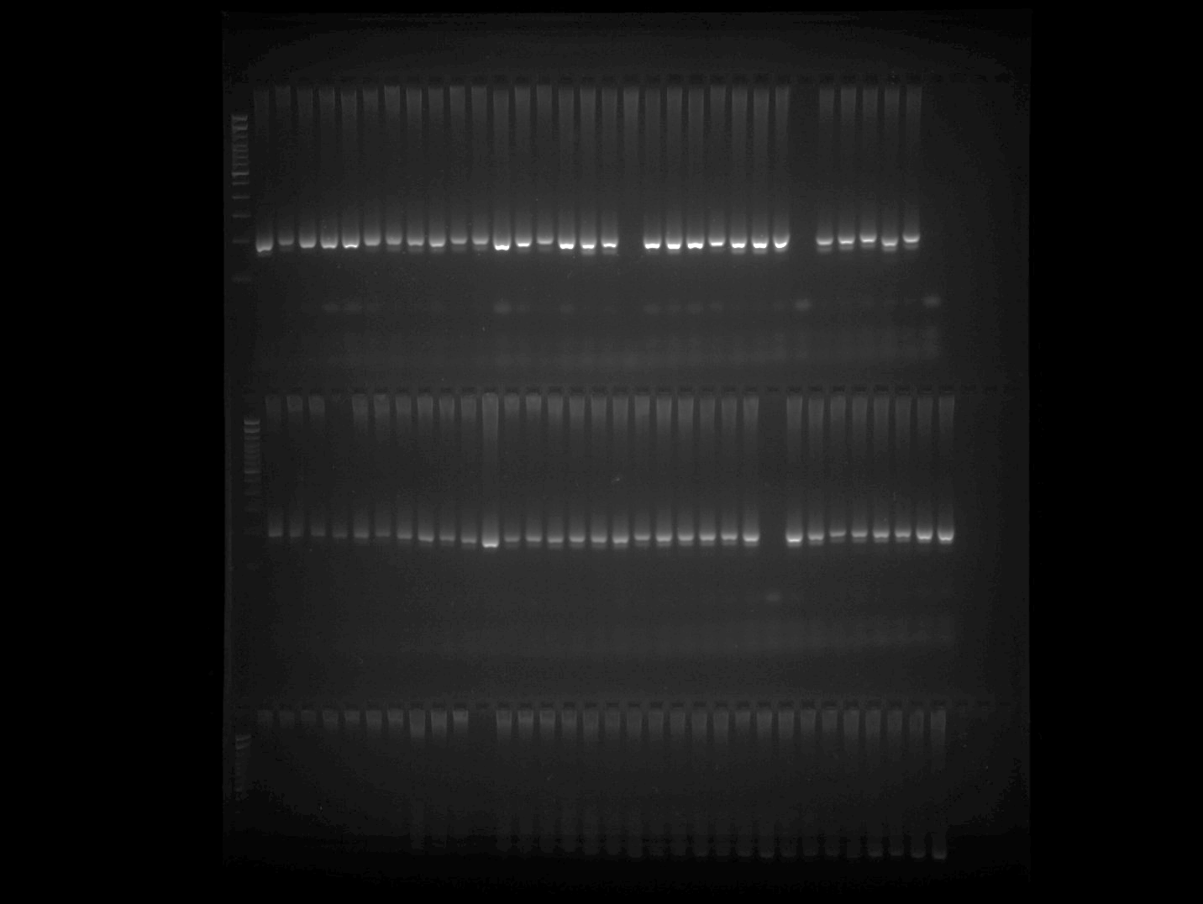

EPMS 418 Plate 3 Part 2
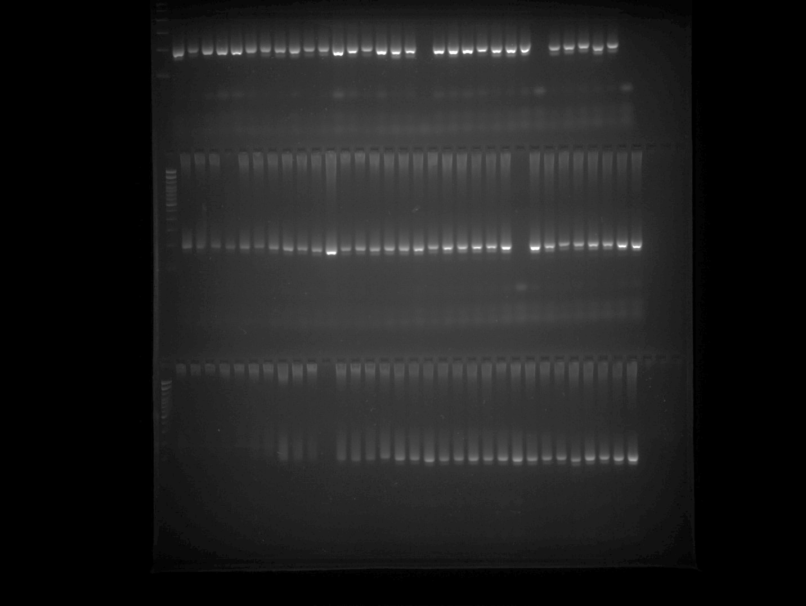

EPMS 418 Plate 4
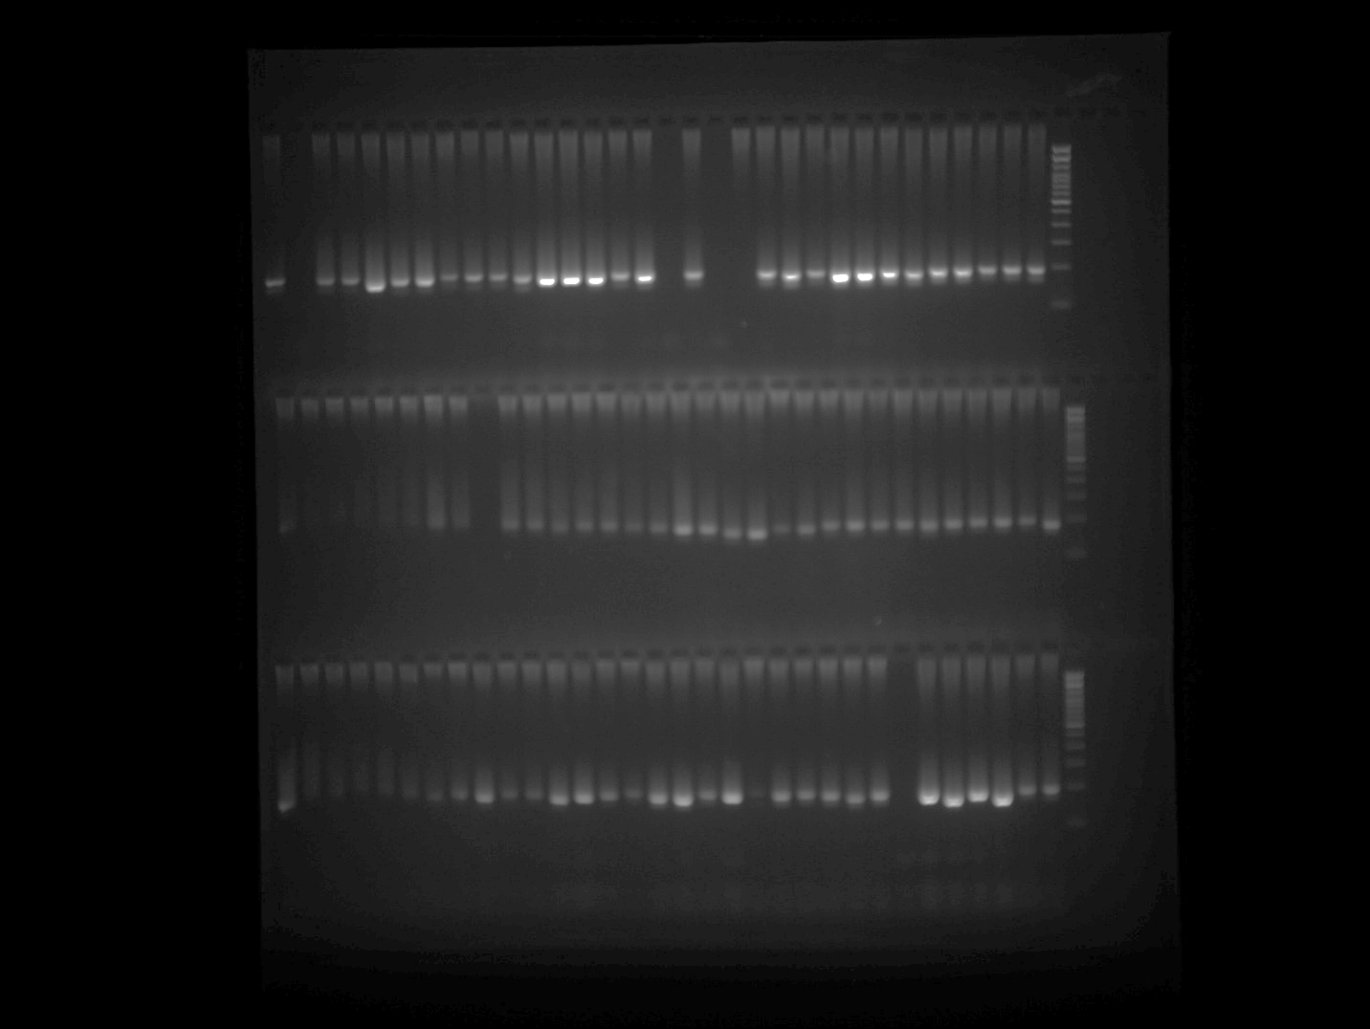

EPMS 418 Plate 5

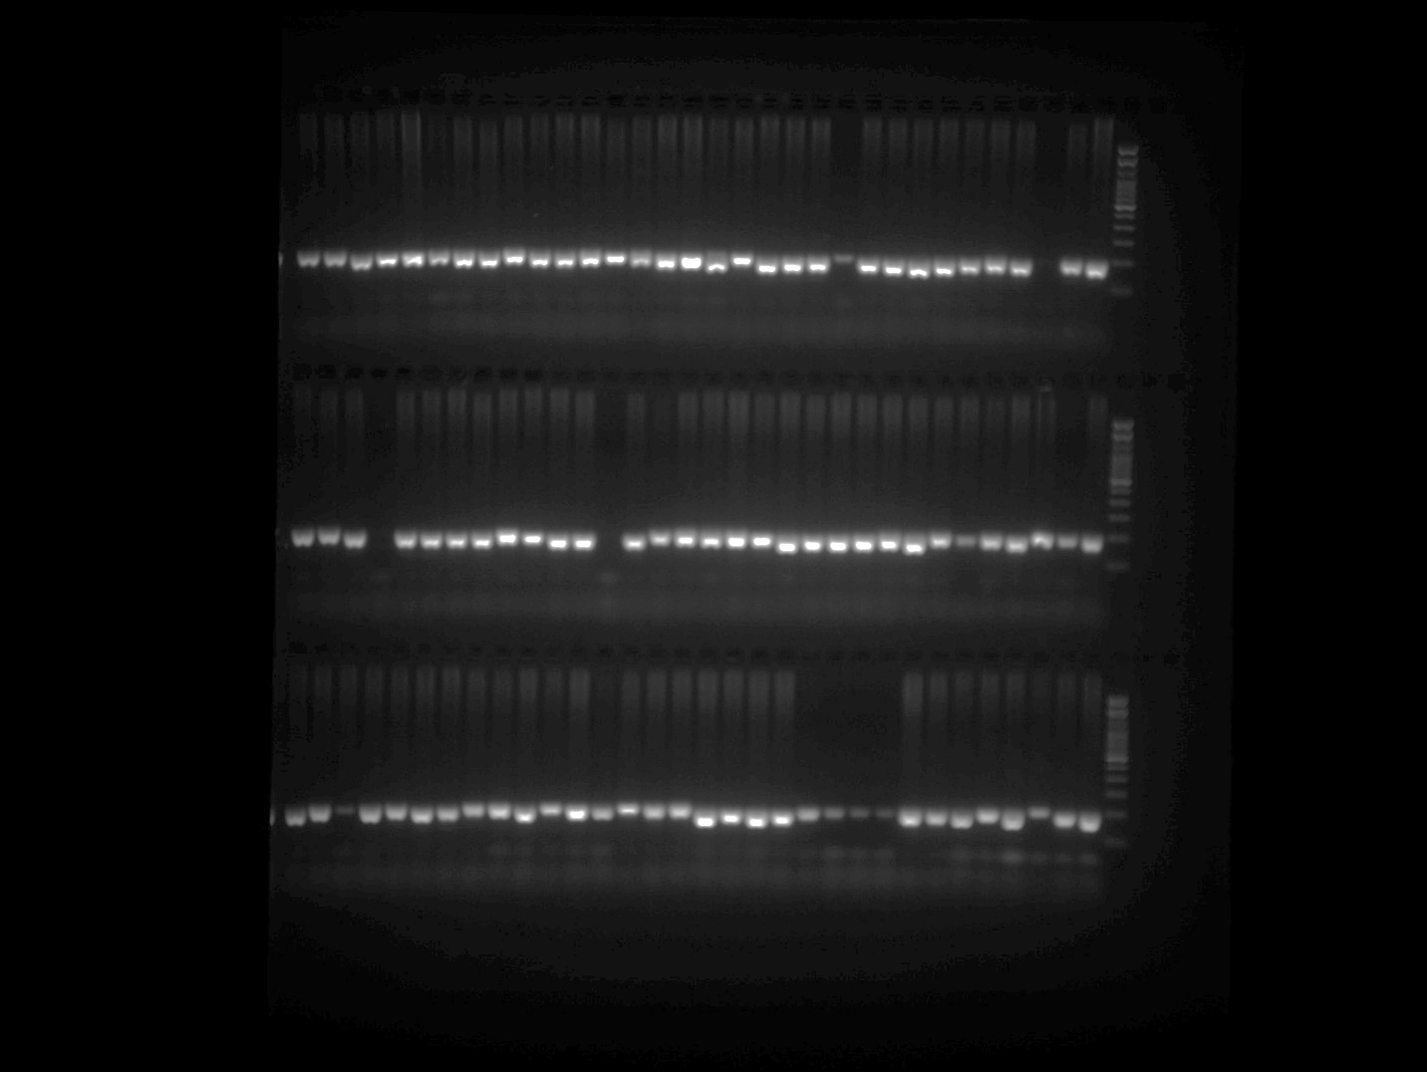

EPMS 480 Plate 1
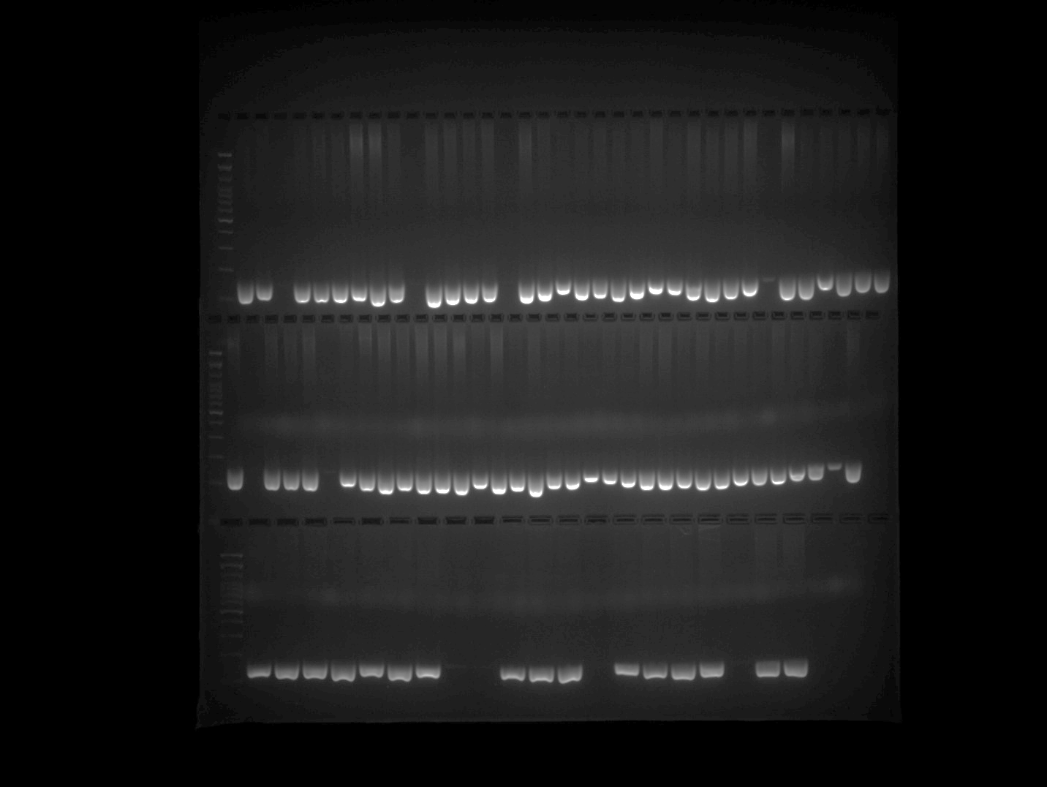

EPMS 480 Plate 2 Part 1
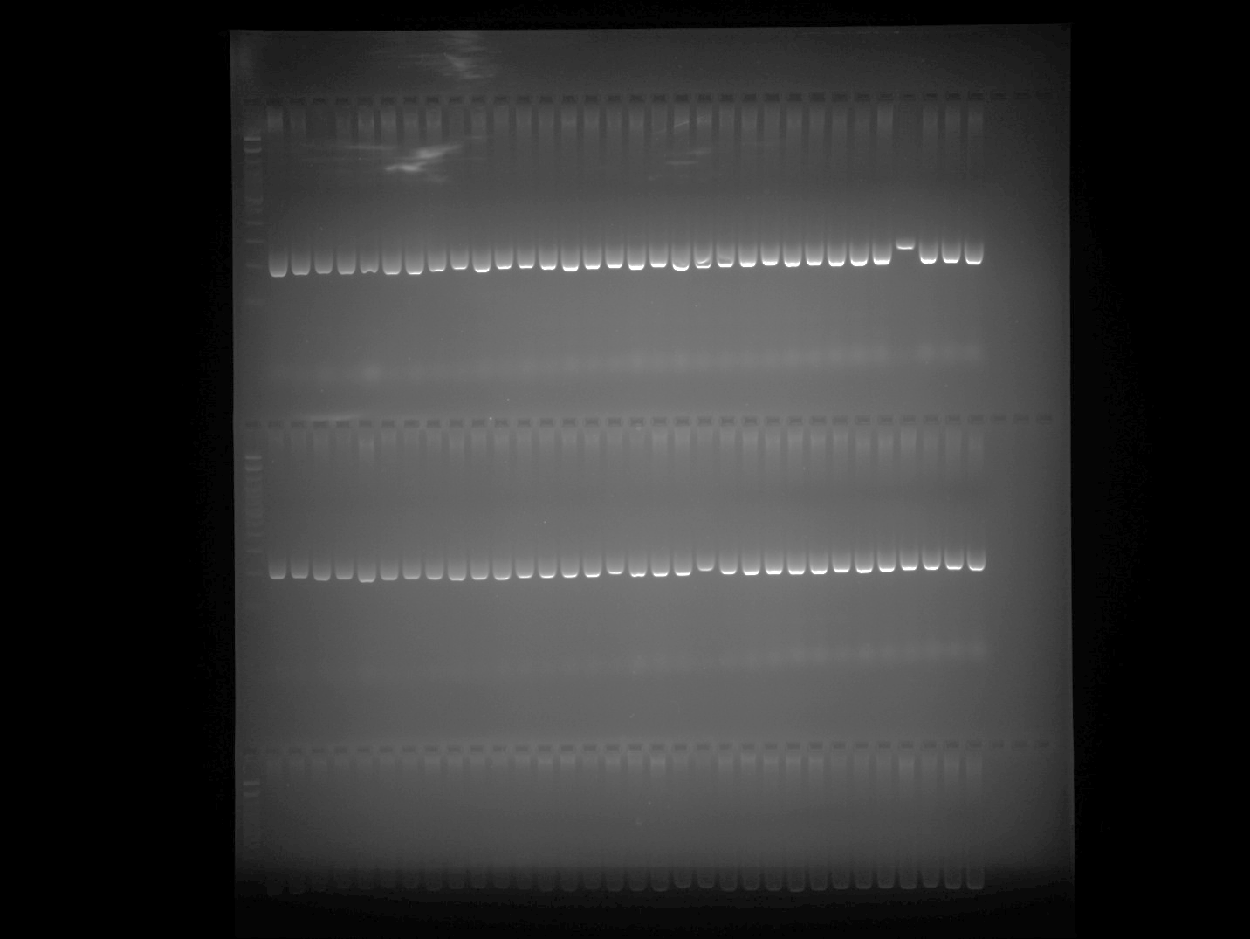

EPMS 480 Plate 2 Part 2
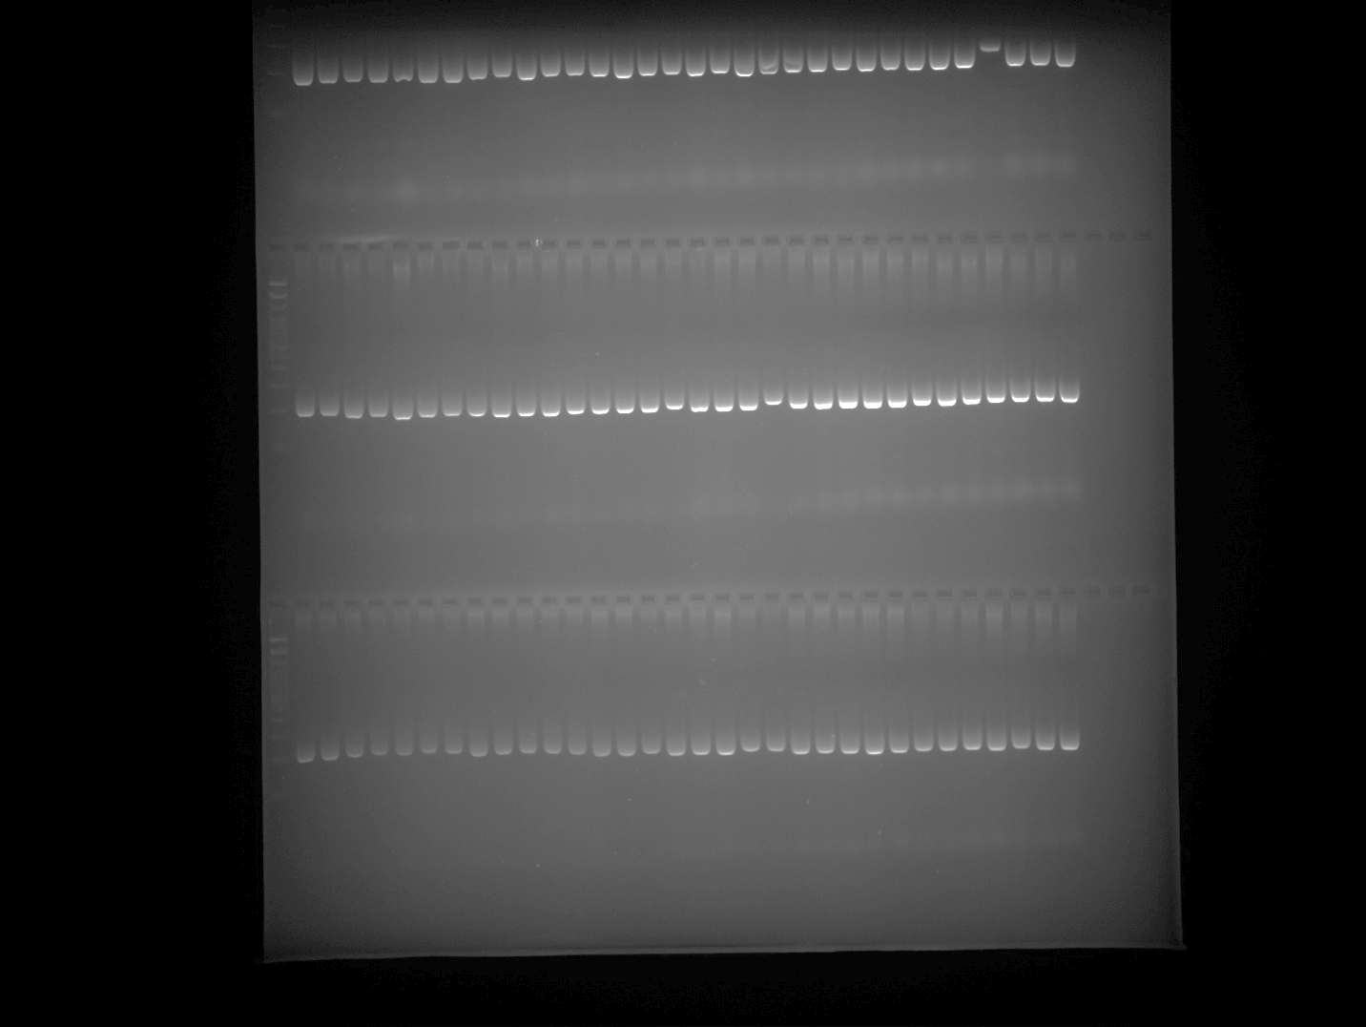

EPMS 480 Plate 3 Part 1
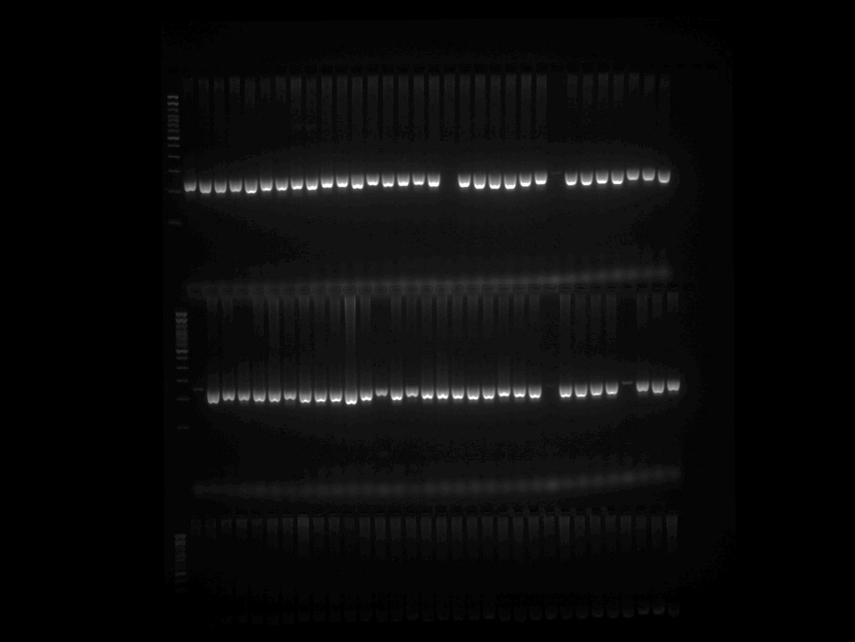

EPMS 480 Plate 3 Part 2
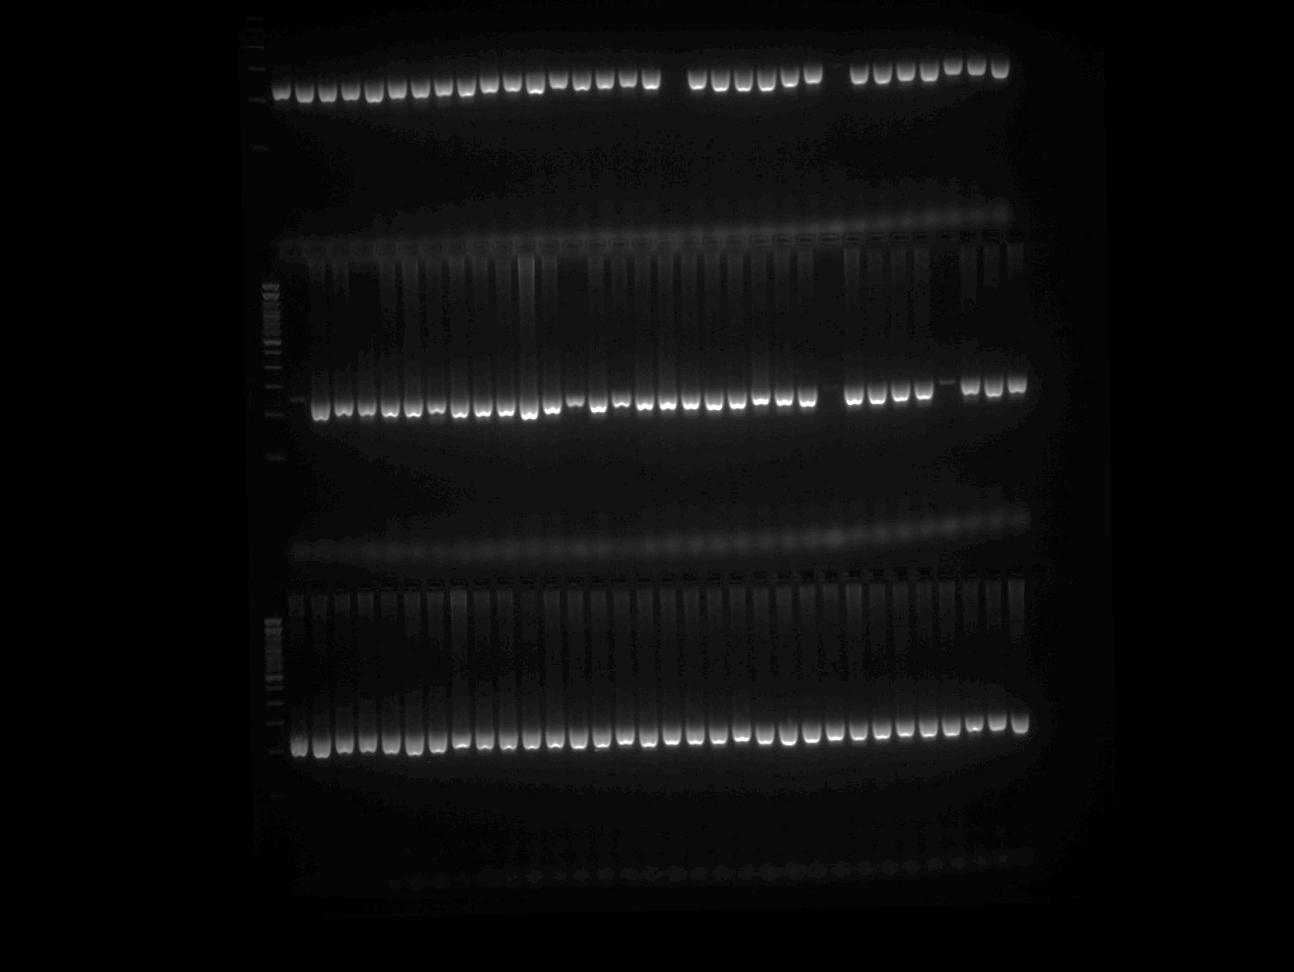

EPMS 480 Plate 4
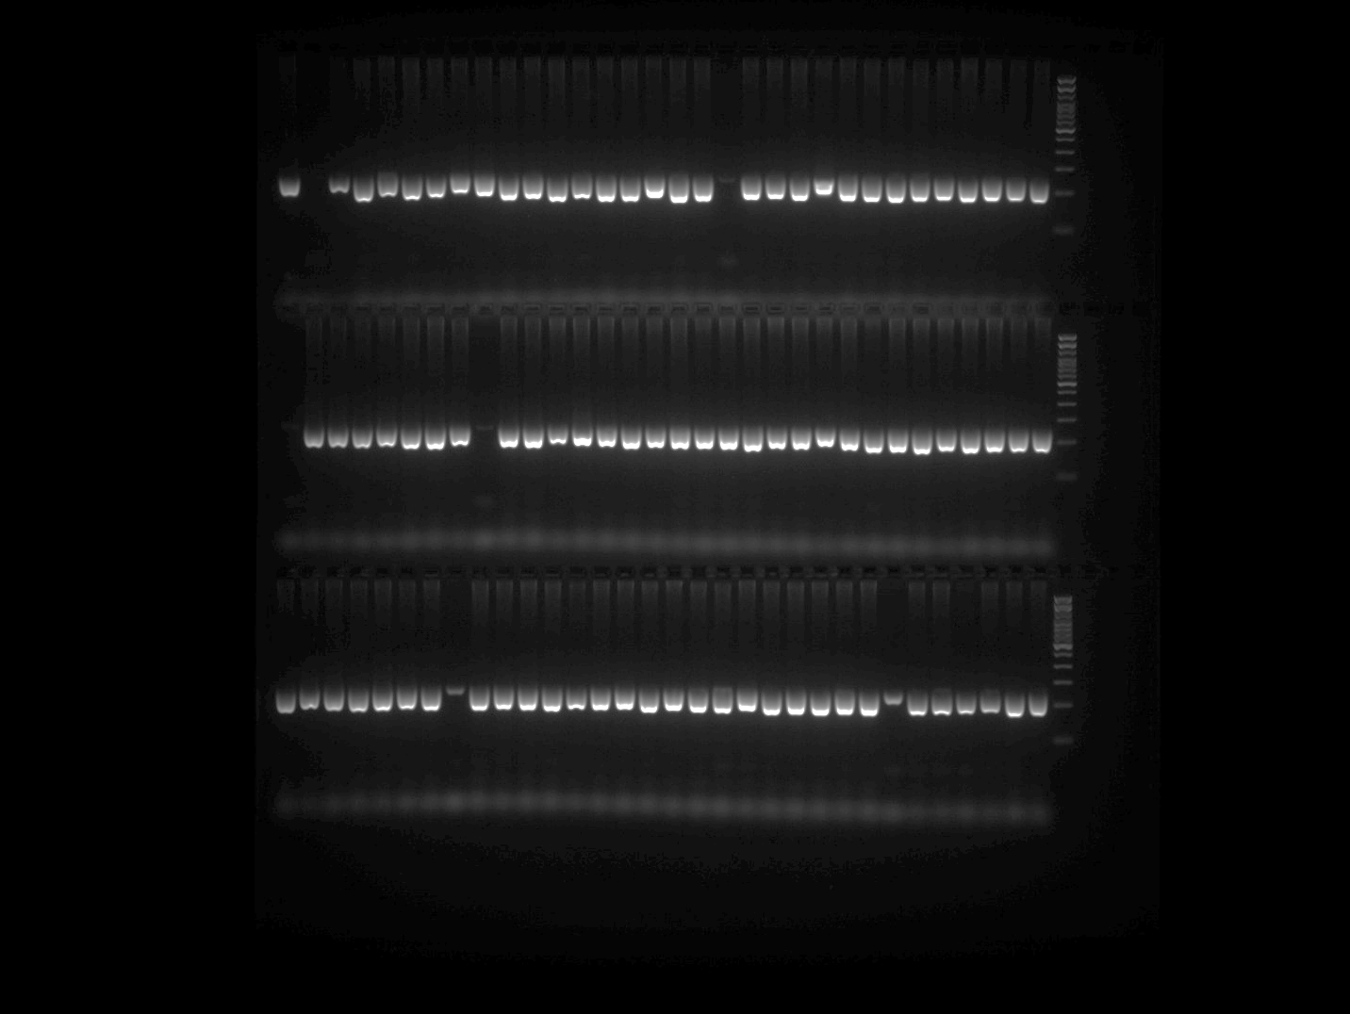

EPMS 480 Plate 5
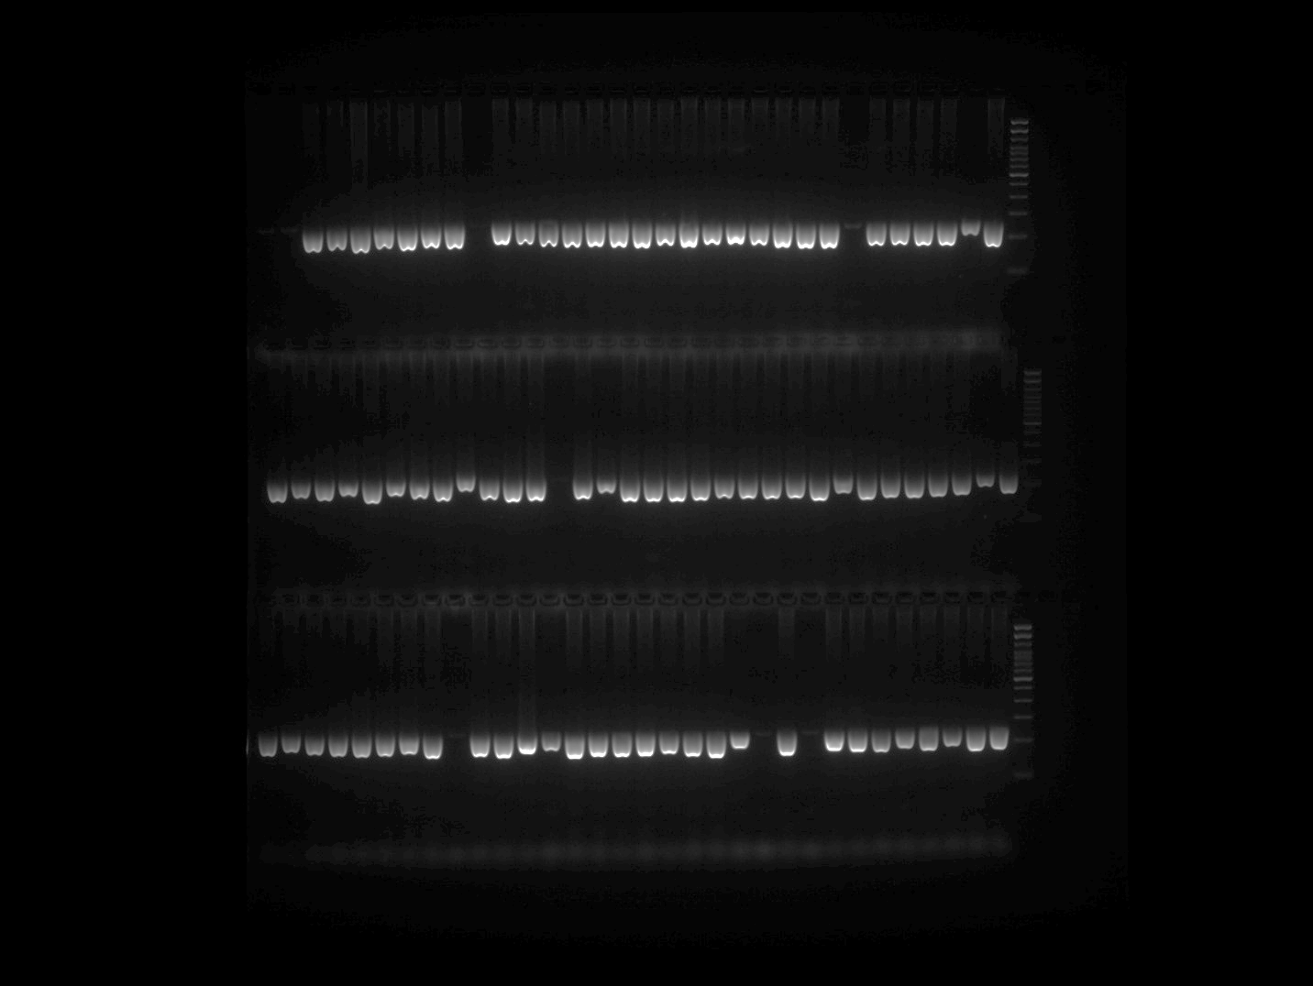

EPMS 501 Plate 1 Part 1
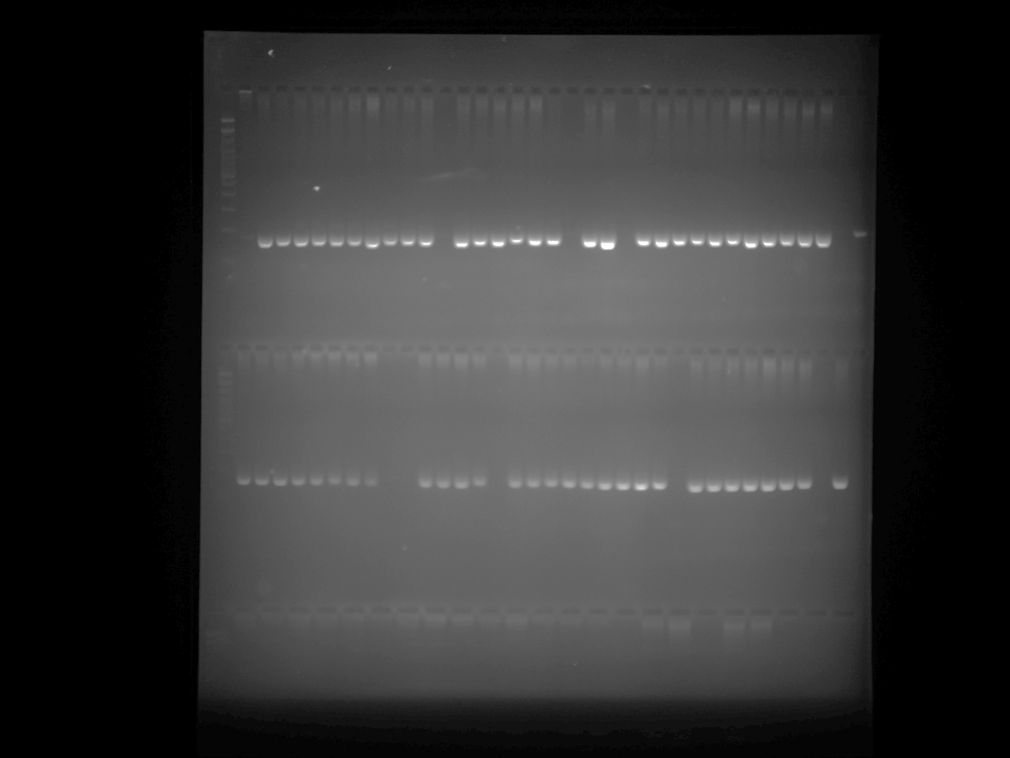

EPMS 501 Plate 1 Part 2
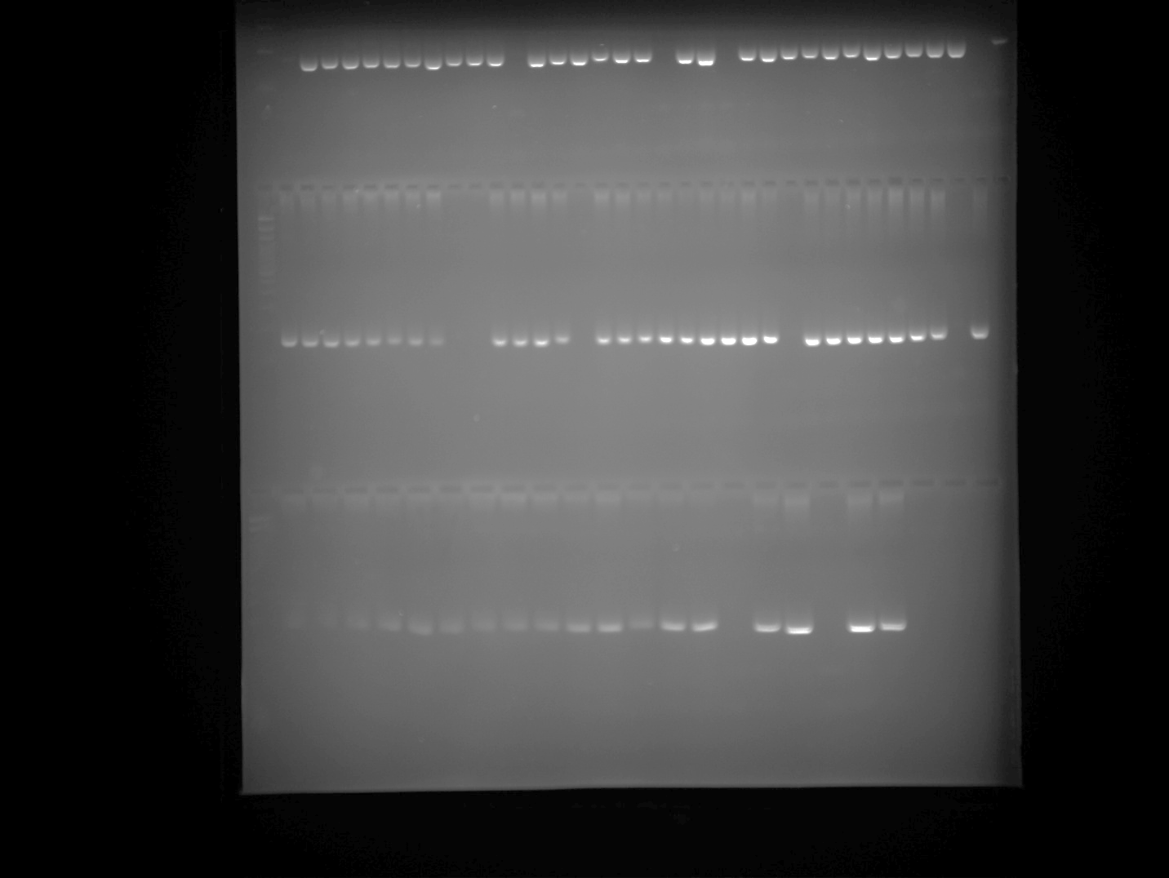

EPMS 501 Plate 2 Part 1
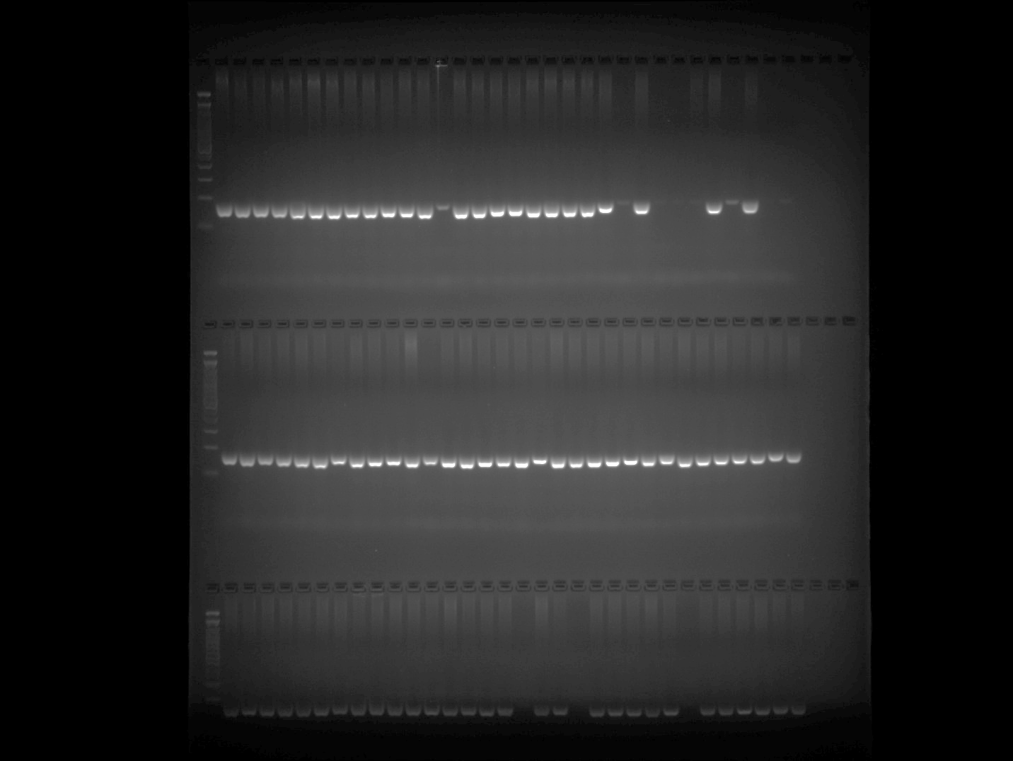

EPMS 501 Plate 2 Part 2
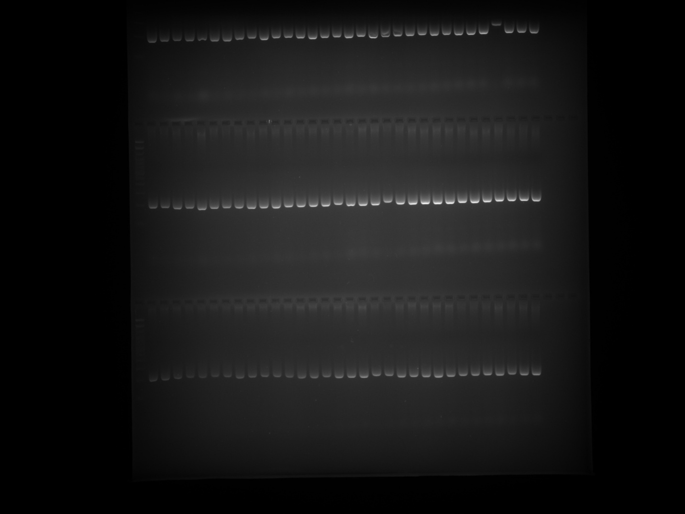

EPMS 501 Plate 3 Part 1
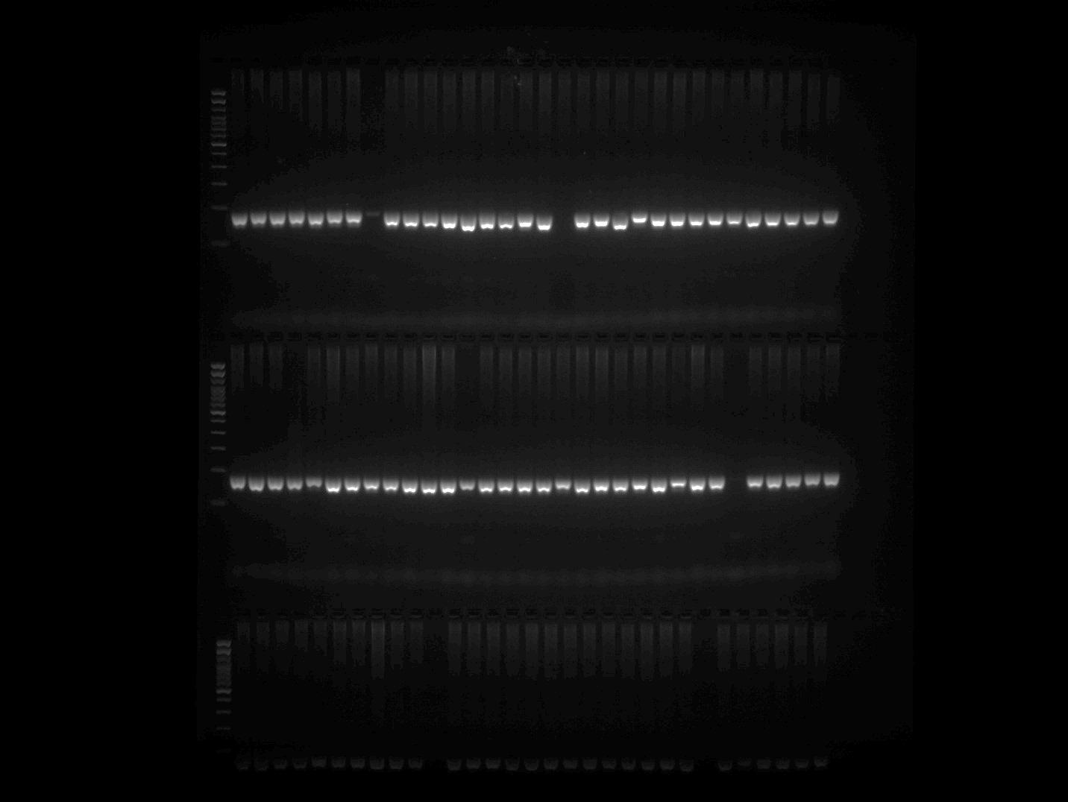

EPMS 501 Plate 3 Part 2
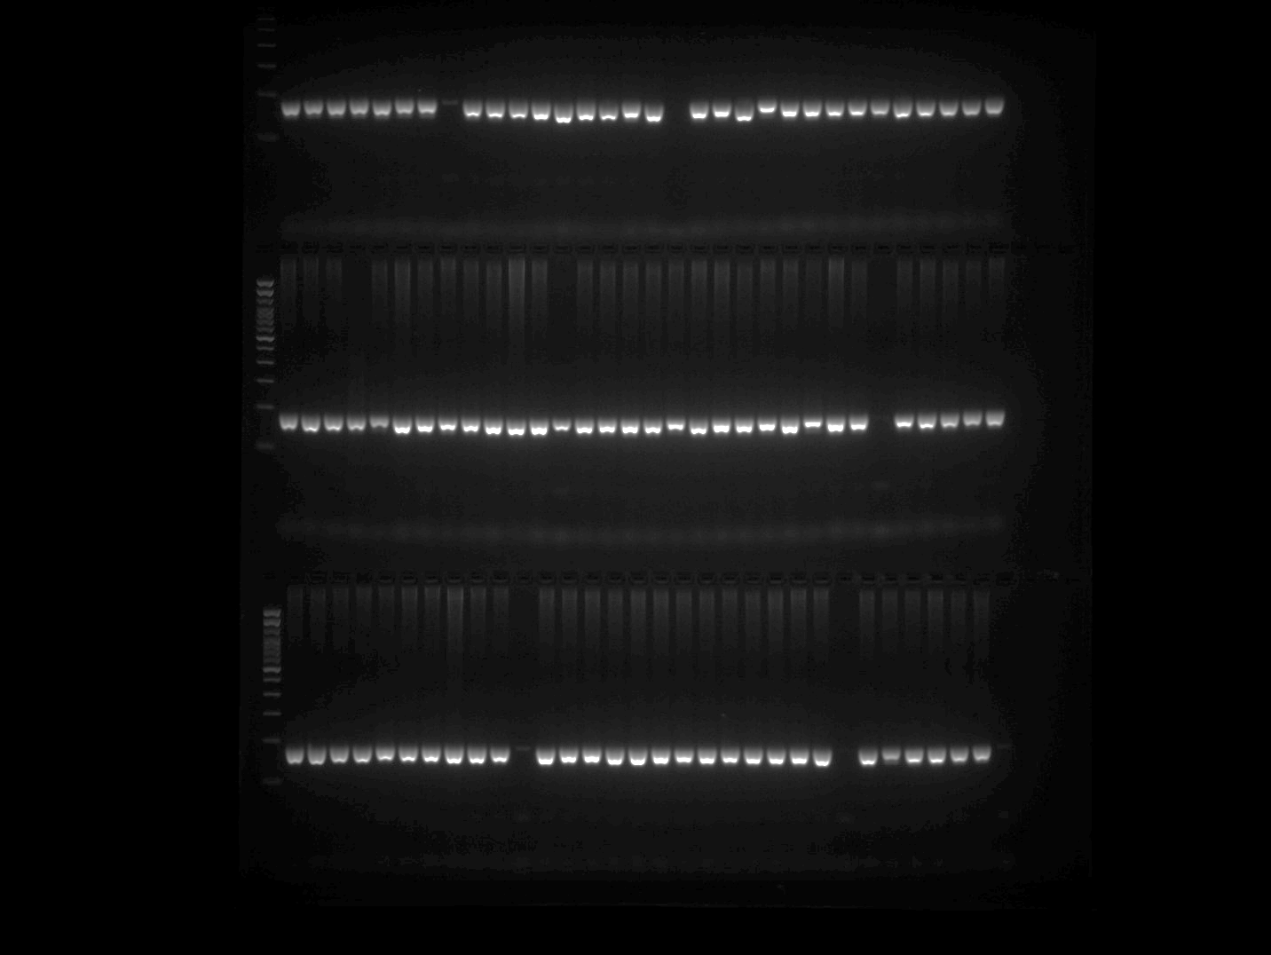

EPMS 501 Plate 4
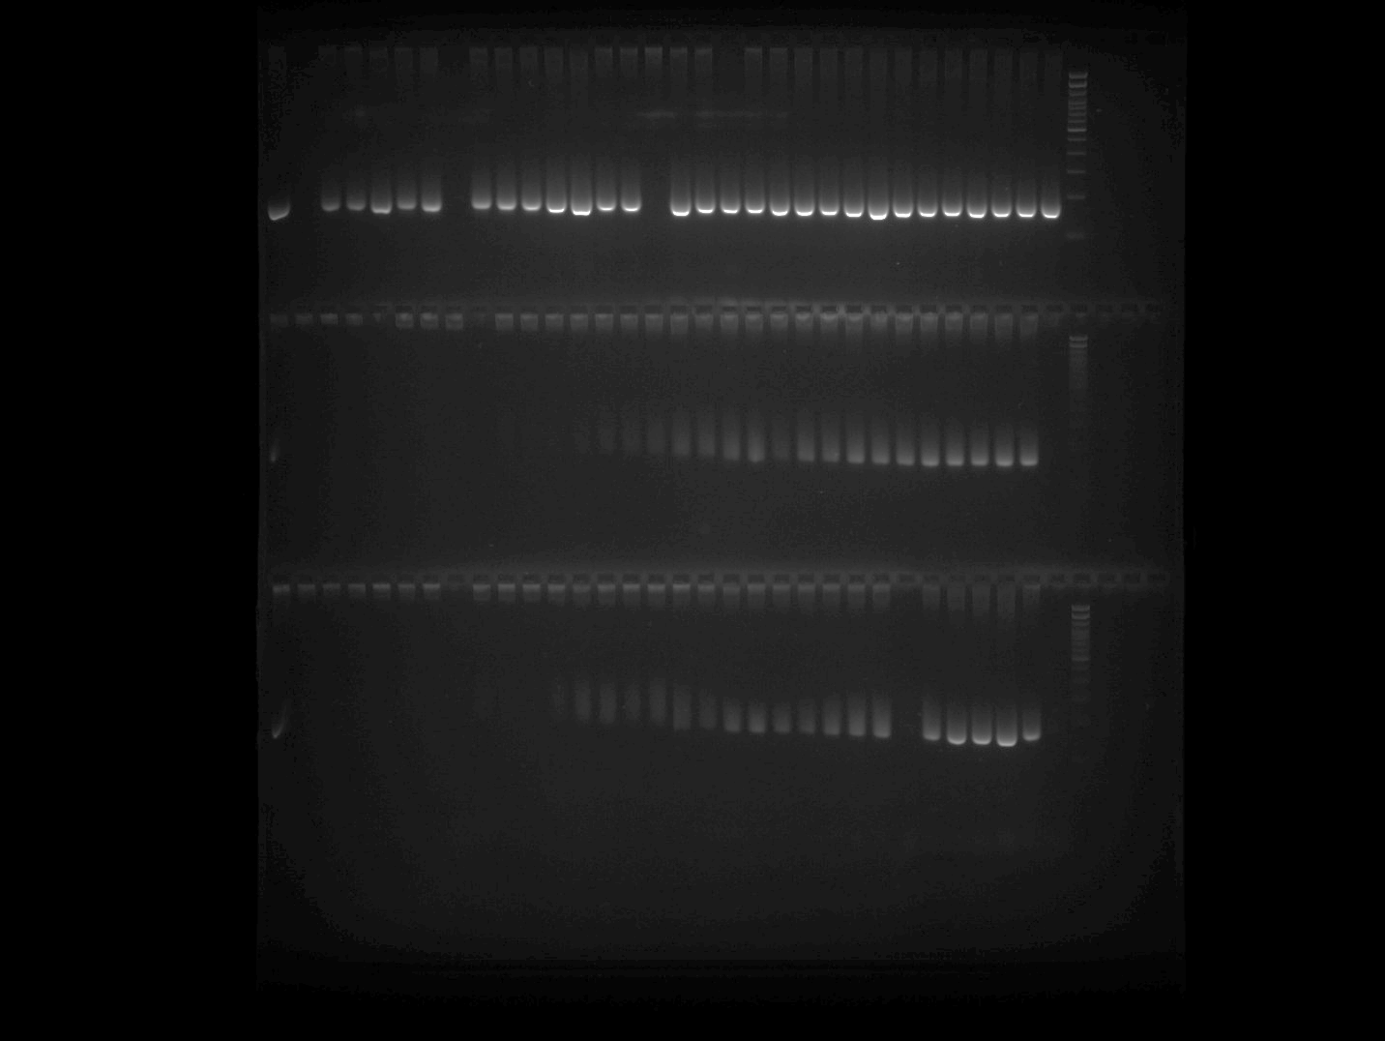

EPMS 501 Plate 4 repetition (row 2 and 3)
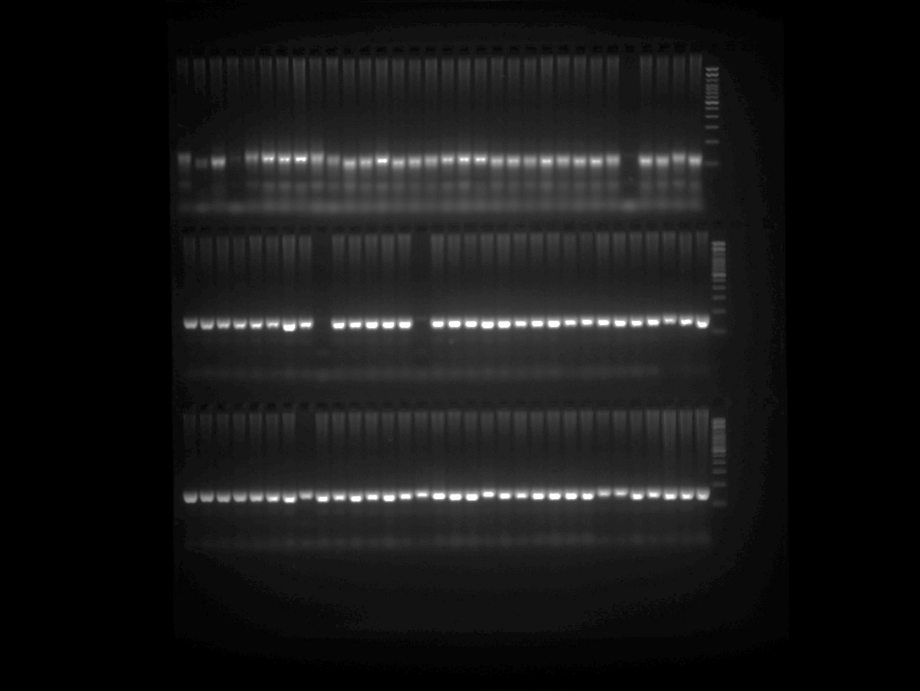

Note: PCR was repeated for the samples belonging to Row 2 and 3 of EPMS 501 Plate 4 gel image and presented in the above gel image at row 2 and 3.

EPMS 501 Plate 5
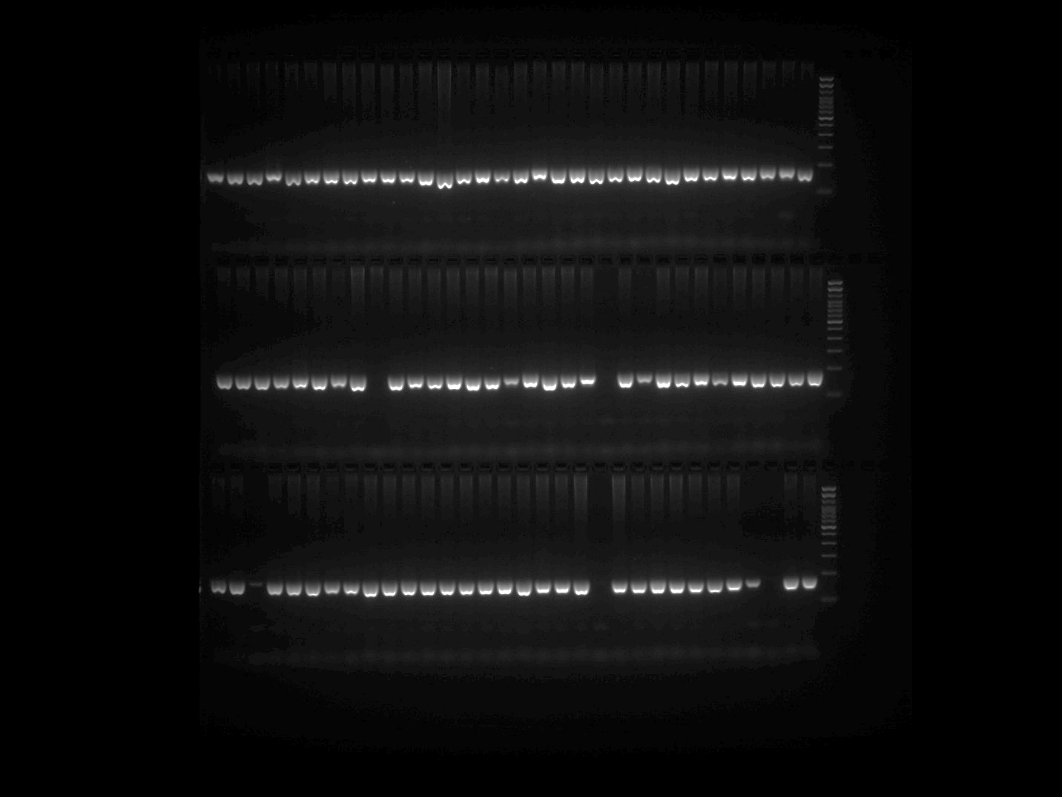

GPMS 117 Plate 1 Part 1
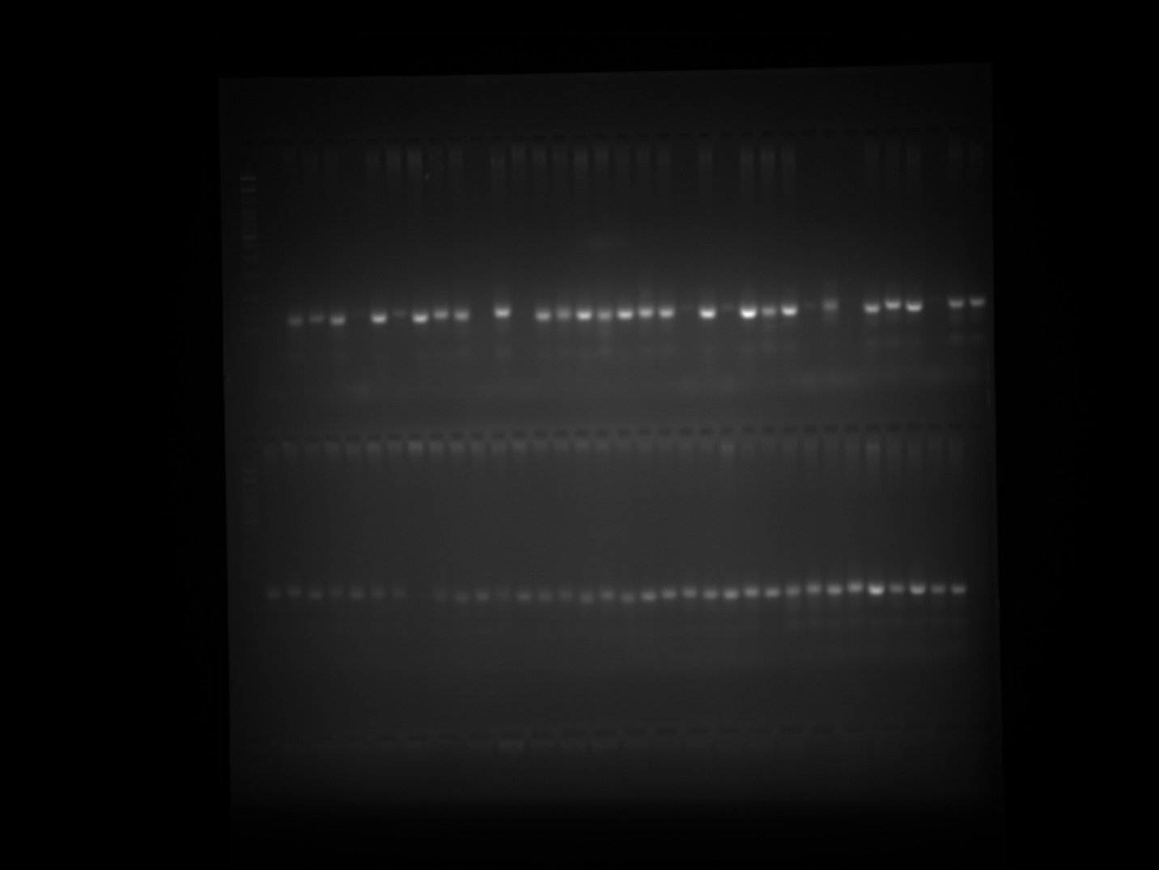

GPMS 117 Plate 1 Part 2
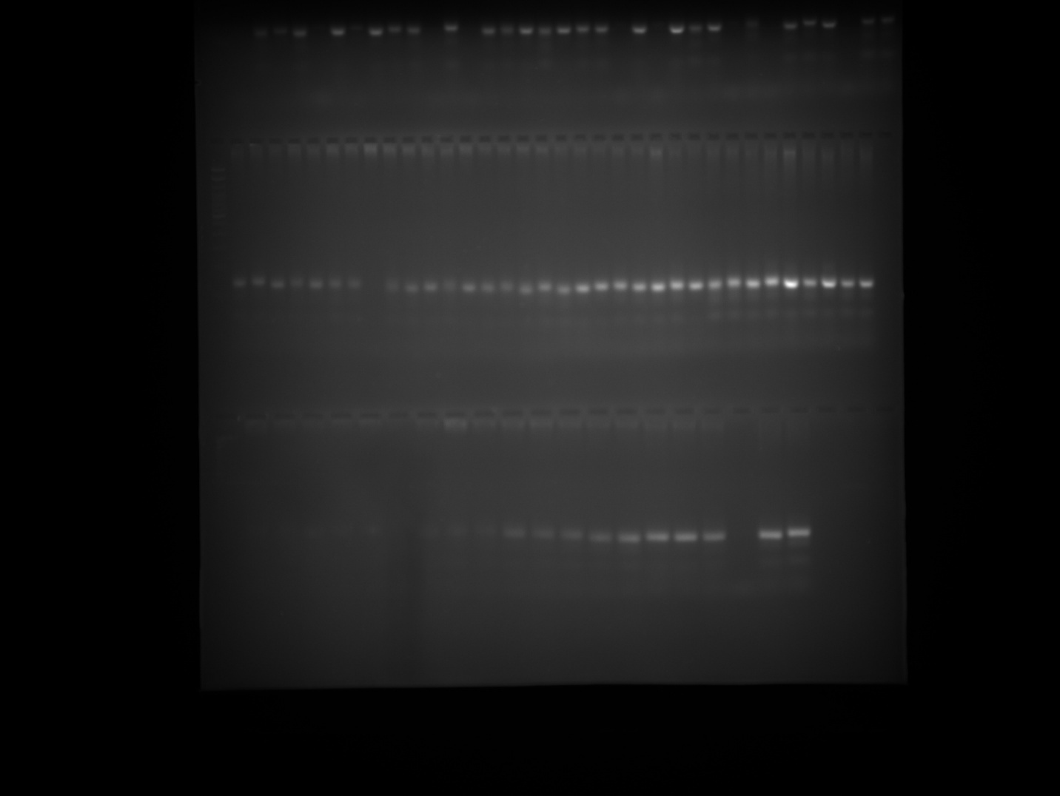

GPMS 117 Plate 1 Part 2 repetition (row 1)

Note: PCR was repeated for the samples belonging to Row 3 of GPMS 117 Plate 1 gel image and presented in the above gel image at row 1.

GPMS 117 Plate 2 Part 1
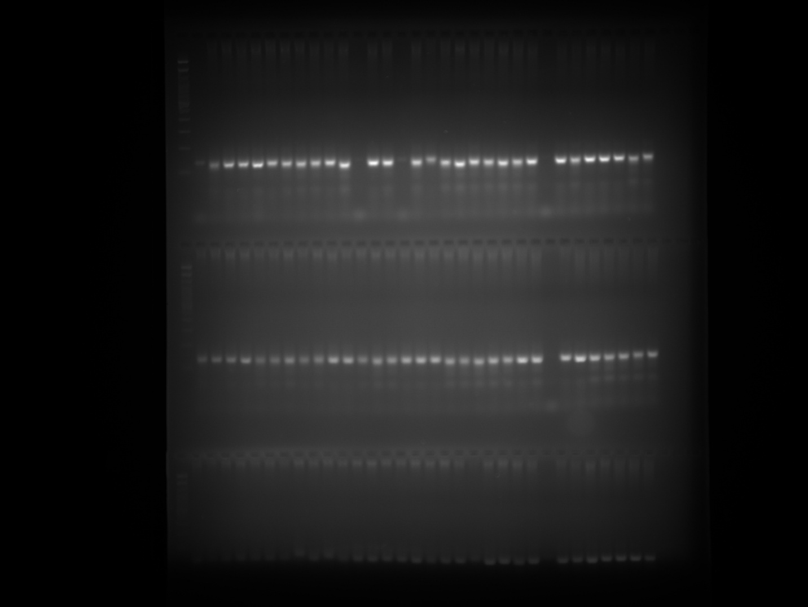

GPMS 117 Plate 2 Part 2
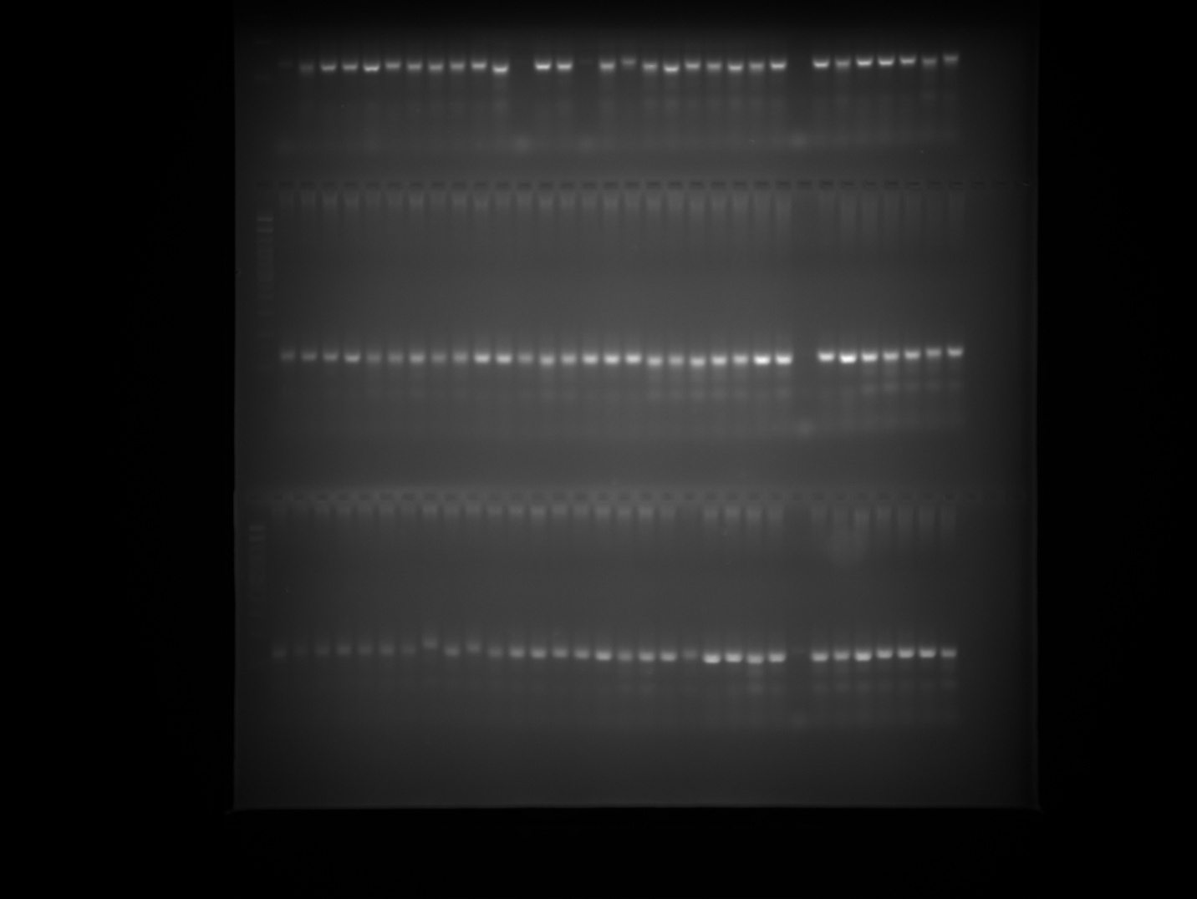

GPMS 117 Plate 3 Part 1
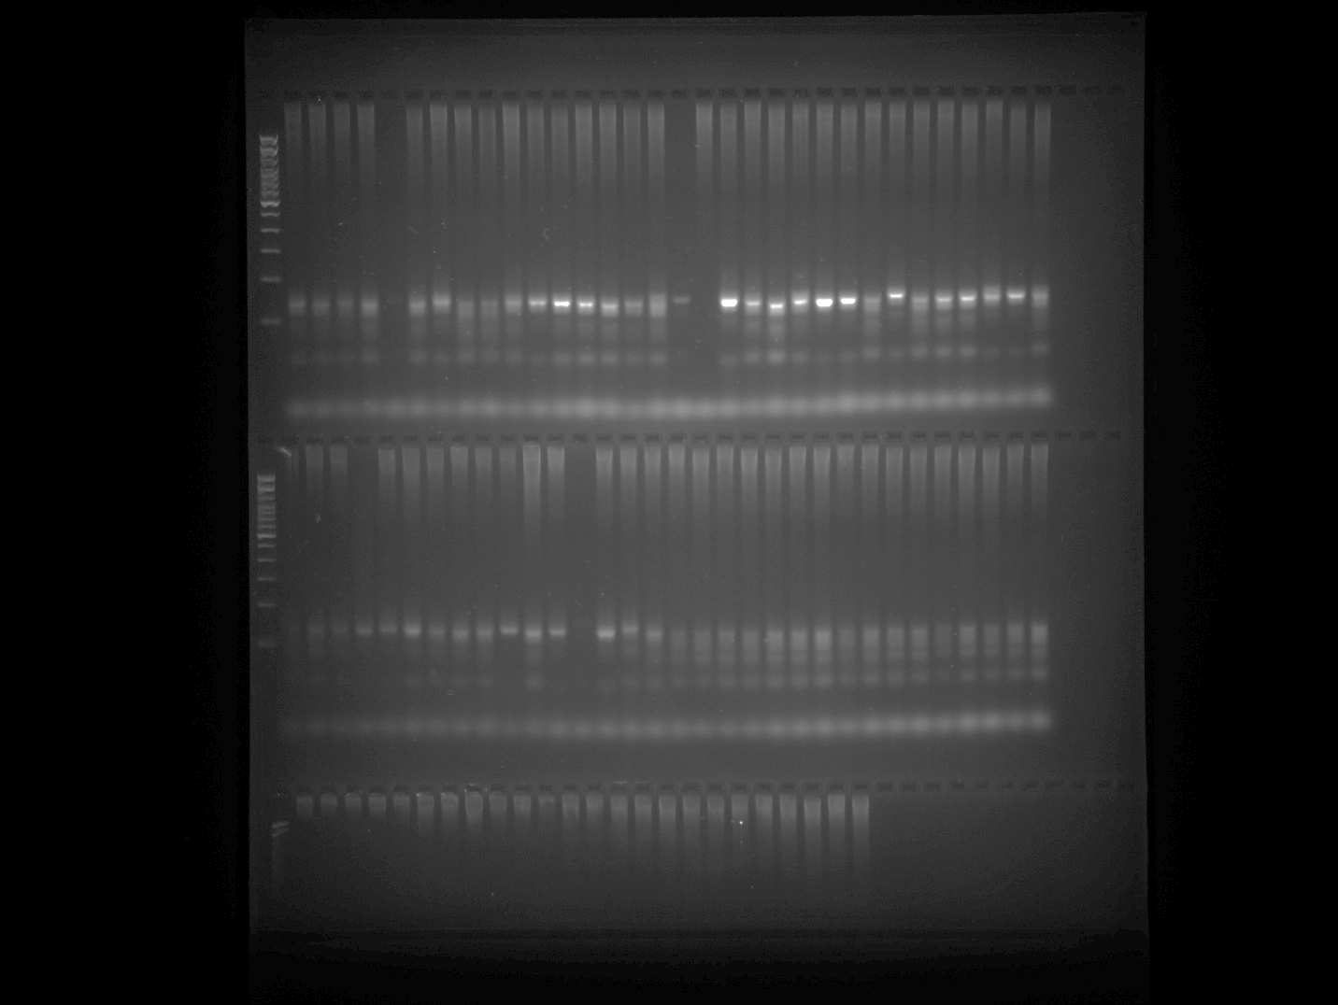

GPMS 117 Plate 3 Part 2
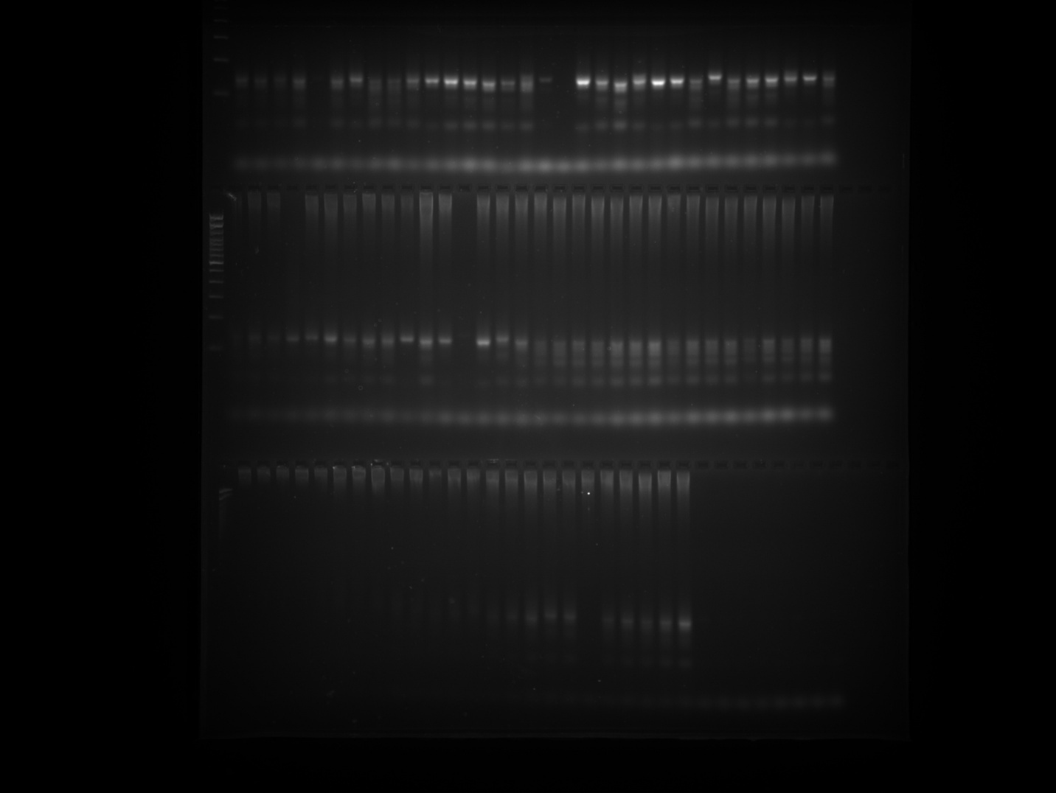

GPMS 117 Plate 3 Part 1 repetition (row 1)
Note: PCR was repeated for the samples belonging to Row 3 of GPMS 117 Plate 3 gel image and presented in the above gel image at row 1.

GPMS 117 Plate 4
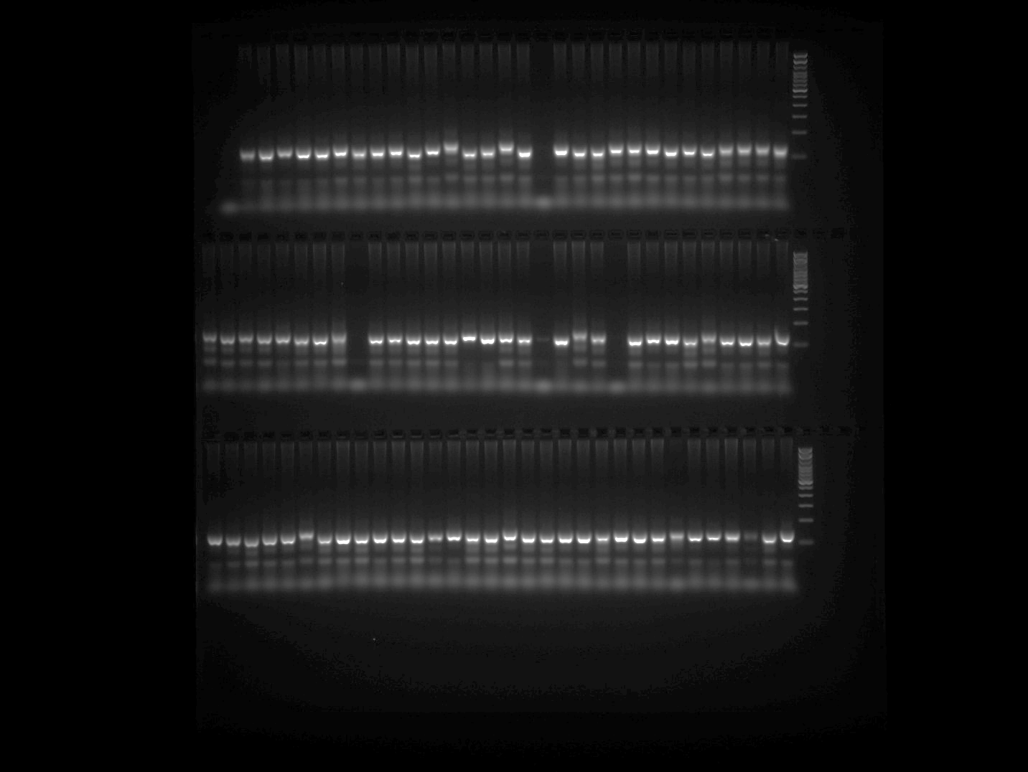

GPMS 117 Plate 5
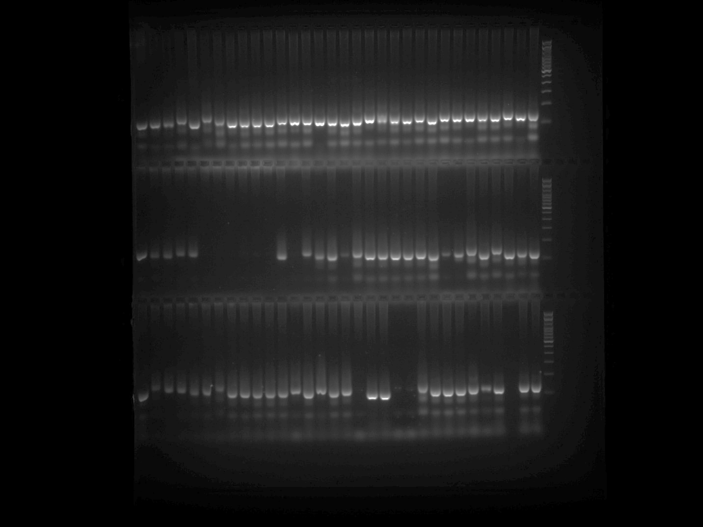

GPMS 117 Plate 5 repetition (row 1)
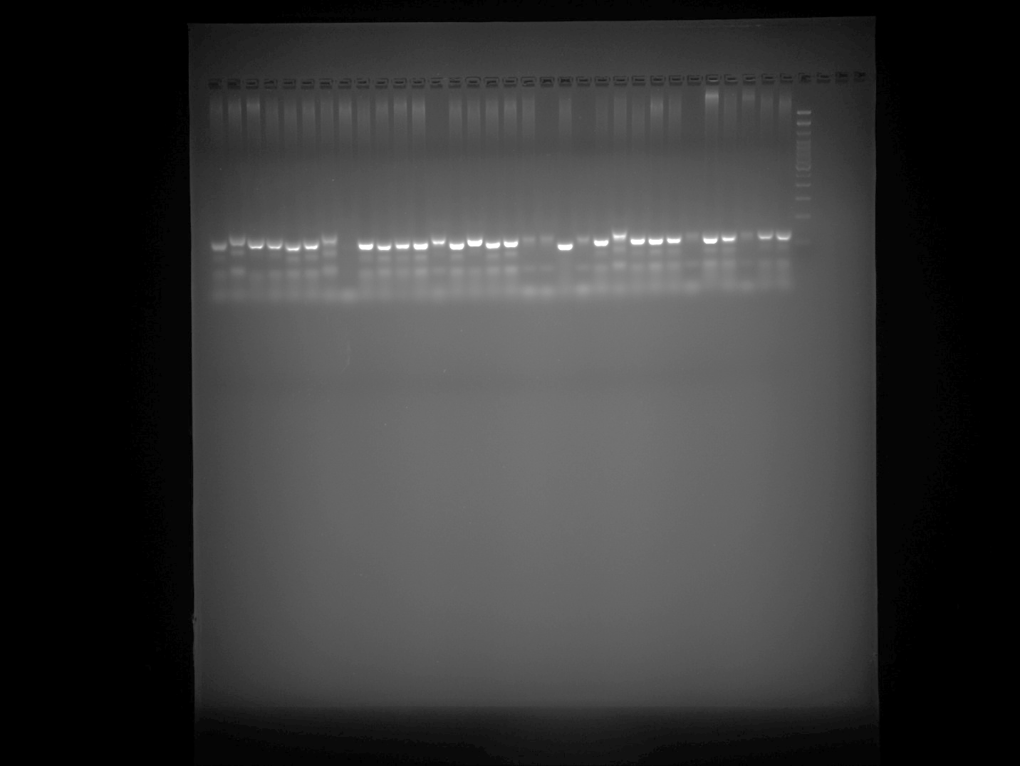

Note: PCR was repeated for the samples belonging to Row 3 of GPMS 117 Plate 5 gel image and presented in the above gel image at row 1.

Hpms1-1 Plate 1 Part 1
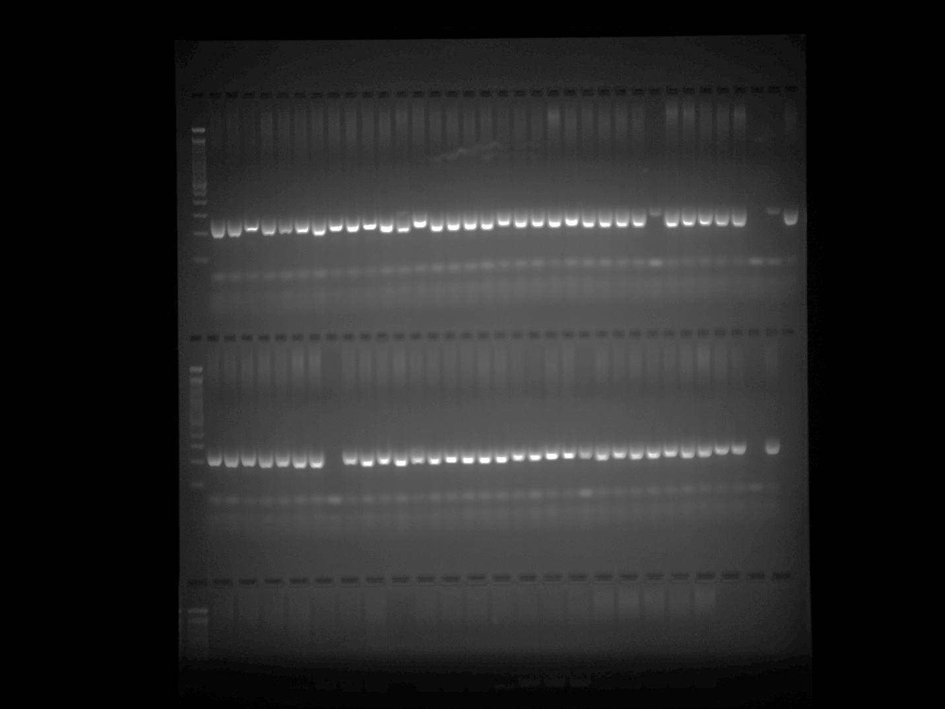

Hpms1-1 Plate 1 Part 2
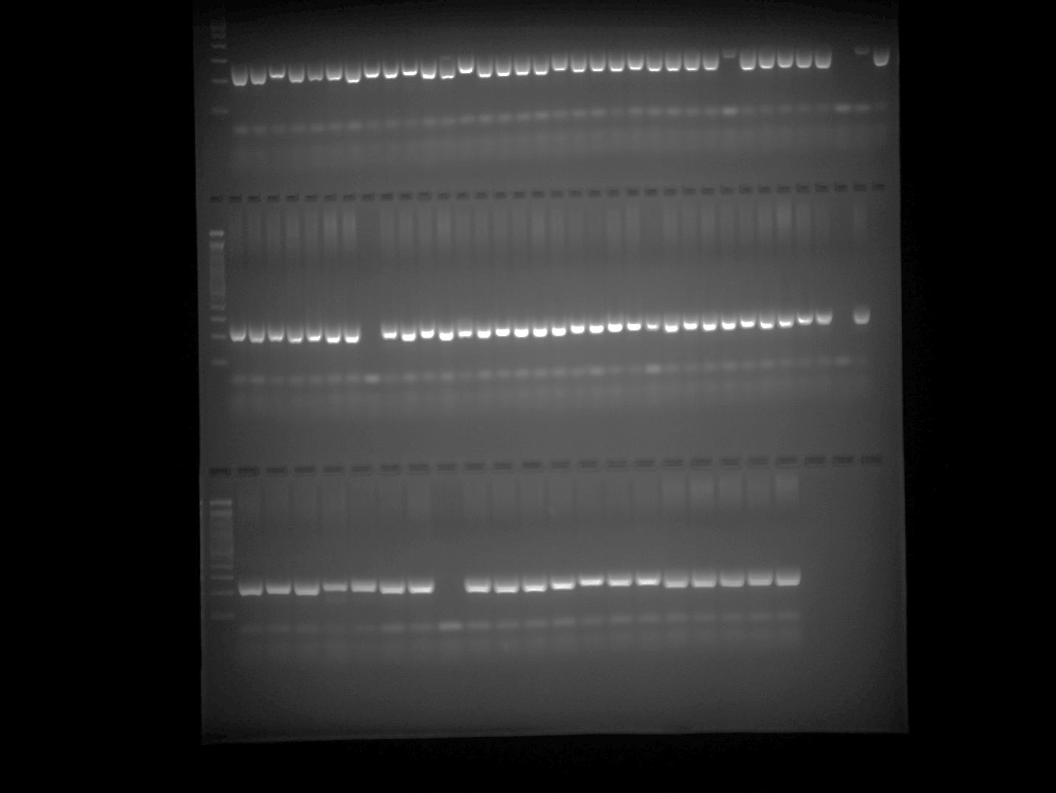

Hpms1-1 Plate 2 Part 1
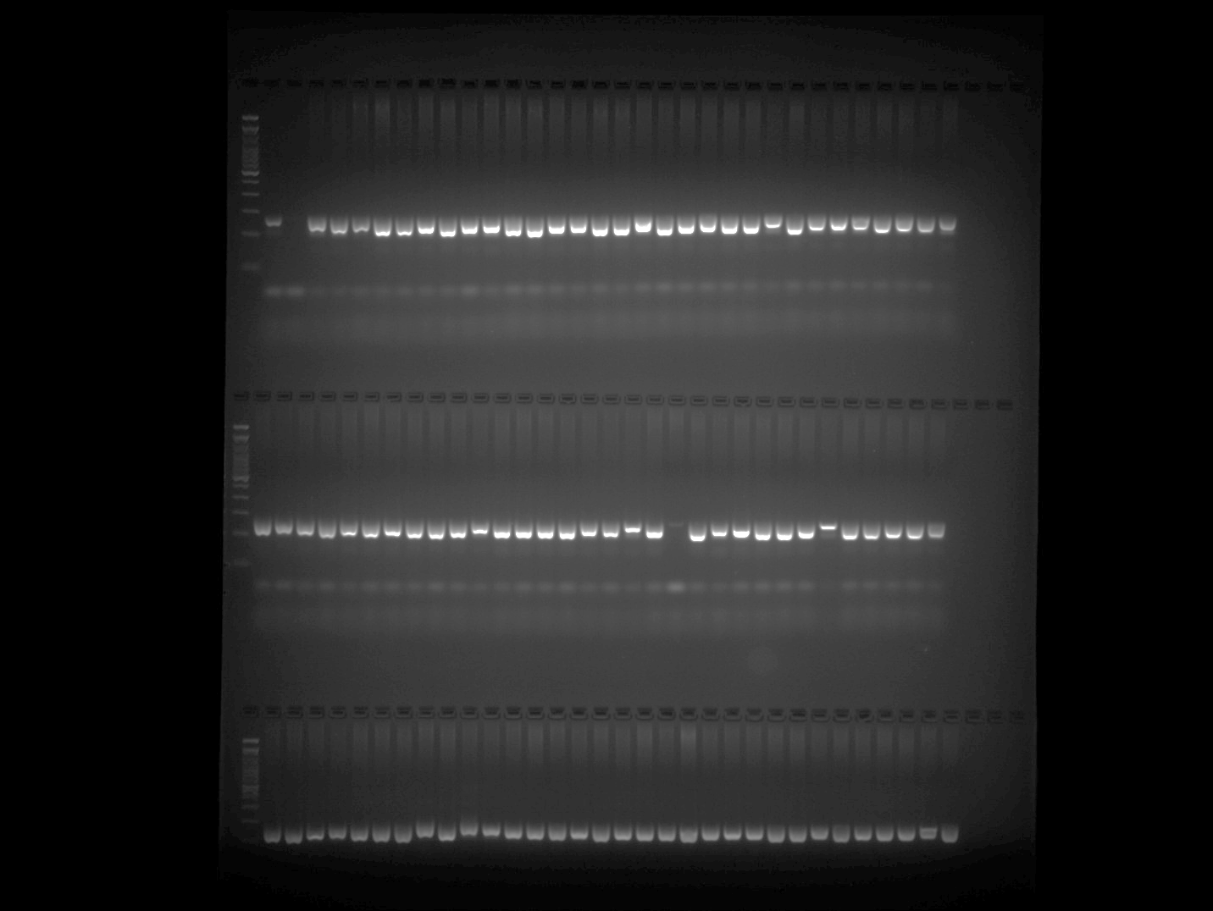

Hpms1-1 Plate 2 Part 2
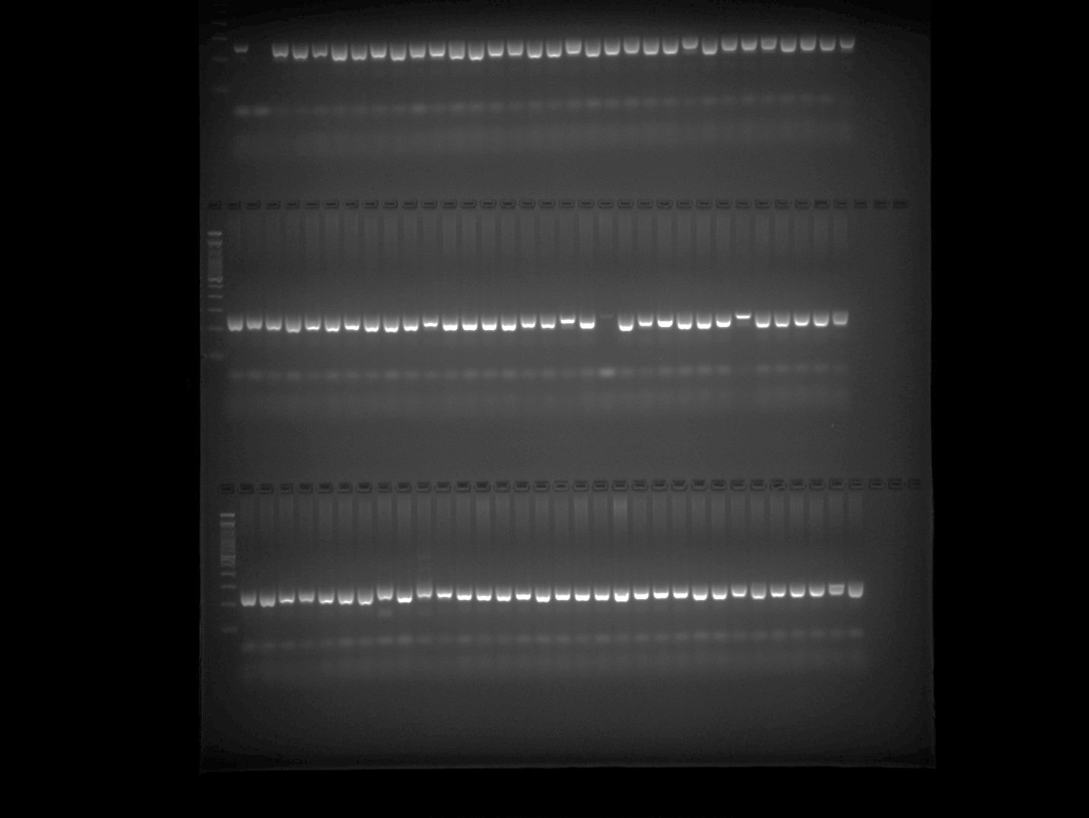

Hpms1-1 Plate 3 Part 1
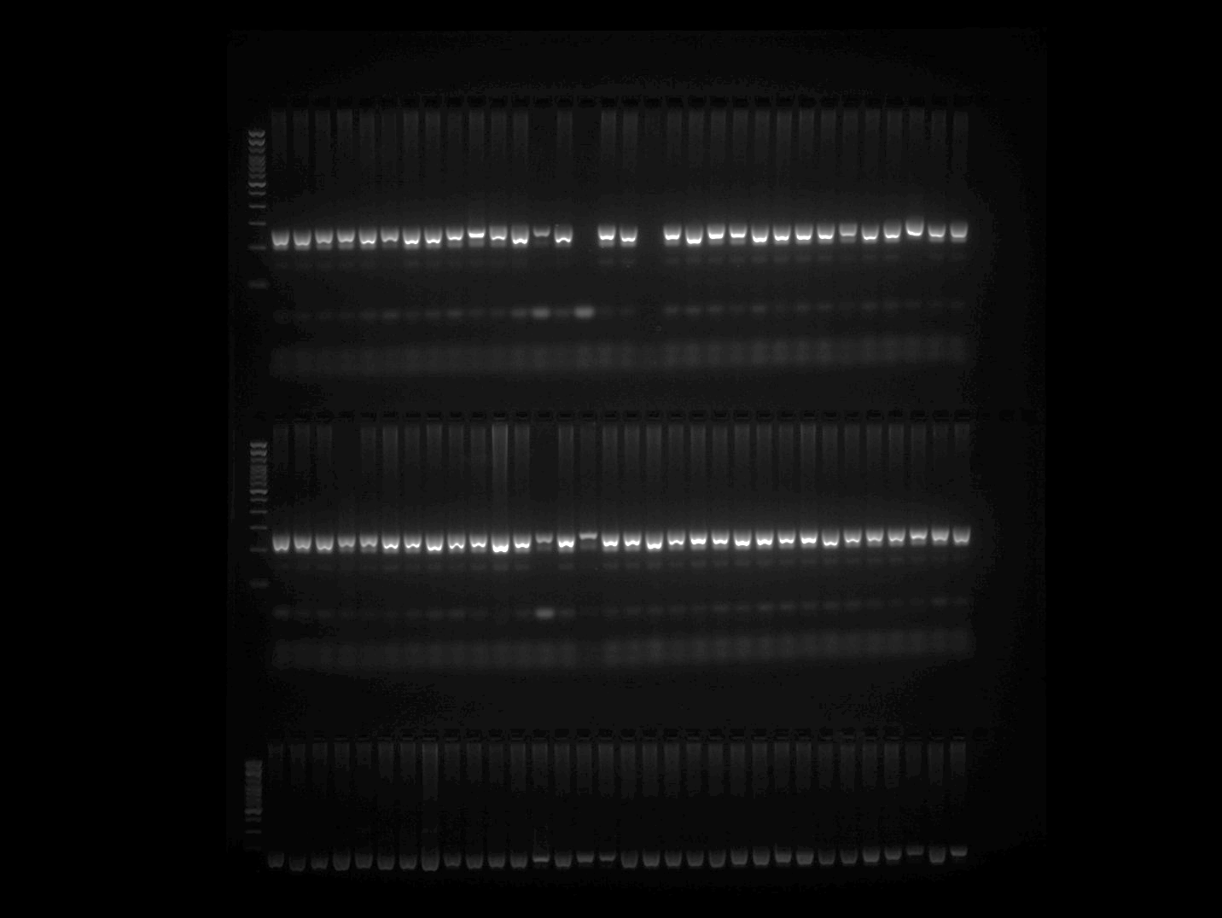

Hpms1-1 Plate 3 Part 2
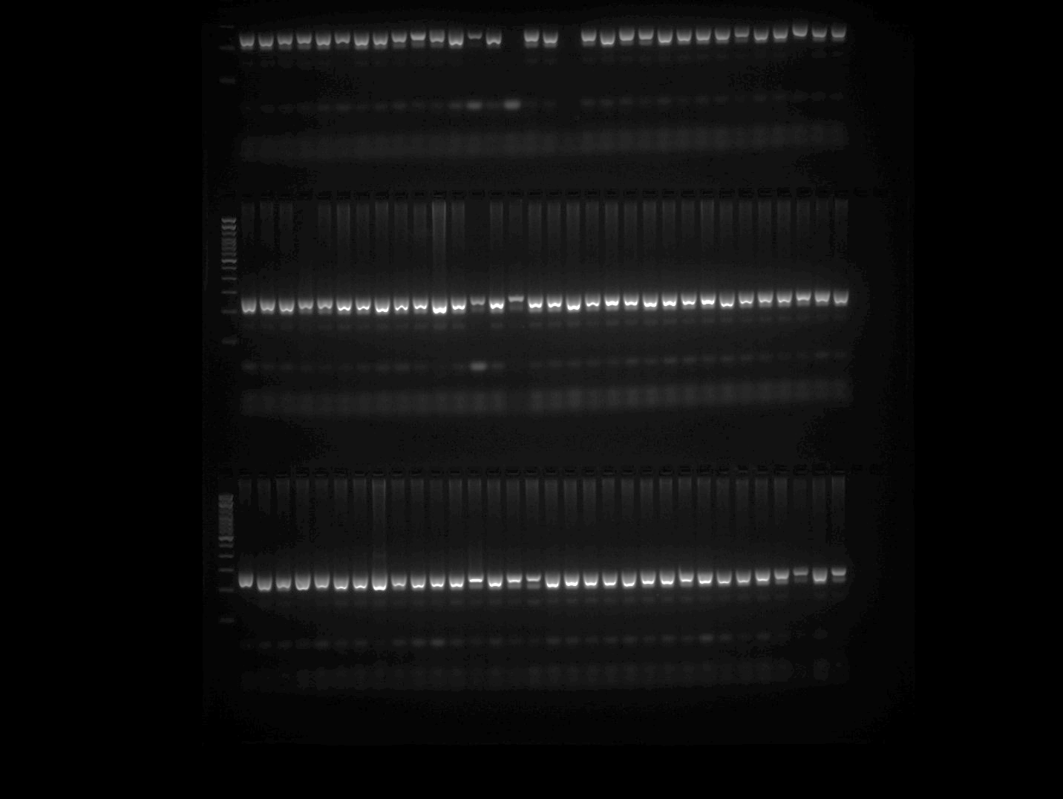

Hpms1-1 Plate 4
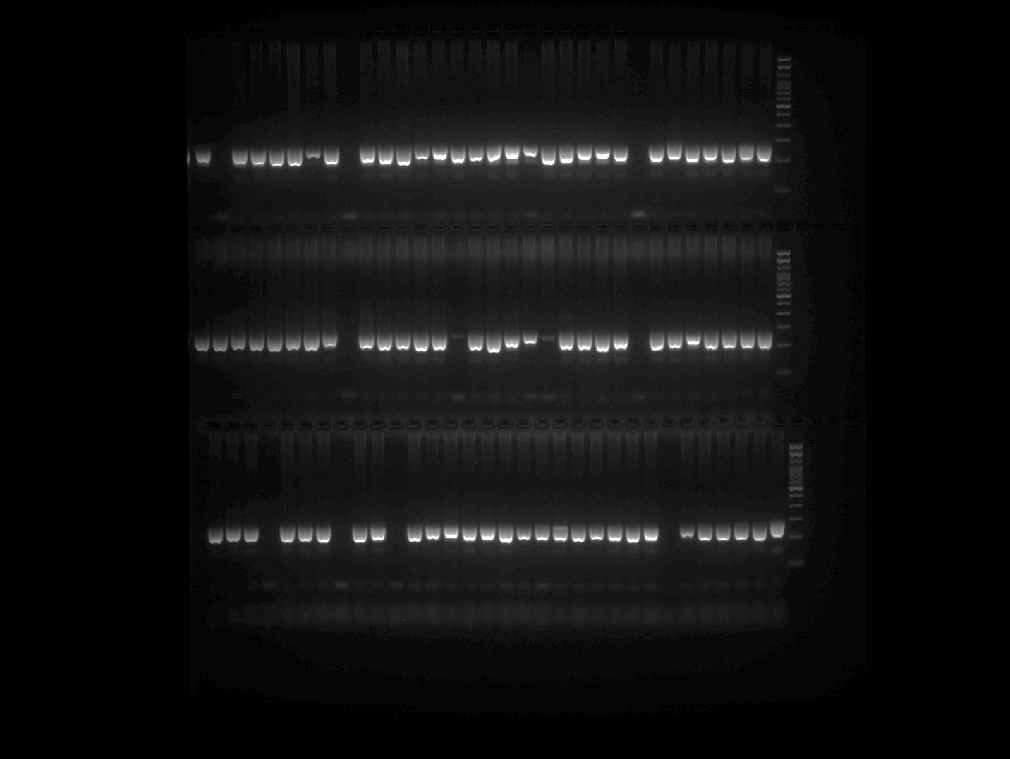

Hpms1-1 Plate 5
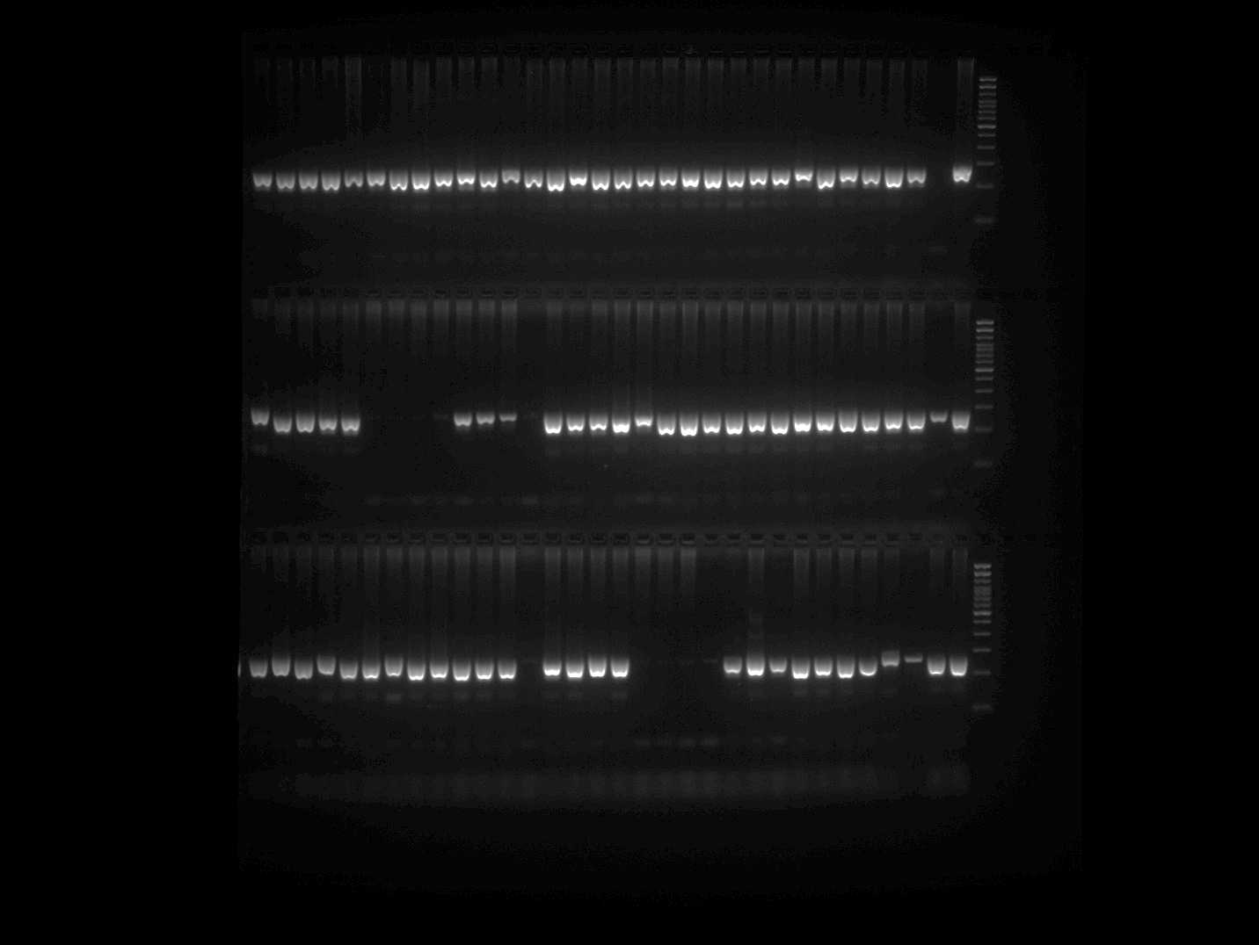

EPMS 399 Plate 1
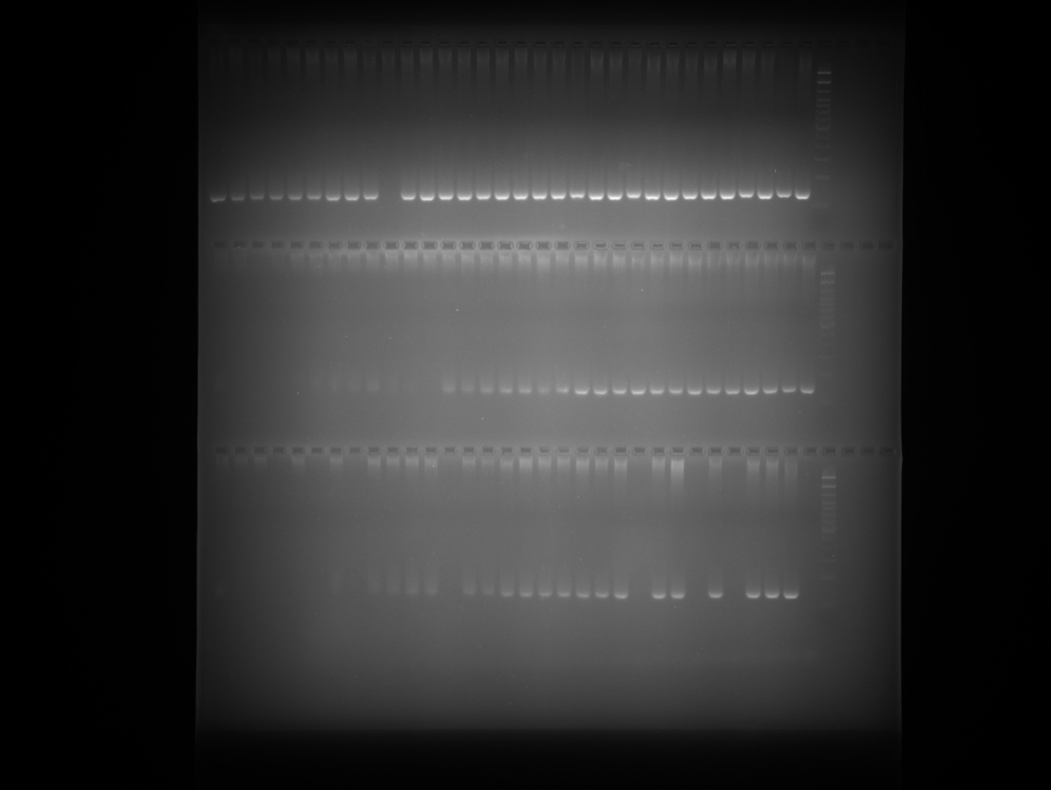

EPMS 399 Plate 1 repetition (row 1)
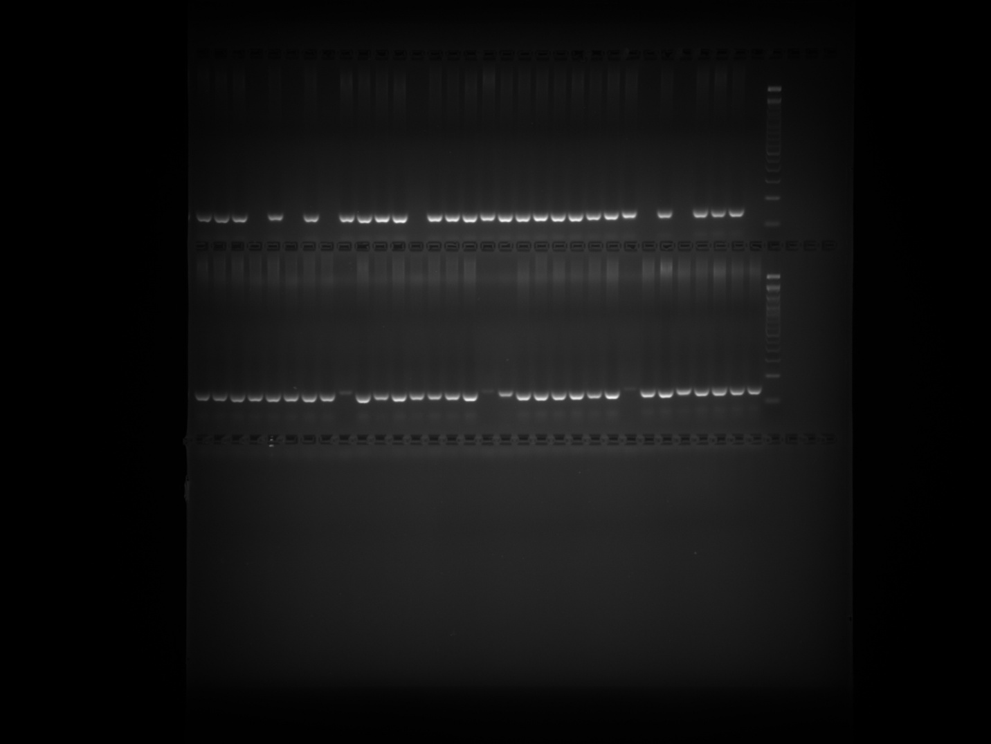
Note: PCR was repeated for the samples belonging to Row 3 of EPMS 399 Plate 1 gel image and presented in the above gel image at row 1.

EPMS 399 Plate 2
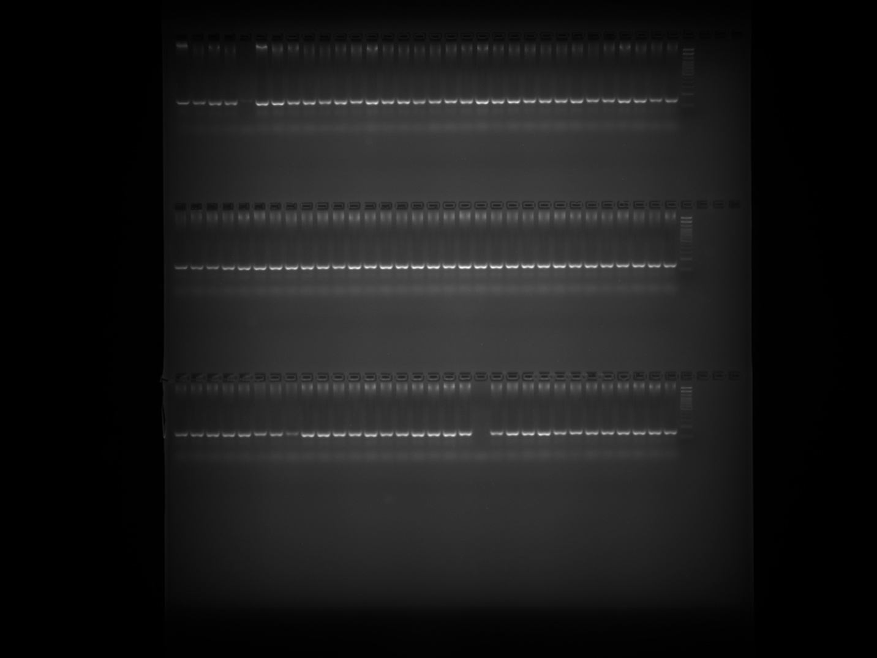

EPMS 399 Plate 3
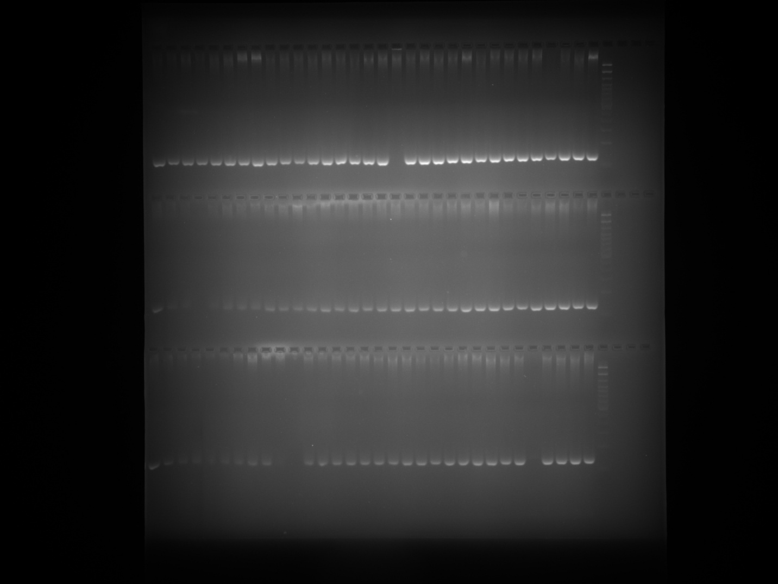

EPMS 399 Plate 4
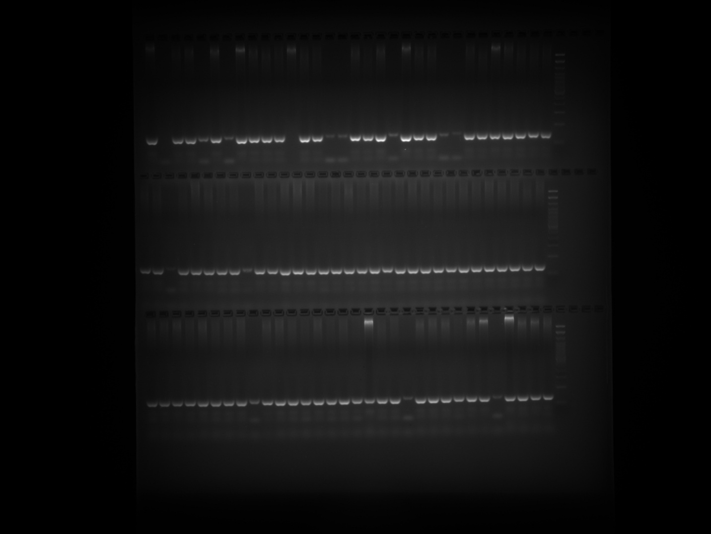

EPMS 399 Plate 5
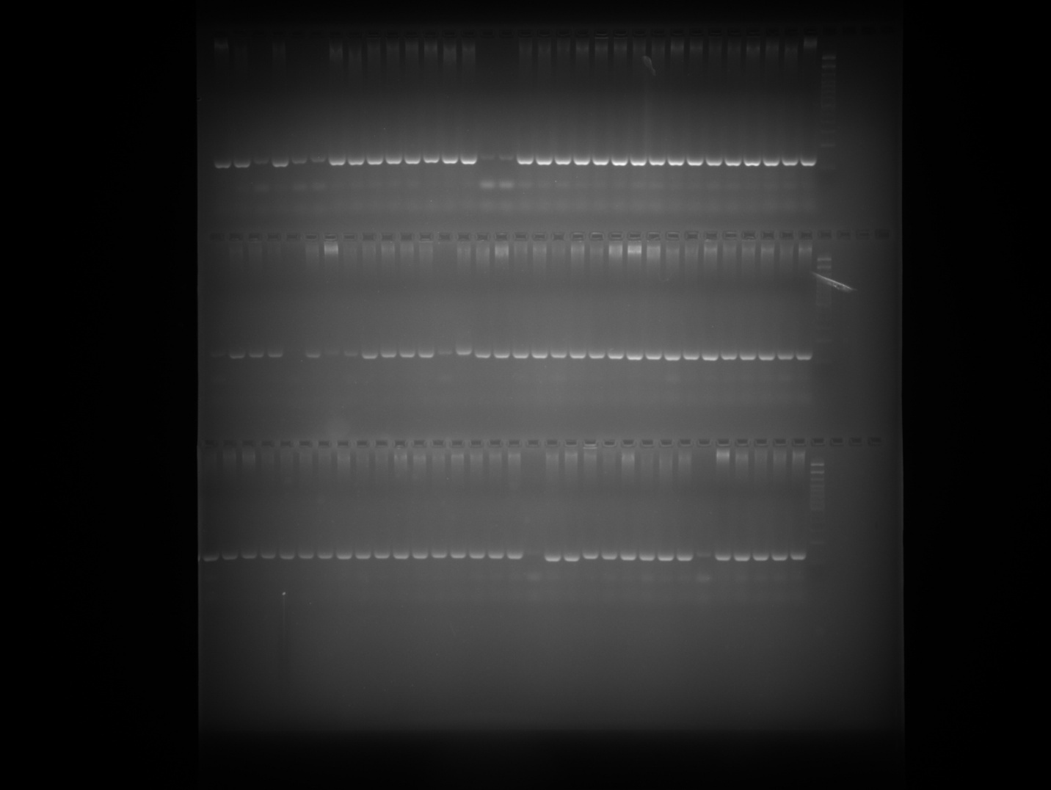

EPMS 404 Plate 1
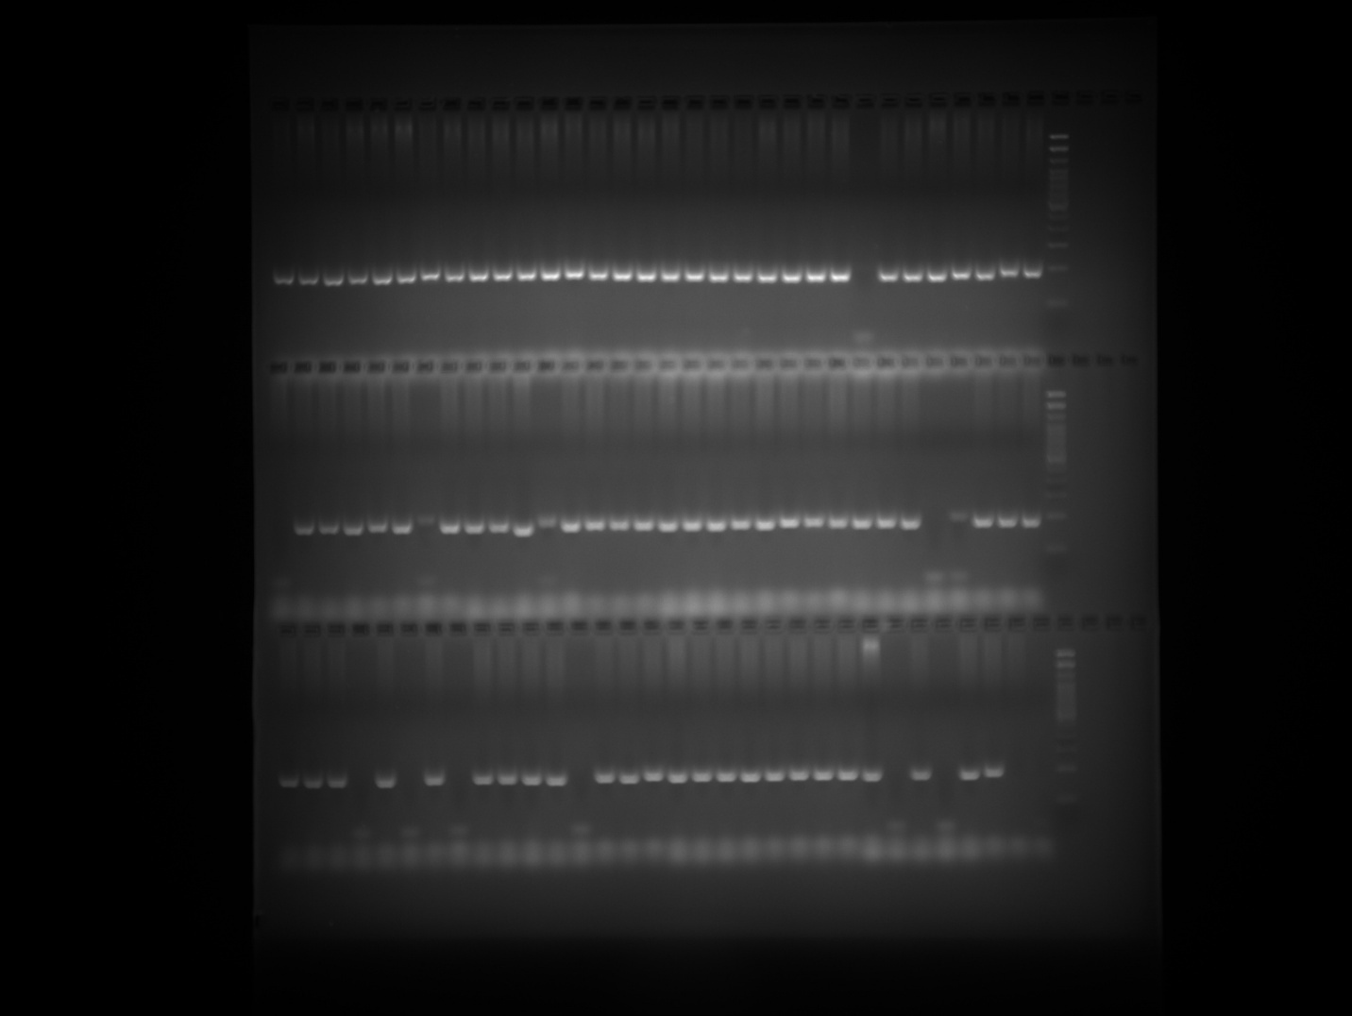

EPMS 404 Plate 2
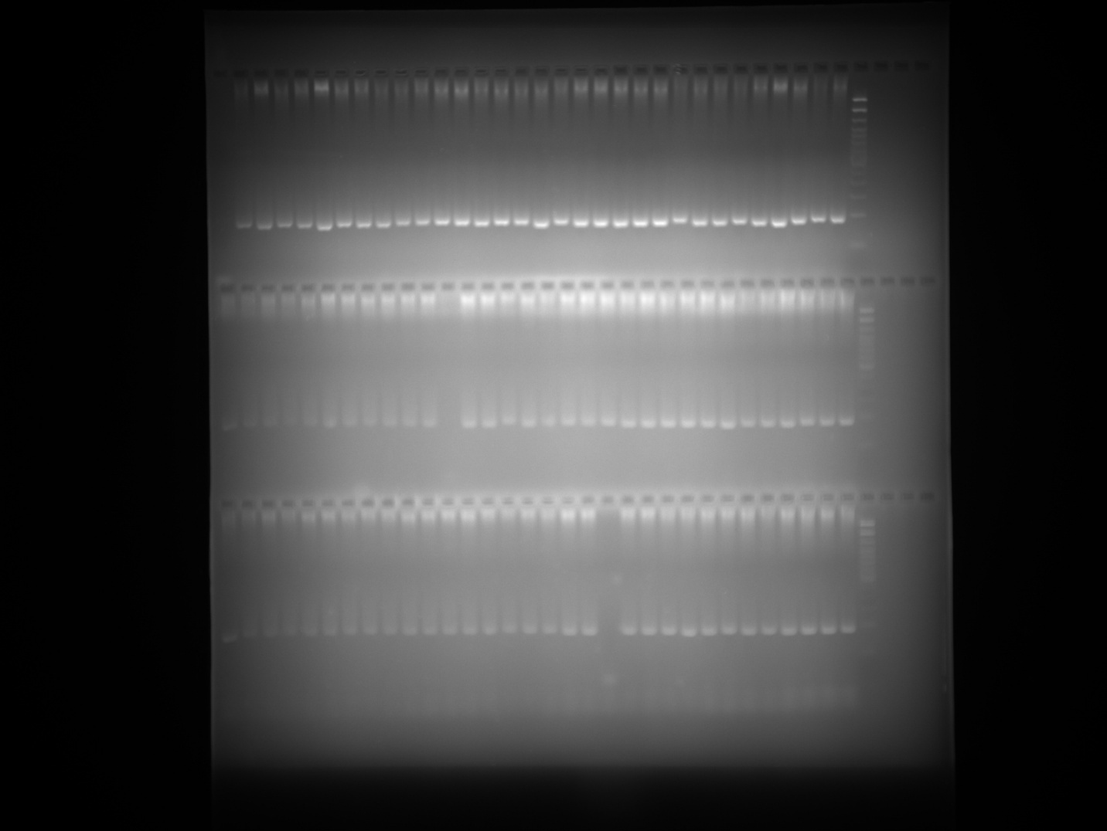

EPMS 404 Plate 3
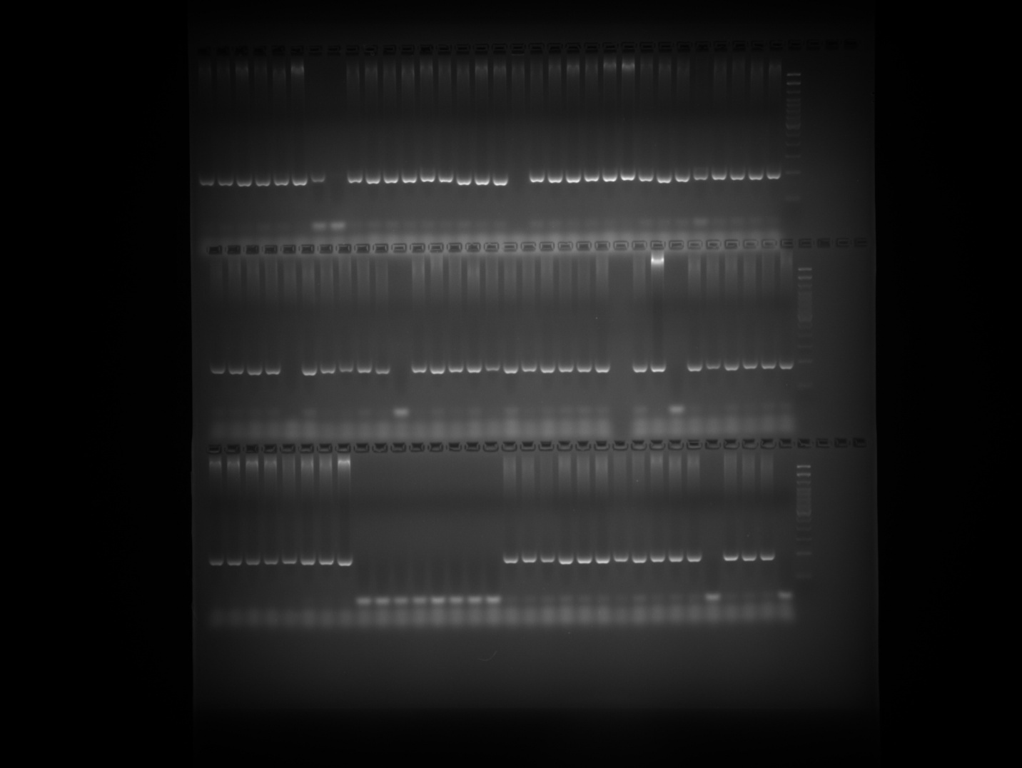

EPMS 404 Plate 4
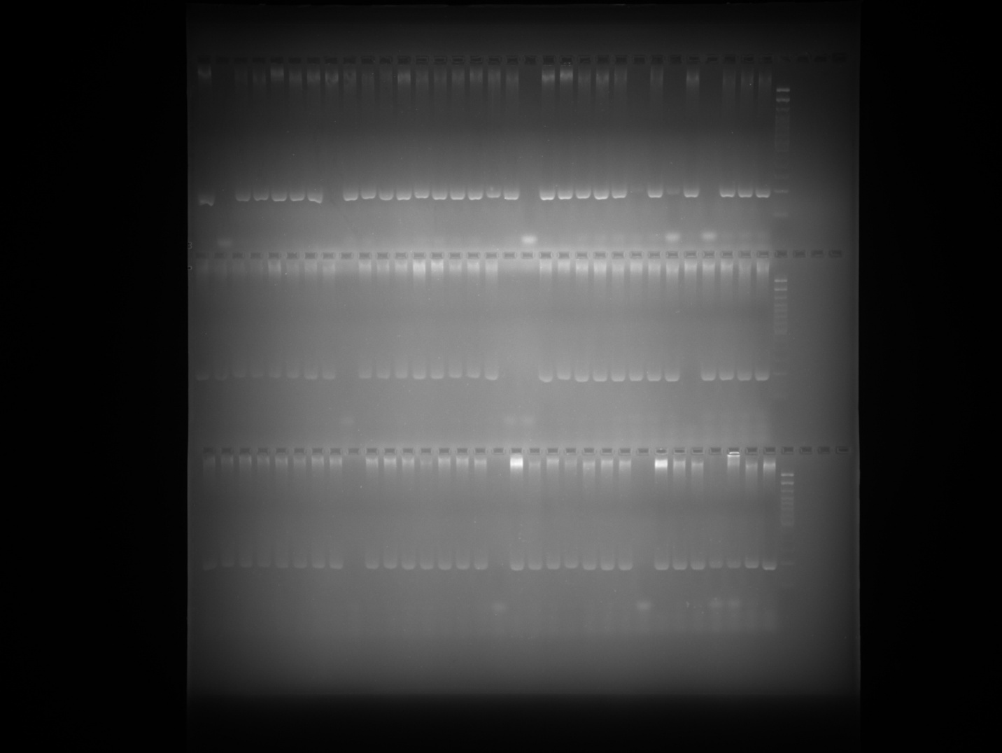

EPMS 404 Plate 5
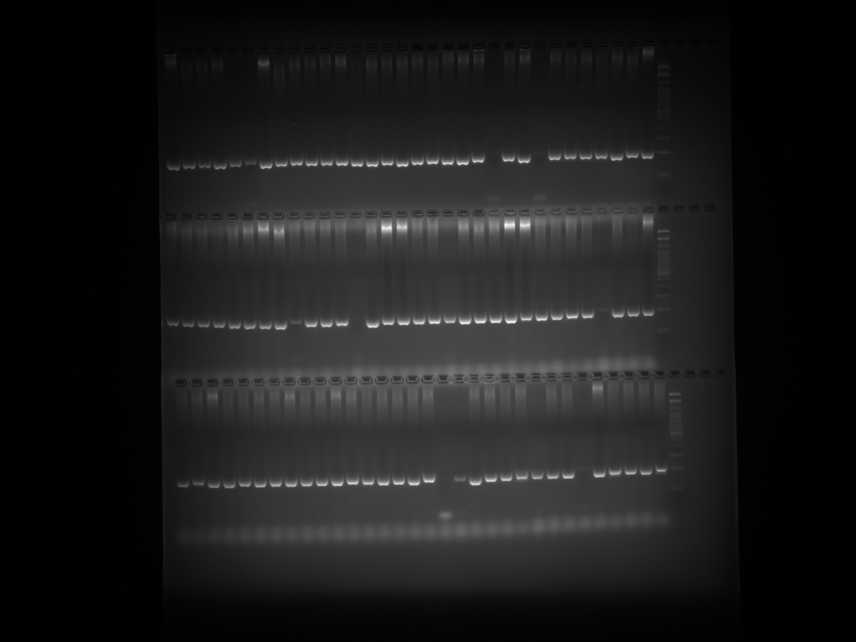

EPMS 542 Plate 1
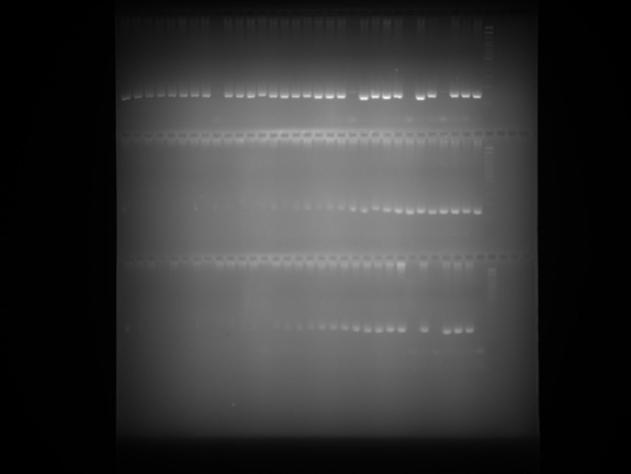

EPMS 542 Plate 1 repetition (row 1 and 2)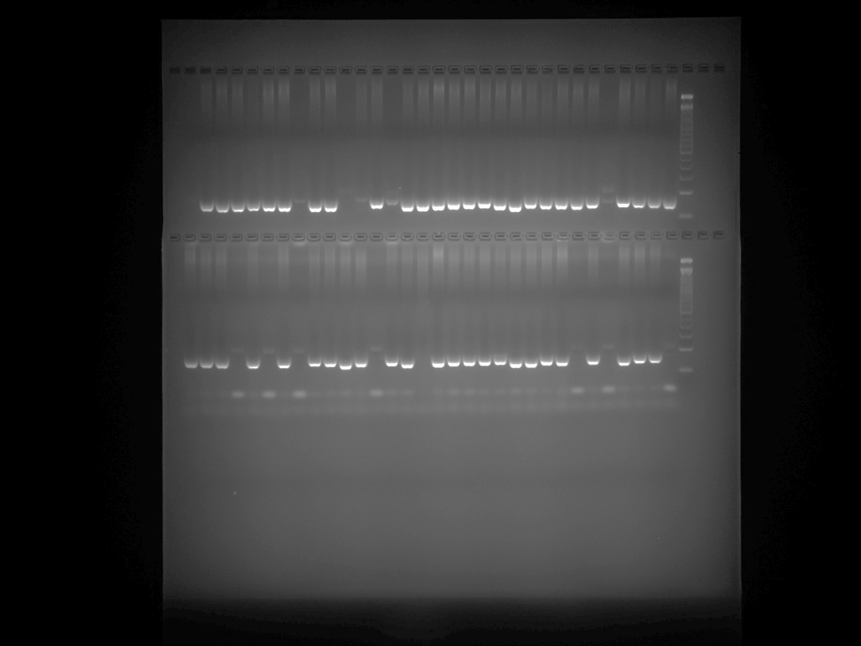

Note: PCR was repeated for the samples belonging to Row 2 and 3 of EPMS 542 Plate 1 gel image and presented in the above gel image at row 1 and 2 respectively.

EPMS 542 Plate 2
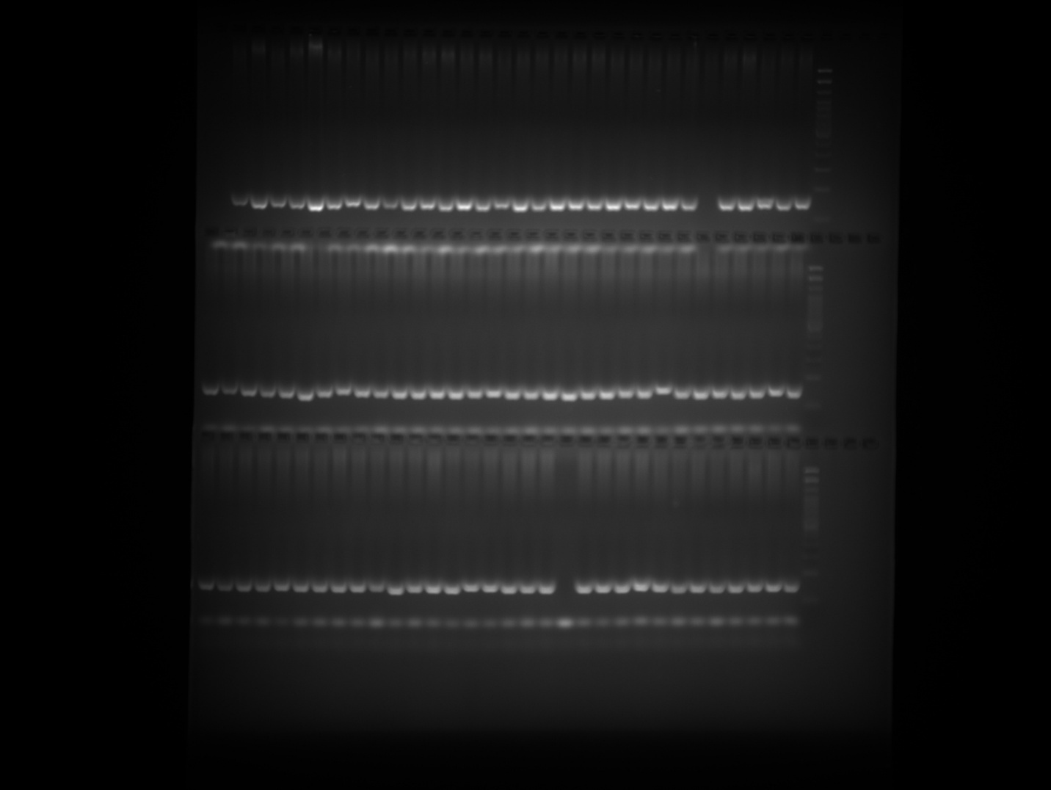

EPMS 542 Plate 3
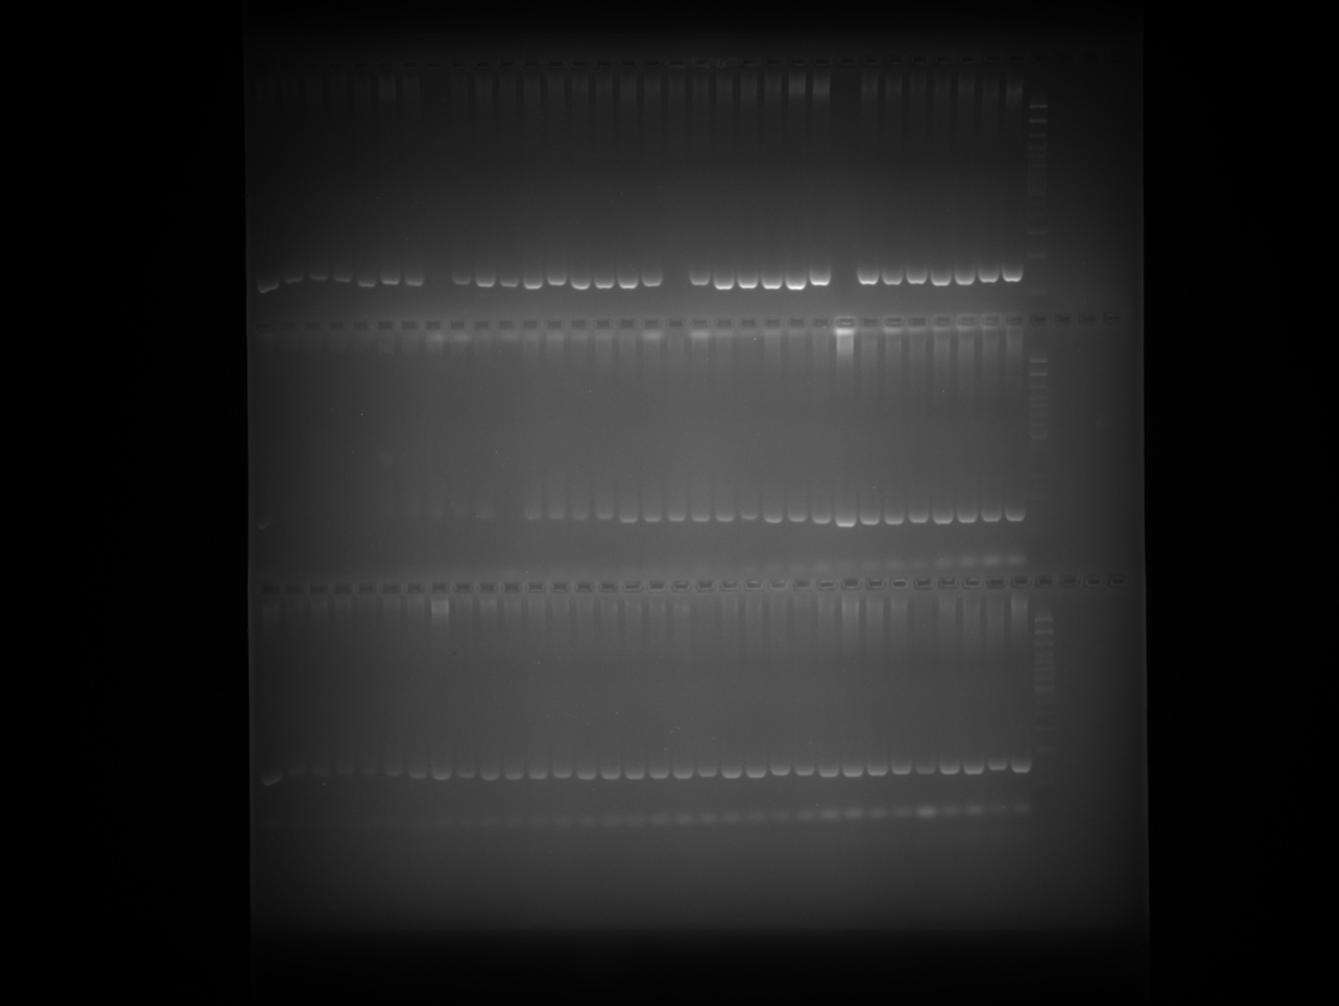

EPMS 542 Plate 4
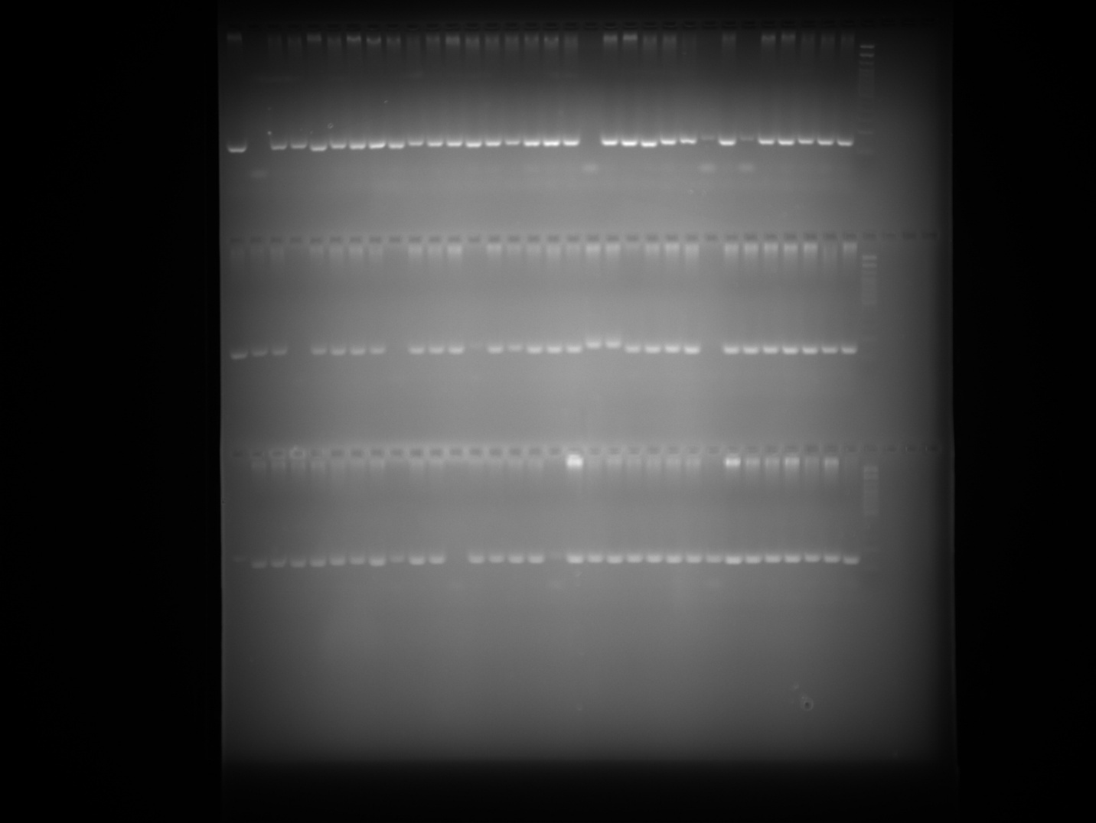

EPMS 542 Plate 5
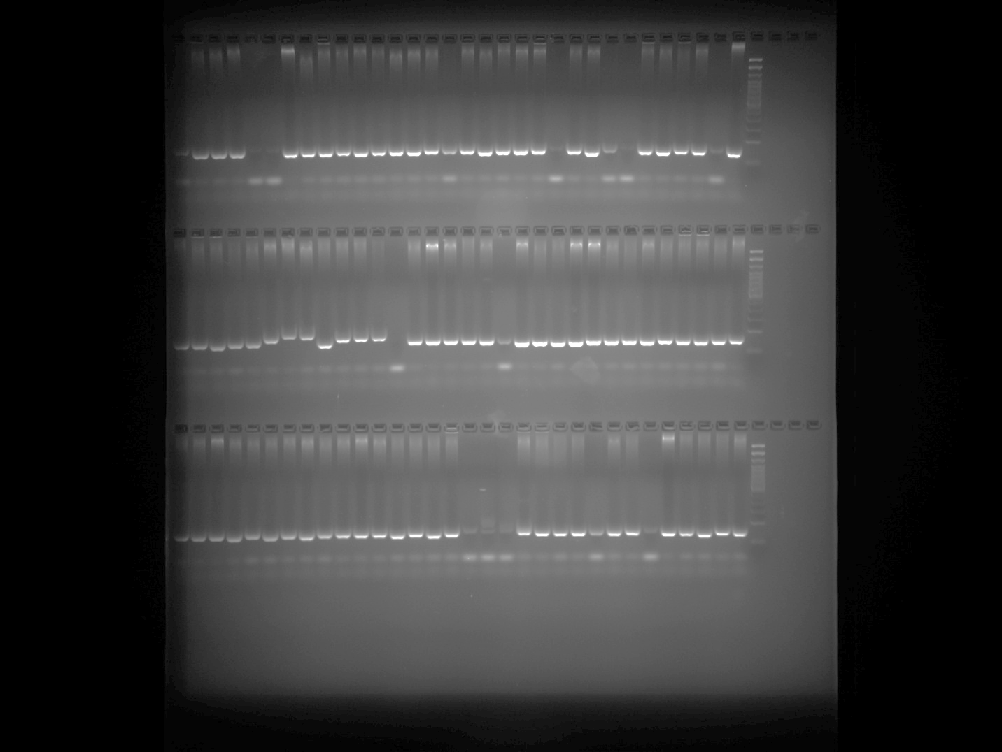

GPMS 112 Plate 1
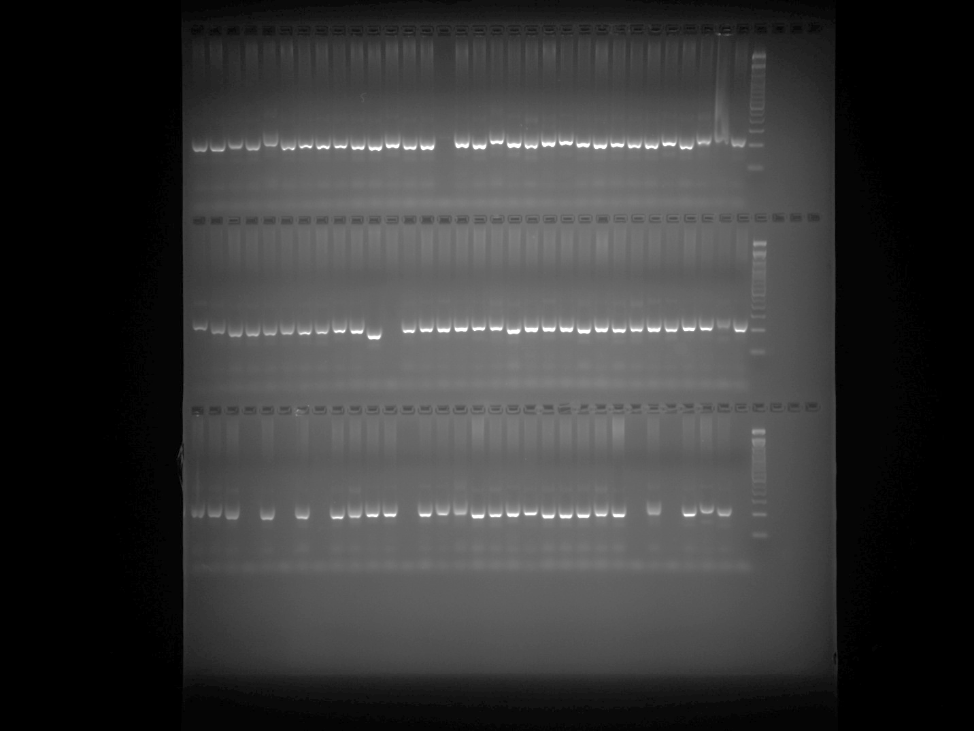

GPMS 112 Plate 2
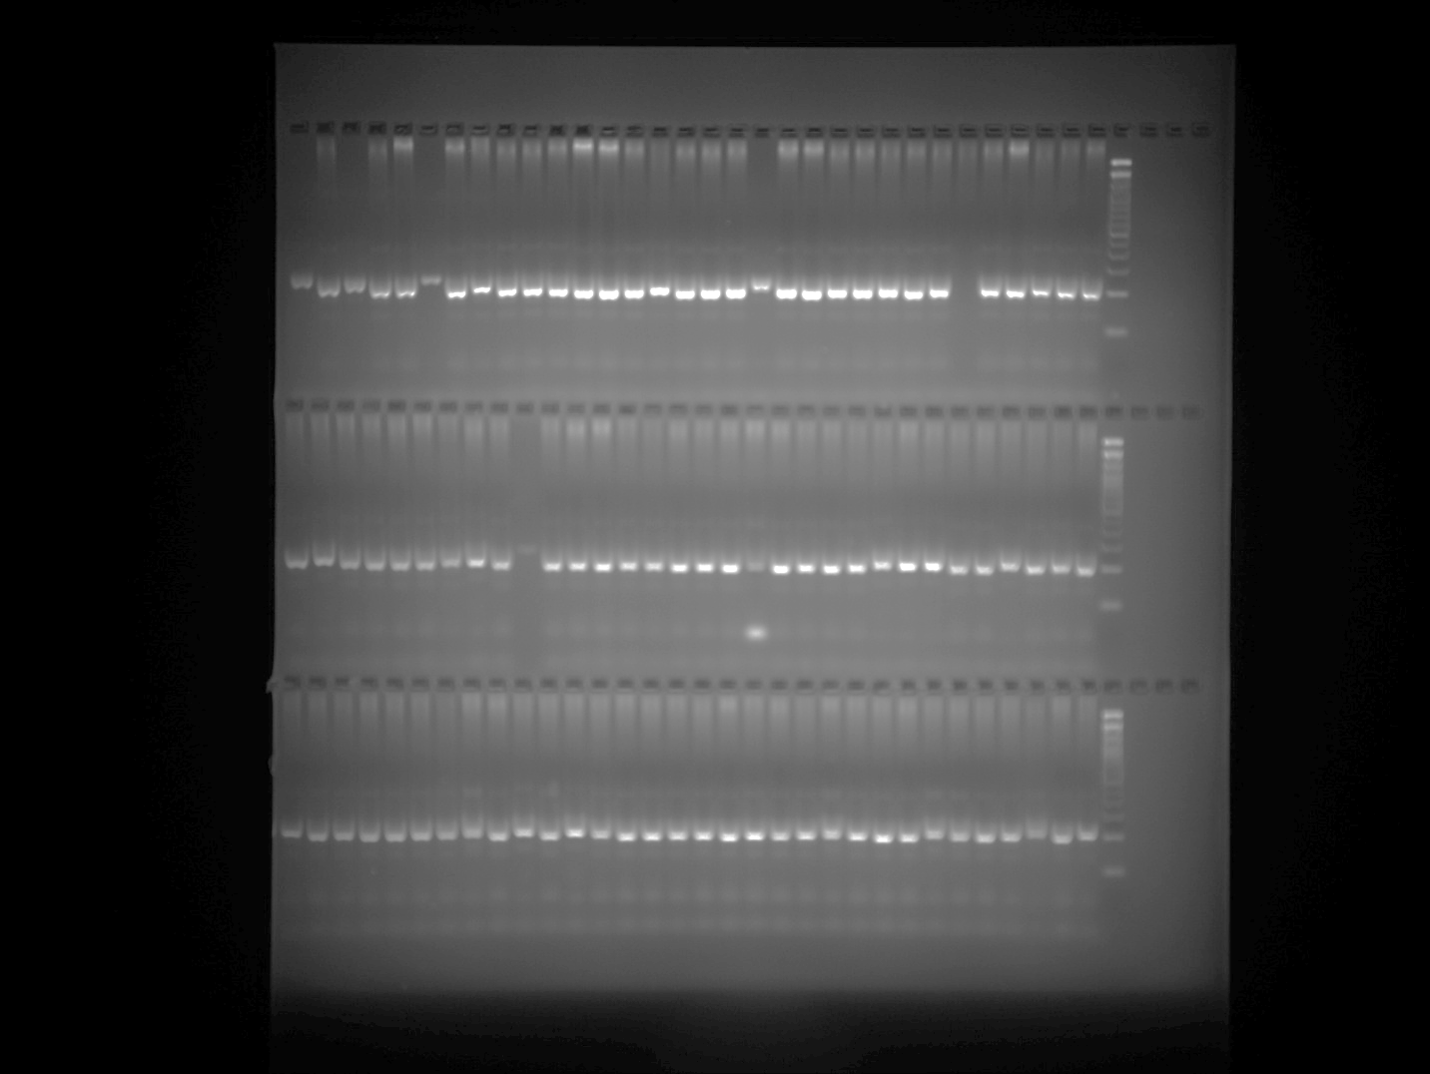

GPMS 112 Plate 3
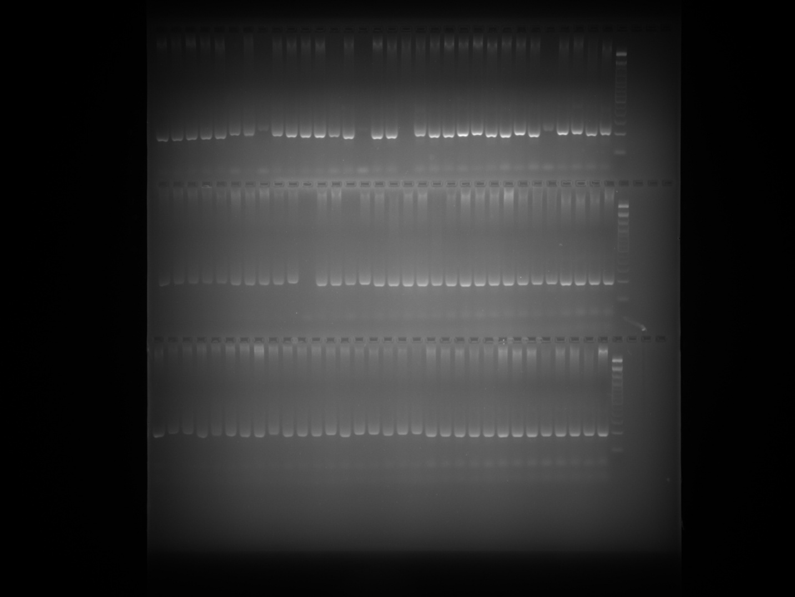

GPMS 112 Plate 4
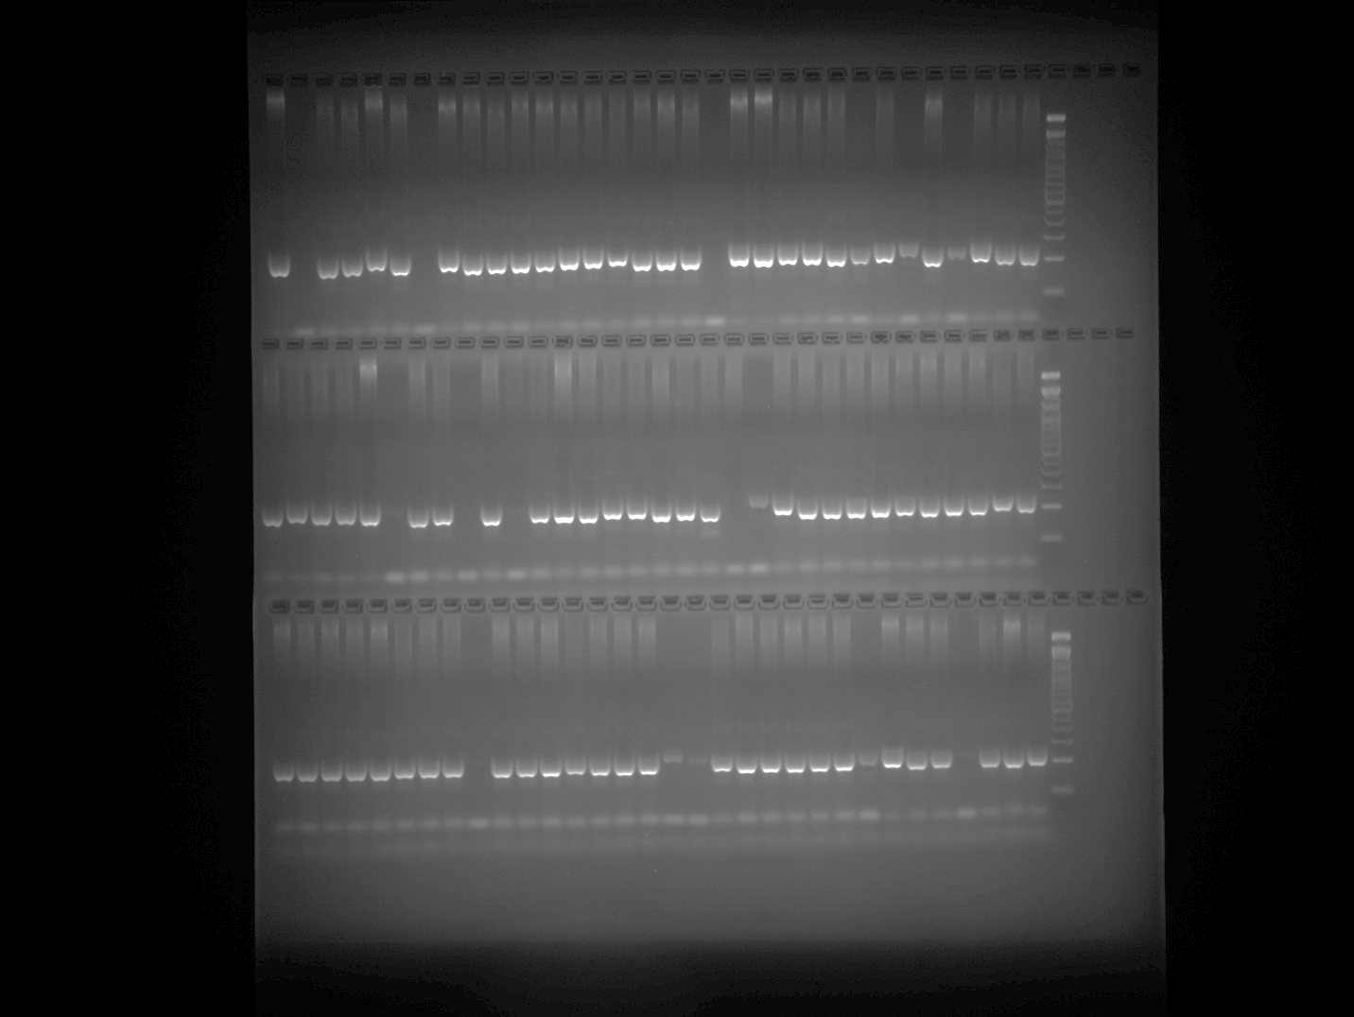

GPMS 112 Plate 5
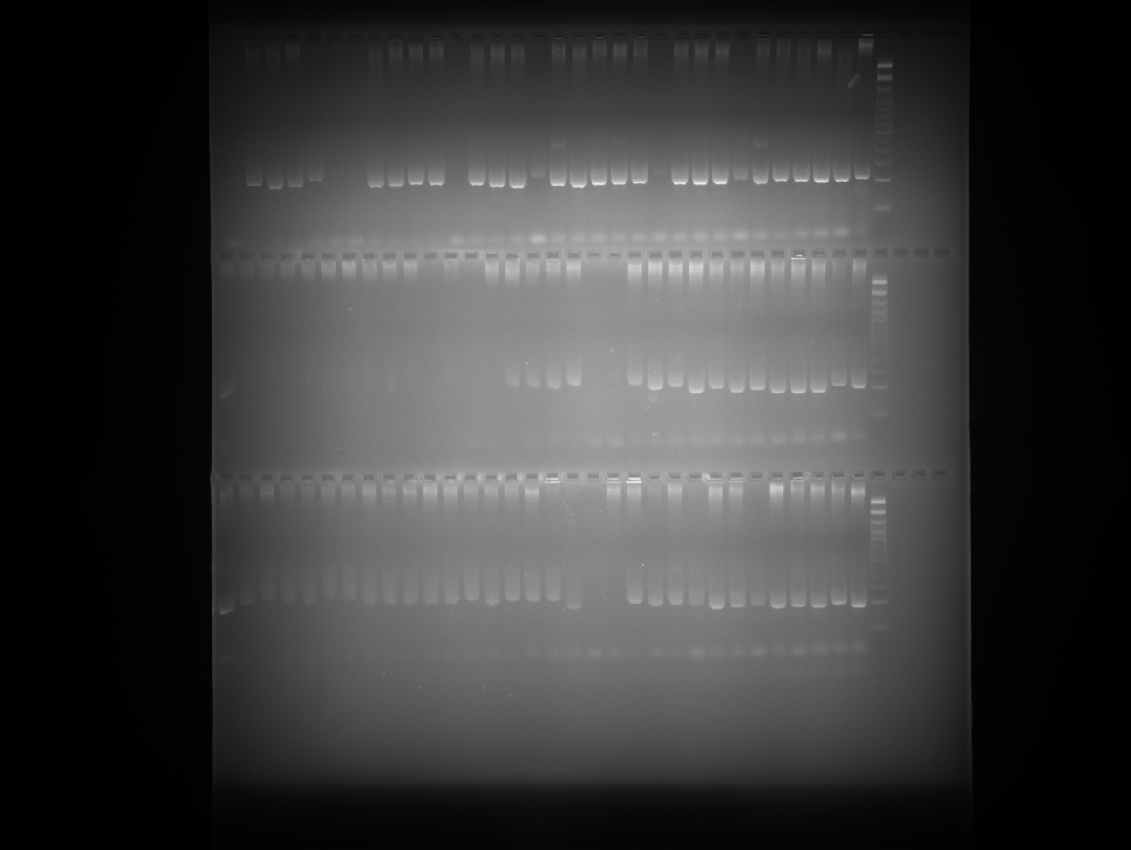

Hpms1-117 Plate 1
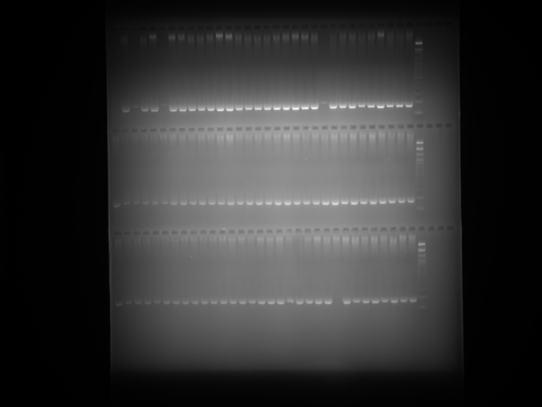

Hpms1-117 Plate 2
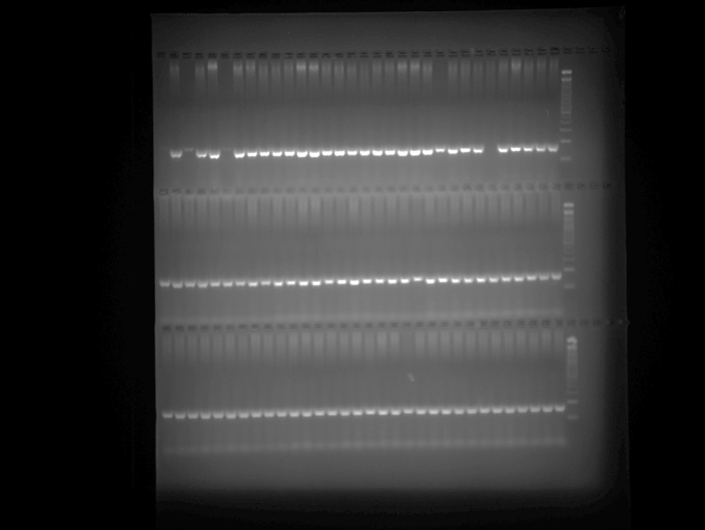

Hpms1-117 Plate 3
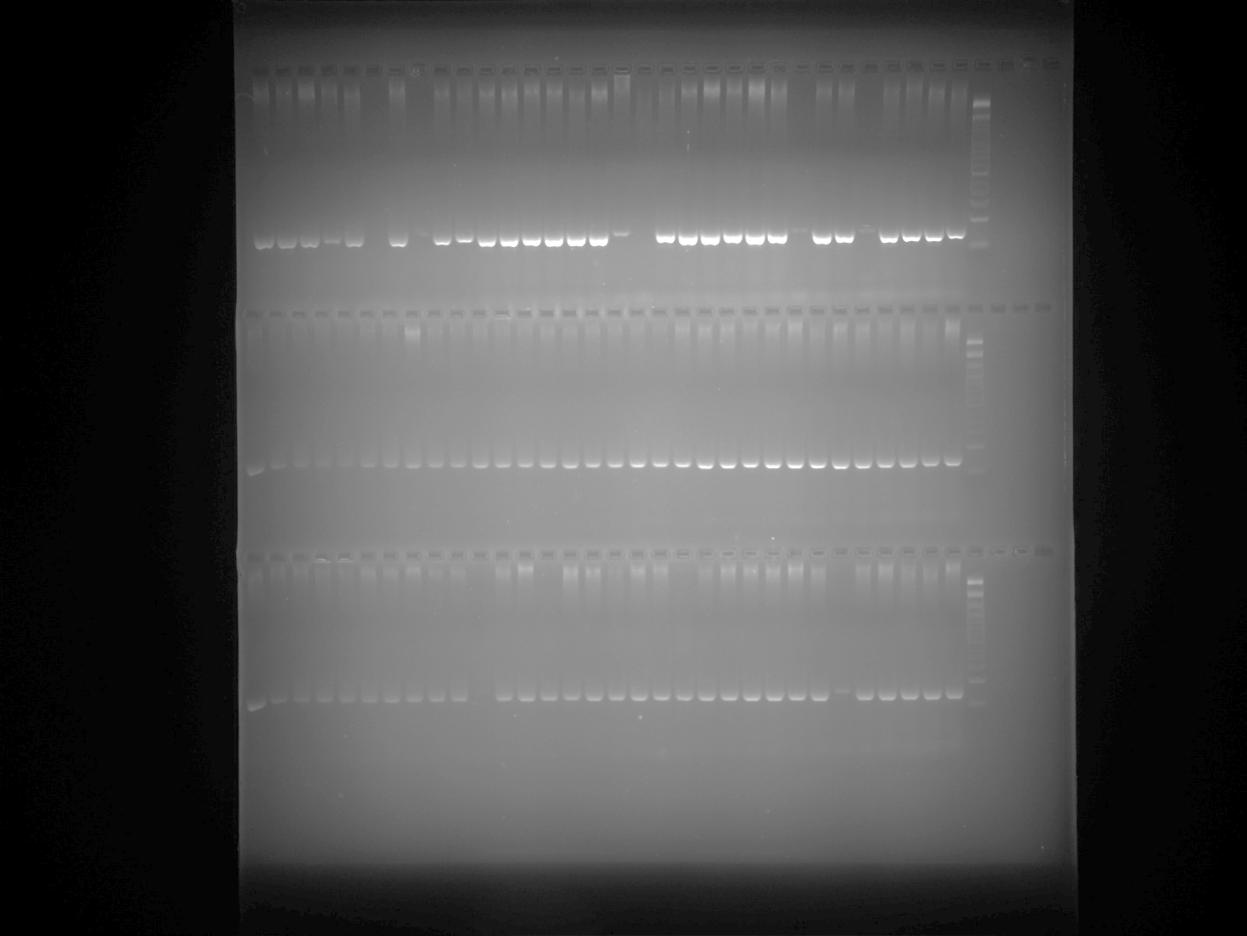

Hpms1-117 Plate 4
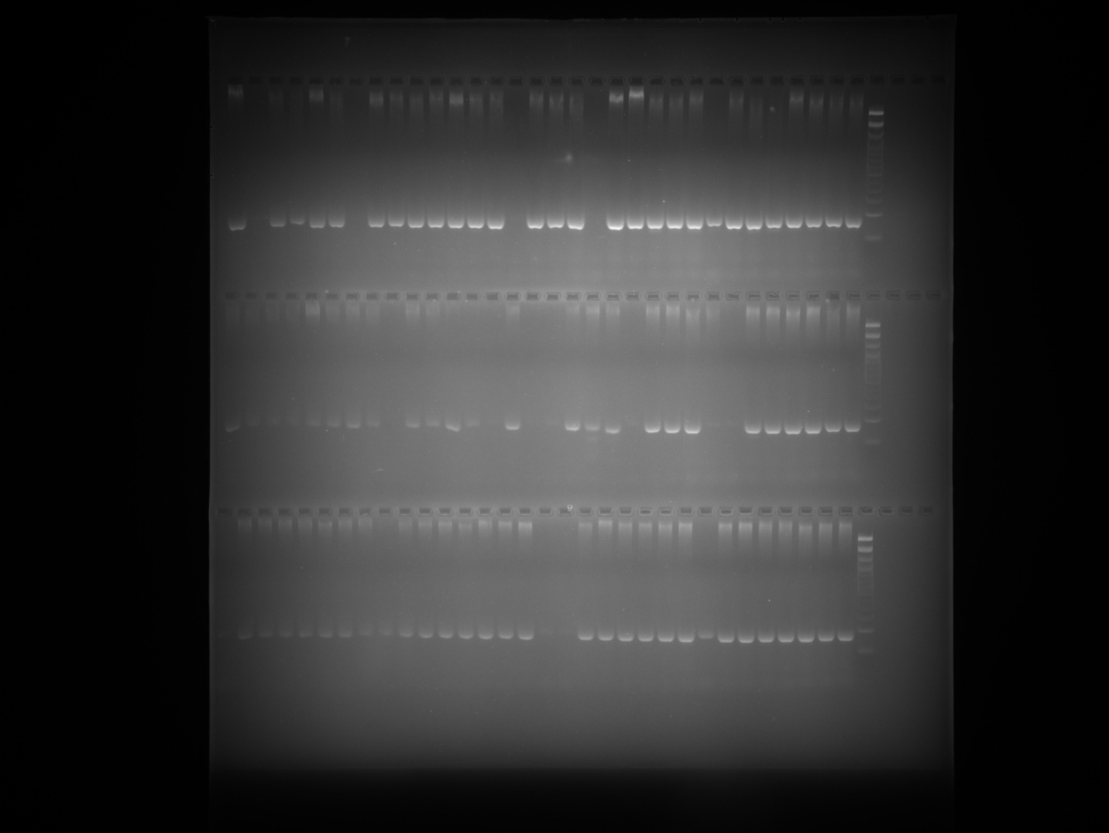

Hpms1-117 Plate 5
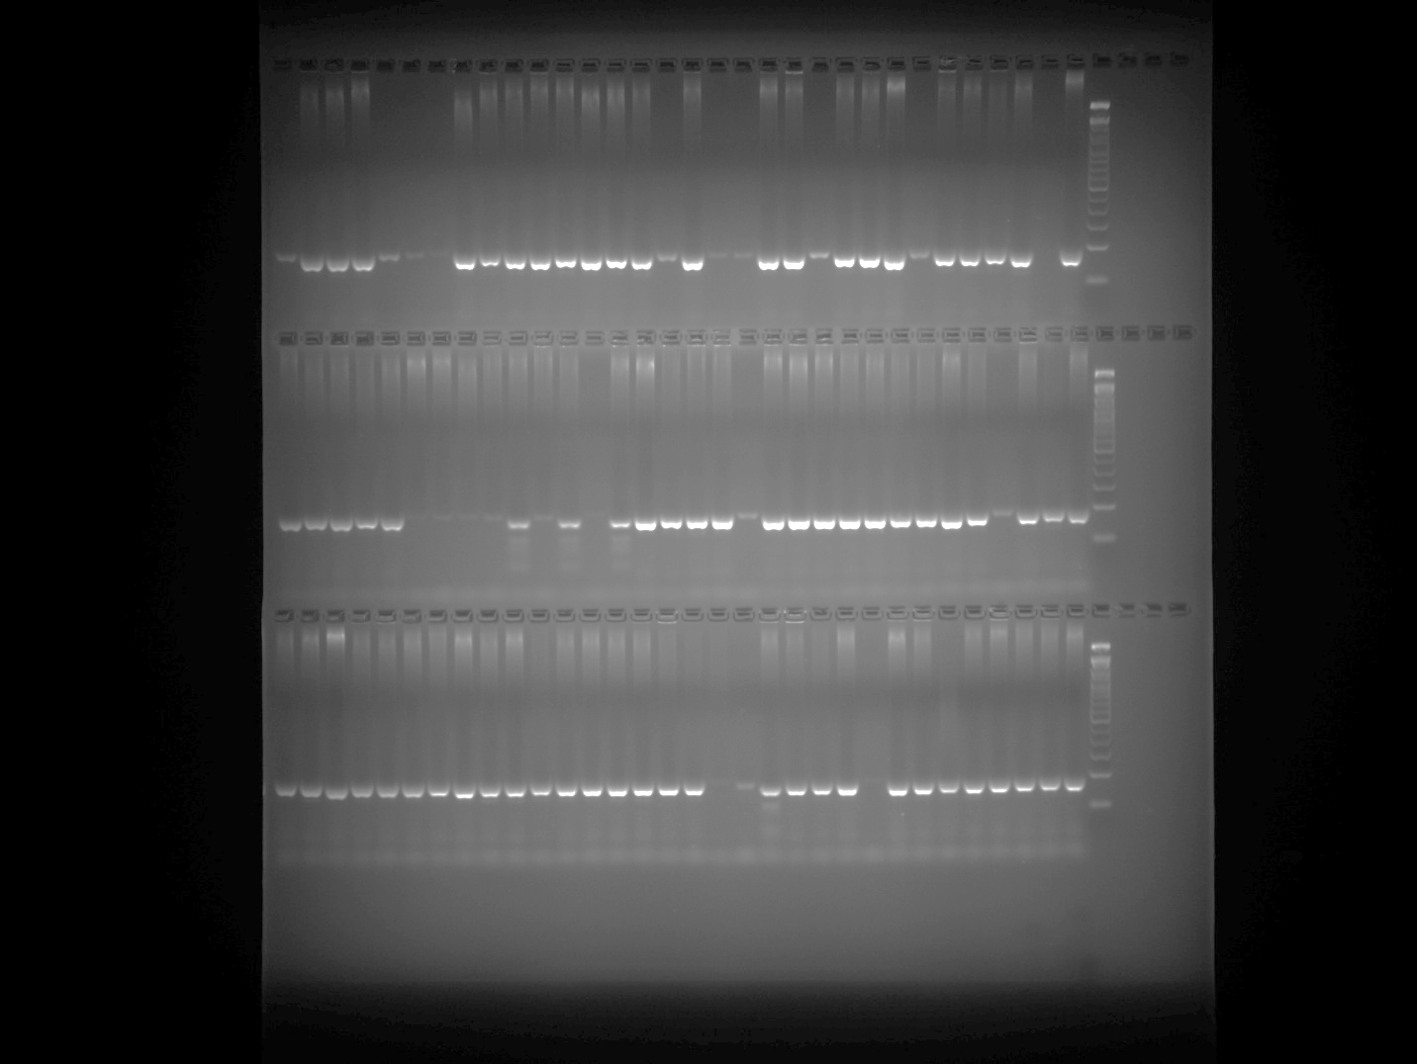

Hpms2-2 Plate 1
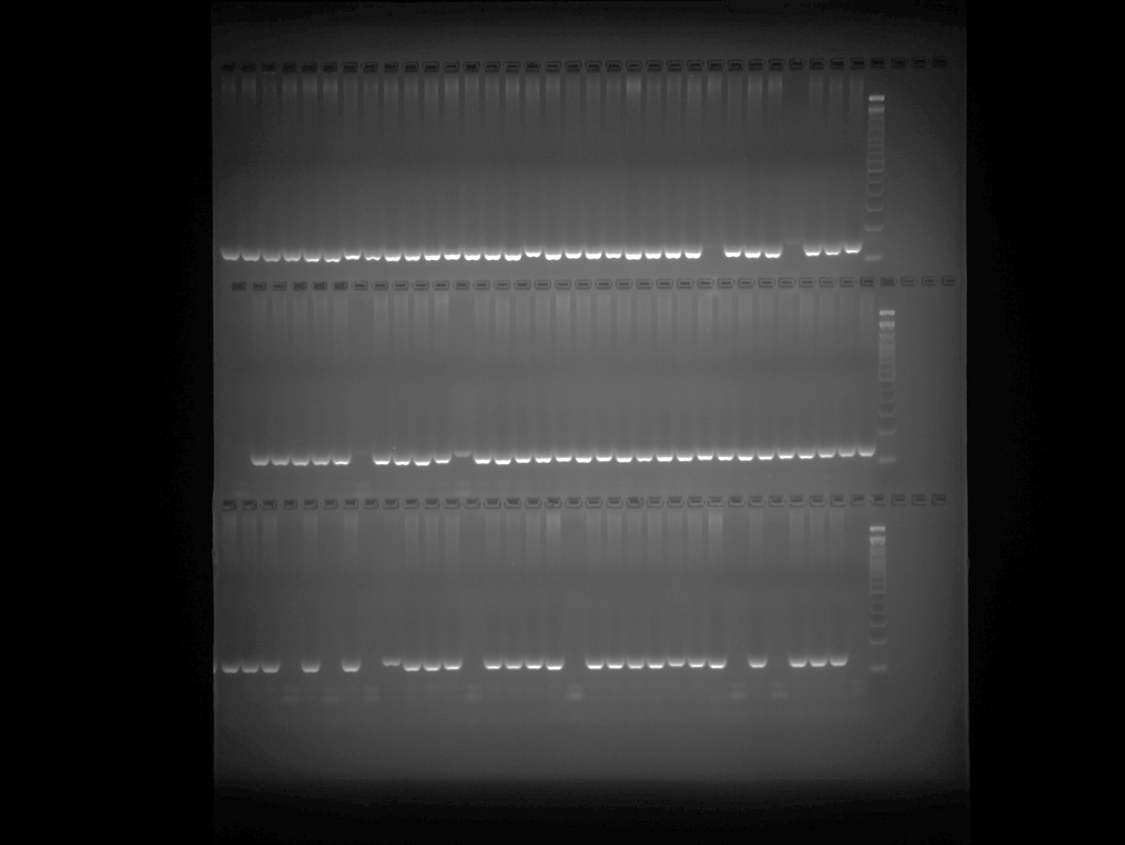

Hpms2-2 Plate 2
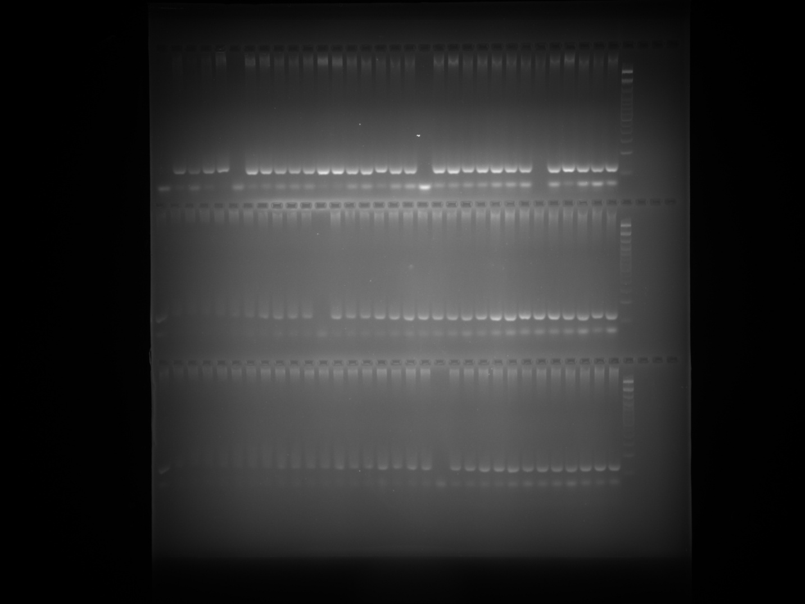

Hpms2-2 Plate 3
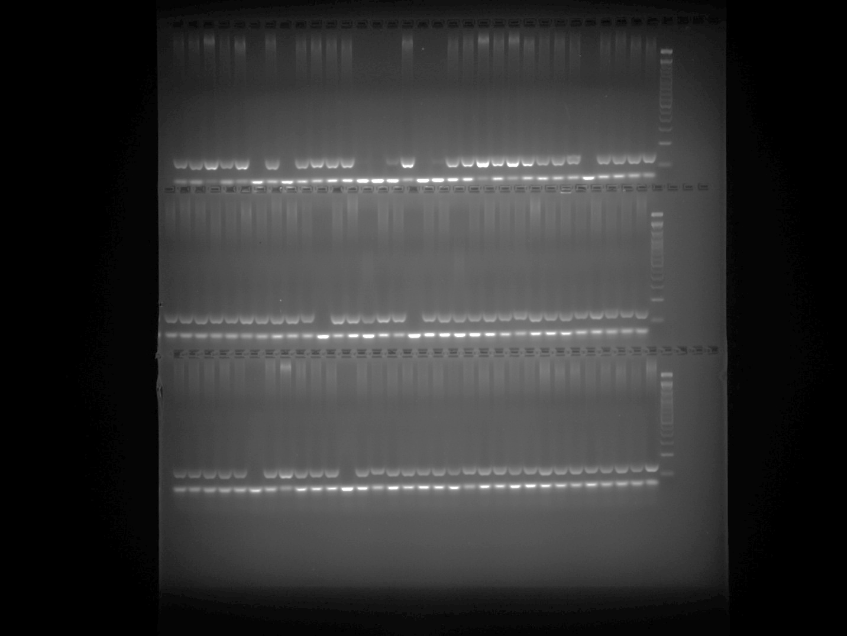

Hpms2-2 Plate 4
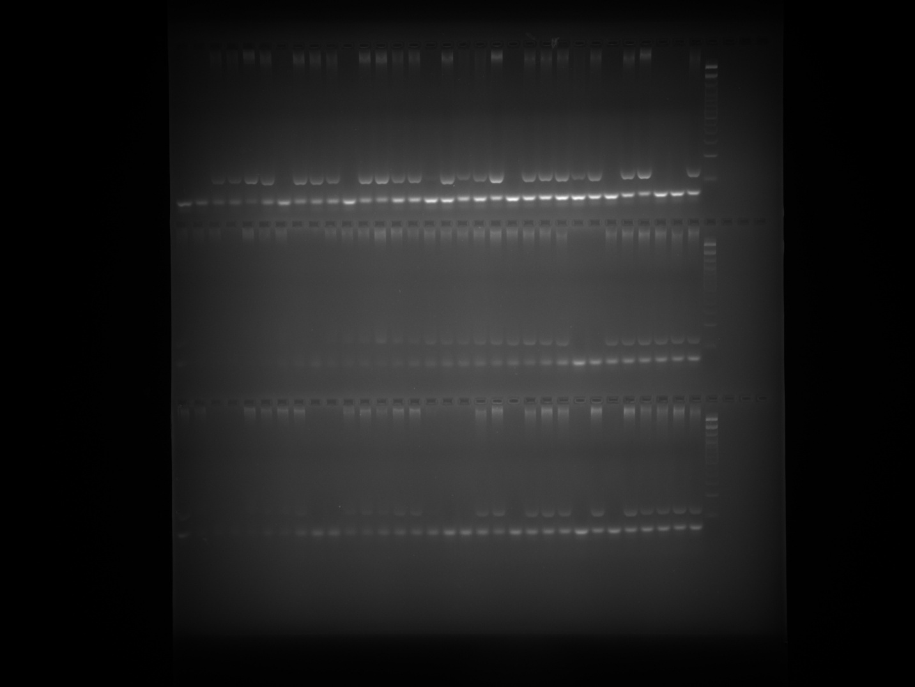

Hpms2-2 Plate 5
