- Figure1
- Figure 1A, panel 1 (METTL14) 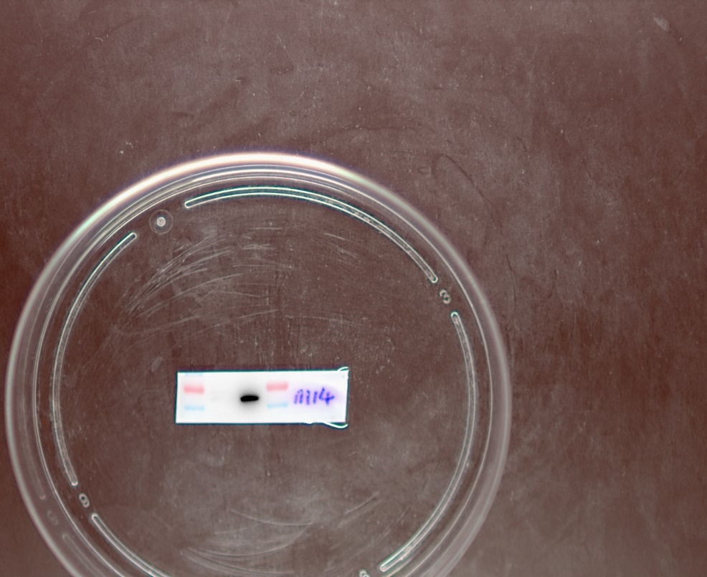
- Figure 1A, panel 2(GAPDH)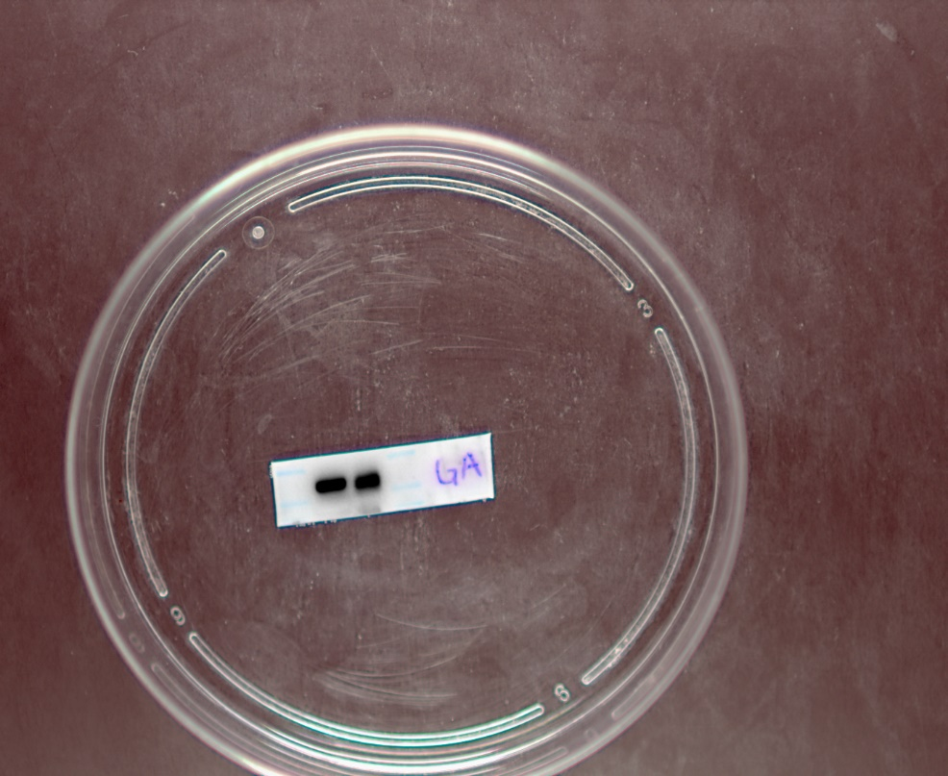
- Full-length gel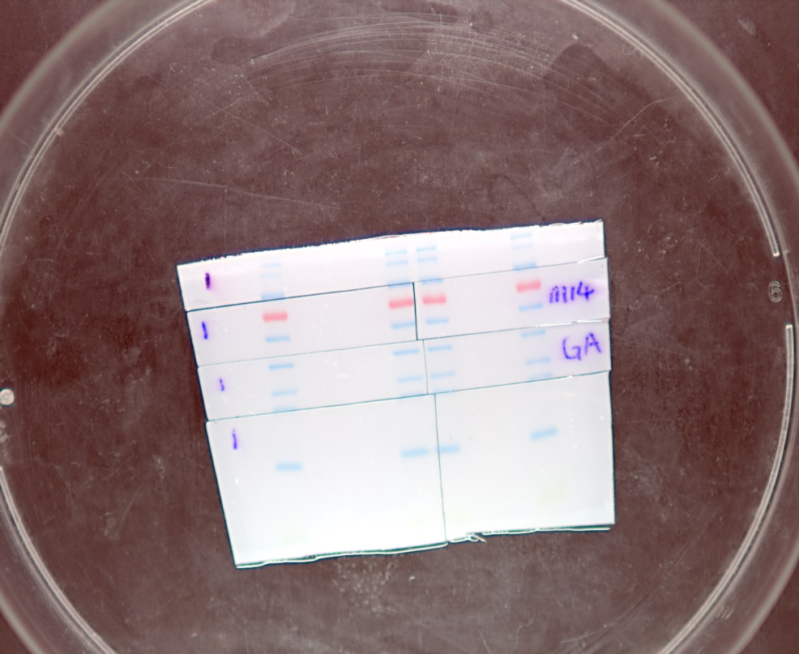

- Figure2
- Figure 2A, panel 1 (METTL14)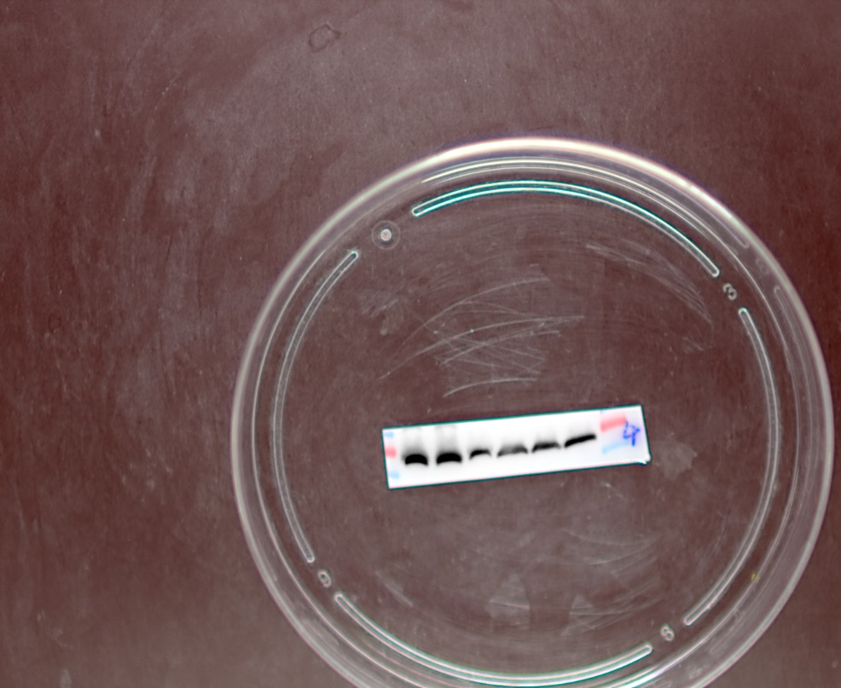
- Figure 2A, panel 2 (GAPDH)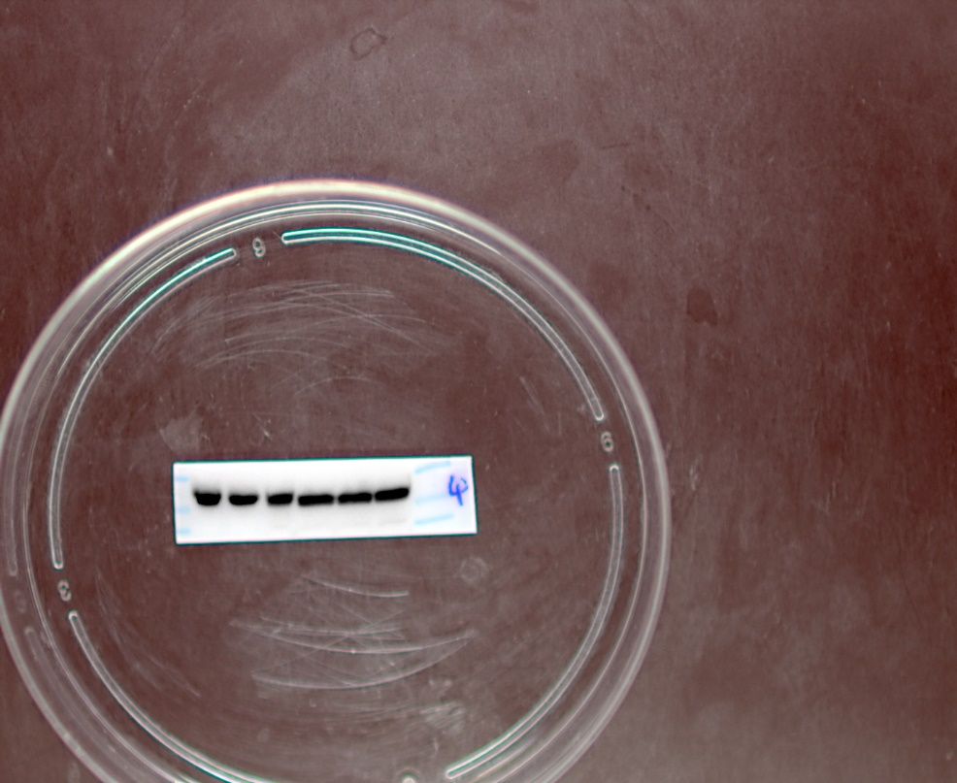
- Full-length gel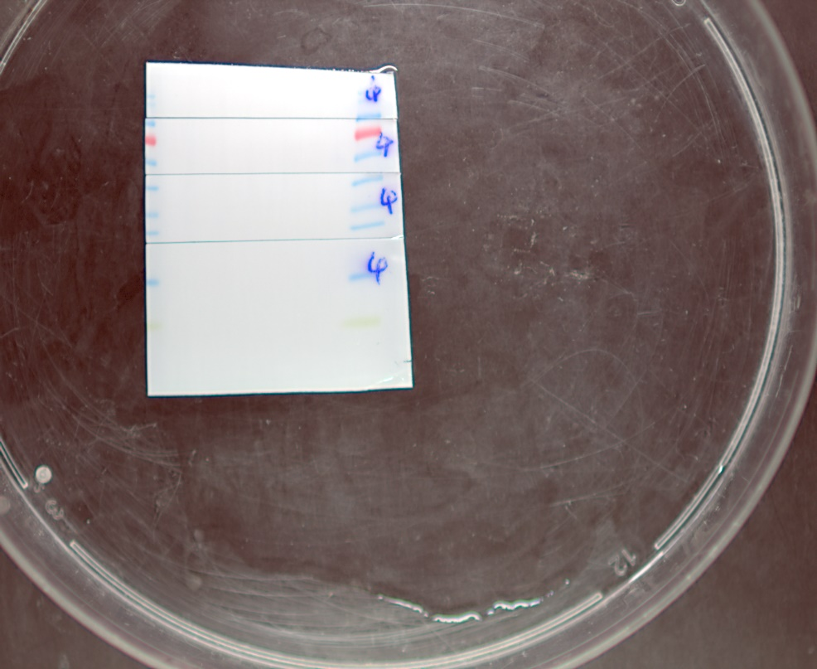

- Figure9- MMP9
- Figure 9B , panel 1 (MMP9)
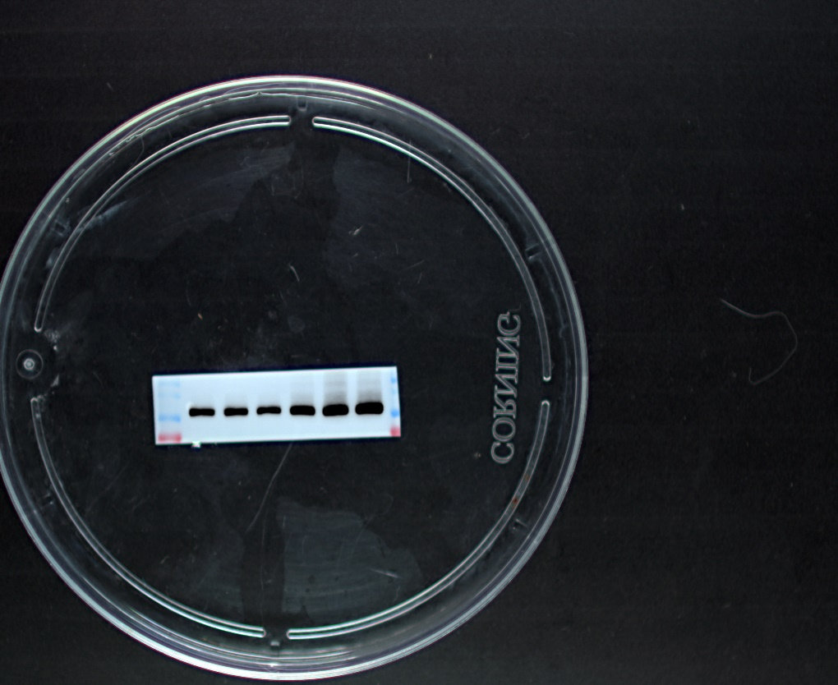
- Figure 9B, panel 2 (GAPDH)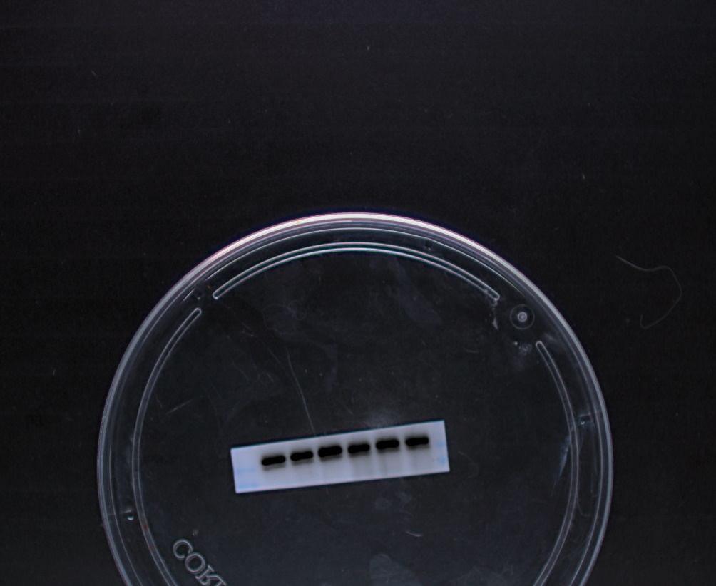
- Full-length gel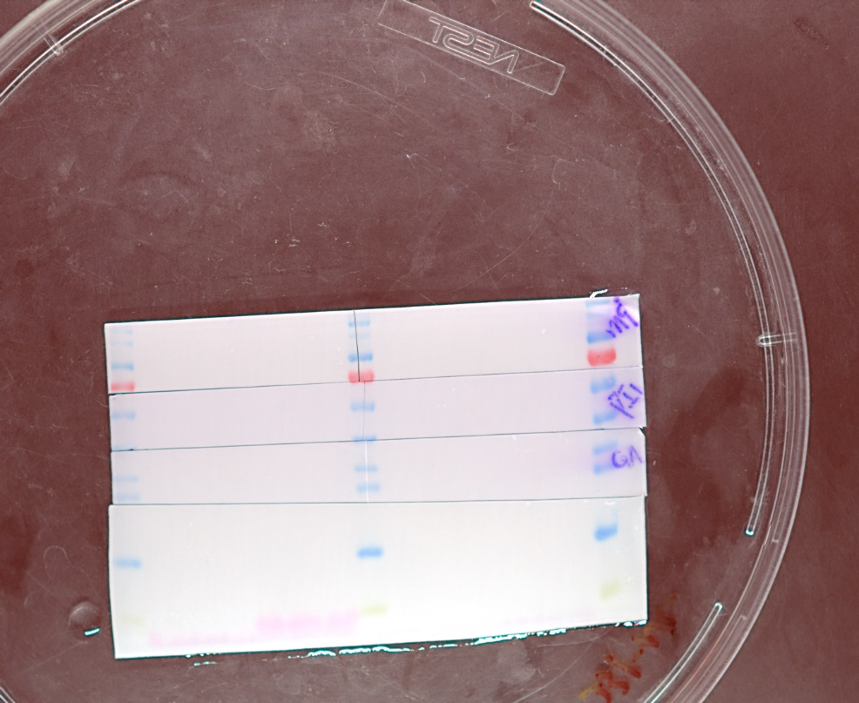

四. Figure9- SERPINE1
1. Figure 9B , panel 1 (SERPINE1)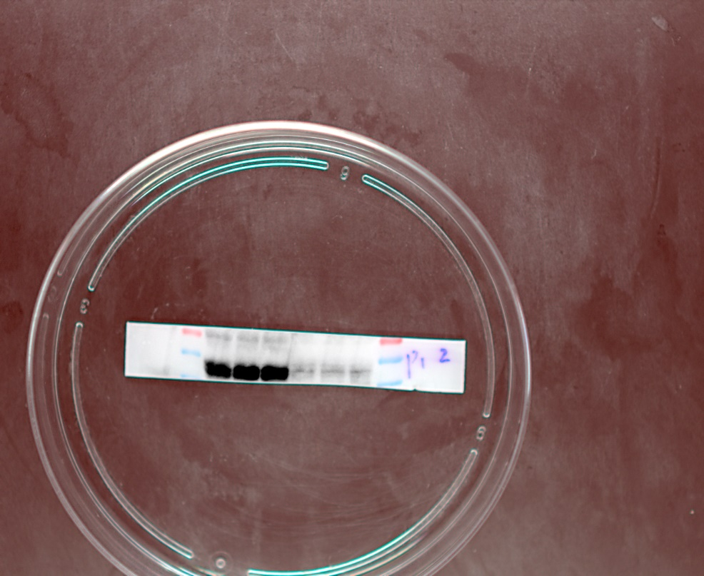
2. Figure 9B , panel 2 (GAPDH)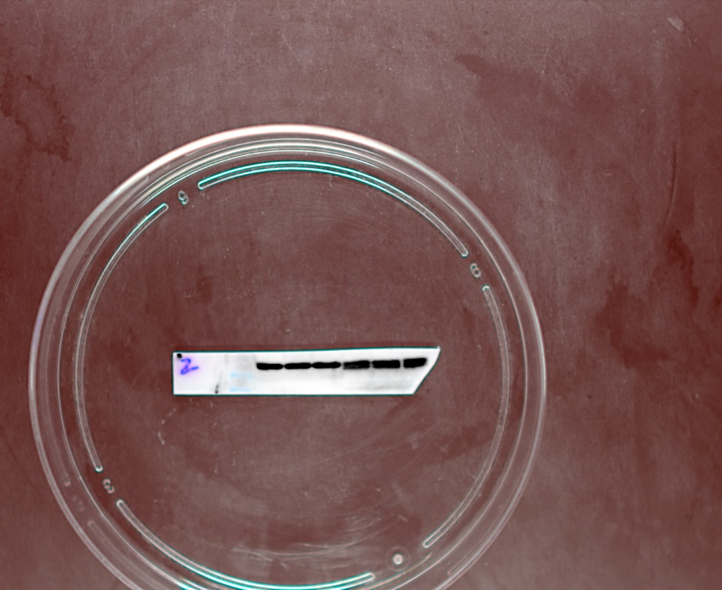
3.Full-length gel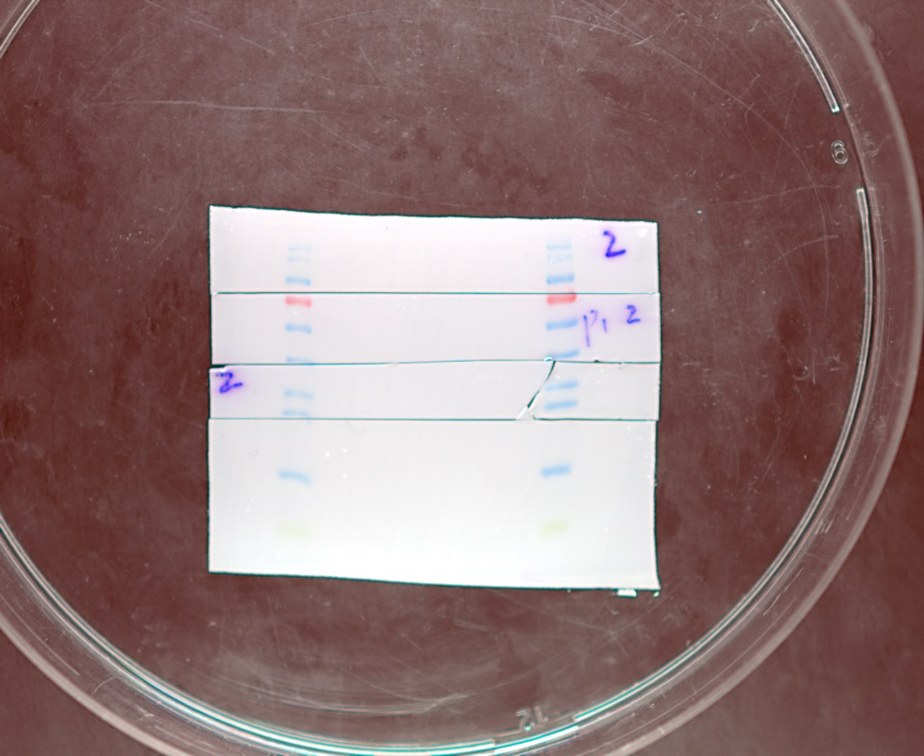

五. Figure9- AGT
1. Figure 9B , panel 1 (AGT)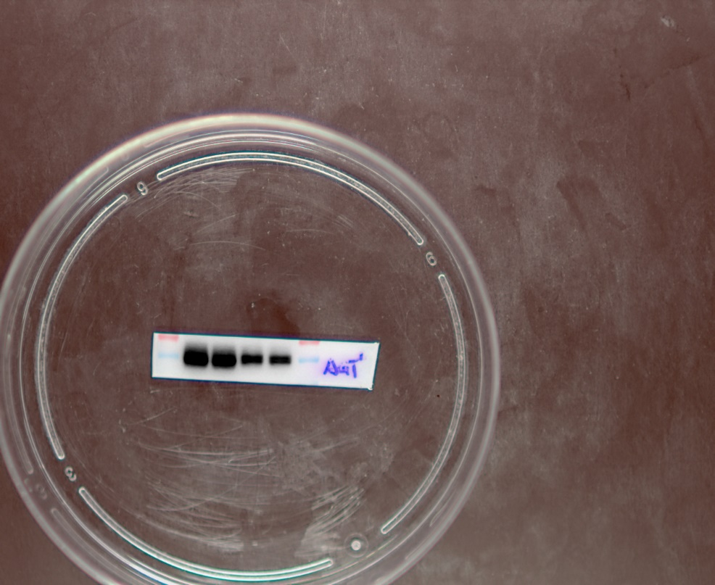
2. Figure 9B , panel 2 (GAPDH)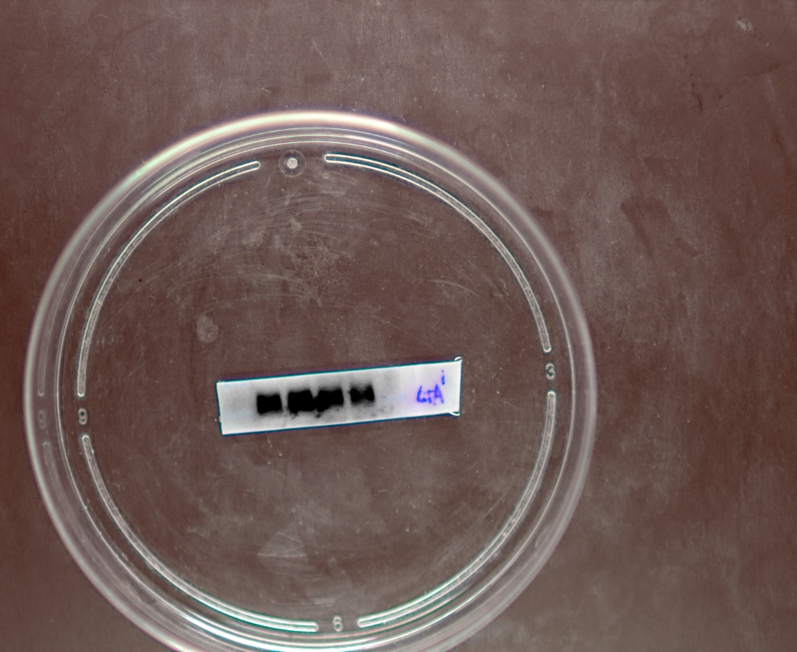
3.Full-length gel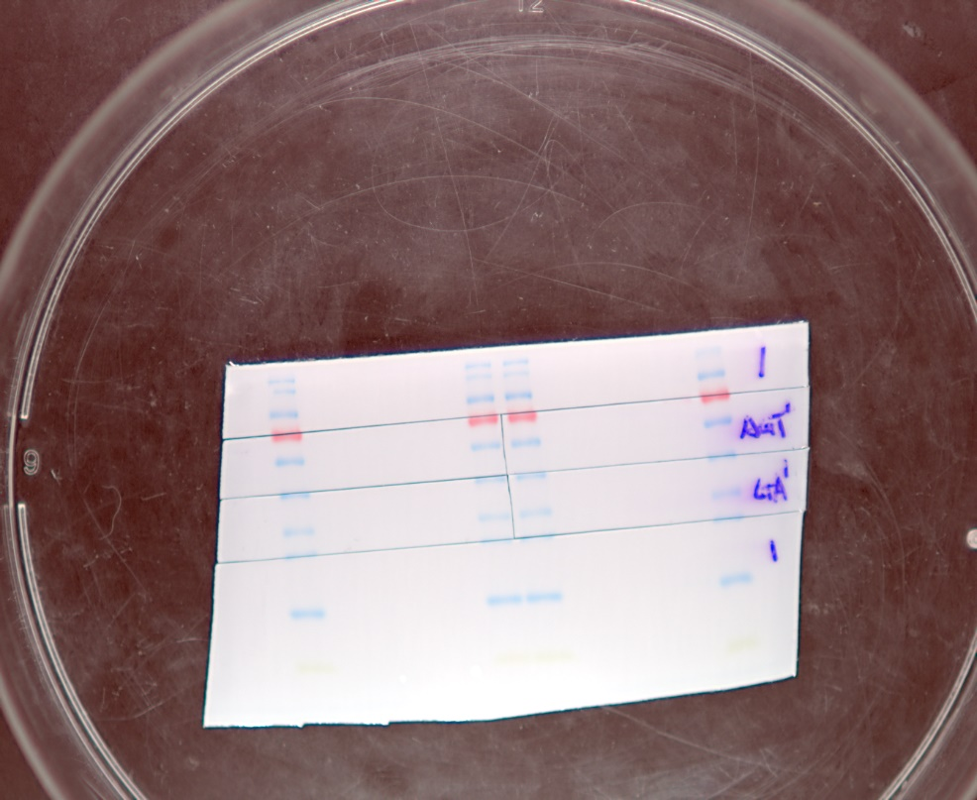

六. Figure9- HMOX1
1. Figure 9B , panel 1 (HMOX1)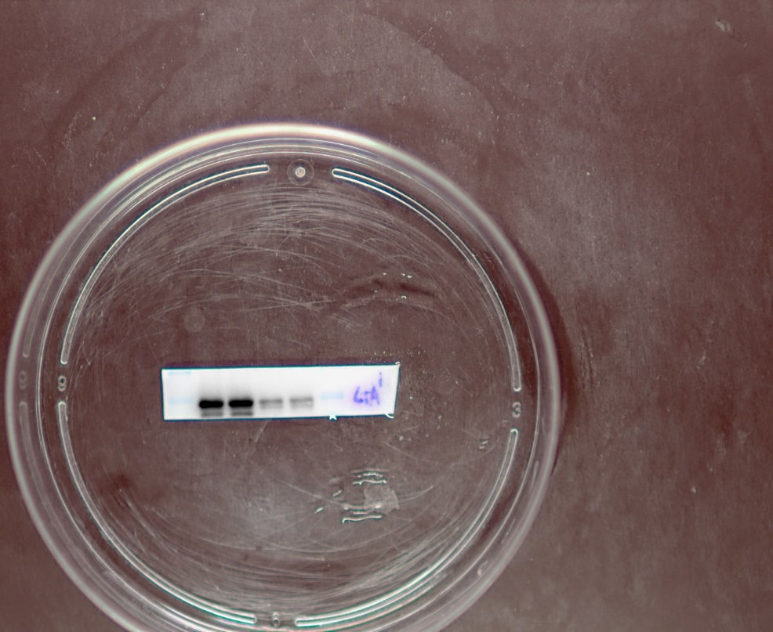
2. Figure 9B , panel 2 (GAPDH)
3. Full-length gel

