Supplementary Material
This supplementary material contains:

Tables
Table S1: Table showing coordinates of camera traps in 2023 and their detections of cats.
Table S2: Table showing coordinates of camera traps in 2021 and their detections of cats
Table S3: Table showing cat detections per individual, for 2021 and 2023.
Table S4: Table showing per camera detections of prey and other animals for the 2023 survey.
Table S5: Table showing per-camera detections of prey and other animals for the 2021 survey.
Table S6: Details of the environmental covariables measured for the 2023 study.
Table S7: Summary of Spatially Explicit Capture-Recapture model using a buffer of 1700 m around each detector.
Table S8: Summary of Spatially Explicit Capture-Recapture model using a buffer of 1200 m around each detector.
Table S9: Summary of different models tested regarding the different random effects and offset tested for 2023 data. Model selected based on R² and AIC_{c} value, describing domestic cat abundance and activity.
Table S10: Summary of most Generalised Linear Mixed Model parsimonious models (<2 AIC from the best fitted model) included in the average model of 2023 data, describing free-ranging cat abundance and activity.
Table S11: Generalised Linear Mixed Model average model explaining the abundance and activity of free-ranging cats for 2023 data. The estimate, standard error, Z value and confidence intervals are indicated for the intercept and environmental variables included in the models.
Table S12: Summary of the Structural Equation Model for cat activity and rodent activity as response variables
Table S13: Summary of the Structural Equation Model for cat abundance and rodent activity as response variables

Figures
Figure S1: Cumulative detection curves showing the number of individuals detected per trapping-day and number of occasions cameras were recording in 2021 and 2023.
Figure S2: Image from the 2023 camera trap survey showing a cat predating a pregnant rat.
Figure S3: AICc scores and plot of density estimates from Half-normal (HN), Exponential (EX) and Hazard-rate (HR) detection functions depending on buffer weight. 1700 m buffer.
Figure S4: AICc scores and plot of density estimates from Half-normal (HN), Exponential (EX) and Hazard-rate (HR) detection functions depending on buffer weight. 1200 m buffer.
Figure S5: Principal Component Analysis circle of correlations plot, showing the trend for “vegetation simplification”, used in subsequent Generalised Linear Mixed Models and Structural Equation Models.
Figure S6: Generalised Linear Model plots showing the change in relationship between cat activity and food-dist between study periods.
Figure S7: DHARMA Residual plots for the most significant 2021 Generalised Linear Mixed Models for cat activity and abundance.
Figure S8: DHARMA Residual plots for the most significant 2023 Generalised Linear Mixed Models for cat activity and abundance.

Tables

Table S1: Table describing the location of camera traps used in the 2023 study. XY coordinates for traps are given, as well as the total detections for each camera of identified and unidentified cats. Sites marked with a * are those for which unidentifiable cats were detected.
Grid | Site | Nights | Latitude | Longitude | Detections | Individuals | Not Identified
1 | 1.1* | 21 | -16.929 | 32.7318 | 10 | 3 | 2
1 | 1.2 | 21 | -16.924 | 32.7248 | 2 | 2 | 0
1 | 1.3* | 21 | -16.93 | 32.7271 | 5 | 3 | 1
2 | 2.1* | 21 | -16.914 | 32.7158 | 3 | 2 | 2
2 | 2.2 | 21 | -16.917 | 32.7209 | 7 | 2 | 0
2 | 2.3 | 21 | -16.926 | 32.7236 | 0 | 0 | 0
3 | 3.1 | 21 | -16.906 | 32.7176 | 2 | 1 | 0
3 | 3.2 | 23 | -16.913 | 32.72 | 8 | 2 | 0
3 | 3.3 | 21 | -16.912 | 32.7177 | 7 | 2 | 0
4 | 4.1 | 17 | -16.917 | 32.7089 | 24 | 5 | 0
4 | 4.2 | 17 | -16.922 | 32.7065 | 3 | 2 | 0
4 | 4.3 | 17 | -16.916 | 32.7144 | 5 | 2 | 0
5 | 5.1* | 17 | -16.906 | 32.7135 | 19 | 1 | 1
5 | 5.2* | 17 | -16.91 | 32.7106 | 15 | 3 | 1
5 | 5.3* | 17 | -16.904 | 32.7067 | 14 | 3 | 1
6 | 6.1 | 12 | -16.897 | 32.709 | 10 | 2 | 0
6 | 6.2 | 20 | -16.902 | 32.7158 | 0 | 0 | 0
6 | 6.3 | 19 | -16.9 | 32.7079 | 17 | 3 | 0
7 | 7.1 | 17 | -16.914 | 32.6992 | 7 | 2 | 0
7 | 7.2* | 17 | -16.915 | 32.7037 | 16 | 3 | 1
7 | 7.3 | 17 | -16.918 | 32.7063 | 3 | 1 | 0
8 | 8.1 | 17 | -16.911 | 32.7 | 13 | 4 | 0
8 | 8.2* | 17 | -16.911 | 32.7026 | 14 | 3 | 3
8 | 8.3 | 17 | -16.904 | 32.7039 | 17 | 5 | 0
9 | 9.1 | 20 | -16.903 | 32.7029 | 1 | 1 | 0
9 | 9.2 | 20 | -16.9 | 32.706 | 14 | 2 | 0
9 | 9.3 | 20 | -16.9 | 32.7017 | 4 | 3 | 0
10 | 10.1 | 18 | -16.914 | 32.6953 | 1 | 1 | 0
10 | 10.2 | 15 | -16.916 | 32.693 | 4 | 1 | 0
10 | 10.3 | 18 | -16.915 | 32.6892 | 19 | 2 | 0
11 | 11.1 | 17 | -16.9 | 32.6893 | 0 | 0 | 0
11 | 11.2 | 17 | -16.909 | 32.6965 | 0 | 0 | 0
11 | 11.3 | 26 | -16.912 | 32.6903 | 0 | 0 | 0

Table S2: Table describing the location of camera traps used in the 2021 study. XY coordinates for traps are given, as well as the total detections for each camera of identified and unidentified cats. Sites marked with a * are those for which unidentifiable cats were detected.
Grid | Site | Nights | Latitude | Longitude | Detections | Individuals | Not identified
1 | 1.1 | 18 | -16.929 | 32.7321 | 2 | 2 | 0
1 | 1.2 | 18 | -16.924 | 32.7249 | 3 | 1 | 0
1 | 1.3* | 18 | -16.929 | 32.7265 | 7 | 3 | 2
2 | 2.1 | 29 | -16.914 | 32.7158 | 5 | 1 | 0
2 | 2.2 | 15 | -16.918 | 32.7209 | 1 | 1 | 0
2 | 2.3* | 18 | -16.926 | 32.7233 | 10 | 2 | 1
3 | 3.1 | 19 | -16.906 | 32.7176 | 0 | 0 | 0
3 | 3.2 | 21 | -16.913 | 32.7194 | 0 | 0 | 0
3 | 3.3 | 23 | -16.909 | 32.7164 | 2 | 2 | 0
4 | 4.1* | 19 | -16.917 | 32.709 | 5 | 3 | 1
4 | 4.2* | 17 | -16.921 | 32.7064 | 7 | 2 | 1
4 | 4.3* | 17 | -16.917 | 32.7143 | 2 | 1 | 0
5 | 5.1 | 17 | -16.906 | 32.7134 | 3 | 2 | 0
5 | 5.2 | 17 | -16.91 | 32.7105 | 3 | 1 | 0
5 | 5.3 | 17 | -16.905 | 32.7076 | 1 | 1 | 0
6 | 6.1 | 16 | -16.897 | 32.7089 | 2 | 1 | 0
6 | 6.2 | 16 | -16.903 | 32.7159 | 2 | 2 | 0
6 | 6.3 | 10 | -16.901 | 32.708 | 3 | 2 | 0
7 | 7.1 | 20 | -16.914 | 32.6992 | 4 | 2 | 0
7 | 7.2 | 20 | -16.915 | 32.7042 | 10 | 5 | 0
7 | 7.3* | 19 | -16.918 | 32.7062 | 7 | 1 | 1
8 | 8.1* | 20 | -16.911 | 32.6995 | 9 | 4 | 1
8 | 8.2* | 28 | -16.911 | 32.7025 | 3 | 2 | 1
8 | 8.3* | 20 | -16.904 | 32.7038 | 6 | 2 | 2
9 | 9.1 | 18 | -16.902 | 32.703 | 0 | 0 | 0
9 | 9.2 | 18 | -16.9 | 32.7059 | 4 | 3 | 0
9 | 9.3 | 18 | -16.9 | 32.7017 | 1 | 1 | 0
10 | 10.1 | 16 | -16.914 | 32.6956 | 9 | 2 | 0
10 | 10.2 | 16 | -16.916 | 32.6929 | 16 | 1 | 0
10 | 10.3 | 16 | -16.914 | 32.6884 | 18 | 1 | 0
11 | 11.1 | 16 | -16.9 | 32.6893 | 0 | 0 | 0
11 | 11.2* | 16 | -16.909 | 32.6965 | 8 | 5 | 1
11 | 11.3* | 16 | -16.912 | 32.6902 | 3 | 1 | 1

Table S3: Table with number of cat detections per individual, for 2021 and 2023. Individuals detected in both study periods are marked with an asterisk and highlighted in bold.
Individual ID | Number of Detections in 2021 | Number of Detections in 2023
Cat 1 | 0 | 3
Cat 2 | 0 | 5
Cat 3 * | 2 | 9
Cat 4 | 0 | 1
Cat 5 * | 1 | 17
Cat 6 | 0 | 6
Cat 7 | 0 | 20
Cat 8 | 0 | 4
Cat 9 | 0 | 7
Cat 10 | 0 | 1
Cat 11 | 0 | 1
Cat 12 | 0 | 11
Cat 13 | 0 | 1
Cat 14 | 0 | 10
Cat 15 * | 8 | 18
Cat 16 | 0 | 11
Cat 17 * | 12 | 3
Cat 18 | 0 | 33
Cat 19 * | 7 | 23
Cat 20 | 0 | 1
Cat 21 | 0 | 15
Cat 22 * | 3 | 7
Cat 23 | 0 | 25
Cat 24 | 0 | 5
Cat 25 | 0 | 5
Cat 26 | 0 | 2
Cat 27 | 0 | 1
Cat 28 | 0 | 11
Cat 29 | 0 | 7
Cat 30 | 0 | 1

Table S4: Table with number of detections for prey species and other animals from the 2023 survey.
Year | Trap ID | Rabbits | Rodents | Ferrets | Partridges | Passerines | Buzzards | Dogs | Sheep
2023 | 1.1 | 17 | 1 | 0 | 0 | 1 | 0 | 0 | 0
2023 | 1.2 | 30 | 17 | 0 | 0 | 16 | 0 | 0 | 0
2023 | 1.3 | 0 | 0 | 0 | 0 | 0 | 0 | 0 | 0
2023 | 2.1 | 8 | 48 | 0 | 0 | 4 | 0 | 0 | 0
2023 | 2.2 | 4 | 2 | 0 | 14 | 1 | 0 | 0 | 0
2023 | 2.3 | 1 | 37 | 0 | 0 | 0 | 0 | 0 | 0
2023 | 3.1 | 0 | 5 | 0 | 0 | 0 | 0 | 0 | 0
2023 | 3.2 | 6 | 0 | 0 | 0 | 1 | 0 | 0 | 0
2023 | 3.3 | 0 | 7 | 0 | 0 | 0 | 0 | 0 | 0
2023 | 4.1 | 0 | 0 | 0 | 0 | 0 | 0 | 0 | 0
2023 | 4.2 | 0 | 21 | 0 | 0 | 0 | 0 | 0 | 0
2023 | 4.3 | 0 | 56 | 0 | 0 | 0 | 0 | 0 | 0
2023 | 5.1 | 1 | 0 | 0 | 0 | 0 | 0 | 1 | 0
2023 | 5.2 | 25 | 4 | 0 | 0 | 0 | 0 | 0 | 0
2023 | 5.3 | 0 | 1 | 0 | 0 | 0 | 0 | 0 | 0
2023 | 6.1 | 33 | 2 | 1 | 0 | 9 | 0 | 0 | 1
2023 | 6.2 | 18 | 61 | 0 | 0 | 13 | 0 | 0 | 0
2023 | 6.3 | 4 | 0 | 1 | 5 | 0 | 0 | 2 | 0
2023 | 7.1 | 1 | 2 | 1 | 0 | 1 | 0 | 4 | 0
2023 | 7.2 | 2 | 0 | 0 | 0 | 0 | 0 | 0 | 0
2023 | 7.3 | 1 | 1 | 0 | 7 | 0 | 1 | 0 | 0
2023 | 8.1 | 8 | 0 | 0 | 0 | 0 | 0 | 0 | 0
2023 | 8.2 | 1 | 2 | 0 | 3 | 0 | 1 | 0 | 0
2023 | 8.3 | 7 | 25 | 1 | 0 | 0 | 0 | 0 | 0
2023 | 9.1 | 0 | 63 | 0 | 0 | 1 | 0 | 0 | 0
2023 | 9.2 | 1 | 8 | 0 | 1 | 7 | 0 | 0 | 0
2023 | 9.3 | 5 | 44 | 0 | 0 | 3 | 0 | 0 | 0
2023 | 10.1 | 0 | 25 | 0 | 0 | 2 | 0 | 0 | 0
2023 | 10.2 | 0 | 41 | 0 | 0 | 0 | 0 | 5 | 0
2023 | 10.3 | 0 | 15 | 0 | 0 | 0 | 0 | 19 | 0
2023 | 11.1 | 2 | 30 | 2 | 0 | 10 | 0 | 0 | 0
2023 | 11.2 | 0 | 58 | 0 | 0 | 2 | 0 | 0 | 0
2023 | 11.3 | 0 | 57 | 1 | 0 | 1 | 0 | 0 | 0

Table S5: Table with number of detections for prey species and other animals from the 2021 survey. Animal groupings are the same as they were grouped by Soto et al., (2023). Their data did not include number of detections for ferrets, dogs or sheep. “Non-passerine birds” includes detections for buzzards (Buteo buteo harterti) and Macaronesian kestrels (Falco tinnunculus canariensis).
Year | Trap ID | Rabbits | Rodents | Non-passerine birds | Passerines
2021 | 1.1 | 26 | 34 | 2 | 9
2021 | 1.2 | 5 | 7 | 0 | 16
2021 | 1.3 | 0 | 1 | 0 | 3
2021 | 2.1 | 1 | 25 | 0 | 2
2021 | 2.2 | 0 | 8 | 0 | 2
2021 | 2.3 | 11 | 0 | 0 | 5
2021 | 3.1 | 0 | 8 | 3 | 1
2021 | 3.2 | 3 | 8 | 0 | 0
2021 | 3.3 | 8 | 0 | 6 | 3
2021 | 4.1 | 3 | 0 | 1 | 0
2021 | 4.2 | 0 | 7 | 0 | 0
2021 | 4.3 | 0 | 4 | 5 | 0
2021 | 5.1 | 1 | 10 | 0 | 3
2021 | 5.2 | 4 | 8 | 1 | 0
2021 | 5.3 | 0 | 41 | 0 | 3
2021 | 6.1 | 0 | 12 | 0 | 8
2021 | 6.2 | 0 | 17 | 0 | 0
2021 | 6.3 | 19 | 4 | 9 | 1
2021 | 7.1 | 1 | 4 | 0 | 1
2021 | 7.2 | 3 | 1 | 2 | 3
2021 | 7.3 | 0 | 18 | 10 | 0
2021 | 8.1 | 2 | 4 | 6 | 24
2021 | 8.2 | 1 | 5 | 2 | 0
2021 | 8.3 | 0 | 9 | 4 | 0
2021 | 9.1 | 0 | 44 | 0 | 3
2021 | 9.2 | 0 | 22 | 0 | 11
2021 | 9.3 | 0 | 26 | 0 | 1
2021 | 10.1 | 1 | 32 | 3 | 9
2021 | 10.2 | 0 | 2 | 0 | 1
2021 | 10.3 | 0 | 11 | 1 | 5
2021 | 11.1 | 0 | 73 | 0 | 4
2021 | 11.2 | 0 | 51 | 0 | 5
2021 | 11.3 | 0 | 24 | 0 | 0

Table S6: Table characterising the environmental covariables used in this study. Provided is the type, unit, range, mean and standard deviation of each variable.
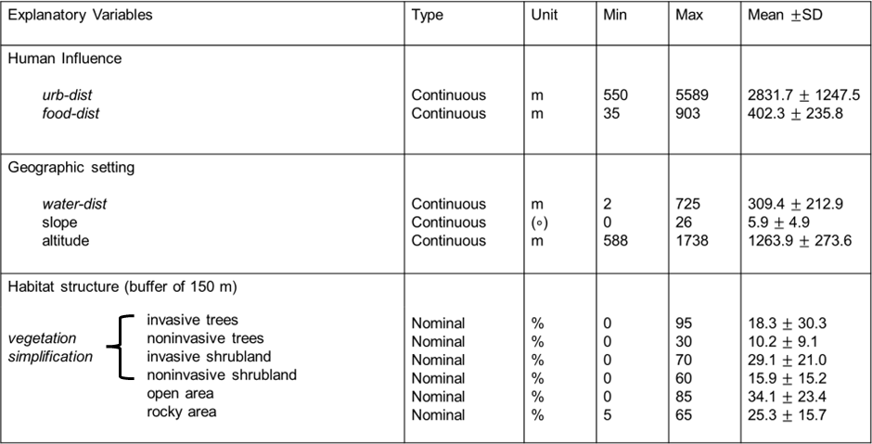

Table S7: Output from Spatially Explicit Capture-Recapture model with a Halfnormal detection function and a 1700 m buffer, chosen with the suggest.buffer() function in R.

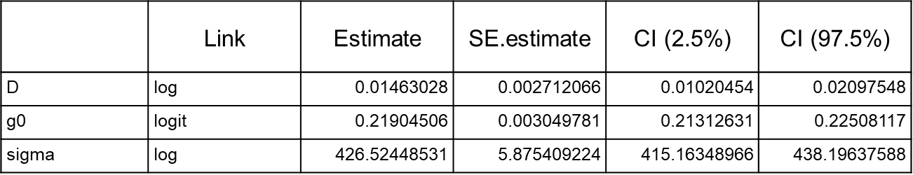

Table S8: Output from Spatially Explicit Capture-Recapture model with a Halfnormal detection function and a 1200 m buffer, as used by Soto et al. (2023)

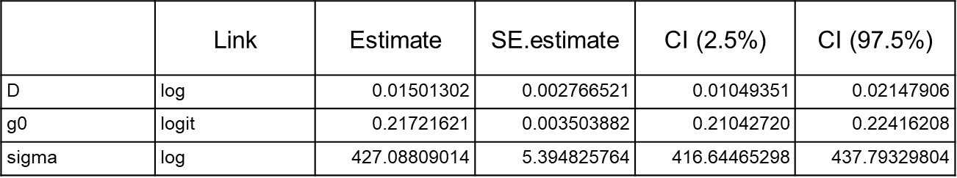

Table S9: Table providing the R² and AIC_{c} values for 2023 Generalised Linear Mixed Models that considered, or did not consider, an offset. Shown both for cat activity and cat abundance as response variables.

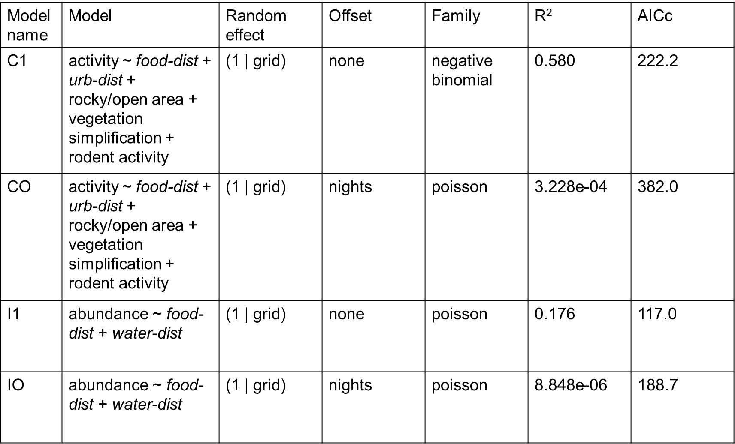

Table S10: Summary of most Generalised Linear Mixed Model parsimonious models (<2 AIC from the best fitted model) included in the average model, describing free-ranging cat abundance and activity.
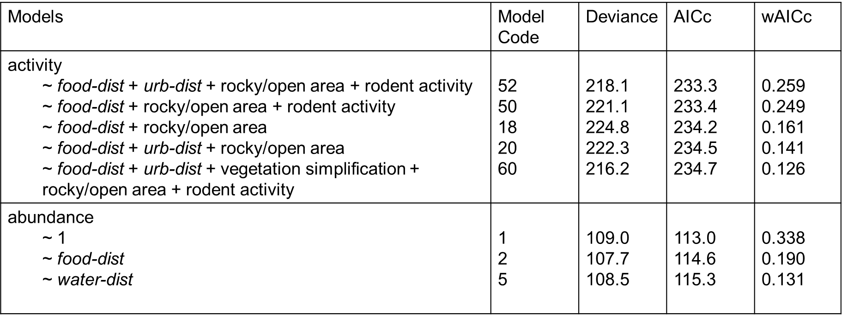

Table S11: Generalised Linear Mixed Model average model explaining the activity and abundance of free-ranging cats. The estimate, standard error, Z value and confidence intervals are indicated for the intercept and environmental variables included in the models.
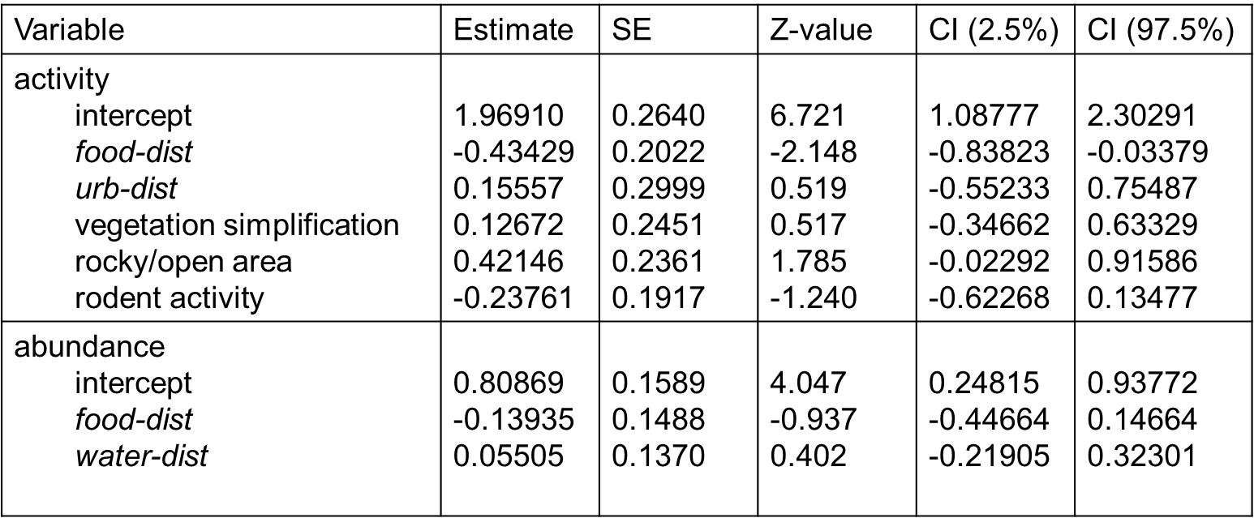

Table S12: Summary of the Structural Equation Model for cat activity and rodent activity as response variables

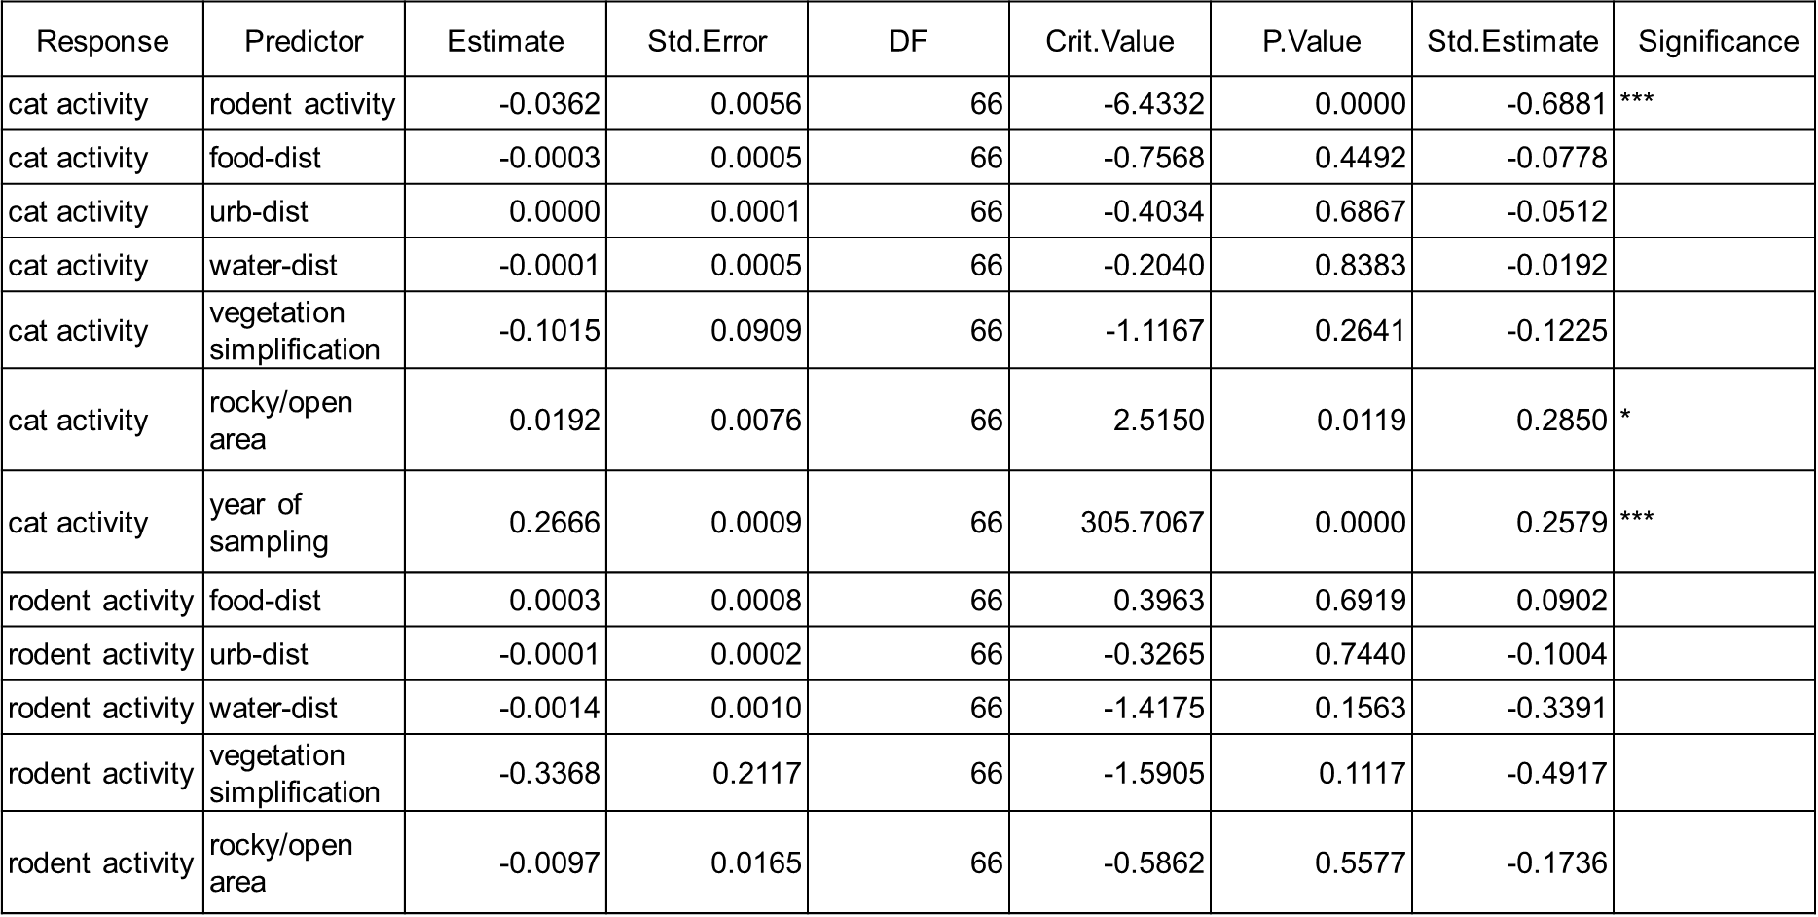

Table S13: Summary of the Structural Equation Model for cat abundance and rodent activity as response variables

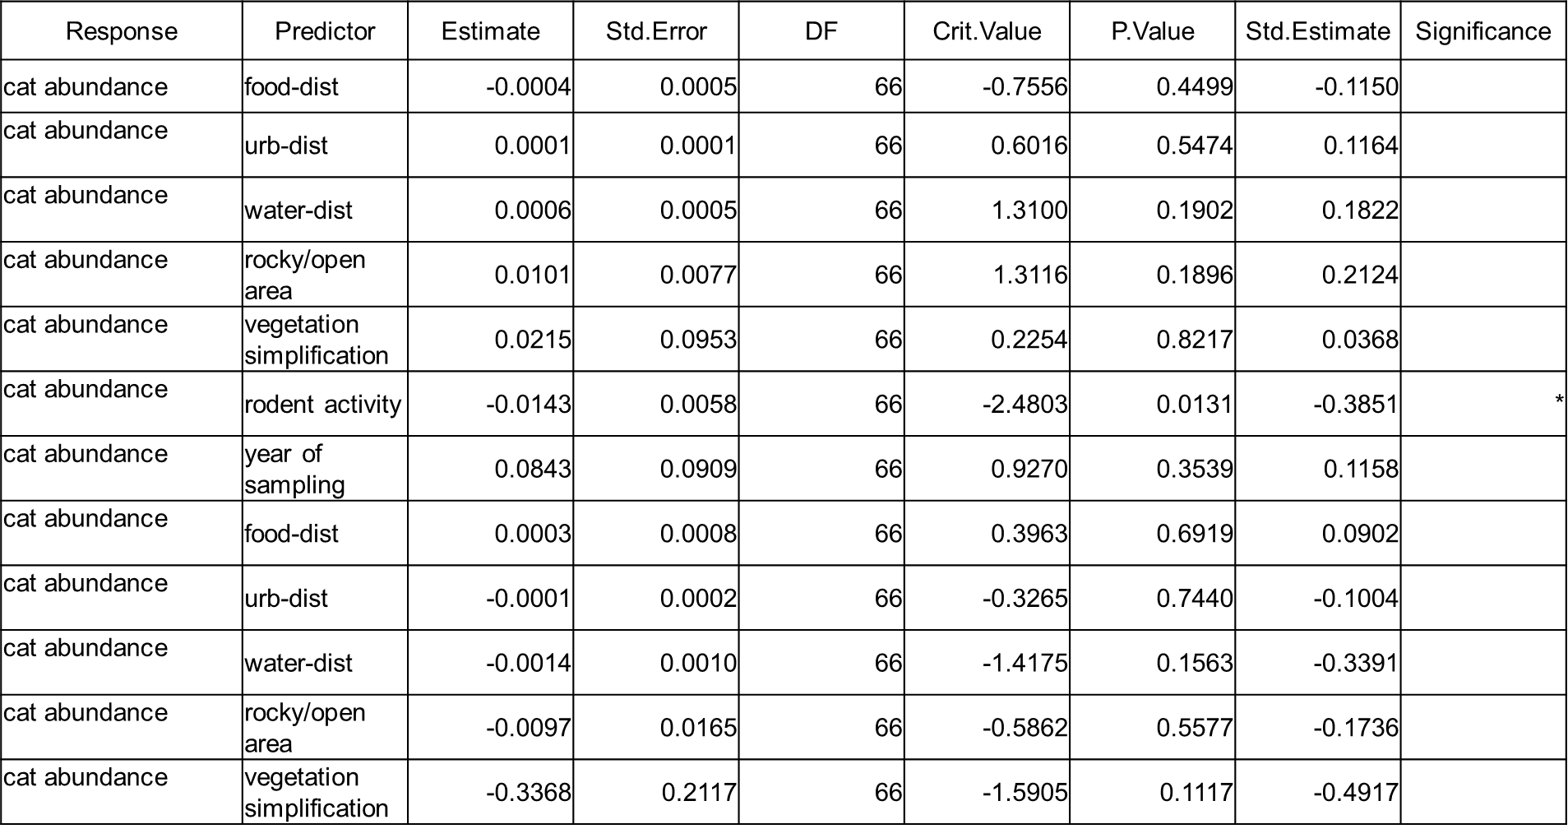

Figures
(a)
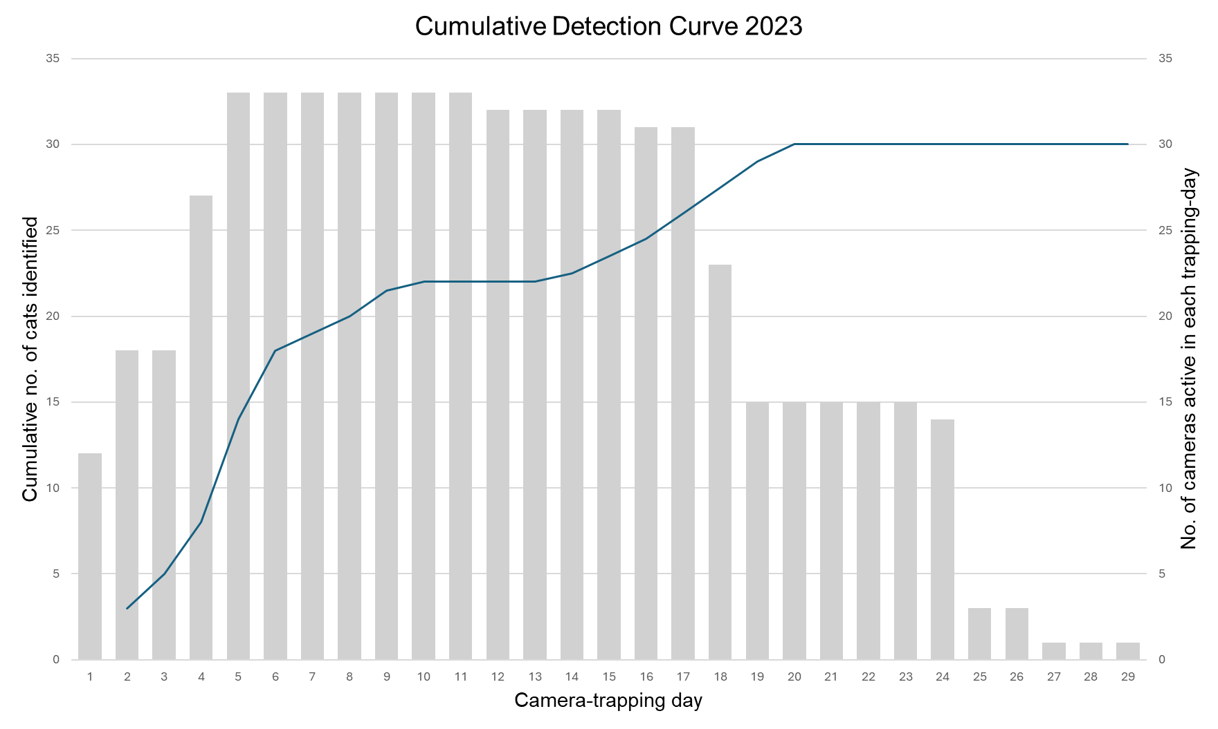
(b)
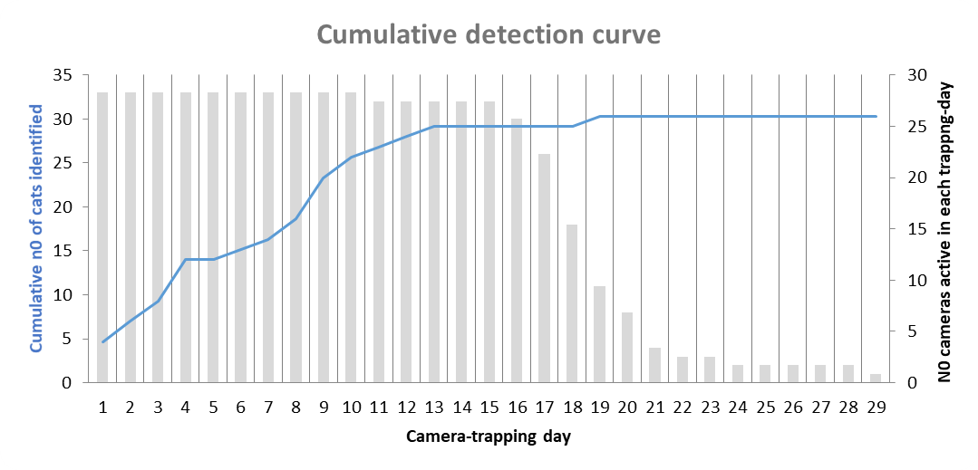

2021
Figure S1: Cumulative detection curve showing the number of individuals detected per trapping-day and number of occasions cameras were recording, for the 2023 (a) and 2021 (b) surveys. Note that both curves reach a plateau before the end of the sampling period, indicating that both study designs were able to detect all detectable cats within the sampling area.

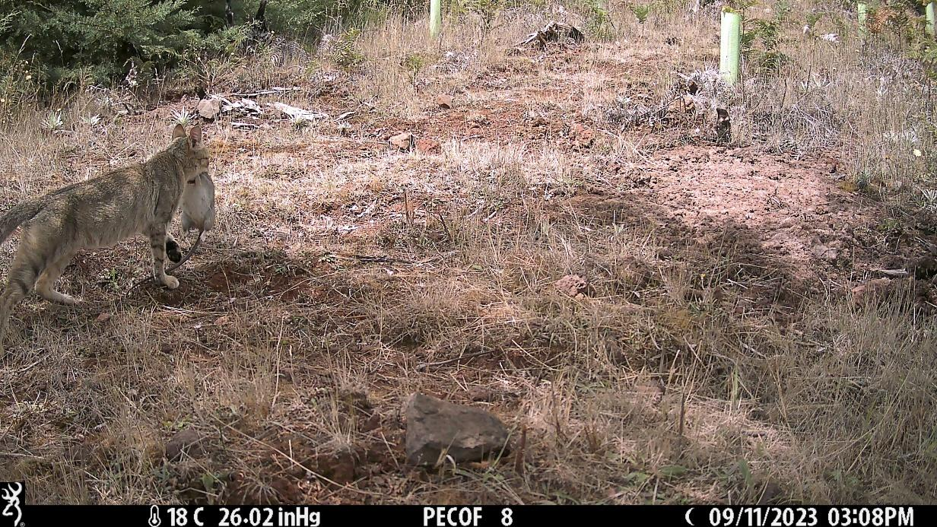
Figure S2: Image from the 2023 camera trap survey showing a cat predating a pregnant rat.

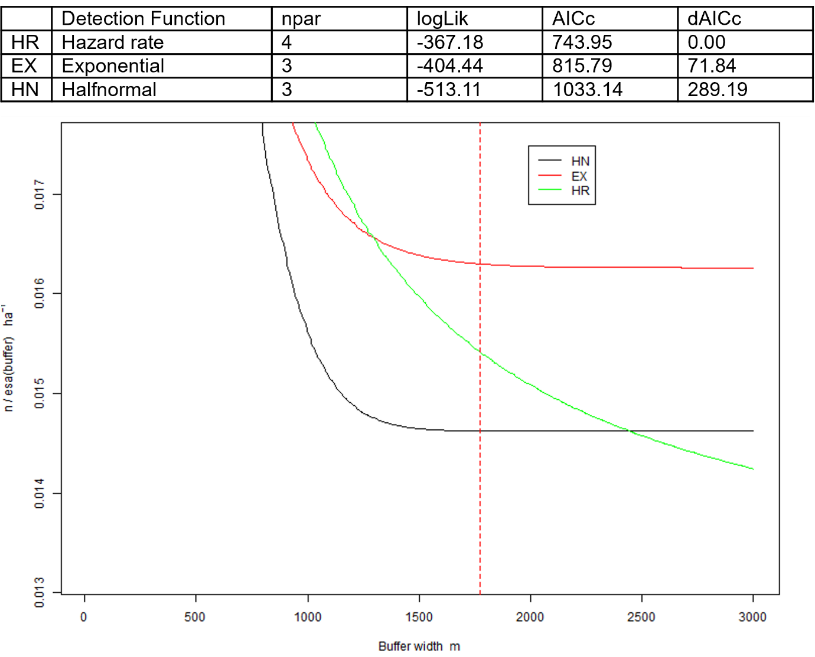Figure S3: AICc scores and ESA plot of density estimates from Half-normal (HN), Exponential (EX) and Hazard-rate (HR) function depending on buffer weight. The red-dashed line represents the suggested buffer for our data, at around 1700 m.

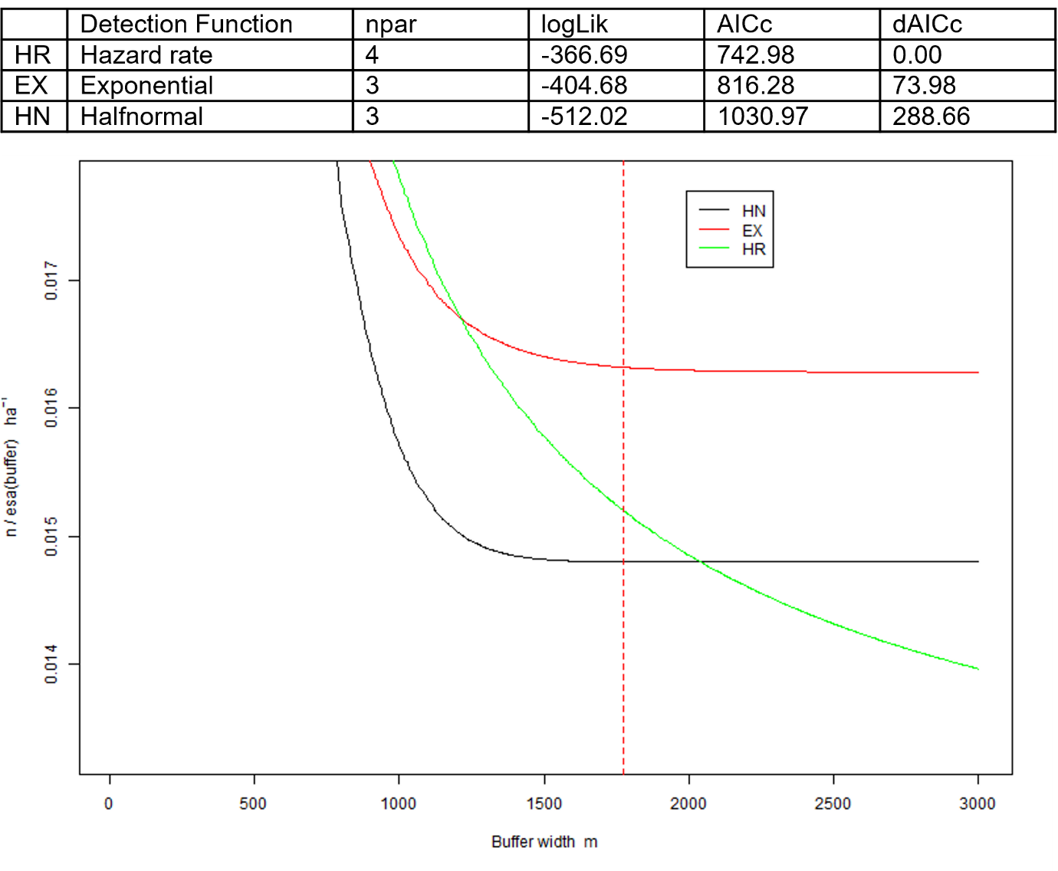
Figure S4: AICc scores and ESA plot of density estimates from Half-normal (HN), Exponential (EX) and Hazard-rate (HR) function depending on buffer weight. In this case, the red dashed line represents the buffer used by Soto et al. (2023), at 1200 m.

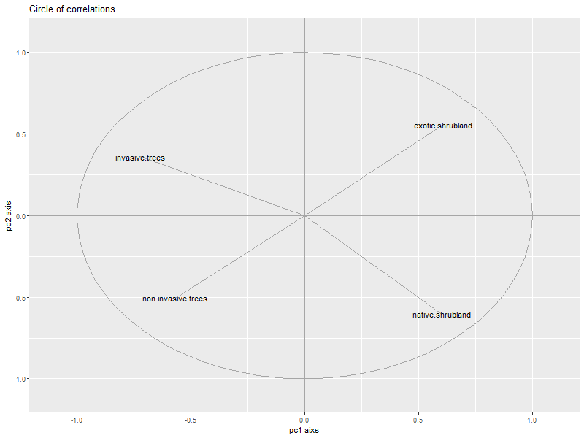

Figure S5: Principal Component Analysis circle of correlations for habitat covariables from the 2023 survey. Shows the trend for PC1 and PC2, where PC1 was used as a covariable characterising the vegetation composition (describing a gradient from tree to shrubland cover) in subsequent Generalised Linear Mixed Models and Structural Equation Models. These models were applied to investigate the environmental covariables associated with variation in cat activity, cat abundance and rodent activity.

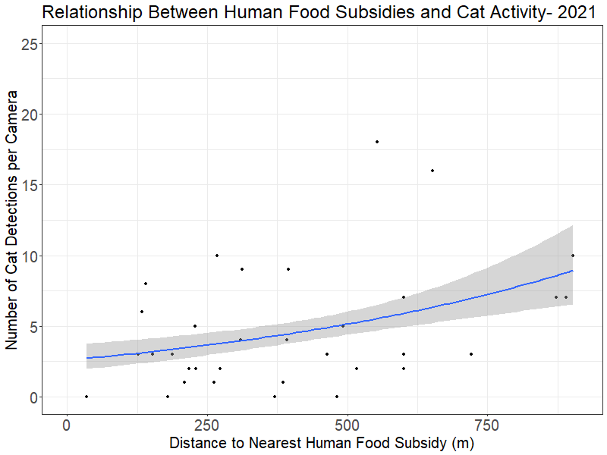

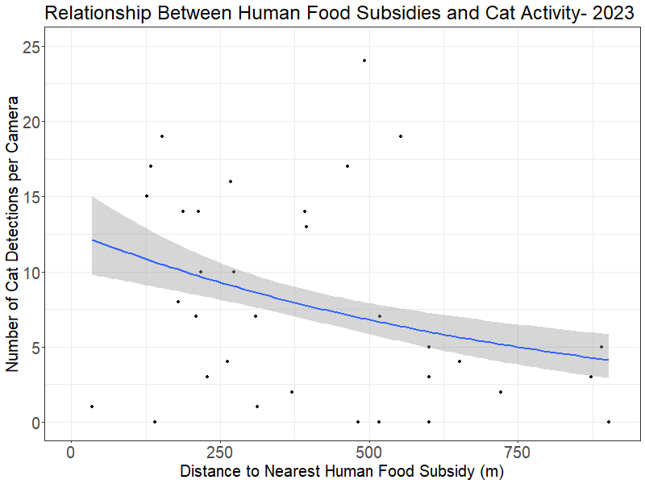

Figure S6: Generalised Linear Model plots showing how the relationship between cat activity and distance to human food subsidies (food-dist) changed between study periods.

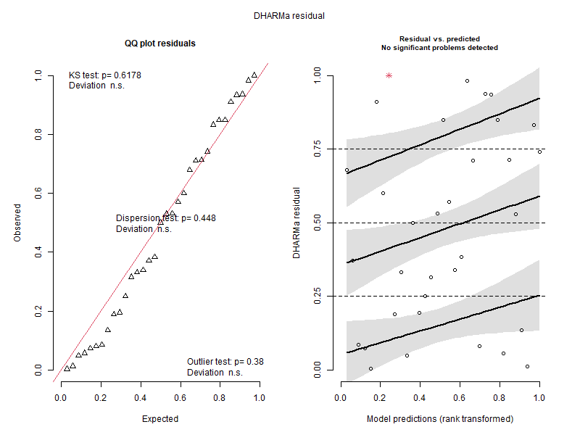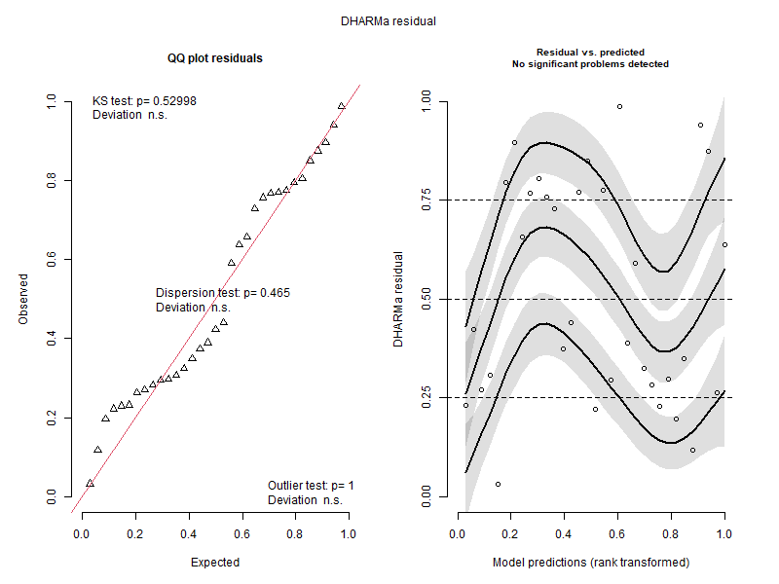
Figure S7: DHARMA Residual plots for the most significant Generalised Linear Mixed Models for 2021 cat activity (top) and 2021 cat abundance (bottom).

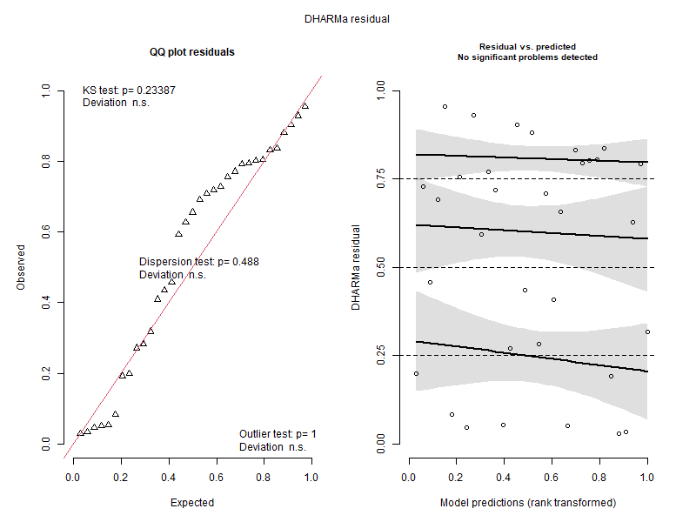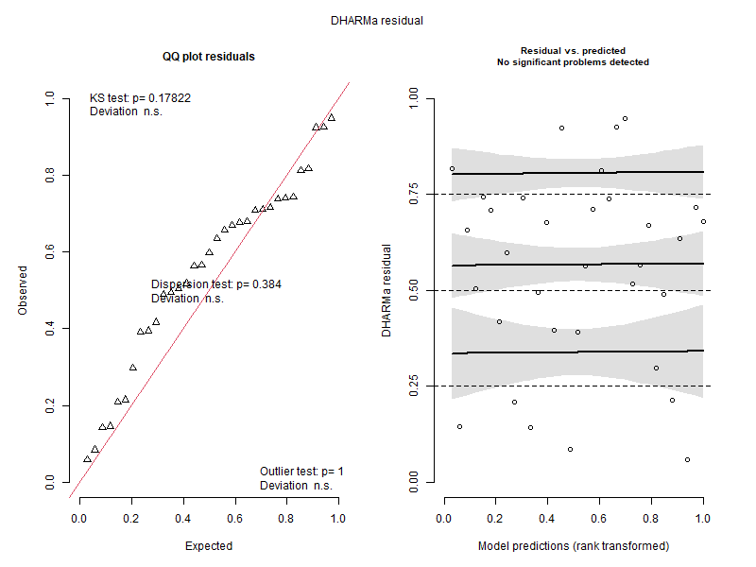
Figure S8: DHARMA Residual plots for the most significant Generalised Linear Mixed Models for 2023 cat activity (top) and 2023 cat abundance (bottom).

