Catalogue

Figure S1: The Certificate of CITI Program Exam. - - - - - - - - - - - - - - - - - - - - - - - - - - - - -2
Table S1: ICD Codes are Used to Identify Acute Pancreatitis and Malignant Tumor. - - - - - - 3
Table S2: The Calculation Process, Formula, and Results of Sample Size Determination. - - -4
Table S3: Definition of Organ Failure. - - - - - - - - - - - - - - - - - - - - - - - - - - - - - - - - - - - - - 5
Figure S2: Pearson Correlation Plot. - - - - - - - - - - - - - - - - - - - - - - - - - - - - - - - - - - - - - - 6
Table S4: Feature Selection Table. - - - - - - - - - - - - - - - - - - - - - - - - - - - - - - - - - - - - - - - -7
Table S5: Baseline Characteristic Table After SMOTE. - - - - - - - - - - - - - - - - - - - - - - - - - -8
Table S6: Performance Comparison of CatBoost Under 5-Fold Cross-Validation. - - - - - - - - 9

Figure S1: The Certificate of CITI Program Exam.
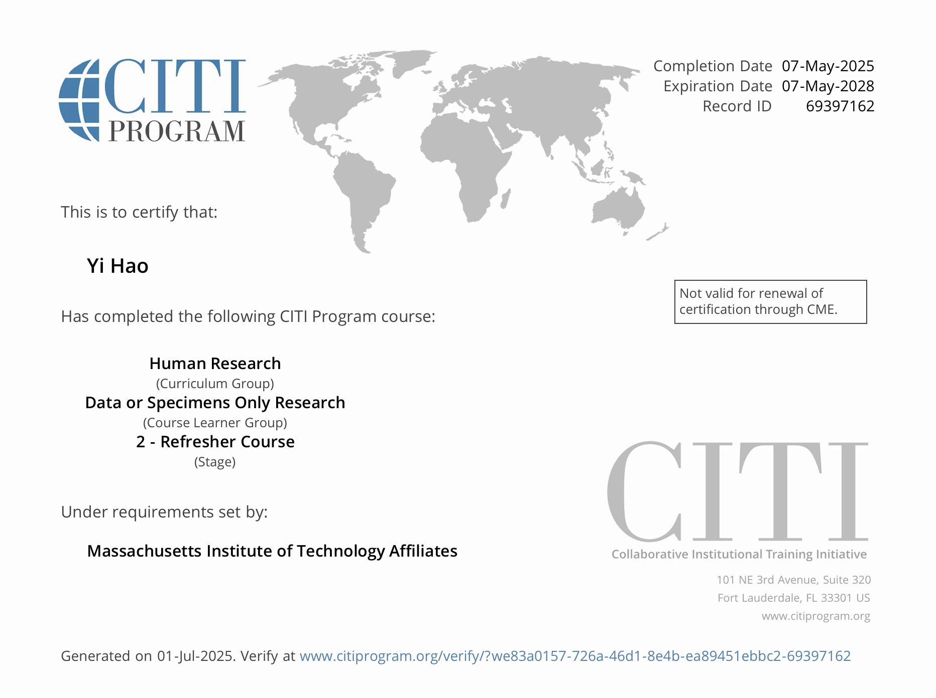

Table S1: ICD Codes are Used to Identify Acute Pancreatitis and Malignant Tumor.
Disease | ICD version | ICD code
Acute Pancreatitis | 9 | 5770
Acute Pancreatitis | 10 | K85, K850, K8501, K8532 K8500, K8502, K851, K8510, K8511, K8512, K852, K8520, K8521, K8522, K853, K8530, K8531, K858, K8580, K8581, K8582, K859, K8590, K8591, K8592
Malignant Tumor | 9 | 1629, 185, 1970, 1976, 1977, 1983, 1985, 19889, V1005, V1011, V103, V103, V1046, V1051, V1052, V1083, V160, V163,
Malignant Tumor | 10 | C61, C786, C787, C7931, C7951, Z800, Z803, Z85038, Z85118, Z853, Z8546, Z8551, Z85828
Hypertension | 9 | 4019, 4011, 4010
Hypertension | 10 | I10, I161
Chronic Kidney Disease | 9 | 40390, 5859, 5853,5854, 5852, 40310, 5855
Chronic Kidney Disease | 10 | I129, N189, N183, I130, I120, N184, N182, N185, E1122

Table S2: The Calculation Process, Formula, and Results of Sample Size Determination.
Method | Sample Size(n) | Formula
Four-Step Procedure
Sample Size for Precise Outcome Risk or Mean Estimates | 262 | 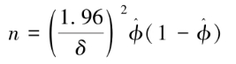
Sample Size for Reducing Predictor Effect Shrinkage | 461 | 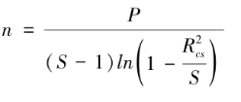
Sample Size for Minimizing Optimism in Model Fit | 393 | 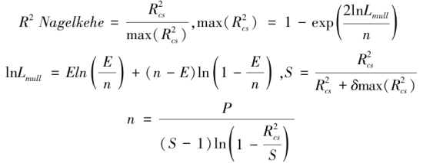
Final Sample Size | 461
Our predictive model ultimately incorporated 15 predictors, The expected R-squared value for the model is set to 0.25. The expected proportion of the endpoint event was estimated to be 0.218. Based on these parameters, we calculated the sample size using the formula mentioned above.

For ease of application, we utilized and organized the pmsampsize package developed by Riley et al. in R to perform the calculations. The parameters of the above formula are explained as follows:
ϕ: Expected proportion of the endpoint event
δ: Absolute error range
P: Number of predictive variables
S: Shrinkage factor
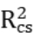: Cox-Snell pseudo R-squared
Nagelkerke: Nagelkerke R-squared, an adjusted version of Cox-Snell R-squared

Table S3: Definition of Organ Failure.
Type | Definition | Reference Standard
Respiratory Failure | On mechanical ventilation with PO₂ ≤ 60 mmHg | Modified Marshall Score
Circulatory Failure | Using VP with Nbps ≤ 90 mmHg | Modified Marshall Score
Hepatic Failure | INR ≥ 1.5 or BIL ≥ 12 mg/dL | SOFA
Renal Failure | Cr ≥ 170 μmol/L | Modified Marshall Score
Multiple Organ Failure | The presence of at least two of the four types of organ failure listed above
Abbreviations: VP: vasopressor; SOFA: sequential organ failure assessment.

Figure S2: Pearson Correlation Plot.
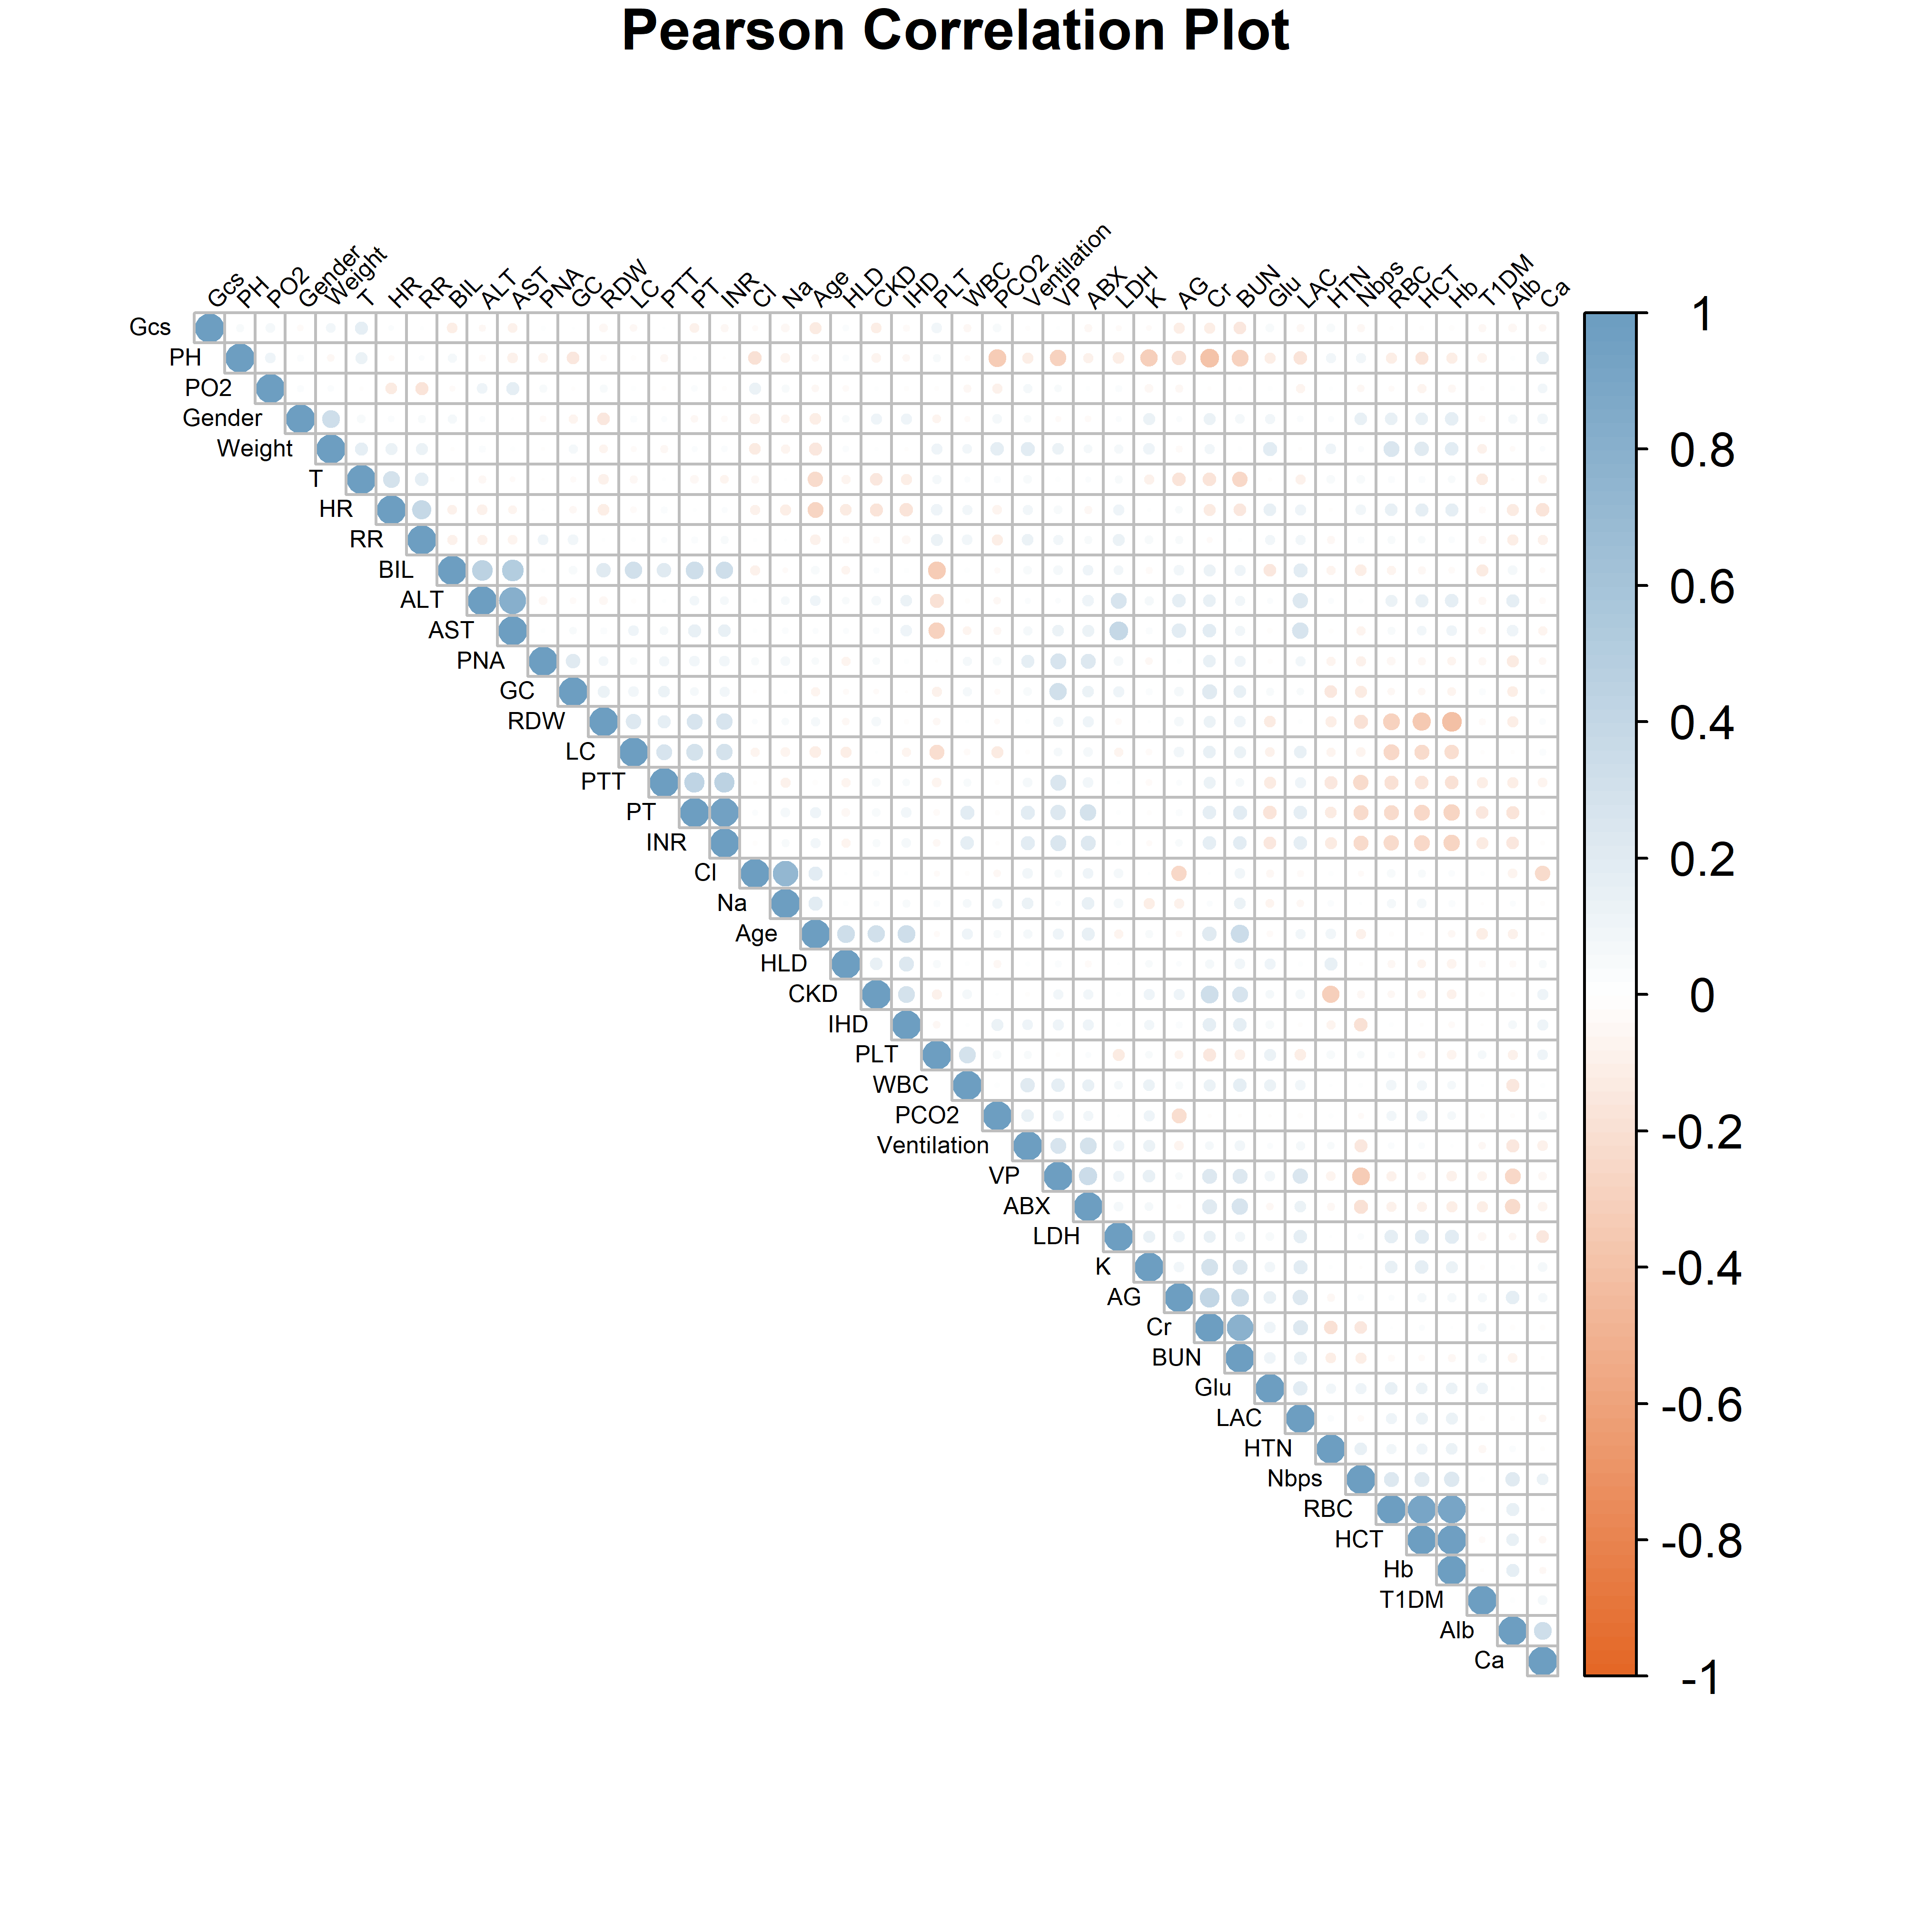
Figure S2 illustrates the Pearson correlation between variables. In the right panel, the triangular section displays the correlation relationships among variables. Blue squares indicate positive correlations, while orange squares denote negative correlations. Each circle's size corresponds to the absolute value of the correlation coefficient. The intensity of color represents the magnitude of the correlation coefficient.
Abbreviations: Gcs: glasgow coma scale; RR: respiratory rate; AST: aspartate aminotransferase; PNA: pneumonia; GC: glucocorticoid; RDW: red blood cell distribution width; LC: liver cirrhosis; PTT: partial thromboplastin time; PT: prothrombin time; Cl⁻: chlorine; Na⁺: sodium; HLD: hyperlipidemia; IHD: ischemic heart disease; PLT: platelet; WBC: white blood cell; PCO2: partial pressure of carbon dioxide; LDH: lactate dehydrogenase; K⁺: potassium; AG: anion gap; BUN: blood urea nitrogen; Glu: glucose; RBC: red blood cell; HCT: hematocrit; T1DM: type 1 diabetes mellitus; Alb: albumin; Ca²⁺: calcium.

Table S4: Feature Selection Table.
Feature Selection Method | Feature
Lasso | age, gender, HTN, LC, PNA, CKD, IHD, Ventilation, GCS, HR, RR, T, Hb, PLT, WBC, Alb, Ca²⁺, K⁺, Na⁺, LAC, PCO₂, PH, PO₂, INR, ALT, BIL, Cr, GC, ABX, Nbps
RFE | age, weight, HTN, LC, CKD, HLD, GCS, HR, RR, T, Hb, PLT, RDW, WBC, Alb, Ca²⁺, Glu, K⁺, Na⁺, LAC, PCO₂, PH, PO₂, INR, ALT, BIL, Cr, LDH, ABX, Nbps
Boruta | age, gender, weight, HTN, LC, CKD, HLD, IHD, Ventilation, GCS, HR, RR, T, Hb, PLT, RDW, WBC, Alb, Ca²⁺, Glu, K⁺, Na⁺, LAC, PCO₂, PH, PO₂, INR, ALT, BIL, Cr, LDH, VP, ABX, Nbps
SWR | HTN, PNA, CKD, Ventilation, HR, T, Hb, Na⁺, LAC, PH, PO₂, INR, ALT, BIL, Cr, GC, ABX, Nbps
A variable will be selected for inclusion in subsequent model building if it is identified by all feature selection methods described above.

Table S5: Baseline Characteristic Table After SMOTE.
Variable | level | Overall | No MOF | MOF | p
 |  | N=910 | N=455 | N=455
BIL |  | 1.515 (0.7-4.362) | 0.9 (0.5-1.8) | 3.101 (1.2-7.992) | <0.001
INR |  | 1.4 (1.2-1.9) | 1.2 (1.1-1.4) | 1.869 (1.495-2.381) | <0.001
Cr |  | 1.6 (0.9-2.7) | 0.9 (0.7-1.4) | 2.386 (1.703-3.41) | <0.001
PO2 |  | 66 (43.25-112.5) | 84 (52-161) | 52 (42-78) | <0.001
Nbps |  | 119 (102-140) | 132 (113-145.5) | 110 (97-127) | <0.001
PH |  | 7.344 (7.277-7.4) | 7.37 (7.3-7.42) | 7.322 (7.261-7.38) | <0.001
LAC |  | 2 (1.394-3.1) | 1.7 (1.2-2.6) | 2.4 (1.6-3.598) | <0.001
Hb |  | 10.737 (9.158-12.4) | 11.4 (9.7-13.2) | 10.135 (8.813-11.755) | <0.001
T |  | 98.33 (97.8-99.1) | 98.5 (97.8-99.2) | 98.268 (97.696-98.888) | 0.271
ALT |  | 46.5 (25-129) | 44 (20-123) | 49 (29-136.5) | 0.200
HR |  | 101 (86-114) | 102 (86-114) | 99 (86-114) | 0.559
Na |  | 138 (135-141) | 138 (135-141) | 138 (134-141) | 0.232
HTN (%) | 0 | 617 (67.80) | 233 (51.21) | 384 (84.40) | <0.001
 | 1 | 293 (32.20) | 222 (48.79) | 71 (15.60)
CKD (%) | 0 | 812 (89.23) | 399 (87.69) | 413 (90.77) | 0.164
 | 1 | 98 (10.77) | 56 (12.31) | 42 (9.23)
ABX (%) | 0 | 110 (12.09) | 87 (19.12) | 23 (5.05) | <0.001
 | 1 | 800 (87.91) | 368 (80.88) | 432 (94.95)
Continuous variables were reported as median (Q1-Q3), Categorical variables were expressed as frequency counts with percentages.

Table S6: Performance Comparison of CatBoost Under 5-Fold Cross-Validation.
Subset | Accuracy | Recall | Precision | AUROC | Sensitivity | Specificity
1 | 0.844 | 0.971 | 0.651 | 0.947 | 0.971 | 0.793
2 | 0.856 | 0.985 | 0.666 | 0.954 | 0.986 | 0.804
3 | 0.828 | 0.929 | 0.635 | 0.946 | 0.929 | 0.788
4 | 0.852 | 0.986 | 0.660 | 0.951 | 0.985 | 0.798
5 | 0.848 | 0.971 | 0.657 | 0.952 | 0.972 | 0.799

