Supporting Information
A Thiosemicarbazone-Derived Fluorescent Probe For The Detection Of Silver Ions And Bioimaging Application.
- Sreedeviª, G. Prabhakaran^{b}, Nattamai Bhuvanesh^{c}, Malathi Mahalinham^{d}, Raju Nandhakumar^{b}, G. Subashini^{a*}

ª Department of Chemistry, PSGR Krishnammal College for Women,
Peelamedu, Coimbatore-641004, Tamilnadu, India.
*E-mail: gsubashini2010@gmail.com
^{b} Fluorensic Materials Lab, Department of Applied Chemistry,
Karunya Institute of Technology and Sciences, (Deemed-to-be University),
Karunya Nagar,Coimbatore - 641 114, India.
^{c} Department of Chemistry, Texas A&M University, United States.
^{d} Department of Chemistry, Bannari Amman Institute of Technology

CONTENTS

S1. Figure S1. FTIR Spectrum of compound 2NP
S2. Figure S2. ¹H NMR Spectrum of compound 2NP
S3. Figure S3. ¹³C NMR Spectrum of compound 2NP
S4. Figure S4. HRMS Spectrum of compound 2NP
S5. Figure S5. Absorbance Spectrum of compound 2NP
S6. Figure S6. The response time study of receptor 2NP to Ag⁺.
S7. Figure S7. Job’s plot variation technique showing 2:1 complexation for receptor 2NP and Ag⁺ in HEPES (50 mM) buffered DMSO-H2O, 1:1 (v/v) solution (pH = 7.4) at λex = 520 nm.
S8. Figure S8. HRMS Spectrum of compound 2NP+Ag
S9. Figure S9. Benesi-Hildebrand plot for determination of association constant for receptor 2NP in presence of various concentration of Ag+ at (λex = 520 nm). Error bars are representing standard deviation of three repeated experiments.
S10. Figure S10. ¹H NMR Titration Spectrum of compound 2NP with 4 equiv. Ag⁺ ions.

Table S1. Comparison of Bond lengths of the free 2NP and complex 2NP+ Ag⁺ ions
Table S2 Cytotoxicity studies with L929 Mouse fibroblast cells.

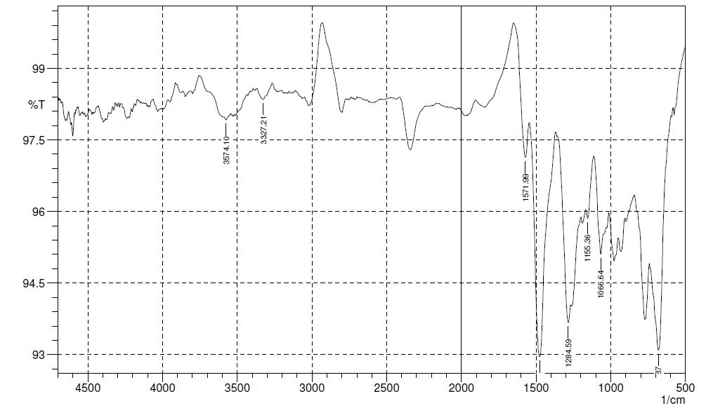

Figure S1. FTIR Spectrum of compound 2NP
Figure S2. ¹H NMR Spectrum of compound 2NP

Figure S3. ¹³C NMR Spectrum of compound 2NP
Figure S4. HRMS Spectrum of compound 2NP

Figure S5. Absorbance Spectrum of compound 2NP
Figure S6. The response time study of receptor 2NP to Ag⁺.

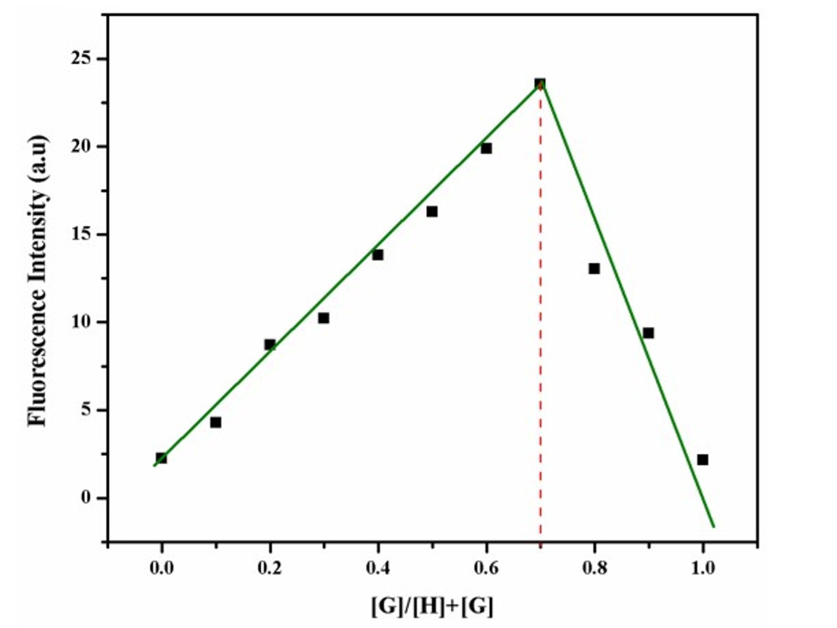
Figure S7. Job’s plot variation technique showing 2:1 complexation for receptor 2NP and Ag⁺ in HEPES (50 mM) buffered DMSO-H₂O, 1:1 (v/v) solution (pH = 7.4) at λex = 520 nm
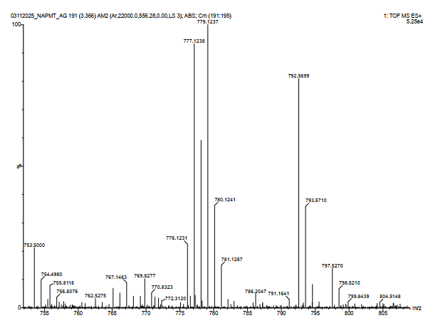
Figure S8. HRMS Spectrum of compound 2NP+Ag

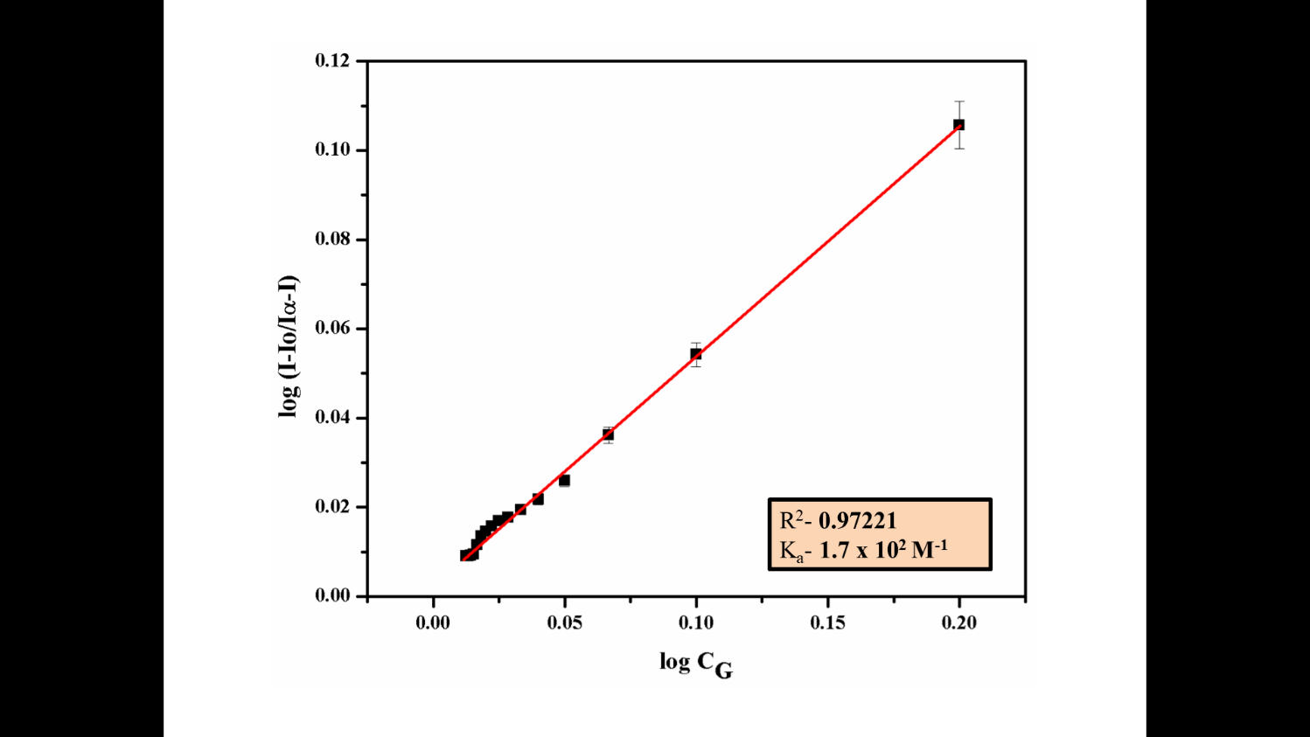
Figure S9. Benesi-Hildebrand plot for determination of association constant for receptor 2NP in presence of various concentration of Ag+ at (λex = 520 nm). Error bars are representing standard deviation of three repeated experiments.

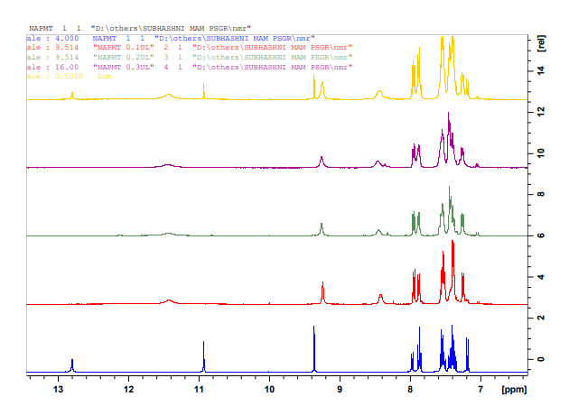

Figure S10. ¹H NMR Titration Spectrum of compound 2NP with 4 equiv. Ag⁺ ions.

Table S1. Comparison of Bond lengths of the free 2NP and complex 2NP+ Ag⁺ ions
S.NO | Bond | Ligand  2NP | Complex | ↓ ↑
1 | C1-C2 | 1.390 | 1.392 | ↑
2 | C2-C3 | 1.428 | 1.423 | ↓
3 | C3-C4 | 1.440 | 1.436 | ↓
4 | C4-C5 | 1.430 | 1.428 | ↓
5 | C5-C6 | 1.391 | 1.395 | ↑
6 | C6-C1 | 1.425 | 1.419 | ↓
7 | C3-C10 | 1.433 | 1.439 | ↑
8 | C4-C11 | 1.445 | 1.466 | ↑
9 | C11-C14 | 1.404 | 1.438 | ↑
10 | C14-C15 | 1.426 | 1.450 | ↑
11 | C15-C10 | 1.381 | 1.372 | ↓
12 | C14-O40 | 1.392 | 1.326 | ↓
13 | C11-C17 | 1.486 | 1.432 | ↓
14 | C17-N19 | 1.310 | 1.327 | ↑
15 | N19-N20 | 1.394 | 1.440 | ↑
16 | N20-C22 | 1.397 | 1.400 | ↑
17 | C22-S23 | 1.729 | 1.736 | ↑
18 | C22-N24 | 1.374 | 1.365 | ↓
19 | N24-C25 | 1.482 | 1.480 | ↓
20 | N24-C29 | 1.451 | 1.451 | ↓
21 | C29-C30 | 1.407 | 1.408 | ↑
22 | C30-C32 | 1.406 | 1.406 | ↑
23 | C32-C36 | 1.409 | 1.409 | ↑
24 | C34-C36 | 1.409 | 1.409 | ↑
25 | C31-C34 | 1.408 | 1.408 | ↓
26 | C29-C31 | 1.411 | 1.409 | ↓

Table S1 Cytotoxicity studies with L929 Mouse fibroblast cells.
Concentration | Cytotoxicity (%) | Cell Viability(%) | Cytotoxic Reactivity
5 | 8 | 92 | Slight
25 | 10 | 90 | Slight
50 | 12 | 88 | Slight
75 | 14 | 86 | Slight
100 | 17 | 83 | Slight

