Supplementary Austrheim et al.

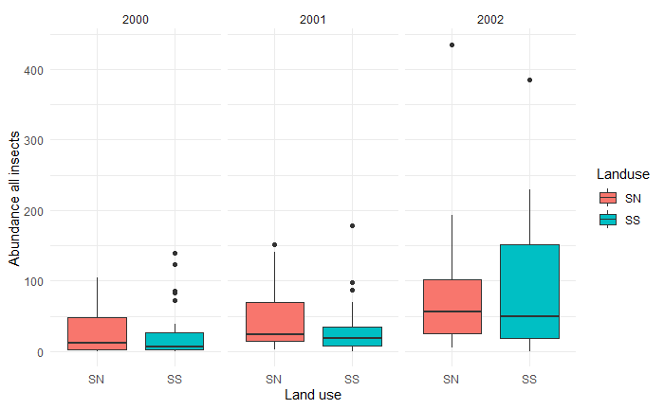
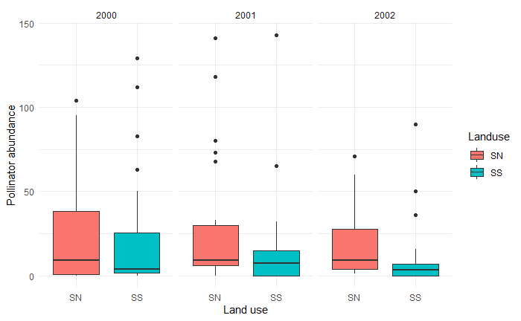
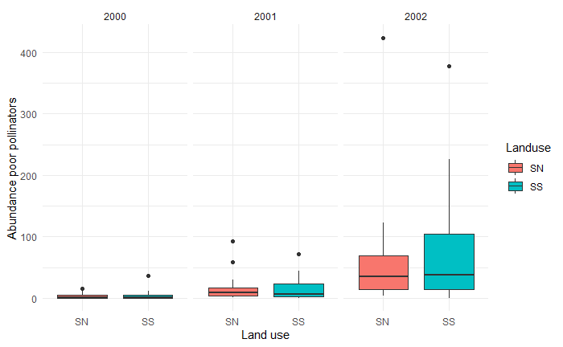

Fig. S1 Number of interactions (a) across all insect species, (b) Pollinating and (c) Poor pollinating insects. The boxplots show the min, max, upper and lower quartile, and median of the data.

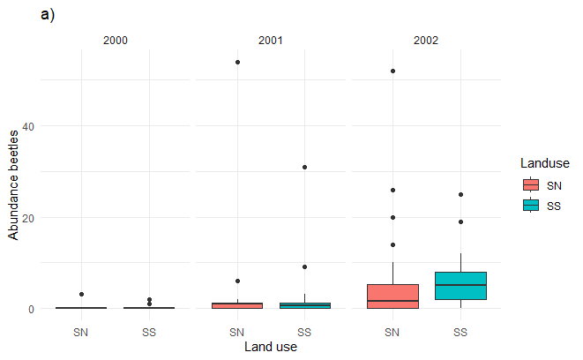
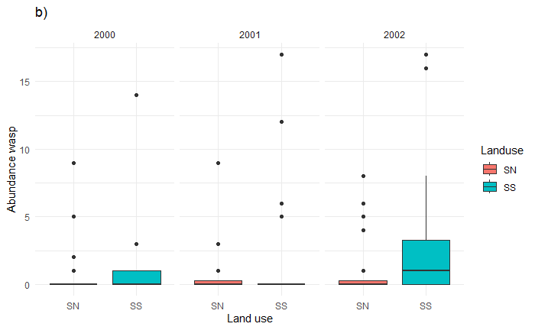
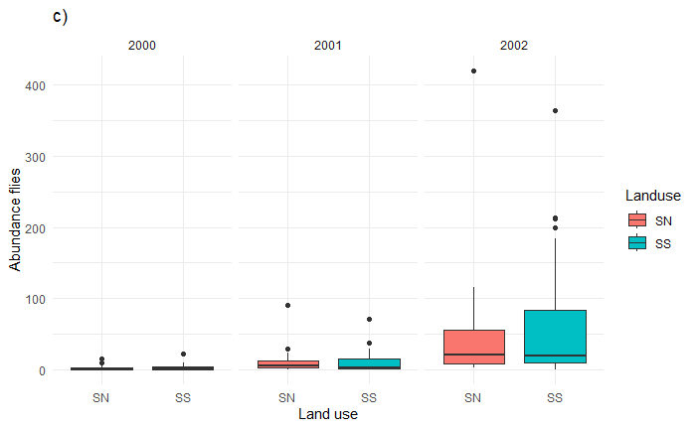
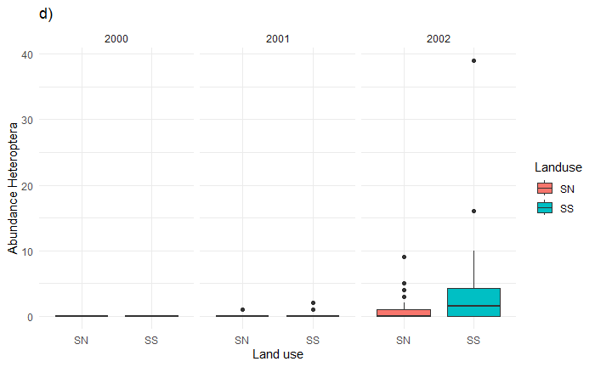

Figure S2. Number of plant-pollinator interactions at successional (SS) and semi-natural (SN) grasslands in years 2020-2022 for (a) Beetles, (b) Wasps, (c) other flies, (d) Heteroptera. The boxplots show the min, max, upper and lower quartile, and median of the data.

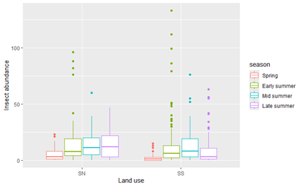
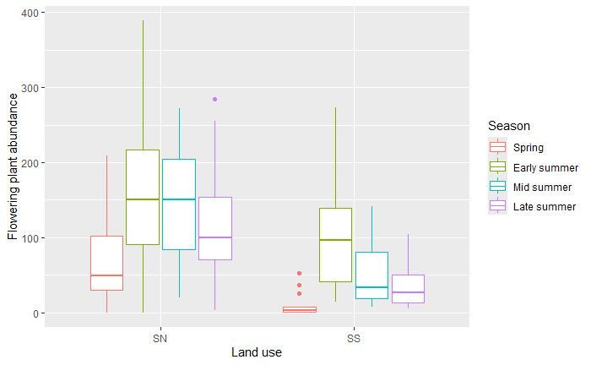

Fig. S3. Insect abundance (a) and herb flower abundances (b) in SN and SS grasslands at 4 different seasons (spring, early summer, mid summer, late summer) across years. The boxplots show the min, max, upper and lower quartile, and median of the data.

a)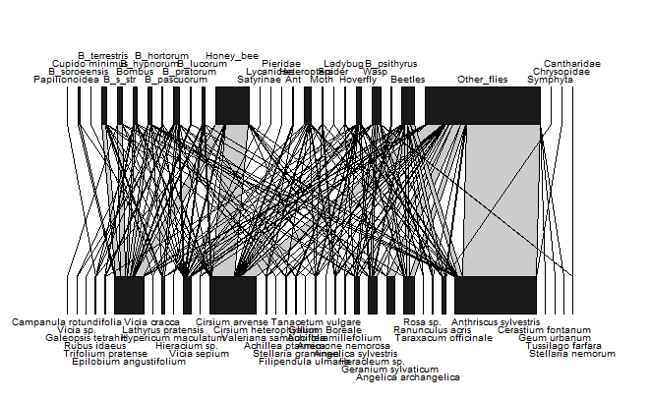
b)
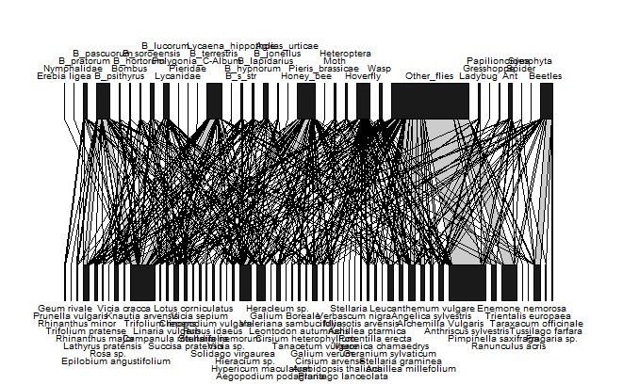

Fig. S4. Bipartite network of plant and pollinator interactions in (a) successional (SS) and (b) semi-natural (SN) grasslands. The upper and lower levels represent insects and plants respectively, and the width of the bars corresponds with the sum of visiting frequencies for each insect and plant taxa in the network. The line between the taxa at upper and lower level represents the plant-pollinator interaction and the line width is proportional to interaction frequency.

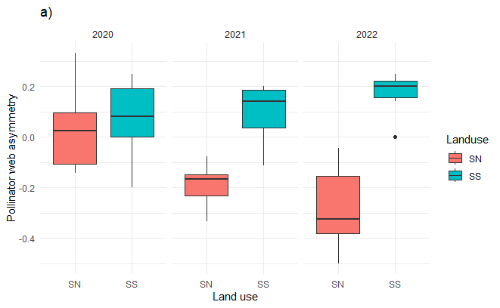
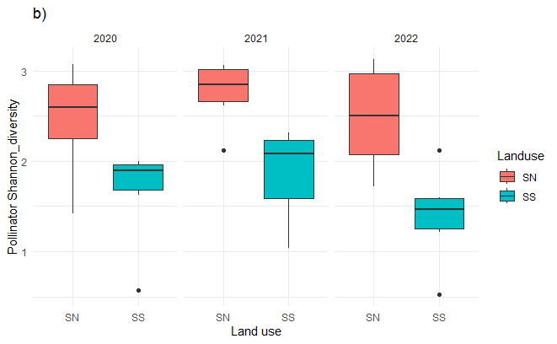
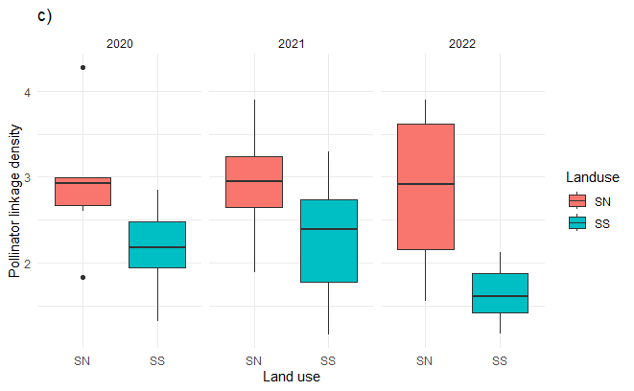

Fig. S5. Effects of grassland type on network indices calculated using the number of interactions for all pollinating insects. (a) web asymmetry, (b) Shannon's diversity, (c) linkage density. The boxplots show the min, max, upper and lower quartile, and median of the data.

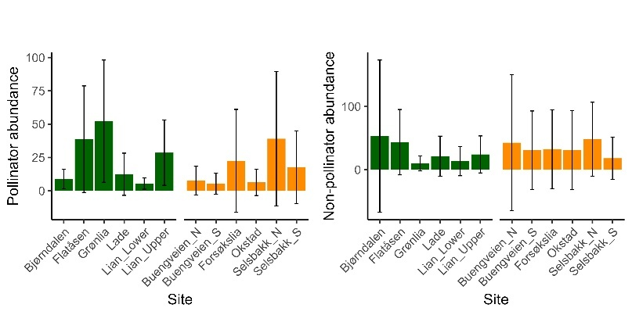

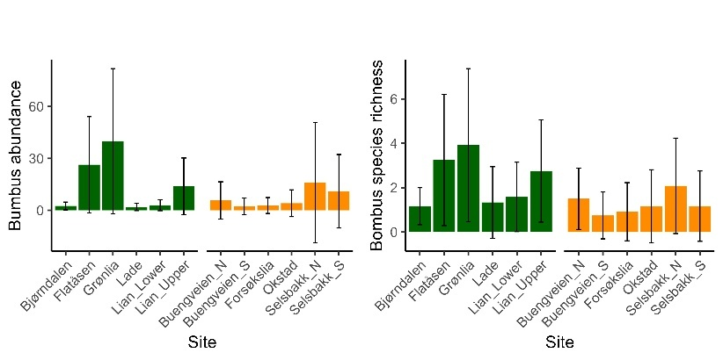

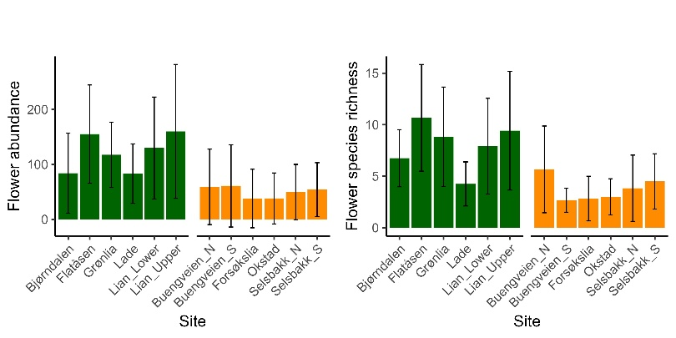

Fig. S6. Site (n=12) specific values (mean and se) for abundance of strict pollinators (a), abundance of poor pollinators (b), bumblebee abundance (c), bumblebee species richness (d), flower abundance (e) and flower species richness (f).

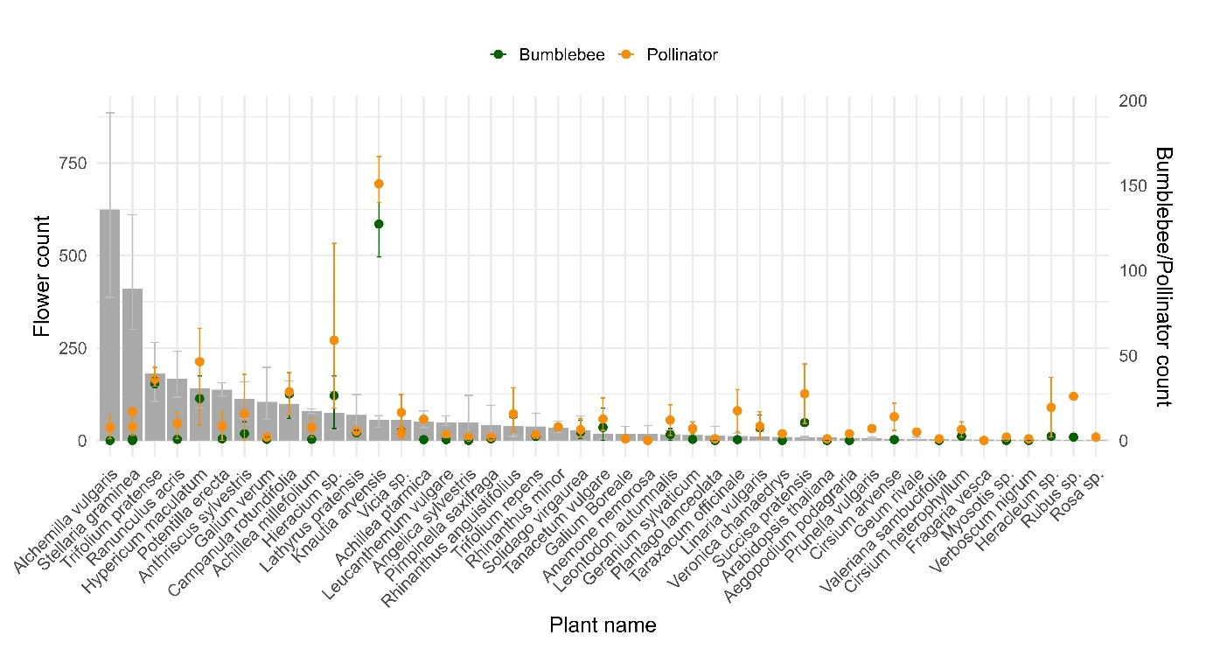

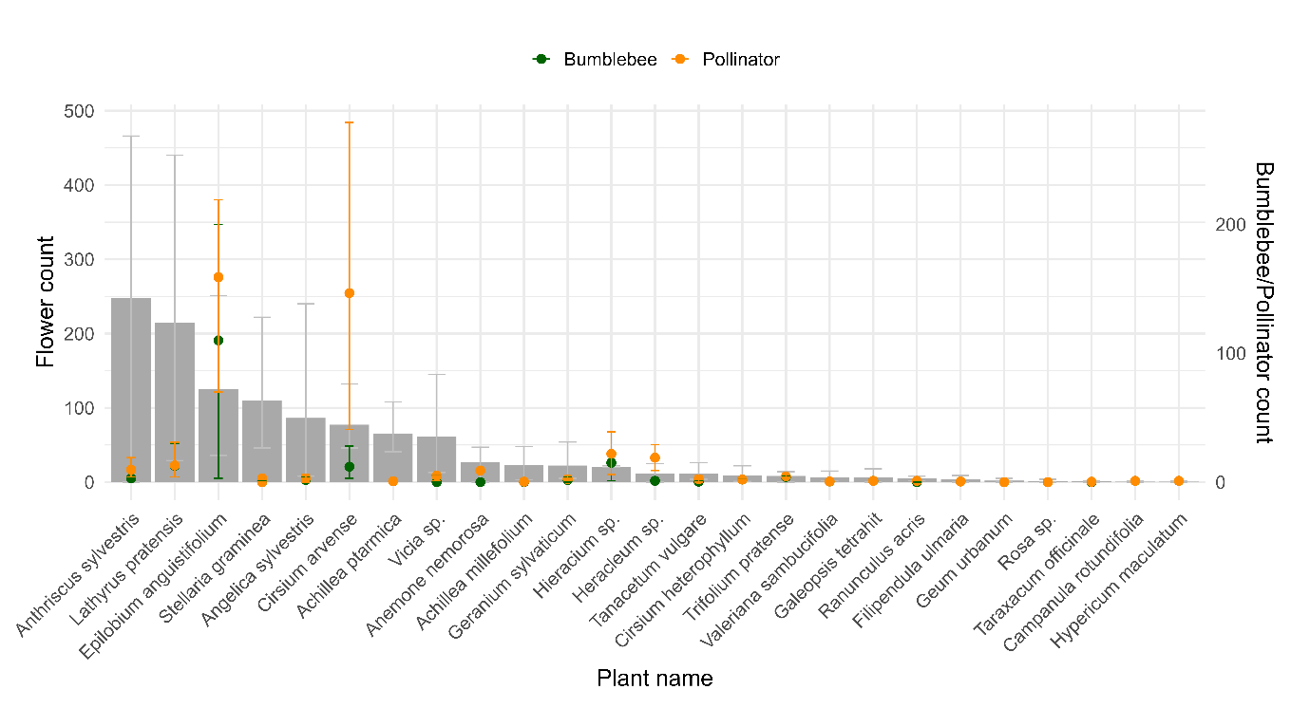

Fig. S7. Relationship between flower abundance (grey bars), and pollinator abundance (orange, mean and se) and (b) bumblebee abundance (green, mean and se) for (a) SN grasslands and (b) SS grasslands.

Table S1. Mean ± se for plant and insect properties (ABU = abundance, SR=species richness) in SN and SS grasslands in 2020, 2021, 2022 and across years.
 | SN |  |  |  | SS
 | 2020 | 2021 | 2022 | All Years | 2020 | 2021 | 2022 | All years
Flower ABU | 140 ± 92 | 122 ± 75 | 103 ± 93 | 122 ± 87 | 89 ± 72 | 37 ± 43 | 23 ± 21 | 50 ± 57
Flower SR | 9 ± 5 | 8 ± 4 | 7 ± 5 | 8 ± 5 | 5 ± 3 | 3 ± 3 | 3 ± 2 | 4 ± 3
Bumblebee ABU | 18 ± 29 | 14 ± 29 | 11 ± 17 | 15 ± 25 | 9 ± 14 | 11 ± 27 | 1 ± 1 | 7 ± 18
Bumblebee SR | 3 ± 3 | 2 ± 2 | 2 ± 2 | 2 ± 2 | 2 ± 2 | 2 ± 2 | 1 ± 1 | 1 ± 2
Pollinator ABU | 26 ± 32 | 28 ± 39 | 20 ± 23 | 24 ± 32 | 23 ± 37 | 16 ± 31 | 10 ± 21 | 16 ± 30

Table S2. List of all plant taxa recorded at the 12 study sites in semi-natural and successional grassland ranked after presence across sites. Mean ± se for plant abundance across years is given.
Table S3. List of all insect taxa recorded at the 12 study sites in semi-natural and successional grasslands ranked after presence across sites. Mean ± se for insect abundance across years is given.

Table S4. Mixed effect models on the effects of land use, year and their interactions and additive effects on different groups of pollinating insects. The best model is presented with AIC scores, and the other models as the change in AIC (Δ) as compared to the best model. Main effect from the best model is given as t-statistics. Abbreviations are Y = year, LSS =land use successional. See Fig. S2 for the abundance of interactions in SS and SN grasslands for all years.
Response variables | # obs | Trans. | Landuse | Year | Interaction | Additive
All non pollinating insects | 144 | Poisson | Δ 33.249 | Δ14.211 | 4616.725  Y2021 14.001***  Y2022 25.295***  LSS:Y2021 3.322*** | Δ15.953
Beetles | 144 | Poisson | Δ 13.923 | 1086.974  Y2021 7.509***  Y2022 12.718*** | Δ 1.708 | Δ 1.617
Wasps | 144 | Poisson | Δ 7.286 | 773.954  Y2021 2.109*  Y2022 6.267*** | Δ 4.609 | Δ 0.800
Flies | 144 | Poisson | Δ 31.129 | Δ 12.435 | 4712.539 Y2021  12.590***  Y2022  21.908***  LSS:Y2021  -3.177** | Δ 14.215

Table S5. Mixed effects models examining the effects land use, year, multiplicative (Interaction) and additive effects on plant-pollinator network indices based on networks with all pollinating insects. The best model is presented with AIC scores, and the other models as the change in AIC (Δ) as compared to the best model. Main effect from the best model is given as t-statistics. Abbreviations are Y = year, LSS =land use successional. See Fig. S5 for the network index values in SS and SN grasslands for all years.
Response variables | # observations | Trans. | Landuse | Year | Interaction | Additive
Shannon's diversity | 36 | Poisson | 107.055 | Δ 4.817 | Δ 5.453 | Δ 1.584
connectance | 36 | Poisson | 48.997 | Δ 2.004 | Δ 5.819 | Δ1.840
web_asymmetry | 36 | Gaussian | Δ 20.993 | Δ 23.963 | LSS -5.564***  Y-5.967***  LSS:Y5.567***  -40.381 | Δ17.901
linkage_density | 36 | Poisson | 114.036 | Δ 4.291 | Δ 5.284 | Δ1.623
links_per_species | 36 | Poisson | 82.578 | Δ 2.566 | Δ5.830 | Δ1.844
weighted_NODF | 36 | Poisson | Δ 19.732 | Δ 13.689 | LSS:Y2022  -4.052***  316.853 | Δ13.157
H2 | 36 | Poisson | 65.059 | Δ 1.880 | Δ 5.756 | Δ1.781

