Supplementary Tables
Table S1. Baseline characteristics of the included randomized controlled trials evaluating endothelin receptor antagonists in pulmonary arterial hypertension
Study ID | Intervention group | Control group | Sample size (experimental/control) | Age (mean ± SD) | WHO-FC | Follow-up time | Outcome
Channick 2001 | Bosentan 125 mg bid | Placebo | 11/21 | 48 ± 12 | III–IV | 12 wks | 6MWD, mPAP, PVR
Rubin 2002 (BREATHE-1) | Bosentan 125/250 mg bid | Placebo | 158 / 80 | 47 ± 15 | III–IV | 16 wks | 6MWD, ADR,LFT
Galiè 2006 (BREATHE-5) | Bosentan 125 mg bid | Placebo | 37 / 17 | 34 ± 12 | III (Eisenmenger) | 16 wks | PVR, 6MWD
Galiè 2008 (EARLY) | Bosentan 125 mg bid | Placebo | 93 / 92 | 43 ± 14 | II | 6 months | PVR, 6MWD, ADR
Jais 2008 (BENEFiT) | Bosentan 125 mg bid | Placebo | 77 / 80 | 51 ± 15 | II–IV (CTEPH) | 16 wks | PVR, 6MWD, ADR
Valerio 2009 | Bosentan 125 mg bid | Placebo | 16 / 16 | 65 ± 9 | II–III (COPD-PAH) | 18 months | mPAP, PVR, 6MWD
Lewis 2002 | Bosentan 125 mg bid | Placebo | 11/21 | 48 ± 16 | II–III | 12 wks | 6MWD, mPAP, ADR
Galiè 2008 (ARIES-1/2) | Ambrisentan 2.5–10 mg qd | Placebo | 261 / 132 | 50 ± 15 | II–III | 12 wks | 6MWD, ADR
Pan 2019 (EDITA) | Ambrisentan  5–10 mg qd | Placebo | 19 / 19 | 56 ± 11 | II–III | 12 wks | mPAP, PVR, 6MWD
Pulido 2013 (SERAPHIN) | Macitentan 10 mg qd | Placebo | 242 / 250 | 45 ± 14 | II–IV | median 115 wks | Composite mortality, 6MWD
Olivier 2019 (PORTICO) | Macitentan 10 mg qd | Placebo | 43 / 42 | 61 ± 15 | II–III (CTEPH) | 12 wks | PVR , mPAP, 6MWD,ADR
Gatzoulis 2019 (MAESTRO) | Macitentan 10 mg qd | Placebo | 114 / 112 | 34 ± 10 | III (Eisenmenger) | 16 wks | 6MWD, PVR, NT-proBNP, ADR
bid = twice daily; qd = once daily; 6MWD = 6-minute walk distance; mPAP = mean pulmonary arterial pressure; PVR = pulmonary vascular resistance; ADR=Adverse drug reaction; LFT = liver function test; CTEPH = chronic thromboembolic pulmonary hypertension; WHO-FC = WHO functional class

Supplementary Figure
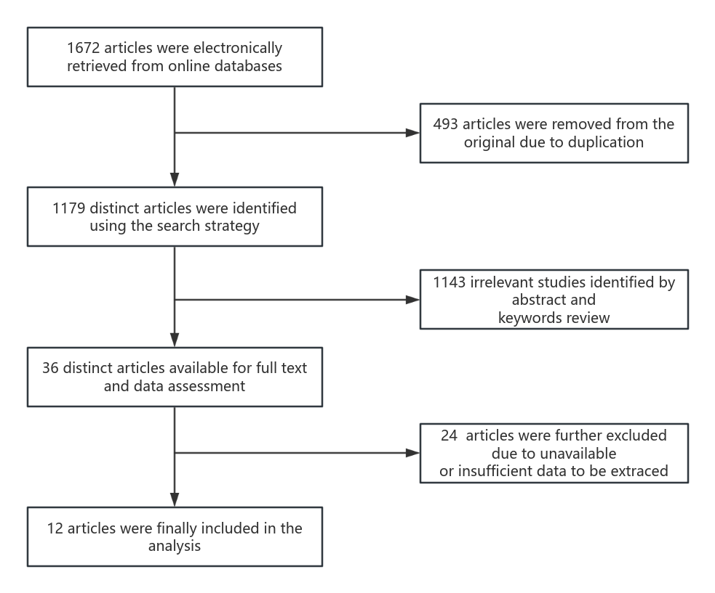
Fig S1. PRISMA Flow Diagram of the Meta-Analysis
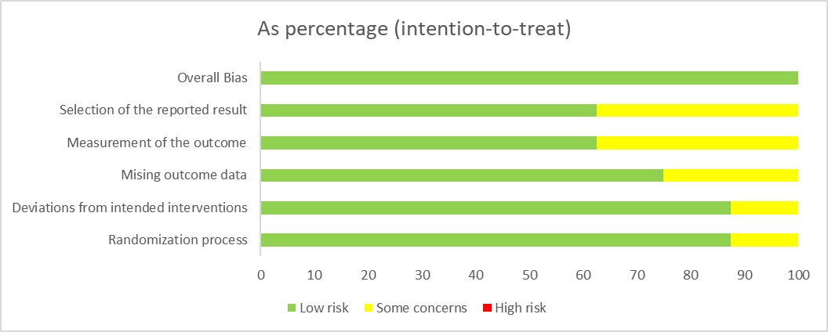
Fig S2. Risk of Bias Assessment for Included Randomized Controlled Trials (RoB2.0Tool)

Fig S3. Forest Plot of PAH Treatment Safety: (a) Treatment-Related Adverse Drug Reactions (ADRs); (b) All-Cause Mortality in Endothelin Receptor Antagonist Trials
Fig S4. Forest Plot of PAH Treatment Efficacy: (a) Effect on 6-Minute Walk Distance (6MWD); (b) Effect on Mean Pulmonary Arterial Pressure (mPAP)

