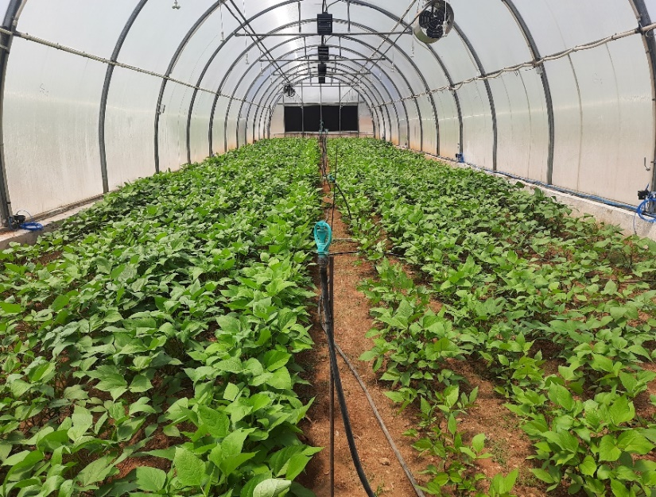
Plate 1 Black gram experiment conducted at eT CTGC facility

