Title: Matrix-resolved profiling of the prenatal chemical exposome reveals selective placental retention and fetal transfer
Authors: Montse Marquès^{1,2,3,4*}, Ruben Gil-Solsona⁴, Ana Megía⁵, Monica Ballesteros⁶, José L. Domingo³, Ana Navas-Acien², Gary Miller², Adrian Covaci¹, Pablo Gago-Ferrero⁴

¹ Toxicological Centre, Department of Pharmaceutical Sciences, University of Antwerp, Universiteitsplein 1, Antwerp, Belgium.
² Department of Environmental Health Sciences Columbia University Mailman School of Public Health New York, New York, NY.
³ School of Medicine, Universitat Rovira i Virgili, Laboratory of Toxicology and Environmental Health, Reus, Spain.
⁴ Institute of Environmental Assessment and Water Research (IDAEA-CSIC), Barcelona, Spain
⁵ Department of Endocrinology and Nutrition, Research Unit, University Hospital of Tarragona Joan XXIII-Institut d'Investigació Sanitària Pere Virgili (IISPV), Tarragona, Spain.
⁶ Department of Obstetrics and Gynecology, University Hospital of Tarragona Joan XXIII. Institut d'Investigació Sanitària Pere Virgili (IISPV), Tarragona, Spain.

*Author for correspondance
Monte Marquès (montse.marques@idaea.csic.es)

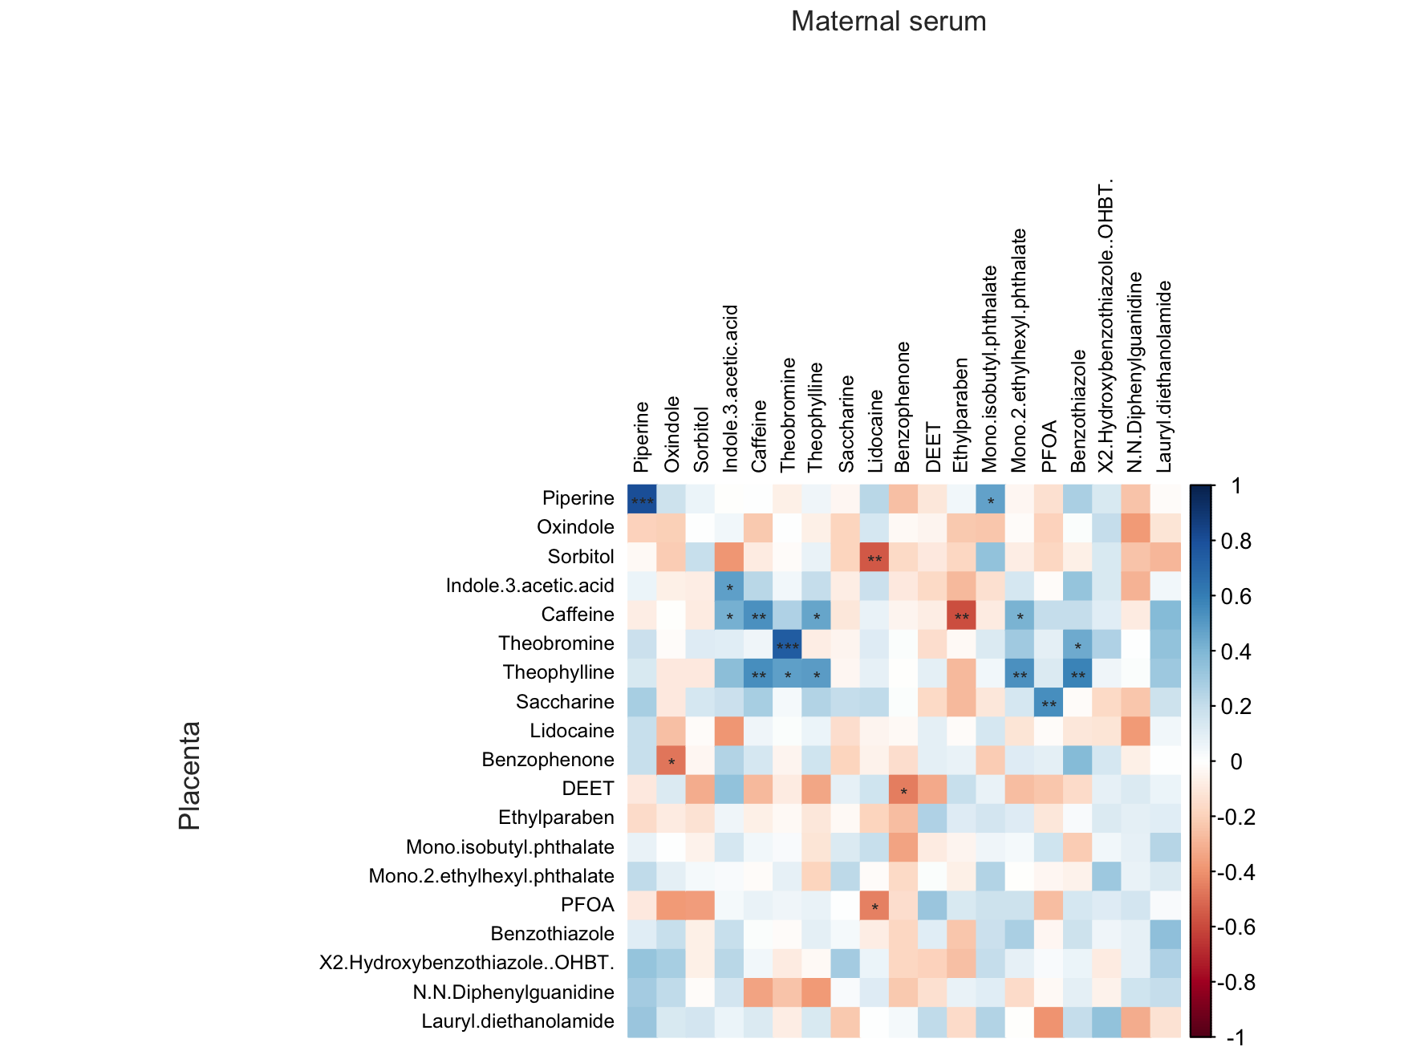

Fig. S1. Spearman correlation heat map between chemicals detected in maternal serum and placenta.
Asterisks indicate significance levels (p < 0.05, p < 0.01, p < 0.001). Only compounds detected in paired matrices in ≥20% of samples were included.

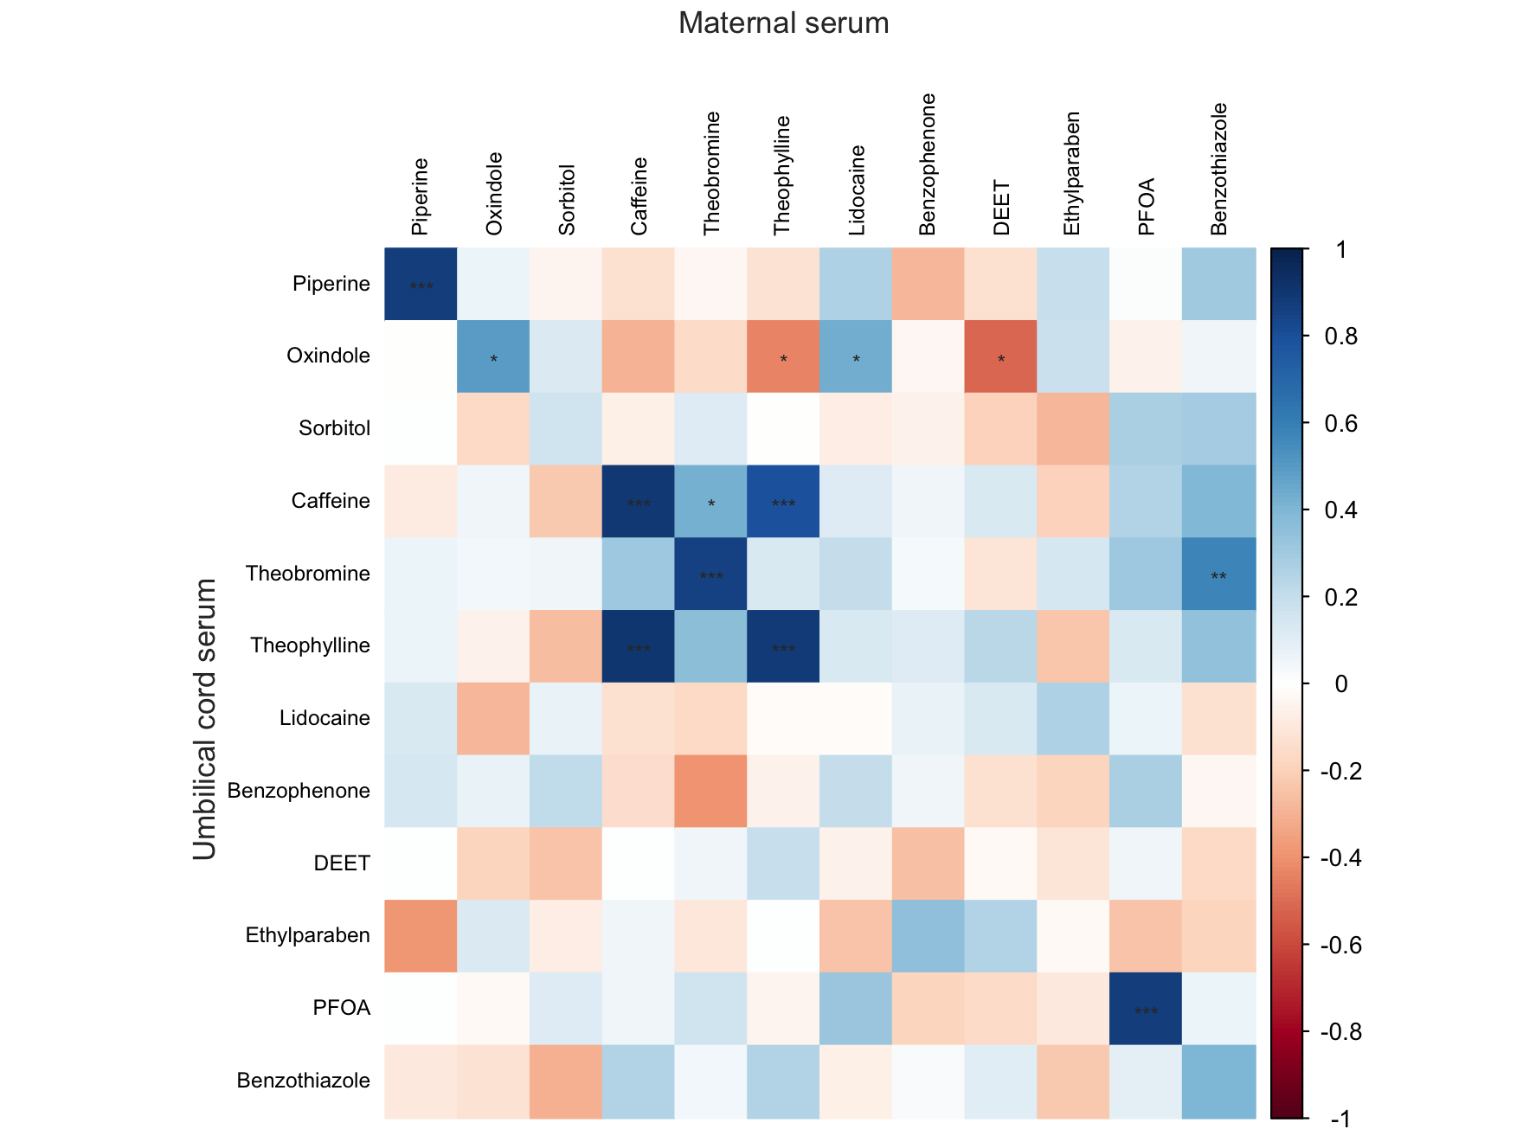

Fig. S2. Spearman correlation heat map between chemicals detected in maternal serum and umbilical cord serum.
Asterisks indicate significance levels (p < 0.05, p < 0.01, p < 0.001). Only compounds detected in paired matrices in ≥20% of samples were included.

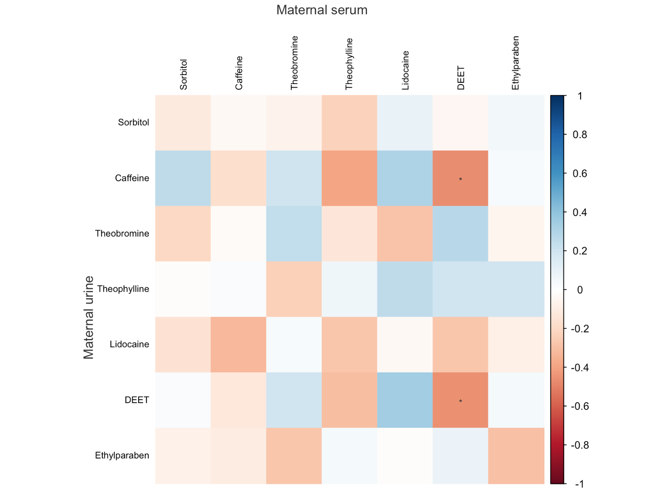
Fig. S3. Spearman correlation heat map between chemicals detected in maternal serum and maternal urine.
Asterisks indicate significance levels (p < 0.05, p < 0.01, p < 0.001). Only compounds detected in paired matrices in ≥20% of samples were included.

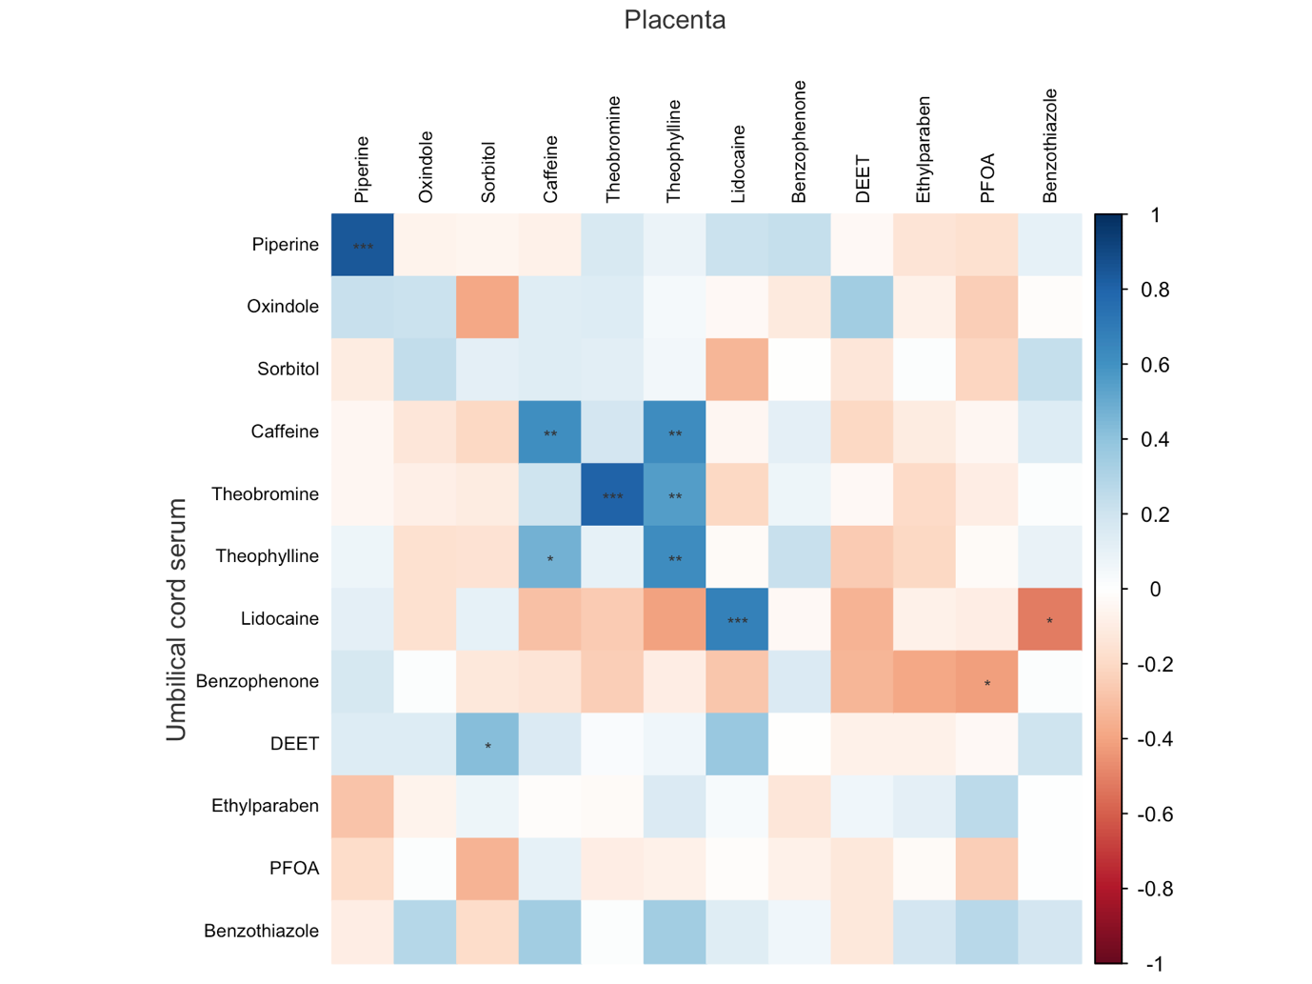
Fig. S4. Spearman correlation heat map between chemicals detected in placenta and umbilical cord serum.
Asterisks indicate significance levels (p < 0.05, p < 0.01, p < 0.001). Only compounds detected in paired matrices in ≥20% of samples were included.

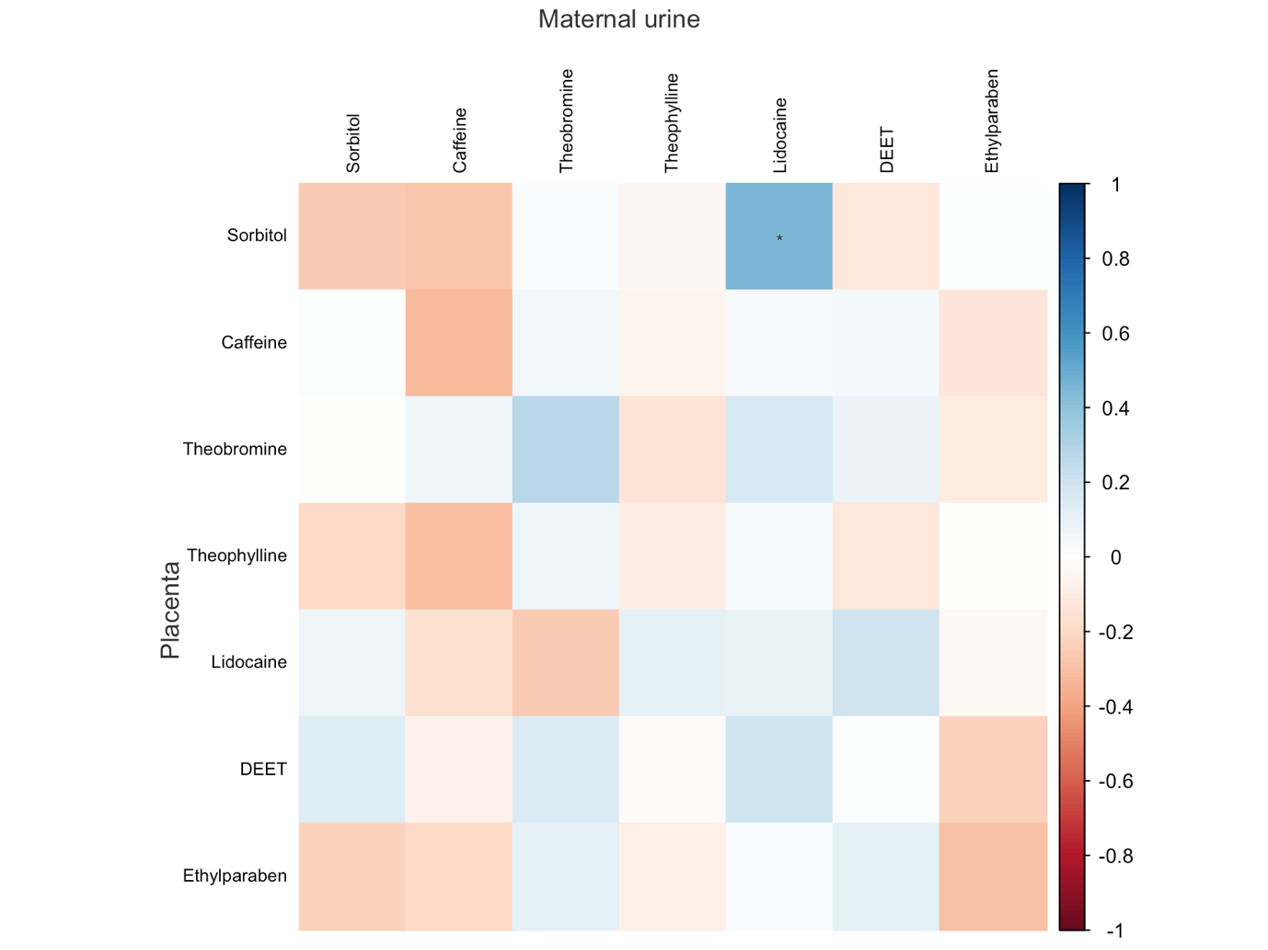
Fig. S5. Spearman correlation heat map between chemicals detected in placenta and maternal urine.
Asterisks indicate significance levels (p < 0.05, p < 0.01, p < 0.001). Only compounds detected in paired matrices in ≥20% of samples were included.

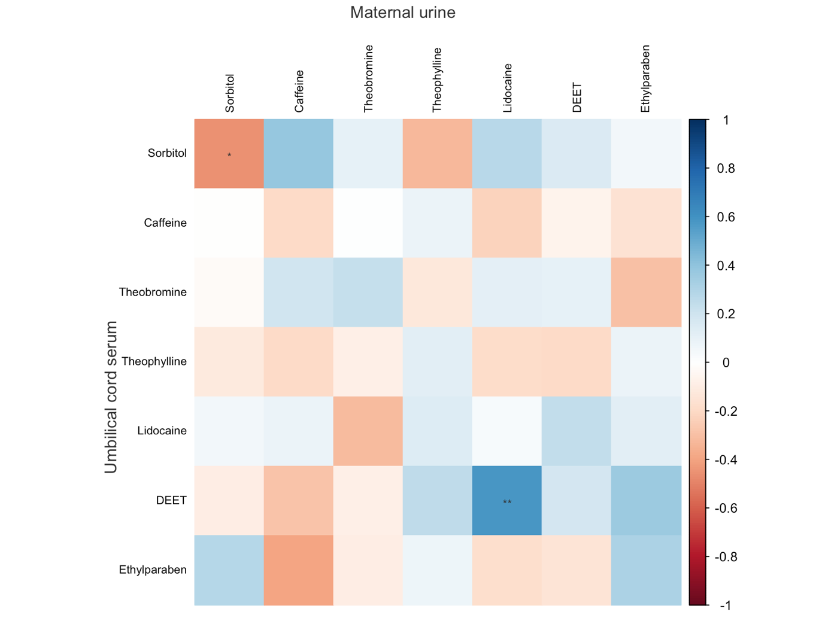
Fig. S6. Spearman correlation heat map between chemicals detected in umbilical cord serum and maternal urine.
Asterisks indicate significance levels (p < 0.05, p < 0.01, p < 0.001). Only compounds detected in paired matrices in ≥20% of samples were included.

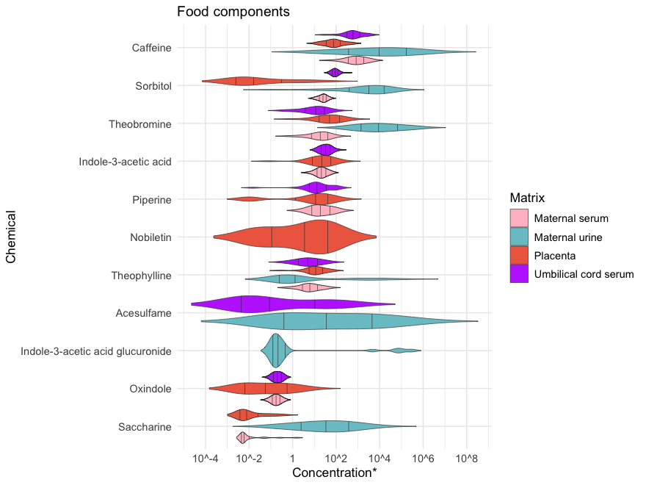
Fig. S7. Violin plots of food components concentrations across biological matrices.
Each distribution represents the log₁₀-transformed concentrations (*ng mL⁻¹ for serum, ng g⁻¹ for placenta and µg g⁻¹ creatinine for urine) of food components in different biological matrices. Violin widths indicate the density of observations, and internal lines represent the 25th, 50th (median), and 75th percentiles. Only chemicals with detection frequencies ≥ 20% in the matrices are shown.

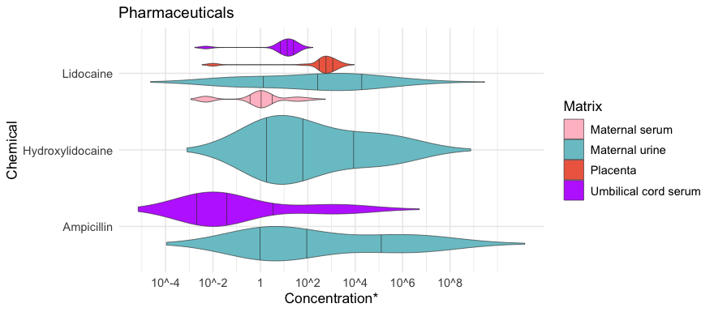

Fig. S8. Violin plots of pharmaceuticals concentrations across biological matrices.
Each distribution represents the log₁₀-transformed concentrations (*ng mL⁻¹ for serum, ng g⁻¹ for placenta and µg g⁻¹ creatinine for urine) of pharmaceuticals in different biological matrices. Violin widths indicate the density of observations, and internal lines represent the 25th, 50th (median), and 75th percentiles. Only chemicals with detection frequencies ≥ 20% in the matrices are shown.
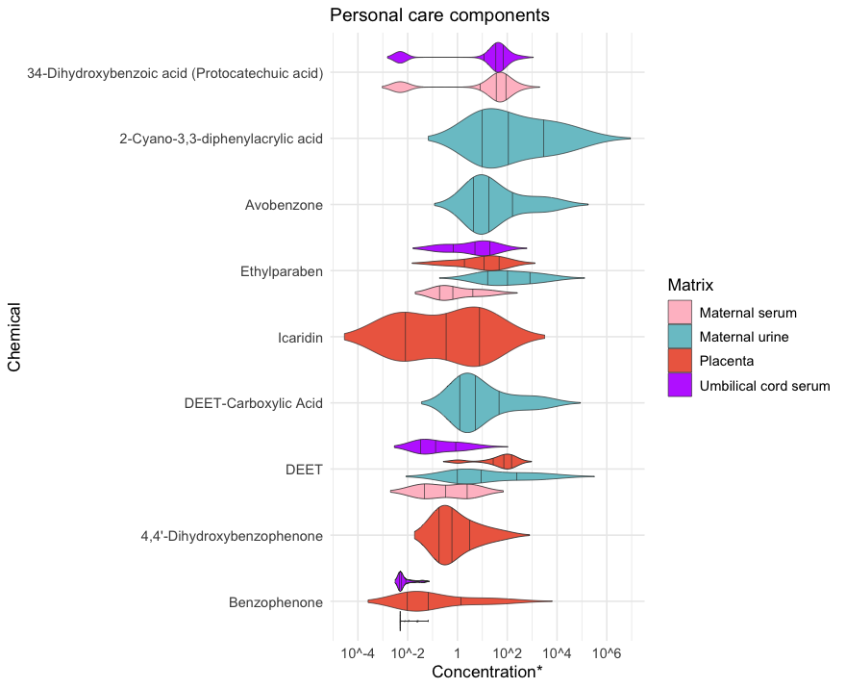

Fig. S9. Violin plots of personal care components concentrations across biological matrices.
Each distribution represents the log₁₀-transformed concentrations (*ng mL⁻¹ for serum, ng g⁻¹ for placenta and µg g⁻¹ creatinine for urine) of personal care components in different biological matrices. Violin widths indicate the density of observations, and internal lines represent the 25th, 50th (median), and 75th percentiles. Only chemicals with detection frequencies ≥ 20% in the matrices are shown.

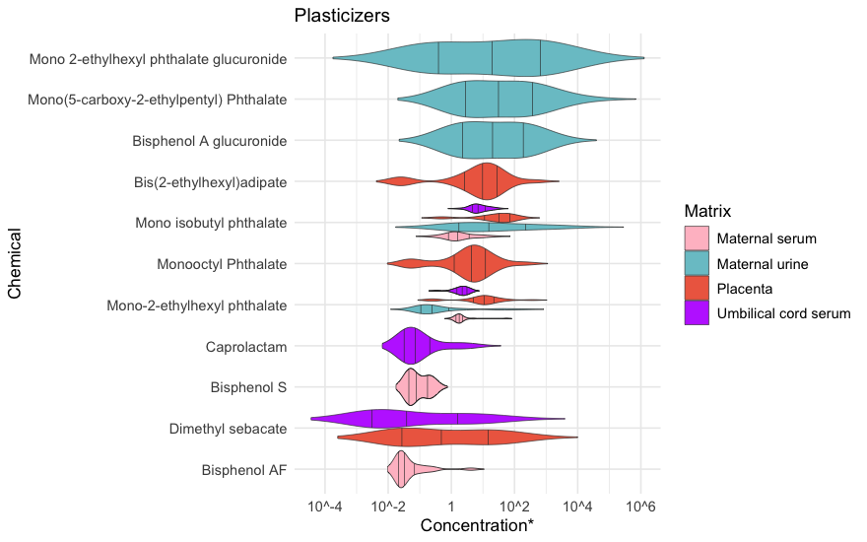

Fig. S10. Violin plots of plasticizers concentrations across biological matrices.
Each distribution represents the log₁₀-transformed concentrations (*ng mL⁻¹ for serum, ng g⁻¹ for placenta and µg g⁻¹ creatinine for urine) of plasticizers in different biological matrices. Violin widths indicate the density of observations, and internal lines represent the 25th, 50th (median), and 75th percentiles. Only chemicals with detection frequencies ≥ 20% in the matrices are shown.

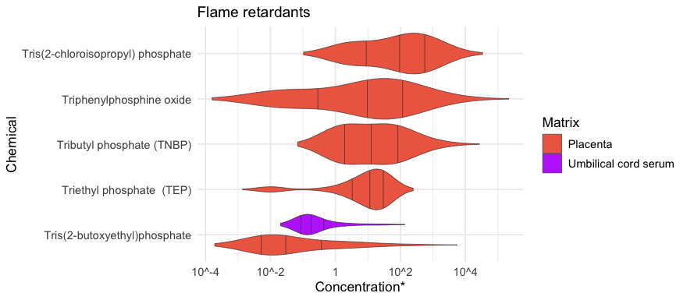

Fig. S11. Violin plots of flame retardants concentrations across biological matrices.
Each distribution represents the log₁₀-transformed concentrations (*ng mL⁻¹ for serum, ng g⁻¹ for placenta and µg g⁻¹ creatinine for urine) of flame retardants in different biological matrices. Violin widths indicate the density of observations, and internal lines represent the 25th, 50th (median), and 75th percentiles. Only chemicals with detection frequencies ≥ 20% in the matrices are shown.

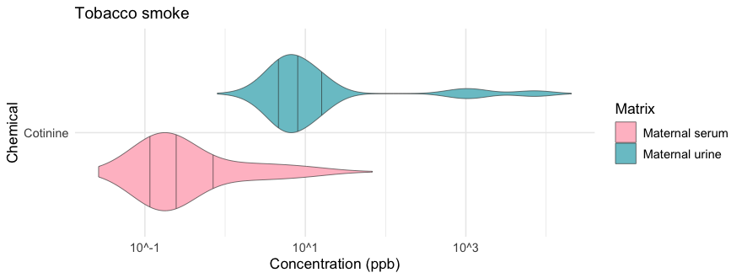

Fig. S12. Violin plots of cotinine concentrations across biological matrices.
Each distribution represents the log₁₀-transformed concentrations (*ng mL⁻¹ for serum and µg g⁻¹ creatinine for urine for urine) of cotinine in different biological matrices. Violin widths indicate the density of observations, and internal lines represent the 25th, 50th (median), and 75th percentiles. Only chemicals with detection frequencies ≥ 20% in the matrices are shown.

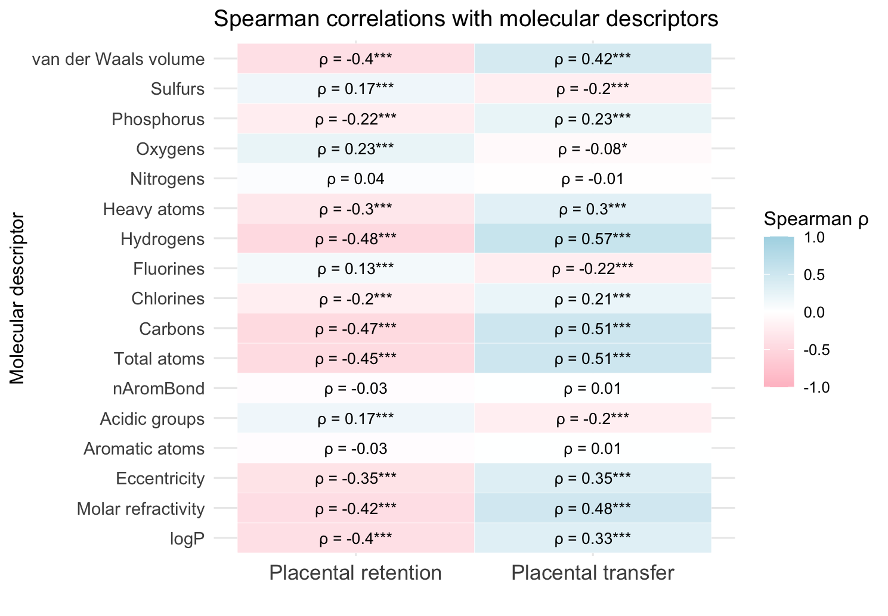
Fig. S13. Correlations between physicochemical properties and placental retention or transplacental transfer.
Spearman correlation coefficients (ρ) are shown for key molecular descriptors (logP, molar refractivity, van der Waals volume, heavy atom count, hydrogen count, carbon count, and molecular eccentricity) in relation to placental retention (left) and transplacental transfer (right) of the compounds detected ≥ 20% of placentas or umbilical cord serums. Significant associations are highlighted with * (p<0.05), ** (p<0.01) and *** (p<0.001).

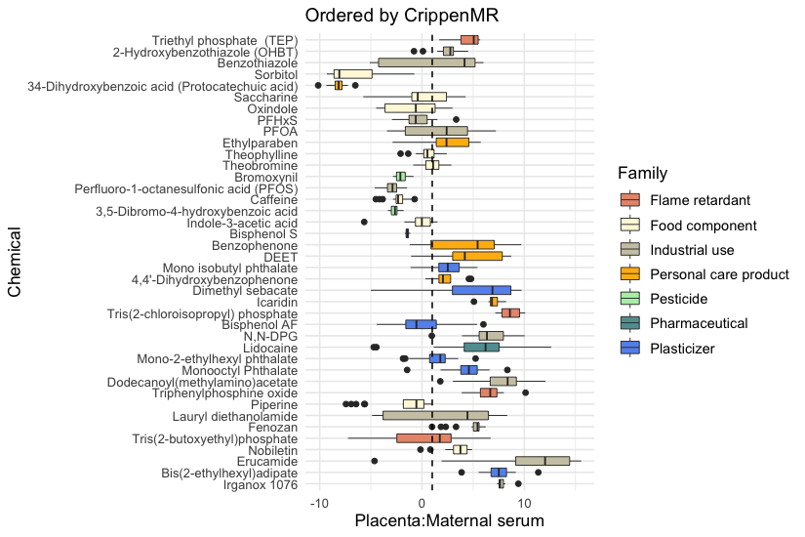

Fig. S14. Placental retention ratios of detected chemicals ordered by molar refractivity.

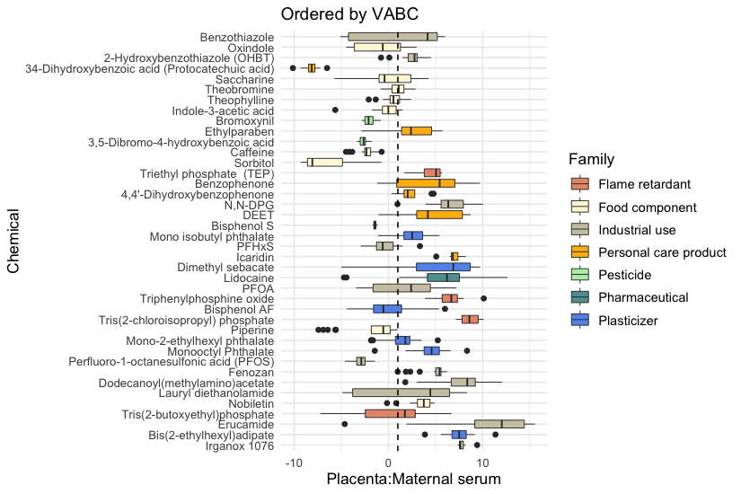
Fig. S15. Placental retention ratios of detected chemicals ordered by Volume of Van der Waals.

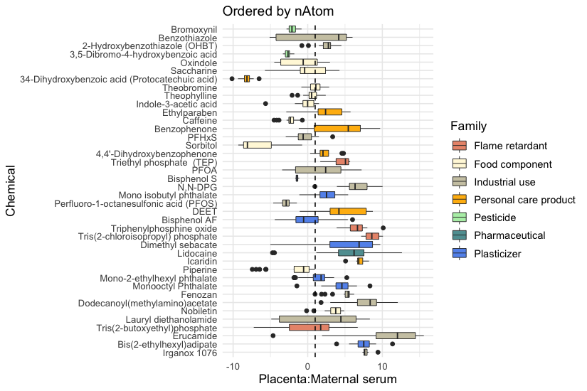
Fig. S16. Placental retention ratios of detected chemicals ordered by the heavy atom count.

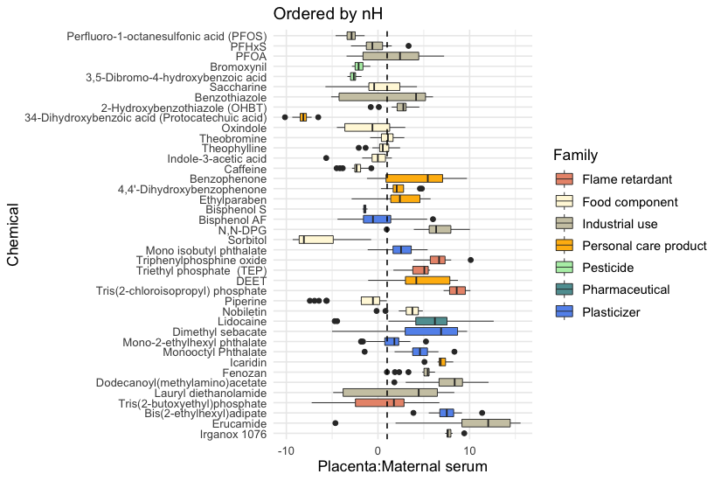
Fig. S17. Placental retention ratios of detected chemicals ordered by the hydrogen count.

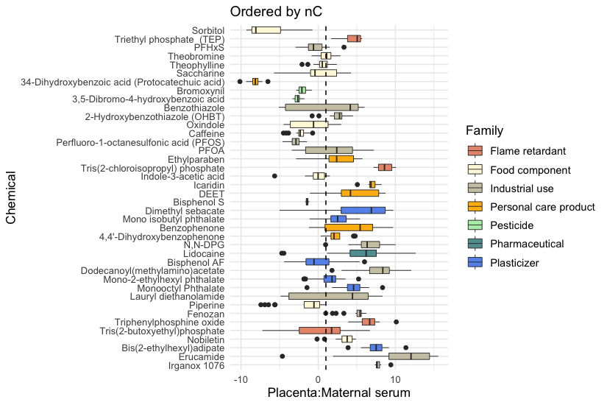
Fig. S18. Placental retention ratios of detected chemicals ordered by the carbon count.

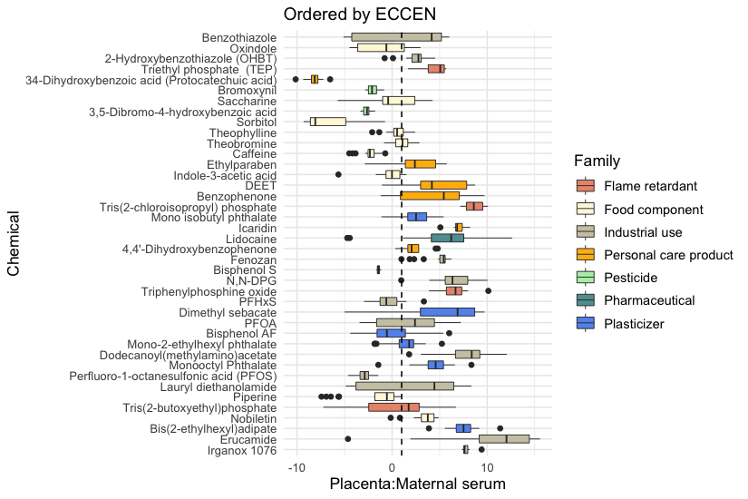
Fig. S19. Placental retention ratios of detected chemicals ordered by the eccentricity

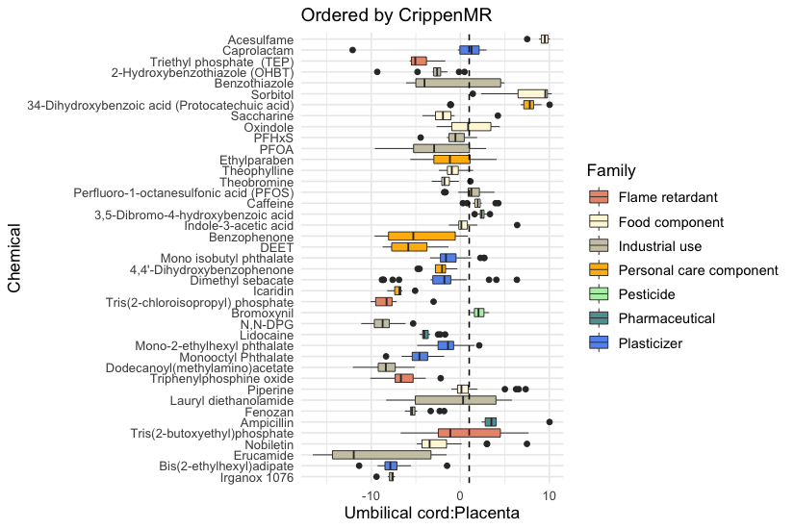

Fig. S20. Placental transfer ratios of detected chemicals ordered by molar refractivity.
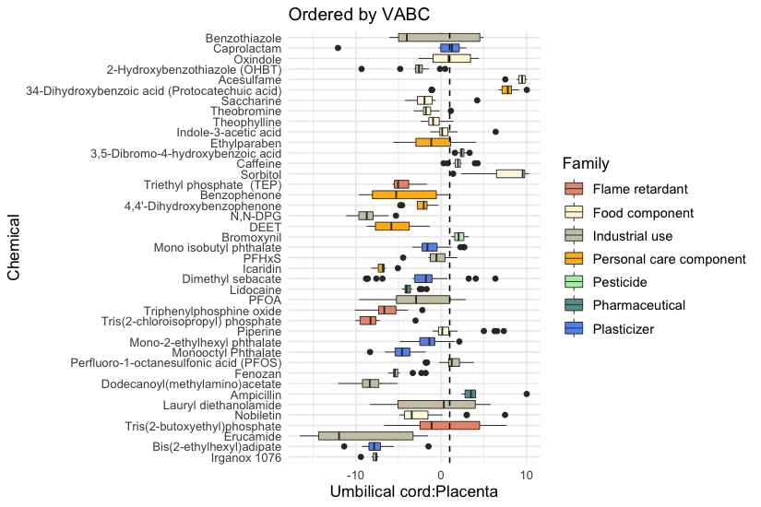
Fig. S21. Placental transfer ratios of detected chemicals ordered by Volume of Van der Waals.

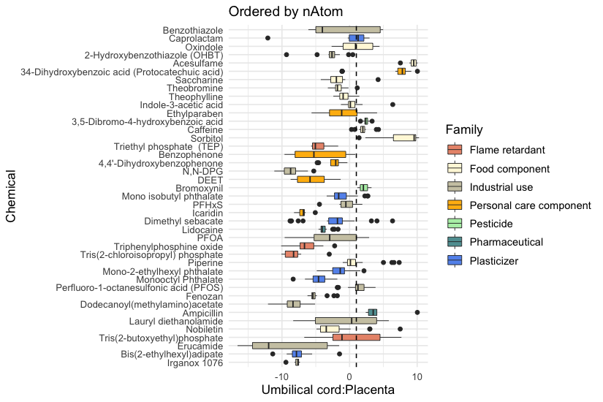
Fig. S22. Placental transfer ratios of detected chemicals ordered by the heavy atom count.

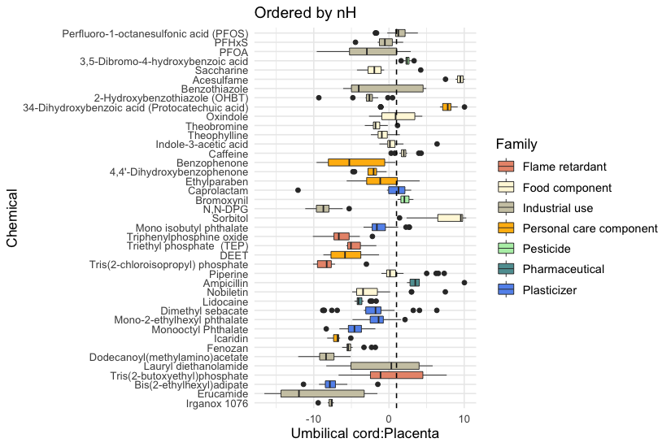
Fig. S23. Placental transfer ratios of detected chemicals ordered by the hydrogen count.

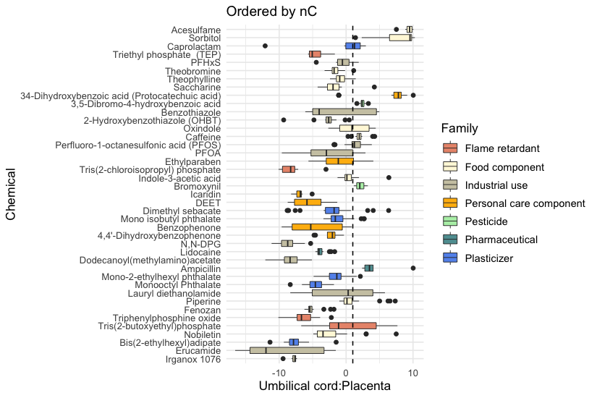
Fig. S24. Placental transfer ratios of detected chemicals ordered by the carbon count.

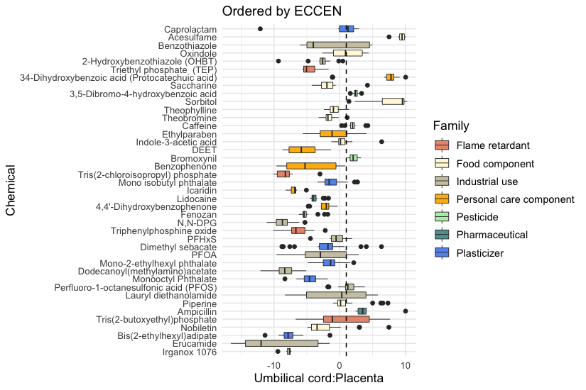
Fig. S25. Placental transfer ratios of detected chemicals ordered by the eccentricity

