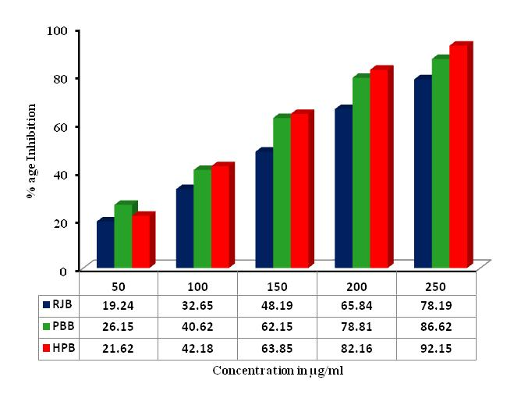
Spl. Figure 1: DPPH radical scavenging potential of various ANL extracts of diverse geographical locations. | Spl. Figure 2: Site specific hydroxyl radical scavenging potential of various ANL extracts of diverse geographical locations.
 | 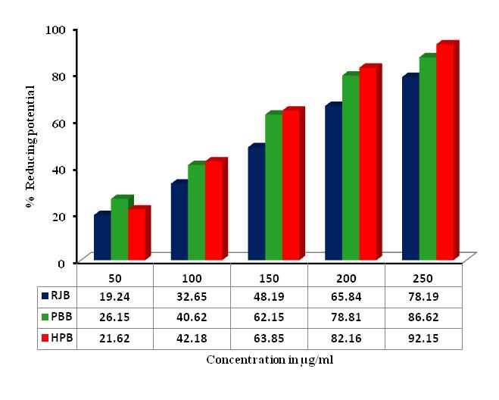
Spl. Figure 3: Non-site specific hydroxyl radical scavenging potential of various ANL extracts of diverse geographical locations. | Spl. Figure 4: Reducing potential of various ANL extracts of diverse geographical locations.
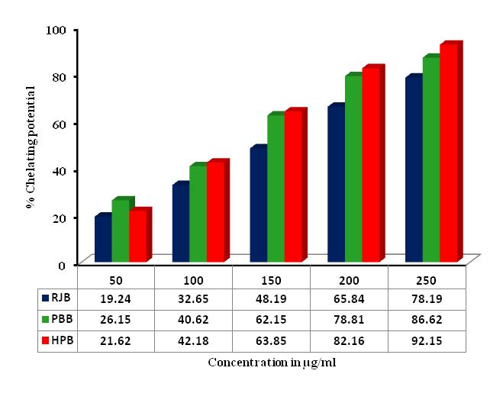 | 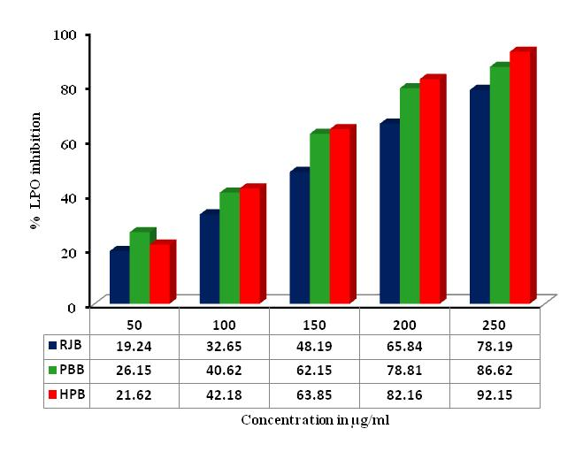
Spl. Figure 5: Chelating potential of various ANL extracts of diverse geographical locations. | Spl. Figure 6: Lipid peroxidation inhibition of various ANL extracts of diverse geographical locations.

