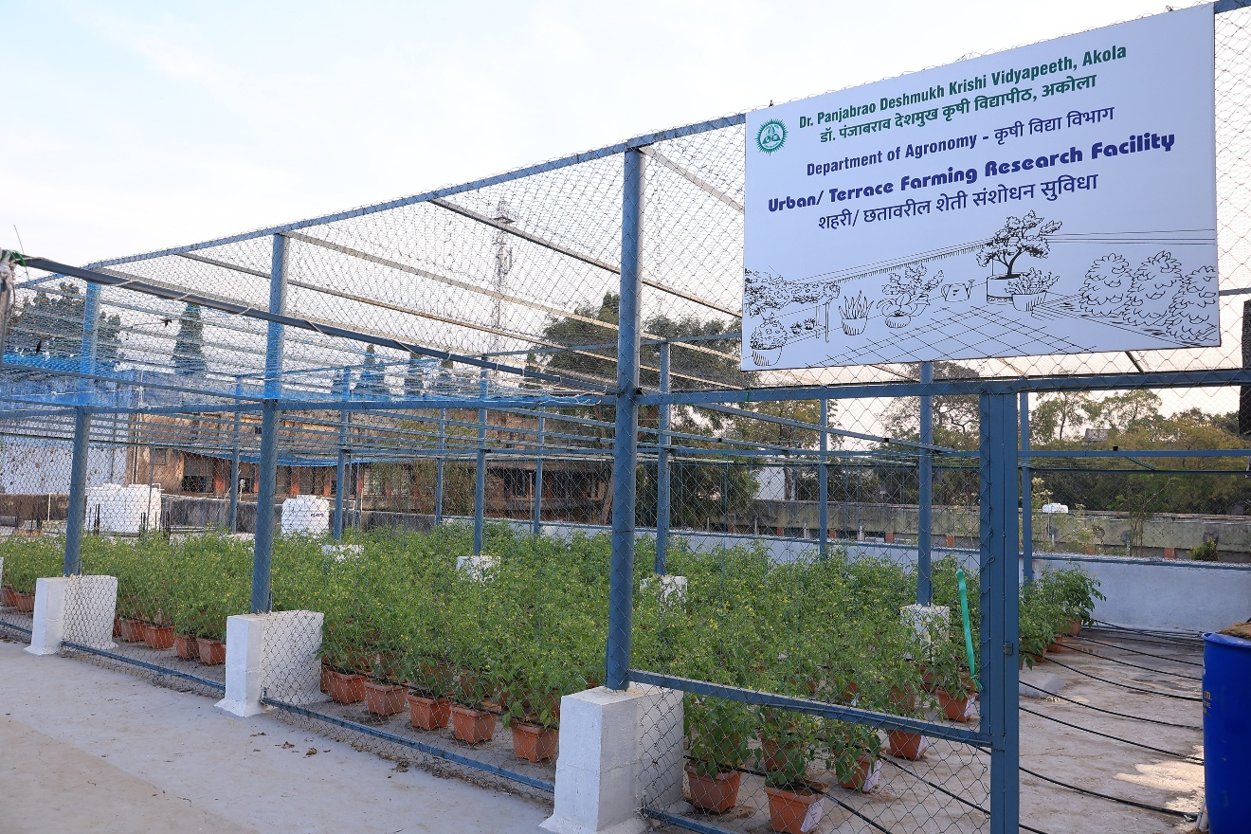
Plate 1. Urban Terrace Farming Research Facility
Department of Agronomy, Dr. PDKV, Akola, (Maharashtra), India
Plate 2. Tomato Crop in Natural Farming (NF₁ and NF₂) under Terrace Farming
Plate 2. General View of the Experiment under Terrace Farming
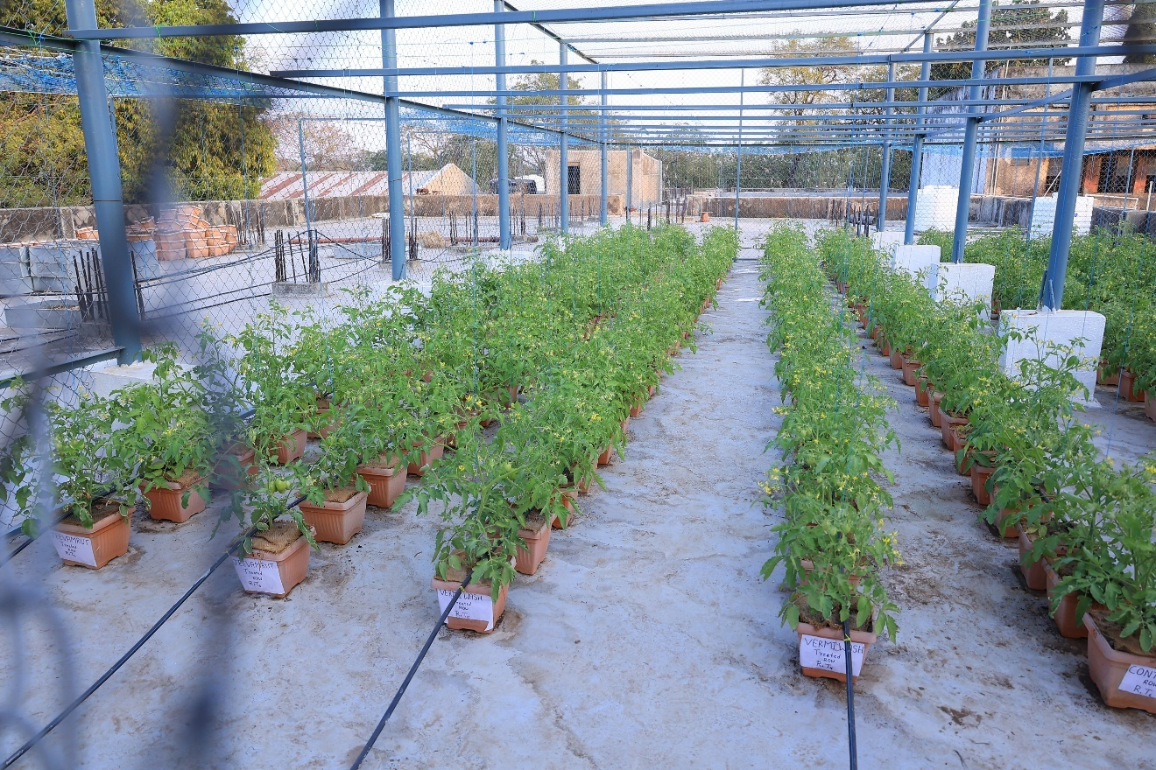

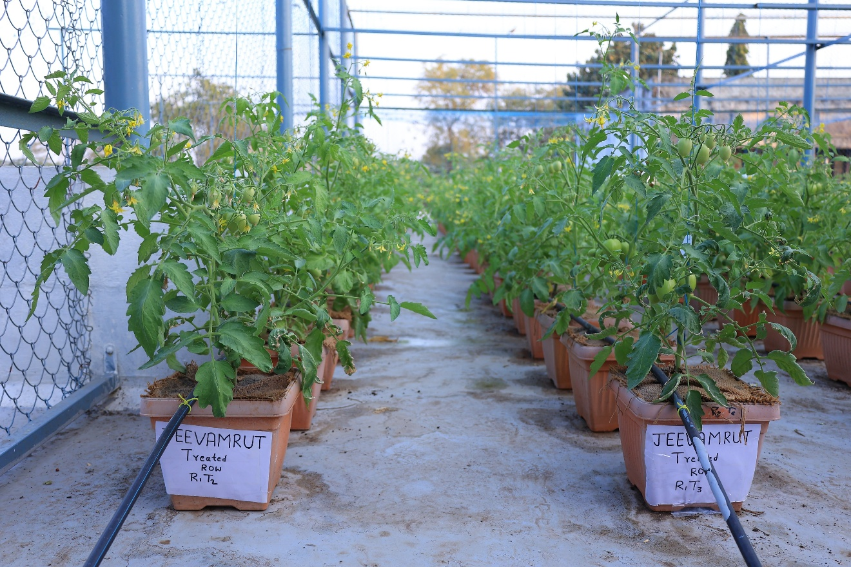
Plate 3. Tomato Crop in Natural Farming (NF₁ and NF₂) under Terrace Farming

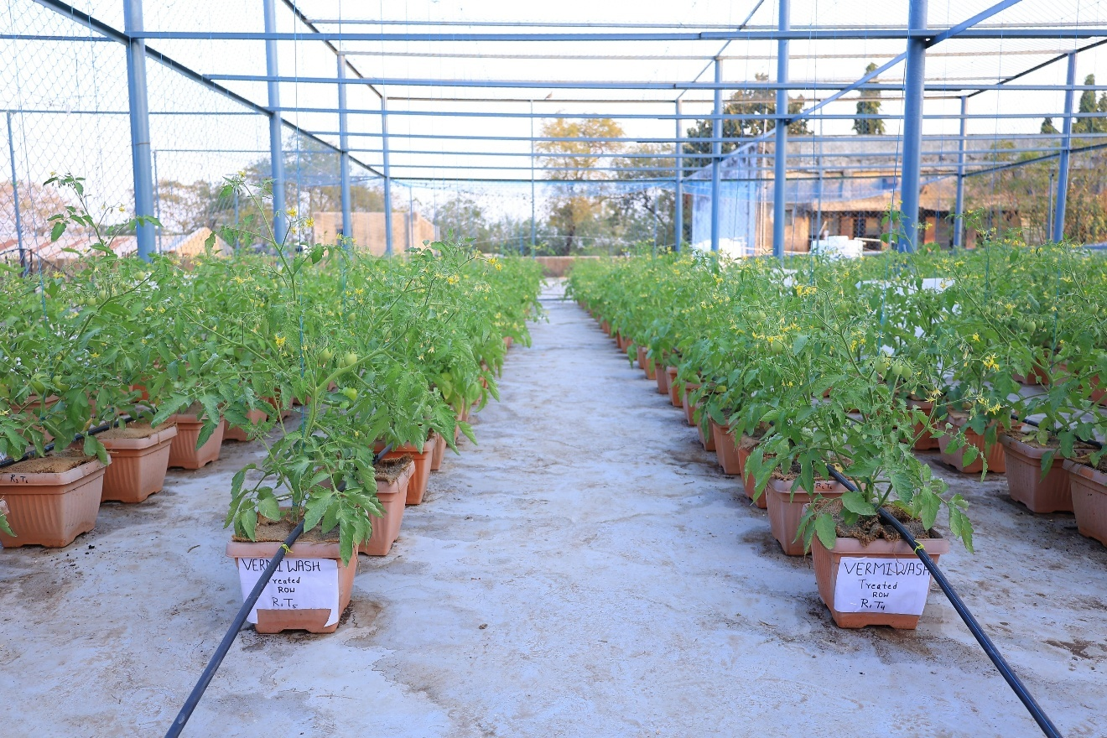
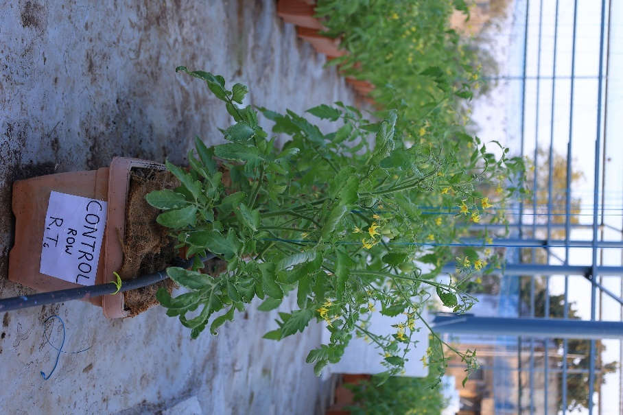
Plate 4. Tomato Crop in Organic Farming (OF₁ and OF₂) under Terrace Farming
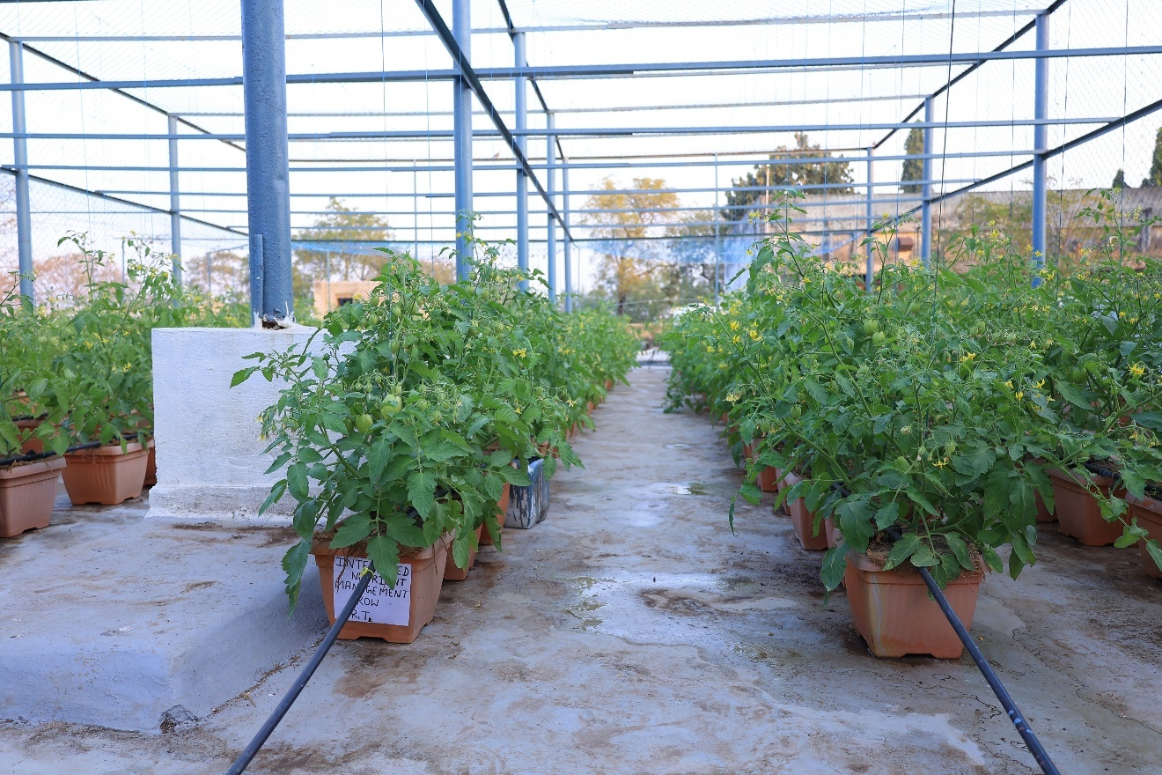
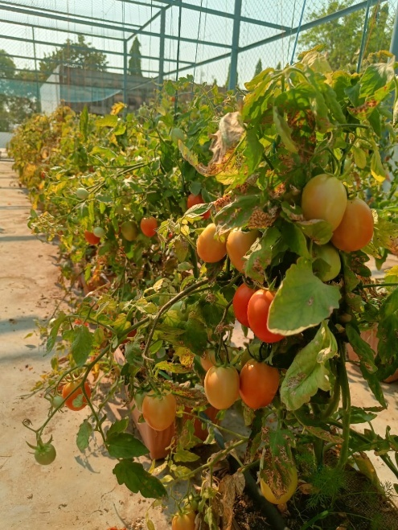
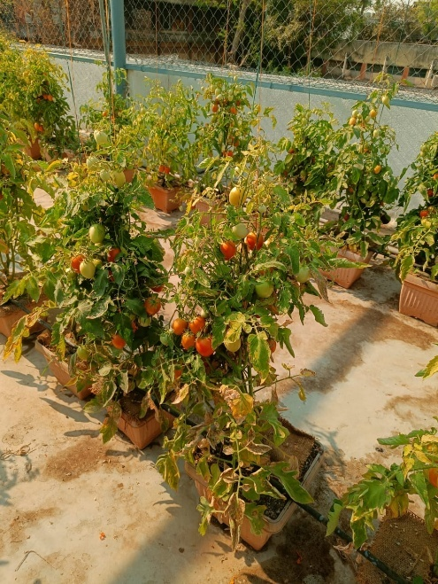
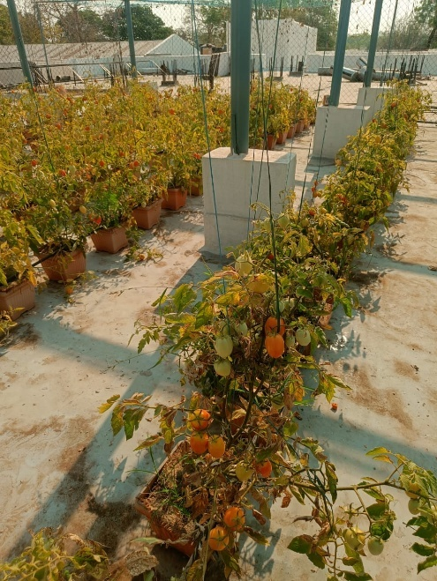
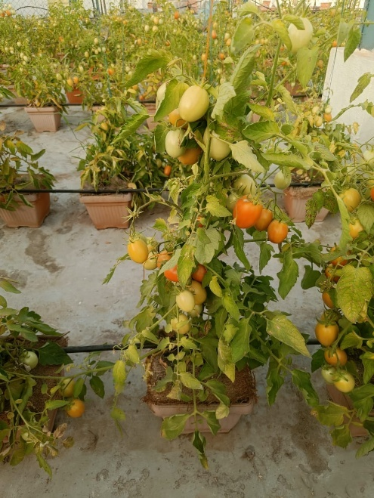
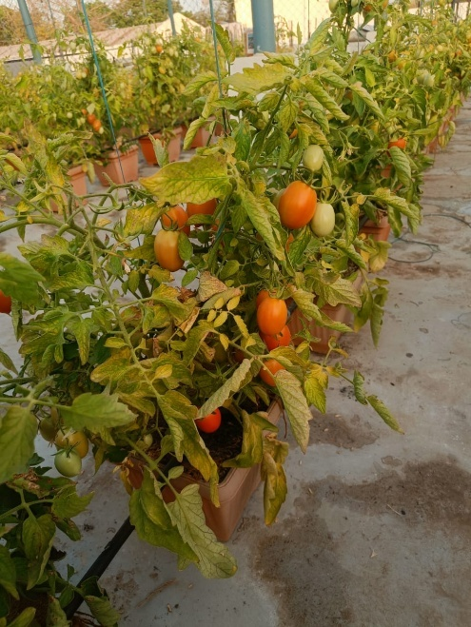
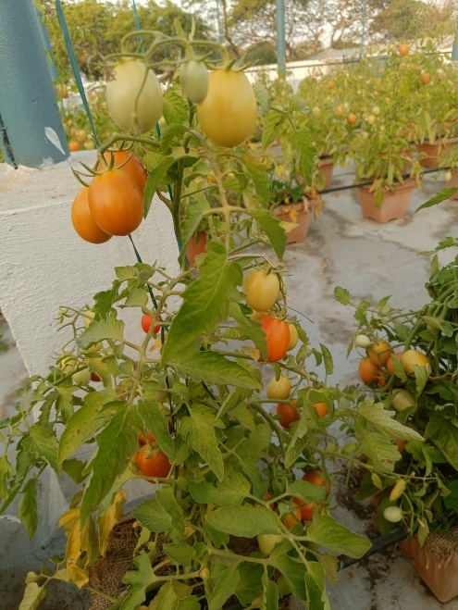
Plate 5. Tomato Crop in Conventional Treatment under Terrace Farming
Plate 5. Tomato Crop in Control Treatment under Terrace Farming
Tomato Plant in OF₁ Treatments
Tomato Plant in OF₂ Treatments
Tomato Plant in NF₂ Treatments
Tomato Plant in NF₁ Treatments
Tomato Plant in Conventional Treatments
Tomato Plant in Control Treatments

