Supplementary Table S1. Chemical reagents and sources used in the synthesis of compounds
Compound/Reagent | CAS No. | Source | Catalog Number | Purity
Benzyl alcohol (BnOH) | 100-51-6 | Bepharm | BD116108 | 98%
L-2-Aminoadipic acid | 1118-90-7 | Bepharm | BD2960 | 98%
Diethyl ether | 60-29-7 | Aladdin | D1506299 | AR, ≥99.7%
Triphosgene | 32315-10-9 | Aladdin | T103041 | ＞99%
Dichloromethane (DCM) | 75-09-2 | Bepharm | BD00959791 | 99.9%
Ditert-butyl 2-isocyanatopentanedioate | 17046-23-0 | Bepharm | BD02242917 | 98%
Triethylamine (TEA) | 121-44-8 | Bepharm | BD155212 | 99.5%
Acetonitrile | 75-05-8 | Bepharm | BD00963977 | 99.9%
Trifluoroacetic acid (TFA) | 76-05-1 | Bepharm | BD34856 | 98%
2-Tert-butyl-1,3-diisopropylisourea | 71432-55-8 | Bepharm | BD78662 | 95%
Tetrahydrofuran (THF) | 109-99-9 | Bepharm | BD54782 | 99.5%
Palladium on carbon (Pd/C) | 7440-05-3 | Bepharm | BD01102729 | 10 %
Benzyl N-(3-(phenylamino) propyl) carbamate | NA | Medicilon | NA | NA
Pyridine | 110-86-1 | Bepharm | BD149696 | 99%
Phosphorus oxychloride | 60-29-7 | Aladdin | D1506299 | AR, ≥99.7%
NaHCO₃ | 144-55-8 | Bepharm | BD151377 | 95%
Isopropanol (IPA) | 67-63-0 | Bepharm | BD34593 | 99%
N,N,N',N'-tetramethylchloroformamidinium hexafluorophosphate (TCFH) | 94790-35-9 | Bepharm | BD19308 | 98%
N-Methylimidazole (NMI) | 616-47-7 | Bepharm | BD40860 | 98%
Boc-trans-4-aminocyclohexanecarboxylic acid | 53292-89-0 | Bepharm | BD117661 | 98%
N,N-Dicyclohexylcarbodiimide (DCC) | 538-75-0 | Bepharm | BD220228 | 98%
4-Dimethylaminopyridine (DMAP) | 1122-58-3 | Bepharm | BD17199 | 98%
Brine | 7647-14-5 | Bepharm | BD01122789 | 99.9% AR
Na₂SO₄ | 7757-82-6 | Bepharm | BD31900 | 99%
Petroleum ether | 8032-32-4 | Aladdin | P116177 | AR
Ethyl acetate | 141-78-6 | Bepharm | BD212846 | 99.8%
DOTA-tri | 1613382-10-7 | Bepharm | BD01435851 | 95%
Figure S1. Synthesis of DOTA ligand
(a) BnOH, DCM, DCC, Ar, rt, 1 h (b) Ar, rt, 4 h
(c) DOTA-tri, TCFH, ACN, rt, 1 h (d) Pd/c, THF, Ar, rt, 16 h

Step a: A mixture of Boc-trans-4-aminocyclohexanecarboxylic acid (Compound 1, 2.00 g, 7.78 mmol), N,N-Dicyclohexylcarbodiimide (DCC, 1.77 g, 8.56 mmol), and 4-dimethylaminopyridine (DMAP, 0.95 g, 7.78 mmol) in dichloromethane (DCM, 20 mL) was prepared. Benzyl alcohol (BnOH, 0.92 g, 8.56 mmol) was then added at room temperature. The reaction mixture was stirred under an argon atmosphere at room temperature for 2 hours. The mixture was diluted with water (50 mL) and extracted with DCM (3 × 20 mL). The combined organic phases were washed with brine (50 mL), dried over anhydrous Na₂SO₄, and concentrated under reduced pressure. Purification by HPLC (petroleum ether/ethyl acetate 10:90 to 20:80) afforded intermediate 2 (1.12 g, 61% yield).

Step b: A solution of intermediate 2 (1.12 g, 3.21 mmol) in an HCl/ethyl acetate solution (10 mL) was stirred at room temperature under an argon atmosphere for 4 hours. The reaction mixture was then concentrated under reduced pressure to afford intermediate 3 (750 mg, 82% yield).

Step c: A mixture of intermediate 3 (750 mg, 2.63 mmol), DOTA-tri (1.81 g, 3.16 mmol), and N-methylimidazole (NMI, 495 mg, 6.04 mmol) in acetonitrile (ACN, 15 mL) was treated with N,N,N′,N′-tetramethylchloroformamidinium hexafluorophosphate (TCFH, 1.25 g, 4.46 mmol) at room temperature under an argon atmosphere. After stirring for 1 hour, the reaction mixture was concentrated under reduced pressure. The residue was purified by RP-HPLC (acetonitrile/water, 10% to 90%, 0.1% TFA) to afford intermediate 4 (400 mg, 20% yield).

Step d: To a solution of intermediate 4 (400 mg, 0.50 mmol) in tetrahydrofuran (THF, 20 mL) was added 10% palladium on carbon (Pd/c, 150 mg). The reaction mixture was stirred under a hydrogen atmosphere at room temperature for 16 hours. The catalyst was then removed by filtration, and the filtrate was concentrated under reduced pressure to afford the final product, DOTA-ligand (300 mg, 84% yield).

HPLC Method for S2, S8 and S11: A: 0.03%TFA in Water B: 0.03%TFA in ACN
Agilent Eclipse Plus C18 3.5um 4.6x150mmm Column, 1.0 ml/min, Column Temperature: 40 ºC
214 nm
Figure S2. HPLC purity analysis of TM-1
Peak 1: RT=8.419 min, 214nm, Width=0.042 min, Area=2379.590, 97.581 %
Peak 2: RT=8.507 min, 214nm, Width=0.093 min, Area=58.990, 2.419 %
Figure S3. Chromatogram of TM-1 in LC/MS analysis
A: Chromatogram of Evaporative Light Scattering Detector (ELSD), RT=5.643, 100%
B: Chromatogram of 254 nm, RT=5.639, 100%
C: Chromatogram of 214 nm, RT1=1.895, 4.834 %, RT2=5.639 95.166%
D: Total Ion Chromatogram (TIC)
Figure S4. Mass Spectrum of TM-1 in LC/MS analysis
A: RT=5.641 min, LCMS (ESI) M/Z: 992.4 [M+H]⁺
B: RT=8.948 min C: RT=12.244 min D: RT=12.559 min E: RT=13.930 min

HPLC Method for LC/MS analysis of TM-1: A: 0.03%TFA in Water B: 0.03%TFA in ACN
Waters SunFire C18 50*4.6mm 5um Column, 1.000ml/min, 15 min, Column Temperature: 40 ºC
Gradient: 10% B hold for 1.8min, increase to 95 % B within 10.2 min, hold at 95 % B for 3.0 min, then back to 10% B within 0.1 min

Figure S5. NMR of TM-1
Pulse length = 8.000 usec, Recycle delay = 1.000 sec, NA (Number of Accumulations) = 8,
Solvent = DMSO, Points in 1D spectrum = 65536, F1 = 400.299988 MHz, Spectral Width= 8196.72, Acquisition Time = 8.00 sec, Hz per Pt 1stD (Digital Resolution) = 0.13 Hz,
Offset Frequency = 2469.2051 Hz, Line Broadening Factor = 0.30 Hz

Figure S6. Synthesis of natGa-TM-1
TM-1 (20 mg) was dissolved in ammonium acetate buffer (0.1 M, pH = 5.0). To this solution was added a 10 mg/mL solution of Ga(NO₃)₃ (2.74 mL). The reaction mixture was heated at 90 °C for 30 min. Reaction completion was confirmed by LC-MS, which indicated full consumption of the starting material and the formation of the product. The mixture was lyophilized, and the crude material was purified by HPLC to afford natGa-TM-1 (8 mg, purity: 98.14%).

Figure S7. Synthesis of natLu-TM-1
TM-1 (15 mg) was dissolved in ammonium acetate buffer (0.1 M, pH = 5.0). To this solution was added a 10 mg/mL solution of LuCl₃ (1.27 mL). The reaction mixture was heated at 90 °C for 10 min. Reaction completion was confirmed by LC-MS, which indicated full consumption of the starting material and the formation of the product. The mixture was lyophilized, and the crude material was purified by HPLC to afford natLu-TM-1 (7 mg, purity: 98.21%).

Figure S8. HPLC purity analysis of natGa-TM-1
Peak 1: RT=5.324 min, 214nm, Width=0.057 min, Area=1684.345, 98.142 %
Peak 2: RT=5.493 min, 214nm, Width=0.077 min, Area=17.507, 1.020 %
Peak 3: RT=5.616 min, 214nm, Width=0.050 min, Area=14.374, 0.838 %
Figure S9. Chromatogram of natGa-TM-1 in LC/MS analysis
A: Chromatogram of ELSD, RT1=1.120, 82.096 %, RT2=2.416, 17.904 %
B: Chromatogram of 254 nm, RT1=0.428, 68.860 %, RT2=1.115, 31.140 %
C: Chromatogram of 214 nm, RT1=0.433, 89.346 %, RT2=0.864, 6.926 %, RT3=1.114, 3.728 %
D: TIC
Figure S10 (Part 1). Mass Spectrum of natGa-TM-1 in LC/MS analysis
A: RT=0.424 min B: RT=0.768 min C: RT=0.914 min D: RT=0.967 min
E: RT=1.107 min, LCMS (ESI) M/Z: 1058.3 [M+H]⁺

Figure S10 (Part 2). Mass Spectrum of natGa-TM-1 in LC/MS analysis
F: RT=1.783 min G: RT=1.993 min H: RT=2.128 min I: RT=2.227 min
J: RT=2.402min

HPLC Method for LC/MS analysis of natGa-TM-1
A: 0.03%TFA in Water B: 0.03%TFA in ACN
Waters SunFire C18 50*4.6mm 5um Column, 2.000ml/min, 2.6 min, Column Temperature: 40 ºC
Gradient: 5% B hold for 0.2 min, increase to 95 % B within 1.4 min, hold at 95 % B for 0.9 min, then back to 5% B within 0.1 min

Figure S11. HPLC analysis of natLu-TM-1
Peak 1: RT=6.587 min, 214nm, Width=6.587 min, Area=2138029, 98.214 %
Peak 2: RT=6.749 min, 214nm, Area=38880, 1.786 %
Figure S12. Chromatogram of natLu-TM-1 in LC/MS analysis
A: Chromatogram of 254 nm, RT1=1.098, 100 %
B: Chromatogram of 214 nm, RT1=1.099, 87.028 %, RT2=87.028, 12.972 %
C: TIC

Figure S13 (Part 1). Mass Spectrum of natLu-TM-1 in LC/MS analysis
A: RT=0.236 min B: RT=0.323 min C: RT=0.452 min D: RT=0.580 min
E: RT=1.012 min
Figure S13 (Part 2). Mass Spectrum of natLu-TM-1 in LC/MS analysis
F: RT=1.099 min LCMS (ESI) M/Z: 1164.3 [M+H]⁺
G: RT=2.149 min H: RT=2.225 min I: RT=2.540 min J: RT=2.686min

HPLC Method for LC/MS analysis of natLu-TM-1
A: 0.03%TFA in Water B: 0.03%TFA in ACN
Waters SunFire C18 50*4.6mm 5um Column, 2.000ml/min, 3.0 min, Column Temperature: 40 ºC
Gradient: 5% B hold for 0.2 min, increase to 95 % B within 1.4 min, hold at 95 % B for 0.9 min, then back to 5% B within 0.1 min

Figure S14. Comparative HPLC analyses of the radio tracers and non-radioactive reference compounds
(A) 68Ga-TM-1 TR =6.651 min (B) 177Lu-TM-1 TR =6.257 min
(C) natGa-TM-1 UV 254nm TR =6.617 min (D) natLu-TM-1 UV 254nm TR =6.203 min

HPLC method for S13: ACE EXCEL 3 C18 150×4.6mm 40℃
A:0.1%TFA in Water B:0.1%TFA in ACN 1.0 mL/min

Figure S15. Distinct subcellular distribution patterns
For experimental wells: Intramembrane rate accounts for 71.91%, internalization rate accounts for 28.09%.
For Block wells: Intramembrane rate accounts for 58.07%, internalization rate accounts for 41.93%.
The raw data for this figure can be located in the Excel file (“Data of Supplementary Figure”, Sheet ) in the Supporting Information.
For underlying data, refer to the Excel file (“Data of Supplementary Figure”, Sheet Figure S15) in the SI.

Figure S16. Radio-biodistribution of ⁶⁸Ga-TM-1 in C57BL/6J mice for 0.5h, 1h, 2h and 4h after injection (n=24)
Refer to the Excel file (“Data of Supplementary Figure”, Sheet Figure S16) in the SI.
Figure S17. Radioactive uptake of organs in PET/MR
A: Organ distribution of 68Ga-TM-1
B: Organ distribution of 68Ga-TM-1 (kidneys and bladder excluded)
C: Organ distribution of 68Ga-TM-1+2-PMPA
D: Organ distribution of 68Ga-TM-1+2-PMPA (kidneys and bladder excluded)
Refer to the Excel file (“Data of Supplementary Figure”, Sheet Figure S17 A-D) in the SI.
Figure S18. SUV after injection of ⁶⁸Ga-TM-1 (bladder excluded)
Refer to the Excel file (“Data of Supplementary Figure”, Sheet Figure S18) in the SI.

Figure S19. SUV after injection of ⁶⁸Ga-TM-1+2-PMPA (bladder excluded)
Refer to the Excel file (“Data of Supplementary Figure”, Sheet Figure S19) in the SI.

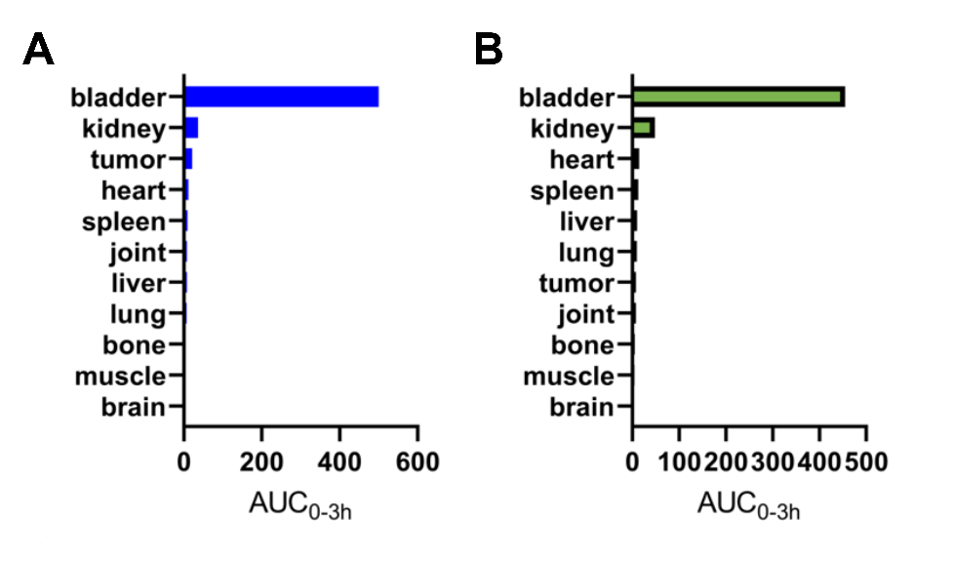
Figure S20. AUC (0-3h) after injection
A: AUC0-3h of 68Ga-TM-1 (AUC_{Tumor}=21.17)
B: AUC of 68Ga-TM-1+2-PMPA (AUC_{Tumor}=7.78)
Refer to the Excel file (“Data of Supplementary Figure”, Sheet Figure S20) in the SI.

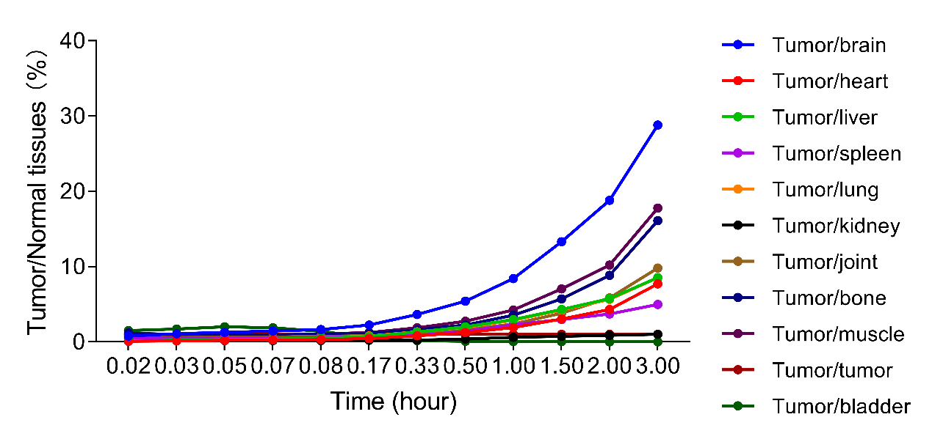
Figure S21. Tumor/Normal tissues after injection of ⁶⁸Ga-TM-1
Refer to the Excel file (“Data of Supplementary Figure”, Sheet Figure S21) in the SI.

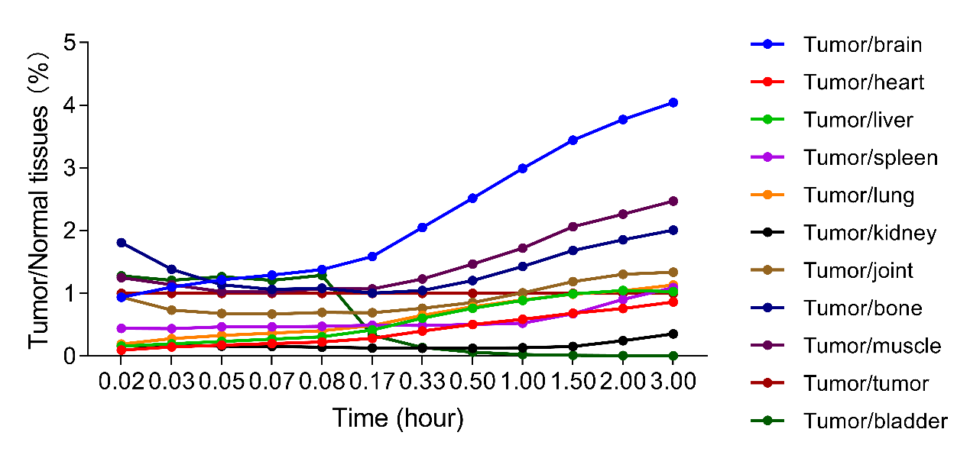
Figure S22. Tumor/Normal tissues after injection of ⁶⁸Ga-TM-1+2-PMPA
Refer to the Excel file (“Data of Supplementary Figure”, Sheet Figure S22) in the SI.
Figure S23. Tumor/Normal tissues after injection of ¹⁷⁷Lu-TM-1 (n=3)
Refer to the Excel file (“Data of Supplementary Figure”, Sheet Figure S23) in the SI.
Figure S24. AUC(0-96h) after injection of ¹⁷⁷Lu-TM-1
Refer to the Excel file (“Data of Supplementary Figure”, Sheet Figure S24) in the SI.

Figure S25. SUV after injection of ¹⁷⁷Lu-TM-1
Refer to the Excel file (“Data of Supplementary Figure”, Sheet Figure S25) in the SI.

NA means not available, this compound was synthesized by Shanghai Medicilon Inc. and is not a commercial product, hence no CAS or catalog number exists.

