Figure S1 Heatmap diagram of differentially expressed metabolites

Figure S2 The distribution of DEPs shown in an upset chart. Set size denotes the total number of DEPs. Counts of intersection represents the amount of DEPs in the comparisons marked by filled circles (single comparisons) or circles with connection lines (multiple comparisons).

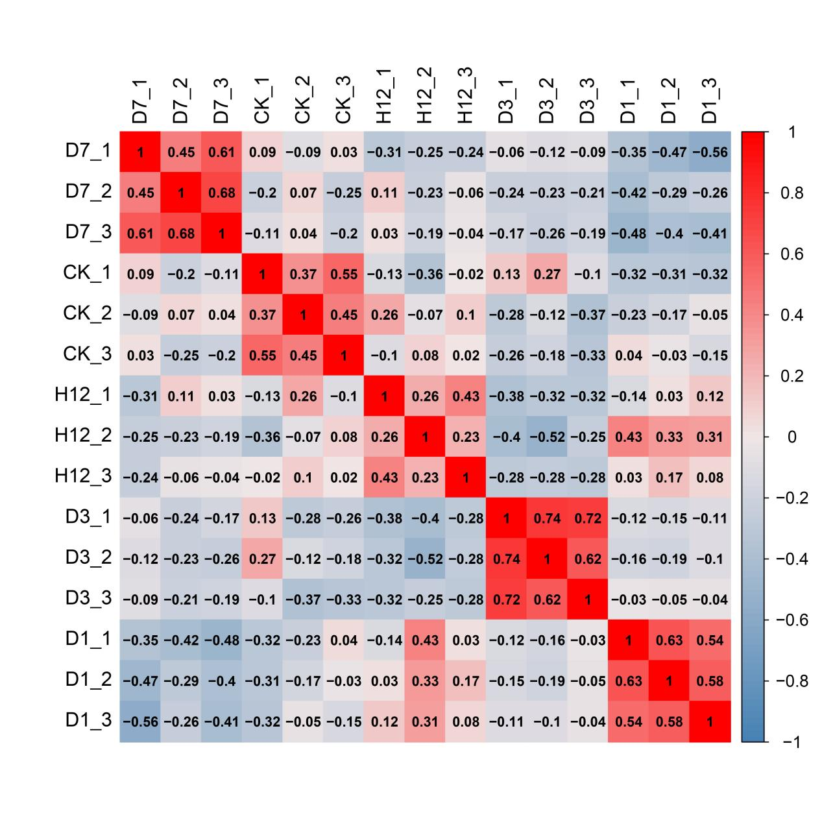

Figure S3 Pearson's Correlation Coefficient of differentially expressed proteins.

Figure S4. Mfuzz analysis based on differentially expressed proteins changing patterns. The left side shows the trend in protein expression in successive treatments. The horizontal axis is the continuous sample; the vertical axis is the protein expression. The fold lines are categorized into four different trends according to the cluster analysis. Heatmaps and enrichment analysis of the GO functions, KEGG pathways and protein structural domains of the DEPs are plotted on the right side for each cluster.

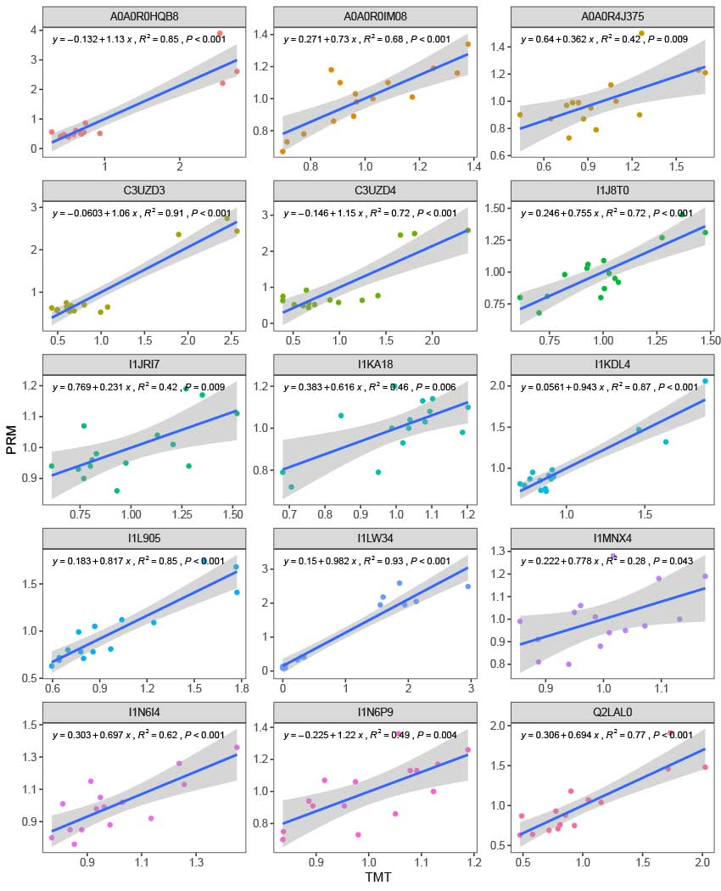

Figure S5. Correlation analysis between the parallel reaction monitoring and proteomics results of 15 peptides.

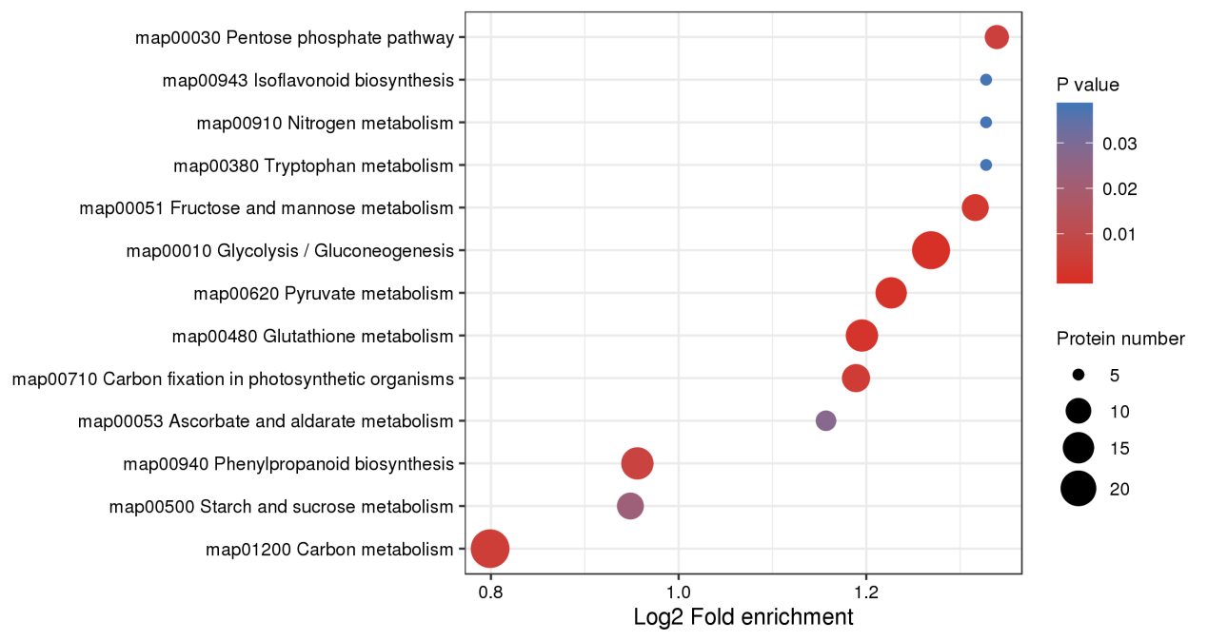

Figure S6. KEGG enrichment analysis of the differential ubiquitination-regulated proteins of soybean roots under low-phosphorus stress.

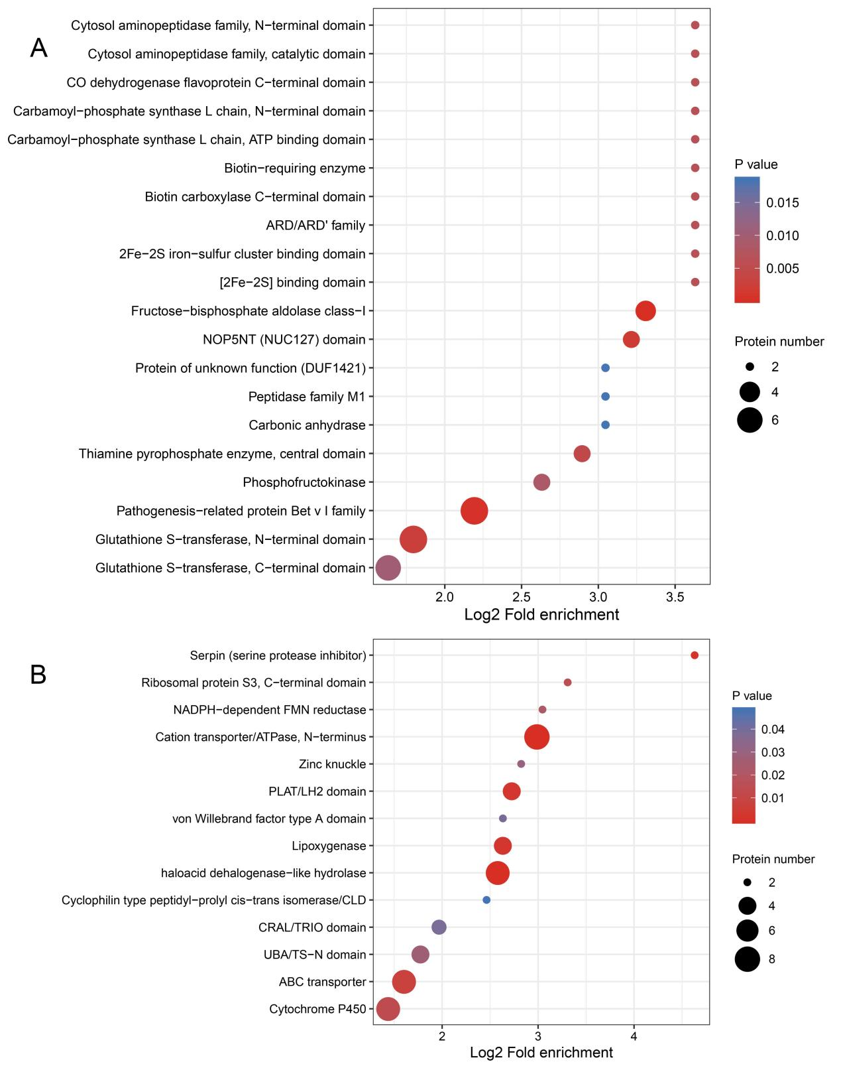

Figure S7 Domain enrichment analysis of differentially up-regulated (A) and down-regulated (B) proteins of soybean root ubiquitination under low phosphorus stress.

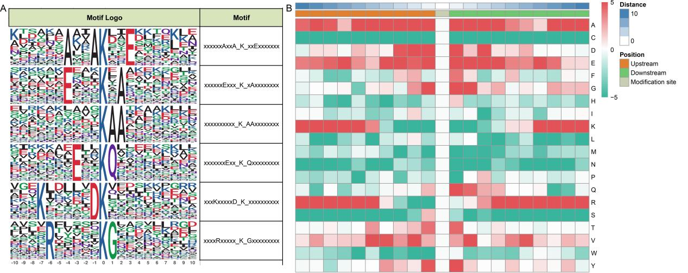

Figure S8. Motif analysis of ubiquitinated peptides under low-phosphorus stress. (A) Central (position 0). K represents ubiquitinated lysines; (B) Heatmap of the amino acid sequence enrichment upstream and downstream of the ubiquitination modification sites.

