Electronic Supplementary Information

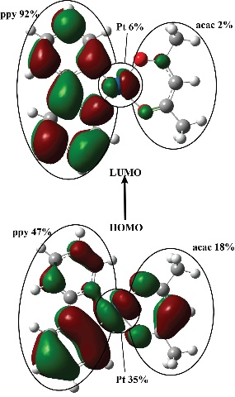  Pt(acc) | 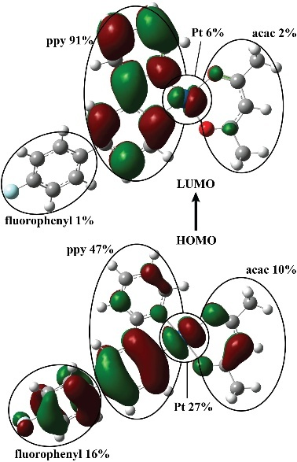  PtM1
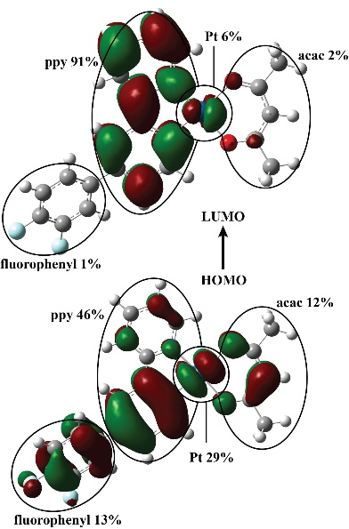  PtM2 | 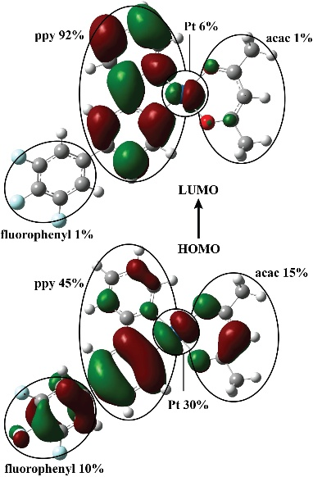  PtM3
Figure 1S. (a) Molecular orbital and energetic levels of HOMO and LUMO (eV) and (b) electron distributions of PtM1, PtM2, and PtM3 complexes in singlet excited states

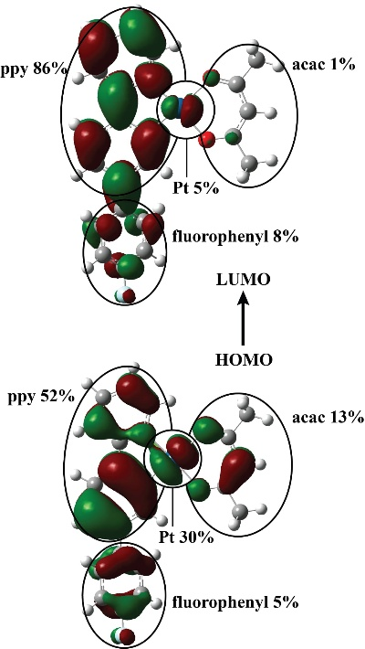  PtP1 | 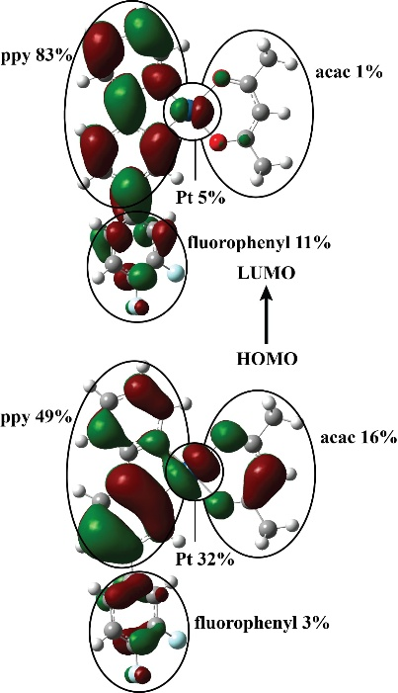  PtP2
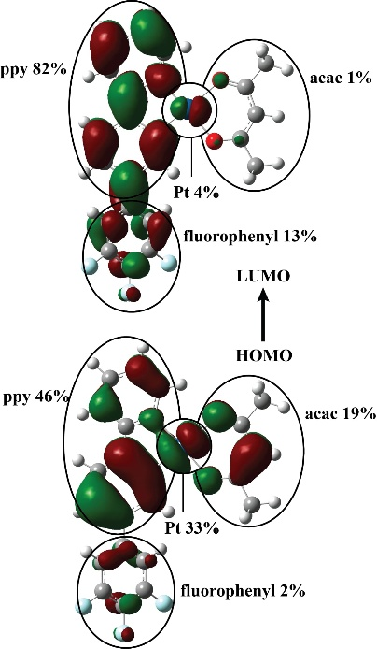
PtP3
Figure 2S. (a) Molecular orbital and energetic levels of HOMO and LUMO (eV) and (b) electron distributions of PtP1, PtP2, and PtP3 complexes in singlet excited states

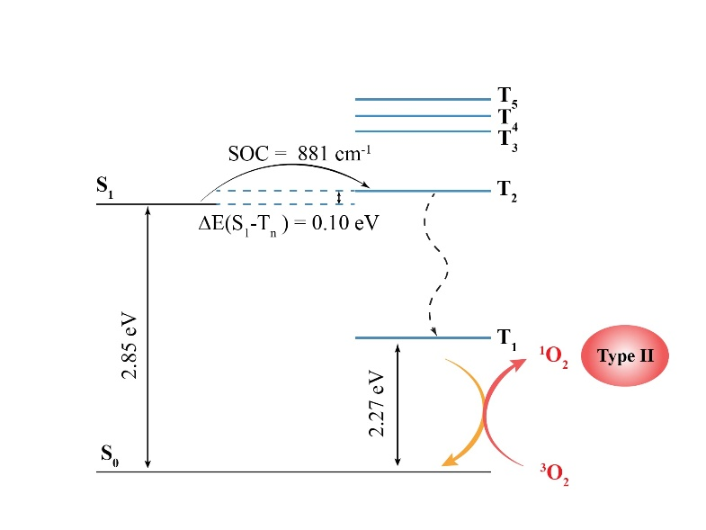
PtM1
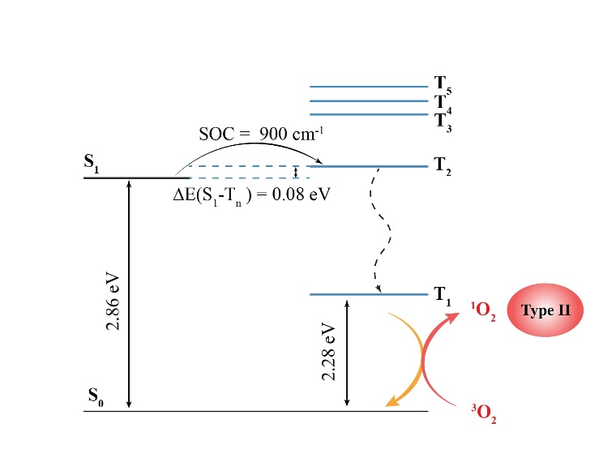
PtM2
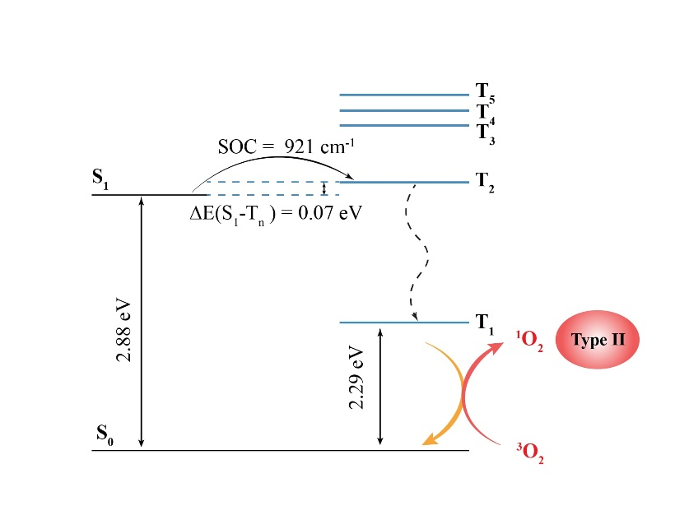
PtM3
Figure 3S. Calculated energy diagram and spin-orbit coupling (SOC) matrix elements of PtM1, PtM2, and PtM3 complexes.

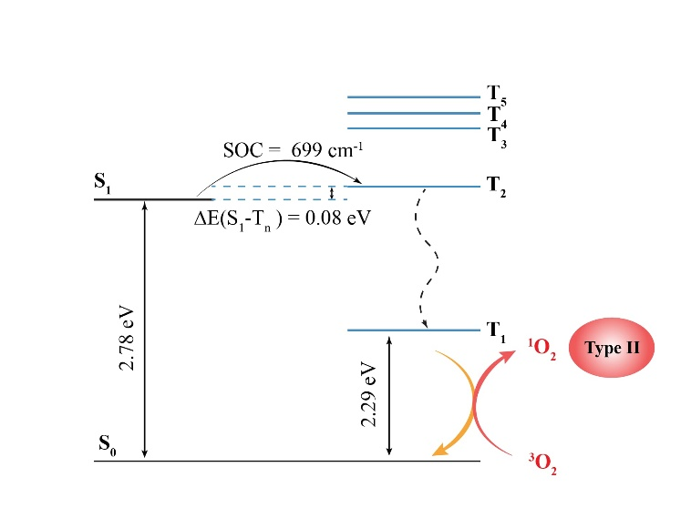
PtP1
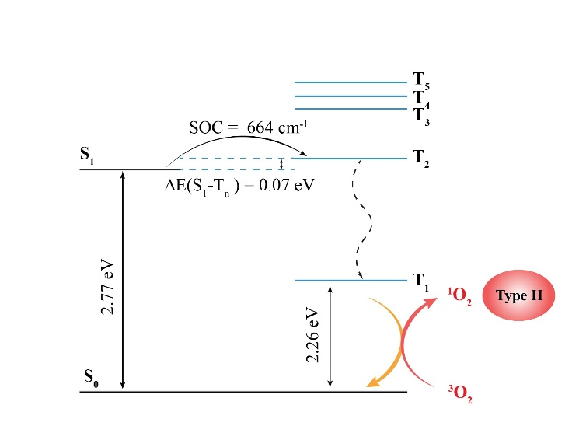
PtP2
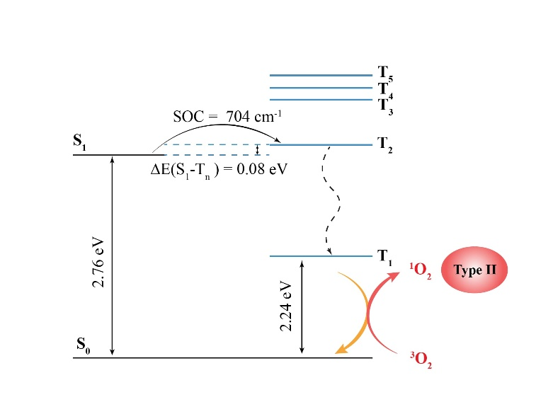
PtP3
Figure 4S. Calculated energy diagram and spin-orbit coupling (SOC) matrix elements of PtP1, PtP2, and PtP3 complexes.

