Supplementary Information for
Differential Tissue Coupled Powering for Battery-Free Injectable Electroceuticals
Han Wu¹, Sultan Mahmud¹, Mali Halac², Domenica Baez¹, Jeremiasz Dados¹, Chaojun Cheng¹, Asif Iftekhar Omi¹, Anyu Jiang¹, Cameron Wallace¹, Anvi Singh¹, Erin Patrick¹, Baibhab Chatterjee¹, Shriya Srinivasan², Adam Khalifa¹
¹Department of Electrical and Computer Engineering, University of Florida, Gainesville, USA.
²Department of Bioengineering, Harvard University, Cambridge, USA
This supplementary file includes:
Supplementary Table 1
Supplementary Figures 1-4
Supplementary Notes 1-2

Supplementary Table 1. Comparison with representative state-of-the-art wireless neural stimulator systems
 | [6] | [23] | [8] | [33] | [13] | TINY
Link | Ultrasound | ME | Ultrasound | Volume conduction | RF link | DTCP
Frequency (MHz) | 1.85 | 0.3-0.4 | 180 | 6.78 | 1180 | 25
Process (nm) | 65 | 180 | 180 | N/A | 130 | 65
Pulse width pulse (µs/s) | 392 | 1500 | 14-470 | 100 | 500 | 500
Stimulation frequency (Hz) | 0.33 | 3 | up to 60 | 1000 | 1 and 5 | 1ª
Mass(mg) | 6.4 (exclude cuff) | 30 | 78 | N/A | <1 | 9
Volume(mm³) | 4.9^{b} | 6.2 | 39 | 2.8^{c} | 0.009 | 2(w/o MN)  2.7(w/MN)
Off-implant elements | Cuff | nothing | Storing capacitor | Needle electrodes and loads | nothing | nothing
Portable External Transmitter | no | no | no | no | no | yes
Electrode size (mm) | 0.55×0.55 | 1×1 | Φ=0.5mm, 2mm long | Φ=0.45mm, 17.5 mm long | 0.25×0.08 | 0.8×0.8
Phantom Model | ultrasound gel | pork | castor oil | N/A | Beef | diluted PBS + Agar
Injectability | Yes (without cuff) | No | No | No | Yes | Yes
Surgery Model | rat sciatic nerve | rat sciatic nerve | frog hind leg | Human arm | rat sciatic nerve | rat sciatic nerve
In vivo depth (mm) | 18 | 15 | Not reported | 14.5^{d} | 5 | 8
In vitro depth (mm) | 48 | 20 (report 0-40) | 105 | N/A | 6.6 | 10  (report 5-20)
PTE (%) at the above depth | 0.7 | 0.12 | 0.04 | 0.035(use in vivo depth) | 0.0019 | 0.34(w/o MN)  0.45(w/MN)
FoM1(max reported depth mm/volume mm³) | 9.8 | 6.5 | 2.7 | 5.2 | 733 | 10 (w/o MN)  7.4(w/MN)
FOM2 (η×d³/V)^{e} | 15799 | 155 | 1187 | 38^{f} | 61 | 167(w/MN)  170(w/o MN)
ªThe pulse width and stimulation frequency are programmable.
^{b}Cuff 3.2 mm³, implant 1.7 mm³
^{c}Calculated from the implanted needle volume. No circuits are implanted in this paper.
^{d}Estimated from the needle exposed length.
^{e}η: PTE(%); d: distance between Tx and Rx (mm); V: volume (mm³)
^{f}Estimated from the in vivo depth

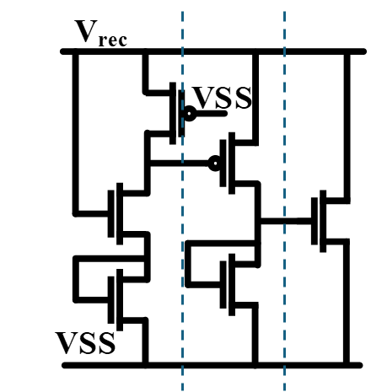
Supplementary Figure 1. Voltage limiter circuits in ASIC. The limiter consists of three cascaded MOSFET stages that progressively conduct to clamp excessive rectified voltage $V_{rec}$. The first stage forms a high-impedance voltage divider that consumes only nW-level leakage within the normal operating range. When $V_{rec}$ rises above the designed threshold, the voltage across the first-stage PMOS is large enough to turn on the second-stage PMOS, increasing the drain current to limit the voltage. If $V_{rec}$ furtherly increases, the third-stage NMOS conducts strongly, causing an exponential rise in drain current to tightly clamp $V_{rec}$. This passive limiter protects both the implant circuitry and tissue, since $V_{rec}$and ground are directly connected to the stimulation electrodes.
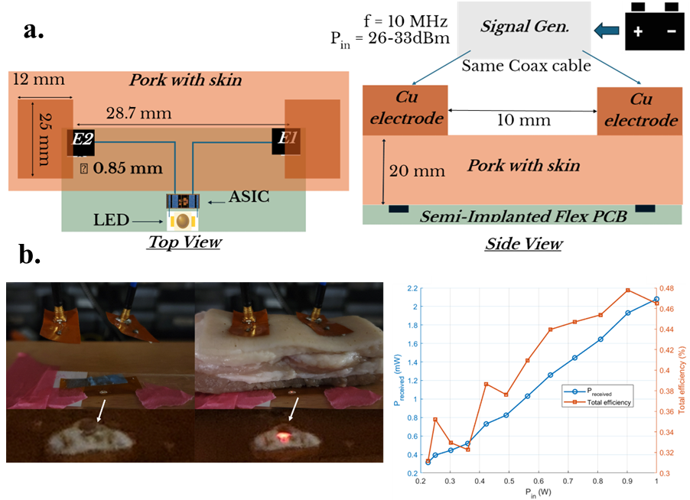
Supplementary Figure 2. Schematic, photo and results of the in vitro wireless power transfer measurement setup using pork tissue. a. A battery-powered signal generator (isolated from earth ground) was used to generate a 10 MHz RF signal, which was amplified to 26–33 dBm through a power amplifier and identical coaxial cables across all tests. The Tx electrode spacing was set to 10 mm (edge-to-edge). The implant model was placed beneath a 20 mm thick pork tissue sample with intact skin. LED brightness was recorded using a stationary smartphone camera, ensuring that both the LED and camera remained fixed throughout the experiment. b. The LED did not emit any measurable brightness in the absence of tissue, whereas noticeable brightness was observed with tissue present. By comparing the measured LED brightness with the calibration database, the total received power (including ASIC consumption and LED optical output) was determined to range from 0.315 mW to 2.08 mW at 10 MHz, corresponding to a total efficiency of 0.31–0.48% for input powers of 100–447 mW (after accounting for reflection loss). Efficiency fluctuates primarily due to the rectifier, which operates more efficiently at higher input voltages. While surface coupling is feasible, stable fixation on rat skin proves challenging and limits repeatability; therefore, pin electrodes are adopted in the main experiments to ensure repeatable conditions. Future designs aim to improve contact stability and re-enable surface electrodes.

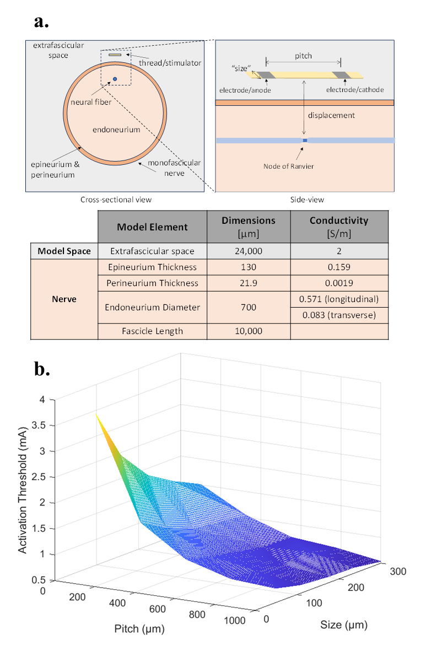
Supplementary Figure 3. a. Schematic and model parameters for a thread-like stimulator in a monofascicular nerve, showing electrode placement and tissue properties used for simulation. A finite element model was constructed in COMSOL Multiphysics (COMSOL Inc., USA) to compute the electric potential field generated by the implant under a fixed 1 mA input current with an electrode-to-fascicle distance of 100 µm. Two key parameters were varied: electrode pitch (100 µm–1 mm) and electrode surface area (0.0025–0.09 mm²), yielding 24 geometric configurations. Neural activation was then simulated in NEURON using the McIntyre–Richardson–Grill (MRG) axon model tuned for a 6 µm rat tibial fiber. A cathodic-first symmetric biphasic pulse (200 µs width) was applied, and the threshold amplitude was defined as the minimum stimulus current that elicited a propagating action potential. b. Simulated activation thresholds for the neural fiber as a function of electrode pitch and size. Both increasing electrode surface area and interelectrode pitch reduced the stimulation threshold. A pitch of 1 mm combined with a 300 µm² electrode surface achieved the lowest threshold of 0.535 mA for the modeled 6 µm fiber. Unlike conventional implants, the thread-like DTCP device can accommodate large electrode pitches, enabling more energy-efficient stimulation without sacrificing design flexibility.

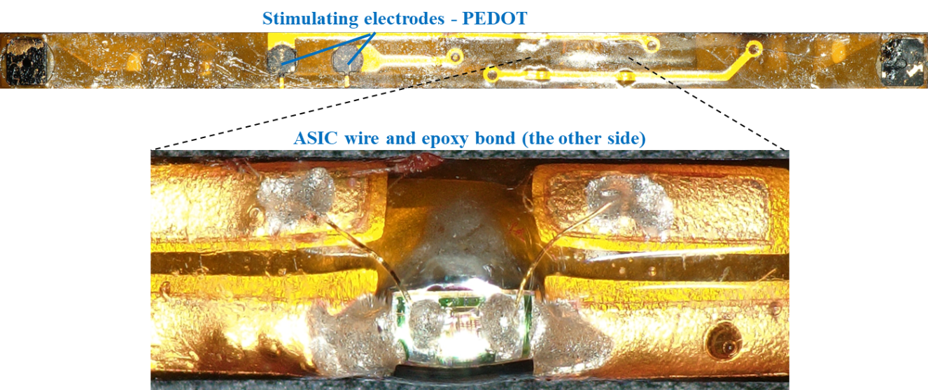
Supplementary Figure 4. Photographs of the TINY device prototype showing the back side and a magnified view of the ASIC assembly region. Top: the stimulation side showing PEDOT-coated gold stimulation electrodes patterned on a flexible polyimide substrate. Bottom: the opposite side showing a magnified view of bonded ASIC chip. After the ASIC was fixed with high temperature glue, wire bonds were first made to 3-µm-thick gold pads on the flex PCB. Because the mechanical reliability of wire bonds on flexible substrates is relatively low, silver epoxy was subsequently applied to reinforce both the electrical and mechanical connections. And finally, PDMS was used to coat the whole assembly.

Supplementary Note 1
According to IEEE C95.1 Table 14 Error! Reference source not found., the human contact current limit in the 3–30 MHz range follows
$$I_{max}(f)=16.7{(\frac{f}{3})}^{0.3}\text{ mA},3≤f≤30\text{ MHz}.$$
Substituting $f=25$MHz gives $I_{max}=16.7(25/3)^{0.3}=31.5$mA.
For comparison, the electrode–tissue impedance measured on the rat hindlimb is $R=325\text{–}362$and $C=27.2\text{–}38.6\text{ pF}$. With 28 dBm available from a 50 Ω source and a stimulation duty of 500 µs / s, the maximum resulting 1-s-RMS current is only $≈0.61$mA, well below the limit.

