Supplementary Information for

Targeted ion sieving via single-chain hydrogels with tunable sub-nanometer meshes

Yi Zhai^{1,2#}, Huili Ren^{1,2#}, Zexu Li^{1,2}, Pengxiang Liu^{1,2}, Xiuqin Yang^{1,2}, Jing Li^{1,2}, Tianyi Zhao^{1,2*}, Longcheng Gao^{1,2*}, Mingjie Liu^{1,2*}

¹State Key Laboratory of Bioinspired Interfacial Materials Science, Center for Bioinspired Science and Technology, Hangzhou International Innovation Institute, Beihang University, Hangzhou, Zhejiang, 311115, China
²School of Chemistry, Beihang University, Beijing, 100191, China
# These authors contributed equally
* Corresponding author. Email: zhaoty@buaa.edu.cn, lcgao@buaa.edu.cn, liumj@buaa.edu.cn

This PDF file includes:
Supplementary Methods
Supplementary Figures 1 to 44
Supplementary Tables 1 to 7
Supplementary References

The Supplementary Information includes:
- Supplementary methods
- Large-area AFM characterization of a BCP nanoporous membrane (Supplementary Fig. 1)
- FTIR of BCP, h-PEI and BCP nanoporous membranes grafted with h-PEI at the pore entrances (Supplementary Fig. 2)
- DLS curve of h-PEI (Supplementary Fig. 3)
- AFM height images of h-PEI-derived SCHs under different conditions (Supplementary Fig. 4)
- The AFM height image of the detached PEI-CC nanosheets (Supplementary Fig. 5)
- GPC curves of h-PEI and SCHs (Supplementary Fig. 6)
- ¹³C NMR spectroscopy of SCHs and h-PEI (Supplementary Fig. 7)
- Stress-strain curves of BCP nanoporous membrane and SCH membrane (Supplementary Fig. 8)
- Water uptake and swelling ratio of the SCHs (Supplementary Fig. 9)
- Optical images of the SCH membrane and acrylamide hydrogel before and after swelling (Supplementary Fig. 10)
- Optical image of SCH membrane over extended periods in aqueous solution (Supplementary Fig. 11)
- 2D LF-NMR spectra of the pre-swelling SCHs (Supplementary Fig. 12)
- LF-NMR spectrum of water in SCHs with varying crosslinking degrees (Supplementary Fig. 13)
- XPS spectrum of original SCHs and Cu-coordinated SCHs before and after acid treatment (Supplementary Fig. 14)
- SCH membranes for long-term, large-area, and mixed salt solution feed ion sieving testing (Supplementary Fig. 15-18)
- The pH-sensitive wettability of the SCH membrane surface (Supplementary Fig. 19)
- Comparison of binding energies between different SCH protonation states (Supplementary Fig. 20)
- Energy landscape of K⁺ and Mg²⁺ transport in the mesh before and after Cu²⁺ coordination. (Supplementary Fig. 21)
- Molecular models of cation transport in the mesh (Supplementary Fig. 22-39)
- Injection-driven heavy metal ion remover loaded with SCH membrane (Supplementary Fig. 40)
- The power densities obtained using SCHs (Supplementary Fig. 41-43)
- AFM height analysis of the membrane thickness (Supplementary Fig. 44)
- Supplementary Table 1: Summary of ion-selective material performance
- Supplementary Table 2: Summary of K⁺ flux and K⁺/Mg²⁺ selectivity
- Supplementary Table 3: Summary of cation size and hydration enthalpies
- Supplementary Table 4: Summary of desalination membrane performance
- Supplementary Table 5: Summary of anti-fouling performance and chlorine resistance of SCH membranes
- Supplementary Table 6: Summary of Li⁺ flux and Li⁺/Mg²⁺ selectivity
- Supplementary Table 7: Summary of water source salinity
- Supplementary References

Supplementary Methods
Materials
BCP (PEO-b-PChal) was synthesized according to our previous work²⁴. BCP contains PEO block with molecular weight of 5,000 g·mol⁻¹ and the PEO weight fraction of 13.8%. Hyperbranched polyethyleneimine (h-PEI, M_{w} = 10,000 g·mol⁻¹, 99%), cyanuric chloride (CC, 98%), polystyrene sulfonic acid sodium salt (PSS, M_{w} = 70,000 g·mol⁻¹, 98%), 1-(3-dimethylaminopropyl)-3-ethylcarbodiimide (EDC, 98%), 4-dimethylaminopyridine (DMAP, 99%), ruthenium(III) chloride (RuCl₃, 99.99%), sodium periodate (NaIO₄, 98%), acrylamide (99.9%), N,N′-methylenebisacrylamide (MBA, ≥ 99%), ammonium persulfate (APS, ≥ 99%), and N,N,N′,N′-tetramethylethylenediamine (TEMED, 99%) were purchased from ​​Alfa Aesar​​ (Thermo Fisher Scientific, USA). Metal chloride salts (e.g., NaCl, ≥ 99.8%; KCl, ≥ 99.8%), hydrochloric acid (HCl, 37%), potassium hydroxide (KOH, ≥ 99.99%), methylene blue (MB, ≥ 70%), humic acid (HA, ≥ 99%), sodium alginate (SA, 98%), sodium hypochlorite (NaClO, 10%), deuterated solvents for NMR spectroscopy (e.g., D₂O, ≥ 99.9 atom% D; CDCl₃, ≥ 99.8 atom% D), and common solvents (e.g., toluene, ≥ 99.7%; acetone, ≥ 99.5%; ethanol ≥ 99.5%) were obtained from ​​Aladdin Biochemical Technology Co., Ltd.​​ (Shanghai, China). Ultrapure water​​ was obtained from a ​​Milli-Q Advantage A10 water purification system​​ (MilliporeSigma, USA) with a resistivity of ​​18.2 MΩ·cm at 25 ℃.​​ All chemicals were used as received without further purification unless otherwise specified.

Preparation of crosslinked PEI nanosheets
As the control experiment for SCHs, the introduction of crosslink agent (CC) was carried out under different situation. Typically, the h-PEI grafted membrane was immersed in ethanol for 10 min, so as to swell the PEI chains. The adjacent PEI chain overlap with each other and form continuous layer. Then, the membrane was immersed in a CC solution in ethanol (2 wt%) for 0.5 hours, ​interchain crosslinking occurred. The rest operations were similar with SCH preparation.

Inductively coupled plasma mass spectrometry (ICP-MS)
Quantification of all ionic concentrations was performed using an Agilent 7800 ICP-MS system (Agilent Technologies, USA). The instrument was calibrated daily with a multi-element standard solution across a concentration range of 1-1000 μg·L⁻¹.
The samples were prepared by filtration through a 0.22 μm nylon syringe filters (Millipore Millex-GV) to remove any potential particulate matter that could clog the introduction system. Subsequently, the filtered samples were appropriately diluted (10- to 50-fold) with a dilute acid solution (1% HNO₃). Each prepared sample was measured three times. The method's accuracy was verified through the analysis of a certified reference material, with measured values agreeing with certified values within a 90-110% range. The short-term stability of the instrument during analysis was monitored by periodically analyzing a quality control standard, with the relative standard deviation of the measured values for the target elements being less than 5%.

Dynamic light scattering (DLS)
DLS measurements were performed on a Malvern Zetasizer Nano ZS90 system (Malvern Panalytical, UK) equipped with a 633 nm He-Ne laser and Non-Invasive Backscatter (NIBS) optical configuration. Measurements were conducted at a fixed scattering angle of 173° with temperature maintained at 25.0 ± 0.1 ℃ using a Peltier temperature controller. The system was calibrated daily using certified polystyrene latex standards (60 nm diameter, Malvern Panalytical) to ensure measurement accuracy within ± 1% for hydrodynamic diameter determination.
Samples were prepared by dissolving test materials in ultrapure water (18.2 MΩ·cm, MilliporeSigma) to achieve a final concentration of 1 mg·mL⁻¹. Solutions were filtered through 0.22 μm PVDF syringe filters (Millipore Millex-GV) to remove particulate contaminants and allowed to equilibrate thermally for 5 min prior to measurement. Three independent sample preparations were analyzed with 15 consecutive measurement runs (10 s integration time per run) performed for each replicate. Data analysis was performed using ZS Xplorer software (v3.4) employing the CONTIN algorithm for size distribution analysis.

Nuclear Magnetic Resonance Spectroscopy (NMR)
High-resolution liquid-state ¹H and ¹³C NMR spectroscopy was performed using Bruker Avance 400 MHz or Ascend 600 MHz spectrometers equipped with 5 mm broadband inverse (BBI) probes. All measurements were conducted under precise temperature regulation (25.0 ± 0.1 ℃) using BCU II cooling units. Magnetic field homogeneity was optimized through manual shimming (< 0.6 Hz residual solvent peak width at 50% height, measured on deuterium lock signal). Relaxation delays (D1 = 15-30 s) were determined via inversion recovery experiments to exceed 10× the longitudinal relaxation time (T₁) of slowest-relaxing nuclei, with extended delays (≥ 15 × T₁) implemented for quantitative integration protocols. Signal acquisition employed 64K data points with digital resolution ≤ 0.25 Hz·pt⁻¹. Fourier transformation utilized exponential line broadening (0.3 Hz) and automated phase correction. Quantitative analysis required minimum signal-to-noise ratios (S/N) of 1,000:1 for target resonances, verified through triplicate measurements. Instrument control and data processing were performed using MestReNova 14.0 software packages respectively.

Transmission electron microscopy (TEM)
TEM characterization was conducted using a JEOL JEM-2100 high-resolution transmission electron microscope equipped with a LaB₆ thermionic electron source and Gatan OneView CMOS camera. Key instrument parameters were configured as follows: Acceleration voltage: 200 kV; Resolution: ≤ 0.19 nm.
Sample preparation involved dissolving the material in toluene via ultrasonic treatment for 1 min, followed by drop-casting the suspension onto a 200-mesh copper grid coated with amorphous carbon film. To enhance phase contrast for polymer matrix visualization, the specimen was exposed to ruthenium tetroxide (RuO₄) vapor for 3 min in a sealed staining chamber prior to imaging. All observations were performed in bright-field TEM mode under low-electron-dose conditions to minimize beam-induced damage.

Gel Permeation Chromatography (GPC)
Molecular weight distributions of the polymer samples (h-PEI and the detached SCHs) were determined using an Agilent 1260 Infinity II GPC system equipped with a refractive index (RID) detector (G1362A). A series of hydrophilic GPC columns was used to ensure compatibility with the aqueous mobile phase. The system was operated with an aqueous mobile phase consisting of 0.1 M sodium nitrate (NaNO₃) solution containing 0.05% sodium azide (NaN₃) as a preservative, delivered at a constant flow rate of 1.0 mL·min⁻¹. Column temperature was maintained at 30°C to ensure stability. Prior to analysis, the instrument was calibrated using narrow-dispersity polyethylene glycol (PEG) standards (molecular weight range: 1,000-500,000 Da) to establish a linear calibration curve. Samples were dissolved in the mobile phase at a concentration of 2-3 mg·mL⁻¹ under gentle agitation for 12 hours, filtered through a 0.22 μm hydrophilic PVDF membrane, and injected with a volume of 100 μL. Data acquisition and processing were performed using Agilent GPC/SEC software (v. 2.0).

Fourier-transform infrared spectroscopy (FTIR)
FT-IR measurements were performed using a Thermo Scientific Nicolet iS50 FTIR spectrometer equipped with a deuterated triglycine sulfate (DTGS) detector and a single-reflection diamond attenuated total reflectance (ATR) accessory. Prior to sample analysis, the spectrometer was calibrated for wavelength accuracy (± 0.1 cm⁻¹) and intensity reproducibility using a certified polystyrene reference film (NIST-traceable standard). Polymer membrane samples were analyzed by directly placing them on a ZnSe/diamond composite ATR crystal (Pike Technologies GladiATRTM, 1.8 mm diameter sampling area) and applying consistent pressure via a calibrated torque clamp (120 N·m) to ensure optimal optical contact. Spectra were acquired over 32 co-added scans in the range of 4000-400 cm⁻¹ at a resolution of 4 cm⁻¹ , with background subtraction performed under identical instrumental conditions. Data processing, including baseline correction and peak deconvolution, was performed using OMNICTM software (v9.0, Thermo Scientific).

Atomic force microscope (AFM)
All experiments were conducted under controlled ambient conditions (25 ℃, 40% relative humidity). A Bruker Dimension Icon AFM, equipped with a silicon nitride probe (tip radius, ~8 nm, nominal spring constant, Kc, 0.4 N·m⁻¹), was employed to simultaneously acquire high-resolution topographical maps and nanomechanical force–displacement curves in Peak Force Tapping mode (scanning rate: 512 × 512). The probe spring constant ($K_{c}$) and deflection sensitivity were calibrated in situ via thermal noise methodology, with tip geometry validated using polydimethylsiloxane (PDMS) reference samples of known modulus.
The applied load Fand indentation depth δ were derived from cantilever deflection ($d-d_{0}$) and sample height variation ($z-z_{0}$) using Hooke’s law:
$$F=K_{c} (d-d_{0})$$
$$δ=\left(z-z_{0}\right)-(d-d_{0})$$
where $d$ and $d_{0}$ denote the instantaneous and initial cantilever deflection values, respectively, and $z$ and $z_{0}$ correspond to the real-time and initial sample height offsets. Force curves were analyzed using the AFM-integrated NanoScope Analysis software to extract cantilever deflection ($d-d_{0}$) and sample height offset ($z-z_{0}$) parameters, enabling the conversion of raw force-displacement data into load-indentation curves.
In the nanomechanical analysis of nanoparticles, the Hertzian contact theory⁵⁰ was employed to calculate the elastic modulus of the sample. According to the Hertzian model, the relationship between the applied load $F$ and the indentation depth $δ$ is expressed as:
$$F=\frac{4}{3}·E·R^{1/2}·δ^{3/2}$$
where $R$ represents the radius of curvature of the spherical AFM probe, $E$ denotes the reduced Young’s modulus, and $E$ is given by:
$$\frac{1}{E}=\frac{1-{v^{2}}_{tip}}{E_{tip}}+\frac{1-{v^{2}}_{sample}}{E_{sample}}$$
with $E_{tip}$ = 160 GPa, $v_{tip}$ = 0.27 (silicon nitride probe), and $v_{sample}$ = 0.33 (polystyrene reference). To mitigate substrate interference, the maximum indentation depth was constrained below 10 nm (< 10% of the film thickness).
Approaching curves were computationally fitted to the Hertzian framework using NanoScope Analysis, and modulus gradients across the film-substrate interface were mapped within a 100 × 100 nm² region. Statistical reliability was ensured through iterative scanning of multiple regions until modulus values converged (standard deviation < 5%).

X-ray photoelectron spectroscopy (XPS)
XPS analysis was conducted on a Thermo Fisher Scientific Nexsa spectrometer equipped with a monochromated Al Kα X-ray source (hν = 1,486.6 eV). Measurements were performed under ultra-high vacuum conditions (base pressure: 5×10⁻⁹ mbar) using a micro-focused X-ray beam with a spot size adjustable between 10 and 400 μm. High-resolution scans were acquired with a pass energy of 20 eV and a step size of 0.1 eV. For insulating samples, a dual-mode MAGCIS ion/electron flood gun provided charge neutralization via simultaneous low-energy electron flooding (< 1 eV) and Ar⁺ ion bombardment (20 eV, 1 μA·cm⁻²).
Samples (powders or films) were mounted on a conductive carbon tape or pressed into indium foil to ensure electrical conductivity. Powder samples were ground into fine particles (< 1 μm) using an agate mortar to minimize surface topography effects. All specimens were degassed in a load-lock chamber (vacuum < 1×10⁻⁶ mbar) for 12 h prior to analysis to remove physiosorbed contaminants. Binding energies were calibrated against the adventitious C 1s peak at 284.8 eV. Three replicate measurements were performed per sample to ensure reproducibility. For depth profiling, selected samples underwent Ar⁺ sputtering (2 keV, 1 μA·cm⁻²) with a 30 s interval between etching and acquisition cycles.

Positron annihilation lifetime spectroscopy (PALS)
PALS measurements were performed using a DPALS-LH spectrometer (TechnoAP, Japan) with a time resolution of 190 ps. The samples were prepared as compressed pellets with a thickness of ~1 mm and stored in sealed bags under ambient temperature and pressure prior to testing. A ²²Na radioactive source (30 μCi) was encapsulated between two layers of compressed pellets to minimize positron annihilation in the source substrate.
The experimental setup utilized a fast-fast coincidence system with BaF₂ scintillation detectors to record the time interval between the 1.28 MeV birth γ-ray and the 511 keV annihilation γ-ray. A total accumulation of 2×10⁶ counts per spectrum was achieved to optimize signal-to-noise ratio. Data analysis was performed via the PATFIT program, which resolved the spectra into three lifetime components after background subtraction. The third component (τ₃, corresponding to ortho-positronium annihilation in free-volume holes) and its intensity (I₃) were extracted to characterize the nanoscale voids in the samples. For comparative analysis, CONTIN software was employed to generate lifetime distributions, and reference spectra from a Kapton® film were used for calibration at each measurement condition⁵¹.

Mesh size and free volume distribution
Free volume analysis was performed using Materials Studio 2020 (Accelrys/BIOVIA, USA) combined with the Zeo++ package⁵². The amorphous polymeric system was constructed via the Amorphous Cell module with periodic boundary conditions. Structural optimization was achieved through Smart Minimizer algorithm with convergence criteria of 10⁻⁴ kcal·mol⁻¹·Å⁻¹ for energy and 0.005 kcal·mol⁻¹ for force.
Molecular dynamics (MD) simulations were executed in the Forcite module with the COMPASS II force field. Temperature (293.15 K) and pressure (101.325 kPa) were regulated by Andersen's thermostat and Berendsen's barostat, respectively, with a 1.0 fs time step. Electrostatic interactions were calculated using Ewald summation, while van der Waals interactions adopted a 12.5 Å cutoff distance. After 500 ps NPT equilibration, a 10 ns production run in NVT ensemble was performed to sample configurations for free volume analysis. Pore size distributions were further analyzed via Zeo++ using a probe radius of 1.2 Å, with Voronoi network decomposition and Monte Carlo sampling (50,000 iterations). The Multiwfn program⁵³ and VMD software package⁵⁴ were employed to quantify the pore regions in the MD simulation system.

Swelling ratio and water uptake characterization
Swelling behavior of SCHs was characterized through AFM dimensional analysis. Individual SCH specimens were subjected to humidity-controlled swelling in a saturated water vapor environment (25 ℃, 100% relative humidity) for ≥ 24 h to achieve equilibrium swelling state. Post-hydration samples were further dissolved in deionized water until reaching a steady state, and then​ transferred onto freshly cleaved mica substrates and gently desiccated under vacuum (30 ℃, 6 h) to remove surface-absorbed moisture while maintaining structural integrity. AFM measurements were conducted using a Bruker ScanAsyst system equipped with silicon nitride probes (k = 0.4 N·m⁻¹), employing peak force tapping mode with 0.2 nN setpoint force and 1 Hz scan rate to minimize probe-induced deformation. Parallel control experiments were performed on polyacrylamide hydrogels using conventional immersion methodology (24 h in deionized water at 25 ℃) followed by volumetric swelling analysis.
Water uptake quantification was performed gravimetrically using a Mettler Toledo XPR6 ultra-microbalance (± 0.1 μg precision). Pre-measurement conditioning involved vacuum dehydration at 30 ℃ for 48 h (SCHs) or ambient drying (control hydrogels) until constant mass (Δ_{m} < 0.01% over 2 h). Hydrated mass values were recorded after equilibrium swelling under respective conditions (humidity chamber for SCHs, aqueous immersion for controls). All measurements were conducted in triplicate with environmental controls (25 ℃, 60% RH).

Wide-angle X-ray scattering characterization
The WAXS measurements were conducted using a Xeuss 3.0 system (Xenocs SA, France) equipped with a micro-focused Cu Kα radiation source (λ = 1.5418 Å). A sample-to-detector distance of 55 mm was calibrated using silver behenate powder (d-spacing = 58.38 Å for the first-order reflection) prior to measurements to ensure accurate angular calibration. To investigate hydration effects, membrane samples were prepared in two distinct states: (1) dry samples obtained by vacuum-drying at 110 ℃ for 12 h, and (2) hydrated membranes equilibrated at 25 ℃ under 95% relative humidity for 24 h. All specimens were sealed in 1.5 mm diameter quartz capillaries using epoxy resin to maintain hydration states during data acquisition. Scattering patterns were collected for 300 s per sample using a Pilatus 300K hybrid pixel detector (Dectris Ltd), with incident beam parameters optimized to 50 kV and 0.6 mA to balance signal intensity and radiation damage.

Low-field nuclear magnetic resonance
The LF-NMR measurements were performed on a ​MesoMR23-040V NMR analyzer (Suzhou Niumag Analytical Instrument Co., Ltd., China) equipped with a permanent magnet (field strength: 0.5 T). To maintain stable molecular dynamics and minimize thermal interference, the magnet temperature was controlled at ​32 ± 0.01 ℃ throughout the experiments. Samples were loaded into standard ​25 mm chromatography vials to ensure uniform filling and coverage of the probe detection region.
Two pulse sequences were employed to probe pore structures: CPMG (Carr-Purcell-Meiboom-Gill) Sequence for T₂ Relaxation Analysis, and ​SR-CPMG (Saturation Recovery-CPMG) Sequence for 2D Relaxation Mapping.
SCH samples were processed into uniform powder to eliminate air gaps and ensure consistent packing in chromatography vials. ​Two types of samples were tested: (1) Non-swollen samples were directly equilibrated in the magnet chamber for 10 min at 32 ℃ prior to analysis. (2) Swollen samples were prepared by exposing the powder to ​saturated water vapor in a sealed chamber at 32 ℃ until reaching ​swelling equilibrium (> 24 h). The swollen samples were then transferred to chromatography vials and equilibrated under identical thermal conditions (32 ℃, 10 min) to minimize moisture loss during testing.
The dynamics of water can be quantitatively analyzed by the correlation time ($τ_{c}$) for the motion of water molecules using the Bloembergen-Purcell-Pound equation⁵⁵:
$$\frac{1}{T_{2}}=\frac{C}{2}\left(3τ_{c}+\frac{5τ_{c}}{1+ω_{0}^{2}τ_{c}^{2}}+\frac{2τ_{c}}{1+{4ω}_{0}^{2}τ_{c}^{2}}\right)$$
where $C$ is a constant for water (5.33×10⁹ s⁻²), and $ω_{0}$ is the Larmor frequency.
Electrochemical characterization of ionic transport
The ionic transport property of the SCH membrane was examined using a custom electrochemical device by measuring the transmembrane ionic current. The I-V curves were recorded with a Keithley 6487 picoammeter (Keithley Instruments, Cleveland, OH). The SCH membrane was mounted within a two-compartment H-cell. Ag/AgCl electrodes were used to apply a transmembrane potential. The SCH side was in contact with high-concentration salt solution (e.g., 0.5 mol·L⁻¹ KCl or 0.25 mol·L⁻¹ CaCl₂), while the nanoporous membrane side was exposed to a low-concentration solution (e.g., 10 μmol·L⁻¹ KCl or 5 μmol·L⁻¹ CaCl₂), with the cathode positioned on the low-concentration side to ensure negligible contribution of anions to the measured ionic current⁵⁶.

K⁺ Conductivity Calculation​ and K⁺ Flux Measurement
The K⁺ conductivity was determined using a current-voltage (I-V) curve analysis under a steady-state electric field. The conductance (G) was calculated as G = I / V, where I is the measured current and V is the applied voltage. The conductivity (σ) was derived using the relationship σ = G × (L / A), where L is the fixed distance between electrodes (3.36 cm) and A is the effective membrane area, calculated for a circular area with a diameter of 500 μm.
K⁺ flux was quantified by monitoring concentration changes in the receiving chamber over time. After applying a voltage across the membrane, aliquots were collected from the receiving solution at defined intervals and analyzed via ICP-MS. The flux was calculated based on cumulative K⁺ mass transfer normalized to membrane area and time, in accordance with established ion flux measurement protocols.

Zeta potential
Zeta potential measurements​ ​were performed using an Anton Paar SurPASS 3 electrokinetic analyzer equipped with a flat-plate measurement cell for macroscopic solid surfaces. The system employed flow potential and flow current methods to directly determine surface zeta potential at the solid-liquid interface. Measurements were conducted at ​​25.0 ± 0.1 ℃​​ (Peltier-controlled) using ​​1 mmol·L⁻¹ KCl​​ electrolyte solutions adjusted to pH values ranging from ​​3 to 10​​. Flow rates were automatically optimized between ​​20-50 mL·min⁻¹​​ by the instrument software, and an applied pressure of ​​0-500 mbar​​ was maintained perpendicular to the sample surface. Data acquisition included ​​10 cycles per pH point​​, with automatic outlier rejection performed by the software. Membrane samples were pre-equilibrated in the electrolyte solution for ​​1 h​​ prior to measurement to ensure interfacial stability.

Desalination performance measurement​
The desalination performance of the SCH membrane was evaluated using a dead-end filtration system. The SCH membrane was supported by a nylon filter membrane (pore size: 50 nm) and tested at effective areas of 1.8, 11.3, 44.2, and 78.5 cm². The membrane was integrated into a sintered glass filter device connected to a vacuum pump. A bias pressure of 0.85 bar was maintained. Each filtration last for 1 hour. The water flux was calculated based on the volume of permeate collected per unit time and membrane area. Salt rejection was determined by analyzing ion concentrations in the permeate using ICP-MS, with calibration standards ensuring accuracy. All experiments were conducted in triplicate to confirm reproducibility.

Anti-fouling performance and chlorine resistance measurements​
The anti-fouling capability and chlorine resistance of the SCH membrane were evaluated using a dead-end filtration system with an effective testing area of ​1.8 cm². The membrane was supported by a nylon filter membrane (pore size: 50 nm) and integrated into a sintered glass filter device connected to a vacuum pump. A constant bias pressure of 0.85 bar was maintained. Membrane performance ​before and after fouling/chlorine exposure​ was assessed by monitoring the water flux and salt rejection ​using a feed solution of 0.01 M NaCl and 0.01 M CaCl₂.
Membrane fouling was simulated by exposing the membrane to various foulant solutions for 24 hours, including humic acid (20 ppm, representing natural organic matter), sodium alginate (20 ppm, simulating microbial polysaccharides), Ca²⁺/SO₄²⁻ (100 ppm, simulating sulfate-based scaling), and Ca²⁺/HCO₃⁻ (100 ppm, simulating carbonate scaling). For regeneration, fouled membranes were treated with NaClO solution (200 ppm) for 4 hours. Chlorine resistance was evaluated by exposing membranes to NaClO (50 ppm) for 8-72 hours (accumulated exposure: 400-3600 ppm·h). Water flux was calculated from the permeate volume collected per unit time and membrane area. Salt rejection was determined by analyzing permeate ion concentrations using ICP-MS. All experiments were conducted in triplicate to ensure reproducibility.

Lithium extraction performance measurement
The ion permeation experiment was conducted using a two-compartment H-cell separated by SCH membrane. The feed chamber contained cationic chloride solutions with varying Li/Mg ratios, while the permeate chamber was filled with deionized water. Both solutions were circulated at a constant flow rate of 10 mL·min⁻¹​​ using peristaltic pumps. Prior to testing, the entire setup was rinsed with deionized water for 0.5 h to eliminate residual contaminants.
After a 24-hour permeation period, samples were collected from the permeate chamber, and analyzed for metal ion concentrations via ICP-MS, using calibration standards. The calculation methods for membrane flux and selectivity remained the same as previously described.

Heavy metal ion removal performance measurement
Heavy metal-laden wastewater was loaded into a 10 mL syringe (pre-washed with deionized water) and connected to a filtration head containing the SCH membrane (Supplementary Fig. 32). A syringe pump was employed to drive the wastewater through the membrane at a controlled flow rate of 5 mL·min⁻¹, simulating extrusion-filtration conditions. Samples were collected from the outlet of the filtration head. Metal ion concentrations in the effluent were quantified using ICP-MS. Triplicate measurements were performed for each sample, and calibration curves were validated using NIST-traceable multielement standards.

Osmotic energy harvesting performance measurement
The osmotic energy harvesting performance was evaluated using a two-compartment H-cell equipped with the SCH membrane. The membrane was securely clamped between two half-cells: Diffusion chamber​​: Contained multiple natural aqueous solution (e.g., lake water, well water); Receiving chamber​​: Filled with river water (0.22 μm filtered).
A natural ion concentration gradient drove directional ion transport across the membrane. The generated current was measured in real-time using a Keithley 6487 picoammeter with Ag/AgCl electrodes placed in both chambers. To determine maximum power output, external resistance was systematically varied from 0.01 MΩ to 10 MΩ using a programmable resistor box, with current measurements recorded at each resistance value after reaching steady state (≥ 10 s). The power density ($P$) was calculated using the formula:
$$P=\frac{I^{2}·R}{A}$$
where $I$ is current, $R$ is external resistance, and $A$ is membrane area.

Supplementary Figures
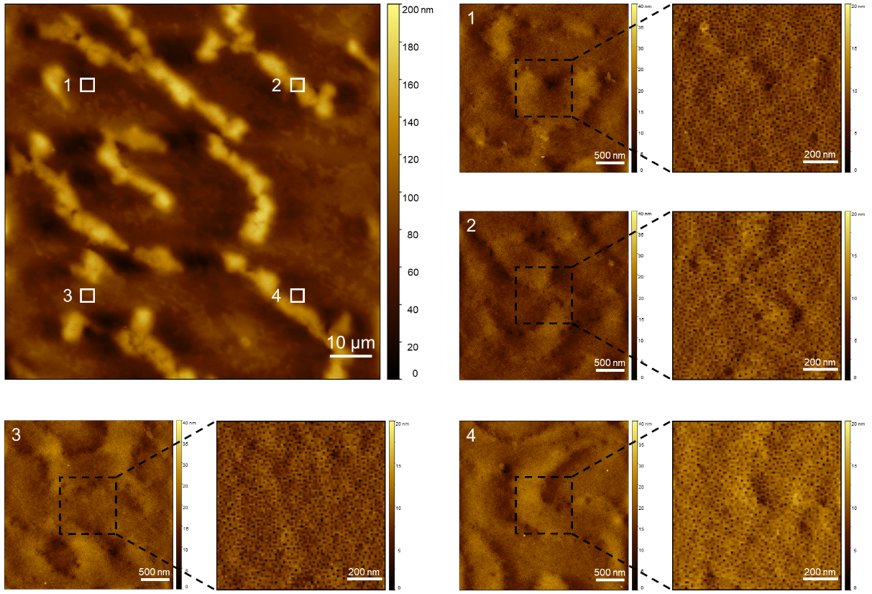
Supplementary Fig. 1 | Large-area AFM characterization of a BCP nanoporous membrane. Magnified views of randomly-selected regions confirm the integrity of the honeycomb-like nanopores.

Supplementary Fig. 2 | FTIR of BCP, h-PEI and h-PEI grafted BCP nanopores. The appearance of a peak at 1631 cm⁻¹ is corresponding to amide bonds.

Supplementary Fig. 3 | DLS curve of h-PEI. The hydrodynamic diameter of h-PEI is ~21 nm.

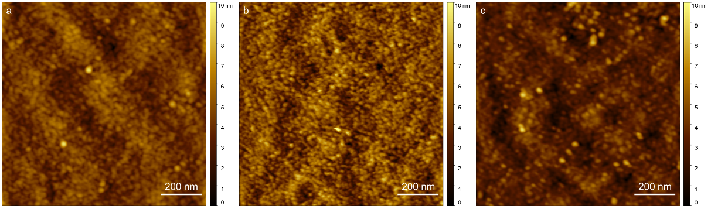
Supplementary Fig. 4 | ​​(a)​​ AFM height image of h-PEI grafted nanopores. According to statistics, there are about 1200 isolated h-PEI nanodots per 1 μm², corresponding to a high density of ~10¹¹ cm⁻².
​​(b) AFM height image of SCHs in aqueous solution. After full swelling, the SCHs exhibited only a 1.2% volume expansion.​​
(c)​​ AFM height image of SCHs after storing in a 0.1 mol·L⁻¹ of KCl solution for 180 days. No significant changes or defects were observed.

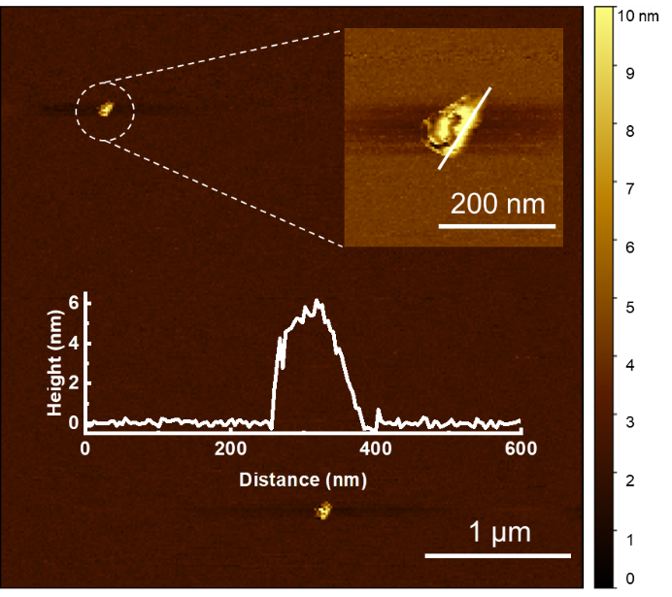
Supplementary Fig. 5 | The AFM height image of the crosslinked PEI nanosheets after detachment. The extended size indicates the presence of inter-chain crosslinking.

Supplementary Fig. 6 | GPC curves of h-PEI and SCHs. The apparent molecular weight of detached SCHs is remarkably lower than that of original h-PEI, indicating no inter-chain crosslinking occurs.

Supplementary Fig. 7 | ¹³C NMR spectroscopy of SCHs and h-PEI. The chemical shifts of 174 and 153 ppm are attributed to the triazine units.

Supplementary Fig. 8 | Stress-strain curves of BCP nanoporous membrane and SCH membrane. The breaking strength of SCH membrane (~106 MPa) is obviously higher than that of BCP nanoporous membrane (~86 MPa).
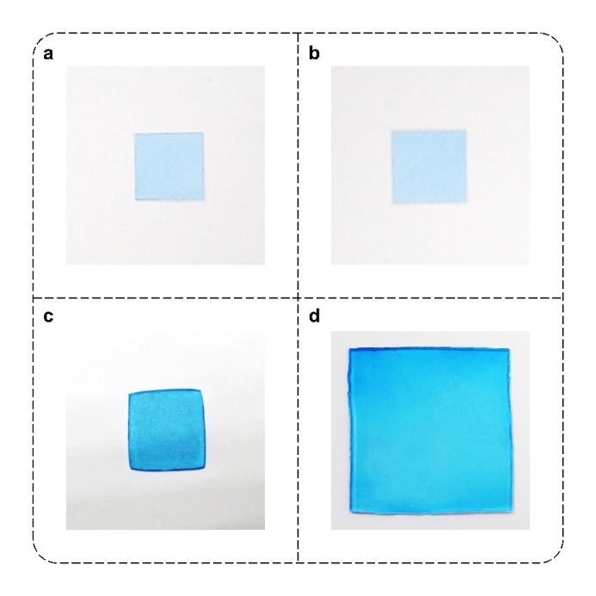
Supplementary Fig. 9 | Optical images of the SCH membrane and acrylamide hydrogel before and after swelling. The SCH membrane showed no significant size change before (a) and after (b) swelling. The acrylamide hydrogel had a volume of 0.05 cm³ before swelling (c), which increased to 1.30 cm³ after swelling (d). The SCH membrane was intentionally dyed blue with methylene blue to enhance visual contrast for accurately comparing its dimensional changes before and after swelling.

Supplementary Fig. 10 | Water uptake and swelling ratio of the SCHs with varying crosslinking degrees. As the crosslinking degree increases, both the swelling ratio and water uptake decrease.
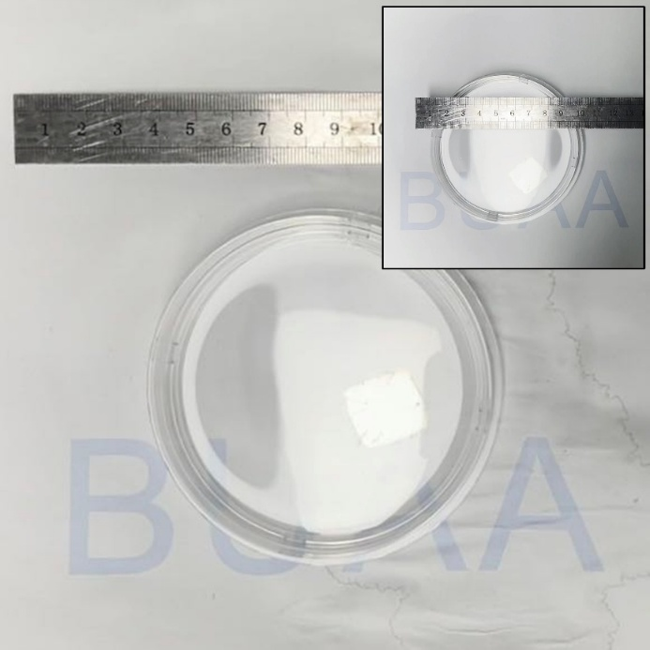
Supplementary Fig. 11 | Optical image of SCH membrane over extended periods. The inset shows the membrane material immediately after being transferred into a 0.1 mol·L⁻¹ KCl solution, with no dimensional expansion or defects observed after 180 days of storage.

Supplementary Fig. 12 | 2D LF-NMR spectra of the pre-swelling SCHs. The T₂ value (< 10 ms) of SCHs indicates the sub-nanometer mesh size. The population with a T₂ between 10 and 100 ms is in the minority, attributed to ~1 nm SCH spacing.

Supplementary Fig. 13 | LF-NMR spectrum of water in SCHs with varying crosslinking degrees (CDs). Using heavy water solution of h-PEI (T₂ > 10 ms, abundant free water) as reference, lower-CD SCHs (0.21, 0.25) retain some free and bound water, while higher-CD SCHs (0.49, 0.69, 0.75) exclusively contain bound water.

Supplementary Fig. 14 | XPS spectrum of original SCHs and Cu-coordination SCHs before and after acid treatment. The absence of characteristic XPS peaks in the Cu 2p region after acid treatment confirms the complete removal of Cu.

Supplementary Fig. 15 | The swelling ratio and selectivity of the SCH membrane change over time. The equilibrium swelling ratio of the SCH membrane is less than 10%. After 24 h of swelling equilibrium, the S_{K/Mg} reaches ~1,200. The increase in selectivity stems from the increase in J_{K}.

Supplementary Fig. 16 | SCH membranes for long-term ion sieving testing. After reaching swelling equilibrium, during the 180-day test, J_{K} and J_{Mg} showed only minimal increases, while S_{K/Mg} remained stable at ~1,200.

Supplementary Fig. 17 | SCH membranes for large-area ion sieving testing. The selectivity of the SCH membrane slightly decreases as the test area increases (from 0.008 to 20 mm²). Under a circular test area with a diameter of 5 mm, S_{K/Mg} still maintains a value above 1,000.

Supplementary Fig. 18 | SCH membranes for mixed salt solution feed testing. At different concentrations of mixed salt solution feed, S_{K/Mg} consistently exceeded 100, reaching the advanced level of current ion-selective materials⁶.

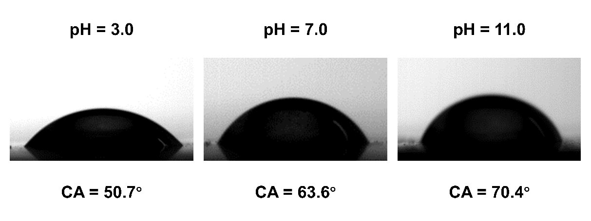
Supplementary Fig. 19 | The pH-sensitive wettability of the SCH membrane surface. At low pH, the protonated nitrogen atoms exhibit enhanced interaction with oxygen atoms in water, leading to increased wettability.

Supplementary Fig. 20 | Comparison of binding energies between cations and sub-nanometer meshes with different protonation states. At lower pH, the mesh is more protonated and has lower binding energy with cations.

Supplementary Fig. 21 | Energy landscape of K⁺ and Mg²⁺ transport in the mesh before and after ​Cu²⁺ coordination. K⁺ gained a more favorable partitioning energy compared to Mg²⁺ and a reduced diffusion barrier compared to original mesh, indicating a strongly facilitated transport.

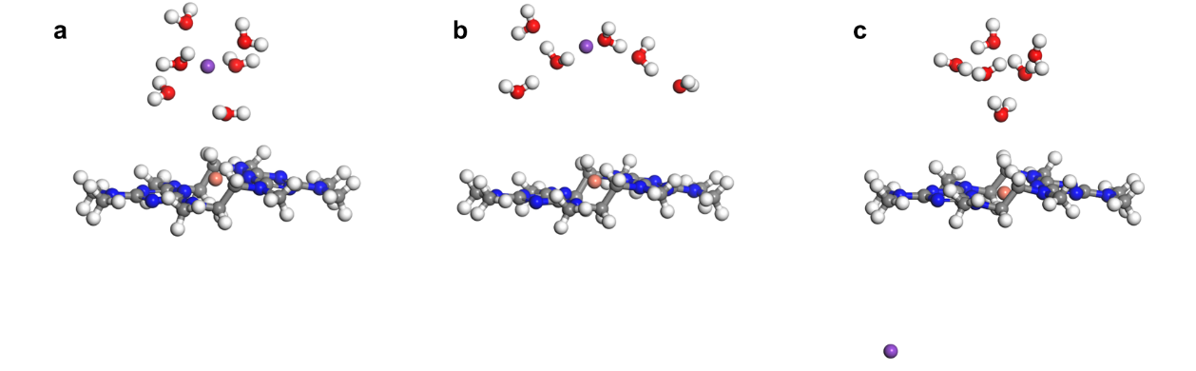
Supplementary Fig. 22 | Molecular models of the three states of K⁺ transport in a Cu-coordinated 5 Å mesh. a, State I (Free), b, State II (Absorbed), and c, State III (Traversed).

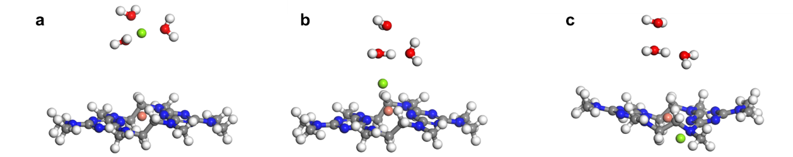
Supplementary Fig. 23 | Molecular models of the three states of Mg²⁺ transport in a Cu-coordinated 5 Å mesh. a, State I (Free), b, State II (Absorbed), and c, State III (Traversed).

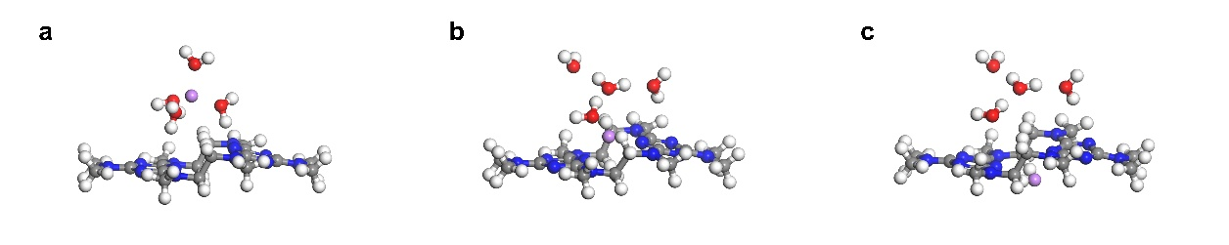
Supplementary Fig. 24 | Molecular models of the three states of Li⁺ transport in a 5 Å mesh. a, State I (Free), b, State II (Absorbed), and c, State III (Traversed).

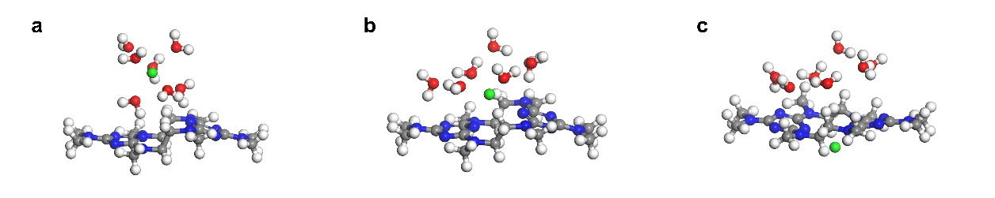
Supplementary Fig. 25 | Molecular models of the three states of Sr²⁺ transport in a 5 Å mesh. a, State I (Free), b, State II (Absorbed), and c, State III (Traversed).

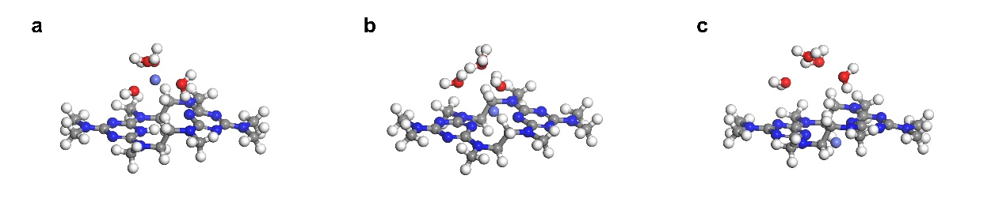
Supplementary Fig. 26 | Molecular models of the three states of Co²⁺ transport in a 5 Å mesh. a, State I (Free), b, State II (Absorbed), and c, State III (Traversed).

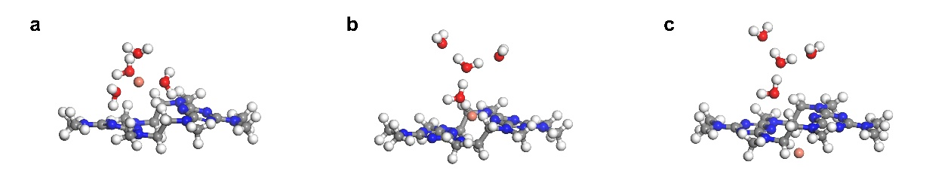
Supplementary Fig. 27 | Molecular models of the three states of Cu²⁺ transport in a 5 Å mesh. a, State I (Free), b, State II (Absorbed), and c, State III (Traversed).

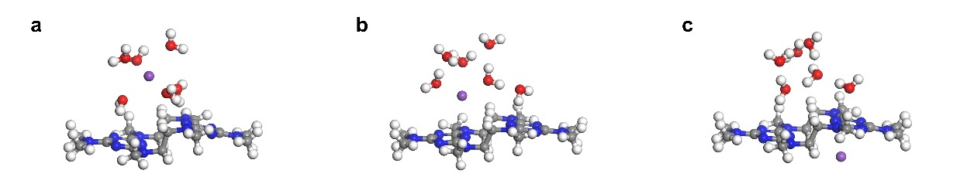
Supplementary Fig. 28 | Molecular models of the three states of K⁺ transport in a 5 Å mesh. a, State I (Free), b, State II (Absorbed), and c, State III (Traversed).

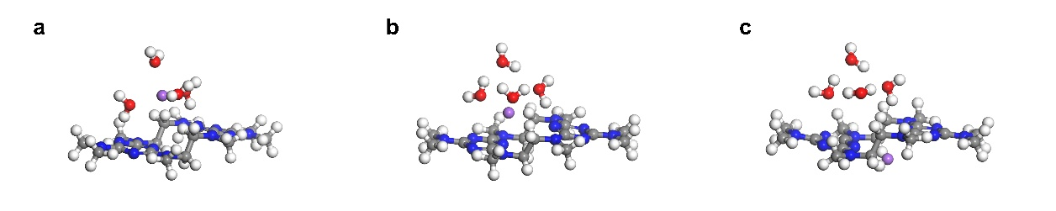
Supplementary Fig. 29 | Molecular models of the three states of Na⁺ transport in a 5 Å mesh. a, State I (Free), b, State II (Absorbed), and c, State III (Traversed).

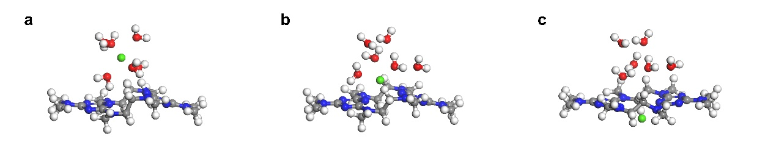
Supplementary Fig. 30 | Molecular models of the three states of Ca²⁺ transport in a 5 Å mesh. a, State I (Free), b, State II (Absorbed), and c, State III (Traversed).

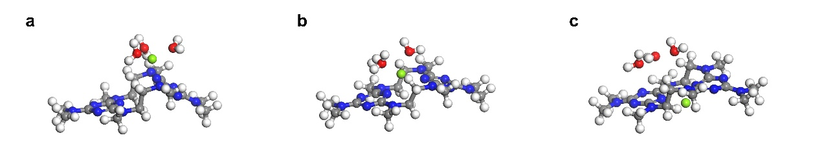
Supplementary Fig. 31 | Molecular models of the three states of Mg²⁺ transport in a 5 Å mesh. a, State I (Free), b, State II (Absorbed), and c, State III (Traversed).

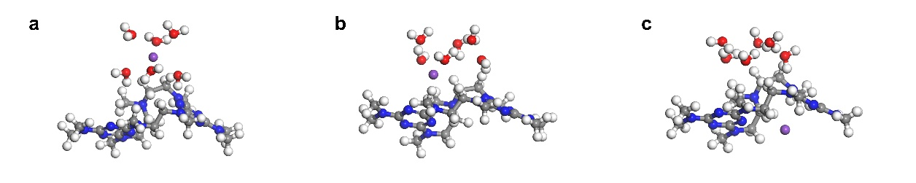
Supplementary Fig. 32 | Molecular models of the three states of K⁺ transport in a 7 Å mesh. a, State I (Free), b, State II (Absorbed), and c, State III (Traversed).

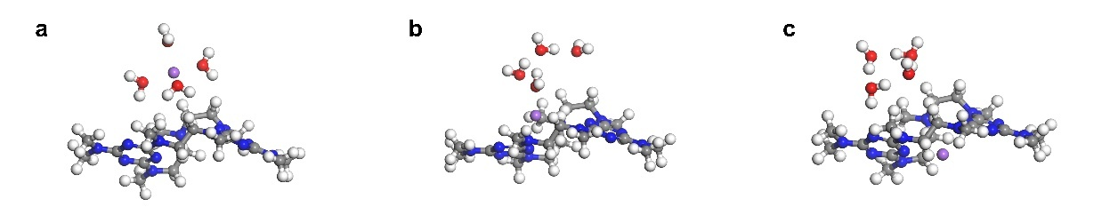
Supplementary Fig. 33 | Molecular models of the three states of Na⁺ transport in a 7 Å mesh. a, State I (Free), b, State II (Absorbed), and c, State III (Traversed).

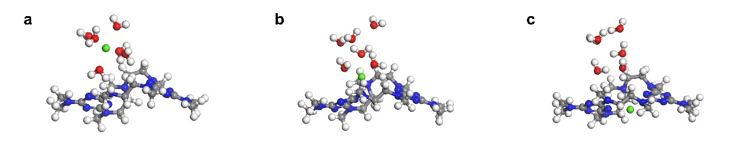
Supplementary Fig. 34 | Molecular models of the three states of Ca²⁺ transport in a 7 Å mesh. a, State I (Free), b, State II (Absorbed), and c, State III (Traversed).

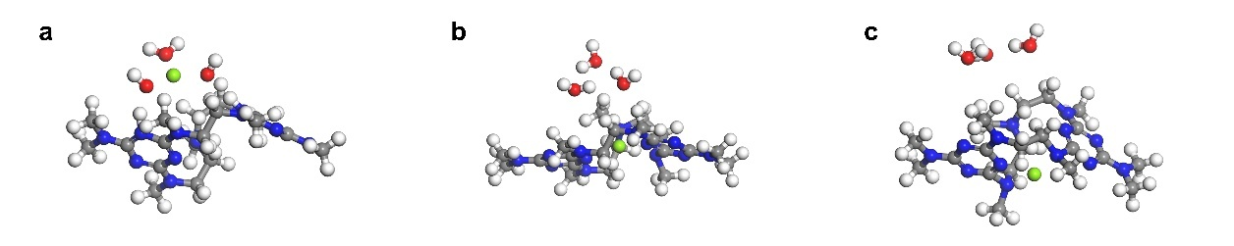
Supplementary Fig. 35 | Molecular models of the three states of Mg²⁺ transport in a 7 Å mesh. a, State I (Free), b, State II (Absorbed), and c, State III (Traversed).

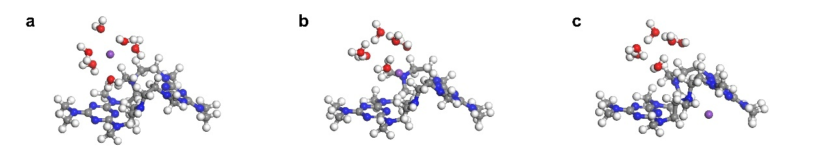
Supplementary Fig. 36 | Molecular models of the three states of K⁺ transport in a 9 Å mesh. a, State I (Free), b, State II (Absorbed), and c, State III (Traversed).

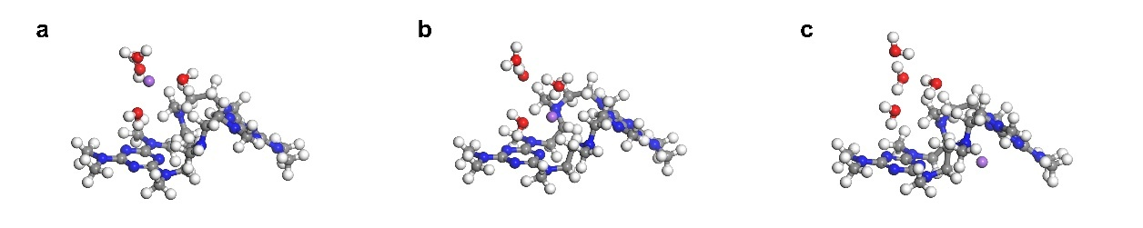
Supplementary Fig. 37 | Molecular models of the three states of Na⁺ transport in a 9 Å mesh. a, State I (Free), b, State II (Absorbed), and c, State III (Traversed).

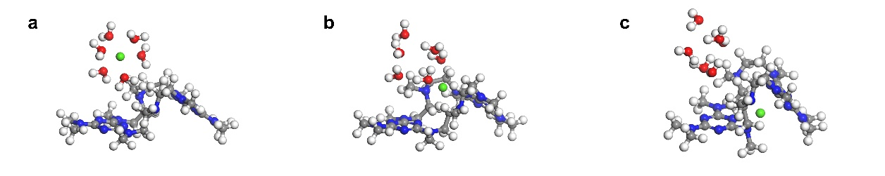
Supplementary Fig. 38 | Molecular models of the three states of Ca²⁺ transport in a 9 Å mesh. a, State I (Free), b, State II (Absorbed), and c, State III (Traversed).

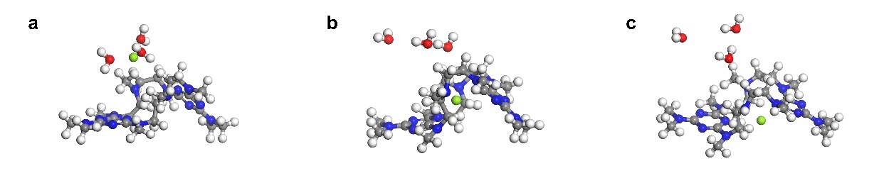
Supplementary Fig. 39 | Molecular models of the three states of Mg²⁺ transport in a 9 Å mesh. a, State I (Free), b, State II (Absorbed), and c, State III (Traversed).

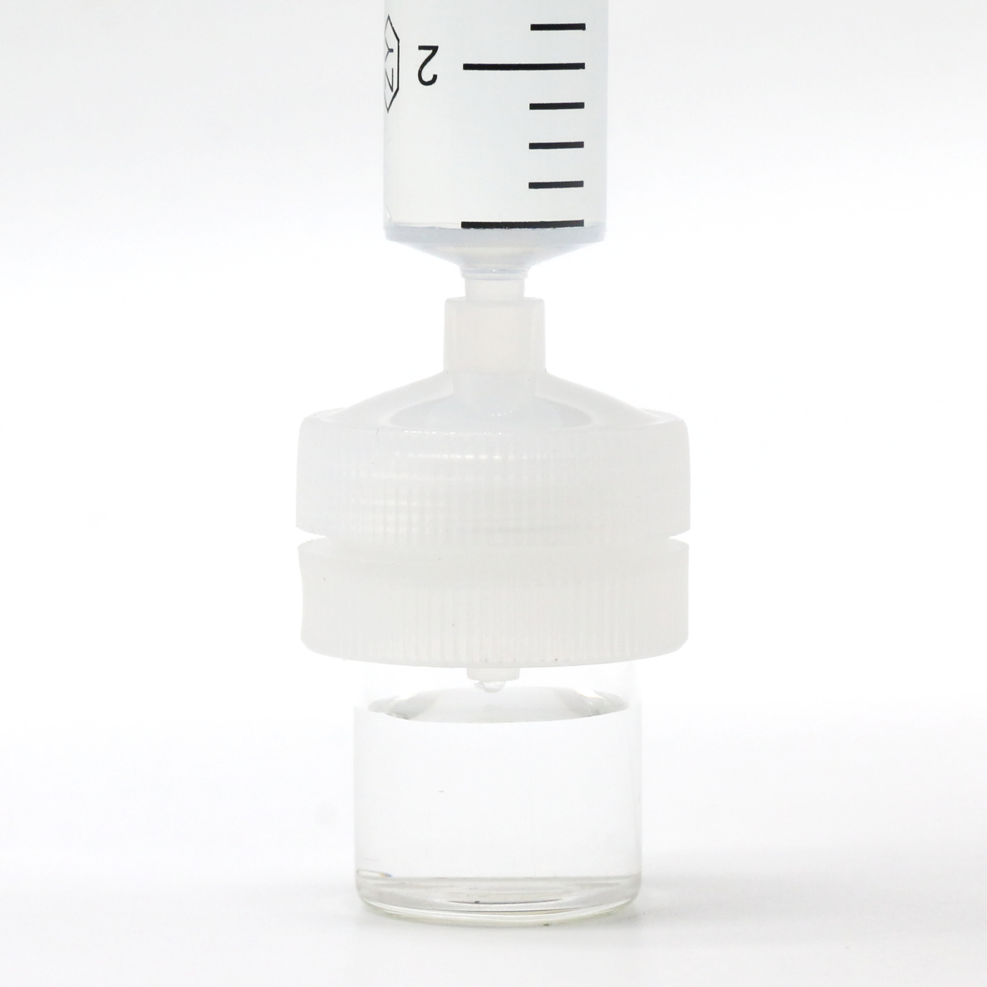
Supplementary Fig. 40 | The home-made injection-driven heavy metal ion remover loaded with SCH membrane. The SCH membrane can be seamlessly integrated into syringes, enabling us to remove heavy metal ions from wastewater through a simple pressure-driven process.

Supplementary Fig. 41 | The power densities obtained using river water and other natural water. The power densities corresponding to rainwater, estuarine water, well water, and lake water are 1.31, 2.15, 1.11, and 4.54 W·m⁻², respectively.

Supplementary Fig. 42 | The power densities obtained using river water and domestic wastewater. The power densities corresponding to laundry water, aquarium water, kitchen sink water, and bath water are 8.76, 14.65, 9.88, and 25.13 W·m⁻², respectively.

Supplementary Fig. 43 | The power densities obtained using river water and industrial/agricultural wastewater. The power densities corresponding to printing and dyeing rinse wastewater, farmland irrigation wastewater, and electroplating rinse wastewater are 4.41, 15.91, and 12.90 W·m⁻², respectively.

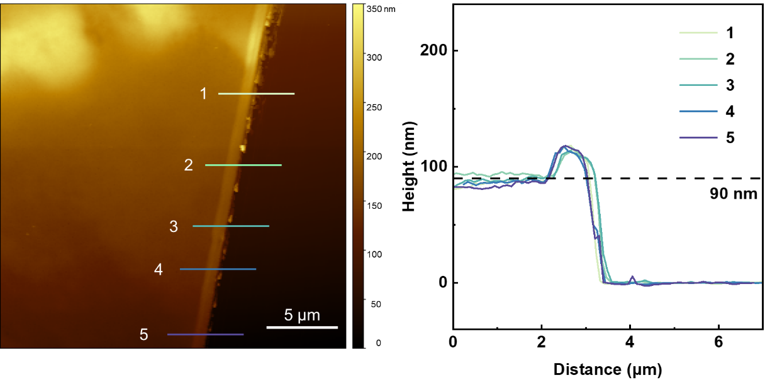
Supplementary Fig. 44 | AFM height analysis of the membrane thickness. The average membrane thickness was measured to be ​90 ± 5 nm.

Supplementary Tables
Supplementary Table 1 | Summary of ion-selective material performance
 |  | Selectivity | Target Ion Flux  (mol·m⁻²·h⁻¹) | Sieving Precision (Ion size difference) | Mesh Size (Å) | Mesh Size Uniformity (Å) | Working Stability (d) | Testing area | Ref.
SCHs |  | 110,000 | 15 | 0 | 4.9 | 1.2 (FWHM), 3.9 (Range) | 180 | 0.20 mm² | Our Work
 |  | 167 | 34.3 | 0.32 | 4.9 | 1.2 (FWHM), 3.9 (Range) | 30 | 1.8 cm² | Our Work
Polymer | cPIM | —— | —— | —— | 5 | ~3.6 (FWHM) | 61 | 2 cm² | 57
Polymer | DMBP-TB | 82 | 10.8 | 1.94 | 5 | ~4 (FWHM) | —— | 14.6 cm² | 58
Polymer | TET-TMC | 28 | —— | 0.7 | 5.2 | —— | 10 | 22.06 cm² | 59
Polymer | PDA | 10.3 | —— | 2.88 | 8.8 | ~4 (FWHM) | 1 | 0.2827 cm² | 60
Polymer | (PDCMAA/PAH)_{n} | 52.1 | 0.01068 | 0.09 | —— | —— | —— | 1.77 cm² | 61
Polymer | Lumirror® | 134.58 | 14 | 1.94 | 10 | —— | —— | 0.7854 mm² | 62
Mixed matrix  membranes (MMM) | HMO-CEM | 100 | 0.0001836 | 0.5 | 794 | —— | 6 | —— | 63
Mixed matrix  membranes (MMM) | Am7CD | 184.1 | —— | 3.4 | 6.6 | —— | —— | 13.8 cm² | 64
Mixed matrix  membranes (MMM) | MOF-gel | —— | —— | 4.4 | 8 | ~6.6 (Range) | 180 | 0.712 cm² | 65
Layered materials | Capillaries | 10 | —— | 1 | 6.8 | —— | —— | 288 μm² | 66
Layered materials | Graphene nanopores | 100 | —— | 1.02 | 20 | —— | —— | 0.0177 μm² | 67
Layered materials | CMP-graphene | 530.4 | —— | 1 | 6 | ~7.5 (FWHM) | 21 | 0.95 cm² | 68
Layered materials | GOMs | —— | 0.0048 | 0.36 | 11.4 | —— | —— | 1.13 cm² | 3
Layered materials | ACN | 10 | 0.00314 | 1.94 | 9.8 | —— | —— | 0.785 cm² | 69
Layered materials | FGOMs | 90 | 0.259 | 1.94 | 12.6 | —— | 1.5 | 0.785 cm² | 70
Layered materials | LCMM | 59 | 0.35 | 1.06 | 6 | —— | 2 | —— | 71
Layered materials | MLM-EDTA | 121.2 | 0.085 | 1.94 | 6 | —— | —— | 2.01 cm² | 28
Framework materials | CC3 | 1031 | 1.9 | 1.94 | 5.4 | ~7 (Range) | 3 | 0.02 mm² | 72
Framework materials | 2D COF | 451 | 0.169 | 0.94 | 5.4 | ~25 (Range) | 2 | 0.9503 cm² | 73
Framework materials | PET-UiO-66-X | 192.04 | —— | 1 | 4.84 | —— | 3 | 1035 nm² | 74
Framework materials | MOFSNC | 4948 | 525,000 | 0.52 | 6 | ~5 (Range) | 7 | 2752 nm² | 75
Framework materials | TpPa-SO₃H | 13.7 | 0.33 | 1 | 13.3 | —— | 1 | 1.54 cm² | 76
Framework materials | UiO-66-(OMe)₂ | 1567.8 | —— | 0.52 | 5 | —— | —— | 3.14 mm² | 77
Framework materials | KcsA | 363.8 | 0.0944 | 0.24 | 7.9 | ~4 (Range) | —— | —— | 78
Framework materials | TpBDMe₂ | 765 | 0.2 | 1.94 | 14 | ~5 (FWHM) | 30 | 3.14 cm² | 79

Supplementary Table 2 | Summary of K⁺ flux and K⁺/Mg²⁺ selectivity
 |  | K⁺ Flux  (mol·m⁻²·h⁻¹) | K⁺/Mg²⁺ Selectivity | Testing area | Ref.
SCHs | CD 0.21, pH = 3 | 11.27 | 24 | 0.20 mm² | Our work
SCHs | CD 0.25, pH = 3 | 4.47 | 123 | 0.20 mm² | Our work
SCHs | CD 0.49, pH = 3 | 0.95 | 287 | 0.20 mm² | Our work
SCHs | CD 0.69, pH = 3 | 0.41 | 1352 | 0.20 mm² | Our work
SCHs | CD 0.75, pH = 3 | 0.40 | 1428 | 0.20 mm² | Our work
SCHs | CD 0.75, pH = 9 | 0.44 | 455 | 0.20 mm² | Our work
SCHs | CD 0.75, pH = 7 | 0.44 | 608 | 0.20 mm² | Our work
SCHs | CD 0.75, pH = 5 | 0.41 | 1,007 | 0.20 mm² | Our work
SCHs | CD 0.75, pH = 3 | 0.40 | 1,364 | 0.20 mm² | Our work
SCHs | CD 0.75, pH = 1 | 0.40 | 674 | 0.20 mm² | Our work
SCHs | CD 0.75, pH = 7,  Cu²⁺-Coordination | 0.44 | 22,412 | 0.20 mm² | Our work
SCHs | CD 0.75, pH = 7,  H⁺-Removal | 0.40 | 3,010 | 0.20 mm² | Our work
SCHs | CD 0.75, pH = 7 | 3.59 | 167 | 1.8 cm² | Our work
EtOH-M |  | 0.0254 | 4.62 | —— | 80
CaCl₂-GO |  | 0.353 | 5.19 | 1.77 cm² | 81
Lumirror® |  | 14 | 20 | 0.7854 mm² | 62
DMBP-TB |  | 0.2 | 49 | 14.6 cm² | 58
FGOM-60 |  | 0.259 | 90 | 0.785 cm² | 70
3D COF |  | 0.276 | 92 | 1.766 cm² | 27
MLM-EDTA |  | 0.085 | 121.2 | 2.01 cm² | 28
M-TpPaCAPEI |  | 0.00716 | 180 | 4.9 cm² | 82
PCGO |  | 0.0065 | 650 | 0.5 cm² | 83
TpBDMe₂ |  | 0.2 | 765 | 3.14 cm² | 79
UiO-66-(OMe)₂ |  | 0.05 | 1,576.8 | 3.14 mm² | 77

Supplementary Table 3 | Summary of cation size and hydration enthalpies^{84,85}
 | Stokes  diameter (Å) | Hydrated  diameter (Å) | Ionic hydration enthalpies (kcal·mol⁻¹)
K⁺ | 2.50 | 6.62 | 77.0
Na⁺ | 3.68 | 7.26 | 97.8
Li⁺ | 4.76 | 7.64 | 124.0
Sr²⁺ | 6.20 | 8.24 | 344.9
Ca²⁺ | 6.20 | 8.24 | 376.9
Mg²⁺ | 6.94 | 8.56 | 459.1
Co²⁺ | 6.70 | 5.46 | 477.1
Cu²⁺ | 6.50 | 8.38 | 501.9

Supplementary Table 4 | Summary of desalination performance of SCH membranes and other ion-selective material
 | Driven Pressure (bar) | Composition of the feed solution | Water flux (LMH·bar⁻¹) | Salt rejection (%) | Testing area (cm²) | Ref.
SCHs | 0.85 | NaCl (0.0001 M) | 209.81 | 97.58 | 1.8 | Our Work
SCHs | 0.85 | NaCl (0.001 M) | 210.35 | 96.91 | 1.8 | Our Work
SCHs | 0.85 | NaCl (0.01 M) | 206.99 | 92.79 | 1.8 | Our Work
SCHs | 0.85 | NaCl (0.1 M) | 201.26 | 88.47 | 1.8 | Our Work
SCHs | 0.85 | NaCl (1.0 M) | 195.24 | 79.33 | 1.8 | Our Work
SCHs | 0.85 | CaCl₂ (0.0001 M) | 192.13 | 99.99 | 1.8 | Our Work
SCHs | 0.85 | CaCl₂ (0.001 M) | 166.90 | 99.97 | 1.8 | Our Work
SCHs | 0.85 | CaCl₂ (0.01 M) | 129.24 | 99.88 | 1.8 | Our Work
SCHs | 0.85 | CaCl₂ (0.1 M) | 109.17 | 99.63 | 1.8 | Our Work
SCHs | 0.85 | CaCl₂ (1.0 M) | 98.83 | 99.12 | 1.8 | Our Work
SCHs | 0.85 | KCl (0.1 M) | 322.78 | 86.92 | 1.8 | Our Work
SCHs | 0.85 | LiCl (0.1 M) | 133.93 | 98.76 | 1.8 | Our Work
SCHs | 0.85 | MgCl₂ (0.1 M) | 83.98 | 99.78 | 1.8 | Our Work
SCHs | 0.85 | NaCl (0.01 M) | 200.01 | 88.15 | 11.3 | Our Work
SCHs | 0.85 | CaCl₂ (0.01 M) | 129.42 | 99.66 | 11.3 | Our Work
SCHs | 0.85 | NaCl (0.01 M) | 178.21 | 88.10 | 44.2 | Our Work
SCHs | 0.85 | CaCl₂ (0.01 M) | 114.02 | 99.66 | 44.2 | Our Work
SCHs | 0.85 | NaCl (0.01 M) | 148.65 | 88.02 | 78.5 | Our Work
SCHs | 0.85 | CaCl₂ (0.01 M) | 93.77 | 99.61 | 78.5 | Our Work
GO-TBO | 10-50, 60 | NaCl (0.01/0.1/0.5 M), | 1-3 | 40-50 | 17.3 | 86
GO-TBO | 10-50, 60 | Na₂SO₄ (0.01/0.1/0.5 M) | 1-3 | 70-80 | 17.3 | 86
ZIF-8-PDPM | 1 | NaCl:Na₂SO₄ = 1:1 (1/80 g·L⁻¹) | 130 | 10 (NaCl) | 15000 | 87
 |  |  |  | 30 (Na₂SO₄) | 15000 | 87
UiO-66 | 10 | KCl (0.20 wt%) | 0.14 | 45.7 | —— | 88
UiO-66 | 10 | NaCl (0.20 wt%) | 0.14 | 47.0 | —— | 88
UiO-66 | 10 | CaCl₂ (0.20 wt%) | 0.14 | 86.3 | —— | 88
UiO-66 | 10 | MgCl₂ (0.20 wt%) | 0.14 | 98.0 | —— | 88
UiO-66 | 10 | AlCl₃ (0.20 wt%) | 0.14 | 99.3 | —— | 88
St/TMC TFCM | 2 | NaCl (1,000 mg·L⁻¹) | 81.2 | 9 | 12.56 | 89
St/TMC TFCM | 2 | Na₂SO₄ (1,000 mg·L⁻¹) | 81.2 | 82-90 | 12.56 | 89

Supplementary Table 5 | Summary of anti-fouling performance and chlorine resistance of SCH membranes
Treatment method | Water flux (LMH·bar⁻¹) | Salt rejection (%)
Humic acid, 20 ppm, 24 h | 96.58 (NaCl 0.01 M),  75.09 (CaCl₂ 0.01 M) | 88.42 (NaCl),  99.71 (CaCl₂)
Sodium alginate, 20 ppm, 24 h | 109.23 (NaCl 0.01 M),  82.28 (CaCl₂ 0.01 M) | 88.29 (NaCl),  99.70 (CaCl₂)
Ca²⁺/SO₄²⁻, 100 ppm, 24 h | 155.01 (NaCl 0.01 M),  110.47 (CaCl₂ 0.01 M) | 88.36 (NaCl),  99.72 (CaCl₂)
Ca²⁺/HCO₃⁻, 100 ppm, 24 h | 136.70 (NaCl 0.01 M),  100.55 (CaCl₂ 0.01 M) | 88.41 (NaCl),  99.71 (CaCl₂)
Humic acid, 20 ppm, 24 h,  Regeneration by NaClO, 200 ppm, 4h | 199.65 (NaCl 0.01 M),  128.35 (CaCl₂ 0.01 M) | 83.63 (NaCl),  99.41 (CaCl₂)
Sodium alginate, 20 ppm, 24 h,  Regeneration by NaClO, 200 ppm, 4h | 206.92 (NaCl 0.01 M),  130.89 (CaCl₂ 0.01 M) | 83.75 (NaCl),  99.54 (CaCl₂)
Ca²⁺/SO₄²⁻, 100 ppm, 24 h,  Regeneration by NaClO, 200 ppm, 4h | 206.15 (NaCl 0.01 M),  130.85 (CaCl₂ 0.01 M) | 83.63 (NaCl),  99.55 (CaCl₂)
Ca²⁺/HCO₃⁻, 100 ppm, 24 h,  Regeneration by NaClO, 200 ppm, 4h | 207.65 (NaCl 0.01 M),  132.26 (CaCl₂ 0.01 M) | 83.79 (NaCl),  99.55 (CaCl₂)
NaClO, 50 ppm, 8h (400 ppm·h) | 215.29 (NaCl 0.01 M),  133.43 (CaCl₂ 0.01 M) | 88.28 (NaCl),  99.69 (CaCl₂)
NaClO, 50 ppm, 24h (1200 ppm·h) | 230.15 (NaCl 0.01 M),  138.64 (CaCl₂ 0.01 M) | 88.13 (NaCl),  99.69 (CaCl₂)
NaClO, 50 ppm, 48h (2400 ppm·h) | 236.53 (NaCl 0.01 M),  136.46 (CaCl₂ 0.01 M) | 83.49 (NaCl),  99.55 (CaCl₂)
NaClO, 50 ppm, 72h (3600 ppm·h) | 242.24 (NaCl 0.01 M),  140.28 (CaCl₂ 0.01 M) | 83.46 (NaCl),  99.54 (CaCl₂)

Supplementary Table 6 | Summary of Li⁺ flux and Li⁺/Mg²⁺ selectivity
 | Li⁺ Flux  (mol·m⁻²·h⁻¹) | Li⁺/Mg²⁺ Selectivity | Method (Li/Mg Mole Ratio) | Ref.
SCHs | 15.03 | 16,015 | Diffusion dialysis (1:1000) | Our work
PSS@HKUST-1-6.7 | 0.0254 | 10,296 | Electrodialysis (1:1) | 90
AAO/PTI/PCN | 0.353 | 1,708 | Diffusion dialysis (1:500) | 40
COF-EO₂/PAN | 14 | 1,352 | Electrodialysis (1:1) | 91
TAT-TP-P | 0.2 | 823 | Electrodialysis (1:1) | 92
EALNF | 0.259 | 679 | Nanofiltration  (1:100 Mass Ratio) | 93
PIM-SBI-OH-AO | 0.276 | 486 | Electrodialysis  (1:80 Mass Ratio) | 94
COF-300-CH_{0.6} | 0.085 | 321.2 | Electrodialysis  (7:24 Mass Ratio) | 95
TpBDMe₂ | 0.00716 | 217 | Diffusion dialysis (1:1) | 79
UiO-66-(SH)₂/PET | 0.6 | 18.8 | Electrodialysis (1:30) | 96
UiO-67/AAO | 0.2 | 159 | Electrodialysis (1:1) | 97
CC3 | 0.05 | 104 | Electrodialysis (1:1) | 72
3D COF | 0.123 | 36 | Diffusion dialysis  (1:35 Mass Ratio) | 27
MXene@PSS | 0.08 | 28 | Diffusion dialysis (1:1) | 98
M-TpPaCAPEI | 1.86 | 25.5 | Electrodialysis  (1:32 Mass Ratio) | 82
M-E₁₊₂ | 0.45 | 23 | Nanofiltration (1:100) | 99
Lumirror® | 0.014 | 21 | Electrodialysis (1:1) | 62
DMBP-TB | 0.065 | 13 | Diffusion dialysis, — | 58
DB18C6@UiO-66 | 0.32 | 13 | Diffusion dialysis (1:1) | 26
IGM | 1.02 | 8 | Nanofiltration  (1:150 Mass Ratio) | 100
Al-intercalated MXMs | 0.002 | 3.1 | Diffusion dialysis, — | 101

Supplementary Table 7 | Summary of water source salinity*
 | Salinity (‰)
River water | 0.92
Rain water | 1.32
Estuarine water | 1.94
Well water | 2.24
Lake water | 3.16
Printing and dyeing rinse wastewater | 6.04
Laundry water | 14.72
Aquarium water | 15.82
Farmland irrigation wastewater | 16.56
Electroplating rinse wastewater | 17.57
Kitchen sink water | 23.83
Bath water | 28.43
Seawater | 32.37
* The salinity values for the various water sources mentioned were measured using a salinity meter based on the conductivity method.

Supplementary Reference
3. Chen, L. et al. Ion sieving in graphene oxide membranes via cationic control of interlayer spacing. Nature 550, 380-383 (2017).
24. Sui, X. et al. Biomimetic nanofluidic diode composed of dual amphoteric channels maintains rectification direction over a wide pH range. Angew. Chem. Int. Ed. 55, 13056 (2016).
26. Xu, T. et al. Perfect confinement of crown ethers in MOF membrane for complete dehydration and fast transport of monovalent ions. Sci. Adv. 10, eadn0944 (2024).
27. Wu, T. et al. Imine-Linked 3D covalent organic framework membrane featuring highly charged sub-1 nm channels for exceptional lithium-ion sieving. Adv. Mater. 37, 2415509 (2025).
28. Xu, R., Kang, Y., Zhang, W., Pan, B. & Zhang, X. Two-dimensional MXene membranes with biomimetic sub-nanochannels for enhanced cation sieving. Nat. Commun. 14, 4907 (2023).
40. Zhang, Y. et al. Congener-welded crystalline carbon nitride membrane for robust and highly selective Li/Mg separation. Sci. Adv. 10, eadm9620 (2024).
50. Hertz, H. On the contact of elastic solids. J. Reine. Angew. Math. 92, 156-171 (1881).
51. Li, J. et al. Free volume characteristics on water permeation and salt rejection of polyamide reverse osmosis membranes investigated by a pulsed slow positron beam. J. Mater. Sci. 53, 16132-16145 (2018).
52. Willems, T. F., Rycroft, C. H., Kazi, M., Meza, J. C. & Haranczyk, M. Algorithms and tools for high-throughput geometry-based analysis of crystalline porous materials. Microporous Mesoporous Mater. 149, 134-141 (2012).
53. Lu, T. & Chen, F. Multiwfn: A multifunctional wavefunction analyzer. J. Comput. Chem. 33: 580-592 (2012).
54. Humphrey, W., Dalke, A. & Schulten, K. VMD: Visual molecular dynamics. J. Mol. Graph. 14, 33-38 (1996).
55. Wu, S. et al. Heterogeneous ice nucleation correlates with bulk-like interfacial water. Sci. Adv. 5, eaat9825 (2019).
56. Zhang, Z. et al. Engineered asymmetric heterogeneous membrane: A concentration-gradient-driven energy harvesting device. J. Am. Chem. Soc. 137, 14765-14772 (2015).
57. Wang, A. et al. Selective ion transport through hydrated micropores in polymer membranes. Nature 635, 353-358 (2024).
58. Tan, R. et al. Hydrophilic microporous membranes for selective ion separation and flow-battery energy storage. Nat. Mater. 19, 195-202 (2020).
59. Li, J., Peng, H., Liu, K. & Zhao, Q. Polyester nanofiltration membranes for efficient cations separation. Adv. Mater. 36, 2309406 (2024).
60. Yu, J. et al. Ion and molecular sieving with ultrathin polydopamine nanomembranes. Adv. Mater. 36, 2401137 (2024).
61. DuChanois, R. M. et al. Designing polymeric membranes with coordination chemistry for high-precision ion separations. Sci. Adv. 8, eabm9436 (2022).
62. Wang, P. et al. Ultrafast ion sieving using nanoporous polymeric membranes. Nat. Commun. 9, 569 (2018).
63. Iddya, A. et al. A reverse-selective ion exchange membrane for the selective transport of phosphates via an outer-sphere complexation-diffusion pathway. Nat. Nanotechnol. 17, 1222-1228 (2022).
64. Hong, S. et al. Precision ion separation via self-assembled channels. Nat. Commun. 15, 3160 (2024).
65. Bai, S. et al. Permselective metal-organic framework gel membrane enables long-life cycling of rechargeable organic batteries. Nat. Nanotechnol. 16, 77-84 (2021).
66. Goutham, S. et al. Beyond steric selectivity of ions using ångström-scale capillaries. Nat. Nanotechnol. 18, 596-601 (2023).
67. Rollings, R., Kuan, A. & Golovchenko, J. Ion selectivity of graphene nanopores. Nat. Commun. 7, 11408 (2016).
68. Zhou, Z. et al. Electrochemical-repaired porous graphene membranes for precise ion-ion separation. Nat. Commun. 15, 4006 (2024).
69. Wang, Y., Lian, T., Tarakina, N. V., Yuan, J. & Antonietti, M. Lamellar carbon nitride membrane for enhanced ion sieving and water desalination. Nat. Commun. 13, 7339 (2022).
70. Qian, Y. et al. Enhanced ion sieving of graphene oxide membranes via surface amine functionalization. J. Am. Chem. Soc. 143, 5080-5090 (2021).
71. Huang, L., Wu, H., Ding, L., Caro, J. & Wang, H. Shearing liquid-crystalline MXene into lamellar membranes with super-aligned nanochannels for ion sieving. Angew. Chem. Int. Ed. 63, e202314638 (2024).
72. Xu, T. et al. Highly ion-permselective porous organic cage membranes with hierarchical channels. J. Am. Chem. Soc. 144, 10220-10229 (2022).
73. Meng, Q.-W. et al. Optimizing selectivity via membrane molecular packing manipulation for simultaneous cation and anion screening. Sci. Adv. 10, eado8658 (2024).
74. Li, X. et al. Fast and selective fluoride ion conduction in sub-1-nanometer metal-organic framework channels. Nat. Commun. 10, 2490 (2019).
75. Lu, J. et al. Efficient metal ion sieving in rectifying subnanochannels enabled by metal-organic frameworks. Nat. Mater. 19, 767-774 (2020).
76. Wang, H. et al. Covalent organic framework membranes for efficient separation of monovalent cations. Nat. Commun. 13, 7123 (2022).
77. Mo, R.-J. et al. Regulating ion affinity and dehydration of metal-organic framework sub-nanochannels for high-precision ion separation. Nat. Commun. 15, 2145 (2024).
78. Xin, W. et al. Biomimetic KcsA channels with ultra-selective K⁺ transport for monovalent ion sieving. Nat. Commun. 13, 1701 (2022).
79. Sheng, F. et al. Efficient ion sieving in covalent organic framework membranes with sub-2-nanometer channels. Adv. Mater. 33, 2104404 (2021).
80. Kang, Y. et al. Nanoconfinement enabled non-covalently decorated MXene membranes for ion-sieving. Nat. Commun. 14, 4075 (2023).
81. Zhou, C. et al. Large-area layered membranes with precisely controlled nano-confined channels. Angew. Chem. Int. Ed. 63, e202410441 (2024).
82. Wang, W. et al. Simultaneous manipulation of membrane enthalpy and entropy barriers towards superior ion separations. Angew. Chem. Int. Ed. 63, e202408963 (2024).
83. Abraham, J. et al. Tunable sieving of ions using graphene oxide membranes. Nat. Nanotechnol. 12, 546-550 (2017).
84. Nightingale, E. R., Jr. Phenomenological theory of ion solvation. effective radii of hydrated ions. J. Phys. Chem. 63, 1381-1387 (1959).
85. Smith, D. W. Ionic hydration enthalpies. J. Chem. Educ. 54, 540 (1977).
86. Wang, Z. et al. Graphene oxide nanofiltration membranes for desalination under realistic conditions. Nat. Sustain. 4, 402-408 (2021).
87. Ji, Y.-L. et al. Roll-to-roll fabrication of large-area metal-organic framework-based membranes for high-performance aqueous separations. Nat. Water 2, 183-192 (2024).
88. Liu, X., Demir, N. K., Wu, Z. & Li, K. Highly water-stable zirconium metal-organic framework UiO-66 membranes supported on alumina hollow fibers for desalination. J. Am. Chem. Soc. 137, 6999-7002 (2015).
89. Bai, Y. et al. Microstructure optimization of bioderived polyester nanofilms for antibiotic desalination via nanofiltration. Sci. Adv. 9, eadg6134 (2023).
90. Guo, Y., Ying, Y., Mao, Y., Peng, X. & Chen, B. Polystyrene sulfonate threaded through a metal-organic framework membrane for fast and selective lithium-ion separation. Angew. Chem. Int. Ed. 55, 15120 (2016).
91. Meng, Q.-W. et al. Enhancing ion selectivity by tuning solvation abilities of covalent-organic framework membranes. Proc. Natl. Acad. Sci. U. S. A. 121, e2316716121 (2024).
92. Meng, W. et al. Dehydration-enhanced ion recognition of triazine covalent organic frameworks for high-resolution Li⁺/Mg²⁺ separation. Angew. Chem. Int. Ed. 64, e202422423 (2025).
93. Yong, M. et al. Sustainable lithium extraction and magnesium hydroxide co-production from salt-lake brines. Nat. Sustain. 7, 1662-1671 (2024).
94. Yang, D. et al. Solution-processable polymer membranes with hydrophilic subnanometre pores for sustainable lithium extraction. Nat. Water 3, 319-333 (2025).
95. Meng, W. et al. Three-dimensional cationic covalent organic framework membranes for rapid and selective lithium extraction from saline water. Nat. Water 3, 191-200 (2025).
96. Zhao, C. et al. Unlocking direct lithium extraction in harsh conditions through thiol-functionalized metal-organic framework subnanofluidic membranes. J. Am. Chem. Soc. 146, 14058-14066 (2024).
97. Xu, R., Kang, Y., Zhang, W., Zhang, X. & Pan, B. Oriented UiO-67 metal-organic framework membrane with fast and selective lithium-ion transport. Angew. Chem. Int. Ed. 61, e202115443 (2022).
98. Lu, Z., Wu, Y., Ding, L., Wei, Y. & Wang, H. A lamellar MXene (Ti₃C₂T_{x})/PSS composite membrane for fast and selective lithium-ion separation. Angew. Chem. Int. Ed. 60, 22265 (2021).
99. Peng, H., Liu, X., Su, Y., Li, J. & Zhao, Q. Advanced lithium extraction membranes derived from tagged-modification of polyamide networks. Angew. Chem. Int. Ed. 62, e202312795 (2023).
100. Wang, R., He, R. He, T., Elimelech, M. & Lin, S. Performance metrics for nanofiltration-based selective separation for resource extraction and recovery. Nat. Water 1, 291-300 (2023).
101. Ding, L. et al. Effective ion sieving with Ti₃C₂T_{x} MXene membranes for production of drinking water from seawater. Nat. Sustain. 3, 296-302 (2020).

