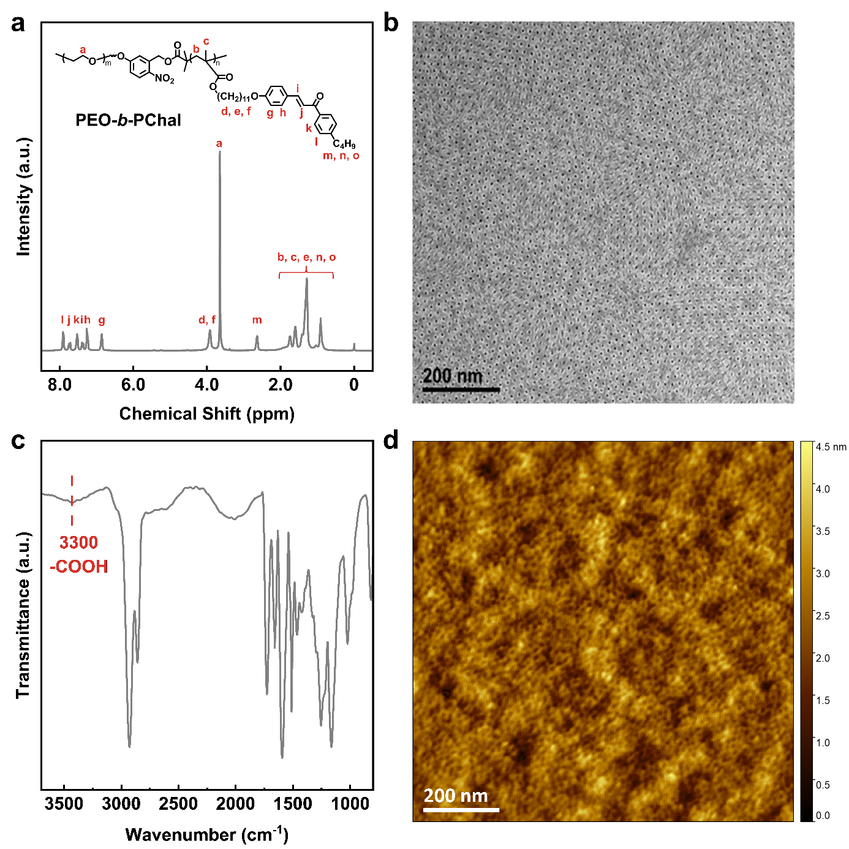
Extended Data Fig. 1 | Nanoporous membrane fabrication. a, ¹H-NMR spectra of BCP precursor. The weight fraction of the PEO was calculated to be 13.8%. b, Transmission electron microscope (TEM) image of the PEO-b-PChal BCP membrane. The diameter of the PEO phase (nanopore) is 8 nm, with a center-to-center distance of 25 nm. c, Fourier transform infrared spectroscopy (FTIR) of PEO-b-PChal membrane after UV treatment. The peak at 3300 cm⁻¹ corresponds to the carboxyl groups. d, The AFM height image of the BCP membrane after removal of PEO.

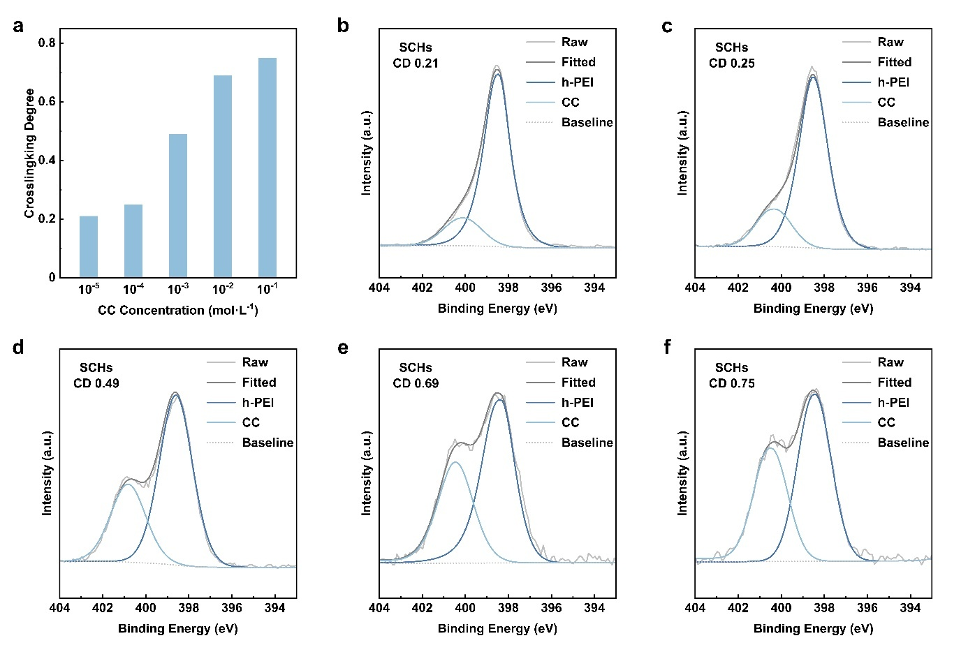
Extended Data Fig. 2 | Determination of the crosslinking degree in SCHs. a, The crosslinking degree (CD) of SCHs obtained at different CC concentrations. b-f, XPS spectral deconvolution of SCHs with varying CDs.

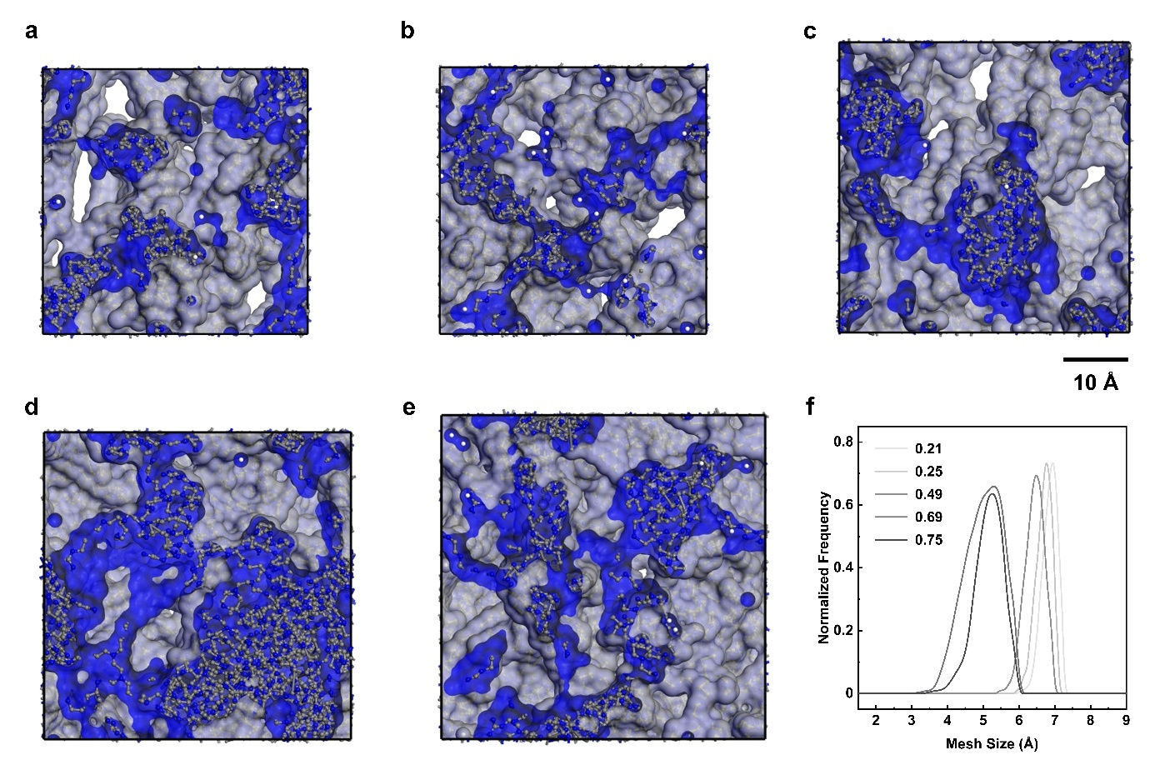
Extended Data Fig. 3 | MD simulations of SCHs. a-e, 3D view of the SCHs with varying CDs (free volume in gray and Connolly surface in blue), in order: 0.21, 0.25, 0.49, 0.69, and 0.75. f, The mesh size distribution calculated from the simulations. As the CD increases, the mesh size decreases.

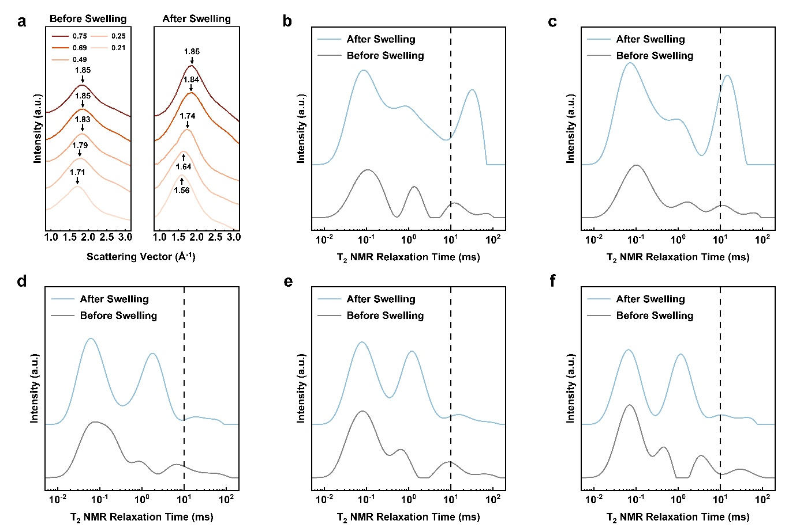
Extended Data Fig. 4 | Analysis of mesh size before and after SCHs swelling. a, WAXS spectrum of SCHs with varying crosslinking degrees before and after swelling. The characteristic WAXS scattering halo of SCHs with higher crosslinking density exhibits a smaller shift. b-f, LF-NMR spectrum of SCHs with varying CDs before and after swelling, in order: 0.21, 0.25, 0.49, 0.69, and 0.75.

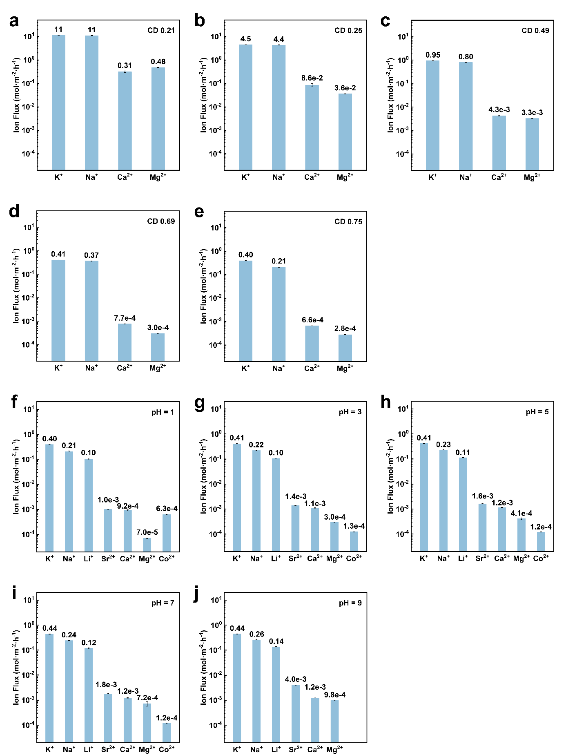

Extended Data Fig. 5 | Cation fluxes in SCHs of different pH and varying CDs. a-e, At CDs of 0.21, 0.25, 0.49, 0.69, and 0.75, the cation fluxes in SCHs (pH = 3). f-j, At pH = 1, 3, 5, 7, and 9, the cation fluxes in fully crosslinked SCHs. At pH = 9, Co²⁺ precipitates.

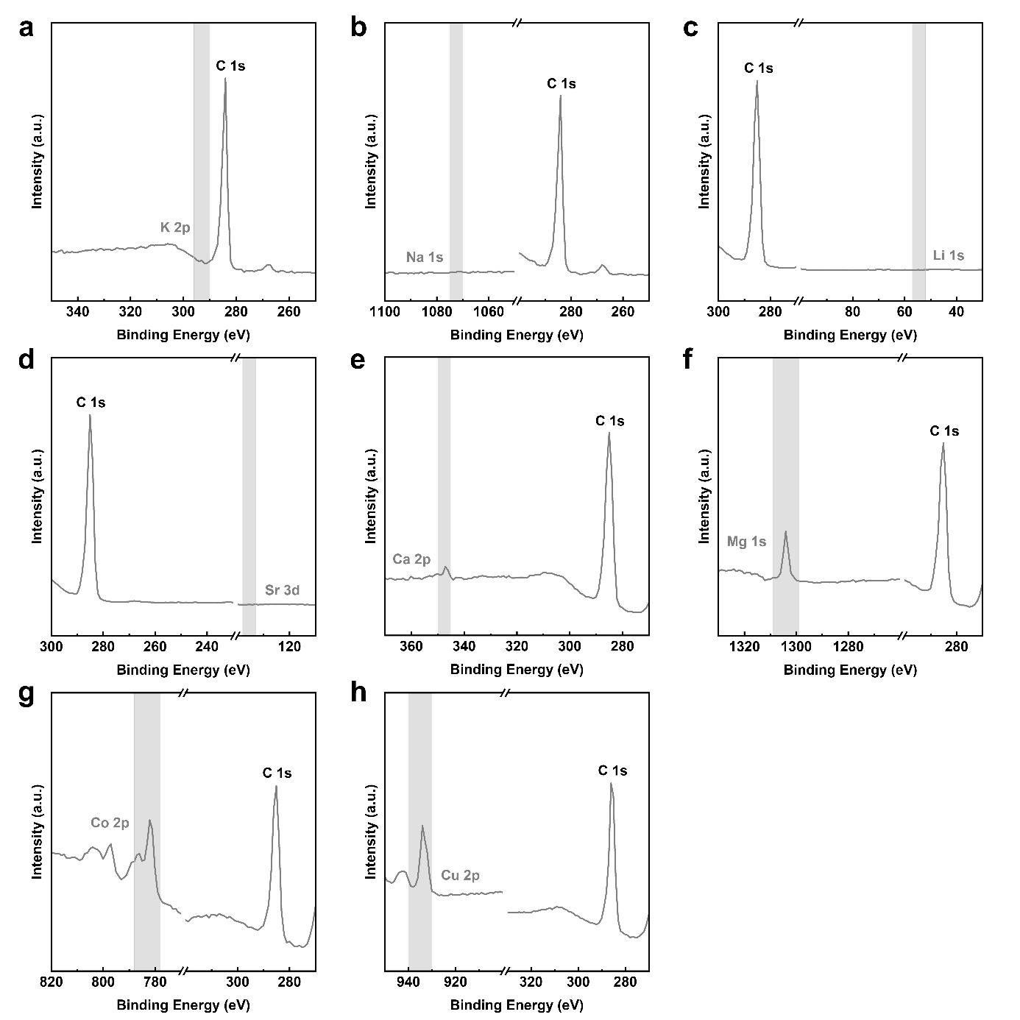
Extended Data Fig. 6 | Comparison of XPS spectrum for SCHs absorbing cations. a-h, The XPS spectrum of SCHs after absorption from 0.1 mol·L⁻¹ cation solutions and rinsing with deionized water, corresponding to the following ion orbitals: K 2p, Na 1s, Li 1s, Sr 3d, Ca 2p, Mg 1s, Co 2p, Cu 2p.

